**Appendix**

We take the opportunity in the following pages to be clear and detailed about our analytical workflow and the auxiliary results that are generated along the way. The general outline of our process is as follows:

1. Recoding and Scaling
2. Sample and Data Imputation
3. Calculating Mediated Effects
4. Listwise Deleted Results
5. Multinomial Logistic Regression Results

**A1. Recoding and Scaling**

We recode education such that those with less than a high school education are in the first category (numerical values less than 5), those with a high school education are in the second group (numerical value equals 5), those with some post-secondary education are in category three (numerical values between 6 and 8, inclusive) and those with a university degree or higher are in category four (numerical values 9-11, inclusive). Region was coded such that Atlantic = New Brunswick, Newfoundland and Labrador, Nova Scotia and Prince Edward Island; the Prairies = Alberta, Manitoba and Saskatchewan; the North = Northwest Territories, Nunavut and Yukon.

Respondents were asked a ten-item battery of personality questions. For each question, they were asked on a scale of (extremely poorly) 1-7 (extremely well), how each set of words described them. We create the “Big 5” measures from the ten-item battery asked in the CES.

* Extraversion: (Extraverted/enthusiastic) – (Reserved/quiet)
* Agreeableness: (Sympathetic/warm) – (Critical/quarrelsome)
* Conscientiousness: (Dependable/self-disciplined) – (Disorganized/careless)
* Emotional Stability: (Calm/emotionally stable) – (Anxious/easily upset)
* Openness: (Open to new experiences/complex) – (Conventional/uncreative)

To create a measure of environmental attitudes, we use data from three questions:

* What causes climate change (humans=1, others=0)
* Spending on the environment should be: (less, same more)
* Environment should be protected even at the expense of higher prices (5-point Likert scale, strongly disagree to strongly agree)

In each of the imputed datasets, we subjected these measures to an ordinal item response theory (IRT) model estimated with the “ltm” package in R (Rizopoulos, 2006). The model assumes an ordinal relationship between the latent variable and the observed ordinal indicator.

$$\log\left(\frac{\operatorname{Pr}\left(y_{k}≤m\right)}{1-\operatorname{Pr}\left(y_{k}≤m\right)}\right)= β_{k}z-α_{mk}$$

where $y_{k}$ is the $k^{th}$ indicator and $m$ is a category in that indicator. The $z$ term represents the latent trait (in this case, environmental support). As a diagnostic measure, we present the proportional reduction in error (PRE) and the expected proportional reduction in error (ePRE) from Herron (1999). These provide a measure of how much knowing the latent variable reduces our error in predicting each of the indicator variables. In a way, these are like $R^{2}$ measures as those also measure the proportional reduction in error, but for continuous variables. The higher the PRE values, the more reliable the indicator is of the latent construct. All variables have a PRE of at least 40% with acknowledgment of human-caused climate change and environmental spending at roughly 60%. These values indicate that each indicator provides a reliable signal for the latent variable model.

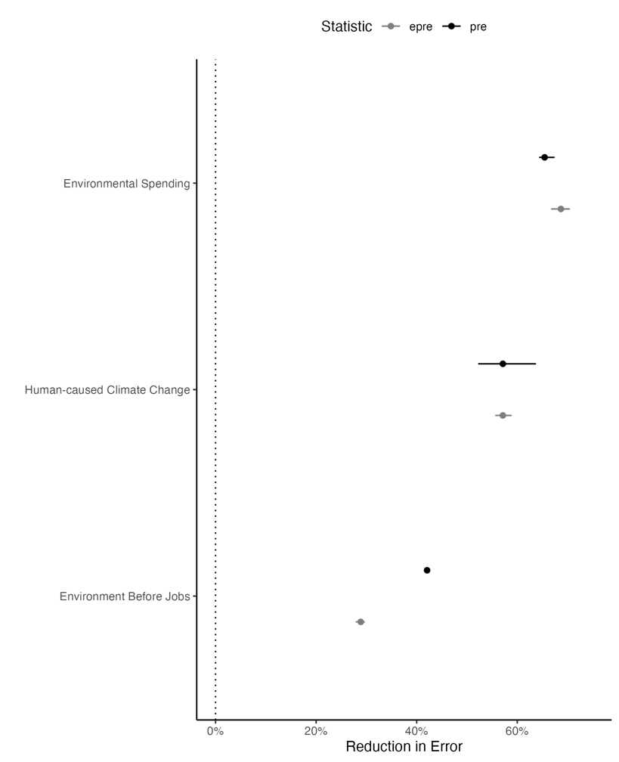

**Figure A1: Proportional Reduction in Error Statistics**

*NB: Points represent the average (e)PRE measure for each variable. The bars represent the full range of the PRE measures across the 25 imputed datasets.*

**A2. Sample and Data Imputation**

We started with the full online sample (n=37,822) from the Canadian Election Study 2019 (Stephenson et. al., 2020). Since the main questions of interest were only asked in the post-election survey, we limit ourselves initially to just the 10,325 respondents who responded to the post-election survey and had a valid survey weight. Roughly 79% of people indicated a vote for one of the six parties identified in the survey – Liberal, NDP, Bloc Quebecois, Green, Conservative and People’s Party. There were 48 who indicated a vote for another party, 22 who indicated that they spoiled their votes and 396 who chose “Don’t Know/Prefer Not to Answer”. Additionally, there were 1731 who did not provide any of the answers above and were coded as missing. In an abundance of caution, we do not impute missing values on the dependent variable, therefore we only use those respondents who indicated a vote for one of the six named parties above (n=8128). The main variables in our study are the personality variables. The personality batter was shown to roughly half (4,083) of the 8,128 respondents who remained in our study. We further limit ourselves to these 4,083 respondents for the analysis.

We identified the variables required for the analysis and calculated the number of missing observations for each (Table A1). The religious importance question was only asked of those who indicated that they had a religion (i.e., they did not answer “I don’t have a religion/atheist”). Thus, we coded those people as having religious importance equal to “not at all”. Similarly, the question about whether humans contribute to climate change was only asked of those people who indicated they thought climate change was happening. Thus, we coded those who did not think climate change was happening as not agreeing with the statements that humans are causing climate change. The left-right self-placement variable was asked in both the campaign and post-election surveys. As such, if a post-election value was available, we used that. If a post-election value was not available and a campaign-period one was, we used that. Otherwise, the variable was coded as missing.

|  |  |  |  |
| --- | --- | --- | --- |
| **Table A1: Variables and Missing Percentages** | | | |
| **Description** | **Variable** | **# Missing** | **Percentage** |
| Survey weight | weight | 0 | 0.0% |
| Vote Choice | vote | 0 | 0.0% |
| Vote for Green Party | green_vote | 0 | 0.0% |
| Indicated environment as one of the most important issues* | env_iss | 0 | 0.0% |
| Respondent level of education | educ | 4 | 0.1% |
| Respondent Age | age | 6 | 0.1% |
| Size of place where respondent resides | urbrur | 10 | 0.2% |
| When there is a conflict between the environment and jobs, jobs should come first | env_first5 | 37 | 0.9% |
| Importance of religion to respondent | relimp | 62 | 1.5% |
| How much should the federal government spend on the environment | spend_env3 | 68 | 1.7% |
| Dependable/self-disciplined | pes19_big5_3 | 119 | 2.9% |
| Disorganized/careless | pes19_big5_8 | 115 | 3.8% |
| Sympathetic/warm | pes19_big5_7 | 180 | 4.4% |
| Open to new experiences/complex | pes19_big5_5 | 182 | 4.5% |
| Calm/emotionally stable | pes19_big5_9 | 213 | 5.2% |
| Reserved/quiet | pes19_big5_6 | 214 | 5.2% |
| Critical/quarrelsome | pes19_big5_2 | 215 | 5.3% |
| Anxious/easily upset | pes19_big5_4 | 228 | 5.6% |
| Extroverted/enthusiastic | pes19_big5_1 | 262 | 6.4% |
| Conventional/uncreative | pes19_big5_10 | 264 | 6.5% |
| Agreement with human-caused climate change | cc_human | 271 | 6.6% |
| Left-right self-placement | lrself | 556 | 13.6% |
|  | | | |

We use multiple imputation by chained equations (MICE) via the “mice” package in R to impute the data (van Buuren, and Groothuis-Oudshoorn, 2011). Specifically, we use predictive mean matching to create 25 imputed datasets which should be sufficient to characterize the uncertainty due to missing data. In our case, it is very likely that the added uncertainty that comes from multiple imputation will be outweighed considerably by the increased power that comes from using the full sample. That said, we present the results of the listwise deletion below.

We use a few different sensitivity diagnostics to show that the imputation models are sufficient. First, we present the means for the listwise deleted data alongside the means for just the values that are imputed in Table A2. The results here are mostly encouraging. Our main independent variables are the personality variables and those means are quite close throughout. On the seven-point scale, the differences between the two are on the order of at most around 2.5%. Two of the environmental attitude variables (human-created climate change and environmental spending) have some notable differences across the listwise deleted and imputed samples. Differences here are not dispositive regarding the effectiveness of the model. If the kinds of people who are missing on those values are different from the overall population in interesting ways that we measure with the other covariates, these differences could happen and remain consistent with the assumptions we make about the missingness mechanism.

Next, we create an augmented dataset where we start with the original data and then, paste on the bottom an additional version of the dataset, but with one variable completely missing. For that block of data, the variable set to missing will be imputed for all observations using the imputation model. We estimate 100 different full imputations of all variables using this mechanism. We refer to these as the “Fully Imputed” datasets as opposed to those datasets used in the analysis, which we refer to as “Original Imputations”. We can do two things with that information.

1. We compare the distribution of the fully imputed data to the distribution of the observed data – assuming a MAR mechanism, these should be similar.
2. We create completed datasets that comprise the fully imputed version of each variable. Thus, our data would have the same variables as our original data, but each variable would be composed of only imputed data. We can then re-run our analysis hopefully showing that the results are quite similar.

If either of these fails, the results are not necessarily meaningless, but it does call into question the robustness of our findings to the imputation procedure. We run these two diagnostic tests below.

First, consider the distribution imputed values that were observed in Figure A2. There are far too many values to present. Instead, we make the following calculation: across the 100 imputations, we calculate the proportion of times that the imputed value is the same as the observed value or alternatively the same or in an adjacent category. We do this for all variables aside from age. For age we calculate the proportion of times the imputed value is within 5 (Same Group) and10 (Same or Adjacent Group) years of the observed age. Ideally, these would tend toward values close to one. As you can see, for most variables the majority of imputed values are either in the same or an adjacent category. This does not necessarily suggest that this imputation model is inappropriate – just that the variables in the model have a great deal of heterogeneity in their predictions.

|  |  |  |  |
| --- | --- | --- | --- |
| **Table A2: Variables and Missing Percentages** | | | |
| **Description** | **Variable** | **LWD** | **Imputed** |
| **Open to new experiences/complex** | pes19_big5_5 | 5.200 | 5.010 |
| **Conventional/uncreative** | pes19_big5_10 | 3.570 | 3.660 |
| **Openness** |  | 1.640 | 1.400 |
| **Dependable/self-disciplined** | pes19_big5_3 | 5.780 | 5.610 |
| **Disorganized/careless** | pes19_big5_8 | 2.500 | 2.680 |
| **Conscientiousness** |  |  |  |
| **Calm/emotionally stable** | pes19_big5_9 | 5.200 | 5.060 |
| **Anxious/easily upset** | pes19_big5_4 | 3.380 | 3.370 |
| **Emotional Stability** |  |  |  |
| **Sympathetic/warm** | pes19_big5_7 | 5.500 | 5.260 |
| **Critical/quarrelsome** | pes19_big5_2 | 3.260 | 3.300 |
| **Agreeableness** |  |  |  |
| **Extroverted/enthusiastic** | pes19_big5_1 | 4.240 | 4.190 |
| **Reserved/quiet** | pes19_big5_6 | 4.520 | 4.420 |
| **Extraversion** |  |  |  |
| **Agreement with human-caused climate change** | cc_human | 0.641 | 0.461 |
| **When there is a conflict between the environment and jobs, jobs should come first** | env_first5 |  |  |
| Strongly Disagree |  | 0.107 | 0.088 |
| Disagree |  | 0.259 | 0.251 |
| Neither |  | 0.216 | 0.237 |
| Agree |  | 0.260 | 0.259 |
| Strongly Agree |  | 0.159 | 0.165 |
| **How much should the federal government spend on the environment** | spend_env3 |  |  |
| Less |  | 0.105 | 0.173 |
| Same |  | 0.285 | 0.381 |
| More |  | 0.610 | 0.446 |
| **Left-right self-placement** | lrself | 5.240 | 5.426 |
| **Respondent Age** | age | 54.5 | 54.3 |
| **Respondent level of education** | educ |  |  |
| <HS |  | 0.037 | 0.020 |
| HS |  | 0.128 | 0.210 |
| Some Post-sec |  | 0.410 | 0.380 |
| Univ Degree + |  | 0.425 | 0.390 |
| **Size of place where respondent resides** | urbrur |  |  |
| rural |  | 0.099 | 0.072 |
| small town |  | 0.122 | 0.112 |
| mid-sized town |  | 0.107 | 0.132 |
| suburb of large town/city |  | 0.236 | 0.232 |
| large town/city |  | 0.437 | 0.072 |
| **Importance of religion to respondent** | relimp |  |  |
| Not at all important |  | 0.127 | 0.109 |
| Not very important |  | 0.183 | 0.150 |
| Somewhat important |  | 0.259 | 0.260 |
| Very important |  | 0.430 | 0.481 |
| *LWD* represents mean for listwise deleted values  *Imptuted* represents mean for only the imputed values  For categorical variables, the mean is the proportion in each category. | | | |

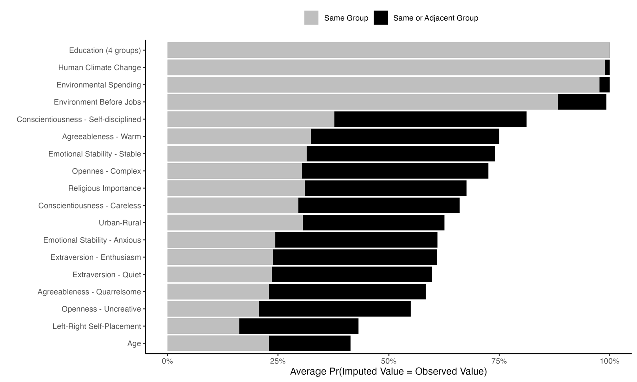

**Figure A2: Correspondence of Imputed and Observed Values**

*NB: For all variables except age, the number represents the proportion of times that fully imputed values were the same as their original observed values (or in an adjacent category). For age, the number represents the proportion of times the fully imputed values are within 5 years (Same Group) or 10 years (Same or Adjacent Group) of the observed age values. The bars represent the average correspondence across the 100 datasets.*

Next, we consider the distribution of the coefficients in the models using both the fully imputed data and the originally imputed data. These are in Figure A3. Ideally, the two distributions would be centered at roughly the same values – indicating that the imputation models are doing a good job of finding the appropriate values for the observed values. Because of the added uncertainty in the imputed data, the fully imputed distributions may be wider than the originally imputed distributions, which is generally the case. There are some other differences here – though the discrepancies tend to be bigger among the controls than the variables of interest. Of the main findings of interest, Openness (in Stage 1) has a bigger effect among the fully imputed data than the originally imputed data. In both cases, openness is bounded well away from zero in the first stage and environmental attitudes well away from zero in the second, so our main result is not sensitive to potential suboptimality in the model generating the imputations.

Though we did not hypothesize about it, conscientiousness has a negative direct effect in the originally imputed data, but not in the diagnostic fully-imputed data. Extraversion also looks to have a more negative effect in the first stage in the diagnostic data. The most obvious difference among control variables is that of religious importance – some coefficients are not significant using the diagnostic fully-imputed data, but are in the original imputations. Again, our main result does not appear to be sensitive to this difference. All of this said, we think the advice of Gelman and Stern (2006) is important to remember. The considerable overlap in the distributions across all parameters and stages suggests that the two models do not produce interestingly different results in terms of the coefficients.

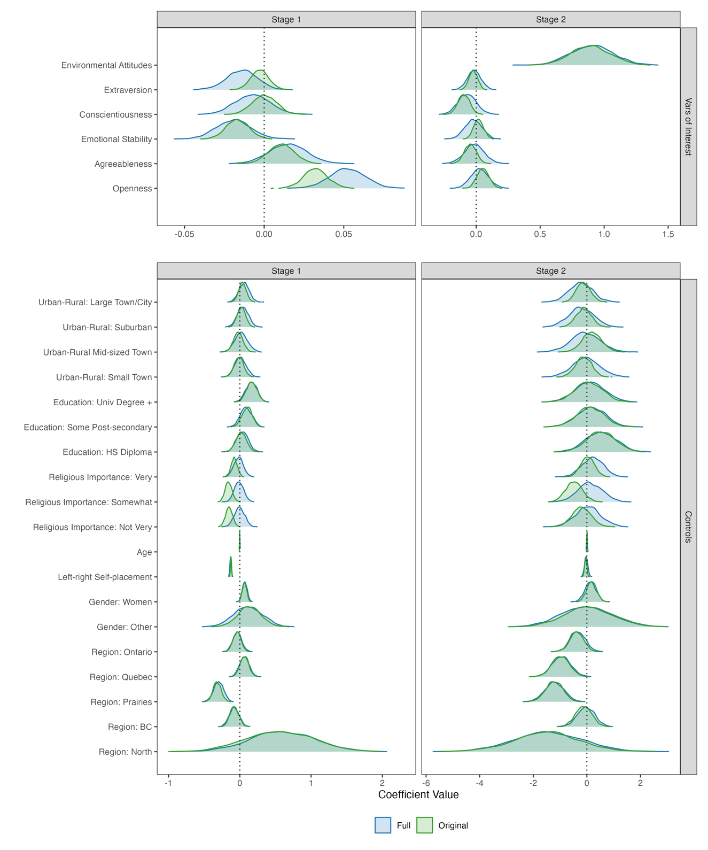

**Figure A3: Distribution of Pooled Model Coefficients (Full Sample, n=4,083).**

**A3. Calculating Mediated Effects**

The most complex part of the analysis comes in calculating the mediated effects. Here, we use a Monte Carlo simulation to calculate the effects and their confidence intervals. Assuming we want to calculate the mediated effect of education, we would do the following for each of the 25 imputed datasets.

1. Create two copies of the original data $D$, call these $D^{(l)}$ and $D^{(h)}$.
2. Replace education in $D^{(l)}$ with the minimum value of education in the dataset (< HS).
3. Replace education in $D^{(h)}$ with the maximum value of education in the dataset (Univ degree +).
4. Using the first-stage pooled model coefficient matrix $b_{1}$ and the first-stage pooled model variance-covariance matrix of the parameters $V_{1}$ to generate 2500 random draws from $B_{1}∼N(b_{1}, V_{1})$.
5. Use $D^{(l)}$ and $D^{(h)}$ to create the design matrices for the first-stage model: $X^{(l)}$ and $X^{(h)}$, respectively.
6. Create the predictions for each design matrix – these are predictions of the environmental attitudes scale: ${\hat{env}}^{(l)}=X^{(l)}B_{1}^{'}$  and ${\hat{env}}^{(h)}=X^{(h)}B_{1}^{'}$.
7. Create two copies of $D:S_{1}, S_{2}$, replacing the environmental attitudes score in $S_{1}$ with ${\hat{env}}^{(l)}$ and in $S_{2}$ with ${\hat{env}}^{(h)}$.
8. Use $S_{1}$ and $S_{2}$ to create the design matrices for the second-stage model: $Z^{(l)}$ and $Z^{(h)}$, respectively.
9. Using the second-stage pooled model coefficient matrix $b_{2}$ and the second-stage pooled model variance-covariance matrix of the parameters $V_{2}$ to generate 2500 random draws from $B_{2}∼N(b_{2}, V_{2})$.
10. Create the predictions for each design matrix: $\hat{Pr}{\left(Green Vote\right)}^{(l)}={F(Z}^{\left(l\right)}B_{2}^{'})$    and $\hat{Pr}{\left(Green Vote\right)}^{(h)}={F(Z}^{\left(h\right)}B_{2}^{'})$, where $F(⋅)$ is the CDF of the logistic distribution.

Technically, this leaves us with $j=\left\{1, 2, …, 25\right\}$ different $N×2500$ matrices of $\hat{Pr}{\left(Green Vote\right)}_{j}^{(l)}$ and $\hat{Pr}{\left(Green Vote\right)}_{j}^{\left(h\right)}$. We then randomly sample columns from each of these matrices until we have a single $N×2500$ matrix of predictions for each of the $l$ and $h$ conditions, $P^{(l)}$ and $P^{(h)}$, where each represents the the predicted probability of voting for the green party for each observation under the two different hypothetical conditions. We then calculate $Δ=P^{(h)}-P^{(l)}$ which produces an $N×2500$ matrix of first differences. For each $j$ column, we calculate ${\overline{δ}}_{j}= \frac{1}{N}\sum_{i=1}^{N}{δ_{ij}}$ , which produces 2500 average differences in predicted probabilities. We then calculate the mean as well as the ${2.5}^{th}$ and ${97.5}^{th}$ percentiles, which constitute the confidence interval of the average difference. We do this for each variable in the first stage model. These values are plotted in the “Mediated” panel of Figure 2.

To calculate the direct effects, we start at step 6 and replace the respective variable with hypothetical low and high conditions, rather than predicted values. The remainder of the exercise proceeds as above. For all effects, we use a maximal change across the range of the variable – this produces effects that are as comparable as possible across the models. The code for all models and post-model analysis will be made available upon acceptance of the manuscript for publication.

In our statistical models we use post-election survey weights (*pes19_weight_general_all*). Specifically, we use the “survey” package in R (Lumley 2010, 2020) to set the design-based weighting scheme and estimate the models using the “svyglm()” function. We use each imputed dataset in turn in the analysis. Once the models are estimated, we use the “MIcombine()” function from the “mitools” package in R (Lumley, 2019) to pool the models according to Rubin’s rules.

**A4. Listwise Deleted Data**

Here, we estimate the same models from Table 1 on the listwise deleted (LWD) sample that includes 2,663 observations. We show these coefficients along with the ones from Table 1 for comparison in Table A3. When predicting environmental attitudes, the age effect is significant in the LWD model, but not the imputed sample. The converse is true for having a university degree. Otherwise, the variable significance in the imputed model corresponds with the significance in the LWD model. In predicting Green Party vote, conscientiousness loses its significance in the LWD model, but religion being “somewhat important” gains significance. Otherwise, the Prairies and Quebec are significant in both models and all remaining variables except for environmental attitudes are insignificant. Multiple imputation increases variability in some effects, but at the same time increases power. It is difficult to tell *a priori* what to expect for any particular finding. Our conclusion is that the results are remarkably similar and our main finding that openness has an indirect effect through environmental attitudes remains strong.

|  |  |  |  |  |
| --- | --- | --- | --- | --- |
| **Table A3: Regressions – Environmental Attitudes and Green Party Support** | | | | |
|  | Environmental  Attitudes | | Green Party  Vote | |
|  | Imputed | LWD | Imputed | LWD |
| Pro-Environmental Attitudes |  |  | 0.941* | 0.851* |
|  |  |  | (0.155) | (0.180) |
| Openness | 0.033* | 0.030* | 0.050 | 0.019 |
|  | (0.007) | (0.009) | (0.046) | (0.055) |
| Extraversion | -0.003 | -0.005 | -0.022 | -0.011 |
|  | (0.006) | (0.007) | (0.033) | (0.038) |
| Agreeableness | 0.010 | 0.003 | -0.045 | -0.026 |
|  | (0.008) | (0.009) | (0.046) | (0.050) |
| Emotional Stability | -0.017* | -0.021* | 0.023 | 0.027 |
|  | (0.007) | (0.009) | (0.039) | (0.046) |
| Conscientiousness | 0.001 | 0.004 | -0.098* | -0.080 |
|  | (0.007) | (0.009) | (0.045) | (0.051) |
| Left-Right Self-Placement (0-10) | -0.125* | -0.129* | -0.035 | -0.017 |
|  | (0.007) | (0.007) | (0.039) | (0.046) |
| Age | -0.002 | -0.002* | 0.006 | 0.009 |
|  | (0.001) | (0.001) | (0.006) | (0.007) |
| Education (ref: <HS) |  |  |  |  |
| High School | 0.023 | -0.066 | 0.528 | 0.828 |
|  | (0.077) | (0.099) | (0.528) | (0.743) |
| Some Post-secondary | 0.107 | 0.072 | 0.099 | 0.509 |
|  | (0.074) | (0.095) | (0.509) | (0.713) |
| University Degree + | 0.174* | 0.124 | 0.039 | 0.548 |
|  | (0.075) | (0.096) | (0.511) | (0.707) |
| Religious Importance (ref: Not at all) |  |  |  |  |
| Not Very Important | -0.146* | -0.171* | -0.186 | -0.228 |
|  | (0.050) | (0.057) | (0.356) | (0.421) |
| Somewhat Important | -0.151* | -0.171* | -0.442 | -0.976* |
|  | (0.048) | (0.056) | (0.313) | (0.333) |
| Very Important | -0.076 | -0.083 | 0.036 | -0.258 |
|  | (0.045) | (0.052) | (0.263) | (0.288) |
| Urban-Rural (ref: Rural) |  |  |  |  |
| Small Town | -0.007 | -0.074 | -0.113 | -0.101 |
|  | (0.067) | (0.082) | (0.303) | (0.361) |
| Mid-sized Town | -0.019 | -0.101 | 0.202 | 0.198 |
|  | (0.065) | (0.081) | (0.359) | (0.382) |
| Suburb of Large Town/City | 0.026 | 0.003 | -0.110 | -0.217 |
|  | (0.058) | (0.070) | (0.287) | (0.346) |
| Large Town/City | 0.046 | -0.003 | -0.129 | -0.085 |
|  | (0.056) | (0.067) | (0.257) | (0.301) |
| Region (ref: Atlantic) |  |  |  |  |
| British Columbia | -0.072 | -0.100 | -0.119 | 0.065 |
|  | (0.061) | (0.079) | (0.297) | (0.339) |
| The North | 0.548 | 0.600 | -1.523 | -0.594 |
|  | (0.464) | (0.649) | (1.250) | (1.366) |
| Ontario | -0.040 | -0.050 | -0.389 | -0.282 |
|  | (0.054) | (0.072) | (0.260) | (0.300) |
| The Prairies | -0.324* | -0.302* | -1.219* | -0.960* |
|  | (0.059) | (0.076) | (0.328) | (0.374) |
| Quebec | 0.069 | 0.058 | -0.988* | -0.932* |
|  | (0.060) | (0.077) | (0.327) | (0.369) |
| Gender (ref: Man) |  |  |  |  |
| Woman | 0.063* | 0.087* | 0.179 | 0.077 |
|  | (0.031) | (0.037) | (0.181) | (0.214) |
| Other | 0.127 | 0.011 | 0.076 | -0.853 |
|  | (0.164) | (0.198) | (0.910) | (1.118) |
| Intercept | 0.781* | 0.968* | -2.186* | -2.662* |
|  | (0.126) | (0.157) | (0.757) | (0.926) |
| Main entries are survey weighted GLM coefficients  (Env Attitudes: Gaussian, Green Vote: Binomial)  N=2,663 listwise deleted original data, 4,038 Imputed Data  * p<0.05 (two-tailed)  Model Fit:  Environmental Attitudes $R^{2}$: LWD = 0.29, Imputed = 0.27 (Average)  Green Party Vote PRE: LWD = 0.00, Imputed = -0.007 (Average)  Green Party Vote ePRE: LWD = 0.062, Imputed = 0.061 (Average) | | | | |

Figure A4 shows the direct and mediated effects of the variables in the model, including those from Figure 2 for comparison. Again, the main takeaway here is that the effects are quite similar across the two models. While occasionally some effects are significant in one model and not in another, we think Gelman and Stern’s (2006) advice is prudent. They suggest that we should not only be thinking about whether the binary state of significance is achieved by one effect and not another, but whether the difference between those two effects is significant. In this case, the differences in effect sizes is very small.

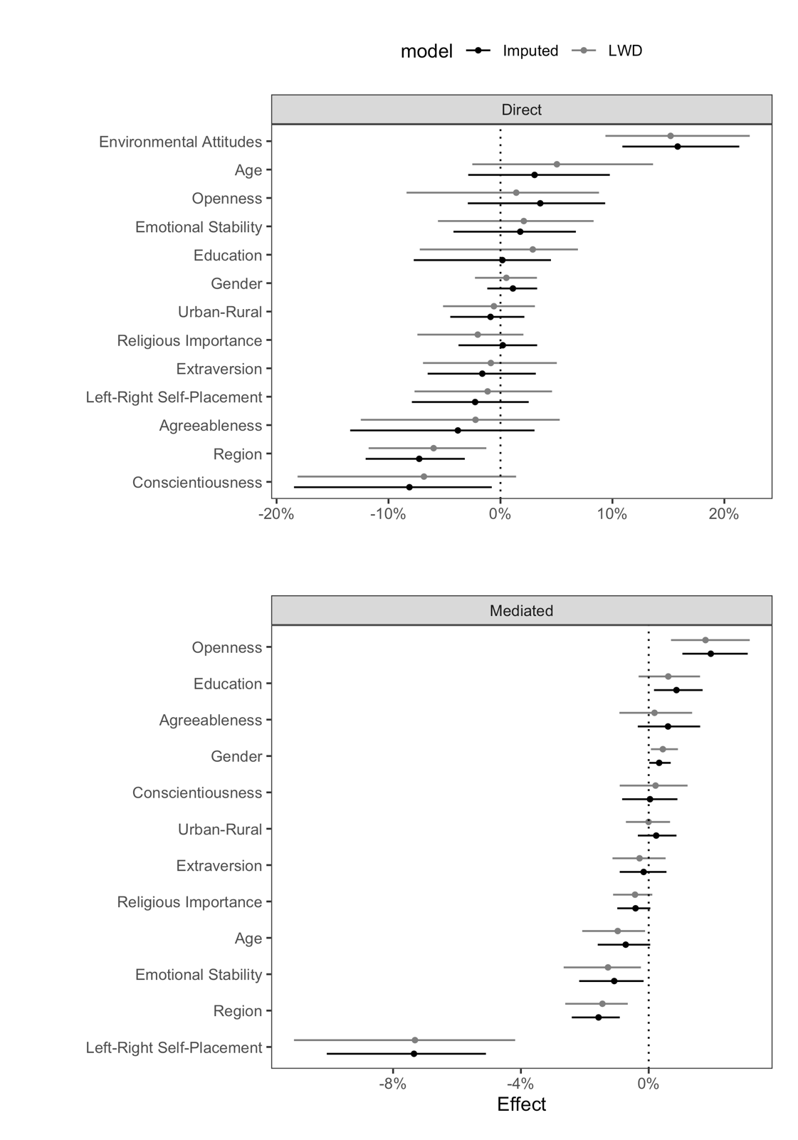

**Figure A4: Mediated and Direct Effects of Variables on Green Vote**

*NB: The effects for the personality measures, environmental attitudes, age and left-right self-placement are all from a change from the minimum to the maximum of the variable of interest. For urban rural, the comparison is between large cities and rural areas, for gender the comparison is between men and women, for religious importance the comparison is between the most and least religious and for region the comparison is between the Atlantic provinces and the Prairies.*

**Appendix A5: Multinomial Logit**

One potential concern is that just considering the vote for the Green party versus all others may obscure some of the effects as both left- and right-wing parties are in the “other” category. While we do not hypothesize about these effects directly, we thought it prudent to present a multinomial logit model that would allow us to disentangle the choice between Green Party support and support for other parties individually. Table A4 presents coefficients from a survey-weighted multinomial logistic regression model on the listwise-deleted data. To do this, we use the “svrepmisc” package in R (Ganz 2024).

There are three significant findings here. First, more pro-environmental attitudes make respondents more likely to vote for the Green Party and less likely to vote for either of the right-wing parties – Conservatives or PPC. Moving to the right in the ideological space makes voters significantly more likely to vote for the Conservatives and less likely to vote for the Green Party. Residing in Quebec makes one more likely to vote for the Bloc Quebecois and less likely to vote for the Green party. All other effects in the choice between the Greens and other parties are insignificant. There are, no doubt, other interesting findings relating to the choice among non-reference parties, but those results are beyond the scope of our paper.

|  |  |  |  |  |  |
| --- | --- | --- | --- | --- | --- |
| **Table A4: Multinomial Logit of Vote on Environmental Attitudes, Personality and Demographics** | | | | | |
|  | NDP | Lib | Con | BQ | PPC |
| Pro-Environmental Attitudes | -0.436 | -0.552 | -1.777* | -0.476 | -2.805* |
|  | (0.323) | (0.309) | (0.346) | (0.577) | (0.932) |
| Openness | -0.007 | -0.049 | -0.039 | -0.079 | 0.078 |
|  | (0.085) | (0.083) | (0.093) | (0.129) | (0.168) |
| Extraversion | 0.004 | 0.020 | 0.002 | 0.051 | 0.082 |
|  | (0.056) | (0.055) | (0.061) | (0.076) | (0.162) |
| Agreeableness | 0.062 | 0.019 | -0.018 | 0.005 | -0.091 |
|  | (0.115) | (0.112) | (0.140) | (0.132) | (0.235) |
| Emotional Stability | -0.055 | -0.009 | 0.014 | -0.093 | -0.043 |
|  | (0.080) | (0.072) | (0.076) | (0.116) | (0.157) |
| Conscientiousness | 0.050 | 0.073 | 0.139 | 0.207 | 0.165 |
|  | (0.106) | (0.109) | (0.122) | (0.122) | (0.217) |
| Left-Right Self-Placement (0-10) | -0.142 | -0.029 | 0.349* | 0.038 | 0.359 |
|  | (0.091) | (0.083) | (0.089) | (0.126) | (0.258) |
| Age | -0.019 | -0.007 | -0.000 | 0.011 | -0.051 |
|  | (0.012) | (0.011) | (0.011) | (0.016) | (0.032) |
| Education (ref: <HS) |  |  |  |  |  |
| High School | -0.570 | -1.287 | -0.510 | 0.085 | -3.573 |
|  | (1.762) | (1.756) | (1.956) | (1.779) | (2.748) |
| Some Post-secondary | -0.155 | -0.834 | -0.116 | -0.871 | -2.527 |
|  | (1.580) | (1.693) | (1.860) | (1.799) | (2.487) |
| University Degree + | -0.040 | -0.740 | -0.621 | -0.930 | -2.940 |
|  | (1.677) | (1.606) | (1.887) | (1.716) | (2.140) |
| Religious Importance (ref: Not at all) |  |  |  |  |  |
| Not Very Important | 0.426 | -0.356 | 0.188 | 0.701 | -0.292 |
|  | (0.982) | (0.760) | (0.745) | (0.978) | (3.005) |
| Somewhat Important | 1.164 | 0.539 | 0.914 | 0.673 | 0.902 |
|  | (1.130) | (0.941) | (0.949) | (1.359) | (2.573) |
| Very Important | 0.420 | -0.058 | 0.207 | 0.104 | -0.355 |
|  | (0.846) | (0.654) | (0.764) | (0.936) | (1.976) |
| Urban-Rural (ref: Rural) |  |  |  |  |  |
| Small Town | 0.110 | 0.069 | -0.004 | 0.555 | -0.265 |
|  | (0.762) | (0.952) | (0.818) | (1.396) | (1.651) |
| Mid-sized Town | -0.096 | -0.864 | -0.002 | 0.013 | -0.205 |
|  | (0.743) | (1.126) | (0.868) | (1.515) | (1.570) |
| Suburb of Large Town/City | 0.559 | -0.482 | 0.296 | 0.136 | -1.274 |
|  | (0.994) | (0.822) | (0.919) | (1.485) | (1.721) |
| Large Town/City | 0.256 | -0.691 | 0.346 | 0.329 | -0.778 |
|  | (0.789) | (1.167) | (0.959) | (1.189) | (2.068) |
| Region (ref: Atlantic) |  |  |  |  |  |
| British Columbia | -0.253 | 0.444 | -0.227 | -0.111 | -0.454 |
|  | (0.845) | (0.849) | (1.031) | (2.173) | (1.777) |
| The North | 1.594 | 0.571 | -4.176 | 0.909 | -2.696 |
|  | (4.126) | (6.372) | (2.809) | (5.200) | (4.183) |
| Ontario | 0.283 | 0.610 | -0.129 | 0.238 | 0.464 |
|  | (0.703) | (0.922) | (0.868) | (2.293) | (1.528) |
| The Prairies | 0.512 | 1.933* | 0.770 | 1.002 | 0.585 |
|  | (0.996) | (0.972) | (0.807) | (2.431) | (1.821) |
| Quebec | 0.556 | 0.399 | 0.219 | 5.951* | 0.102 |
|  | (0.747) | (0.906) | (0.845) | (2.813) | (1.548) |
| Gender (ref: Man) |  |  |  |  |  |
| Woman | -0.203 | -0.050 | 0.195 | -0.592 | -0.578 |
|  | (0.579) | (0.614) | (0.630) | (0.799) | (1.796) |
| Other | 1.121 | 1.769 | 1.061 | -0.671 | -1.609 |
|  | (2.075) | (1.799) | (1.902) | (1.429) | (1.839) |
| Intercept | 1.424 | -0.653 | 2.261 | -4.944 | 0.703 |
|  | (2.117) | (1.989) | (1.868) | (3.451) | (2.889) |
| DV: Vote, reference category = Green Party  Main entries are survey weighted Multinomial Logit Coefficients, standard errors in parentheses.  N=2,663 – listwise deleted  * p<0.05 (two-tailed) | | | | | |

**Appendix A6. Bivariate Relationships**

Another useful tool to understand how conditioning on other covariates changes the nature of relationships is to consider the bivariate relationships alongside multiple regression results. For each of the terms in the model, we have estimated a bivariate relationship between the our two dependent variables (Green Party vote and environmental attitudes) and all the other variables in the model. Figure A5 shows the bivariate (marginal) and multiple (partial) regression effects for all variables in the models using the listwise deleted data. We calculated these effects by simulating a maximal change in the indicated variable holding all other variables at observed values – an average first difference approach.

The results from Figure A5 are more or less as expected – bivariate relationships tend to be somewhat stronger, though this is not always the case. One of the most interesting findings is that left-right self-placement has a significant, negative effect when controlling for all other variables, but its bivariate relationship is insignificant. This is likely because both left- and right-wing parties are in the “other” category. Also, education has a significant, positive effect on environmental attitudes when controlling for other variables, but not in the bivariate relationship.

**Figure A5. Marginal and Partial Effects on Environmental Attitudes and Green Party Vote.**

**References:**

Ganz, Carl. “svrepmisc: Miscellaneous Functions for Replicate Weights” R Package version 0.2.2

Gelman, A. and Stern, H. 2006.  “The Difference Between ‘Significant’ and ‘Not Significant’ is not Itself Statistically Significant.” *The American Statistician* 60(4): 328-331.

Herron, M. 1999. “Postestimation Uncertainty in Limited Dependent Variable Models.” *Political Analysis* 8 (1): 83–98.

Honaker, J. and King, G. 2010. “What to Do about Missing Values in Time-Series Cross-Section Data.” *American Journal of Political Science* 54(2):561–581.

Lumley, T. 2010. *Complex Surveys: A Guide to Analysis Using R*. John Wiley and Sons.

Lumley, T. 2019. “mitools: Tools for Multiple Imputation of Missing Data.” R package version 2.4

Lumley, T. 2020. "survey: analysis of complex survey samples". R package version 4.0.

Pokropek, A. 2011. “Missing by Design: Planned Missing Data-Designs in Social Science” *Ask Research & Methods* 20(1): 81-105.

Rizopoulos, D. 2006. “ltm: An R package for Latent Variable Modelling and Item Response Theory Analyses” *Journal of Statistical Software* 17(5): 1-25.

Stephenson, Laura B; Harell, Allison; Rubenson, Daniel; Loewen, Peter John, 2020, "2019 Canadian Election Study (CES) - Online Survey", <https://doi.org/10.7910/DVN/DUS88V>, Harvard Dataverse, V2.

van Buuren, Stef and Karin Groothuis-Oudshoorn (2011). mice: Multivariate Imputation by Chained Equations in R. Journal of Statistical Software, 45(3), 1-67. DOI 10.18637/jss.v045.i03.