**List of Appendices**

**Appendix 1. Survey questions and wording of variables** 2

**Appendix 2. Descriptive statistics of included variables** 3

**Appendix 3. Sample Size by Region** 4

**Appendix 4. Testing Quebec’s differences with the Rest of Canada** 5

**Appendix 5. Principal Component Analysis for Index Construction** 6

**Appendix 6. Full OLS Model Results** 10

**Appendix 7. Effects of Political Ideology on Foreign Policy Alignment Preferences** 11

**Appendix 8. Mediation Analysis Results** 12

Full model 12

Naïve model 12

# **Appendix 1. Survey questions and wording of variables**

1. **FP Alignment with US**: “How closely should Canada’s foreign policy align with the following actors (USA)”

[Mark on the scale (0-10): Not at all; Completely]

1. **Gender**: “You are…”

[Female, Male, Other, I don’t want to answer][1]

1. **Age:** “How old are you? Write the answer”

[…]

1. Education: “What is the highest level of education you have completed?”

[Primary (elementary school); Secondary (secondary school/high school); Tertiary (University/College)]

1. **Urban Rural**: “Where do you live?”

[Village (up to 10,000 inhabitants); Town (of 10,000 -100,000 inhabitants); City (of 100,000 to 1,000,000 inhabitants); Big City (over 1 million inhabitants)]

1. **Political Interest**: “How interested are you in politics?”

[Mark on the scale (0-10) Not interested at all; Very much interested]

1. **Political Ideology**: “When it comes to politics, do you consider yourself more to the Left or the Right?”

[Mark on the scale (1-7): Very left; very right]

1. **Favourability to Capitalism:** “How positive or negative do you feel about the following systems/ideologies on a scale of 0 to 100, where 0 represents cold, negative feelings, 50 represents neutral, and 100 represents warm, positive feelings? (Capitalism)” [Mark on the scale]

# **Appendix 2. Descriptive statistics of included variables**

The tables below show summary statistics for all variables included in the analysis, adjusted with survey weights. These weights are provided by the Sinophone Border project, based on target distributions of gender, age, education level, region as well as urban/rural divide, to ensure the representativeness of the sample with respect to Canada’s population. The quotas for these demographic characteristics are based on census data from Statistics Canada, UN data (2018) and Human Capital data from Wittgenstein Centre (2020). To apply survey weights to the raw data, we used the “survey” package in R.

Table 1: Summary statistics for continuous variables

|  |  |  |  |  |  |
| --- | --- | --- | --- | --- | --- |
| Variable | Min | Max | Mean | Median | SD |
| FP Alignment with US | 1 | 7 | 6.36 | 4 | 2.29 |
| Level of Can ID | 1 | 7 | 5.47 | 5.75 | 1.31 |
| Age | 18 | 87 | 43.15 | 45 | 15.37 |
| Political Interest | 0 | 10 | 5.47 | 6 | 2.69 |
| Political Ideology (L to R) | 1 | 7 | 3.97 | 4 | 1.36 |
| Favourability to Capitalism | 0 | 100 | 47.2 | 50 | 25.28 |

Table 2: Frequency table for categorical variables

|  |  |  |  |  |  |
| --- | --- | --- | --- | --- | --- |
| Variable | Category | Frequency | Percentage | Mean Foreign Policy alignment | SE |
| Gender | Female | 760 | 50.33% | 6.18 | 0.08 |
| Male | 747 | 49.53% | 6.55 | 0.10 |
| Other | 2 | 0.13% | 3.60 | 0.72 |
| Education | Primary | 40 | 2.64% | 6.32 | 0.31 |
| Secondary | 511 | 33.78% | 6.32 | 0.11 |
| Tertiary | 961 | 63.58% | 6.38 | 0.08 |
| Urban/Rural | Village | 327 | 21.60% | 6.35 | 0.17 |
| Town | 279 | 18.47% | 6.17 | 0.13 |
| City | 571 | 37.79% | 6.43 | 0.10 |
| Big City | 335 | 22.14% | 6.37 | 0.14 |

# **Appendix 3. Sample Size by Region**

For regional dummy variables, we grouped the residents residing in New Brunswick, Newfoundland and Labrador, Nova Scotia and Prince Edward Island under the “Atlantic” region. Respondents from Alberta, Saskatchewan and Manitoba are grouped under “Prairies”. For the territories, we only obtained a limited number of respondents and therefore grouped them under “Other”.

Figure 1: Sample size by region

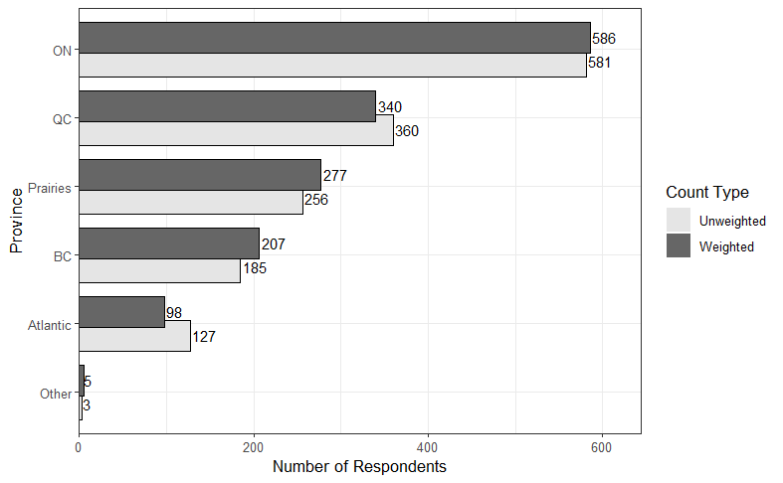

# **Appendix 4. Testing Quebec’s differences with the Rest of Canada**

Table 3 Wald test results reported as F-statistics

|  |  |  |  |  |
| --- | --- | --- | --- | --- |
| Interaction Term | F-value | Df1 | Df2 | p-value |
| Level of CanID x QC | 1.78 | 1 | 1494 | 0.183 |
| Age x QC | 0.01 | 1 | 1494 | 0.92 |
| Gender x QC | 27.45 | 3 | 1493 | 1.96e-12 *** |
| Education level x QC | 1.01 | 2 | 1493 | 0.37 |
| Urban/Rural x QC | 1.45 | 3 | 1492 | 0.23 |
| Political Interest x QC | 0.38 | 1 | 1494 | 0.85 |
| Political ideology x QC | 0.014 | 1 | 1494 | 0.91 |
| Favourability to capitalism x QC | 3.05 | 1 | 1494 | 0.08 |
| *Note: conducting the Wald test on Gender x QC without including the “gender: other” category yields a p-value of 0.36*. | | | | |

# **Appendix 5. Principal Component Analysis for Index Construction**

To construct our index of ideational continentalism, we first run an exploratory PCA on selected variables. These variables are chosen as they capture various aspects of Canadians’ perceptions of shared realities with the United States. The wordings of the included variables can be found below:

1. **Cultural Similarity with the US**: “How similar are the following Countries/entities and Canada regarding cultural values? (USA)”

[Mark on the scale (1-7): Not similar at all; Very Similar]

1. **US cultural attractiveness**: “How positively or negatively do you perceive the cultures of the following countries/entities? (USA)”

[Mark on the scale (1-7): Very unattractive; Very attractive]

1. **Favourability toward US Political Values**: “How positively or negatively do you perceive the political values of the following countries/entities? (USA)”

[Mark on the scale (1-7): Very negatively; Very positively]

1. **Favourability toward Americans**: “How positively or negatively do you feel about the following groups of people? (Americans from USA)”

[Mark on the scale (1-100): Cold, negative feelings; Warm, positive feelings]

1. **Likelihood of purchasing an American car**: “How likely is it that the next car you will buy will be American (USA)?”

[Mark on the scale (1-7): Very unlikely; Very likely]

1. **Likelihood to purchase an iPhone**: “How likely is it that the next smartphone you buy will be Apple?”

[Mark on the scale (1-7): Very unlikely; Very likely]

1. **Frequency to travel to the US**: “How often have you visited the following places (USA)?”

[Mark on the scale (1-7): Never; Frequently]

Additionally, we include one variable that captures the traditional material-based dimension of continentalism. This variable is included in the exploratory PCA as a conceptual test to differentiate between the material and ideational dimensions of the concept and to provide support for the consistency between the final variables used to construct the index.

1. **Economic Importance of the US**: “How important or unimportant do you consider the following countries/entities for the development of Canada’s economy? (USA)”

[Mark on the scale (1-7): Very unimportant; Very important]

Table 2 presents the descriptive statistics for the eight variables on which we perform exploratory PCA.

Table 4 Descriptive statistics for index construction

|  |  |  |  |  |  |
| --- | --- | --- | --- | --- | --- |
| Variable | Min | Max | Mean | Median | SD |
| Cultural Similarity with the US | 1 | 7 | 4.88 | 5 | 1.52 |
| US cultural attractiveness | 1 | 7 | 4.61 | 5 | 1.51 |
| Favourability toward US Political Values | 1 | 7 | 4.22 | 4 | 1.55 |
| Favourability toward Americans | 0 | 100 | 60 | 62 | 23.78 |
| Likelihood of purchasing an American car | 1 | 7 | 4.04 | 4 | 1.85 |
| Likelihood of purchasing an iPhone | 1 | 7 | 4.23 | 5 | 2.38 |
| Frequency of travel to the US | 1 | 7 | 3.98 | 4 | 1.89 |
| Economic Importance of the US | 1 | 7 | 5.50 | 6 | 1.38 |

As a part of the exploratory analysis, we conduct a parallel analysis to determine the appropriate number of components for the PCA. The parallel analysis scree plot is presented in Figure 2, showing that a single component solution is recommended for PCA. This result aligns with our goal of index construction for a singular underlying construct of continentalism in the ideational realm.

Figure 2 Parallel Analysis Scree Plot

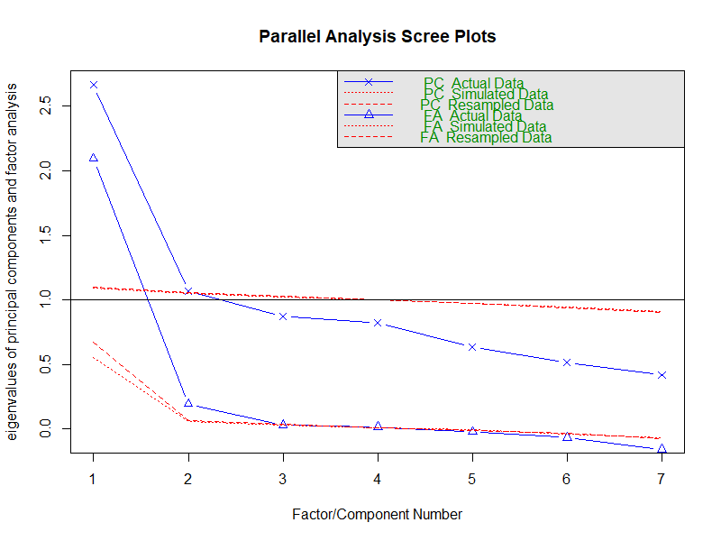

Before conducting the PCA, we standardize all variables, given that they are initially measured on different scales. This step is important given the assumption of normal distribution required for PCA. The exploratory PCA is then conducted using the ‘psych’ package in R, with the result shown in Table 3.

Table 5: Exploratory PCA result

|  |  |  |
| --- | --- | --- |
| Variable | Factor Loading | Commonality |
| Cultural Similarity with the US | 0.68 | 0.47 |
| US cultural attractiveness | 0.80 | 0.63 |
| Favourability toward US Political Values | 0.75 | 0.57 |
| Favourability toward Americans | 0.74 | 0.54 |
| Likelihood of purchasing an American car | 0.43 | 0.18 |
| Likelihood of purchasing an iPhone | 0.28 | 0.07 |
| Frequency of travel to the US | 0.35 | 0.12 |
| Economic Importance of the US | 0.51 | 0.26 |
| Eigenvalue: 2.85 | | | |
| Variance explained: 0.36 | | | |

The initial PCA reveals high factor loadings for four variables as highlighted above. For the rest, the low level of communalities associated with each variable indicates that these variables have little in common with the other variables selected for our index. This justifies our choice of excluding these variables. Moreover, in terms of the economic importance variable, the exclusion is justified as the item has a commonality of less than 0.4, suggesting a very low level of correlation with the other items. As a result, we conduct a second PCA on a subset that only includes the four variables with high factor loadings. The final ideational continentalism index is constructed using the loading scores of the four variables. Weights are added after the construction of the index to adjust for demographic representativeness. The decision to apply survey weights post-PCA was made to ensure the analysis directly reflects the interrelations between attitudes without any preliminary bias introduced by weighting. Figure 3 shows the density distribution of the final ideational continentalism index with a mean of 0 and a standard deviation of 1.

Figure 3 Density Plot of Ideational Continentalism

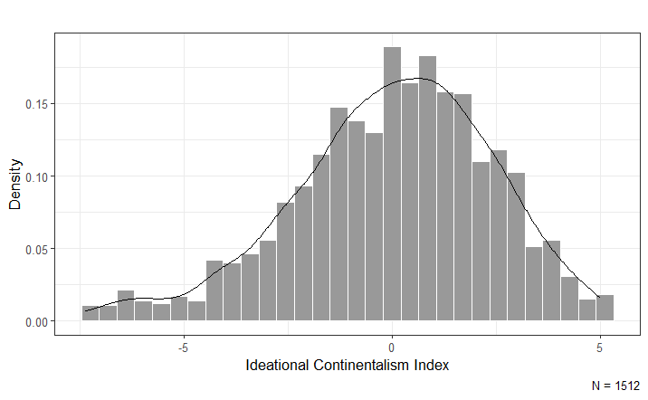

# **Appendix 6. Full OLS Model Results**

Table 6 Regression output with model reiterations

|  |  |  |  |  |  |
| --- | --- | --- | --- | --- | --- |
|  | Model 1.1 | Model 1.2 | Model 1.3 | Model 1.4 | Model 1.5 |
| Level of Can ID | 0.32*** | 0.32*** | 0.28*** | 0.28*** | 0.30*** |
| (0.06) | (0.06) | (0.06) | (0.06) | (0.06) |
| Gender: Male |  | 0.42** |  | 0.17 | 0.14 |
|  | (0.13) |  | (0.13) | (0.13) |
| Gender: Other |  | -2.53*** |  | -2.39*** | -2.39*** |
|  | (0.74) |  | (0.65) | (0.59) |
| Age |  | 0.01 |  | 0.005 | 0.004 |
|  | (0.004) |  | (0.004) | (0.004) | |
| Education: Secondary |  | -0.23 |  | -0.24 | -0.23 |
|  | (0.33) |  | (0.35) | (0.35) | |
| Education: Tertiary |  | -0.09 |  | -0.17 | -0.17 | |
|  | (0.32) |  | (0.35) | (0.35) | |
| Urban/ Rural: Town |  | -0.25 |  | -0.27 | -0.25 | |
|  | (0.21) |  | (0.20) | (0.20) | |
| Urban/Rural: City |  | 0.07 |  | 0.03 | 0.11 | |
|  | (0.20) |  | (0.19) | (0.20) | |
| Urban/Rural: Big City |  | -0.05 |  | -0.16 | -0.03 | |
|  | (0.22) |  | (0.22) | (0.23) | |
| Political interest |  |  | 0.11*** | 0.10*** | 0.10*** | |
|  |  | (0.03) | (0.03) | (0.03) | |
| Political Ideology (L to R) |  |  | 0.11* | 0.11* | 0.11* | |
|  |  | (0.05) | (0.05) | (0.05) | |
| Favourability to Capitalism |  |  | 0.01*** | 0.01*** | 0.01** | |
|  |  | (0.003) | (0.003) | (0.003) | |
| Constant | 4.58*** | 4.27*** | 3.21*** | 3.32*** | 3.20*** | |
| (0.34) | (0.48) | (0.39) | (0.53) | (0.53) | |
| Province Dummies | No | No | No | No | Yes | |
| N | 1,512 | 1,509 | 1,512 | 1,509 | 1,509 | |
| R2 | 0.03 | 0.05 | 0.08 | 0.10 | 0.10 | |
| Adjusted R2 | 0.03 | 0.05 | 0.08 | 0.09 | 0.09 | |
| Note:*p< .05; **p< .01; ***p< .001 | | | | | |
| Ontario is set as the baseline for provinces in Model 1.5 | | | | | |

# **Appendix 7. Effects of Political Ideology on Foreign Policy Alignment Preferences**

Table 7: Full results of political ideology models

|  |  |  |  |
| --- | --- | --- | --- |
|  | Model2.1 | Model 2.2 | Model 2.3 |
| Level of Can ID | 0.33*** | 0.56** | 0.54** |
| (0.06) | (0.19) | (0.19) |
| Political Ideology | 0.19*** | 0.50 | 0.44 |
|  | (0.05) | (0.27) | (0.27) |
| CanID x Political Ideology |  | -0.06 | -0.06 |
|  |  | (0.05) | (0.05) |
| Political Attitude Controls | No | No | Yes |
| Demographic controls | No | No | Yes |
| Province Dummies | No | No | Yes |
| N | 1,512 | 1,512 | 1,509 |
| R2 | 0.03 | 0.05 | 0.10 |
| Adjusted R2 | 0.03 | 0.05 | 0.09 |
| Note: *p<.05; **p< .01; ***p< .001 | | | |

# **Appendix 8. Mediation Analysis Results**

To conduct the mediation analysis, we ran two different models: a full model and a naïve model. In the full model, the two initial regressions used to establish the foundation for the mediation analysis include potential confounding variables, aiming at controlling for their effects on the mediator. These variables include gender, age, education level, urban/ rural residence, political interest, political ideology, favourability towards capitalism, and the current province of residence. For the naïve model, no control variables are included. The mediation analysis is performed using the mediation package in R. The following tables present the mediation analysis results for both models.

## Full model

Figure 3: Mediation Analysis Results-full model

|  |  |  |  |  |
| --- | --- | --- | --- | --- |
| **Quasi-Bayesian Confidence Intervals** | | | | |
|  | Estimate | 95% CI Lower | 95% CI Upper | P-value |
| **Mediated Effect** | 0.26 | 0.20 | 0.32 | <2e-16 *** |
| **Direct Effect** | 0.04 | -0.07 | 0.15 | 0.52 |
| **Total Effect** | 0.30 | 0.19 | 0.41 | <2e-16 *** |
| **Prop. Mediated** | 0.88 | 0.63 | 1.35 | <2e-16 *** |
| **N = 1,509 ; Simulations : 1000** | | | | |
| **Note:                                                                                       *p< .05; **p< .01; ***p< .001** | | | | |

## Naïve model

Table 8 Mediation Analysis Results-naive model

|  |  |  |  |  |  |
| --- | --- | --- | --- | --- | --- |
| Quasi-Bayesian Confidence Intervals | | | | | |
|  | Estimate | | 95% CI Lower | 95% CI Upper | P-value |
| Mediated Effect | 0.27 | 0.21 | | 0.33 | <2e-16 *** |
| Direct Effect | 0.06 | -0.04 | | 0.16 | 0.23 |
| Total Effect | 0.32 | 0.22 | | 0.43 | <2e-16 *** |
| Prop. Mediated | 0.83 | 0.62 | | 1.19 | <2e-16 *** |
| N = 1,512 ; Simulations : 1000 | | | | | |
| Note: *p< .05; **p< .01; ***p< .001 | | | | | |

1. The option of “I don’t want to answer” is coded as NA.