Appendix
Understanding the iterative process of inductive, interpretive coding by another researcher can be challenging. This appendix outlines my decision-making process to create transparency and to support other researchers who might be interested in this approach. The analysis of the speeches fit within the theoretical framework of the paper. Since these speeches are multifaceted, other researchers might uncover additional themes using similar or different research processes or analytical frameworks.
All the speeches by Liberal Ministers were captured from the Hansard record directly using a comprehensive keyword search for gender-based violence related terms. While Hansard is not a verbatim report, it can be described as nearly verbatim (Chilton and Schäffner, 2002: 7; McGill Library, n.d.). The language is cleaned up of grammatical errors and pauses and Members can request minor changes that do not affect the meaning (McGill Library, n.d.). I only captured the speeches using the English translation to ensure consistency of search terms. The major drawback is the differences between French and English speeches were not analyzed and any French nuances were missed. To ensure comprehensiveness of the corpus, speech transcripts were spot-checked for missing speeches and each speech was read carefully to ensure that it met the selection criteria of focusing on gender-based violence. All of the speeches were uploaded to MAXQDA, a software package that is well-suited for interpretive research (Saillard, 2011).
The speeches were read and re-read to inductively code them (Rice and Douglas, 1999: 258) and coded using a variety of tools on MAXQDA to identify patterns and answer the three questions from the WPR framework. To categorize the speeches, I used the Lexical Search function to subdivide the speeches that focus on different types of gender-based violence and to initially code key terms or phrases. The Lexical Search button allows one to search for specific phrases or words within the corpus and automatically code and categorize them. For example, I expected to find speeches specifically referencing Indigenous women and used the Lexical Search button to find direct references to terms like “Indigenous women” or “Cree girl” or “Aboriginal woman” or “two-spirit”. In later stages of coding, I identified any missing references or implied references that could not be captured through the Lexical Search tool. The Lexical Search function was also used once, in later stages coding, I noticed emerging patterns. For example, many of the references to criminal justice changes used the language of “strengthen,” “tough” or “strong.” Once I noticed a saturation of these phrases, I used the Lexical Search feature to find additional references and marked them appropriately used MAXQDA’s in-text codes.

Figure 1: Coded speech by Hon. Jody Wilson-Raybould
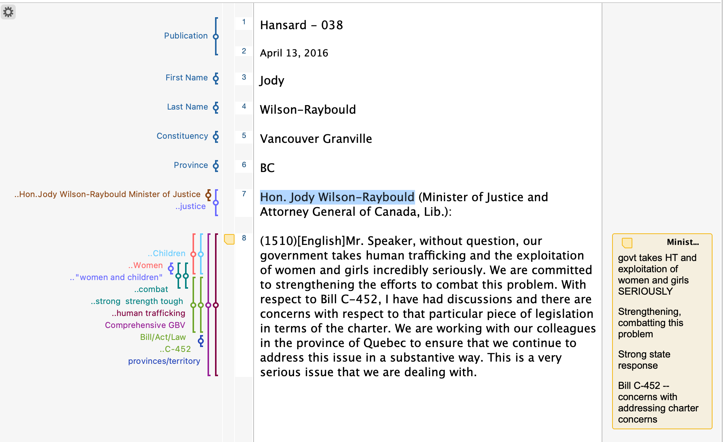

Open coding was also used as I read and re-read the speeches. MAXQDA allows researchers to add codes to sections of the speech. These were colour coded and adjusted a number of times as I read and re-read the speeches. The codes were identified inductively as I read the speech. I also read the speeches in light of the theoretical framework of the research, allowing for additional codes to be identified. This includes both the theories of governance and carceral feminism, along with the questions from the WPR method. Figure is a screenshot of a coded speech. Not all the codes became salient in the analysis as these speeches are rich texts. However, the example coded speech demonstrate the thoughtful and extensive nature of the qualitative, interpretive coding conducted.
I wrote memos about individual speeches to identify themes and patterns in what was being said or not being said (Peters and Wester, 2007: 638). Memos start the process of reflecting on and refining the ideas and decisions that arise during analysis (Peters and Wester, 2007: 638). When necessary, I returned to the speeches in the context of the debates themselves. Memos were written when needed to outline what they were responding to or how the speech was situated. This was not needed for most speeches as the meanings were similar in context and as standalone speeches. Each memo was titled by the name of the speaker and the date of the speech. Since they can be easily viewed in MAXQDA alongside the original text, the memos focused on analysis and reflection rather than restating manifest content. Some of the example memos I wrote included:

Figure 2: Example Memos

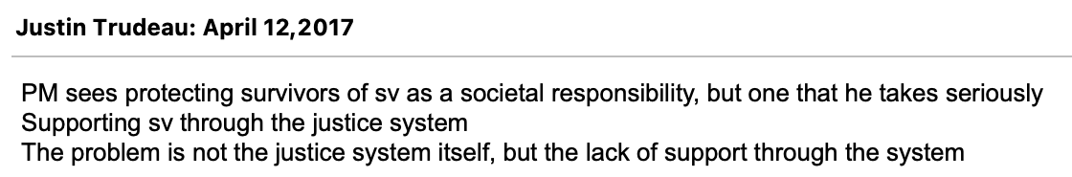
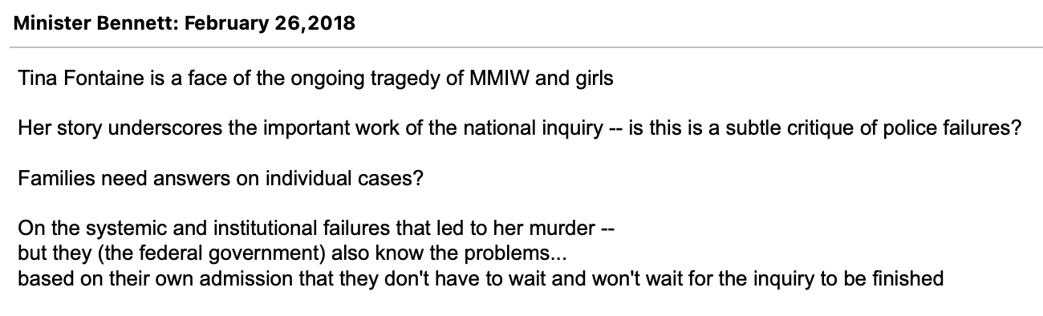

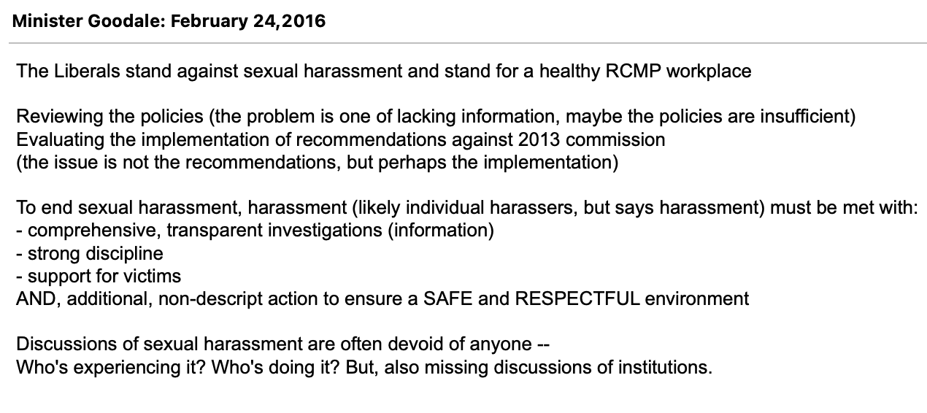

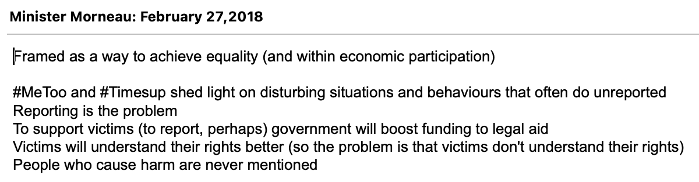
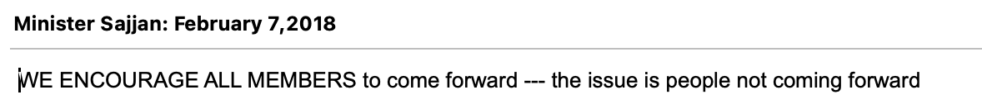

Additional analysis came through organizing the individual codes into broader themes using the Creative Coding feature of MAXQDA. In this blank space, one can group codes together, combine codes or organize them in relationship with one another. This organization happened iteratively. Codes were grouped, combined and organized as I read and re-read the speeches to best reflect the themes emerging. Figures 3-5 are examples of final versions of codes maps created for this project. Because they are the final code maps, they do not reflect the iterative processes undertaken throughout the analysis period. Both the themes of lacking information and suggestions to report the violence were the most straight forward and do not have complex code maps.

Figure 3: Code Map for Systemic Definitions of Gender-Based Violence
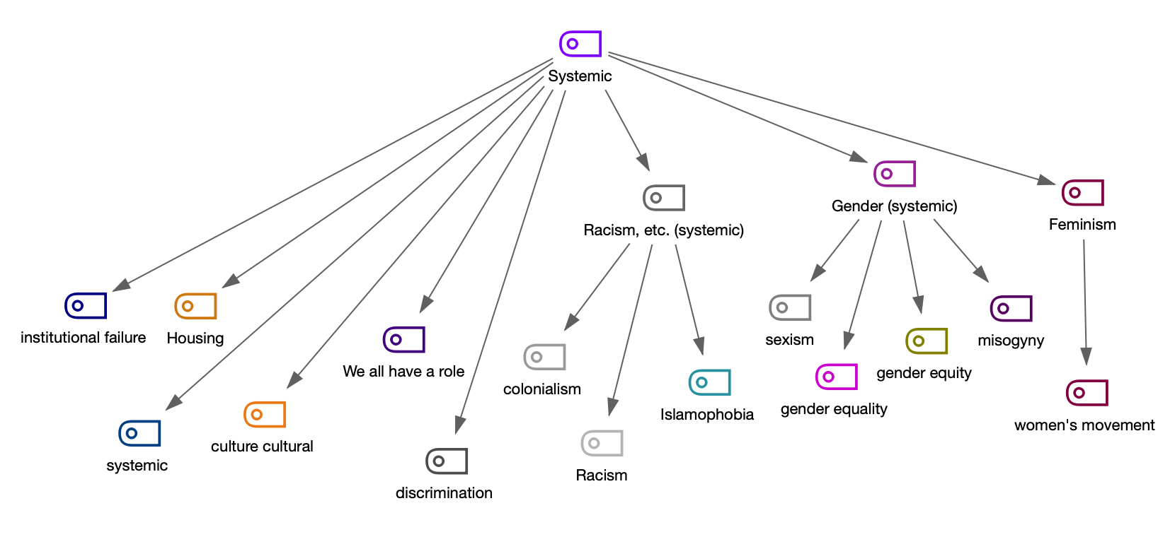

These code maps were helpful in identifying the saturation of each theme across the corpus and within each speech. Once I had created the code maps, I re-read the speeches again to ensure that the individual codes continued to match the sentiment each speech. This verified the combining and organizing codes through the code map. Remarkably, I found that all overarching categories for the code maps accurately represented the parts of the speeches they were attached to. From the code maps, I distilled the information into six dominant themes and linked these problematization with the theoretical engagements of the research. That I can enumerate the use of each of the themes, however, should not distract from the goal of the paper. This approach is not a content analysis. The goal was not to assign a numerical value to manifest or latent content. The goal is to identify the types of feminist arguments, assumptions and silences used by the Trudeau Liberals. The goal is to provide a rich analysis of the speeches and to build an inductive and qualitative basis for understanding governance feminism. The goal is to understand how gender-based violence is problematized, the underpinning logics, the proposed solution and, importantly, each’s connection to the declared feminist orientation of the 42nd parliament.

Figure 4: Code Map for Neoliberal Themes
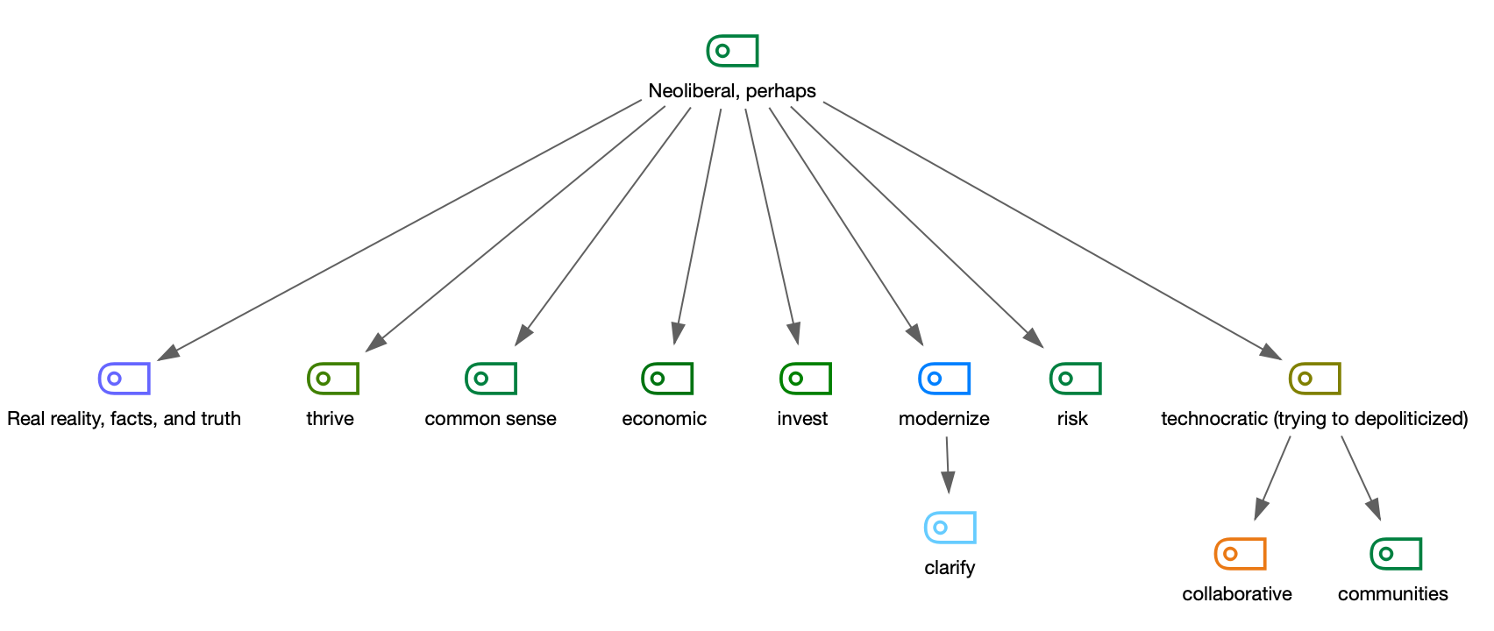

Figure 5: Code Map for Tough State Approaches to Gender-Based Violence
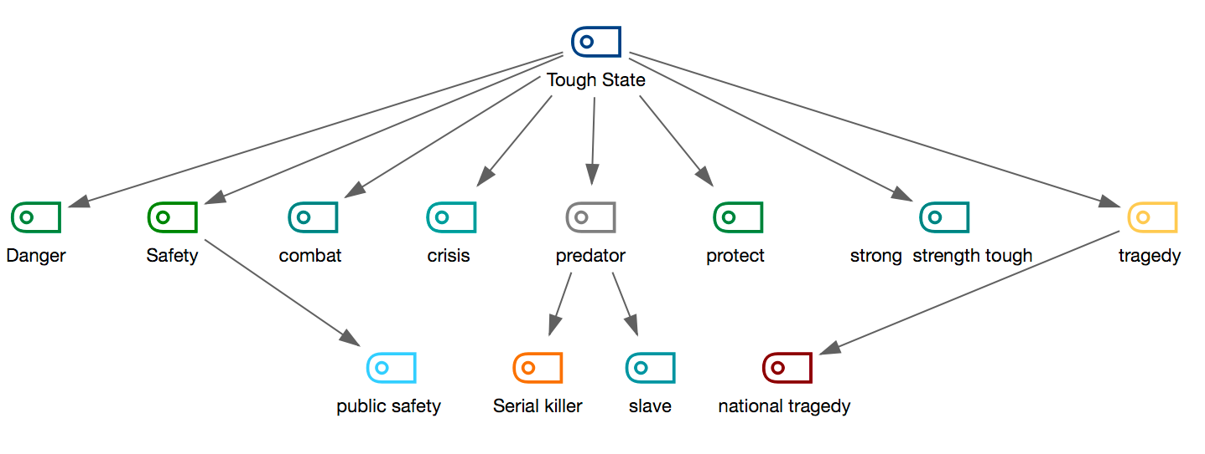
Through this analysis, this paper adds to literature on WPR and offers a methodological map for others interested in problematization of Canadian policy. WPR is most often used to understand policy texts. Speeches are not often considered within this framework (Bacchi, 2018). Stretching the WPR approach to consider speeches has its advantages. It allows for a deeper understanding of policy pronouncements and the ways they rely on and reproduce specific kinds of discourse (in this case, social knowledge). It creates additional avenues for considering how problems come to be represented as problems. A policy text, one traditionally analyzed through WPR, might not come into effect until well after the speeches about the matter are spoken. Speeches are meant to promote policy responses, emphasizing aspects of existing or forthcoming policy changes. Stretching the WPR too far might overstate the role of political actors in constructing discourses and might reduce discourses to linguistic frames. However, the goal of this paper in applying WPR to gender-based violence speeches by Liberal ministers in their first four years in power was “to tease out deep-seated ‘ways of thinking’ in identified problem representations that play significant roles in how governing takes place” (Bacchi, 2018). The appendix provides a roadmap for one way of tackling the how. How to apply WPR to understand speeches? How to get at themes across policy pronouncements? How to use MAXQDA to organize thoughts and identify patterns? How to identify the unspoken?

Bibliography

Bacchi, Carol. 2018. “Comparing WPR and Critical Discourse Analysis.” Carol Bacchi (blog), May 14. https://carolbacchi.com/2018/05/14/comparing-wpr-and-critical-discourse-analysis/.

Chilton, Paul and Christina Schäffner. 2002. “Introduction: Themes and Principles in the Analysis of Political Discourse.” In Politics as Text and Talk: Analytic Approaches to Political Discourse, ed. Paul Chilton and Christina Schäffner. Amsterdam: John Benjamins.

McGill Library. n.d. “Canadian Parliamentary Debates (Hansard).” https://www.mcgill.ca/library/find/govinfo/canada/canada-debates (April 29, 2021).

Peters, Vincent and Fred Wester. 2007. “How Qualitative Data Analysis Software May Support the Qualitative Analysis Process.” Quality & Quantity 41 (5): 635–59. https://doi.org/10.1007/s11135-006-9016-8.

Rice, Pranee Liamputtong and Ezzy Douglas. 1999. Qualitative Research Methods: A Health Focus. Oxford: Oxford University Press.

Saillard, Elif Kuş. 2011. “Systematic versus Interpretive Analysis with Two CAQDAS Packages: NVivo and MAXQDA.” Forum Qualitative Sozialforschung / Forum: Qualitative Social Research 12 (1). https://doi.org/10.17169/fqs-12.1.1518.

