Supplementary material – Parasitism by, species composition, morphometry, and parasitoidism of Protocalliphora bird blowflies (Diptera: Calliphoridae) in Québec’s farmlands: a 16-year dataset.

Simon Coroller-Chouraki^{1,2}, Jade Savage³, Fanie Pelletier¹, Dany Garant¹, and Marc Bélisle^{1,2}

¹Département de biologie, Université de Sherbrooke, 2500 Boulevard de l’Université, Sherbrooke, Quebec, Canada, ²Centre d’étude de la forêt, Pavillon des Sciences biologiques, Montréal, Quebec, Canada, and ³Department of Biology and Biochemistry, Bishop’s University, Sherbrooke, Quebec, Canada
Corresponding author: Simon Coroller-Chouraki; Email: simon.coroller@usherbrooke.ca

Supplementary material, File S3 – model diagnostics of temporal trends in Protocalliphora spp. nest infestation and loads
Here, we report the codes, model diagnostics and results of the generalised linear additive mixed models (GAMMs) fitted with the mgcv package, version 1.9-1 (Wood 2023) in R, version 4.3.1 (R Core Team 2023) and used to explore temporal trends in the infestation rate of tree swallow nests by Protocalliphora and the number of Protocalliphora puparia per infested nest found on the 40 farms that were monitored between 2004 and 2019. We assessed how the annual mean nest infestation rate across farms varied during this period and to what level each farm followed that global trend, if any. We modelled the response variable using a global smooth term for year and group-level smooth terms allowing for farm-specific temporal trends that may differ in shape and wiggliness from the global trend (i.e., see Pedersen et al. 2019, Model GI). Temporal autocorrelation in the residuals was assessed using the acf function in R (Simpson 2018).

Script S3. Codes, model diagnostics, and results of the generalised linear additive mixed models (GAMMs) fitted with the mgcv package, version 1.9-1 (Wood 2023) in R, version 4.3.1 (R Core Team 2023.
Nest infestation rate
m_rate <- gam(Infest.rate ~ s(Year, k=15, bs="tp", m=2) + s(Year, by=Farm, k=10, bs="tp", m=1) + s(Farm, bs="re", k=20), family=binomial(link="logit"), weight=n_Broods, data=data.rate, method="ML")

summary(m_rate)
##
## Family: binomial
## Link function: logit
##
## Formula:
## Infest.rate ~ s(Year, k = 15, bs = "tp", m = 2) + s(Year, by = Farm,
## k = 10, bs = "tp", m = 1) + s(Farm, bs = "re", k = 20)
##
## Parametric coefficients:
## Estimate Std. Error z value Pr(>|z|)
## (Intercept) -0.2834 0.1376 -2.06 0.0394 *
## ---
## Signif. codes: 0 '***' 0.001 '**' 0.01 '*' 0.05 '.' 0.1 ' ' 1
##
## Approximate significance of smooth terms:
## edf Ref.df Chi.sq p-value
## s(Year) 1.298e+01 13.81 101.401 < 2e-16 ***
## s(Year):Farm1 1.432e+00 9.00 2.988 0.11949
## s(Year):Farm2 3.708e+00 9.00 22.533 0.12997
## s(Year):Farm3 6.559e+00 9.00 42.325 0.00259 **
## s(Year):Farm4 7.035e-05 9.00 0.000 0.61305
## s(Year):Farm5 1.433e-05 9.00 0.000 0.68286
## s(Year):Farm6 4.148e-05 9.00 0.000 0.91376
## s(Year):Farm7 2.307e-04 9.00 0.000 0.38550
## s(Year):Farm8 4.943e-06 8.00 0.000 0.42310
## s(Year):Farm9 6.290e-05 9.00 0.000 0.50425
## s(Year):Farm10 1.732e+00 9.00 3.169 0.17457
## s(Year):Farm11 5.248e-05 9.00 0.000 0.69822
## s(Year):Farm12 4.475e-01 9.00 0.564 0.25871
## s(Year):Farm13 2.932e-01 9.00 0.342 0.30346
## s(Year):Farm14 1.848e-04 9.00 0.000 0.48403
## s(Year):Farm15 2.432e+00 9.00 6.601 0.03064 *
## s(Year):Farm16 8.780e-05 9.00 0.000 0.58275
## s(Year):Farm17 2.734e+00 9.00 11.546 0.00378 **
## s(Year):Farm18 2.608e-05 9.00 0.000 0.80270
## s(Year):Farm19 4.590e-05 9.00 0.000 0.65308
## s(Year):Farm20 4.753e-04 9.00 0.000 0.38212
## s(Year):Farm21 3.433e-05 9.00 0.000 0.90616
## s(Year):Farm22 2.879e+00 9.00 19.168 0.00530 **
## s(Year):Farm23 6.771e-05 9.00 0.000 0.89045
## s(Year):Farm24 2.125e+00 9.00 4.622 0.05964 .
## s(Year):Farm25 2.857e-05 9.00 0.000 0.93904
## s(Year):Farm26 1.623e-04 9.00 0.000 0.46858
## s(Year):Farm27 8.269e-05 9.00 0.000 0.74348
## s(Year):Farm28 4.446e-05 9.00 0.000 0.73338
## s(Year):Farm29 4.268e-01 9.00 0.637 0.23083
## s(Year):Farm30 2.055e+00 9.00 3.952 0.24409
## s(Year):Farm31 5.145e-05 9.00 0.000 0.69437
## s(Year):Farm32 3.899e+00 9.00 15.467 0.11586
## s(Year):Farm33 5.940e+00 9.00 14.609 0.02290 *
## s(Year):Farm34 1.612e+00 9.00 4.686 0.03724 *
## s(Year):Farm35 1.246e-05 9.00 0.000 0.83202
## s(Year):Farm36 2.341e+00 9.00 6.447 0.05096 .
## s(Year):Farm37 1.169e+00 9.00 2.344 0.09712 .
## s(Year):Farm38 5.650e+00 9.00 14.580 0.01924 *
## s(Year):Farm39 3.222e+00 9.00 14.189 0.01506 *
## s(Year):Farm40 1.645e+00 9.00 4.159 0.04680 *
## s(Farm) 3.336e+01 39.00 254.388 < 2e-16 ***
## ---
## Signif. codes: 0 '***' 0.001 '**' 0.01 '*' 0.05 '.' 0.1 ' ' 1
##
## R-sq.(adj) = 0.488 Deviance explained = 49.8%
## -ML = 864.2 Scale est. = 1 n = 587
gam.check(m_rate)
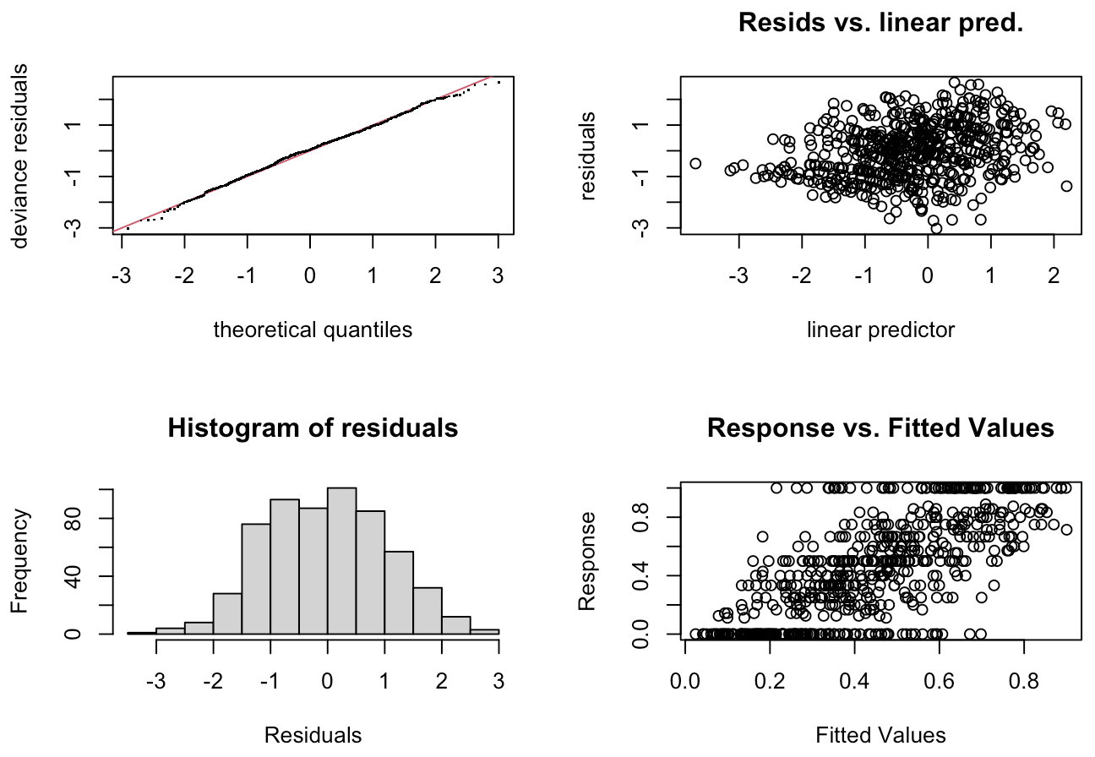

##
## Method: ML Optimizer: outer newton
## full convergence after 13 iterations.
## Gradient range [-2.552142e-05,2.841186e-05]
## (score 864.196 & scale 1).
## Hessian positive definite, eigenvalue range [4.343004e-07,13.99244].
## Model rank = 415 / 415
##
## Basis dimension (k) checking results. Low p-value (k-index<1) may
## indicate that k is too low, especially if edf is close to k'.
##
## k' edf k-index p-value
## s(Year) 1.40e+01 1.30e+01 0.99 0.46
## s(Year):Farm1 9.00e+00 1.43e+00 0.99 0.45
## s(Year):Farm2 9.00e+00 3.71e+00 0.99 0.43
## s(Year):Farm3 9.00e+00 6.56e+00 0.99 0.36
## s(Year):Farm4 9.00e+00 7.04e-05 0.99 0.39
## s(Year):Farm5 9.00e+00 1.43e-05 0.99 0.38
## s(Year):Farm6 9.00e+00 4.15e-05 0.99 0.36
## s(Year):Farm7 9.00e+00 2.31e-04 0.99 0.43
## s(Year):Farm8 9.00e+00 4.94e-06 0.99 0.43
## s(Year):Farm9 9.00e+00 6.29e-05 0.99 0.39
## s(Year):Farm10 9.00e+00 1.73e+00 0.99 0.46
## s(Year):Farm11 9.00e+00 5.25e-05 0.99 0.46
## s(Year):Farm12 9.00e+00 4.48e-01 0.99 0.40
## s(Year):Farm13 9.00e+00 2.93e-01 0.99 0.42
## s(Year):Farm14 9.00e+00 1.85e-04 0.99 0.50
## s(Year):Farm15 9.00e+00 2.43e+00 0.99 0.46
## s(Year):Farm16 9.00e+00 8.78e-05 0.99 0.43
## s(Year):Farm17 9.00e+00 2.73e+00 0.99 0.47
## s(Year):Farm18 9.00e+00 2.61e-05 0.99 0.42
## s(Year):Farm19 9.00e+00 4.59e-05 0.99 0.41
## s(Year):Farm20 9.00e+00 4.75e-04 0.99 0.48
## s(Year):Farm21 9.00e+00 3.43e-05 0.99 0.43
## s(Year):Farm22 9.00e+00 2.88e+00 0.99 0.43
## s(Year):Farm23 9.00e+00 6.77e-05 0.99 0.45
## s(Year):Farm24 9.00e+00 2.12e+00 0.99 0.42
## s(Year):Farm25 9.00e+00 2.86e-05 0.99 0.39
## s(Year):Farm26 9.00e+00 1.62e-04 0.99 0.40
## s(Year):Farm27 9.00e+00 8.27e-05 0.99 0.44
## s(Year):Farm28 9.00e+00 4.45e-05 0.99 0.42
## s(Year):Farm29 9.00e+00 4.27e-01 0.99 0.44
## s(Year):Farm30 9.00e+00 2.05e+00 0.99 0.34
## s(Year):Farm31 9.00e+00 5.14e-05 0.99 0.35
## s(Year):Farm32 9.00e+00 3.90e+00 0.99 0.43
## s(Year):Farm33 9.00e+00 5.94e+00 0.99 0.40
## s(Year):Farm34 9.00e+00 1.61e+00 0.99 0.40
## s(Year):Farm35 9.00e+00 1.25e-05 0.99 0.42
## s(Year):Farm36 9.00e+00 2.34e+00 0.99 0.39
## s(Year):Farm37 9.00e+00 1.17e+00 0.99 0.42
## s(Year):Farm38 9.00e+00 5.65e+00 0.99 0.45
## s(Year):Farm39 9.00e+00 3.22e+00 0.99 0.40
## s(Year):Farm40 9.00e+00 1.65e+00 0.99 0.44
## s(Farm) 4.00e+01 3.34e+01 NA NA

acf(residuals(m_rate), lag.max = 10, main = "ACF")

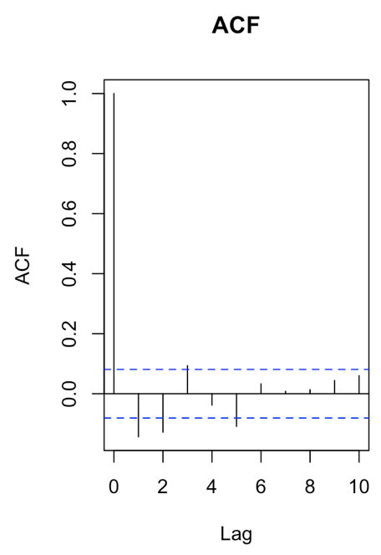
draw(m_rate, select=c(1,42))
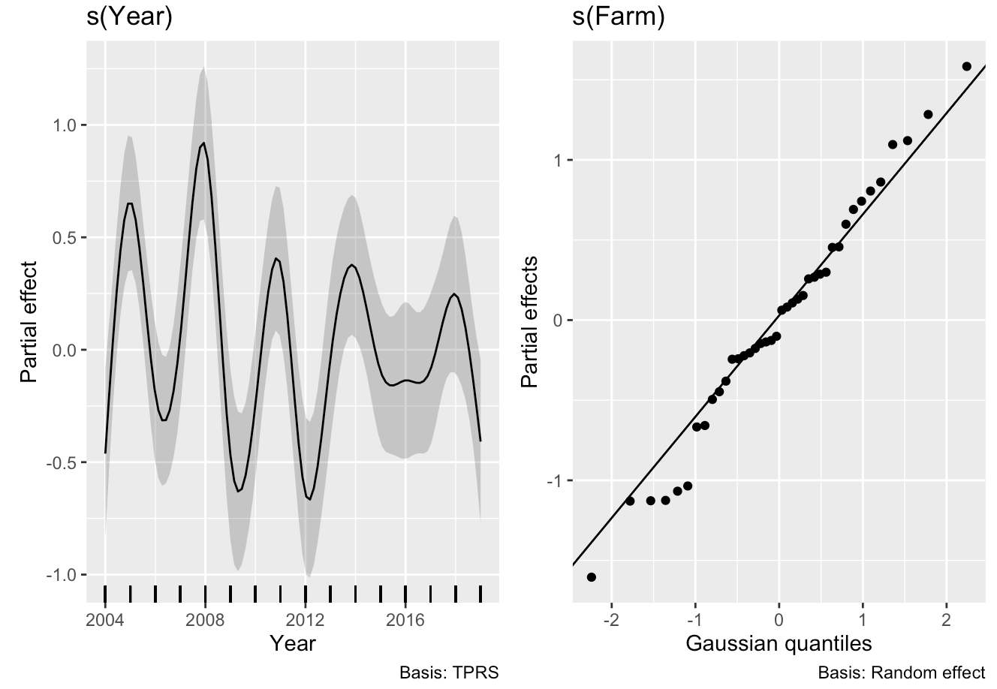
Number of Protocalliphora puparia per infested nest
m_number <- gam(n_Protos ~ s(Year, k=15, bs="tp", m=2) + s(Year, by=Farm, k=10, bs="tp", m=1) + s(Farm, bs="re", k=20), family=tw, data=data.load.infest, method="ML")

summary(m_number)
## Family: Tweedie(p=1.99)
## Link function: log
##
## Formula:
## n_Protos ~ s(Year, k = 15, bs = "tp", m = 2) + s(Year, by = Farm,
## k = 10, bs = "tp", m = 1) + s(Farm, bs = "re", k = 20)
##
## Parametric coefficients:
## Estimate Std. Error t value Pr(>|t|)
## (Intercept) 2.76387 0.04958 55.75 <2e-16 ***
## ---
## Signif. codes: 0 '***' 0.001 '**' 0.01 '*' 0.05 '.' 0.1 ' ' 1
##
## Approximate significance of smooth terms:
## edf Ref.df F p-value
## s(Year) 1.138e+01 12.92 7.012 < 2e-16 ***
## s(Year):Farm1 1.373e-02 9.00 0.001 0.62802
## s(Year):Farm2 8.747e-01 6.00 0.284 0.30627
## s(Year):Farm3 1.382e-03 9.00 0.000 0.57734
## s(Year):Farm4 7.937e-01 9.00 0.148 0.15892
## s(Year):Farm5 1.779e-03 9.00 0.000 0.47290
## s(Year):Farm6 1.095e-02 9.00 0.001 0.27087
## s(Year):Farm7 7.159e-04 9.00 0.000 0.61489
## s(Year):Farm8 9.436e-04 5.00 0.000 0.83031
## s(Year):Farm9 1.623e+00 9.00 0.592 0.01986 *
## s(Year):Farm10 2.376e-03 9.00 0.000 0.38974
## s(Year):Farm11 9.511e-01 9.00 0.214 0.10781
## s(Year):Farm12 1.286e+00 9.00 0.234 0.15730
## s(Year):Farm13 7.598e-01 9.00 0.123 0.20101
## s(Year):Farm14 9.879e-01 9.00 0.176 0.16614
## s(Year):Farm15 1.947e-03 9.00 0.000 0.59872
## s(Year):Farm16 2.497e-03 9.00 0.000 0.55083
## s(Year):Farm17 4.124e-01 9.00 0.052 0.30715
## s(Year):Farm18 8.711e-04 9.00 0.000 0.83578
## s(Year):Farm19 1.514e+00 6.00 0.763 0.03419 *
## s(Year):Farm20 3.009e+00 7.00 1.497 0.01188 *
## s(Year):Farm21 9.937e-04 9.00 0.000 0.78825
## s(Year):Farm22 2.230e+00 9.00 0.820 0.01336 *
## s(Year):Farm23 1.350e+00 9.00 0.224 0.19458
## s(Year):Farm24 1.159e-03 9.00 0.000 0.59947
## s(Year):Farm25 1.427e+00 3.00 2.255 0.00748 **
## s(Year):Farm26 4.506e-04 9.00 0.000 0.99107
## s(Year):Farm27 2.652e-03 9.00 0.000 0.66958
## s(Year):Farm28 2.360e+00 7.00 2.994 3.24e-05 ***
## s(Year):Farm29 2.537e-03 4.00 0.001 0.35355
## s(Year):Farm30 2.573e+00 8.00 0.896 0.05671 .
## s(Year):Farm31 7.689e-01 9.00 0.156 0.14029
## s(Year):Farm32 1.054e-03 9.00 0.000 0.43156
## s(Year):Farm33 8.575e-01 9.00 0.145 0.18986
## s(Year):Farm34 1.258e+00 3.00 1.558 0.04346 *
## s(Year):Farm35 1.565e-03 9.00 0.000 0.75436
## s(Year):Farm36 1.263e-02 9.00 0.001 0.46835
## s(Year):Farm37 2.482e-03 9.00 0.000 0.38497
## s(Year):Farm38 1.802e-03 9.00 0.000 0.45869
## s(Year):Farm39 1.037e+00 8.00 0.277 0.13061
## s(Year):Farm40 2.074e+00 9.00 0.761 0.01716 *
## s(Farm) 2.179e+01 39.00 1.884 < 2e-16 ***
## ---
## Signif. codes: 0 '***' 0.001 '**' 0.01 '*' 0.05 '.' 0.1 ' ' 1
##
## R-sq.(adj) = 0.122 Deviance explained = 17.2%
## -ML = 4760.3 Scale est. = 0.95101 n = 1227

gam.check(m_number)
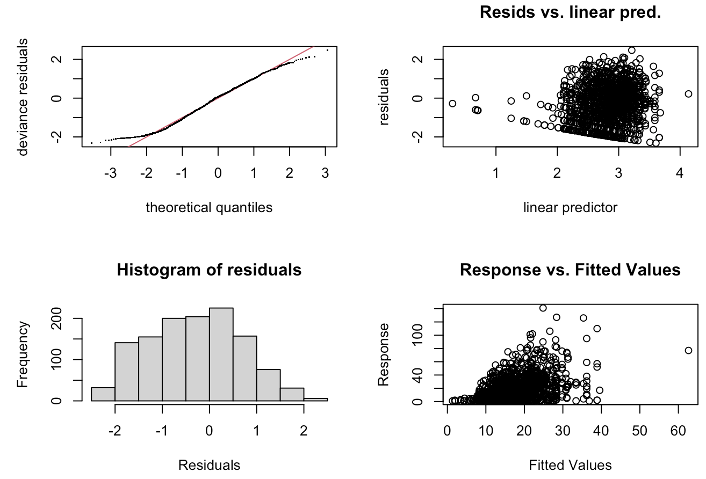

##
## Method: ML Optimizer: outer newton
## full convergence after 17 iterations.
## Gradient range [-0.009328435,0.000225552]
## (score 4760.302 & scale 0.9510084).
## eigenvalue range [-0.0002268827,784.2636].
## Model rank = 415 / 415
##
## Basis dimension (k) checking results. Low p-value (k-index<1) may
## indicate that k is too low, especially if edf is close to k'.
##
## k' edf k-index p-value
## s(Year) 1.40e+01 1.14e+01 0.89 0.28
## s(Year):Farm1 9.00e+00 1.37e-02 0.89 0.25
## s(Year):Farm2 9.00e+00 8.75e-01 0.89 0.25
## s(Year):Farm3 9.00e+00 1.38e-03 0.89 0.25
## s(Year):Farm4 9.00e+00 7.94e-01 0.89 0.28
## s(Year):Farm5 9.00e+00 1.78e-03 0.89 0.31
## s(Year):Farm6 9.00e+00 1.10e-02 0.89 0.30
## s(Year):Farm7 9.00e+00 7.16e-04 0.89 0.27
## s(Year):Farm8 9.00e+00 9.44e-04 0.89 0.24
## s(Year):Farm9 9.00e+00 1.62e+00 0.89 0.25
## s(Year):Farm10 9.00e+00 2.38e-03 0.89 0.21
## s(Year):Farm11 9.00e+00 9.51e-01 0.89 0.28
## s(Year):Farm12 9.00e+00 1.29e+00 0.89 0.21
## s(Year):Farm13 9.00e+00 7.60e-01 0.89 0.25
## s(Year):Farm14 9.00e+00 9.88e-01 0.89 0.28
## s(Year):Farm15 9.00e+00 1.95e-03 0.89 0.30
## s(Year):Farm16 9.00e+00 2.50e-03 0.89 0.23
## s(Year):Farm17 9.00e+00 4.12e-01 0.89 0.21
## s(Year):Farm18 9.00e+00 8.71e-04 0.89 0.28
## s(Year):Farm19 9.00e+00 1.51e+00 0.89 0.28
## s(Year):Farm20 9.00e+00 3.01e+00 0.89 0.26
## s(Year):Farm21 9.00e+00 9.94e-04 0.89 0.24
## s(Year):Farm22 9.00e+00 2.23e+00 0.89 0.20
## s(Year):Farm23 9.00e+00 1.35e+00 0.89 0.22
## s(Year):Farm24 9.00e+00 1.16e-03 0.89 0.26
## s(Year):Farm25 9.00e+00 1.43e+00 0.89 0.26
## s(Year):Farm26 9.00e+00 4.51e-04 0.89 0.27
## s(Year):Farm27 9.00e+00 2.65e-03 0.89 0.31
## s(Year):Farm28 9.00e+00 2.36e+00 0.89 0.24
## s(Year):Farm29 9.00e+00 2.54e-03 0.89 0.25
## s(Year):Farm30 9.00e+00 2.57e+00 0.89 0.28
## s(Year):Farm31 9.00e+00 7.69e-01 0.89 0.26
## s(Year):Farm32 9.00e+00 1.05e-03 0.89 0.22
## s(Year):Farm33 9.00e+00 8.57e-01 0.89 0.28
## s(Year):Farm34 9.00e+00 1.26e+00 0.89 0.28
## s(Year):Farm35 9.00e+00 1.56e-03 0.89 0.21
## s(Year):Farm36 9.00e+00 1.26e-02 0.89 0.23
## s(Year):Farm37 9.00e+00 2.48e-03 0.89 0.26
## s(Year):Farm38 9.00e+00 1.80e-03 0.89 0.28
## s(Year):Farm39 9.00e+00 1.04e+00 0.89 0.28
## s(Year):Farm40 9.00e+00 2.07e+00 0.89 0.21
## s(Farm) 4.00e+01 2.18e+01 NA NA

acf(residuals(m4), lag.max = 10, main = "ACF")

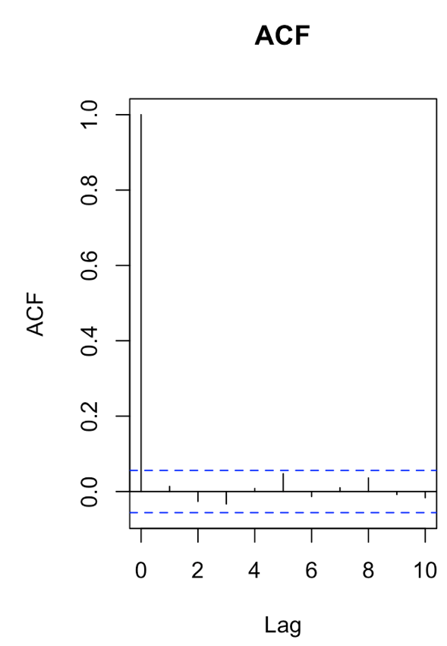
draw(m_number, select=c(1,42))

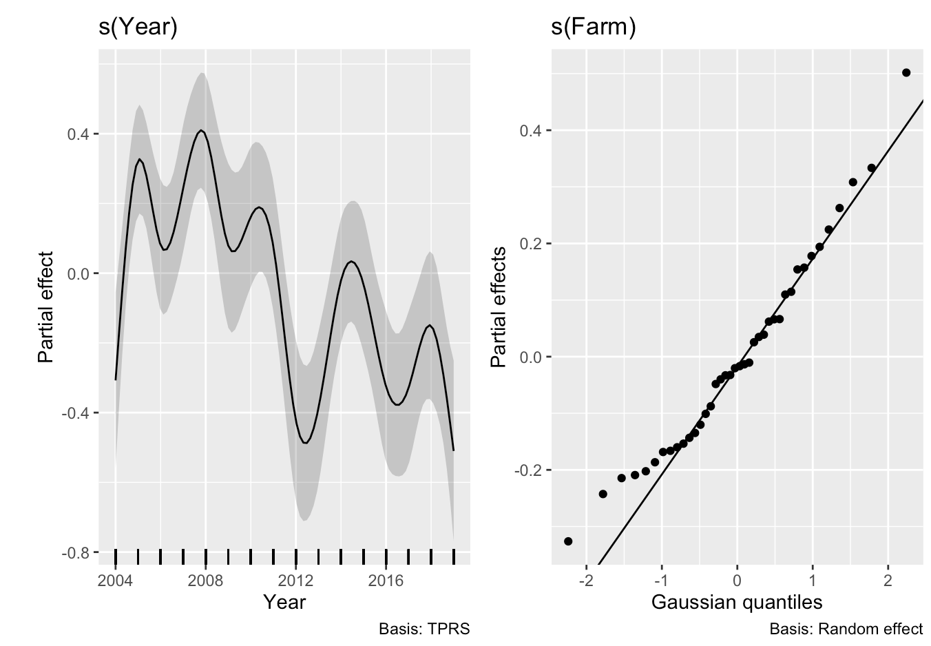

REFERENCES
For the bibliographic information of the references cited in Supplementary material, please see the references in the main paper.

