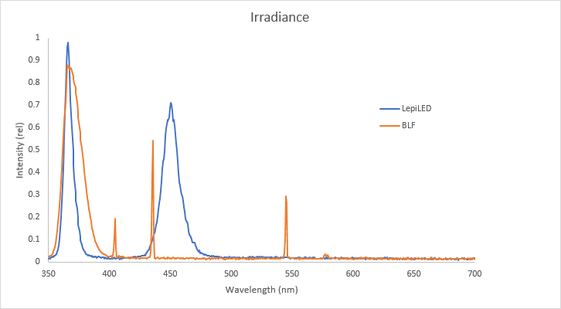

**Supplementary material, Figure S1.** Plot of relative peak irradiation across the ultraviolet (UV) and visible spectrum measured using Vernier Emissions Spectromer (VSP-EM; Vernier, Beaverton, Oregon, United States of America) equipped with Vernier Emissions Fiber (VSP-EM-Fiber; Vernier) at 1-m distance. The black-light fluorescent (BLF) has a large broad peak in the UV region spanning from 355 to 390 nm, covering a wider range of the UVA spectrum than the LepiLED does, with a peak at 365 nm. Smaller peaks are also present at 404 nm, 435 nm and 545 nm. The LepiLED has a large but narrow peak in the UV region, emitting light between 360 and 380 nm, with a peak at 366 nm. A second large peak is detected in the LepiLED from 430 to 475 nm, with peak at 450 nm.