# Supplementary materials



**Figure S1.** Change-over-time in mean mass of oven-dried (50 °C; grey symbols) and ambient (20 °C; black symbols) *Pinus halepensis* shoots. The mean difference between oven-dried and ambient branches was 10% after 24 hours. Bars show ± 1 standard error of the mean.

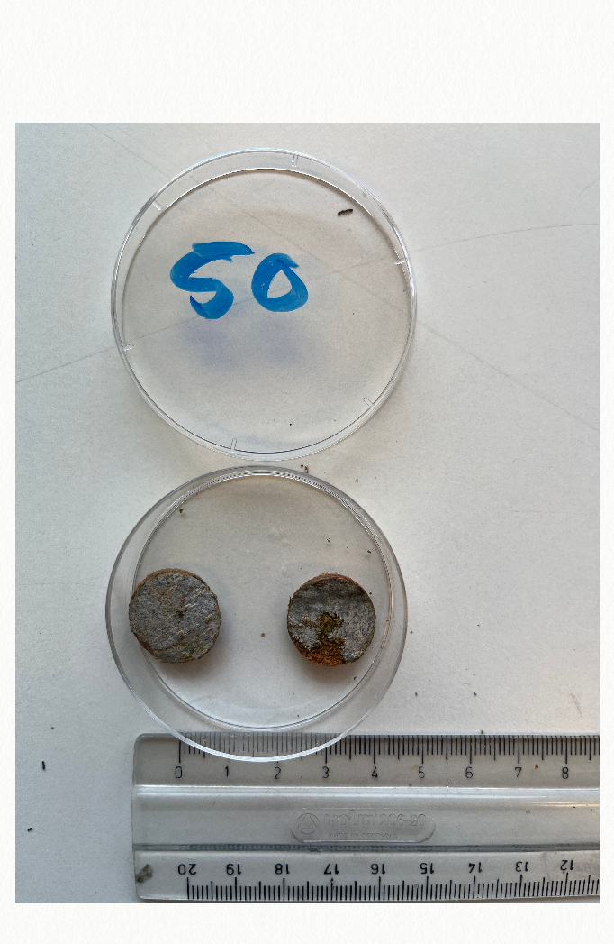

**F**

**D**

**Figure S2**. Example of bark discs (F = ‘fresh’; D =’dried’) showing feeding of newly emerged *M. galloprovincialis* on fresh and dried material in a 24-hour assay period. Area consumed on each disc for each trial was measured using the ‘polygon’ tool in ImageJ software; scale shown is in centimetres. Here, an estimated 0 and 53 mm2 were consumed from fresh and dried discs, respectively.