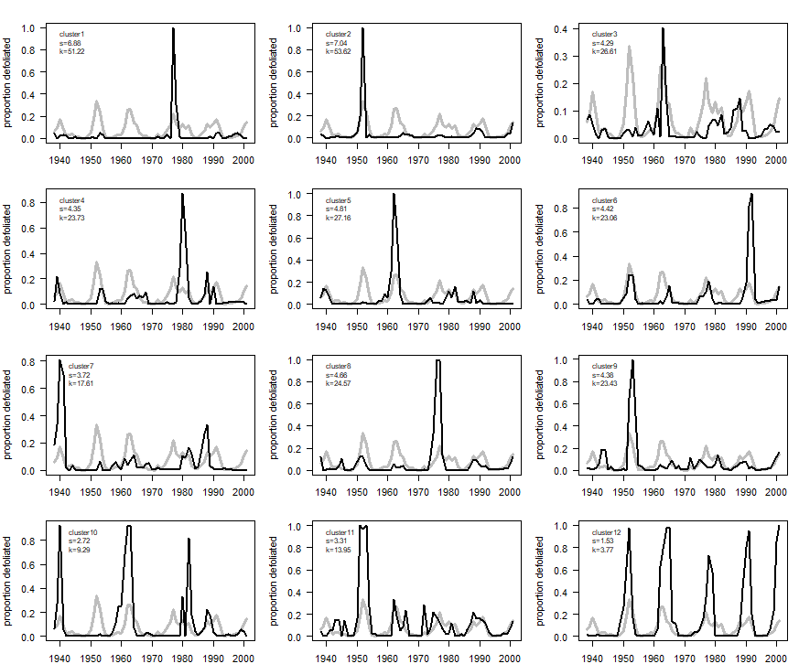
Fig. S1. The 12-cluster time-series from Cooke (2024), each with kurtosis and skewness estimated. Also shown in the background of each frame (grey line) is the aggregate national-scale time-series of Fig. 1. The overlay helps clarify that the regional spikes that are the source of heavy skewness and kurtosis are aligned with national-scale cycling.

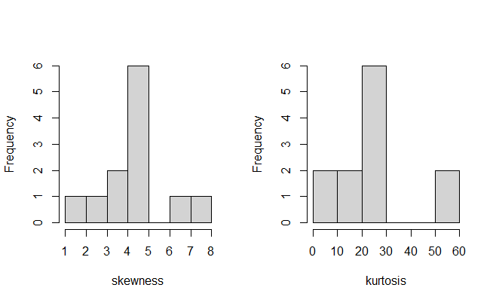

Fig. S2. Histograms of skewness and kurtosis estimated from the 12-cluster time-series in Fig. S1.

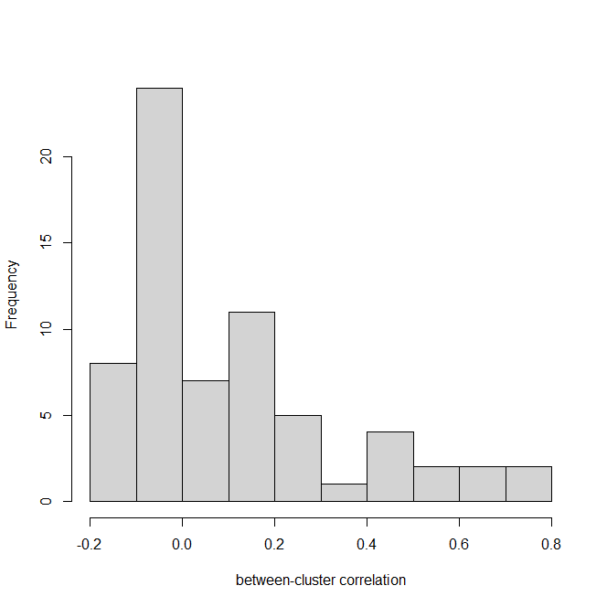
Fig. S3. Histogram of pairwise correlations between cluster time-series in Fig. S1.

