Supplementary file
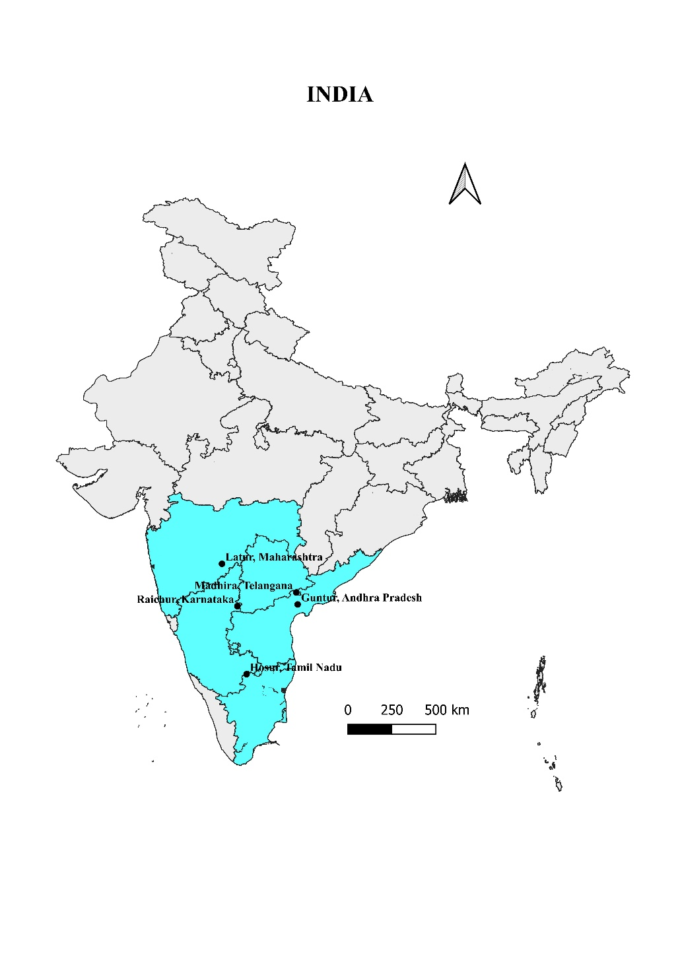

Figure S1. Sampling sites for collection of field populations of Maruca vitrata in legume crop cultivated areas of South India.

