Table S1. Primer sequences

|  |  |  |  |
| --- | --- | --- | --- |
| Primer | Forward Primer (5’-3’) | Reverse Primer (5’-3’) | Efficiency (%) |
| *InR1* | TTATGTTTCAATGGGCTTCA | TGCGGTTCCAATCCTCTAC | 91.45 |
| *InR2* | GTCAACCGACCTTAGTCA | ATATGCCATACCATCAGC | 92.35 |
| *Akt* | AATAATGCCAACCGATAAAC | ATCCATTCTTCACGCTCA | 91.06 |
| *erk* | TATTCAAACATAAGGCAAATCAA | ATTGGTAGTTGTATCATCATCA | 92.66 |
| *Vg1* | CGTACGCGTAATGAATGTCGCA | TCAGTCACAGCGTCACGGTA | 94.21 |
| *actin* | GTCAACCGACCTTAGTCA | ATATGCCATACCATCAGC | / |
| *ribosomal protein S26e* | CGAAACAGAAGTAAAACCGAAC | TGCGTTGTTGTTGTGGAT | / |

Table S2. Developmental time and fecundity of the L-F1 generation of *C. pallens* treated GBH at different doses

|  |  |  |  |  |
| --- | --- | --- | --- | --- |
| Stage/d | Control | 5 mL/L | 10 mL/L | 20 mL/L |
| Egg | 3.58±0.09 a | 3.47±0.09 a | 3.56±0.08 a | 3.47±0.09 a |
| First instar | 3.03±0.10 ab | 2.81±0.11 b | 2.82±0.07 b | 3.14±0.11 a |
| Second instar | 2.42±0.10 ab | 2.50±0.10 ab | 2.28±0.07 b | 2.69±0.10 a |
| Third instar | 3.90±0.11 b | 3.86±0.13 b | 3.90±0.09 b | 4.31±0.15 a |
| Pupa | 13.14±0.17 a | 13.15±0.14 a | 13.13±0.12 a | 13.00±0.15 a |
| Female adult | 24.90±1.86 b | 25.00±2.59 b | 25.23±1.16 b | 32.89±2.94 a |
| Male adult | 21.89±1.54 a | 20.4±1.05 a | 20.36±1.28 a | 20.43±2.05 a |
| Total longevity | 46.42±1.87 a | 44.49±2.12 a | 42.82±1.94 a | 48.58±2.99 a |
| Female total longevity | 51.51±1.88 a | 50.73±2.60 a | 50.93±1.21 a | 55.78±2.70 a |
| Male total longevity | 47.72±1.60 a | 46.19±1.56 a | 46.00±1.30 a | 47.00±1.94 a |
| Female pre-oviposition period (APOP) | 6.50±0.37 a | 7.36±0.36 a | 7.24±0.66 a | 6.89±0.71 a |
| Total pre-oviposition period (TPOP) | 33.10±0.48 a | 33.09±0.43 a | 32.93±0.76 a | 33.67±0.98 a |
| Fecundity (eggs) | 231.37±56.21 a | 239.64±61.59 a | 231.91±27.43 a | 174.78±48.39 a |
| Oviposition days | 14.1±2.13 a | 13.36±2.50 a | 13.46±1.35 a | 13.67±1.88 a |

Note: Means ± SE in the same row followed by different lowercase letters represent significant differences between treatments using a paired bootstrap test (*P* < 0.05).

Table S3. Population parameters of the L-F1 generation of *C. pallens* treated GBH at different doses

|  |  |  |  |  |
| --- | --- | --- | --- | --- |
| Population Parameters | Control | 5 mL/L | 10 mL/L | 20 mL/L |
| Preadult survival rate (%) | 90.32±5.31 a | 87.09±6.01 a | 84.44±5.40 a | 82.14±5.98 a |
| Net reproductive rate (*R0*) (offspring/individual) | 74.61±26.08 a | 85.03±29.50 a | 67.00±17.46 a | 42.55±16.64 a |
| Intrinsic rate of increase (*r*)(d-1) | 0.1033±0.0096 a | 0.1092±0.0096 a | 0.1092±0.0078 a | 0.0911±0.0121 a |
| Finite rate of increase (*λ*)(d-1) | 1.1088±0.0107 a | 1.1154±0.0107 a | 1.1154±0.0087 a | 1.0928±0.0133 a |
| Mean generation time (*T*)(d) | 41.12±1.05 a | 40.08±1.00 a | 39.19±0.80 a | 41.38±1.42 a |

Note: Means ± SE in the same row followed by different lowercase letters represent significant differences between treatments using a paired bootstrap test (*P* <0.05).

Table S4. Developmental time and fecundity of the A-F1 generation of *C. pallens* treated GBH at different doses

|  |  |  |  |  |
| --- | --- | --- | --- | --- |
| Stage/d | Control | 5 mL/L | 10 mL/L | 20 mL/L |
| Egg | 3.24±0.07 ab | 3.41±0.08 a | 3.32±0.08 a | 3.13±0.05 b |
| First instar | 3.17±0.07 a | 3.11±0.08 a | 3.03±0.08 a | 2.79±0.08 b |
| Second instar | 2.63±0.08 b | 2.70±0.08 ab | 2.54±0.09 b | 2.92±0.09 a |
| Third instar | 4.31±0.07 ab | 4.19±0.06 b | 4.32±0.10 ab | 4.49±0.10 a |
| Pupa | 13.54±0.09 a | 13.68±0.11 a | 13.56±0.10 a | 12.78±0.09 b |
| Female adult | 24.90±2.40 a | 22.50±1.11 a | 23.11±1.62 a | 21.30±1.37 a |
| Male adult | 16.48±0.92 a | 16.89±1.45 a | 17.20±1.54 a | 14.96±0.96 a |
| Total longevity | 42.62±1.57 ab | 43.54±1.44 ab | 44.46±1.52 a | 39.50±1.63 b |
| Female total longevity | 52.00±2.24 a | 49.72±1.09 a | 49.69±1.61 a | 47.60±1.34 a |
| Male total longevity | 43.24±0.92 a | 44.95±1.50 a | 44.27±1.55 a | 40.87±1.08 a |
| Female pre-oviposition period (APOP) | 6.90±0.65 a | 7.14±0.70 a | 6.06±0.61 a | 6.00±1.04 a |
| Total pre-oviposition period (TPOP) | 34.00±0.85 a | 34.36±0.72 a | 32.65±0.64 a | 32.30±1.18 a |
| Fecundity (eggs) | 127.05±42.48 a | 136.94±28.42 a | 146.00±37.09 a | 138.40±35.06 a |
| Oviposition days | 10.30±2.36 a | 9.43±1.01 a | 8.71±1.02 a | 9.30±1.42 a |

Note: Means ± SE in the same row followed by different lowercase letters represent significant differences between treatments using a paired bootstrap test (*P* < 0.05).

Table S5. Population parameters of the A-F1 generation of *C. pallens* treated GBH at different doses

|  |  |  |  |  |
| --- | --- | --- | --- | --- |
| Population Parameters | Control | 5 mL/L | 10 mL/L | 20 mL/L |
| Preadult survival rate (%) | 85.38±5.53 a | 83.74±6.06 a | 86.49±5.60 a | 84.19±5.93 a |
| Net reproductive rate (*R0*) (offspring/individual) | 31.03±13.10 a | 51.82±15.22 a | 67.13±20.59 a | 36.42±13.30 a |
| Intrinsic rate of increase (*r*)(d-1) | 0.08644±0.0123 a | 0.1007±0.0084 a | 0.1066±0.0075 a | 0.0945±0.0107 a |
| Finite rate of increase (*λ*)(d-1) | 1.0877±0.0133 a | 1.1106±0.0093 a | 1.1126±0.0083 a | 1.1099±0.0117 a |
| Mean generation time (*T*)(d) | 39.70±1.89 a | 38.75±0.98 a | 38.96±1.22 a | 37.26±0.86 a |

Note: Means ± SE in the same row followed by different lowercase letters represent significant differences between treatments using a paired bootstrap test (*P* < 0.05).

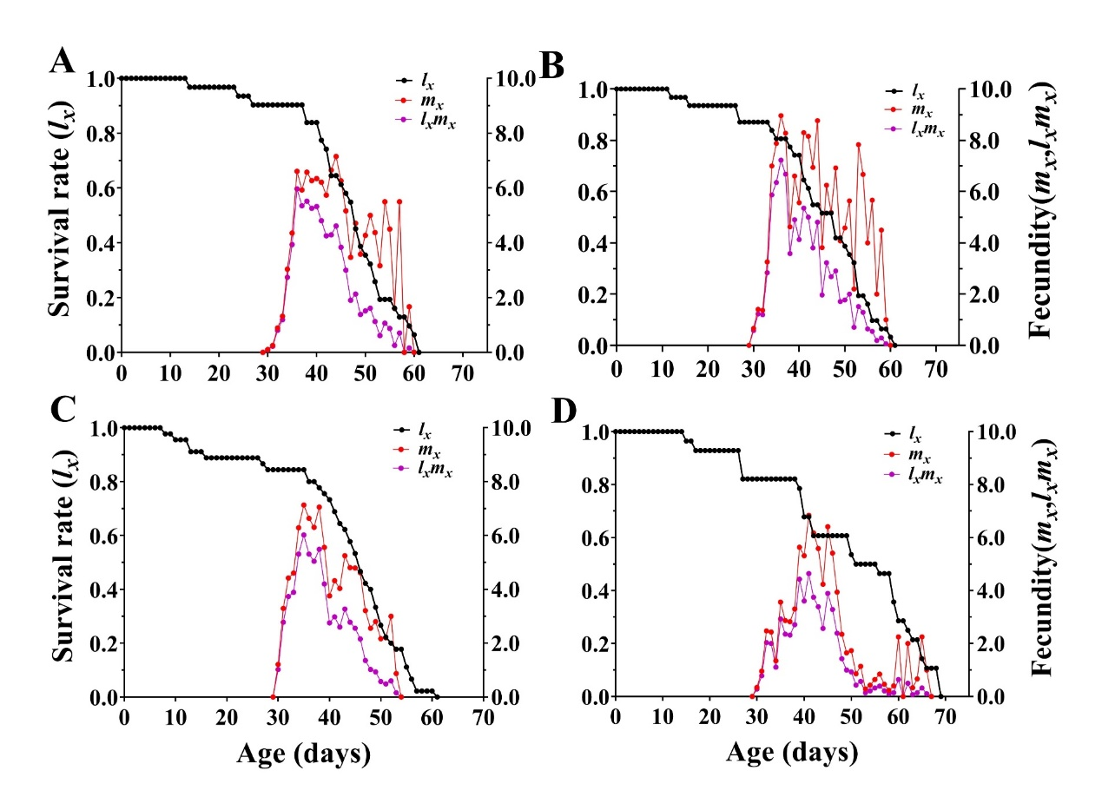

**Fig. S1.** Survival rate (*lx*), age-specific fecundity (*mx*), and age-specific maternity (*lxmx*) of the L-F1 generation of *C. pallens* treated GBH at different doses.

The *lx*curve represents the probability that a newborn nymph will survive to age *x*; the *mx* curve represents the fecundity of individuals at age *x*. A: Control; B: 5 mL/L; C: 10 mL/L; D: 20 mL/L.

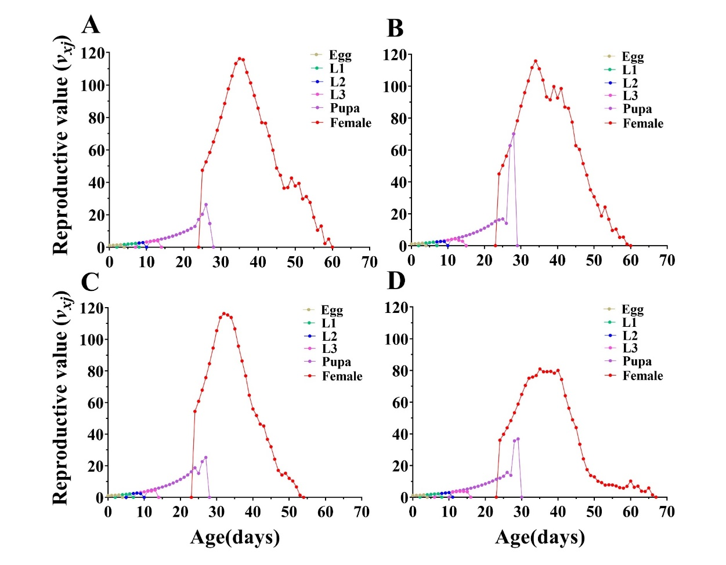

**Fig. S2.** Age-stage-specific reproductive (*Vxj*) values of the L-F1 generation of *C. pallens* treated GBH at different doses. A: Control; B: 5 mL/L; C: 10 mL/L; D: 20 mL/L.

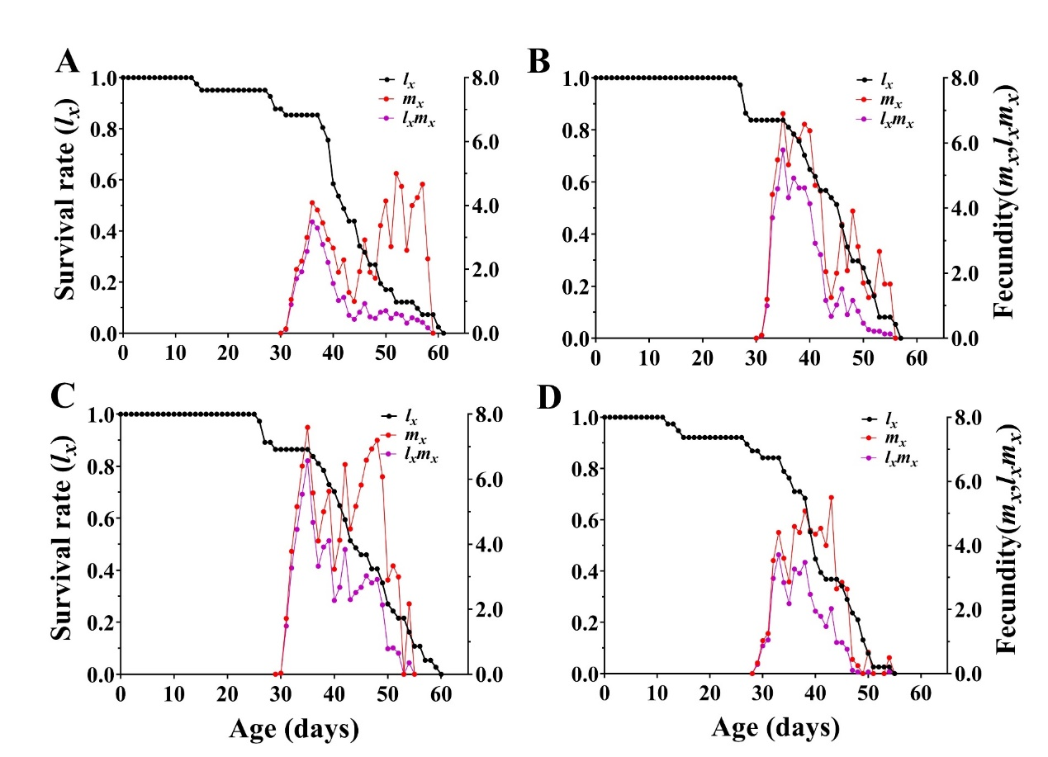

**Fig. S3.** Survival rate (*lx*), age-specific fecundity (*mx*), and age-specific maternity (*lxmx*) of the A-F1 generation of *C. pallens* treated GBH at different doses.

The *lx*curve represents the probability that a newborn nymph will survive to age *x*; the *mx* curve represents the fecundity of individuals at age *x*. A: Control; B: 5 mL/L; C: 10 mL/L; D: 20 mL/L.

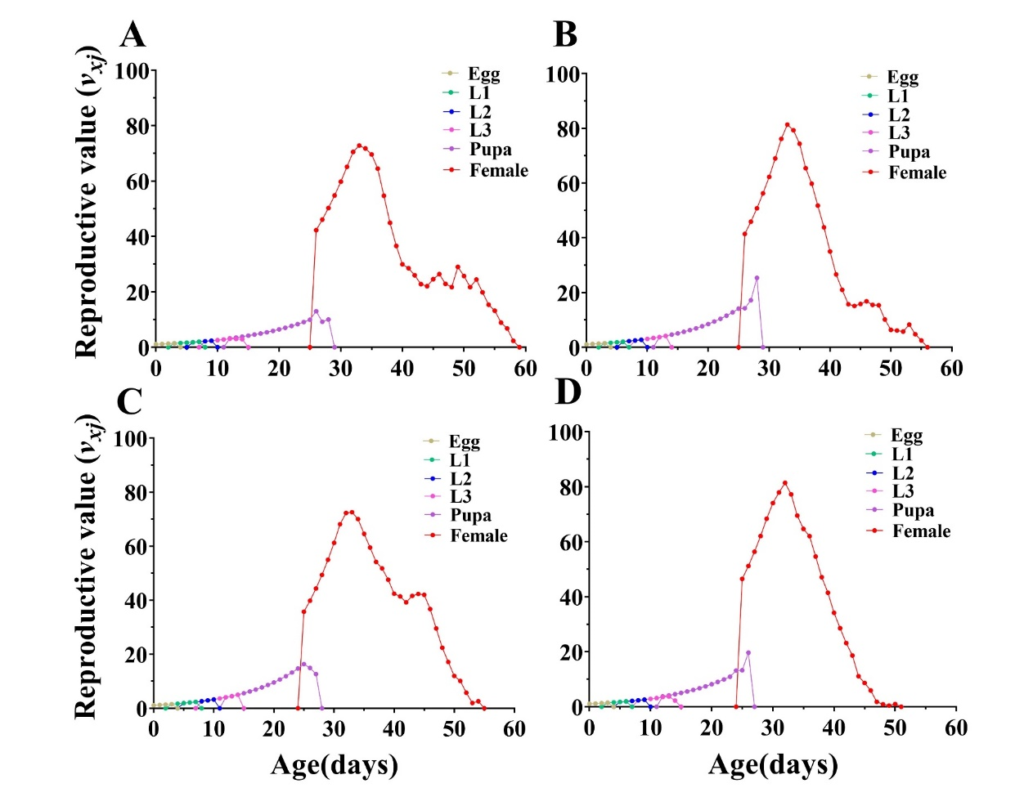

**Fig. S4.** Age-stage-specific reproductive (*Vxj*) values of the A-F1 generation of *C. pallens* treated GBH at different doses. A: Control; B: 5 mL/L; C: 10 mL/L; D: 20 mL/L.