Figure legends
Fig. S1: Satellite image of the study area in Jenaer Forst. a) Part of Jenaer Forst with Bismarckturm and Forstturm, both towers are marked with yellow arrows. Close-up images show the three positions of traps in the understorey at b) Bismarckturm and c) Forstturm. Original image file © GDI-Thdl-en/by-2-0. From: Singh et al. (2022).

Fig. S2: Set-up trap on the Bismarckturm (left) with mesh bag as well as egg cartons and 3 D model of a trap (right). The powerbank battery (not shown here) is in an attached waterproof bag. The trap is attached to the tower at the top eyelet with a carabiner and thread. Photo (04.07.2021) and illustration: Dennis Böttger.

Fig. S3: Comparison of the number of trapped individuals in the canopy and understorey per lunar phase. The points are plotted with a jitter.

Fig. S4: Sampling coverage of the samples from the canopy (blue) and the understorey (green). Numbers represent the exact coverage values. The solid line represents sample size (solid line) and extrapolated species numbers (dashed line) with 95% confidence interval (shade).

Fig. S5: Boxplot for forewing length (FWL) of all captured moths in canopy and understorey. The coloured dots represent outliers.

Fig. S6: Medians (top) and means (bottom) of forewing length (FWL) of individual samples (n = 38) compared in pairs for trapping nights (n = 19) in the three lunar phases. The start date of a trapping night is indicated in each sample.

Fig. S7: Pairwise comparison of medians as well as interquartile range of forewing length (FWL) of each trapping night (n = 19). Each black dot represents an individual in each sample (N = 38). These dots are plotted with jitter. Each colored dot represents an outlier. The indicated date above each individual graph represents the start date of the sampling event. Top: Forstturm, bottom: Bismarckturm; the top line represents the 1st lunar phase, the middle line the 2nd lunar phase, and the bottom line the 3rd lunar phase.
Fig. S8: Range of variation in body size. Each point represents the interquartile range of forewing length (FWL) of a sample (n = 38). Lines connect pairs of traps (n = 19) from the canopy and understorey. Points are plotted with a jitter.
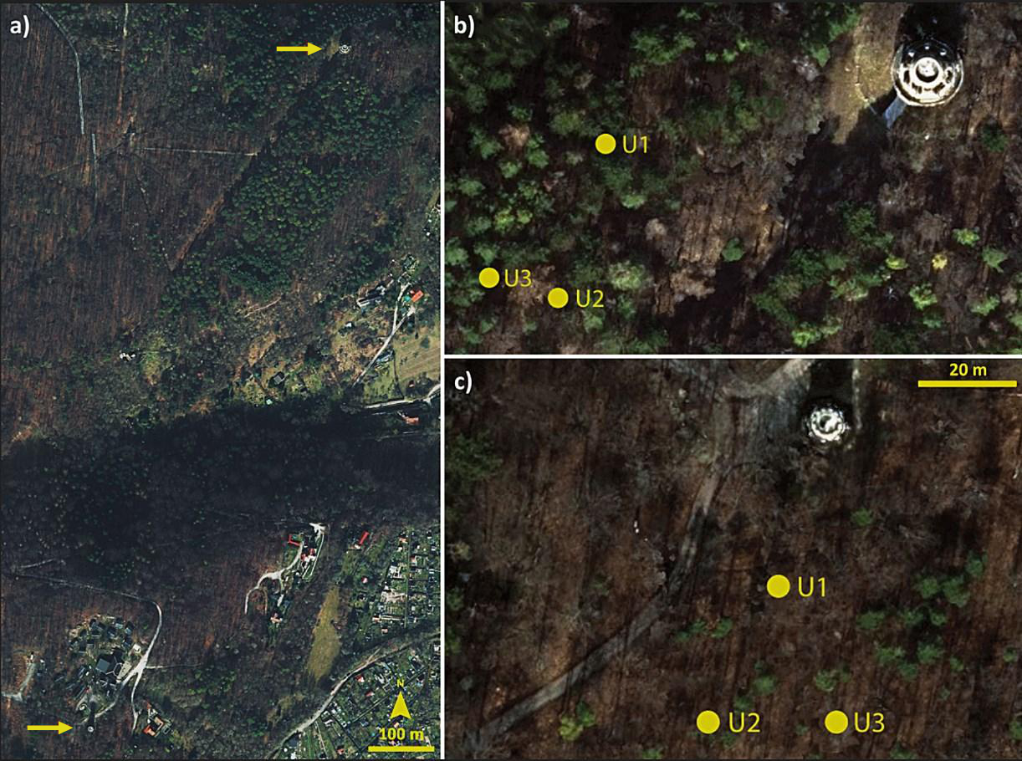
Fig. S1

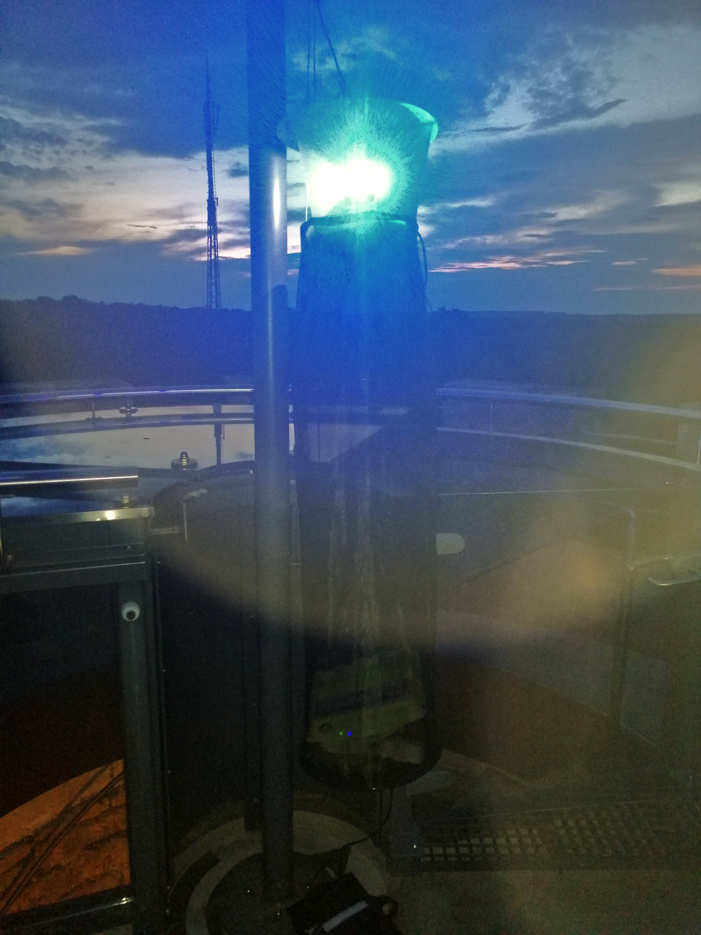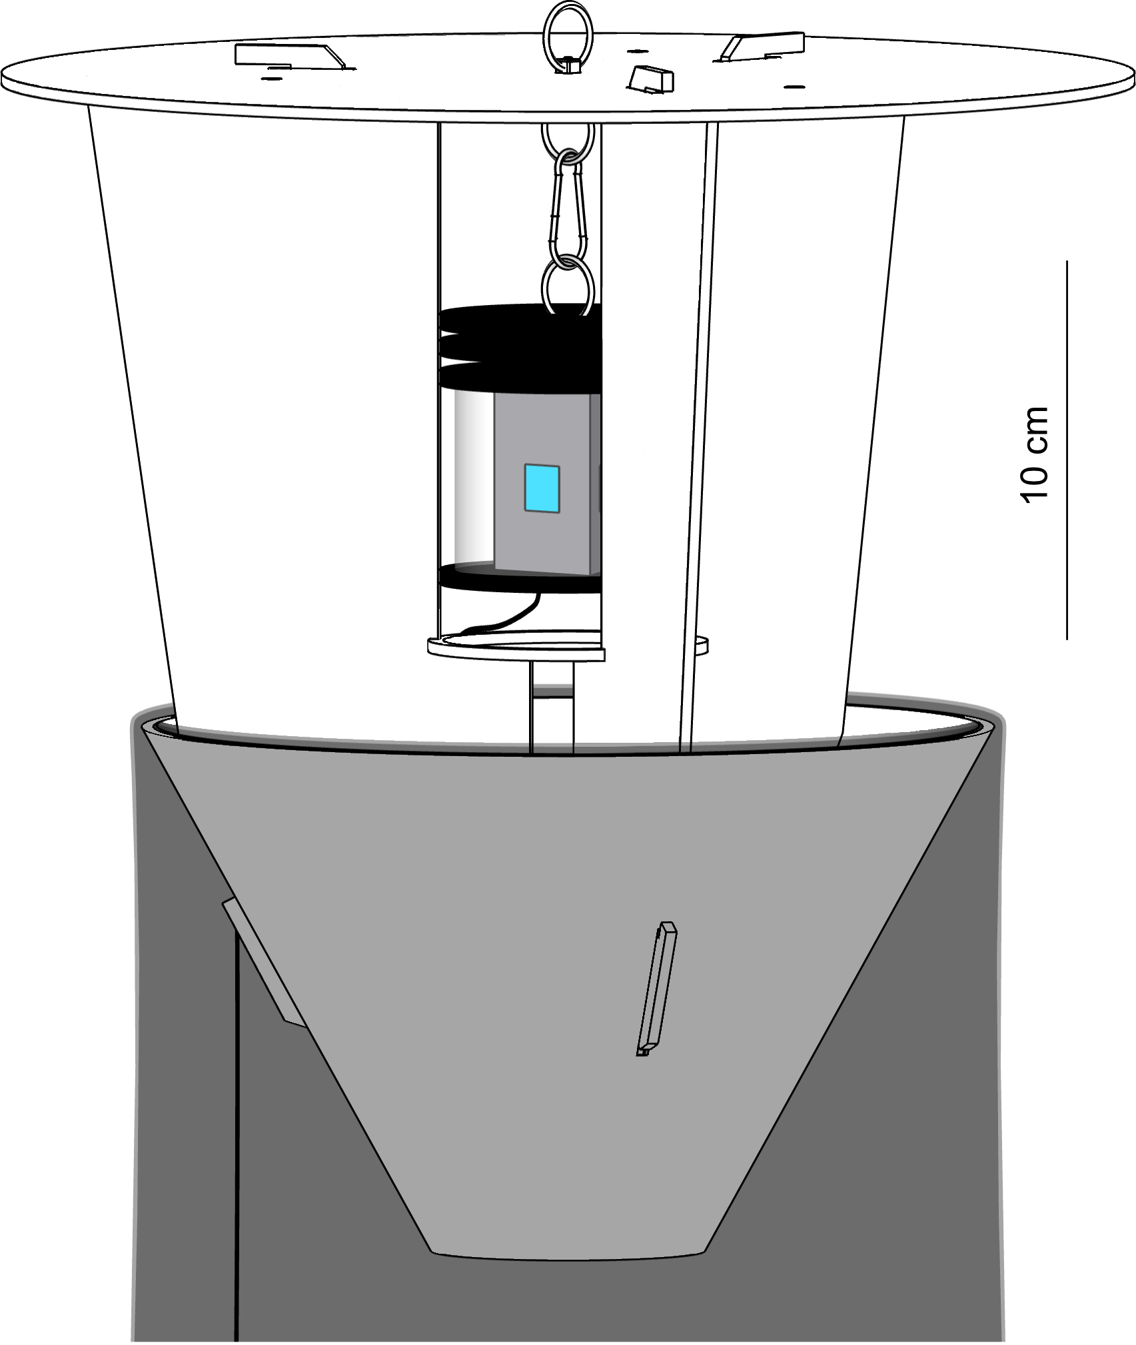
Fig. S2
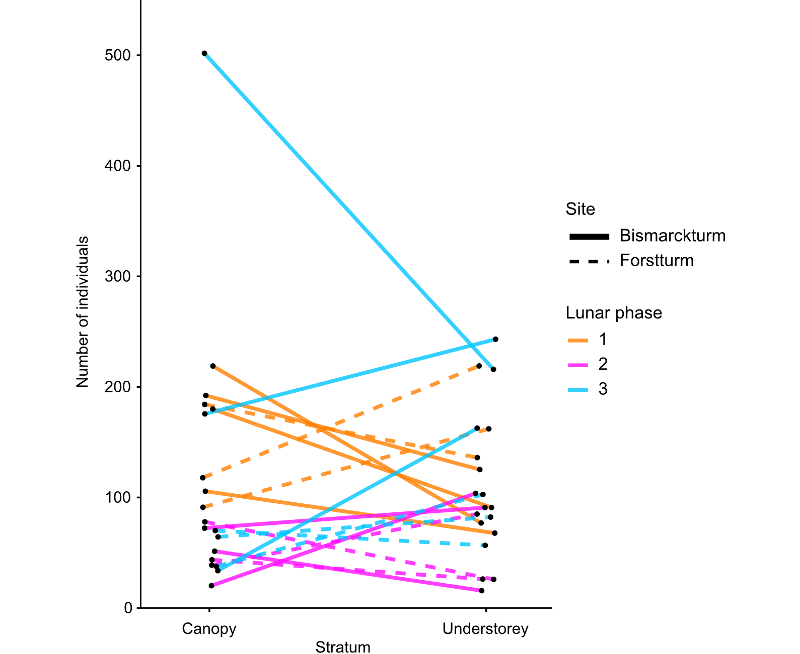
Fig. S3

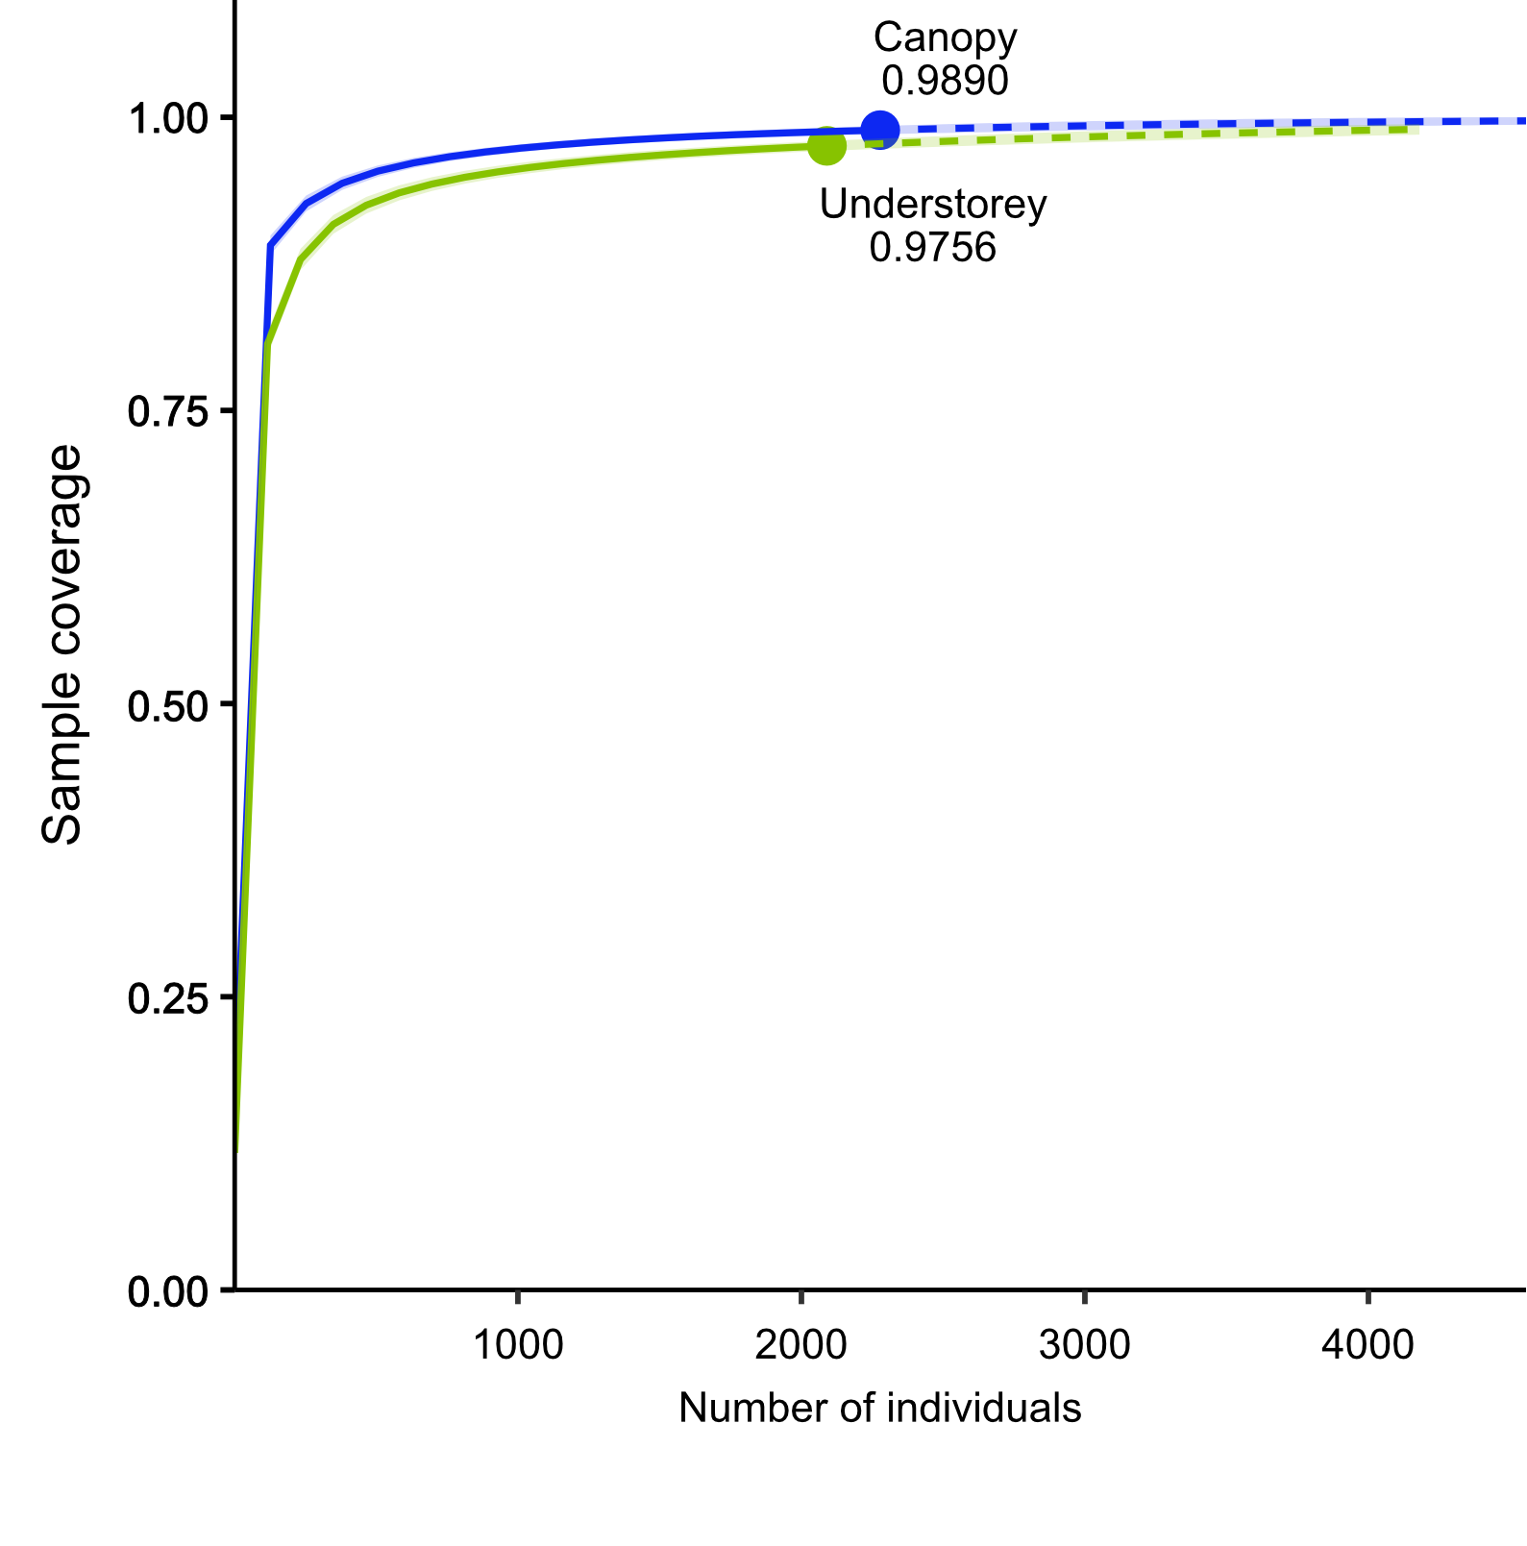
Fig. S4

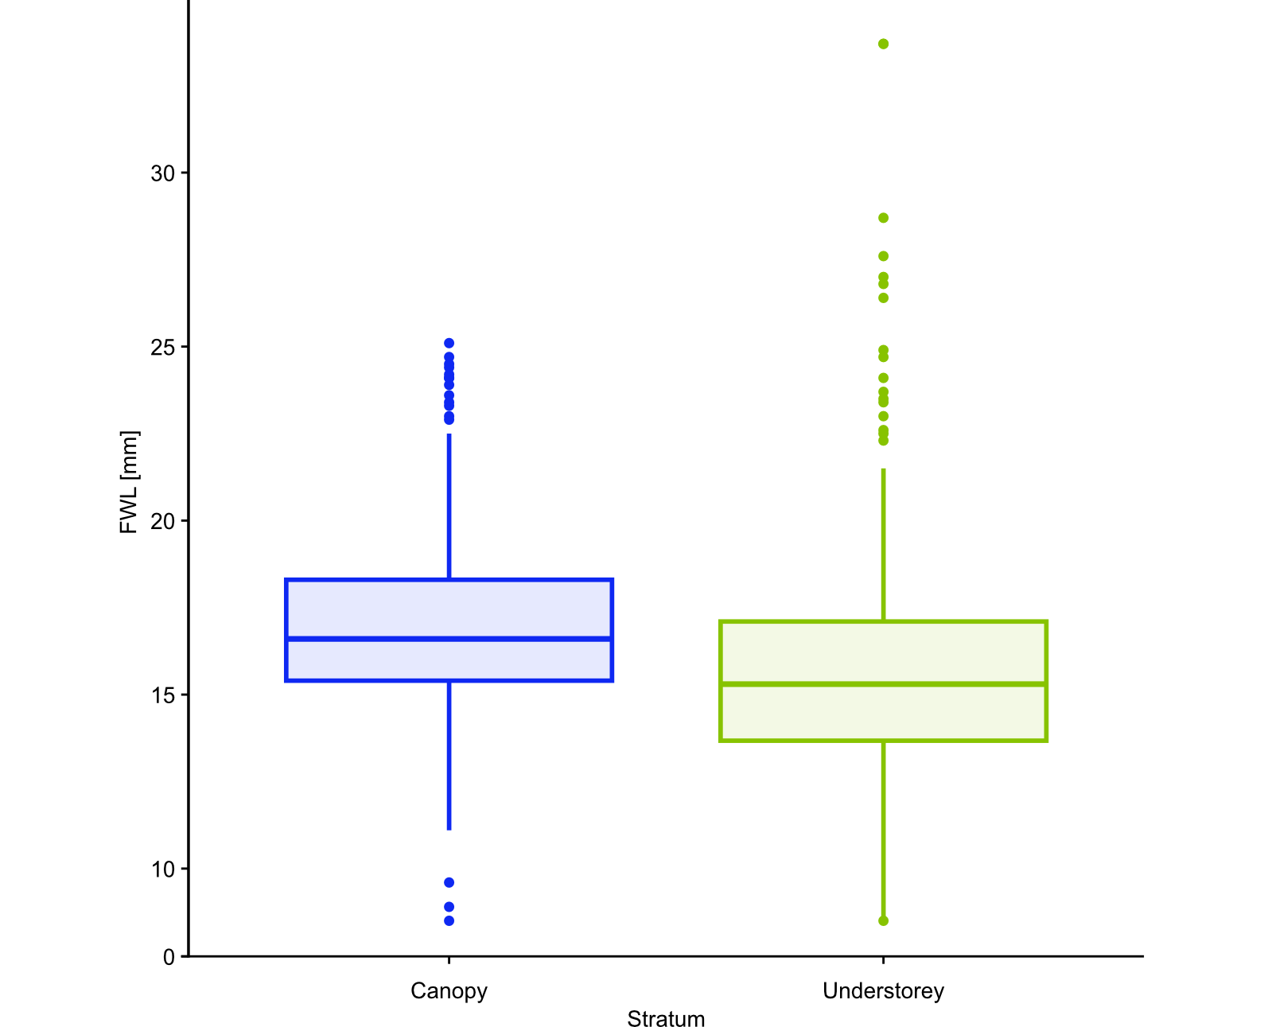
Fig. S5
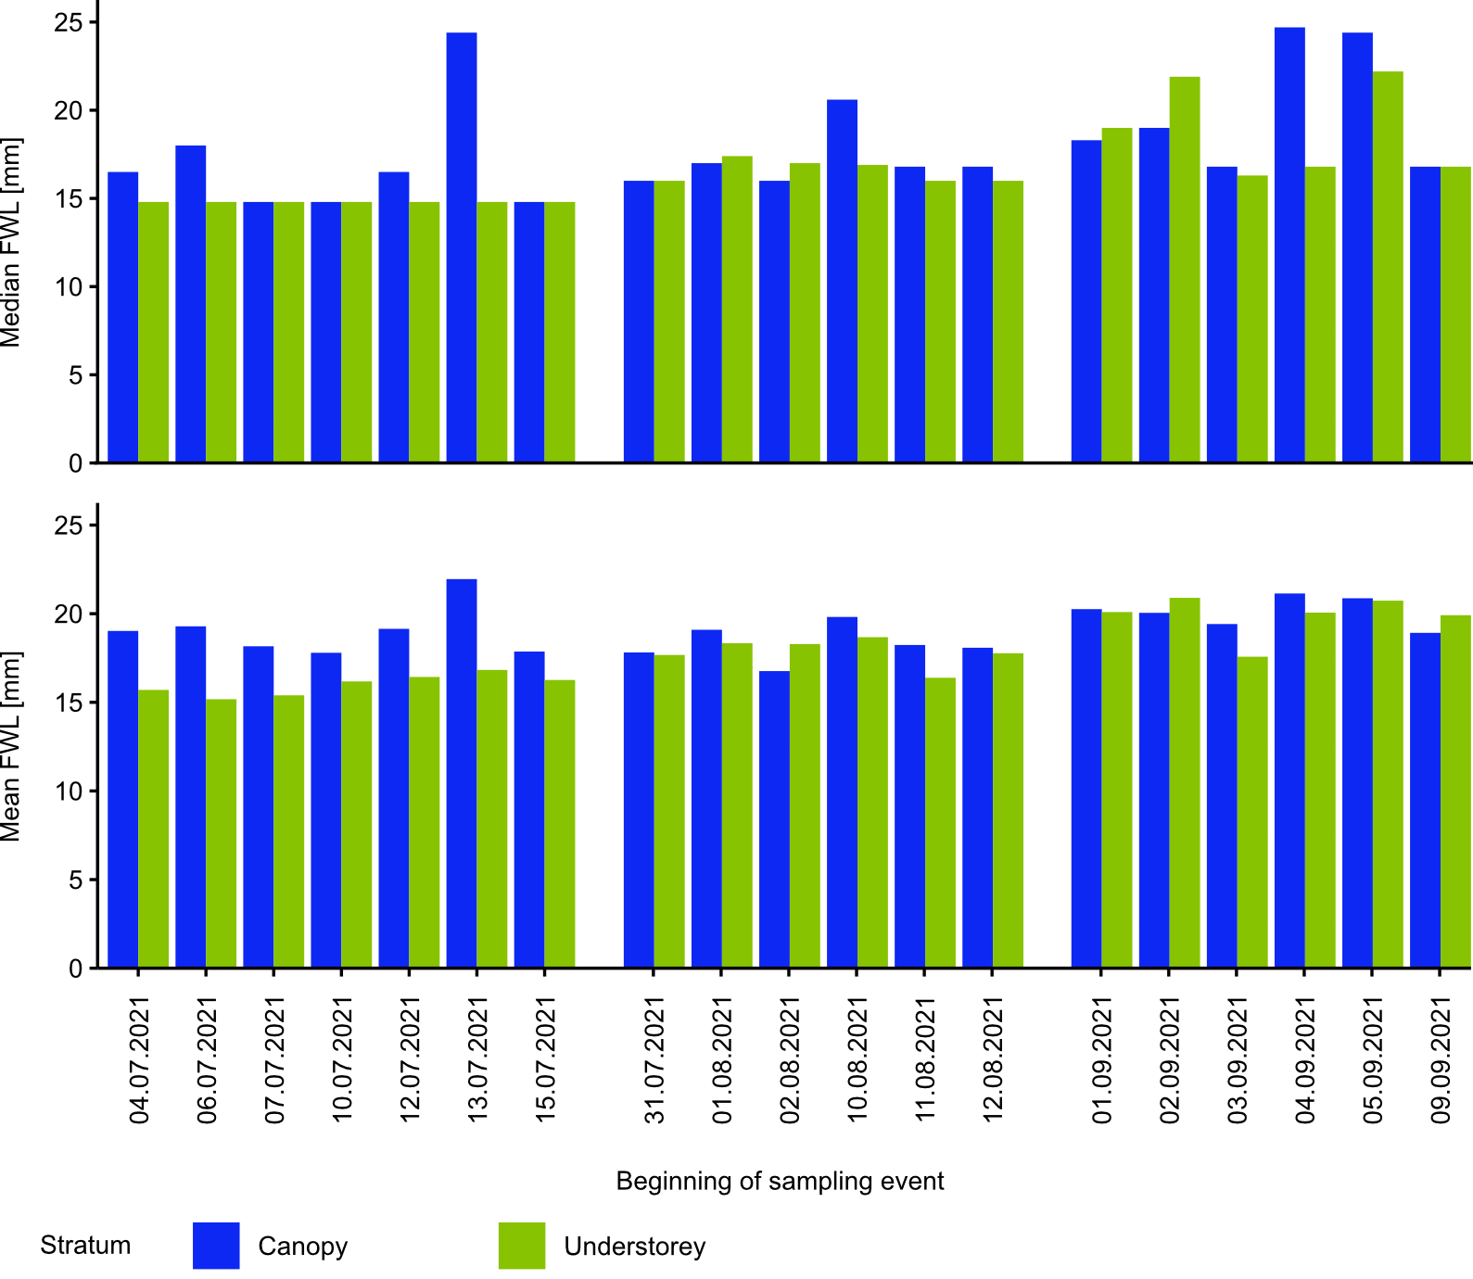
Fig. S6
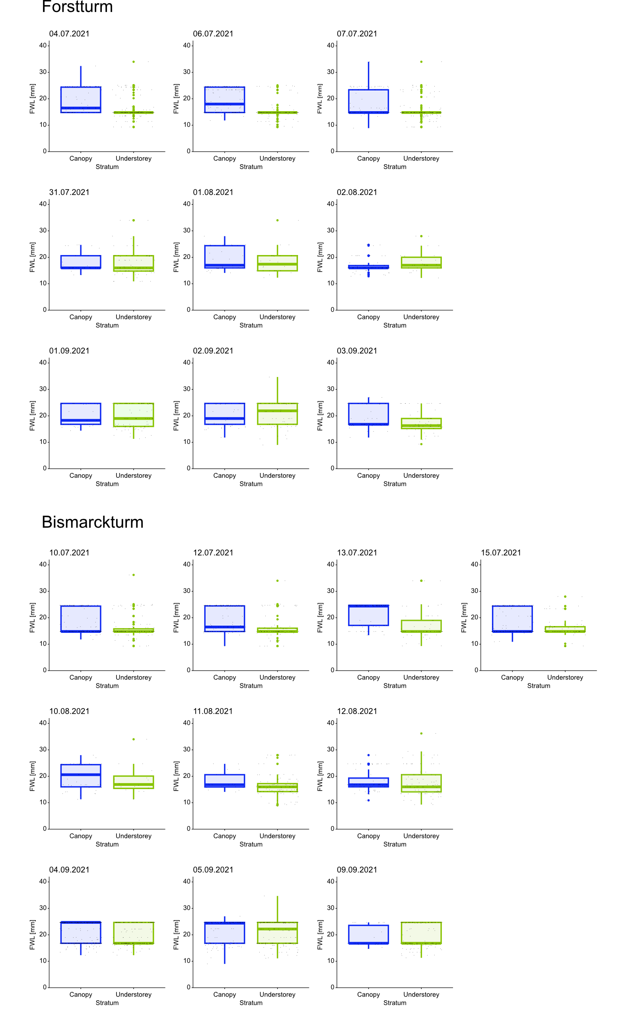
Fig. S7
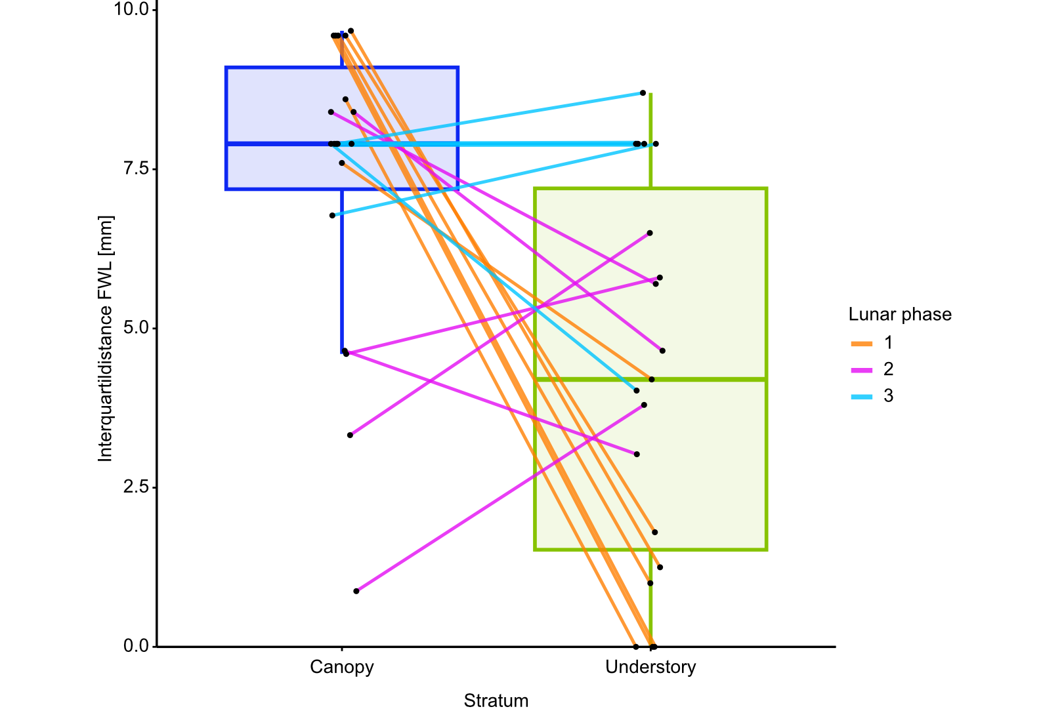
Fig. S8

Table legends
Tab. S1: Numbers of species and individuals in the canopy of the trapped families, separated by lunar phase. Also shown is the sum of all species and families captured per lunar phase.

Tab. S2: Numbers of species and individuals in the understorey of trapped families, separated by lunar phase. Also shown is the sum of all species and families caught per lunar phase.

Tab. S3: Indices for estimating actual species numbers for pooled samples by lunar phase, sites, and stratum.

Tab. S4: Number of species within each sample.

Tab. S5: Pairwise comparison of differences in estimated means for strata of the generalized linear mixed model.

Tab. S6: Host plants of the stratum specialists, separated by tree plants and herbaceous plants/ shrubs.

Tab. S7: Results of the generalized linear mixed model with moon phase and location as fixed effects to test for body size differences between strata.

Tab. S8: Results of the generalized mixed linear model for the influence of stratum, site, and moon phase. Fixed effects are canopy space, understorey, Bismarck tower, forest tower and moon phase 1- 3. The references for each of these factors are shown.
Tab. S1
Family | Lunar phase 1 |  |  | Lunar phase 2 |  |  | Lunar phase 3
 | Species | Individuals |  | Species | Individuals |  | Species | Individuals
Cossidae | 1 | 1 |  | 1 | 3 |  | — | —
Drepanidae | 2 | 4 |  | 1 | 1 |  | 1 | 1
Erebidae | 7 | 511 |  | 7 | 132 |  | 5 | 14
Geometridae | 10 | 25 |  | 4 | 6 |  | 5 | 7
Hepialidae | — | — |  | — | — |  | — | —
Lasiocampidae | — | — |  | 1 | 3 |  | — | —
Limacodidae | — | — |  | — | — |  | — | —
Noctuidae | 31 | 526 |  | 26 | 155 |  | 29 | 862
Nolidae | 1 | 8 |  | — | — |  | — | —
Notodontidae | 1 | 13 |  | 3 | 4 |  | — | —
Sphingidae | 2 | 2 |  | — | — |  | — | —
Sum | 55 | 1090 |  | 43 | 304 |  | 40 | 884
Abbreviations used:
— = No moths detected in the samples
Tab. S2
Family | Lunar phase 1* |  |  | Lunar phase 2 |  |  | Lunar phase 3
 | Species | Individuals |  | Species | Individuals |  | Species | Individuals
Cossidae | — | — |  | — | — |  | — | —
Drepanidae | 1 | 1 |  | 2 | 3 |  | 1 | 2
Erebidae | 8 | 543 |  | 9 | 123 |  | 8 | 52
Geometridae | 38 | 125 |  | 22 | 64 |  | 18 | 76
Hepialidae | — | — |  | — | — |  | 1 | 1
Lasiocampidae | 1 | 1 |  | 1 | 13 |  | — | —
Limacodidae | 1 | 23 |  | — | — |  | — | —
Noctuidae | 26 | 138 |  | 25 | 129 |  | 32 | 735
Nolidae | 1 | 1 |  | — | — |  | 1 | 1
Notodontidae | 4 | 35 |  | 5 | 10 |  | — | —
Sphingidae | 2 | 7 |  | 2 | 6 |  | — | —
Sum | 82 | 875 |  | 66 | 348 |  | 60 | 867
Abbreviations used:
— = No moths detected in the samples
* = We were unable to determine one individual at the Bismarck Tower on 12.07.2021 and therefore it is not represented in this table.
Tab. S3
P | S | Stratum | N | chao | chao.se | jack1 | jack1.se | boot | boot.se | shan | fisher | n
1 | BiT | C | 40 | 65.93 | 15.63 | 56,50 | 9.66 | 47.42 | 4.65 | 1.79 | 9.22 | 4
1 | BiT | U | 52 | 73.03 | 10.98 | 72.25 | 11.56 | 61.38 | 5.6 | 2.42 | 16.68 | 4
1 | FoT | C | 40 | 67.43 | 16.13 | 56.00 | 11.78 | 47.37 | 5.78 | 2.10 | 10.76 | 3
1 | FoT | U | 38 | 63.19 | 15.04 | 53.33 | 11.12 | 45.07 | 5.43 | 1.69 | 14.83 | 3
2 | BiT | C | 30 | 39.38 | 6.62 | 40.00 | 8.00 | 34.74 | 4.53 | 2.76 | 11.57 | 3
2 | BiT | U | 58 | 80.69 | 10.49 | 81.33 | 16.96 | 69.04 | 9.18 | 3.56 | 26.41 | 3
2 | FoT | C | 30 | 45.43 | 10.12 | 42.00 | 8.79 | 35.59 | 4.41 | 2.20 | 10.86 | 3
2 | FoT | U | 32 | 51.05 | 11.98 | 45.33 | 10.69 | 38.19 | 5.64 | 2.92 | 13.13 | 3
3 | BiT | C | 33 | 57.50 | 15.46 | 47.00 | 11.37 | 39.44 | 6.01 | 1.54 | 7.16 | 3
3 | BiT | U | 40 | 48.31 | 5.38 | 52.00 | 8.33 | 45.81 | 4.52 | 1.90 | 9.53 | 3
3 | FoT | C | 25 | 31.00 | 4.74 | 33.00 | 6.22 | 28.85 | 3.58 | 2.28 | 8.04 | 3
3 | FoT | U | 42 | 63.33 | 12.16 | 58.00 | 12.49 | 49.44 | 6.33 | 2.63 | 14.68 | 3
Abbreviations used:
BiT = Bismarckturm, boot = Bootstrap estimator, C = Canopy, chao = Chao-Index, fisher = Fishers α, FoT = Forstturm, jack1 = Jacknife 1-Index, N = number of species detected, n = number of sampling events, P = lunar phase, S = site, se = Standard error of the respective index, shan = Shannon-Wiener-Index, U = Understorey
Tab. S4
P | S | Stratum | species  1. sample/ lunar phase | species  2. sample /  lunar phase | species  3. sample /  lunar phase | species  4. sample /  lunarphase
1 | BiT | C | 19 | 21 | 11 | 24
1 | BiT | U | 25 | 24 | 22 | 23
1 | FoT | C | 20 | 28 | 17 | ●
1 | FoT | U | 19 | 26 | 16 | ●
2 | BiT | C | 18 | 11 | 23 | ●
2 | BiT | U | 14 | 36 | 36 | ●
2 | FoT | C | 12 | 17 | 18 | ●
2 | FoT | U | 24 | 13 | 12 | ●
3 | BiT | C | 21 | 22 | 8 | ●
3 | BiT | U | 22 | 24 | 25 | ●
3 | FoT | C | 10 | 18 | 15 | ●
3 | FoT | U | 28 | 19 | 22 | ●

Abbreviations used:
BiT = Bismarckturm, C = Canopy, FoT= Forstturm, P = lunar phase, S = site,
U = Understorey
● = no repetition of one of the first three samples.
Tab. S5
Comparison | estimator | Standard error | z- value | p- value
Understorey vs. Canopy | -1.69 | 0.134 | -1.2626 | <0.001

Tab. S6
Family | Specialist | Tree Hostplants | Hostplants: Shrubs (S) and Herbaceous plants (H) | Ref
CANOPY (3 species)
Noctuidae | Agrotis exclamationis | NONE | H: Rumex spp., Poa annua, Daucus carota, Rosa sp., Viola wittrockiana, Plantago sp., Taraxacum sp. | 1,2
Noctuidae | Craniophora ligustri | Corylus avellana, Alnus glutinosa, Acer sp., Fraxinus excelsior, Syringa vulgaris | S: Ligustrum vulgare, Ligustrum ovalifolium | 1,3
Noctuidae | Noctua fimbriata | Salix spp., Populus tremula | e.g. H: Prunus spinosa, Rubus fruticosus, Crataegus monogyna, Crataegus spp.,  S: Cyripedium calceolus, Iris variegata, Urtica dioica, Berberis thunbergii, Rumex spp. | 1,2
UNDERSTOREY (16 species)
Erebidae | Hypena proboscidalis | NONE | H: Urtica dioica, U. sp. | 4
Erebidae | Lymantria monacha | e.g.:Salix spp., Betula spp., Quercus spp., Populus tremula, Ulmus spp., Crataegus spp., Fagus sylvatica, Abies alba, Picea abies, Larix decidua, Pinus sylvestris, Fagus sylvatica | H:Vaccinium myrtillus, V. uliginosum | 1,5
Geometridae | Campaea margaritata | Salix spp., Betula spp., Betula pubescens, Quercus spp., Crataegus spp., Crataegus monogyna, Corylus avellana, Alnus glutinosa, Quercus robur, Ulmus spp Fagus sylvatica | S: Prunus spinosa | 1
Geometridae | Cyclophora annularia | Acer campestre, Betula pendula, Carpinus betulus, Salix sp. | NONE | 4,6
Geometridae | Ectropis crepuscularia | Larix sp., Betula pendula | S: Rubus idaeus | 4,7
Geometridae | Epirrhoe alternata | NONE | H: Galium mollugo, G. palustre, G. verum, G. sylvaticum, G. aparine | 3,4
Geometridae | Hypomecis roboraria | Quercus spp., Quercus robur | NONE | 1
Geometridae | Idaea aversata | NONE | H: Rumex spp., Taraxacum spp., Galium sp., Polygonum sp., Stellaria sp. | 1,4
Geometridae | Idaea fuscovenosa | NONE | H: Taraxacum sp. | 4
Geometridae | Selenia tetralunaria | Salix spp., Betula spp., Quercus spp., Crataegus spp., Crataegus monogyna, Corylus avellana, Alnus glutinosa | NONE | 1
Geometridae | Timandra comae | NONE | H: Rumex sanguineus, R. obtusifolius, R. crispus, R. acetosa, R. rugosus, R. sp, Polygonum aviculare, P.convolvulus, P. auberti, P. sp. | 1,6
Limacodidae | Apoda limacodes | e.g. Quercus spp., Quercus robur, Populus tremula, Juglans regia, Carpinus betulus, Betula pendula, Alnus glutinosa, Fagus sylvatica, Castanea sativa | H: Rubus fruticosus agg. | 1,8
Noctuidae | Colocasia coryli | Salix spp., Betula spp., Quercus spp., Corylus avellana, Populus tremula, Betula pubescens, Crataegus spp., Fagus sylvatica | S :Prunus spinosa | 1
Noctuidae | Hoplodrina octogenaria | NONE | H: Rumex spp., Taraxacum spp., Daucus carota, Sedum telephium, Galium sp. | 1,3, 4
Noctuidae | Rusina ferruginea | NONE | H: Rumex spp., Taraxacum spp., Geranium pratense, Rumex sp., Viola sp., Fragaria sp.  S:Rubus fruticosus | 1,3
Sphingidae | Sphinx pinastri | Larix decidua, Larix sibirica,Larix decidua, Cedrus atlantica, Picea abies, Pinus sylvestris, Pinus nigra, Pinus parviflora, Pinus wallichiana | NONE | 4,5

References:
- Cook, P. M., Tordoff, G. M., Davis, T. M., Parsons, M. S., Dennis, E. B., Fox, R., Botham, M. S., & Bourn, N. A. D. (2022). Traits data for the butterflies and macro-moths of Great Britain and Ireland. Ecology, 103, e3670. https://doi.org/10.1002/ecy.3670

- Steiner, A. (1998). In: Ebert, G. Die Schmetterlinge Baden-Württembergs. Chapter 7 Nachtfalter V. Eugen Ulmer GmbH & Co. Stuttgart (Hohenheim). ISBN: 3-8001-3500-0. (in german).

- Steiner, A. (1997). In: Ebert, G. Die Schmetterlinge Baden-Württembergs. Chapter 6 Nachtfalter IV. Eugen Ulmer GmbH & Co. Stuttgart (Hohenheim). ISBN: 3-8001-3482-9. (in german).

- Robinson, G. S.; Ackery, P. R., Kitching, I., Beccaloni, G. W. and Hernández, L. M. (2023). HOSTS - a Database of the World's Lepidopteran Hostplants [Data set]. Natural History Museum. https://doi.org/10.5519/havt50xw

- Ebert, G. (1994). In: Ebert, G. In: Die Schmetterlinge Baden-Württembergs. Chapter 4 Nachtfalter II. Eugen Ulmer GmbH & Co. Stuttgart (Hohenheim). ISBN: 3-8001-3474-8. (in german).

- Steiner, A. and Ebert, G. (2001). Ebert, G. In: Die Schmetterlinge Baden-Württembergs. Chapter 8 Nachtfalter VI. Eugen Ulmer GmbH & Co. Stuttgart (Hohenheim). ISBN: 3-8001-3497-7. (in german).

- De Prins W. and Steeman C. 2003–2023. Catalogue of the Lepidoptera of Belgium.
Online at https://projects.biodiversity.be/lepidoptera

- Lussi, H. G. (1994). Ebert, G. In: Die Schmetterlinge Baden-Württembergs. Chapter 3 Nachtfalter I. Eugen Ulmer GmbH & Co. Stuttgart (Hohenheim). ISBN: 3-8001-3472-1. (in german).

Tab. S7
Modell formula: glmm_fwl <- glmer.nb (ten_FWL ~ Stratum + Site + LunarPhase + (1 |Pair). data = DataGlmm)
Stratum | Estimated Marginal Mean FWL [mm] | Standard error | lower confidence limit | upper confidence limit
Canopy | 19.4 | 0.201 | 19.0 | 19.8
Understorey | 17.7 | 0.183 | 17.3 | 18.1

Tab. S8
Modell formula: glmm_fwl <- glmer.nb (ten_FWL ~ Stratum + Site + LunarPhase + (1 |Pair). data = DataGlmm)
 | (exp)Estimate | Standard error | 95 % Confidence interval | z- value | p-value
FIXED EFFECTS
Intercept | 18.56 | 0.327 | 17.93–19.21 | 29.65 | < 0.001
Canopy | REFERENCE
Understorey | 0.09 | 0.001 | 0.09–0.093 | -1.27 | < 0.001
Bismarckturm | REFERENCE
Forstturm | 0.1 | 0.002 | 0.09–0.1 | -0.18 | 0.073
Lunar phase 1 | REFERENCE
Lunar phase 2 | 0.1 | 0.002 | 0.1–0.11 | 0.11 | 0.268
Lunar phase 3 | 0.12 | 0.003 | 0.11–0.12 | 0.58 | < 0.001
RANDOM EFFECTS
σ² | 0.05
Marginal R² / Conditional R² | 0.135 / 0.160

