**Supplementary data**

**Dissecting the relationships between the insect vector *Empoasca paraparvipenis* with *Camptotheca acuminata* witches broom phytoplasma**

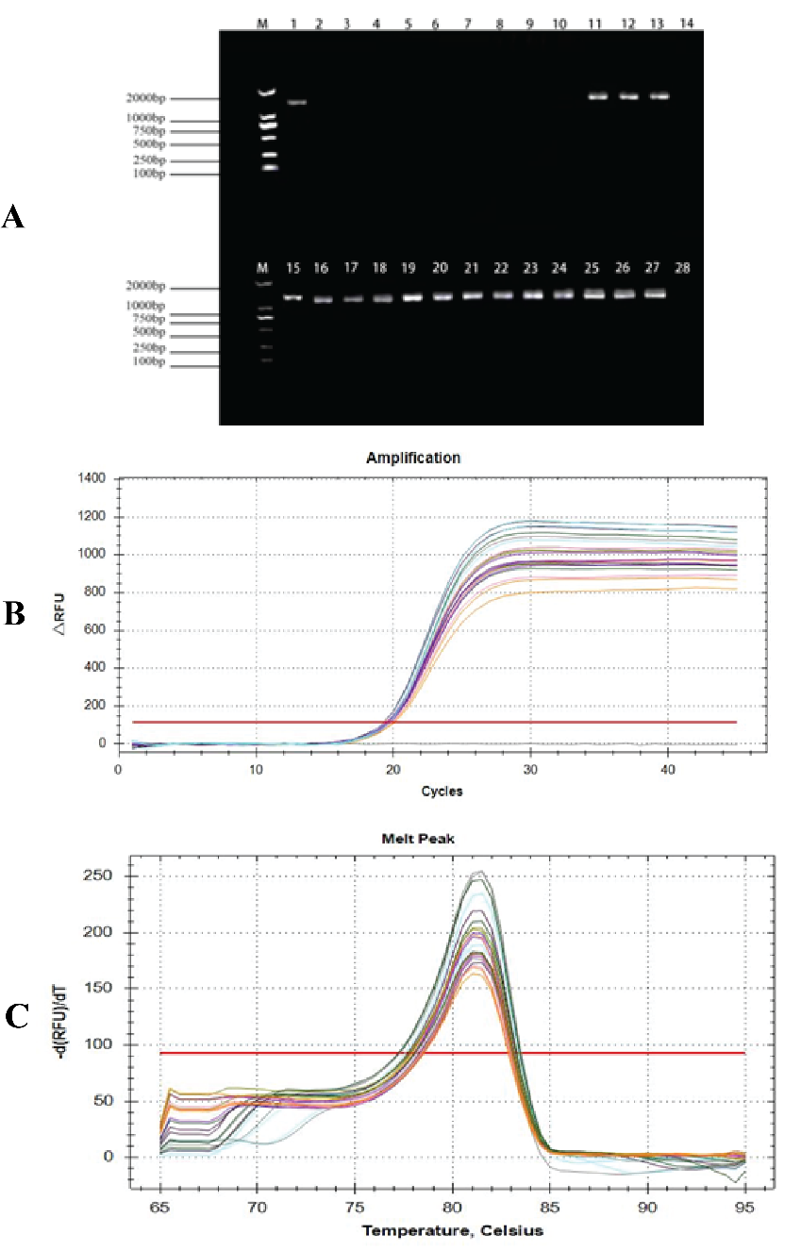

**Figure S1.** Pathogen-transmission ability of insect vector: (**A**) agarose gel electrophoresis of phytoplasma in *C. acuminata* leaves in different pathogen transmission time after 10 days (M: marker; 1, 15: Positive control; 2-4: 5 min; 5-7: 10 min; 8-10: 30 min; 11-13: 1 h; 16-18: 3 h; 19-21: 6 h; 22-24: 24 h; 25-27: 48 h; 14, 28: negative control); (**B**) amplification curve of internal reference gene of CaWB-Ynws; (**C**) melting curve of internal reference gene ofCaWB-Ynws.

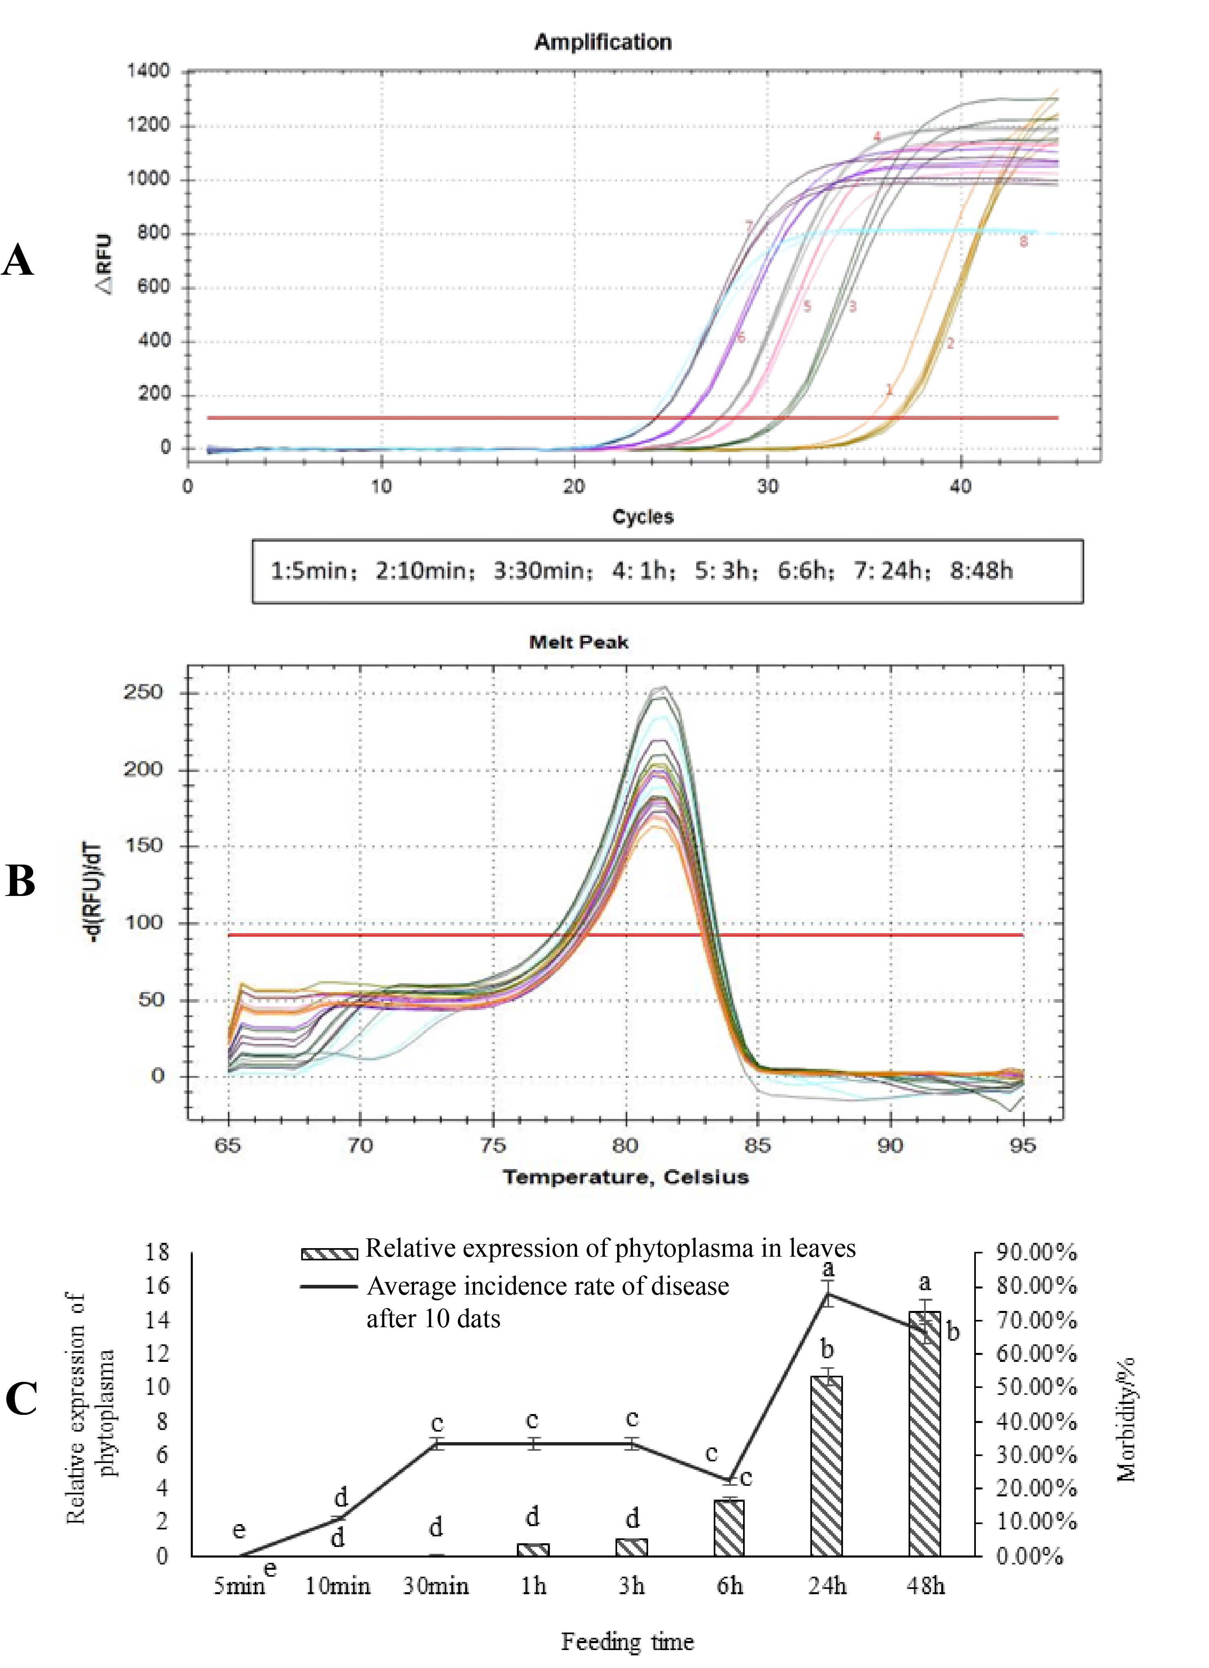

**Figure S2.** Pathogen-transmission ability of insect vector: (**A**) amplification curve of phytoplasma in leaves of *C. acuminata* at different pathogen transmission time; (**B**) melting curve of phytoplasma in leaves of *C. acuminata* at different pathogen transmission tim.

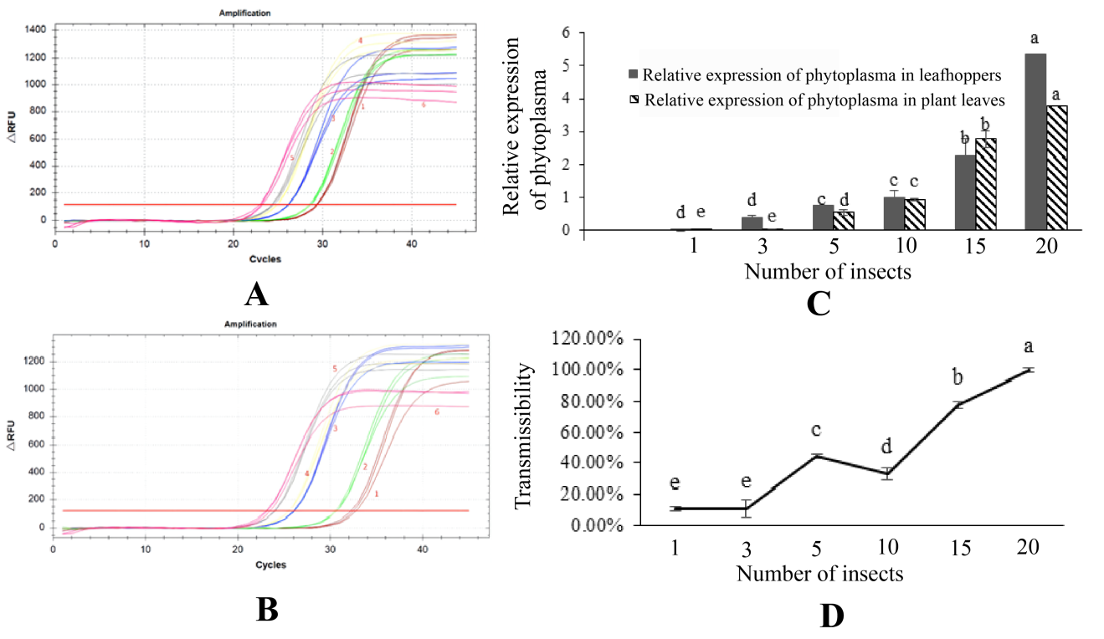

**Figure S3.** Transmission effects of different insect vector numbers: (**A**) amplification curve of phytoplasma in *E. paraparvipenis* in different numbers; (**B**) amplification curve of phytoplasma in *C. acuminata* leaves at different amount inoculation.

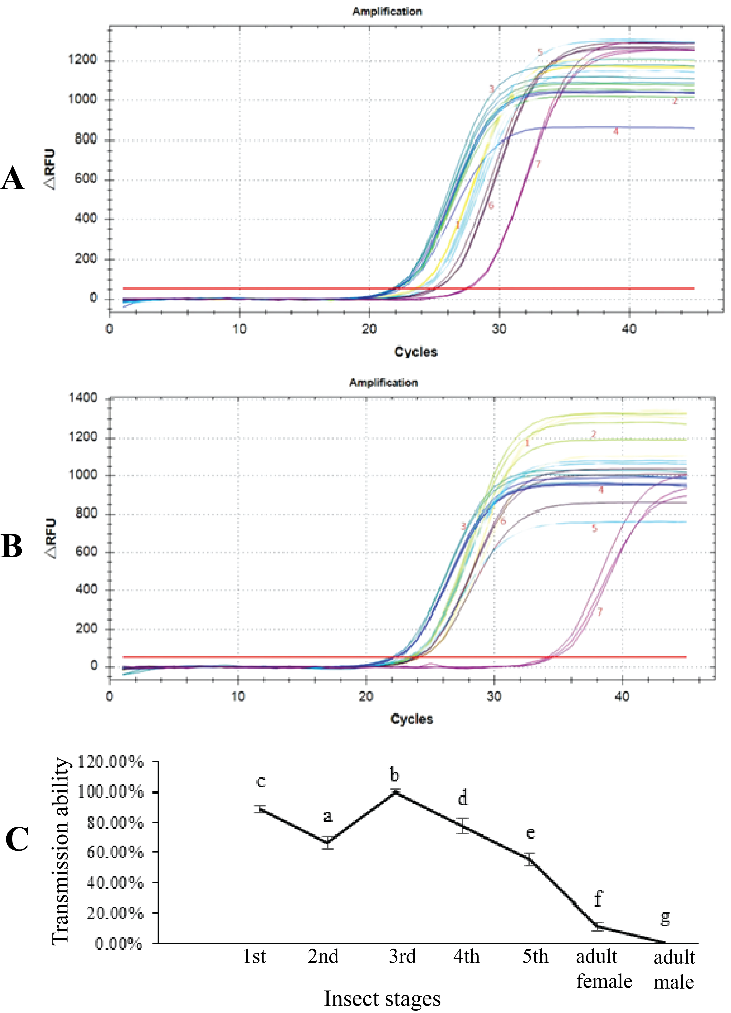

**Figure S4.** Transmission effects of different insect vector ages: (**A**) amplification curve of phytoplasma in *E. paraparvipenis* in different ages; (**B**) amplification curve of phytoplasma in *C. acuminata* leaves in different ages.

|  |  |  |  |  |  |
| --- | --- | --- | --- | --- | --- |
| **Table S1.** Population life parameters of offspring of highly infected and healthy *E. paraparvipenis* fed on virulent and non-virulent *C. acuminata* at 28 ℃ | | | | | |
| **Life parameters of progeny populations of highly infected *E. paraparvipenis* (P♂×P♀) at 28 ℃** | | | | | |
|  | **Insect stage** | **Number of starting individuals** | **Average number of deaths** | **Average mortality rate (%)** | **Growth period** |
| Healthy  *C. acuminata* plant A1 | Eggs | 265.00±13.23ab | 149.00 | 56.23% | 9.83±0.17a |
| 1st instar | 116.00±1.73b | 23.67 | 20.40% | 2.33±0.08ab |
| 2nd | 92.33±4.37ab | 9.00 | 9.75% | 1.33±0.08ab |
| 3rd | 83.33±4.70ab | 4.00 | 4.80% | 1.50±0.00a |
| 4th | 79.33±4.70ab | 8.33 | 10.50% | 1.67±0.17b |
| 5th | 71.00±4.73a | 36.00 | 50.70% | 3.92±0.17ab |
| Adult female | 18.33±1.20ab | - | - | 8.00±0.25b |
| Adult male | 16.67±0.88ab | 49.30% | 0.9091 | 5.75±0.29a |
| Infected  *C. acuminata* plant A2 | Eggs | 285.00±8.66a | 167.67 | 58.83% | 9.17±0.08b |
| 1st instar | 122.67±1.76a | 19.00 | 16.19% | 2.00±0.14b |
| 2nd | 98.33±2.03a | 12.33 | 12.54% | 1.08±0.08b |
| 3rd | 86.00±2.08a | 3.00 | 3.50% | 1.17±0.08b |
| 4th | 83.00±2.08a | 11.33 | 13.65% | 2.33±0.17a |
| 5th | 71.67±1.45a | 32.67 | 45.58% | 4.25±0.14a |
| Adult female | 20.67±0.88a | - | - | 8.75±0.14a |
| Adult male | 18.33±0.33a | 54.42% | 0.8871 | 6.17±0.22a |
| **Life parameters of progeny populations of healthy *E .paraparvipenis* (N♂×N♀) at 28 ℃** | | | | | |
|  | **Insect stage** | **Number of starting individuals** | **Average number of deaths** | **Average mortality rate (%)** | **Growth period** |
| Healthy  *C. acuminata* plant B1 | Eggs | 225.00±8.66c | 112.67 | 50.07% | 10.25±0.14a |
| 1st instar | 112.33±1.76b | 30.00 | 26.71% | 2.75±0.14a |
| 2nd | 82.33±0.88c | 10.00 | 12.15% | 1.58±0.08a |
| 3rd | 72.33±1.86c | 2.33 | 3.26% | 1.50±0.14a |
| 4th | 70.00±1.53b | 3.00 | 4.29% | 1.75±0.14b |
| 5th | 67.00±1.15a | 35.67 | 53.23% | 3.33±0.08c |
| Adult female | 16.00±0.58b | - | - | 7.42±0.08b |
| Adult male | 15.33±0.88b | 46.77% | 0.9583 | 5.50±0.14a |
| Healthy  *C. acuminata* plant B2 | Eggs | 235.00±10.00bc | 122.00 | 51.91% | 10.00±0.14a |
| 1st instar | 113.00±2.08b | 29.33 | 25.96% | 2.33±0.22ab |
| 2nd | 83.67±2.91bc | 8.00 | 9.56% | 1.42±0.08a |
| 3rd | 75.67±1.20bc | 5.00 | 6.61% | 1.33±0.08ab |
| 4th | 70.67±1.20b | 3.00 | 4.25% | 1.58±0.22b |
| 5th | 67.67±0.88a | 35.67 | 52.71% | 3.58±0.08bc |
| Adult female | 16.33±0.88b | - | - | 7.67±0.22b |
| Adult male | 15.67±0.67b | 47.30% | 0.9592 | 5.58±0.22a |

Note: The data presented in the table are means ± standard error. Different lowercase letters represent significant (*p*< 0.05) differences in the progeny population of plant leafhoppers at different temperatures. Different capital letters represent significant (p< 0.05) differences in the reproductive calendar of infected and healthy plant leafhoppers of the same age at the same temperature.

**Table S2.** Transmission effects of different numbers of *Empoasca paraparvipenis.*

|  |  |  |  |  |  |  |
| --- | --- | --- | --- | --- | --- | --- |
|  | | | | | | |
| Number of insects | qPCR detection of average Ct in leafhoppers | Relative expression of phytoplasma in leafhoppers | qPCR detection of plant phytoplasma average Ct | Relative expression level of phytoplasma in leaves | qPCR detected positive/healthy plants | Pathogen transmission ability |
| 1 | 29.45 | 0.0026±0.001d | 31.64 | 0.0076±0.0015e | 1/9 | 11.11% |
| 3 | 27.95 | 0.37±0.02cd | 29.71 | 0.02±0.0025e | 1/9 | 11.11% |
| 5 | 26.92 | 0.75±0.07c | 25.19 | 0.54±0.02d | 4/9 | 44.44% |
| 10 | 26.45 | 1.00±0.0061c | 24.58 | 0.94±0.08c | 3/9 | 33.33% |
| 15 | 25.29 | 2.26±0.20b | 23.14 | 2.76±0.03b | 7/9 | 77.77% |
| 20 | 24.08 | 5.34±0.52a | 22.41 | 3.78±0.25a | 9/9 | 100% |

Note: Each treatment was repeated three times and the means were subjected to Duncan’s multiple range test at *p* ≤ 0.05. Different letters showed significant differences.