**Supplementary materials:**

**Unveiling symbiotic bacterial communities in insects feeding on the latex-rich plant *Ficus microcarpa***

Waleed Afzal Naveed1: waleedafzal75@gmail.com

Qian Liu1: liuqian9502@163.com

Congcong Lu1: lcchuaer613@126.com

Xiaolei Huang1*: [huangxl@fafu.edu.cn](mailto:huangxl@fafu.edu.cn)

1 State Key Laboratory of Ecological Pest Control for Fujian and Taiwan Crops, College of Plant Protection, Fujian Agriculture and Forestry University, Fuzhou 350002, China

*Corresponding author: [huangxl@fafu.edu.cn](mailto:huangxl@fafu.edu.cn)

**Table S1.** The Illumina HiSeq sequencing results of bacterial 16S rRNA gene. Raw tags = number of 16S rDNA sequences after merging the PE reads, Clean tags = number of 16S rDNA sequences after further quality filtering the Raw tags, Effective Reads = number of 16S rDNA sequences after discarding the OTUs with several sequences < 0.005% of the total number of sequences.

|  |  |  |  |  |
| --- | --- | --- | --- | --- |
| **Sample ID** | **Insect Species** | **Raw Reads** | **Clean Reads** | **Effective Reads** |
| FWA1 | *Gynaikothrips ficorum* (Summer) | 79966 | 75011 | 69581 |
| FWA2 | 80224 | 75092 | 69976 |
| FWA3 | 79848 | 74708 | 68455 |
| FWB1 | *Gynaikothrips uzeli* | 79735 | 73806 | 67514 |
| FWB2 | 79614 | 74596 | 69959 |
| FWB3 | 79923 | 74365 | 69257 |
| FWC1 | *Gynaikothrips ficorum* (Winter) | 79993 | 75081 | 70290 |
| FWC2 | 80021 | 75577 | 68066 |
| FWC3 | 80184 | 76020 | 72093 |
| FWD1 | *Aphis aurantii* | 79951 | 74898 | 69855 |
| FWD2 | 79994 | 75140 | 70490 |
| FWD3 | 79648 | 74796 | 71533 |
| FWE1 | *Ocinara albicollis* | 80082 | 74533 | 69970 |
| FWE2 | 80222 | 75070 | 70424 |
| FWE3 | 79895 | 74704 | 69248 |
| FWF1 | *Bambusiphila vulgaris* | 63741 | 60682 | 60244 |
| FWF2 | 60372 | 57401 | 56949 |
| FWF3 | 62195 | 59069 | 58659 |
| FWG1 | *Teleiodes saltuum* | 79679 | 75582 | 70491 |
| FWG2 | 79864 | 75707 | 70008 |
| FWG3 | 79890 | 75712 | 69025 |
| FWH1 | *Perina nuda* (Summer) | 79797 | 75613 | 70654 |
| FWH2 | 79946 | 75657 | 71267 |
| FWH3 | 79940 | 75649 | 68508 |
| FWJ1 | *Homoeocerus angulatus* | 80001 | 75540 | 74757 |
| FWJ2 | 80110 | 75356 | 72073 |
| FWJ3 | 80106 | 74670 | 69698 |
| FWM1 | *Perina nuda* (Winter) | 79977 | 75884 | 70719 |
| FWM2 | 80380 | 76022 | 70874 |
| FWM3 | 79765 | 75751 | 69617 |
| FWO1 | *Harmostes reflexulus* | 79876 | 75755 | 75076 |
| FWO2 | 79863 | 75157 | 74793 |
| FWO3 | 79845 | 75264 | 74763 |

**Table S2.** Detailed information on the diversity indices of all samples of symbionts. OTUs, number of operational taxonomic units at a 0.03 cut-off; ACE and Chao1, estimates of species richness; Simpson and Shannon, estimates of diversity; Coverage, the probability of species being measured in the sample.

|  |  |  |  |  |  |  |  |
| --- | --- | --- | --- | --- | --- | --- | --- |
| **Sample ID** | **Insect Species** | **OTUs** | **ACE** | **Chao1** | **Simpson** | **Shannon** | **Coverage** |
| FWA1 | *Gynaikothrips ficorum* (Summer) | 775 | 840.93 | 957.57 | 0.9560 | 7.2147 | 0.9987 |
| FWA2 | 839 | 961.32 | 993.47 | 0.9344 | 6.8415 | 0.9978 |
| FWA3 | 852 | 871.64 | 890.08 | 0.9339 | 7.0125 | 0.9991 |
| FWB1 | *Gynaikothrips uzeli* | 787 | 825.80 | 866.57 | 0.9132 | 6.7070 | 0.9988 |
| FWB2 | 900 | 921.80 | 939.75 | 0.9342 | 6.6804 | 0.9990 |
| FWB3 | 775 | 832.01 | 909.06 | 0.9466 | 7.0643 | 0.9988 |
| FWC1 | *Gynaikothrips ficorum* (Winter) | 701 | 932.67 | 888.05 | 0.9372 | 6.5316 | 0.9985 |
| FWC2 | 1299 | 1330.68 | 1342.51 | 0.9890 | 8.2217 | 0.9982 |
| FWC3 | 1312 | 1336.03 | 1342.71 | 0.9925 | 8.5936 | 0.9987 |
| FWD1 | *Aphis aurantii* | 774 | 805.04 | 869.06 | 0.9192 | 6.2898 | 0.9990 |
| FWD2 | 827 | 850.99 | 899.06 | 0.9292 | 6.8400 | 0.9991 |
| FWD3 | 813 | 832.48 | 870.04 | 0.7744 | 4.6869 | 0.9991 |
| FWE1 | *Ocinara albicollis* | 944 | 1019.66 | 1115.70 | 0.9272 | 6.9749 | 0.9981 |
| FWE2 | 841 | 885.76 | 965.25 | 0.9331 | 6.8840 | 0.9987 |
| FWE3 | 881 | 923.03 | 957.39 | 0.9533 | 6.3346 | 0.9983 |
| FWF1 | *Bambusiphila vulgaris* | 135 | 177.86 | 169.20 | 0.8110 | 3.4940 | 0.9997 |
| FWF2 | 167 | 177.62 | 187.00 | 0.8056 | 3.4572 | 0.9997 |
| FWF3 | 145 | 211.12 | 208.25 | 0.8121 | 3.4592 | 0.9996 |
| FWG1 | *Teleiodes saltuum* | 1309 | 1326.80 | 1335.16 | 0.9927 | 8.5993 | 0.9988 |
| FWG2 | 1302 | 1322.05 | 1324.41 | 0.9922 | 8.5648 | 0.9987 |
| FWG3 | 1309 | 1330.15 | 1334.20 | 0.9922 | 8.5763 | 0.9986 |
| FWH1 | *Perina nuda* (Summer) | 1304 | 1332.74 | 1347.67 | 0.9916 | 8.4758 | 0.9985 |
| FWH2 | 1341 | 1362.67 | 1374.50 | 0.9930 | 8.6405 | 0.9987 |
| FWH3 | 1316 | 1345.10 | 1361.14 | 0.9928 | 8.6810 | 0.9981 |
| FWJ1 | *Homoeocerus angulatus* | 749 | 826.79 | 865.11 | 0.3262 | 2.1135 | 0.9982 |
| FWJ2 | 739 | 761.85 | 784.75 | 0.8411 | 4.3793 | 0.9991 |
| FWJ3 | 893 | 940.14 | 974.28 | 0.9245 | 6.8600 | 0.9986 |
| FWM1 | *Perina nuda* (Winter) | 1322 | 1245.14 | 1267.64 | 0.9924 | 8.5973 | 0.9985 |
| FWM2 | 1303 | 1222.14 | 1227.67 | 0.9925 | 8.6024 | 0.9988 |
| FWM3 | 1329 | 1248.96 | 1256.90 | 0.9923 | 8.5171 | 0.9987 |
| FWO1 | *Harmostes reflexulus* | 312 | 322.87 | 331.33 | 0.1086 | 0.7209 | 0.9996 |
| FWO2 | 239 | 661.46 | 410.65 | 0.2217 | 0.7603 | 0.9983 |
| FWO3 | 248 | 609.76 | 399.25 | 0.4923 | 1.5652 | 0.9984 |

**Table S3.** Percentage of relative abundance of ten major symbiotic bacteria in all samples.

|  |  |  |  |  |  |  |  |  |  |  |  |  |  |
| --- | --- | --- | --- | --- | --- | --- | --- | --- | --- | --- | --- | --- | --- |
| **Sample ID** | **Insect Specie** | **Host Plant** | **Insect Order** | **Burkholderia** | **Pseudomonas** | **Acinetobacter** | **Muribaculum** | **Bacteroides** | **Buchnera** | **Dubosiella** | **Lactobacillus** | **Staphylococcus** | **Oscillospiraceae** |
| **FWA1** | *Gynaikothrips ficorum* (Summer) | *Ficus microcarpa* | Thysanoptera | 0.05 | 43.82 | 6.54 | 2.53 | 6.00 | 0.53 | 6.33 | 3.90 | 2.64 | 5.61 |
| **FWA2** | 0.11 | 48.18 | 2.83 | 3.53 | 9.21 | 0.49 | 7.90 | 2.05 | 1.78 | 8.09 |
| **FWA3** | 0.09 | 46.98 | 7.36 | 4.80 | 6.45 | 0.31 | 6.38 | 2.47 | 3.85 | 3.87 |
| **FWB1** | *Gynaikothrips uzeli* | *Ficus microcarpa* | 0.18 | 38.39 | 6.70 | 18.76 | 5.40 | 0.55 | 5.22 | 3.27 | 2.45 | 4.43 |
| **FWB2** | 0.04 | 38.26 | 10.05 | 18.43 | 5.33 | 0.46 | 4.52 | 2.50 | 2.54 | 3.47 |
| **FWB3** | 0.08 | 34.24 | 5.56 | 19.29 | 5.72 | 0.52 | 8.43 | 3.10 | 3.07 | 3.98 |
| **FWC1** | *Gynaikothrips ficorum* (Winter) | *Ficus microcarpa* | 0.13 | 11.40 | 7.87 | 7.87 | 7.77 | 0.49 | 10.63 | 4.45 | 4.28 | 7.99 |
| **FWC2** | 0.10 | 13.64 | 3.43 | 12.25 | 4.52 | 0.32 | 3.00 | 9.61 | 8.61 | 2.97 |
| **FWC3** | 0.23 | 10.93 | 2.93 | 11.11 | 4.54 | 0.45 | 2.69 | 10.11 | 9.51 | 4.04 |
| **FWD1** | *Aphis aurantii* | *Ficus microcarpa* | Hemipteran | 0.02 | 24.50 | 4.01 | 2.06 | 3.58 | 43.56 | 3.95 | 1.53 | 2.17 | 3.08 |
| **FWD2** | 0.03 | 28.65 | 5.22 | 2.07 | 3.94 | 38.38 | 3.47 | 2.16 | 2.28 | 2.44 |
| **FWD3** | 0.04 | 24.31 | 3.48 | 1.17 | 3.02 | 51.35 | 2.88 | 1.52 | 1.99 | 1.72 |
| **FWJ1** | *Homoeocerus angulatus* | *Ficus microcarpa* | 71.87 | 10.16 | 0.14 | 0.41 | 0.42 | 0.03 | 1.93 | 0.86 | 0.77 | 0.29 |
| **FWJ2** | 51.13 | 16.98 | 1.34 | 0.81 | 1.36 | 0.11 | 1.29 | 0.75 | 1.01 | 0.88 |
| **FWJ3** | 59.90 | 16.55 | 2.45 | 1.07 | 1.84 | 0.12 | 2.13 | 0.95 | 1.19 | 1.44 |
| **FWO1** | *Harmostes reflexulus* | *Ficus microcarpa* | 98.54 | 0.03 | 0.03 | 0.02 | 0.29 | 0.13 | 0.08 | 0.11 | 0.09 | 0.10 |
| **FWO2** | 98.92 | 0.12 | 0.04 | 0.00 | 0.14 | 0.22 | 0.00 | 0.00 | 0.00 | 0.00 |
| **FWO3** | 97.22 | 0.17 | 0.12 | 0.00 | 0.31 | 0.53 | 0.02 | 0.00 | 0.01 | 0.00 |
| **FWH1** | *Perina nuda* (Summer) | *Ficus microcarpa* | Lepidoptera | 0.22 | 18.31 | 4.12 | 13.21 | 5.46 | 0.40 | 3.41 | 10.29 | 9.85 | 3.65 |
| **FWH2** | 0.20 | 18.43 | 3.64 | 14.29 | 5.37 | 0.44 | 4.15 | 10.34 | 9.34 | 4.05 |
| **FWH3** | 0.29 | 19.30 | 2.31 | 12.94 | 3.98 | 0.43 | 2.78 | 13.61 | 8.43 | 4.00 |
| **FWE1** | *Ocinara albicollis* | *Ficus microcarpa* | 0.00 | 50.40 | 6.80 | 2.98 | 7.44 | 0.45 | 5.70 | 2.71 | 2.28 | 4.76 |
| **FWE2** | 0.00 | 45.53 | 8.00 | 3.37 | 6.58 | 0.50 | 6.55 | 3.19 | 3.04 | 4.20 |
| **FWE3** | 0.03 | 44.58 | 5.65 | 8.97 | 6.90 | 0.57 | 3.65 | 1.33 | 1.22 | 5.23 |
| **FWG1** | *Teleiodes saltuum* | *Ficus microcarpa* | 0.29 | 2.23 | 19.89 | 11.81 | 6.21 | 0.56 | 3.86 | 9.37 | 8.39 | 5.19 |
| **FWG2** | 0.38 | 2.65 | 18.01 | 8.81 | 6.61 | 0.60 | 3.62 | 11.51 | 11.38 | 4.82 |
| **FWG3** | 0.45 | 3.44 | 16.32 | 14.85 | 5.83 | 0.37 | 3.36 | 8.42 | 10.81 | 4.99 |
| **FWF1** | *Bambusiphila vulgaris* | *Ficus microcarpa* | 0.09 | 16.25 | 78.56 | 0.80 | 0.47 | 0.03 | 0.20 | 0.18 | 0.26 | 0.24 |
| **FWF2** | 0.02 | 14.89 | 79.43 | 0.67 | 0.88 | 0.24 | 0.00 | 0.12 | 0.15 | 0.37 |
| **FWF3** | 0.01 | 17.52 | 78.29 | 0.33 | 0.20 | 0.17 | 0.00 | 0.10 | 0.35 | 0.03 |
| **FWM1** | *Perina nuda* (Winter) | Ficus microcarpa | 0.23 | 4.52 | 4.12 | 16.82 | 9.63 | 0.65 | 4.08 | 4.89 | 13.65 | 6.08 |
| **FWM2** | 0.37 | 7.42 | 4.94 | 16.23 | 6.09 | 0.65 | 3.91 | 6.38 | 14.27 | 5.88 |
| **FWM3** | 0.22 | 6.50 | 4.51 | 23.45 | 5.43 | 0.63 | 4.04 | 5.68 | 12.46 | 4.81 |

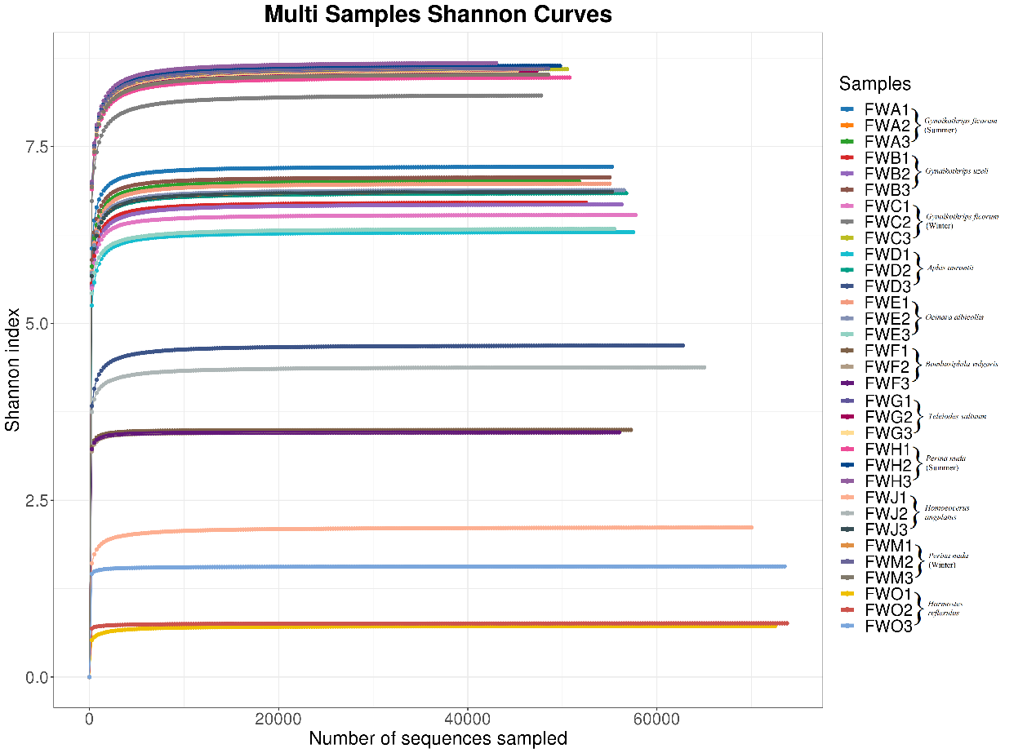

**Figure S1**. Shannon index rarefaction curves for all samples.

**Figure S2．** Relative abundance of symbiotic bacteria in different insects at the genus level. (A) Nutritional symbionts (B) Detoxifying symbionts.

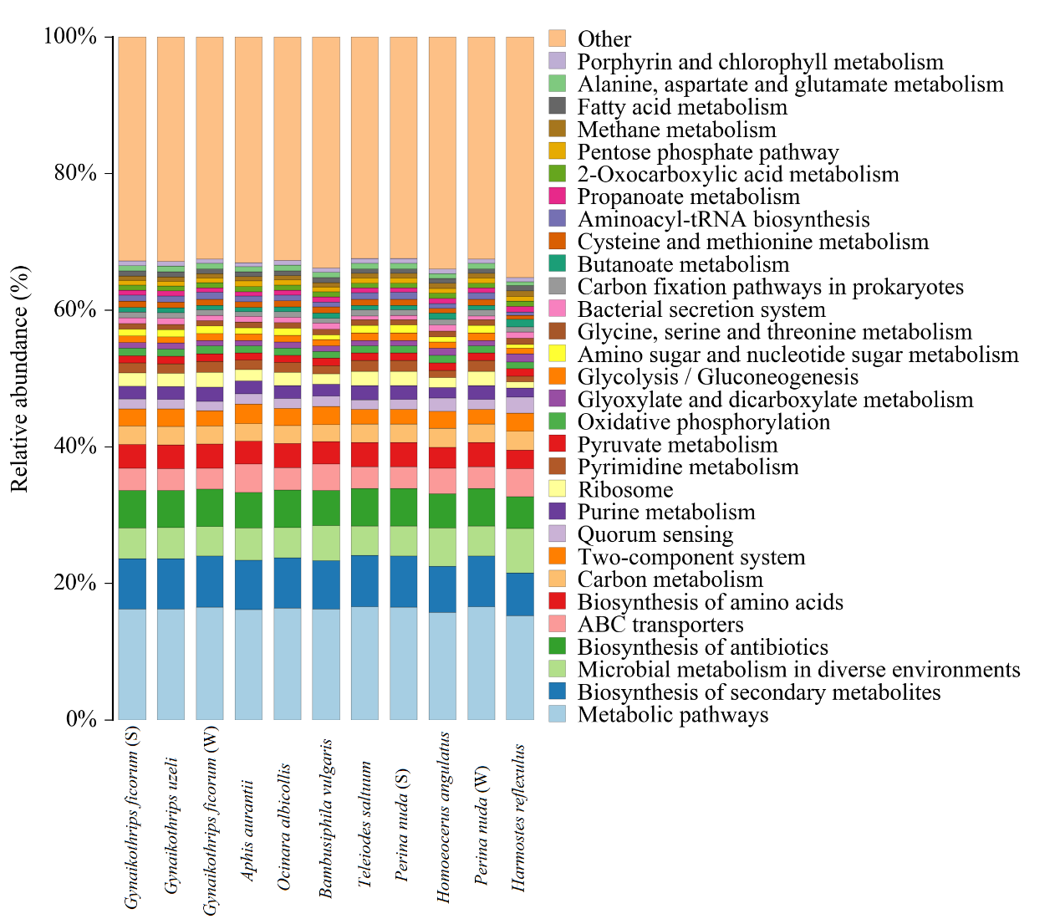

**Figure S3．** Relative abundance of predicted genes in top 30 abundant pathways identified in the symbiotic bacterial communities of *Ficus* (Latex) feeding insects by the PICRUSt2 analysis. The pathways are presented according to KEGGs.



**Figure S4**. T-test results of abundant pathways for comparing three insect orders. Only the pathways with significant differences in relative abundance are shown. See **Table 1 and Table S3** for detailed information.