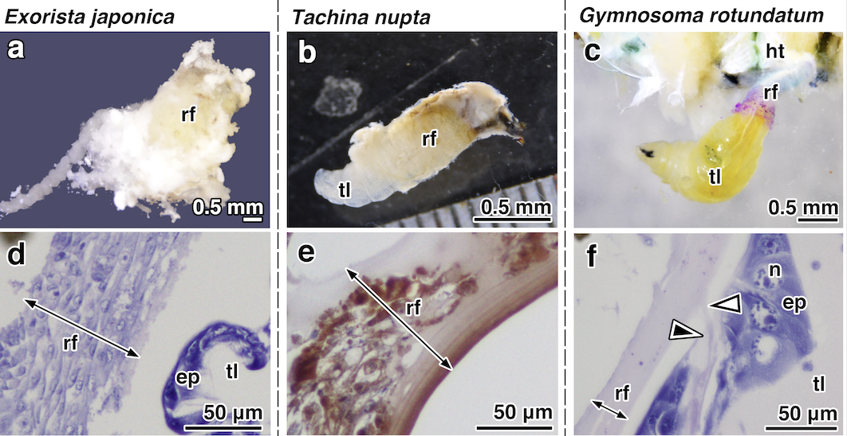Fig. S1. Morphological and histological comparisons of the respiratory funnels in second instar larvae. The larvae with respiratory funnel (a-c). Inner structures of the respiratory funnels in cross-section (d-f). The respiratory funnel of G. rotundatum, in contrast to those of E. japonica and T. nupta, covers only the caudal end without the layer containing cells derived from the host encapsulation capsule. The larva of E. japonica is entirely covered by the respiratory funnel and is not visible from the outside. Filled arrowhead indicates the anus. A white arrowhead indicates the tubular faeces. Abbreviations: ep, epidermis; ht, host trachea; n, nucleus; rf, respiratory funnel; tl, tachinid larva.
Fig. S2. Comparison of the anal lobes of second instar larvae in E. japonica, T. nupta, and G. rotundatum. The dashed lines indicate the extent of the anal plate. Gymnosoma rotundatum shows that its plate is larger than the other species examined. Filled arrowheads indicate the anus. Abbreviation: ap, anal plate.

Fig. S3. Larvae of Euthera sp. (a, b) and its respiratory funnels (c-e). The larva forms the respiratory funnel and fixes its body randomly on the host thorax (a) or abdomen (b, c). The respiratory funnel engulfs the host fat body and trachea (d), and its wall is thin and translucent (e). Filled arrowheads indicate the connecting point of the respiratory funnels and host tracheae. Abbreviations: h fb, host fat body; h tr, host trachea; rf, respiratory funnel; tl, tachinid larva.

Fig. S4. Adults of the species examined on comparison of the respiratory funnels. (a) Clairvilliops breviforceps; (b) Clairvilliops sp.; (c) Ectophasia rotundiventris; (d) Gymnosoma inornatum; (e) G. philippinense; (f) Euthera sp.

