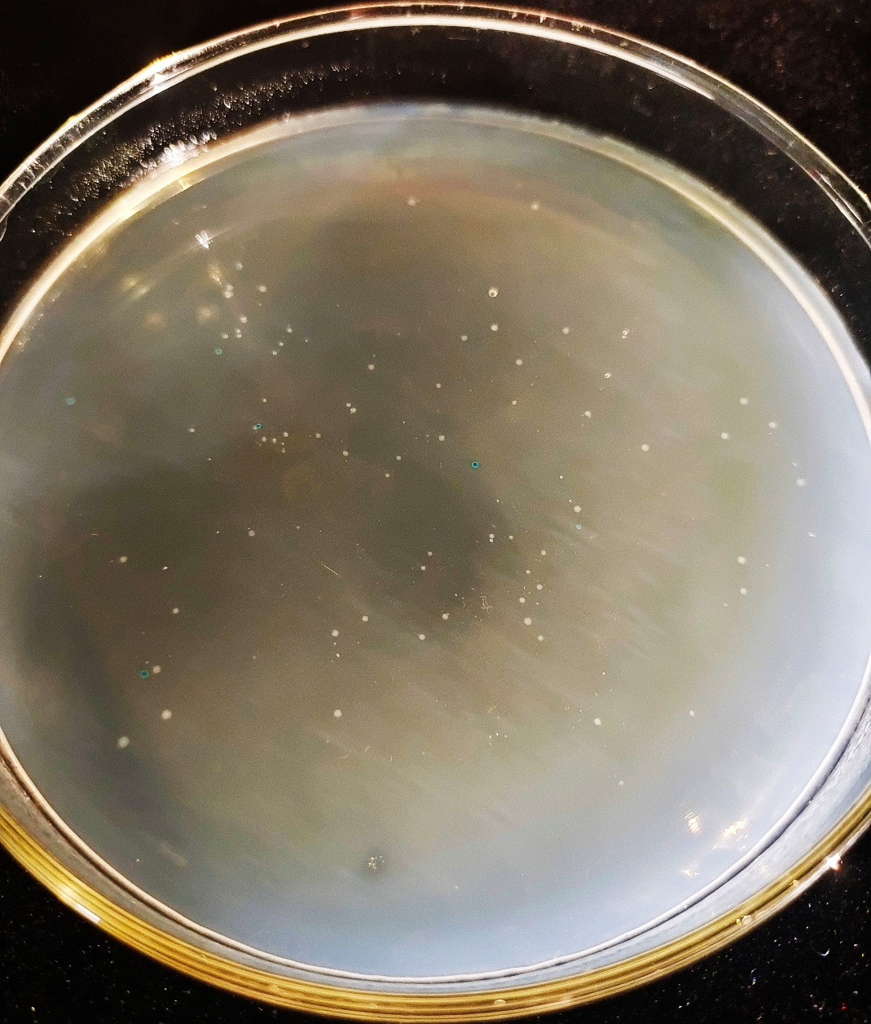
Figure S2. Positive colonies (the white dots) were selected by blue–white screening.

