Supplementary Material to “Nesting behaviour and nest structure of the exotic bee Megachile sculpturalis”

Gherardo Bogo*, Alessandro Fisogni, Antonio Iannone, Francesca-Vittoria Grillenzoni, Francesca Corvucci & Laura Bortolotti

*Corresponding author: Gherardo Bogo
E-mail address: gherardo1985@hotmail.com

Supplementary Fig. 1. Map of the area surrounding the bee hotel (blue triangle). In red the allotment gardens, in green the public parc where the Styphnolobium japonicum trees are located, and in yellow the urban areas with private gardens.
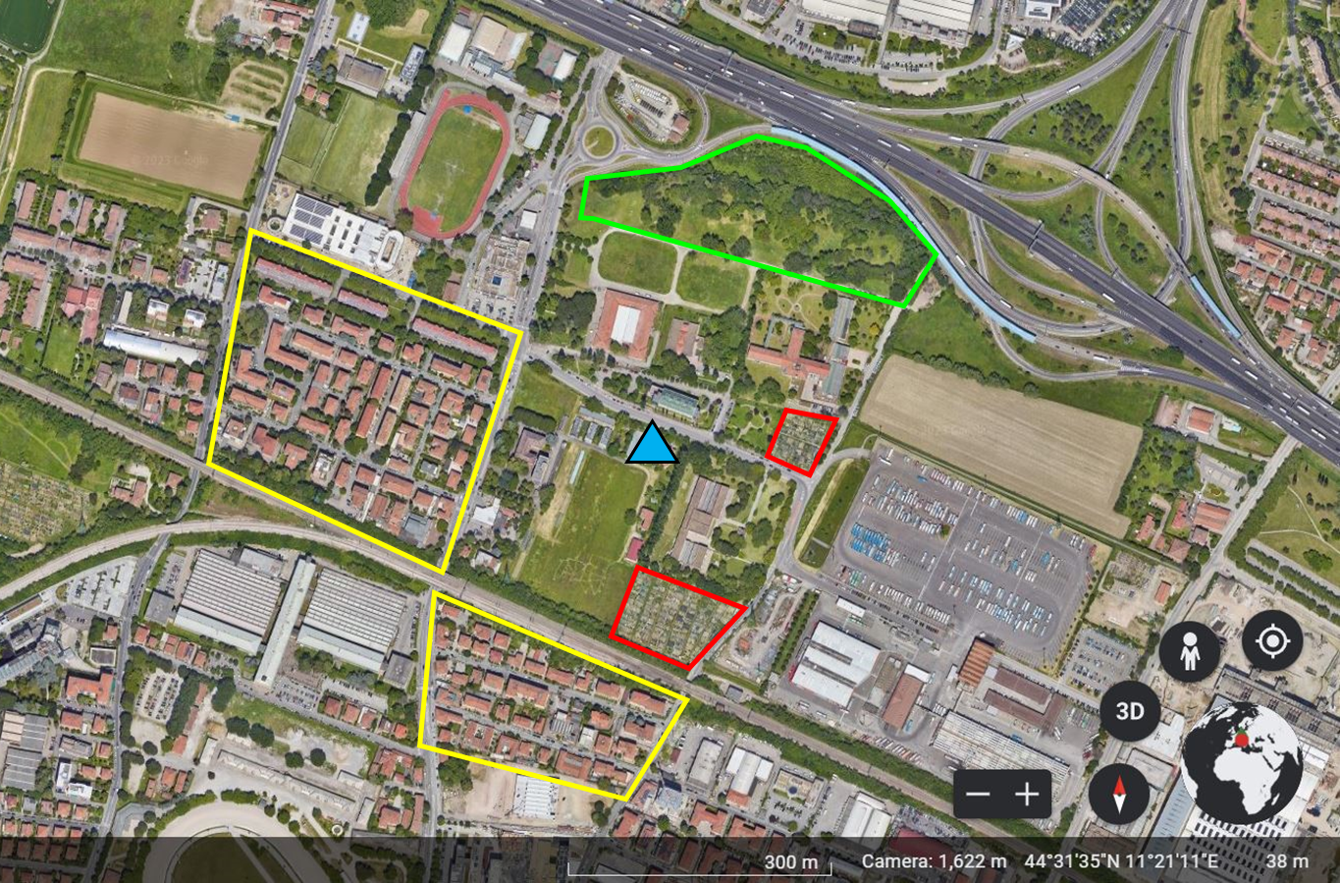

Supplementary Fig.2. Intra-specific aggressions among Megachile sculpturalis females. Photo by Laura Bortolotti.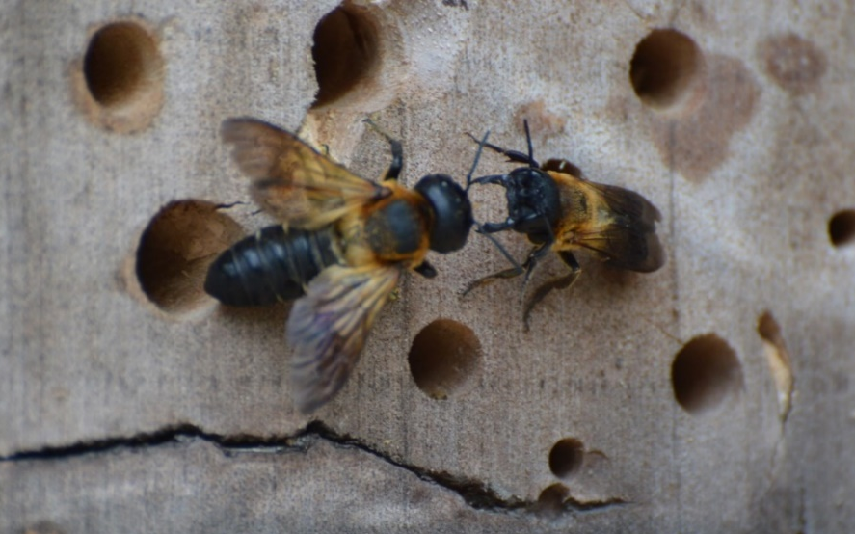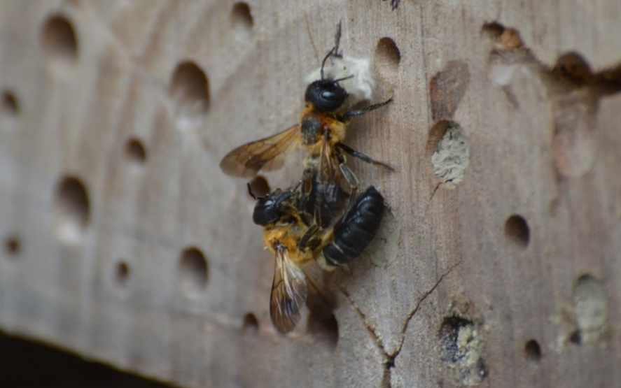

Supplementary Fig. 3. Inter-specific aggression between nesting females of Megachile sculpturalis (bigger, marked in red and green on the thorax) and Megachile disjunctiformis. Photo by Laura Bortolotti.
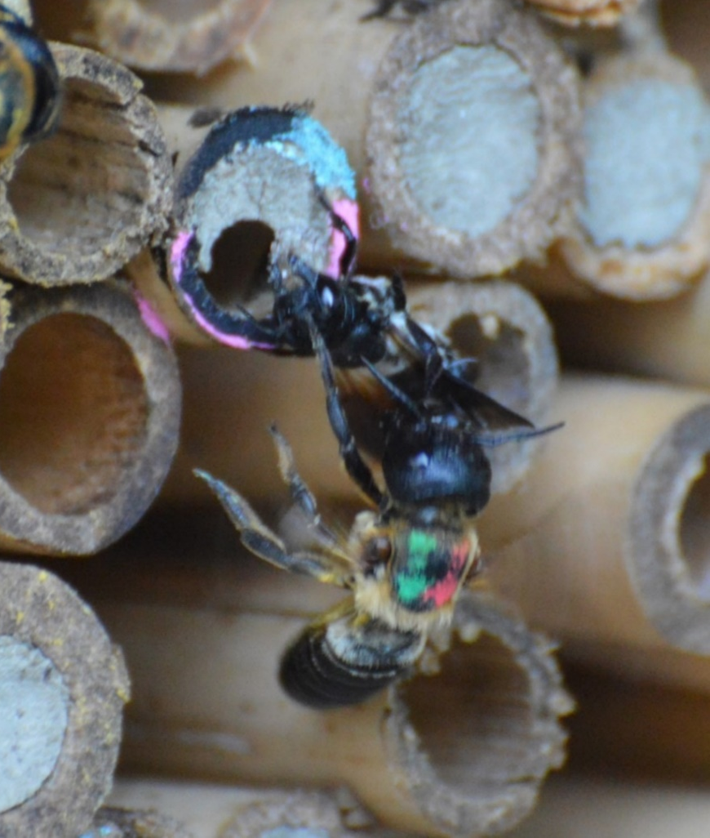

Supplementary Fig. 4. Megachile sculpturalis larval provision. Pollen is of two different colours, yellow and orange, but palynological analysis showed that it all belonged to Styphnolobium japonicum. Note the translucent whitish egg of M. sculpturalis. Photo by Gherardo Bogo.

Supplementary Table 1. Mean daily a) temperatures (°C) and b) precipitations (mm) from June to September in Bologna (Italy) in the three years of study.
Variable | Month | 2016 | 2017 | 2018
Temperature
 | June | 22.4 ± 0.55  (18.0-28.4) | 25.2 ± 0.42  (20.5-29.7) | 23.2 ± 0.39  (18.5-28.2)
 | July | 26.3 ± 0.36  (20.1-29.4) | 26.4 ± 0.38  (22.4-29.5) | 25.8 ± 0.34  (21.1-30.0)
 | August | 24.3 ± 0.35  (19.9-27.9) | 27.0 ± 0.54  (22.4-33.2) | 25.7 ± 0.49  (17.9-30.5)
 | September | 21.7 ± 0.53  (17.8-26.8) | 18.6 ± 0.46  (13.4-24.8) | 21.6 ± 0.56  (14.6-25.0)
Precipitation
 | June | 1.9 ± 0.75  (0-17.8) | 0.8 ± 0.46  (0-12.7) | 2.6 ± 1.3  (0-31.7)
 | July | 0.27 ± 0.18  (0-5.5) | 0.18 ± 0.18  (0-5.5) | 1.66 ± 0.66  (0-15.3)
 | August | 1.24 ± 0.64  (0-18.1) | 0.8 ± 0.60  (0-17.4) | 1.23 ± 0.57  (0-11.8)
 | September | 1.26 ± 0.96  (0-28.5) | 3.28 ± 1.33  (0-33.6) | 0.67 ± 0.35  (0-9.4)

Supplementary Table 2. Linear model coefficients for the variation of antechamber length in relation to total nest length and nest diameter. Asterisks indicate statistically significant differences.
Variable | Estimate | SE | t value | P value
Intercept | 4.347 | 3.441 | 1.263 | 0.210
Nest length | 0.457 | 0.181 | 2.526 | 0.014*
Nest diameter | −2.705 | 3.573 | −0.757 | 0.451

Supplementary Table 3. Linear model coefficients for the variation of (log-transformed) brood cell length in relation to total nest length, nest diameter, antechamber length and number of brood cells. Asterisks indicate statistically significant differences.
Variable | Estimate | SE | t value | P value
Intercept | 1.003 | 0.257 | 3.902 | < 0.001*
Nest length | 0.027 | 0.015 | 1.818 | 0.071
Nest diameter | −0.061 | 0.249 | −0.247 | 0.806
Antechamber length | −0.019 | 0.010 | −1.948 | 0.053
N. brood cells | −0.123 | 0.031 | −3.938 | < 0.001*

Supplementary Table 4. Generalized linear model coefficients for the variation of number of completed brood cells in relation to total nest length, nest diameter, and antechamber length. Asterisks indicate statistically significant differences.
Variable | Estimate | SE | z value | P value
Intercept | −0.834 | 0.393 | −2.127 | 0.033*
Nest length | 0.043 | 0.021 | 2.088 | 0.037*
Nest diameter | 1.303 | 0.427 | 3.052 | 0.002*
Antechamber length | −0.050 | 0.013 | −3.802 | < 0.001*

