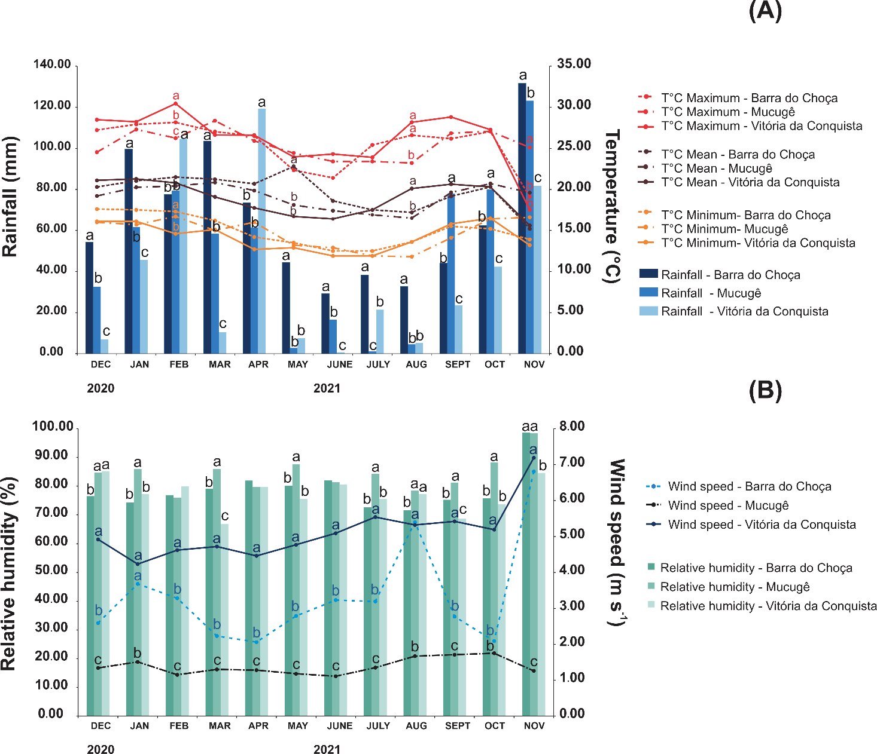

Supplementary Figure S3. Monthly averages of air temperature (maximum, average, and minimum) (°C), rainfall (mm) (A), wind speed (m s-1), and relative humidity (%) (B) of the Barra do Choça, Vitória da Conquista and Mucugê in the Planalto region, Bahia, Brazil. Lines and slashes followed by the same letter do not differ from each other (GLM, family: gaussian (link = identity), p < 0.05).

