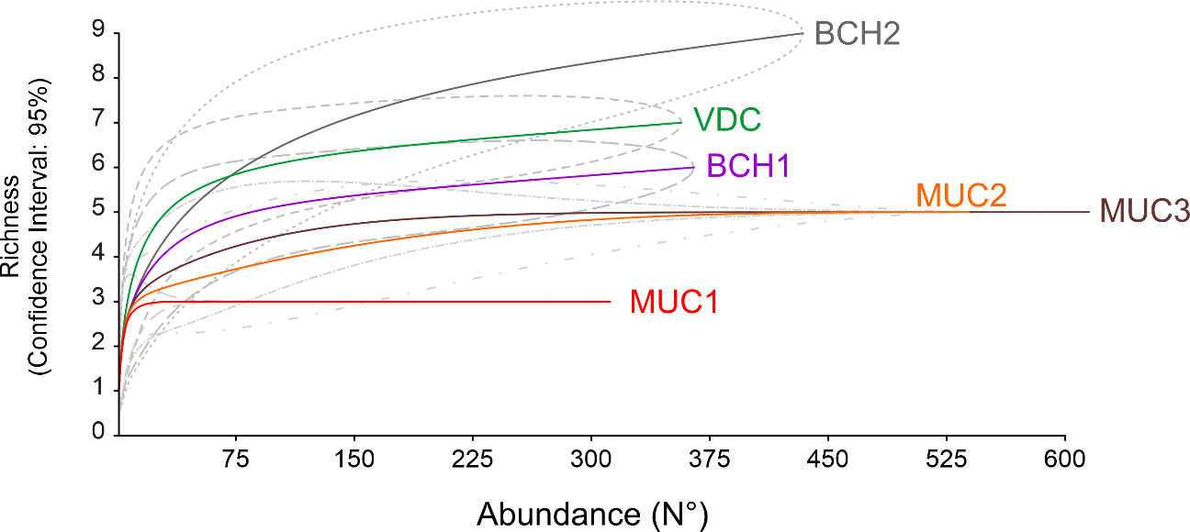
Supplementary Figure S2. Species rarefaction curve according to the abundance of parasitoids collected on coffee farms in the Planalto region, Bahia. The gray outline ellipses represent the 95% Confidence Intervals. (VDC = Vitória da Conquista; BCH1 = Barra do Choça; BCH2 = Barra do Choça; MUC1 = Mucugê; MUC2= Mucugê, and MUC3 = Mucugê).

