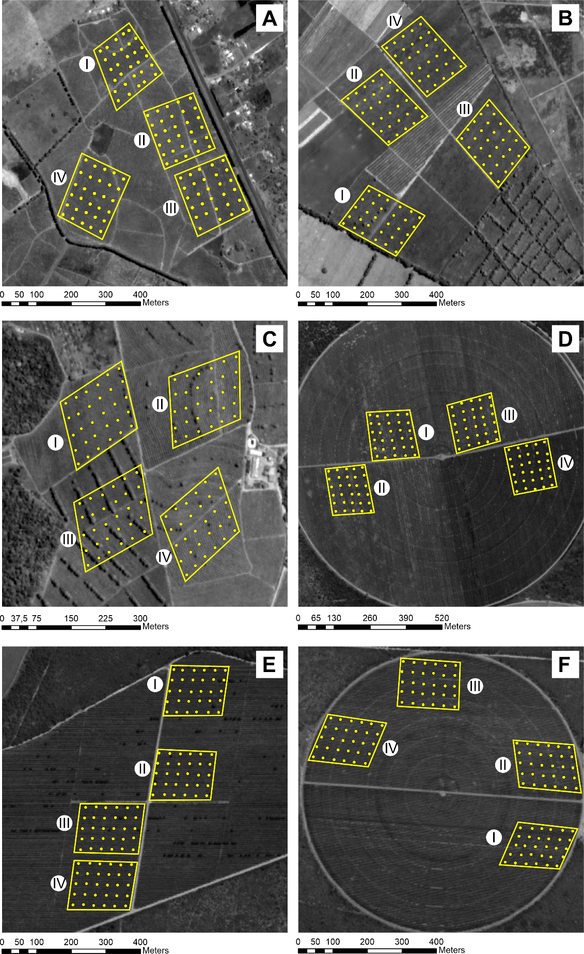

Supplementary Figure S1. Areas and sample points of the natural parasitism and coffee leaf miner infestations in six coffee farms in the Planalto region, Bahia, Brazil. (A) VDC1, (B) BCH1, (C) BCH2, (D) MUC1, (E) MUC2, and (F) MUC3. VDC1 = Vitória da Conquista; BCH1 = Barra do Choça; BCH2 = Barra do Choça; MUC1 = Mucugê; MUC2 = Mucugê; MUC3 = Mucugê. The yellow symbols represent the sampling points (3 coffee plants within a radius of 5 meters). SIRGAS 2000, spatial scale: 1:8000.

