Supplementary materials
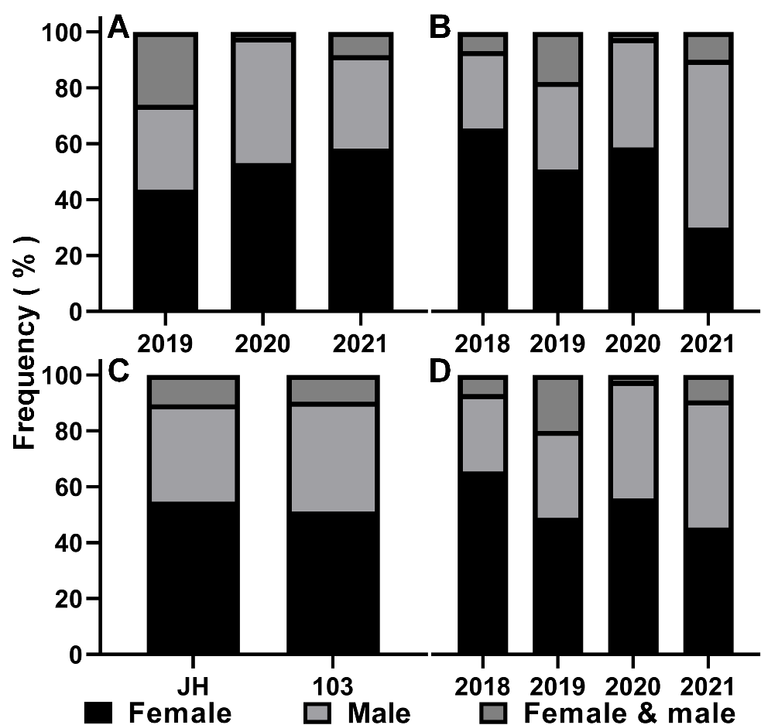
Figure S1. The monogenous frequency of gall midges from swollen galls on N. sibirica at S1(A) or S2(B) from 2018 to 2021, at two site(C) or among four years(D).

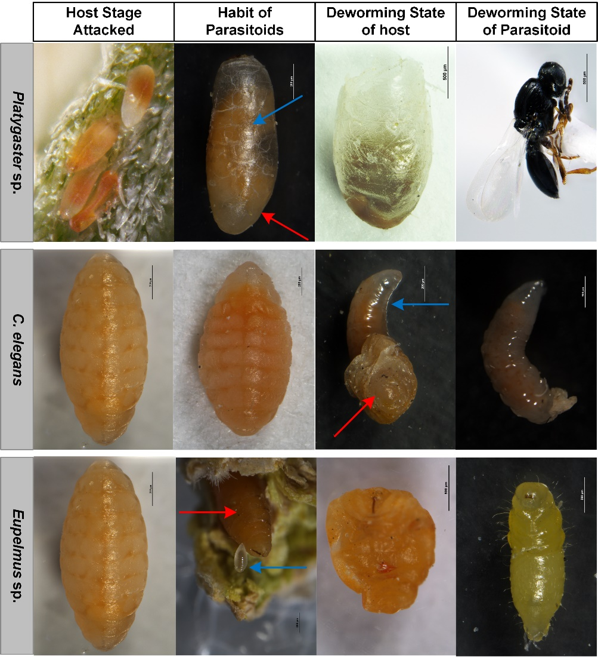
Figure S2. The parasitical characteristic of parasitoids of gall midges for swollen galls on N. sibirica. Parasitized gall midges and corresponding parasitoids were represented by red arrows and blue arrows, respectively.

