Supplemental Clinician Questionnaire
Thank you for agreeing to take part in this survey.
The aim of this survey is to collect opinions from clinicians about the lithium mandatory monitoring requirement and the possibility to use finger prick test to
The survey should not take more than 10 minutes to be completed.
Thanks!
Before you begin, please ensure that you have read the Participant Information Briefing.

CONSENT FORM
1. I confirm that I have read and understood the Participant Information Briefing for this survey. I have considered the information and feel able to ask questions about the survey.
2. I understand that my participation is voluntary and that I am free to withdraw at any time without giving any reason.
3. I consent to the processing of my personal information for the purposes explained to me in the information sheet. I understand that such information will be handled in accordance with the terms of the UK Data Protection Act 1998.
4. I understand that my information may be subject to review by responsible individuals from Department of Psychiatry at Oxford Univeristy.
5. I understand that confidentiality and anonymity will be maintained and it will not be possible to identify me in any publications.

YES NO

- Please indicate you age

___________________________________________________________________________

- Please select your gender
- Male
- Female
- Non-binary / third gender
- Prefer not to say

- Years of practice since you have qualified in your profession

- Still in training
- < 5 years since finished training
- 5–10 years since finished training
- >10 years since finished training

- Please, select your role
- Resident Doctor
- Psychiatrist
- General Practitioner

- Type of health centre you work for
- Psychiatric Hospital
- Liaison psychiatry
- Outpatient setting
- Other
If you selected Other, please specify

- Please rank the following identified barriers to lithium treatment in order of significance – 1 being the most significant and 5 being the least significant

- Concerns among clinicians about mandatory monitoring requirements (e.g, time constrains, lack of resources to ensure a regular lithium monitoring).
- Low patient adherence to regular serum-level monitoring.
- Patients' negative perceptions of lithium.
- Lack of adequate clinician training or experience with lithium use.
- Concerns among clinicians about side effects.

Are there other barriers to lithium prescription that you think are relevant but were not mentioned in the previous question?

Example of finger-prick procedure

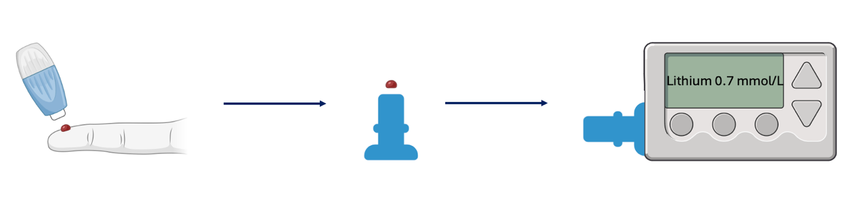

- How is your knowledge of finger-prick tests for psychiatric medications?
- Poor
- Good
- Neutral

- Have you ever cared for patients who have received point-of-care testing for antipsychotic medications (e.g., clozapine)?
- Yes
- No

- How useful would it be to know the patients’ lithium level immediately from a finger-prick test?
- Useful
- Indifferent
- Not useful

- Please check YES if you perceive the following as potential benefits for point-of-care testing for lithium , or No if you don’t
- Improved patient adherence to lithium. YES NO
- Better control of potential side effects YES NO
- Easier and more rapid dose adjustments YES NO
- Increased frequency of monitoring. YES NO
- Enhanced patient engagement in their treatment YES NO

- Do you think that having a point of care method to monitor lithium will increase your propensity to prescribe it?
- Yes
- Undecided
- No

- If the opportunity arose for patients to self-test at home with remote follow-up would this improve practice?
- Yes
- Neutral
- No

Please explain your answers

- Do you think patients would be adherent to at home self-testing for lithium monitoring?
- Yes
- Undecided
- No

Supplemental Patient Questionnaire
Thank you for agreeing to take part in this survey.
The aim of this survey is to collect opinions from patients about the need to monitor lithium concentration in blood.
The survey should not take more than 5 minutes to be completed.
Your time is very much appreciated.

Before you begin, please ensure that you have read the Participant Information Briefing.
CONSENT FORM
1. I confirm that I have read and understood the Participant Information Briefing for this survey. I have considered the information and feel able to ask questions about the survey.
2. I understand that my participation is voluntary and that I am free to withdraw at any time without giving any reason.
3. I consent to the processing of my personal information for the purposes explained to me in the information sheet. I understand that such information will be handled in accordance with the terms of the UK Data Protection Act 1998.
4. I understand that my information may be subject to review by responsible individuals from Department of Psychiatry at Oxford Univeristy.
5. I understand that confidentiality and anonymity will be maintained and it will not be possible to identify me in any publications.
YES NO

- Please indicate you age

___________________________________________________________________________

- Please select your gender
- Male
- Female
- Non-binary / third gender
- Prefer not to say

- How long have you been receiving lithium treatment? (Please specify in months or years)

- How often do you have your lithium level checked by a medical professional?
- More often than once every 3 months
- Once every 3 months
- Once every 6 months
- Once every year
- Less often than once every year

- Please check YES if you agree, or NO if you don't, for the following concerns about lithium treatment:

- You find regular monitoring a burden YES NO
- You have concerns about side effects YES NO
- You think lithium seems outdated or unsafe YES NO
- You are worried about frequent blood tests YES NO
- You think that lithium monitoring affects your social and/or YES NO
work life

Have you any other concerns about lithium that were not mentioned in the previous question?

There are two possible method to test lithium concentration (as shown in the picture below):
- STANDARD PROCEDURE -> involves drawing blood from a vein in your arm using a needle
- FINGER-PRICK TEST -> a procedure that involves a small needle to draw blood form the tip of the finger

STANDARD PROCEDURE

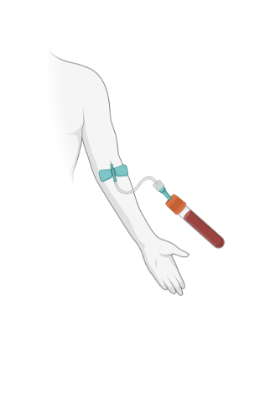
FINGER-PRICK TEST
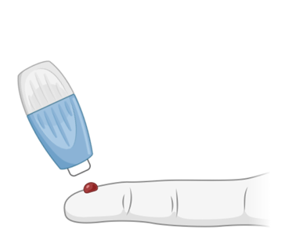

- Would you be more likely to take lithium if it could be monitored with a finger-prick test rather than the standard procedure?
  - Yes
  - Not sure
  - No

Example of how the procedure works.

- How useful would it be to know your level of lithium immediately from a finger-prick test?
- Useful
- Useless
- I don’t mind

- If you could self-test your lithium levels at home with remote follow-up from your healthcare provider, do you think this would improve your experience with the medication?
- Yes
- Not at all
- I don’t mind

Supplemental table 1. Study Outliers (n=2)
Outliers | Medimate POC lithium (mmol/L) | Alinity c lithium (mmol/L)
1 | 0.82 | 1.1
2 | 0.73 | 0.5

Supplemental Figure 1. Individual differences between Medimate and Alinity c results divided by the Standard Deviation of all differences
