Supplementary Tables and Figures
Table S1. Baseline demographic and clinical characteristics of the OLE participants (irrespective of dosing regimen) retained in study at each assessment timepoint.
Characteristic | START-OLE  N = 130 | END-OLE  N = 116 | OLE-4WK-FUP  N = 110 | OLE-6MO-FUP  N = 73
AGE, Mean (SD) | 47 (14) | 48 (13) | 47 (13) | 48 (13)
Female, n (%) | 42 (32%) | 38 (32%) | 35 (32%) | 23 (32%)
Weight (kg), Mean (SD) | 87 (22) | 87 (22) | 87 (22) | 85 (21)
Unsuccessful antidepressant trials (Current episode), Mean (SD) | 3.48 (2.46) | 3.59 (2.50) | 3.50 (2.41) | 3.34 (2.36)
Unsuccessful antidepressant trials (Lifetime), Mean (SD) | 5.67 (2.83) | 5.56 (2.65) | 5.51 (2.65) | 5.62 (2.88)
Failed ECT (current episode), n (%) | 25 (19%) | 24 (21%) | 21 (19%) | 14 (19%)
SCID DSM Melancholia, n (%) | 79 (61%) | 73 (62%) | 71 (65%) | 44 (60%)
MADRS Total at/from OLE START, Mean (SD) | 28.8 (6.0) | 29.1 (5.8) | 29.0 (5.8) | 28.3 (5.4)
HAM_A Total at OLE start, Mean (SD) | 19 (7) | 19 (7) | 19 (7) | 18 (7)
C-SSRS score at OLE start, Mean (SD) | 1.14 (1.20) | 1.19 (1.17) | 1.19 (1.16) | 1.14 (1.11)

Figure S1. KADS OLE CONSORT Diagram
♦ Completed OLE 6-month follow-up (n=57)
♦ Did not complete follow-up
- Lost to follow-up (n=27)
♦ Completed OLE 4-week follow-up (n=83)
♦ Did not complete follow-up
- Missed visit^{c} (n=1)
- Withdrew from study (n=2)
- Lost to follow-up (n=6)
♦ Completed OLE End visit (n=89)
♦ Did not complete follow-up
- Discontinued intervention & did not attend follow-up (n=3)
- Missed visit^{b} (n=3)
- Lost to follow-up (n=2)

Discontinued OLE ketamine treatment (n=7)
- Deterioration of mental state/ lack of improvement (n=2)
- Unable to attend (n=1)
- Intolerability of side effects (n=1)
- Withdrawal of consent (n=2)
- Lost to follow up (n=1)

Final dose level (Flexible Dosing Regimen):
- Level 1 (0.5 mg/kg): n=5ª
- Level 2 (0.6 mg/kg): n=12
- Level 3 (0.75 mg/kg): n=23
- Level 4 (0.9 mg/kg): n=57

Enrolled under Flexible Dosing Regimen (n=98)
RCT Cohort 1: Ketamine (n=7) & Midazolam (n=9)
RCT Cohort 2: Ketamine (n=40) & Midazolam (n=42)

♦ Received OLE ketamine treatment (n=97)
♦ Did not receive OLE ketamine treatment
- MADRS <20; no longer eligible (n=1)

♦ Completed OLE 6-month follow-up (n=16)
♦ Did not complete follow-up
- Did not reconsent^{d} (n=8)
- Lost to follow-up (n=3)
♦ Completed OLE 4-week follow-up (n=27)
♦ Did not complete follow-up
- Lost to follow-up (n=1)
♦ Completed OLE End visit (n=27)
♦ Did not complete follow-up
- Discontinued intervention & did not attend follow-up (n=3)
- Missed visit^{b} (n=1)

Discontinued OLE ketamine treatment (n=4)
- Lack of improvement (n=1)
- Unable to attend (n=2)
- Prohibited medication change (n=1)

Final dose level (Fixed Dosing Regimen):
- Level 1 (0.5 mg/kg): n=31

Enrolled under Fixed Dosing Regimen (n=32)
RCT Cohort 1: Ketamine (n=17) & Midazolam (n=15)

♦ Received OLE ketamine treatment (n=31)
♦ Did not receive OLE ketamine treatment
- Hospitalisation for deterioration in mood and functioning (n=1)

OLE End Analysis (Primary Endpoint)

OLE Treatment Phase (Weeks 1-4)

Post-OLE 6-Month Follow-Up (Week 30)

Post-OLE 4-Week Follow-Up (Week 8)
Enrolled in OLE (n=130)
Assessed for OLE eligibility (n=151)
Excluded (n=21)
♦ Not meeting inclusion criteria (n=12)
♦ Declined to participate (n=8)
♦ Other reasons (n=1)

ª One participant in the Flexible Dosing Regimen had dose reduction to approximately 0.45 mg/kg ketamine due to tolerability issues.
^{b} One participant in the Fixed Dosing Regimen and three participants in the Flexible Dosing Regimen missed the OLE End visit but attended post-OLE 4-week follow-up.
^{c} One participant in the Flexible Dosing Regimen missed the post-OLE 4-week follow-up but attended 6-month follow-up.
^{d} The 6-month follow-up was introduced partway through recruitment (approximately April 2017) after some participants had already completed the study. Of this group, there were 8 participants who either declined or could not be contacted for reconsent, and thus did not complete the OLE 6-month follow-up.

Figure S2. Comparative Effectiveness of the two dosing regimens in the OLE (Change in MADRS)
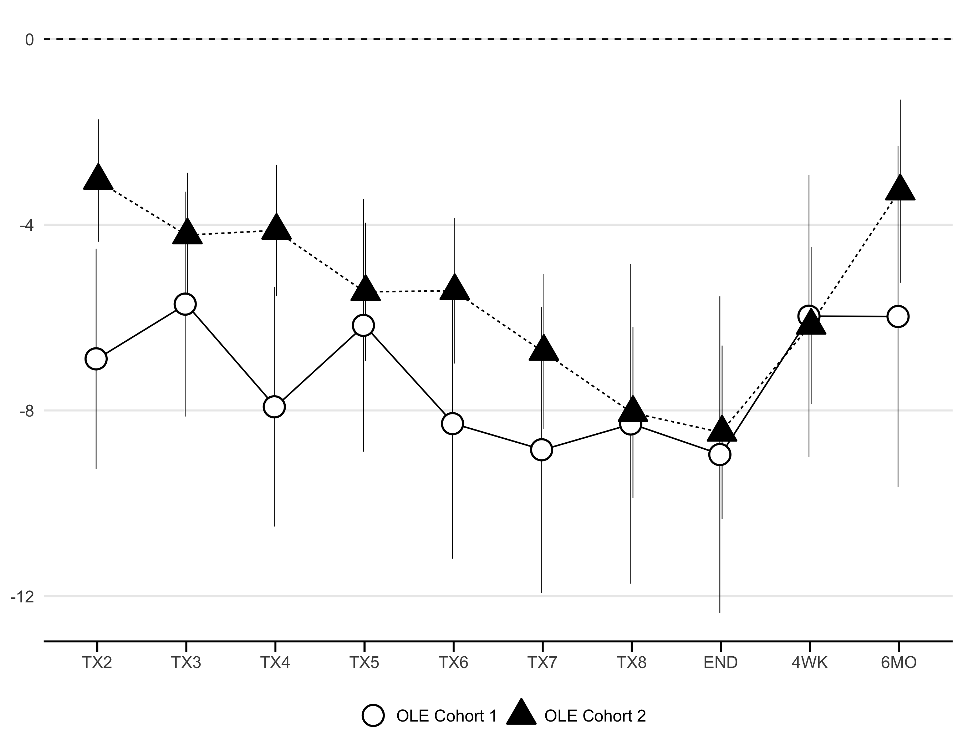
Change in MADRS from OLE Baseline
OLE Cohort 1 = Fixed Dose Regimen (0.5mg/kg) N=32
OLE Cohort 2 = Flexible Dose Regimen (0.5mg/kg increasing up to 0.9mg/kg) N=98

Table S3 Estimated difference in MADRS change scores between RCT treatment arms (Midazolam - Ketamine) at each OLE session and follow-up. Comparisons represent estimated mean differences marginalized over site and adjusted for OLE baseline differences (p-value adjustment by FDR).
OLE Session | Estimate (SE) | t.ratio | p.value
TX2 | -3.16 (1.12) | -2.82 | 0.005
TX3 | -1.23 (1.15) | -1.07 | 0.284
TX4 | -0.65 (1.25) | -0.52 | 0.604
TX5 | 0 (1.29) | -0.00 | 0.997
TX6 | -1.25 (1.37) | -0.91 | 0.364
TX7 | -0.22 (1.46) | -0.15 | 0.881
TX8 | 0.65 (1.61) | 0.40 | 0.688
END | 2.6 (1.61) | 1.62 | 0.107
4WK | -0.66 (1.47) | -0.45 | 0.654
6MO | 1.9 (1.72) | 1.11 | 0.269
df = asymptotic
A model of the change in MADRS restricted to the baseline-to-OLE session scores as repeats (i.e., TX2 to TX8), as well as group, OLE baseline and site, tested whether the change over time was different between the groups.
gls(y ~ TRT * TIME + OLE_START*TIME + SITE)
## Denom. DF: 932
## numDF F-value p-value
## (Intercept) 1 123.76517 <.0001
## TRT 1 2.28211 0.1312
## TIME 1 32.62275 <.0001
## OLE_START 1 7.69615 0.0056
## SITE 6 1.54314 0.1609
## TRT:TIME 1 8.54551 0.0035
## TIME:OLE_START 1 0.71291 0.3987
The linear trend in MADRS gain was significantly different between groups (TIME:Group interaction $F_{\left(1,932\right)}$ = 8.54, $p$ = .003). The group by time interaction confirmed the (linear) change in MADRS among the RCT ketamine group was faster than the midazolam group.

Figure S3 Change in MADRS over OLE stratified by RCT responder status

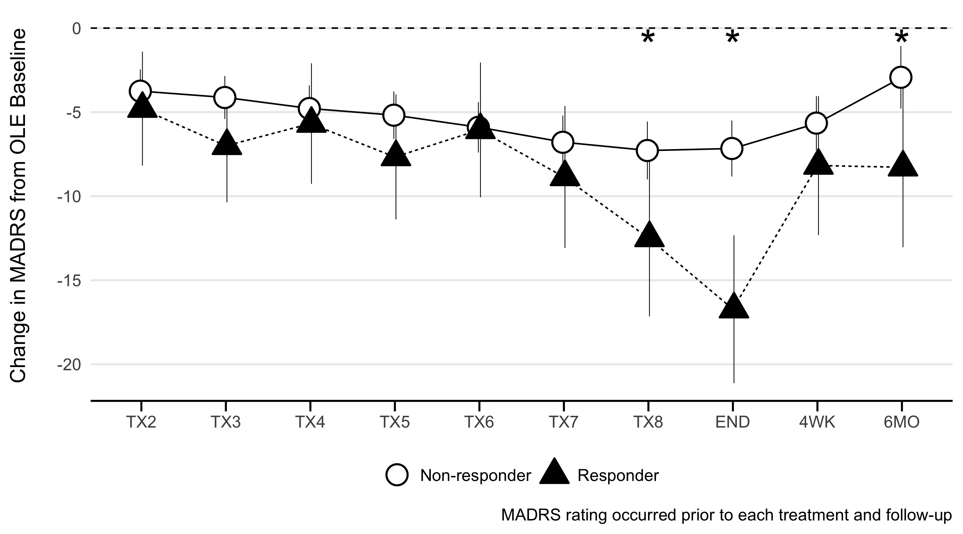
Estimated least squares mean MADRS change from OLE baseline marginalized over site and adjusted for OLE baseline differences

Table S2 Comparison of the estimated MADRS change scores between RCT responders and non-responders at each OLE session and follow-up. Comparisons represent estimated mean differences marginalized over site and adjusted for OLE baseline differences (p-value adjustment by FDR).
OLE Session | Estimate (SE) | t.ratio | p.value
TX2 | 1.04 (1.85) | 0.56 | 0.574
TX3 | 2.87 (1.83) | 1.57 | 0.117
TX4 | 0.89 (1.96) | 0.46 | 0.648
TX5 | 2.49 (2.03) | 1.22 | 0.221
TX6 | 0.15 (2.18) | 0.07 | 0.945
TX7 | 2.06 (2.3) | 0.90 | 0.370
TX8 | 5.2 (2.54) | 2.05 | 0.040
END | 9.56 (2.4) | 3.98 | 0.000
4WK | 2.52 (2.27) | 1.11 | 0.266
6MO | 5.35 (2.59) | 2.07 | 0.039
df = asymptotic

Table S4: Association between end of treatment RCT and OLE Response status in participants treated with active placebo in RCT
 | Open Label Extension Response |  | Total
 | Responder | Non-responder
RCT response
Responder | 2 (66%) | 1 (33%) | 3
Non-responder | 13 (22%) | 45 (78%) | 54
Total | 14 | 46

Figure S4 Clinical Global Impression (Severity) at Start and End of OLE, and 4 week FU
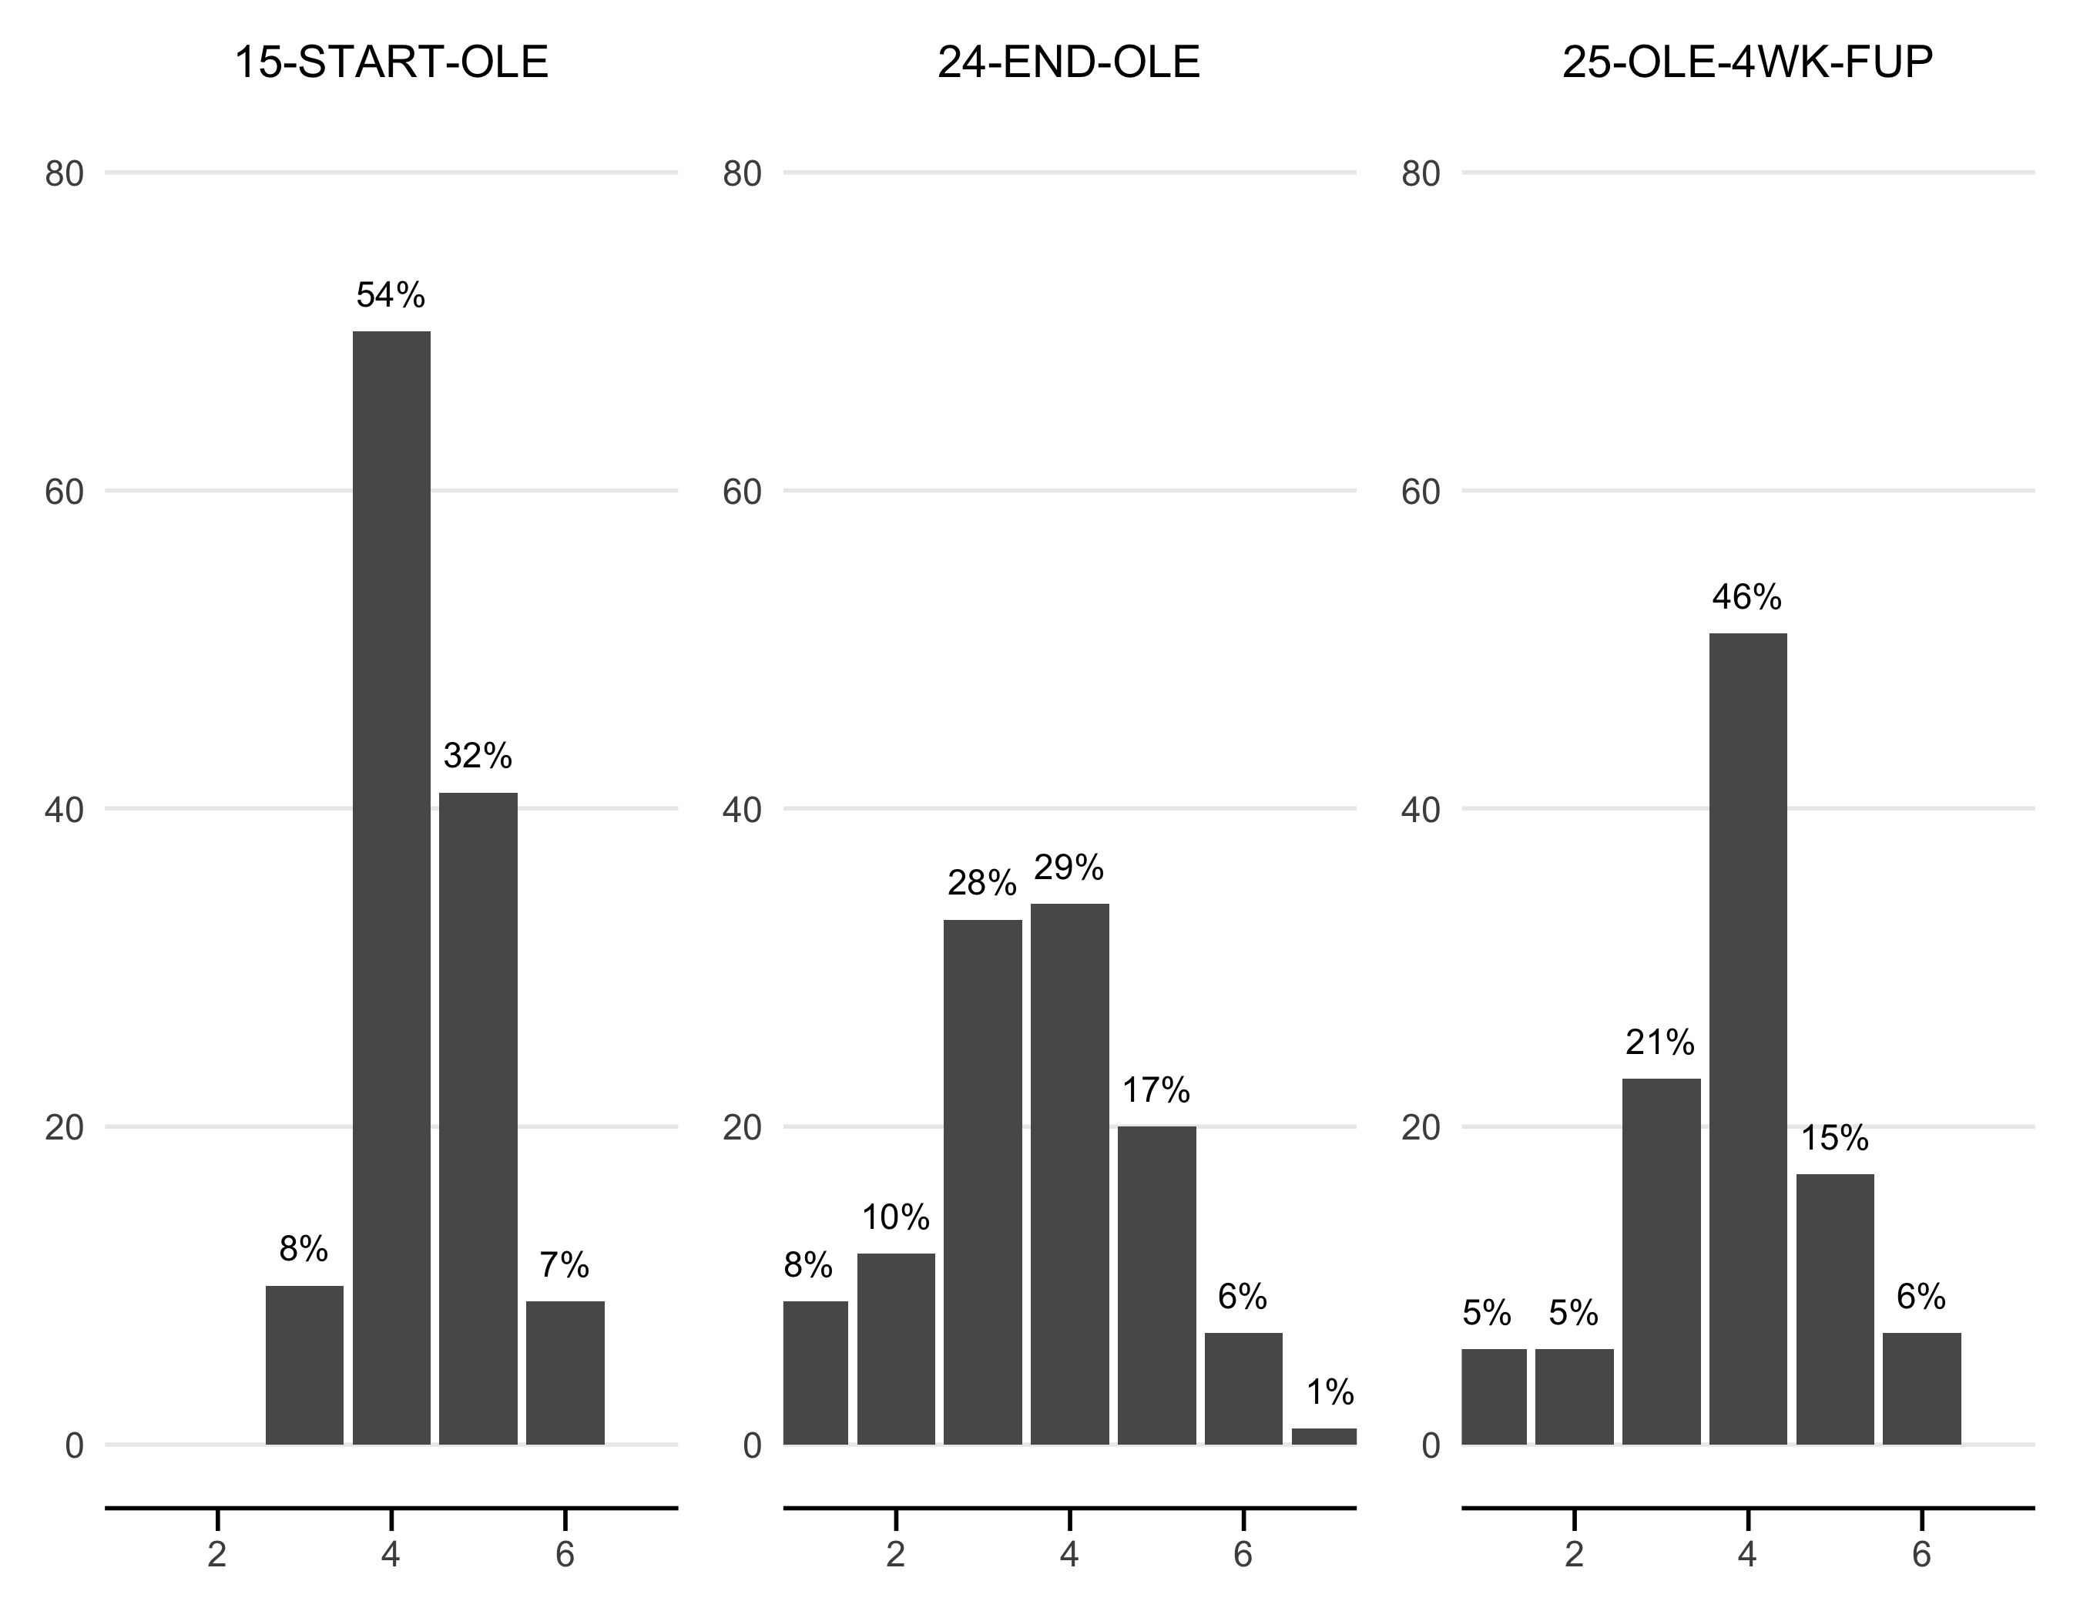
Number of participants in Category
CGI (severity) 1 = Normal, not at all ill, 2 = Borderline mentally ill, 3 = Mildly ill, 4 = Moderately ill, 5 = Markedly ill, 6 = Severely ill, 7 = Among the most extremely ill patients
Figure S5 Clinical Global Impression (Change) at End of OLE, and 4 week and 6 month

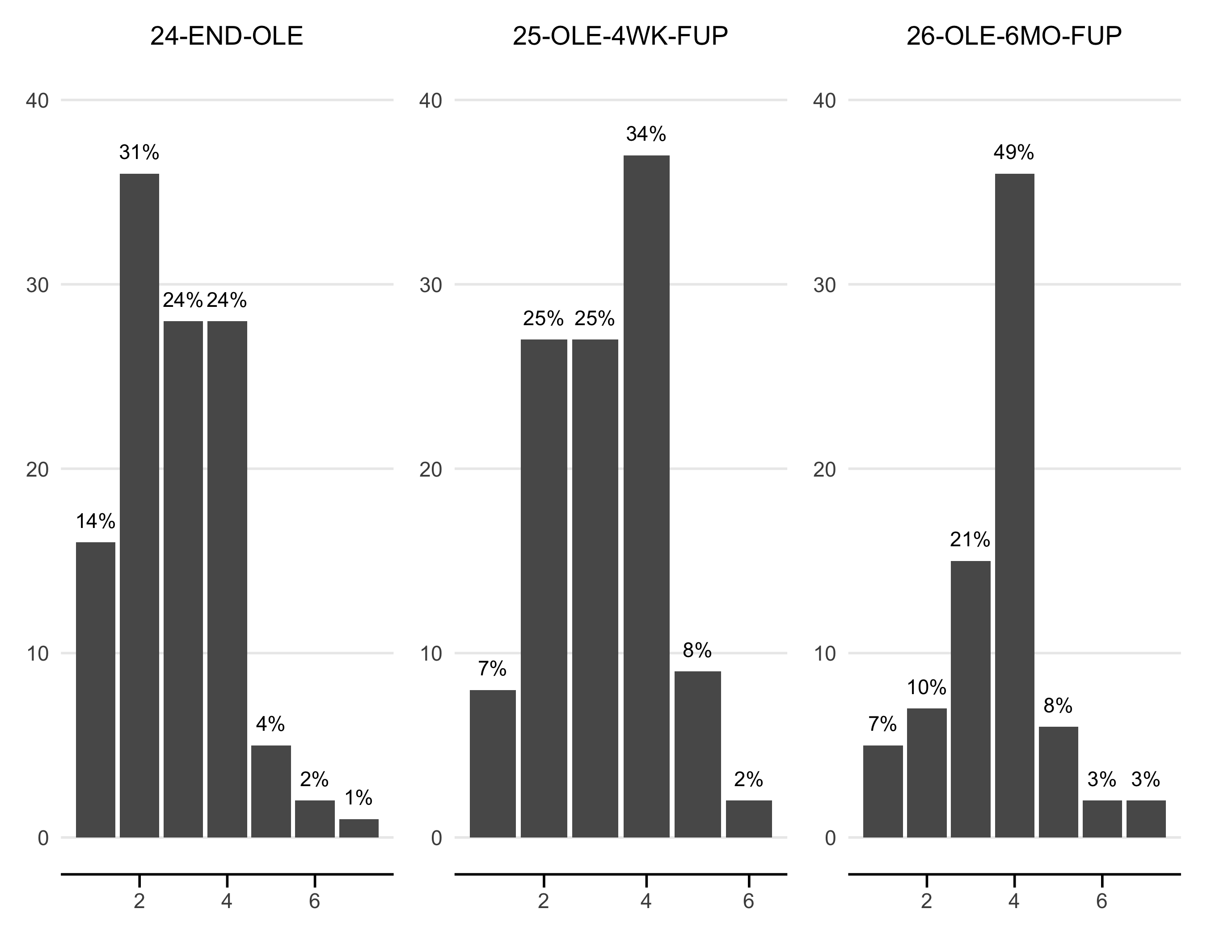
Number of participants in Category
CGI (change) 1: Very much improved, 2:Moderately/much improved 3:Minimally improved, 4:No change, 5:Minimally worse, 6:Moderately/much worse, 7:Very much worse

KADS OLE Safety Outcomes
There were 2 participants who met OLE entry criteria post RCT 4-week follow-up but did not enter the OLE phase due to hospitalisation for mood deterioration (1 each from the fixed and flexible/adjusted dosing groups). Both events were judged as being unrelated to the study.
Figure S6: Mean systolic and diastolic blood pressure over treatment at each sessions. Blood pressure measurements were taken pre-injection, and at 15 minutes, 60 minutes and 120 minutes post injection at each treatment session.

Figure S7: heart rate, measured in beats per minute (BPM), over treatment at each session. Blood pressure measurements were taken pre-injection, and at 15 minutes, 60 minutes and 120 minutes post injection at each treatment session.
Figure S8: Mean change in CADSS scores from pre-treatment at 60 and 120 minutes post injection for the two treatment regimens at each treatment session.

Table S5: Acute post-treatment adverse events (over the first 60 min post dosing).
Acute adverse events were evaluated using Section B of the Ketamine Side Effect Tool (KSET). Section B of the KSET reflects symptoms observed at any time in the 60 min following ketamine injection. The incidence of participants experiencing each adverse event was compared between fixed and flexible regimens using a Fisher's exact test with Bonferroni correction
Events are reported in order from lowest to highest proportions observed in flexible dosing regimen including all events reported by at least 10% of participants in one arm at any stage of treatment

 | Fixed-dosing  (n=31) |  | Flexible dosing  (n=97) |  | Difference
Adverse Event | n | % | n | % | p-value
Sedation | 27 | 87.1 | 75 | 77.3 | 0.31
Dissociation | 15 | 48.4 | 76 | 78.4 | 0.00
Light-headedness | 21 | 67.7 | 65 | 67.0 | 1.00
Dizziness/vertigo | 18 | 58.1 | 67 | 69.1 | 0.28
Numbness/tingling | 18 | 58.1 | 65 | 67.0 | 0.39
Reduced concentration | 14 | 45.2 | 64 | 66.0 | 0.06
Confusion | 10 | 32.3 | 58 | 59.8 | 0.01
Visual changes | 15 | 48.4 | 51 | 52.6 | 0.84
Dry mouth | 15 | 48.4 | 43 | 44.3 | 0.84
Injection Site Redness/Swelling/Pain | 18 | 58.1 | 37 | 38.1 | 0.06
Weakness/fatigue | 13 | 41.9 | 38 | 39.2 | 0.83
Dysgeusia | 12 | 38.7 | 32 | 33.0 | 0.66
Headache/Pressure in Head | 8 | 25.8 | 31 | 32.0 | 0.66
Feeling Hot/Cold or Sweaty | 10 | 32.3 | 26 | 26.8 | 0.65
Anxiety | 4 | 12.9 | 32 | 33.0 | 0.04
Nausea | 9 | 29.0 | 26 | 26.8 | 0.82
Tinnitus | 7 | 22.6 | 22 | 22.7 | 1.00
Moodiness | 6 | 19.4 | 21 | 21.6 | 1.00
Restlessness | 4 | 12.9 | 21 | 21.6 | 0.43
Hypersalivation | 5 | 16.1 | 18 | 18.6 | 1.00
Shortness of breath | 7 | 22.6 | 16 | 16.5 | 0.43
Chest heaviness/discomfort | 4 | 12.9 | 18 | 18.6 | 0.59
Abnormal movements | 3 | 9.7 | 15 | 15.5 | 0.56
Palpitations | 0 | 0.0 | 12 | 12.4 | 0.04
Euphoria | 0 | 0.0 | 10 | 10.3 | 0.12
Bruising | 4 | 12.9 | 5 | 5.2 | 0.22

*This includes subjective reports of dissociation as well as the number of participants with a > 4-point increase in the Clinician-Administered Dissociative States Scale (CADSS) total score from baseline. **Euphoria was operationalised as the number of participants with a score of ≥ 4 on item 1 of the Young Mania Rating Scale (YMRS).

Table S6: New onset adverse events between treatment sessions. This shows the new onset of, or exacerbation of, symptoms reported by at least 5% of participants (and two key symptoms of new onset bladder symptoms and ketamine craving) since their last ketamine treatment in the OLE phase.
The incidence of participants experiencing each adverse event was compared between fixed and flexible regimens using a Fisher's exact test with Bonferroni correction
 | Fixed-dosing  (n=31) |  | Flexible/adjusted dosing  (n=96)
Adverse Event | n | % | n | % | p-value
Increased Energy | 19 | 61.3 | 48 | 50.0 | 0.31
Bruising | 18 | 58.1 | 44 | 45.8 | 0.30
Headache/Pressure in Head | 14 | 45.2 | 46 | 47.9 | 0.84
Insomnia | 14 | 45.2 | 43 | 44.8 | 1.00
Weakness/Fatigue | 15 | 48.4 | 38 | 39.6 | 0.41
Moodiness | 13 | 41.9 | 39 | 40.6 | 0.53
Anxiety | 11 | 35.5 | 41 | 42.7 | 1.00
Reduced Concentration | 12 | 38.7 | 32 | 33.3 | 0.67
Restlessness | 10 | 32.3 | 26 | 27.1 | 0.65
Nightmares | 6 | 19.4 | 26 | 27.1 | 0.48
Skin changes (rash, itch) | 10 | 32.3 | 18 | 18.8 | 0.14
Urination (frequency, pain, discomfort) | 6 | 19.4 | 18 | 18.8 | 1.00
Diarrhoea | 3 | 9.7 | 16 | 16.7 | 0.56
Constipation | 6 | 19.4 | 11 | 11.5 | 0.36
Tinnitus | 3 | 9.7 | 11 | 11.5 | 1.00
Nausea/Vomiting | 4 | 12.9 | 9 | 9.4 | 0.52
Cold/Flu Symptoms | 2 | 6.5 | 5 | 5.2 | 0.68
Mood Deterioration | 2 | 6.5 | 3 | 3.1 | 0.59
Urinary Symptoms | 1 | 3.2 | 3 | 3.1 | 1.00
Pain (not injection site) | 2 | 6.5 | 2 | 2.1 | 0.25
Feeling Hot/Cold or Sweaty | 3 | 9.7 | 1 | 1.0 | 0.04
Dizziness | 2 | 6.5 | 2 | 2.1 | 0.25
Craving | 1 | 3.2 | 3 | 3.1 | 1.00

The K-SET Section A reflects new onset or exacerbation of symptoms observed since the participant’s last ketamine injection. The incidence of participants experiencing each adverse event was compared between groups using a Fisher’s exact test. Events are reported in order from highest to lowest frequency across all participants.

References
1. European Medicines Agency. Guideline on the investigation of subgroups in confirmatory clinical trials 2019.
2. US Food and Drug Administration. Briefing information for the Feb 12, 2019 joint meeting of the Psychopharmacologic Drugs Advisory Committee (PDAC) and the Drug Safety and Risk Management Advisory Committee (DSaRM). 2019.

