Supplementary Material

Supplementary Table 1 – Explanation of Network Nodes

Node | Statement
Compulsive Sexual Behavior Disorder (CSBD)
CSBD 1 | Even though my sexual behavior was irresponsible or reckless, I found it difficult to stop.
CSBD 2 | Sex has been the most important thing in my life.
CSBD 3 | I was able to resist my sexual urges for only a little while before I surrendered to them.
CSBD 4 | I had sex even when I did not enjoy it anymore.
CSBD 5 | My sexual urges and impulses changed me in a negative way.
CSBD 6 | I could not control my sexual cravings and desires.
CSBD 7 | I would rather have had sex than to have done anything else.
CSBD 8 | Trying to reduce the amount of sex I had almost never worked.
CSBD 9 | Although sex was not as satisfying for me as before, I engaged in it.
CSBD 10 | I did not accomplish important tasks because of my sexual behavior.
CSBD 11 | My sexual desires controlled me.
CSBD 12 | When I could have sex, everything else became irrelevant.
CSBD 13 | I was not successful in reducing the amount of sex I had.
CSBD 14 | Although my sex life was not as satisfying as it had been before, I had sex.
CSBD 15 | My sexual activities interfered with my work and/or education.
CSBD 16 | My sexual behaviors had negative impact on my relationships with others.
CSBD 17 | I have been upset because of my sexual behaviors.
CSBD 18 | My sexual activities interfered with my ability to experience healthy sex.
CSBD 19 | I often found myself in an embarrassing situation because of my sexual behavior.
Problematic Pornography Consumption Scale (PPCS)
PPCS 1 | I felt that pornography is an important part of my life.
PPCS 2 | I used pornography to restore the tranquility of my feelings.
PPCS 3 | I felt pornography caused problems in my sexual life.
PPCS 4 | I felt that I had to watch more and more pornography for satisfaction.
PPCS 5 | I unsuccessfully tried to reduce the amount of pornography I watched.
PPCS 6 | I became stressed when something prevented me from watching pornography.
PPCS 7 | I thought about how good it would be to watch pornography.
PPCS 8 | Watching pornography got rid of my negative feelings.
PPCS 9 | Watching pornography prevented me from bringing out the best in me.
PPCS 10 | I felt that I needed more and more pornography in order to satisfy my needs.
PPCS 11 | When I vowed not to watch pornography anymore, I could only do it for a short period of time.
PPCS 12 | I became agitated when I was unable to watch pornography.
PPCS 13 | I continually planned when to watch pornography.
PPCS 14 | I released my tension by watching pornography.
PPCS 15 | I neglected other leisure activities as a result of watching pornography.
PPCS 16 | I gradually watched more “extreme” pornography, because the pornography I watched before was less satisfying.
PPCS 17 | I resisted watching pornography for only a little while before I relapsed.
PPCS 18 | I missed pornography greatly when I didn’t watch it for a while.
Adult Attention-Deficit / Hyperactivity Disorder (ADHD) Self-Report Scale (ASRS)
ASRS 1 | How often do you have trouble wrapping up the final details of a project, once the challenging parts have been done?
ASRS 2 | How often do you have difficulty getting things in order when you have to do a task that requires organization?
ASRS 3 | When you have a task that requires a lot of thought, how often do you avoid or delay getting started?
ASRS 4 | How often do you have problems remembering appointments or obligations?
ASRS 5 | How often do you fidget or squirm with your hands or feet when you have to sit down for a long time?
ASRS 6 | How often do you feel overly active and compelled to do things, like you are driven by a motor?

Supplementary Table 2 - Whole Sample divided by Sex Assigned at Birth

Characteristics | Groups |  | p-value² | Effect size³
Characteristics | Women  N = 48,987¹ | Men  N = 33,245¹ | p-value² | Effect size³
Age | 27 (22, 34) | 34 (24, 46) | <0.001 | -0.295
Education  Primary (e.g., elementary school)  Secondary (e.g., high school)  Tertiary (e.g., college or university) | 589 (1.2%)  12,354 (25%)  36,034 (74%) | 412 (1.2%)  7,969 (24%)  24,854 (75%) | <0.001 | 0.013
Relationship status  Single  In a relationship  Married or common-law partners  Divorced  Widow or widower | 16,517 (34%)  18,703 (38%)  12,189 (25%)  1,351 (2.8%)  212 (0.4%) | 11,019 (33%)  8,734 (26%)  12,146 (37%)  1,121 (3.4%)  216 (0.6%) | <0.001 | 0.147
Gender identity  Cisgender  Transgender | 46,974 (96%)  1,089 (2.2%) | 32,302 (97%)  438 (1.3%) | <0.001 | 0.043
ADHD diagnosis  Probable ADHD  No ADHD | 10,264 (21%)  38,723 (79%) | 5,587 (17%)  27,658 (83%) | <0.001 | 0.051
CSBD Total Score | 27 (23, 33) | 31 (25, 40) | <0.001 | -0.262
PPCS Total Score | 20 (18, 26) | 33 (23, 49) | <0.001 | -0.544
ASRS Total Score | 10.0 (7.0, 13.0) | 9.0 (6.0, 12.0) | <0.001 | 0.096

¹ Median (Q1, Q3) / N (%)
² Wilcoxon test; Pearson’s Chi-squared test
³Rank-biserial correlation and Cramér’s V were used for continuous and categorical variables, respectively
Legend: CSBD - Compulsive Sexual Behavior Scale; PPCS - Problematic Pornography Consumption Scale; ASRS - Adult Attention-Deficit / Hyperactivity Disorder Self-Report Scale

Supplementary Table 3 - Whole Sample divided by Gender Identity

Characteristics | Groups |  | p-value² | Effect size³
Characteristics | Cisgender individuals  N = 79,280¹ | Transgender individuals  N = 1,533¹ | p-value² | Effect size³
Sex assigned at birth  Women  Men | 46,974 (59%)  32,302 (41%) | 1,089 (71%)  438 (29%) | <0.001 | 0.033
Age | 29 (23, 40) | 24 (20, 30) | <0.001 | 0.302
Education  Primary (e.g., elementary school)  Secondary (e.g., high school)  Tertiary (e.g., college or university) | 933 (1.2%)  19,264 (24%)  59,064 (75%) | 29 (1.9%)  545 (36%)  959 (63%) | <0.001 | 0.037
Relationship status  Single  In a relationship  Married or common-law partners  Divorced  Widow or widower | 26,058 (33%)  26,413 (33%)  23,956 (30%)  2,417 (3.0%)  412 (0.5%) | 761 (50%)  554 (36%)  179 (12%)  32 (2.1%)  7 (0.5%) | <0.001 | 0.061
ADHD diagnosis  Probable ADHD  Non ADHD | 14,474 (18%)  64,806 (82%) | 764 (50%)  769 (50%) | <0.001 | 0.110
CSBD Total Score | 28 (23, 36) | 29 (23, 38) | 0.6 | -0.041
PPCS Total Score | 23 (18, 36) | 25 (19, 40) | <0.001 | -0.073
ASRS Total Score | 9.0 (6.0, 12.0) | 13.0 (9.0, 17.0) | <0.001 | -0.400

¹ Median (Q1, Q3) / N (%)
² Wilcoxon test; Pearson’s Chi-squared test
³Rank-biserial correlation and Cramér’s V were used for continuous and categorical variables, respectively
Legend: CSBD - Compulsive Sexual Behavior Scale; PPCS - Problematic Pornography Consumption Scale; ASRS - Adult Attention-Deficit / Hyperactivity Disorder Self-Report Scale

Supplementary Table 4 - Transgender Sample divided by Gender

Characteristics | Groups |  | p-value² | Effect size³
Characteristics | Trans Men  N = 357¹ | Trans Women  N = 295¹ | p-value² | Effect size³
Sex assigned at birth  Women  Men | 315 (88%)  42 (12%) | 76 (26%)  217 (74%) | <0.001 | 0.632
Age | 23 (20, 28) | 29 (23, 38) | <0.001 | -0.333
Education  Primary (e.g., elementary school)  Secondary (e.g., high school)  Tertiary (e.g., college or university) | 10 (2.8%)  133 (37%)  214 (60%) | 5 (1.7%)  90 (31%)  200 (68%) | 0.10 | 0.062
Relationship status  Single  In a relationship  Married or common-law partners  Divorced  Widow or widower | 188 (53%)  121 (34%)  41 (11%)  6 (1.7%)  1 (0.3%) | 141 (48%)  88 (30%)  44 (15%)  18 (6.1%)  4 (1.4%) | 0.007 | 0.124
ADHD diagnosis  Probable ADHD  Non ADHD | 176 (49%)  181 (51%) | 102 (35%)  193 (65%) | <0.001 | 0.143
CSBD Total Score | 29 (23, 41) | 30 (24, 42) | 0.5 | 0.000
PPCS Total Score | 28 (20, 44) | 29 (19, 46) | 0.6 | 0.000
ASRS Total Score | 13 (9, 18) | 11 (7, 15) | <0.001 | 0.330

¹ Median (Q1, Q3) / N (%)
² Wilcoxon test; Pearson’s Chi-squared test
Legend: CSBD - Compulsive Sexual Behavior Scale; PPCS - Problematic Pornography Consumption Scale; ASRS - Adult Attention-Deficit / Hyperactivity Disorder Self-Report Scale
³Rank-biserial correlation and Cramér’s V were used for continuous and categorical variables, respectively

Supplementary Table 5 - Whole Sample divided by Age Categories

Characteristics | Groups |  | p-value² | Effect size³
Characteristics | General Adult  N = 80,148¹ | Older Adult  N = 2,082¹ | p-value² | Effect size³
Sex assigned at birth  Women  Men | 48,647 (61%)  31,492 (39%) | 333 (16%)  1,747 (84%) | <0.001 | 0.142
Education  Primary (e.g., elementary school)  Secondary (e.g., high school)  Tertiary (e.g., college or university) | 914 (1.1%)  19,724 (25%)  59,491 (74%) | 88 (4.2%)  596 (29%)  1,397 (67%) | <0.001 | 0.047
Relationship status  Single  In a relationship  Married or common-law partners  Divorced  Widow or widower | 27,379 (34%)  27,242 (34%)  23,022 (29%)  2,220 (2.8%)  264 (0.3%) | 157 (7.6%)  194 (9.3%)  1,313 (63%)  252 (12%)  163 (7.8%) | <0.001 | 0.231
Gender identity  Cisgender  Transgender | 77,232 (96%)  1,519 (1.9%) | 2,035 (98%)  14 (0.7%) | <0.001 | 0.025
ADHD diagnosis  Probable ADHD  Non ADHD | 15,766 (20%)  64,382 (80%) | 86 (4.1%)  1,996 (96%) | <0.001 | 0.061
CSBD Total Score | 28 (23, 36) | 30 (24, 38) | <0.001 | -0.011
PPCS Total Score | 23 (18, 36) | 26 (19, 37) | <0.001 | -0.011
ASRS Total Score | 10.0 (7.0, 13.0) | 7.0 (4.0, 9.0) | <0.001 | 0.02

¹ Median (Q1, Q3) / N (%)
² Wilcoxon test; Pearson’s Chi-squared test
Legend: CSBD - Compulsive Sexual Behavior Scale; PPCS - Problematic Pornography Consumption Scale; ASRS - Adult Attention-Deficit / Hyperactivity Disorder Self-Report Scale
³Rank-biserial correlation and Cramér’s V were used for continuous and categorical variables, respectively

Supplementary Table 6 - Arc Strengths of the proposed Directed Acyclic Graph (DAG)

No. | From | To | Strength
1 | ASRS1 | ASRS4 | -347.7923
2 | ASRS1 | ASRS5 | -247.3292
3 | ASRS1 | ASRS6 | -70.88444
4 | ASRS1 | PPCS16 | 0.7906684
5 | ASRS2 | ASRS1 | -6436.917
6 | ASRS2 | ASRS3 | -9392.708
7 | ASRS2 | ASRS4 | -1521.385
8 | ASRS2 | ASRS5 | -110.7839
9 | ASRS2 | ASRS6 | -17.67376
10 | ASRS3 | ASRS1 | -1335.151
11 | ASRS3 | ASRS4 | -516.5829
12 | ASRS3 | ASRS5 | -930.7289
13 | ASRS3 | CSBD2 | -196.6831
14 | ASRS3 | CSBD4 | -128.2304
15 | ASRS3 | PPCS16 | -6.504091
16 | ASRS5 | ASRS4 | -394.0961
17 | ASRS5 | ASRS6 | -4155.428
18 | ASRS5 | CSBD2 | -241.5782
19 | ASRS5 | PPCS16 | -146.0348
20 | ASRS6 | ASRS4 | -96.15348
21 | ASRS6 | CSBD1 | -11.40655
22 | ASRS6 | CSBD2 | -24.22505
23 | CSBD2 | CSBD1 | -35.78827
24 | CSBD3 | ASRS6 | -25.81914
25 | CSBD3 | CSBD1 | -1585.893
26 | CSBD4 | ASRS1 | -61.75916
27 | CSBD4 | ASRS4 | -16.98349
28 | CSBD4 | ASRS6 | -16.20124
29 | CSBD4 | CSBD1 | -189.8536
30 | CSBD4 | CSBD3 | -206.8078
31 | CSBD5 | ASRS2 | -211.9703
32 | CSBD5 | CSBD1 | -122.3656
33 | CSBD5 | CSBD3 | -59.24437
34 | CSBD5 | CSBD4 | -248.6658
35 | CSBD5 | CSBD9 | -47.47651
36 | CSBD6 | ASRS6 | -53.6091
37 | CSBD6 | CSBD1 | -146.53
38 | CSBD6 | CSBD3 | -673.8878
39 | CSBD6 | CSBD5 | -1469.746
40 | CSBD6 | CSBD7 | -407.1374
41 | CSBD6 | CSBD8 | -723.4595
42 | CSBD7 | CSBD2 | -2183.178
43 | CSBD7 | CSBD3 | -208.2172
44 | CSBD7 | CSBD4 | -11.83899
45 | CSBD7 | CSBD9 | 2.04153
46 | CSBD7 | CSBD14 | -177.8609
47 | CSBD8 | ASRS3 | -42.6081
48 | CSBD8 | CSBD1 | -74.6855
49 | CSBD8 | CSBD2 | -335.7945
50 | CSBD8 | CSBD3 | -508.6508
51 | CSBD8 | CSBD5 | -127.5501
52 | CSBD8 | CSBD7 | -1234.108
53 | CSBD8 | CSBD9 | -242.2131
54 | CSBD9 | CSBD4 | -3881.569
55 | CSBD9 | PPCS16 | -5.736523
56 | CSBD10 | ASRS2 | -273.4904
57 | CSBD10 | CSBD1 | -17.26155
58 | CSBD10 | CSBD4 | -11.99783
59 | CSBD10 | CSBD5 | -141.4697
60 | CSBD10 | CSBD7 | -31.63483
61 | CSBD10 | CSBD8 | -94.49825
62 | CSBD10 | CSBD9 | -6.054442
63 | CSBD10 | CSBD11 | -2689.954
64 | CSBD10 | CSBD12 | -265.1538
65 | CSBD10 | CSBD13 | -271.3328
66 | CSBD10 | CSBD15 | -8210.606
67 | CSBD11 | ASRS2 | -1.425769
68 | CSBD11 | CSBD1 | -18.48761
69 | CSBD11 | CSBD2 | -138.3288
70 | CSBD11 | CSBD3 | -96.72418
71 | CSBD11 | CSBD4 | -57.92696
72 | CSBD11 | CSBD5 | -111.628
73 | CSBD11 | CSBD6 | -2328.316
74 | CSBD11 | CSBD7 | -116.5475
75 | CSBD11 | CSBD8 | -29.33536
76 | CSBD11 | CSBD12 | -3697.977
77 | CSBD11 | CSBD13 | -921.1461
78 | CSBD11 | PPCS16 | -9.540399
79 | CSBD12 | ASRS6 | -14.26074
80 | CSBD12 | CSBD1 | -6.244242
81 | CSBD12 | CSBD2 | -651.3852
82 | CSBD12 | CSBD3 | -199.2932
83 | CSBD12 | CSBD4 | -35.49428
84 | CSBD12 | CSBD5 | -34.31485
85 | CSBD12 | CSBD6 | -310.4092
86 | CSBD12 | CSBD7 | -2155.195
87 | CSBD12 | CSBD8 | -151.3001
88 | CSBD12 | CSBD13 | -1712.383
89 | CSBD12 | CSBD14 | -82.73559
90 | CSBD13 | ASRS3 | -23.58536
91 | CSBD13 | CSBD1 | -34.92732
92 | CSBD13 | CSBD2 | -20.08435
93 | CSBD13 | CSBD3 | -65.90392
94 | CSBD13 | CSBD6 | -980.1341
95 | CSBD13 | CSBD8 | -7088.816
96 | CSBD13 | CSBD14 | -567.7436
97 | CSBD14 | CSBD2 | -40.64655
98 | CSBD14 | CSBD4 | -808.7592
99 | CSBD14 | CSBD9 | -16270.26
100 | CSBD15 | ASRS3 | -25.46421
101 | CSBD15 | CSBD5 | -7.244711
102 | CSBD15 | CSBD7 | -11.54803
103 | CSBD15 | CSBD11 | -579.6075
104 | CSBD15 | CSBD12 | -149.203
105 | CSBD15 | CSBD13 | -169.9871
106 | CSBD16 | ASRS5 | -0.7604637
107 | CSBD16 | CSBD1 | -48.38592
108 | CSBD16 | CSBD2 | -16.21453
109 | CSBD16 | CSBD4 | -8.874317
110 | CSBD16 | CSBD5 | -619.8461
111 | CSBD16 | CSBD7 | -1.042522
112 | CSBD16 | CSBD10 | -1679.818
113 | CSBD16 | CSBD11 | -282.5879
114 | CSBD16 | CSBD12 | -69.26616
115 | CSBD16 | CSBD14 | -60.63896
116 | CSBD16 | CSBD15 | -1249.084
117 | CSBD16 | CSBD19 | -1709.309
118 | CSBD16 | PPCS12 | -56.07612
119 | CSBD17 | ASRS3 | -301.4236
120 | CSBD17 | ASRS5 | -153.8647
121 | CSBD17 | CSBD1 | -74.3444
122 | CSBD17 | CSBD2 | -41.36596
123 | CSBD17 | CSBD4 | -49.41243
124 | CSBD17 | CSBD5 | -780.1174
125 | CSBD17 | CSBD6 | -161.1412
126 | CSBD17 | CSBD9 | -74.63007
127 | CSBD17 | CSBD11 | -74.59528
128 | CSBD17 | CSBD12 | -23.76992
129 | CSBD17 | CSBD14 | -397.892
130 | CSBD17 | CSBD15 | -77.60358
131 | CSBD17 | CSBD16 | -3637.649
132 | CSBD17 | CSBD19 | -1430.495
133 | CSBD17 | PPCS1 | -10.54538
134 | CSBD17 | PPCS13 | -53.77669
135 | CSBD18 | CSBD1 | -28.31282
136 | CSBD18 | CSBD4 | -64.21502
137 | CSBD18 | CSBD5 | -379.1955
138 | CSBD18 | CSBD6 | -107.3833
139 | CSBD18 | CSBD9 | -49.41199
140 | CSBD18 | CSBD10 | -294.2519
141 | CSBD18 | CSBD11 | -81.61892
142 | CSBD18 | CSBD13 | -197.0749
143 | CSBD18 | CSBD14 | -380.5667
144 | CSBD18 | CSBD15 | -44.28868
145 | CSBD18 | CSBD16 | -2844.526
146 | CSBD18 | CSBD17 | -8021.135
147 | CSBD18 | CSBD19 | -2266.977
148 | CSBD18 | PPCS16 | -58.19596
149 | CSBD19 | ASRS2 | -111.0375
150 | CSBD19 | ASRS4 | -63.75068
151 | CSBD19 | ASRS6 | -49.61729
152 | CSBD19 | CSBD1 | -124.9593
153 | CSBD19 | CSBD4 | -26.20324
154 | CSBD19 | CSBD5 | -67.37865
155 | CSBD19 | CSBD6 | -133.6813
156 | CSBD19 | CSBD10 | -525.5105
157 | CSBD19 | CSBD11 | -121.6967
158 | CSBD19 | CSBD13 | -91.14973
159 | CSBD19 | CSBD15 | -80.52413
160 | PPCS1 | ASRS5 | -103.7477
161 | PPCS1 | ASRS6 | -64.10603
162 | PPCS1 | CSBD2 | -794.7274
163 | PPCS1 | CSBD4 | -61.69154
164 | PPCS1 | CSBD7 | -48.95197
165 | PPCS1 | CSBD11 | -261.0522
166 | PPCS1 | PPCS13 | -172.2683
167 | PPCS1 | PPCS16 | -66.93949
168 | PPCS2 | ASRS1 | -116.7291
169 | PPCS2 | ASRS3 | -33.31326
170 | PPCS2 | ASRS6 | -20.16906
171 | PPCS2 | CSBD7 | -2.943283
172 | PPCS2 | PPCS1 | -4379.797
173 | PPCS2 | PPCS7 | -2498.462
174 | PPCS2 | PPCS8 | -11396.68
175 | PPCS2 | PPCS14 | -2010.011
176 | PPCS3 | CSBD5 | -93.59248
177 | PPCS3 | CSBD13 | -102.3236
178 | PPCS3 | CSBD16 | -161.3475
179 | PPCS3 | CSBD17 | -114.1923
180 | PPCS3 | CSBD18 | -2260.69
181 | PPCS3 | CSBD19 | -25.85017
182 | PPCS3 | PPCS1 | -64.18644
183 | PPCS3 | PPCS14 | -30.70525
184 | PPCS3 | PPCS15 | -105.386
185 | PPCS3 | PPCS16 | -22.43038
186 | PPCS4 | ASRS3 | -40.92256
187 | PPCS4 | CSBD5 | -27.64628
188 | PPCS4 | PPCS3 | -1457.019
189 | PPCS4 | PPCS6 | -181.1688
190 | PPCS4 | PPCS15 | -149.7821
191 | PPCS4 | PPCS16 | -298.5184
192 | PPCS5 | CSBD6 | -53.90763
193 | PPCS5 | CSBD8 | -41.57275
194 | PPCS5 | CSBD13 | -277.1971
195 | PPCS5 | CSBD17 | -65.98732
196 | PPCS5 | PPCS1 | -197.9375
197 | PPCS5 | PPCS3 | -508.4289
198 | PPCS5 | PPCS4 | -1900.95
199 | PPCS5 | PPCS6 | -235.2846
200 | PPCS5 | PPCS7 | -605.0906
201 | PPCS5 | PPCS9 | -1392.608
202 | PPCS5 | PPCS10 | -851.7003
203 | PPCS5 | PPCS15 | -75.52316
204 | PPCS5 | PPCS16 | -76.77222
205 | PPCS6 | CSBD19 | -227.616
206 | PPCS6 | PPCS2 | -757.9159
207 | PPCS6 | PPCS8 | -87.46959
208 | PPCS6 | PPCS13 | -68.90839
209 | PPCS6 | PPCS16 | -30.91679
210 | PPCS7 | CSBD2 | -12.19138
211 | PPCS7 | CSBD5 | -20.69129
212 | PPCS7 | CSBD7 | -4.378208
213 | PPCS7 | CSBD12 | -84.13536
214 | PPCS7 | PPCS8 | -1630.105
215 | PPCS7 | PPCS13 | -1529.861
216 | PPCS7 | PPCS14 | -271.9194
217 | PPCS7 | PPCS16 | -46.04591
218 | PPCS8 | ASRS6 | -4.954648
219 | PPCS8 | CSBD12 | -28.46193
220 | PPCS8 | PPCS1 | -51.62036
221 | PPCS8 | PPCS13 | -54.68831
222 | PPCS8 | PPCS14 | -2370.977
223 | PPCS9 | ASRS5 | 0.511776
224 | PPCS9 | CSBD4 | -9.07803
225 | PPCS9 | CSBD5 | -147.6834
226 | PPCS9 | CSBD10 | -168.222
227 | PPCS9 | CSBD11 | -10.17058
228 | PPCS9 | CSBD15 | -37.03433
229 | PPCS9 | CSBD18 | -745.6807
230 | PPCS9 | PPCS1 | -89.19694
231 | PPCS9 | PPCS2 | -340.0188
232 | PPCS9 | PPCS3 | -3755.212
233 | PPCS9 | PPCS4 | -149.3201
234 | PPCS9 | PPCS6 | -12.62445
235 | PPCS9 | PPCS8 | -138.9713
236 | PPCS9 | PPCS10 | -2585.859
237 | PPCS9 | PPCS12 | -650.5217
238 | PPCS9 | PPCS15 | -2194.054
239 | PPCS10 | CSBD9 | 5.508539
240 | PPCS10 | PPCS3 | -45.05057
241 | PPCS10 | PPCS4 | -17454.42
242 | PPCS10 | PPCS6 | -36.64075
243 | PPCS10 | PPCS13 | -84.21838
244 | PPCS10 | PPCS15 | -277.6219
245 | PPCS10 | PPCS16 | -519.2082
246 | PPCS11 | CSBD3 | -17.34662
247 | PPCS11 | CSBD8 | -30.707
248 | PPCS11 | CSBD16 | -3.088994
249 | PPCS11 | CSBD17 | -31.16102
250 | PPCS11 | PPCS3 | -79.28773
251 | PPCS11 | PPCS5 | -3814.627
252 | PPCS11 | PPCS9 | -443.5582
253 | PPCS11 | PPCS10 | -101.7391
254 | PPCS11 | PPCS12 | -221.4334
255 | PPCS11 | PPCS16 | -29.15719
256 | PPCS12 | ASRS6 | -14.1407
257 | PPCS12 | PPCS6 | -8216.951
258 | PPCS12 | PPCS8 | -98.65445
259 | PPCS12 | PPCS13 | -952.6796
260 | PPCS13 | ASRS3 | -9.73456
261 | PPCS13 | CSBD7 | -62.77392
262 | PPCS13 | CSBD11 | -72.11948
263 | PPCS13 | CSBD12 | -6.055463
264 | PPCS13 | CSBD14 | -30.1389
265 | PPCS13 | PPCS14 | -61.11443
266 | PPCS14 | ASRS5 | -80.54
267 | PPCS14 | CSBD2 | -0.9068621
268 | PPCS14 | CSBD3 | -10.89357
269 | PPCS14 | CSBD7 | -11.02462
270 | PPCS14 | CSBD12 | -29.83295
271 | PPCS14 | CSBD14 | -50.65054
272 | PPCS14 | PPCS16 | -122.8761
273 | PPCS15 | ASRS3 | -40.73086
274 | PPCS15 | CSBD2 | -30.17723
275 | PPCS15 | CSBD3 | -31.18538
276 | PPCS15 | CSBD10 | -1789.204
277 | PPCS15 | CSBD15 | -329.207
278 | PPCS15 | PPCS1 | -119.602
279 | PPCS15 | PPCS2 | -805.0025
280 | PPCS15 | PPCS6 | -312.4448
281 | PPCS15 | PPCS12 | -1270.165
282 | PPCS15 | PPCS13 | -442.028
283 | PPCS15 | PPCS14 | -423.1503
284 | PPCS15 | PPCS16 | -117.3026
285 | PPCS16 | ASRS4 | -71.65166
286 | PPCS16 | CSBD2 | -19.31862
287 | PPCS17 | CSBD2 | -54.1463
288 | PPCS17 | CSBD3 | -7.638913
289 | PPCS17 | CSBD4 | -32.64964
290 | PPCS17 | CSBD6 | -21.0845
291 | PPCS17 | CSBD11 | -99.9081
292 | PPCS17 | CSBD13 | -59.4876
293 | PPCS17 | PPCS3 | -109.8944
294 | PPCS17 | PPCS5 | -3019.721
295 | PPCS17 | PPCS9 | -1028.176
296 | PPCS17 | PPCS10 | -53.95389
297 | PPCS17 | PPCS11 | -23223.18
298 | PPCS17 | PPCS12 | -16.8566
299 | PPCS17 | PPCS13 | -83.00579
300 | PPCS17 | PPCS14 | -148.3936
301 | PPCS17 | PPCS15 | -435.9759
302 | PPCS17 | PPCS16 | -380.6416
303 | PPCS17 | PPCS18 | -17565.48
304 | PPCS18 | CSBD6 | -43.33225
305 | PPCS18 | CSBD13 | -74.7721
306 | PPCS18 | PPCS1 | -3670.864
307 | PPCS18 | PPCS2 | -2481.499
308 | PPCS18 | PPCS3 | -11.51064
309 | PPCS18 | PPCS5 | -857.0409
310 | PPCS18 | PPCS6 | -756.6283
311 | PPCS18 | PPCS7 | -5612.486
312 | PPCS18 | PPCS8 | -34.72621
313 | PPCS18 | PPCS10 | -2807.112
314 | PPCS18 | PPCS11 | -656.002
315 | PPCS18 | PPCS12 | -4036.755
316 | PPCS18 | PPCS13 | -669.554
317 | PPCS18 | PPCS14 | -16.25627
318 | PPCS18 | PPCS15 | -1108.776
319 | PPCS18 | PPCS16 | -82.49382

Legend: CSBD - Compulsive Sexual Behavior Scale; PPCS - Problematic Pornography Consumption Scale; ASRS - Adult Attention-Deficit / Hyperactivity Disorder Self-Report Scale
Supplementary Figure 1 – Structure of the proposed network model among men

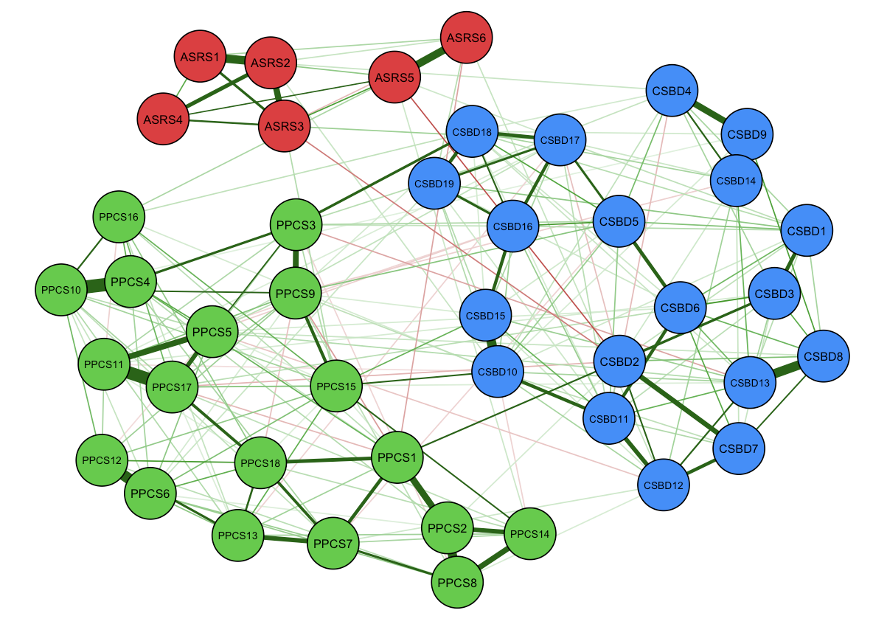

Legend: CSBD (blue) - Compulsive Sexual Behavior Scale; PPCS (green) - Problematic Pornography Consumption Scale; ASRS (red) - Adult Attention-Deficit / Hyperactivity Disorder Self-Report Scale. Dark green edges indicate a positive correlation between nodes, whereas red edges indicate a negative correlation; thicker lines indicate a stronger correlation.

Supplementary Figure 2 – Structure of the proposed network model among women

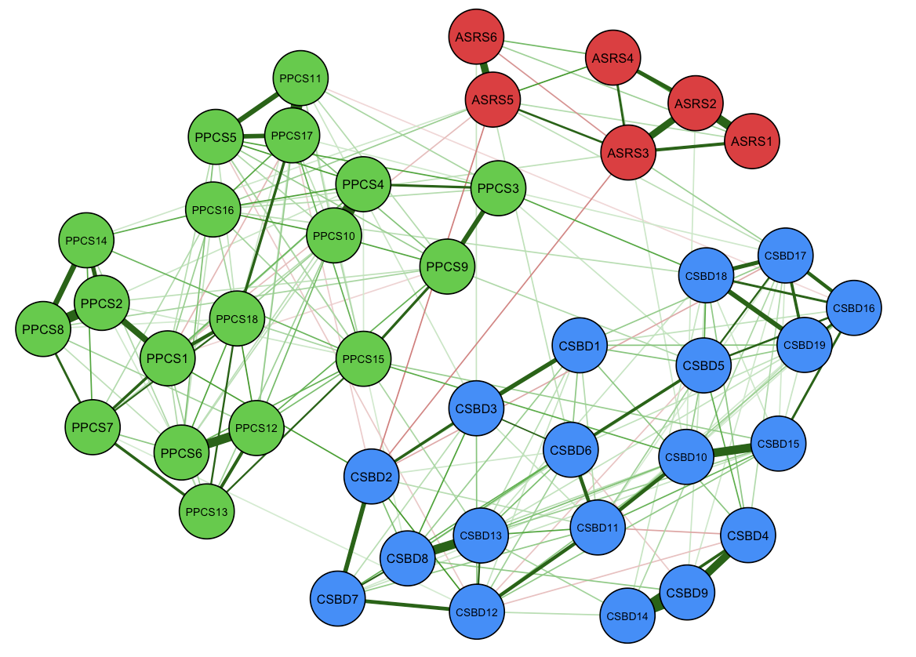

Legend: CSBD (blue) - Compulsive Sexual Behavior Scale; PPCS (green) - Problematic Pornography Consumption Scale; ASRS (red) - Adult Attention-Deficit / Hyperactivity Disorder Self-Report Scale. Dark green edges indicate a positive correlation between nodes, whereas red edges indicate a negative correlation; thicker lines indicate a stronger correlation.

Supplementary Figure 3 – Structure of the proposed network model among the cisgender population

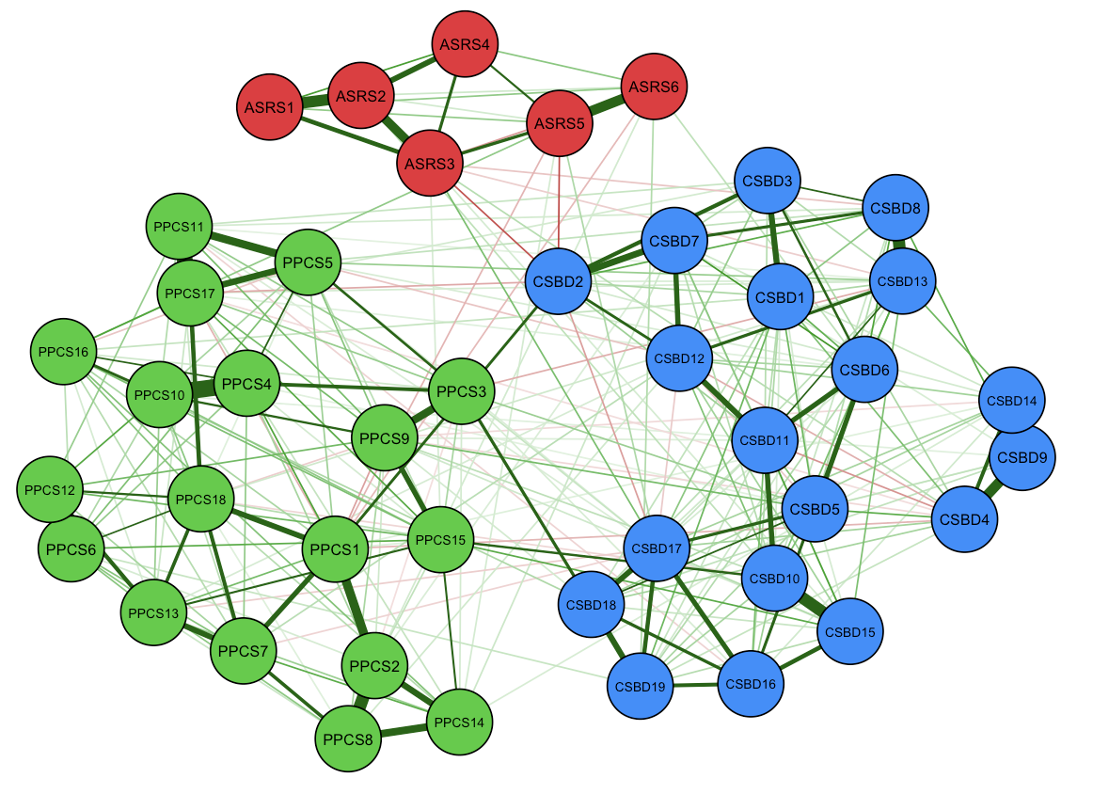

Legend: CSBD (blue) - Compulsive Sexual Behavior Scale; PPCS (green) - Problematic Pornography Consumption Scale; ASRS (red) - Adult Attention-Deficit / Hyperactivity Disorder Self-Report Scale. Dark green edges indicate a positive correlation between nodes, whereas red edges indicate a negative correlation; thicker lines indicate a stronger correlation.

Supplementary Figure 4 – Structure of the proposed network model among the transgender population

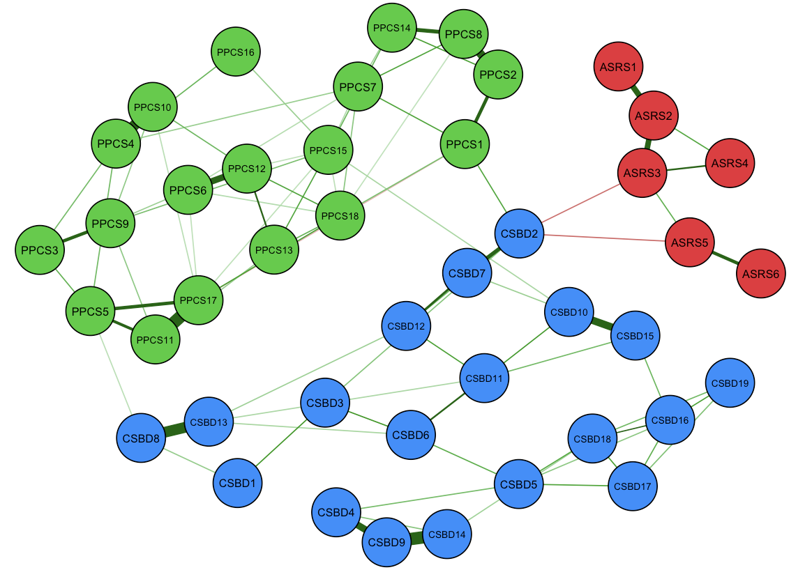

Legend: CSBD (blue) - Compulsive Sexual Behavior Scale; PPCS (green) - Problematic Pornography Consumption Scale; ASRS (red) - Adult Attention-Deficit / Hyperactivity Disorder Self-Report Scale. Dark green edges indicate a positive correlation between nodes, whereas red edges indicate a negative correlation; thicker lines indicate a stronger correlation.

Supplementary Figure 5 – Structure of the proposed network model among transgender men

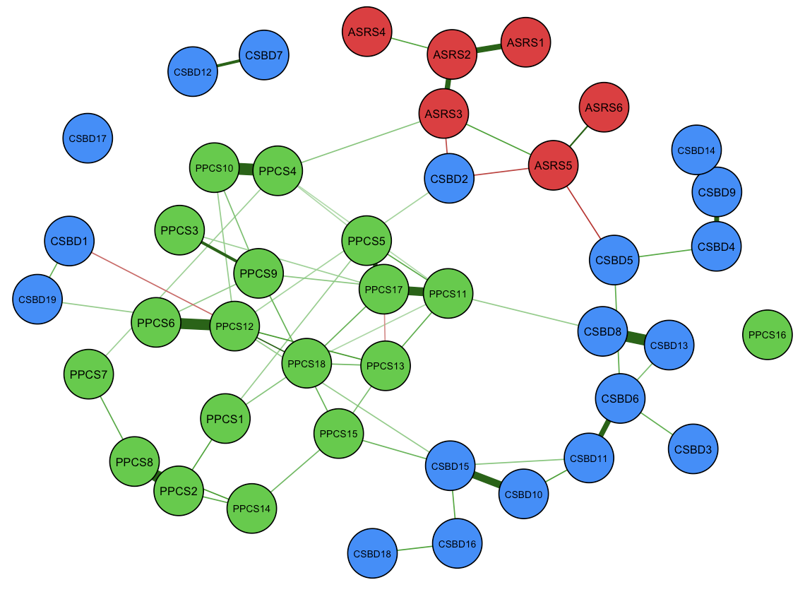

Legend: CSBD (blue) - Compulsive Sexual Behavior Scale; PPCS (green) - Problematic Pornography Consumption Scale; ASRS (red) - Adult Attention-Deficit / Hyperactivity Disorder Self-Report Scale. Dark green edges indicate a positive correlation between nodes, whereas red edges indicate a negative correlation; thicker lines indicate a stronger correlation.

Supplementary Figure 6 – Structure of the proposed network model among transgender women

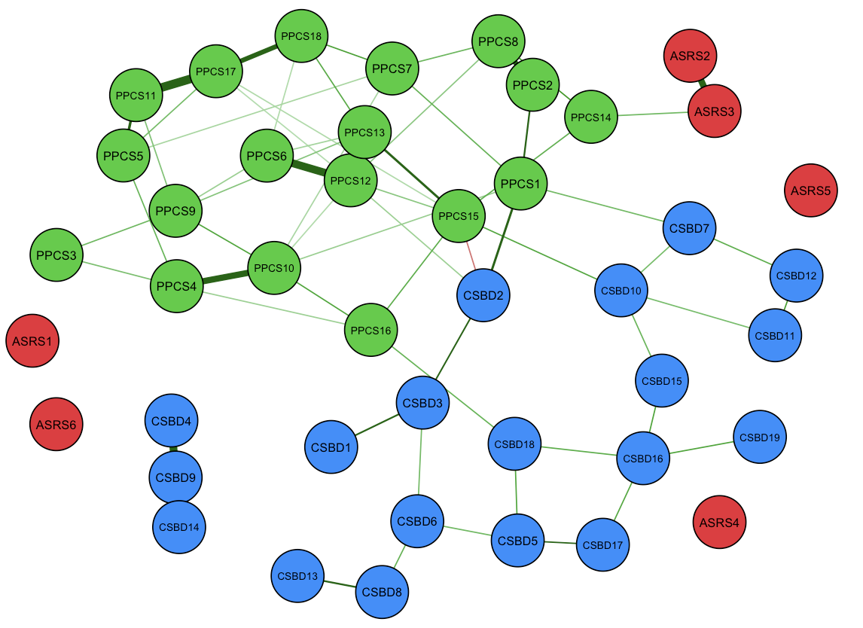

Legend: CSBD (blue) - Compulsive Sexual Behavior Scale; PPCS (green) - Problematic Pornography Consumption Scale; ASRS (red) - Adult Attention-Deficit / Hyperactivity Disorder Self-Report Scale. Dark green edges indicate a positive correlation between nodes, whereas red edges indicate a negative correlation; thicker lines indicate a stronger correlation.

Supplementary Figure 7 – Structure of the proposed network model among the general adult (18-64 years old) population

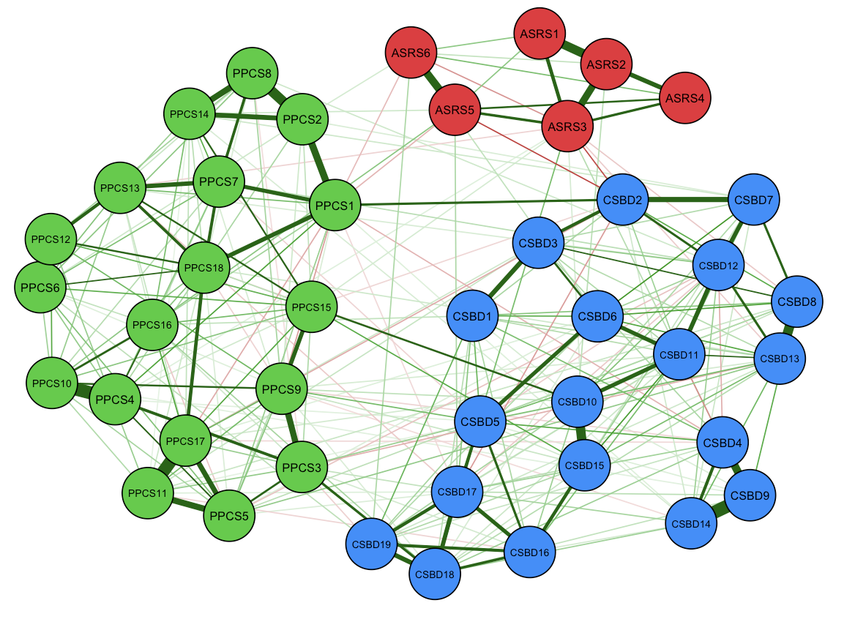

Legend: CSBD (blue) - Compulsive Sexual Behavior Scale; PPCS (green) - Problematic Pornography Consumption Scale; ASRS (red) - Adult Attention-Deficit / Hyperactivity Disorder Self-Report Scale. Dark green edges indicate a positive correlation between nodes, whereas red edges indicate a negative correlation; thicker lines indicate a stronger correlation.

Supplementary Figure 8 – Structure of the proposed network model among the older adult ≥ 65 years old) population

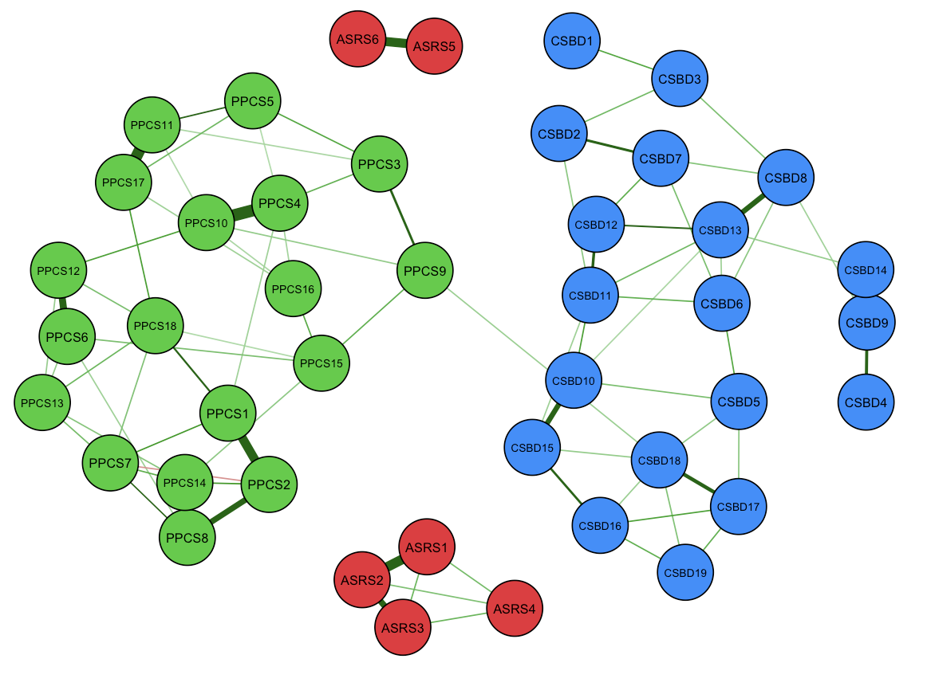

Legend: CSBD (blue) - Compulsive Sexual Behavior Scale; PPCS (green) - Problematic Pornography Consumption Scale; ASRS (red) - Adult Attention-Deficit / Hyperactivity Disorder Self-Report Scale. Dark green edges indicate a positive correlation between nodes, whereas red edges indicate a negative correlation; thicker lines indicate a stronger correlation.

Supplementary Figure 9 – Bridge centrality indices for the network structure of men

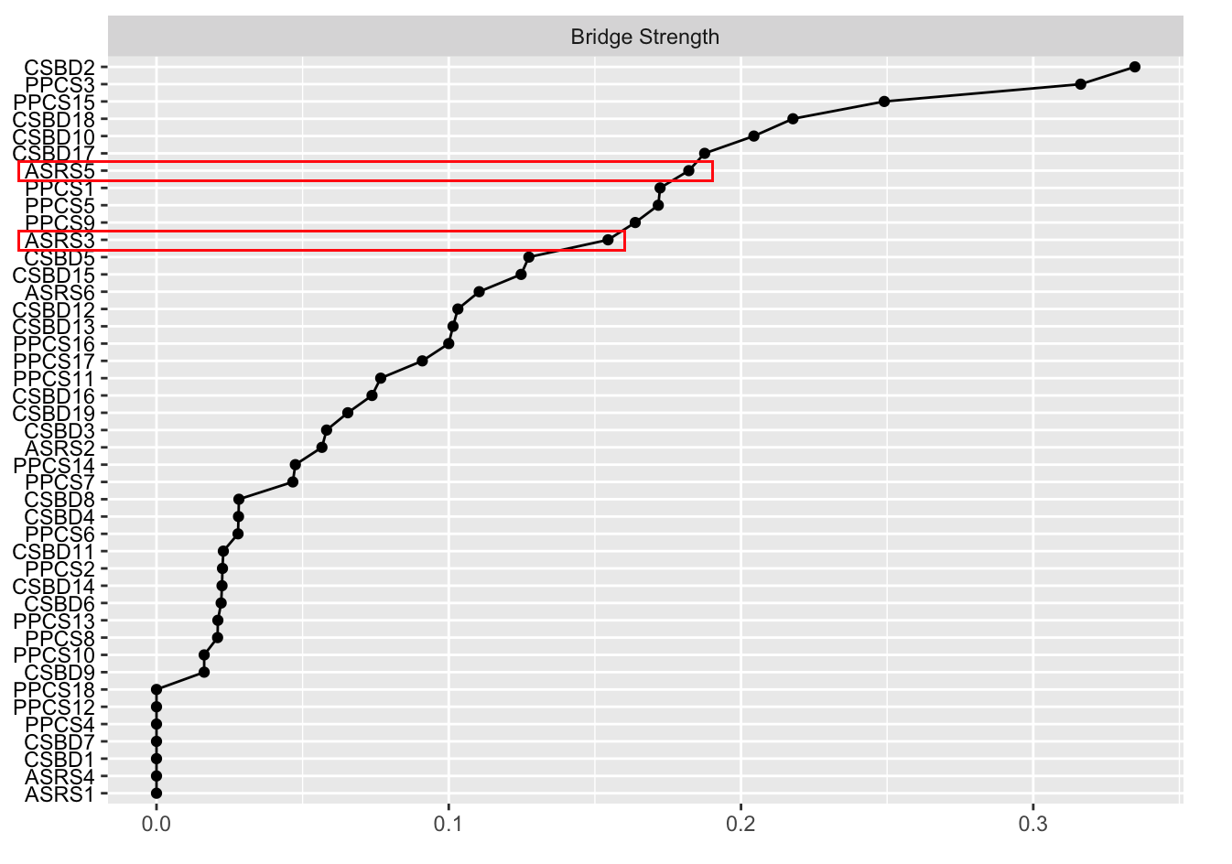

Legend: CSBD - Compulsive Sexual Behavior Scale; PPCS - Problematic Pornography Consumption Scale; ASRS - Adult Attention-Deficit / Hyperactivity Disorder Self-Report Scale; red rectangles indicate the highest ASRS nodes in bridge strength. Red boxes indicate ASRS items with highest bridge strength.

Supplementary Figure 10 – Bridge centrality indices for the network structure of women

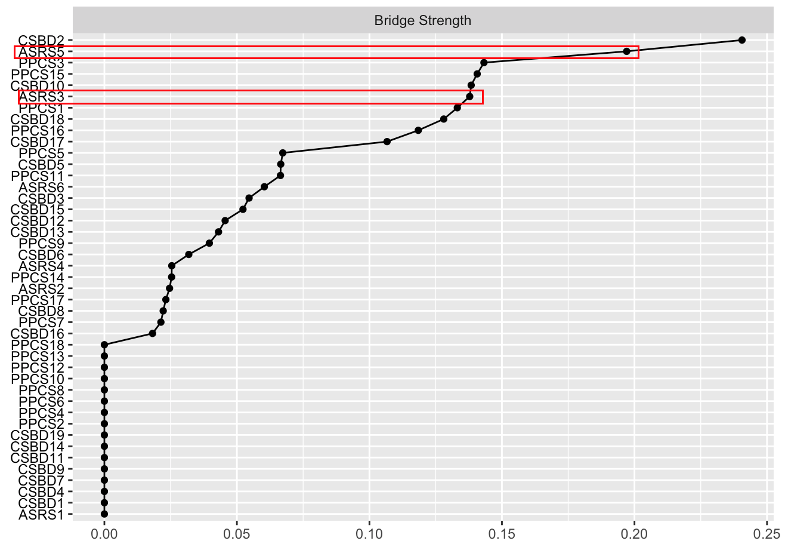

Legend: CSBD - Compulsive Sexual Behavior Scale; PPCS - Problematic Pornography Consumption Scale; ASRS - Adult Attention-Deficit / Hyperactivity Disorder Self-Report Scale; red rectangles indicate the highest ASRS nodes in bridge strength. Red boxes indicate ASRS items with highest bridge strength.

Supplementary Figure 11 – Bridge centrality indices for the network structure of the cisgender population

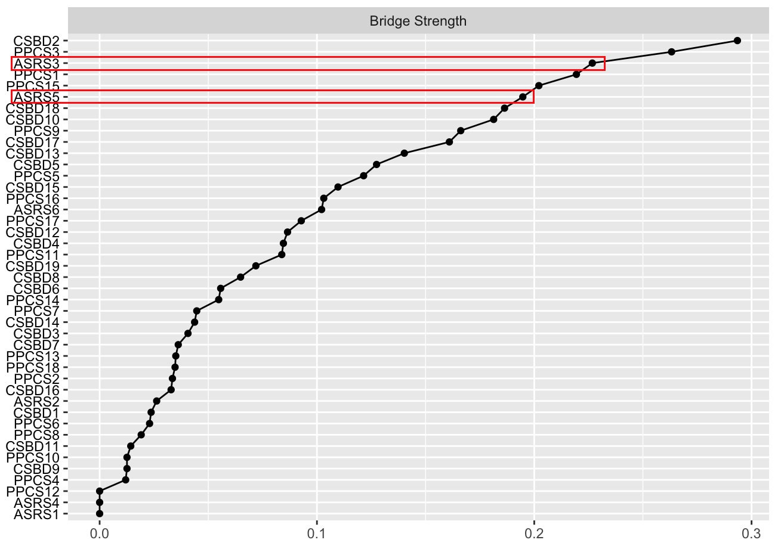

Legend: CSBD - Compulsive Sexual Behavior Scale; PPCS - Problematic Pornography Consumption Scale; ASRS - Adult Attention-Deficit / Hyperactivity Disorder Self-Report Scale; red rectangles indicate the highest ASRS nodes in bridge strength. Red boxes indicate ASRS items with highest bridge strength.

Supplementary Figure 12 – Bridge centrality indices for the network structure of the transgender population

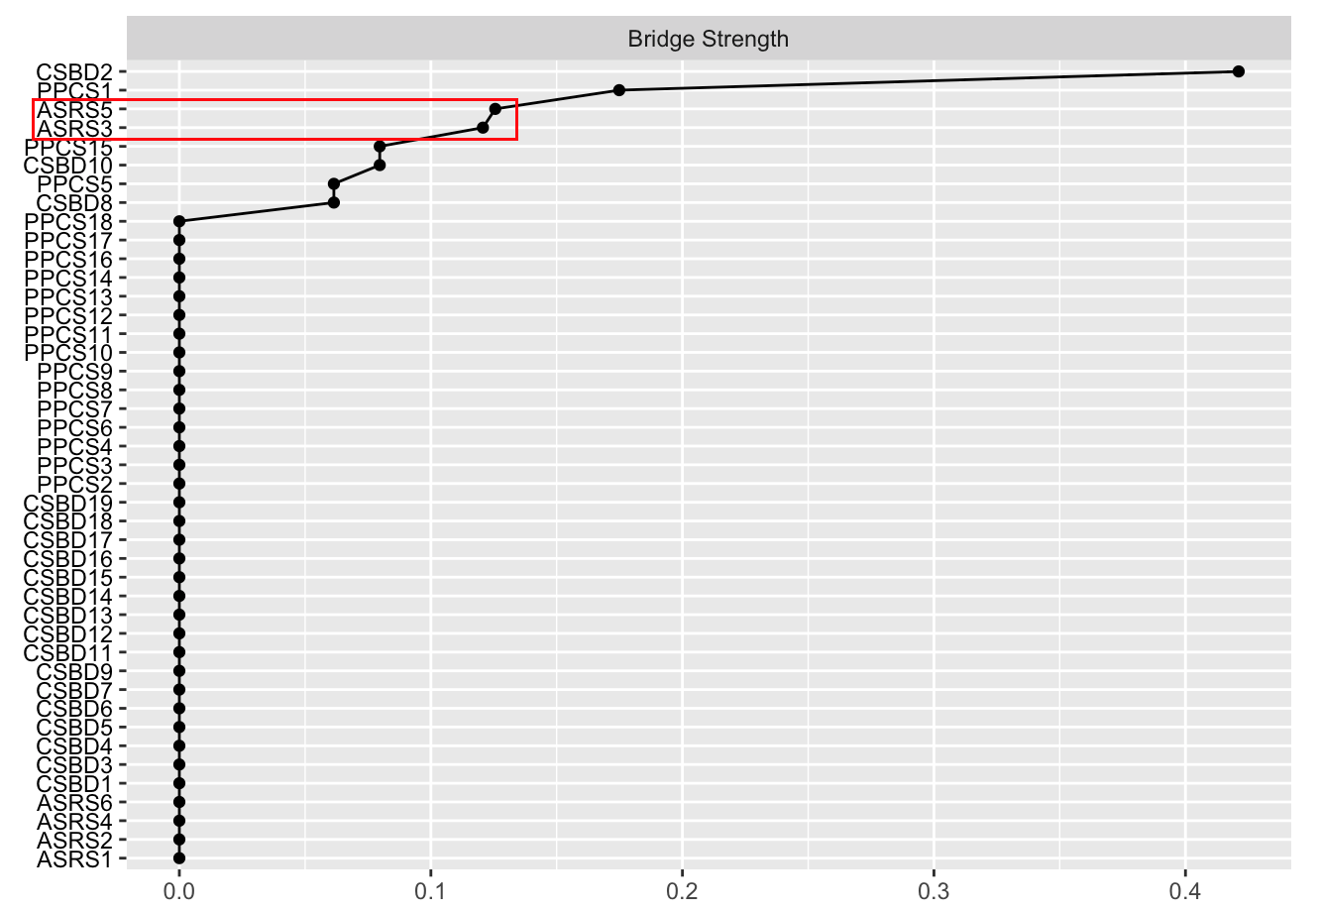

Legend: CSBD - Compulsive Sexual Behavior Scale; PPCS - Problematic Pornography Consumption Scale; ASRS - Adult Attention-Deficit / Hyperactivity Disorder Self-Report Scale; red rectangle indicates the highest ASRS nodes in bridge strength. Red boxes indicate ASRS items with highest bridge strength.

Supplementary Figure 13 – Bridge centrality indices for the network structure of transgender men

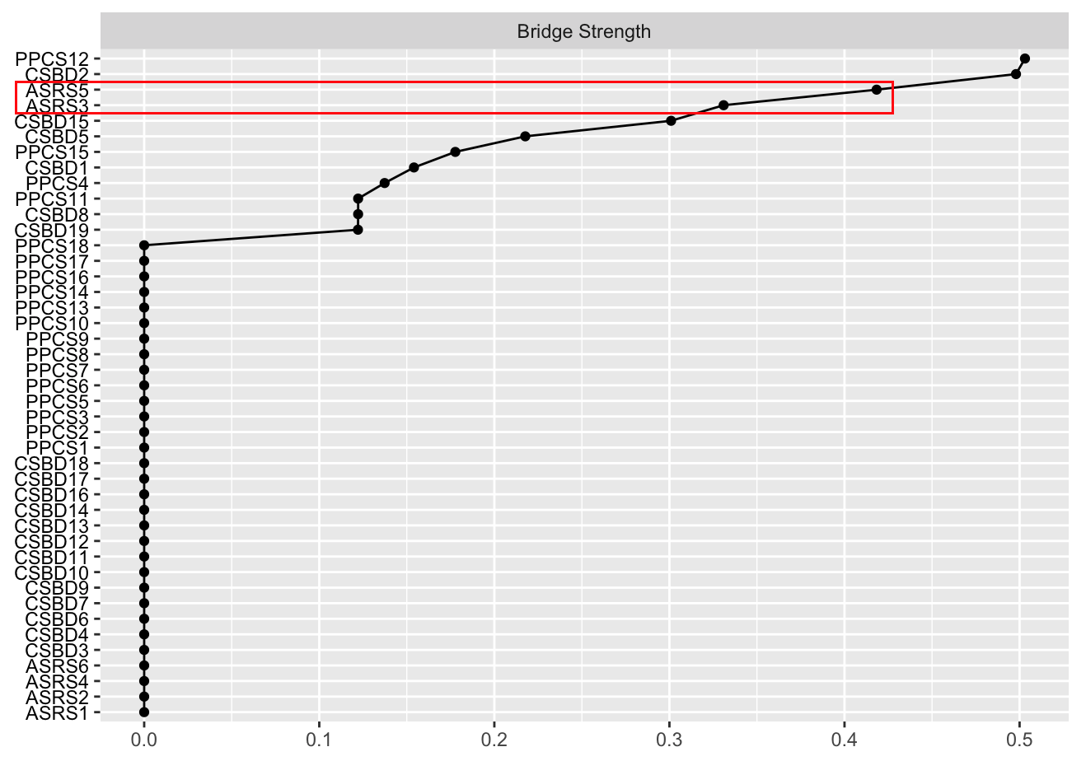

Legend: CSBD - Compulsive Sexual Behavior Scale; PPCS - Problematic Pornography Consumption Scale; ASRS - Adult Attention-Deficit / Hyperactivity Disorder Self-Report Scale; red rectangle indicates the highest ASRS nodes in bridge strength. Red boxes indicate ASRS items with highest bridge strength.

Supplementary Figure 14 – Bridge centrality indices for the network structure of transgender women

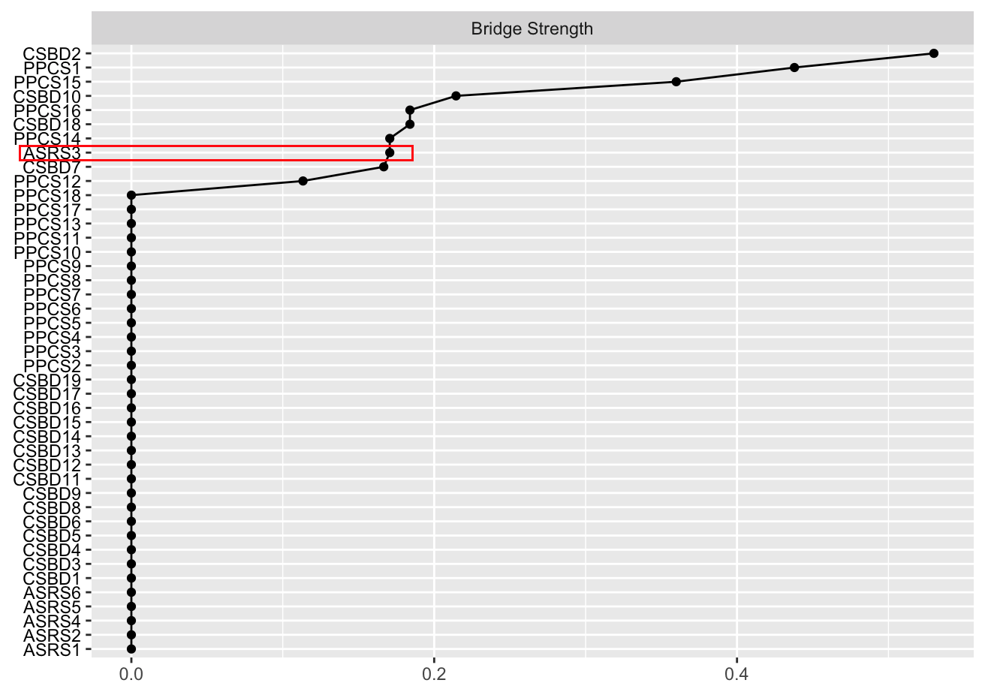

Legend: CSBD - Compulsive Sexual Behavior Scale; PPCS - Problematic Pornography Consumption Scale; ASRS - Adult Attention-Deficit / Hyperactivity Disorder Self-Report Scale; red rectangle indicates the highest ASRS node in bridge strength. Red boxes indicate ASRS items with highest bridge strength.

Supplementary Figure 15 – Bridge centrality indices for the network structure of the general adult population (18-64 years old)

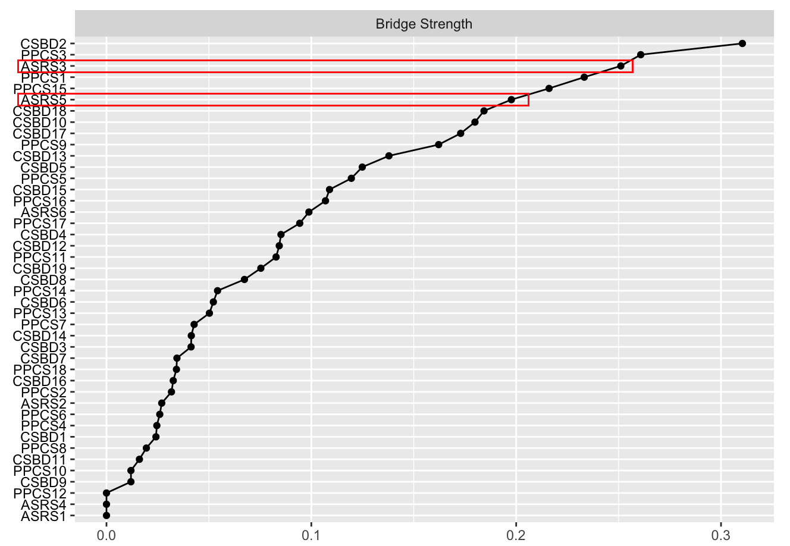

Legend: CSBD - Compulsive Sexual Behavior Scale; PPCS - Problematic Pornography Consumption Scale; ASRS - Adult Attention-Deficit / Hyperactivity Disorder Self-Report Scale; red rectangles indicate the highest ASRS nodes in bridge strength. Red boxes indicate ASRS items with highest bridge strength.

Supplementary Figure 16 – Bridge centrality indices for the network structure of the older adult population (≥ 65 years old)

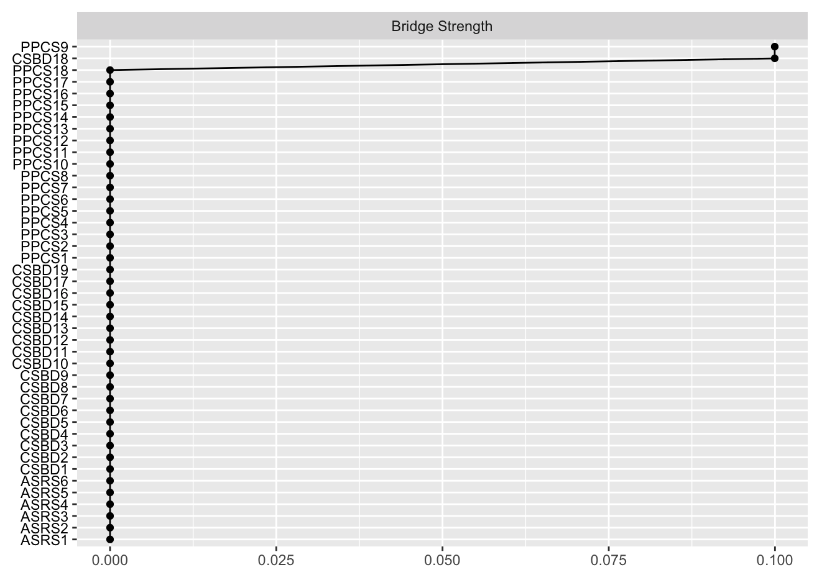

Legend: CSBD - Compulsive Sexual Behavior Scale; PPCS - Problematic Pornography Consumption Scale; ASRS - Adult Attention-Deficit / Hyperactivity Disorder Self-Report Scale.

Ethical approval references

Name of collaborator(s) | Country | Granting institution | Ethical approval number
Nihel Klouche | Algeria | Université Abou Bekr Belkaid | 11/2021 EDCTU
Daniel Miller | Australia | James Cook University | No approval number
Julian Strizek | Austria | Tyrolean Private University | RCSEQ 2888/21
Md. Saiful Islam | Bangladesh | Uttara Adhunik Medical College | UAMC/ERC/ 03/2021
Ann Rousseau | Belgium | Katholieke Universiteit Leuven | G-2021-3432-R2(MIN)
Marion Schulmeyer | Bolivia | Universidad Privada de Santa Cruz de la Sierra | No approval number
Marco Scanavino | Brazil | Hospital das Clínicas da Faculdade de Medicina da Universidade de São Paulo | 042934/2021
Beata Bothe, Sophie Bergeron, Marie-Pier Vaillancourt-Morel | Canada | Université de Montréal; Université du Québec à Trois-Rivières | CEREP-21-042-P; CER-21-276-07.03
Gonzalo R. Quintana Zunino | Chile | Universidad de Tarapacá | CEC C43-2021
Lijun Chen | China | Fuzhou University | 4
Martha Cecilia Jiménez-Martínez | Colombia | Universidad Pedagógica y Tecnológica de Colombia | No approval number
Tanja Jurin, Aleksandar Stulhofer | Croatia | University of Zagreb | EPOP-2021-010
Katerina Lukavska  Roman Gabrhelik | Czech Republic | General University Hospital, Prague | 63/21 S-IV
Silvia Lucia Lopez Alvarado | Ecuador | Universidad de Cuenca | 2022-004EO-IE
Gábor Orosz | France | Université de Lille | 2021-540-S99
Verena Klein, Johannes Fuss, Peer Briken | Germany | University Medical Center Hamburg Eppendorf | LPEK-0060
Zsolt Demetrovics | Gibraltar | University of Gibraltar | No approval number
Zsolt Demetrovics, Mónika Koós, Léna Nagy | Hungary | Eötvös Loránd University | 2020/474-2
Pratap Sharan  Sheikh Shoib | India | All India Institute of Medical Sciences | IEC-302/07.05.2021
Hashim Talib Hashim | Iraq | University of Baghdad | 1457
András Költő | Ireland | University of Galway | 2021.05.011
Ateret Gewirtz-Meydan | Israel | University of Haifa | 252/21
Giacomo Ciocca | Italy | Sapienza Università di Roma | 315
Hironobu Fujiwara, Mami Shibata | Japan | Kyoto University | R3068
Julius Burkauskas, Vesta Steibliene | Lithuania | Lietuvos sveikatos mokslų universitetas | BE-2-67
Elaine Fernandez, David Fernandez | Malaysia | HELP University | E202104/S004
Georgina Cárdenas-López | Mexico | Universidad Nacional Autónoma de México | FPCE_ 06082021_H_AC
Rita Csako, Luke Sniewski | New Zealand | Auckland University of Technology | 21/132
Biljana Gjoneska | North Macedonia | Macedonian Academy of Sciences and Arts | No approval number
Gabriel Quintero | Panama | Comité Nacional de Bioética de la Investigación | PT-023
Jano Ramos-Diaz | Peru | Universidad de Ciencias y Humanidades | ID-009-21
Karol Lewczuk, Mateusz Gola | Poland | Polish Academy of Sciences | 05/IV/2021
Joana Carvalho | Portugal | University of Porto | 2021/05-01
Ondrej Kalina, Olina Orosová | Slovakia | Univerzita Pavla Jozefa Šafárika v Košiciach | FIL003813/2021
Christine Lochner, Dan Stein | South Africa | Stellenbosch University | 767/2021
Sang-Kyu Lee, Kyeongwoo Park | South Korea | Hallym University | CHUNCHEON 2021-06-023-004
Jesús Castro-Calvo, Rafael Ballester-Arnal | Spain | Universitat Jaume | CD/84/2021
Joel Billieux, Vera Lúcia Sigre Leirós | Switzerland | Université de Lausanne | No approval number
CY Lin | Taiwan | National Cheng Kung University Hospital | 8800-4-07-001
Berk Ünsal | Turkey | Eötvös Loránd University | 2020/474-2
Marie Claire Van Hout, Ornella Corazza | United Kingdom | University of Hertfordshire | No approval number
Shane Kraus, Josh Grubbs | United States | University of Nevada, Las Vegas | 1807499-2

