***Notes for supplementary material***

One-stage IPDMA vs two-stage IPDMA.

Based on current recommendations we used only a two-stage IPDMA (1, 2). A one-stage approach which is generally only recommended over a two-stage analysis for trials with few events or small sample sizes. In our case, as trials were large and there were few rare events, our estimation was that using a one-stage as a supportive analysis would not have been of added value.

Alternative data processing strategies

A two-stage meta-analysis of the primary outcome (YBOCS endpoint, corrected for YBOCS baseline, age and gender) in the group with only completers, showed a somewhat larger mean difference, of 3.04 (95% CI 2.25 to 3.04) . Heterogeneity was insignificant (1 11.8, p = 0.29) with a I-squared of 20% and a tau-squared of 0.29. The OR for response also increased (2.44, 95% CI 1.85 – 3.22).

We also repeated our primary and secondary efficacy analyses after processing the crude data using multiple imputation by chained equation (MICE), with the ‘mice’-package in R. We used predictive mean matching as our outcomes were continuous (YBOCS). We stratified for trial in order to account for between-trial differences in the nature of the data. We generated five multiple imputations for each trial subset, with a maximum of 50 iterations per imputation for convergence. For our primary outcome (mean change in YBOCS at endpoint), the mean difference remained comparable (-2.55, 95% CI 1.82 to 3.28), with an increase in heterogeneity (Q = 76.8, p <0.0001, I-squared 87% and tau-squared 1.02, prediction interval 0.16 – 4.95), while individual studies show a more narrow confidence interval with only one non-significant study. Enhanced precision with multiple imputation can be explained by the fact that MICE with PMM produces more accurate and representative imputations, better capturing the data structure of the individual trials. This might furthermore explain the increased, more realistic uncertainty and variability between studies.

Attrition rates for adjusted intent-to-treat population

|  |  |  |  |  |  |  |
| --- | --- | --- | --- | --- | --- | --- |
| Trial | W8 | W10 | W11 | W12 | W13 | Attrition rate |
| 1 |  |  | 17.6 |  | **13.7** | 13.7 |
| 2 | 18.8 | **10.1** |  |  |  | 10.1 |
| 3 | 27.7 | **36.4** |  |  |  | 36.4 |
| 4 | 12.4 | 15.4 |  | **18.6** |  | 18.6 |
| 5 | 23.3 | 36.3 |  | **24.1** |  | 24.1 |
| 6 | 19.4 | 28.9 |  | **30.2** |  | 30.2 |
| 7 | 11.5 | **18.4** |  |  |  | 18.4 |
| 8 | 14.8 | 19.5 |  | **23.7** |  | 23.7 |
| 9 | 14.8 | 20.1 |  | **23.8** |  | 23.8 |
| 10 | 22.1 | 29.3 |  | **33.2** |  | 33.2 |
| 11 | 18.3 | 23.8 |  | **29.3** |  | 29.3 |
|  |  |  |  |  |  |  |

**Supplementary table 1** Table of attrition rates of participants in trials. Numbers are percentages of total of included patients. Empty cell means that this week no patients were measured for symptom severity.

|  |  |  |  |  |  |
| --- | --- | --- | --- | --- | --- |
| **Potential modifiers of effect, symptom change** |  |  |  |  |  |
| **Predictor** | **β-coefficient** | **95% CI Lower** | **95% CI Upper** | **P-value** | **Available trials** |
| *Continuous predictors* |  |  |  |  |  |
| Age | 0.0054 | -0.0763 | 0.0870 | 0.8868 | 11 |
| YBOCS baseline severity | 0.0714 | -0.0494 | 0.1921 | 0.2172 | 11 |
| Duration of illness | -0.0095 | -0.1115 | 0.0925 | 0.8322 | 8 |
| Depressive symptoms (HDRS-17) | -0.0205 | -0.2344 | 0.1934 | 0.8222 | 7 |
| Weight at baseline | -0.0003 | -0.0383 | 0.0376 | 0.9841 | 7 |
| *Dichotomous predictors* |  |  |  |  |  |
| Sex (male) | -0.7711 | -2.0302 | 0.4881 | 0.2023 | 11 |
| History of antidepressants | 0.3524 | -1.7477 | 2.4526 | 0.7033 | 8 |
| Smoking status (current, yes) | -0.7069 | -2.7716 | 1.3579 | 0.3957 | 5 |
| **Potential modifiers of effect, response** |  |  |  |  |  |
| *Continuous predictors* |  |  |  |  |  |
| Age | 0.0015 | -0.0328 | 0.0357 | 0.9262 | 11 |
| YBOCS baseline severity | 0.0322 | -0.0343 | 0.0988 | 0.3060 | 11 |
| Duration of illness | -0.0099 | -0.0274 | 0.0077 | 0.2257 | 8 |
| Depressive symptoms (HDRS-17) | -0.0072 | -0.0885 | 0.0740 | 0.8346 | 7 |
| Weight at baseline | 0.0049 | -0.0118 | 0.0216 | 0.4995 | 7 |
| *Dichotomous predictors* |  |  |  |  |  |
| Sex (male) | -0.1191 | -0.4355 | 0.1974 | 0.4214 | 11 |
| History of antidepressants | 0.3115 | -0.2200 | 0.8430 | 0.2084 | 8 |
| Smoking status (current, yes) | -0.3018 | -1.6718 | 1.0683 | 0.5739 | 5 |
|  |  |  |  |  |  |

**Supplementary table 2** Beta-coefficient of the variable with the interaction term. Moderators of symptom change, and moderators of OR of ‘response’, as defined by a ≥35% YBOCS decrease after treatment. Both outcomes regard treatment effect compared to placebo. YBOCS = Yale-Brown Obsessive-Compulsive Scale. 95% CI = 95% confidence interval. P-value = probability value

|  |  |  |  |  |  |  |
| --- | --- | --- | --- | --- | --- | --- |
| **Post hoc analysis** | **Outcome** | **Value** | **95% CI Lower** | **95% CI Upper** | **P-value** | **Available trials** |
| Full sample incl clomipramine vs placebo | Mean difference YBOCS | 2.83 | 2.21 | 3.46 | <0.0001 | 11 |
| Full sample incl clomipramine vs placebo | OR for response | 2.27 | 1.85 | 2.79 | <0.0001 | 11 |
| Clomipramine vs SSRIs | Mean difference YBOCS | 1.51 | -1.09 | 4.11 | 0.13 | 3 |
| Clomipramine vs SSRIs | OR for response | 1.34 | 0.71 | 2.56 | 0.19 | 3 |
| Clomipramine vs SSRIs | OR for acceptability | 0.77 | 0.54 | 1.11 | 0.093 | 3 |
| Meta-regression of obsessions and compulsions | β-coefficient mean difference YBOCS | -0.46 | -0.92 | 0.0042 | 0.052 | 10 |
| Only published trials | Mean difference YBOCS | 3.1 | 2.2 | 4.0 | <0.0001 | 9 |
| Response defined as YBOCS ≥35% and CGI-I 1 or 2 | OR for response | 2.54 | 1.76 | 3.66 | <0.0001 | 7 |

**Supplementary table 3** Overview of outcomes from different post hoc analyses. YBOCS = Yale-Brown Obsessive-Compulsive Scale. 95% CI = 95% confidence interval. P-value = probability value. Response is defined as defined by a ≥35% YBOCS decrease after treatment unless explicitly mentioned otherwise.

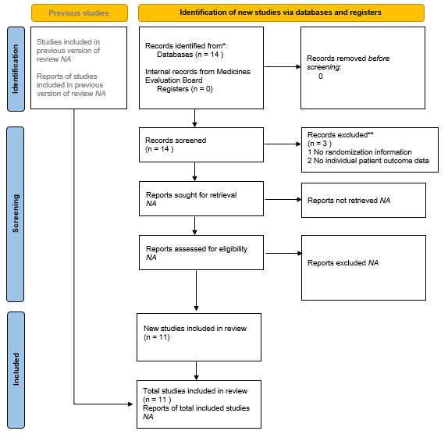

PRISMA flow-chart of included studies from the data from the Medicines Evaluation Board.

**Supplementary figure 1**

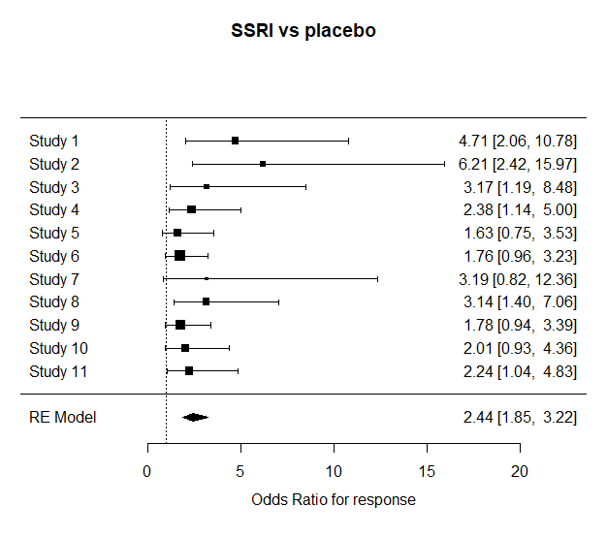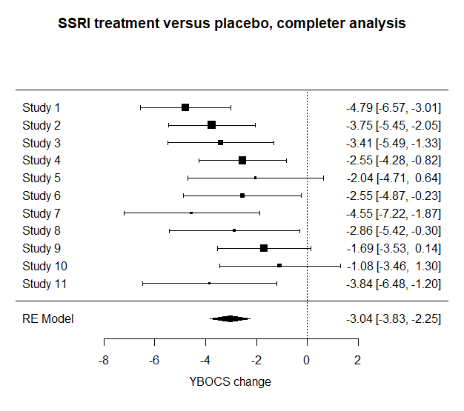

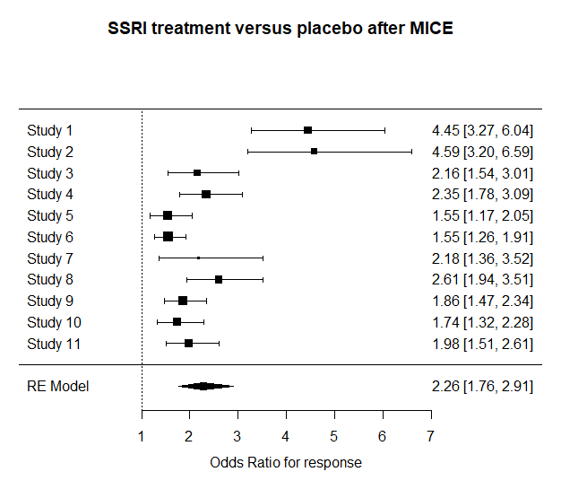**Supplementary figure 2** Continuous outcome (mean difference in YBOCS at endpoint compared to YBOCS at baseline) and dichotomous outcomes for response (more than or equal to 35% decrease in YBOCS at endpoint compared to YBOCS at baseline), for the completer analysis, after excluding all patients that dropped out before the time of primary endpoint.

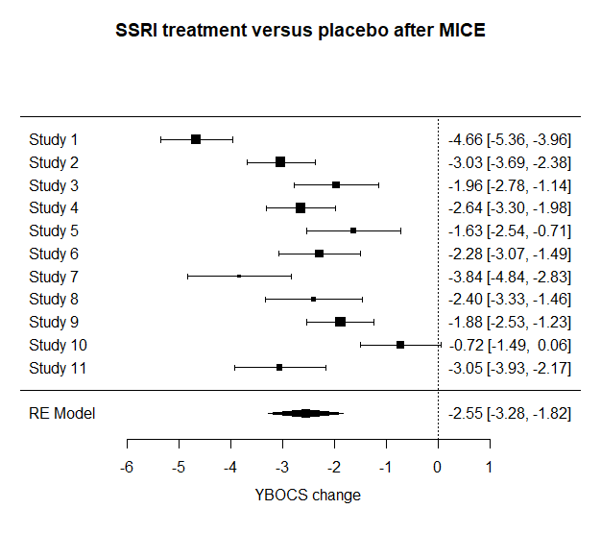

**Supplementary figure 3** Continuous outcome (mean difference in YBOCS at endpoint compared to YBOCS at baseline) and dichotomous outcomes for response (more than or equal to 35% decrease in YBOCS at endpoint compared to YBOCS at baseline) after multiple imputation with predictive mean matching.

1. Morris TP, Fisher DJ, Kenward MG, Carpenter JR. Meta-analysis of Gaussian individual patient data: Two-stage or not two-stage? Statistics in Medicine. 2018;37(9):1419-38.

2. Riley RD, Debray TPA, Fisher D, Hattle M, Marlin N, Hoogland J, et al. Individual participant data meta-analysis to examine interactions between treatment effect and participant-level covariates: Statistical recommendations for conduct and planning. Statistics in Medicine. 2020;39(15):2115-37.