Supplementary Material
Search strategy
The searches below yielded 3.428 results on 8 February 2024: PsycInfo (945 results), Medline (706 results), EMBASE (606 results), Web of Science Core Collection (756 results) and PTSDpubs (415 results).
PsycInfo (Ovid, APA PsycInfo, 1806 to January Week 5 2024)
- (infancy 2 23 mo OR preschool age 2 5 yrs OR school age 6 12 yrs OR adolescence 13 17 yrs).ag. OR (infant OR infants OR toddler* OR preschooler* OR child OR children* OR kid OR kids OR preteen* OR teen* OR youngster* OR youth OR youths OR girl* OR boy* OR preadolesc* OR adolesc*).ti,ab,id.
- posttraumatic stress disorder/ OR complex ptsd/ OR (((posttrauma* OR post-trauma* OR psychotrauma* OR psycho-trauma*) ADJ3 disorder*) OR PTSD* OR PTSS*).ti,ab,id.
- structured clinical interview/ OR psychodiagnostic interview/ OR (CAPS-CA* OR (clinician* administer* PTSD scale* ADJ3 (child* OR adolescen*)) OR ADIS-C* OR ADIS-IV* OR ADIS-5* OR (anxiety ADJ3 (disorder* interview* schedule*)) OR DICA-R* OR DICA-C* OR K-SADS* OR KSADS* OR kiddie-SADS* OR kiddie schedule* OR (diagnostic* infan* ADJ3 preschool* assessment*) OR DIPA OR CPTSDI* OR child* posttrauma* stress disorder* inventor* OR child* post-trauma* stress disorder* inventor* OR child* PTSD inventor*).ti,ab,id,tm,rf. OR ((semistruct* OR structur* OR psychiatric* OR psychodiagnostic* OR diagnostic* OR clinical OR clinician-administered) ADJ3 interview*).ti,ab,id,tm.
- ((adulthood 18 yrs older OR thirties 30 39 yrs OR middle age 40 64 yrs OR aged 65 yrs older OR very old 85 yrs older) NOT (infancy 2 23 mo OR preschool age 2 5 yrs OR school age 6 12 yrs OR adolescence 13 17 yrs)).ag.
- 1 AND 2 AND 3
- 5 NOT 4
- limit 6 to yr="2013 -Current"
Key: / = subject heading, ti = title, ab = abstract, id = key concepts (other keywords added by PsycInfo indexers to supplement the subject headings), ag = age group, tm = tests & measures, rf = cited references, ADJn = word distance of maximum n words, * = unlimited number of characters

MEDLINE (Ovid MEDLINE ALL, including Epub Ahead of Print, In-Process, In-Data-Review & Other Non-Indexed Citations and Daily, 1946 to 8 February 2024)
- infant/ OR child, preschool/ OR child/ OR adolescent/ OR (infant OR infants OR toddler* OR preschooler* OR child OR children* OR kid OR kids OR preteen* OR teen* OR youngster* OR youth OR youths OR girl* OR boy* OR preadolesc* OR adolesc*).ti,ab,kf.
- stress disorders, post-traumatic/ OR complex ptsd/ OR (((posttrauma* OR post-trauma* OR psychotrauma* OR psycho-trauma*) ADJ3 disorder*) OR PTSD* OR PTSS*).ti,ab,kf.
- (CAPS-CA* OR (clinician* administer* PTSD scale* ADJ3 (child* OR adolescen*)) OR ADIS-C* OR ADIS-IV* OR ADIS-5* OR (anxiety ADJ3 (disorder* interview* schedule*)) OR DICA-R* OR DICA-C* OR K-SADS* OR KSADS* OR kiddie-SADS* OR kiddie schedule* OR (diagnostic* infan* ADJ3 preschool* assessment*) OR DIPA OR CPTSDI* OR child* posttrauma* stress disorder* inventor* OR child* post-trauma* stress disorder* inventor* OR child* PTSD inventor*).ti,ab,kf,rf. OR ((semistruct* OR structur* OR psychiatric* OR psychodiagnostic* OR diagnostic* OR clinical OR clinician-administered) ADJ3 interview*).ti,ab,kf.
- (adult/ OR aged/ OR middle aged/) NOT (infant/ OR child, preschool/ OR child/ OR adolescent/)
- 1 AND 2 AND 3
- 5 NOT 4
- limit 6 to yr="2013 -Current"
Key: / = medical subject heading (MeSH), ti = title, ab = abstract, kf = author supplied keywords, rf = cited references, ADJn = word distance of maximum n words, * = unlimited number of characters

EMBASE (Ovid, Embase Classic+Embase 1947 to 8 February 2024)
- juvenile/ OR infant/ OR toddler/ OR preschool child/ OR school child/ OR child/ OR adolescent/ OR (infant OR infants OR toddler* OR preschooler* OR child OR children* OR kid OR kids OR preteen* OR teen* OR youngster* OR youth OR youths OR girl* OR boy* OR preadolesc* OR adolesc*).ti,ab,kf.
- posttraumatic stress disorder/ OR (((posttrauma* OR post-trauma* OR psychotrauma* OR psycho-trauma*) ADJ3 disorder*) OR PTSD* OR PTSS*).ti,ab,kf.
- (CAPS-CA* OR (clinician* administer* PTSD scale* ADJ3 (child* OR adolescen*)) OR ADIS-C* OR ADIS-IV* OR ADIS-5* OR (anxiety ADJ3 (disorder* interview* schedule*)) OR DICA-R* OR DICA-C* OR K-SADS* OR KSADS* OR kiddie-SADS* OR kiddie schedule* OR (diagnostic* infan* ADJ3 preschool* assessment*) OR DIPA OR CPTSDI* OR child* posttrauma* stress disorder* inventor* OR child* post-trauma* stress disorder* inventor* OR child* PTSD inventor* OR (semistruct* OR structur* OR psychiatric* OR psychodiagnostic* OR diagnostic* OR clinical OR clinician-administered) ADJ3 interview*).ti,ab,kf.
- (adult/ OR middle aged/ OR aged/ OR frail elderly/ OR very elderly/) NOT (juvenile/ OR infant/ OR toddler/ OR preschool child/ OR school child/ OR child/ OR adolescent/)
- 1 AND 2 AND 3
- 5 NOT 4
- limit 6 to conference abstracts
- 6 NOT 7
- limit 8 to yr="2013 -Current"
Key: / = EMTREE subject heading, ti = title, ab = abstract, kf = author supplied keywords, ADJn = word distance of maximum n words

Web of Science Core Collection (Web of Science Core Collection Editions: Science Citation Index Expanded (SCI-EXPANDED), 1975–present, Social Sciences Citation Index (SSCI), 1975–present, Arts & Humanities Citation Index (A&HCI), 1975–present, Emerging Sources Citation Index (ESCI), 2005–present))
- TS=("infant" OR "infants" OR "toddler*" OR "preschooler*" OR "child" OR "children* " OR "kid" OR "kids" OR "preteen*" OR "teen*" OR "youngster*" OR "youth" OR "youths" OR "girl*" OR "boy*" OR "preadolesc*" OR "adolesc*")
- TS=((("posttrauma*" OR "post-trauma*" OR "psychotrauma*" OR "psycho-trauma*") NEAR/2 "disorder*") OR "PTSD*" OR "PTSS*")
- TS=("CAPS-CA*" OR ("clinician* administer* PTSD scale*" NEAR/2 ("child*" OR "adolescen*")) OR "ADIS-C*" OR "ADIS-IV*" OR "ADIS-5*" OR ("anxiety" NEAR/2 ("disorder* interview* schedule*")) OR "DICA-R*" OR "DICA-C*" OR "K-SADS*" OR "KSADS*" OR "kiddie-SADS*" OR "kiddie schedule*" OR ("diagnostic* infan*" NEAR/2 "preschool* assessment*") OR "DIPA" OR "CPTSDI*" OR "child* posttrauma* stress disorder* inventor*" OR "child* post-trauma* stress disorder* inventor*" OR "child* PTSD inventor*" OR (("semistruct*" OR "structur*" OR "psychiatric*" OR "psychodiagnostic*" OR "diagnostic*" OR "clinical" OR "clinician-administered") NEAR/2 "interview*"))
- #1 AND #2 AND #3
- Timespan: 2013-01-01 to 2024-01-01
Key: TS = topic, which includes title, abstract, author keywords and Web of Science Keywords Plus, NEAR/n = word distance of maximum n words, * = unlimited number of characters

PTSDpubs (ProQuest)
- ALL("infant" OR "infants" OR "toddler*" OR "preschooler*" OR "child" OR "children* " OR "kid" OR "kids" OR "preteen*" OR "teen*" OR "youngster*" OR "youth" OR "youths" OR "girl*" OR "boy*" OR "preadolesc*" OR "adolesc*")
- ALL((("posttrauma*" OR "post-trauma*" OR "psychotrauma*" OR "psycho-trauma*") NEAR/2 "disorder*") OR "PTSD*" OR "PTSS*")
- ALL("CAPS-CA*" OR ("clinician* administer* PTSD scale*" NEAR/2 ("child*" OR "adolescen*")) OR "ADIS-C*" OR "ADIS-IV*" OR "ADIS-5*" OR ("anxiety" NEAR/2 ("disorder* interview* schedule*")) OR "DICA-R*" OR "DICA-C*" OR "K-SADS*" OR "KSADS*" OR "kiddie-SADS*" OR "kiddie schedule*" OR ("diagnostic* infan*" NEAR/2 "preschool* assessment*") OR "DIPA" OR "CPTSDI*" OR "child* posttrauma* stress disorder* inventor*" OR "child* post-trauma* stress disorder* inventor*" OR "child* PTSD inventor*" OR (("semistruct*" OR "structur*" OR "psychiatric*" OR "psychodiagnostic*" OR "diagnostic*" OR "clinical" OR "clinician-administered") NEAR/2 "interview*"))
- SU.EXACT(("adults" OR "middle aged" OR "aged") NOT ("children" OR "infants" OR "preschool age children" OR "school age children" OR "adolescents"))
- [S1] AND [S2] AND [S3]
- [S5] NOT [S4]
- Limit to 2013-..

Key: ALL = all fields, SU.EXACT = subject heading, NEAR/n = word distance of maximum n words, * = unlimited number of characters

Data supplement
Table S1. Study characteristics of all included DSM-IV studies
Sample | Country | nª | Age range in years (M, SD) | Girls % | Exposure | Exclusion criteria^{b} | Time since exposure^{c} | Informant^{d} | Instrument
Ahmad et al (2000) (partly)⁵⁰ | Sweden | 66 | 6–18 (12.5, NR) | NR | War-related trauma | 1 | NR | C | DICA-R
Ahmad et al (2000) (partly) ⁵⁰ | Sweden | 23 | (12.4, NR) | NR | War-related trauma | NR | NR | C | CPTSDI
Bal et al (2004) ⁵¹ | Belgium | 100 | 11–18 (14.3, 1.8) | 87 | Sexual abuse | 1, 9 | <4 weeks | C | CAPS-CA
Bayarri Fernandez et al (2011) ⁵² | Spain | 144 | 4–17 (8.4, NR) | 39 | Domestic violence | NR | >52 weeks | C | DICA-R
Bosquet Enlow et al (2010) ⁵³ | USA | 100 | 6–18 (13.1, 3.5) | 26 | Accidental or non-accidental injury | 2, 3, 7 | 12 weeks | C | DICA-R
Brown et al (2016) ⁵⁴ | USA | 140 | 7–18 (NR, NR) | NR | Severe injury | 2 | 12 weeks | C | DICA-R
Bui et al (2010) ^{55,56} | France | 103 | 8–15 (11.7, 2.2) | 47 | Road accident | 1, 4, 9 | 5 weeks | C | CAPS-CA
Catani et al (2009) ⁵⁷ | Afghanistan | 27 | 8–14 (11.6, NR) | 26 | Various | NR | Mean 116 weeks | C | CAPS-CA
Chemtob & Carson (2004) ⁵⁸ | USA | 24 | 7–17 (11.2, NR) | NR | Domestic violence | NR | >24 weeks | C | CAPS-CA
Crozier et al (2014) ⁵⁹ | USA | 29 | 8–16 (12.8, 2.5) | 45 | Maltreatment | 1, 5, 7, 9 | NR | C, P | K-SADS
Daviss et al (2000) ⁶⁰ | USA | 48 | 7–17 (13.5, 3.2) | 35 | Accidental injury | 1, 3, 5 | 4–32 weeks | C | CAPS-CA
Delahanty et al (2005)⁶¹⁻⁶⁴ | USA | 76 | 8–18 (13.3, NR) | 32 | Various | 4, 6, 9 | 6–10 weeks | C | CAPS-CA
Erickson et al (2008)⁶⁵ | USA | 29 | 12–18 (15.3, 1.8) | 38 | Cancer | 9 | >52 weeks | C | CAPS-CA
Fischer et al (2016)⁴⁴ | Switzerland | 370 | 11–18 (15.7, 1.8) | 34 | Various | NR | NR | C, P | K-SADS
Iselin et al (2009)^{66, 67} | Australia | 184 | 6–14 (10.8, NR) | NR | Traumatic brain injury | 1, 2, 6, 9 | >12 weeks | C | CAPS-CA
Jakobsen & Elklit (2021)⁶⁸ | Denmark | 16 | 0–5 (NR, NR) | NR | Severe epilepsy | 2, 9 | NR | P | DIPA
Ji et al (2010)⁶⁹ | China | 358 | 5–17 (9.4, 2.8) | 44 | Animal bite | 1, 2, 5 | >12 weeks | C | CAPS-CA
Jones-Alexander et al (2006)⁷⁰ | USA | 21 | 8–17 (12.7, NR) | 48 | Motor vehicle accidents | NR | NR | C, P | Combination
Karam et al (2014)⁷¹ | Lebanon | 143 | NR (11.5, 3.3) | NR | War-related trauma | NR | 48 weeks | C, P | DICA-R
Keeshin et al (2014)⁷² | USA | 24 | 12–17 (15, 1.5) | 100 | Sexual abuse | 1, 2, 4, 5, 7 | 14 weeks | C, P | CAPS-CA
Kenardy et al⁷³ (2006) (partly)⁷⁴⁻⁷⁶ | Australia | 139 | 6–16) (10.4, xx) | 35 | Accidental injury | 1, 2, 7, 9 | 24 weeks | P | ADIS-C
Kenardy et al (2006) (partly)⁷³ | Australia | 89 | 7–15 (10.4, xx) | 37 | Accidental injury | 1, 2, 7, 9 | 4 weeks | P | ADIS-C
Landolt et al (1998)⁷⁷ | Switzerland | 23 | 5–16 (10.5, 3.3) | 52 | Various | 1 | 6–8 weeks | C | CAPS-CA
Landolt et al (2009)⁷⁸ | Switzerland | 43 | 7–16 (10.4, 3.9) | 35 | Burn injury | 1 | 52–364 weeks | C | CAPS-CA
Lansing et al (2023)⁷⁹ | USA | 206 | 13–18 (NR, NR) | 100 | Various | 1, 2, 9 | NR | C | CAPS-CA
Lemos-Miller & Kearney (2006)⁸⁰ | USA | 90 | 11–17 (13.8, 1.5) | 40 | Various interpersonal trauma | NR | 80 weeks | C | CPTSDI
Linning & Kearney (2004)⁸¹ | USA | 55 | 8–17 (12.7, 2.6) | 58 | Maltreatment | NR | <104 weeks | C | CPTSDI
MacMillan et al (2009)^{82, 83} | USA | 65 | 12–16 (14.2, 1.2) | 100 | Maltreatment | 1, 4, 5, 9 | NR | C | K-SADS
Mather et al (2003)⁸⁴ | Australia | 43 | 6–15 (9.7, 2.5) | 53 | Road traffic accident | 1, 2, 7 | 6 weeks | P | ADIS-C
Max et al (2011)⁸⁵ | USA and Canada | 141 | 4–15 (10.4, 2.8) | 29 | Traumatic brain injury | 1, 4 | 24 weeks | C, P | K-SADS
Meiser Stedman et al (2005)⁸⁶⁻⁹⁰ | England | 64 | 10–16 (13.9, 1.9) | 33 | Assaults and motor vehicle accidents | 1, 2, 9 | 24 weeks | C | ADIS-C
Meiser Stedman et al (2008)⁹¹ | England | 60 | 2–6 (4.6, NR) | 48 | Motor vehicle accident | 1, 2, 7 | 24 weeks | p | ADIS-C
Meiser Stedman et al (2008)⁹² | England | 48 | 7–10 (9.3, NR) | 47 | Motor vehicle accident | 1, 2, 7 | 24 weeks | C, P | ADIS-C
Meiser Stedman et al (2017)^{18, 93} | England | 208 | 8–17 (14.1, 2.9) | 43 | Various single incidents | 1, 2, 7, 9 | 9 weeks | C | CPTSDI
Melhem et al (2007)⁹⁴⁻⁹⁶ | USA | 182 | 7–17 (12.4, 2.8) | 46 | Death of parent | 9 | <52 weeks | C | K-SADS
Morais et al (2018)⁹⁷ | USA | 166 | NR (15.9, 1.5) | 0 | Sexual abuse | NR | >52 weeks | C | K-SADS
Morais et al (2018)⁹⁷ | USA | 332 | NR (15.9, 1.5) | 0 | Various | NR | >52 weeks | C | K-SADS
Murat et al (2015)⁹⁸ | Turkey | 590 | 1–18 (13.6, 3.4) | 86 | Sexual abuse | NR | NR | C. P | K-SADS
Nasiroglu & Ceri (2016)⁹⁹ | Turkey | 55 | 6–17 (11.0, 3.7) | 45 | War-related trauma | 1, 5 | >108 weeks | C, P | K-SADS
Nasiroglu et al (2018)¹⁰⁰ | Turkey | 136 | 6–17 (11.1, 3.1) | 44 | War-related trauma | 1, 5 | NR | C | K-SADS
Nixon et al (2010)¹⁰¹ | Australia | 86 | 7–17 (12.2, 2.8) | 39 | Various single incidents | 7, 9 | 12 weeks | C | CAPS-CA
Ostrowski et al (2007)^{102,103} | USA | 50 | 8–18 (13.3, NR) | 46 | Injury | 9 | 6 weeks | C | CAPS-CA
Ostrowski et al (2011)³³ | USA | 99 | 8–18 (12.2, 3.0) | 39 | Various single incidents | 1, 5 | 6 weeks | C | CAPS-CA
Pervanidou et al (2007)¹⁰⁴⁻¹⁰⁶ | Greece | 57 | 7–18 (10.9, xx) | 32 | Motor vehicle accident | 1, 2, 4, 5, 7, 9 | 4 weeks | C | K-SADS
Pfeffer et al (2007)¹⁰⁷ | USA | 45 | 4.8–13 (8.9, 2.9) | 49 | Loss of parent during 9/11 | NR | Mean 76 weeks | C, P | K-SADS
Phipps et al (2014)¹⁰⁸ | USA | 255 | 8–17 (12.7, 2.9) | 48 | Various | 1, 2, 9 | NR | C, P | CAPS-CA
Pine et al (2005)¹⁰⁹⁻¹¹¹ | USA | 116 | 6–14 (10.2, 2.2) | 53 | Maltreatment | NR | 4–28 weeks | C, P, O | K-SADS
Rees et al (2004)¹¹² | England | 19 | 5–18 (10.6, NR) | 34 | PICU | 1, 2, 9 | 24–48 weeks | C, P | CAPS-CA
Rosner et al (2012)¹¹³ | Germany | 33 | 10–18 (13.9, 2.4) | 44 | Various | 1 | Mean 328 weeks | C | CAPS-CA
Samuelson et al (2010)¹¹⁴ | USA | 62 | 7–16 (11.7, 2.8) | 44 | Domestic violence | 1,4, 5, 7, 9 | NR | C, P | CAPS-CA
Schafer et al (2006)¹¹⁵ | Germany | 69 | 8–18 (13.6, 3.3) | 39 | Road traffic accident | 9 | 12 weeks | C | ADIS-C
Stallard et al (1998)^{116, 117} | England | 116 | 5–18 (14.0, 3.6) | 41 | Road traffic accident | NR | 6 weeks | C | CAPS-CA
Stoddard et al (2017)¹¹⁸ | USA | 42 | 1–4 (1.93, NR) | 43 | Burn injury | 1, 5, 7 | 4 weeks | P | DICA-R
Suliman et al (2005)¹¹⁹ | South Africa | 50 | 16–18 (16.6, 0.6) | 68 | Various | NR | NR | C | K-SADS
Tang et al (2017)¹²⁰ | China | 435 | 8–18 (14.0, 2.3) | 58 | Earthquake | NR | 48 weeks | C | K-SADS
Van der Bilt et al (2008)¹²¹ | USA | 18 | 7–17 (11.0, 2.9) | 24 | Various | 1, 2 | NR | C | DICA-R
Van Meijel et al (2015)¹²² | Netherlands | 147 | 8–17 (13.9, 2.8) | 35 | Accidental trauma | 1, 3, 9 | 12 weeks | C, P | ADIS-C
Wechsler-Zimring et al (2011)³⁴ | USA | 84 | 11–17 (NR, NR) | NR | Neglect, sexual/physical abuse | 1, 9 | NR | C | CPTSDI
Winston et al (2003)¹²³⁻¹²⁶ | USA | 204 | 8–17 (11.0, 2.5) | 26 | Accidental injury | 1, 2, 3 | 12–48 weeks | C | CAPS-CA
Notes. ADIS-C, Anxiety and Depression Interview Schedule for DSM-IV: Child Version; CAPS-CA, Clinician-Administered PTSD Scale for Children and Adolescents; CPTSDI, Children’s PTSD Inventory; DICA-R, Diagnostic Interview for Children and Adolescents: Revised Version; DIPA, Diagnostic Infant and Preschool Assessment; K-SADS, Schedule for Affective Disorders and Schizophrenia for School-Age Children: Present and Lifetime Version; PICU, Paediatric Intensive Care Unit; NR, not reported.
ª Sample exposed to a traumatic event according to the DSM-IV A1 criterion. When studies had several follow-up assessments, we show the first measurement that assessed PTSD at least 1 month after exposure.
^{b} Codes for exclusion criteria: 1, cognitive impairment; 2, insufficient language skills to participate in assessment; 3, home too far away from hospital; 4, prior mental disorder; 5, current mental disorder or current medication for a mental disorder; 6, prior trauma exposure; 7, head injury or traumatic brain injury; 8, current medication; 9, other.
^{c} For chronic trauma, this is the time elapsed since the end of exposure.
^{d} Codes for informant: C, child; P, parent; O, other.
Table S2. Study characteristics of all included DSM-5 studies
Sample | Country | nª | Age range in years (M, SD) | Girls % | Exposure | Exclusion criteria^{b} | Time since exposure^{c} | Informant^{d} | Instrument
Ceri et al (2018)¹²⁷ | Turkey | 117 | 7–14 (NR, NR) | 49 | War-related trauma | NR | >8 weeks | C, P | K-SADS
Gigengack et al (2015)¹²⁸ | Netherlands | 98 | 1–13 (6.2, 2.7) | 32 | Accident necessitating ambulance and emergency department attendance | 3, 7, 9 | 26–316 weeks | P | Combination
Grant et al (2020)¹²⁹ | USA | 130 | 6–14 (10, 2.5) | 82 | Maltreatment | NR | >24 weeks | C, P | K-SADS
Hitchcock et al (2022)¹³⁰ | England | 79 | 3–8 (NR, NR) | NR | Accident necessitating ambulance and emergency department attendance | 2, 7, 9 | 12 weeks | P | DIPA
Ibrahim et al (2021)¹³¹ | Iraq | 86 | 8–16 (2.93, 2.07) | 48 | War-related trauma | NR | NR | C | CAPS-CA
Pavlova et al (2020)¹³² | Canada | 138 | 10–18 (14.29, 2.3) | 75 | Various | 1, 2, 5, 9 | <4 weeks | C, P | K-SADS
Thompson et al (2022)¹³³⁻¹³⁵ | USA | 11877 | 9–10 (9.5, NR) | 48 | Various | NR | NR | P | K-SADS
Yilmaz & Uytun (2020)¹³⁶ | Turkey | 119 | 12–16 (NR, NR) | 64 | War-related trauma | 1, 2, 7, 9 | >144 weeks | C | K-SADS
Notes. CAPS-CA, Clinician-Administered PTSD Scale for Children and Adolescents; DIPA, Diagnostic Infant and Preschool Assessment; K-SADS, Schedule for Affective Disorders and Schizophrenia for School-Age Children: Present and Lifetime Version; NR, not reported.
ª Sample exposed to a traumatic event according to the DSM-IV A1 criterion. When studies had several follow-up assessments we show the first measurement assessing PTSD at least 1 month after exposure.
^{b} Codes for exclusion criteria: 1, cognitive impairment; 2, insufficient language skills to participate in assessment; 3, home too far away from hospital; 4, prior mental disorder; 5, current mental disorder or current medication for a mental disorder; 6, prior trauma exposure; 7, head injury or traumatic brain injury; 8, current medication; 9, other.
^{c} For chronic trauma, this is the time elapsed since the end of exposure.
^{d} Code for informant: C, child; P, parent; O, other.

Figure S1. Forest plot for DSM-IV meta-analysis
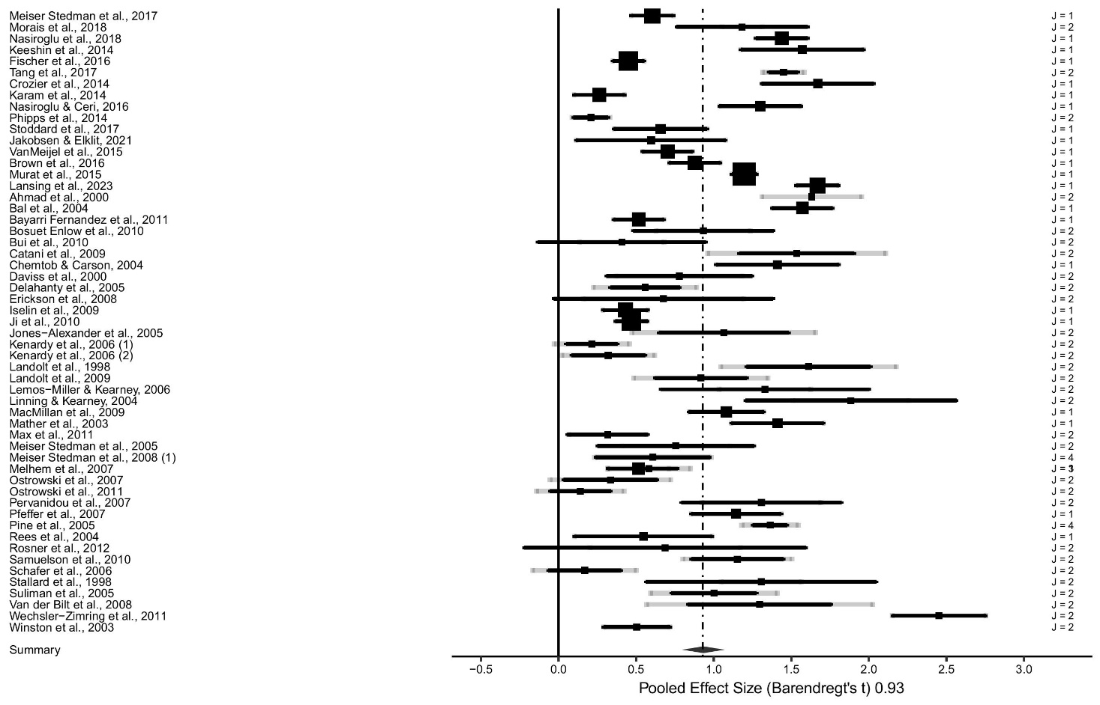
Note. Forest plot displaying the (pooled) transformed PTSD prevalence rate for DSM-IV data.
Figure S2. Forest plot for DSM-5 meta-analysis
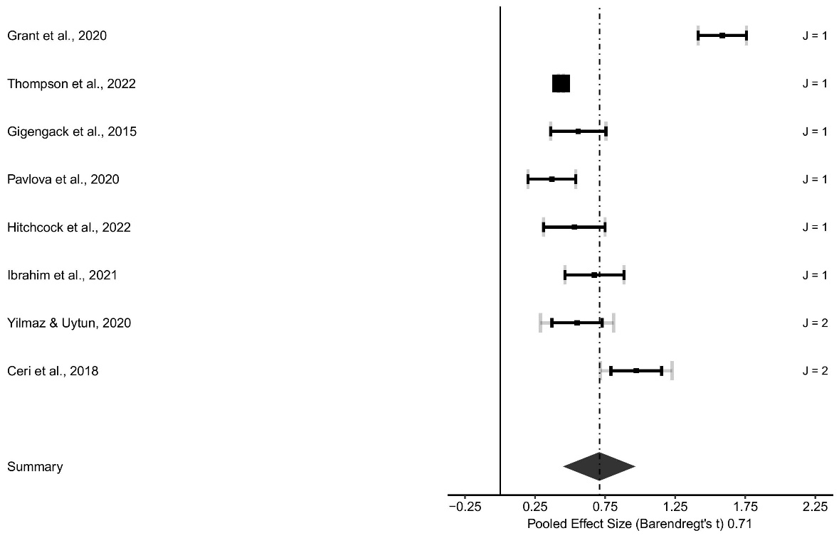
Note. Forest plot displaying the (pooled) transformed PTSD prevalence rate for DSM-5 data.

Sensitivity analyses for DSM-5 analyses
After exclusion of the single identified outlier by the boxplot in the DSM-5 data, the estimated PTSD prevalence rate for the trauma-exposed children and adolescents decreased by Δt = 3.92% to 8.09% (95% CI 4.00–13.45), with 7 independent samples and 8 effect sizes. We encountered conflicting results in the bias analyses. Specifically, the Egger’s regression test was significant (b₀ = 0.40, SE = 0.16, t(7) = 2.15, 95% CI 0.02–0.77, P = .040), suggesting publication bias; but the multilevel trim-and-fill analyses did not yield estimator values above the threshold for publication bias, with R₀ = 1 and L₀ = 0, thus contradicting the Egger’s outcome. In addition, visual inspection of the funnel plot (Figure S3) indicates no clear symmetry.

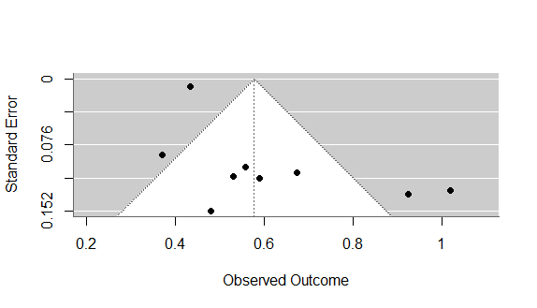
Figure S3. Funnel plot for DSM-5 meta-analysis excluding identified outlier

Note. Funnel plot displaying DSM-5 transformed prevalence rates plotted against their standard errors to assess publication bias, excluding the identified outlier.

Figure S4. Forest plot for DSM-5 meta-analysis excluding identified outlier
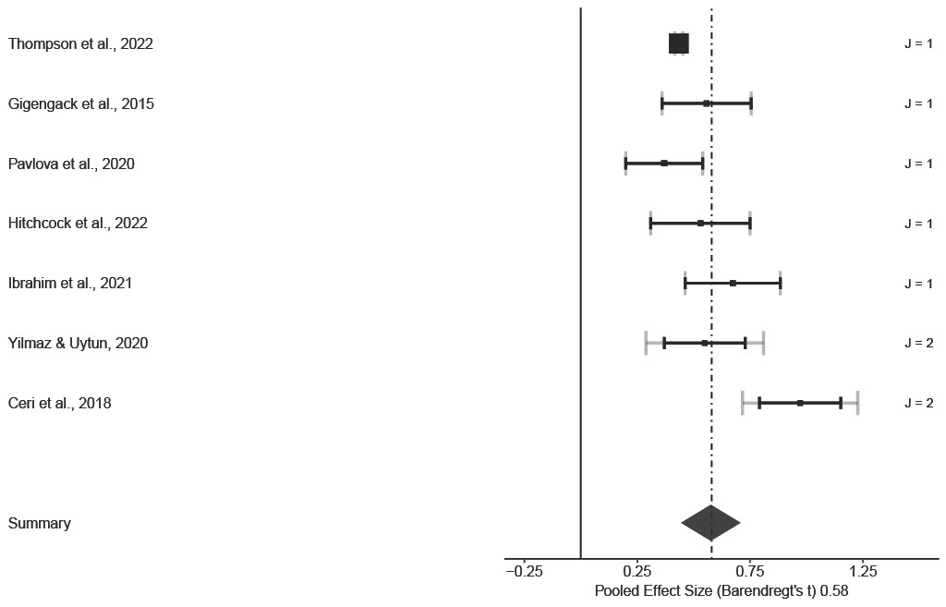
Note. Forest plot displaying the (pooled) transformed PTSD prevalence rate for DSM-5 data, excluding the identified outlier.

Table S3. Quality Appraisal of Newly Included Prevalence Studies
Reference | Q1 = Was the sample frame appropriate to address the target population? | Q2 = Were study participants sampled in an appropriate way? | Q3 = Was the sample size adequate? | Q4 = Were the study subjects and the setting described in detail? | Q5 = Was the data analysis conducted with sufficient coverage of the identified sample? | Q6 = Were valid method used for identification of the condition? | Q7 = Was the condition measured in a standard, reliable way for all participant? | Q8 = Was there appropriate statistical analysis? | Q9 = Was the response adequate and, if not, was the low response rate managed appropriately?
Ceri et al (2018)¹²⁷ | Yes | Yes | Yes | Yes | Yes | Yes | Yes | Yes | No
Fischer et al (2016)⁴⁴ | Yes | Yes | Yes | Yes | Yes | Yes | Yes | Yes | Yes
Gigengack et al (2015)¹²⁸ | Yes | Yes | Yes | Yes | Yes | Yes | Yes | Yes | Yes
Grant et al (2020)¹²⁹ | Yes | Yes | Yes | Yes | Yes | Yes | Yes | Yes | Yes
Hitchcock et al (2022)¹³⁰ | Yes | Yes | Yes | Yes | Yes | Yes | Yes | Yes | Yes
Jakobsen & Elklit (2021)⁶⁸ | Yes | Yes | Yes | Yes | Yes | Yes | Yes | Yes | Yes
Karam et al (2014)⁷¹ | Yes | Yes | Yes | Yes | Yes | Yes | Yes | Yes | Yes
Morais et al (2018)⁹⁷ | No | Yes | Yes | Yes | Yes | Yes | Yes | Yes | Yes
Meiser Stedman et al (2017)^{18, 93} | Yes | Yes | Yes | No | Yes | Yes | Yes | Yes | Yes
Nasiroglu & Ceri (2016)⁹⁹ | Yes | Yes | Yes | Yes | Yes | Yes | Yes | Yes | Yes
Phipps et al (2014)¹⁰⁸ | Yes | Yes | Yes | Yes | Yes | Yes | Yes | Yes | Yes
Stoddard et al (2017)¹¹⁸ | Yes | Yes | No | Yes | Yes | Yes | Yes | Yes | Yes
Tang et al (2017)¹²⁰ | Yes | Yes | Yes | Yes | Yes | Yes | Yes | Yes | Yes
Van Meijel et al (2015)¹²² | Yes | Yes | Yes | Yes | Yes | Yes | Yes | Yes | Yes
Murat et al (2015)⁹⁸ | Yes | Yes | Yes | No | Yes | Yes | Yes | Yes | Yes

Table S4. Quality Appraisal of Newly Included Analytical Cross-Sectional Studies
Reference | Q1 = Were the criteria for inclusion in the sample clearly defined? | Q2 = Were the study subjects and the setting described in detail? | Q3= Was the exposure measured in a valid and reliable way? | Q4 = Were objective, standard criteria used for measurement of the condition? | Q5 = Were confounding factors identified? | Q6 = Were strategies to deal with confounding factors stated? | Q7 = Were the outcomes measured in a valid and reliable way? | Q8 = Was appropriate statistical analysis used?
Brown et al (2016) ⁵⁴ | Yes | Yes | Yes | Yes | Yes | Yes | Yes | Yes
Ibrahim et al (2021)¹³¹ | Yes | Yes | Yes | Yes | No | N/A | Yes | Yes
Lansing et al (2023)⁷⁹ | Yes | Yes | Yes | Yes | No | N/A | Yes | Yes
Nasiroglu et al (2018)¹⁰⁰ | Yes | Yes | Yes | Yes | Yes | Yes | Yes | Yes
Thompson et al (2022)¹³³⁻¹³⁵ | Yes | Yes | Yes | Yes | Yes | Yes | Yes | Yes
Yilmaz & Uytun (2020)¹³⁶ | Yes | Yes | Yes | Yes | No | N/A | Yes | Yes

Table S5. Quality Appraisal of Newly Included Case Control Studies
Reference | Q1 = Were the groups comparable other than the presence of disease (disorder) in cases or the absence of disease (disorder) in control? | Q2 = Were cases and controls matched appropriately? | Q3 = Were the same criteria used for identification of cases and controls? | Q4 = Was exposure measured in the same way for cases and controls? | Q5 = Were confounding factors identified? | Q6 = Were strategies to deal with confounding factors stated? | Q7 = Were outcomes assessed in a standard, valid, and reliable way for cases and controls? | Q8 = Was the exposure period of interest long enough to be meaningful? | Q9 = Was appropriate statistical analyses used?
Crozier et al (2014) ⁵⁹ | Yes | Yes | Yes | Yes | Yes | Yes | Yes | Yes | Yes
Keeshin et al (2014)⁷² | Yes | Yes | Yes | Yes | Yes | Yes | Yes | Yes | Yes

Table S6. Quality Appraisal of Newly Included Cohort Studies
Reference | Q1 = Were the two groups similar and recruited from the same population? | Q2 = Were the exposures measured similarly to assign people to both the exposed and unexposed groups? | Q3 = Was the exposure measured in a valid and reliable way? | Q4 = Were confounding factors identified? | Q5 = Were strategies to deal with confounding factors stated? | Q6 = Were the groups/participants free of the outcome at the start of the study? (or the moment of the exposure) | Q7 = Were the outcomes measured in a valid and reliable way? | Q8 = Was the follow-up reported and sufficient to be long enough for outcomes to occur? | Q9 = Was follow-up complete and, if not, were the reasons to loss to follow-up described and explored? | Q10 = Were strategies to address incomplete follow-up utilized? | Q11 = Was appropriate statistical analysis used?
Pavlova et al (2020)¹³² | N/A | N/A | Yes | No | N/A | Yes | Yes | Yes | Yes | N/A | Yes

Additional references
50. Ahmad A, Sundelin-Wahlsten V, Sofi MA, Qahar JA, von Knorring AL. Reliability and validity of a child-specific cross-cultural instrument for assessing posttraumatic stress disorder. Eur Child Adolesc Psychiatry 2000; 9: 285–94.
51. Bal S, De Bourdeaudhuij I, Crombez G, Van Oost P. Differences in trauma symptoms and family functioning in intra-and extrafamilial sexually abused adolescents. J Interpers Violence 2004; 19: 108–23.
52. Bayarri Fernandez E, Ezpeleta L, Granero R, de la Osa N, Domenech JM. Degree of exposure to domestic violence, psychopathology, and functional impairment in children and adolescents. J Interpers Violence 2011; 26: 1215–31.
53. Bosquet Enlow M, Kassam-Adams N, Saxe G. The Child Stress Disorders Checklist-Short Form: a four-item scale of traumatic stress symptoms in children. Gen Hosp Psychiatry 2010; 32: 321–7.
54. Brown RC, Nugent NR, Hawn SE, Koenen KC, Miller A, Amstadter AB, Saxe G. Predicting the transition from acute stress disorder to posttraumatic stress disorder in children with severe injuries. J Pediatr Health Care 2016; 30(6): 558–68.
55. Bui E, Brunet A, Allenou C, Camassel C, Raynaud JP, Claudet I, et al. Peritraumatic reactions and posttraumatic stress symptoms in school-aged children victims of road traffic accident. Gen Hosp Psychiatry 2010; 32: 330–3.
56. Bui E, Brunet A, Olliac B, Very E, Allenou C, Raynaud JP, et al. Validation of the Peritraumatic Dissociative Experiences Questionnaire and Peritraumatic Distress Inventory in school-aged victims of road traffic accidents. Eur Psychiatry 2011; 26: 108–11.
57. Catani C, Schauer E, Elbert T, Missmahl I, Bette JP, Neuner F. War trauma, child labor, and family violence: life adversities and PTSD in a sample of school children in Kabul. J Trauma Stress 2009; 22: 163–71.
58. Chemtob CM, Carlson JG. Psychological effects of domestic violence on children and their mothers. Int J Stress Management 2004; 11: 209–26.
59. Crozier JC, Wang L, Huettel SA, De Bellis MD. Neural correlates of cognitive and affective processing in maltreated youth with posttraumatic stress symptoms: does gender matter? Dev Psychopathol 2014; 26(2): 491–513.
60. Daviss WB, Mooney D, Racusin R, Ford JD, Fleischer A, McHugo GJ. Predicting posttraumatic stress after hospitalization for pediatric injury. J Am Acad Child Adolesc Psychiatry 2000; 39: 576–83.
61. Delahanty DL, Nugent NR, Christopher NC, Walsh M. Initial urinary epinephrine and cortisol levels predict acute PTSD symptoms in child trauma victims. Psychoneuroendocrinology 2005; 30: 121–8.
62. Nugent NR, Christopher NC, Delahanty DL. Emergency medical service and in-hospital vital signs as predictors of subsequent PTSD symptom severity in pediatric injury patients. J Child Psychol Psychiatry 2006; 47: 919–26.
63. Nugent NR, Christopher NC, Delahanty DL. Initial physiological responses and perceived hyperarousal predict subsequent emotional numbing in pediatric injury patients. J Trauma Stress 2006; 19: 349–59.
64. Nugent NR, Ostrowski S, Christopher NC, Delahanty DL. Parental posttraumatic stress symptoms as a moderator of child’s acute biological response and subsequent posttraumatic stress symptoms in pediatric injury patients. J Pediatr Psychol 2007; 32: 309–18.
65. Erickson SJ, Gerstle M, Montague EQ. Repressive adaptive style and self-reported psychological functioning in adolescent cancer survivors. Child Psychiatry Hum Dev 2008; 39: 247–60.
66. Iselin G, Le Brocque R, Kenardy J, Anderson V, McKinlay L. Which method of posttraumatic stress disorder classification best predicts psychosocial function in children with traumatic brain injury? J Anxiety Disord 2010; 24: 774–9.
67. Kenardy J, Le Brocque R, Hendrikz J, Iselin G, Anderson V, McKinlay L. Impact of posttraumatic stress disorder and injury severity on recovery in children with traumatic brain injury. J Clin Child Adolesc Psychol 2012; 41: 5–14.
68. Jakobsen AV, Elklit A. Post-traumatic stress disorder (PTSD) symptoms in children with severe epilepsy. Epilepsy Behav 2021; 122: 108217.
69. Ji L, Xiaowei Z, Chuanlin W, Wei L. Investigation of posttraumatic stress disorder in children after animal-induced injury in China. Pediatrics 2010; 126: 320–4.
70. Jones-Alexander J, Blanchard EB, Hickling EJ. Psychophysiological assessment of youthful motor vehicle accident survivors. Appl Psychophysiol Biofeedback 2005; 30: 115–23.
71. Karam EG, Fayyad J, Karam AN, Melhem N, Mneimneh Z, Dimassi H, et al. Outcome of depression and anxiety after war: a prospective epidemiologic study of children and adolescents. J Trauma Stress 2014; 27(2): 192–9.
72. Keeshin BR, Strawn JR, Out D, Granger DA, Putnam FW. Elevated salivary alpha amylase in adolescent sexual abuse survivors with posttraumatic stress disorder symptoms. J Child Adolesc Psychopharmacol 2015; 25(4): 344–50.
73. Kenardy JA, Spence SH, Macleod AC. Screening for posttraumatic stress disorder in children after accidental injury. Pediatrics 2006; 118: 1002–9.
74. De Young AC, Kenardy JA, Spence SH. Elevated heart rate as a predictor of PTSD six months following accidental pediatric injury. J Trauma Stress 2007; 20: 751–6.
75. Kenardy J, Smith A, Spence SH, Lilley PR, Newcombe P, Dob R, et al. Dissociation in children’s trauma narratives: an exploratory investigation. J Anxiety Disord 2007; 21: 456–66.
76. Murray BL, Kenardy JA, Spence SH. Brief report. Children’s responses to trauma- and nontrauma-related hospital admission: a comparison study. J Pediatr Psychol 2008; 33: 435–40.
77. Olsson KA, Kenardy JA, De Young AC, Spence SH. Predicting children’s post-traumatic stress symptoms following hospitalization for accidental injury: combining the Child Trauma Screening Questionnaire and heart rate. J Anxiety Disord 2008; 22: 1447–53.
78. Landolt MA, Boehler U, Schwager C, Schallberger U, Nuessli R. Post-traumatic stress disorder in paediatric patients and their parents: an exploratory study. J Paediatr Child Health 1998; 34: 539–43.
79. Landolt MA, Buehlmann C, Maag T, Schiestl C. Brief report. Quality of life is impaired in pediatric burn survivors with posttraumatic stress disorder. J Pediatr Psychol 2009; 34: 14–21
80. Lansing AE, Plante WY, Beck AN, Ellenberg M. Loss and grief among persistently delinquent youth: the contribution of adversity indicators and psychopathy-spectrum traits to broadband internalizing and externalizing psychopathology. J Child Adolesc Trauma 2018; 11: 375–89.
81. Lemos-Miller A, Kearney CA. Depression and ethnicity as intermediary variables among dissociation, trauma-related cognitions, and PTSD symptomatology in youths. J Nerv Ment Dis 2006; 194: 584–90.
82. Linning LM, Kearney CA. Post-traumatic stress disorder in maltreated youth: a study of diagnostic comorbidity and child factors. J Interpers Violence 2004; 19: 1087–101.
83. MacMillan HL, Georgiades K, Duku EK, Shea A, Steiner M, Niec A, et al. Cortisol response to stress in female youths exposed to childhood maltreatment: results of the youth mood project. Biol Psychiatry 2009; 66: 62–8.
84. Miskovic V, Schmidt LA, Georgiades K, Boyle M, Macmillan HL. Adolescent females exposed to child maltreatment exhibit atypical EEG coherence and psychiatric impairment: linking early adversity, the brain, and psychopathology. Dev Psychopathol 2010; 22: 419–32.
85. Mather FJ, Tate RL, Hannan TJ. Post-traumatic stress disorder in children following road traffic accidents: a comparison of those with and without mild traumatic brain injury. Brain Inj 2003; 17: 1077–87.
86. Max JE, Keatley E, Wilde EA, Bigler ED, Levin HS, Schachar RJ, et al. Anxiety disorders in children and adolescents in the first six months after traumatic brain injury. J Neuropsychiatry Clin Neurosci 2011; 23: 29–39.
87. Meiser-Stedman R, Dalgleish T, Glucksman E, Yule W, Smith P. Maladaptive cognitive appraisals mediate the evolution of posttraumatic stress reactions: a 6-month follow-up of child and adolescent assault and motor vehicle accident survivors. J Abnorm Psychol 2009; 118: 778–87.
88. Meiser-Stedman R, Smith P, Glucksman E, Yule W, Dalgleish T. Parent and child agreement for acute stress disorder, post-traumatic stress disorder and other psychopathology in a prospective study of children and adolescents exposed to single-event trauma. J Abnorm Child Psychol 2007; 35: 191–201.
89. Meiser-Stedman R, Yule W, Smith P, Glucksman E, Dalgleish T. Acute stress disorder and posttraumatic stress disorder in children and adolescents involved in assaults or motor vehicle accidents. Am J Psychiatry 2005; 162: 1381–3.
90. Meiser-Stedman RA, Yule W, Dalgleish T, Smith P, Glucksman E. The role of the family in child and adolescent posttraumatic stress following attendance at an emergency department. J Pediatr Psychol 2006; 31: 397–402.
91. Perrin S, Meiser-Stedman R, Smith P. The Children’s Revised Impact of Event Scale (CRIES): validity as a screening instrument for PTSD. Behav Cogn Psychother 2005; 33: 487.
92. Meiser-Stedman R, Smith P, Glucksman E, Yule W, Dalgleish T. The posttraumatic stress disorder diagnosis in preschool- and elementary school-age children exposed to motor vehicle accidents. Am J Psychiatry 2008; 165: 1326–37.
93. Meiser‐Stedman R, McKinnon A, Dixon C, Boyle A, Smith P, Dalgleish T. A core role for cognitive processes in the acute onset and maintenance of post‐traumatic stress in children and adolescents. J Child Psychol Psychiatry 2019; 60(8): 875–84.
94. Melhem NM, Moritz G, Walker M, Shear MK, Brent D. Phenomenology and correlates of complicated grief in children and adolescents. J Am Acad Child Adolesc Psychiatry 2007; 46: 493–9.
95. Melhem NM, Porta G, Shamseddeen W, Walker Payne M, Brent DA. Grief in children and adolescents bereaved by sudden parental death. Arch Gen Psychiatry 2011; 68: 911–9.
96. Melhem NM, Walker M, Moritz G, Brent DA. Antecedents and sequelae of sudden parental death in offspring and surviving caregivers. JAMA Pediatr 2008; 162: 403–10.
97. Morais HB, Alexander AA, Fix RL, Burkhart BR. Childhood sexual abuse in adolescents adjudicated for sexual offenses: mental health consequences and sexual offending behaviors. Sex Abuse 2018; 30(1): 23–42.
98. Murat YÜ, Karabekiroğlu K, Yildirim Z, Şahin S, Sapmaz D, Babadaği Z, Turla A, Aydin B. The psychiatric consequences of child and adolescent sexual abuse. Noro Psikiyatr Ars 2015; 52(4): 393.
99. Nasıroğlu S, Çeri V. Posttraumatic stress and depression in Yazidi refugees. Neuropsychiatr Dis Treat 2016; 12: 2941–8.
100. Nasıroğlu S, Çeri V, Erkorkmaz Ü, Semerci B. Determinants of psychiatric disorders in children refugees in Turkey’s Yazidi refugee camp. Psychiatry Clin Psychopharmacol 2018; 28(3): 291–9.
101. Nixon RD, Ellis AA, Nehmy TJ, Ball SA. Screening and predicting posttraumatic stress and depression in children following single-incident trauma. J Clin Child Adolesc Psychol 2010; 39: 588–96.
102. Ostrowski SA, Christopher NC, Delahanty DL. Brief report. The impact of maternal posttraumatic stress disorder symptoms and child gender on risk for persistent posttraumatic stress disorder symptoms in child trauma victims. J Pediatr Psychol 2007; 32: 338–42.
103. Ostrowski SA, Christopher NC, van Dulmen MH, Delahanty DL. Acute child and mother psychophysiological responses and subsequent PTSD symptoms following a child’s traumatic event. J Trauma Stress 2007; 20: 677–87.
104. Kolaitis G, Giannakopoulos G, Liakopoulou M, Pervanidou P, Charitaki S, Mihas C, et al. Predicting pediatric posttraumatic stress disorder after road traffic accidents: the role of parental psychopathology. J Trauma Stress 2011; 24: 414–21.
105. Pervanidou P, Kolaitis G, Charitaki S, Lazaropoulou C, Papassotiriou I, Hindmarsh P, et al. The natural history of neuroendocrine changes in pediatric posttraumatic stress disorder (PTSD) after motor vehicle accidents: progressive divergence of noradrenaline and cortisol concentrations over time. Biol Psychiatry 2007; 62: 1095–102.
106. Pervanidou P, Kolaitis G, Charitaki S, Margeli A, Ferentinos S, Bakoula C, et al. Elevated morning serum interleukin (IL)-6 or evening salivary cortisol concentrations predict posttraumatic stress disorder in children and adolescents six months after a motor vehicle accident. Psychoneuroendocrinology 2007; 32: 991–9.
107. Pfeffer CR, Altemus M, Heo M, Jiang H. Salivary cortisol and psychopathology in children bereaved by the September 11, 2001 terror attacks. Biol Psychiatry 2007; 61: 957–65.
108. Phipps S, Klosky JL, Long A, Hudson MM, Huang Q, Zhang H, et al. Posttraumatic stress and psychological growth in children with cancer: has the traumatic impact of cancer been overestimated? J Clin Oncol 2014; 32(7): 641–6.
109. Masten CL, Guyer AE, Hodgdon HB, McClure EB, Charney DS, Ernst M, et al. Recognition of facial emotions among maltreated children with high rates of post-traumatic stress disorder. Child Abuse Negl 2008; 32: 139–53.
110. Pine DS, Mogg K, Bradley BP, Montgomery L, Monk CS, McClure E, et al. Attention bias to threat in maltreated children: implications for vulnerability to stress-related psychopathology. Am J Psychiatry 2005; 162: 291–6.
111. Grasso D, Boonsiri J, Lipschitz D, Guyer A, Houshyar S, Douglas-Palumberi H, et al. Posttraumatic stress disorder: the missed diagnosis. Child Welfare 2009; 88: 157–76.
112. Rees G, Gledhill J, Garralda ME, Nadel S. Psychiatric outcome following paediatric intensive care unit (PICU) admission: a cohort study. Intens Care Med 2004; 30: 1607–14.
113. Rosner R, Arnold J, Groh EM, Hagl M. Predicting PTSD from the Child Behavior Checklist: data from a field study with children and adolescents in foster care. Child Youth Serv Rev 2012; 34: 1689–94.
114. Samuelson KW, Krueger CE, Burnett C, Wilson CK. Neuropsychological functioning in children with posttraumatic stress disorder. Child Neuropsychol 2010; 16: 119–33.
115. Schäfer I, Barkmann C, Riedesser P, Schulte-Markwort M. Posttraumatic syndromes in children and adolescents after road traffic accidents – a prospective cohort study. Psychopathology 2006; 39: 159–64.
116. Stallard P, Velleman R, Baldwin S. Prospective study of post-traumatic stress disorder in children involved in road traffic accidents. BMJ 1998; 317: 1619–23.
117. Stallard P, Velleman R, Baldwin S. Psychological screening of children for post-traumatic stress disorder. J Child Psychol Psychiatry 1999; 40: 1075–82.
118. Stoddard FJ Jr, Sorrentino E, Drake JE, Murphy JM, Kim AJ, Romo S, et al. Posttraumatic stress disorder diagnosis in young children with burns. J Burn Care Res 2017; 38(1): 343–51
119. Suliman S, Kaminer D, Seedat S, Stein D. Assessing post-traumatic stress disorder in South African adolescents: using the child and adolescent trauma survey (CATS) as a screening tool. Ann Gen Psychiatry 2005; 4: 2.
120. Tang W, Zhao J, Lu Y, Yan T, Wang L, Zhang J, Xu J. Mental health problems among children and adolescents experiencing two major earthquakes in remote mountainous regions: a longitudinal study. Compr Psychiatry 2017; 72: 66–73.
121. Vanderbilt D, Young R, MacDonald HZ, Grant-Knight W, Saxe G, Zuckerman B. Asthma severity and PTSD symptoms among inner city children: a pilot study. J Trauma Dissociation 2008; 9: 191–207
122. van Meijel EP, Gigengack MR, Verlinden E, Opmeer BC, Heij HA, Goslings JC, Bloemers FW, Luitse JS, Boer F, Grootenhuis MA, Lindauer RJ. Predicting posttraumatic stress disorder in children and parents following accidental child injury: evaluation of the Screening Tool for Early Predictors of Posttraumatic Stress Disorder (STEPP). BMC Psychiatry 2015; 15: 1–8.
123. Kassam-Adams N, Garcia-Espana JF, Fein JA, Winston FK. Heart rate and posttraumatic stress in injured children. Arch Gen Psychiatry 2005; 62: 335–40.
124. Kassam-Adams N, Marsac ML, Cirilli C. Posttraumatic stress disorder symptom structure in injured children: functional impairment and depression symptoms in a confirmatory factor analysis. J Am Acad Child Adolesc Psychiatry 2010; 49: 616–25.
125. Kassam-Adams N, Winston FK. Predicting child PTSD: the relationship between acute stress disorder and PTSD in injured children. J Am Acad Child Adolesc Psychiatry 2004; 43: 403–11.
126. Winston FK, Kassam-Adams N, Garcia-Espana F, Ittenbach R, Cnaan A. Screening for risk of persistent posttraumatic stress in injured children and their parents. JAMA 2003; 290: 643–9.
127. Çeri V, Nasıroğlu S, Ceri M, Çetin FÇ. Psychiatric morbidity among a school sample of Syrian refugee children in Turkey: a cross-sectional, semistructured, standardized interview-based study. J Am Acad Child Adolesc Psychiatry 2018; 57(9): 696–8.
128. Gigengack MR, van Meijel EP, Alisic E, Lindauer RJ. Comparing three diagnostic algorithms of posttraumatic stress in young children exposed to accidental trauma: an exploratory study. Child Adolesc Psychiatry Ment Health 2015; 9: 1-–8.
129. Grant BR, O’Loughlin K, Holbrook HM, Althoff RR, Kearney C, Perepletchikova F, Grasso DJ, Hudziak JJ, Kaufman J. A multi-method and multi-informant approach to assessing post-traumatic stress disorder (PTSD) in children. Int Rev Psychiatry 2020; 32(3): 212–20.
130. Hitchcock C, Goodall B, Wright IM, Boyle A, Johnston D, Dunning D, et al. The early course and treatment of posttraumatic stress disorder in very young children: diagnostic prevalence and predictors in hospital‐attending children and a randomized controlled proof‐of‐concept trial of trauma‐focused cognitive therapy, for 3‐to 8‐year‐olds. J Child Psychol Psychiatry 2022; 63(1):58-67.
131. Ibrahim H, Catani C, Neuner F. The posttraumatic stress interview for children (KID-PIN): development and validation of a semi-structured interview of PTSD symptoms among displaced children in the Middle East. PeerJ 2021; 9: e12403.
132. Pavlova M, Kopala-Sibley DC, Nania C, Mychasiuk R, Christensen J, McPeak A, et al. Sleep disturbance underlies the co-occurrence of trauma and pediatric chronic pain: a longitudinal examination. Pain 2020; 161(4): 821–30.
133. Thompson EL, Lever NA, Connors KM, Cloak CC, Reeves G, Chang L. Associations between potentially traumatic events and psychopathology among preadolescents in the Adolescent Brain and Cognitive Development Study®. J Trauma Stress 2022; 35(3): 852–67.
134. Gaus R, Pölsterl S, Greimel E, Schulte-Körne G, Wachinger C. Can we diagnose mental disorders in children? A large-scale assessment of machine learning on structural neuroimaging of 6916 children in the adolescent brain cognitive development study. JCPP Adv 2023; 3(4): e12184.
135. Smith KE, Mason TB. Psychiatric comorbidity associated with weight status in 9 to 10 year old children. Pediatr Obes 2022; 17(5): e12883.
136. Yilmaz R, Cikili Uytun M. What do we know about bullying in Syrian adolescent refugees? A cross sectional study from Turkey. Psychiatr Q 2020; 91(4):1395–406.

