**Supplementary Appendix Content**

Supplementary Fig. 1. Flowchart of participant selection

Supplementary Fig. 2. Antipsychotics use trajectories within 1 year prior to delivery

Supplementary Fig. 3. Risks of admission for psychosis surrounding delivery among women with schizophrenia (N=3,026)

Supplementary Fig. 4. Subgroup analyses

Supplementary Table 1. List of included psychotropic drugs

Supplementary Table 2. Descriptive characteristics of women with schizophrenia by antipsychotics use pattern (N=3,026)

Supplementary Table 3. Risks of admission for psychosis surrounding delivery by antipsychotics use pattern (N=3,026)

Supplementary Table 4. Risks of admission for psychosis surrounding delivery by time point of antipsychotics discontinuation (N=1,260)

**Supplementary Fig. 1. Flowchart of participant selection**

ICD, International Classification of Diseases

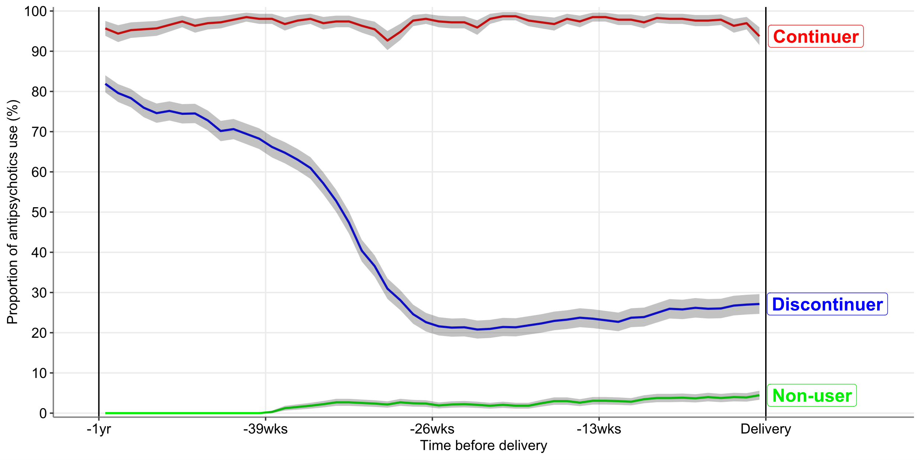

**Supplementary Fig. 2. Antipsychotics use trajectories within 1 year prior to delivery**

Antipsychotic use trajectories during the period from 1 year before delivery to the date of delivery (the period of antipsychotic use pattern ascertainment) were presented by the antipsychotic use pattern. We divided this 1 year into 1-week intervals and coded whether women used antipsychotics or not for each interval. The proportions (represented by solid lines) and the 95% confidence intervals (indicated by shaded areas) of antipsychotic use in each 1-week interval were presented.

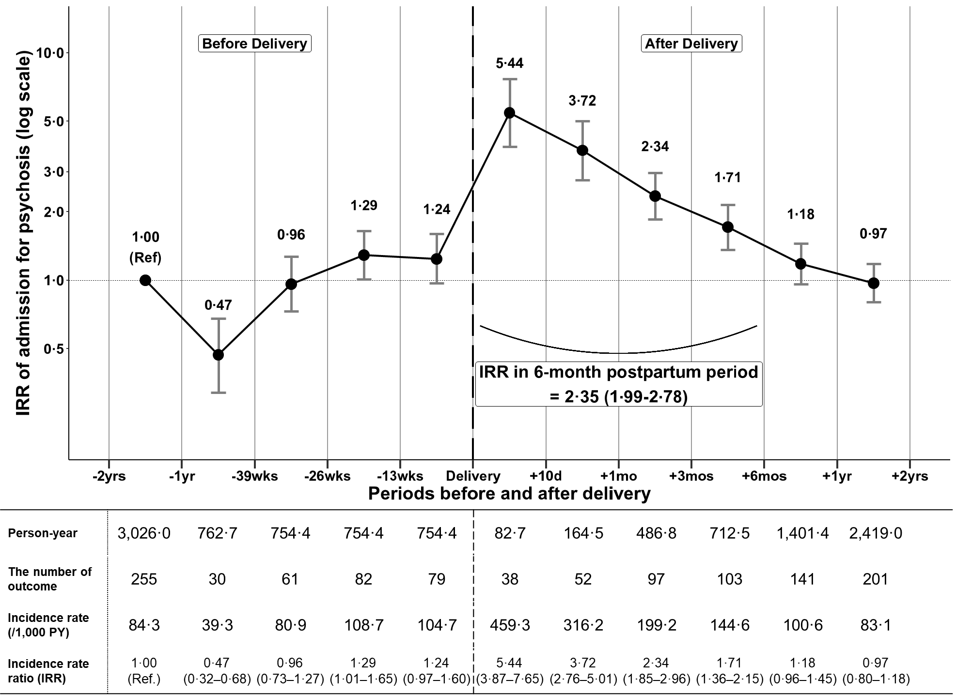

**Supplementary Fig. 3. Risks of admission for psychosis surrounding delivery among women with schizophrenia (N=3,026)**

With the period from 2 years to 1 year before delivery as the reference, the incidence rate ratio of admission for psychosis in each period was estimated using conditional Poisson regression analyses.

IRR, incidence rate ratio; PY, person-year

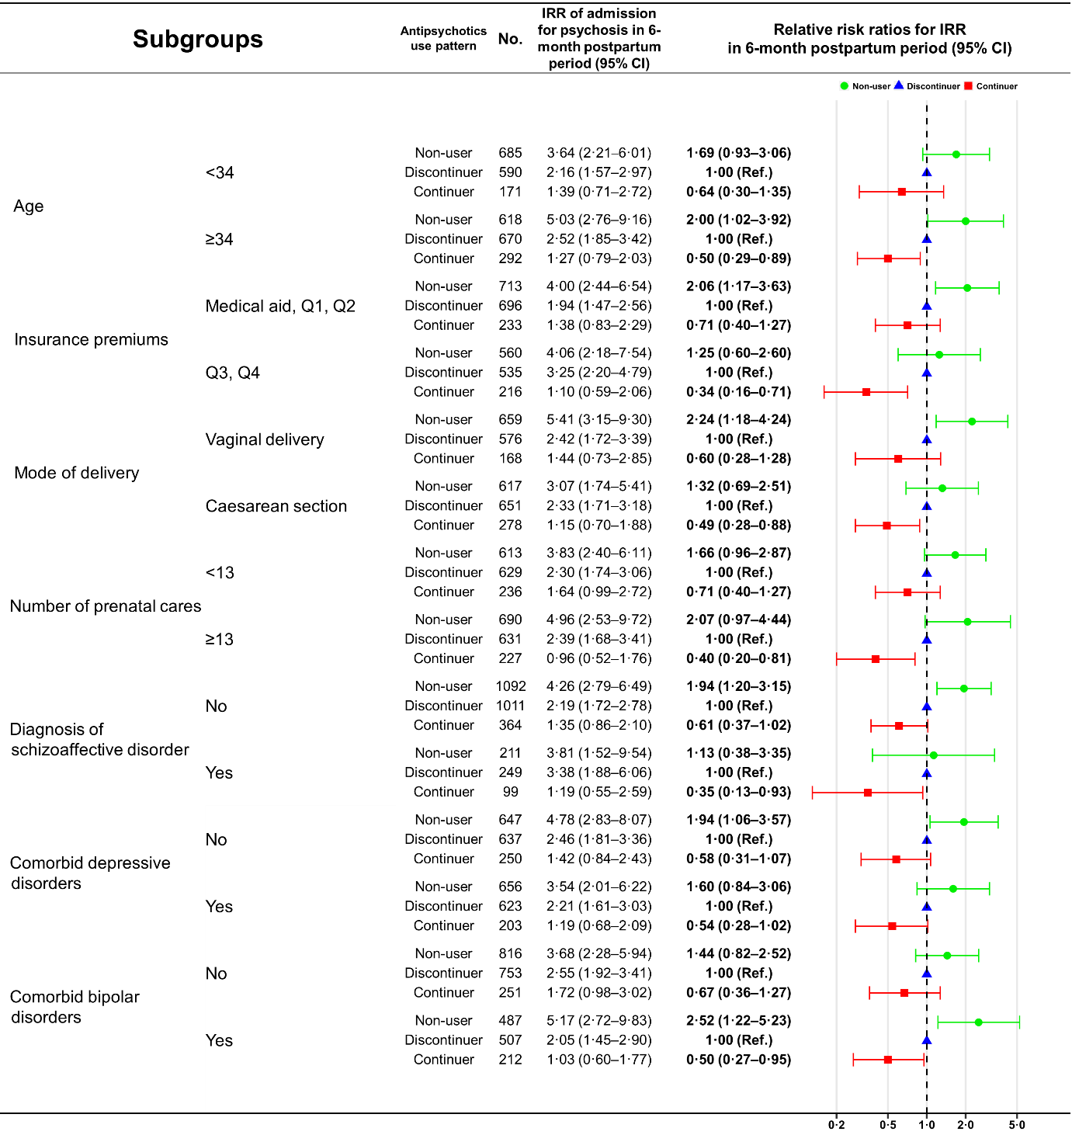

**Supplementary Fig. 4. Subgroup analyses**

With the period from 2 years to 1 year before delivery as the reference, the incidence rate ratio of admission for psychosis in each period was estimated using conditional Poisson regression analyses.

Non-user: No antipsychotics use from 1 year to 39 weeks before delivery.

Discontinuer: Antipsychotics use from 1 year to 39 weeks before delivery + discontinued antipsychotics before delivery.

Continuer: Antipsychotics use from 1 year to 39 weeks before delivery + no discontinuation of antipsychotics before delivery.

Subgroups for age and the number of prenatal cares were stratified based on their respective median values.

Insurance premium is categorized based on quartiles among the entire South Korean population; and medical aid group consists of socioeconomically disadvantaged individuals who do not pay medical insurance premiums.

Diagnosis of schizoaffective disorder was defined as a diagnosis of F25 in the period from the first diagnosis of schizophrenia to 2 years before the index delivery.

Comorbid depressive disorders were defined as a diagnosis of F32–33 or consecutive antidepressant use for 90 days or more in the period from the first diagnosis of schizophrenia to 2 years before the index delivery.

Comorbid bipolar disorders were defined as a diagnosis of F30–31 or consecutive mood stabilizer use for 90 days or more in the period from the first diagnosis of schizophrenia to 2 years before the index delivery

IRR, incidence rate ratio

|  |  |  |
| --- | --- | --- |
| **Supplementary Table 1. List of included psychotropic drugs** | | |
| **Antipsychotics** | **Antidepressants** | **Mood stabilisers** |
| Haloperidol | Fluoxetine | Lithium |
| Levomepromazine | Paroxetine | Valproate (Divalproex) |
| Chlorpromazine | Sertraline | Topiramate |
| Perphenazine | Escitalopram | Lamotrigine |
| Pimozide | Citalopram | Carbamazepine |
| Risperidone | Fluvoxamine | Oxcarbazepine |
| Paliperidone | Duloxetine |  |
| Olanzapine | Venlafaxine |  |
| Quetiapine | Desvenlafaxine |  |
| Clozapine | Milnacipran |  |
| Aripiprazole | Bupropion |  |
| Ziprasidone | Tianeptine |  |
| Sulpiride | Mirtazapine |  |
| Amisulpride | Trazodone |  |
| Zotepin | Vortioxetine |  |
| Blonanserin | Agomelatine |  |
|  | | |

|  |  |  |  |  |
| --- | --- | --- | --- | --- |
| **Supplementary Table 2. Descriptive characteristics of women with schizophrenia by antipsychotics use pattern (N=3,026)** | | | | |
| **Variables** | **Non-user1**  **(N=1,303, 43·1%)** | **Discontinuer2**  **(N=1,260, 41·6%)** | **Continuer3**  **(N=463, 15·3%)** | **p-value** |
| **Age at delivery, years, Median [IQR]** | 33 [30-36] | 34 [31-37] | 35 [32-38] | <0·001 |
| **Insurance premium quartile4, N (%)** |  |  |  | <0·001 |
| Medical aid5 | 91 (7·1) | 134 (10·9) | 61 (13·6) |  |
| Q1(lowest) | 307 (24·1) | 277 (22·5) | 83 (18·5) |  |
| Q2 | 315 (24·7) | 285 (23·2) | 89 (19·8) |  |
| Q3 | 357 (28·0) | 346 (28·1) | 123 (27·4) |  |
| Q4(highest) | 203 (15·9) | 189 (15·4) | 93 (20·7) |  |
| **Region of residence, N(%)** |  |  |  | 0·602 |
| Metropolitan area | 544 (41·8) | 513 (40·7) | 187 (40·4) |  |
| Urban area | 644 (49·5) | 615 (48·8) | 234 (50·5) |  |
| Rural area | 113 (8·7) | 132 (10·5) | 42 (9·1) |  |
| **Mode of delivery, N(%)** |  |  |  | <0·001 |
| Vaginal delivery | 659 (51·6) | 576 (46·9) | 168 (37·7) |  |
| Cesarean section | 617 (48·4) | 651 (53·1) | 278 (62·3) |  |
| **Number of prenatal cares, Median [IQR]** | 13 [9-16] | 13 [9-16] | 12 [8-16] | 0·254 |
| **Admission for psychosis in the 6-months postpartum period, N(%)** | 77 (5·9) | 162 (12·9) | 41 (8·9) | <0·001 |
| From the first diagnosis of schizophrenia to two years before delivery | | | | |
| **Diagnosis of schizoaffective disorder, N(%)** | 211 (16·2) | 249 (19·8) | 99 (21·4) | 0·014 |
| **Comorbid depressive disorders,6 N(%)** | 656 (50·3) | 623 (49·4) | 203 (43·8) | 0·051 |
| **Comorbid bipolar disorders,7 N(%)** | 487 (37·4) | 507 (40·2) | 212 (45·8) | 0·006 |
| 1Non-user: No antipsychotics use from 1 year to 39 weeks before delivery.  2Discontinuer: Antipsychotics use from 1 year to 39 weeks before delivery + discontinued antipsychotics before delivery.  3Continuer: Antipsychotics use from 1 year to 39 weeks before delivery + no discontinuation of antipsychotics before delivery.  4Insurance premium is categorized based on quartiles among the entire South Korean population.  5Medical aid group consists of socioeconomically disadvantaged individuals who do not pay medical insurance premiums.  6Comorbid depressive disorders: diagnosis of depressive disorders (ICD-10; F32,F33) or antidepressants use≥ 60days  7Comorbid bipolar disorders: diagnosis of bipolar disorders (ICD-10; F30,F31) or mood stabilisers use≥ 60days  IQR, interquartile range | | | | |

|  |  |  |  |  |
| --- | --- | --- | --- | --- |
| **Supplementary Table 3. Risks of admission for psychosis surrounding delivery by antipsychotics use pattern (N=3,026)** | | | | |
| **Period (the date of delivery as a fiducial time point)** | **Person-years** | **The number of admissions for psychosis** | **IR of admission for psychosis (/1,000PY)** | **IRR of admission for psychosis (95% CI)** |
| **Non-user1 (N=1,303)** | | | | |
| -2years ≤ period < -1year (Reference) | 1303·0 | 39 | 29·9 | 1·00 (Ref.) |
| -1year ≤ period < -39weeks | 328·4 | 0 | 0 | - |
| -39weeks ≤ period < -26weeks | 324·9 | 13 | 40·0 | 1·34 (0·71-2·50) |
| -26weeks ≤ period < -13weeks | 324·9 | 10 | 30·8 | 1·03 (0·51-2·06) |
| -13weeks ≤ period < delivery | 324·9 | 12 | 36·9 | 1·23 (0·65-2·36) |
| +1day ≤ period < +10days | 35·6 | 10 | 280·7 | 9·36 (4·67-18·8) |
| +10days ≤ period < +30days | 70·9 | 16 | 225·7 | 7·49 (4·18-13·4) |
| +30days ≤ period < +90days | 209·6 | 25 | 119·2 | 3·90 (2·36-6·44) |
| +90days ≤ period < +180days | 306·3 | 29 | 94·7 | 3·06 (1·89-4·95) |
| +180days ≤ period < +1year | 597·0 | 28 | 46·9 | 1·51 (0·93-2·47) |
| +1year ≤ period < +2years | 1009·0 | 49 | 48·6 | 1·50 (0·97-2·31) |
| +1day ≤ period < +180days (6-months postpartum period) | 622·5 | 80 | 128·5 | 4·18 (2·85-6·12) |
| **Discontinuer2 (N=1,260)** | | | | |
| -2years ≤ period < -1year (Reference) | 1260·0 | 149 | 118·3 | 1·00 (Ref.) |
| -1year ≤ period < -39weeks | 317·6 | 19 | 59·8 | 0·51 (0·31-0·82) |
| -39weeks ≤ period < -26weeks | 314·1 | 29 | 92·3 | 0·78 (0·52-1·16) |
| -26weeks ≤ period < -13weeks | 314·1 | 64 | 203·7 | 1·72 (1·29-2·31) |
| -13weeks ≤ period < delivery | 314·1 | 55 | 175·1 | 1·48 (1·09-2·02) |
| +1day ≤ period < +10days | 34·5 | 21 | 608·7 | 5·14 (3·26-8·12) |
| +10days ≤ period < +30days | 68·5 | 29 | 423·1 | 3·55 (2·39-5·29) |
| +30days ≤ period < +90days | 203·2 | 57 | 280·5 | 2·36 (1·74-3·20) |
| +90days ≤ period < +180days | 298·3 | 61 | 204·5 | 1·74 (1·29-2·34) |
| +180days ≤ period < +1year | 589·5 | 88 | 149·3 | 1·27 (0·97-1·66) |
| +1year ≤ period < +2years | 1038·9 | 115 | 110·7 | 0·96 (0·75-1·24) |
| +1day ≤ period < +180days (6-months postpartum period) | 604·6 | 168 | 277·9 | 2·34 (1·87-2·91) |
| **Continuer3 (N=463)** | | | | |
| -2years ≤ period < -1year (Reference) | 463·0 | 67 | 144·7 | 1·00 (Ref.) |
| -1year ≤ period < -39weeks | 116·7 | 11 | 94·3 | 0·65 (0·34-1·23) |
| -39weeks ≤ period < -26weeks | 115·4 | 19 | 164·6 | 1·14 (0·68-1·89) |
| -26weeks ≤ period < -13weeks | 115·4 | 8 | 69·3 | 0·48 (0·23-1·00) |
| -13weeks ≤ period < delivery | 115·4 | 12 | 104·0 | 0·72 (0·39-1·33) |
| +1day ≤ period < +10days | 12·6 | 7 | 555·2 | 3·81 (1·75-8·31) |
| +10days ≤ period < +30days | 25·0 | 7 | 279·4 | 1·91 (0·88-4·15) |
| +30days ≤ period < +90days | 74·0 | 15 | 202·7 | 1·38 (0·79-2·42) |
| +90days ≤ period < +180days | 107·9 | 13 | 120·5 | 0·83 (0·46-1·50) |
| +180days ≤ period < +1year | 214·8 | 25 | 116·4 | 0·79 (0·49-1·25) |
| +1year ≤ period < +2years | 371·2 | 37 | 99·7 | 0·67 (0·44-1·02) |
| +1day ≤ period < +180days (6-months postpartum period) | 219·5 | 42 | 191·3 | 1·31 (0·89-1·92) |
| 1Non-user: No antipsychotics use from one year before delivery to 39 weeks before delivery.  2Discontinuer: Antipsychotics use from one year before delivery to 39 weeks before delivery + discontinued antipsychotics before delivery.  3Continuer: Antipsychotics use from one year before delivery to 39 weeks before delivery + no discontinuation of antipsychotics before delivery.  IR, incidence rate; IRR, incidence rate ratio; CI, confidence interval | | | | |

|  |  |  |  |  |
| --- | --- | --- | --- | --- |
| **Supplementary Table 4. Risks of admission for psychosis surrounding delivery by time point of antipsychotics discontinuation (N=1,260)** | | | | |
| **Period (the date of delivery as a fiducial time point)** | **Person-years** | **The number of admissions for psychosis** | **IR of admission for psychosis (/1,000PY)** | **IRR of admission for psychosis (95% CI)** |
| **One year before delivery ~ 39 weeks before delivery (N=468)** | | | | |
| -2years ≤ period < -1year (Reference) | 468·0 | 54 | 115·4 | 1·00 (Ref.) |
| -1year ≤ period < -39weeks | 118·0 | 4 | 33·9 | 0·29 (0·11-0·81) |
| -39weeks ≤ period < -26weeks | 116·7 | 14 | 120·0 | 1·04 (0·58-1·87) |
| -26weeks ≤ period < -13weeks | 116·7 | 25 | 214·3 | 1·86 (1·16-2·98) |
| -13weeks ≤ period < delivery | 116·7 | 19 | 162·8 | 1·41 (0·84-2·38) |
| +1day ≤ period < +10days | 12·8 | 8 | 623·9 | 5·41 (2·57-11·4) |
| +10days ≤ period < +30days | 25·5 | 9 | 353·3 | 3·04 (1·50-6·16) |
| +30days ≤ period < +90days | 75·6 | 19 | 251·4 | 2·21 (1·31-3·73) |
| +90days ≤ period < +180days | 111·4 | 23 | 206·5 | 1·83 (1·12-2·99) |
| +180days ≤ period < +1year | 221·1 | 29 | 131·2 | 1·19 (0·75-1·89) |
| +1year ≤ period < +2years | 388·3 | 44 | 113·3 | 1·08 (0·71-1·65) |
| +1day ≤ period < +180days (6-months postpartum period) | 225·2 | 59 | 262·0 | 2·28 (1·58-3·31) |
| **39 weeks before delivery ~ 26 weeks before delivery (N=625)** | | | | |
| -2years ≤ period < -1year (Reference) | 625·0 | 72 | 115·2 | 1·00 (Ref.) |
| -1year ≤ period < -39weeks | 157·5 | 14 | 88·9 | 0·77 (0·44-1·37) |
| -39weeks ≤ period < -26weeks | 155·8 | 9 | 57·8 | 0·50 (0·25-1·00) |
| -26weeks ≤ period < -13weeks | 155·8 | 34 | 218·2 | 1·89 (1·26-2·85) |
| -13weeks ≤ period < delivery | 155·8 | 29 | 186·1 | 1·62 (1·05-2·49) |
| +1day ≤ period < +10days | 17·1 | 9 | 526·2 | 4·56 (2·28-9·12) |
| +10days ≤ period < +30days | 33·9 | 14 | 412·7 | 3·55 (2·00-6·29) |
| +30days ≤ period < +90days | 100·7 | 31 | 307·9 | 2·62 (1·72-3·99) |
| +90days ≤ period < +180days | 147·9 | 31 | 209·6 | 1·78 (1·17-2·71) |
| +180days ≤ period < +1year | 291·3 | 41 | 140·8 | 1·17 (0·79-1·71) |
| +1year ≤ period < +2years | 512·2 | 54 | 105·4 | 0·88 (0·61-1·26) |
| +1day ≤ period < +180days (6-months postpartum period) | 299·6 | 85 | 283·7 | 2·41 (1·76-3·30) |
| **26 weeks before delivery ~ 13 weeks before delivery (N=113)** | | | | |
| -2years ≤ period < -1year (Reference) | 124·0 | 15 | 121·0 | 1·00 (Ref.) |
| -1year ≤ period < -39weeks | 31·3 | 0 | 0 | - |
| -39weeks ≤ period < -26weeks | 30·9 | 4 | 129·4 | 1·07 (0·35-3·22) |
| -26weeks ≤ period < -13weeks | 30·9 | 4 | 129·4 | 1·07 (0·35-3·22) |
| -13weeks ≤ period < delivery | 30·9 | 6 | 194·1 | 1·60 (0·62-4·14) |
| +1day ≤ period < +10days | 3·4 | 4 | 1177·4 | 9·73 (3·23-29·3) |
| +10days ≤ period < +30days | 6·8 | 4 | 588·7 | 4·87 (1·62-14·7) |
| +30days ≤ period < +90days | 20·2 | 5 | 247·5 | 2·09 (0·76-5·76) |
| +90days ≤ period < +180days | 29·4 | 3 | 101·9 | 0·96 (0·27-3·35) |
| +180days ≤ period < +1year | 58·4 | 11 | 188·4 | 1·90 (0·83-4·32) |
| +1year ≤ period < +2years | 104·5 | 11 | 105·2 | 1·07 (0·46-2·48) |
| +1day ≤ period < +180days (6-months postpartum period) | 59·8 | 16 | 267·4 | 2·34 (1·15-4·76) |
| **13 weeks before delivery ~ delivery (N=53)** | | | | |
| -2years ≤ period < -1year (Reference) | 43·0 | 8 | 186·0 | 1·00 (Ref.) |
| -1year ≤ period < -39weeks | 10·8 | 1 | 92·3 | 0·50 (0·06-3·97) |
| -39weeks ≤ period < -26weeks | 10·7 | 2 | 186·6 | 1·00 (0·21-4·72) |
| -26weeks ≤ period < -13weeks | 10·7 | 1 | 93·3 | 0·50 (0·06-4·01) |
| -13weeks ≤ period < delivery | 10·7 | 1 | 93·3 | 0·50 (0·06-4·01) |
| +1day ≤ period < +10days | 1·2 | 0 | 0 | - |
| +10days ≤ period < +30days | 2·4 | 2 | 850·8 | 4·56 (0·97-21·5) |
| +30days ≤ period < +90days | 6·7 | 2 | 296·7 | 1·52 (0·32-7·16) |
| +90days ≤ period < +180days | 9·6 | 4 | 415·0 | 2·03 (0·61-6·73) |
| +180days ≤ period < +1year | 18·8 | 7 | 372·0 | 1·73 (0·63-4·76) |
| +1year ≤ period < +2years | 33·7 | 6 | 177·8 | 0·85 (0·29-2·53) |
| +1day ≤ period < +180days (6-months postpartum period) | 19·9 | 8 | 401·9 | 2·03 (0·76-5·40) |
| IR, incidence rate; IRR, incidence rate ratio; CI, confidence interval | | | | |