Supplementary data

**PRISMA-P Table**

**[to be added on submission]**

# Search strings used

A search was conducted in MEDLINE, PsychINFO and EMBASE using the following terms as keywords:

“prenatal or pre-natal or in utero or in-utero or ante-natal or antenatal or pregnancy or prepartum or pregnant or infancy or infant or early life or neonate or newborn or child or 0-2 year*” and “antibiotic* or antimicrobial” and ”Neurocognitive or cognitive or cognition or neurodevelopment or autism or ASD or emotional or behavioral or behavioural or developmental delay or internalizing behavior or externalizing behavior or Attention Deficit Hyperactivity Disorder or ADHD or educational outcome or psychiatric or mental illness or mental disorder or major depressive disorder or major depression or anxiety or schizophrenia or psychotic or bipolar disorder or bipolar affective disorder or mood disorder or eating disorder or anorexia or bulimia or conduct disorder”.

Searches were limited to English, peer reviewed and humans.

# PICOS table

|  |  |
| --- | --- |
| **Population** | Anyone with available health data pertaining to early life or in-utero antibiotic exposure and later psychiatric and neurocognitive outcomes |
| **Intervention** | Exposure to antibiotics in utero or childhood (prior to age 2) |
| **Comparison** | No antibiotic exposure in-utero or childhood (prior to age 2) |
| **Outcome** | Any psychiatric or neurocognitive outcomes (e.g. ASD, ADHD, Major Depressive Disorder, educational outcomes, etc) |
| **Setting** | inpatient, outpatient, community or maternal (in-utero) exposure |
| **Question** | Is early antibiotic exposure associated with an increased risk of psychiatric or neurocognitive outcomes? |

# List of all included papers

1. Abelson N, Meiri G, Solomon S, Flusser H, Michaelovski A, Dinstein I, et al. Association Between Antenatal Antimicrobial Therapy and Autism Spectrum Disorder—A Nested Case-Control Study. Front Psychiatry. 2021;12.
2. Bittker SS, Bell KR. Acetaminophen, antibiotics, ear infection, breastfeeding, vitamin D drops, and autism: An epidemiological study. Neuropsychiatr Dis Treat. 2018;14.
3. Grossi E, Veggo F, Narzisi A, Compare A, Muratori F. Pregnancy risk factors in autism: a pilot study with artificial neural networks. Pediatric Research. 2016;79(2):339-47.
4. Grossi E, Migliore L, Muratori F. Pregnancy risk factors related to autism: an Italian case–control study in mothers of children with autism spectrum disorders (ASD), their siblings and of typically developing children. Journal of Developmental Origins of Health and Disease. 2018;9(4):442-9.
5. Guisso DR, Saadeh FS, Saab D, El Deek J, Chamseddine S, Abou-El-Hassan H, et al. Association of Autism with Maternal Infections, Perinatal and Other Risk Factors: A Case-Control Study. J Autism Dev Disord. 2018;48(6):2010-21.
6. George B, Padmam MS, Nair MK, Leena ML, Russell PS. CDC Kerala 13: Antenatal, natal and postnatal factors among children (2-6 y) with autism--a case control study. Indian J Pediatr. 2014;81 Suppl 2:S133-7.
7. Mrozek-Budzyn D, Majewska R, Kieltyka A. Prenatal, perinatal and neonatal risk factors for autism - study in Poland. Open Medicine. 2013;8(4):424-30.
8. Slob EMA, Brew BK, Vijverberg SJH, Dijs T, van Beijsterveldt CEM, Koppelman GH, et al. Early-life antibiotic use and risk of attention-deficit hyperactivity disorder and autism spectrum disorder: results of a discordant twin study. Int J Epidemiol. 2021;50(2):475-84.
9. Atladóttir HÓ, Henriksen TB, Schendel DE, Parner ET. Autism after infection, febrile episodes, and antibiotic use during pregnancy: An exploratory study. Pediatrics. 2012;130(6):e1447-e54.
10. Aversa Z, Atkinson EJ, Schafer MJ, Theiler RN, Rocca WA, Blaser MJ, et al. Association of Infant Antibiotic Exposure With Childhood Health Outcomes. Mayo Clin Proc. 2021;96(1):66-77.
11. Axelsson PB, Clausen TD, Petersen AH, Hageman I, Pinborg A, Kessing LV, et al. Investigating the effects of cesarean delivery and antibiotic use in early childhood on risk of later attention deficit hyperactivity disorder. Journal of Child Psychology and Psychiatry. 2019;60(2):151-9.
12. Axelsson PB, Clausen TD, Petersen AH, Hageman I, Pinborg A, Kessing LV, et al. Relation Between Infant Microbiota and Autism?: Results from a National Cohort Sibling Design Study. Epidemiology. 2019;30(1):52-60.
13. Delara M, McMillan DE, Nickel NC, Jong GWt, Seitz DP, Mignone J. Early life exposure to antibiotics and the risk of mood and anxiety disorders in children and adolescents: A population-based cohort study. Journal of psychiatric research. 2021;137:621-33.
14. Hamad AF, Alessi-Severini S, Mahmud SM, Brownell M, Kuo IF. Antibiotic Exposure in the First Year of Life and the Risk of Attention-Deficit/Hyperactivity Disorder: A Population-Based Cohort Study. Am J Epidemiol. 2019;188(11):1923-31.
15. Hamad AF, Alessi-Severini S, Mahmud S, Brownell M, Kuo IF. Prenatal antibiotic exposure and risk of attention-deficit/hyperactivity disorder: a population-based cohort study. CMAJ. 2020;192(20):E527-E35.
16. Hamad AF, Alessi-Severini S, Mahmud SM, Brownell M, Kuo IF. Early childhood antibiotics use and autism spectrum disorders: a population-based cohort study. Int J Epidemiol. 2018;47(5):1497-506.
17. Hamad AF, Alessi-Severini S, Mahmud SM, Brownell M, fan Kuo I. Prenatal antibiotics exposure and the risk of autism spectrum disorders: A population-based cohort study. PLoS ONE. 2019;14(8).
18. Lavebratt C, Yang LL, Giacobini M, Forsell Y, Schalling M, Partonen T, et al. Early exposure to antibiotic drugs and risk for psychiatric disorders: a population-based study. Transl Psychiatry. 2019;9(1):317.
19. Holingue C, Brucato M, Ladd‐Acosta C, Hong X, Volk H, Mueller NT, et al. Interaction between maternal immune activation and antibiotic use during pregnancy and child risk of autism spectrum disorder. Autism Res. 2020;13(12):2230-41.
20. Slykerman RF, Coomarasamy C, Wickens K, Thompson JMD, Stanley TV, Barthow C, et al. Exposure to antibiotics in the first 24 months of life and neurocognitive outcomes at 11 years of age. Psychopharmacology. 2019;236(5):1573-82.
21. Slykerman RF, Thompson J, Waldie KE, Murphy R, Wall C, Mitchell EA. Antibiotics in the first year of life and subsequent neurocognitive outcomes. Acta Paediatr. 2017;106(1):87-94.
22. Firestein MR, Myers MM, Austin J, Stark RI, Barone JL, Ludwig RJ, et al. Perinatal antibiotics alter preterm infant EEG and neurobehavior in the Family Nurture Intervention trial. Dev Psychobiol. 2019;61(5):661-9.
23. Stark CM, Susi A, Nierenberg AA, Nylund CM. Association of Early Life Prescriptions for Antibiotics and Acid Suppressants with Childhood Psychotropic Prescriptions. The Journal of Pediatrics. 2022;246:191-8.e4.
24. and the risk of attention-deficit/hyperactivity disorder: A real-world evidence study. Early Human Development. 2023;187:105897.
25. Lin Y-C, Lin C-H, Lin M-C. The Association of Prenatal Antibiotic Use with Attention Deficit and Autism Spectrum Disorders: A Nationwide Cohort Study. Children [Internet]. 2023; 10(7).
26. Ozsvar J, Gissler M, Lavebratt C, Nilsson IAK. Exposures during pregnancy and at birth are associated with the risk of offspring eating disorders. Int J Eat Disord. 2023.
27. Straughen JK, Sitarik AR, Wegienka G, Cole Johnson C, Johnson-Hooper TM, Cassidy-Bushrow AE. Association between prenatal antimicrobial use and offspring attention deficit hyperactivity disorder. PLoS One. 2023;18(5):e0285163.
28. Nitschke AS, do Valle HA, Vallance BA, Bickford C, Ip A, Lanphear N, et al. Association between prenatal antibiotic exposure and autism spectrum disorder among term births: A population-based cohort study. Paediatric and Perinatal Epidemiology. 2023;37(6):516-26.
29. Njotto LL, Simin J, Fornes R, Odsbu I, Mussche I, Callens S, et al. Maternal and Early-Life Exposure to Antibiotics and the Risk of Autism and Attention-Deficit Hyperactivity Disorder in Childhood: a Swedish Population-Based Cohort Study. Drug Safety. 2023;46(5):467-78.
30. Slykerman RF, Neumann D, Underwood L, Hobbs M, Waldie KE. Age at first exposure to antibiotics and neurodevelopmental outcomes in childhood. Psychopharmacology (Berl). 2023;240(5):1143-50.

**Supplementary Table 1 – Characteristics of included studies**

|  |  |  |  |  |  |  |
| --- | --- | --- | --- | --- | --- | --- |
| **First author, year** | **Study details** | **Population**  **(cohort or case-control definition)** | **Sample size and demographic data** | **Antibiotic exposure details** | **Details of Outcome** | **Adjustment for covariates/ matching** |
| **ASD** | | | | | | |
| Abelson, 2021 | **Country:** Israel  **Study type:** Case-control | **Cases:** Children with a diagnosis of ASD who were born at the Soroka University Medical Center (SUMC), Beer-Sheva, between the years 2008 and 2016 and who were members of Clalit, the largest Health Maintenance Organization (HMO)  in Israel.  **Controls**: As above, but without a diagnosis of ASD, or other psychiatric or genetic disorders, randomly sampled from the electronic medical records of SUMC and individually matched to cases | **Number of participants (n=):**  Total: 2706  Cases: 451  Controls: 2255  **Sibling control group**: no  **Male (%):** 81%  **Ethnicity**: Jewish 71%, Bedoin 19% | **Exposure period:** perinatal and 3 months prior to pregnancy  **Data source**: SUMC database, and outpatient clinic database | **Outcome:** ASD  **Age at diagnosis:** Not reported  **Data source:** SUMC database, and outpatient clinic database  **Definition/determination of ASD**: Diagnosed with ASD at SUMC, and enrolled in the database of the National Autism Research Centre of Israel | **Adjustment for covariates**: age, low socioeconomic status, obesity, epilepsy, hypertension, anti-hyperglycaemic medication, and inhaled adrenergic medication  **Matching**: Controls were individually matched to the case group at a ratio of 5:1 according to age, sex, and ethnic origin (Jewish or Bedouin) |
| Atladottir, 2012 | **Country:** Denmark  **Study type:** Cohort study | **Study cohort:** children aged 8-14 years with a diagnosis of ASD whose mothers were registered with the Danish National Birth Cohort (DNBC) from 1996-2002. | **Number of participants (n=):**  Total: 96,736  ASD: 792  Non-ASD: 48808  **Sibling control group**: no  **Male (%):**  ASD: 51.0  Non-ASD: 81.1  **Ethnicity**: not reported | **Exposure period:** prenatal  **Data source**: telephone interviews during pregnancy and early postpartum | **Outcome:** ASD  **Age at diagnosis:** Not reported  **Data source:** Danish psychiatric central register  **Definition/determination of ASD**: DNBC children with an ICD-10 dx of ASD made by a psychiatrist | **Adjustment for covariates**: gender, maternal age, parity, and maternal smoking during pregnancy, paternal age, parental psych history before the birth of the child, parent’s educational status  **Matching**: Nil |
| Axelsson, 2019 | **Country:** Denmark  **Study type:** Cohort study | **Study cohort:** All live-born singleton births in Denmark to Danish parents from January 1997 - December 2010. All children who had not been diagnosed with autism and were living in Denmark at their second birthday were followed up. | **Number of participants (n=):**  Total: 671,606  ASD: 8,267  Non-ASD: 663339  **Sibling control group**: Yes  **Male (%):**51.3  **Ethnicity**: Not reported | **Exposure period:** early life (age 0-2 years)  **Data source**: The Register of Medicinal Products Statistics (1997 to 2015) | **Outcome:** ASD  **Age at diagnosis:** 2-18 years  **Data source:** The Psychiatric Central Research Register (1969 to 2015)  **Definition/determination of ASD**: time to first autism diagnosis as identified through ICD-9 and 10 codes using outpatient and inpatient diagnoses, and discharge diagnoses | **Adjustment for covariates**: mode of delivery, maternal age at birth, parental age difference, parental education, marital status, maternal smoking, infant sex, Apgar score, instrumental delivery, use of CPAP/ventilator, asphyxia, parental epilepsy, pre-eclampsia/HTN, gestational diabetes, parity, induction of labour, induction of contractions, maternal Abx use in pregnancy, maternal infections in pregnancy), parental psych history  **Matching**: Nil |
| Bittker, 2019 | **Country:** US  **Study type:** Case-control | **Cases**: Children born to parents living in USA aged 3-12 years of age with ASD identified through parental report. Parents were informed about the survey via postings on social media, websites, and listservs and through the Interactive Autism Network.  **Controls**: Children aged 3-12 years of age without ASD according to parental report. Recruitment strategies as above. | **Number of participants (n=):**  Total: 1515  Cases: 1001  Controls: 514  **Sibling control group**: No  **Male (%):**  Cases: 80.0  Controls: 52.1  **Ethnicity**:  Cases:  White (non-Hispanic): 77.2  Hispanic/Latino: 10.4  African American/Black: 3.9  Asian: 1.9  Other: 6.6  Controls:  White (non-Hispanic): 85.2 Hispanic/Latino: 5.8  African American/Black: 1.0  Asian: 2.1  Other: 5.8 | **Exposure period:**  early life (age 0-2 years)  **Data source**: parental report via internet survey | **Outcome:** ASD  **Age at diagnosis:** Not reported  **Data source:** An Internet-based survey was conducted.  **Definition/determination of ASD**: ASD was identified through parental report | **Adjustment for covariates**: Unadjusted. The OR for outcome of interest was not provided in study. However, raw data was available, and as such ORs were manually calculated and used in this meta-analysis.  **Matching**: Nil |
| George, 2014 | **Country:** India  **Study type:** Case-control | **Cases**: 2–6 year-old children with autism, attending autism clinic of Child Development Centre of Sree Avittam Thirunal (SAT) Hospital, Thiruvananthapuram, who had a CARS score of ≥30  **Controls**: normal children in the same age group were recruited from the well-baby/immunization clinic of SAT Hospital, Thiruvananthapuram | **Number of participants (n=):**  Total: 343  Cases: 143  Controls: 200  **Sibling control group**: No  **Male (%):**  Cases: 83.7  Controls: 57.5  **Ethnicity**: Not reported | **Exposure period:**  prenatal  **Data source**: Structured parental interview conducted by a social scientist | **Outcome:** ASD  **Age at diagnosis:** Not reported  **Data source:** Structured parental interview conducted by a social scientist  **Definition/determination of ASD**: Diagnosis via the autism clinic of SAT Hospital, using CARS score of ≥30 | **Adjustment for covariates**: Nil adjustment  **Matching**: Nil |
| Grossi, 2016 | **Country:** Italy  **Study type:** Case-control | **Cases:** children with independent diagnoses of autism according to DSM-5 criteria, subsequently confirmed by a qualified child and adolescent psychiatrist at Villa Santa Maria, Tavernerio (Italy) where the patients reside. Further details of the recruitment or study population are not provided.  **Controls:** Controls were recruited via public announcement in the same geographical location as the cases resided. Of note, 31 participants were children of the staff members of Villa Santa Maria and 37 were children of women living in the area. | **Number of participants (n=):**  Total: 113  Cases: 45  Controls: 68  **Sibling control group**: yes  **Male (%):**  Cases: 91.1  Controls: 57.4  **Ethnicity**: Not reported | **Exposure period:**  early life (age 0-3 months)  **Data source**: structured maternal interview | **Outcome:** ASD  **Age at diagnosis:** Not reported  **Data source:** structured maternal interview  **Definition/determination of ASD**: diagnosis using DSM-V criteria, confirmed by an independent child and adolescent psychiatrist | **Adjustment for covariates**: Nil adjustment  **Matching**: Nil |
| Grossi, 2018 | **Country:** Italy  **Study type:** Case-control | **Cases**: Children with a DSM-5 diagnosis of ASD made at Villa Santa Maria Institute and Stella Maris Institute.  **Controls**: Neurotypical controls were recruited via public announcement In the two hospital regions where the cases were recruited. | **Number of participants (n=):**  Total: 169  Cases: 73  Controls: 96  **Sibling control group**: Yes  **Male (%):** Not reported  **Ethnicity**: Not reported | **Exposure period:**  early life (age 0-3 months)  **Data source**: structured maternal interview | **Outcome:** ASD  **Age at diagnosis:** Not reported  **Data source:** structured maternal interview  **Definition/determination of ASD**: diagnosis using DSM-5 criteria, confirmed by an independent child and adolescent psychiatrist | **Adjustment for covariates**: Nil adjustment  **Matching**: Nil |
| Guisso, 2018 | **Country:** Lebanon  **Study type:**  Case control study | **Cases**: children aged 2-18 years attending the American University of Beirut Medical Center Special  Kids Clinic (ASKC) diagnosed with ASD  **Controls**: Lebanese children of the same age without ASD of the same age group recruited through randomized systematic digit dialling in the Greater Beirut area, which aligns with the catchment area of the clinic which cases were recruited from. | **Number of participants (n=):**  Total: 314  Cases: 136  Controls: 178  **Sibling control group**: No  **Male (%):**  Cases: 54.0  Controls: 46.0  **Ethnicity**: Not reported | **Exposure period:** prenatal  **Data source**: maternal questionnaire | **Outcome:** ASD  **Age at diagnosis:** mean age 2.8years (+/-1.5)  **Data source:** maternal questionnaire  **Definition/determination of ASD**: Diagnosis of cases at ASKC was performed by an experienced American Board of Neurology and Psychiatry licensed pediatric neurologist using DSM-IV or DSM-V, depending on the year of diagnosis. Patients diagnosed with Pervasive Developmental Disorder-Not Otherwise Specified and Asperger syndrome were excluded from the study. | **Adjustment for covariates**: The  perinatal variables that were considered were gender, age, type of delivery, delivery complications, and feeding difficulty. Gestation variables comprised infection during pregnancy, influenza, other infections, fever, ingestion of medication, antipyretics, or antibiotics, pregnancy complications, other pregnancy complication, folic acid intake, psychological support, and exposure to smoking at work. Maternal education, paternal education, extended family living in the household, and family history of psychiatric disease were the socioeconomic variables examined  **Matching**: Nil |
| Hamad, 2018 | **Country:** Canada  **Study type:** Cohort Study | **Study cohort:** all live births in Manitoba, Canada, between 1 April 1998 and 31 March 2016 | **Number of participants (n=):**  Total: 214,834  Antibiotic exposure: 94024  Nil antibiotic exposure: 120810  **Sibling control group**: Yes  **Male (%):**  Total: 51.3  Antibiotic exposure: 54.1  Nil antibiotic exposure: 49.0  **Ethnicity**: Not reported | **Exposure period:** early life (0-1years)  **Data source**: antibiotic purchase data via the Manitoba Population Research Data Repository housed at the Manitoba Centre for Health Policy | **Outcome:** ASD  **Age at diagnosis:** mean age of 5.48 years (+/- 3.24)  **Data source:** Administrative health data from the Manitoba Population Research Data Repository. hospital discharge abstracts, medical services (physician claims) and the Manitoba Education and Training Special Needs Funding data  **Definition/determination of ASD**: ICD-9 and 10 codes, as well as DSM-V criteria were used to define ASD from various data sources as above | **Adjustment for covariates**: Adjusted for sex, region, health care access, SES, maternal age at delivery, maternal medical conditions (mood and anxiety disorders, schizophrenia, diabetes, prenatal infections), prenatal antidepressants use, size for gestational age, childhood medical conditions (epilepsy, infections, neonatal jaundice, asthma and diagnosis with other developmental disability disorder), birth complications, mode of delivery, multiple birth, breastfeeding initiation, year of birth, season of birth and birth order.    **Matching**: Nil |
| Hamad, 2019 | **Country:** Canada  **Study type:** Cohort study | **Study cohort:**  all live births identified in the Manitoba Health Insurance Registry between April 1, 1998 and March 31, 2016. | **Number of participants (n=):**  Total: 214,834  antibiotic exposure: 80 750  no antibiotic exposure: 134 084  **Sibling control group**: Yes  **Male (%):** 51.3  **Ethnicity**: Not reported | **Exposure period:** perinatal  **Data source**: antibiotic purchase data via the Manitoba  Population Research Data Repository housed at the Manitoba Centre for Health Policy | **Outcome:** ASD  **Age at diagnosis:** 18 months to 18 years  **Data source:** Administrative  health data from the Manitoba Population Research Data Repository. hospital discharge abstracts, medical services (physician claims) and the Manitoba Education and Training Special Needs Funding data  **Definition/determination of ASD**: ICD-9 and 10 codes, as well as DSM-V criteria were used to define ASD from various data sources as above | **Adjustment for covariates**: sex, region, SES, maternal age at delivery, maternal medical conditions (mood and anxiety disorders, schizophrenia, DM, prenatal infections) prenatal antidepressants use, size for gestational age, childhood medical conditions (epilepsy, infections, neonatal jaundice, asthma and a diagnosis with other developmental disability disorder), antibiotics use in the first year of life, birth complications, mode of delivery, multiple birth, breastfeeding initiation, year of birth, season of birth, and birth order, health care access  **Matching**: Nil |
| Holingue, 2020 | **Country:** USA  **Study type:** Cohort study | **Study cohort**: mother–child pairs from the Boston Birth Cohort, a prospective birth cohort recruited from the Boston Medical Center. Women with a live, singleton birth at Boston Medical Center are eligible for recruitment. Pregnancies involving IVF, chromosomal abnormalities, major birth defects, and preterm deliveries due to maternal trauma are excluded. | **Number of participants (n=):** 976  **Sibling control group**: No  **Male (%):** 44.3  **Ethnicity, maternal (%)**:  Black 61.4  White, non-Hispanic 8.5  Other races 30.0 | **Exposure period:** prenatal  **Data source**: written questionnaire administered 24-72 hours post partum, electronic medical records | **Outcome:** ASD  **Age at diagnosis:** mean age 7.8 years (SD 3.3).  **Data source:** electronic medical records  **Definition/determination of ASD**: ICD-9 codes identified in medical records | **Adjustment for covariates**: Unadjusted. The OR for outcome of interest was not provided in study. However, raw data was available, and as such ORs were manually calculated and used in this meta-analysis.  **Matching**: Nil |
| Mrozek-budzyn, 2013 | **Country:** Poland  **Study type:** Case control study | **Cases**: children, aged 2-15 years, from the Malopolska Voivodship area with a diagnosis of Autism were identified psychiatric outpatient clinic medical records. This clinic services the entire region, and diagnoses are made by a child psychiatrist. Cases with uncertain diagnosis of autism or genetic syndromes, (eg. tuberous sclerosis complex, Fragile X syndrome, and Down syndrome were excluded.  **Controls**: Two individually matched controls were selected for each affected child, by the year of birth, gender, and outpatients’ clinic. The first two children, who visited the GP after the autistic child visit, and met entry criteria served as controls | **Number of participants (n=):**  Total: 288  Cases: 96  Controls: 192  **Sibling control group**: No  **Male (%):**  Total 81.2  Cases: Not reported  Controls: Not reported  **Ethnicity**: Not reported | **Exposure period:** prenatal  **Data source**: parental interview and medical records | **Outcome:** ASD  **Age at diagnosis:** Not reported  **Data source:** parental interview and medical records  **Definition/determination of ASD**: diagnosis made by a child psychiatrist, identified via medical record from outpatient psychiatric clinic | **Adjustment for covariates**: Unadjusted. The OR for outcome of interest was not provided in study. However, raw data was available, and as such ORs were manually calculated and used in this meta-analysis.  **Matching:**controls were matched by year of birth, gender, and outpatients’ clinic |
| Nitschke, 2023 | **Country:** Canada    **Study type:** Cohort study | **Study cohort:** A retrospective cohort of all singleton, term births in the province of British Columbia, Canada between August 2000 and December 2014. Children were followed up until a clinical diagnosis of ASD, their death, the study end date of December 31, 2016, or until they moved out of the province and were lost to follow-up. The cohort comprised nearly 100% of deliveries in British Columbia including home births. | **Number of participants (n=):**  **Total:** 569,953  **Antibiotic exposure:** 169,922  **Nil antibiotic exposure:** 400,031    **Sibling control group:** Yes    **Male (%):**  **Total** 51.3    **Ethnicity:** Not reported | **Exposure period:** prenatal    **Data source:** outpatient prescription and dispensation data | **Outcome: ASD**    **Age at diagnosis:** mean age 5.4 years    **Data source:** Nation wide data records    **Definition/determination of ASD:** ASD diagnosis made by clinicians trained in ASD diagnosis, using structured/standardised clinical instruments: Autism Diagnostic Observation Schedule, and the Autism Diagnostic Interview-Revised. Diagnoses made | **Adjustment for covariates:** Sociodemographic variables including maternal age at delivery, neighbourhood income quintile, location of residence (urban, rural, or semi-rural residence), and co-parentage, pregnancy conditions and risk factors, including parity, smoking during pregnancy, pre-existing diabetes, gestational diabetes, pregnancy-induced hypertension, and other forms of hypertension (which include pre-existing hypertension, hypertensive renal disease, high blood pressure distinct from pre-existing hypertension and proteinuria) and pre-pregnancy body mass index, and labour and delivery factors such as year of delivery, intrapartum antibiotics and mode of delivery, and neonatal characteristics such as infant sex    **Matching:** Nil matching for main analysis |
| **ADHD** | | | | | | |
| Axelsson, 2019 | **Country:** Denmark  **Study type:** Cohort study | **Study cohort:** Danish singleton children born between 1997-2010, alive and living in Denmark on their second birthday | **Number of participants (n=):**  Total: 671,592  ADHD: 17971  Non-ADHD: 653621  **Sibling control group**: Yes  **Male (%):** 81.9  **Ethnicity**: Danish | **Exposure period:** early life (age 0-2 years)  **Data source**: outpatient prescription data | **Outcome:** ADHD  **Age at diagnosis:** mean age 8.05 years (+/- 2.88)  **Data source:** Danish nation wide registers of data for Danish singleton live births in Denmark from 1997 to 2010  **Definition/determination of ASD**: an assignment of an ADHD diagnosis or at least 2 redeemed prescriptions for ADHD medication on separate dates | **Adjustment for covariates**: mode of delivery, maternal age at birth, parental age difference, parental education, marital status, maternal smoking, infant sex, Apgar score, instrumental delivery, use of CPAP/ventilator, asphyxia, parental epilepsy, pre-eclampsia/HTN, gestational diabetes, parity, induction of labour, induction of contractions, maternal antibiotic use in pregnancy, maternal infections in pregnancy, parental ADHD history  **Matching**: Nil |
| Hamad, 2019 | **Country:** Canada  **Study type:** Cohort study | **Study cohort** all children registered in the Manitoba Health Insurance Registry who were born between 1/4/98 and 31/3/17 | **Number of participants (n=):**  Total (matched cohort): 69,738  Antibiotic exposure: 18152  Nil antibiotic exposure: 18152  **Sibling control group**: Yes  **Male (%):** 52.1  **Ethnicity**: Not reported | **Exposure period:** early life (0-1 years)  **Data source**: the Drug Program Information Network, which captures all prescription drug dispensations through community pharmacies. | **Outcome:** ADHD  **Age at diagnosis:** mean age of 8.05 (standard deviation, 2.88) years  **Data source:** Manitoba Population Research Data Repository.  **Definition/determination of ASD**: 1 or more hospitalisations or physician visits with a diagnosis of hyperkinetic syndrome (ICD-9-CM code 314 or ICD-10 code F90), or 2 or more prescriptions for ADHD drugs within a year. Participants were excluded if they had diagnoses of conduct disorder (ICD-9-CM code 312 or ICD-10 codes F63, F91, F92), disturbance of emotions (ICD-9-CM code 313 or ICD-10 codes F93, F94), or cataplexy/ narcolepsy (ICD-9-CM code 347 or ICD-10 code G47.4) | **Adjustment for covariates**: Nil adjustment  **Matching:** cohort was matched by high-dimensional propensity score. |
| Hamad, 2020 | **Country:** Canada  **Study type:** Cohort study | **Study cohort:** all children registered in the Manitoba Health Insurance Registry born between 1/4/98 and 31/3/17 | **Number of participants (n=):**  Total (matched cohort): 129,674  Antibiotic exposure: 64837  Nil antibiotic exposure: 64837  **Sibling control group**: Yes  **Male (%):** 51.5  **Ethnicity**: Not reported | **Exposure period:** prenatal  **Data source**: outpatient prescription data | **Outcome:** ADHD  **Age at diagnosis**: median age of 7.5 (IQR 6.0–9.5) years  **Data source:** the Manitoba Population  Research Data Repository, a collection of de-identified administrative, registry, survey and other types of data housed at the Manitoba Centre for Health Policy.  **Definition/determination of ASD**: ICD-9 and 10 codes in outpatient claims and hospitalisation records, or 2 or more prescriptions for ADHD drugs within a single year without a diagnosis of conduct disorder, disturbance of emotions or cataplexy/narcolepsy | **Adjustment for covariates**: adjusted for maternal asthma.  **Matching**: Cohort was matched by high-dimensional propensity scores |
| Lin, 2023 | **Country:** Taiwan  **Study type:** Cohort study | **Study cohort:** Children born in Taiwan from 2004 to 2012. Exclusion criteria included stillborn infants, death within two years of birth, ADHD diagnosis before age 2, those with a brain injury, and participants with missing data. | **Number of participants (n=):**  Total: 1,601, 689  Antibiotic exposure: 1,141,146  Nil antibiotic exposure: 460,543  **Sibling control group**: No  **Male (%)**: 52.0%  **Ethnicity:** Not reported | **Exposure period:**  Early life (0-2 years)  **Data source:**  Medical records and prescription data | **Outcomes:** ADHD  **Age at diagnosis:** Not reported  **Data source:** National Health Insurance Research Database (NHIRD) [2002-2017] and Taiwan’s Maternal and Child Health Database (TMCHD)  **Definition / determination of ADHD:**  ICD-9 and ICD-10 categories corresponding to ADHD reported as primary or secondary diagnoses with at least three outpatient visits or at least one hospitalization within a year. | **Adjustment for covariates:**  maternal age, mode of delivery, maternal comorbidities, birth weight, gestational age, sex of the child, medication used during pregnancy, insurance amount, degree of urbanisation  **Matching**: Nil |
| Straughen, 2023 | **Country:** America  **Study type:** Cohort study | **Study cohort**: Data for this analysis are from the Wayne County Health, Environment, Allergy and Asthma Longitudinal Study (WHEALS) birth cohort. WHEALS recruited pregnant women who were in their second trimester or later and were seeing a Henry Ford Health System obstetrics practitioner at 1 of 5 clinics [21]. All women delivered from September 2003 through December 2007, were age 21–49 years, and lived in a predefined geographic area that was selected to encourage racial and socioeconomic diversity (city of Detroit and surrounding suburban areas). Children and their parent/guardian were invited to return for a clinic visit at child age 2 years and again at child age 10 years for assessment of child health and parent/guardian completion of surveys about child health as well as sociodemographic and household characteristic | **Number of participants (n=):**  Total:555  ADHD: 108  No ADHD: 447  **Sibling control group**: No  **Male (%):** 51.7  **Ethnicity**:  White: 22.2%  African American: 62.5  Other/mixed: 15.3 | **Exposure period:** prenatal  **Data source**: maternal prenatal and delivery medical records | **Outcome:** ADHD  **Age at diagnosis**: prior to age 10  **Data source:** maternal report at age 10  **Definition/determination of ADHD**: maternal report as to whether a diagnosis of ADHD had been made prior to age 10 | **Adjustment for covariates:** race-ethnicity, insurance coverage, household income, education, marital status, previous pregnancies, smoking during pregnancy, household environmental tobacco smoke, alcohol use, indoor pets, history of asthma and allergies, urban or suburban residence, mode of delivery, body mass index at the first prenatal visit, gestational age at delivery, birthweight, sex- and gestational-age adjusted birthweight z-scores, and breast feeding status.  **Matching**: Nil |
| **Other psychiatric or behavioural outcomes** | | | | | | |
| Delara, 2021 | **Country:** Canada  **Study type:** Cohort Study | **Study cohort:** all children born in Manitoba between  January 1, 1996, and December 31, 2012 in receipt of a public health insurance plan, with at least 3 years coverage from birth, and maternal cover in the one year periods before and after pregnancy. Children were followed until diagnosis of mood of anxiety disorder, age 19, migration, death, or end of the study period. Divided into two cohorts: prenatal and postnatal. | **Number of participants (n=):**  Total: 221,139  Pre-natal cohort: 221,139,  Post-natal cohort: 221,139  **Sibling control group**: no  **Male (%):** 51.2  **Ethnicity**: Not reported | **Exposure period:** prenatal and early life (age 0-3 years)  **Data source**: outpatient dispensing records at Drug Prescriptions Information  Network | **Outcome:** Mood and anxiety disorders  **Age at diagnosis:** mean 11 (+/-3.9)  **Data source:** medical claims, Hospitalization  Discharge Abstracts Database, and Drug Prescriptions Information Network  **Definition/determination of mood and anxiety disorders**:  One or more hospitalisations or physician visits, with mood and anxiety related ICD-9 or 10 codes, or antidepressant or mood stabiliser prescriptions. | **Adjustment for covariates**: maternal age, household income, breastfeeding status, mode of delivery, infant sex, region of residence, number of births per pregnancy, number of children in the household, child medical comorbidity and antibiotic  use, health care utilization, maternal history of mood and anxiety and medical conditions.  **Matching**: Nil |
| Firestein, 2018 | **Country:** USA  **Study type:** Cohort Study | **Study cohort:** children born between 26 and 34 weeks in NICU enrolled in the Family Nurture Study RCT cohort. This RCT involved randomisation to a family nurture intervention or standard care., infants were excluded if they had a positive blood or cerebral fluid culture during their NICU admission to account for the impact of antibiotic exposure and infection | **Number of participants (n=):**  Total: 66  Antibiotic exposure: 52  No antibiotic exposure: 14  **Sibling control group**: No  **Male (%):** sex was measured and used as a covariate, but not reported  **Ethnicity**: Not reported | **Exposure period:** perinatal Abx exposure (prenatally and/or early life, during NICU admission)  **Data source**: hospital electronic records | **Outcomes:** externalising behaviours, aggressive behaviour, attention problems, internalising behaviours, anxious/depressed behaviour, emotionally reactive behaviour, withdrawn behaviour or somatic problems  **Age at outcome assessment:** 4-5 years  **Data source:** hospital electronic records  **Definition/determination of outcome**: Child Behaviour Checklist at around age 4-5 | **Adjustment for covariates**: child sex and gestational age at birth  **Matching**: Nil |
| Ozsvar, 2023 | **Country:**  Finland  **Study type:**  Cohort study | **Study cohort:**  The study cohort includes all live births in Finland, registered 1996–2014 (1,097,753 offspring from 590,939 mothers) and followed until 2018. This population-based register cohort study was based on the Finnish registers | **Number of participants (n=):**  1,097,753  **Sibling control group:** No  **Male (%):** 51.13  **Ethnicity:** Not reported | **Exposure period:**  Prenatal and labour  **Data source:**  purchases of reimbursed medications were identified using Anatomical Therapeutic Chemical codes from the Finnish Register on Reimbursement Drugs | **Outcome:** Eating disorders including anorexia nervosa, bulimia nervosa, and eating disorder not otherwise specified.  **Age at diagnosis**: 4-22 years of age, mean age 17.0 years  **Data source:**  Finnish registers originating from the Medical Birth Register and the Finnish Care Register for Health Care  **Definition / determination of outcomes:**  ICD 10 codes for eating disorders | **Adjustment for covariates:**  Maternal age, mode of delivery, mode of conception, smoking, polycystic ovarian syndrome, offspring birth year, birthweight, sex, parity, marital status, maternal country of birth, comorbidities, Apgar score, socioeconomic status, and maternal eating disorder diagnosis, other maternal in- and outpatient psychiatric diagnoses  **Matching:** Matched sensitivity cohort |
| Stark, 2022 | **Country:** USA  **Study type:** Cohort study | **Study cohort:**  Eligible children were identified through TRICARE Management Activity Military Health System database. Inclusion criteria consisted of a birth medical record in the database between October 1, 2001, and September 30, 2012, and continued enrolment from within 35 days of birth until at least 2 years of age. Children were excluded if they were prescribed psychotropic medications within the first 2 years, or had incomplete enrolment or demographic data or an initial birth hospitalization stay >7 days | **Number of participants (n=):** 647,349  **Sibling control group**: No  **Male (%):** 52  **Ethnicity**: Not reported | **Exposure period:** early life (0-2 years)  **Data source**: inpatient and outpatient prescriptions | **Outcome:** childhood psychiatric disorders  **Age at diagnosis:** mean age at  first psychotropic prescription was 6.8 years  **Data source:** prescription data (outpatient and inpatient)  **Definition/determination of outcome**: childhood psychiatric disorders were defined by psychotropic medication prescriptions only | **Adjustment for covariates**: caesarean delivery, sex, service member rank, prematurity, and visit counts in the first 2 years  **Matching**: Nil |
| **Mixed outcomes** | | | | | | |
| Aversa, 2021 | **Country:** USA  **Study type:** Cohort Study | **Study cohort:** all children born between January 1, 2003, and December 31, 2011 in Olmsted County, Minnesota, of mothers who were residents at the time of delivery, identified through the Rochester Epidemiology Project medical records-linkage system. Children were excluded if they were part of a multiple birth, maternal consent was not provided, or less than two years of data was available. | **Number of participants (n=):** 14,572  Antibiotic exposure: 10220  No antibiotic exposure: 4352  **Sibling control group**: No  **Male (%):** 51.8  **Ethnicity (%)**:  White 71.0  Black 8.9  Asian 6.6  Hawaiian/Pacific Islander 0.4  American Indian 0.3  Other/unknown 12.8 | **Exposure period:** early life (ages 0-2)  **Data source**:  Prescription data issued by the Mayo Clinic, and Olmsted Medical Centre | **Outcomes:** ASD, ADHD and learning disorders  **Age at diagnosis:** 2- 14 years  **Data source:** the Rochester Epidemiology Project medical records-linkage system  **Definition/determination of outcomes:**  ICD-9 and 10 codes for ADHD, ASD and learning disorders | **Adjustment for covariates**: infant confounders (male sex, birth weight, ethnicity, and caesarean section) and maternal confounders (age, education, smoking, and antibiotic use during pregnancy  **Matching**: Nil |
| Lavebratt, 2019 | **Country:** Finland  **Study type:** Cohort study | **Study cohort:**  all pregnancies ending in live birth in Finland between 1996-2012 | **Number of participants (n=):**  Total: 990,098  **Sibling control group**: Yes  **Male (%):** 51.1  **Ethnicity**: Not reported | **Exposure period:** prenatal and early life (0-2 years)  **Data source**: Information on maternal and offspring drug purchases was obtained from the Finnish Register on Reimbursement  Drugs maintained by the National Social  Insurance Institution | **Outcome:** allpsychiatric conditions including ASD and ADHD  **Age at diagnosis:** Not reported  **Data source:** Finnish Care Registers for Health Care  **Definition/determination of outcomes:** ICD-10 categories documented in medical records | **Adjustment for covariates**: Birth-related factors adjusted for: maternal age, parity, maternal smoking during pregnancy, mother unmarried, mother born elsewhere than Finland, caesarean section, mother’s inpatient care due to mental health disorders, mother’s purchase of psychotropic drugs during pregnancy, mother’s diagnoses related to systemic inflammatory disorders, multiple birth, offspring sex, perinatal health problems (birth weight < 2500 grams, gestational age < 37 weeks or small for gestational age according to Finnish sex-specific standards)  **Matching**: Nil |
| Lin, 2023 | **Country:** Taiwan  **Study type:** Cohort study | **Study cohort**: all first born infants in Taiwan from 2004 to 2010. Preterm delivery, and those who died before reaching 5 years old were excluded. | **Number of participants (n=):**  Total: 906,942  Antibiotic exposure: 484,202  Nil antibiotic exposure: 422,740  **Sibling control group**: No  **Male (%):** 51.5  **Ethnicity**: Not reported | **Exposure period:** prenatal  **Data source**: prescription data | **Outcomes:** ADHD and ASD  **Age at diagnosis:** Not reported  **Data source:** Taiwan National  Health Insurance Research Database  **Definition/determination of ADHD/ASD**: ICD-9 categories pertaining to ADHD or ASD documented in medical records | **Adjustment for covariates**: maternal age, mode of delivery, maternal comorbidities, maternal allergic diseases, pregnancy-related complications, and the gender of the infant.    **Matching**: Nil |
| Njotto, 2023 | **Country:** Sweden  **Study type:** Cohort study | **Study cohort**: All first live singleton births in Sweden between January 2006 and December 2016 | **Number of participants (n=):**  Total: 483,459  Antibiotic exposure: 125,106  Nili antibiotic exposure: 358,353  **Sibling control group**: No  **Male (%):** 51.5%  **Ethnicity**: no | **Exposure period:** prenatal and early life (0-2)  **Data source**:  Dispensation records derived from the Swedish Prescribed Drug Registry | **Outcomes:** ADHD and ASD  **Age at diagnosis:** Prior to age 11  **Data source:** Swedish nationwide registries  **Definition/determination of ADHD/ASD**: A diagnosis or ASD or ADHD according to the Swedish version of ICD-10 | **Adjustment for covariates:** Country of birth (Nordic: Denmark, Norway, Sweden, Finland, Iceland, the Faroe Islands, Greenland, and Åland; or non-Nordic), delivery mode (vaginal, caesarean section), maternal age at gestation (< 25, 25–29, 30–34, or ≥ 35 years), maternal body mass index at gestation (categorised as under-, normal-, over-weight, obese, missing) tobacco consumption (self-reported smoking and/or moist snuf use) during pregnancy (yes/no), parity (first born, second, third, and fourth or higher), family situation (single, cohabiting or other), and child characteristics including sex, age, gestational age at birth (< 37 weeks, or ≥ 37 weeks), Apgar score at 5 min (< 7 or ≥ 7 out of 10), and size of gestational age (small, appropriate or large for gestational age).    **Matching**: Nil |
| Slob, 2021 | **Country:** Netherlands and Sweden  **Study type:** Cohort study | **Study cohort**: twins aged 7–12 years; from the Netherlands Twin Register (NTR) and aged 9 years from a replication study in the Childhood and Adolescent Twin Study (CATS) in Sweden  * Data extracted for Slob et al, 2020 were from monozygotic (rather than dizygotic) twins, as this outcome was thought to best adjust for genetic covariates | **Number of participants (n=):**  Total: 33727  NTR: 25781  CATS: 7946  **Sibling control group**: Yes, study used only twin controls (monozygotic and dizygotic twins)  **Male (%):**  NTR: 48.8  CATS: 50.1  **Ethnicity**: Not reported | **Exposure period:** early life (0-2)  **Data source**:  NTR: written parental survey CATS: prescription claim data | **Outcomes:** ADHD and ASD  **Age at diagnosis:**  NTR: prior to age 12  CATS: age 3-9  **Data source:** NTR and CATTS data available between 1989 and 2016.  **Definition/determination of ADHD/ASD**:  NTR: ADHD was identified via maternal survey at ages of 7, 9 and/or 12 years, using the short Conners’s Parental Rating Scale Revised. ASD was identified via a t-score score of ≥65 using an autism scale consisting of 10 items from the Child Behaviour Checklist (CBCL). CATS: ADHD and ASD were based on the Autism-Tics, and ADHD and other Comorbidities inventory from parental questionnaires, or a diagnosis derived from the National Patient Register defined by ADHD or ASD ICD-9 or 10 codes between ages 3 and 9 years. | **Adjustment for covariates**: Adjusted for gender, delivery mode, educational attainment, birthweight, breastfeeding, asthma.    **Matching**: Nil |
| Slykerman, 2017 | **Country:** New Zealand  **Study type:** Cohort Study | **Study cohort:**  Auckland Birthweight Collaborative Study was used as the study cohort. This was a case–control study in which all small-for-gestational age children (birth weight ≤ 10th percentile for sex and gestation) and a random selection of appropriate-for-gestational age children (birth weight >10th percentile for sex and gestation) were invited to participate. Children were excluded if they were preterm (<37 weeks of gestation), from a multiple birth, not resident in the study area or if they had a congenital condition likely to affect growth or development | **Number of participants (n=):** 871  **Sibling control group**: No  **Male (%):** 49.3  **Ethnicity (%)**:  European: 100 (mothers) | **Exposure period:** prenatal and early life (ages 0-1).  **Data source**:  Prenatal exposure: Parental report based on structured interview  Childhood exposure:  maternal interview when children were aged three and-  a-half years. | **Outcomes:** cognitive assessments, depression scores, ADHD scores, emotional and behavioural outcomes  **Age at diagnosis:** assessments conducted at ages 3.5, 7 and 11 years  **Data source:** maternal interview, self-rated and teacher-rated questionnaires, and cognitive assessments conducted by qualified assessors  **Definition/determination of outcomes:**  SDQ, Conners Rating Scales Revised, The Centre for Epidemiological Studies for Depression Scale for Children, Wechsler Intelligence Scale for Children Fourth Edition, Stanford Binet Fourth Edition, Reading ability age 7 | **Adjustment for covariates**: SGA status, sex, maternal school leaving age, method of delivery, maternal smoking in pregnancy and duration of breastfeeding  **Matching**: Nil |
| Slykerman, 2019 | **Country:** New Zealand  **Study type:** Cohort Study | **Study cohort:** children born to mothers enrolled in a separate probiotics study in which one parent had a history of allergic disease, and mothers were randomised to receive one of two probiotics or a placebo from 35 weeks of pregnancy until 6-months postpartum (if breastfeeding), infants also received the same treatment until age 2. | **Number of participants (n=):** 342  **Sibling control group**: No  **Male (%):** Not reported  **Ethnicity**: Not reported | **Exposure period:** early life (age 0-2 years)  **Data source**: parental self-report | **Outcome:** Cognitive, behavioural and mood outcomes, and ADHD  **Age at diagnosis:** age 11  **Data source:** children were assessed at 11 years of age using parent-report, self-report and individually administered measures  **Definition/determination of outcomes**: ADHD was defined as a Conners-3: parent form score of ≥60.  Other cognitive outcomes included the Behaviour Rating Inventory of Executive Function: parent form, Wechsler Intelligence Scale for Children-fourth edition, Multidimensional Anxiety Scale for Children, Conners Continuous Performance Test-third edition, Cambridge Automated Neuropsychological Test Battery, Center for Epidemiological Studies for Children, Strengths and Difficulties Questionnaire | **Adjustment for covariates**: probiotic treatment, method of delivery, breastfeeding and income  **Matching**: Nil |
| Slykerman, 2023 | **Country:**  New Zealand  **Study type:**  Cohort Study | **Study cohort:** children enrolled in the Growing Up in New Zealand cohort study who were a socioeconomically and ethnically diverse sample of children born to 6822 pregnant women from three contiguous District Health Board regions in New Zealand who had expected delivery dates between 25 April 2009 and 25 March 2010. Children were included only if they had antibiotic exposure data and outcome data at age 4.5 years. | **Number of participants (n=):**  5589  **Sibling control group:** No  **Male (%):** 51.7%  **Ethnicity, maternal (%)**  European 51.0  Māori 17.8  Pacific Peoples 13.2  Asian 14.5  Other 3.5 | **Exposure period:**  early life (0-1 year)  **Data source:**  Prescription data from the Pharmaceutical Collection | **Outcome:** Behavioural and Cognitive  **Age at diagnosis:** 4.5 years at outcome assessment  **Data source**: parental interview and cognitive assessment at age 4.5 years  **Definition / determination of outcomes:**  Parent report Strengths and Difficulties Questionnaire (SDQ), Luria hand clap task, and the Peabody Picture Vocabulary Test-III were used to assess behavioural and cognitive outcomes. | **Adjustment for covariates:** maternal age, maternal ethnicity, socioeconomic status, mode of delivery, child sex, birthweight, gestational age, and otitis media  **Matching:** Nil |

# Additional analyses

**Supplementary Fig 1 – Leave one out analysis for prenatal antibiotic exposure and likelihood of later development of ASD**

### 

**Supplementary Fig 2 – Leave one out analysis for childhood antibiotic exposure and likelihood of later development of ASD**

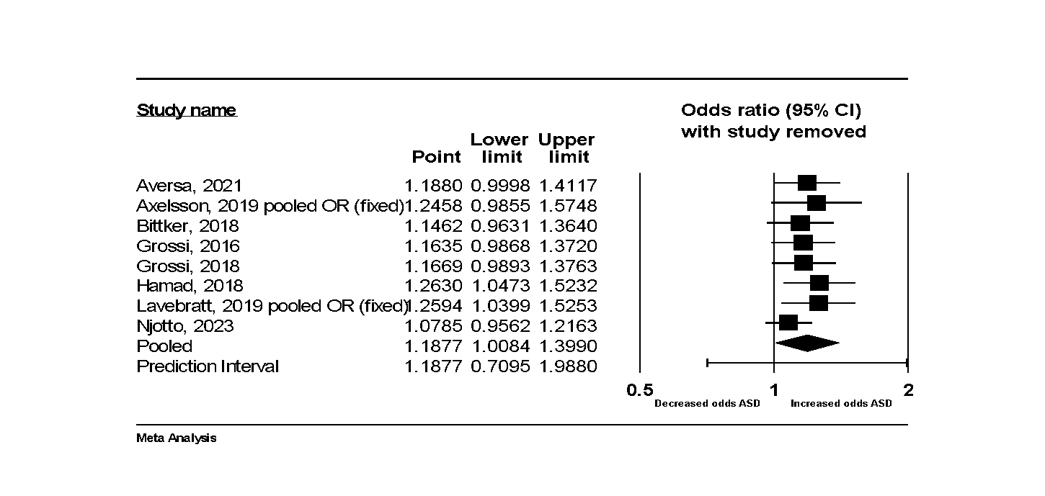

**Supplementary Fig 3 - Childhood antibiotic exposure and likelihood of later development of ASD (sibling-controlled data only)**

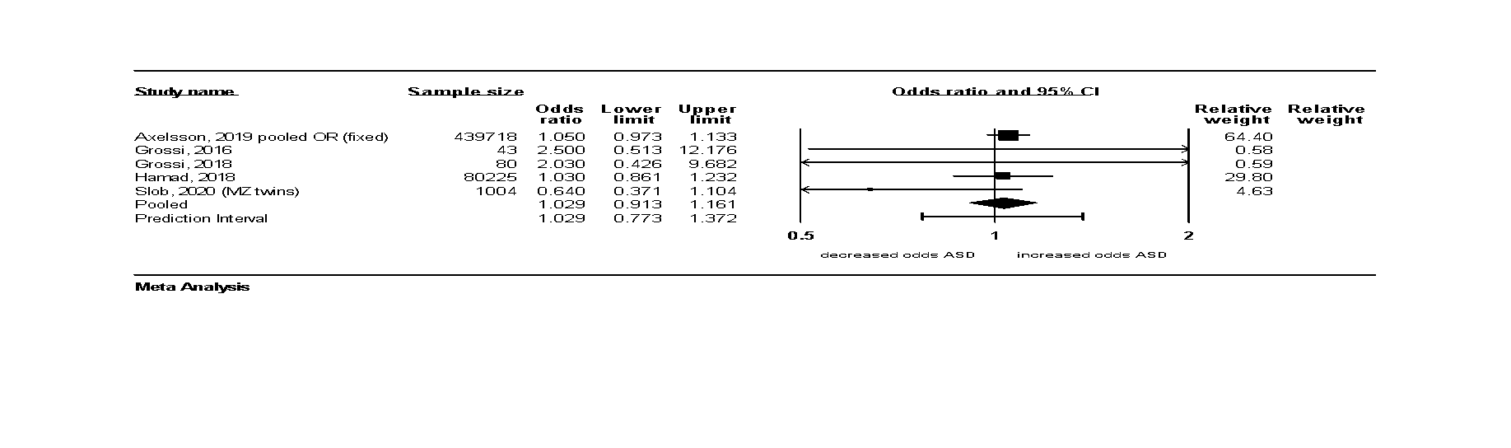

**Supplementary Fig 4 – Leave one out analysis for childhood antibiotic exposure and likelihood of later development of ASD (sibling-controlled data only)**

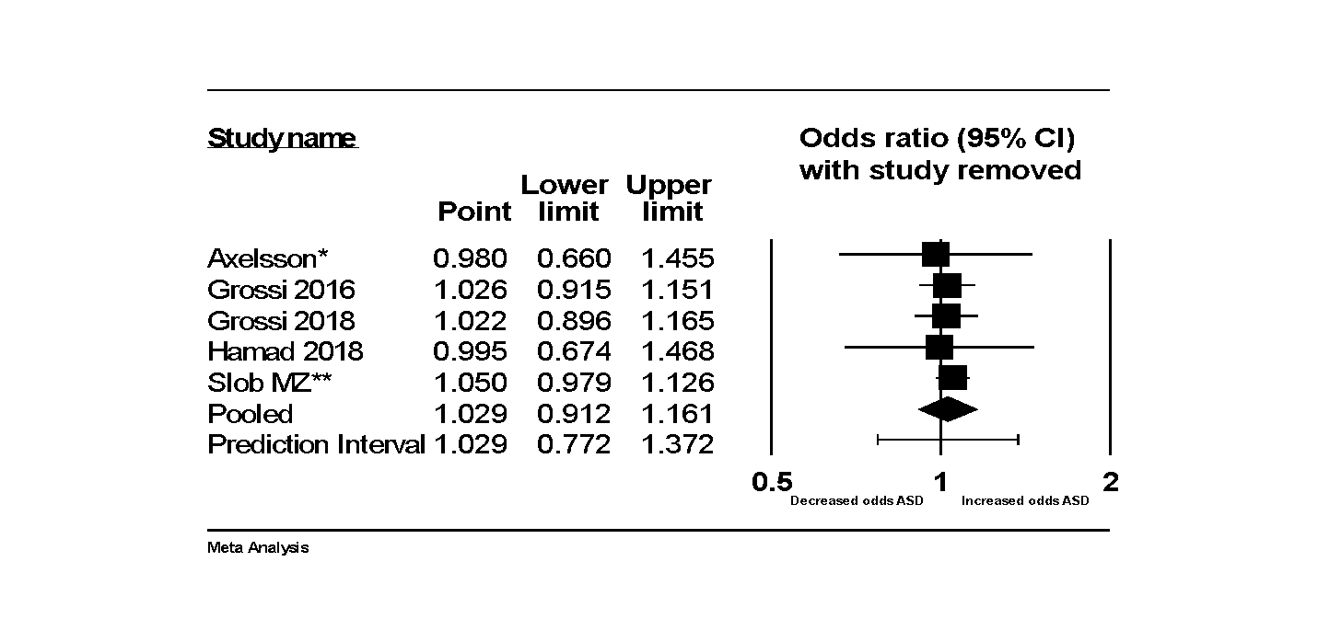

**Supplementary Fig 5 – Leave one out analysis for** **prenatal antibiotic exposure and likelihood of later development of ADHD**

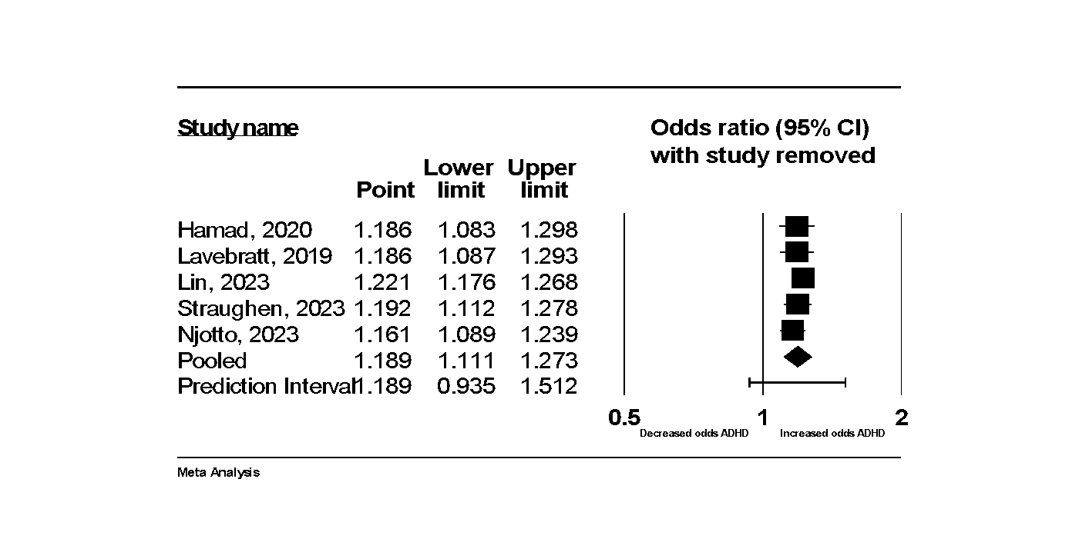

**Supplementary Fig 6 – Leave one out analysis for** **childhood antibiotic exposure and likelihood of later development of ADHD**

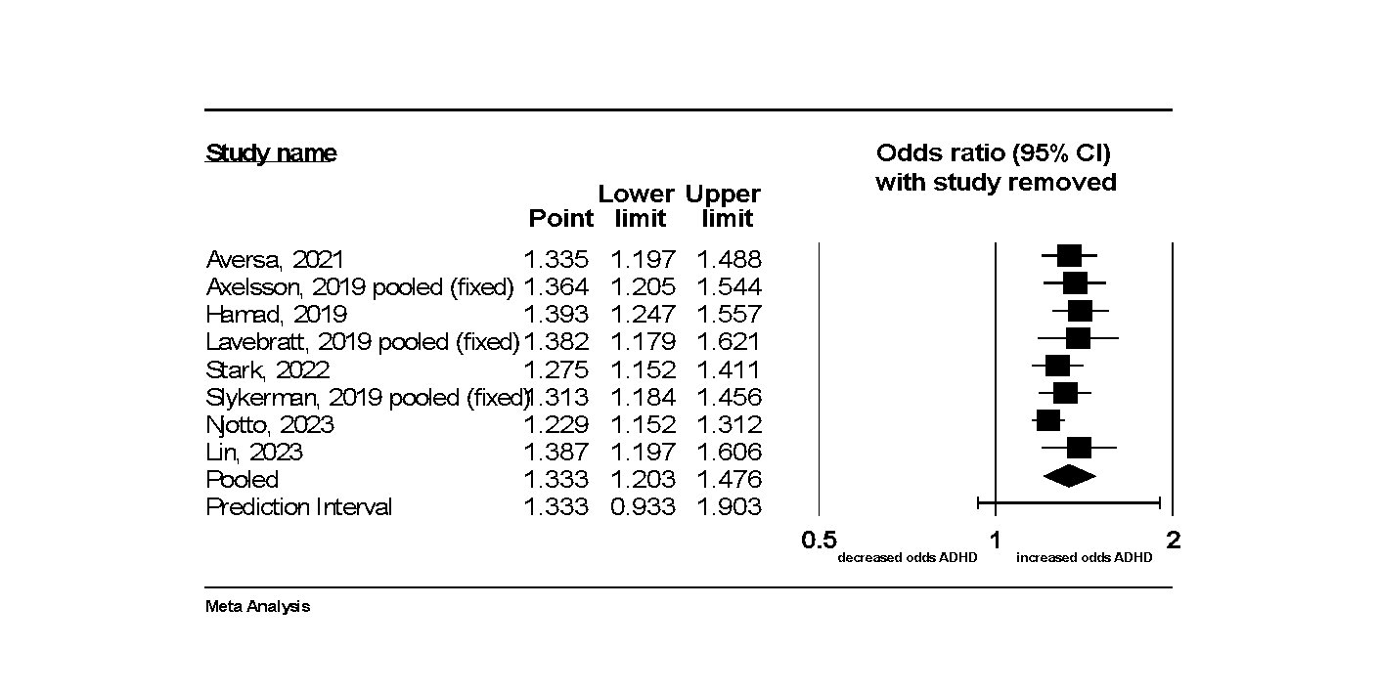

**Supplementary Fig 7 - Childhood antibiotic exposure and likelihood of later development of ADHD (sibling-controlled data only)**

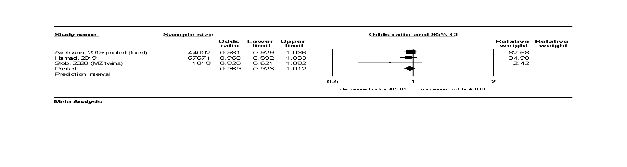

**Supplementary Fig 8 – Leave one out analysis for childhood antibiotic exposure and likelihood of later development of ADHD (sibling-controlled data only)**

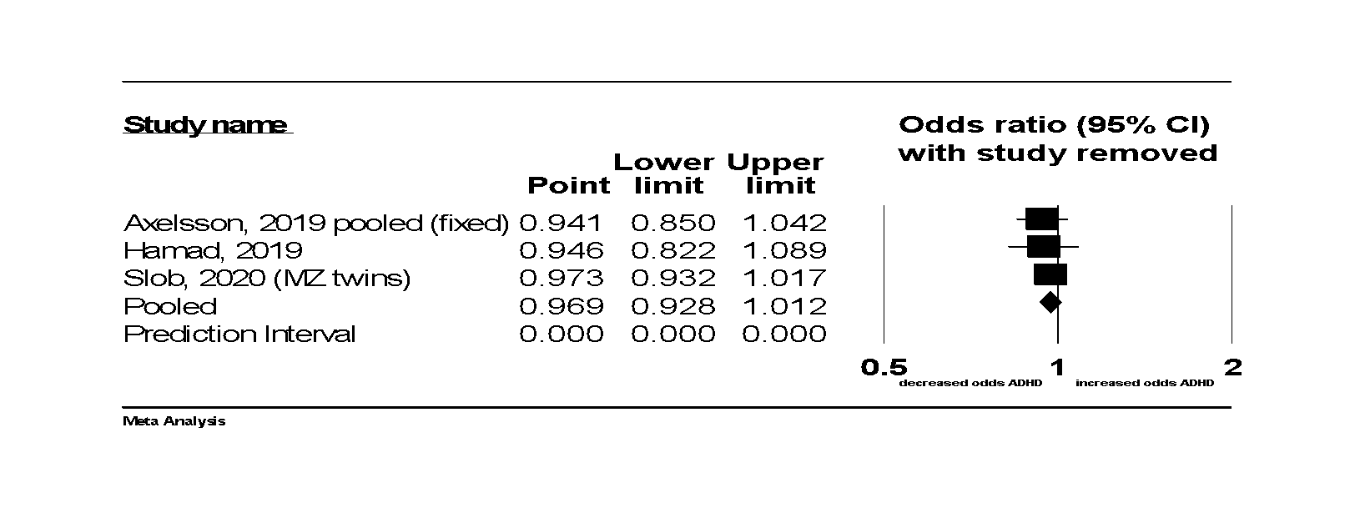

**Supplementary Fig 9 – Leave one out analysis for** **childhood antibiotic exposure and likelihood of later development of MDD**

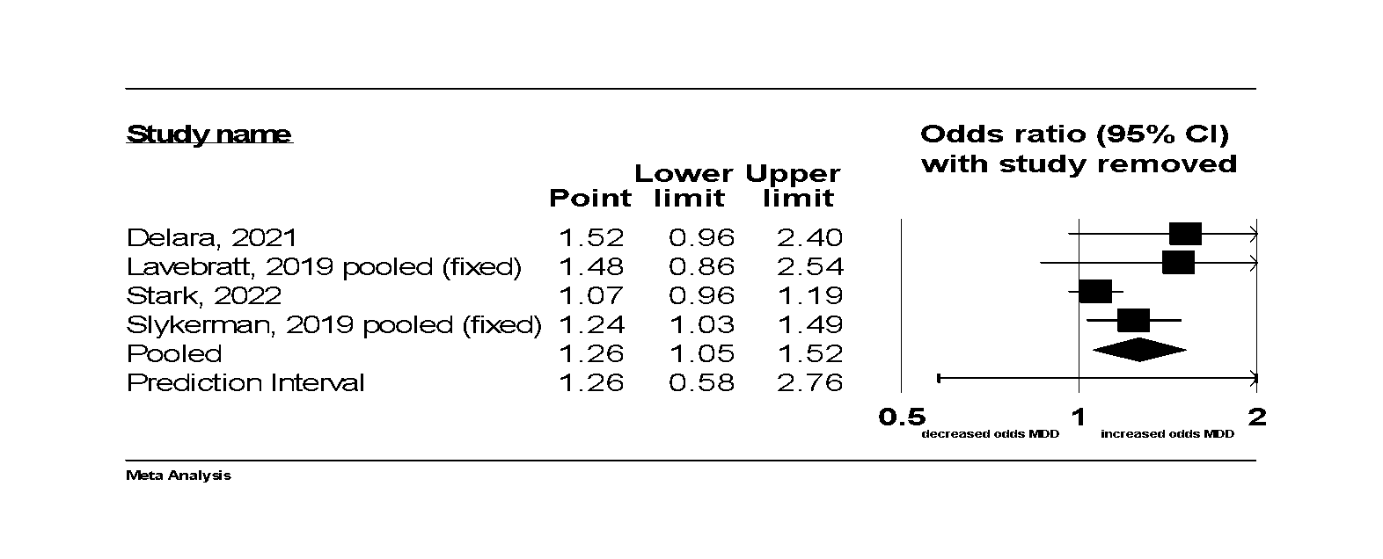

## Subgroup analyses conducted by study type

ASD Perinatal cohort (n=7): OR=1.10 (95%CI: 1.05, 1.14)

ASD perinatal case control (n=4): OR=0.13 (95%CI: -0.20, 0.44)  
ASD perinatal combined (n=11): OR=1.09 (95%CI: 1.02, 1.16)

ASD childhood cohort (n=5): OR=1.09 (95%CI: 0.92, 1.30)

ASD childhood case control (n=3): OR=1.60 (95%CI: 1.26, 2.03)

ASD childhood combined (n=8): OR=1.19 (95%CI: 1.01-1.40)

ASD childhood sibling cohort (n=3): OR=1.018 (95%CI: 0.897, 1.155)

ASD childhood sibling case control (n=2): OR=2.250 (95%CI: 0.740, 6.840)

ASD childhood sibling combined (n=5): OR=1.03 (95% CI: 0.91-1.16)

ADHD perinatal cohort (n=5): OR=1.19 (95%CI: 1.11-1.27)

ADHD case-control (n=0): n/a

ADHD childhood cohort (n=8): OR=1.33 (95% CI: 1.08-1.39)

ADHD childhood case-control (n=0): n/a

ADHD childhood sibling cohort (n=3): OR=0.98 (95% CI: 0.90-1.08)

ADHD childhood sibling case control (n=0): n/a

MDD childhood cohort (n=4): OR 1.29 (95% CI 1.04-1.60)

MDD childhood case control (n=0): n/a

# Publication bias

## Funnel plots and Egger’s intercept

**Funnel plot of standard error by Log OR for studies reporting the likelihood of ASD following prenatal antibiotic exposure**

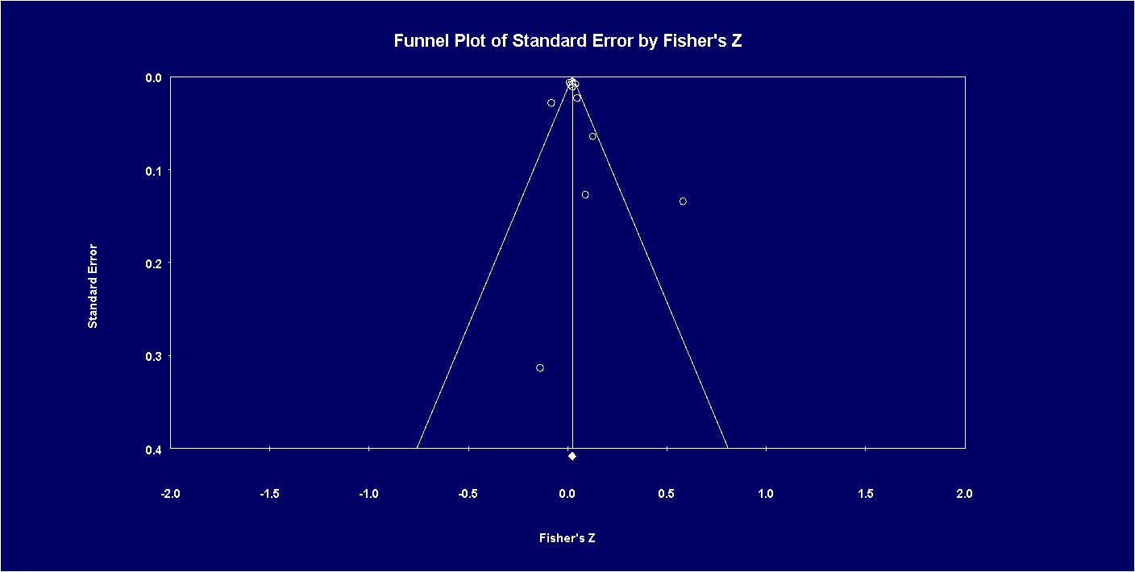

The Egger’s intercept (B0) is 0.84367, 95% confidence interval (-1.37425, 3.06160), with t=0.86050, df=9. The 1-tailed p-value (recommended) is 0.20593, and the 2-tailed p-value is 0.41185.

**Funnel plot of standard error by Log OR for studies reporting the likelihood of ASD following childhood antibiotic exposure**

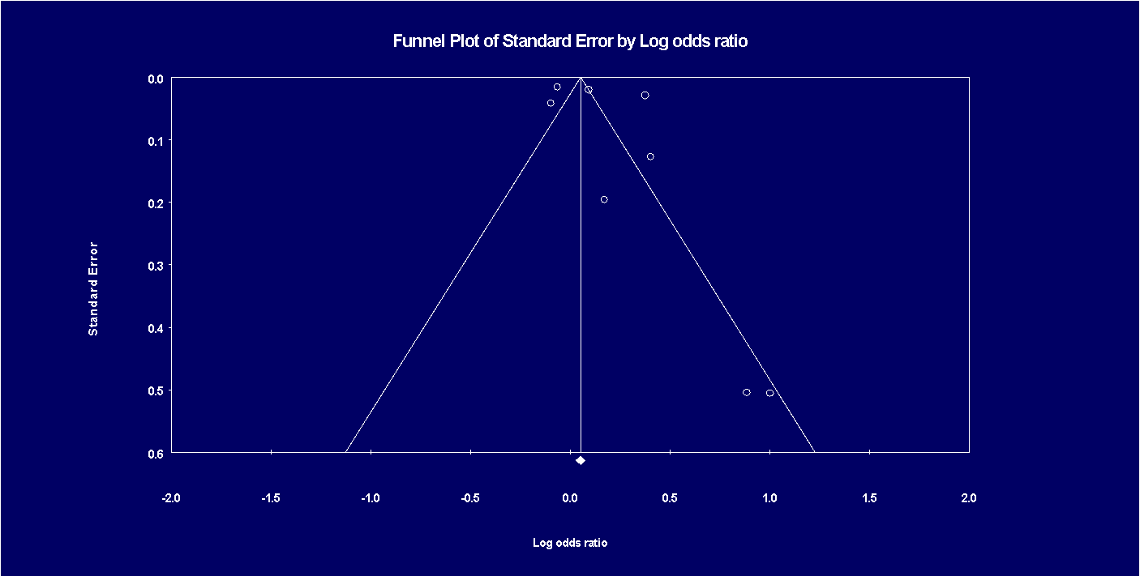

The Egger’s intercept (B0) is 2.59011, 95% confidence interval (-4.28694, 9.46717), with t=0.92158, df=6. The 1-tailed p-value (recommended) is 0.19615, and the 2-tailed p-value is 0.39229

**Funnel plot of standard error by Log OR for studies reporting the likelihood of ASD following childhood antibiotic exposure (sibling-controlled studies only)**

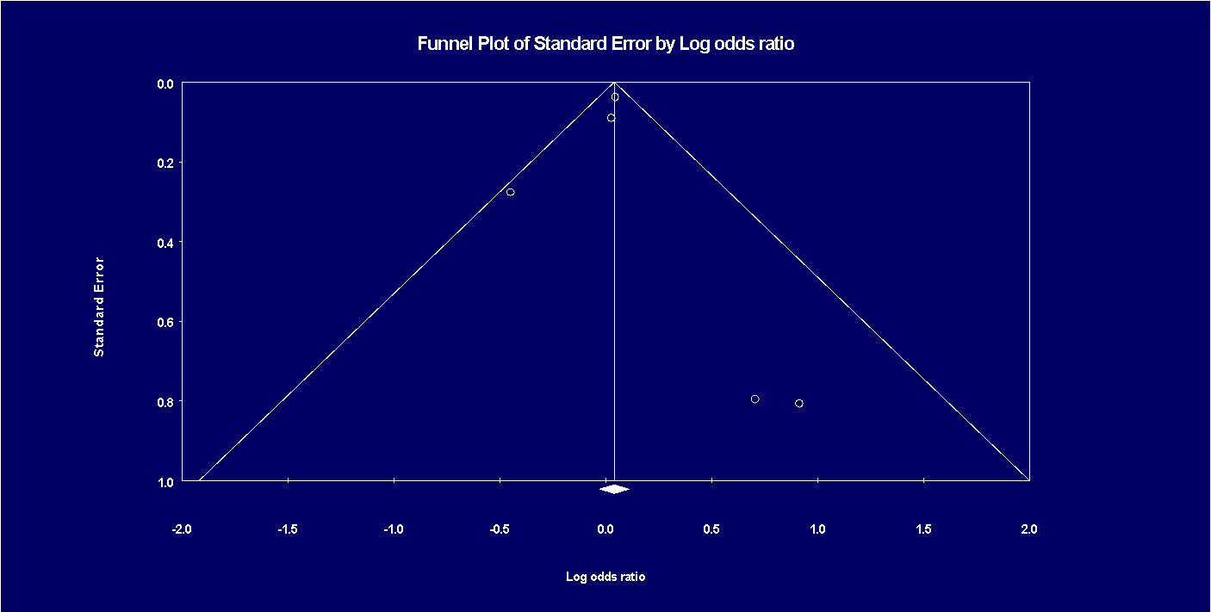

The Egger’s intercept (B0) is 0.09252, 95% confidence interval (-2.40059, 2.58562), with t=0.11810, df=3. The 1-tailed p-value (recommended) is 0.45673, and the 2-tailed p-value is 0.91345.

**Funnel plot of standard error by Log OR for studies reporting the likelihood of ADHD following prenatal antibiotic exposure**

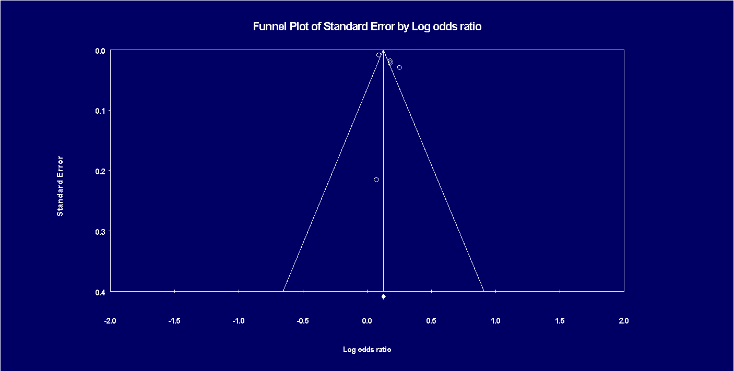

The Egger’s intercept (B0) is 3.36647, 95% confidence interval (-3.91996, 10.65290), with t=1.47035, df=3. The 1-tailed p-value (recommended) is 0.11891, and the 2-tailed p-value is 0.23782.

**Funnel plot of standard error by Log OR for studies reporting the likelihood of ADHD following childhood antibiotic exposure**

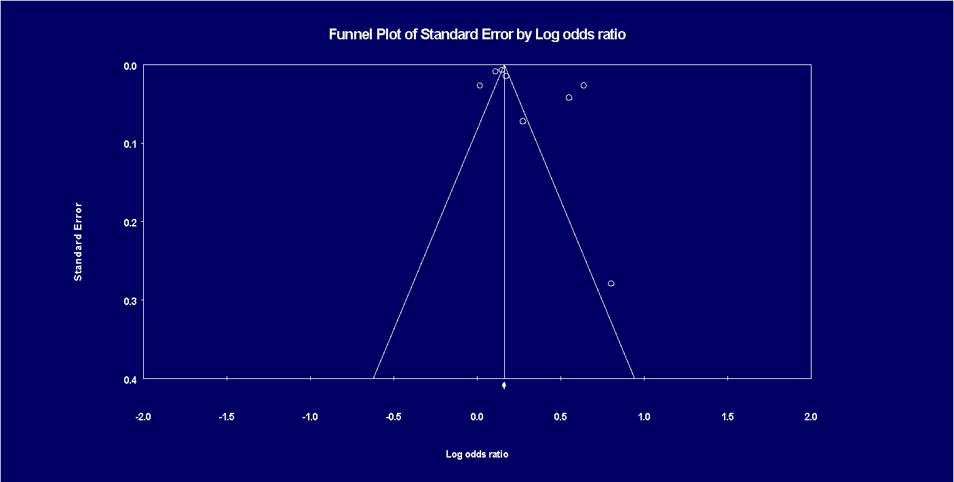

The Eggesr’s intercept (B0) is 6.10356, 95% confidence interval (-4.21336, 16.42048), with t=1.44761, df=6. The 1-tailed p-value (recommended) is 0.09894, and the 2-tailed p-value is 0.19788.

**Funnel plot of standard error by Log OR for studies reporting the likelihood of ADHD following childhood antibiotic exposure (sibling-controlled studies only)**

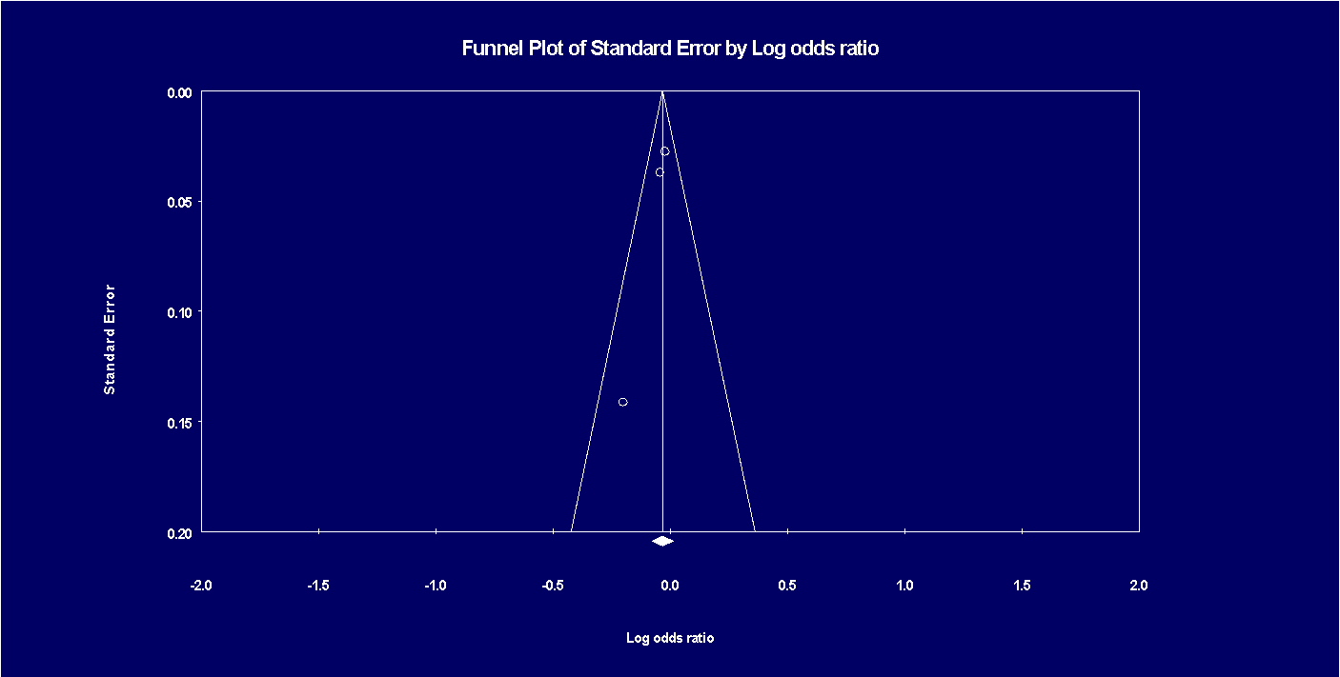

The Egger’s intercept (B0) is -1.60169, 95% confidence interval (-3.90367, 0.70029), with t=8.84081, df=1. The 1-tailed p-value (recommended) is 0.03585, and the 2-tailed p-value is 0.07170.

**Funnel plot of standard error by Log OR for studies reporting the likelihood of MDD following childhood antibiotic exposure**

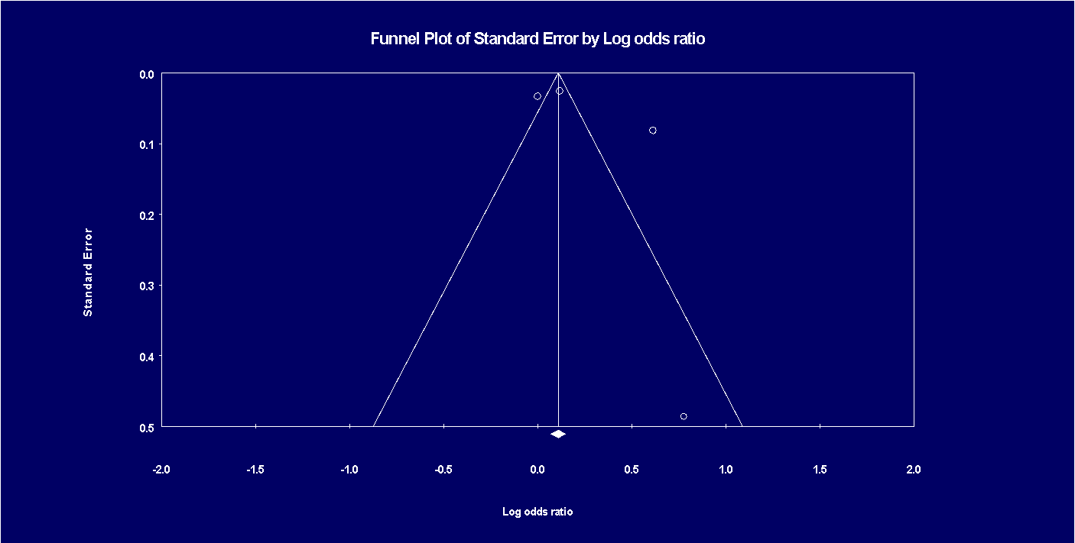

The Egger’s intercept (B0) is 2.05630, 95% confidence interval (-10.84176, 14.95437), with t=0.68596, df=2. The 1-tailed p-value (recommended) is 0.28179, and the 2-tailed p-value is 0.56358.

# Quality assessment

See Table 1 (GRADE Certainty Assessment) and Supplementary Table 2 (Newcastle Ottawa Scale)

**Supplementary Table 2 - Newcastle Ottawa Scale**

|  |  |  |  |  |  |  |  |  |  |  |
| --- | --- | --- | --- | --- | --- | --- | --- | --- | --- | --- |
| **Case control studies** | | | | | | | | | | |
| Study details | | selection | | | | comparability | exposure | | | Total score |
| first author | year | Is case definition adequate | representativeness of cases | selection of controls | definition of controls | comparability | ascertainment of exposure | same method of ascertainment for cases and controls | non-response rate |  |
| Abelson | 2021 | 1 | 0 | 1 | 1 | 1 | 1 | 1 | 0 | 6 |
| Bittker | 2018 | 0 | 0 | 0 | 1 | 1 | 0 | 1 | 0 | 3 |
| Grossi | 2016 | 1 | 0 | 0 | 1 | 0 | 0 | 1 | 1 | 3 |
| Grossi | 2018 | 1 | 0 | 0 | 1 | 0 | 0 | 1 | 1 | 3 |
| Guisso | 2018 | 1 | 1 | 1 | 1 | 2 | 0 | 1 | 1 | 8 |
| George | 2014 | 0 | 0 | 1 | 0 | 0 | 0 | 1 | 0 | 2 |
| Mrozek-budzyn | 2013 | 1 | 1 | 1 | 1 | 1 | 0 | 1 | 0 | 6 |
| **Cohort studies** | | | | | | | | | | |
| Study details | | representativeness of the exposed cohort | selection of the non-exposed cohort | ascertainment of exposure | demonstration that outcome of interest was not present at start of the study | comparability of cohorts on the basis of the design or analysis | assessment of outcome | was the follow-up long enough for outcomes to occur | adequacy of follow up of cohorts | total |
| Slob | 2020 | 0 | 1 | 1 | 0 | 2 | 0 | 0 | 0 | 4 |
| Atladottir | 2012 | 1 | 1 | 1 | 1 | 2 | 1 | 1 | 1 | 9 |
| Aversa | 2021 | 1 | 1 | 1 | 1 | 2 | 1 | 1 | 1 | 9 |
| Axelsson (ASD) | 2019 | 1 | 1 | 1 | 1 | 2 | 1 | 1 | 0 | 8 |
| Axelsson (ADHD) | 2019 | 1 | 1 | 1 | 1 | 2 | 1 | 1 | 0 | 8 |
| Delara | 2021 | 1 | 1 | 1 | 1 | 2 | 1 | 1 | 1 | 9 |
| Hamad (childhood ADHD) | 2019 | 1 | 1 | 1 | 1 | 2 | 1 | 1 | 0 | 8 |
| Hamad (prenatal ADHD) | 2020 | 1 | 1 | 1 | 1 | 2 | 1 | 1 | 0 | 8 |
| Hamad (childhood ASD) | 2018 | 1 | 1 | 1 | 1 | 2 | 1 | 1 | 1 | 9 |
| Hamad (prenatal ASD) | 2019 | 1 | 1 | 1 | 1 | 2 | 1 | 1 | 1 | 9 |
| Lavebratt | 2019 | 1 | 1 | 1 | 1 | 2 | 1 | 1 | 1 | 9 |
| Lin (prenatal ASD/ADHD) | 2023 | 1 | 1 | 1 | 1 | 2 | 1 | 1 | 1 | 9 |
| Oszvar | 2023 | 1 | 1 | 1 | 1 | 2 | 1 | 1 | 1 | 9 |
| Lin (postnatal ADHD) | 2023 | 1 | 1 | 1 | 1 | 2 | 1 | 1 | 1 | 9 |
| Njotto | 2023 | 1 | 1 | 1 | 1 | 2 | 1 | 1 | 1 | 9 |
| Nitschke | 2023 | 1 | 1 | 1 | 1 | 2 | 1 | 1 | 1 | 9 |
| Holingue | 2020 | 0 | 1 | 1 | 1 | 0 | 1 | 1 | 0 | 5 |
| Slykerman | 2019 | 0 | 1 | 1 | 1 | 1 | 1 | 1 | 0 | 6 |
| Slykerman | 2017 | 0 | 1 | 1 | 1 | 2 | 1 | 1 | 0 | 7 |
| Slykerman | 2023 | 1 | 1 | 0 | 0 | 2 | 1 | 1 | 1 | 7 |
| Firestein | 2018 | 0 | 1 | 1 | 1 | 1 | 1 | 0 | 0 | 5 |
| Stark | 2022 | 0 | 1 | 1 | 1 | 2 | 0 | 0 | 0 | 5 |
| Straughen | 2023 | 0 | 1 | 1 | 1 | 2 | 0 | 1 | 0 | 5 |