**Air Pollutants, Genetic Susceptibility, and the Risk of** **Schizophrenia: A Large Prospective Study**

**Contents**

Table S1. Range of average air pollutants concentrations of participants over the entire study period.

Table S2. Associations between air pollutants and the risk of incident SCZ after excluding participants diagnosed with SCZ during the first two years of follow-up.

Table S3. Associations between air pollutants and the risk of incident SCZ among participants with length of living time at baseline address more than five years.

Table S4. Associations between air pollutants and the risk of incident SCZ in participants without missing covariates.

Table S5. Associations between air pollutants and the risk of incident SCZ after further adjusting lifestyle.

Table S6. Associations between air pollutants and the risk of incident SCZ in 2-pollutant models.

Table S7. Associations between air pollutants and the risk of incident SCZ in non-movers.

Table S8. Associations of PRS with the risk of incident SCZ among participants in UK Biobank.

Table S9. Associations of air pollutants and PRS with the risk of incident SCZ in a model.

Table S10. Additive effect between air pollutants and PRS on the risk of incident Schizophrenia among participants in the UK Biobank.

Figure S1. Directed Acyclic Graph for the association between air pollution and SCZ.

Figure S2. Flowchart for the association between air pollution and SCZ.

Method S1. Detailed information about social isolation.

Method S2. Detailed information about first ten genetic principal components.

Method S3. Detailed information about interaction models.

Method S4. Detailed information about models with addictive effects.

Table S1. Range of average air pollutants concentrations of participants over the entire study period (n=485,288)

|  |  |  |  |  |
| --- | --- | --- | --- | --- |
| Air Pollutants | Mean (SD), μg/m3 | T1 (range of concentration),  μg/m3 | T2 (range of concentration),  μg/m3 | T3 (range of concentration),  μg/m3 |
| PM2.5 | 10.20 (2.16) | <9.22 | 9.22-11.01 | ≥11.01 |
| PM10 | 15.10 (2.97) | <13.75 | 13.75-16.14 | ≥16.14 |
| NO2 | 18.70 (6.80) | <15.39 | 15.39-20.66 | ≥20.66 |
| NOx | 28.20 (12.60) | <21.77 | 21.77-30.90 | ≥30.90 |

Abbreviations: SD, standard deviation; PM2.5, fine particulate matter with diameter <2.5 μm; PM10, particulate matter with diameter <10 μm; NO2, nitrogen dioxide; NOx, nitrogen oxides.

Note: the range of average air pollutants concentrations takes into account air pollutants concentrations measured every year for each participant throughout the entire study period. For individuals diagnosed with SCZ or who died, only the annual air pollutants measurements up until the time of diagnosis or death were included in the analysis. For individuals without the occurrence of SCZ or death, the annual air pollutants measurements from enrollment to December 12, 2020.

Table S2. Associations between air pollutants and the risk of incident SCZ after excluding participants diagnosed with SCZ during the first two years of follow-up (n=485,076).

|  |  |  |  |
| --- | --- | --- | --- |
| Air Pollutants | HRs (95% CIs) | *P* values | *P* for trend |
| PM2.5 |  |  |  |
| T1 | Ref. | -- | <0.001 |
| T2 | 1.60 (1.44, 1.77) | <0.001 |
| T3 | 1.99 (1.80, 2.20) | <0.001 |
| PM10 |  |  |  |
| T1 | Ref. | -- | <0.001 |
| T2 | 1.80 (1.61, 2.00) | <0.001 |
| T3 | 2.25 (2.03, 2.49) | <0.001 |
| NO2 |  |  |  |
| T1 | Ref. | -- | <0.001 |
| T2 | 1.43 (1.26, 1.61) | <0.001 |
| T3 | 2.31 (2.05, 2.59) | <0.001 |
| NOx |  |  |  |
| T1 | Ref. | -- | <0.001 |
| T2 | 1.53 (1.36, 1.73) | <0.001 |
| T3 | 2.36 (2.10, 2.66) | <0.001 | -- |

Cox regression models adjusted for age, sex, ethnicity, education, employment, household income, TDI, urbanity, social isolation.

Abbreviations: SCZ, Schizophrenia; HRs, hazard ratios; CIs, confidence intervals; Ref, T1 as the reference; PM2.5, fine particulate matter with diameter <2.5 μm; PM10, particulate matter with diameter <10 μm; NO2, nitrogen dioxide; NOx, nitrogen oxides; TDI, Townsend deprivation index.

Table S3. Associations between air pollutants and the risk of incident SCZ among participants with length of living time at baseline address more than five years (n=407,441).

|  |  |  |  |
| --- | --- | --- | --- |
| Air Pollutants | HRs (95% CIs) | *P* values | *P* for trend |
| PM2.5 |  |  |  |
| T1 | Ref. | -- | <0.001 |
| T2 | 1.49 (1.33, 1.67) | <0.001 |
| T3 | 1.93 (1.73, 2.16) | <0.001 |
| PM10 |  |  |  |
| T1 | Ref. | -- | <0.001 |
| T2 | 1.67 (1.48, 1.88) | <0.001 |
| T3 | 2.16 (1.93, 2.42) | <0.001 |
| NO2 |  |  |  |
| T1 | Ref. | -- | <0.001 |
| T2 | 1.43 (1.25, 1.65) | <0.001 |
| T3 | 2.39 (2.10, 2.73) | <0.001 |
| NOx |  |  |  |
| T1 | Ref. | -- | <0.001 |
| T2 | 1.57 (1.37, 1.80) | <0.001 |
| T3 | 2.41 (2.11, 2.76) | <0.001 |

Cox regression models adjusted for age, sex, ethnicity, education, employment, household income, TDI, urbanity, social isolation.

Abbreviations: SCZ, Schizophrenia; HRs, hazard ratios; CIs, confidence intervals; Ref, T1 as the reference; PM2.5, fine particulate matter with diameter <2.5 μm; PM10, particulate matter with diameter <10 μm; NO2, nitrogen dioxide; NOx, nitrogen oxides; TDI, Townsend deprivation index.

Table S4. Associations between air pollutants and the risk of incident SCZ in participants without missing covariates (n=403,605).

|  |  |  |  |
| --- | --- | --- | --- |
| Air Pollutants | HRs (95% CIs) | *P* values | *P* for trend |
| PM2.5 |  |  |  |
| T1 | Ref. | -- | <0.001 |
| T2 | 1.49 (1.32, 1.68) | <0.001 |
| T3 | 1.80 (1.60, 2.03) | <0.001 |
| PM10 |  |  |  |
| T1 | Ref. | -- | <0.001 |
| T2 | 1.68 (1.48, 1.90) | <0.001 |
| T3 | 2.10 (1.86, 2.37) | <0.001 |
| NO2 |  |  |  |
| T1 | Ref. | -- | <0.001 |
| T2 | 1.27 (1.10, 1.47) | <0.001 |
| T3 | 2.13 (1.86, 2.43) | <0.001 |
| NOx |  |  |  |
| T1 | Ref. | -- | <0.001 |
| T2 | 1.31 (1.14, 1.52) | <0.001 |
| T3 | 2.16 (1.89, 2.48) | <0.001 |

Cox regression models adjusted for age, sex, ethnicity, education, employment, household income, TDI, urbanity, social isolation.

Abbreviations: SCZ, Schizophrenia; HRs, hazard ratios; CIs, confidence intervals; Ref, T1 as the reference; PM2.5, fine particulate matter with diameter <2.5 μm; PM10, particulate matter with diameter <10 μm; NO2, nitrogen dioxide; NOx, nitrogen oxides; TDI, Townsend deprivation index.

Table S5. Associations between air pollutants and the risk of incident SCZ after further adjusting lifestyle (n=485,288).

|  |  |  |  |
| --- | --- | --- | --- |
| Air Pollutants | HRs (95% CIs) | *P* values | *P* for trend |
| PM2.5 |  |  |  |
| T1 | Ref. | -- | <0.001 |
| T2 | 1.60 (1.44, 1.77) | <0.001 |
| T3 | 2.01 (1.82, 2.22) | <0.001 |
| PM10 |  |  |  |
| T1 | Ref. | -- | <0.001 |
| T2 | 1.82 (1.63, 2.02) | <0.001 |
| T3 | 2.33 (2.10, 2.58) | <0.001 |
| NO2 |  |  |  |
| T1 | Ref. | -- | <0.001 |
| T2 | 1.42 (1.26, 1.61) | <0.001 |
| T3 | 2.31 (2.06, 2.59) | <0.001 |
| NOx |  |  |  |
| T1 | Ref. | -- | <0.001 |
| T2 | 1.53 (1.36, 1.73) | <0.001 |
| T3 | 2.43 (2.18, 2.72) | <0.001 |

Cox regression models adjusted for age, sex, ethnicity, education, employment, household income, TDI, urbanity, social isolation and lifestyle factors including alcohol consumption status, smoking status, healthy diet score, physical activity.

Abbreviations: SCZ, Schizophrenia; HRs, hazard ratios; CIs, confidence intervals; Ref, T1 as the reference; PM2.5, fine particulate matter with diameter <2.5 μm; PM10, particulate matter with diameter <10 μm; NO2, nitrogen dioxide; NOx, nitrogen oxides; TDI, Townsend deprivation index.

Table S6. Associations between air pollutants and the risk of incident SCZ in 2-pollutant models (n=485,288).

|  |  |  |  |  |
| --- | --- | --- | --- | --- |
| Air Pollutants | Models | HRs (95% CIs) | *P* values | *P* for trend |
| PM2.5 | +NO2 |  |  |  |
| T1 | Ref. | -- | <0.001 |
| T2 | 1.58 (1.43, 1.76) | <0.001 |
| T3 | 1.96 (1.75, 2.19) | <0.001 |
| +NOx |  |  |  |
| T1 | Ref. | -- | <0.001 |
| T2 | 1.59 (1.43, 1.76) | <0.001 |
| T3 | 1.98 (1.77, 2.22) | <0.001 |
| PM10 | +NO2 |  |  |  |
| T1 | Ref. | -- | <0.001 |
| T2 | 1.83 (1.64, 2.03) | <0.001 |
| T3 | 2.36 (2.10, 2.65) | <0.001 |
| +NOx |  |  |  |
| T1 | Ref. | -- | <0.001 |
| T2 | 1.83 (1.64, 2.04) | <0.001 |
| T3 | 2.38 (2.13, 2.67) | <0.001 |
| NO2 | + PM2.5 |  |  |  |
| T1 | Ref. | -- | <0.001 |
| T2 | 1.45 (1.28, 1.64) | <0.001 |
| T3 | 2.42 (2.13, 2.76) | <0.001 |
| + PM10 |  |  |  |
| T1 | Ref. | -- | <0.001 |
| T2 | 1.46 (1.29, 1.65) | <0.001 |
| T3 | 2.48 (2.18, 2.81) | <0.001 |
| NOx | +PM2.5 |  |  |  |
| T1 | Ref. | -- | <0.001 |
| T2 | 1.55 (1.37, 1.75) | <0.001 |
| T3 | 2.45 (2.15, 2.80) | <0.001 |
| +PM10 |  |  |  |
| T1 | Ref. | -- | <0.001 |
| T2 | 1.56 (1.38, 1.76) | <0.001 |
| T3 | 2.51 (2.20, 2.85) | <0.001 |

Cox regression models adjusted for age, sex, ethnicity, education, employment, household income, TDI, urbanity, social isolation.

Abbreviations: SCZ, Schizophrenia; HRs, hazard ratios; CIs, confidence intervals; Ref, T1 as the reference; PM2.5, fine particulate matter with diameter <2.5 μm; PM10, particulate matter with diameter <10 μm; NO2, nitrogen dioxide; NOx, nitrogen oxides; TDI, Townsend deprivation index.

Table S7. Associations between air pollutants and the risk of incident SCZ in non-movers (n=408,800).

|  |  |  |  |
| --- | --- | --- | --- |
| Air Pollutants | HRs (95% CIs) | *P* values | *P* for trend |
| PM2.5 |  |  |  |
| T1 | Ref. | -- | <0.001 |
| T2 | 1.48 (1.31, 1.67) | <0.001 |
| T3 | 1.98 (1.77, 2.22) | <0.001 |
| PM10 |  |  |  |
| T1 | Ref. | -- | <0.001 |
| T2 | 1.76 (1.55, 1.99) | <0.001 |
| T3 | 2.31 (2.05, 2.61) | <0.001 |
| NO2 |  |  |  |
| T1 | Ref. | -- | <0.001 |
| T2 | 1.25 (1.09, 1.44) | <0.001 |
| T3 | 2.03 (1.78, 2.32) | <0.001 |
| NOx |  |  |  |
| T1 | Ref. | -- | <0.001 |
| T2 | 1.36 (1.19, 1.57) | <0.001 |
| T3 | 2.06 (1.81, 2.36) | <0.001 |

Cox regression models adjusted for age, sex, ethnicity, education, employment, household income, TDI, urbanity, social isolation, alcohol consumption status, smoking status, healthy diet score, physical activity.

Abbreviations: SCZ, Schizophrenia; HRs, hazard ratios; CIs, confidence intervals; PM2.5, fine particulate matter with diameter <2.5 μm; PM10, particulate matter with diameter <10 μm; NO2, nitrogen dioxide; NOx, nitrogen oxides; TDI, Townsend deprivation index; Ref, T1 as the reference.

Table S8. Associations of PRS with the risk of incident SCZ among participants in UK Biobank (n=485,288)

|  |  |  |  |
| --- | --- | --- | --- |
| PRS | HRs (95% CIs) | *P* values | *P* for trend |
| Low genetic risk | Ref. | -- |  |
| Medium genetic risk | 1.52 (1.12, 2.04) | <0.001 | <0.001 |
| High genetic risk | 2.75 (2.10, 3.60) | <0.001 |  |
| PRS for continuous | 1.65 (1.50, 1.81) | <0.001 | -- |

Cox regression models adjusted for age, sex, education, employment, household income, TDI, urbanity, social isolation, genotyping batch, and the first ten genetic principal components.

Abbreviations: SCZ, Schizophrenia; HRs, hazard ratios; CIs, confidence intervals; Ref, reference; TDI, Townsend deprivation index.

Table S9. Associations of air pollutants and PRS with the risk of incident SCZ in a model (n=485,288).

|  |  |  |  |
| --- | --- | --- | --- |
|  | HRs (95% CIs) | *P* values | *P* for trend |
| PM2.5 |  |  |  |
| T1 | Ref. | -- | <0.001 |
| T2 | 1.61 (1.45, 1.78) | <0.001 |
| T3 | 2.00 (1.81, 2.21) | <0.001 |
| PRS | 1.63 (1.58, 1.69) | <0.001 |  |
| PM10 |  |  |  |
| T1 | Ref. | -- | <0.001 |
| T2 | 1.83 (1.65, 2.04) | <0.001 |
| T3 | 2.32 (2.09, 2.57) | <0.001 |
| PRS | 1.63 (1.58, 1.69) | <0.001 |  |
| NO2 |  |  |  |
| T1 | Ref. | -- | <0.001 |
| T2 | 1.42 (1.26, 1.60) | <0.001 |
| T3 | 2.27 (2.02, 2.54) | <0.001 |
| PRS | 1.62 (1.56, 1.68) | <0.001 |  |
| NOx |  |  |  |
| T1 | Ref. | -- | <0.001 |
| T2 | 1.51 (1.34, 1.71) | <0.001 |
| T3 | 2.31 (2.06, 2.60) | <0.001 |
| PRS | 1.62 (1.56, 1.68) | <0.001 |  |

Cox regression models adjusted for age, sex, ethnicity, education, employment, household income, TDI, urbanity, social isolation.

Abbreviations: SCZ, schizophrenia; HRs, hazard ratios; CIs, confidence intervals; Ref, T1 as the reference; PM2.5, fine particulate matter with diameter <2.5 μm; PM10, particulate matter with diameter <10 μm; NO2, nitrogen dioxide; NOx, nitrogen oxides; TDI, Townsend deprivation index; PRS, Polygenic Risk Score.

Table S10. Additive effect between air pollutants and PRS on the risk of incident Schizophrenia among participants in the UK Biobank.

|  |  |  |  |
| --- | --- | --- | --- |
|  | RERIs (95% CIs) | APs (95% CIs) | SIs (95% CIs) |
| PM2.5 |  |  |  |
| Medium genetic risk |  |  |  |
| PM2.5**-**T2 | 0.44 (-0.05, 0.93) | 0.17 (-0.02, 0.36) | 1.39 (0.89, 2.18) |
| PM2.5**-**T3 | 0.32 (-0.22, 0.86) | 0.11 (-0.07, 0.29) | 1.19 (0.86, 1.65) |
| High genetic risk |  |  |  |
| PM2.5**-**T2 | 1.47 (0.88, 2.07) | 0.31 (0.20, 0.43) | 1.65 (1.29, 2.12) |
| PM2.5**-**T3 | 2.32 (1.61, 3.02) | 0.38 (0.29, 0.47) | 1.82 (1.48, 2.25) |
| PM10 |  |  |  |
| Medium genetic risk |  |  |  |
| PM10**-**T2 | 0.31 (-0.25, 0.87) | 0.11 (-0.09, 0.31) | 1.21 (0.83, 1.78) |
| PM10**-**T3 | 0.62 (0.01, 1.23) | 0.17 (0.0, 0.33) | 1.30 (0.97, 1.74) |
| High genetic risk |  |  |  |
| PM10**-**T2 | 1.82 (1.13, 2.50) | 0.33 (0.22, 0.44) | 1.69 (1.34, 2.13) |
| PM10**-**T3 | 2.88 (2.04, 3.73) | 0.40 (0.32, 0.49) | 1.89 (1.54, 2.30) |
| NO2 |  |  |  |
| Medium genetic risk |  |  |  |
| NO2-T2 | -0.05 (-0.54, 0.44) | -0.03 (-0.30, 0.25) | 0.94 (0.52, 1.69) |
| NO2-T3 | 0.10 (-0.45, 0.65) | 0.03 (-0.15, 0.21) | 1.05 (0.79, 1.40) |
| High genetic risk |  |  |  |
| NO2-T2 | 1.96 (1.37, 2.55) | 0.47 (0.35, 0.58) | 2.58 (1.68, 3.96) |
| NO2-T3 | 2.47 (1.77, 3.16) | 0.43 (0.33, 0.52) | 2.07 (1.62, 2.64) |
| NOx |  |  |  |
| Medium genetic risk |  |  |  |
| NOx-T2 | -0.07 (-0.59, 0.45) | -0.04 (-0.30, 0.23) | 0.93 (0.57, 1.53) |
| NOx-T3 | -0.01 (-0.58, 0.57) | -0.00 (-0.19, 0.19) | 1.00 (0.76, 1.31) |
| High genetic risk |  |  |  |
| NOx-T2 | 2.06 (1.43, 2.69) | 0.46 (0.35, 0.57) | 2.44 (1.66, 3.60) |
| NOx-T3 | 2.68 (1.93, 3.43) | 0.44 (0.35, 0.53) | 2.08 (1.64, 2.65) |

Cox regression models adjusted for age, sex, education, employment, household income, TDI, urbanity, social isolation, genotyping batch, and the first ten genetic principal components.

Abbreviations: HRs, hazard ratios; CIs, confidence intervals; PM2.5, fine particulate matter with diameter <2.5 μm; PM10, particulate matter with diameter <10 μm; NO2, nitrogen dioxide; NOx, nitrogen oxides; TDI, Townsend deprivation index; RERI, the relative excess risk due to interaction; AP, the attributable proportion due to interaction; and SI, the synergy index.

Note: individuals with low air pollution exposure (the first tertile group) and low genetic risk as the reference group.

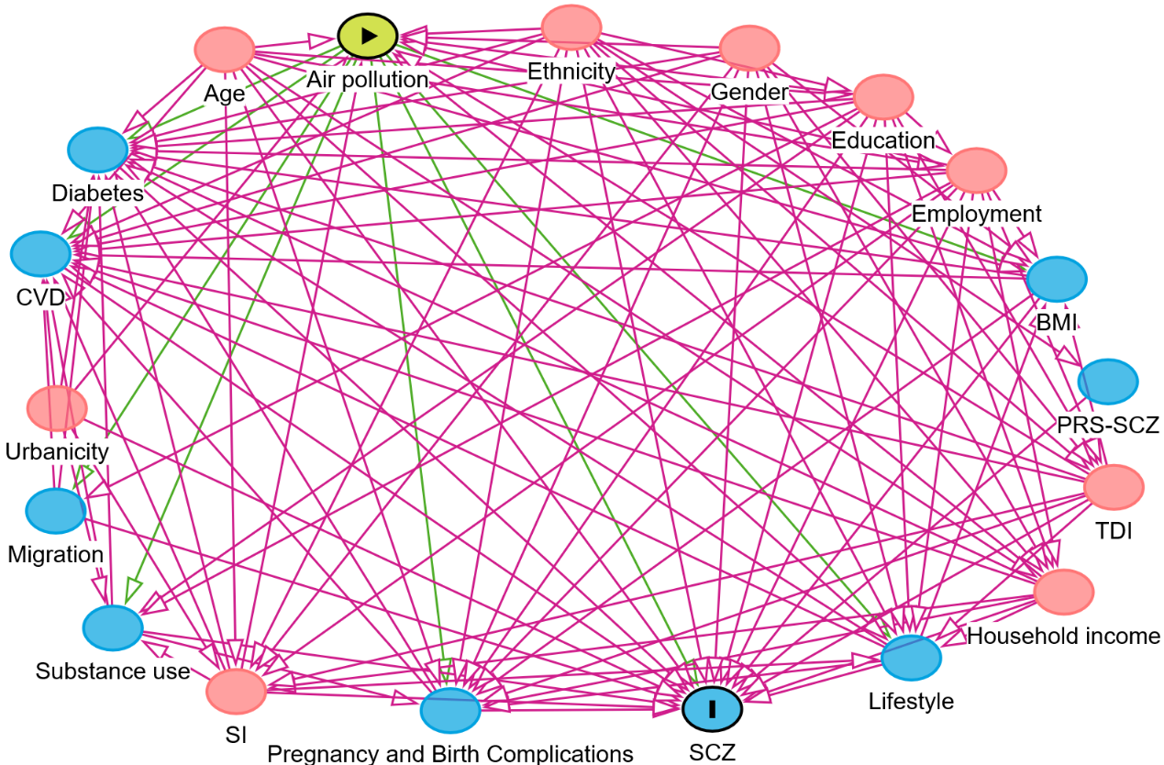

Figure S1. Directed Acyclic Graph for the association between air pollution and SCZ.

Abbreviations: SCZ, schizophrenia; TDI, Townsend deprivation index; PRS-SCZ: the polygenic risk score for schizophasia; BMI, body mass index; CVD, cardiovascular disease; SI, social isolation.

Ovals labeled with "air pollution," "PRS-SCZ," and "SCZ" represent exposure, genetic score, and outcome; All other ovals represent potential covariates; Red ovals indicate the minimum variable set that should be adjusted for; Blue ovals represent variables that do not need to be included in the minimum variable set.

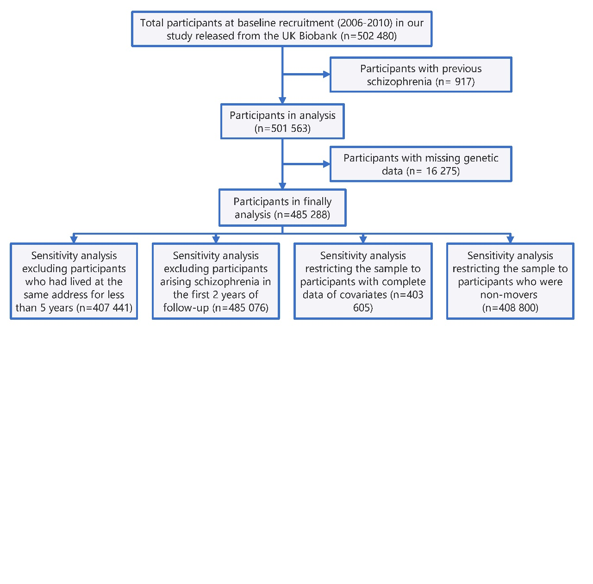

Figure S2. Flowchart for the association between air pollution and SCZ.

Method S1. Detailed information about social isolation.

The social isolation index used in the Million Women Study was constructed from four questions: question 1, how many people live in your household? (number of people including you; 1 point for living alone); question 2, how often do you contact (eg phone, meet, email) family; question 3, how often do you contact (eg phone, meet, email) friends; question 4, how often do you contact (eg phone, meet, email) groups (eg, religious groups, Women’s Institute, fitness, adult education). The possible responses for questions 2–4 were: rarely or never, monthly, weekly or fortnightly, or most days (1 point was given for answering rarely or never, or monthly in response to both question 2 and question 3, and 1 point was given for rarely or never, or monthly in response to question 4). The social isolation index used in the UK Biobank was constructed from three questions: question 1, including yourself, how many people are living together in your household (1 point was given for living alone); question 2, how often do you visit friends or family or have them visit you (1 point was given for answering about once a month, once every few months, never or almost never, or no friends or family outside household); question 3, which of the following (sports club or gym, pub or social club, religious group, adult education class, other group activity) do you engage in once a week or more often (1 point was given for answering none of the above). Individual scores were summed to calculate an overall score ranging from 0 to 3. For the purposes of this analysis, individuals from both studies were defined as least isolated if they scored 0, moderately isolated if they scored 1, and most isolated if they scored 2 or 3 (scores of 2 or 3 were grouped since few individuals had scores of 3).

Method S2. Detailed information about first ten genetic principal components.

The diversity in ancestral origins of UK Biobank participants is evident from the self-reported ethnic background and country of birth information. The genotype data provides a unique opportunity to study their ancestral origins in a quantitative manner. Accounting for the ancestral background of participants is an essential component of analysis of the UK Biobank resource, both for epidemiological studies, and genetic analyses, such as GWAS (1). UK Biobank used principal components analysis (PCA) to measure population structure within the UK Biobank cohort. PCA is widely used as a method for assessing and potentially controlling for population structure in GWAS (2).

UK Biobank computed principal components (PCs) using an algorithm (fastPCA) which performs well on datasets with hundreds of thousands of samples by approximating only the top n PCs that explain the most variation, where n is specified in advance(3). We computed the top 40 PCs using a set of 407,219 unrelated, high quality samples and 147,604 high quality markers pruned to minimise linkage disequilibrium (LD)(4). UK Biobank then computed the corresponding PC-loadings and projected all samples onto the PCs, thus forming a set of PC scores for all samples in the cohort. In line with most previous studies in UK Biobank(5, 6), we adjusted for the first 10 principal components in our study to adjust for population structure.

Method S3. Detailed information about interaction models.

To account for interaction, the interaction was assessed by adding a product term of each air pollutant and PRS, the significance was assessed by the *P*-value for interaction. In the present study, the formula of Cox regression model (interaction modelling) as follows:

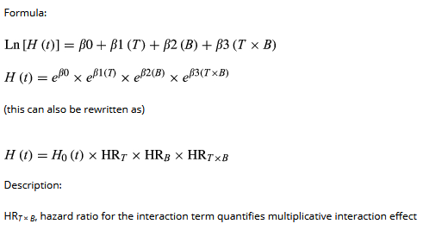

Description: T and B represent two independent variables; T×B signifies the interaction term between these two independent variables; HRT×B, hazard ratio for the interaction term quantifies interaction effect; *β*0, *β*1, *β*2, and *β*3 were coefficients in a regression model.

Based on the above formula, we included the air pollution, PRS, and a product term of them into the model. Therefore, main effect for PRS was included in the models.

Method S4. Detailed information about models with additive effect.

The additive effect between two multi-level classification exposures was tested and measured using the Cox proportional risk model, which is reliable(7) and has been widely used in previous studies(6, 8). In the assessment of additivity of joint effects, we used a series of measurement of additive effect, including the attributable proportion due to additive interaction (RERI), the attributable proportion due to interaction (AP), and the synergy index (SI). According to previous researches(9-11), the formulas of these are as follows:

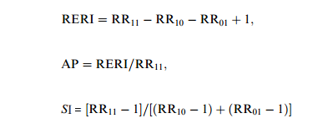

Description: RR11, the relative risk for individuals exposed to both factors (for example, exposures A and B) compared to those not exposed to either factor; RR10, the relative risk for individuals exposed only to factor A compared to those not exposed to either factor; RR01, the relative risk for individuals exposed only to factor B compared to those not exposed to either factor.

Based on the aforementioned formula for additive effect, we considered individuals with low air pollution exposure (specifically, those in the first tertile group of air pollution, such as PM2.5: PM2.5-T1) and low genetic risk were treated as the reference. We evaluated the additive effect by examining the combined effect of air pollution exposure and genetic risk through the assessment of RERI, AP, SI, and their corresponding confidence intervals.

1. Marchini J, Cardon LR, Phillips MS, Donnelly P. The effects of human population structure on large genetic association studies. Nat Genet. 2004; 36(5): 512-7.

2. Price AL, Patterson NJ, Plenge RM, Weinblatt ME, Shadick NA, Reich D. Principal components analysis corrects for stratification in genome-wide association studies. Nat Genet. 2006; 38(8): 904-9.

3. Galinsky KJ, Bhatia G, Loh PR, Georgiev S, Mukherjee S, Patterson NJ, et al. Fast Principal-Component Analysis Reveals Convergent Evolution of ADH1B in Europe and East Asia. Am J Hum Genet. 2016; 98(3): 456-72.

4. Price AL, Weale ME, Patterson N, Myers SR, Need AC, Shianna KV, et al. Long-range LD can confound genome scans in admixed populations. Am J Hum Genet. 2008; 83(1): 132-5; author reply 5-9.

5. Said MA, Verweij N, van der Harst P. Associations of Combined Genetic and Lifestyle Risks With Incident Cardiovascular Disease and Diabetes in the UK Biobank Study. JAMA Cardiol. 2018; 3(8): 693-702.

6. Arthur RS, Wang T, Xue X, Kamensky V, Rohan TE. Genetic Factors, Adherence to Healthy Lifestyle Behavior, and Risk of Invasive Breast Cancer Among Women in the UK Biobank. J Natl Cancer Inst. 2020; 112(9): 893-901.

7. Li R, Chambless L. Test for additive interaction in proportional hazards models. Annals of epidemiology. 2007; 17(3): 227-36.

8. Huang Y, Zhu M, Ji M, Fan J, Xie J, Wei X, et al. Air Pollution, Genetic Factors, and the Risk of Lung Cancer: A Prospective Study in the UK Biobank. Am J Respir Crit Care Med. 2021; 204(7): 817-25.

9. Mathur MB, VanderWeele TJ. R Function for Additive Interaction Measures. 2018; 29(1): e5-e6.

10. Rod NH, Lange T, Andersen I, Marott JL, Diderichsen F. Additive Interaction in Survival Analysis: Use of the Additive Hazards Model. 2012; 23(5): 733-7.

11. Knol MJ, VanderWeele TJ, Groenwold RH, Klungel OH, Rovers MM, Grobbee DE. Estimating measures of interaction on an additive scale for preventive exposures. Eur J Epidemiol. 2011; 26(6): 433-8.