**Appendix**

**Tables**

|  |  |  |  |  |  |
| --- | --- | --- | --- | --- | --- |
|  | **CNRD cohort** | **Threshold-based agranulocytosis** | **Mild to moderate neutropenia** | **Transient**  **agranulocytosis** | **Pattern-based agranulocytosis** |
| **Sociodemographic characteristics** | | | | | |
| Patients | 3,029 | 593 | 2,436 | 245 | 348 |
| Hematological measurements per patient, median (IQR) | 34 (65) | 24 (55) | 38 (67) | 27 (70) | 18 (48) |
| Age in years at clozapine start, mean (SD) | 39 (13) | 43 (13) | 39 (13) | 38 (13) | 46 (13) |
| Age in years at clozapine start, Quantiles | | | | | |
| Q1 ≤29 | 833 (27.5) | 106 (17.9) | 727 (29.8) | 71 (29.5) | 35 (10.1) |
| Q2 30 - 40 | 787 (26.0) | 145 (24.5) | 642 (26.4) | 62 (25.3) | 83 (23.9) |
| Q3 41 - 48 | 585 (19.3) | 123 (20.7) | 462 (19.0) | 54 (22.0) | 69 (19.8) |
| Q4 >48 | 824 (27.2) | 219 (36.9) | 605 (24.8) | 58 (23.7) | 161 (46.3) |
| Age in years at CIA, mean (SD) | 43 (14) | 46 (13) | 42 (14) | 42 (13) | 49 (13) |
| Female | 1141 (37.66%) | 201 (33.89%) | 940 (38.58%) | 73 (29.8%) | 128 (36.78%) |
| Male | 1888 (62.33%) | 392 (66.10%) | 1496 (61.41%) | 172 (70.2%) | 220 (63.21%) |
| Asian | 117 (3.86%) | 22 (3.70%) | 95 (3.89%) | 6 (2.44%) | 16 (4.59%) |
| Black | 276 (9.11%) | 23 (3.87%) | 253 (10.38%) | 20 (8.16%) | 3 (0.86%) |
| White | 2569 (84.81%) | 539 (90.89%) | 2030 (83.33%) | 215 (87.75%) | 324 (93.10%) |
| Others | 67 (2.21%) | 9 (1.51%) | 58 (2.38%) | 4 (1.63%) | 5 (1.43%) |
| TRS | 2644 (87.28%) | 513 (86.50%) | 2131 (87%) | 210 (85.71%) | 303 (87.06%) |
| Rechallenge | 584 | 93 | 491 | 34 | 59 |
| Signed Off-label Agreement | 237 (7.82%) | 59 (9.94%) | 178 (7.30%) | 31 (12.65%) | 28 (8.04%) |
| Others | 148 (4.88%) | 21 (3.54%) | 127 (5.21%) | 4 (1.63%) | 17 (4.88%) |
| Duration of clozapine treatment years, mean (SD) | 2.94 (3.70) | 2.57 (3.65) | 3.11 (3.78) | 2.93 (3.79) | 2.32 (3.52) |
| Duration of clozapine treatment years, median (IQR) | 1.30 (3.98) | 0.62 (3.52) | 1.55 (4.25) | 0.98 (4.03) | 0.28 (3.25) |
| **Haematological characteristics at baseline** | | | | | |
| White cell count, mean (SD) | 6.78 (2.59) | 7.67 (2.50) | 6.56 (2.56) | 7.55 (2.48) | 7.75 (2.51) |
| White cell count, median (IQR) | 6.3 (2.8) | 7.37 (3.01) | 6.1 (2.68) | 7.20 (2.96) | 7.49 (3) |
| Absolute neutrophil count, mean (SD) | 4.21 (2.03) | 4.92 (2.12) | 4.04 (1.97) | 4.72 (2.14) | 5.06 (2.09) |
| Absolute neutrophil count, median (IQR) | 3.8 (2.37) | 4.50 (2.63) | 3.6 (2.23) | 4.28 (2.40) | 4.72 (2.57) |
| Platelet count, mean (SD) | 235.13 (79.89) | 246 (81.15) | 232.49 (79.38) | 246.73 (83.65) | 245.49 (79.47) |
| Platelet count, median (IQR) | 230 (87) | 238 (82) | 228 (87) | 238 (77) | 239 (88.25) |
| **Haematological characteristics during clozapine treatment** | | | | | |
| White cell count, mean (SD) | 6.43 (2.67) | 7.13 (3.76) | 6.25 (2.44) | 7.52 (4.28) | 6.78 (3.18) |
| White cell count, median (IQR) | 6 (2.77) | 6.79 (3.49) | 5.8 (2.6) | 7 (3.40) | 6.51 (3.5) |
| Absolute neutrophil count, mean (SD) | 4.02 (1.99) | 4.5 (2.74) | 3.88 (1.87) | 4.67 (2.69) | 4.45 (2.78) |
| Absolute neutrophil count, median (IQR) | 3.6 (2.26) | 4.20 (2.80) | 3.5 (2.1) | 4.27 (2.84) | 4.17 (2.8) |
| Platelet count, mean (SD) | 221.05 (78.38) | 232.83 (83.54) | 218.72 (77.80) | 233.95 (83.61) | 231.82 (83.48) |
| Platelet count, median (IQR) | 217 (87) | 227 (88) | 215 (87) | 226 (84) | 229 (93) |
| **Haematological characteristics at haematological event** | | | | | |
| White cell count, mean (SD) | 3.24 (1.49) | 2.95 (3.01) | 3.20 (0.88) | 4.48 (3.99) | 1.88 (1.22) |
| White cell count, median (IQR) | 2.9 (0.99) | 2 (1.6) | 2.96 (0.90) | 2.78 (4.8) | 1.8 (1.1) |
| Absolute neutrophil count, mean (SD) | 1.21 (0.44) | 0.23 (0.15) | 1.33 (0.30) | 0.21 (0.18) | 0.25 (0.13) |
| Absolute neutrophil count, median (IQR) | 1.3 (0.42) | 0.27 (0.3) | 1.34 (0.28) | 0.20 (0.4) | 0.3 (0.27) |
| Platelet count, mean (SD) | 193.45 (93.32) | 216.45 (123.36) | 186.81 (86.36) | 203.51 (126.10) | 225.56 (120.75) |
| Platelet count, median (IQR) | 195 (102) | 224 (134) | 189 (96) | 208 (143) | 235.5 (131) |

**Table 1.** Socio-demographic and clinical characteristics of patients registered on the CNRD. Aggregated groups refer to all patients who recorded the named haematological event and isolated group refers to patients who only recorded the distinct named haematological event.

|  |  |  |
| --- | --- | --- |
| **Percentage of agranulocytosis in period** | **Threshold-based criterion** | **Pattern-based criterion** |
| **18 weeks** | 43.58 | 50.13 |
| **1 year** | 55.41 | 55.20 |
| **2 years** | 63.85 | 63.20 |
| **3 years** | 71.11 | 69.87 |
| **4 years** | 76.52 | 77.07 |

**Table 2.** Percentage of agranulocytosis cases (threshold-based vs. pattern-based) in the CNRD sample (N=3,029)

**Figures**

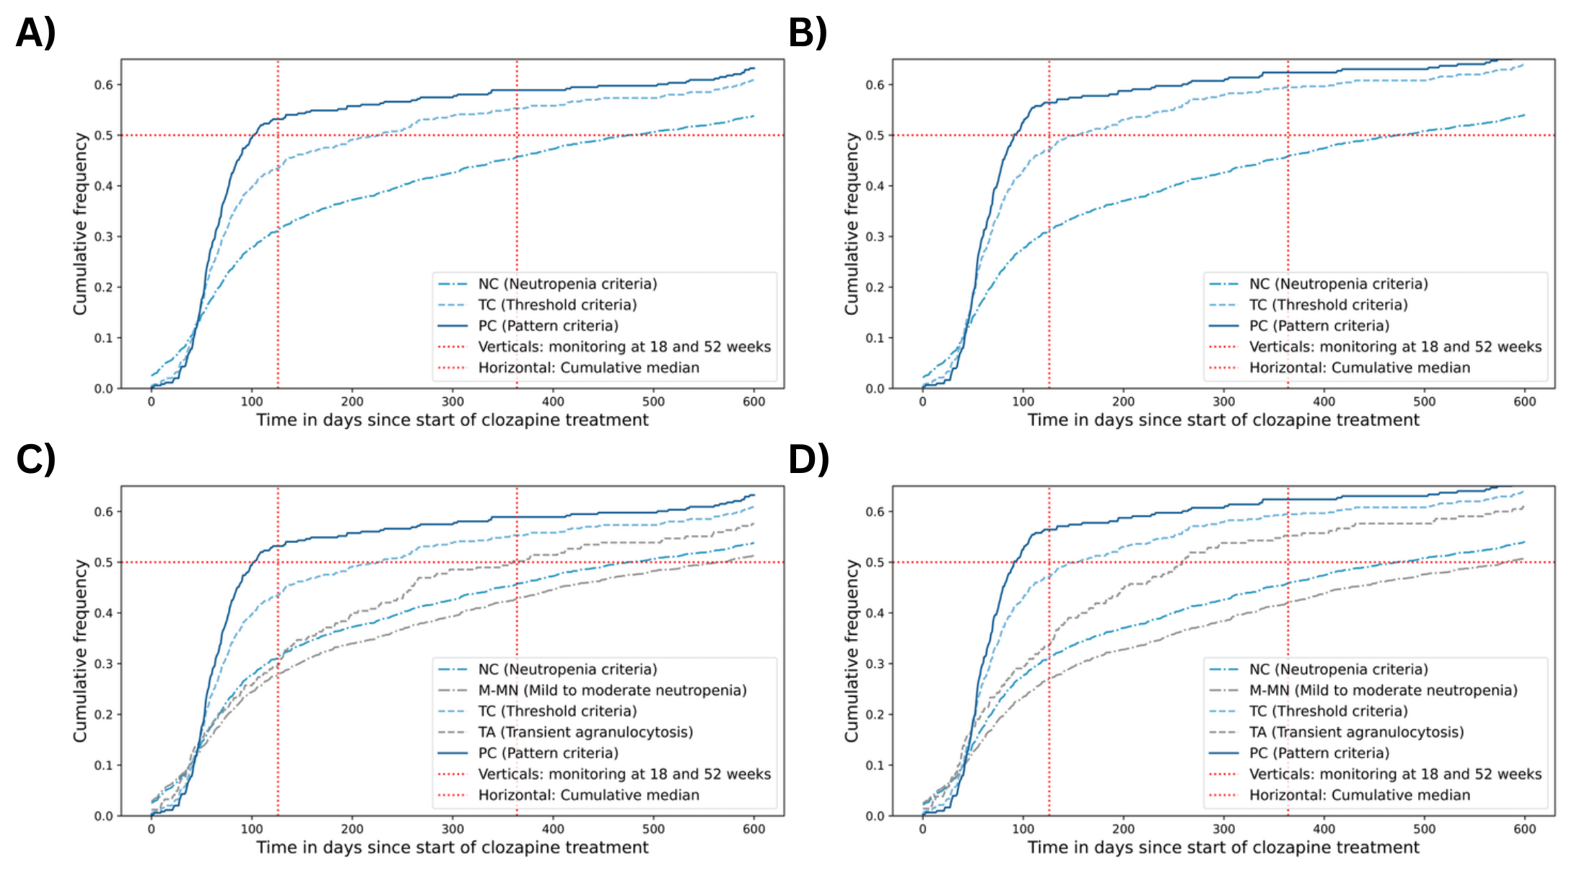

**Figure 2.** Cumulative frequency of haematological events (NC, M-MN, TC, TA, PC) in patients registered on the CNRD. A & C) includes all recorded clozapine indications and B & D) is restricted to only patients with TRS

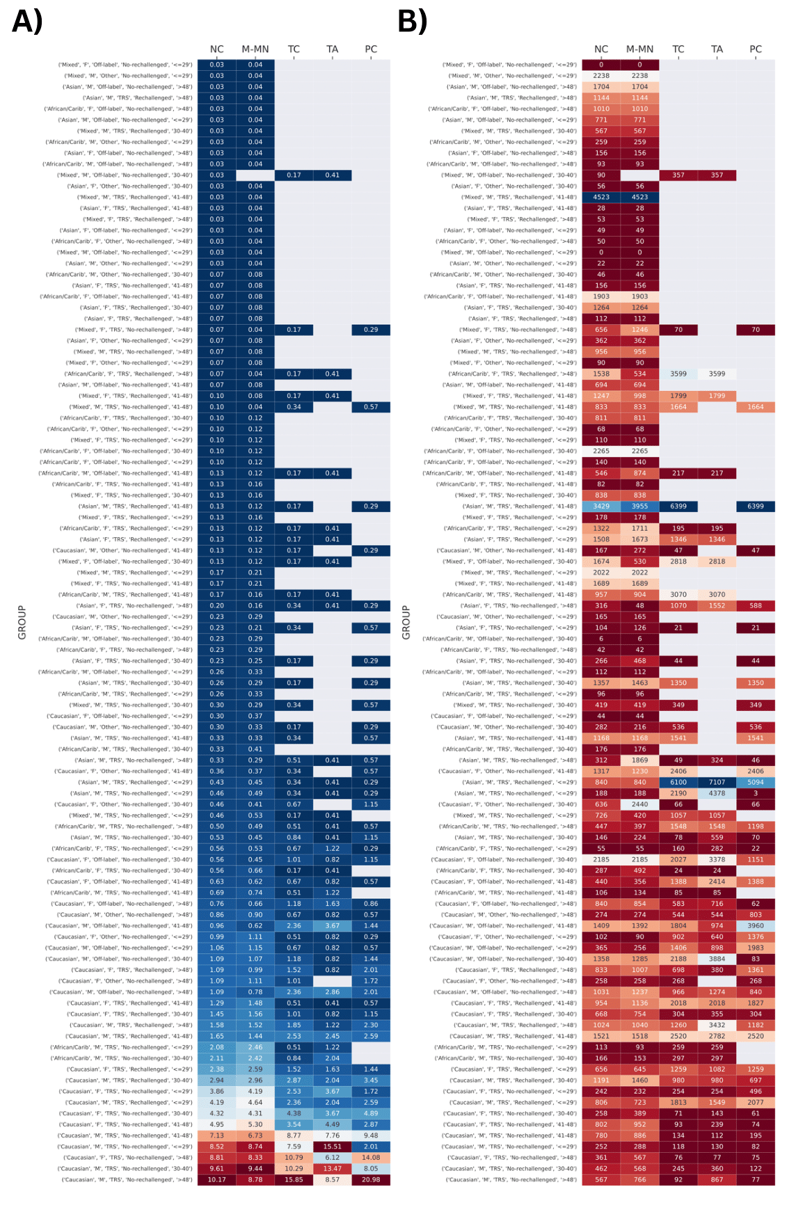

**Figure 2.** Heatmaps represent (A) the prevalence and (B) the expected median time of different haematological events (neutropenia, mild-to moderate neutropenia, threshold-based agranulocytosis, transient agranulocytosis and pattern-based agranulocytosis) for different demographic groups (ethnicity, gender, clozapine indication, rechallenge status age).



**Figure 3.** Cumulative number of patients entering the CNRD by year (Mixed)



**Figure 4.** Cumulative number of patients entering the CNRD by year (Afro-Caribbean)



**Figure 4.** Cumulative number of patients entering the CNRD by year (Afro-Caribbean)



**Figure 5.** Cumulative number of patients entering the CNRD by year (Caucasian)