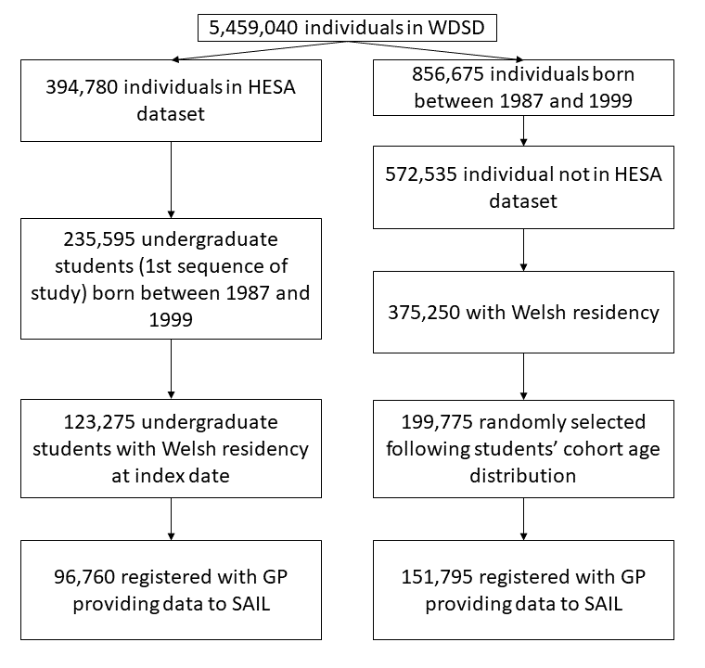
Figure 1 – Flow diagram of cohort selection

