Data supplement 1. Additional information about treatment integrity
Treatment adherence (i.e. whether the therapy protocol was followed) and competence (i.e. how well the therapy was performed) were measured by four expert raters (clinical psychologists in training): two raters scored SPSP sessions, two scored ST sessions. One SPSP and one ST-rater were independent. The other two had participated as therapists in the trial. To reduce bias, these raters were not allowed to score audio sessions of their patients or patients of colleagues from their supervision- or consultation team. A total of 160 audio sessions were rated of 80 randomly selected patients, 20 in each condition and stratified to depression severity (BDI-II score < 29 vs BDI-II score >= 29). For each patient two sessions were selected per condition from start phase (25-condition: between session 6-12, 50-condition: between session 12-24) and end phase of therapy (25-condition: between session 18-24, 50-condition: between session 36-48) based on availability. If audio sessions within these ranges were not available, the next patient was selected. In both ST conditions the aimed 20 patients with two audiotaped sessions within the pre-agreed range were available. In the SPSP-50 condition only 14 were available. Therefore the sessions of 26 (instead of 20) patients from the SPSP-25 condition were used in order to reach a total of 40 patients in both ST and SPSP. For 7 patients in the SPSP-25 condition one session outside the pre-agreed range had to be selected as no complete sets of audios were available for any more patients within the range. In addition, an equal division between low and high depression severity could not be reached in the SPSP condition (n=11 low vs n=29 high).
Adherence ratings consisted of intervention lists and indicated whether the sessions included specific ST and SPSP interventions. For ST this scale was based on previous research.¹ The SPSP Adherence Scale was developed for this study. For competence, the Schema Therapy Competence Scale (STCS-I-1) was used for ST and a scale for SPSP was developed for the study on the basis of instruments used in other psychodynamic trials.²⁻⁴

For the scores on the ST and SPSP adherence and competence scales, ICCs (two-way random, absolute agreement, average measures) were computed. Therefore, 12 single sessions of 12 patients were double rated and compared to the means of the two rated session for 40 patients in both SPSP and ST. ICC’s were fair for SPSP (ICC adherence: 0.54, ICC competence: 0.71) and excellent for ST (ICC adherence: 0.79, ICC competence: 0.80). Note that the ICC’s on the adherence measures were computed using all item scores of the instrument, while the ICC’s on the competence measures were computed using mean scores.
Although intraclass correlation coefficients (ICC) were satisfactory and the ST-adherence scale was found to have validity and high interrater agreement in a previous study, no other psychometric properties were available for the adherence and competence scales.
References:
- Bamelis LL, Evers SM, Spinhoven P, Arntz A. Results of a multicenter randomized controlled trial of the clinical effectiveness of schema therapy for personality disorders. Am J Psychiatry 2014; 171(3): 305–22.
- Young JE, Fosse G. Schema Therapist Competency Scale (STCS-I-1). Unpublished document available on www.isstonline.com, 2008.
- Barber J, Critis-Christoph P. Development of a therapist adherence/competence rating scale for supportive-expressive dynamic psychotherapy: A preliminary report. Psychotherapy research 1996; 6(2): 81-94. https://doi.org/10.1080/10503309612331331608.
- Miggiels MF, Ten Klooster PM, Bremer-Hoeve S et al. The D* Phase-study: study protocol for a pragmatic two-phased, randomised controlled (non-inferiority) trial that addresses treatment non-response and compares cognitive behavioural therapy and short-term psychodynamic supportive psychotherapy for major depression. BMC psychiatry 2021; 21(1): 1-15. https://doi.org/10.1186/s12888-021-03156-8.

Supplement 2. Baseline characteristics for each condition.
Table 1. Baseline characteristics
 | 25 sessions (n=132) |  | 50 sessions (n=114)
 | ST-25  (n=64) | SPSP-25  (n=68) | ST-50  (n=60) | SPSP-50  (n=54)
Age (years, SD) | 39.8 (11.4) | 39.0 (12.0) | 40.7 (12.6) | 39.4 (11.0)
Sex
- Women | 40 (63%) | 53 (78%) | 42 (70%) | 36 (67%)
- Men | 24 (38%) | 15 (22%) | 18 (30%) | 18 (33%)
Dutch nationality* | 48 (92%) | 56 (89%) | 44 (85%) | 47 (94%)
Marital status*
- Single | 23 (46%) | 34 (57%) | 31 (69%) | 35 (70%)
- Married or cohabiting | 17 (34%) | 19 (32%) | 11 (24%) | 14 (28%)
- Divorced or widowed | 10 (20%) | 7 (12%) | 3 (7%) | 1 (2%)
Education*
- Low | 7 (12%) | 3 (5%) | 0 (0%) | 4 (8%)
- Medium | 24 (41%) | 36 (55%) | 25 (47%) | 23 (44%)
- High | 27 (47%) | 27 (41%) | 28 (53%) | 25 (48%)
Employment* | 35 (57%) | 35 (52%) | 39 (66%) | 33 (62%)
Previous treatment* | 52 (81%) | 56 (82%) | 52 (87%) | 45 (83%)
Drop-out previous treatment* | 16 (28%) | 20 (31%) | 11 (20%) | 17 (36%)
History of antidepressants* | 30 (63%) | 33 (60%) | 26 (58%) | 25 (70%)
Current use of antidepressants | 23 (36%) | 20 (30%) | 15 (25%) | 19 (35%)
BDI-II total score (SD) | 32.9 (10.7) | 33.5 (9.8) | 33.9 (9.1) | 33.7 (10.0)
Severe depression | 37 (58%) | 44 (65%) | 42 (70%) | 35 (67%)
No. of depressive episodes*
- 1 | 14 (30%) | 16 (31%) | 19 (37%) | 12 (27%)
- 2 | 8 (17%) | 5 (10%) | 6 (12%) | 7 (16%)
- 3 or more | 25 (53%) | 31 (60%) | 27 (52%) | 26 (58%)
MINI diagnoses
- Current depression | 54 (84%) | 51 (75%) | 54 (90%) | 44 (82%)
- Dysthymia | 10 (16%) | 17 (25%) | 6 (10%) | 10 (19%)
SCID-II/ SCID-5-PD diagnoses
- Cluster A
- Paranoid | 12 (19%) | 5 (7%) | 4 (7%) | 2 (4%)
- Schizotypal | 1 (2%) | 0 (0%) | 0 (0%) | 0 (0%)
- Schizoid | 0 (0%) | 2 (3%) | 1 (2%) | 0 (0%)
- Cluster B
- Histrionic | 0 (%) | 1 (2%) | 0 (0%) | 0 (0%)
- Borderline | 20 (31%) | 18 (27%) | 12 (20%) | 14 (26%)
- Narcissistic | 3 (5%) | 3 (4%) | 3 (5%) | 3 (6%)
- Antisocial | 0 (0%) | 0 (0%) | 1 (2%) | 0 (0%)
- Cluster C
- Avoidant | 28 (44%) | 31 (46%) | 31 (52%) | 17 (32%)
- Dependent | 5 (8%) | 3 (4%) | 1 (2%) | 2 (4%)
- Obsessive compulsive | 19 (30%) | 16 (24%) | 21 (35%) | 15 (28%)
- NOS | 10 (16%) | 19 (28%) | 14 (123%) | 18 (33%)
Number of PDs
1 | 44 (69%) | 49 (72%) | 41 (76%) | 40 (67%)
2 | 10 (16%) | 10 (15%) | 10 (19%) | 14 (23%)
3 or more | 10 (16%) | 9 (13%) | 3 (6%) | 6 (10%)
Number of PD traits** (SD) | 12.7 (6.3) | 11.7 (6.7) | 11.5 (6.5) | 10.8 (6.8)
Data are n (%) or mean (SD). BDI-II=Beck Depression Inventory, second edition. Note that severe depression is defined as a BDI-II score of >28. MINI=Mini International Neuropsychiatric Interview. SCID-II=Structured clinical interview for DSM-IV Axis II personality disorders. SCID-5-P= Structured Clinical Interview for DSM-5 Personality Disorders: SCID-5-PD. Note that employment was defined as having a working contract, regardless of sick leave of up to 2 years. *=Data were not available for all randomized participants. In case of missing data, the available data per condition are given: data were missing for Dutch nationality (ST-25 n=12, SPSP-25 n=5, ST-50 n=8, SPSP-50 n=4), marital status (ST-25 n=14, SPSP-25 n=8, ST-50 n=7, SPSP-50 n=4), educational level (ST-25 n=6, SPSP-25 n=2, ST-50 n=7, SPSP-50 n=2), employment (ST-25 n=2, ST-50 n=1, SPSP-50 n=1), previous treatment (ST-25 n=6, SPSP-25 n=4, ST-50 n=4, SPSP-50 n=6), previous dropout (ST-25 n=7, SPSP-25 n=4, ST-50 n=4, SPSP-50 n=7), number of depressive episodes (ST-25 n=17, SPSP-25 n=16, ST-50 n=7, SPSP-50 n=8) and history of antidepressants (ST-25 n=16, SPSP-25 n=13, ST-50 n=15, SPSP-50 n=18). ** When patients had >= cut-off -1 score on a PD section on the screener at inclusion, only those sections were assessed in the SCID interview.

Supplement 3. Baseline characteristics of 25- vs 50-conditions.
 | 25 sessions  (n=132) | 50 sessions (n=114)
Age (years, SD) | 39.4 (11.7) | 40.1 (11.9)
Sex
- Women | 93 (70%) | 78 (68%)
- Men | 39 (30%) | 36 (32%)
Dutch nationality¹ | 104 (90%) | 91 (89%)
Marital status¹
- Single | 57 (52%) | 66 (69%)
- Married or cohabiting | 36 (33%) | 25 (26%)
- Divorced or widowed | 17 (15%) | 4 (4%)
Education¹
- Low | 10 (8%) | 4 (4%)
- Medium | 60 (48%) | 48 (46%)
- High | 54 (44%) | 53 (50%)
Employment¹ | 70 (54%) | 72 (64%)
Previous treatment¹ | 108 (82%) | 97 (85%)
Drop-out previous treatment¹ | 36 (30%) | 28 (27%)
History of antidepressants¹ | 63 (61%) | 51 (63%)
Current use of antidepressants | 43 (33%) | 34 (30%)
BDI-II total score (SD) | 33.2 (10.2) | 33.8 (9.5)
Severe depression | 81 (61%) | 78 (68%)
No. of depressive episodes¹
- 1 | 30 (30%) | 31 (31%)
- 2 | 13 (13%) | 15 (15%)
- 3 or more | 56 (57%) | 53 (54%)
MINI diagnoses
- Current depression | 105 (80%) | 98 (86%)
- Dysthymia | 27 (20%) | 16 (14%)
SCID-II/ SCID-5-PD diagnoses
- Cluster A
- Paranoid | 17 (13%) | 6 (5%)
- Schizotypal | 1 (1%) | 0 (0%)
- Schizoid | 2 (2%) | 1 (1%)
- Cluster B
- Histrionic | 1 (1%) | 0 (0%)
- Borderline | 38 (29%) | 26 (23%)
- Narcissistic | 6 (5%) | 6 (5%)
- Antisocial | 0 (0%) | 1 (1%)
- Cluster C
- Avoidant | 59 (45%) | 48 (42%)
- Dependent | 8 (6%) | 3 (3%)
- Obsessive compulsive | 35 (27%) | 36 (32%)
- NOS | 29 (22%) | 32 (28%)
Number of PDs
1 | 93 (71%) | 81 (71%)
2 | 20 (15%) | 24 (21%)
3 or more | 19 (14%) | 9 (8%)
Number of PD traits² (SD) | 12.2 (6.5) | 11.2 (6.6)
Data are n (%) or mean (SD). BDI-II=Beck Depression Inventory, second edition. Note that severe depression is defined as a BDI-II score of >28. MINI=Mini International Neuropsychiatric Interview. SCID-II=Structured clinical interview for DSM-IV Axis II personality disorders. SCID-5-P= Structured Clinical Interview for DSM-5 Personality Disorders: SCID-5-PD. Note that employment was defined as having a working contract, regardless of sick leave of up to 2 years. 1=Data were not available for all randomised participants. In case of missing data, the available data per condition are given: data were missing for Dutch nationality (25-condition n=17, 50-condition n=12), marital status (25-condition n=22, 50-condition n=11), educational level (25-condition n=8, 50-condition n=9), employment (25-condition n=2, 50-condition n=2), previous treatment (25-condition n=10, 50-condition n=10), previous dropout (25-condition n=11, 50-condition n=11), number of depressive episodes (25-condition n=33, 50-condition n=15), and history of antidepressants (25-condition n=29, 50-condition n=33). 2=When patients had >= cut-off -1 score on a PD section on the screener at inclusion, only those sections were assessed in the SCID interview.

Supplement 4. Treatment characteristics
 | ST25 (N=64) | SPSP25 (N=68) | ST50 (N=60) | SPSP50 (N=54) | 25 vs 50 (p)
Information about the waiting period
Days between baseline and treatment start, M (SD) | 92.7 (55.0) | 104.8 (54.5) | 116.8 (60.5) | 95.8 (59.6) | ns
Observed BDI-II score before treatment start, M (SD) | 30.2 (12.0) | 30.7 (9.9) | 31.2 (9.6) | 32.4 (11.0) | ns
Psychotherapy dosage
Days between sessions, M (SD) | 12.9 (4.3) | 14.0 (6.8) | 7.9 (4.6) | 8.4 (3.0) | p<0.001
Total treatment length, in days, M (SD) | 299.3 (75.7) | 295.9 (49.1) | 321.2 (75.0) | 334.4 (59.1) | p<0.001
Total number of sessions, M (SD) | 25.0 (4.6) | 24.1 (5.7) | 46.0 (9.6) | 43.7 (9.6) | p<0.001
Antidepressant medication
At inclusion, N (%) | 23 (25.9%) | 20 (29.9%) | 16 (27.1%) | 18 (34.0%) | ns
During treatment, N (%) | 24 (40.7%) | 19 (31.1%) | 16 (29.6%) | 24 (48.0%) | ns
At end of treatment, N (%) | 20 (33.9%) | 18 (30.5%) | 16 (30.2%) | 19 (38.8%) | ns
Drop out
Non-completers, N (%) | 14 (22%) | 15 (22%) | 17 (28%) | 15 (28%) | ns
Note. BDI-II, Beck Depression Inventory, second edition; M = mean; SD = standard deviation. Note that information about the waiting period is based on data of all patients, except for those who did not start treatment (N=14). BDI scores at treatment start were missing for 26 patients; ST-25 (missing n=9), SPSP-25 (missing n=2), ST-50 (missing n=5); SPSP-50 (missing n=10). Note that the information about psychotherapy dosage is based on data of the completers only and that days between sessions include weekend days.

Supplement 5.
- Time until dropout 25 vs 50 session, including completers, treatment dropouts and patients who did not start the intervention.

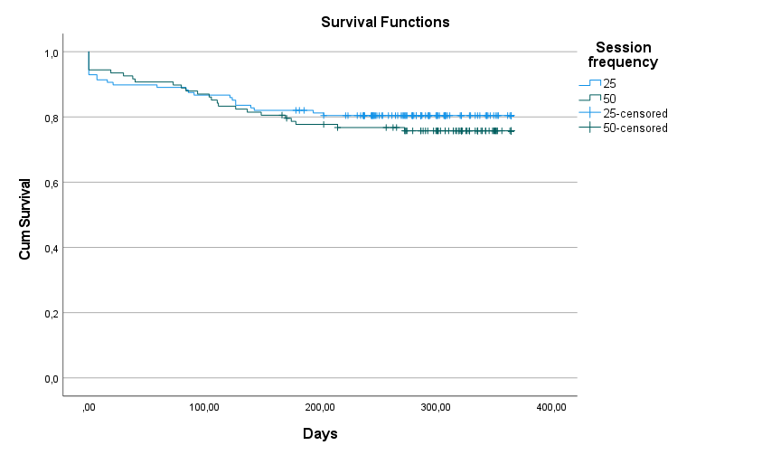

Numbers at risk
Start 1 month 2 months 3 months 6 months 12 months
25: 128 115 114 112 103 11
50: 108 101 98 95 82 18

HR 0.81 (95% CI 0.47-1.41); p=0.457
Log-rank 0.554

- Time until dropout 25 vs 50 session, including completers and treatment dropouts.

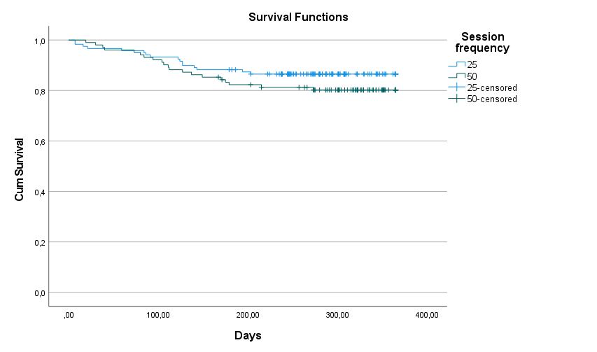
Numbers at risk
Start 1 month 2 months 3 months 6 months 12 months
25: 119 115 114 112 103 11
50: 102 101 98 95 82 18

HR 0.68 (95% CI 0.35-1.30); p=0.242
Log-rank 1.379

Supplement 6. Estimated marginal means on the BDI-II per time-point on the intention-to-treat sample.
 | ST-25 (n=64) |  | SPSP-25 (n=68) |  | ST-50 (n=60) |  | SPSP-50 (n=54)
 | mean (SD) | 95% CI | mean (SD) | 95% CI | mean (SD) | 95% CI | mean (SD) | 95% CI
Start | 30.5 (1.0) | 28.5-32.6 | 30.9 (1.0) | 29.0-32.8 | 29.9 (1.0) | 27.9-32.0 | 31.8 (1.1) | 29.6-34.0
1 month | 29.4 (1.0) | 27.5-31.3 | 29.8 (0.9) | 28.0-31.6 | 28.4 (1.0) | 26.5-30.4 | 30.2 (1.1) | 28.1-32.2
2 months | 28.3 (1.0) | 26.4-30.2 | 28.8 (0.9) | 27.0-30.5 | 27.0 (1.0) | 25.1-28.9 | 28.5 (1.0) | 26.5-30.6
3 months | 27.3 (1.0) | 25.4-29.3 | 27.8 (0.9) | 25.9-29.6 | 25.6 (1.0) | 23.6-27.5 | 27.0 (1.1) | 24.9-29.1
6 months | 24.7 (1.2) | 22.4-27.1 | 25.3 (1.1) | 23.1-27.5 | 21.9 (1.2) | 19.6-24.2 | 22.8 (1.2) | 20.3-25.2
308 days | 22.3 (1.7) | 19.0-25.6 | 23.0 (1.7) | 19.9-26.1 | 17.9 (1.6) | 14.7-21.0 | 18.0 (1.6) | 14.8-21.3
1 year | 21.6 (2.1) | 17.6-25.7 | 22.4 (1.9) | 18.6-26.2 | 16.5 (1.9) | 12.7-20.2 | 16.3 (1.9) | 12.6-20.1
Mean= estimated marginal means on the BDI-II, SD= standard deviation, 95% CI= 95% confidence interval. Note that all randomised patients who had completed at least one BDI-measurement were included in ITT-analysis. Patients of whom no BDI-data were available were therefore excluded from ITT analysis per condition: ST-25: n=7; SPSP-25: n=2; ST-50: n=4; SPSP-50: n=4. Note that both the mean therapy duration of 308 days was presented as well as results at 1 year after the start of therapy.

Supplement 7. Estimated means (95% CI) at start and 12 months and effect sizes (within and between 25- and 50-condition) for all primary and secondary outcomes.
 | 25-condition |  |  | 50-condition |  |  | 25 vs 50
 | Start estimated mean/sum score  (95% CI) | End estimated mean/sum score  (95% CI) | Within group ES | Start estimated mean/sum score  (95% CI) | End estimated mean/sum score  (95% CI) | Within group ES | Between group ES
BDI | 30.69 (29.27-32.10) | 308 days:  22.67 (20.38-24.96)  1 year:  22.02 (19.09-24.94) | 0.75  0.81 | 30.85 (29.32-32.38) | 308 days:  17.94 (15.69-20.19)  1 year:  16.38 (13.66-19.11) | 1.21  1.36 | -0.44  -0.53
SMI
- Functional modes | 3.03 (2.92-3.13) | 3.36 (3.15-3.57) | 0.57 | 3.13 (3.01-3.24) | 3.72 (3.54-3.89) | 1.01 | -0.62
- Dysfunctional modes | 2.94 (2.85-3.04) | 2.61 (2.49-2.74) | 0.62 | 2.96 (2.86-3.06) | 2.45 (2.32-2.58) | 0.95 | -0.30
YSQ-sf
- Dysfunctional schemas | 3.38 (3.22-3.53) | 2.89 (2.67-3.10) | 0.60 | 3.42 (3.25-3.58) | 2.68 (2.48-2.88) | 0.90 | -0.25
DPI
- Adaptive level of development | 53.98 (51.77-56.19) | 60.20 (57.62-62.78) | 0.51 | 56.70 (54.31-59.10) | 64.57 (61.91-67.23) | 0.65 | -0.36
- Disadaptive neurotic level | 47.67 (45.10-50.24) | 41.79 (38.57-45.02) | 0.43 | 48.56 (45.77-51.35) | 38.26 (35.10-41.41) | 0.75 | -0.26
- Disadaptive primitive level | 35.04 (32.59-37.49) | 30.68 (27.90-33.45) | 0.33 | 33.50 (30.84-36.17) | 25.69 (22.80-28.57) | 0.59 | -0.38
SIPP
- Self-control | 4.50 (4.30-4.71) | 5.10 (4.83-5.37) | 0.68 | 4.68 (4.49-4.87) | 5.58 (5.36-5.80) | 1.02 | -0.54
- Identity integration | 3.31 (3.17-3.45) | 3.75 (3.51-4.00) | 0.72 | 3.34 (3.20-3.47) | 4.28 (4.08-4.48) | 1.53 | -0.85
- Responsibility | 4.44 (4.27-4.61) | 4.61 (4.44-4.79) | 0.24 | 4.57 (4.40-4.74) | 5.00 (4.68-5.14) | 0.58 | -0.52
- Relational capacities | 3.71 (3.54-3.89) | 4.09 (3.85-4.33) | 0.49 | 3.80 (3.63-3.96) | 4.48 (4.27-4.68) | 0.89 | -0.51
- Social concordance | 5.45 (5.26-5.63) | 5.86 (5.63-6.09) | 0.50 | 5.56 (5.37-5.74) | 6.09 (5.91-6.28) | 0.65 | -0.28
Quality of life:
- General life happiness | 3.39 (3.13-3.64) | 4.20 (3.89-4.51) | 0.75 | 3.36 (3.09-3.64) | 4.70 (4.38-5.02) | 1.24 | -0.46
- Health rel. qual. of life (EQ-5D) | 0.56 (0.53-0.60) | 0.69 (0.64-0.75) | 0.55 | 0.56 (0.52-0.60) | 0.72 (0.67-0.77) | 0.69 | -0.14
Other:
- Symptomatic distress (OQ-SD) | 60.46 (57.97-62.95) | 50.20 (46.52-53.89) | 0.91 | 59.70 (57.31-62.10) | 42.60 (39.35-45.84) | 1.51 | -0.67
- Brief Symptom Inventory (BSI) | 81.54 (74.96-88.12) | 66.43 (59.13-73.73) | 0.41 | 79.64 (72.54-86.74) | 55.04 (47.54-62.54) | 0.67 | -0.31
Note that mean scores were used for SMI, YSQ, SIPP and sum scores were used for BDI, DPI, OQ, BSI. The index-score was used for EQ-5D. Note that for SIPP and OQ the observed means at inclusion were used, because no measure at treatment start were available. Note that end of treatment estimated marginal means are set at 1 year after start of treatment. In addition, the results for the BDI were calculated for the mean therapy duration (308 days).

