Decoding anxiety-impulsivity subtypes in preadolescent internalizing disorders identifies distinct neurodevelopmental, genetic, cognitive, and clinical trajectory signatures

Supplemental Methods

Measures

Trait impulsivity and sub-facets
Trait impulsivity and its sub-facets were assessed by means of the validated UPPS model of impulsivity (UPPS-P Impulsive Behavior Scale) encompassing the sub-facets Negative and Positive Urgency (nu and pu, behavioral dysregulations in the context of negative or positive emotions, respectively), Lack of Premeditation and Perseverance (lopl and lope, indexed by tendencies to act without planning or quit difficult tasks, respectively), and Sensation Seeking (ss, seeking arousing and stimulating activities).¹

Anxiety, depression, and behavioral problems scores
Levels of anxiety were derived from the Child Behavior Checklist (CBCL) a widely used parent-report of child and adolescent behavior ¹ by capitalizing on raw scores of the Anxiety Problems scale which is aligned with DSM-anxiety symptoms. We additionally included the Depressive Problems as an index of depressive symptom load and other subscales (Externalizing Problems, Rule-Breaking Behavior, Aggressive Behavior, ADHD Problems, Oppositional Defiant Problems, Conduct Problems) to represent children’s behavioral problems.

Behavioral inhibition and activation
Gray’s Reinforcement Sensitivity Theory proposes two neurobiological rooted motivational systems, the Behavioral Inhibition System (BIS) which determines responses to punishment and generates anxious emotions, and the Behavioral Activation System (BAS) which determines sensitivity to rewards and has been related to impulsivity.² Four sub-facets are included in the validated BIS/BAS scale, three for behavioral activation: Drive (basdr, intensity of goal directed behavior), Fun seeking (basfs, enjoyment for its own sake, spontaneity), and Reward Responsiveness (basrr, excitement over reinforcing outcomes) and one for behavioral inhibition (bis, e.g., worry, fearfulness).¹

Brain structure
T1-weighted structural MRI (sMRI) data were collected on 3T MRI systems (Siemens Prisma, General Electric MR 750, Philips). Detailed information is provided elsewhere.³ SMRI data preprocessing was completed by the ABCD study according to standardized processing pipelines.⁴ Cortical surface reconstruction and subcortical segmentation were implemented via FreeSurfer, version 5.3.0. The current study used post-processed structural data of cortical thickness, surface area, cortical volume, and sulcus depth with the Desikan atlas-based classification (n = 68) and subcortical volumes (left/right thalamus, caudate, putamen, pallidum, hippocampus, amygdala, and accumbens area). Participant data were excluded from the neuroimaging analysis if the T1 images failed to pass visual inspection and FreeSurfer quality control (imgincl_t1w_include = 1).

Statistical analyses

Clustering analysis
We performed a two-step procedure using hierarchical and non-hierarchical clustering in tandem that has been thoroughly validated ⁵, and has been successfully employed in multiple disciplines ^{6,7}. According to Ketchen and Shook ⁵, using hierarchical algorithms alone suffers from problems including the choice of a potential poor algorithm to measure the distance between clusters, and the single processing of the data set may cause the poor cluster assignments which cannot be modified. These two problems can be resolved by non-hierarchical clustering with multiple passes made through the data set, which allows the switching of cluster membership because the cluster centroids are recomputed in each iteration, thus maximizing within-cluster homogeneity and between-cluster heterogeneity. However, using the non-hierarchical clustering alone also has problems such that it requires an a priori number of clusters and predefinition of starting points in advance. The combination of hierarchical and non-hierarchical clustering therefore can account for these issues and is valid such that the hierarchical clustering is used to define the number of clusters and cluster centroids which in turn serve as the starting points for subsequent non-hierarchical clustering.

Genotype data processing
Saliva samples at baseline were genotyped using the Affymetrix Smokescreen array.⁸ Details of biospecimen collection can be found in elsewhere.⁹ In order to assign the genetic ancestry to ABCD samples, we firstly computed genetic Principal components (PCs) across 302,901 high-quality autosomal single nucleotide polymorphisms (SNPs) in the combined ABCD and the 1000 Genomes Project phase 3 reference samples and only kept ABCD samples that can be assigned to one of five ancestries [African (AFR), American (AMR), East Asian (EAS), European (EUR) and South Asian (SAS)] by the random forest classifier with a predicted probability greater than 0.9. The random forest classifier was trained on HCP (Human Connectome Project) genotypes and 1000 Genomes Project data (details can be found at https://github.com/Annefeng/PBK-QC-pipeline). We performed genotype imputation using the Michigan Imputation Server with hrc.r1.1.2016 reference panel and Eagle v2.4 phasing.¹⁰ Best guess conversion at a threshold of 0.9 was used to convert dosage files to PLINK binary PED files. After imputation, we excluded individuals with great than 10% missing rate and SNPs with less than 0.3 imputation info score, greater than 5% missing rate, less than 1% MAF (Minor Allele Frequency), or out of Hardy-Weinberg equilibrium violation ($p>1×{10}^{-6}$), yielding 4,326,912 SNPs. Genetically unrelated individuals with less than 0.2 PI_HAT were retained. We then performed GWAS using PLINK v2.0 on genetically unrelated preadolescents with European ancestry who passed structural image quality control (imgincl_t1w_include = 1), containing 4,468 individuals.¹¹ On the premise of additive genetic effects, general linear regression models were fitted to determine the association between cortical thickness (CT) and allele dosages of SNPs in these individuals. To correct for population stratification, the first 10 genetic principal components (PCs) were derived using genetic Principal Component Analysis (PCA) performed on these unrelated European preadolescents. Sex, age, mean cortical thickness, 10 PCs, and study sites were included as covariates.

Functional mapping
The genome-wide significant loci from GWAS were defined by the online platform (version 1.3.7) of Functional Mapping and Annotation of Genome-Wide Association Studies (FUMA) by clumping each phenotype separately in PLINK (LD $R^{2}=0.1$, distance = 250kb, $P<5×{10}^{-8}$).¹² The reference panel population was European of the 1000 Genomes Project phase 3. Given the known link between the brain, psychiatric disorders and immune system,^{13,14} we included the Major Histocompatibility Complex (MHC) region in our FUMA analyses. We employed three strategies to link the SNPs to protein-coding genes: positional mapping, eQTL (expression quantitative trait loci) mapping and 3D Chromatin Interaction mapping. Details of these strategies were consistent with Makowski et al.¹⁵ In addition, to combine cumulative effects of SNPs assigned to a gene, gene-based association analysis was performed using Multi-marker Analysis of GenoMic Annotation (MAGMA) implemented in FUMA.¹⁶ SNPs were mapped to protein-coding genes if they are located within the genes. The gene-based P-value for each gene was calculated by combing SNP P-values into a gene test-statistic, indicating the association between the gene and the GWAS phenotype. Genes significantly associated with CT at each ROI were identified as exceeding the Bonferroni corrected threshold.

Spatial association with neurotransmitter receptor/transporter density maps
To determine which neurotransmitter systems are associated with altered brain regions in each subtype relative to healthy individuals, JuSpace toolbox (v1.3, https://github.com/juryxy/JuSpace) was used to calculate the spatial correlation between the t-map of each subtype versus HC and 28 PET-based neurotransmitter receptor/transporter density maps.¹⁷ Before calculating spatial correlation, t value is filled into Desikan-Killiany Atlas to get a t-map in surface space, and then the mri_surf2vol tool of Freesurfer was used to transform the t-map from surface space into MNI space, to keep consistent with PET images. Spearman correlation and permutation test were used to test whether the correlation between t-map and PET-maps is significant (based on the Neuromorphometrics atlas; exact p values, n = 1,000 permutations; adjusted for spatial autocorrelation). FDR was used for multiple comparisons correction at q < 0.05 for the 28 measures of neurotransmitter receptor/transporter density maps.

Supplemental Results

 | Subtype 1  (n = 1203) | Subtype 2  (n = 1227) | Statistical analysis | P-value | Effect Size^{c}
Age, years, Mean (SD) | 9.89 (0.63) | 9.96 (0.62) | $t_{2425.4}$ = -2.950 | 0.003 | 0.12
Educationª, Mean (SD) | 3.69 (1.20) | 3.89 (1.13) | $t_{2140.6}$ = -4.253 | < 0.001 | 0.17
Income^{b}, Mean (SD) | 7.17 (2.39) | 7.41 (2.27) | $t_{2221.8}$ = -2.431 | 0.015 | 0.10
Sex, n (%) |  |  | $χ_{1}^{2}$ = 31.114 | < 0.001 | 0.11
Male | 618 (51.37) | 491 (40.02)
Race, n (%) |  |  | $χ_{5}^{2}$ = 10.924 | 0.053 | 0.07
Caucasian | 773 (64.26) | 850 (69.27)
African American | 164 (13.63) | 153 (12.47)
Mixed | 149 (12.39) | 134 (10.92)
Asian | 27 (2.24) | 23 (1.87)
AIAN/NHPI | 5 (0.42) | 10 (0.81)
Other | 65 (5.40) | 43 (3.50)
Table S2: Demographic information of two subtypes in pure internalizing patients at baseline.
AIAN, American Indian/Alaska Native; NHPI = Native Hawaiian and other Pacific Islander.
a: Education of parents was measured by the years of education of the parent with the highest education, categorized as an ordinal variable across five bins (1: < HS Diploma; 2: HS Diploma/GED; 3: Some College; 4: Bachelor; 5: Post Graduate Degree).
b: Income was the sum of the annual incomes of both parents, categorized as an ordinal variable across ten bins (1: < $5,000; 2: $5,000-11,999; 3: $12,000-15,999; 4: $16,000-24,999; 5: $25,000-34,999; 6: $35,000-49,999; 7: $50,000-74,999; 8: $75,000-99,999; 9: $100,000-199,999; 10: > $200,000).
c: Cohen’s d for age, Education, and Income. φ for Sex. Cramer’s V for race.

Diagnosis, n (%) | Subtype 1  (n = 1203) | Subtype 2  (n = 1227) | Statistical analysis | P-value
Depression | 155 (12.88) | 110 (8.96) | $χ_{1}^{2}$ = 9.205 | 0.002
Panic disorder | 15 (1.25) | 19 (1.55) | $χ_{1}^{2}$ = 0.212 | 0.65
Agoraphobia | 10 (0.83) | 11 (0.90) | $χ_{1}^{2}$ < 0.001 | 1.0
Separation anxiety disorder | 331 (27.51) | 387 (31.54) | $χ_{1}^{2}$ = 4.538 | 0.033
Social anxiety disorder | 136 (11.31) | 152 (12.39) | $χ_{1}^{2}$ = 0.582 | 0.45
Specific phobia | 833 (69.24) | 849 (69.19) | $χ_{1}^{2}$ = 0 | 1.0
Generalized anxiety disorder | 98 (8.15) | 111 (9.05) | $χ_{1}^{2}$ = 0.517 | 0.47
Posttraumatic stress disorder | 85 (7.07) | 60 (4.89) | $χ_{1}^{2}$ = 4.744 | 0.029
Obsessive-compulsive disorder | 136 (11.31) | 138 (11.25) | $χ_{1}^{2}$ < 0.001 | 1.0
Neurodevelopmental disorder | 305 (25.35) | 306 (24.94) | $χ_{1}^{2}$ = 0.036 | 0.85
Eating disorder | 136 (11.31) | 122 (9.94) | $χ_{1}^{2}$ = 1.048 | 0.31
Homicidal problems | 4 (0.33) | 2 (0.16) | $χ_{1}^{2}$ = 0.187 | 0.67
Sleeping problems | 146 (12.14) | 101 (8.23) | $χ_{1}^{2}$ = 9.720 | 0.002
Suicidal ideation | 98 (8.15) | 64 (5.22) | $χ_{1}^{2}$ = 7.918 | 0.005
Suicide attempt | 13 (1.08) | 6 (0.49) | $χ_{1}^{2}$ = 2.031 | 0.15
Nonsuicidal self-injury | 50 (4.16) | 41 (3.34) | $χ_{1}^{2}$ = 0.904 | 0.34
Table S3: Diagnosis of two subtypes in pure internalizing patients at baseline.

Figure S1: Determination of the cluster number and evaluation of the clustering result.
(A) Curve of average silhouette width in the clustering analysis of pure internalizing patients. (B) Correlation between five UPPS-P dimensions measuring the clustering effectiveness. (C) Distribution of Cohen’s kappa coefficients measuring the clustering stability.

Figure S2: Differences of BIS/BAS between groups in pure internalizing patients at baseline.
basdr, behavioral activation: Drive; basfs, behavioral activation: Fun seeking; basrr, behavioral activation: Reward Responsiveness; bis, behavioral inhibition; HC, healthy control. ANOVA models revealed significant differences in basdr, basfs, and bis, which passed FDR correction at q < 0.05 for the ten measures (one anxiety measure, five impulsivity measures, and four motivational systems measures). * p < 0.5; ** p < 0.01; *** p < 0.001; **** p < 0.0001, which were Bonferroni corrected at p < 0.05/3 in post hoc tests for three pair-wise comparisons between three groups.

Figure S3: Behavioral differences between groups in pure internalizing patients at 2-year follow-up.
(A) Comparisons of anxiety (CBCL-Anxiety Problems) between all groups. (B) Comparisons of UPPS-P between all groups. (C) Comparisons of BIS/BAS between all groups. basdr, behavioral activation: Drive; basfs, behavioral activation: Fun seeking; basrr, behavioral activation: Reward Responsiveness; bis, behavioral inhibition; nu, negative urgency; pu, positive urgency; lope, lack of perseverance; lopl, lack of planning; ss, sensation seeking; HC, healthy control. ANOVA models revealed significant differences in all of six measures of anxiety and impulsivity, as well as basfs and bis of motivational systems, which passed FDR correction at q < 0.05 for the ten measures (one anxiety measure, five impulsivity measures, and four motivational systems measures). * p < 0.5; ** p < 0.01; *** p < 0.001; **** p < 0.0001, which were Bonferroni corrected at p < 0.05/3 in post hoc tests for three pair-wise comparisons between three groups.

Figure S4: Thickness alterations in all pure internalizing patients (subtype 1 and subtype 2) compared to the healthy control at baseline.
HC, healthy control. Yellow asterisks indicate q < 0.05, FDR corrected for the 68 cortical thickness measures.

Figure S5: Neurobiological characterization of the subtypes of pure internalizing patients at 2-year follow-up.
(A) Thickness of brain regions with significant differences between the two subtypes and HC in ANOVA. (B) Thickness alterations in subtype 1 compared to HC. (C) Thickness alterations in subtype 2 compared to HC. (D) Thickness alterations in subtype 1 compared to subtype 2. HC, healthy control. mdtmrh, right middle temporal gyrus; parsopclh, left pars opercularis; sutmrh, right superior temporal gyrus. In (A), * q < 0.05, which were FDR corrected for the 68 cortical thickness measures in ANOVA. In (B), (C), and (D), yellow asterisks indicate p-values passed Bonferroni correction (p < 0.05/3) in post hoc tests for three pair-wise comparisons between three groups.

Figure S6: Correlation between impulsivity and cortical thickness in the entire sample.
(A) Correlation between sensation seeking and cortical thickness at baseline. (B) Correlation between positive urgency and cortical thickness at baseline. Regions with significant difference between subtype 1 (in pure internalizing patients) and HC at baseline were examined. All passed FDR correction at q < 0.05 for the six measures of significantly altered brain regions.

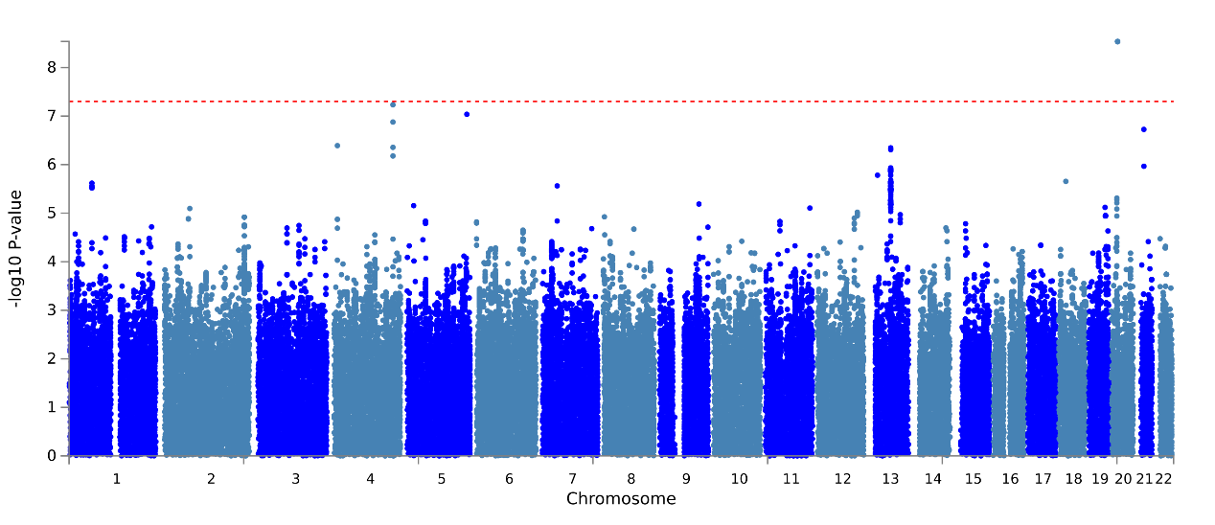
Figure S7: Manhattan plot of GWAS summary statistics of cortical thickness in left pars opercularis.

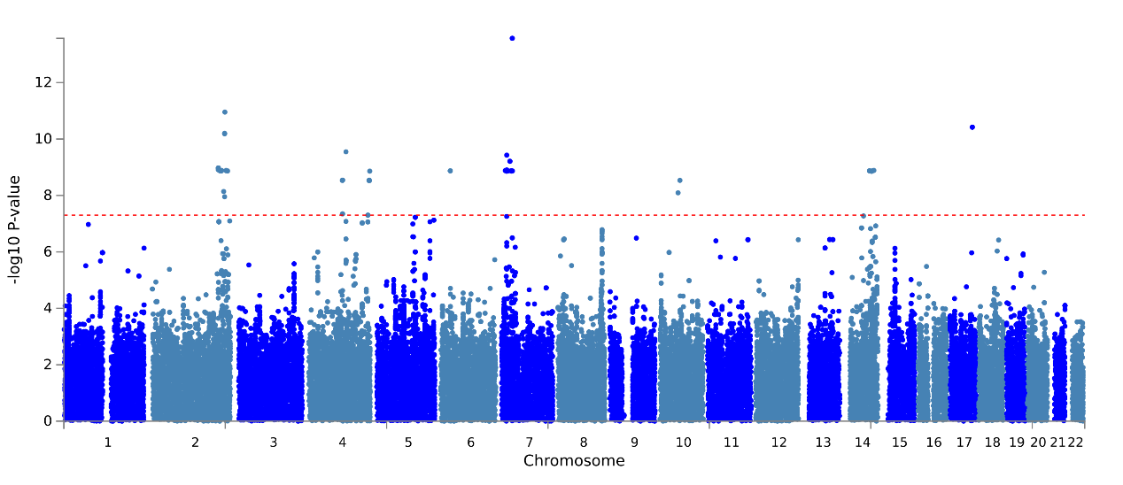
Figure S8: Manhattan plot of GWAS summary statistics of cortical thickness in left precentral gyrus.

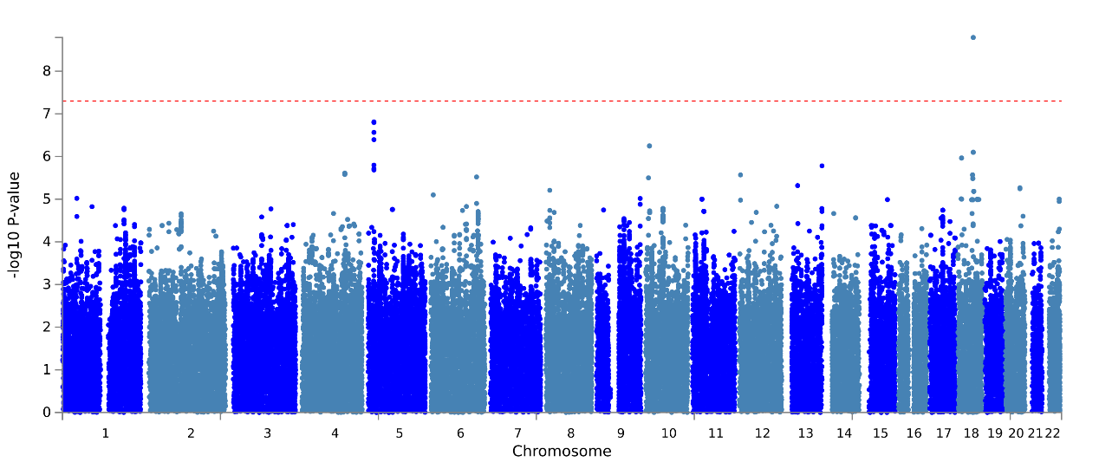
Figure S9: Manhattan plot of GWAS summary statistics of cortical thickness in left caudal middle frontal gyrus.

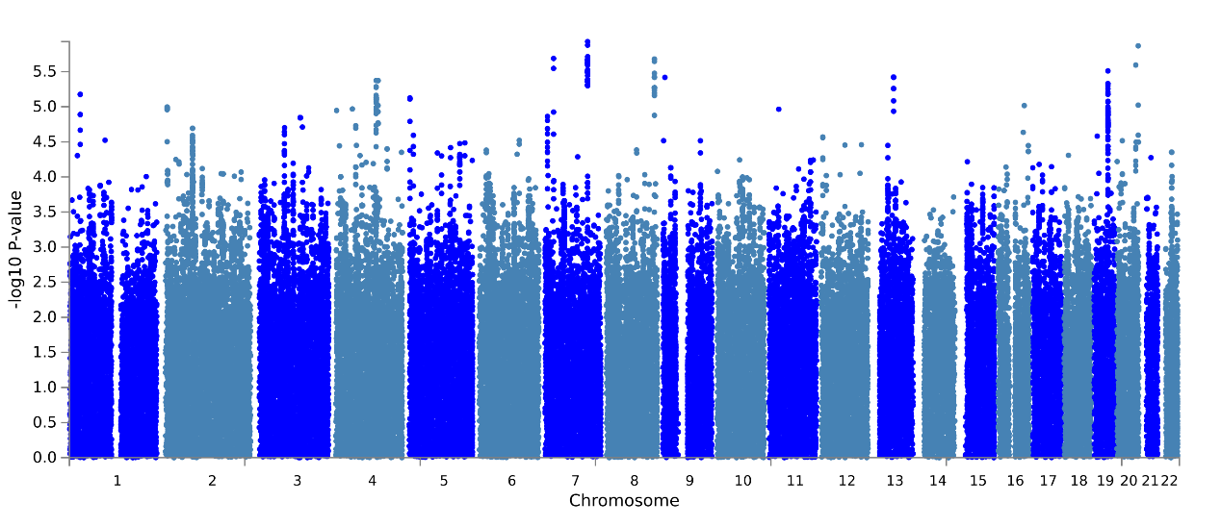
Figure S10: Manhattan plot of GWAS summary statistics of cortical thickness in left fusiform gyrus.

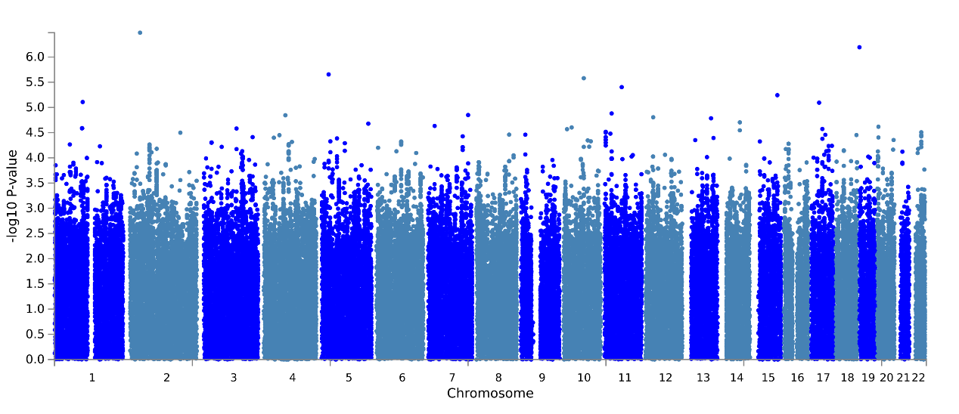
Figure S11: Manhattan plot of GWAS summary statistics of cortical thickness in right inferior temporal gyrus.

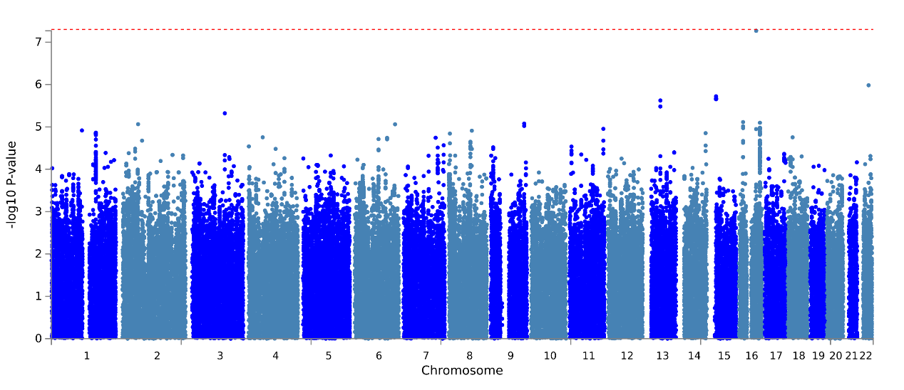
Figure S12: Manhattan plot of GWAS summary statistics of cortical thickness in left superior frontal gyrus.

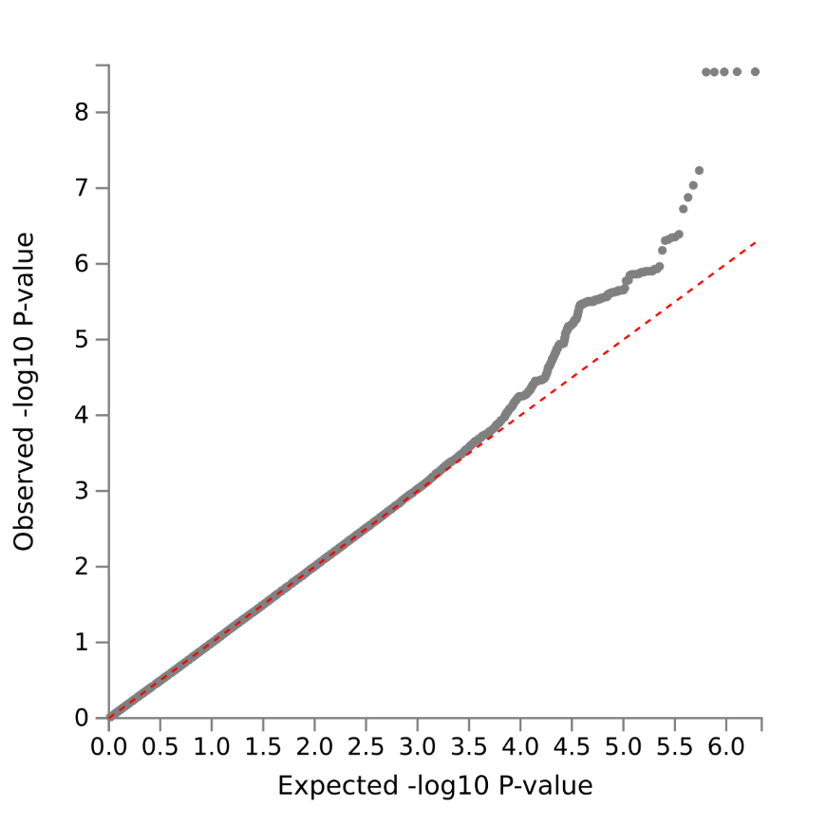
Figure S13: Q-Q plot of GWAS summary statistics of cortical thickness in left pars opercularis.

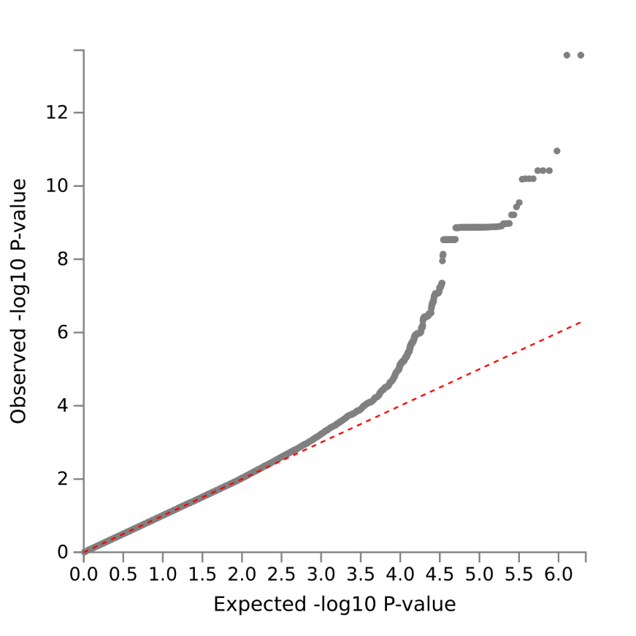
Figure S14: Q-Q plot of GWAS summary statistics of cortical thickness in left precentral gyrus.

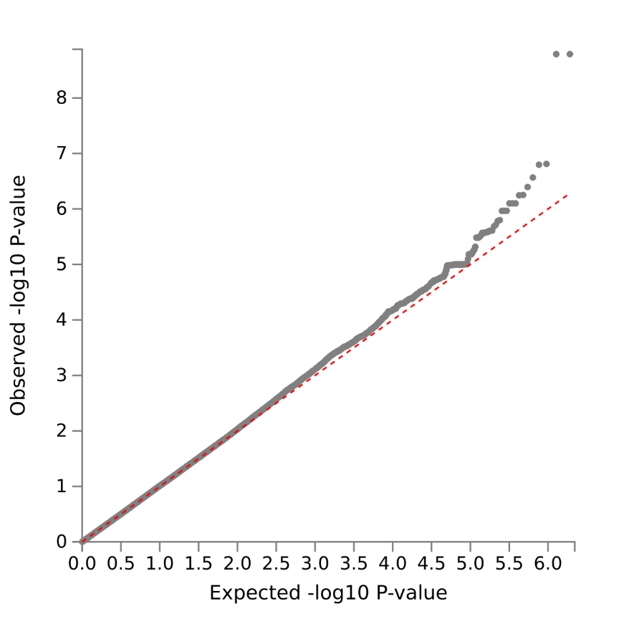
Figure S15: Q-Q plot of GWAS summary statistics of cortical thickness in left caudal middle frontal gyrus.

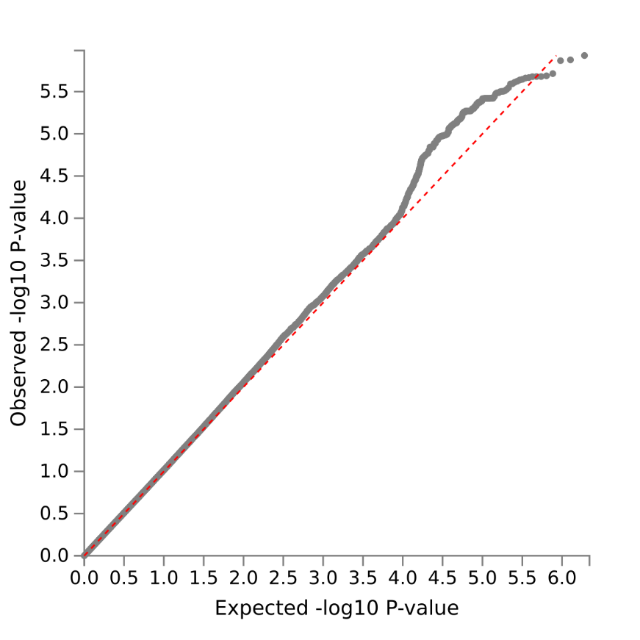
Figure S16: Q-Q plot of GWAS summary statistics of cortical thickness in left fusiform gyrus.

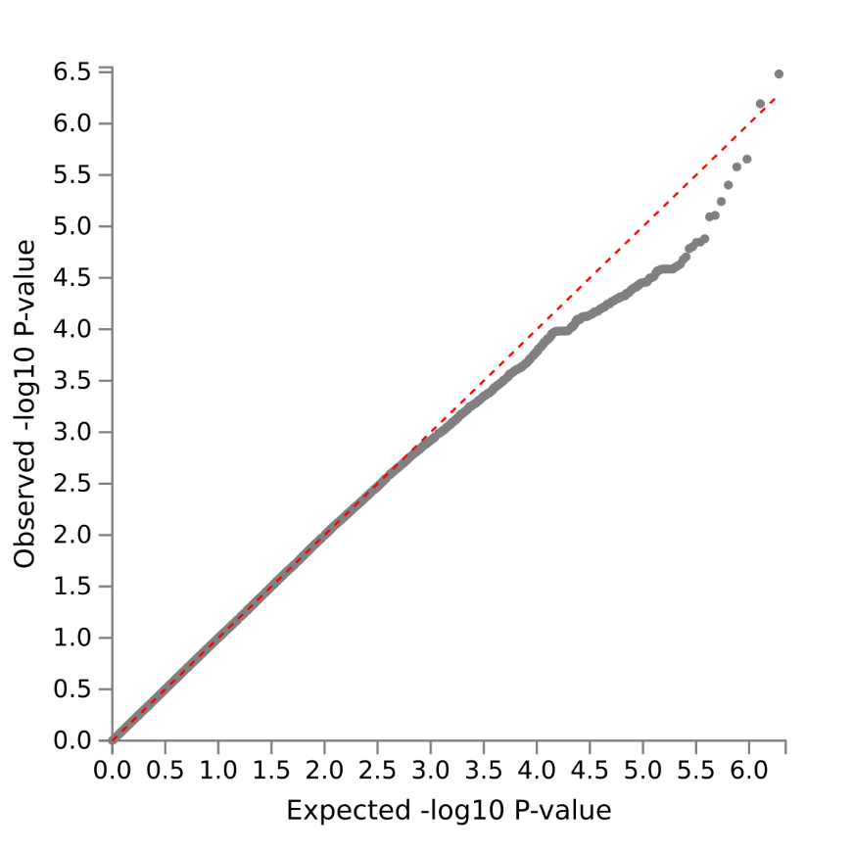
Figure S17: Q-Q plot of GWAS summary statistics of cortical thickness in right inferior temporal gyrus.

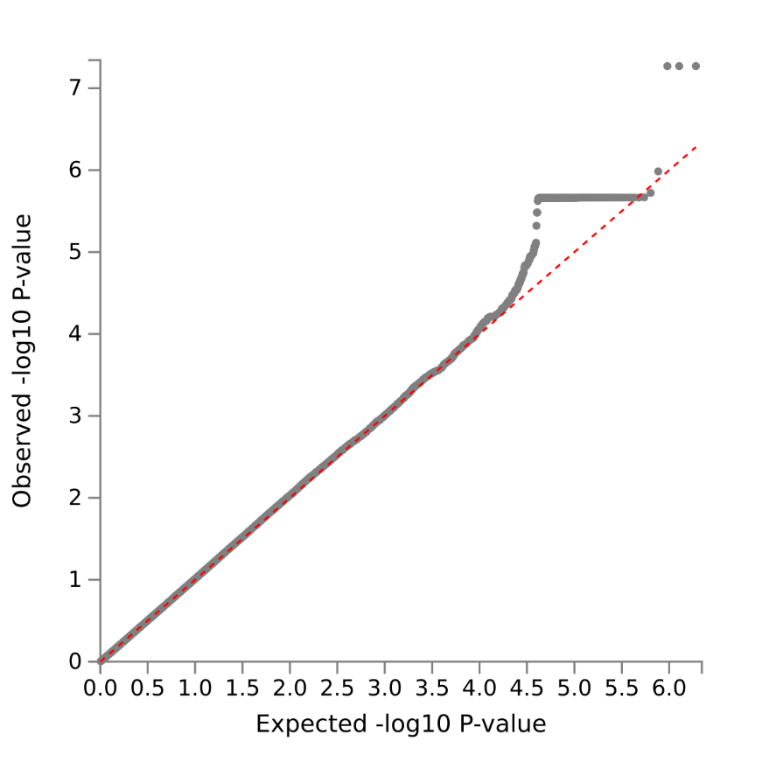
Figure S18: Q-Q plot of GWAS summary statistics of cortical thickness in left superior frontal gyrus.

Figure S19: Sensitivity analyses of cross-sectional and longitudinal associations between anxiety and impulsivity in pure internalizing disorders patients.
(A) Cross-sectional and longitudinal association between anxiety and lack of perseverance in subtype 1. (B) Cross-sectional and longitudinal association between anxiety and sensation seeking in subtype 2. Associations labeled by solid line were significant after FDR correction at q < 0.05 for the 30 measures (There are five sub-facets of impulsivity, with each sub-facet corresponding to a CLPM model. In each model, there are six cross-sectional/longitudinal correlations between anxiety or impulsivity, thus 5*6 = 30 measures totally).

Figure S20: Sensitivity analyses of the cognitive, behavioral and clinical characterization of subtypes in pure internalizing disorders patients at baseline.
(A) Comparisons of anxiety (CBCL-Anxiety Problems) between all groups. (B) Comparisons of BIS/BAS between all groups. (C) Comparisons of UPPS-P between all groups. (D) Differences of gradesª at baseline between groups. (E) Differences of cognition at baseline between groups. (F) Differences of psychopathology at baseline between subtypes. basdr, behavioral activation: Drive; basfs, behavioral activation: Fun seeking; basrr, behavioral activation: Reward Responsiveness; bis, behavioral inhibition; nu, negative urgency; pu, positive urgency; lope, lack of perseverance; lopl, lack of planning; ss, sensation seeking; external, Externalizing Problems; picvoc, picture vocabulary; list, list sorting working memory; cryst, crystallized intelligence; HC, healthy control; rulebreak, Rule-Breaking Behavior; aggressive, Aggressive Behavior; adhd, ADHD Problems; odd, Oppositional Defiant Problems; cd, Conduct Problems; depress, depressive problems. In (A), (B), and (C), ANOVA models revealed significant differences in all of ten measures of anxiety, impulsivity, and motivational systems, which passed FDR correction at q < 0.05 for the ten measures (one anxiety measure, five impulsivity measures, and four motivational systems measures). * p < 0.5; ** p < 0.01; *** p < 0.001; **** p < 0.0001, which in (B), (C), and (D) were Bonferroni corrected at p < 0.05/3 in post hoc tests for three pair-wise comparisons between three groups. In (D) and (E), ANOVA models revealed significant differences in grades as well as picvoc, list, and cryst of cognition, which passed FDR correction at q < 0.05 for the 11 measures of academic performance and cognition. In these two subfigures, * p < 0.5; ** p < 0.01; *** p < 0.001; **** p < 0.0001, which were Bonferroni corrected at p < 0.05/3 in post hoc pair-wise comparisons between three groups. In (F), * q < 0.05, ** q < 0.01, *** q < 0.001, **** q < 0.0001, FDR corrected for the seven measures of CBCL.
a: grades were scored reversely and 1 = excellent, 2 = good, 3 = average, 4 = below average, 5 = struggling a lot, and 6 = ungraded.
Figure S21: Differences of anxiety, impulsivity, motivational systems and anxiety-impulsivity relationship between two subtypes in all internalizing patients and controls.
(A) Clustering results using five dimensions of impulsivity. (B) Comparisons of anxiety (CBCL-Anxiety Problems) between all groups. (C) Comparisons of UPPS-P between all groups. (D) Comparisons of BIS/BAS between all groups. (E) Cross-sectional and longitudinal association between anxiety and lack of perseverance in subtype 1’. (F) Cross-sectional and longitudinal association between anxiety and sensation seeking in subtype 2’. nu, negative urgency; pu, positive urgency; lope, lack of perseverance; lopl, lack of planning; ss, sensation seeking; basdr, behavioral activation: Drive; basfs, behavioral activation: Fun seeking; basrr, behavioral activation: Reward Responsiveness; bis, behavioral inhibition; HC, healthy control. In (B), (C), and (D), ANOVA models revealed significant differences in all of six measures of anxiety and impulsivity, as well as basdr, basfs and bis of motivational systems, which passed FDR correction at q < 0.05 for the ten measures (one anxiety measure, five impulsivity measures, and four motivational systems measures). * p < 0.5; ** p < 0.01; *** p < 0.001; **** p < 0.0001, which in (B), (C), and (D) were Bonferroni corrected at p < 0.05/3 in post hoc tests for three pair-wise comparisons between three groups. In (E) and (F), associations labeled by solid line were significant after FDR correction at q < 0.05 for the 30 measures (There are five sub-facets of impulsivity, with each sub-facet corresponding to a CLPM model. In each model, there are six cross-sectional/longitudinal correlations between anxiety or impulsivity, thus 5*6 = 30 measures totally).
Figure S22: Differences of cortical thickness between groups in all internalizing patients at baseline.
(A) Thickness of brain regions with significant differences between the two subtypes and HC in ANOVA. (B) Thickness alterations in subtype 1’ compared to HC. (C) Thickness alterations in subtype 2’ compared to HC. (D) Thickness alterations in subtype 1’ compared to subtype 2’. HC, healthy control. parsopclh, left pars opercularis. In (A), ** q < 0.01, FDR corrected for the 68 cortical thickness measures in ANOVA. In (B), (C), and (D), yellow asterisks indicate p-values passed Bonferroni correction (p < 0.05/3) in post hoc tests for three pair-wise comparisons between three groups.

References
1. Barch DM, Albaugh MD, Avenevoli S, Chang L, Clark DB, Glantz MD, et al. Demographic, physical and mental health assessments in the adolescent brain and cognitive development study: Rationale and description. Dev Cogn Neurosci. 2018;32:55-66.
2. Gray JA. Perspectives on anxiety and impulsivity - a commentary. J Res Pers. 1987;21:493-509.
3. Casey BJ, Cannonier T, Conley MI, Cohen AO, Barch DM, Heitzeg MM, et al. The Adolescent Brain Cognitive Development (ABCD) study: Imaging acquisition across 21 sites. Dev Cogn Neurosci. 2018;32:43-54.
4. Hagler Jr DJ, Hatton S, Cornejo MD, Makowski C, Fair DA, Dick AS, et al. Image processing and analysis methods for the Adolescent Brain Cognitive Development Study. Neuroimage. 2019;202:116091.
5. Ketchen DJ, Shook CL. The application of cluster analysis in strategic management research: an analysis and critique. Strateg Manag J. 1996;17:441-58.
6. Pearce D, Dora M, Wesana J, Gellynck X. Toward sustainable primary production through the application of lean management in South African fruit horticulture. J Clean Prod. 2021;313:127815.
7. Assunção R, Matos PM. Adolescents' profiles of problematic Facebook use and associations with developmental variables. Comput Human Behav. 2017;75:396-403.
8. Baurley JW, Edlund CK, Pardamean CI, Conti DV, Bergen AW. Smokescreen: a targeted genotyping array for addiction research. BMC Genomics. 2016;17:1-12.
9. Uban KA, Horton MK, Jacobus J, Heyser C, Thompson WK, Tapert SF, et al. Biospecimens and the ABCD study: Rationale, methods of collection, measurement and early data. Dev Cogn Neurosci. 2018;32:97-106.
10. Das S, Forer L, Schönherr S, Sidore C, Locke AE, Kwong A, et al. Next-generation genotype imputation service and methods. Nat Genet. 2016;48:1284-7.
11. Chang CC, Chow CC, Tellier LC, Vattikuti S, Purcell SM, Lee JJ. Second-generation PLINK: rising to the challenge of larger and richer datasets. Gigascience. 2015;4:s13715-42.
12. Watanabe K, Taskesen E, Van Bochoven A, Posthuma D. Functional mapping and annotation of genetic associations with FUMA. Nat Commun. 2017;8:1-11.
13. Michel M, Schmidt MJ, Mirnics K. Immune system gene dysregulation in autism and schizophrenia. Dev Neurobiol. 2012;72:1277-87.
14. Dantzer R. Neuroimmune interactions: from the brain to the immune system and vice versa. Physiol Rev. 2018;98:477-504.
15. Makowski C, van der Meer D, Dong W, Wang H, Wu Y, Zou J, et al. Discovery of genomic loci of the human cerebral cortex using genetically informed brain atlases. Science. 2022;375:522-8.
16. de Leeuw CA, Mooij JM, Heskes T, Posthuma D. MAGMA: generalized gene-set analysis of GWAS data. PLoS Comput Biol. 2015;11:e1004219.
17. Dukart J, Holiga S, Rullmann M, Lanzenberger R, Hawkins PCT, Mehta MA, et al. JuSpace: A tool for spatial correlation analyses of magnetic resonance imaging data with nuclear imaging derived neurotransmitter maps. Hum Brain Mapp. 2021;42:555-66.

