**ONLINE APPENDIX**

**Defending the Status Quo or Seeking Change? Electoral Outcomes, Affective Polarisation, and Support for Referendums**

**TABLE OF CONTENTS**

**Appendix A. Details on the data**

***A.1***Countries and respondents

***A.2***Summary statistics

**Appendix B. Robustness tests**

***B.1*** Fixed-effects ordered logit models

***B.2*** Fixed-effects linear regression models controlling for SWD

***B.3*** T-tests for first dependent variable

***B.4*** T-tests for second dependent variable

***B.5*** Fixed-effects linear regression models separated by dependent variable

***B.6*** Fixed-effects linear regressions models controlling for PRR vote

***B.7*** Fixed-effects linear regressions models with abstainers coded as electoral losers

***B.8*** Fixed-effects linear regression models controlling for structural electoral losers

***B.9*** Fixed-effects linear regression models controlling for party size

***B.10*** Fixed-effects linear regression models controlling for SWD, populist radical right vote, structural electoral losers, and party size

***B.11*** Fixed-effects linear regression models splitting electoral winners between junior and largest coalition partner

***B.12*** Jackknife tests excluding one country at a time, results for electoral losers

***B.13*** Jackknife tests excluding one country at a time, results for interaction effect

***B.14*** Regressions for each country, results for electoral losers

***B.15*** Regressions for each country, results for interaction effect

**Appendix A. Details on the data**

|  |  |
| --- | --- |
| ***Table A.1*** Countries and respondents | |
| **Country** | **N** |
| Belgium (FL) | 1,066 |
| Belgium (WAL) | 1,100 |
| Czech Republic | 1,985 |
| Denmark | 1,384 |
| Finland | 1,316 |
| France | 1,119 |
| Germany | 1,251 |
| Greece | 1,223 |
| Ireland | 1,259 |
| Netherlands | 1,288 |
| Poland | 1,284 |
| Spain | 1,276 |
| United Kingdom | 1,216 |

|  |  |  |  |  |  |
| --- | --- | --- | --- | --- | --- |
| ***Table A.2*** Summary statistics | | | | | |
|  | N | Mean | SD | Min | Max |
| Referendum support | 16,767 | 3.882 | 0.854 | 1 | 5 |
| Electoral loser | 14,802 | 0.586 | 0.493 | 0 | 1 |
| Affective Polarisation | 16,767 | 2.049 | 1.112 | 0 | 4.993 |
| Political interest | 16,767 | 3.057 | 0.795 | 1 | 4 |
| Left-right | 16,767 | 5.377 | 2.362 | 0 | 10 |
| Political efficacy | 16,767 | 2.262 | 0.892 | 1 | 4 |
| Gender | 16,767 | 0.535 | 0.499 | 0 | 1 |
| Age | 16,767 | 3.659 | 1.580 | 1 | 7 |
| Education | 16,767 | 4.192 | 1.585 | 1 | 6 |
| Employment | 16,767 | 1.549 | 0.608 | 0 | 2 |
|  | | | | | |

**Appendix B. Robustness tests**

|  |  |  |  |  |  |  |
| --- | --- | --- | --- | --- | --- | --- |
| ***Table B.1*** Fixed-effects ordered logit models | | | | | | |
|  | M1 | | M2 | | M3 | |
| Electoral loser | 0.496*** | (0.030) | 0.502*** | (0.031) | -0.006 | (0.064) |
| Affective Polarization | -0.072*** | (0.014) | -0.060*** | (0.015) | -0.195*** | (0.022) |
| Loser*Affective Polarisation |  |  |  |  | 0.237*** | (0.028) |
| Political interest |  |  | 0.242*** | (0.022) | 0.242*** | (0.022) |
| Left-right placement |  |  | 0.012 | (0.007) | 0.015* | (0.007) |
| Internal political efficacy |  |  | 0.138*** | (0.019) | 0.139*** | (0.019) |
| Male |  |  | -0.039 | (0.030) | -0.036 | (0.030) |
| Age |  |  | 0.051*** | (0.010) | 0.051*** | (0.010) |
| Education |  |  | -0.080*** | (0.010) | -0.080*** | (0.010) |
| Labour status (ref: unemployed) |  |  |  |  |  |  |
| Not in labour force |  |  | -0.058 | (0.073) | -0.064 | (0.073) |
| Employed |  |  | 0.084 | (0.070) | 0.080 | (0.069) |
| cut1 | -4.513*** | (0.088) | -3.648*** | (0.157) | -3.946*** | (0.160) |
| cut2 | -3.837*** | (0.068) | -2.970*** | (0.147) | -3.268*** | (0.150) |
| cut3 | -2.835*** | (0.050) | -1.962*** | (0.140) | -2.258*** | (0.143) |
| cut4 | -2.143*** | (0.044) | -1.264*** | (0.138) | -1.559*** | (0.142) |
| cut5 | -1.160*** | (0.040) | -0.262 | (0.137) | -0.555*** | (0.141) |
| cut6 | -0.379*** | (0.039) | 0.543*** | (0.137) | 0.253 | (0.141) |
| cut7 | 0.753*** | (0.039) | 1.720*** | (0.138) | 1.435*** | (0.142) |
| cut8 | 1.712*** | (0.040) | 2.709*** | (0.140) | 2.426*** | (0.143) |
| N | 14,802 |  | 14,802 |  | 14,802 |  |
| Robust standard errors in parentheses. Country fixed effects are not displayed.  *p<0.05, **p< 0.01, ***p< 0.001. | | | | | | |

|  |  |  |  |  |  |  |
| --- | --- | --- | --- | --- | --- | --- |
| ***Table B.2*** Fixed-effects linear regression models controlling for SWD | | | | | | |
|  | M1 | | M2 | | M3 | |
| Electoral loser | 0.235*** | (0.014) | 0.154*** | (0.015) | 0.011 | (0.030) |
| Affective Polarisation | -0.046*** | (0.007) | -0.042*** | (0.007) | -0.080*** | (0.010) |
| Loser*Affective Polarisation |  |  |  |  | 0.067*** | (0.013) |
| Political interest |  |  | 0.116*** | (0.010) | 0.114*** | (0.010) |
| Left-right placement |  |  | 0.013*** | (0.003) | 0.013*** | (0.003) |
| Internal political efficacy |  |  | 0.095*** | (0.008) | 0.094*** | (0.008) |
| Male |  |  | -0.026 | (0.014) | -0.025 | (0.014) |
| Age |  |  | 0.021*** | (0.005) | 0.021*** | (0.005) |
| Education |  |  | -0.036*** | (0.005) | -0.036*** | (0.005) |
| Labour status (ref: unemployed) |  |  |  |  |  |  |
| Not in labour force |  |  | -0.006 | (0.033) | -0.008 | (0.033) |
| Employed |  |  | 0.062 | (0.031) | 0.060 | (0.031) |
| SWD |  |  | -0.062*** | (0.003) | -0.060*** | (0.003) |
| Constant | 3.842*** | (0.018) | 3.608*** | (0.063) | 3.688*** | (0.064) |
| Adjusted R2 | 0.023 |  | 0.096 |  | 0.098 |  |
| N | 14,802 |  | 14,711 |  | 14,711 |  |
| Robust standard errors in parentheses. Country fixed effects are not displayed.  *p<0.05, **p< 0.01, ***p< 0.001. | | | | | | |

|  |  |  |  |  |
| --- | --- | --- | --- | --- |
| ***Table B.3*** T-tests for first dependent variable | | | | |
| **Country** | **Mean electoral losers** | **Mean electoral winners** | **Difference** | **p-value** |
| Belgium (WAL) | 4.180 | 3.843 | **0.337** | 0.000 |
| Belgium (FL) | 4.101 | 3.977 | **0.124** | 0.028 |
| Czech Republic | 4.012 | 3.711 | **0.301** | 0.000 |
| Denmark | 4.036 | 3.822 | **0.214** | 0.000 |
| Finland | 3.926 | 3.789 | **0.137** | 0.013 |
| France | 4.046 | 3.693 | **0.354** | 0.000 |
| Germany | 4.106 | 3.828 | **0.278** | 0.000 |
| Greece | 4.104 | 3.842 | **0.261** | 0.000 |
| Ireland | 4.029 | 3.900 | **0.128** | 0.014 |
| Netherlands | 3.997 | 3.562 | **0.435** | 0.000 |
| Poland | 4.356 | 4.018 | **0.338** | 0.000 |
| Spain | 4.117 | 4.064 | **0.053** | 0.183 |
| UK | 3.810 | 3.768 | **0.041** | 0.244 |
| The p-values are based on a one-tailed t-test. Differences in bold are in the hypothesised direction. Dependent variable: *When collecting a sufficient number of signatures, citizens can force the government to hold a referendum on a policy issue* (1-5). | | | | |

|  |  |  |  |  |
| --- | --- | --- | --- | --- |
| ***Table B.4*** T-tests for second dependent variable | | | | |
| **Country** | **Mean electoral losers** | **Mean electoral winners** | **Difference** | **p-value** |
| Belgium (WAL) | 3.884 | 3.559 | **0.325** | 0.000 |
| Belgium (FL) | 3.854 | 3.700 | **0.154** | 0.012 |
| Czech Republic | 3.679 | 3.158 | **0.521** | 0.000 |
| Denmark | 3.948 | 3.773 | **0.176** | 0.002 |
| Finland | 3.880 | 3.729 | **0.151** | 0.005 |
| France | 3.964 | 3.507 | **0.457** | 0.000 |
| Germany | 3.769 | 3.503 | **0.266** | 0.000 |
| Greece | 3.993 | 3.736 | **0.257** | 0.000 |
| Ireland | 4.258 | 4.131 | **0.127** | 0.004 |
| Netherlands | 3.644 | 3.104 | **0.540** | 0.000 |
| Poland | 4.144 | 3.969 | **0.175** | 0.001 |
| Spain | 4.012 | 4.026 | -0.014 | 0.595 |
| UK | 3.828 | 3.759 | **0.069** | 0.135 |
| The p-values are based on a one-tailed t-test. Differences in bold are in the hypothesised direction. Dependent variable: *It is important for democracy that citizens have the final say on political issues by voting in referendums* (1-5). | | | | |

|  |  |  |  |  |  |  |  |
| --- | --- | --- | --- | --- | --- | --- | --- |
| ***Table B.5*** Fixed-effects linear regression models separated by dependent variable | | | | | | | |
|  |  | DV 1 |  |  | DV 2 |  |
|  | M1 | M2 | M3 | M1 | M2 | M3 |
| Electoral loser | 0.225*** | 0.222*** | 0.020 | 0.245*** | 0.241*** | -0.015 |
|  | (0.016) | (0.016) | (0.035) | (0.017) | (0.017) | (0.035) |
|  |  |  |  |  |  |  |
| Affective Polarisation | -0.027*** | -0.029*** | -0.082*** | -0.066*** | -0.049*** | -0.116*** |
|  | (0.007) | (0.008) | (0.012) | (0.008) | (0.008) | (0.012) |
|  |  |  |  |  |  |  |
| Loser*Affective Polarisation |  |  | 0.093*** |  |  | 0.117*** |
|  |  |  | (0.015) |  |  | (0.015) |
|  |  |  |  |  |  |  |
| Political interest |  | 0.092*** | 0.091*** |  | 0.093*** | 0.092*** |
|  |  | (0.011) | (0.011) |  | (0.012) | (0.012) |
|  |  |  |  |  |  |  |
| Left-right placement |  | -0.001 | -0.000 |  | 0.006 | 0.007* |
|  |  | (0.004) | (0.004) |  | (0.004) | (0.004) |
|  |  |  |  |  |  |  |
| Internal political efficacy |  | 0.061*** | 0.061*** |  | 0.095*** | 0.095*** |
|  |  | (0.010) | (0.010) |  | (0.010) | (0.010) |
|  |  |  |  |  |  |  |
| Male |  | -0.020 | -0.018 |  | -0.039* | -0.036* |
|  |  | (0.016) | (0.016) |  | (0.016) | (0.016) |
|  |  |  |  |  |  |  |
| Age |  | 0.022*** | 0.022*** |  | 0.016** | 0.015** |
|  |  | (0.005) | (0.005) |  | (0.006) | (0.006) |
|  |  |  |  |  |  |  |
| Education |  | -0.031*** | -0.031*** |  | -0.043*** | -0.042*** |
|  |  | (0.005) | (0.005) |  | (0.005) | (0.005) |
|  |  |  |  |  |  |  |
| Labour status (ref: unemployed) |  |  |  |  |  |  |
| Not in labour force |  | 0.008 | 0.006 |  | -0.049 | -0.051 |
|  |  | (0.039) | (0.039) |  | (0.038) | (0.038) |
|  |  |  |  |  |  |  |
| Employed |  | 0.049 | 0.047 |  | 0.035 | 0.032 |
|  |  | (0.037) | (0.037) |  | (0.037) | (0.036) |
|  |  |  |  |  |  |  |
| Constant | 3.891*** | 3.591*** | 3.710*** | 3.794*** | 3.323*** | 3.474*** |
|  | (0.020) | (0.073) | (0.075) | (0.021) | (0.075) | (0.076) |
| Adjusted R2 | 0.015 | 0.037 | 0.039 | 0.021 | 0.082 | 0.086 |
| N | 14,802 | 14,802 | 14,802 | 14,802 | 14,802 | 14,802 |
| Robust standard errors in parentheses. Country fixed effects are not displayed. *p<0.05, **p< 0.01, ***p< 0.001. DV 1: *When collecting a sufficient numbers of signatures, citizens can force the government to hold a referendum on a policy issue* (1-5). DV 2: *It is important for democracy that citizens have a final say on political issues by voting in referendums* (1-5). | | | | | | |

|  |  |  |  |  |  |  |
| --- | --- | --- | --- | --- | --- | --- |
| ***Table B.6*** Fixed-effects linear regression models controlling for PRR vote | | | | | | |
|  | M1 | | M2 | | M3 | |
| Electoral loser | 0.235*** | (0.014) | 0.203*** | (0.015) | -0.021 | (0.030) |
| Affective Polarisation | -0.046*** | (0.007) | -0.044*** | (0.007) | -0.103*** | (0.010) |
| Loser*Affective Polarisation |  |  |  |  | 0.103*** | (0.013) |
| Political interest |  |  | 0.095*** | (0.010) | 0.094*** | (0.010) |
| Left-right placement |  |  | -0.006 | (0.003) | -0.005 | (0.003) |
| Internal political efficacy |  |  | 0.079*** | (0.008) | 0.079*** | (0.008) |
| Male |  |  | -0.033* | (0.014) | -0.031* | (0.014) |
| Age |  |  | 0.019*** | (0.005) | 0.019*** | (0.005) |
| Education |  |  | -0.034*** | (0.005) | -0.034*** | (0.005) |
| Labour status (ref: unemployed) |  |  |  |  |  |  |
| Not in labour force |  |  | -0.015 | (0.033) | -0.018 | (0.033) |
| Employed |  |  | 0.044 | (0.031) | 0.042 | (0.031) |
| Voted Populist Radical Right |  |  | 0.204*** | (0.021) | 0.201*** | (0.020) |
| Constant | 3.842*** | (0.018) | 3.496*** | (0.063) | 3.628*** | (0.065) |
| R2 | 0.023 |  | 0.075 |  | 0.079 |  |
| N | 14,802 |  | 14,802 |  | 14,802 |  |
| Robust standard errors in parentheses. Country fixed effects are not displayed.  *p<0.05, **p< 0.01, ***p< 0.001. | | | | | | |

|  |  |  |  |  |  |  |
| --- | --- | --- | --- | --- | --- | --- |
| ***Table B.7*** Fixed-effects linear regression models with abstainers coded as electoral losers | | | | | | |
|  | M1 | | M2 | | M3 | |
| Electoral losers | 0.217*** | (0.014) | 0.220*** | (0.014) | -0.019 | (0.028) |
| Affective Polarisation | -0.035*** | (0.006) | -0.031*** | (0.006) | -0.101*** | (0.010) |
| Loser*Affective Polarisation |  |  |  |  | 0.111*** | (0.012) |
| Political interest |  |  | 0.097*** | (0.009) | 0.093*** | (0.009) |
| Left-right placement |  |  | 0.002 | (0.003) | 0.003 | (0.003) |
| Internal political efficacy |  |  | 0.068*** | (0.008) | 0.067*** | (0.008) |
| Male |  |  | -0.026* | (0.013) | -0.025 | (0.013) |
| Age |  |  | 0.024*** | (0.004) | 0.024*** | (0.004) |
| Education |  |  | -0.038*** | (0.004) | -0.038*** | (0.004) |
| Labour status (ref: unemployed) |  |  |  |  |  |  |
| Not in labour force |  |  | 0.001 | (0.029) | -0.003 | (0.029) |
| Employed |  |  | 0.071* | (0.028) | 0.066* | (0.027) |
| Constant | 3.816*** | (0.017) | 3.406*** | (0.057) | 3.578*** | (0.060) |
| R2 | 0.019 |  | 0.064 |  | 0.068 |  |
| N | 16,767 |  | 16,767 |  | 16,767 |  |
| Robust standard errors in parentheses. Country fixed effects are not displayed.  *p<0.05, **p< 0.01, ***p< 0.001. | | | | | | |

|  |  |  |  |  |  |  |
| --- | --- | --- | --- | --- | --- | --- |
| ***Table B.8*** Fixed-effects linear regression models controlling for structural electoral losers | | | | | | |
|  | M1 | | M2 | | M3 | |
| Electoral loser | 0.235*** | (0.014) | 0.215*** | (0.015) | -0.025 | (0.030) |
| Affective Polarisation | -0.046*** | (0.007) | -0.037*** | (0.007) | -0.099*** | (0.010) |
| Loser*Affective Polarisation |  |  |  |  | 0.109*** | (0.013) |
| Political interest |  |  | 0.092*** | (0.010) | 0.091*** | (0.010) |
| Left-right placement |  |  | 0.004 | (0.003) | 0.005 | (0.003) |
| Internal political efficacy |  |  | 0.079*** | (0.008) | 0.079*** | (0.008) |
| Male |  |  | -0.031* | (0.014) | -0.029* | (0.014) |
| Age |  |  | 0.021*** | (0.005) | 0.021*** | (0.005) |
| Education |  |  | -0.036*** | (0.005) | -0.036*** | (0.005) |
| Labour status (ref: unemployed) |  |  |  |  |  |  |
| Not in labour force |  |  | -0.019 | (0.033) | -0.021 | (0.033) |
| Employed |  |  | 0.044 | (0.032) | 0.042 | (0.031) |
| Structural electoral loser |  |  | 0.082*** | (0.016) | 0.090*** | (0.016) |
| Constant | 3.842*** | (0.018) | 3.372*** | (0.066) | 3.504*** | (0.067) |
| R2 | 0.023 |  | 0.071 |  | 0.075 |  |
| N | 14,802 |  | 14,802 |  | 14,802 |  |
| Robust standard errors in parentheses. Country fixed effects are not displayed.  *p<0.05, **p< 0.01, ***p< 0.001. | | | | | | |

|  |  |  |  |  |  |  |
| --- | --- | --- | --- | --- | --- | --- |
| ***Table B.9*** Fixed-effects linear regression models controlling for party size | | | | | | |
|  | M1 | | M2 | | M3 | |
| Electoral loser | 0.235*** | (0.014) | 0.215*** | (0.017) | -0.035 | (0.032) |
| Affective Polarisation | -0.046*** | (0.007) | -0.035*** | (0.007) | -0.096*** | (0.010) |
| Loser*Affective Polarisation |  |  |  |  | 0.110*** | (0.013) |
| Political interest |  |  | 0.092*** | (0.010) | 0.091*** | (0.010) |
| Left-right placement |  |  | 0.003 | (0.003) | 0.005 | (0.003) |
| Internal political efficacy |  |  | 0.078*** | (0.008) | 0.079*** | (0.008) |
| Male |  |  | -0.030* | (0.014) | -0.028* | (0.014) |
| Age |  |  | 0.020*** | (0.005) | 0.020*** | (0.005) |
| Education |  |  | -0.037*** | (0.005) | -0.037*** | (0.005) |
| Labour status (ref: unemployed) |  |  |  |  |  |  |
| Not in labour force |  |  | -0.020 | (0.033) | -0.022 | (0.033) |
| Employed |  |  | 0.043 | (0.032) | 0.041 | (0.031) |
| Party size |  |  | -0.125* | (0.061) | -0.196** | (0.061) |
| Constant | 3.842*** | (0.018) | 3.472*** | (0.064) | 3.623*** | (0.065) |
| R2 | 0.023 |  | 0.070 |  | 0.074 |  |
| N | 14,802 |  | 14,802 |  | 14,802 |  |
| Robust standard errors in parentheses. Country fixed effects are not displayed.  *p<0.05, **p< 0.01, ***p< 0.001. | | | | | | |

|  |  |  |  |  |  |  |
| --- | --- | --- | --- | --- | --- | --- |
| ***Table B.10*** Fixed-effects linear regression models controlling for SWD, populist radical right vote, structural electoral losers, and party size | | | | | | |
|  | M1 | | M2 | | M3 | |
| Electoral loser | 0.235*** | (0.014) | 0.124*** | (0.017) | -0.035 | (0.032) |
| Affective Polarisation | -0.046*** | (0.007) | -0.044*** | (0.007) | -0.083*** | (0.010) |
| Loser*Affective Polarisation |  |  |  |  | 0.071*** | (0.013) |
| Political interest |  |  | 0.116*** | (0.010) | 0.114*** | (0.010) |
| Left-right placement |  |  | 0.007* | (0.003) | 0.008* | (0.003) |
| Internal political efficacy |  |  | 0.095*** | (0.008) | 0.095*** | (0.008) |
| Male |  |  | -0.030* | (0.014) | -0.029* | (0.014) |
| Age |  |  | 0.022*** | (0.005) | 0.022*** | (0.005) |
| Education |  |  | -0.033*** | (0.005) | -0.033*** | (0.005) |
| Labour status (ref: unemployed) |  |  |  |  |  |  |
| Not in labour force |  |  | -0.002 | (0.033) | -0.004 | (0.033) |
| Employed |  |  | 0.064* | (0.031) | 0.062* | (0.031) |
| SWD |  |  | -0.059*** | (0.003) | -0.056*** | (0.003) |
| Voted Populist Radical Right |  |  | 0.157*** | (0.020) | 0.157*** | (0.020) |
| Structural electoral loser |  |  | 0.040* | (0.017) | 0.043* | (0.017) |
| Party size |  |  | -0.031 | (0.064) | -0.076 | (0.064) |
| Constant | 3.842*** | (0.018) | 3.594*** | (0.067) | 3.682*** | (0.068) |
| R2 | 0.023 |  | 0.100 |  | 0.102 |  |
| N | 14,802 |  | 14,711 |  | 14,711 |  |
| Robust standard errors in parentheses. Country fixed effects are not displayed.  *p<0.05, **p< 0.01, ***p< 0.001. | | | | | | |

|  |  |  |  |  |  |  |
| --- | --- | --- | --- | --- | --- | --- |
| ***Table B.11*** Fixed-effects linear regression models splitting electoral winners between junior and largest coalition partner | | | | | | |
|  | M1 |  | M2 |  | M3 |  |
| Coalition voter (ref: electoral loser) |  |  |  |  |  |  |
| Junior coalition partner | -0.244*** | (0.019) | -0.195*** | (0.020) | 0.051 | (0.040) |
| Largest coalition partner | -0.228*** | (0.017) | -0.257*** | (0.017) | -0.044 | (0.036) |
| Affective Polarisation | -0.047*** | (0.007) | -0.038*** | (0.007) | 0.006 | (0.009) |
| Junior coalition partner*Affective Polarisation |  |  |  |  | -0.117*** | (0.019) |
| Largest coalition partner*Affective Polarisation |  |  |  |  | -0.096*** | (0.015) |
| Political interest |  |  | 0.092*** | (0.010) | 0.092*** | (0.010) |
| Left-right placement |  |  | 0.003 | (0.003) | 0.004 | (0.003) |
| Internal political efficacy |  |  | 0.078*** | (0.008) | 0.078*** | (0.008) |
| Male |  |  | -0.029* | (0.014) | -0.027 | (0.014) |
| Age |  |  | 0.019*** | (0.005) | 0.019*** | (0.005) |
| Education |  |  | -0.038*** | (0.005) | -0.037*** | (0.005) |
| Employment status (ref: unemployed) |  |  |  |  |  |  |
| Not in labour force |  |  | -0.021 | (0.033) | -0.023 | (0.033) |
| Employed |  |  | 0.043 | (0.032) | 0.040 | (0.031) |
| Constant | 4.078*** | (0.015) | 3.673*** | (0.063) | 3.587*** | (0.064) |
| R2 | 0.023 |  | 0.070 |  | 0.074 |  |
| N | 14,802 |  | 14,802 |  | 14,802 |  |
| Robust standard errors in parentheses. Country fixed effects are not displayed.  *p<0.05, **p< 0.01, ***p< 0.001. | | | | | | |

***Graph B.12*** Jackknife tests excluding one country at a time, results for electoral losers

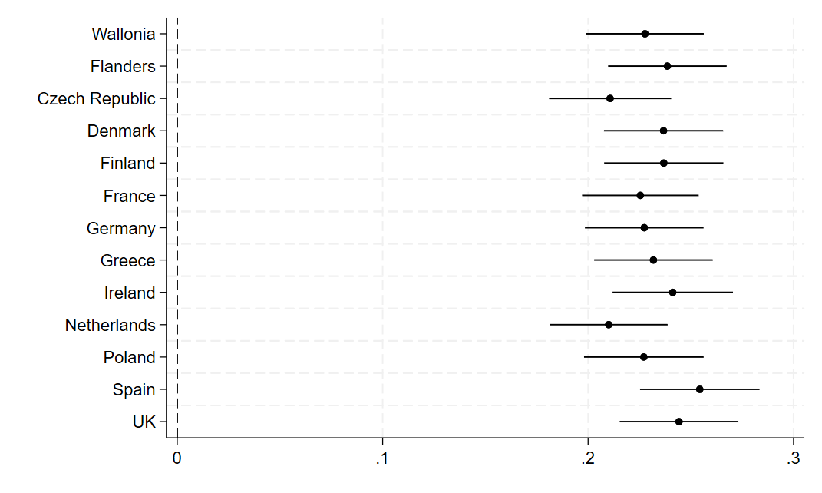

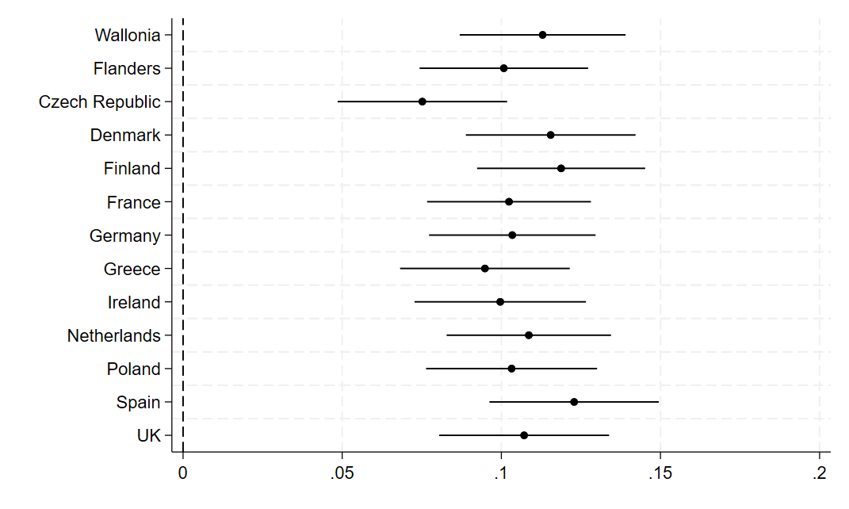***Graph B.13*** Jackknife tests excluding one country at a time, results for interaction effect

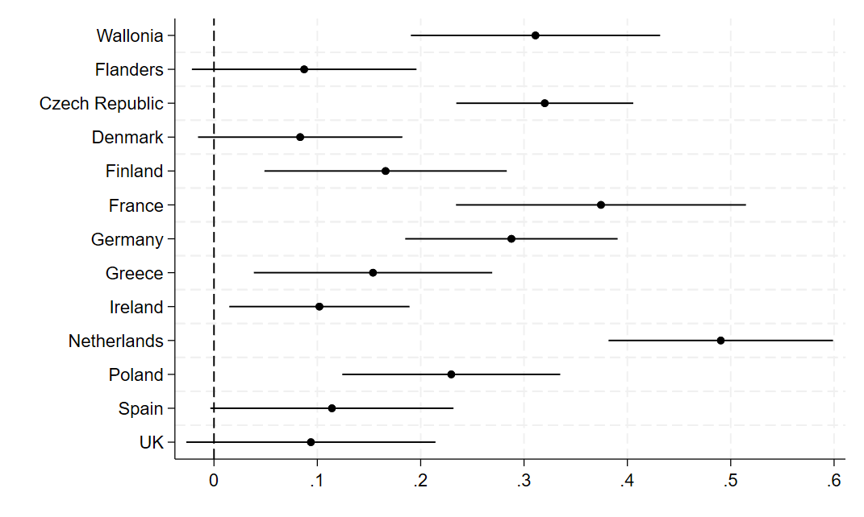***Graph B.14*** Regressions for each country, results for electoral losers

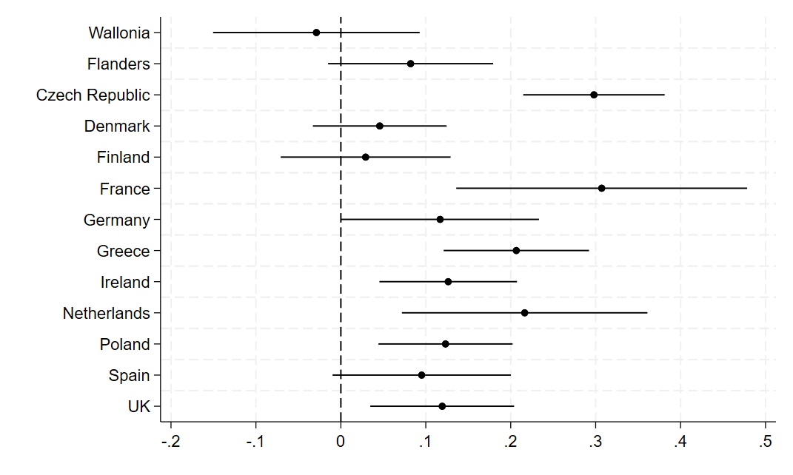***Graph B.15*** Regressions for each country, results for interaction effect