Appendix 1: Tracking News Narratives about Women & Representation

Operational Definitions and Coding Instructions

- Public [Does coverage refer to people wanting to support/vote/campaign for/volunteer/donate to women candidates?]: yes (1), no (0)
  - Women [If yes, is there a specific reference to women (i.e. women voters, women citizens)?]: yes (1), no (0)
- Women Different [does it imply that women candidates are distinct or unique from men candidates?]: yes (1), no (0)
- Women’s Issues [does coverage refer to women’s issues such as abortion, reproductive rights, equal pay, sexual harassment, sexism, care giving, education, domestic violence (Carroll and Fox 2006)]: yes (1), no (0)

Inter-Coder Reliability Statistics

Inter-coder reliability coefficients calculated using Recal2 (Freelon 2013). Per best practice, we established an a priori threshold of K=0.7. Given the binary nature of the data, Cohen’s Kappa is the appropriate coefficient for these analyses (Grant, Button, and Snook 2017).

Table A1: Intercoder Reliability
Measures | Cohen’s Kappa | % Agreement
Public | .77 | 95
Women | 1 | 100
Women Different | 1 | 100
Women’s Issues | .8 | 90

Figure A1 shows the average number of seconds of “women candidates” coverage by outlet by year. Breaking down the data in this way illustrates the extent to which much of this coverage is driven by MSNBC. This is of interest given MSNBC’s audience is primarily Democratic, and we expect differences in voter behavior and attitudes by partisanship. At the very least, our news data suggests that the Democrats that tune-in to MSNBC are exposed to more frequent coverage of women candidates, and thus, are likely exposed to coverage that emphasizes women-as-unique. Whether the gendered information provided as part of these frames explains the outcomes is supported by subsequent experimental analyses.
Figure A1: Annual Average Duration of “Women Candidates” News Coverage, by Outlet 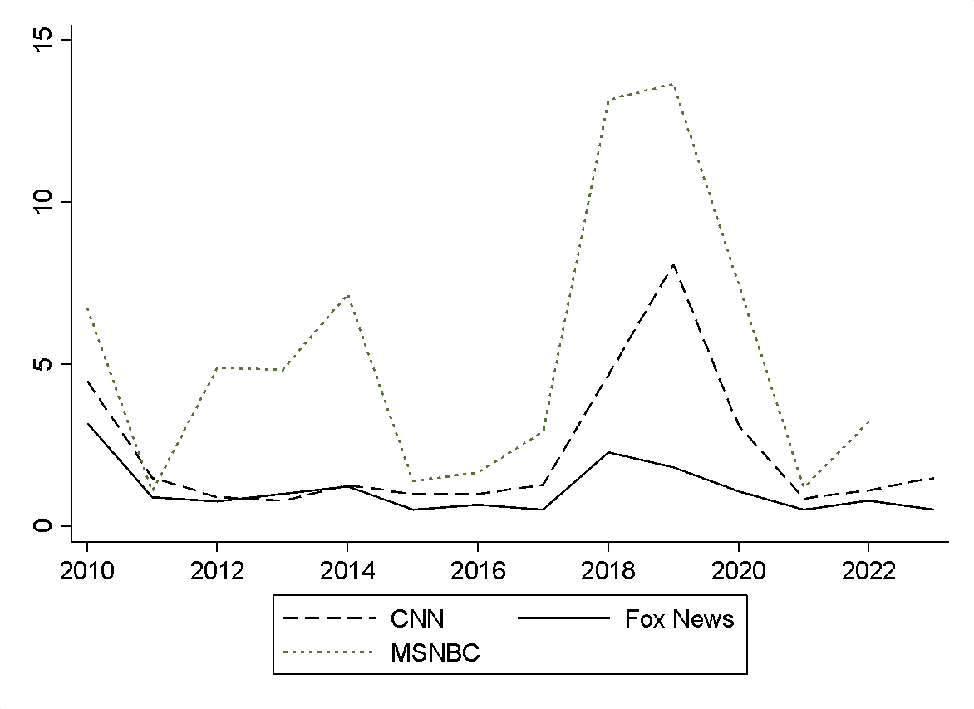

Appendix 2: Pre-registration Information

1) Have any data been collected for this study already?
No, no data have been collected for this study yet.
2) What's the main question being asked or hypothesis being tested in this study?
The main question asks whether women and men receive different evaluations for supporting or failing to support legislation on women's issues, such as reproductive rights or equal pay. We hypothesize that women and men will be evaluated differently for their levels of support (or lack thereof) on women's issues. We predict that women will be more likely to face an in-partisan punishment when they fail to support a women's issue bill but not an out-partisan punishment and men will not face an in-partisan or out-partisan punishment. We think people will be disproportionately reward men for their support of women's issues regardless of the participant's partisanship.
3) Describe the key dependent variable(s) specifying how they will be measured.
We will measure the level of support for a hypothetical legislature through questions about vote support, electoral viability, favorability, strong leadership, legislative effectiveness, how well the candidate represents the interests of constituents, women, and related measures of candidate perceptions.
4) How many and which conditions will participants be assigned to?
The first will vary candidate gender and whether or not a legislature voted in a pro-woman way on a bill about women's issues = 4 conditions, and the study will match participants into shared party conditions.
A second study will include these same four conditions but will also vary relative partisanship so that some participants evaluate in-partisan candidates and some participants evaluate out-partisan candidates and this will give an 8 condition study.
5) Specify exactly which analyses you will conduct to examine the main question/hypothesis.
The main analyses will use two tailed t-tests, and difference-in-difference tests as needed. We may also use anova and/or regression analyses to see how individual level characteristics such as participant gender or ideology affect evaluations.
6) Describe exactly how outliers will be defined and handled, and your precise rule(s) for excluding observations.
We will not exclude participants based on responses that are outliers. We may exclude individuals who do not complete the full study.
7) How many observations will be collected or what will determine sample size?
No need to justify decision, but be precise about exactly how the number will be determined.
The sample for Study 1 [the abortion study] with four conditions will include approximately 400-450 participants with the goal of having approximately 400 participants in each condition. Study 2 [the equal pay study] will include about 800-850 participants with the goal of having about 100 people per condition We've based this on a power analysis indicating a medium effect size between the women and the men conditions and from past research on the sample size per condition needed to detect effects between treatment groups in work on candidate gender.
8) Anything else you would like to pre-register?
(e.g., secondary analyses, variables collected for exploratory purposes, unusual analyses planned?)
Appendix 3: Adherence to Ethical Principles

Adherence to Principles and Guidance for Human Subjects Research

In this section, we outline how the experiments conducted meet the American Political Science Association’s Principles and Guidance for Human Subjects Research.

Researcher responsibility: The APSA Guidelines state that researchers “have an individual responsibility to consider the ethics of their research related activities and cannot outsource ethical reflection to review boards.” The research conducted was approved by my university’s institutional review board. The research team thought carefully about ethical matters in all phases of the described research. We informed subjects that they were taking part in a research study through a consent script that asked subjects to read before they could complete the study.

Potential for harm: We assessed the potential for direct harm coming from participating in this research to be low and conforms to the “no more than minimal risk” standard. The only techniques used to measure post-treatment outcomes are unobtrusive survey-based measures. We considered whether any parts of the survey instrument could induce anxiety or feelings of trauma for participants and did not identify any for which this was likely. (We discuss potential harm related to breaches of confidentiality below.)

Potential benefits: We considered any potential benefits that might redound to study participants (aside from any compensation related to participation). The benefits are small, though it is possible that being induced to think about how to evaluate legislators based on their voting records, may spur individuals to do more research into how their own elected representatives vote on issues that disproportionately affect women.

Privacy and confidentiality: We took steps to address risks related to breaches of confidentiality. First, we considered if any information collected would be harmful if disclosed. This seemed unlikely, as the studies reported focus on opinions about a fictional legislator. Nevertheless, we collected data anonymously, individually identifiable participant information was not part of the data collection. We also considered the possibility of deductive identification of respondents. This too seemed unlikely since we asked about only a few pieces of core demographic information.

Informed consent: All the studies described above included an informed consent disclosure that stated the true objectives of the proposed research, as well as compensation information. The consent forms also covered all considerations standardly required by governmental oversight. The consent clarified, per IRB guidelines, the precise process of the studies.

Deception: The studies reported did not involve deception.

Power: Both studies, 1 Lucid and 1 CES studies, use adult samples who opt-in to participate and can opt-out of participating at any stage. This minimizes the power differential between the researcher and the participants.

Compensation: For Lucid respondents, compensation is set by the research firm. The CES study participants were compensated through YouGov who administers the study.

Impact: We considered the possible beneficial impacts of this research. While they are abstract, we believe they have the potential to deepen understanding of descriptive representation and its full impacts, and thereby help elucidate ways to bring about a better political system and world.

Laws and regulations: The research herein conformed with all local, state, and national laws.

Appendix 4: Study Information

Outcome Questions:

How well do you think the following phrases describe Chris/Carol Hartley? Use the scale below where 1 means not well at all and 7 means extremely well.

1 (not well at all) – 7 (very well)

How favorable do you feel toward Hartley based on his support for and vote on this abortion bill?
1 (very unfavorable) – 100 (very favorable)

How likely is it would you vote for Chris/Carol Hartley if he were running for re-election in your district?
Very unlikely, Somewhat unlikely, Somewhat likely, Very likely

Table A2: Study Demographics
 | Abortion Study Lucid | Equal Pay Study  CES | 2020 Census
Party
% Democrat | 48.4% | 38.60% | --
% Republican | 31% | 22.60% | --
% Independent | 19% | 28.80%
Ideology
% Strong Conservative | 13.6% | 12.51% | --
% Conservative | 17.6% | 16.42% | --
% Moderate | 38.6% | 31.13% | --
% Liberal | 17.2% | 18.82% | --
% Strong Liberal | 11.2% | 13.11% | --
% Other | 1.8% | 8.01% | --
Sex
% Women | 52% | 56.30% | 50.77%
Age | M=47.41  SD=16.62 | M=50.04  SD=17.10 | Modal Category: 65+
Race
% White | 76.80% | 66.60% | 62.71%
Education
% College Degree or higher | 50.91% | 45.8% | 43.84%
Income
$20,000 to $39,999 | 18.84% | 21.2% | 24.52%

Table A3: Sample size by Party and Gender for Each Condition
Abortion Study
 | Woman Legislator, Expand Abortion | Woman Legislator, Limit Abortion | Man Legislator, Expand Abortion | Man Legislator, Limit Abortion
Women Participants | 67 | 64 | 64 | 65
Men Participants | 61 | 61 | 59 | 59
Democratic Participants | 68 | 59 | 61 | 71
Republican Participants | 60 | 66 | 62 | 53
Equal Pay Study
 | Woman Legislator, Pro-Equal Pay | Woman Legislator, Anti-Equal Pay | Man Legislator, Pro-Equal Pay | Man Legislator, Anti-Equal Pay
Women Participants | 143 | 141 | 139 | 140
Men Participants | 110 | 111 | 114 | 102
Democratic Participants | 112 | 131 | 117 | 120
Republican Participants | 57 | 50 | 67 | 52

Table A4: Models predicting group assignment
 | Abortion Study | Equal Pay Study
Woman, Anti
Age | -0.009 | -0.003
 | (0.009) | (0.006)
Gender | -0.115 | -0.069
 | (0.267) | (0.184)
Region | 0.032 | 0.014
 | (0.122) | (0.089)
Ideology | -0.021 | 0.009
 | (0.108) | (0.063)
Married | -0.369 | -0.045
 | (0.297) | (0.189)
Income | -0.004 | 0.151
 | (0.065) | (0.118)
Employed | -0.081 | -0.389**
 | (0.305) | (0.191)
Education | 0.002 | -0.175
 | (0.008) | (0.127)
White | 0.204 | 0.101
 | (0.325) | (0.198)
Constant | 0.683 | 0.345
 | (0.894) | (0.616)
Woman, Pro (base condition)
Man, Pro
Age | -0.011 | 0.006
 | (0.009) | (0.006)
Gender | 0.008 | -0.009
 | (0.269) | (0.183)
Region | -0.059 | 0.018
 | (0.122) | (0.090)
Ideology | 0.058 | 0.078
 | (0.108) | (0.063)
Married | -0.311 | 0.289
 | (0.297) | (0.186)
Income | 0.004 | 0.013
 | (0.068) | (0.115)
Employed | -0.168 | 0.269
 | (0.308) | (0.191)
Education | 0.064 | -0.100
 | (0.063) | (0.124)
White | 0.236 | -0.006
 | (0.328) | (0.197)
Constant | 0.202 | -0.610
 | (0.916) | (0.630)
Man, Anti
Age | -0.001 | -0.003
 | (0.009) | (0.006)
Gender | -0.026 | 0.103
 | (0.267) | (0.185)
Region | 0.029 | -0.103
 | (0.122) | (0.089)
Ideology | 0.083 | 0.015
 | (0.108) | (0.064)
Married | -0.235 | -0.056
 | (0.296) | (0.190)
Income | -0.011 | 0.068
 | (0.065) | (0.118)
Employed | 0.278 | 0.197
 | (0.307) | (0.191)
Education | 0.002 | -0.193
 | (0.008) | (0.127)
White | -0.047 | 0.104
 | (0.318) | (0.199)
Constant | -0.218 | 0.508
 | (0.902) | (0.619)
Observations | 499 | 999
Pseudo R² | 0.009 | 0.012
Standard errors in parentheses
* p<0.10, ** p<0.05, *** p<0.01

Appendix 5: Full means and Group Comparisons

Table A5: Abortion Study Full Results with Group Means and Standard Deviations
Favorability
 | Pro-Abortion | Anti-Abortion | p-value
Woman | 0.5459  (0.3019) | 0.4693  (0.3411) | 0.0596
Man | 0.5255  (0.3267) | 0.3267  (0.3515) | 0.6550
p-value | 0.6089 | 0.4010
Vote Support
 | Pro-Abortion | Anti-Abortion | p-value
Woman | 0.4714  (0.3308) | 0.5493  (0.3623) | 0.0749
Man | 0.4607  (0.3374) | 0.4866  (0.3617) | 0.5619
p-value | 0.8009 | 0.1725

Table A6: Abortion Study: Partisan Differences
Favorability
 | Democrats | Republicans | p-value
Woman Pro-Abortion | 0.682  (0.229) | 0.353  (0.289) | 0.0001
Man Pro-Abortion | 0.632  (0.290) | 0.364  (0.316) | 0.0001
p-value | 0.2506 | 0.8612
 | Democrats | Republicans | p-value
Woman Anti-Abortion | 0.3908  (0.332) | 0.587  (0.323) | 0.0014
Man Anti-Abortion | 0.402  (0.338) | 0.656  (0.318) | 0.0001
p-value | 0.8403 | 0.2850
Vote
 | Democrats | Republicans | p-value
Woman Pro-Abortion | 0.689  (0.259) | 0.302  (0.287) | 0.0001
Man Pro-Abortion | 0.631  (0.305) | 0.401  (0.340) | 0.002
p-value | 0.2106 | 0.1126
 | Democrats | Republicans | p-value
Woman Anti-Abortion | 0.391  (0.361) | 0.54  (0.349) | 0.0238
Man Anti-Abortion | 0.411  (0.336) | 0.660  (0.350) | 0.0001
p-value | 0.7297 | 0.0872

Table A7: Abortion Study: Differences across Participant Gender
Favorability
 | Women | Men | p-value
Woman Pro-Abortion | 0.505  (0.309) | 0.591  (0.290) | 0.1082
Woman Anti-Abortion | 0.384  (0.328) | 0.559  (0.339) | 0.0038
p-value | 0.0317 | 0.5716
 | Women | Men | p-value
Man Pro-Abortion | 0.490  (0.346) | 0.596  (0.303) | 0.2044
Man Anti-Abortion | 0.392  (0.353) | 0.632  (0.306) | 0.001
p-value | 0.1145 | 0.2285
Vote
 | Women | Men | p-value
Woman Pro-Abortion | 0.512  (0.325) | 0.546  (0.339) | 0.5633
Woman Anti-Abortion | 0.375  (0.349) | 0.530  (0.362) | 0.0162
p-value | 0.0211 | 0.7967
 | Women | Men | p-value
Man Pro-Abortion | 0.505  (0.346) | 0.576  (0.327) | 0.2449
Man Anti-Abortion | 0.4  (0.354) | 0.638  (0.329) | 0.002
p-value | 0.0907 | 0.3054

Table A8: Abortion Study: Differences across Participant Gender & Participant Party
Favorability
 | Democratic Women | Republican Women | p-value
Woman Pro-Abortion | 0.652  (0.229) | 0.324  (0.300) | 0.0001
Woman Anti-Abortion | 0.306  (0.229) | 0.514  (0.323) | 0.0131
p-value | 0.0001 | 0.0297
 | Democratic Women | Republican Women | p-value
Man Pro-Abortion | 0.630  (0.304) | 0.285  (0.301) | 0.0001
Man Anti-Abortion | 0.266  (0.299) | 0.620  (0.339) | 0.0001
p-value | 0.0001 | 0.0006
Vote
 | Democratic Women | Republican Women | p-value
Woman Pro-Abortion | 0.694  (0.227) | 0.289  (0.289) | 0.0057
Woman Anti-Abortion | 0.283  (0.316) | 0.528  (0.353) | 0.0001
p-value | 0.0001 | 0.0083
 | Democratic Women | Republican Women | p-value
Man Pro-Abortion | 0.640  (0.314) | 0.308  (0.297) | 0.0001
Man Anti-Abortion | 0.294  (0.314) | 0.594  (0.348) | 0.0007
p-value | 0.0001 | 0.0032

Table A9: Equal Pay Study: Full Results with Group Means and Standard Deviations
Favorability
 | Pro-Equal Pay | Anti-Equal Pay | p-value
Woman | 0.3140  (0.3772) | 0.2297  (0.3010) | 0.0057
Man | 0.3163  (0.3735) | 0.2071  (0.2913) | 0.0003
p-value | 0.9462 | 0.3959
Vote Support
 | Pro-Equal Pay | Anti-Equal Pay | p-value
Woman | 0.3567  (0.3990) | 0.2788  (0.3354) | 0.0179
Man | 0.3458  (0.3914) | 0.2727  (0.3213) | 0.0239
p-value | 0.7572 | 0.8382

Table A10: Equal Pay Study: Partisan Differences
Favorability
 | Democrats | Republicans | p-value
Woman Pro-Equal Pay | 0.3652  (0.4035) | 0.2734  (0.3511) | 0.0544
Man Pro-Equal Pay | 0.3968  (0.4089) | 0.2471  (0.3261) | 0.0014
p-value | 0.5572 | 0.5185
 | Democrats | Republicans | p-value
Woman Anti-Equal Pay | 0.2394  (0.3130) | 0.2193  (0.2883) | 0.5967
Man Anti-Equal Pay | 0.1974  (0.2963) | 0.2166  (0.2872) | 0.6103
p-value | 0.2774 | 0.9418
Vote
 | Democrats | Republicans | p-value
Woman Pro-Equal Pay | 0.3996  (0.4290) | 0.3227  (0.3715) | 0.1283
Man Pro-Equal Pay | 0.4082  (0.4267) | 0.2923  (0.3517) | 0.0186
p-value | 0.8797 | 0.4849
 | Democrats | Republicans | p-value
Woman Anti-Equal Pay | 0.2786  (0.3448) | 0.2789  (0.3263) | 0.9944
Man Anti-Equal Pay | 0.2688  (0.3260) | 0.2767  (0.3179) | 0.8490
p-value | 0.8162 | 0.9559
Table A11: Equal Pay Study: Differences across Participant Gender
Favorability
 | Women | Men | p-value
Woman Pro-Equal Pay | 0.348  (0.394) | 0.270  (0.351) | 0.1057
Woman Anti-Equal Pay | 0.244  (0.314) | 0.211  (0.284) | 0.3910
p-value | 0.0150 | 0.1714
 | Women | Men | p-value
Man Pro-Equal Pay | 0.342  (0.388) | 0.284  (0.354) | 0.2206
Man Anti-Equal Pay | 0.187  (0.002) | 0.234  (0.291) | 0.2183
p-value | 0.0002 | 0.2585
Vote
 | Women | Men | p-value
Woman Pro-Equal Pay | 0.381  (0.414) | 0.325  (0.380) | 0.2683
Woman Anti-Equal Pay | 0.299  (0.350) | 0.252  (0.315) | 0.2662
p-value | 0.0746 | 0.1216
 | Women | Men | p-value
Man Pro-Equal Pay | 0.371  (0.409) | 0.316  (0.369) | 0.2695
Man Anti-Equal Pay | 0.246  (0.316) | 0.309  (0.327) | 0.1360
p-value | 0.0049 | 0.8839

Table A12: Equal Pay Study: Differences across Participant Gender & Participant Party
Favorability
 | Democratic Women | Republican Women | p-value
Woman Pro-Equal Pay | 0.376  (0.414) | 0.323  (0.287) | 0.4248
Woman Anti-Equal Pay | 0.273  (0.332) | 0.208  (0.287) | 0.2772
p-value | 0.0966 | 0.0502
 | Democratic Women | Republican Women | p-value
Man Pro-Equal Pay | 0.398  (0.409) | 0.286  (0.359) | 0.0886
Man Anti-Equal Pay | 0.207  (0.317) | 0.163  (0.263) | 0.3769
p-value | 0.0016 | 0.0284
Vote
 | Democratic Women | Republican Women | p-value
Woman Pro-Equal Pay | 0.410  (0.441) | 0.355  (0.390) | 0.4285
Woman Anti-Equal Pay | 0.323  (0.356) | 0.270  (0.343) | 0.3775
p-value | 0.1861 | 0.1806
 | Democratic Women | Republican Women | p-value
Man Pro-Equal Pay | 0.418  (0.431) | 0.322  (0.381) | 0.1697
Man Anti-Equal Pay | 0.266  (0.318) | 0.222  (0.314) | 0.4213
p-value | 0.0153 | 0.1037

Appendix References:

Freelon, Deen. 2013. "ReCal OIR: Ordinal, Interval, and Ratio Intercoder Reliability as a Web Service." International Journal of Internet Science 8 (1):10-16.
Grant, Malcolm, Cathryn M. Button, and Brent Snook. 2017. "An evaluation of interrater reliability measures on binary tasks using d-prime." Applied psychological measurement 41 (4):264-276.

