Online Appendix

to

**The Causal Effect of Affluence on Voter Turnout:**

**Evidence from Lottery Winnings**

Table of contents

**Appendix A. Main supplementary diagrams and tables.**

Figure A.1. Share lottery winners by gender

Figure A.2. Robustness check using the absolute size of the income windfall

Figure A.3. Robustness check including individual controls and gender-specific estimates

Figure A.4. Robustness check using the entire Norwegian population

Figure A.5. Size of lottery wins and voter turnout

Figure A.6. Relation income and voter turnout, by education levels

Figure A.7. The effect of lottery wins on voter turnout, by age groups

Figure A.8. Distribution of lottery wins

Figure A.9 Baseline model estimates with individual fixed effects

Table A.1. Data on voter turnout 2015-2021

**Appendix B. Tables corresponding to main text figures.**

Table B.1. Estimated effects corresponding to Figures 2 and A.9

Table B.2. Estimated effects corresponding to Figure 3

**Appendix C. Tables corresponding to Appendix figures.**

Table C.1. Estimated effects corresponding to Figure A.2

Table C.2. Estimated effects corresponding to Figure A.3

Table C.3. Estimated effects corresponding to Figure A.4

Table C.4. Estimated effects corresponding to Figure A.7

Table C.5 External validity

**Appendix D. Access to replication micro data.**

Figure A.1. Share lottery winners by gender.



Note: The diagrams display the share of male and female lottery winners in the 1993-2021 period. The left diagram shows winners of prizes exceeding NOK 10,000, where data is available for the 1993-2006 period. The right diagram indicates winners of prizes exceeding NOK 100,000, where data is available for the 1993-2021 period. The shaded area shows the years of lottery wins used in our main analysis. The vertical dashed lines indicate the election years with register data on voter turnout.

Figure A.2. Robustness check using absolute size of income windfall (mill. NOK).



Notes. The diagrams show the estimated effects of of the size of lottery income windfalls (in million NOK) on voter participation. The right diagram shows effects when only including individuals winning in the period 2009-2021 (cf. top-right panel in Table 1), while the left diagram displays effects for the sample extended with all lottery winners in the years 1993-2006 (cf. Panel B in Table 1). The diagrams illustrate 95% confidence intervals, calculated using standard errors that are clustered at the individual level. For additional details, refer to Appendix Table C.1.

Figure A.3. Robustness check with individual controls (lhs) and gender-specific estimates (rhs).



Notes. The diagrams show the estimated effects of lottery income windfalls on voter participation. The left-hand diagram includes controls for individuals’ age, gender, income and education, while the right-hand diagram displays gender-specific estimates for the baseline model. Both diagrams display effects for the sample including all lottery winners in the years 1993-2006 (cf. Panel B in Table 1). The diagrams illustrate 95% confidence intervals, calculated using standard errors that are clustered at the individual level. For additional details, refer to Appendix Table C.2.

Figure A.4. Robustness check using the entire Norwegian population.



Notes. The diagrams show the estimated effects of lottery income windfalls on voter participation. The left-hand diagram effects using an indicator variable equal to 1 for an income windfall (0 otherwise), while the right diagram looks at the size of the income windfall (coded 0 in case there is no lotter windfall). Both diagrams display effects for the sample including all lottery winners in the years 1993-2006 (cf. Panel B in Table 1), and include a full set of individual fixed effects to account for unobservable individual-level characteristics that do not change over time. The diagrams illustrate 95% confidence intervals, calculated using standard errors that are clustered at the individual level. For additional details, refer to Appendix Table C.3.

Figure A.5. Size of lottery wins and voter turnout.



Note. The diagrams display average voter turnout in the 2015 and 2019 national elections (right-hand diagram) and the 2017 and 2021 local elections (left-hand diagram), conditional on lottery wins in five size categories (on the Y axis). Both diagrams cover the sample including all lottery winners in the years 1993-2006 (cf. Panel B in Table 1). Lottery wins are calculated as the maximum win in the election year and the two years preceding the election year.

Figure A.6. Relation income and voter turnout, by education levels

Note. The two diagrams illustrate the relationship between voter turnout and income, conditioned on education level, using data from local and national elections held between 2007 and 2021. Education levels are categorized based on whether individuals have attained higher education. We thereby set the cutoff for higher education at a Bachelor’s degree (or equivalent; ISCED level 6). Income is divided into annual income deciles. Consistent with Figure 1, the dashed line represents data encompassing all education levels.

Figure A.7. The effect of lottery wins on voter turnout, by age groups



Notes. The diagrams show the estimated effects of lottery income windfalls on voter participation separately for age groups 18-40, 41-65, and 66 and higher. The diagram shows effects for individuals winning in the period 2009-2021. The diagrams illustrate 95% confidence intervals, calculated using standard errors that are clustered at the individual level. For additional details, refer to Appendix Table C.4.

Figure A.8 Distribution of annual lottery wins exceeding NOK 100,000

Notes. The histogram shows the frequency of annual lottery wins exceeding NOK 100,000 from 2009 to 2021. The scale intervals are denoted in thousands (k) and millions (m).

Figure A.9 Baseline model estimates with individual fixed effects

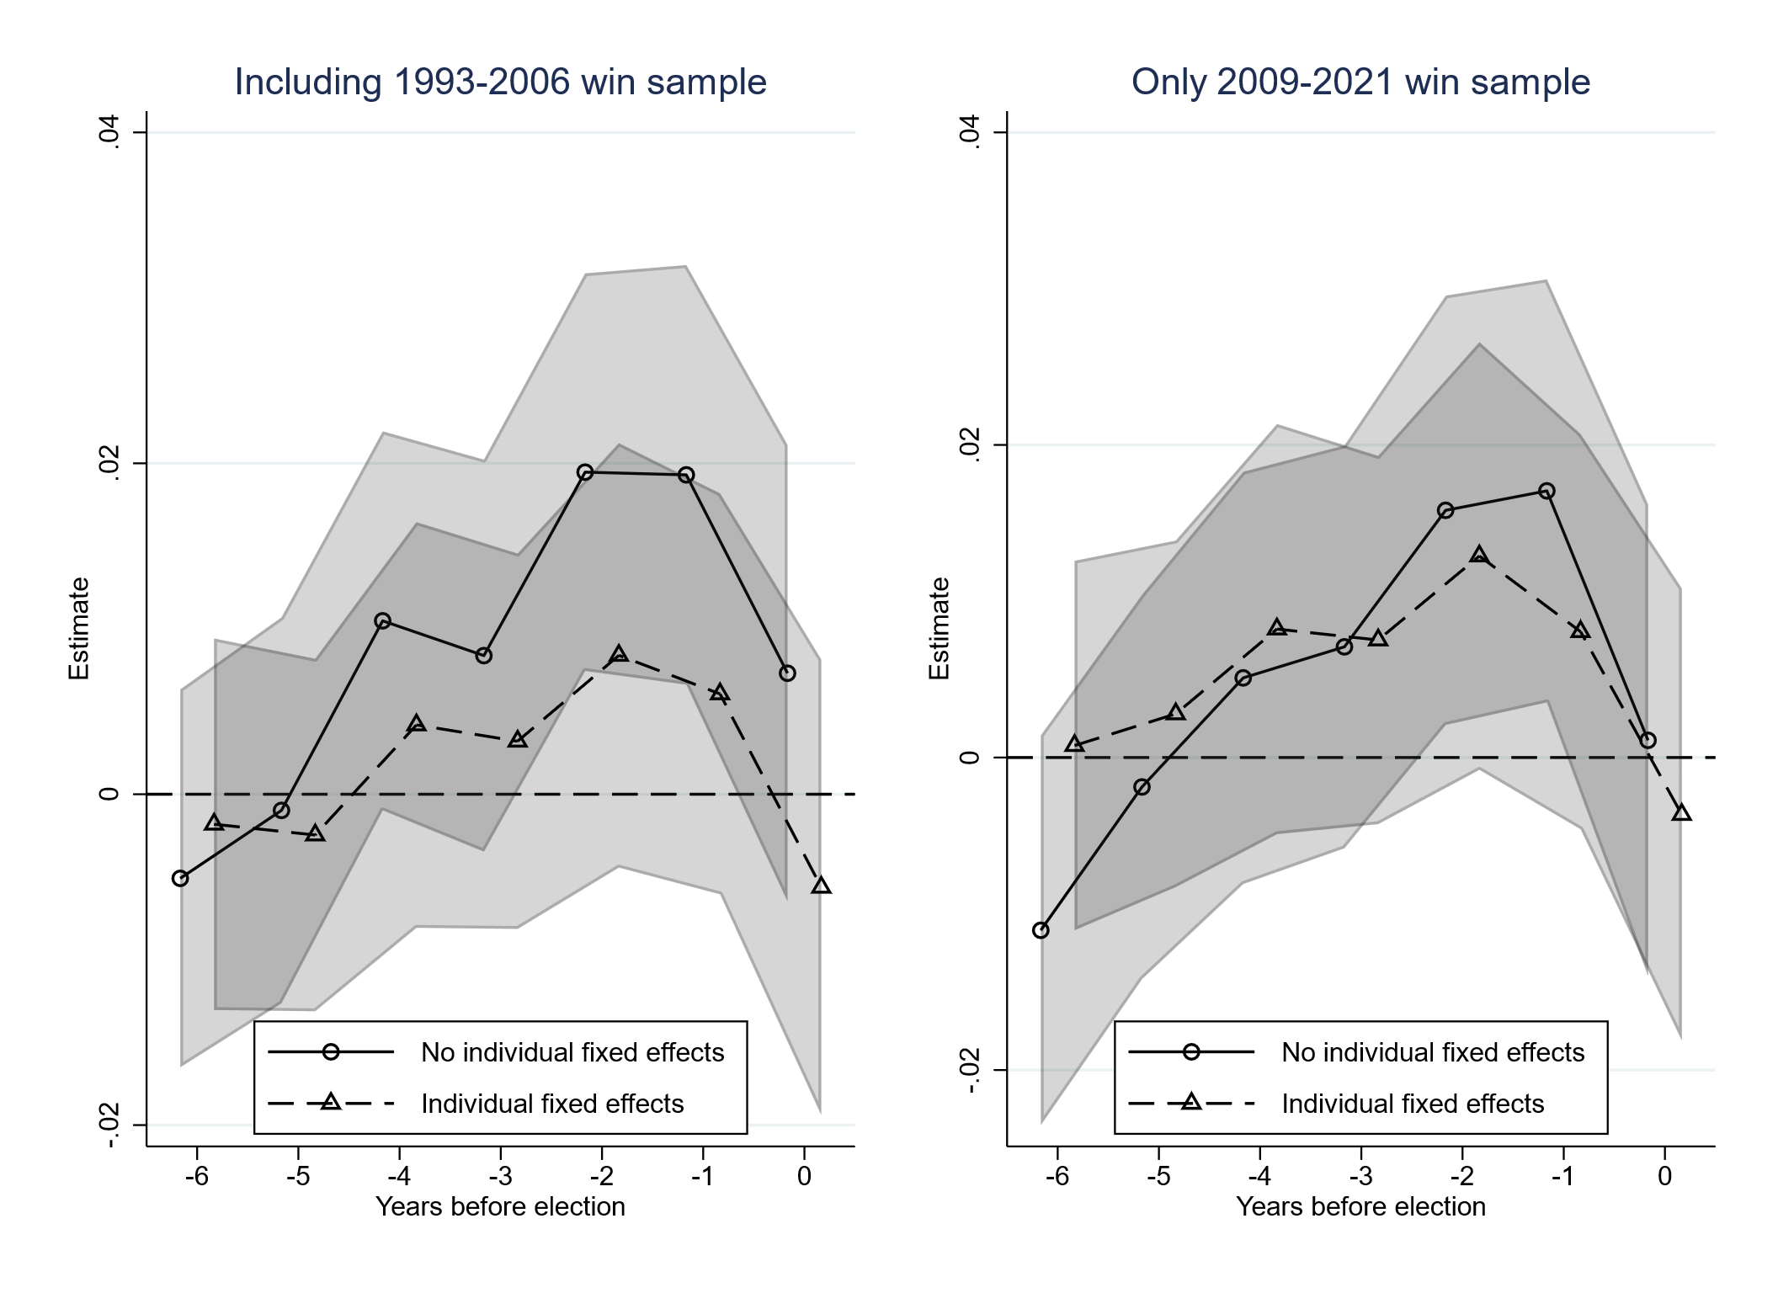

Notes. The diagrams show the estimated effects of lottery income windfalls on voter participation. The right diagram shows effects when only including individuals winning in the period 2009-2021 (cf. top-right panel in Table 1), while the left diagram displays effects for the sample extended with all lottery winners in the years 1993-2006 (cf. Panel B in Table 1). Both diagram display estimates for models with no individual fixed effects (corresponding to Figure 2) and with individual fixed effects (dashed lines). The diagrams illustrate 95% confidence intervals, calculated using standard errors that are clustered at the individual level. For additional details, refer to Appendix Table B.1.

Table A.1. Data on voter turnout 2015-2021.

|  |  |  |
| --- | --- | --- |
| **Election year** | **Description** | **Data coverage** |
| 2015 | Full count in 27 municipalities with a total of 1,715,200 people and a sample of 22,950 individuals sent to the municipalities. | 48.8% |
| 2017 | Full count in 255 municipalities and a representative sample drawn in all other 170 municipalities in Norway (which are generally less populous municipalities). | 86.7% |
| 2019 | Full count in all municipalities. 298 municipalities submitted electoral rolls and the remaining 58 were asked to deliver the electoral lists directly to Statistics Norway. | 100% |
| 2021 | Full count in all municipalities. 318 municipalities submitted electoral rolls and the remaining 38 were asked to deliver the electoral lists directly to Statistics Norway | 100% |

Note: Description taken from <https://www.ssb.no/valg/stortingsvalg/statistikk/valgdeltakelse>. Data coverage is defined by the share of the eligible population living in municipalities with complete count. These statistics derive from the datasets provided by Statistics Norway.

Table B1. Estimated effects corresponding to Figures 2 and A.9.

|  |  |  |  |  |
| --- | --- | --- | --- | --- |
|  | (1) | (2) | (3) | (4) |
|  | Baseline estimates  (Figure 2) | | Estimates with individual fixed effects  (Figure A.9) | |
|  | Sample including also  1993-2006 winners | Sample including only  2009-2021 winners | Sample including also  1993-2006 winners | Sample including only  2009-2021 winners |
| Lagged effects: |  |  |  |  |
| -6 | -0.00508 | -0.0111* | -0.00181 | 0.000766 |
|  | (0.00583) | (0.00636) | (0.00573) | (0.00603) |
| -5 | -0.000979 | -0.00188 | -0.00246 | 0.00279 |
|  | (0.00595) | (0.00627) | (0.00544) | (0.00566) |
| -4 | 0.0105* | 0.00510 | 0.00419 | 0.00822 |
|  | (0.00584) | (0.00673) | (0.00625) | (0.00669) |
| -3 | 0.00838 | 0.00708 | 0.00320 | 0.00752 |
|  | (0.00604) | (0.00658) | (0.00579) | (0.00601) |
| -2 | 0.0195*** | 0.0158** | 0.00839 | 0.0129* |
|  | (0.00613) | (0.00701) | (0.00654) | (0.00698) |
| -1 | 0.0193*** | 0.0171** | 0.00607 | 0.00805 |
|  | (0.00647) | (0.00690) | (0.00618) | (0.00645) |
| 0 | 0.00731 | 0.00110 | -0.00562 | -0.00365 |
|  | (0.00704) | (0.00770) | (0.00702) | (0.00738) |
|  |  |  |  |  |
| Observations | 275,649 | 44,820 | 271,869 | 44,366 |
| R-squared | 0.016 | 0.020 | 0.669 | 0.652 |

Notes. The table shows the estimated effects of lottery income windfalls on voter participation. The estimates presented in Columns (1) and (2) correspond to the results presented in Figure 2, while the estimates displayed in Columns (3) and (4) correspond to the results presented in Figure A.9. Columns (2) and (4) include only individuals winning in the period 2009-2021 (cf. top-right panel in Table 1), while Columns (1) and (3) extend the sample with all lottery winners in the years 1993-2006 (cf. Panel B in Table 1). The standard errors are robust standard errors clustered on individuals. Significance levels: *** p<0.01, ** p<0.05, * p<0.1

Table B.2 Estimated effects corresponding to Figure 3.

|  |  |  |  |
| --- | --- | --- | --- |
|  | (1) | (2) | (3) |
|  | Election year | One-year lag | Two-year lag |
|  |  |  |  |
| Income decile 1 | 0.005 | -0.024 | 0.006 |
|  | (0.046) | (0.048) | (0.043) |
| Income decile 2 | 0.115*** | 0.037 | 0.043 |
|  | (0.032) | (0.033) | (0.033) |
| Income decile 3 | -0.005 | 0.041* | -0.021 |
|  | (0.028) | (0.024) | (0.026) |
| Income decile 4 | 0.014 | 0.009 | 0.038* |
|  | (0.024) | (0.022) | (0.021) |
| Income decile 5 | -0.017 | 0.013 | 0.026 |
|  | (0.023) | (0.020) | (0.020) |
| Income decile 6 | -0.037 | -0.002 | 0.012 |
|  | (0.023) | (0.020) | (0.019) |
| Income decile 7 | -0.015 | -0.031 | -0.012 |
|  | (0.021) | (0.021) | (0.019) |
| Income decile 8 | 0.026 | 0.018 | 0.024 |
|  | (0.018) | (0.016) | (0.016) |
| Income decile 9 | -0.001 | 0.018 | -0.000 |
|  | (0.017) | (0.015) | (0.015) |
| Income decile 10 | -0.041** | -0.004 | 0.017 |
|  | (0.017) | (0.015) | (0.013) |
| Observations | 276,792 | 276,676 | 276,545 |
| R-squared | 0.036 | 0.036 | 0.035 |

Notes. The table shows the estimated effects of lottery income windfalls on voter participation, conditional on income defined by annual deciles. All models employ the sample of individuals winning in the period 2009-2021 extended with all lottery winners in the years 1993-2006 (cf. Panel B in Table 1). We estimate effects with zero, one- and two-year lags for income and the lottery win variables. The standard errors are robust standard errors clustered on individuals. Significance levels: *** p<0.01, ** p<0.05, * p<0.1

Table C1. Estimated effects corresponding to Figure A.2.

|  |  |  |
| --- | --- | --- |
|  | (1) | (2) |
|  | Sample including also  1993-2006 winners | Sample including only  2009-2021 winners |
| Lagged effects: |  |  |
| -6 | 0.000861 | 0.000495 |
|  | (0.000847) | (0.000888) |
| -5 | -0.000530 | -0.000857 |
|  | (0.00169) | (0.00172) |
| -4 | 0.000432 | 0.000263 |
|  | (0.000981) | (0.000968) |
| -3 | 0.000479 | 0.000363 |
|  | (0.000624) | (0.000621) |
| -2 | 0.000442 | 0.000435 |
|  | (0.000418) | (0.000415) |
| -1 | 0.000297 | 0.000224 |
|  | (0.000288) | (0.000295) |
| 0 | -0.000563 | -0.000666 |
|  | (0.000881) | (0.000903) |
|  |  |  |
| Observations | 275,649 | 44,820 |
| R-squared | 0.015 | 0.020 |

Notes. The table shows the estimated effects of the size of lottery income windfalls (in million NOK) on voter participation. Column (2) includes only individuals winning in the period 2009-2021 (cf. top-right panel in Table 1), while Column (1) extends the sample with all lottery winners in the years 1993-2006 (cf. Panel B in Table 1). The standard errors are robust standard errors clustered on individuals. Significance levels: *** p<0.01, ** p<0.05, * p<0.1

Table C.2. Estimated effects corresponding to Figure A.3

|  |  |  |  |
| --- | --- | --- | --- |
|  | (1) | (2) | (3) |
|  | Women | Men | With controls |
| Lagged effects: |  |  |  |
| -6 | 0.013 | -0.013* | -0.005 |
|  | (0.009) | (0.007) | (0.006) |
| -5 | 0.014 | -0.007 | 0.001 |
|  | (0.010) | (0.008) | (0.006) |
| -4 | 0.025*** | 0.005 | 0.014** |
|  | (0.010) | (0.007) | (0.006) |
| -3 | 0.022** | 0.003 | 0.014** |
|  | (0.010) | (0.008) | (0.006) |
| -2 | 0.039*** | 0.010 | 0.025*** |
|  | (0.010) | (0.008) | (0.006) |
| -1 | 0.032*** | 0.013 | 0.026*** |
|  | (0.010) | (0.009) | (0.006) |
| 0 | 0.014 | 0.005 | 0.015** |
|  | (0.011) | (0.009) | (0.007) |
|  |  |  |  |
| Observations | 105,957 | 169,692 | 275,649 |
| R-squared | 0.015 | 0.016 | 0.061 |

Notes. The table shows the estimated effects of lottery income windfalls on voter participation for women (column (1)) and men (column (2). Column (3) estimates the baseline model with controls for individuals’ age, gender, income, and education. All models use the sample of lottery participants including also winners in the years 1993-2006 (cf. Panel B in Table 1). The standard errors are robust standard errors clustered on individuals (in parentheses). Significance levels: *** p<0.01, ** p<0.05, * p<0.1

Table C.3 Estimated effects corresponding to Figure A.4

|  |  |  |
| --- | --- | --- |
|  | (1) | (2) |
|  | Win (=1) | Win (mill NOK) |
| Lagged effects: |  |  |
| -6 | 0.003 | 0.001 |
|  | (0.006) | (0.001) |
| -5 | 0.001 | -0.000 |
|  | (0.006) | (0.001) |
| -4 | 0.010 | 0.000 |
|  | (0.007) | (0.001) |
| -3 | 0.004 | 0.001* |
|  | (0.006) | (0.001) |
| -2 | 0.013* | -0.000 |
|  | (0.006) | (0.001) |
| -1 | 0.012* | 0.001* |
|  | (0.006) | (0.000) |
| 0 | 0.003 | -0.001 |
|  | (0.007) | (0.001) |
|  |  |  |
| Observations | 11,047,590 | 11,047,590 |
| R-squared | 0.682 | 0.682 |

Notes. The table shows the estimated effects of lottery income windfalls on voter participation using the entire Norwegian population. The left column displays effects using an indicator variable equal to 1 for an income windfall (0 otherwise), while the right column shows the effects of the size of the income windfall (measured in mill NOK, coded 0 in case there is no lotter windfall). All models include a full set of individual fixed effects to account for unobservable individual-level characteristics that do not change over time. The standard errors are robust standard errors clustered on individuals (in parentheses). Significance levels: *** p<0.01, ** p<0.05, * p<0.1

Table C.4. Estimated effects corresponding to Figure A.7

|  |  |  |  |
| --- | --- | --- | --- |
|  | (1) | (2) | (3) |
|  | 18-40 years | 41-65 years | 66 and older |
| Lagged effects: |  |  |  |
| -6 | -0.036* | -0.008 | 0.004 |
|  | (0.021) | (0.008) | (0.009) |
| -5 | -0.014 | 0.002 | 0.011 |
|  | (0.019) | (0.008) | (0.010) |
| -4 | -0.041** | 0.013* | 0.020** |
|  | (0.020) | (0.008) | (0.010) |
| -3 | -0.004 | 0.008 | 0.028*** |
|  | (0.019) | (0.008) | (0.010) |
| -2 | -0.018 | 0.024*** | 0.039*** |
|  | (0.019) | (0.008) | (0.010) |
| -1 | 0.004 | 0.026*** | 0.037*** |
|  | (0.019) | (0.009) | (0.011) |
| 0 | -0.063*** | 0.018* | 0.047*** |
|  | (0.021) | (0.009) | (0.012) |
|  |  |  |  |
| Observations | 11,728 | 141,273 | 99,754 |
| R-squared | 0.032 | 0.019 | 0.012 |

Notes. The table shows the estimated effects of lottery income windfalls on voter participation, by age group (18-40, 41-65, and 66 and higher). All models use the sample of lottery participants including also winners in the years 1993-2006 (cf. Panel B in Table 1). The standard errors are robust standard errors clustered on individuals (in parentheses). Significance levels: *** p<0.01, ** p<0.05, * p<0.1

Table C.5 External validity

|  |  |  |
| --- | --- | --- |
|  | Model A | Model B |
| Income deciles: |  |  |
| 2 | 0.0141*** | 0.0137*** |
|  | (0.0008) | (0.0008) |
| 3 | 0.0301*** | 0.0292*** |
|  | (0.0008) | (0.0008) |
| 4 | 0.0411*** | 0.0401*** |
|  | (0.0008) | (0.0008) |
| 5 | 0.0497*** | 0.0486*** |
|  | (0.0009) | (0.0009) |
| 6 | 0.0580*** | 0.0569*** |
|  | (0.0009) | (0.0009) |
| 7 | 0.0645*** | 0.0633*** |
|  | (0.0009) | (0.0009) |
| 8 | 0.0665*** | 0.0652*** |
|  | (0.0009) | (0.0009) |
| 9 | 0.0688*** | 0.0676*** |
|  | (0.0009) | (0.0009) |
| 10 | 0.0700*** | 0.0692*** |
|  | (0.0010) | (0.0010) |
|  |  |  |
| Observations | 12,454,045 | 12,453,651 |
| R-squared | 0.674 | 0.675 |
| Year | Y | Y |
| Individual FEs | Y | Y |
| Municipality FEs | N | Y |
| Mun. Spec. trend | N | Y |

Notes. The table displays regression estimates of total income on voter turnout using data for the eligible population in the national and local elections conducted in 2015, 2017, 2019 and 2021. Income has been defined by annual income deciles, indicated by numbers 2-10 in the table. The reference group is the lowest income decile (1). The models include fixed effects for individuals and years. Model B also include fixed effects for municipalities and municipality specific linear time trends. The standard errors are robust with standard errors clustered on individuals (in parentheses). Significance levels: *** p<0.01, ** p<0.05, * p<0.1

Appendix D. Access to replication micro data

“The Causal Effect of Affluence on Voter Turnout:

New Evidence from Lottery Winnings”

This paper's analysis utilizes registry data owned by Statistics Norway and regulated by the Norwegian Statistics Act. Due to the Act's provisions, we cannot share individual-level data on voter turnout and lottery winnings publicly. However, researchers affiliated with accredited institutions may request access to this detailed data from Statistics Norway, as outlined at cf. <https://www.ssb.no/en/omssb/tjenester-og-verktoy/data-til-forskning>. Applicants must ensure compliance with the General Data Protection Regulation (GDPR) by demonstrating adequate confidentiality measures and submitting a Data Protection Impact Assessment (DPIA). Our team is committed to supporting researchers in replicating our analysis and facilitating their access to the data from Statistics Norway.