Supplementary Information to “Party Positioning under Populist State Leaders”

Details on propensity score matching
This appendix section provides additional details on the propensity score matching conducted in the empirical part of the paper. We predict the likelihood that the incumbent state leader is a populist as a function of the aggregate populist vote share, GDP per capita, the inflation rate, the unemployment rate, and the first principal component of Varieties of Democracy (V-Dem) indices on judicial independence, election fairness, and media freedom. In countries treated with a populist state leader, we use the pre-treatment values of these variables for all remaining elections to ensure that shifts in mainstream parties’ positions are attributed to the treatment rather than changes in public sentiments, macroeconomic conditions, and institutional factors. When conducting the matching, we omit all party pairs that include the party of a populist leader or else it would be difficult to interpret the results in a causal manner. To eliminate the effect of outliers, we winsorize the top and bottom 10% of the matching variables on a yearly basis.
To estimate average treatment effects, we denote $Y(1)$ as the potential outcome if a party pair is treated and $Y(0)$ if not. The average treatment effect on the treated ($ATT$) is represented by:
$$ATT=E\left[Y\left(1\right) | A=1\right]-E[Y(0)|A=1]$$ | (A1)
where $A∈\left\{0,1\right\}$ indicates the treatment status. The first term can be estimated from the data, whereas the counterfactual term $E[Y(0)|A=1]$ is not observed. $E\left[Y\left(0\right) | A=1\right]≠E[Y(0)|A=0]$ if selection into treatment is non-random. However, $A$ can be considered independent of $Y(0)$ after conditioning on all covariates $x$ that jointly affect this selection and the potential outcome (Frölich, 2004). Therefore, to estimate the $ATT$, we need an assumption of mean independence in means under no treatment (Wooldrige, 2010, p.911) represented as:
$$E\left[Y\left(0\right) | x,A\right]=E[Y(0)|x]$$ | (A2)
When dealing with a situation where the data contains multiple covariates $x$, estimating the counterfactual mean using nonparametric regression of the potential outcome $Y$ on $x$can be a computationally challenging task, especially in the untreated group (Frölich, 2004). For that reason, Rosenbaum and Rubin (1983) suggest an alternative approach, which involves creating a one-dimensional function based on $x$, called the propensity score ($pscore$). The propensity score is the conditional probability of a party pair being treated given the observed characteristics $x$:
$$pscore=P(A=1|x=x)$$ | (A3)
Propensity score matching implies that each treated party pair is matched to one or more treated party pair(s) that are closest based on the observed characteristics $x$, for which the estimated $pscore$ as defined in Equation (A3) can be used.
Once the $pscore$ is estimated, there are different methods to implement the matching, such as one-to-one matching, kernel matching, inverse probability weighting, and entropy balancing. There is no clear-cut rule of which method to use (Huber et al., 2013). For our baseline specification, we use kernel matching because this method retains most control observations for the analysis. That is, with kernel matching, we assign an individual weight to each party pair in the control group based on the $pscore$, such that the weighted mean of control observations is used to estimate the counterfactual to the treated party pair. However, we confirm that our results remain the same when using alternative methods.
After applying the kernel ridge estimator to estimate the $ATT$, we follow Rosenbaum and Rubin (1983) and compare the distribution of propensity scores between treated and control observations. As Figure A1 shows, the propensity scores of treated and control observations have visually distinct distributions before the matching but exhibit sufficient overlap afterwards. In addition, as shown in Table 5 in the main text, the covariates appear to be balanced after the matching. That is, we do not detect statistically significant differences in means between the treated and control groups. These two results together support a weak version of the ignorability condition required for causal inference (Wooldrige, 2010, p. 911).

Additional tables and figures

Table A1: List of countries and elections in the sample
 | Elections |  |  |  |  | Elections
Country | First  year | Last  year | Number |  |  | First  year | Last  year | Number
Argentina | 1989 | 2013 | 6 |  | Latvia | 2006 | 2018 | 5
Armenia | 2007 | 2018 | 4 |  | Lithuania | 2000 | 2016 | 3
Australia | 2004 | 2016 | 5 |  | Luxembourg | 2004 | 2013 | 3
Austria | 1999 | 2017 | 6 |  | Mexico | 2003 | 2018 | 6
Belgium | 2007 | 2014 | 3 |  | Moldova | 2014 | 2014 | 1
Bolivia | 2009 | 2014 | 2 |  | Montenegro | 2001 | 2016 | 3
Bosnia-Herzegovina | 2002 | 2018 | 4 |  | Netherlands | 2006 | 2017 | 4
Bulgaria | 2009 | 2017 | 4 |  | New Zealand | 1993 | 2017 | 8
Canada | 2004 | 2015 | 5 |  | North Macedonia | 2002 | 2016 | 6
Chile | 1989 | 2017 | 6 |  | Norway | 2005 | 2017 | 4
Croatia | 2000 | 2016 | 6 |  | Poland | 1993 | 2015 | 5
Cyprus | 2006 | 2016 | 3 |  | Portugal | 1999 | 2015 | 3
Czech Republic | 2006 | 2017 | 4 |  | Romania | 1996 | 2016 | 6
Denmark | 1998 | 2015 | 5 |  | Russia | 1993 | 2011 | 4
Estonia | 2007 | 2015 | 3 |  | Serbia | 2012 | 2016 | 3
Finland | 2007 | 2015 | 3 |  | Slovakia | 1990 | 2016 | 6
France | 2012 | 2017 | 2 |  | Slovenia | 2004 | 2018 | 5
Georgia | 1990 | 2016 | 3 |  | South Africa | 1994 | 2014 | 4
Germany | 1998 | 2017 | 6 |  | Spain | 2000 | 2016 | 5
Greece | 2004 | 2015 | 7 |  | Sweden | 2006 | 2018 | 4
Hungary | 2002 | 2018 | 5 |  | Turkey | 2002 | 2018 | 5
Iceland | 2003 | 2017 | 6 |  | Ukraine | 1994 | 2014 | 6
Ireland | 2007 | 2016 | 3 |  | United Kingdom | 2015 | 2017 | 2
Israel | 2003 | 2015 | 5 |  | United States | 2004 | 2016 | 3
Italy | 2008 | 2018 | 3 |  | Uruguay | 2014 | 2014 | 1
Japan | 2017 | 2017 | 1

Table A2: Comparison of traditional and semantic position measures (equality and welfare example)
New Zealand National Party, 2011 | Green Party of Aotearoa New Zealand, 2011
[+] … on delivering shorter waiting times  [-] We've been straight-up and said that in its current form, Labour's gold-plated KiwiSaver scheme isn't affordable.  [+] … continuing all Working for Families payments at current levels …  [+] Number 8, we will give seniors financial certainty by keeping the age of eligibility of NZ Superannuation at 65 [+] and steadily increasing the amount of Super paid each week as a result of our personal tax cuts. [+] I pledge to keep NZ Super at 66% of the average after-tax wage. [+] Labour hasn't made that pledge. [+] Labour hasn't put aside the funds for that pledge. [+] Labour is hoping our seniors won't notice. [+] Well, I won't play games with our senior citizens.  [+] … and we will make sure their Super payments rise every single year.  [-] Number 9, we will encourage people to save for their retirement, [+] by retaining KiwiSaver, with contributions at the 2% plus 2% level. [-] We'll make KiwiSaver a 2 2 plan.  [+] Number 10, we will provide a safety net for those who are unable to work, by passing a law to maintain and inflation-index all benefit payments, [-] while encouraging those who can work to go back to work.  [+] I believe in the welfare state. [+] I personally benefited from it when I was growing up and I will never turn my back on it. [-] So we will do what it takes to get those who can work back to work. | [+] … a decent health and education system …  [+] Did the health system invest in keeping her well, with healthy food choices, [+] warm dry housing, [+] and early intervention to catch threats like diabetes and dental problems before they develop.  [+] But if your parent is on an invalid or sickness benefit, you don’t get that extra help.  [+] Who do you trust to invest in preventative health care rather than waiting till you are sick?  [+] Insulation of all state houses.  [+] More money for COGS.  [+] Quit smoking assistance.  [+] … not least of which is a $1 billion fund to upgrade homes, right across the country, making them warm and dry, with lower power bills.
Difference between percent of pos. and neg. statements: 12.57 - 4.68 = 7.89 | Difference between percent of pos. and neg. statements: 8.33 – 0.00 = 8.33
Semantic measure (cosine distance): 0.83 (i.e., fairly different)
Notes: The table shows all statements from the manifestos tagged by the Manifesto Project as “welfare state”. Brackets indicate whether a statement was coded as positive (welfare state expansion; CMP code 504) or negative (welfare state limitation; CMP code 505). The percent of positive and negative statements are relative to the total number of coded statements in a party’s manifesto.
Table A3: Comparison of traditional and semantic position measures (multiculturalism example)
New Democratic Party (Canada), 2015 | Conservative Party of Canada, 2015
[+] … we will introduce a comprehensive action plan to foster immigration to Francophone minority communities across the country.  [+] Furthermore, the ability to not just maintain but revitalize Indigenous culture and languages requires focused effort and investment. [+] The NDP will: Support initiatives to revitalize Indigenous languages by establishing …  [+] … a National Indigenous Languages Revitalization Fund and a National Indigenous Languages Institute with a total new investment of $68 million over four years. | [-] Sadly, there are some newcomers who embrace the promise of Canada, but not those values that make this country great, and who import certain brutal practices – most often affecting women and girls – that have no place here, or anywhere. [-] The tragic truth is that certain practices, such as female genital mutilation, so-called honour killings, polygamy, and early and forced marriages, are taking place within some cultural communities in Canada.  [+] … and support minority language communities in Canada.  [+] Increasing funding to support the preservation and promotion of traditional Aboriginal languages. [+] Ongoing support for Aboriginal post-secondary bursaries in partnership with Indspire, an Aboriginal-led national charity dedicated to helping First Nations students receive post-secondary education.  [+] Our Conservative Government introduced the First Nations Control of First Nations Education Act to improve K-12 educational outcomes for First Nations students. [+] The legislation was rooted in a historic agreement with the Assembly of First Nations and was backed by significant new funding for core education programming, including language and cultural programming. [+] A re-elected Conservative Government remains committed to working with willing First Nations partners and provinces to improve First Nations educational outcomes so that students living on reserve are better placed to reach their full potential.  [-] A majority of Canadians believe that new citizens should be seen and heard at the moment they join the Canadian family. [-] That's why, this past June, our Government introduced a bill requiring all individuals seeking to become Canadians to show their faces while taking the Oath of Citizenship. [-] We believe it's critically important that, at the moment an individual joins the Canadian family, they do so freely and openly, rather than hiding their identity. [-] A re-elected Conservative Government will reintroduce and pass the Oath of Citizenship Act requiring citizenship candidates to be seen and heard when reciting the Oath in community with others, to confirm their commitment as new citizens to Canada's laws and values.
Difference between percent of pos. and neg. statements: 0.53 – 0.00 = 0.53 | Difference between percent of pos. and neg. statements: 0.39 – 0.39 = 0.00
Semantic measure (cosine distance): 0.64 (i.e., fairly different)
Notes: The table shows all statements from the manifestos tagged by the Manifesto Project as “multiculturalism”. Brackets indicate whether a statement was coded as positive (CMP code 607) or negative (CMP code 608) toward multiculturalism. The percent of positive and negative statements are relative to the total number of coded statements in a party’s manifesto.
Table A4: Impact of populist leadership on party positions (traditional position measures)
 | Baseline sample |  | Extended sample
 | (1) | (2) | (3) | (4)
 | Equality and welfare | Multiculturalism | Equality and welfare | Multiculturalism
Left populist | -2.434 | -0.628* | -1.222 | -4.369***
 | (1.810) | (0.358) | (2.140) | (1.483)
Right populist | 0.606 | 1.200** | -2.492** | 1.353*
 | (1.751) | (0.534) | (0.971) | (0.709)
Mean of dep. variable | 9.194 | 2.515 | 8.368 | 2.525
SD of dep. variable | 6.879 | 4.094 | 6.500 | 4.071
Adj. R² | 0.167 | 0.190 | 0.147 | 0.488
Observations | 2083 | 2083 | 2728 | 2728
Estimates based on matched party-pair data. The baseline sample includes observations where content-analytical data are available, whereas the extended sample includes all observations where only data for the traditional position measures are available. The dependent variables capture the degree of differentiation between pairs of parties in the policy categories stated in the column headers, measured as the absolute difference of percentages of relevant statements in their manifestos. All coefficients, standard errors, means, and standard deviation are exponentiated. All models include country fixed effects, year fixed effects, and binary variable indicating party-pairs with a state leader (output omitted). Standard errors (in parentheses) are clustered by election.
* p<0.10, ** p<0.05, *** p<0.01

Table A5: Impact of populist leadership on party positions (recoding positions measures)
 | Winsorized at p1 and p99 |  | Winsorized at p10 and p90
 | (1) | (2) | (3) | (4)
 | Equality and welfare | Multiculturalism | Equality and welfare | Multiculturalism
Left populist | 0.050 | -0.145* | 0.034 | -0.069*
 | (0.047) | (0.087) | (0.038) | (0.040)
Right populist | 0.028 | 0.178*** | 0.021 | 0.093***
 | (0.020) | (0.058) | (0.016) | (0.029)
Mean of dep. variable | 0.529 | 0.573 | 0.524 | 0.627
SD of dep. variable | 0.085 | 0.267 | 0.065 | 0.129
Adj. R² | 0.315 | 0.355 | 0.359 | 0.282
Notes: Based on matched data on 2,083 party pairs. The dependent variables capture the degree of differentiation between pairs of parties in the policy categories stated in the column headers, measured as the average cosine distance between parties’ manifesto statements pertaining to the categories (winsorized at the percentiles specified in the table header). All models include country fixed effects, year fixed effects, and binary variable indicating party-pairs with a state leader (output omitted). Standard errors (in parentheses) are clustered by election.
* p<0.10, ** p<0.05, *** p<0.01

Table A6: Impact of populist leadership on party positions (alternative text-analysis approach)
 | (1) | (2)
 | Equality and welfare | Multiculturalism
Left populist | 0.011 | -0.243*
 | (0.053) | (0.145)
Right populist | 0.000 | 0.272***
 | (0.027) | (0.097)
Mean of dep. variable | 0.614 | 0.516
SD of dep. variable | 0.105 | 0.446
Adj. R² | 0.426 | 0.394
Notes: Based on matched data on 2,083 party pairs. The dependent variables capture the degree of differentiation between pairs of parties in the policy categories stated in the column headers, measured as the average cosine distance between parties’ manifesto statements pertaining to the categories. In contrast to the baseline position measures, which are created by using a multilingual version of Sentence-BERT, the regressions shown in the table use position measures created by first translating all manifestos to English using Opus-MT (Tiedemann et al., 2024), and then using the monolingual (English) Sentence-BERT to compute the cosine distances. All models include country fixed effects, year fixed effects, and binary variable indicating party-pairs with a state leader (output omitted). Standard errors (in parentheses) are clustered by election.
* p<0.10, ** p<0.05, *** p<0.01

Table A7: Impact of populist leadership on party positions (alternative matching procedures)
 | Inverse probability weighting |  | Entropy balancing
 | (1) | (2) | (3) | (4)
 | Equality and welfare | Multiculturalism | Equality and welfare | Multiculturalism
Left populist | 0.042 | -0.260* | 0.039 | -0.243*
 | (0.044) | (0.140) | (0.040) | (0.139)
Right populist | 0.032 | 0.256*** | 0.025 | 0.257***
 | (0.026) | (0.097) | (0.025) | (0.098)
Mean of dep. variable | 0.537 | 0.502 | 0.537 | 0.504
SD of dep. variable | 0.091 | 0.449 | 0.091 | 0.447
Adj. R² | 0.276 | 0.384 | 0.275 | 0.371
Notes: Based on matched data on 2,083 party pairs. The dependent variables capture the degree of differentiation between pairs of parties in the policy categories stated in the column headers, measured as the average cosine distance between parties’ manifesto statements pertaining to the categories. All models include country fixed effects, year fixed effects, and binary variable indicating party-pairs with a state leader (output omitted). Standard errors (in parentheses) are clustered by election.
* p<0.10, ** p<0.05, *** p<0.01

Table A8: Impact of populist leadership on party positions (no winsorizing of matching variables)
 | (1) | (2)
 | Equality and welfare | Multiculturalism
Left populist | 0.038 | -0.285**
 | (0.038) | (0.119)
Right populist | 0.022 | 0.262***
 | (0.022) | (0.092)
Mean of dep. variable | 0.536 | 0.477
SD of dep. variable | 0.091 | 0.450
Adj. R² | 0.322 | 0.440
Notes: Based on matched data on 2,110 party pairs. The dependent variables capture the degree of differentiation between pairs of parties in the policy categories stated in the column headers, measured as the average cosine distance between parties’ manifesto statements pertaining to the categories. All models include country fixed effects, year fixed effects, and binary variable indicating party-pairs with a state leader (output omitted). Standard errors (in parentheses) are clustered by election.
* p<0.10, ** p<0.05, *** p<0.01

Table A9: Impact of populist leadership on party positions (alternative standard errors)
 | Clustered by country |  | Clustered by party pair |  | Heteroscedasticity-robust
 | (1) | (2) | (3) | (4) | (5) | (6)
 | Equality and  welfare | Multiculturalism | Equality and  welfare | Multiculturalism | Equality and  welfare | Multiculturalism
Left populist | 0.060 | -0.249* | 0.060 | -0.249* | 0.060 | -0.249**
 | (0.044) | (0.134) | (0.042) | (0.131) | (0.042) | (0.120)
Right populist | 0.031 | 0.295** | 0.031 | 0.295*** | 0.031 | 0.295***
 | (0.028) | (0.113) | (0.020) | (0.095) | (0.020) | (0.095)
Mean of dep. variable | 0.531 | 0.516 | 0.531 | 0.516 | 0.531 | 0.516
SD of dep. variable | 0.092 | 0.445 | 0.092 | 0.445 | 0.092 | 0.445
Adj. R² | 0.306 | 0.393 | 0.306 | 0.394 | 0.306 | 0.394
Notes: Based on matched data on 2,083 party pairs. The dependent variables capture the degree of differentiation between pairs of parties in the policy categories stated in the column headers, measured as the average cosine distance between parties' manifesto statements pertaining to the categories. All models include country fixed effects, year fixed effects, and binary variable indicating party-pairs with a state leader (output omitted). Standard errors are in parentheses.
* p<0.10, ** p<0.05, *** p<0.01

Table A10: Impact of populist leadership on party positions (additional matching variables)
 | Adding development status  (advanced vs. emerging) |  | Adding political system  (parliamentary vs. presidential)
 | (1) | (2) | (3) | (4)
 | Equality and welfare | Multiculturalism | Equality and welfare | Multiculturalism
Left populist | 0.039 | -0.234* | 0.038 | -0.226*
 | (0.045) | (0.131) | (0.032) | (0.124)
Right populist | 0.032 | 0.195** | 0.025 | 0.270***
 | (0.028) | (0.093) | (0.023) | (0.100)
Mean of dep. variable | 0.530 | 0.508 | 0.529 | 0.507
SD of dep. variable | 0.093 | 0.443 | 0.090 | 0.442
Adj. R² | 0.357 | 0.414 | 0.318 | 0.398
Notes: Based on matched data on 2,083 party pairs. The dependent variables capture the degree of differentiation between pairs of parties in the policy categories stated in the column headers, measured as the average cosine distance between parties’ manifesto statements pertaining to the categories. All models include country fixed effects, year fixed effects, and binary variable indicating party-pairs with a state leader (output omitted). Standard errors (in parentheses) are clustered by election.
* p<0.10, ** p<0.05, *** p<0.01

Table A11: Impact of populist leadership on party positions (alternative definition of populist state leaders)
 | (1) | (2)
 | Equality and welfare | Multiculturalism
Left populist | 0.007 | 0.136
 | (0.026) | (0.155)
Right populist | -0.002 | 0.213**
 | (0.033) | (0.090)
Mean of dep. variable | 0.531 | 0.458
SD of dep. variable | 0.092 | 0.447
Adj. R² | 0.350 | 0.293
Notes: Based on matched data on 2,126 party pairs. The regressions use data where we classify four borderline cases of populist incumbent state leaders as non-populist (Boyko Borisov, Robert Fico, Cristina Fernández de Kirchner, and Aléxis Tsípras). The dependent variables capture the degree of differentiation between pairs of parties in the policy categories stated in the column headers, measured as the average cosine distance between parties’ manifesto statements pertaining to the categories. All models include country fixed effects, year fixed effects, and binary variable indicating party-pairs with a state leader (output omitted). Standard errors (in parentheses) are clustered by election.
* p<0.10, ** p<0.05, *** p<0.01

Table A12: Impact of populist leadership on party positions (election-level regressions)
 | (1) | (2)
 | Equality and welfare | Multiculturalism
Left populist | 0.056 | -0.244*
 | (0.050) | (0.135)
Right populist | 0.025 | 0.302**
 | (0.027) | (0.119)
Mean of dep. variable | 0.531 | 0.518
SD of dep. variable | 0.061 | 0.314
Adj. R² | 0.613 | 0.750
Notes: Based on matched data collapsed by 215 elections. The dependent variables measure the degree of differentiation between pairs of parties in the policy categories stated in the column headers, measured as the average cosine distance between parties’ manifesto statements pertaining to the categories. All models include country fixed effects and year fixed effects. Standard errors (in parentheses) are clustered by country.
* p<0.10, ** p<0.05, *** p<0.01

Figure A1: Distribution of propensity scores
A: Before matching
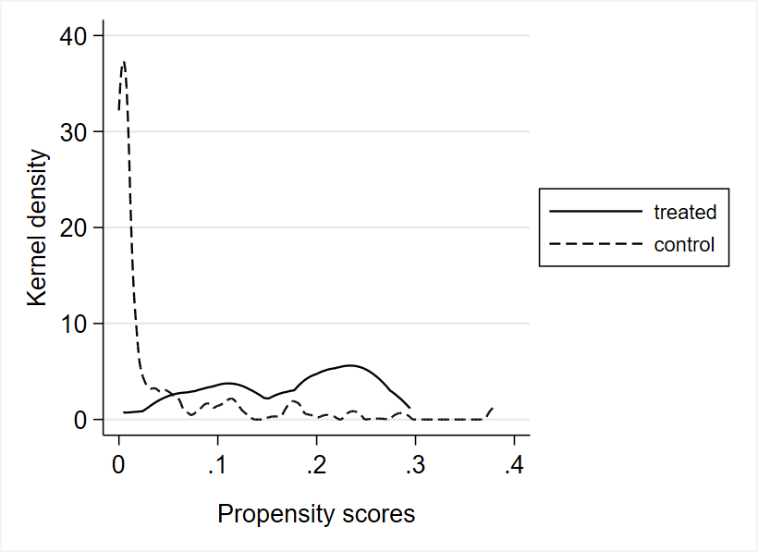
B: After matching
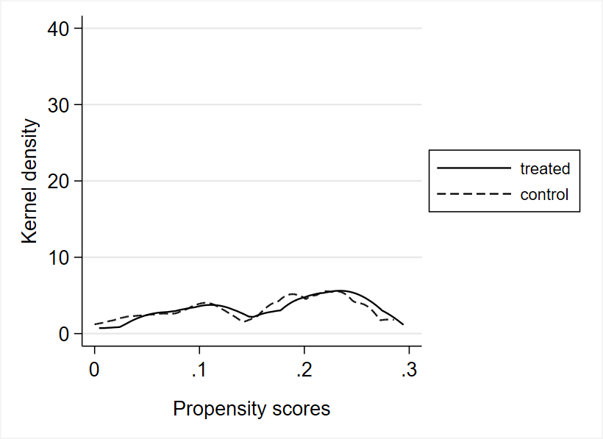

Figure A2: Placebo estimates
A: Equality and welfare | B: Multiculturalism
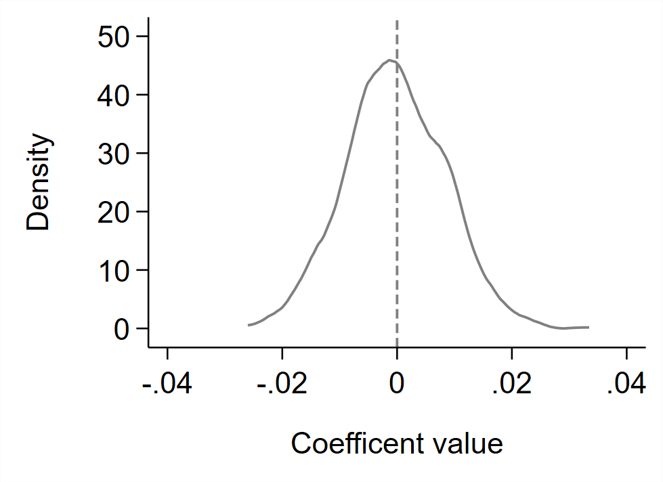 | 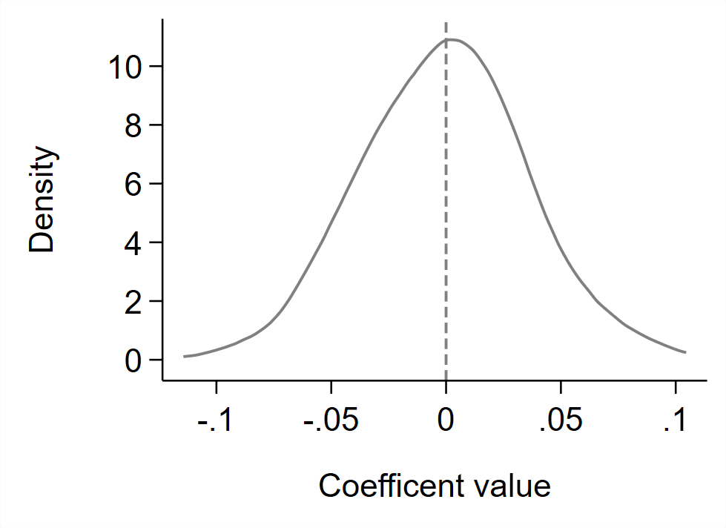
Notes: The figure shows kernel density plots of the distribution of coefficients from re-estimating the baseline specification 1,000 times with randomly drawn placebo treatments. The placebo treatment indicators are binary variables with an average treatment probability of 4.75% (following the true probability of treatment with an incumbent populist state leader in the dataset). The regressions use matched data on 2,083 party pairs.

Appendix References
Frölich, M. (2004). Finite-sample properties of propensity-score matching and weighting estimators. Review of Economics and Statistics, 86, 77–90.
Huber, M., Lechner, M., & Wunsch, C. (2013). The performance of estimators based on the propensity score. Journal of Econometrics, 175, 1–21.
Tiedemann, J., Aulamo, M., Bakshandaeva, D. et al. (2024). Democratizing neural machine translation with OPUS-MT. Language Resources & Evaluation, 58, 713–755.
Wooldridge, J. M. (2010). Econometric analysis of cross section and panel data. MIT Press.

