Contents
Appendix A Ethics and data availability 2
Appendix B Data details 3
Table B1. Number of observations, years and survey projects included from each country in the dataset. 3
Table B2. Number of aggregate observations for each measure of political trust in each survey project. 7
Table B3. Number of aggregate observations for each measure of political trust in each country. 9
Table B4. Number of aggregate observations for each measure of political trust in each year. 13
Table B5. Countries included in each regional category. 15
Table B6. Classification of countries as democratic or not. 17
Survey measures, response scales and dichotomization 20
Appendix C Descriptive trends by survey sources 31
C.1 Parliament 31
C.2 Government 37
C.3 Political parties 43
C.4 The civil service 49
C.5 The legal system 55
C.6 The police 61
Appendix D Country-trends in six trust measures 67
D.1 Parliament 67
D.2 Government 73
D.3 Political parties 79
D.4 The civil service 85
D.5 The legal system 91
D.6 The police 97
Appendix E Factor analyses 103
Appendix F Sensitivity analysis 107
F.1 Stimson’s dyad-ratios algorithm 108
F.2 Multi-level regression models (MLMs) 111
F.3 Global MLMs without using survey weights. 121
F.4 Global MLMs using logistic regression models. 122
F.5 Global MLMs using aggregated dataset. 123
Appendix G Stan model information and code 124
G.1 Model information 124
G.2 Code: Country models 124
G.3 Code: Regional models 127
G.4 Code: Global model 129
Appendix H Survey weights 131
References 142

- Ethics and data availability
Our study draws solely on secondary data, i.e., survey data that has already been collected and made available by third parties (for a full list of survey sources, see Table 1 in the main text). We are confident that the survey sources used all abided by the relevant ethics requirements at the time and place of collection, as they are all recognised and respected cross-national or national survey research programmes.
For the same reason, we are unable to make the underlying data for our analysis directly available as the rights belong to the proprietors of each survey project. In most cases, these are publicly available to access online, but in some cases the proprietors require log-in to their web portals, agreement of terms and services and/or approved applications for access. However, we share for replication the aggregated version of the individual-level data, which is aggregated at the country-year-study level (where "study" is short-hand for each survey project in question). This version of the dataset is used in almost all of the analysis presented in this paper (the exception is the part of the sensitivity analysis which uses multi-level regression models on the individual-level data). In addition, we share all code (in Stata and R) needed to perform all of the analysis and produce all of the graphs presented in the main text of the paper and in the Supplementary Material.

- Data details

Table B1. Number of observations, years and survey projects included from each country in the dataset.
Country | N | First year | Last year | Year N | Study N
United Kingdom | 97 | 1974 | 2019 | 32 | 17
United States | 88 | 1958 | 2019 | 44 | 8
Spain | 77 | 1981 | 2019 | 28 | 13
Poland | 72 | 1989 | 2019 | 30 | 14
Germany | 69 | 1974 | 2019 | 28 | 15
Russia | 67 | 1990 | 2017 | 25 | 14
Slovenia | 67 | 1991 | 2019 | 25 | 14
Hungary | 66 | 1982 | 2019 | 28 | 14
Czechia | 65 | 1990 | 2019 | 27 | 14
Slovakia | 63 | 1990 | 2019 | 26 | 15
France | 61 | 1981 | 2019 | 26 | 12
Netherlands | 61 | 1974 | 2019 | 29 | 11
Estonia | 58 | 1990 | 2019 | 24 | 14
Sweden | 58 | 1982 | 2019 | 26 | 10
Bulgaria | 56 | 1990 | 2019 | 27 | 13
Finland | 55 | 1975 | 2019 | 26 | 9
Italy | 54 | 1975 | 2019 | 28 | 13
Denmark | 53 | 1981 | 2019 | 25 | 8
Lithuania | 53 | 1990 | 2019 | 25 | 12
Belgium | 52 | 1981 | 2019 | 25 | 8
Latvia | 52 | 1990 | 2019 | 24 | 13
Ireland | 50 | 1981 | 2019 | 27 | 8
Austria | 49 | 1974 | 2019 | 26 | 9
Portugal | 48 | 1990 | 2019 | 23 | 8
Chile | 44 | 1990 | 2019 | 25 | 5
Romania | 44 | 1990 | 2019 | 24 | 10
Croatia | 43 | 1993 | 2019 | 23 | 10
Turkey | 43 | 1990 | 2019 | 21 | 9
Mexico | 41 | 1981 | 2019 | 26 | 5
Cyprus | 40 | 1996 | 2019 | 21 | 9
Colombia | 39 | 1996 | 2018 | 22 | 4
Greece | 39 | 1997 | 2019 | 22 | 9
South Korea | 38 | 1982 | 2018 | 20 | 7
Argentina | 37 | 1984 | 2019 | 27 | 4
Uruguay | 37 | 1995 | 2019 | 24 | 6
Brazil | 35 | 1991 | 2019 | 25 | 4
Peru | 34 | 1995 | 2019 | 24 | 3
Australia | 33 | 1969 | 2019 | 22 | 5
South Africa | 33 | 1982 | 2018 | 21 | 6
Venezuela | 33 | 1995 | 2018 | 23 | 4
Luxembourg | 32 | 1997 | 2019 | 22 | 5
Norway | 32 | 1982 | 2019 | 23 | 6
Ecuador | 31 | 1996 | 2019 | 23 | 4
Guatemala | 31 | 1996 | 2019 | 23 | 4
Bolivia | 30 | 1996 | 2019 | 23 | 3
Canada | 30 | 1965 | 2019 | 22 | 5
El Salvador | 29 | 1996 | 2018 | 23 | 3
Malta | 29 | 1983 | 2019 | 22 | 5
Panama | 29 | 1996 | 2018 | 22 | 2
Paraguay | 29 | 1995 | 2019 | 24 | 3
Costa Rica | 28 | 1996 | 2018 | 22 | 2
Honduras | 28 | 1996 | 2018 | 22 | 2
Nicaragua | 28 | 1996 | 2019 | 23 | 2
Ukraine | 28 | 1991 | 2016 | 19 | 11
Japan | 27 | 1981 | 2019 | 21 | 7
Dominican Republic | 25 | 1996 | 2019 | 18 | 5
Georgia | 25 | 1996 | 2019 | 16 | 8
Serbia | 25 | 1996 | 2019 | 19 | 8
North Macedonia | 24 | 1998 | 2019 | 16 | 5
Philippines | 23 | 1991 | 2019 | 17 | 6
Switzerland | 23 | 1975 | 2018 | 18 | 5
Armenia | 21 | 1997 | 2019 | 15 | 6
Iceland | 21 | 1984 | 2019 | 16 | 5
Belarus | 20 | 1990 | 2018 | 17 | 7
New Zealand | 20 | 1991 | 2018 | 16 | 3
Taiwan | 20 | 1994 | 2019 | 13 | 6
Israel | 19 | 1991 | 2018 | 15 | 3
Montenegro | 19 | 1996 | 2019 | 14 | 6
Azerbaijan | 18 | 1997 | 2018 | 11 | 7
China | 17 | 1990 | 2018 | 15 | 6
Morocco | 15 | 2001 | 2018 | 10 | 6
Albania | 14 | 1998 | 2019 | 11 | 5
Egypt | 14 | 2001 | 2018 | 9 | 5
India | 14 | 1990 | 2019 | 12 | 6
Thailand | 14 | 2000 | 2019 | 12 | 5
Jordan | 13 | 2001 | 2018 | 9 | 4
Nigeria | 13 | 1990 | 2018 | 11 | 3
Tunisia | 13 | 2011 | 2019 | 8 | 5
Algeria | 12 | 2002 | 2019 | 9 | 4
Moldova | 12 | 1996 | 2016 | 10 | 5
Ghana | 11 | 2000 | 2017 | 10 | 4
Uganda | 11 | 2000 | 2017 | 10 | 3
Indonesia | 10 | 1999 | 2018 | 9 | 5
Lebanon | 10 | 2006 | 2018 | 7 | 3
Malaysia | 10 | 2000 | 2018 | 9 | 4
Singapore | 10 | 2000 | 2015 | 10 | 4
Kazakhstan | 9 | 2001 | 2018 | 8 | 5
Mali | 9 | 2000 | 2017 | 9 | 3
Palestine | 9 | 2006 | 2018 | 7 | 3
Tanzania | 9 | 2000 | 2017 | 9 | 3
Zambia | 9 | 2000 | 2017 | 8 | 3
Zimbabwe | 9 | 2000 | 2017 | 8 | 2
Bosnia and Herzegovina | 8 | 1998 | 2019 | 8 | 4
Haiti | 8 | 2006 | 2017 | 7 | 2
Hong Kong | 8 | 2001 | 2018 | 8 | 3
Iraq | 8 | 2004 | 2019 | 7 | 3
Jamaica | 8 | 2006 | 2019 | 8 | 1
Kenya | 8 | 2003 | 2016 | 7 | 3
Kyrgyzstan | 8 | 2001 | 2016 | 7 | 4
Malawi | 8 | 2000 | 2017 | 8 | 1
Mongolia | 8 | 2003 | 2016 | 6 | 3
Pakistan | 8 | 1997 | 2018 | 7 | 4
Senegal | 8 | 2002 | 2017 | 8 | 3
Bangladesh | 7 | 1996 | 2018 | 6 | 4
Botswana | 7 | 2000 | 2017 | 7 | 1
Burkina Faso | 7 | 2003 | 2017 | 6 | 4
Lesotho | 7 | 2000 | 2017 | 7 | 1
Namibia | 7 | 2000 | 2017 | 7 | 1
Cape Verde | 6 | 2002 | 2017 | 6 | 1
Guyana | 6 | 2006 | 2016 | 6 | 1
Libya | 6 | 2012 | 2019 | 4 | 4
Mozambique | 6 | 2002 | 2018 | 6 | 1
Sudan | 6 | 2010 | 2018 | 4 | 2
Uzbekistan | 6 | 2003 | 2016 | 6 | 3
Vietnam | 6 | 2001 | 2015 | 5 | 3
Benin | 5 | 2005 | 2016 | 5 | 1
Cambodia | 5 | 2004 | 2015 | 5 | 2
Kosovo | 5 | 2008 | 2016 | 5 | 4
Madagascar | 5 | 2005 | 2018 | 5 | 1
Sri Lanka | 5 | 2003 | 2013 | 3 | 3
Suriname | 5 | 2010 | 2019 | 5 | 2
Trinidad and Tobago | 5 | 2006 | 2014 | 4 | 2
Yemen | 5 | 2007 | 2018 | 5 | 2
Belize | 4 | 2008 | 2014 | 4 | 1
Liberia | 4 | 2008 | 2018 | 4 | 1
Nepal | 4 | 2003 | 2013 | 3 | 3
Tajikistan | 4 | 2005 | 2016 | 4 | 2
Cameroon | 3 | 2013 | 2018 | 3 | 1
Eswatini | 3 | 2013 | 2018 | 3 | 1
Guinea | 3 | 2013 | 2017 | 3 | 1
Ivory Coast | 3 | 2013 | 2017 | 3 | 1
Kuwait | 3 | 2014 | 2019 | 2 | 2
Mauritius | 3 | 2012 | 2017 | 3 | 1
Niger | 3 | 2013 | 2018 | 3 | 1
Sierra Leone | 3 | 2012 | 2018 | 3 | 1
Togo | 3 | 2012 | 2017 | 3 | 1
Andorra | 2 | 2005 | 2018 | 2 | 1
Burundi | 2 | 2012 | 2014 | 2 | 1
Ethiopia | 2 | 2003 | 2007 | 2 | 2
Gabon | 2 | 2015 | 2017 | 2 | 1
Iran | 2 | 2000 | 2007 | 2 | 1
Rwanda | 2 | 2007 | 2012 | 2 | 1
Sao Tome and Principe | 2 | 2015 | 2018 | 2 | 1
Total | 3377 | 1958 | 2019

Table B2. Number of aggregate observations for each measure of political trust in each survey project.
 |  | Parliament |  | Government | Political Parties | Civil service | Legal system | Police
Eurobarometer |  | 598 |  | 592 | 595 | 207 | 497 | 467
Latinobarometro | 372 |  |  | 302 | 372 | 155 | 372 | 374
World Values Survey |  | 262 |  | 244 | 243 | 254 | 226 | 263
European Social Survey |  |  | 228 | 0 | 202 | 0 | 224 | 224
AmericasBarometer |  | 202 |  | 93 | 172 | 0 | 139 | 170
Afrobarometer |  | 158 |  | 0 | 0 | 0 | 172 | 172
European Values Study |  | 148 |  | 78 | 78 | 147 | 151 | 151
International Social Survey Programme |  | 119 |  | 108 | 0 | 107 | 139 | 0
European Quality of Life Surveys |  | 99 |  | 99 | 0 | 0 | 98 | 98
Life in Transition Survey |  | 98 |  | 98 | 98 | 0 | 98 | 98
New Europe Barometer |  | 80 |  | 43 | 78 | 8 | 79 | 78
European Election Study |  | 79 |  | 23 | 0 | 0 | 0 | 0
Asian Barometer Survey |  | 66 |  | 65 | 57 | 58 | 58 | 57
Candidate Countries Eurobarometer |  | 52 |  | 52 | 52 | 39 | 52 | 52
EU Neighbourhood Barometer |  | 47 |  | 47 | 47 | 0 | 0 | 0
Arab Barometer |  | 43 |  | 39 | 32 | 0 | 34 | 46
AsiaBarometer |  | 37 |  | 37 | 29 | 0 | 37 | 37
Integrated and United |  | 36 |  | 36 | 0 | 0 | 0 | 0
United States General Social Survey |  | 30 |  | 30 | 0 | 0 | 30 | 0
Consolidation of Democracy in Central and Eastern Europe |  | 25 |  | 25 | 25 | 0 | 0 | 25
Caucasus Barometer |  | 24 |  | 24 | 12 | 0 | 24 | 24
Eurasia Barometer |  | 17 |  | 17 | 17 | 0 | 17 | 17
Asia Europe Survey |  | 17 |  | 0 | 0 | 0 | 0 | 0
Korean General Social Survey |  | 14 |  | 14 | 0 | 0 | 0 | 0
New Russia Barometer |  | 12 |  | 1 | 12 | 2 | 11 | 10
New Baltic Barometer |  | 12 |  | 0 | 12 | 3 | 12 | 12
South African Social Attitudes Survey |  | 11 |  | 11 | 0 | 0 | 0 | 0
Pew Global Attitudes and Trends |  | 8 |  | 9 | 0 | 0 | 0 | 0
Polish General Social Survey |  | 8 |  | 8 | 0 | 0 | 0 | 0
British Social Attitudes |  | 7 |  | 24 | 0 | 0 | 0 | 0
Arab Transformations Project |  | 6 |  | 0 | 0 | 0 | 0 | 0
Norwegian National Election Study |  | 5 |  | 5 | 5 | 0 | 5 | 0
Values and Political Change in Post-Communist Europe |  | 5 |  | 5 | 0 | 0 | 0 | 0
Dutch Parliamentary Election Study |  | 5 |  | 2 | 3 | 4 | 5 | 5
Australian Survey of Social Attitudes |  | 5 |  | 0 | 0 | 0 | 0 | 0
Comparative National Elections Project |  | 4 |  | 8 | 0 | 0 | 0 | 0
General Election Study Belgium |  | 4 |  | 4 | 4 | 0 | 4 | 4
Australian Election Study |  | 3 |  | 11 | 3 | 3 | 3 | 3
New Zealand Election Study |  | 3 |  | 7 | 0 | 0 | 0 | 0
Flash Eurobarometer |  | 3 |  | 3 | 0 | 0 | 0 | 0
British Election Study |  | 2 |  | 4 | 1 | 1 | 2 | 2
Finnish National Election Study |  | 2 |  | 2 | 2 | 1 | 2 | 2
Australian Social Cohesion Survey |  | 2 |  | 1 | 0 | 0 | 0 | 0
World Health Survey |  | 0 |  | 34 | 0 | 0 | 0 | 0
American National Election Studies |  | 0 |  | 29 | 0 | 0 | 0 | 0
International Social Justice Project |  | 0 |  | 19 | 0 | 0 | 0 | 0
Canadian Election Study |  | 0 |  | 13 | 0 | 8 | 8 | 8
Political Action - Political Ideology |  | 0 |  | 11 | 0 | 0 | 0 | 0
East Asian Social Survey |  | 0 |  | 4 | 0 | 0 | 0 | 0
Irish National Election Study |  | 0 |  | 0 | 2 | 0 | 0 | 0
Total |  | 2959 |  | 2282 | 2153 | 997 | 2499 | 2399

Table B3. Number of aggregate observations for each measure of political trust in each country.
 | Parliament | Government | Political Parties | Civil service | Legal system | Police
Poland | 67 | 51 | 44 | 18 | 49 | 47
Spain | 66 | 49 | 48 | 27 | 54 | 53
United Kingdom | 64 | 70 | 35 | 20 | 45 | 39
Hungary | 60 | 43 | 43 | 18 | 49 | 45
Slovenia | 58 | 44 | 43 | 17 | 49 | 45
Russia | 58 | 30 | 52 | 16 | 51 | 47
Germany | 57 | 45 | 39 | 22 | 46 | 42
Slovakia | 55 | 45 | 41 | 15 | 45 | 42
Czechia | 55 | 44 | 42 | 16 | 47 | 44
Estonia | 54 | 39 | 44 | 14 | 44 | 45
Netherlands | 53 | 38 | 37 | 22 | 46 | 42
Bulgaria | 51 | 41 | 39 | 14 | 41 | 40
France | 51 | 37 | 34 | 18 | 42 | 37
Sweden | 51 | 34 | 36 | 20 | 44 | 39
Italy | 50 | 36 | 31 | 17 | 39 | 34
United States | 49 | 73 | 12 | 11 | 45 | 12
Finland | 48 | 35 | 36 | 19 | 43 | 39
Belgium | 48 | 35 | 35 | 14 | 40 | 38
Lithuania | 48 | 34 | 41 | 14 | 43 | 42
Denmark | 47 | 32 | 31 | 16 | 39 | 34
Latvia | 45 | 34 | 35 | 15 | 38 | 36
Austria | 45 | 34 | 29 | 14 | 36 | 31
Portugal | 45 | 30 | 31 | 13 | 36 | 33
Ireland | 45 | 27 | 33 | 16 | 38 | 34
Romania | 44 | 37 | 36 | 15 | 36 | 37
Turkey | 40 | 37 | 31 | 16 | 34 | 32
Greece | 39 | 30 | 28 | 12 | 30 | 29
Croatia | 38 | 32 | 30 | 11 | 34 | 30
Colombia | 38 | 31 | 33 | 13 | 33 | 33
Chile | 38 | 30 | 34 | 17 | 34 | 34
Cyprus | 38 | 30 | 30 | 12 | 32 | 29
Mexico | 37 | 30 | 35 | 16 | 35 | 36
Argentina | 35 | 25 | 32 | 17 | 31 | 34
Peru | 34 | 25 | 33 | 14 | 31 | 33
Brazil | 34 | 25 | 32 | 14 | 31 | 33
Uruguay | 34 | 25 | 31 | 13 | 30 | 31
South Korea | 32 | 31 | 11 | 13 | 15 | 14
Luxembourg | 32 | 26 | 24 | 11 | 26 | 25
Ecuador | 30 | 23 | 30 | 10 | 27 | 30
Guatemala | 30 | 23 | 29 | 9 | 26 | 29
Bolivia | 30 | 21 | 29 | 9 | 28 | 29
Malta | 29 | 24 | 21 | 11 | 24 | 23
Venezuela | 29 | 23 | 23 | 13 | 23 | 23
El Salvador | 29 | 22 | 29 | 8 | 27 | 29
Panama | 29 | 20 | 28 | 8 | 26 | 28
Honduras | 28 | 23 | 28 | 8 | 27 | 28
Paraguay | 28 | 21 | 28 | 9 | 26 | 28
Nicaragua | 28 | 20 | 28 | 8 | 28 | 28
Costa Rica | 28 | 20 | 28 | 8 | 26 | 28
Ukraine | 27 | 19 | 23 | 5 | 21 | 22
North Macedonia | 24 | 24 | 18 | 8 | 17 | 17
Serbia | 25 | 24 | 21 | 12 | 20 | 21
South Africa | 25 | 20 | 5 | 8 | 15 | 13
Norway | 25 | 13 | 17 | 10 | 25 | 16
Dominican Republic | 23 | 18 | 22 | 8 | 20 | 22
Georgia | 22 | 24 | 18 | 6 | 19 | 19
Armenia | 21 | 21 | 17 | 4 | 18 | 18
Belarus | 20 | 16 | 19 | 6 | 16 | 17
Montenegro | 19 | 18 | 17 | 8 | 15 | 16
Australia | 18 | 19 | 7 | 11 | 11 | 8
Azerbaijan | 18 | 18 | 13 | 4 | 14 | 14
Japan | 18 | 17 | 11 | 14 | 17 | 14
Iceland | 18 | 12 | 13 | 6 | 16 | 14
Philippines | 16 | 15 | 10 | 12 | 13 | 10
Switzerland | 16 | 8 | 12 | 7 | 17 | 13
China | 14 | 15 | 9 | 9 | 11 | 11
Albania | 14 | 14 | 13 | 8 | 13 | 14
Morocco | 14 | 10 | 9 | 3 | 8 | 10
Canada | 13 | 18 | 9 | 14 | 18 | 17
Taiwan | 13 | 14 | 10 | 11 | 13 | 10
Jordan | 13 | 11 | 11 | 4 | 7 | 9
Thailand | 13 | 11 | 9 | 8 | 12 | 10
Israel | 13 | 6 | 8 | 4 | 10 | 6
Moldova | 12 | 12 | 12 | 4 | 8 | 9
Tunisia | 12 | 9 | 8 | 2 | 8 | 9
Egypt | 11 | 9 | 9 | 4 | 6 | 8
Algeria | 11 | 8 | 8 | 2 | 7 | 9
Nigeria | 11 | 6 | 5 | 5 | 11 | 12
New Zealand | 10 | 12 | 3 | 7 | 8 | 3
Lebanon | 10 | 9 | 9 | 2 | 6 | 7
Malaysia | 10 | 9 | 8 | 6 | 9 | 9
Singapore | 10 | 9 | 6 | 4 | 6 | 6
Indonesia | 10 | 8 | 8 | 6 | 7 | 8
India | 9 | 12 | 8 | 8 | 9 | 9
Palestine | 9 | 8 | 8 | 0 | 5 | 6
Uganda | 9 | 2 | 0 | 0 | 9 | 10
Kazakhstan | 8 | 9 | 8 | 2 | 8 | 8
Hong Kong | 8 | 8 | 8 | 7 | 7 | 7
Mongolia | 8 | 8 | 8 | 4 | 8 | 8
Kyrgyzstan | 8 | 8 | 8 | 2 | 7 | 8
Haiti | 8 | 4 | 7 | 0 | 6 | 7
Ghana | 8 | 4 | 2 | 2 | 9 | 9
Jamaica | 8 | 3 | 7 | 0 | 5 | 7
Zimbabwe | 8 | 2 | 2 | 2 | 8 | 9
Bosnia and Herzegovina | 7 | 8 | 7 | 4 | 6 | 7
Mali | 7 | 2 | 0 | 0 | 8 | 8
Zambia | 7 | 2 | 0 | 0 | 8 | 8
Tanzania | 7 | 2 | 0 | 0 | 7 | 8
Malawi | 7 | 0 | 0 | 0 | 8 | 8
Pakistan | 6 | 7 | 7 | 6 | 6 | 7
Iraq | 6 | 7 | 4 | 2 | 4 | 5
Bangladesh | 6 | 6 | 6 | 5 | 5 | 6
Uzbekistan | 6 | 6 | 5 | 0 | 6 | 6
Libya | 6 | 5 | 4 | 0 | 2 | 3
Sudan | 6 | 3 | 2 | 0 | 5 | 6
Guyana | 6 | 3 | 0 | 0 | 0 | 0
Kenya | 6 | 2 | 0 | 0 | 6 | 6
Senegal | 6 | 2 | 0 | 0 | 6 | 6
Botswana | 6 | 0 | 0 | 0 | 7 | 7
Lesotho | 6 | 0 | 0 | 0 | 7 | 7
Namibia | 6 | 0 | 0 | 0 | 7 | 7
Cape Verde | 6 | 0 | 0 | 0 | 6 | 6
Mozambique | 6 | 0 | 0 | 0 | 6 | 6
Vietnam | 5 | 6 | 5 | 5 | 4 | 5
Cambodia | 5 | 5 | 5 | 3 | 5 | 5
Yemen | 5 | 4 | 4 | 0 | 4 | 5
Kosovo | 5 | 4 | 3 | 0 | 4 | 4
Trinidad and Tobago | 5 | 3 | 4 | 2 | 5 | 5
Burkina Faso | 5 | 3 | 0 | 0 | 5 | 5
Benin | 5 | 0 | 0 | 0 | 5 | 5
Sri Lanka | 4 | 5 | 3 | 2 | 4 | 4
Tajikistan | 4 | 4 | 4 | 0 | 4 | 4
Belize | 4 | 2 | 4 | 0 | 4 | 4
Suriname | 4 | 0 | 2 | 0 | 5 | 3
Madagascar | 4 | 0 | 0 | 0 | 5 | 5
Liberia | 4 | 0 | 0 | 0 | 4 | 4
Kuwait | 3 | 3 | 0 | 0 | 2 | 3
Cameroon | 3 | 0 | 0 | 0 | 3 | 3
Eswatini | 3 | 0 | 0 | 0 | 3 | 3
Guinea | 3 | 0 | 0 | 0 | 3 | 3
Ivory Coast | 3 | 0 | 0 | 0 | 3 | 3
Mauritius | 3 | 0 | 0 | 0 | 3 | 3
Niger | 3 | 0 | 0 | 0 | 3 | 3
Sierra Leone | 3 | 0 | 0 | 0 | 3 | 3
Togo | 3 | 0 | 0 | 0 | 3 | 3
Nepal | 2 | 3 | 3 | 2 | 3 | 3
Iran | 2 | 2 | 2 | 2 | 0 | 2
Rwanda | 2 | 0 | 2 | 2 | 2 | 2
Burundi | 2 | 0 | 0 | 0 | 2 | 2
Gabon | 2 | 0 | 0 | 0 | 2 | 2
Sao Tome and Principe | 2 | 0 | 0 | 0 | 2 | 2
Andorra | 0 | 2 | 2 | 2 | 2 | 2
Ethiopia | 0 | 2 | 0 | 0 | 0 | 0
Total | 2959 | 2282 | 2153 | 997 | 2499 | 2399

Table B4. Number of aggregate observations for each measure of political trust in each year.
 | Parliament | Government | Political Parties | Civil service | Legal system | Police
1958 | 0 | 1 | 0 | 0 | 0 | 0
1964 | 0 | 1 | 0 | 0 | 0 | 0
1965 | 0 | 1 | 0 | 0 | 0 | 0
1966 | 0 | 1 | 0 | 0 | 0 | 0
1968 | 0 | 2 | 0 | 0 | 0 | 0
1969 | 0 | 1 | 0 | 0 | 0 | 0
1970 | 0 | 1 | 0 | 0 | 0 | 0
1972 | 0 | 1 | 0 | 0 | 0 | 0
1973 | 1 | 1 | 0 | 0 | 1 | 0
1974 | 1 | 7 | 0 | 0 | 1 | 0
1975 | 1 | 4 | 0 | 0 | 1 | 0
1976 | 1 | 2 | 0 | 0 | 1 | 0
1977 | 1 | 1 | 0 | 0 | 1 | 0
1978 | 1 | 2 | 0 | 0 | 1 | 0
1979 | 0 | 3 | 0 | 0 | 0 | 0
1980 | 1 | 3 | 0 | 0 | 1 | 0
1981 | 13 | 1 | 0 | 13 | 13 | 13
1982 | 8 | 2 | 0 | 7 | 8 | 6
1983 | 2 | 1 | 0 | 1 | 2 | 1
1984 | 3 | 3 | 0 | 2 | 3 | 2
1985 | 0 | 4 | 0 | 0 | 0 | 0
1986 | 1 | 3 | 0 | 0 | 1 | 0
1987 | 1 | 5 | 0 | 0 | 1 | 0
1988 | 1 | 3 | 0 | 0 | 1 | 0
1989 | 3 | 2 | 0 | 1 | 3 | 1
1990 | 38 | 14 | 15 | 32 | 36 | 39
1991 | 29 | 22 | 7 | 20 | 22 | 14
1992 | 6 | 6 | 4 | 1 | 5 | 5
1993 | 28 | 20 | 18 | 3 | 22 | 20
1994 | 5 | 7 | 3 | 3 | 4 | 3
1995 | 29 | 29 | 28 | 18 | 28 | 28
1996 | 51 | 54 | 50 | 66 | 51 | 50
1997 | 42 | 28 | 43 | 31 | 43 | 43
1998 | 73 | 35 | 45 | 10 | 65 | 46
1999 | 60 | 24 | 22 | 46 | 52 | 51
2000 | 68 | 16 | 46 | 27 | 54 | 62
2001 | 97 | 64 | 94 | 68 | 73 | 96
2002 | 82 | 61 | 57 | 38 | 75 | 78
2003 | 80 | 99 | 53 | 17 | 75 | 76
2004 | 144 | 135 | 114 | 3 | 114 | 115
2005 | 113 | 97 | 87 | 38 | 103 | 103
2006 | 162 | 138 | 154 | 55 | 158 | 155
2007 | 143 | 135 | 85 | 24 | 118 | 118
2008 | 186 | 124 | 130 | 62 | 179 | 151
2009 | 110 | 86 | 71 | 28 | 86 | 45
2010 | 159 | 163 | 146 | 29 | 153 | 149
2011 | 136 | 131 | 94 | 42 | 104 | 104
2012 | 142 | 92 | 117 | 23 | 86 | 87
2013 | 121 | 100 | 96 | 32 | 60 | 68
2014 | 162 | 93 | 98 | 11 | 106 | 107
2015 | 84 | 77 | 65 | 6 | 84 | 84
2016 | 177 | 139 | 122 | 62 | 154 | 159
2017 | 125 | 80 | 95 | 61 | 123 | 113
2018 | 157 | 105 | 121 | 75 | 154 | 132
2019 | 110 | 51 | 73 | 42 | 73 | 75
Total | 2959 | 2282 | 2153 | 997 | 2499 | 2399

Table B5. Countries included in each regional category.
W-Europe & N-America | E-Europe & C-Asia | L-America & Caribbean | M-East & N-Africa | Sub-Saharan  Africa | Asia & Pacific
Andorra | Albania | Antigua and Barbuda | Algeria | Benin | Afghanistan
Australia | Armenia | Argentina | Bahrain | Botswana | Bangladesh
Austria | Azerbaijan | Bahamas | Egypt | Burkina Faso | Bhutan
Belgium | Belarus | Barbados | Iran | Burundi | Cambodia
Canada | and Herzegovina | Belize | Iraq | Cameroon | China
Cyprus | Bulgaria | Bolivia | Israel | Cape Verde | Hong Kong
Denmark | Croatia | Brazil | Jordan | Chad | India
Finland | Czech Republic | Chile | Kuwait | Comoros | Indonesia
France | Estonia | Colombia | Lebanon | Democratic Republic of the Congo | Japan
Germany | Georgia | Costa Rica | Libya | Eswatini | Laos
Greece | Hungary | Dominica | Morocco | Ethiopia | Macau
Iceland | Kazakhstan | Dominican Republic | Palestine | Gabon | Malaysia
Ireland | Kosovo | Ecuador | Qatar | Gambia | Maldives
Italy | Kyrgyzstan | El Salvador | Saudi Arabia | Ghana | Myanmar
Luxembourg | Latvia | Guatemala | Tunisia | Guinea | Nepal
Malta | Lithuania | Guyana | Turkey | Ivory Coast | Pakistan
Netherlands | Moldova | Haiti | Yemen | Kenya | Philippines
New Zealand | Mongolia | Honduras |  | Lesotho | Singapore
Norway | Montenegro | Jamaica |  | Liberia | South Korea
Portugal | North Macedonia | Mexico |  | Madagascar | Sri Lanka
Spain | Poland | Nicaragua |  | Malawi | Taiwan
Sweden | Romania | Panama |  | Mali | Thailand
Switzerland | Russia | Paraguay |  | Mauritania | Vietnam
United Kingdom | Serbia | Peru |  | Mauritius
United States | Slovakia | St Kitts and Nevis |  | Mozambique
 | Slovenia | St Lucia |  | Namibia
 | Tajikistan | St Vincent and Grenadines |  | Niger
 | Turkmenistan | Suriname |  | Nigeria
 | Ukraine | Trinidad and Tobago |  | Rwanda
 | Uzbekistan | Uruguay |  | Sao Tome and Principe
 |  | Venezuela |  | Senegal
 |  |  |  | Sierra Leone
 |  |  |  | South Africa
 |  |  |  | Sudan
 |  |  |  | Tanzania
 |  |  |  | Togo
 |  |  |  | Uganda
 |  |  |  | Zambia
 |  |  |  | Zimbabwe

Table B6. Classification of countries as democratic or not.
This classification is based on the ‘Regions of the World’ measure from the Varieties of Democracy (2022) dataset. Countries that were coded as an ‘electoral democracy’ or ‘liberal democracy’ in a majority of the years in which they are included in our dataset are coded as democratic and others not. The table indicates the % of years in our dataset that the country was coded as a democracy by this criterion.
Not democratic | % of years | Democratic | % of years
Malawi | 50.0% | Andorra | 100.0%
Nigeria | 46.0% | Argentina | 100.0%
Serbia | 44.0% | Australia | 100.0%
Nicaragua | 43.0% | Austria | 100.0%
Sri Lanka | 40.0% | Belgium | 100.0%
Kenya | 38.0% | Belize | 100.0%
Thailand | 36.0% | Benin | 100.0%
Ivory Coast | 33.0% | Bosnia and Herzegovina | 100.0%
Ukraine | 29.0% | Botswana | 100.0%
Venezuela | 24.0% | Brazil | 100.0%
Montenegro | 21.0% | Canada | 100.0%
Kosovo | 20.0% | Cape Verde | 100.0%
Madagascar | 20.0% | Chile | 100.0%
Libya | 17.0% | Colombia | 100.0%
Bangladesh | 14.0% | Costa Rica | 100.0%
Palestine | 11.0% | Cyprus | 100.0%
Belarus | 10.0% | Czechia | 100.0%
Algeria | 0.0% | Denmark | 100.0%
Armenia | 0.0% | Dominican Republic | 100.0%
Azerbaijan | 0.0% | Ecuador | 100.0%
Burundi | 0.0% | Estonia | 100.0%
Cambodia | 0.0% | Finland | 100.0%
Cameroon | 0.0% | France | 100.0%
China | 0.0% | Germany | 100.0%
Egypt | 0.0% | Ghana | 100.0%
Eswatini | 0.0% | Greece | 100.0%
Ethiopia | 0.0% | Guyana | 100.0%
Gabon | 0.0% | Iceland | 100.0%
Guinea | 0.0% | Indonesia | 100.0%
Haiti | 0.0% | Ireland | 100.0%
Hong Kong | 0.0% | Israel | 100.0%
Iran | 0.0% | Italy | 100.0%
Iraq | 0.0% | Jamaica | 100.0%
Jordan | 0.0% | Japan | 100.0%
Kazakhstan | 0.0% | Latvia | 100.0%
Kuwait | 0.0% | Liberia | 100.0%
Kyrgyzstan | 0.0% | Lithuania | 100.0%
Malaysia | 0.0% | Luxembourg | 100.0%
Morocco | 0.0% | Malta | 100.0%
Mozambique | 0.0% | Mauritius | 100.0%
Nepal | 0.0% | Mongolia | 100.0%
Pakistan | 0.0% | Namibia | 100.0%
Russia | 0.0% | Netherlands | 100.0%
Rwanda | 0.0% | New Zealand | 100.0%
Singapore | 0.0% | Niger | 100.0%
Sudan | 0.0% | Norway | 100.0%
Tajikistan | 0.0% | Panama | 100.0%
Tanzania | 0.0% | Paraguay | 100.0%
Togo | 0.0% | Portugal | 100.0%
Uganda | 0.0% | Sao Tome and Principe | 100.0%
Uzbekistan | 0.0% | Senegal | 100.0%
Vietnam | 0.0% | Sierra Leone | 100.0%
Yemen | 0.0% | Slovakia | 100.0%
Zimbabwe | 0.0% | Slovenia | 100.0%
 |  | Spain | 100.0%
 |  | Suriname | 100.0%
 |  | Sweden | 100.0%
 |  | Switzerland | 100.0%
 |  | Trinidad and Tobago | 100.0%
 |  | United Kingdom | 100.0%
 |  | United States | 100.0%
 |  | Uruguay | 100.0%
 |  | Poland | 99.0%
 |  | Bulgaria | 98.0%
 |  | Romania | 98.0%
 |  | Bolivia | 97.0%
 |  | South Korea | 97.0%
 |  | Taiwan | 95.0%
 |  | South Africa | 94.0%
 |  | India | 93.0%
 |  | Mexico | 93.0%
 |  | Tunisia | 92.0%
 |  | Hungary | 91.0%
 |  | El Salvador | 90.0%
 |  | Guatemala | 90.0%
 |  | Mali | 89.0%
 |  | Croatia | 88.0%
 |  | Georgia | 88.0%
 |  | Lesotho | 86.0%
 |  | Peru | 82.0%
 |  | Albania | 79.0%
 |  | Moldova | 75.0%
 |  | Burkina Faso | 71.0%
 |  | Lebanon | 70.0%
 |  | Turkey | 70.0%
 |  | Zambia | 67.0%
 |  | Philippines | 61.0%
 |  | North Macedonia | 56.0%
 |  | Honduras | 54.0%

Survey measures, response scales and dichotomization
To harmonize the data from these different survey measures fielded by 50 distinct survey projects, we dichotomize all responses so that a value of 1 indicates an expression of trust while a value of 0 indicates an expression of lacking trust (the same approach as in Claassen (2017, 2020, 2020)). We believe this is the most consistent way to harmonize measures that range from giving two options (e.g. trust or do not trust) to an 11-point scale; stretching all measures to the latter (or another scale) would mean that respondents would only have to choose ‘trust’ on the former to get a value of 10 and be counted as more trusting than those who choose, for example, 8 or 9 on a full scale – or we would need to choice an arbitrary mid-point instead. We discard all non-responses (don’t know’s and refusals; in line with prior research (e.g. Graham 2021; Shoemaker, Eichholz, and Skewes 2002), we consider that we should believe respondents when they tell us that they do not know whether they trust or lack trust, instead of assuming that they actually lack trust). However, the question remains about what to do with survey responses that choose the mid-point of response scales when these are offered in survey measures of trust.
Tables B7 and B8 present the number and percentage of aggregate observations of each of our trust measures that are based on survey measures that used response scales of different lengths, first for ‘representative’ institutions in Table B7 and then for ‘implementing’ institutions in Table B8. These show that a clear plurality of all our trust measures are based on survey measures that use 4 response options; these are typically ‘institutional confidence’ measures from the World Values Survey / European Values Study (WVS/EVS) survey project(s) and identical – or nearly identical – measures employed in many other projects (the options are typically ‘a great deal’ of trust or ‘confidence’, ‘quite a lot’, ‘not very much’ or ‘none at all’ or something very similar). A large number of observations only have two response options and these are all from the Eurobarometer and its sibling projects (the Candidate Countries Eurobarometer, EU Neighbourhood Barometer and Flash Eurobarometer), which ask whether respondents ‘tend to trust’ or ‘tend not to trust’ each institution. In all of these cases (with two and four response options), we simply code respondents who choose the one or two more trusting options as trusting and others as not trusting.
A few survey projects ask respondents to rate their trust in institutions on a 10-point scale from 1-10: this is primarily the European Quality of Life Surveys and the European Election Study, as well as the Eurasia Barometer in one wave and the national election studies of New Zealand, Norway and the UK in one or two years each. In these cases, we code responses from 6-10 as not trusting and responses from 1-5 as not trusting. Only one measure is based on an 8-point scale, a measure of trust in parliament in the New Zealand Election Study in 2002 (where the 4 more trusting values are coded as trusting and vice versa) and one measure on a 9-point scale; the measure of trust in political parties in the Norwegian National Election Study in 1997 (where the value 5 is coded as missing here).
The only cases where dichotomization is less straightforward are the measures based on 3, 5, 7 and 11 response options. Table B9 lists the number of observations that are based on such scales by survey project, for the measure of trust in parliament (we focus on this measure for three reasons: it is the one we have most observations for, measures of trust in government are less consistently formulated, and the other four types of measures are practically always fielded as part of a battery of items including parliament, so are formulated in the same way). The General Social Survey in the United States (USGSS) and the Korean General Social Survey (KGSS) are the only studies that use measures of trust in parliament with three response options. The International Social Survey Programme (ISSP) and the Life in Transition Survey (LITS) dominate the field when it comes to measures with 5 response options, whereas 7-point scales are primarily from the AmericasBarometer and the New Europe Barometer (NEB). Finally, 11-point scales (trust on a scale from 0-10) are almost exclusively from the European Social Survey (ESS), which has employed such scales in all of its waves to date. In total, looking at the measure of trust in parliament, 289,340 respondents out of 5,308,030 in our overall dataset (5,5%) chose a mid-point in any of these scales.
The GSS and KGSS ask respondents if they have “a great deal of confidence, only some confidence, or hardly any confidence” in “the people running” several institutions. When it comes to 5-point worded scales, the ISSP asks respondents if they have “complete confidence”, “a great deal of confidence”, “some confidence”, “very little confidence” or “no confidence at all” in the institutions listed but LITS asks whether they have “complete trust”, “some trust”, “neither trust nor distrust”, “some distrust” or “complete distrust” in them. The AmericasBarometer asks respondents to what extent they trust the institutions on a 7-point scale where 1 stands for “not at all” and 7 for “a lot” and the NEB asks them to what extent they “trust each of the following institutions to look after your interests” on a scale where 1 stands for “no trust at all” and 7 stands for “great trust”. Finally, the ESS gives respondents an 11-point scale, where 1 stands for “no trust at all” and 10 stands for “complete trust”.
In terms of face validity, it is very difficult to say whether “some” and “only some” trust should be classified as a trusting or untrusting response; let alone when it comes to 4 on a scale from 1-7 or 5 on a scale from 0-10. It may be argued that “some” trust does indeed entail trust, but “only some” appears to imply that there is lack of trust, but it is difficult to determine with confidence. Thus, we approach the question empirically, taking a similar approach as Foa et al. (2020), by examining how consistent each dichotomization approach is with other measures of trust, which do not have mid-points, in the same institution conducted by other survey projects in the same country-years. Here, we continue to use our data for trust in parliament, for the reasons stated above. The three approaches to dichotomization are coding mid-points as missing (which we will call ‘mid-missing’ for short-hand below), as trusting (‘mid-high’) or as lacking trust (‘mid-low’).
For the 3-point scales only used in the GSS and KGSS, we have only 12 such observations, where measures of trust in parliament from other sources are available in the same country-years (and these are obviously only from the US and Korea): the correlation with other measures is slightly better when making the mid-points missing in these cases (0.87 Pearson’s r, compared with 0.85 and 0.86 for the mid-low and mid-high alternatives, respectively). For the 5-point scales used in the ISSP we have 76 such observations; here, coding the mid-points as trusting has the strongest correlation with other measures (0.81, compared with 0.72 for mid-missing and 0.65 for mid-low). However, the 117 observations for 5-point measures from other projects (which generally include more neutrally phrased mid-points) have a stronger correlation when coded as missing (0.85, compared with 0.82 for mid-low and 0.77 for mid-high). When we look at the 7-point scales, we have 136 observations and here, coding the mid-points as lacking trust appears to be the best (or least bad) approach; the correlation of that version of the variable with the measures for other sources is 0.49 Pearson’s r, compared with 0.45 for mid-missing and 0.40 for mid-high. For the 11-point scales (almost entirely from the ESS), we have 230 country-year observations and here, the strongest correlation is for the mid-missing variable (0.90 Pearson’s r), but it is followed closely by the mid-low (0.89) and mid-high (0.87) versions.
Based on the above, we code the mid-point of the variables from measures with 3-point response scales as missing, the mid-points from the 5-point ISSP measures as trusting but the mid-points from other 5-point measures as missing, the mid-points from 7-point scales as lacking trust and the mid-points from 11-point scales as missing. With this approach, a total of 135,054 respondents who chose mid-points on any of the scales for trust in parliament are made missing in our analysis (about 2.5% of respondents). To examine to what extent we might be losing important information with this dichotomization, we compare trends in trust in parliament from this dichotomized variable on one hand and a standardized (to a scale from 0-1) version of the full original scales on the other, using data from the three most prevalent survey projects that use scales with mid-points (the ESS, ISSP and AmericasBarometer), in Figures B1-B3 below. These suggest that there is a high degree of consistency between results using the two approaches (the Pearson’s r correlation coefficient between the two versions of each measure is above 0.97 in all cases).
In Appendix C, we present the descriptive trends in all trust measures by grouped survey sources and world region. These also inspire our confidence in our approach (and in the reliability of inferences from survey data more broadly): the trends and levels of trust estimated by different survey projects in the same countries are generally very similar, despite different response scales, different formulations of measures of trust in government and other slight differences in wording, language and survey methods. The main exceptions are in non-democracies, and in the ISSP 5-point measure over-estimating trust in some cases (when coding the mid-point as missing, this measure generally under-estimated trust by a larger margin than the over-estimation we see here).
Table B7. Number of aggregate observations that are based on survey measures with response scales of different lengths: ‘representative’ institutions.
 | Parliament |  | Government |  | Political parties
N of response options | N of observations | % of observations | N of observations | % of observations | N of observations | % of observations
2 | 700 | 23.64 | 696 | 30.47 | 694 | 32.14
3 | 44 | 1.49 | 49 | 2.15
4 | 1233 | 41.64 | 919 | 40.24 | 863 | 39.97
5 | 304 | 10.27 | 318 | 13.92 | 114 | 5.28
7 | 271 | 9.15 | 127 | 5.56 | 267 | 12.37
8 | 1 | 0.03
9 |  |  |  |  | 1 | 0.05
10 | 134 | 4.53 | 131 | 5.74 | 10 | 0.46
11 | 274 | 9.25 | 44 | 1.93 | 210 | 9.73
Total | 2961 | 100 | 2284 | 100 | 2159 | 100

Table B8. Number of aggregate observations that are based on survey measures with response scales of different lengths: ‘implementing’ institutions.
 | Civil service |  | Legal system |  | Police
N of response options | N of observations | % of observations | N of observations | % of observations | N of observations | % of observations
2 | 246 | 24.31 | 549 | 21.95 | 519 | 21.62
3 |  |  | 30 | 1.2
4 | 645 | 63.74 | 1083 | 43.3 | 1157 | 48.19
5 | 108 | 10.67 | 265 | 10.6 | 126 | 5.25
7 | 10 | 0.99 | 234 | 9.36 | 263 | 10.95
10 | 2 | 0.2 | 110 | 4.4 | 109 | 4.54
11 | 1 | 0.1 | 230 | 9.2 | 227 | 9.45
Total | 1012 | 100 | 2501 | 100 | 2401 | 100

Table B9. Number of aggregate observations that are based on survey measures which include 3, 5, 7 or 11 response options, by survey project (information for trust in parliament).
Survey project
3 response options | N of obs. | % of obs.
Korean General Social Survey | 14 | 31.82
United States General Social Survey | 30 | 68.18
Total | 44 | 100
5 response options | N of obs. | % of obs.
Australian Survey of Social Attitudes | 1 | 0.33
British Social Attitudes | 5 | 1.64
Caucasus Barometer | 24 | 7.89
Comparative National Elections Project | 1 | 0.33
European Election Study | 28 | 9.21
General Election Study Belgium | 4 | 1.32
International Social Survey Programme | 119 | 39.14
Life in Transition Survey | 98 | 32.24
Polish General Social Survey | 8 | 2.63
South African Social Attitudes Survey | 11 | 3.62
Values and Political Change in Post-Communist Europe | 5 | 1.64
Total | 304 | 100
7 response options | N of obs. | % of obs.
AmericasBarometer | 174 | 64.21
New Baltic Barometer | 6 | 2.21
New Europe Barometer | 80 | 29.52
New Russia Barometer | 11 | 4.06
Total | 271 | 100
11 response options | N of obs. | % of obs.
Comparative National Elections Project | 2 | 0.73
European Election Study | 2 | 0.73
European Social Survey | 228 | 83.21
Finnish National Election Study | 2 | 0.73
Integrated and United | 36 | 13.14
Norwegian National Election Study | 4 | 1.46
Total | 274 | 100

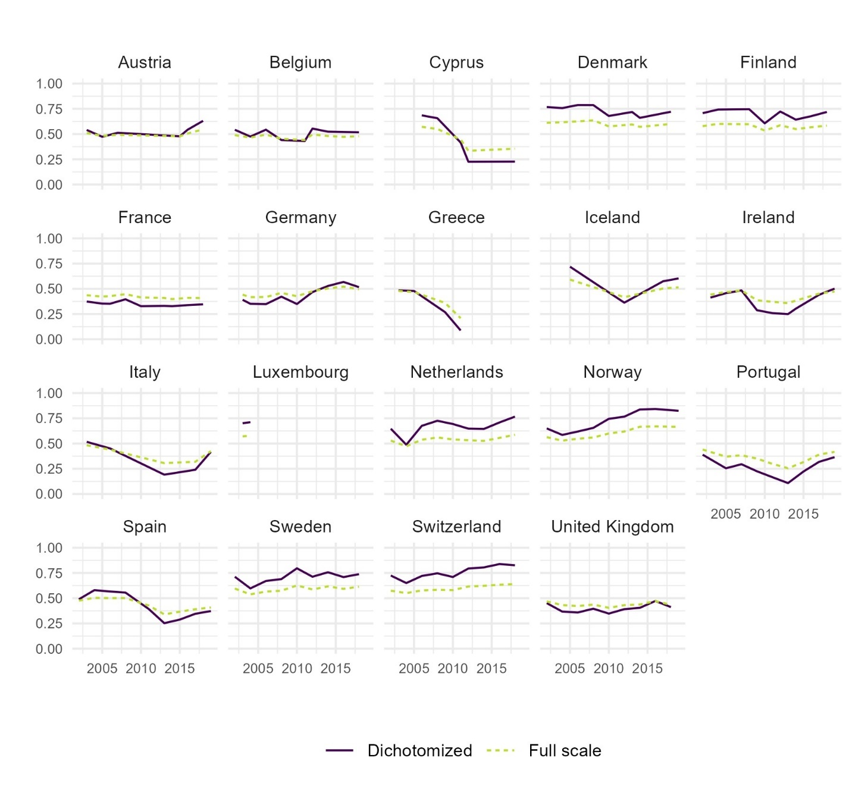
Figure B1. Comparing trust in parliament according to data from the European Social Survey, when using either our dichotomized variable (where lack of trust is coded as 0 and trust as 1) or averages of responses to the full original scale (11-point scale from 0-10), standardized to a scale from 0-1, in Western Europe and North America.

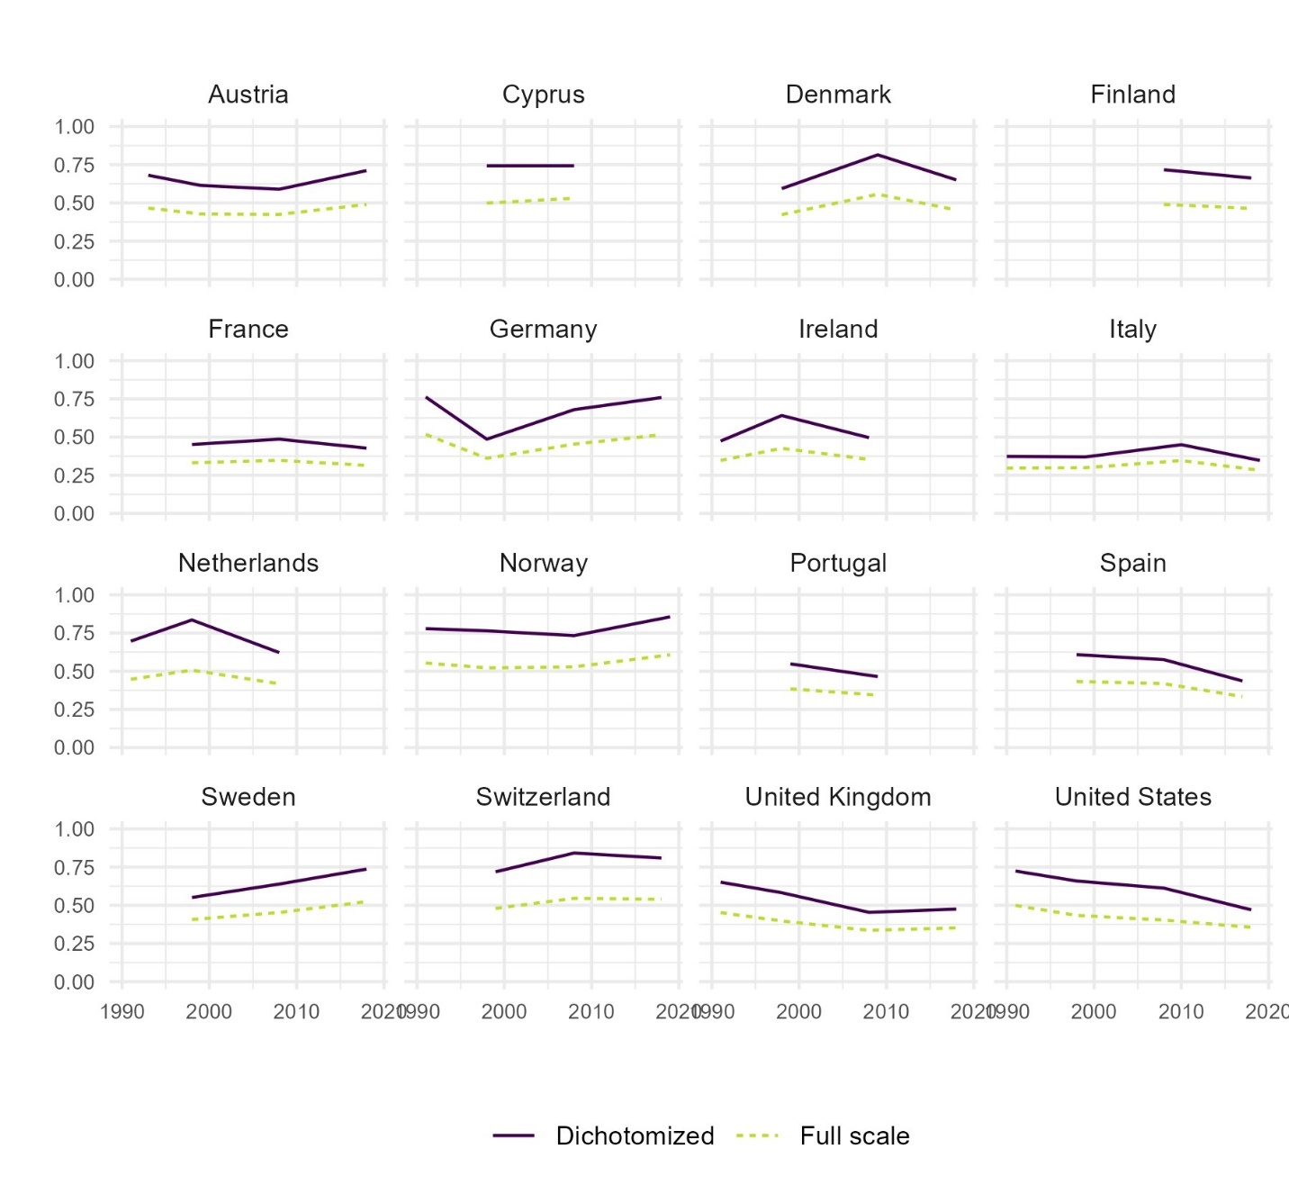
Figure B2. Comparing trust in parliament according to data from the International Social Survey Programme, when using either our dichotomized variable (where lack of trust is coded as 0 and trust as 1) or averages of responses on the full original scale (5 response options with different statements ranging from less to more trusting), standardized to a scale from 0-1, in Western Europe and North America.

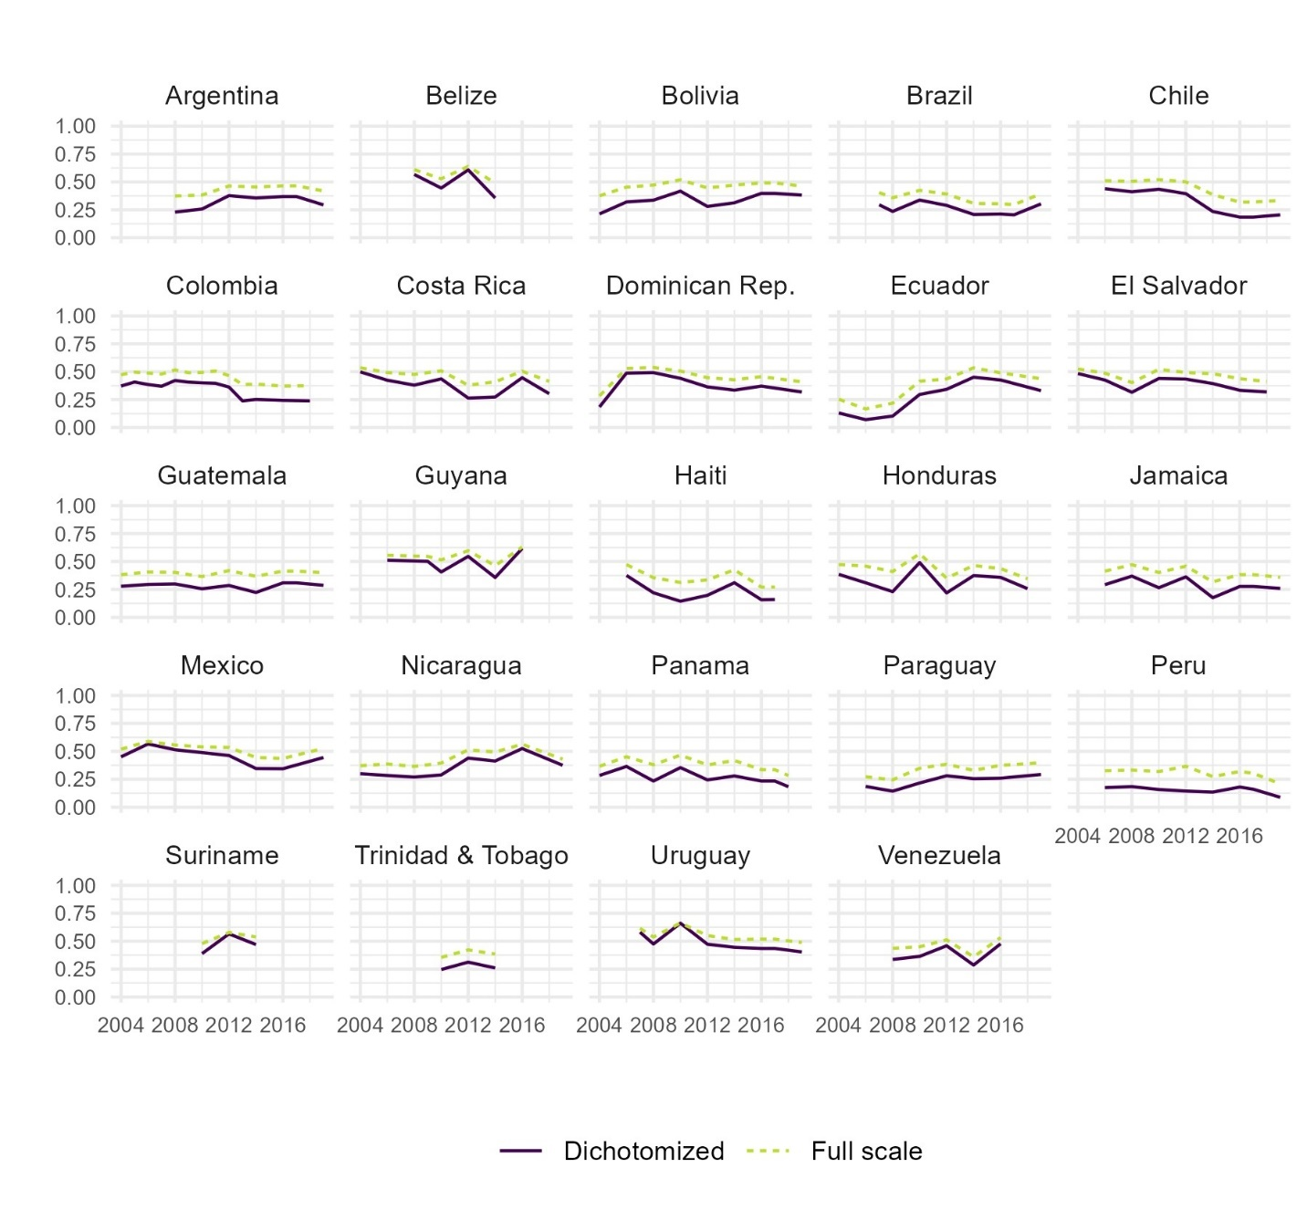
Figure B3. Comparing trust in parliament according to data from the AmericasBarometer, when using either our dichotomized variable (where lack of trust is coded as 0 and trust as 1) or averages of responses on the full original scale (7-point scale from 1-7), standardized to a scale from 0-1, in Latin America and the Caribbean.
- Descriptive trends by survey sources
  - Parliament
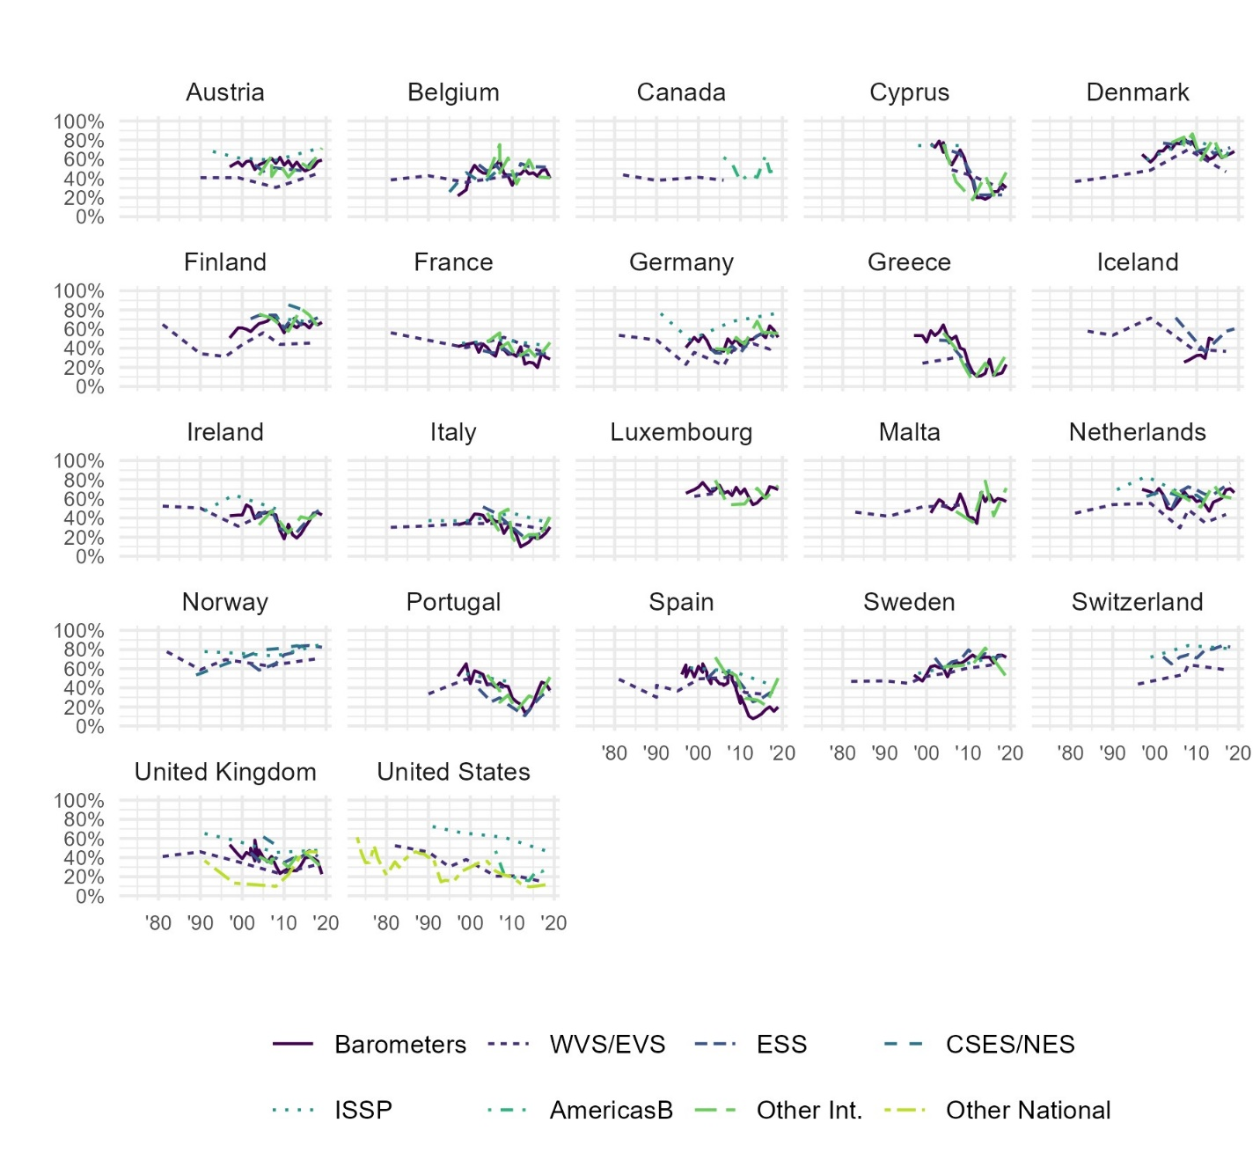
Figure C1. Descriptive trends in trust in parliament within each country in Western Europe and North America, from Bayesian latent trend models, by survey project (grouped).
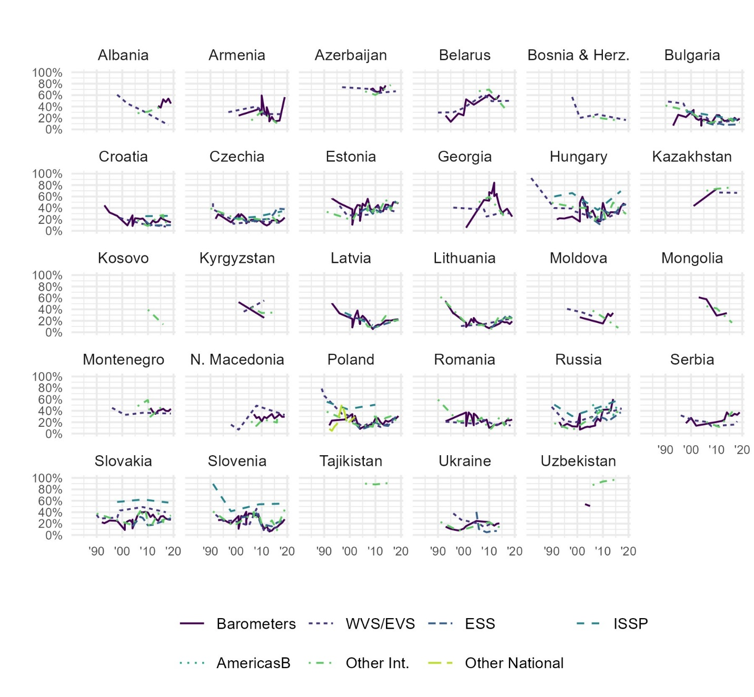
Figure C2. Descriptive trends in trust in parliament within each country in Eastern Europe and Central Asia, from Bayesian latent trend models, by survey project (grouped).
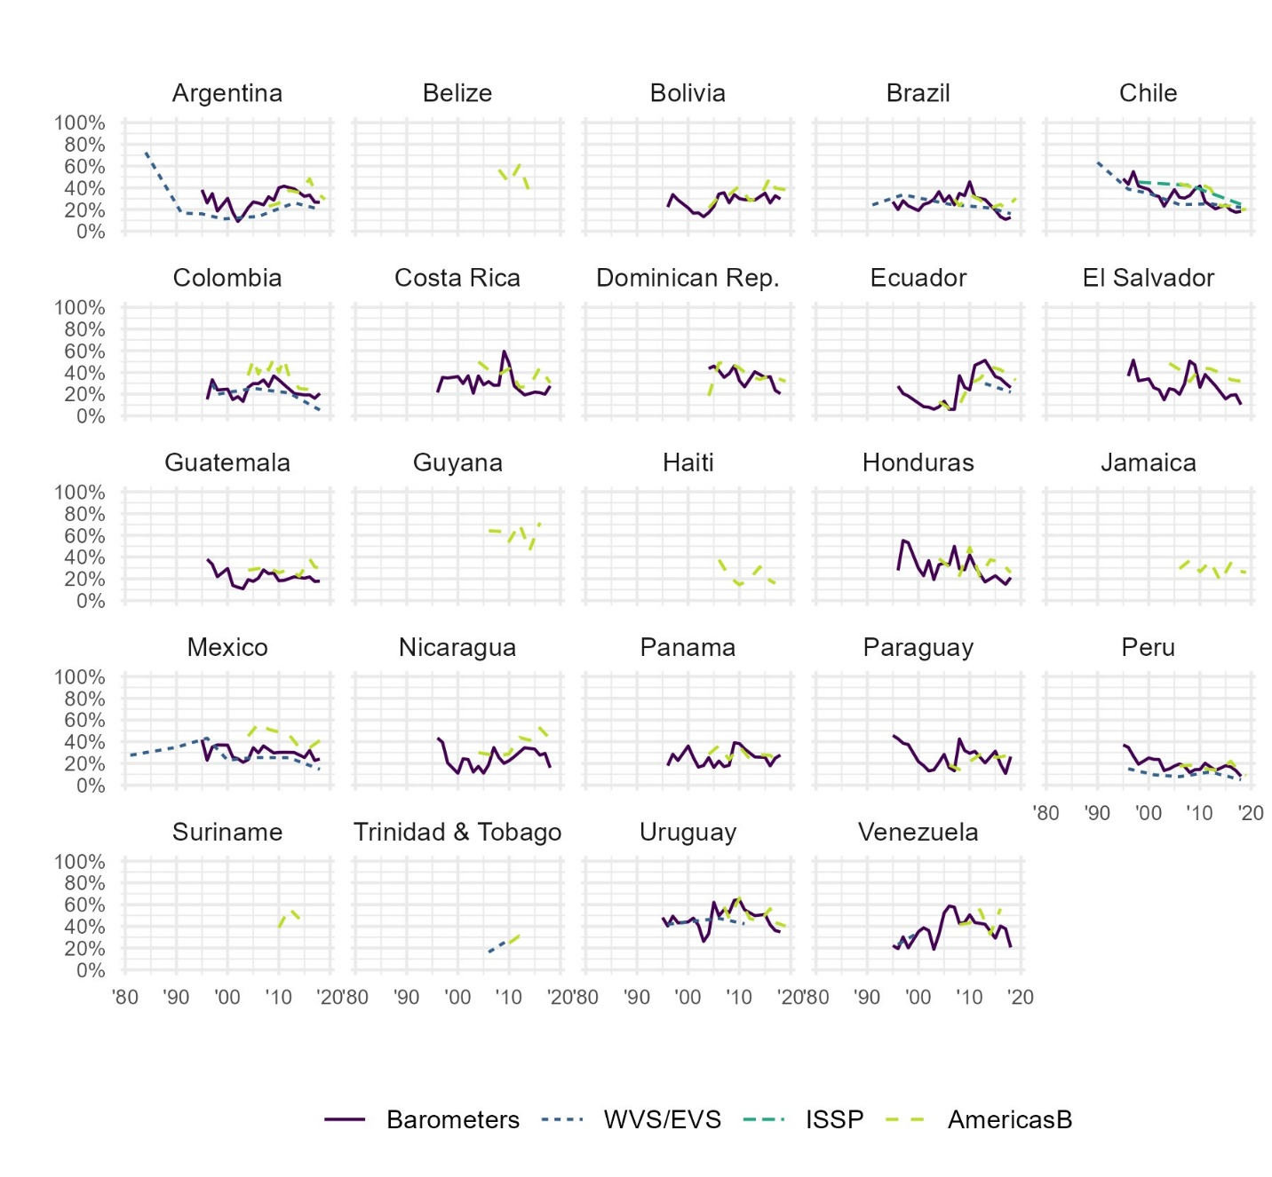
Figure C3. Descriptive trends in trust in parliament within each country in Latin America and the Caribbean, from Bayesian latent trend models, by survey project (grouped).
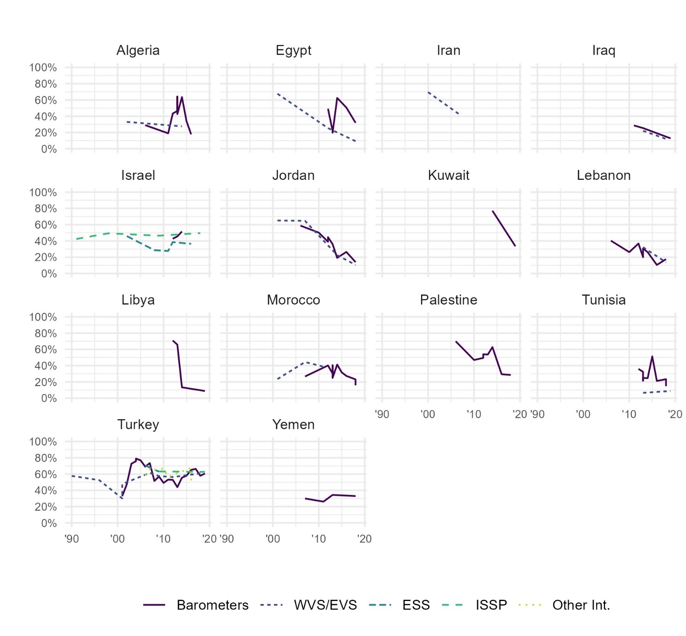
Figure C4. Descriptive trends in trust in parliament within each country in the Middle East and North Africa, from Bayesian latent trend models, by survey project (grouped).
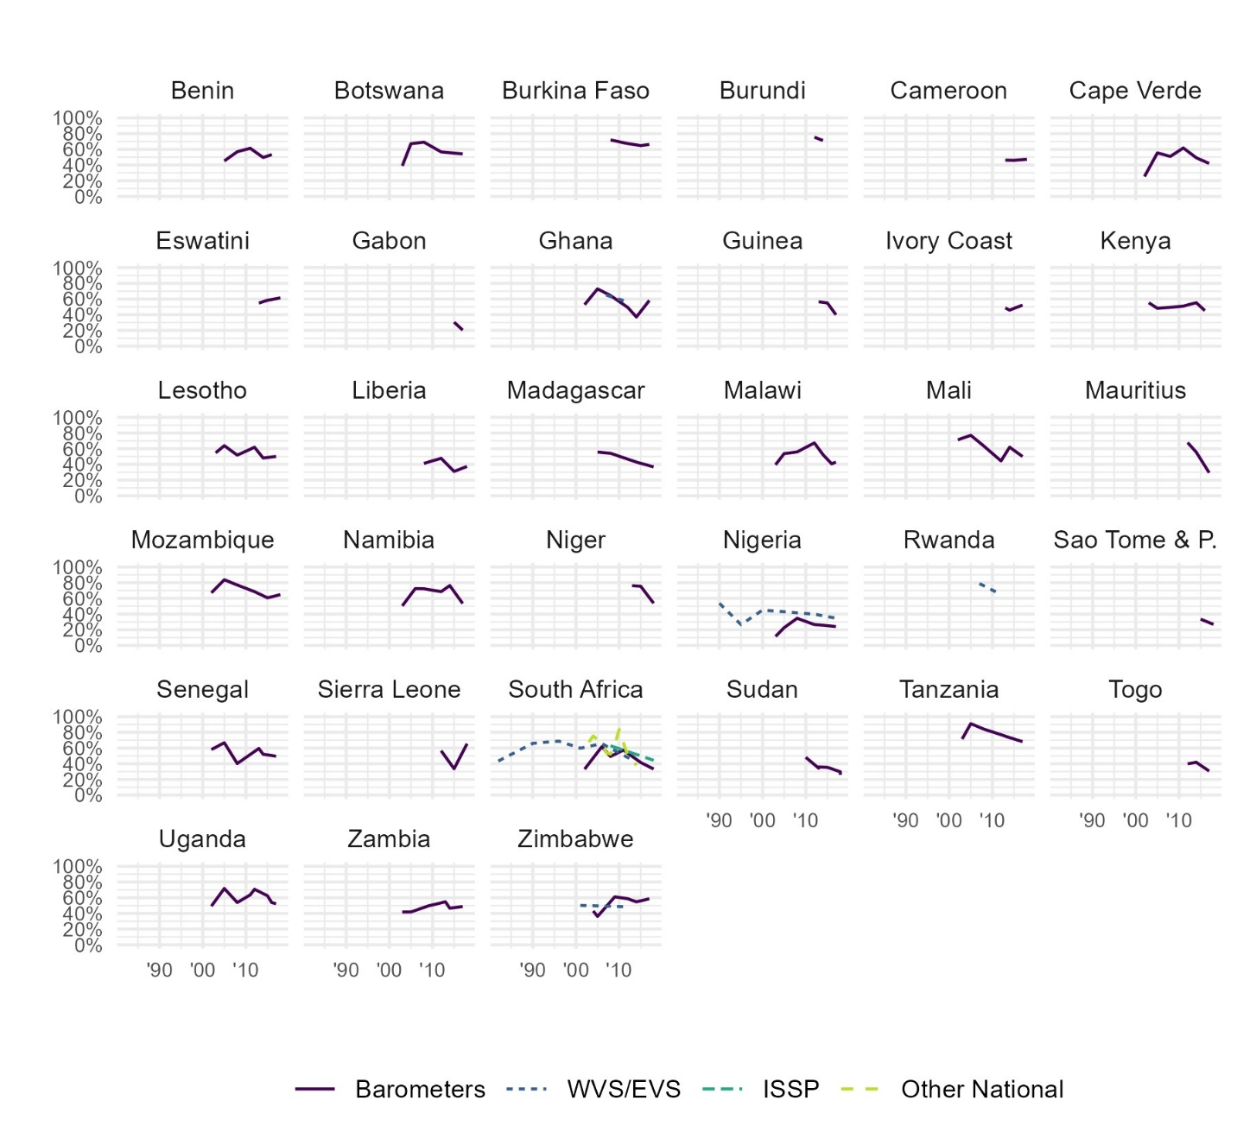
Figure C5. Descriptive trends in trust in parliament within each country in Sub-Saharan Africa, from Bayesian latent trend models, by survey project (grouped).
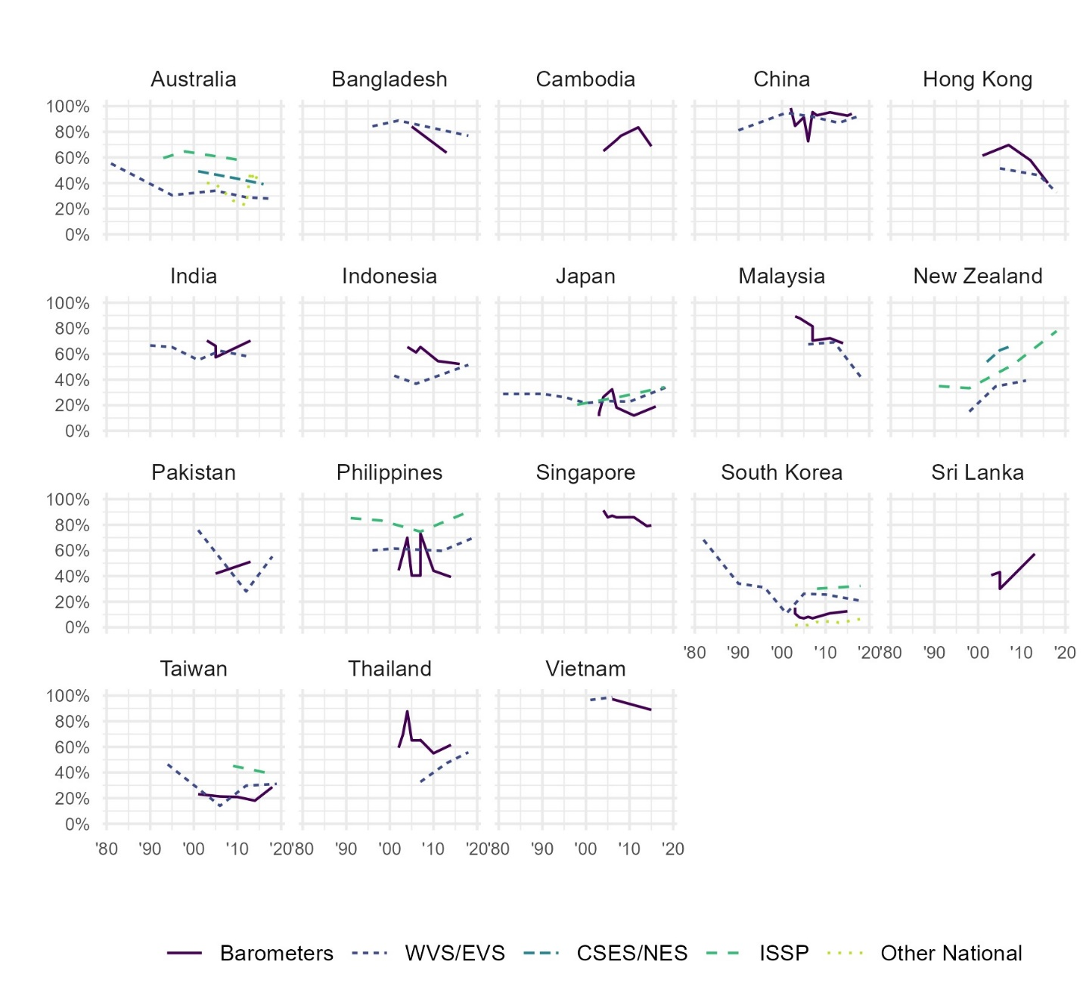
Figure C6. Descriptive trends in trust in parliament within each country in Asia and the Pacific, from Bayesian latent trend models, by survey project (grouped).

  - Government
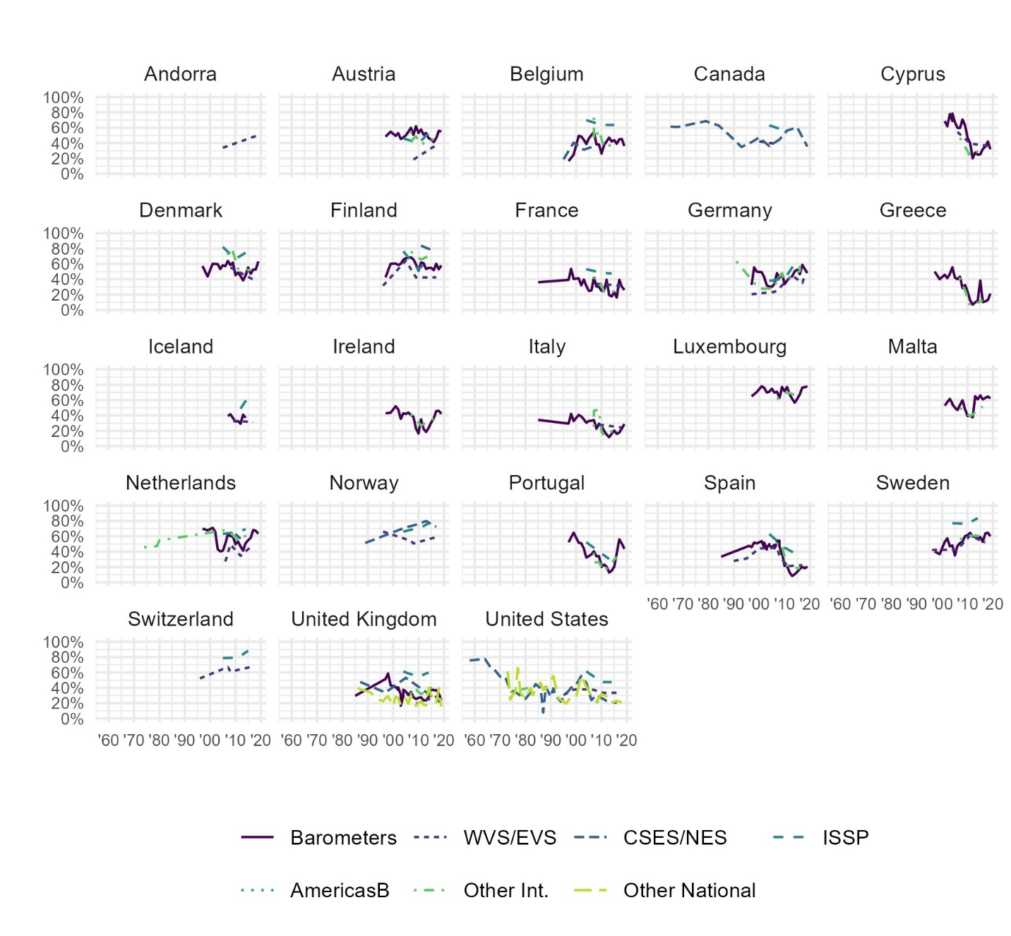
Figure C7. Descriptive trends in trust in government within each country in Western Europe and North America, from Bayesian latent trend models, by survey project (grouped).
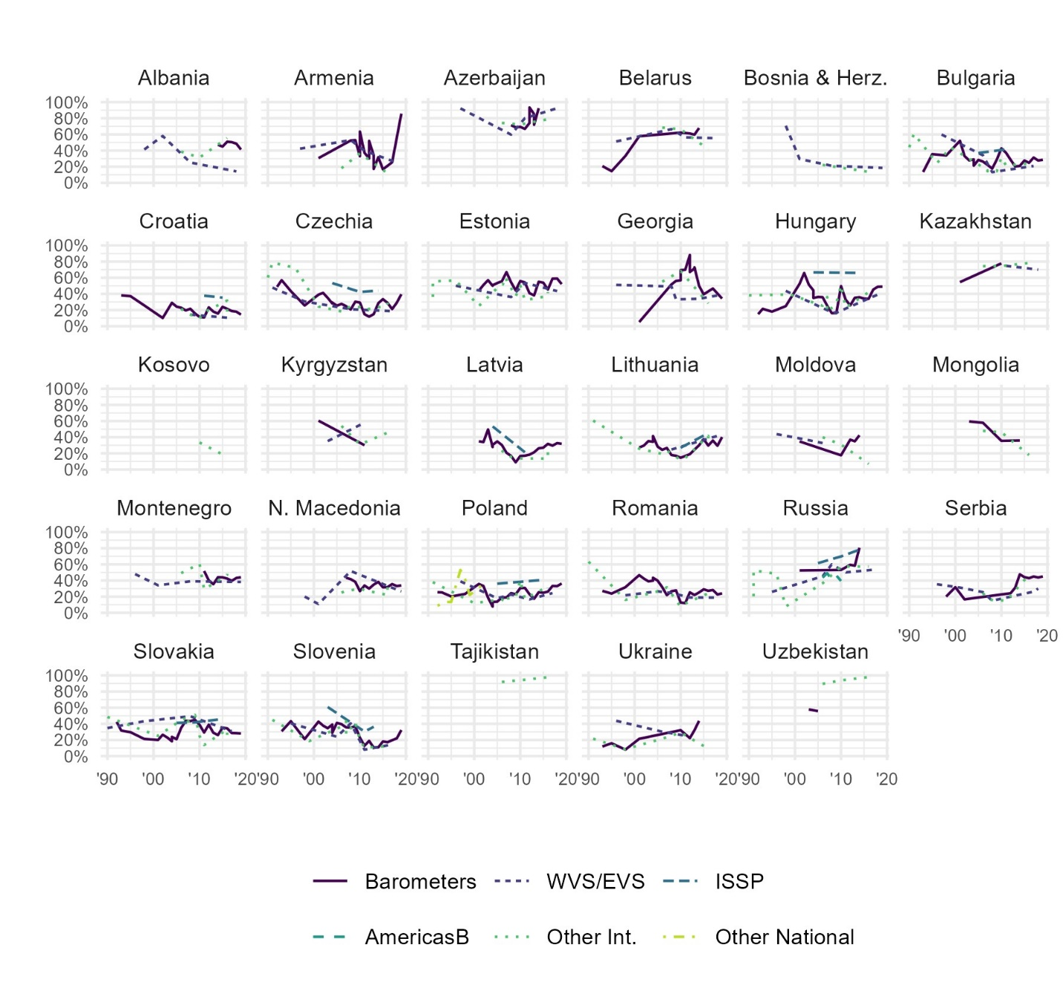
Figure C8. Descriptive trends in trust in government within each country in Eastern Europe and Central Asia, from Bayesian latent trend models, by survey project (grouped).
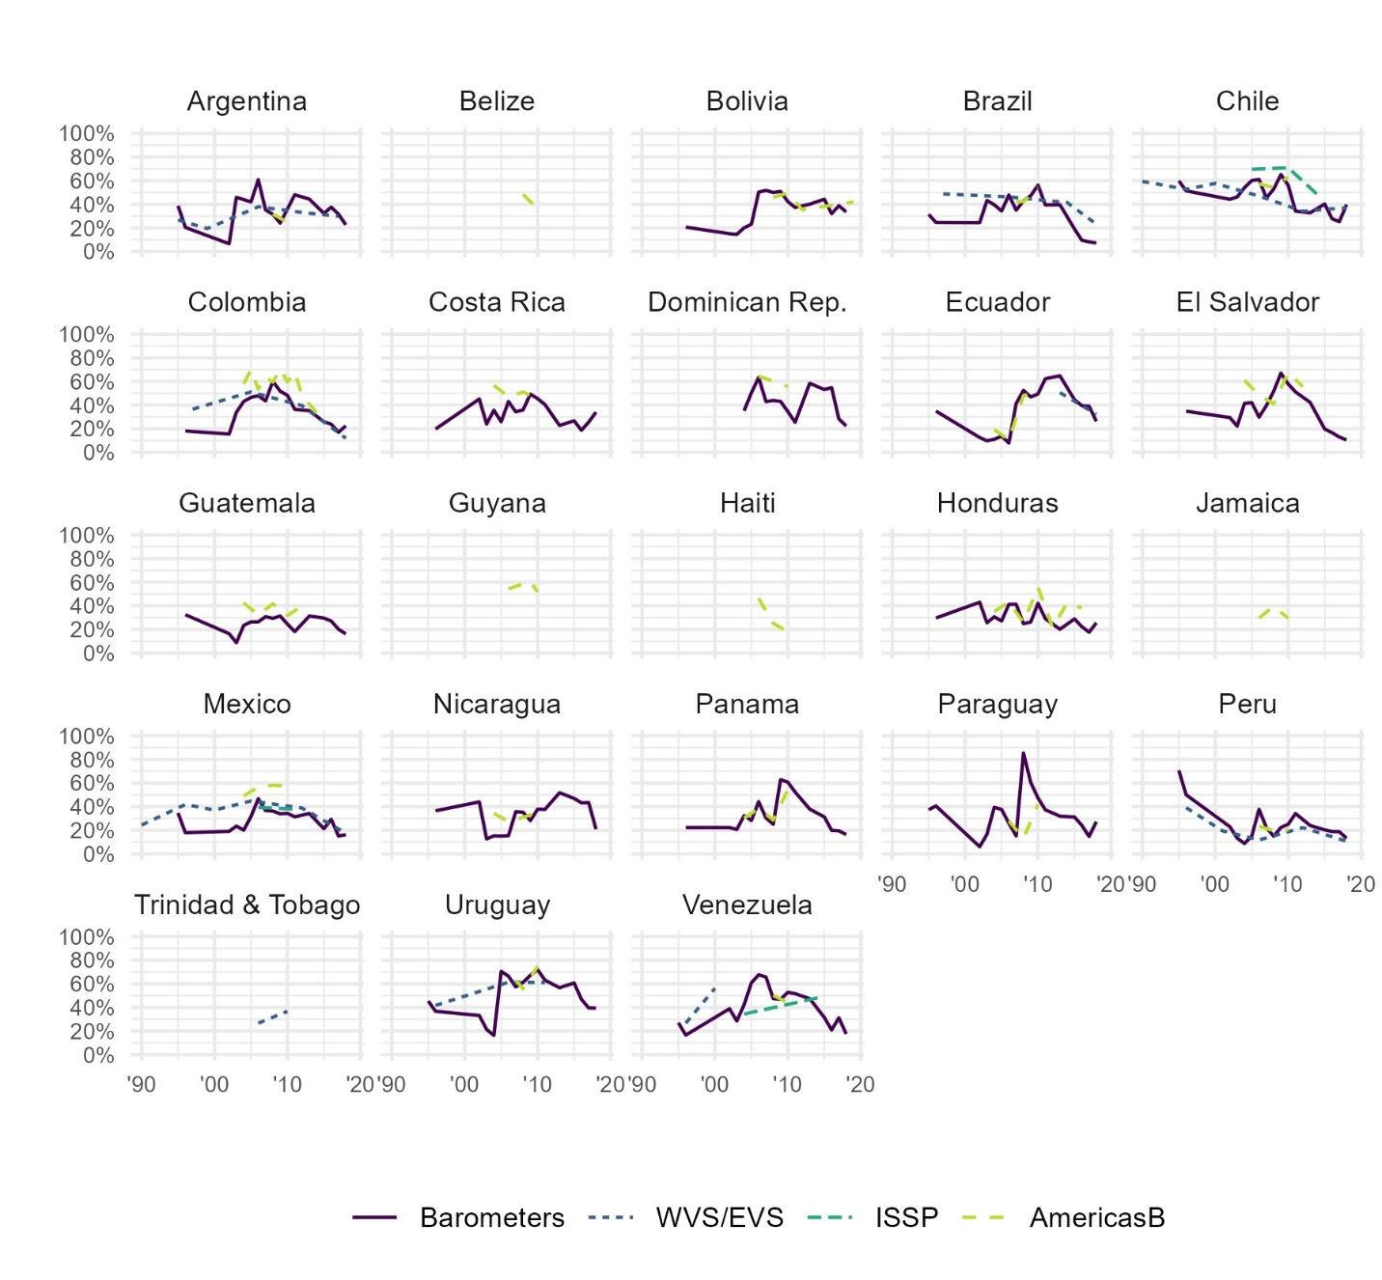
Figure C9. Descriptive trends in trust in government within each country in Latin America and the Caribbean, from Bayesian latent trend models, by survey project (grouped).
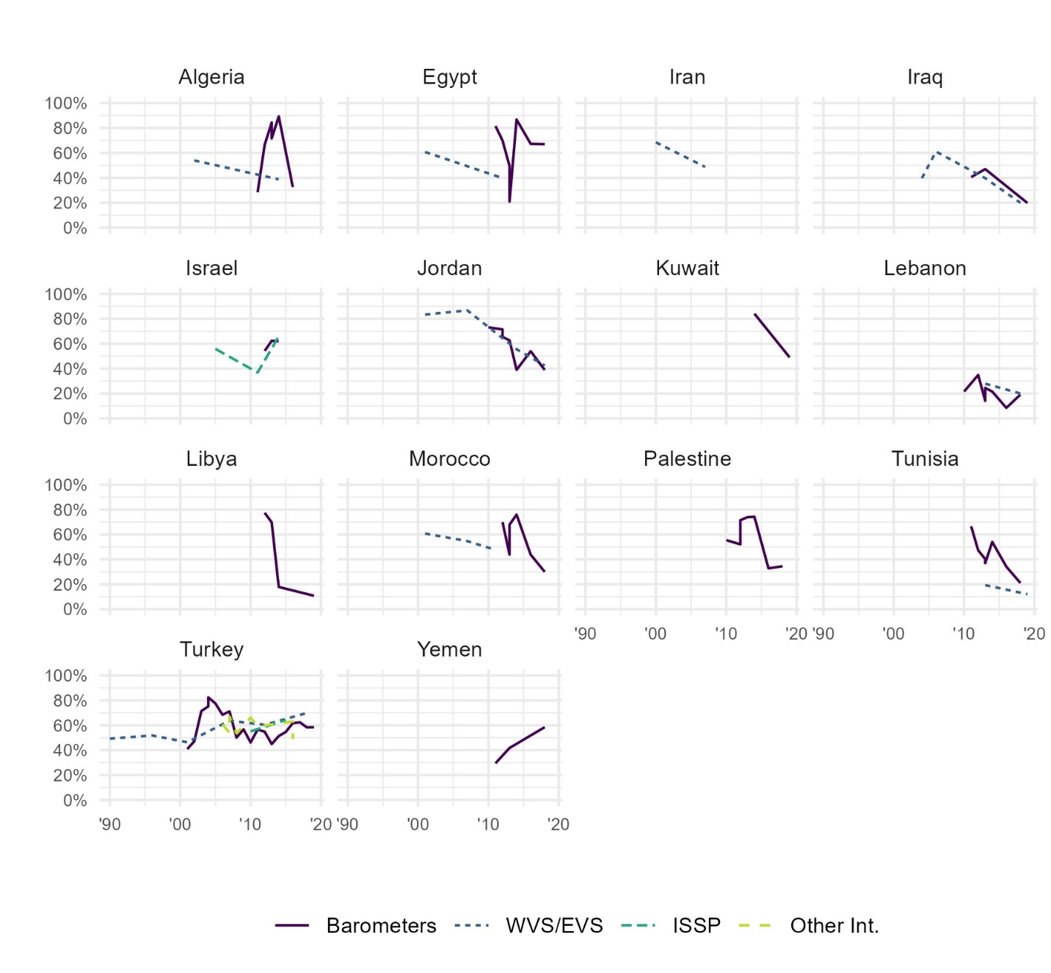
Figure C10. Descriptive trends in trust in government within each country in the Middle East and North Africa, from Bayesian latent trend models, by survey project (grouped).
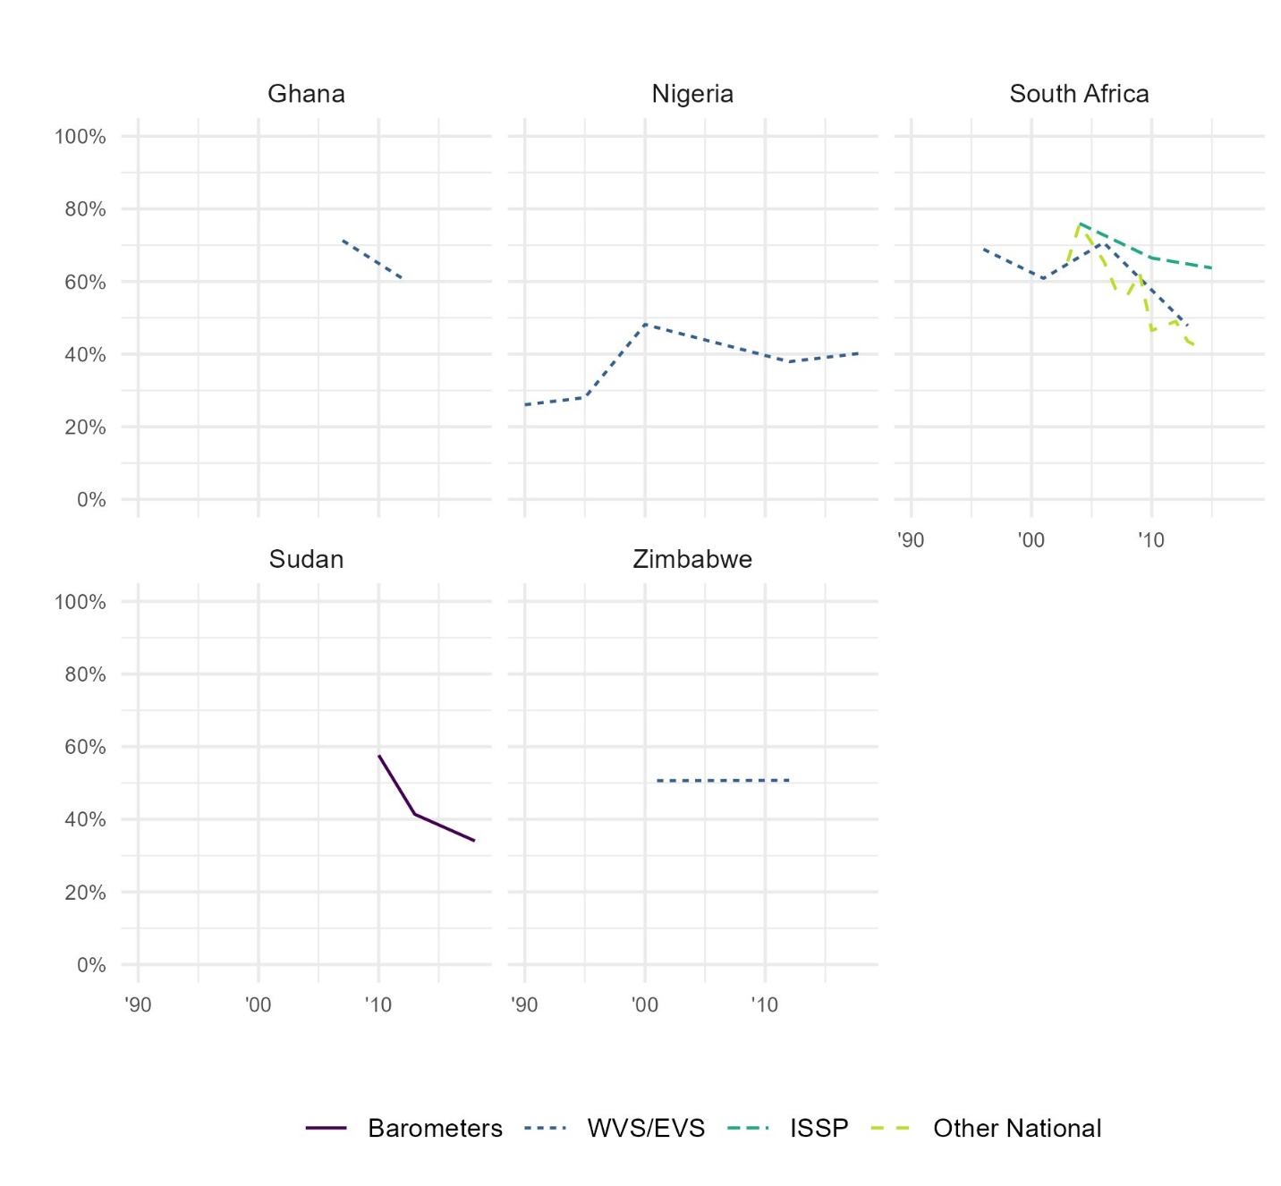
Figure C11. Descriptive trends in trust in government within each country in Sub-Saharan Africa, from Bayesian latent trend models, by survey project (grouped).
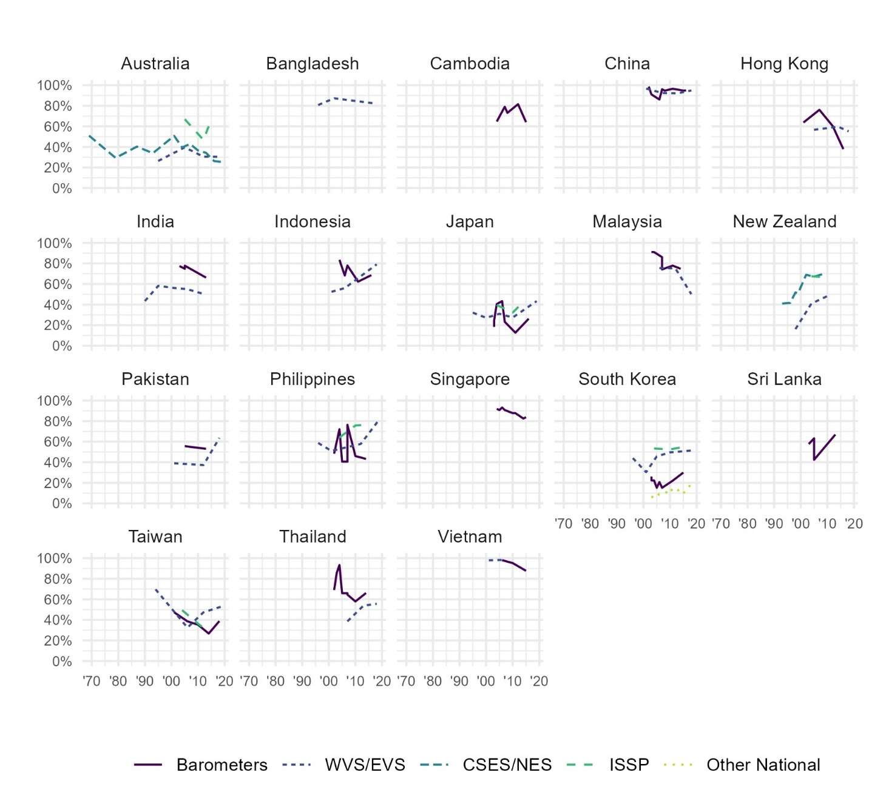
Figure C12. Descriptive trends in trust in government within each country in Asia and the Pacific, from Bayesian latent trend models, by survey project (grouped).

  - Political parties
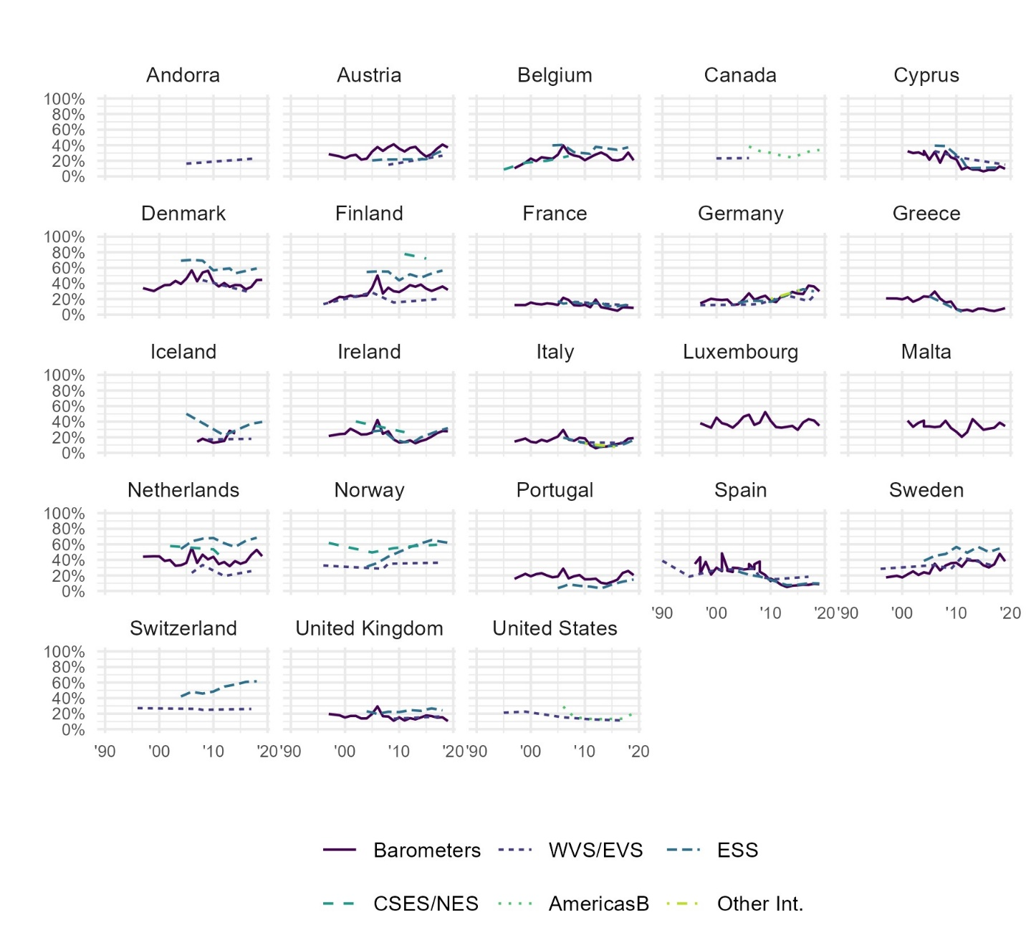
Figure C13. Descriptive trends in trust in political parties within each country in Western Europe and North America, from Bayesian latent trend models, by survey project (grouped).
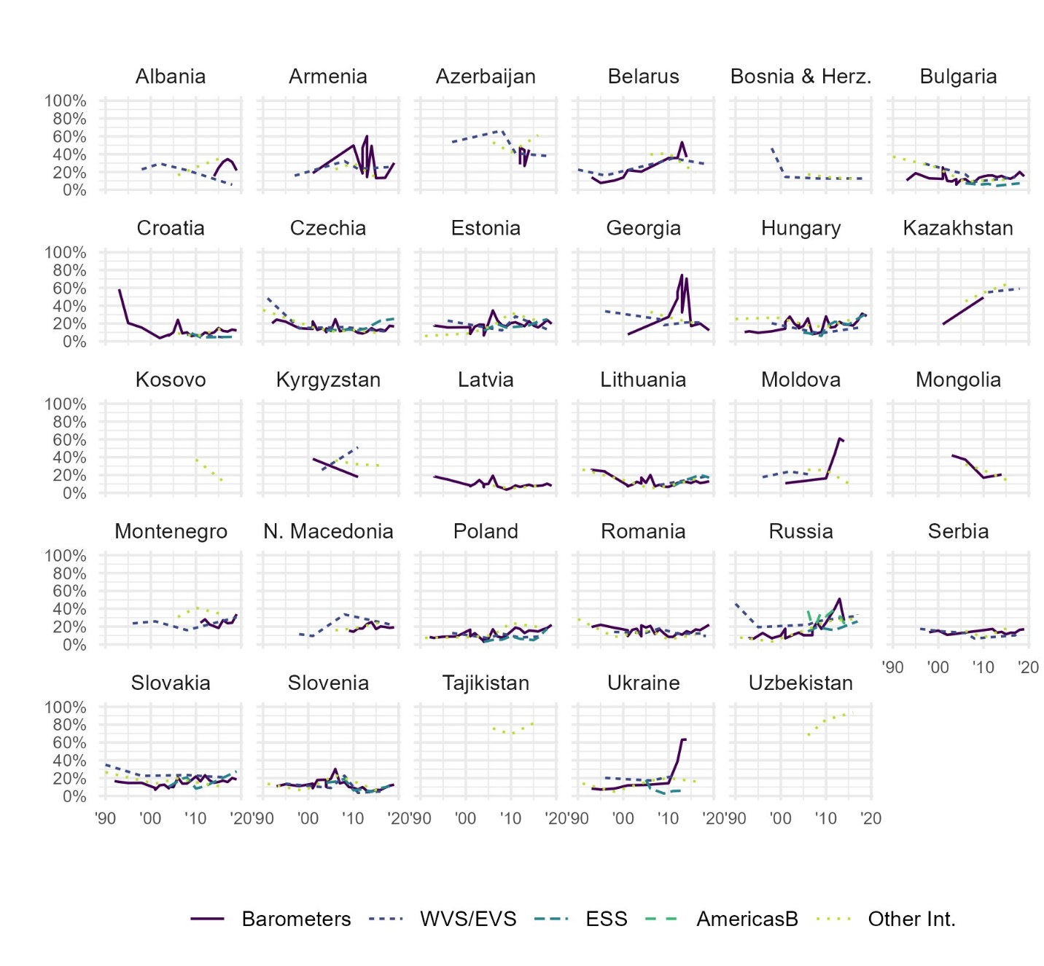
Figure C14. Descriptive trends in trust in political parties within each country in Eastern Europe and Central Asia, from Bayesian latent trend models, by survey project (grouped).
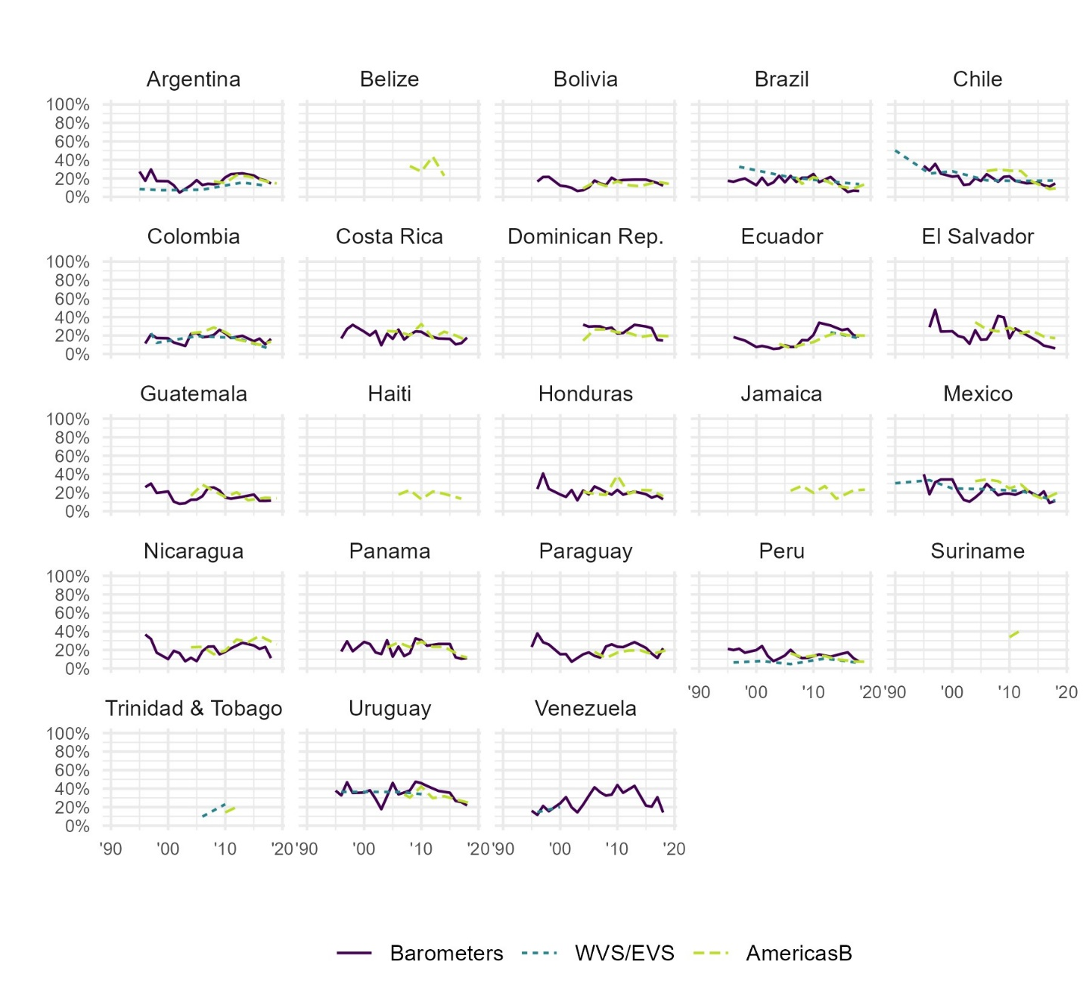
Figure C15. Descriptive trends in trust in political parties within each country in Latin America and the Caribbean, from Bayesian latent trend models, by survey project (grouped).
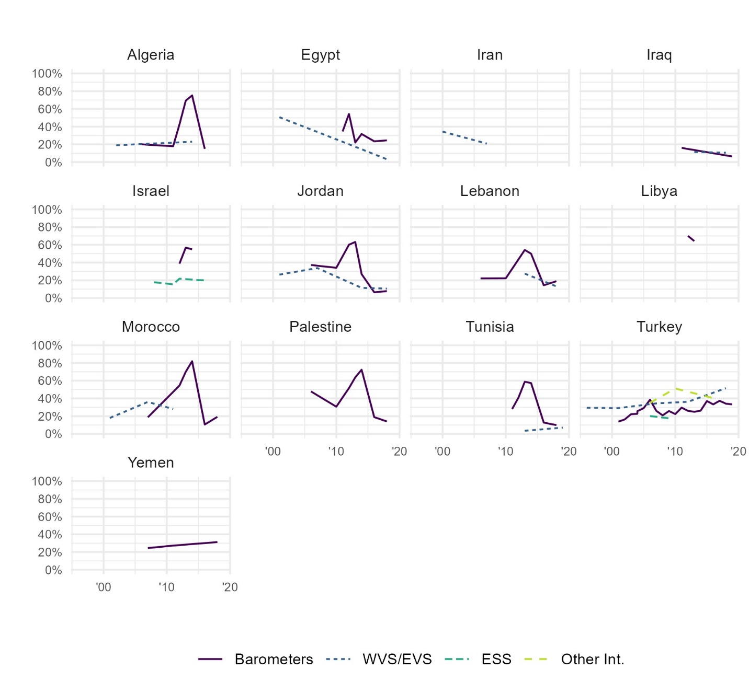
Figure C16. Descriptive trends in trust in political parties within each country in the Middle East and North Africa, from Bayesian latent trend models, by survey project (grouped).
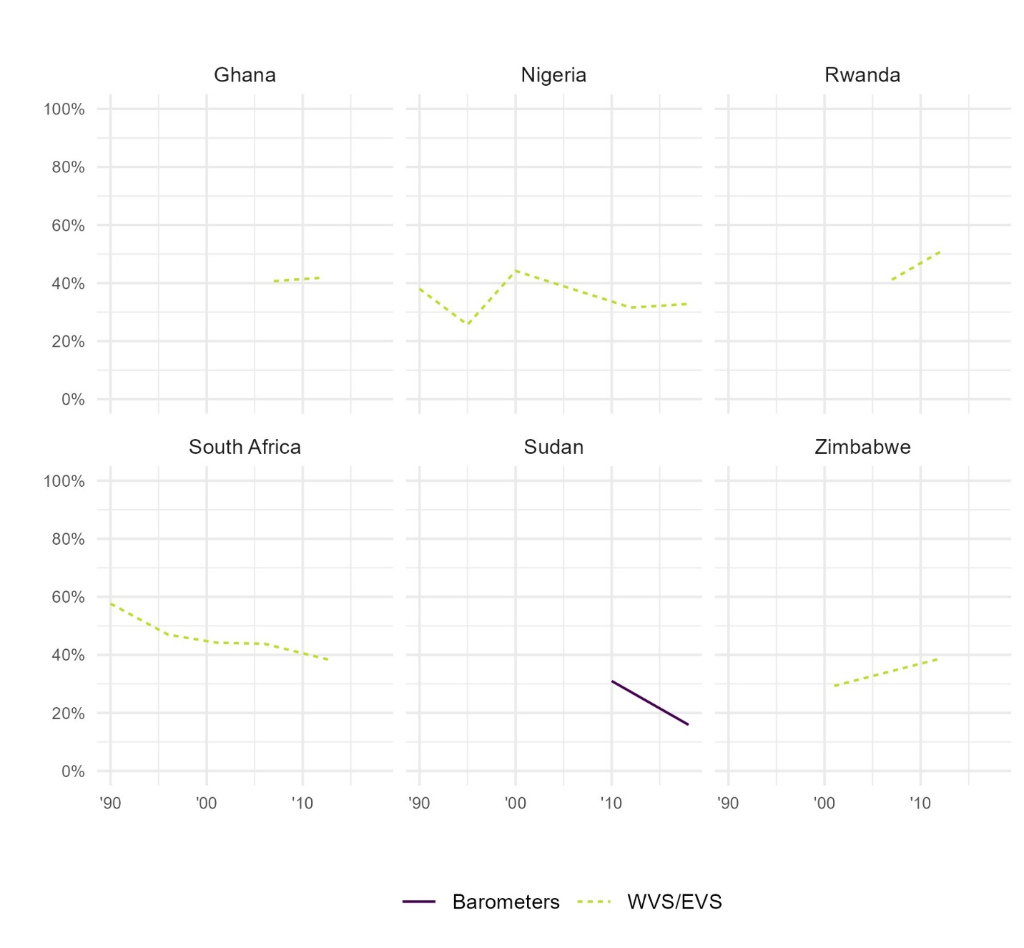
Figure C17. Descriptive trends in trust in political parties within each country in Sub-Saharan Africa, from Bayesian latent trend models, by survey project (grouped).
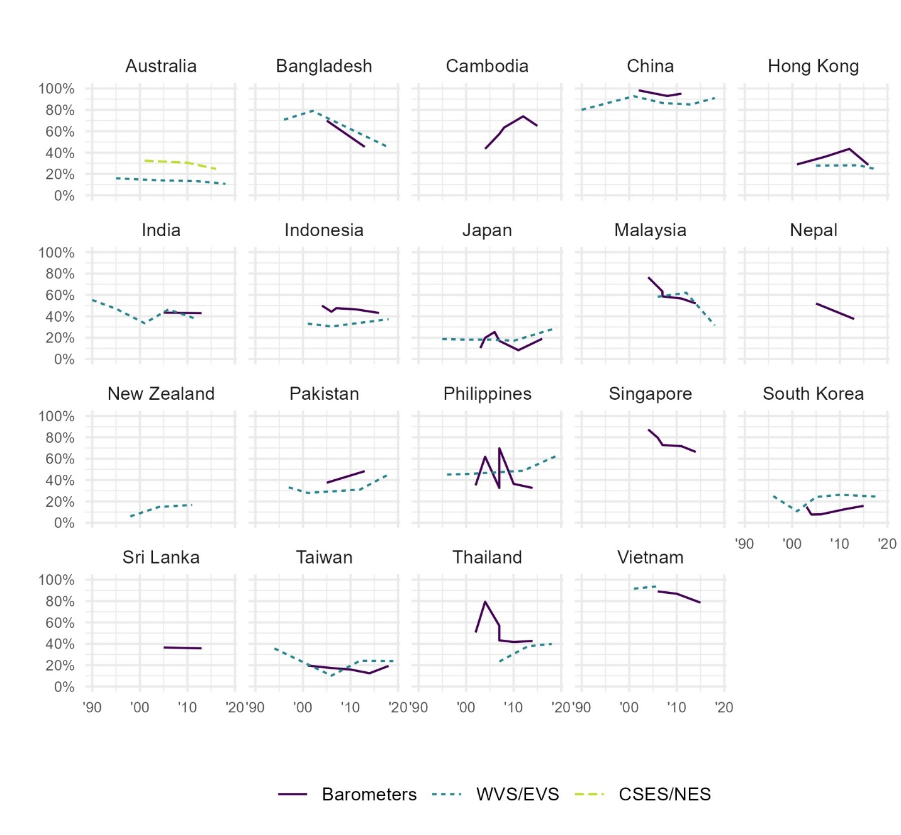
Figure C18. Descriptive trends in trust in political parties within each country in Asia and the Pacific, from Bayesian latent trend models, by survey project (grouped).

  - The civil service
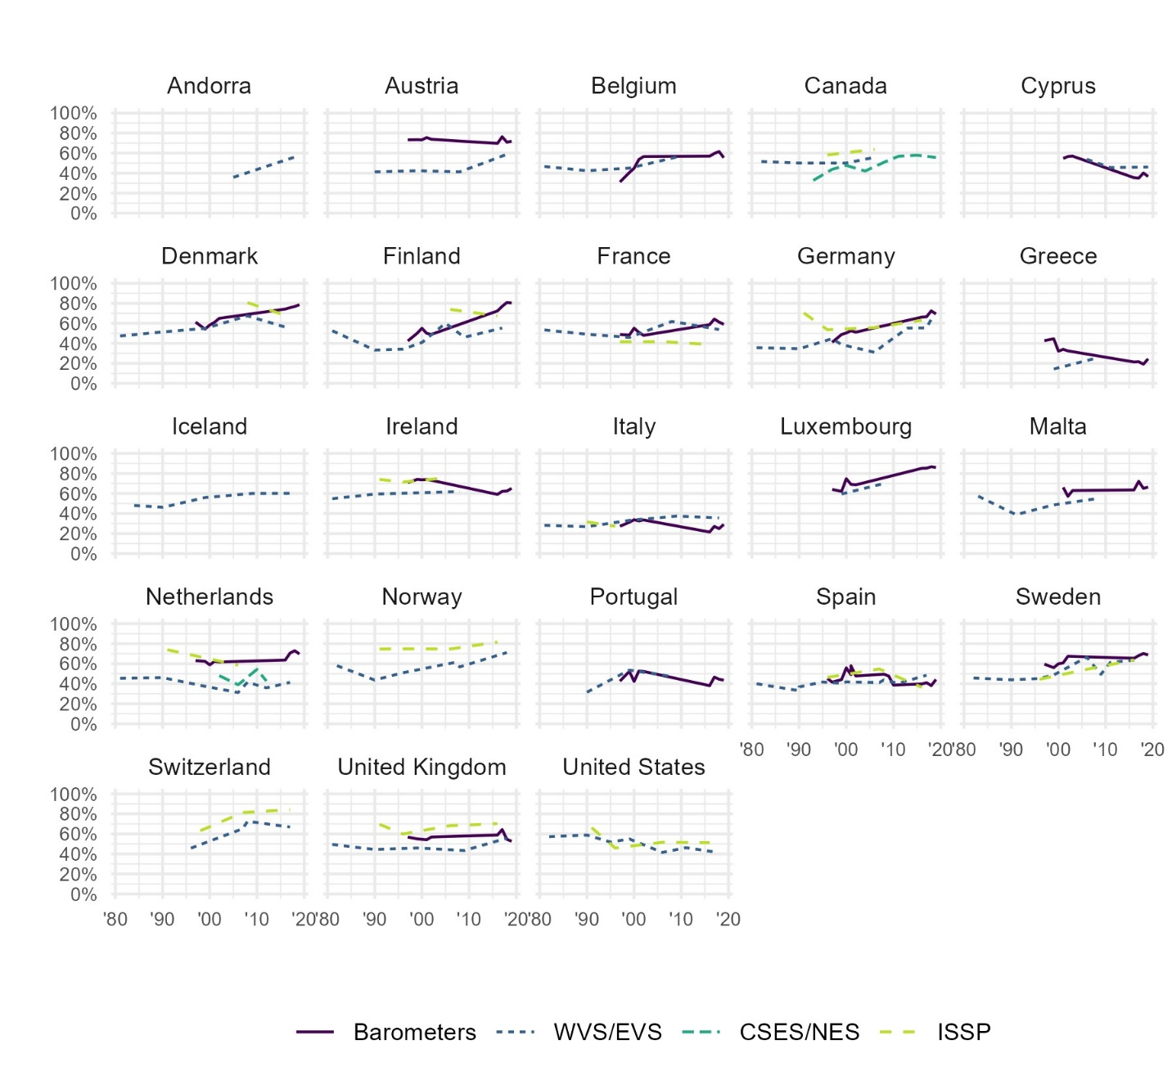
Figure C19. Descriptive trends in trust in the civil service within each country in Western Europe and North America, from Bayesian latent trend models, by survey project (grouped).
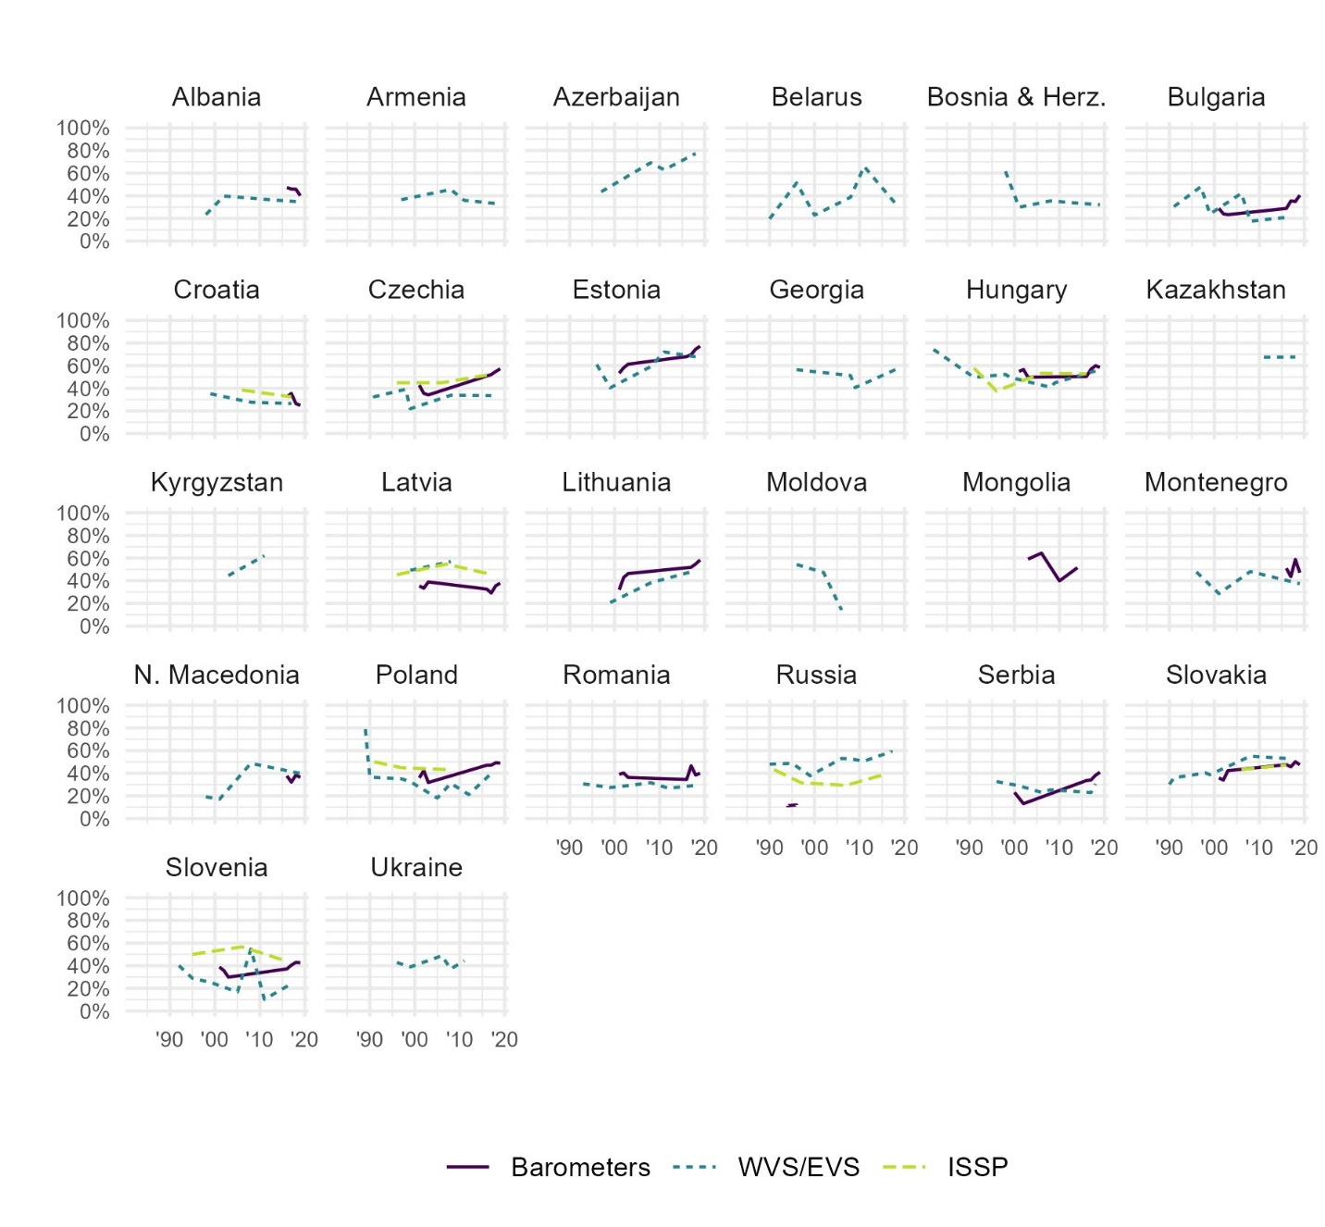
Figure C20. Descriptive trends in trust in the civil service within each country in Eastern Europe and Central Asia, from Bayesian latent trend models, by survey project (grouped).
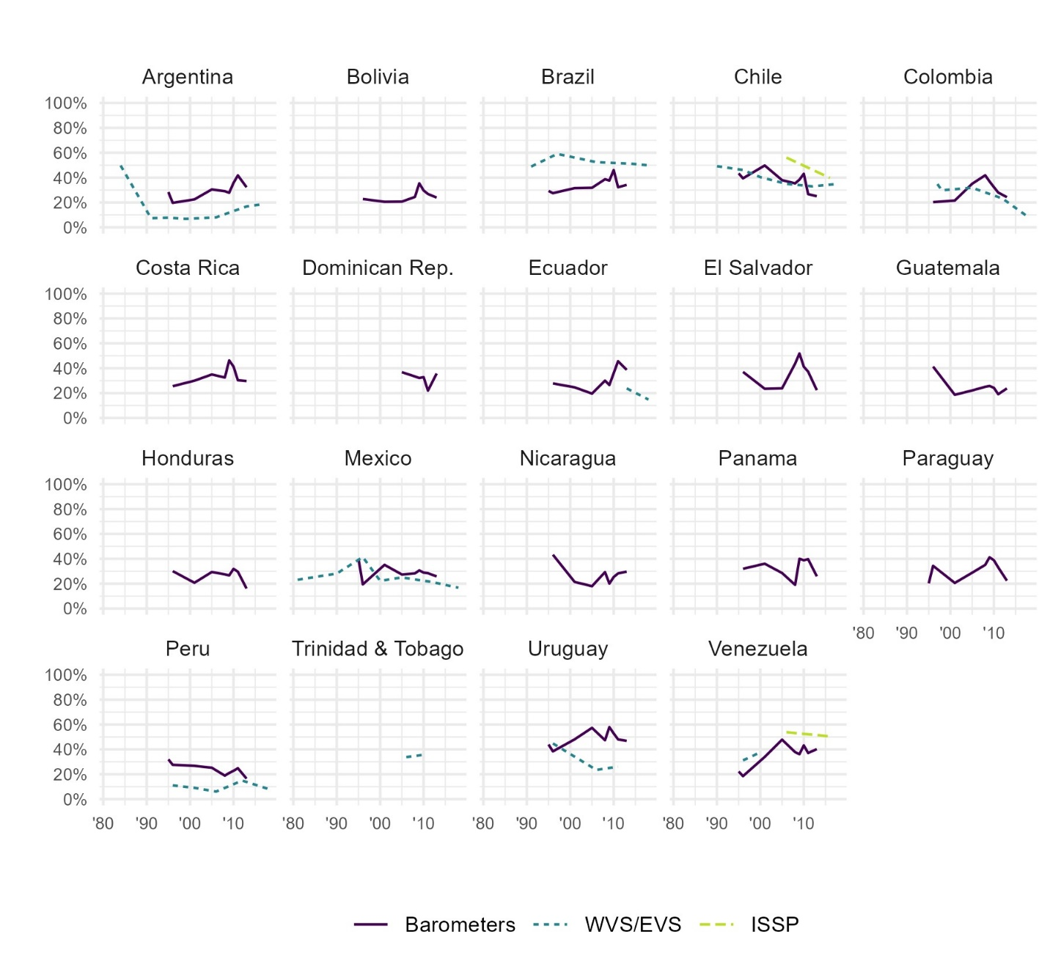
Figure C21. Descriptive trends in trust in the civil service within each country in Latin America and the Caribbean, from Bayesian latent trend models, by survey project (grouped).
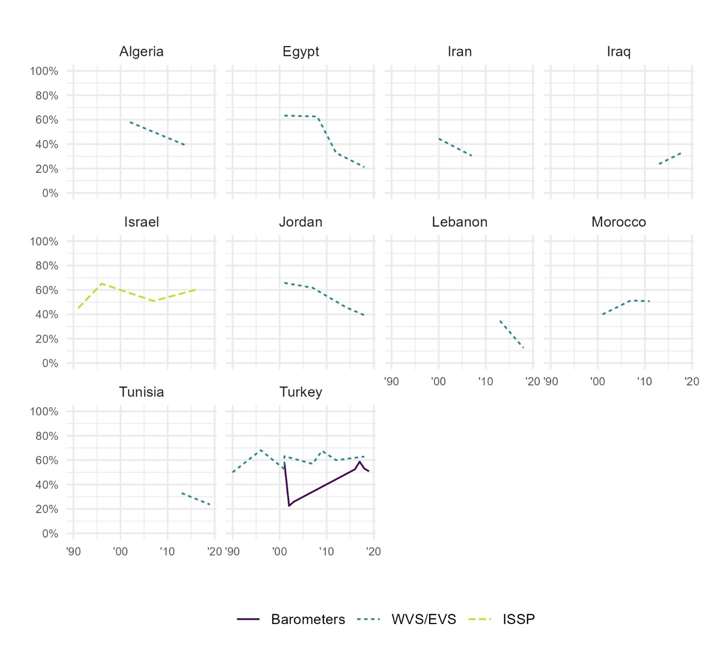
Figure C22. Descriptive trends in trust in the civil service within each country in the Middle East and North Africa, from Bayesian latent trend models, by survey project (grouped).
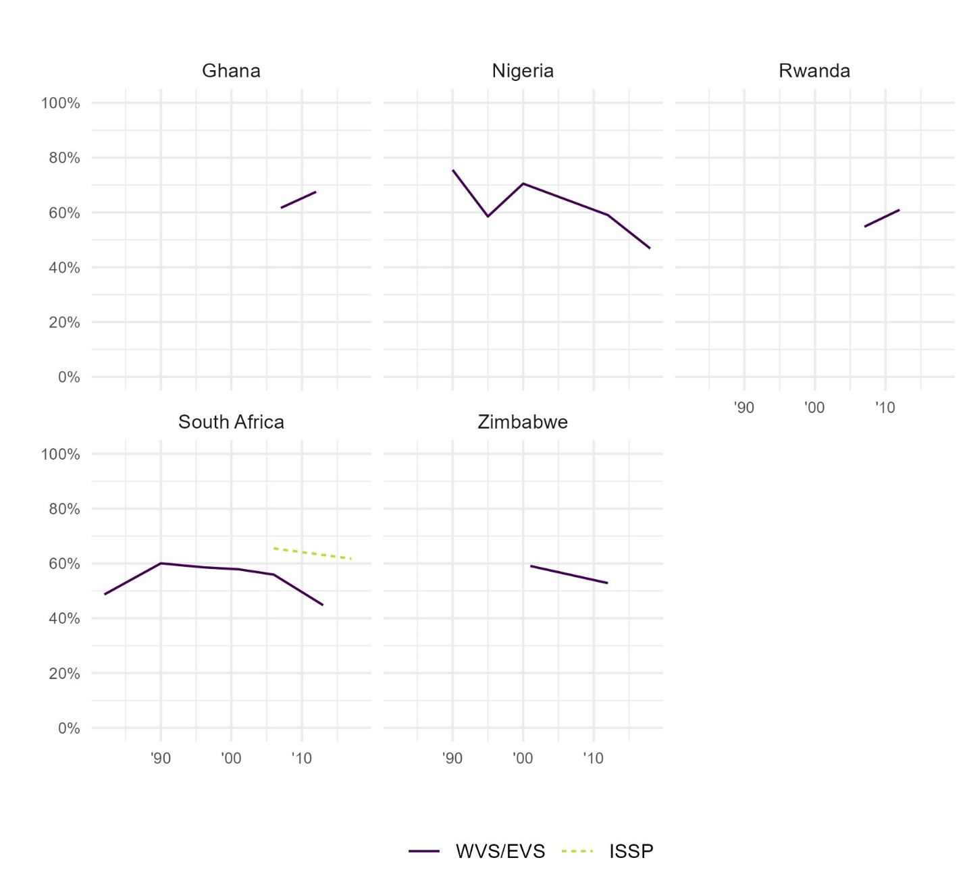
Figure C23. Descriptive trends in trust in the civil service within each country in Sub-Saharan Africa, from Bayesian latent trend models, by survey project (grouped).
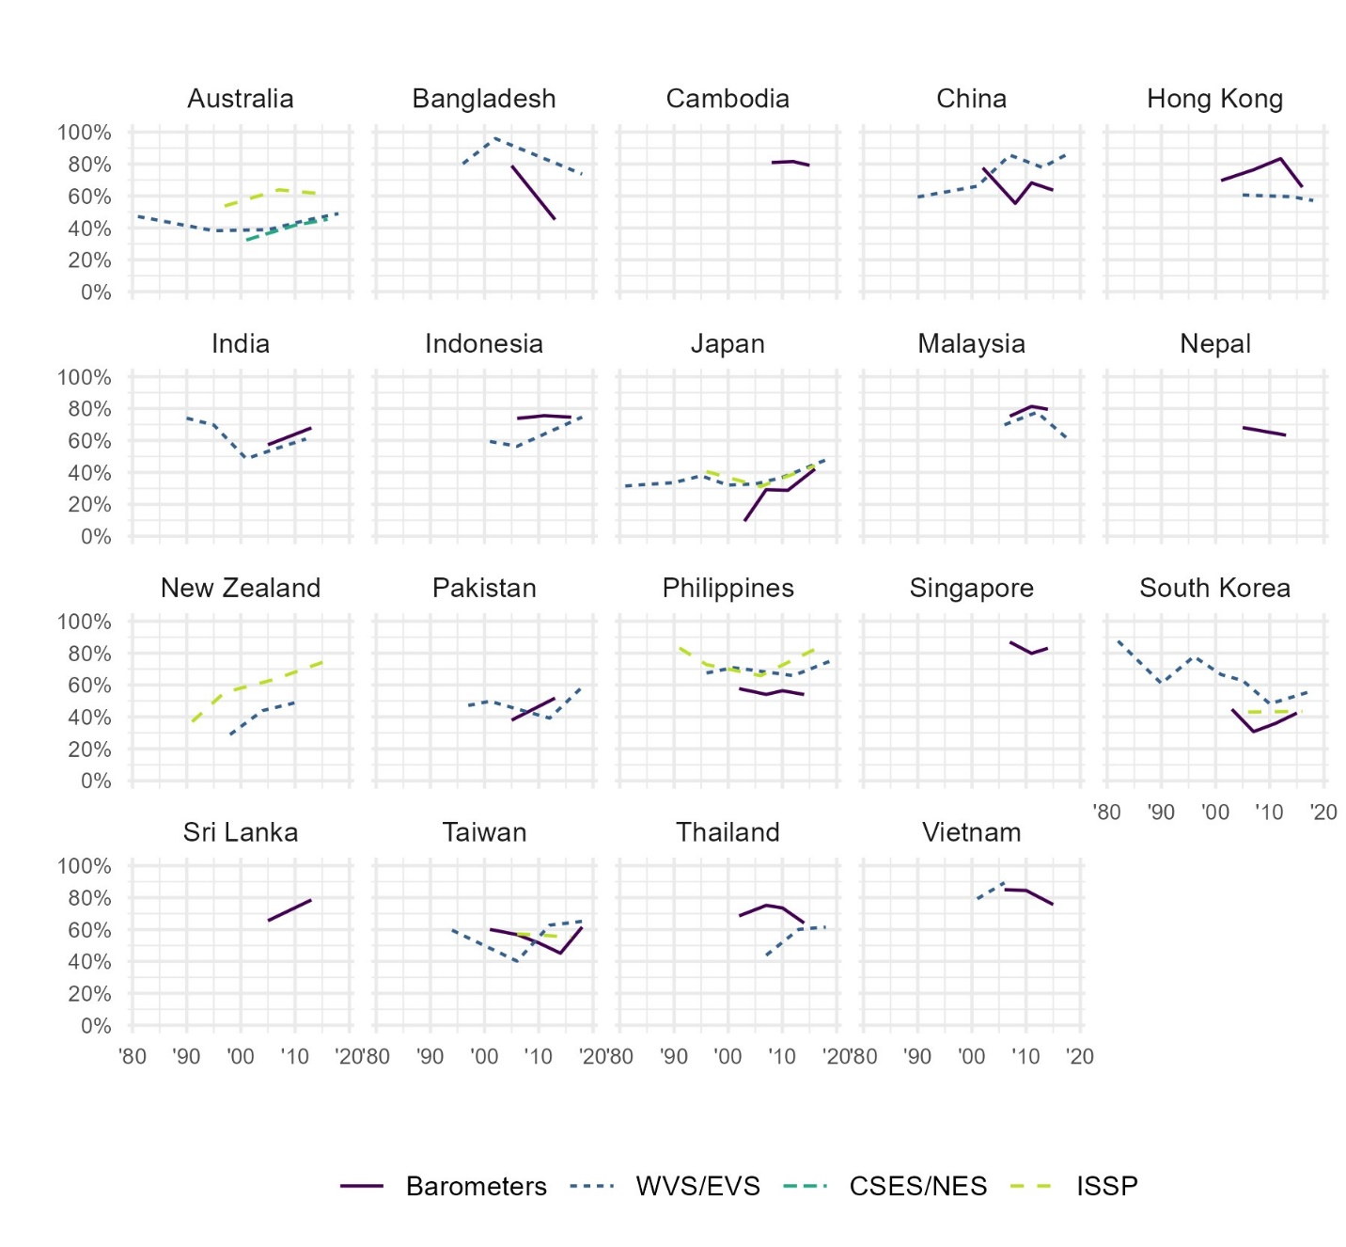
Figure C24. Descriptive trends in trust in the civil service within each country in Asia and the Pacific, from Bayesian latent trend models, by survey project (grouped).

  - The legal system
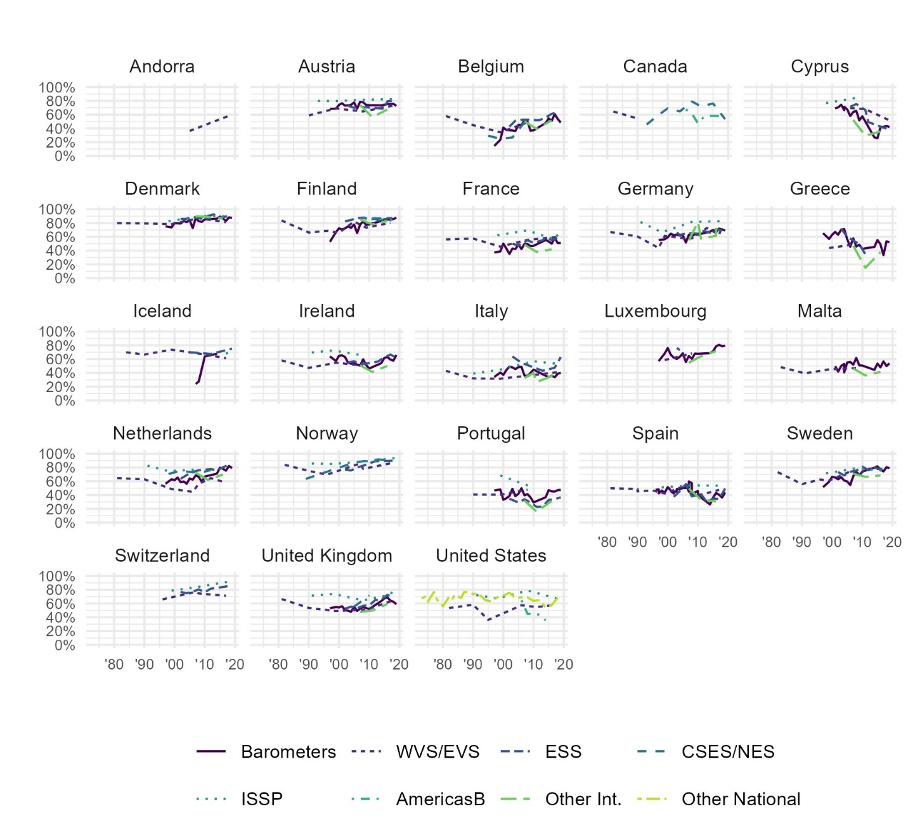
Figure C25. Descriptive trends in trust in the legal system within each country in Western Europe and North America, from Bayesian latent trend models, by survey project (grouped).
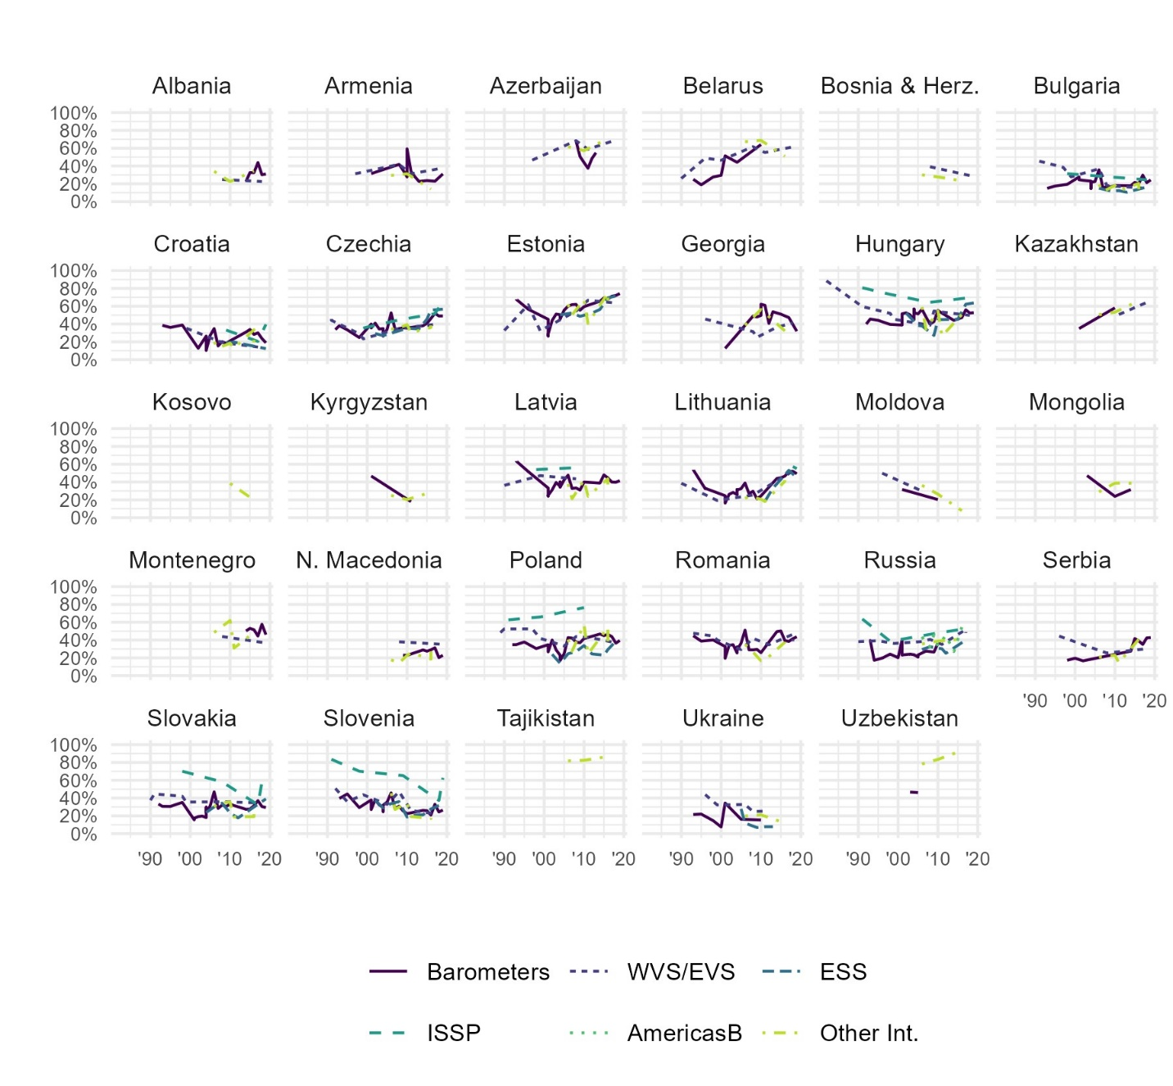
Figure C26. Descriptive trends in trust in the legal system within each country in Eastern Europe and Central Asia, from Bayesian latent trend models, by survey project (grouped).
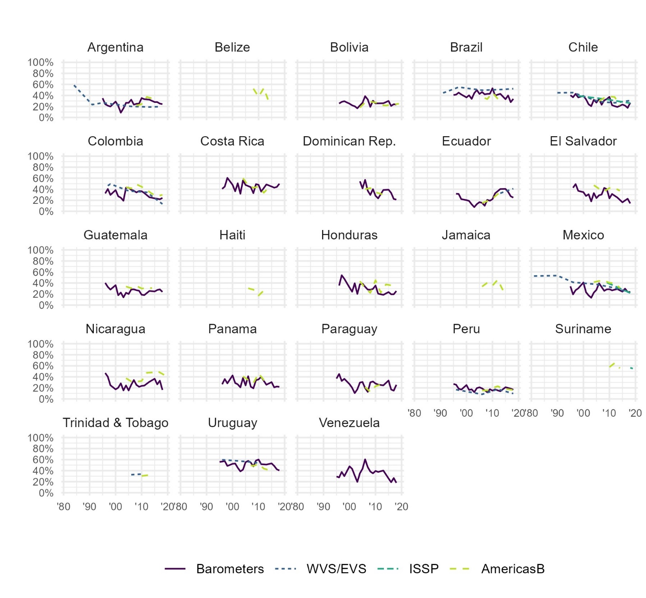
Figure C27. Descriptive trends in trust in the legal system within each country in Latin America and the Caribbean, from Bayesian latent trend models, by survey project (grouped).
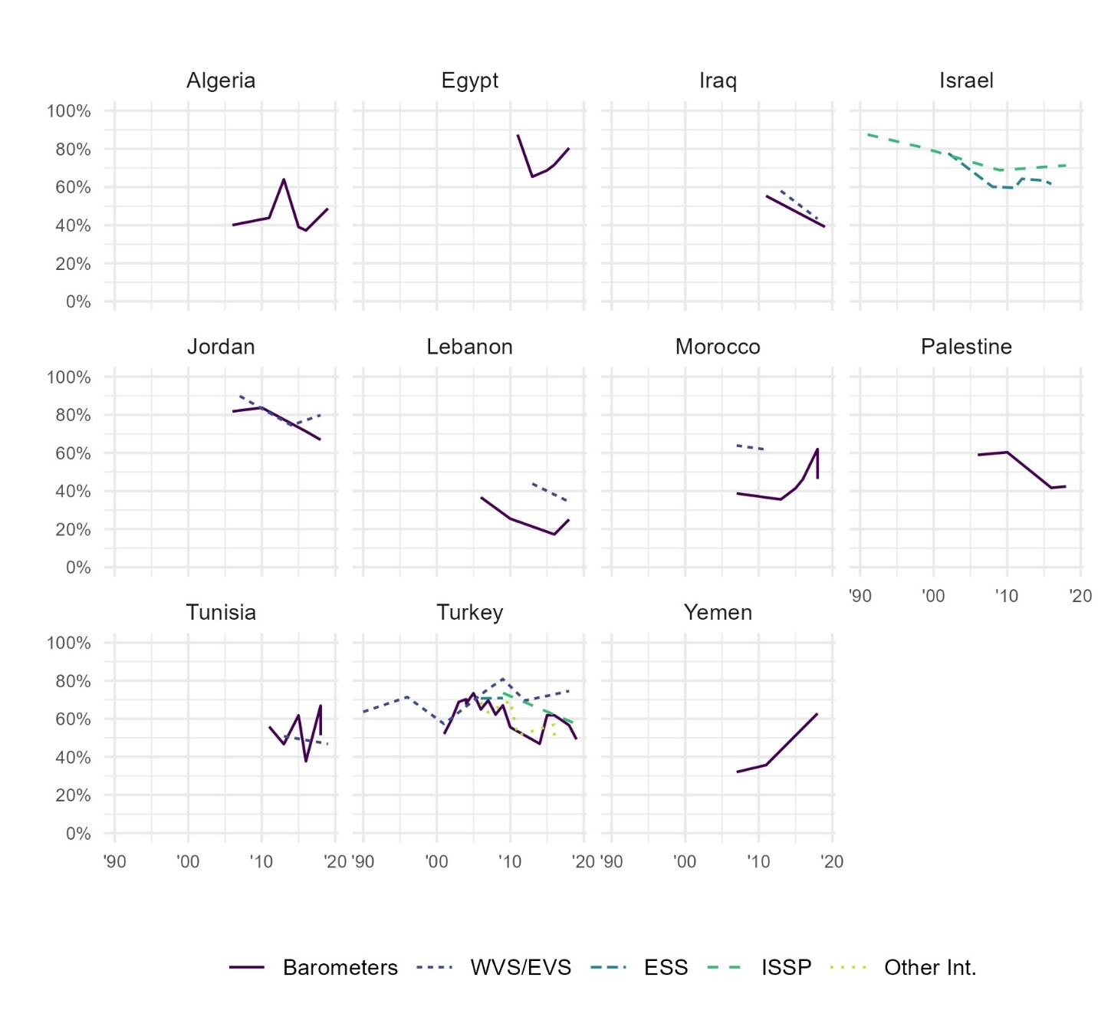
Figure C28. Descriptive trends in trust in the legal system within each country in the Middle East and North Africa, from Bayesian latent trend models, by survey project (grouped).
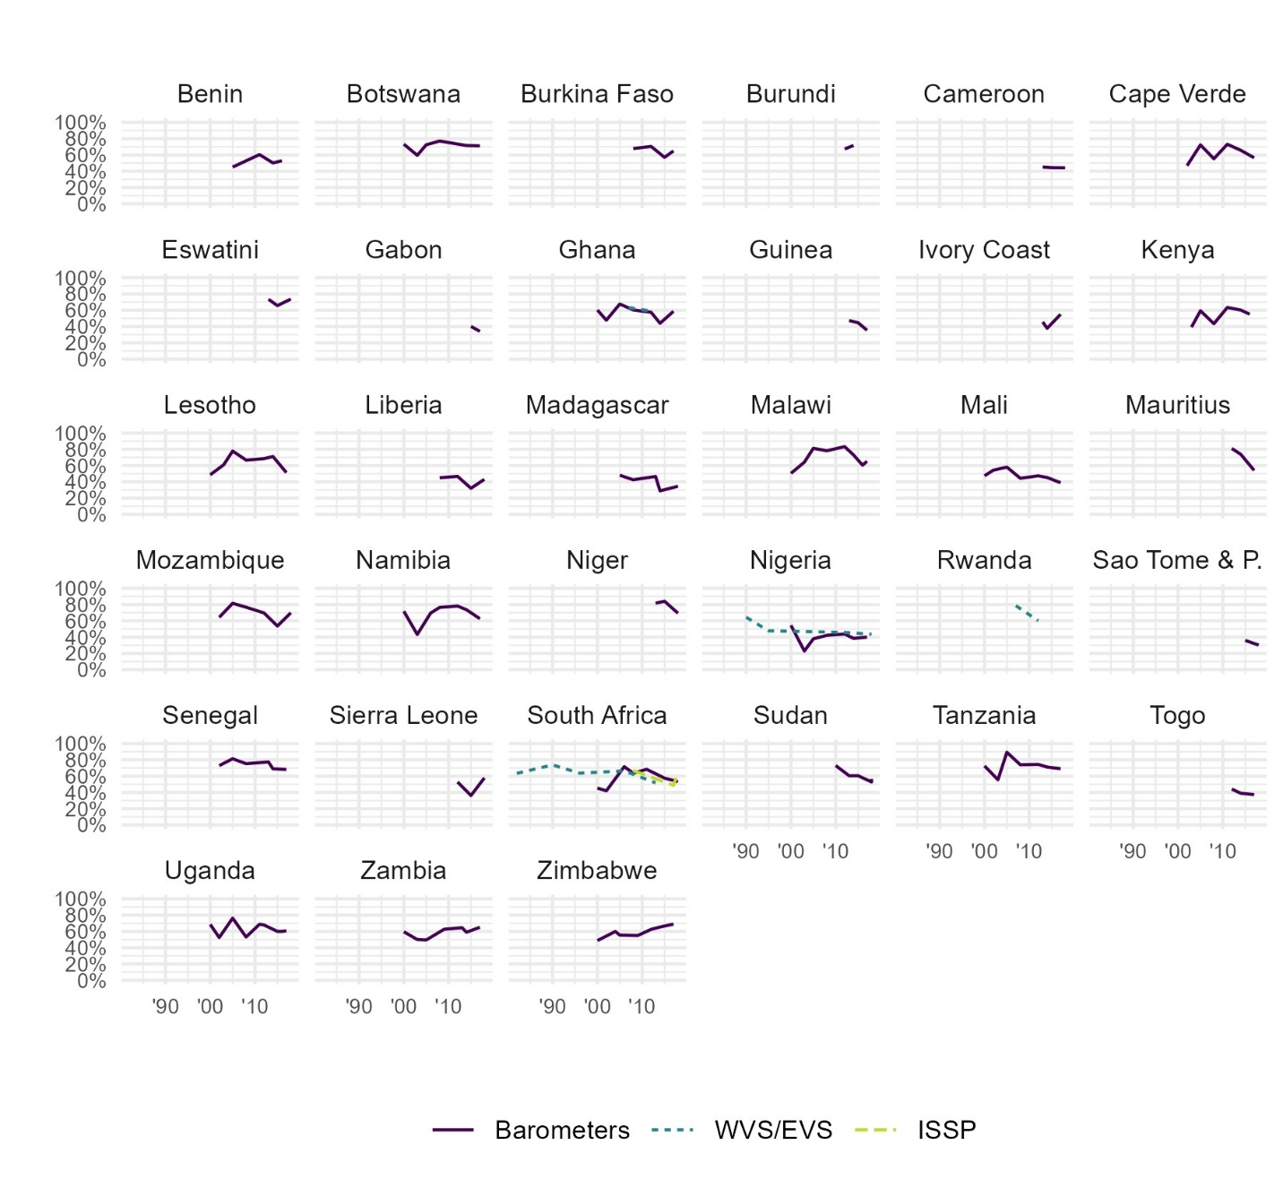
Figure C29. Descriptive trends in trust in the legal system within each country in Sub-Saharan Africa, from Bayesian latent trend models, by survey project (grouped).
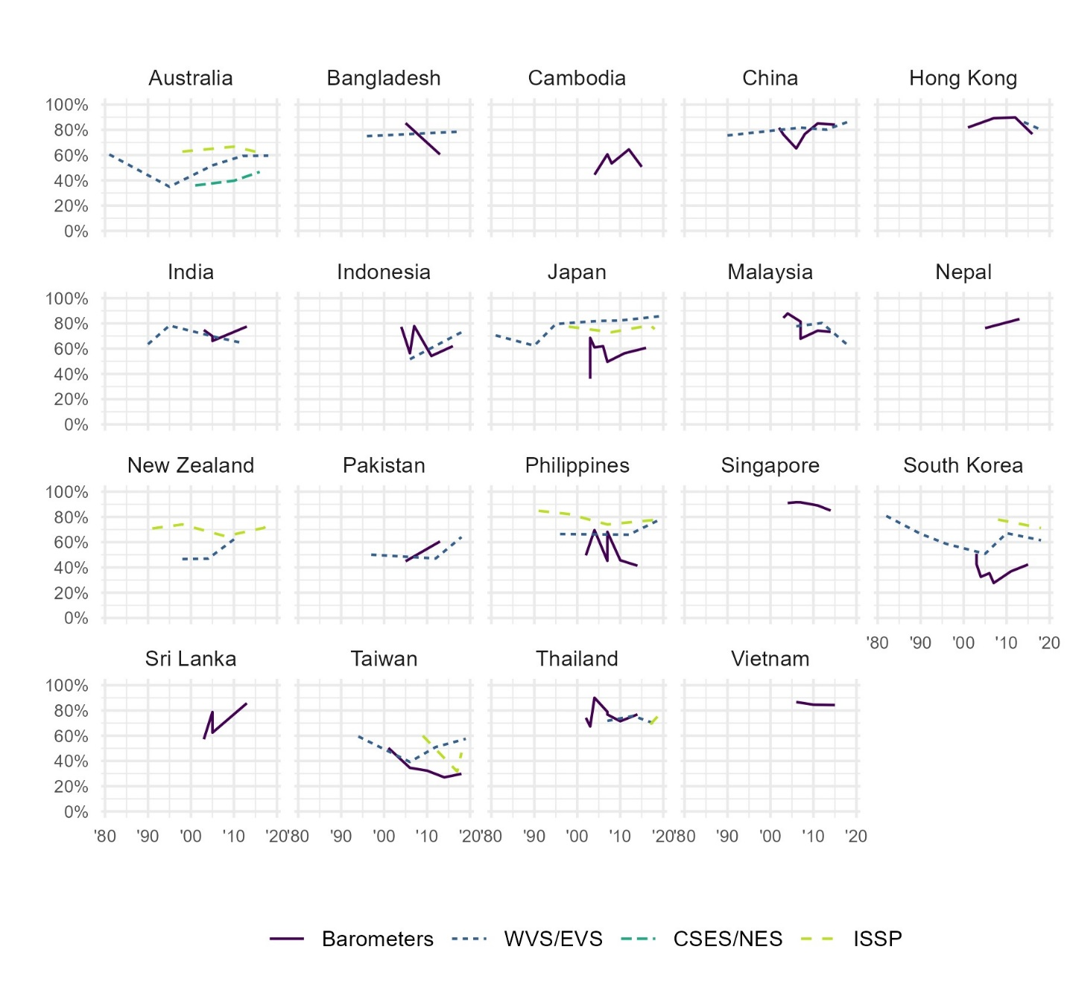
Figure C30. Descriptive trends in trust in the legal system within each country in Asia and the Pacific, from Bayesian latent trend models, by survey project (grouped).

  - The police
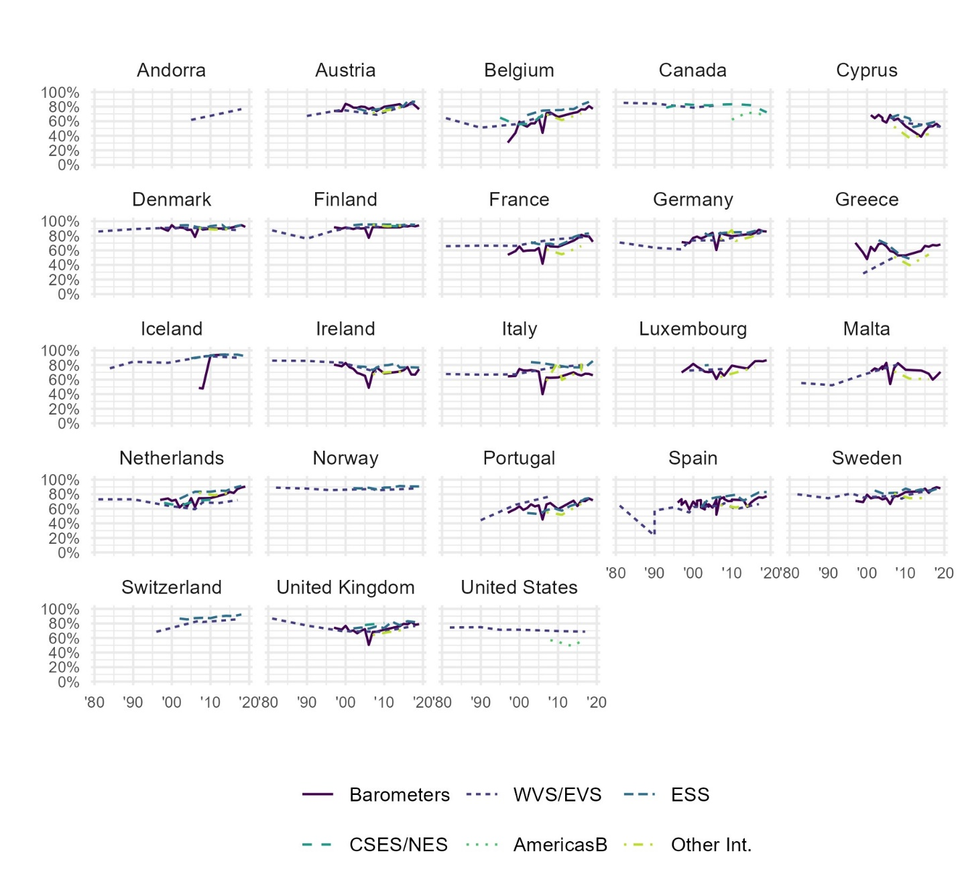
Figure C31. Descriptive trends in trust in the police within each country in Western Europe and North America, from Bayesian latent trend models, by survey project (grouped).
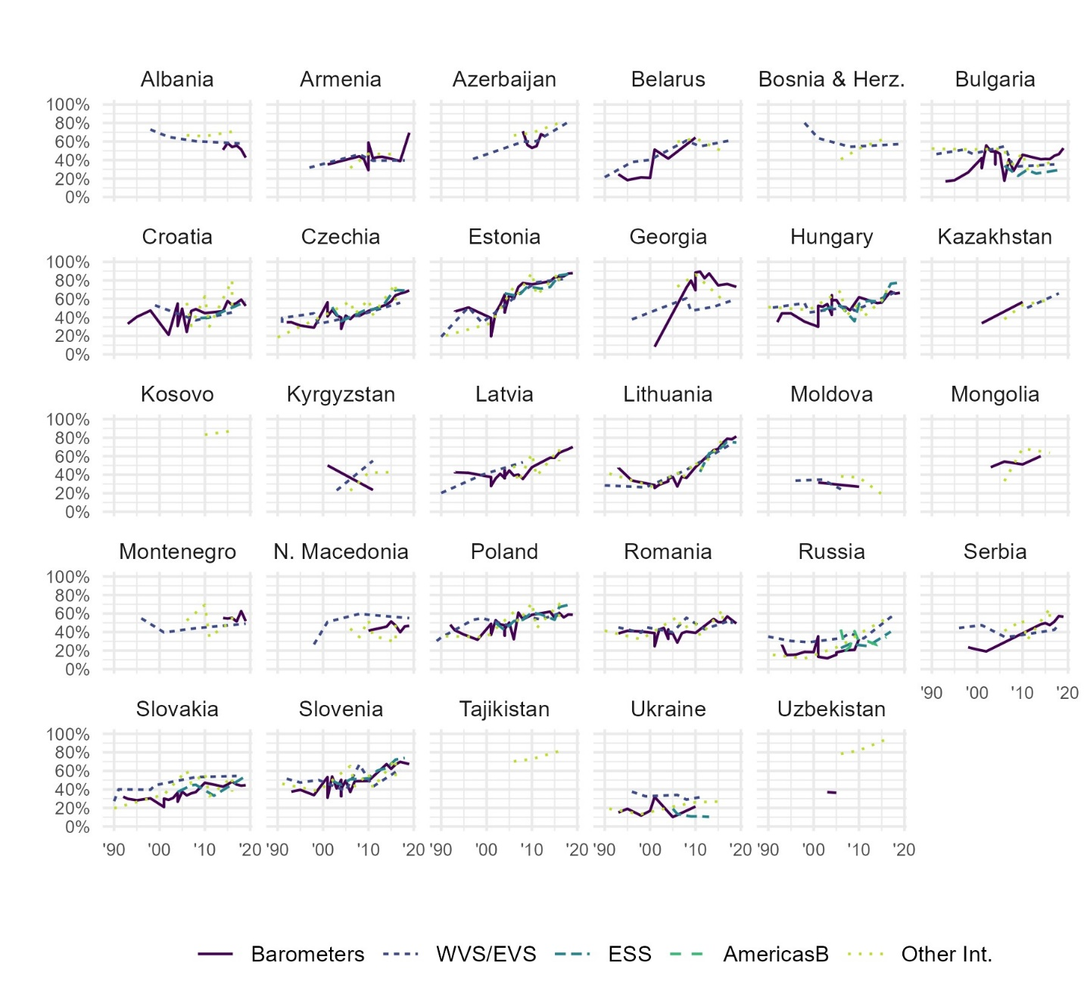
Figure C32. Descriptive trends in trust in the police within each country in Eastern Europe and Central Asia, from Bayesian latent trend models, by survey project (grouped).
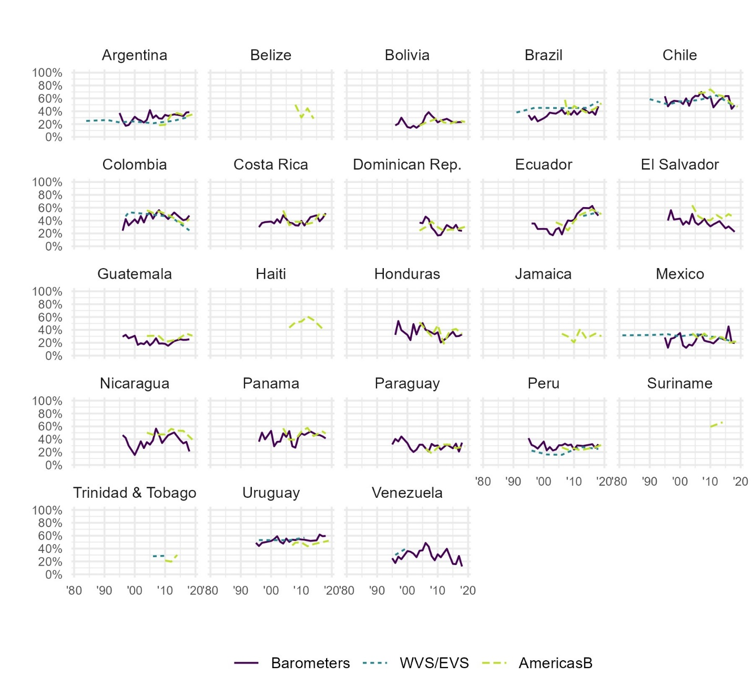
Figure C33. Descriptive trends in trust in the police within each country in Latin America and the Caribbean, from Bayesian latent trend models, by survey project (grouped).
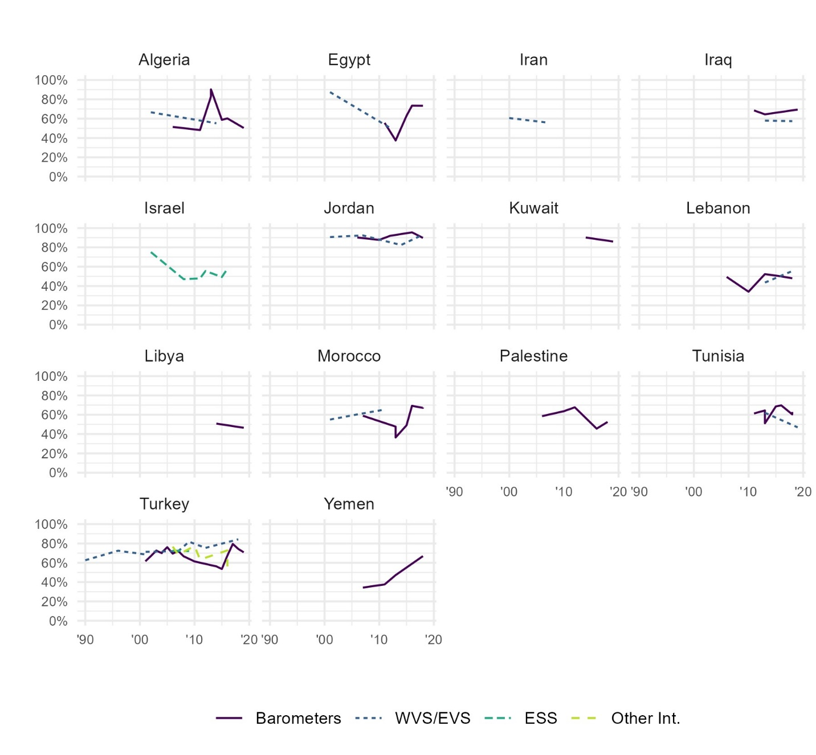
Figure C34. Descriptive trends in trust in the police within each country in the Middle East and North Africa, from Bayesian latent trend models, by survey project (grouped).
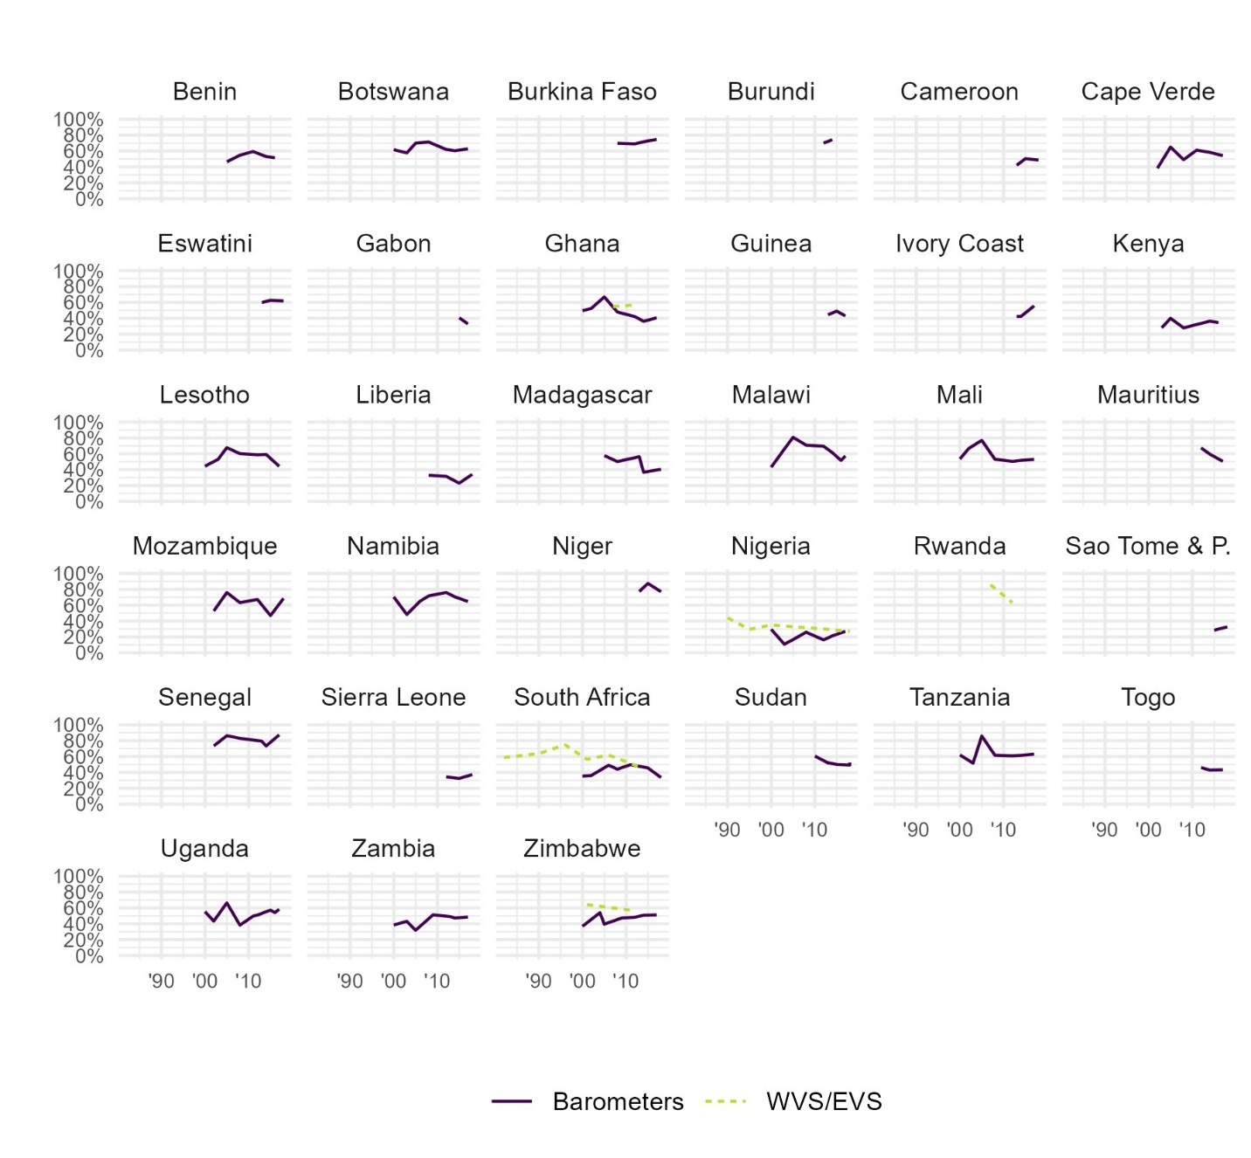
Figure C35. Descriptive trends in trust in the police within each country in Sub-Saharan Africa, from Bayesian latent trend models, by survey project (grouped).
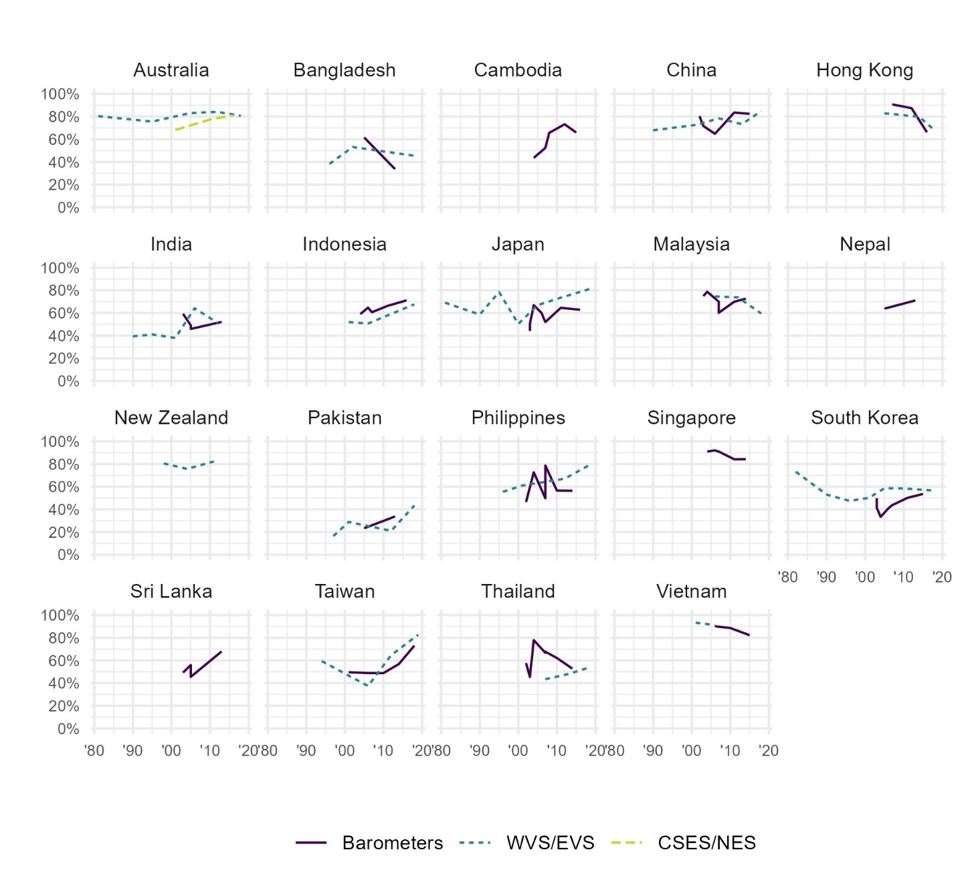
Figure C36. Descriptive trends in trust in the police within each country in Asia and the Pacific, from Bayesian latent trend models, by survey project (grouped).

- Country-trends in six trust measures
  - Parliament
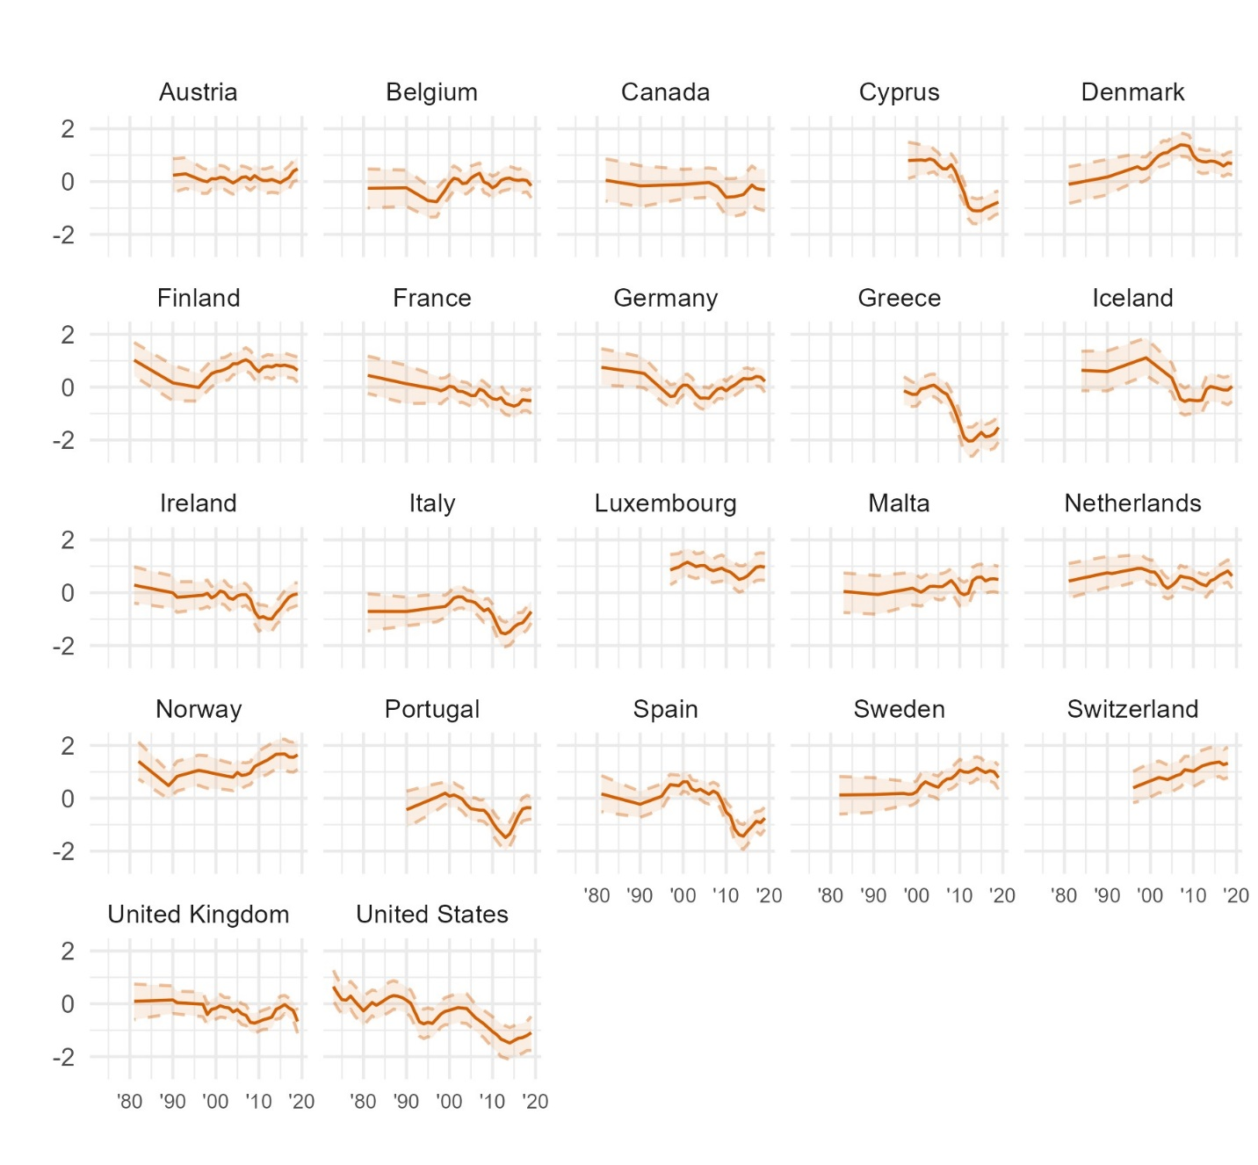
Figure D1. Latent trends in trust in parliament within each country in Western Europe and North America, from Bayesian latent trend models.
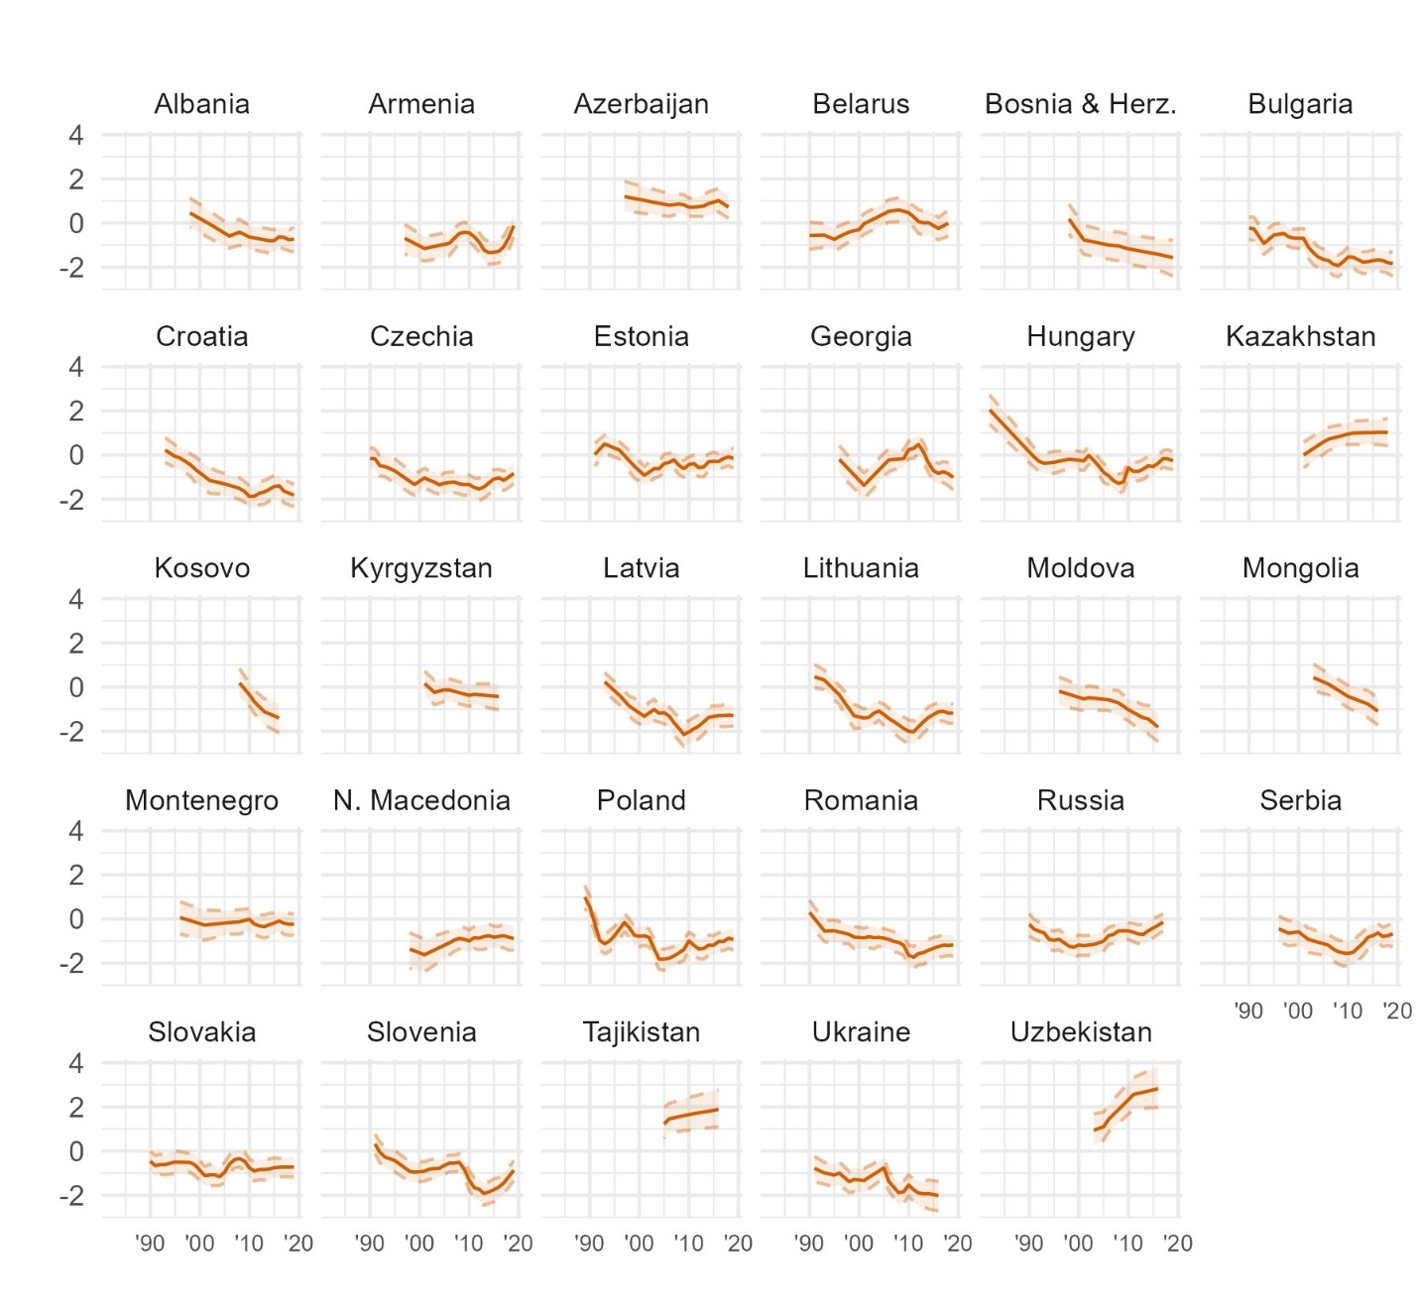
Figure D2. Latent trends in trust in parliament within each country in Eastern Europe and Central Asia, from Bayesian latent trend models.
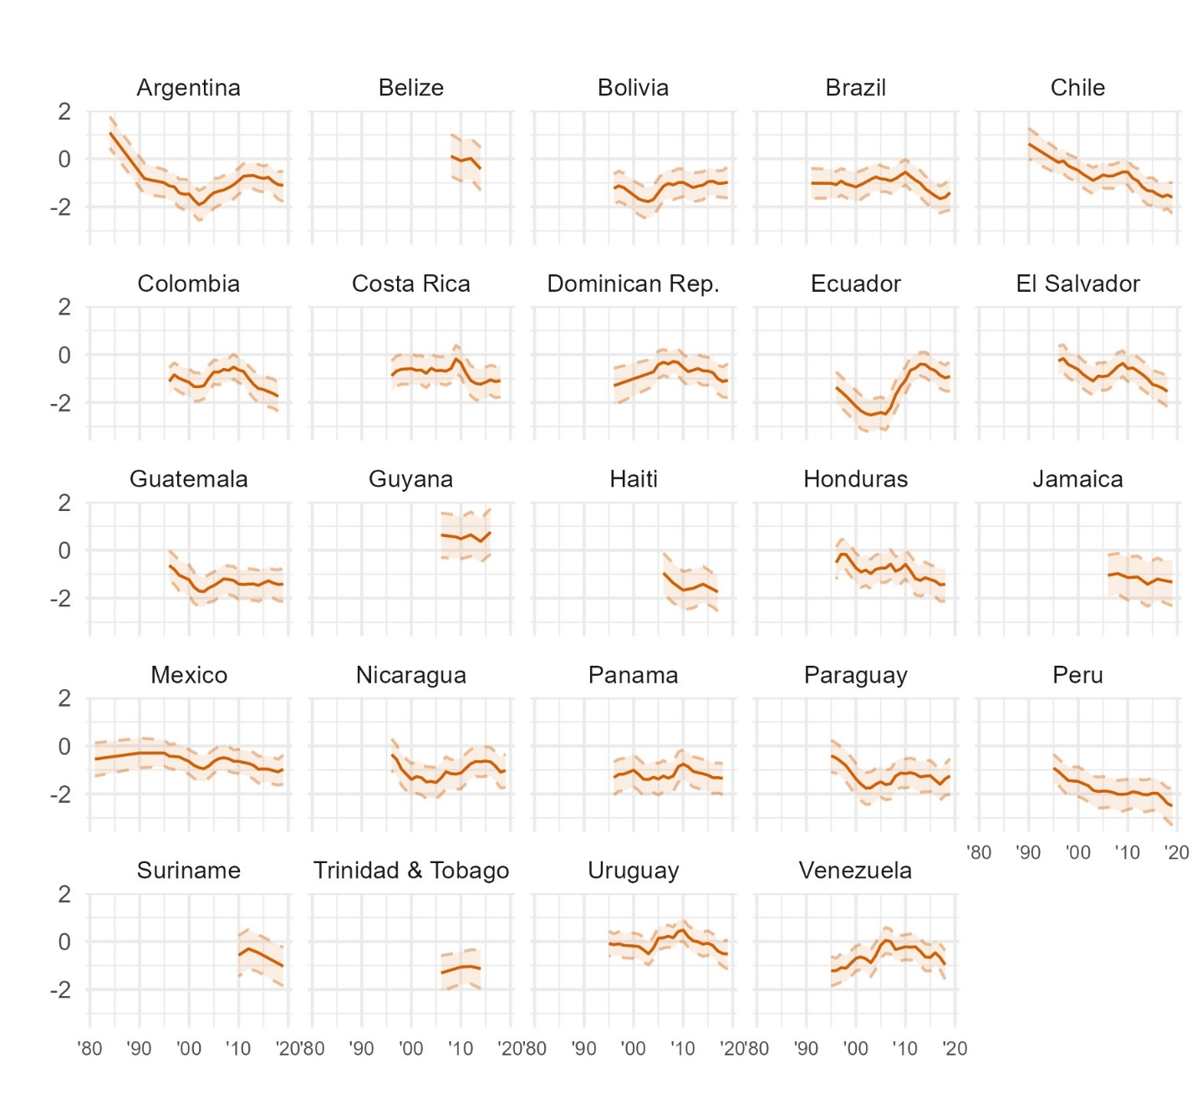
Figure D3. Latent trends in trust in parliament within each country in Latin America and the Caribbean, from Bayesian latent trend models.
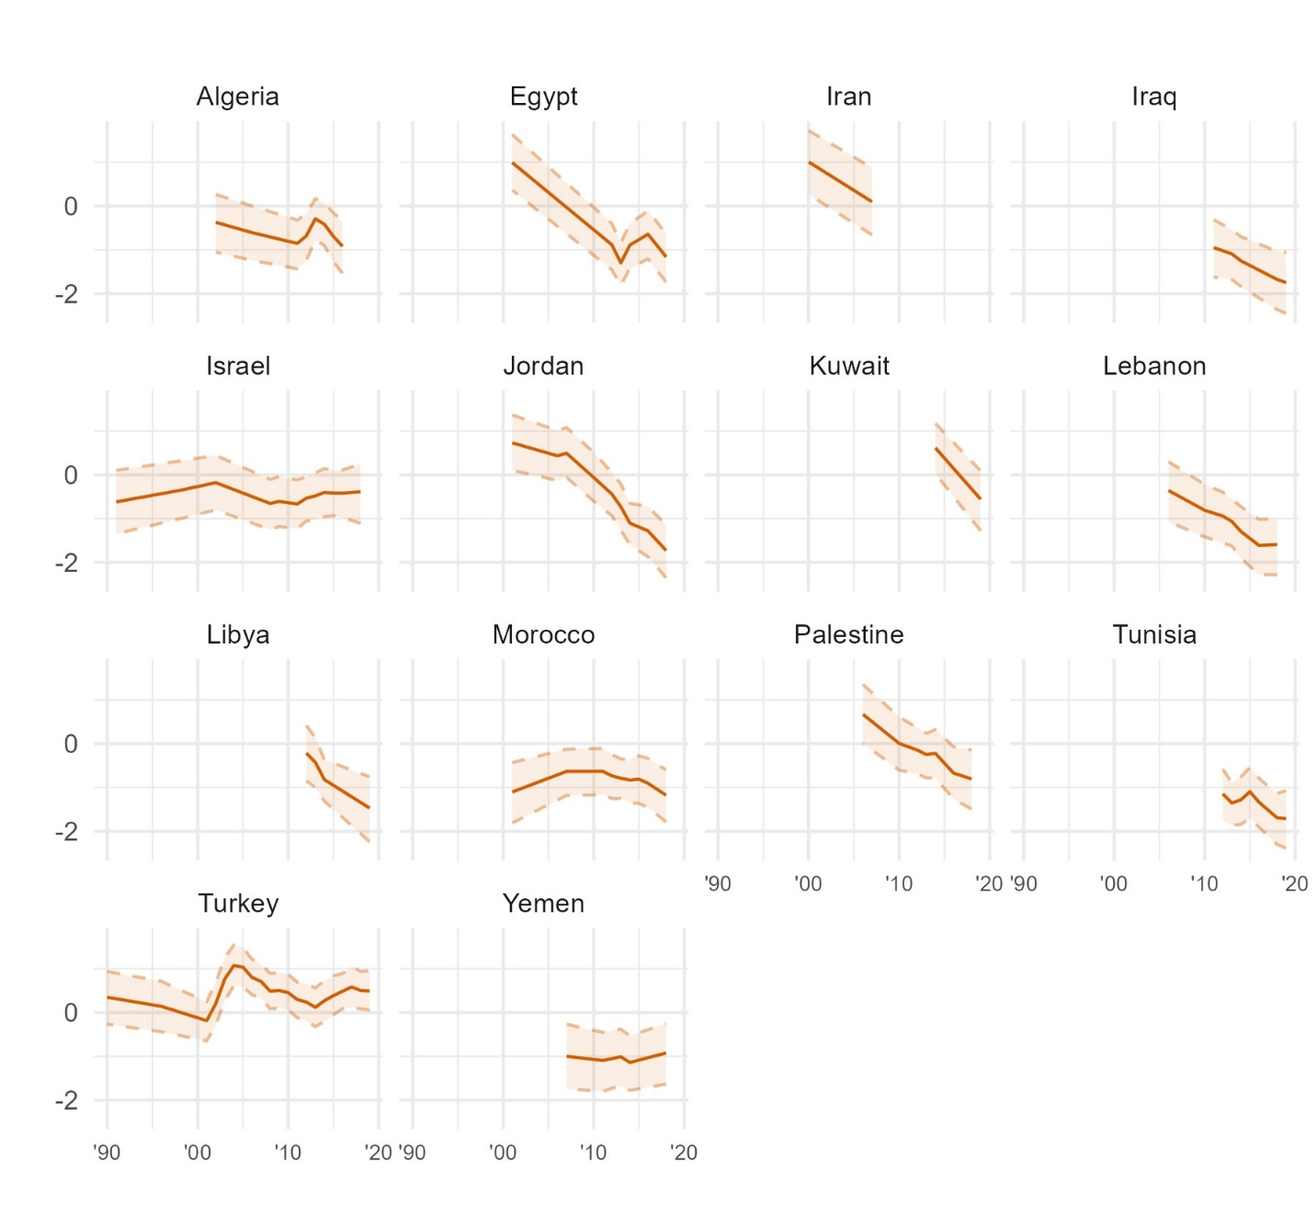
Figure D4. Latent trends in trust in parliament within each country in the Middle East and North Africa, from Bayesian latent trend models.
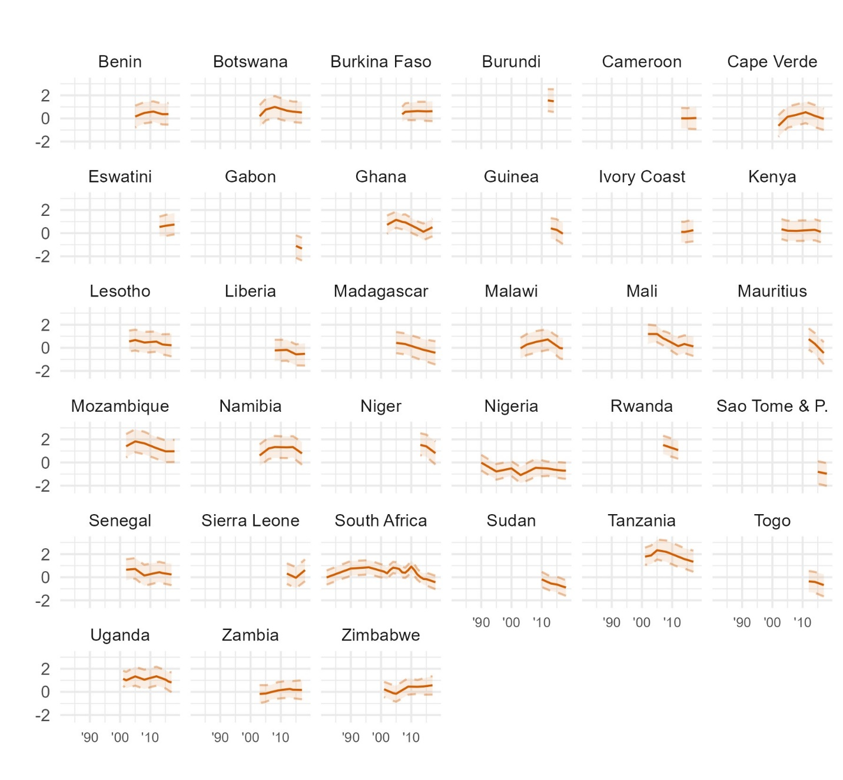
Figure D5. Latent trends in trust in parliament within each country in Sub-Saharan Africa, from Bayesian latent trend models.
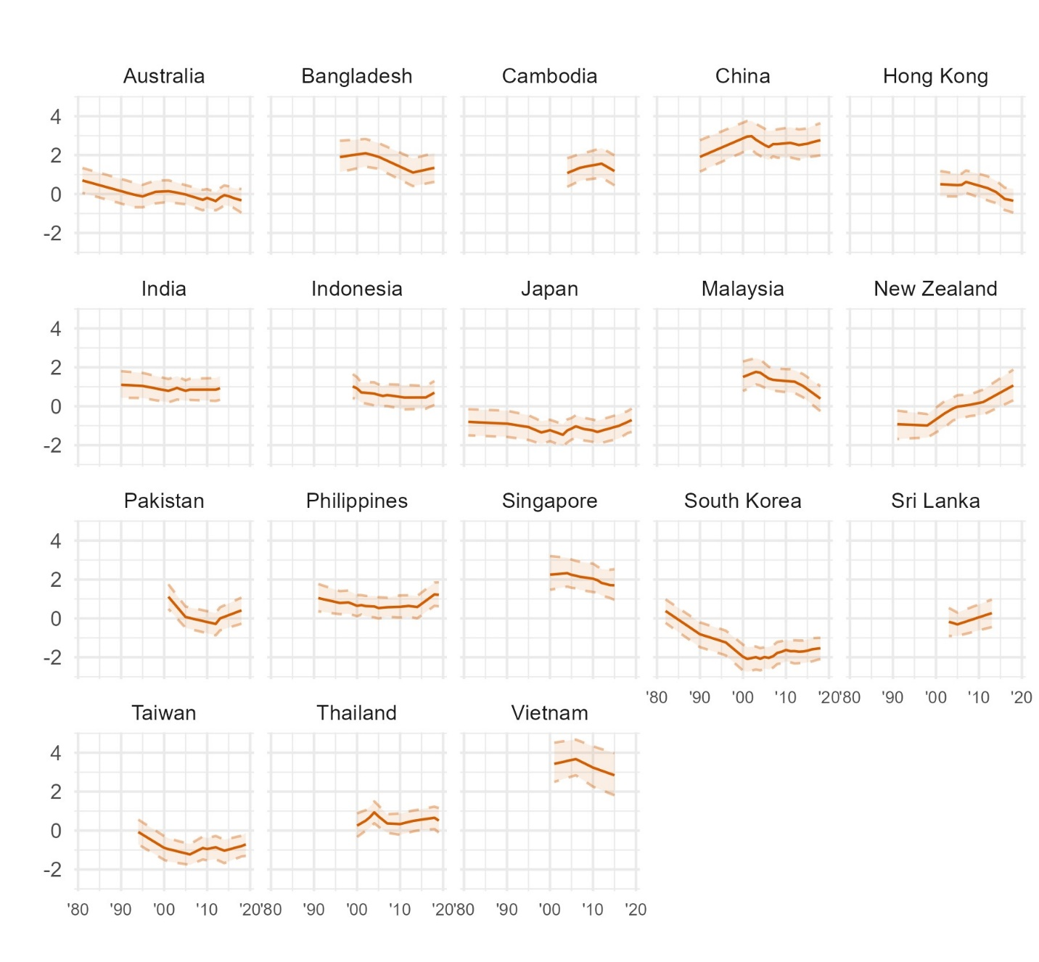
Figure D6. Latent trends in trust in parliament within each country in Asia and the Pacific, from Bayesian latent trend models.

  - Government
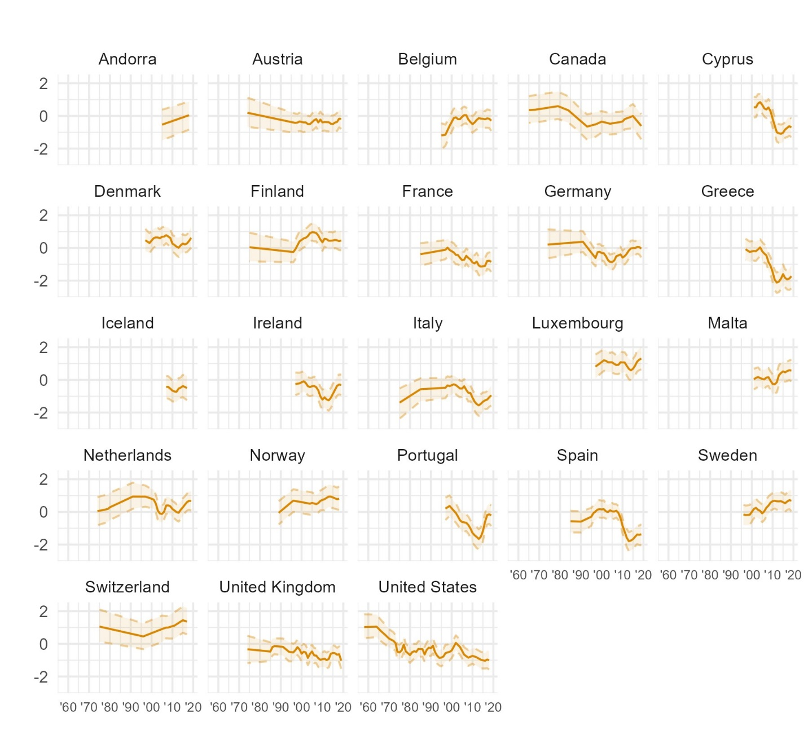
Figure D7. Latent trends in trust in government within each country in Western Europe and North America, from Bayesian latent trend models.
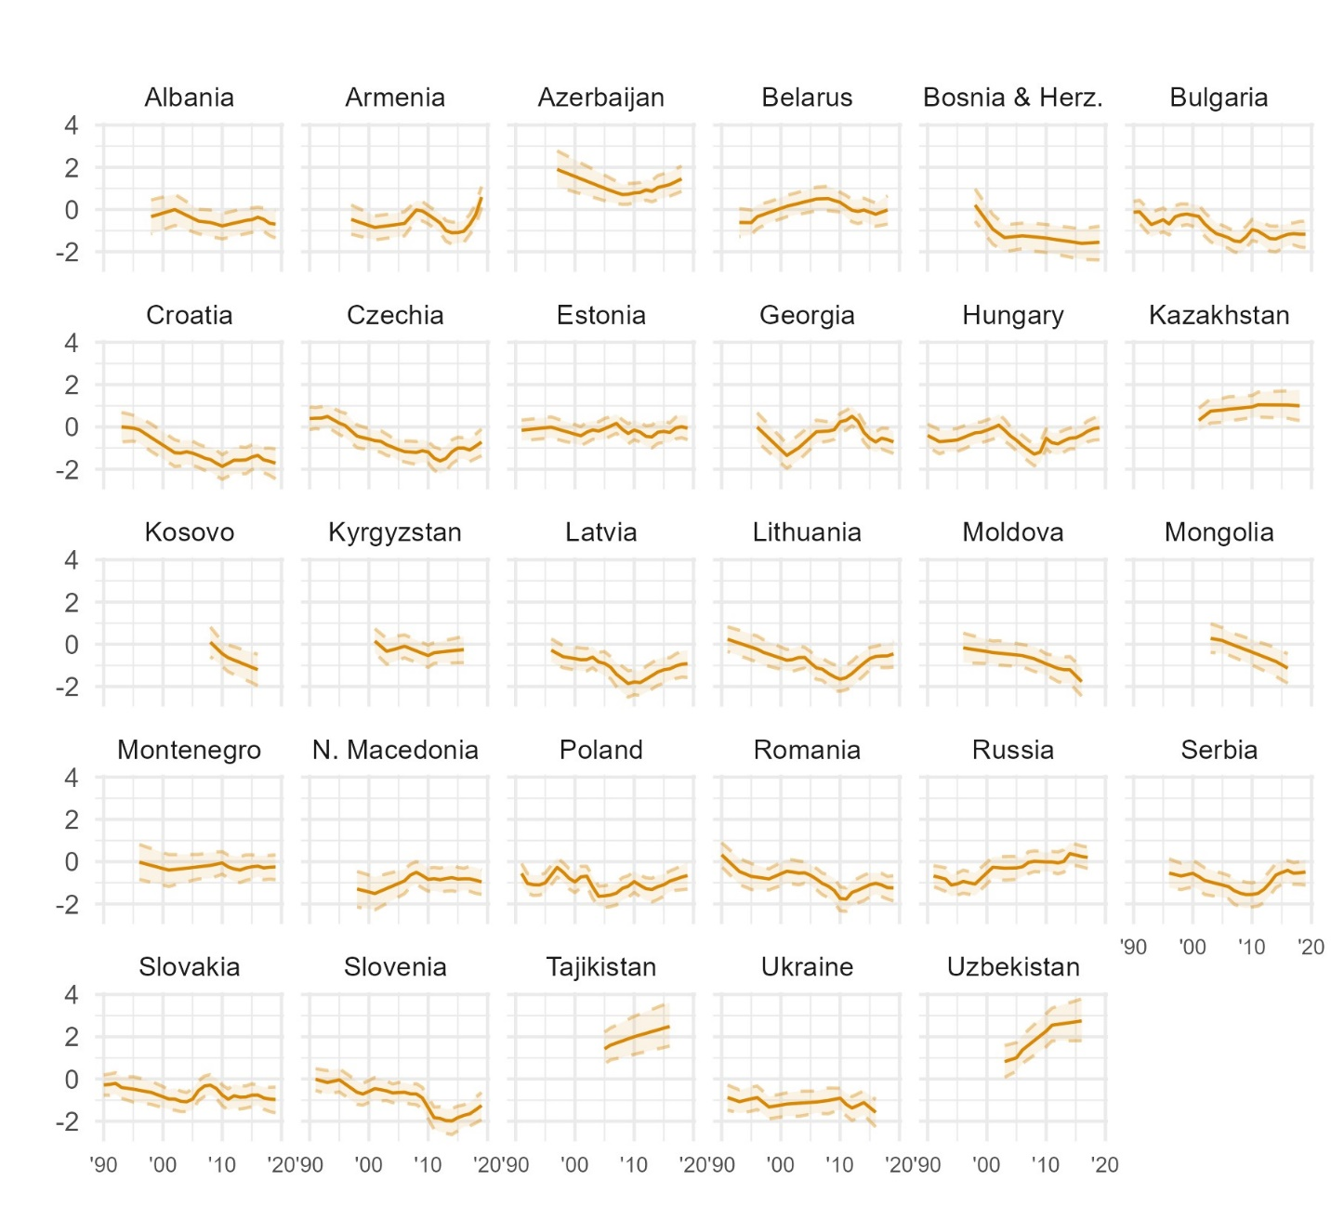
Figure D8. Latent trends in trust in government within each country in Eastern Europe and Central Asia, from Bayesian latent trend models.
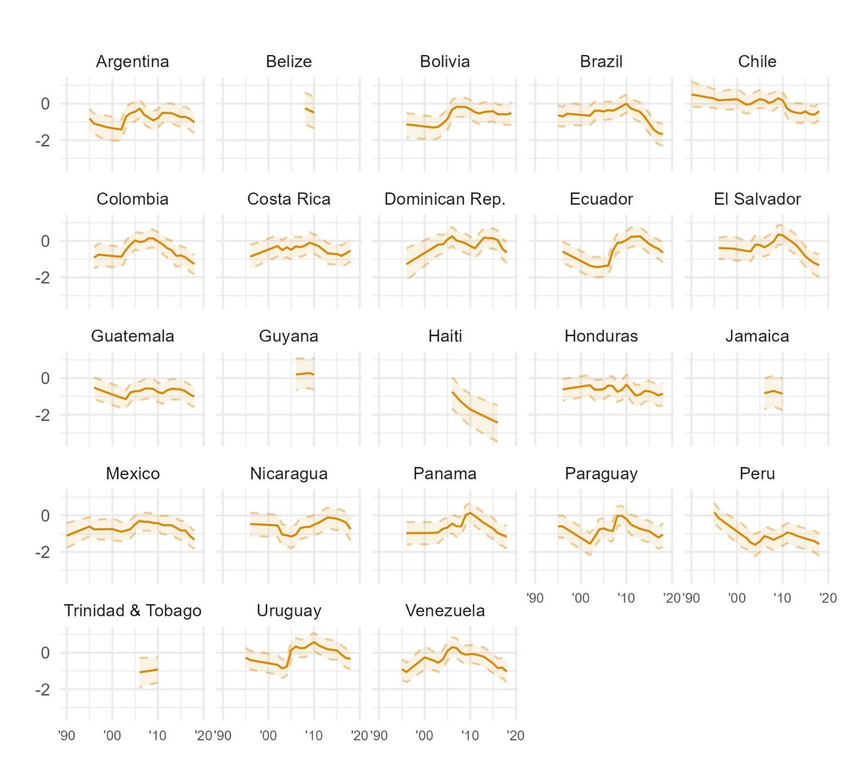
Figure D9. Latent trends in trust in government within each country in Latin America and the Caribbean, from Bayesian latent trend models.
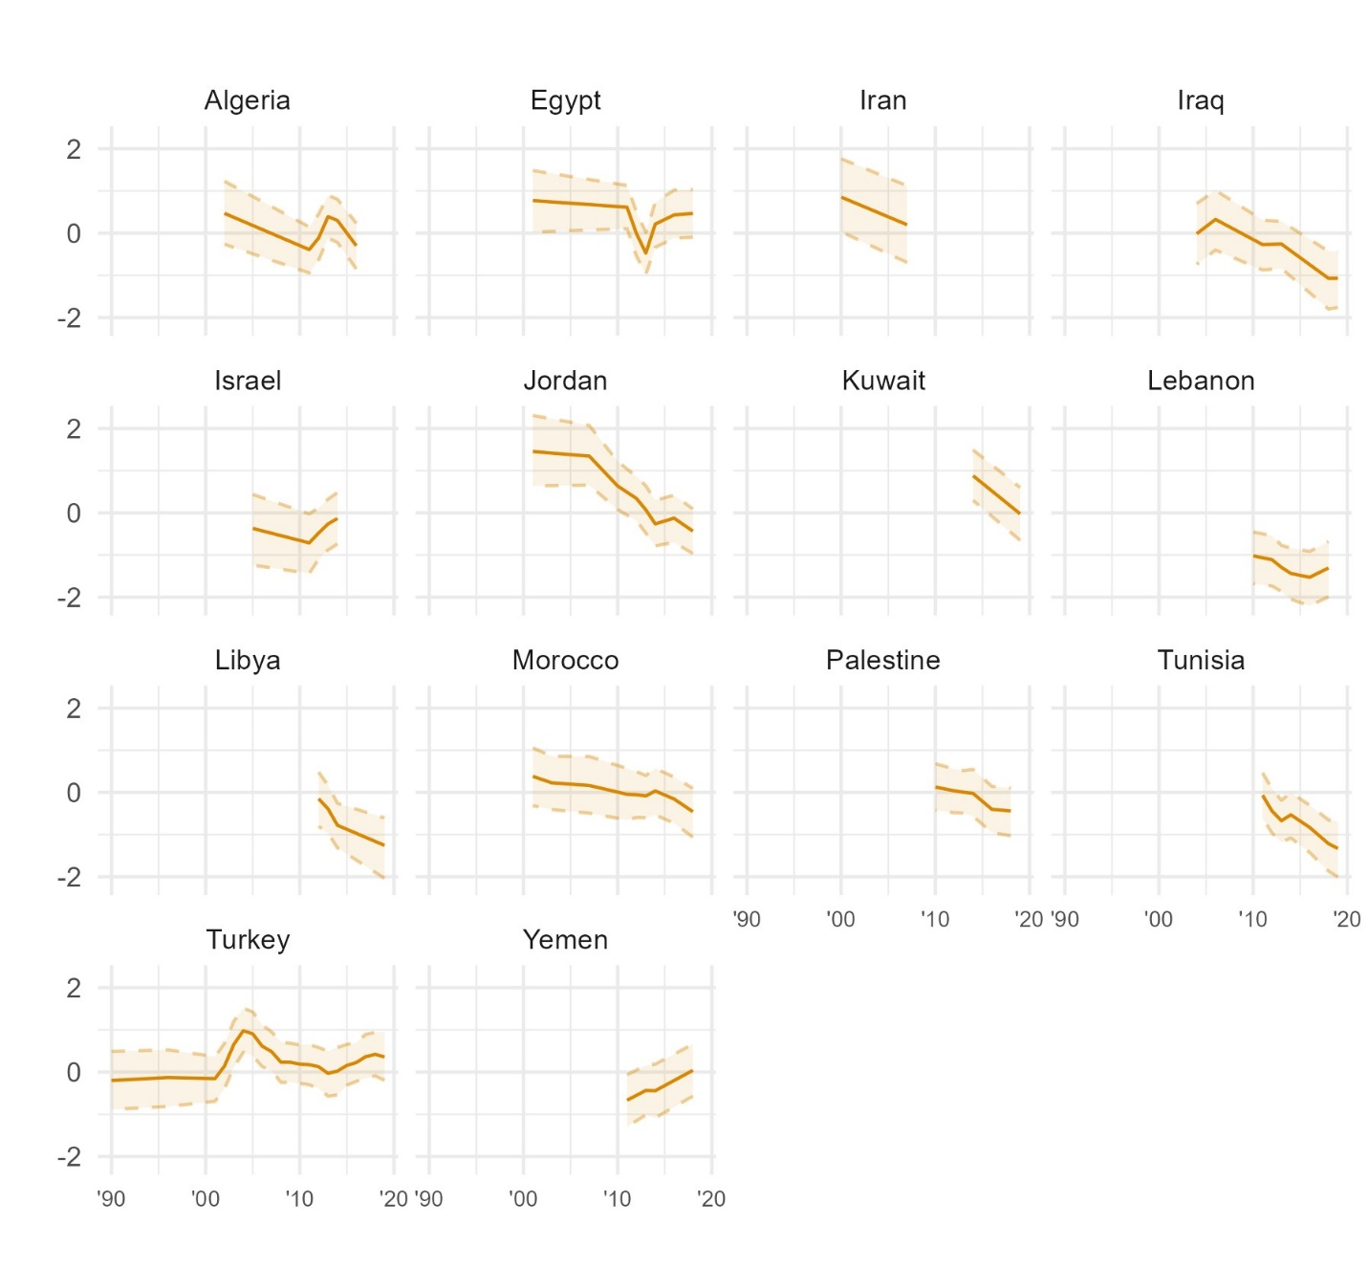
Figure D10. Latent trends in trust in government within each country in the Middle East and North Africa, from Bayesian latent trend models.
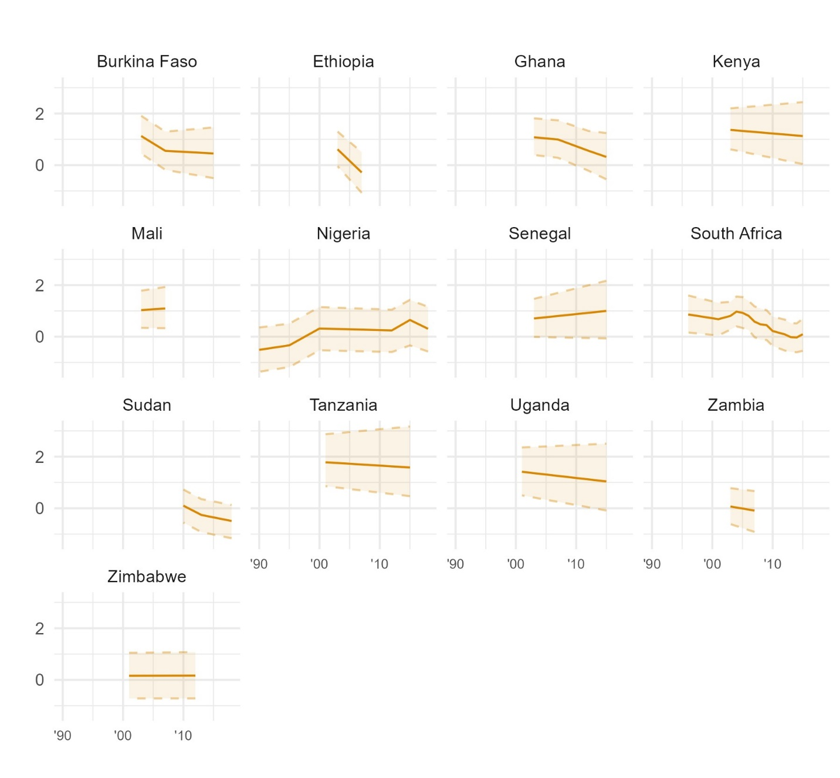
Figure D11. Latent trends in trust in government within each country in Sub-Saharan Africa, from Bayesian latent trend models.
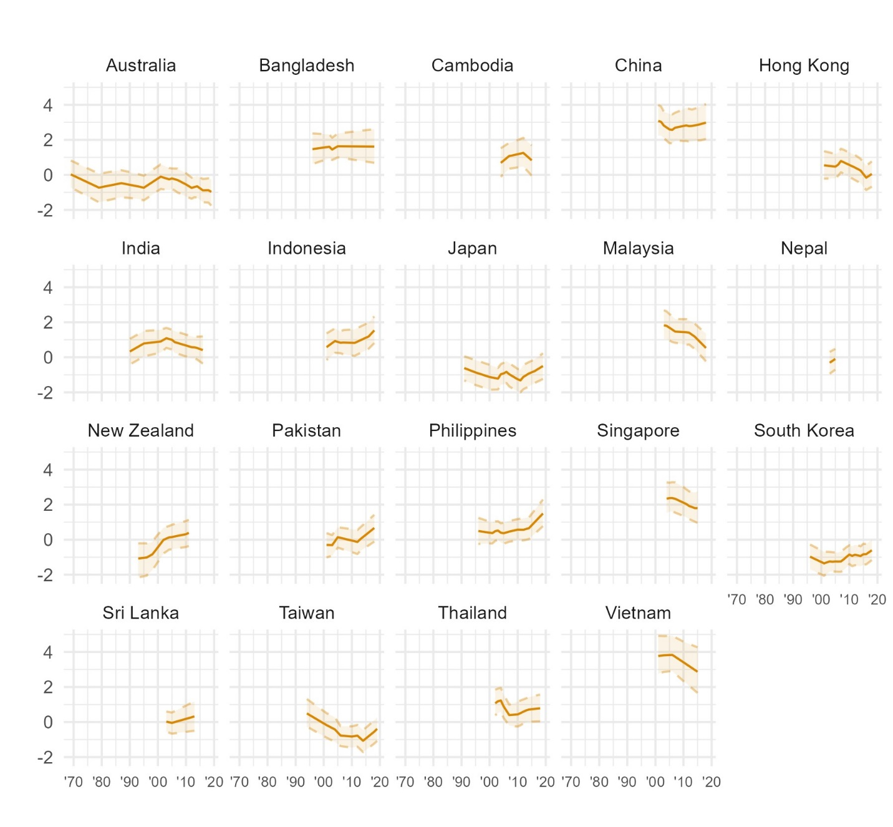
Figure D12. Latent trends in trust in government within each country in Asia and the Pacific, from Bayesian latent trend models.

  - Political parties
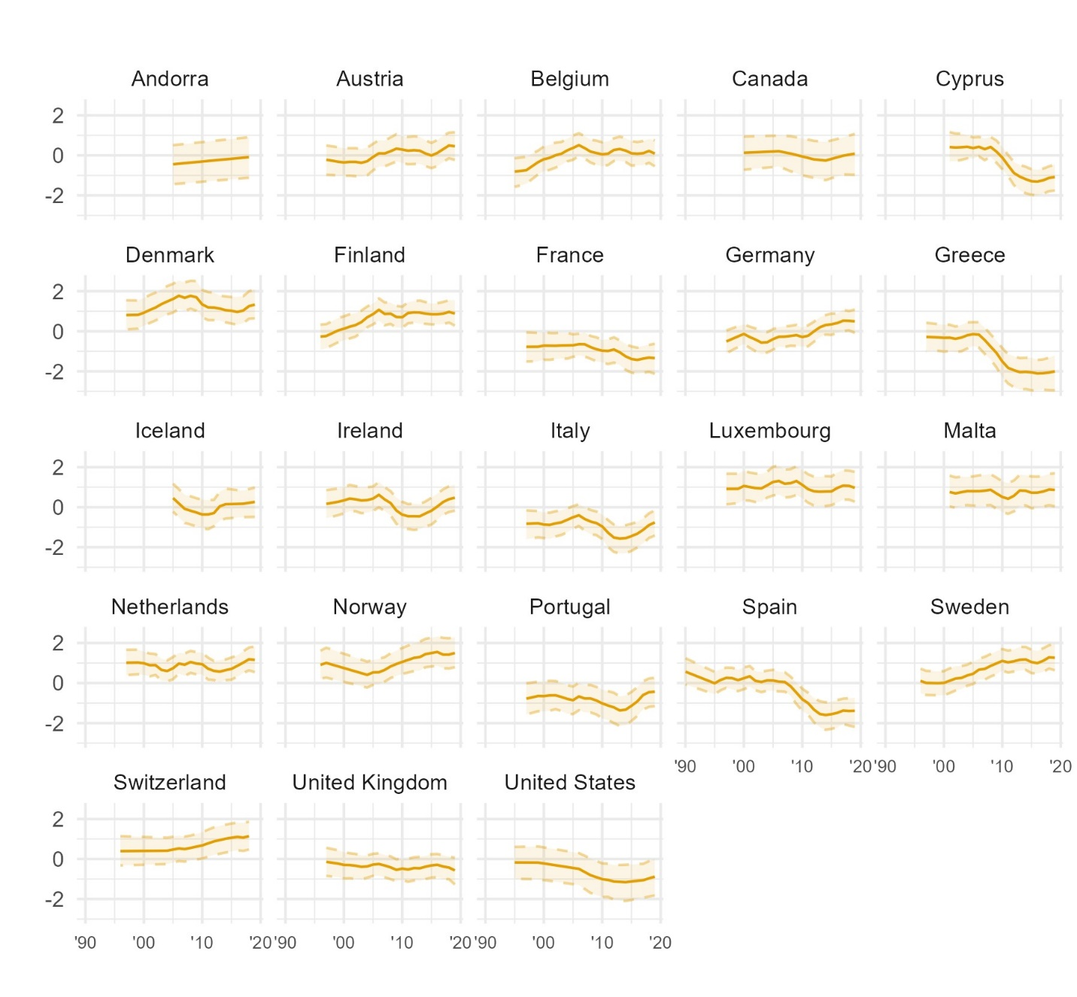
Figure D13. Latent trends in trust in political parties within each country in Western Europe and North America, from Bayesian latent trend models.
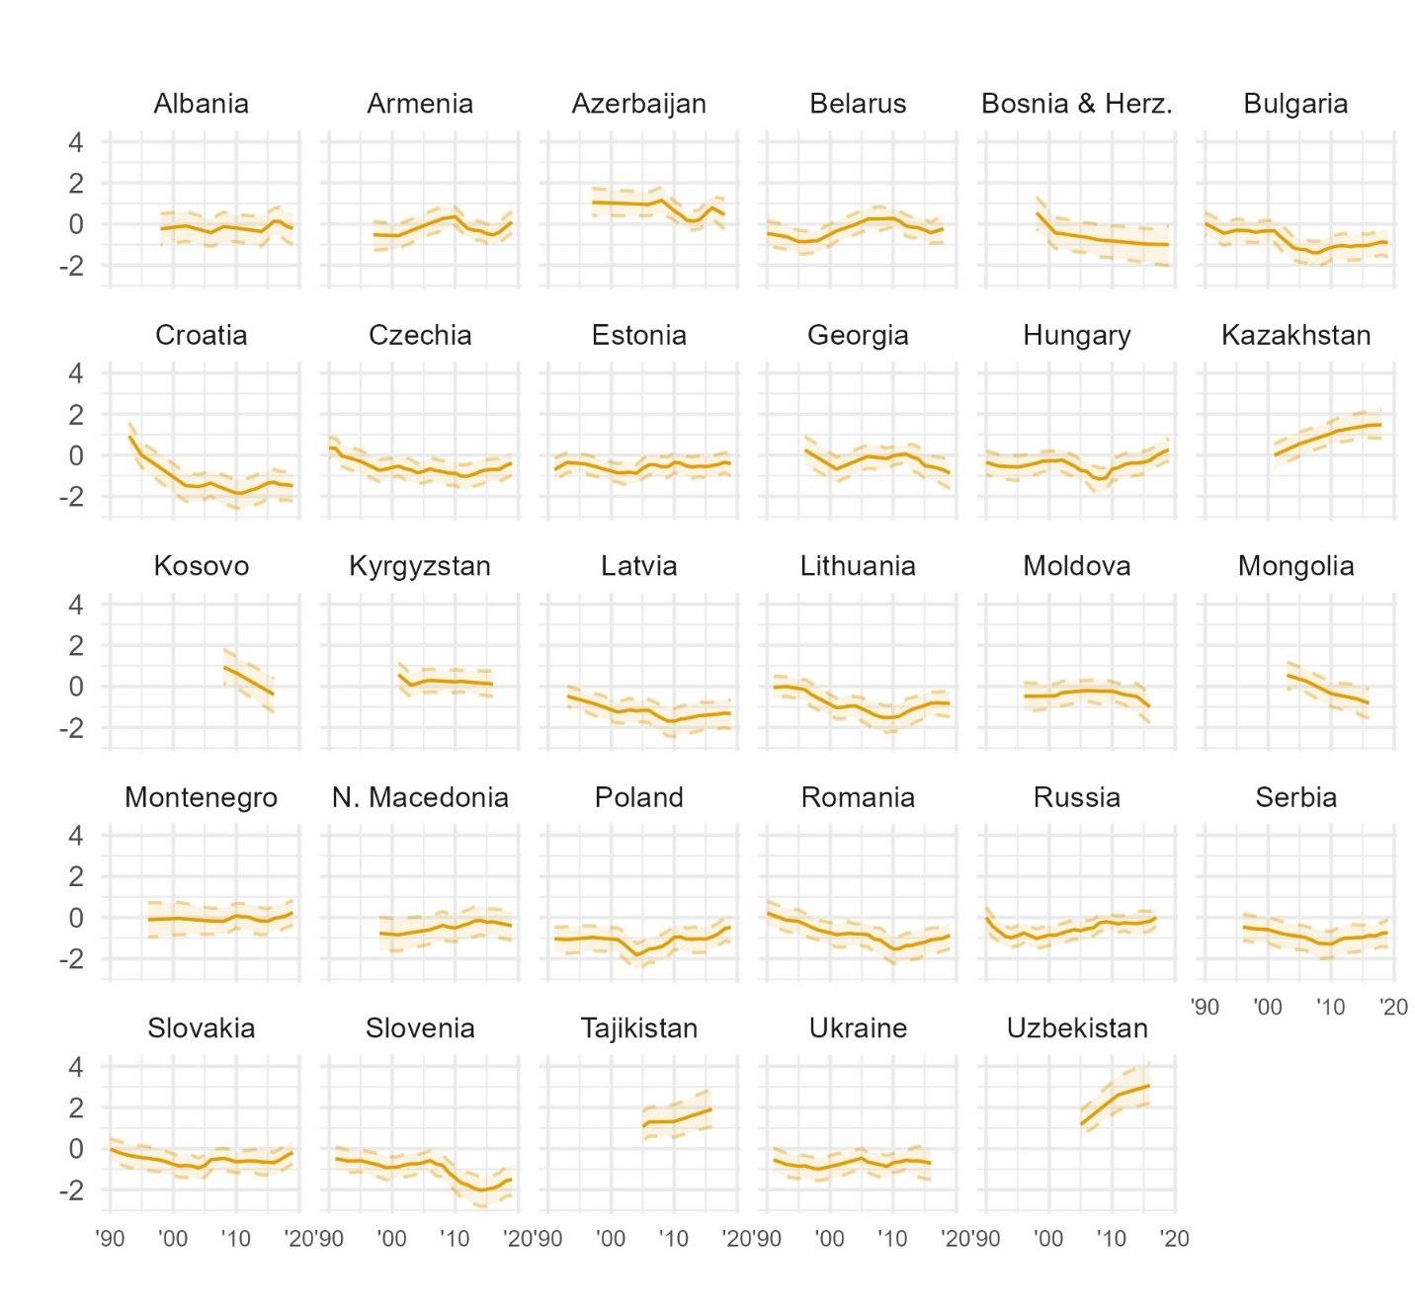
Figure D14. Latent trends in trust in political parties within each country in Eastern Europe and Central Asia, from Bayesian latent trend models.
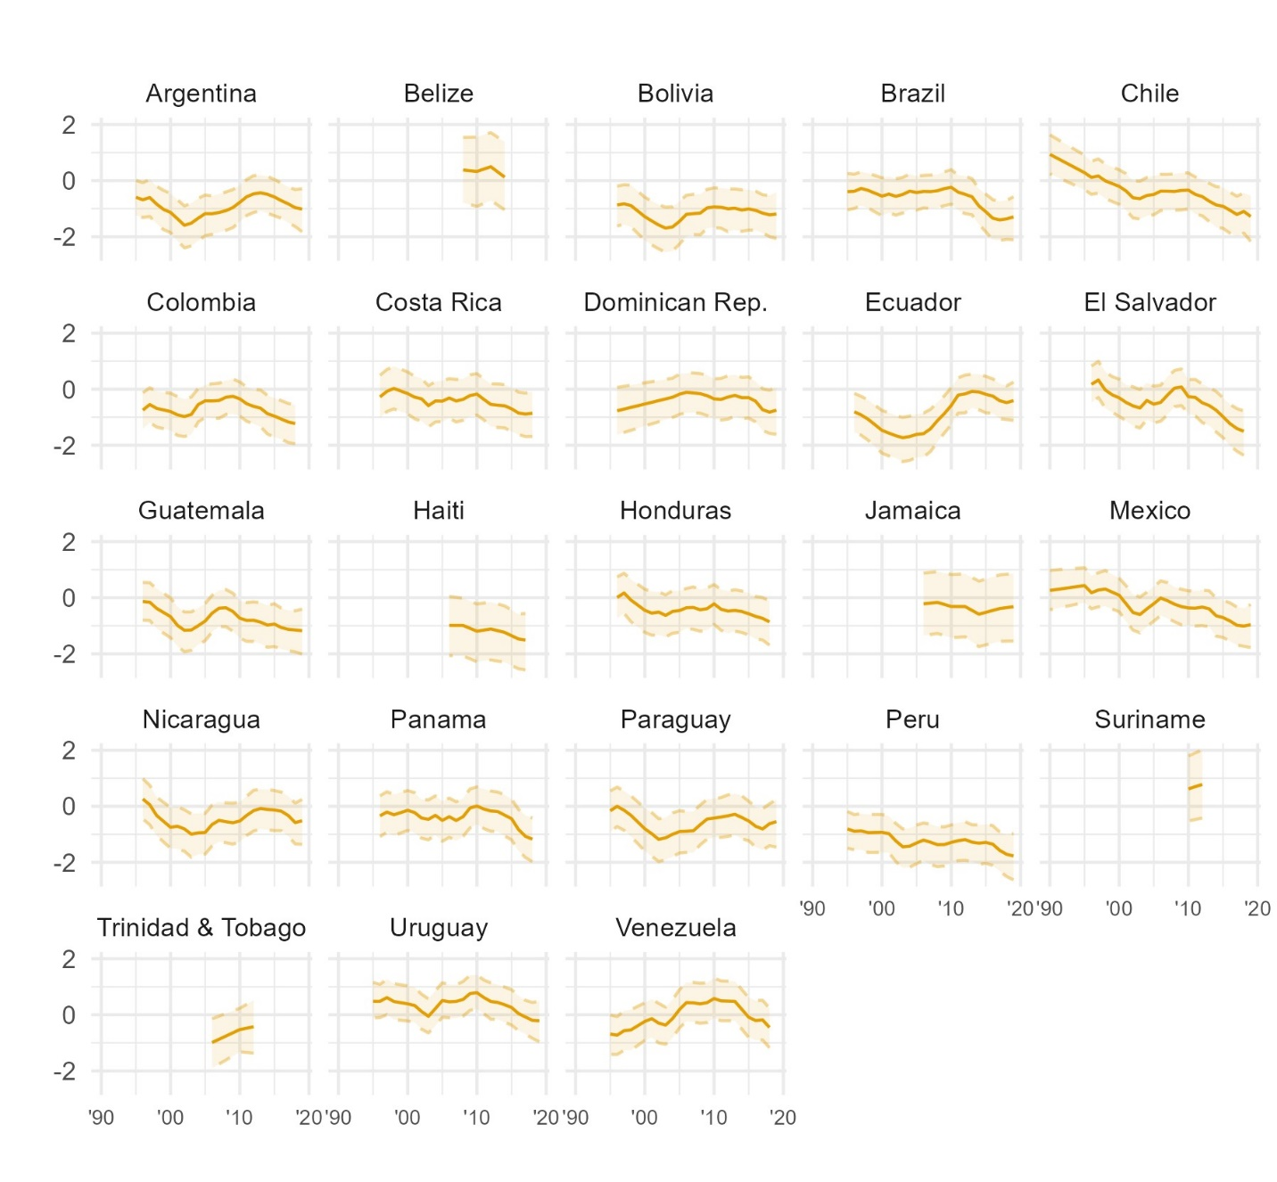
Figure D15. Latent trends in trust in political parties within each country in Latin America and the Caribbean, from Bayesian latent trend models.
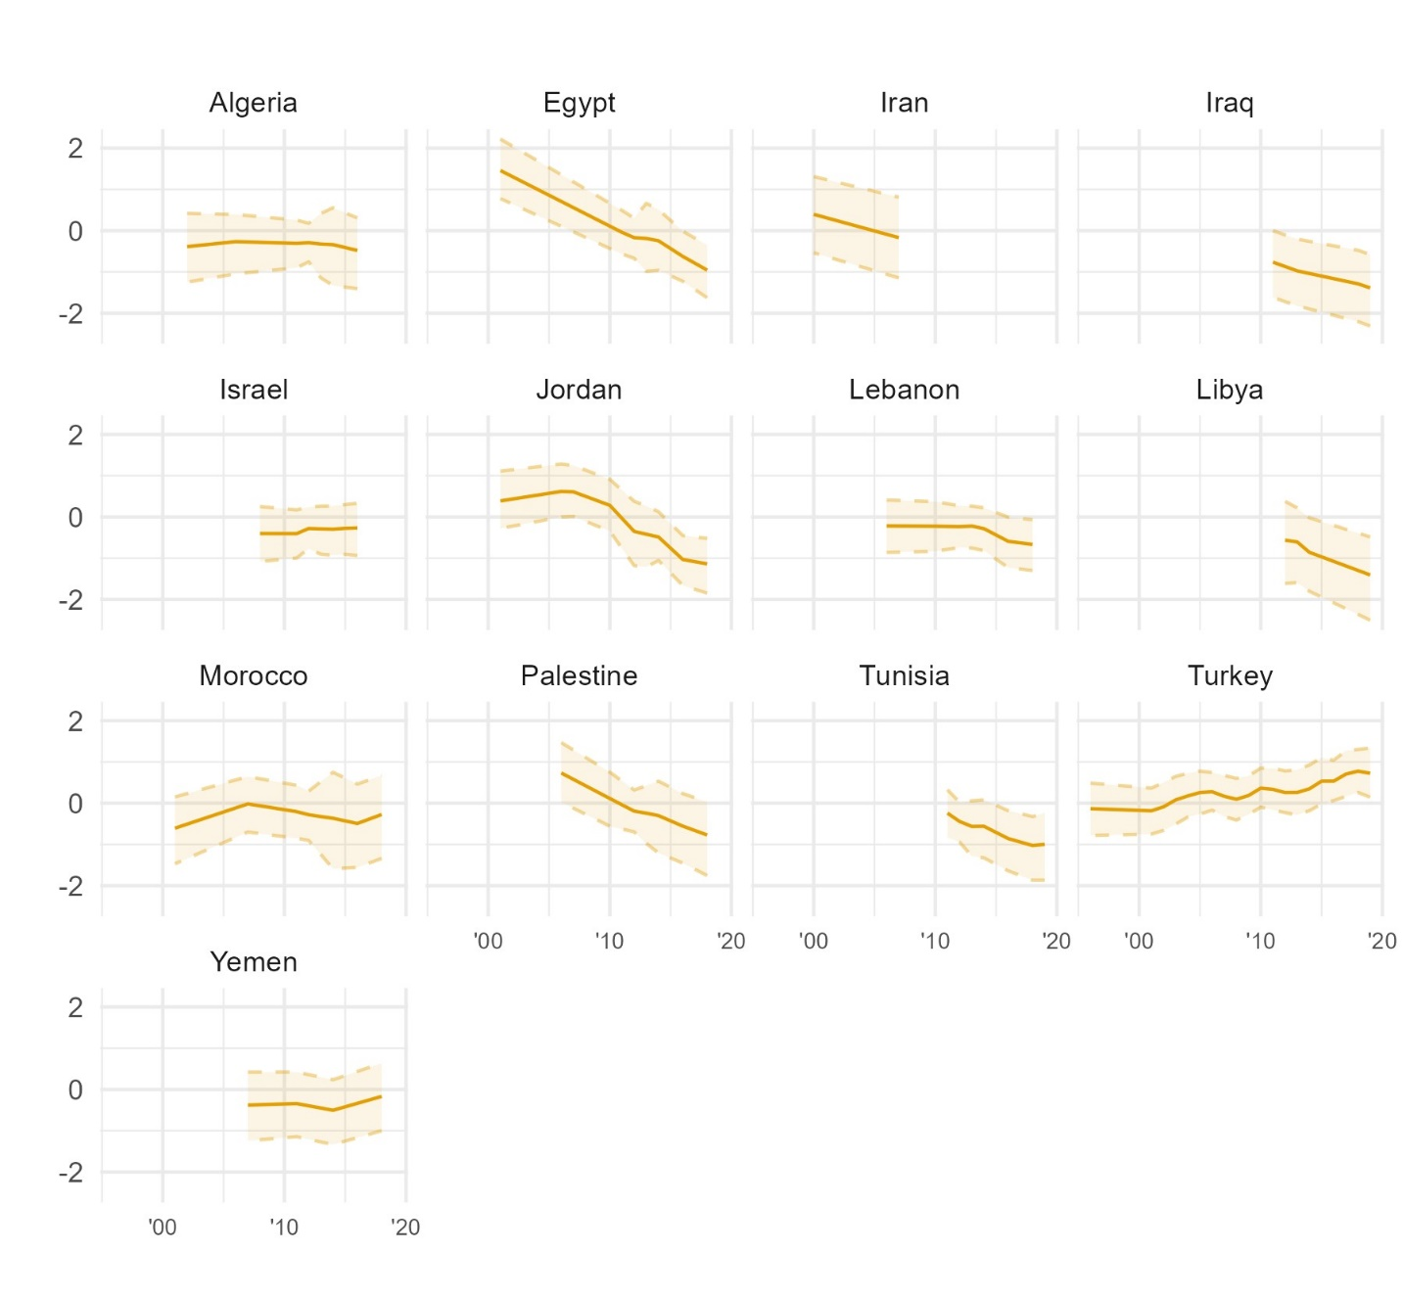
Figure D16. Latent trends in trust in political parties within each country in the Middle East and North Africa, from Bayesian latent trend models.
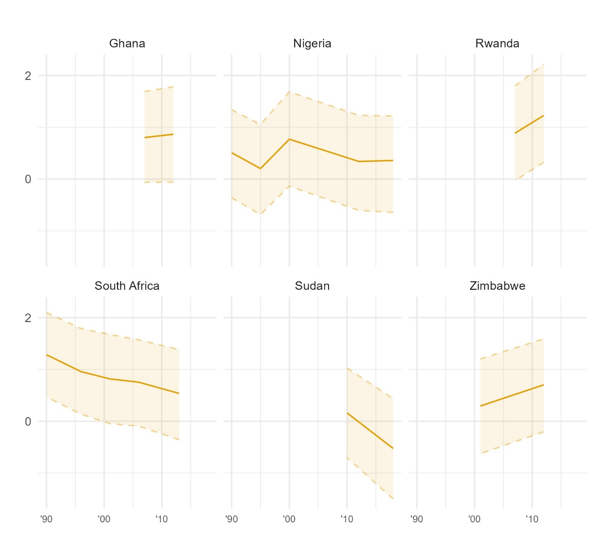
Figure D17. Latent trends in trust in political parties within each country in Sub-Saharan Africa, from Bayesian latent trend models.
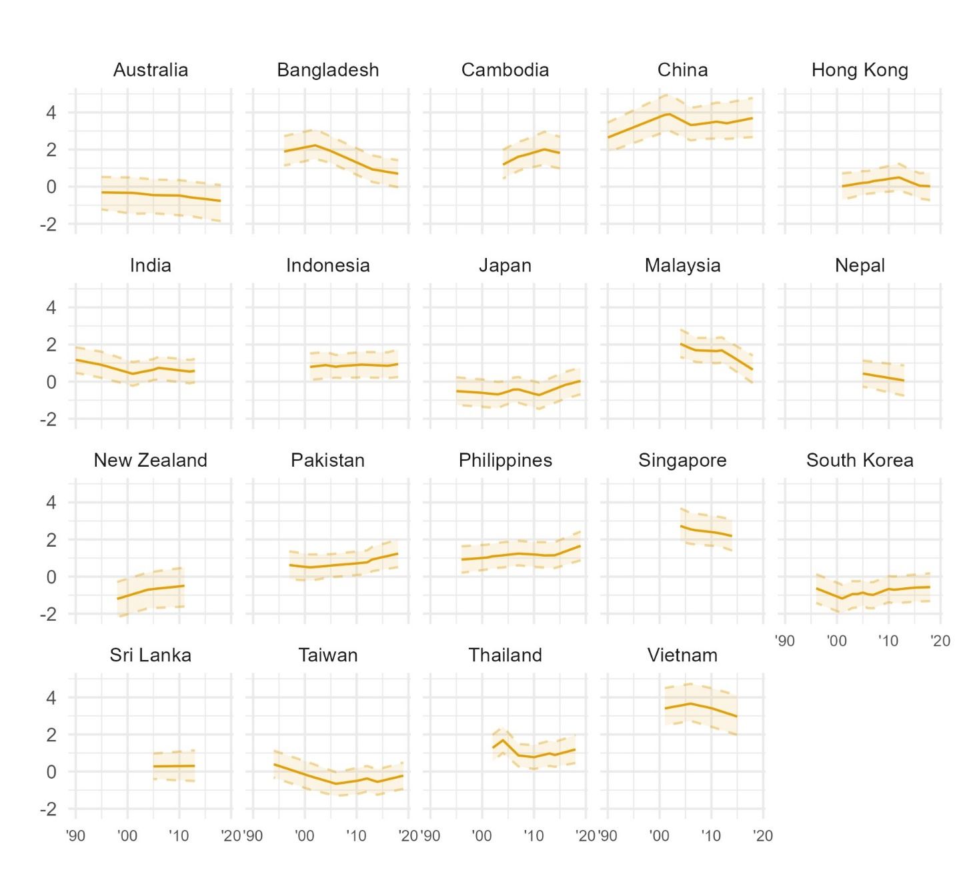
Figure D18. Latent trends in trust in political parties within each country in Asia and the Pacific, from Bayesian latent trend models.

  - The civil service
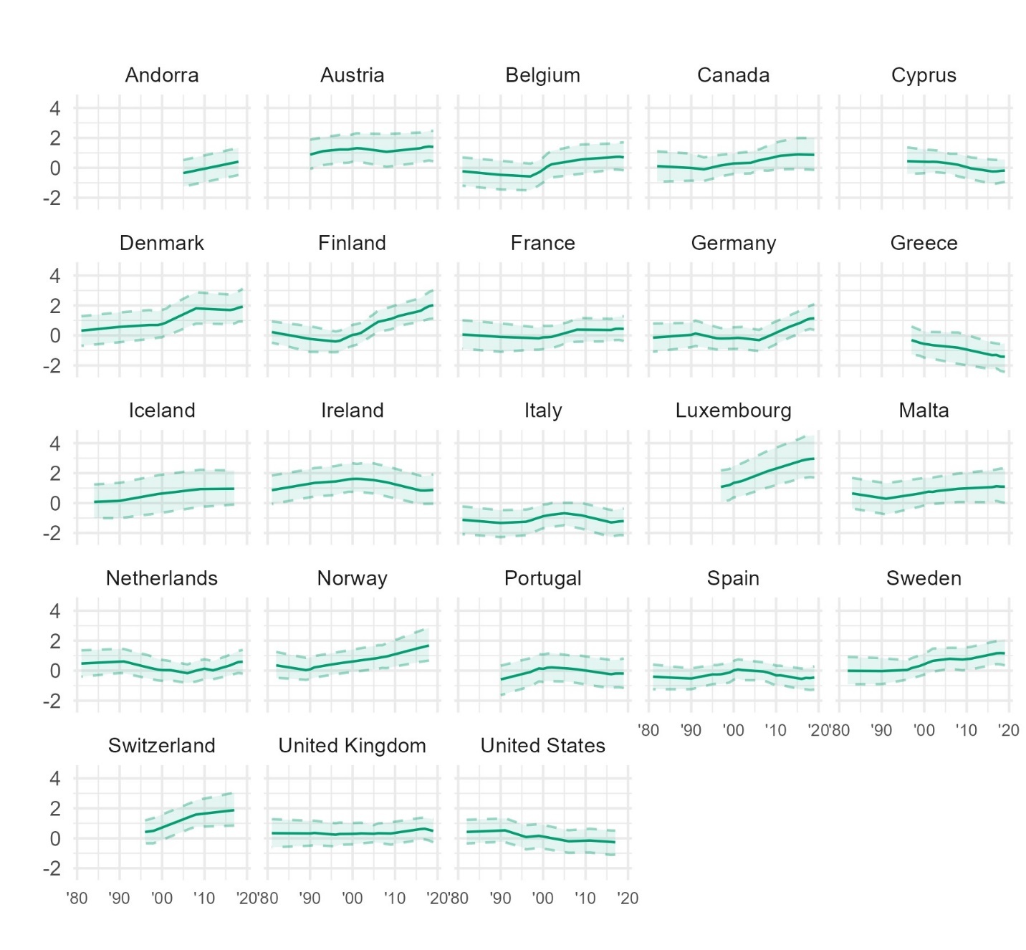
Figure D19. Latent trends in trust in the civil service within each country in Western Europe and North America, from Bayesian latent trend models.
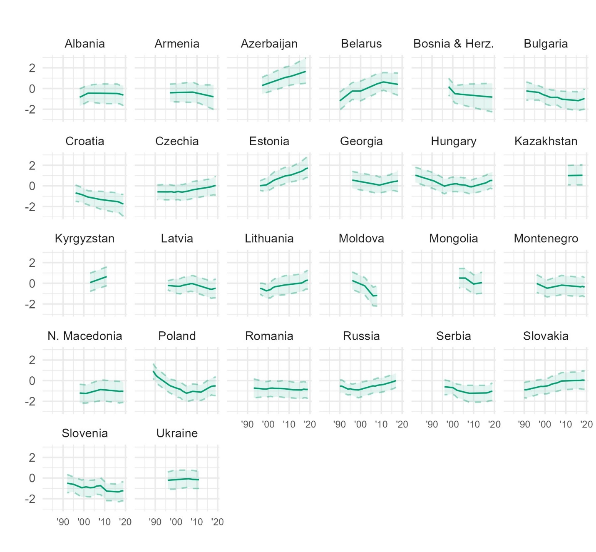
Figure D20. Latent trends in trust in the civil service within each country in Eastern Europe and Central Asia, from Bayesian latent trend models.
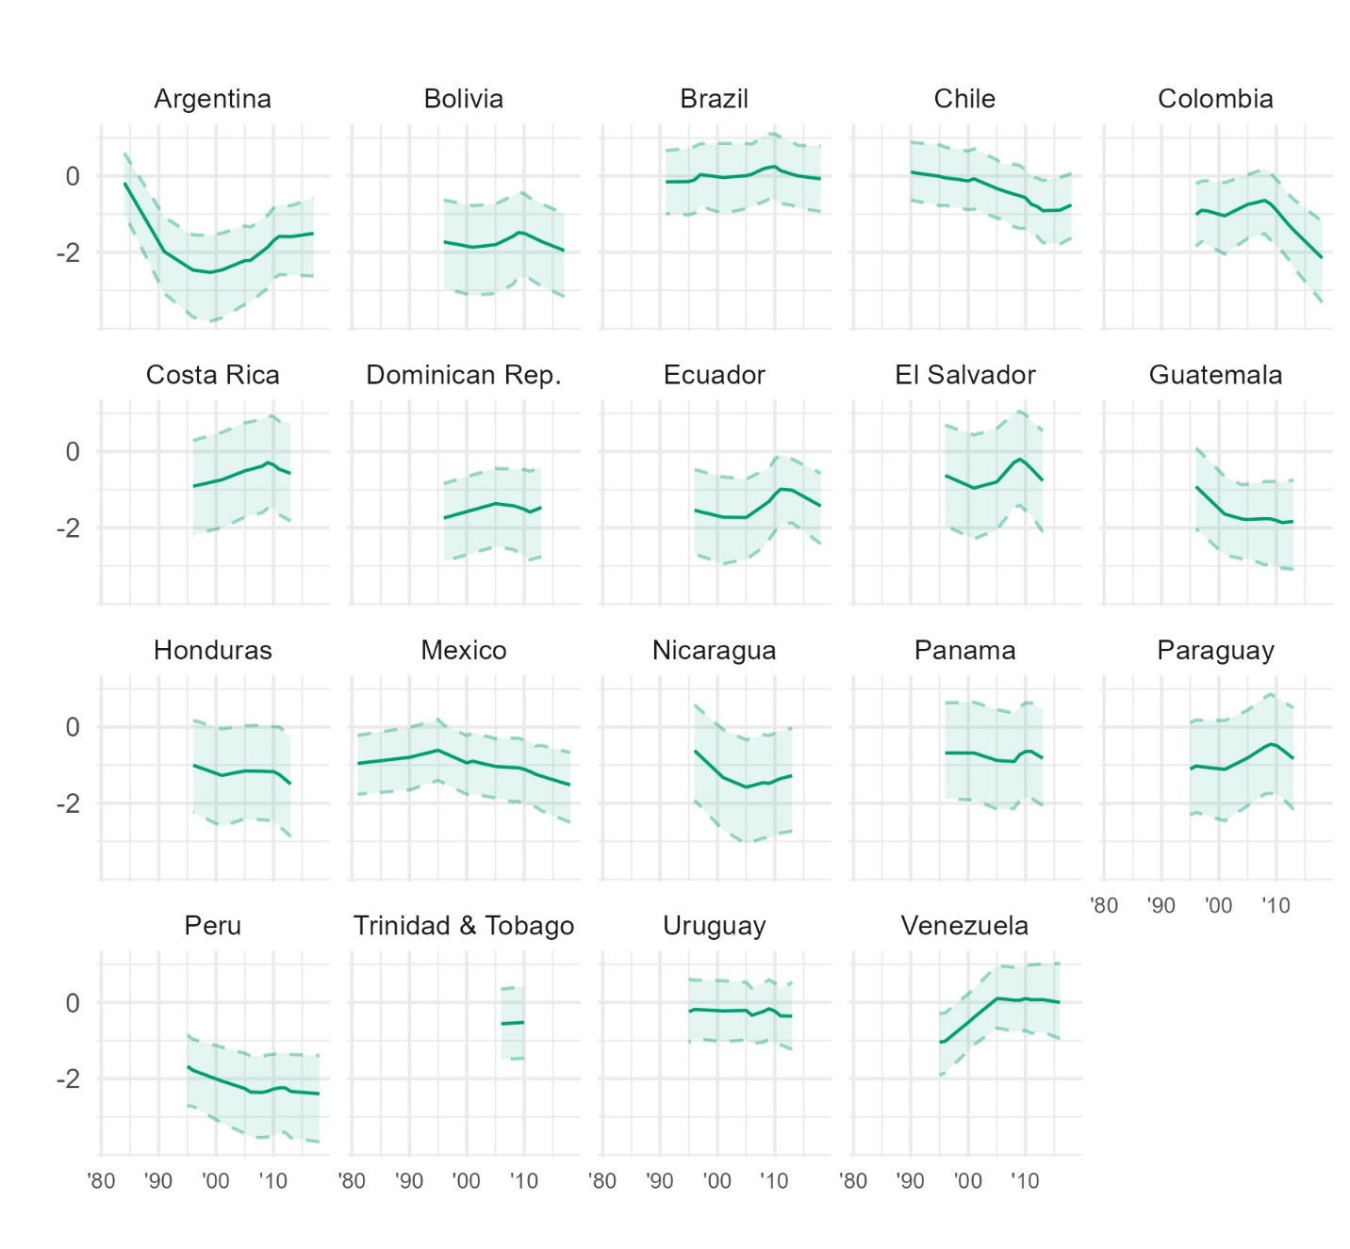
Figure D21. Latent trends in trust in the civil service within each country in Latin America and the Caribbean, from Bayesian latent trend models.
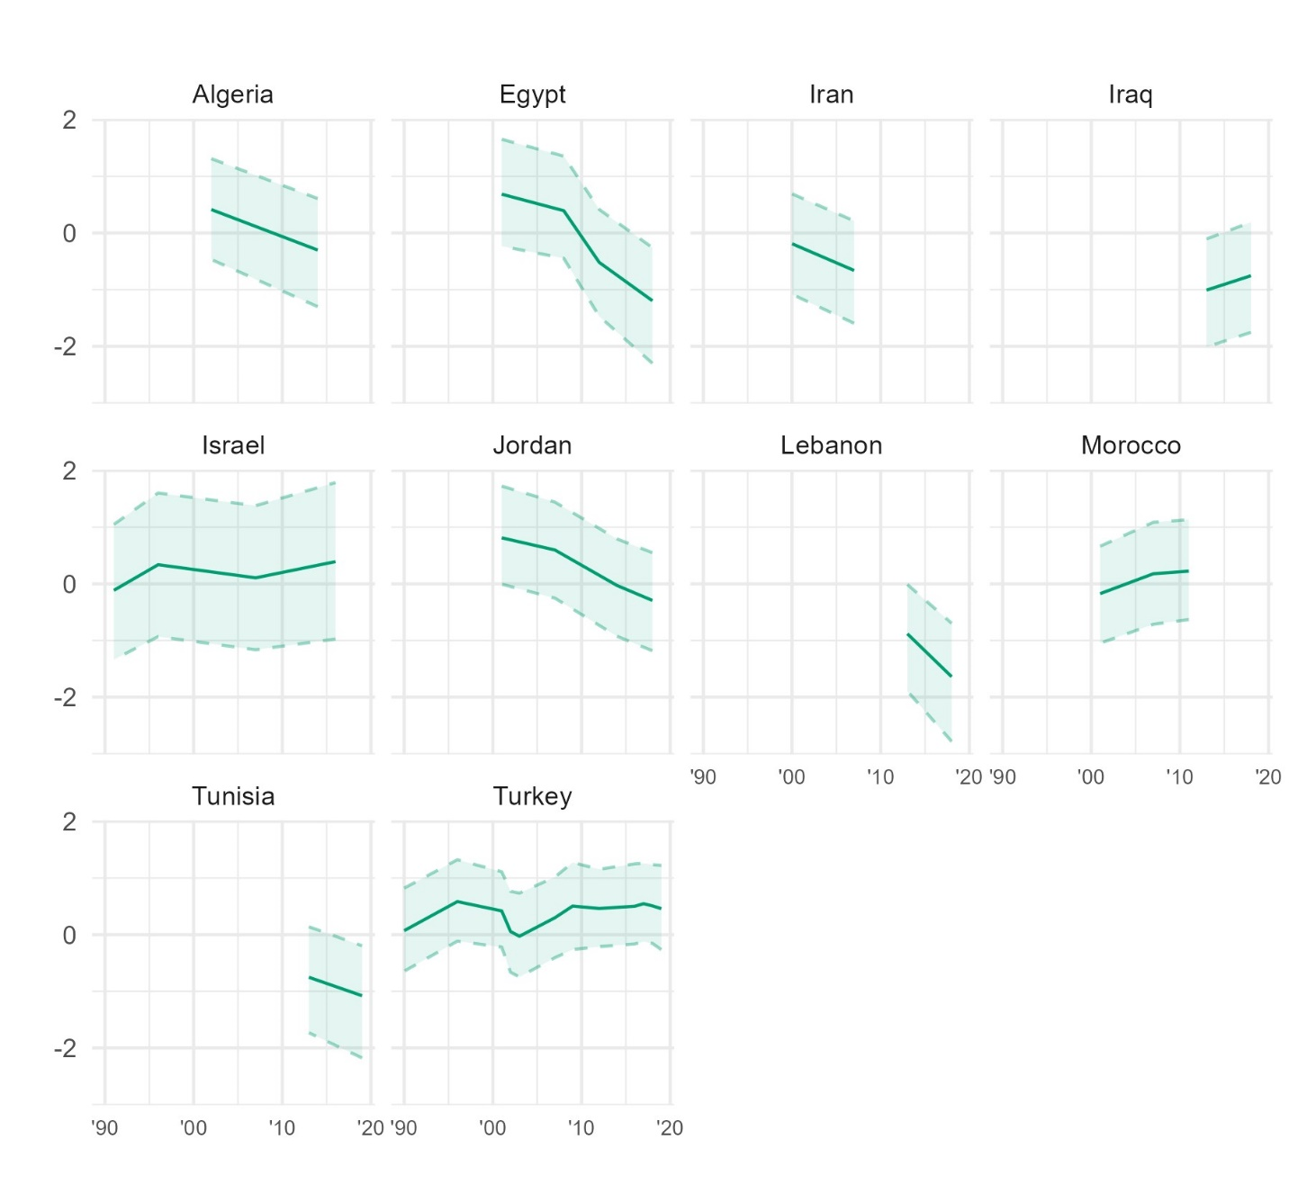
Figure D22. Latent trends in trust in the civil service within each country in the Middle East and North Africa, from Bayesian latent trend models.
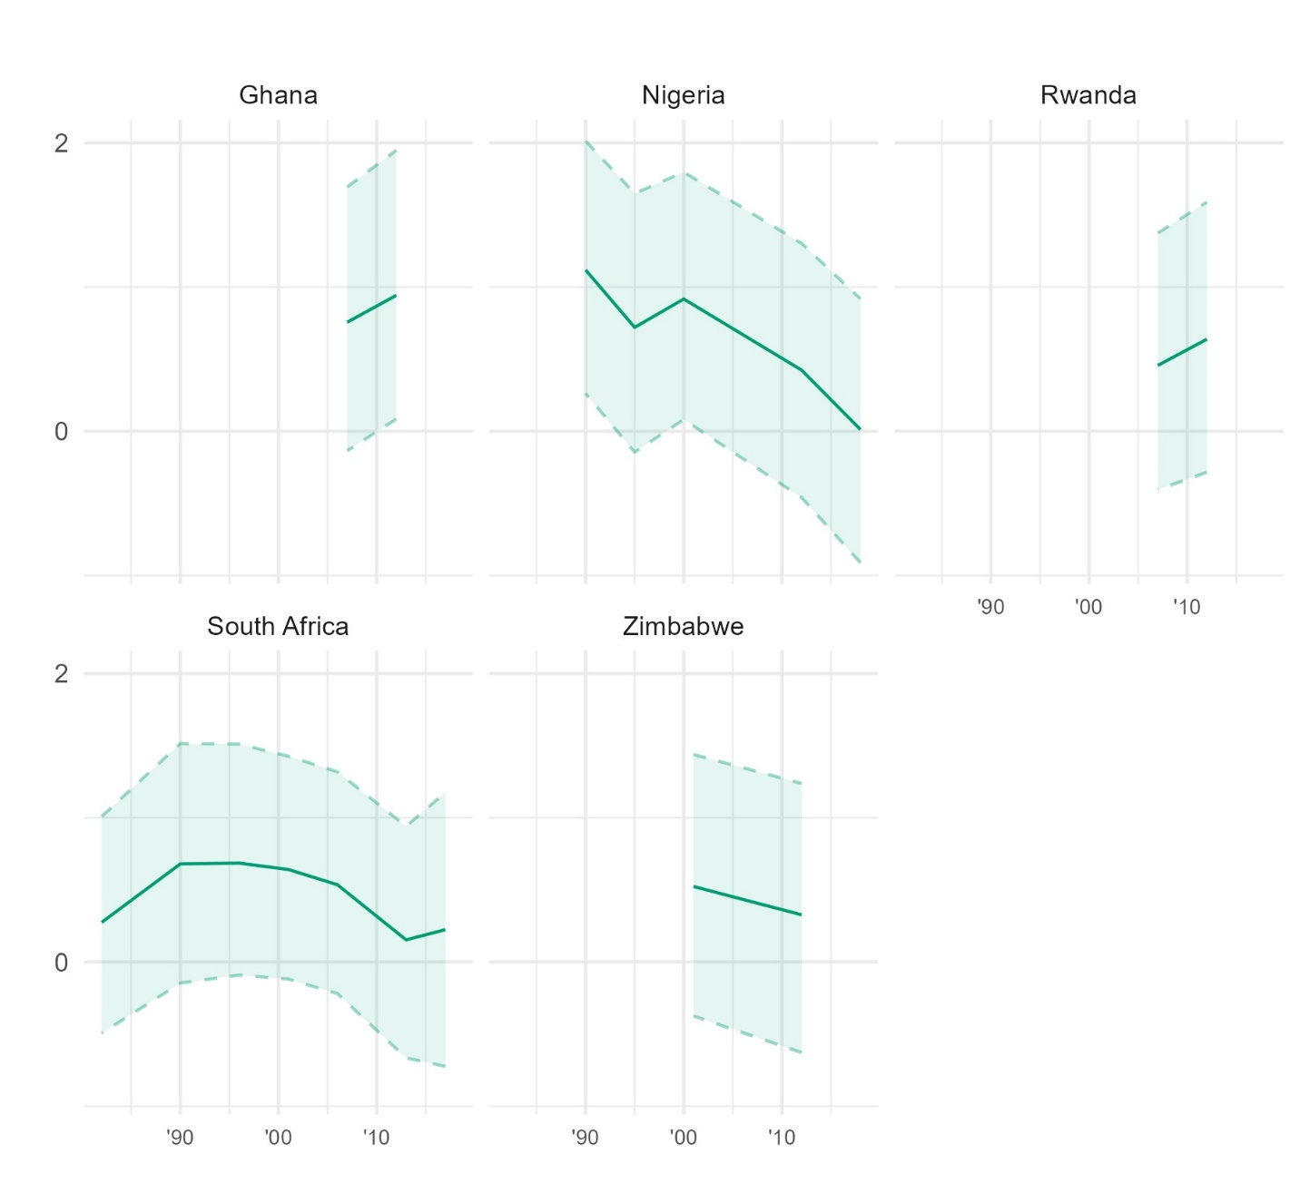
Figure D23. Latent trends in trust in the civil service within each country in Sub-Saharan Africa, from Bayesian latent trend models.
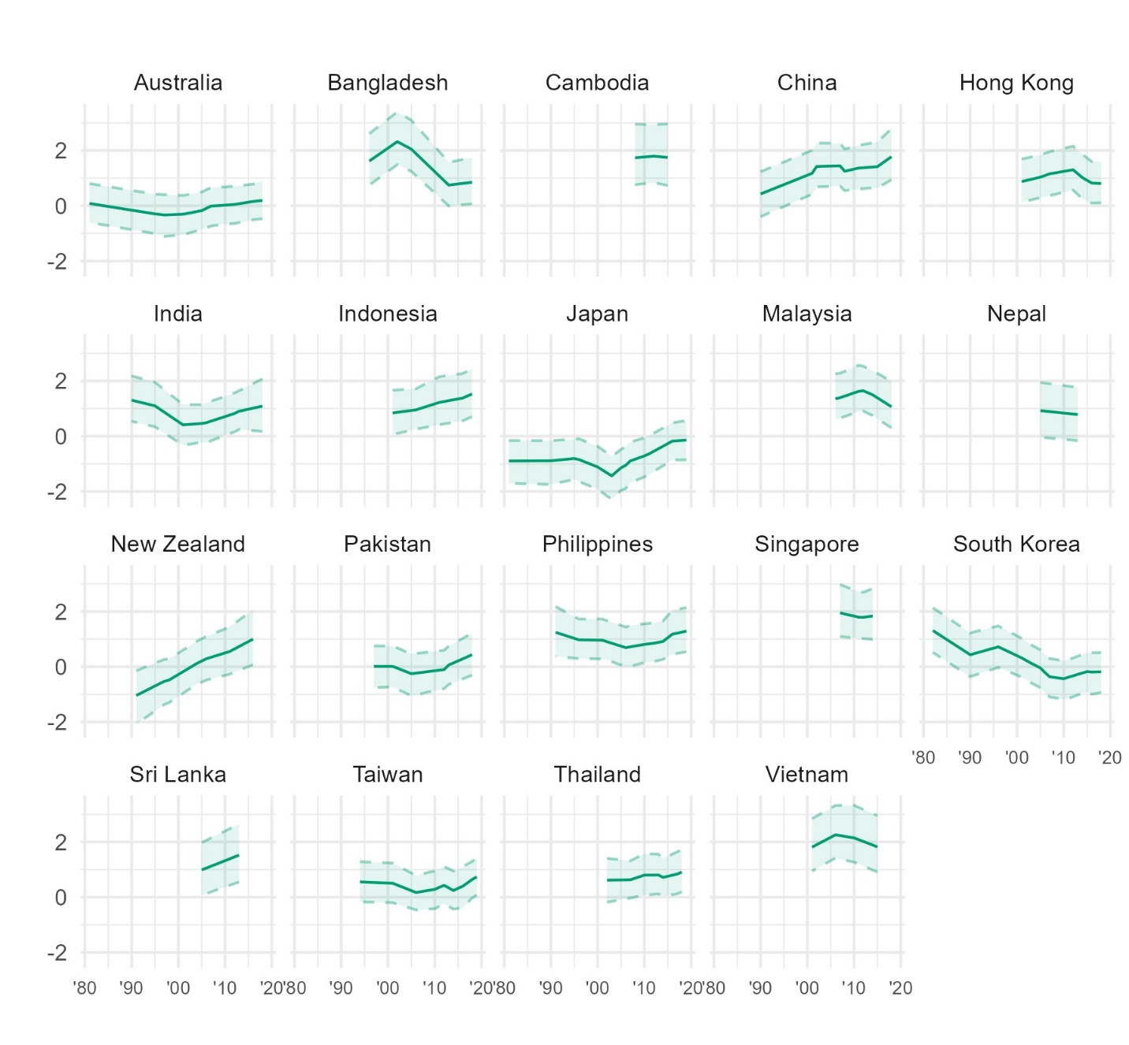
Figure D24. Latent trends in trust in the civil service within each country in Asia and the Pacific, from Bayesian latent trend models.

  - The legal system
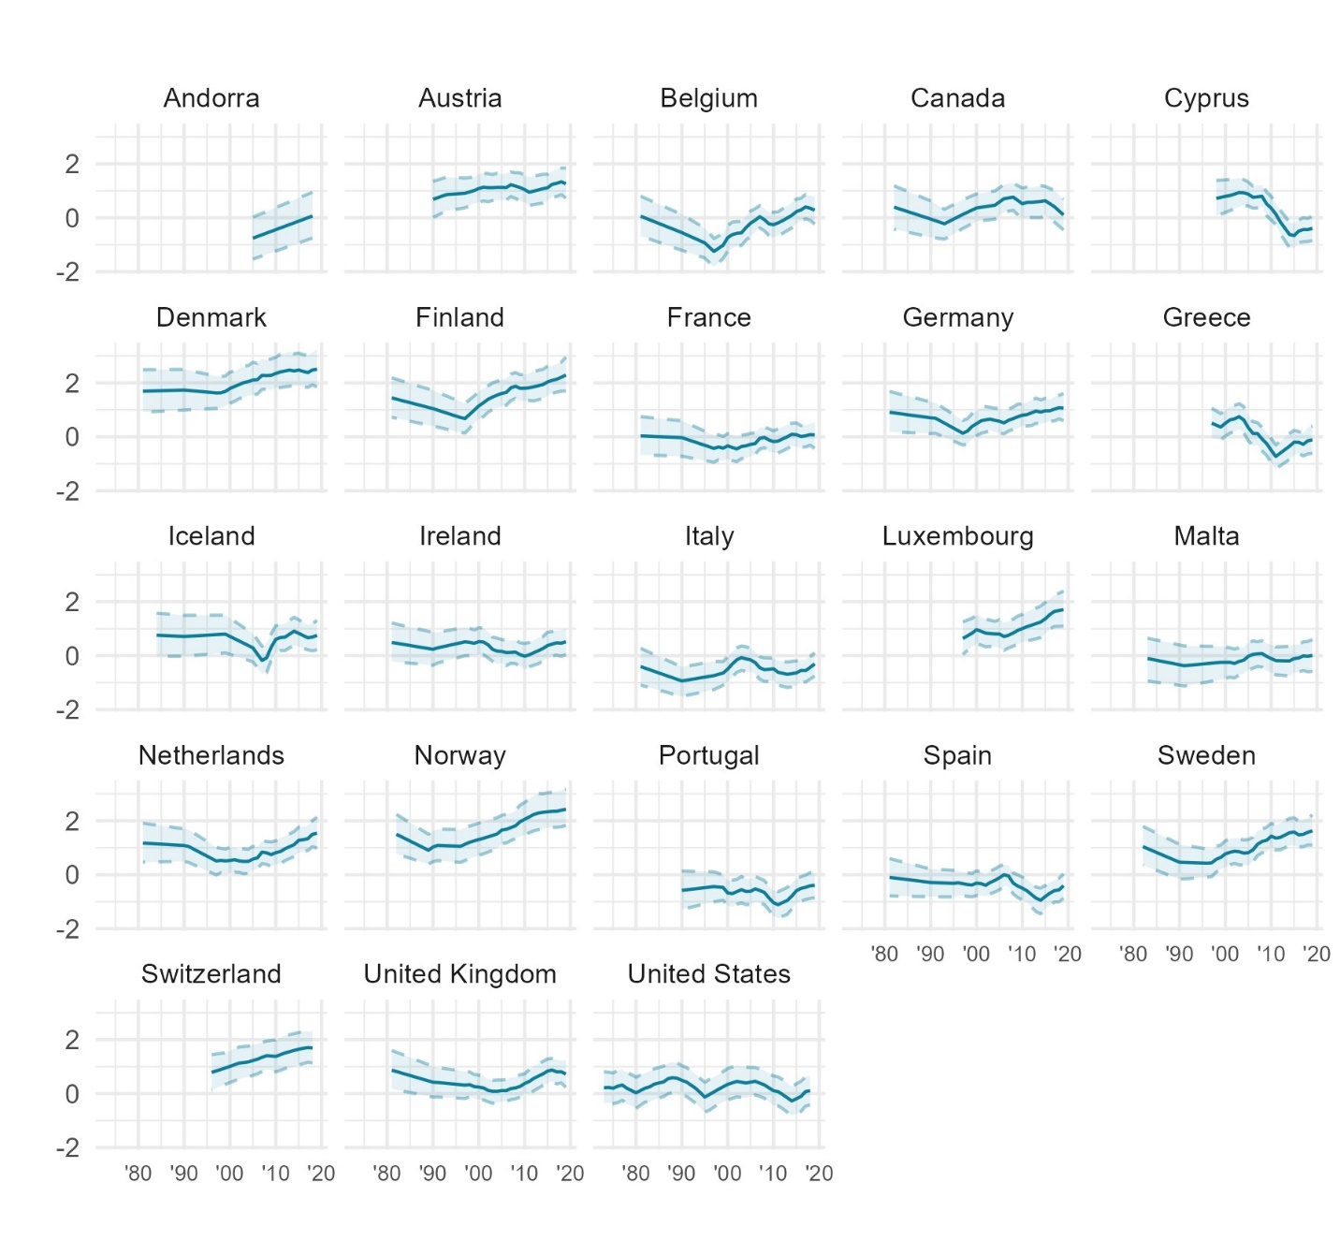
Figure D25. Latent trends in trust in the legal system within each country in Western Europe and North America, from Bayesian latent trend models.
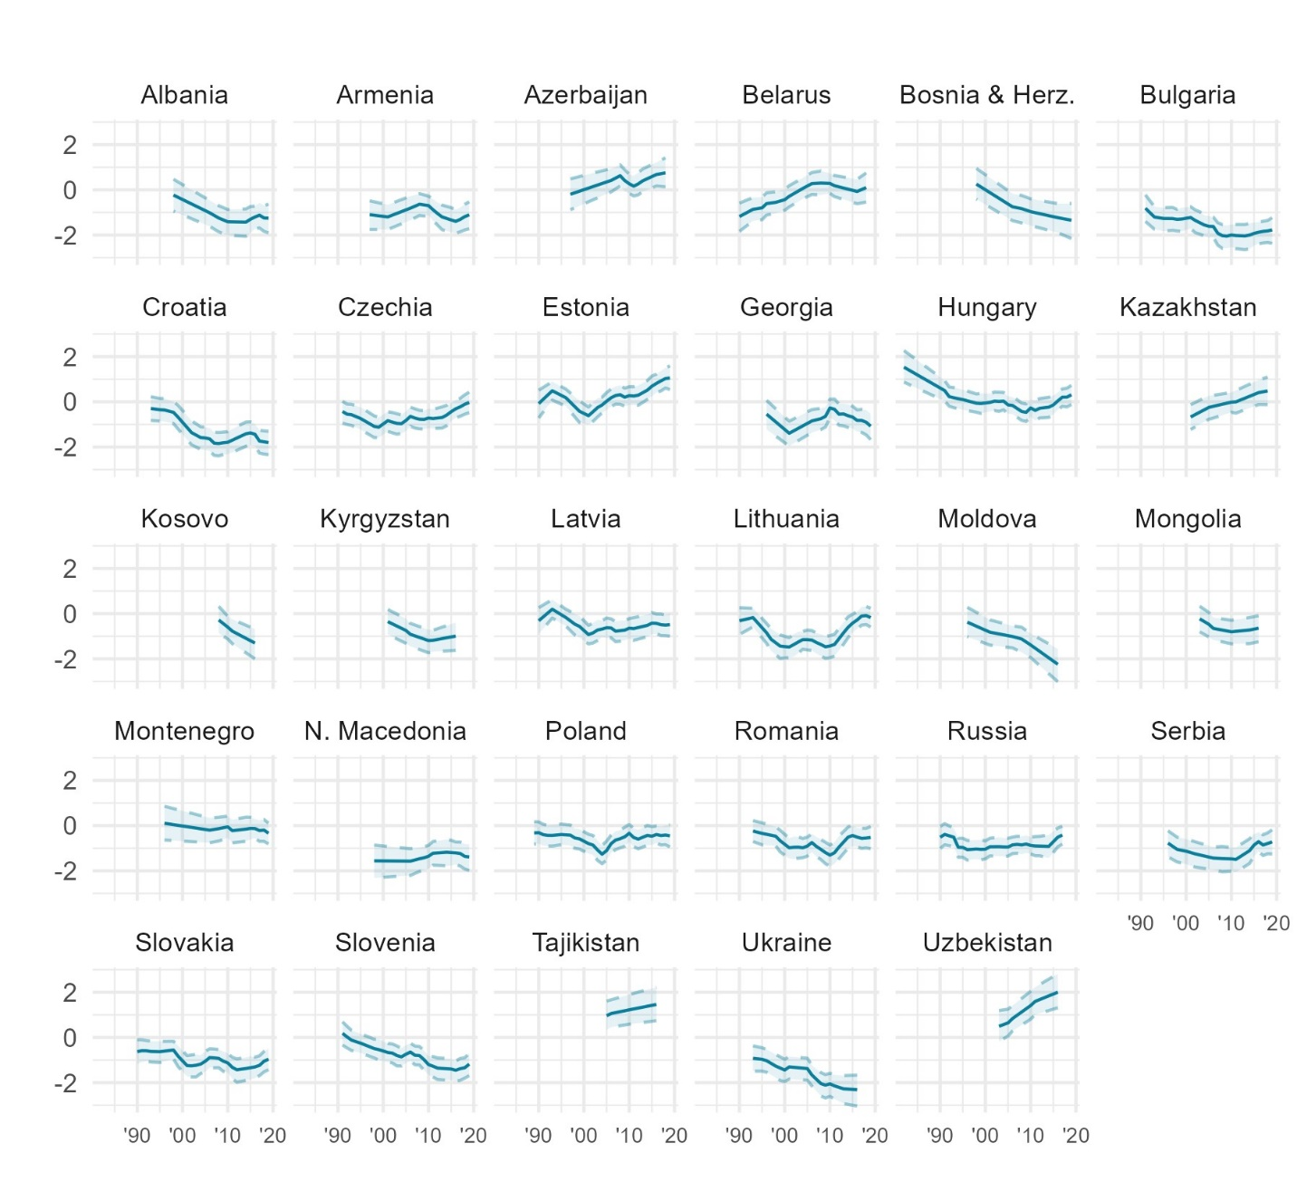
Figure D26. Latent trends in trust in the legal system within each country in Eastern Europe and Central Asia, from Bayesian latent trend models.
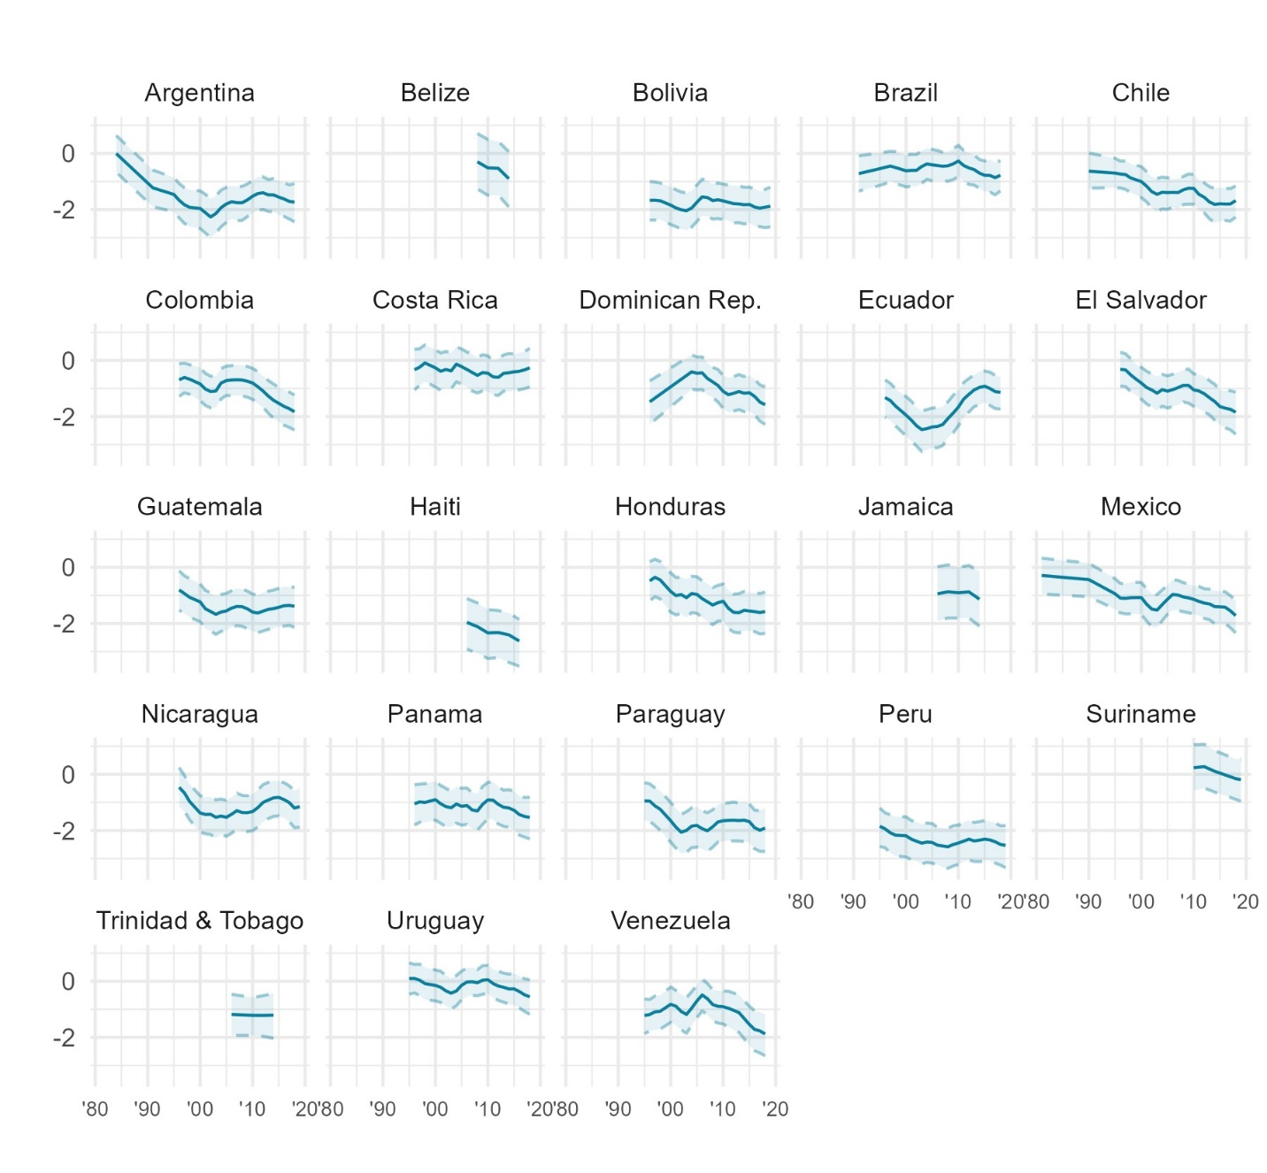
Figure D27. Latent trends in trust in the legal system within each country in Latin America and the Caribbean, from Bayesian latent trend models.
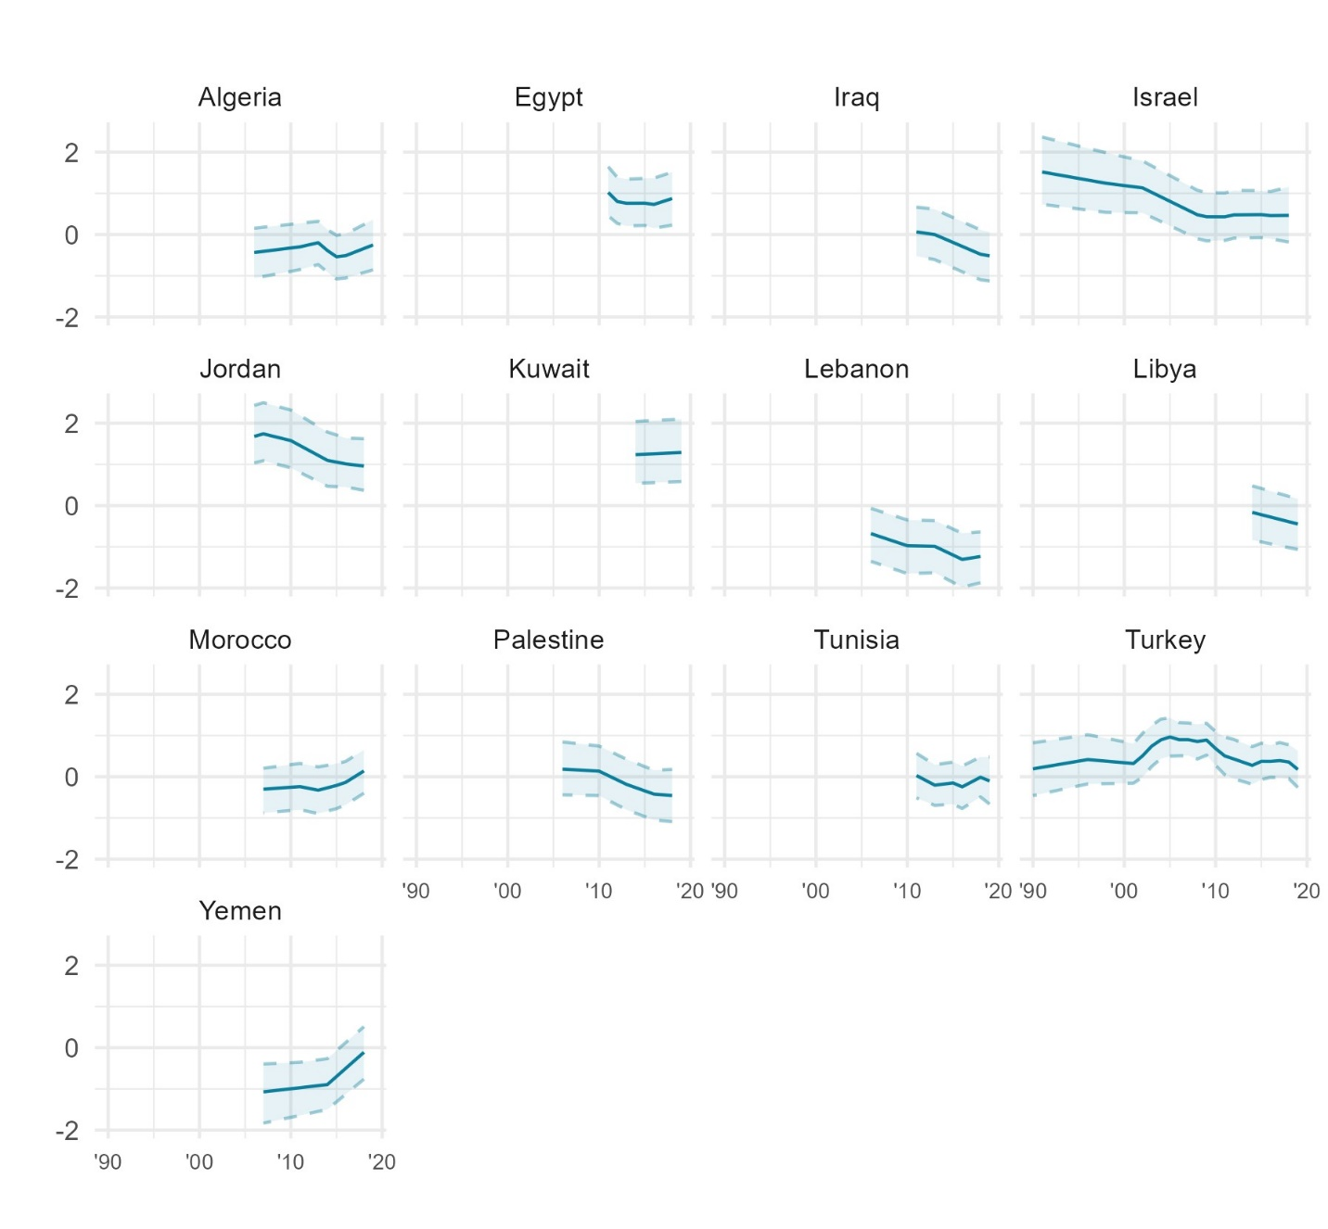
Figure D28. Latent trends in trust in the legal system within each country in the Middle East and North Africa, from Bayesian latent trend models.
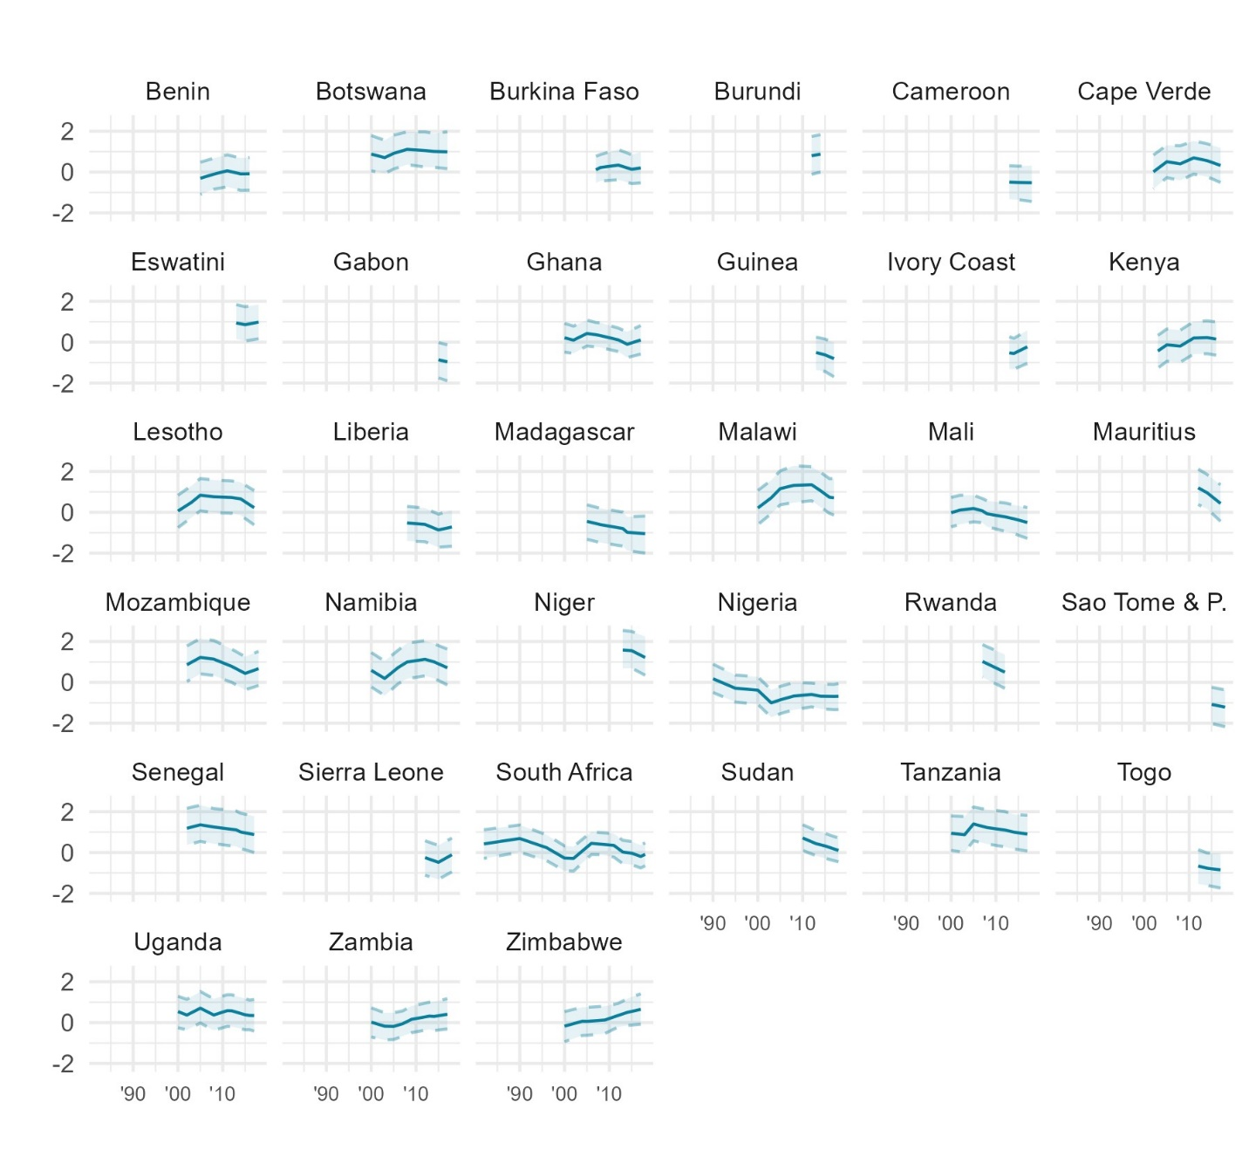
Figure D29. Latent trends in trust in the legal system within each country in Sub-Saharan Africa, from Bayesian latent trend models.
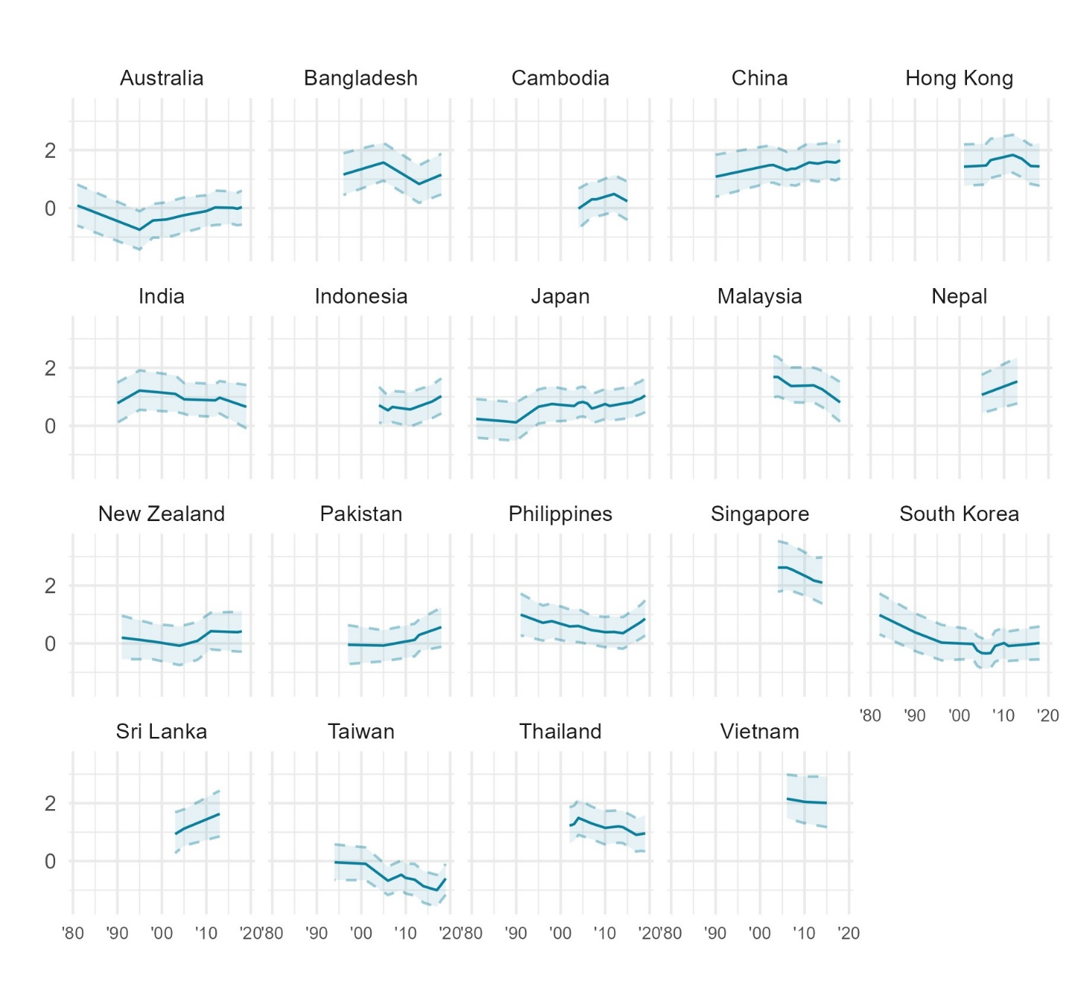
Figure D30. Latent trends in trust in the legal system within each country in Asia and the Pacific, from Bayesian latent trend models.

  - The police
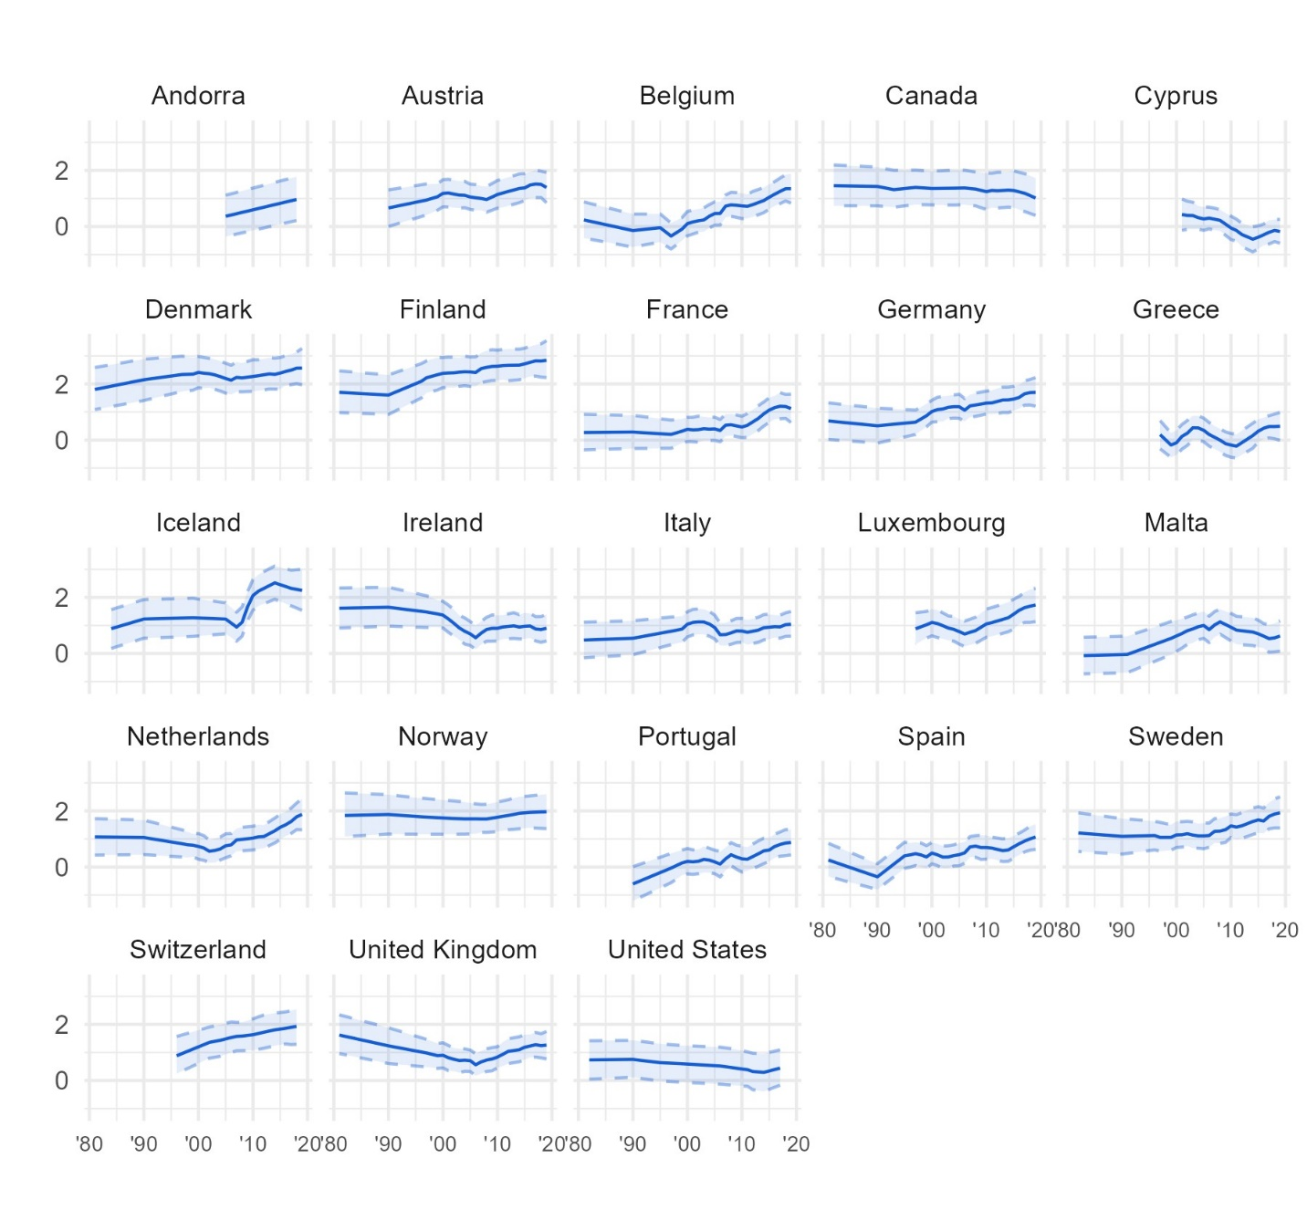
Figure D31. Latent trends in trust in the police within each country in Western Europe and North America, from Bayesian latent trend models.
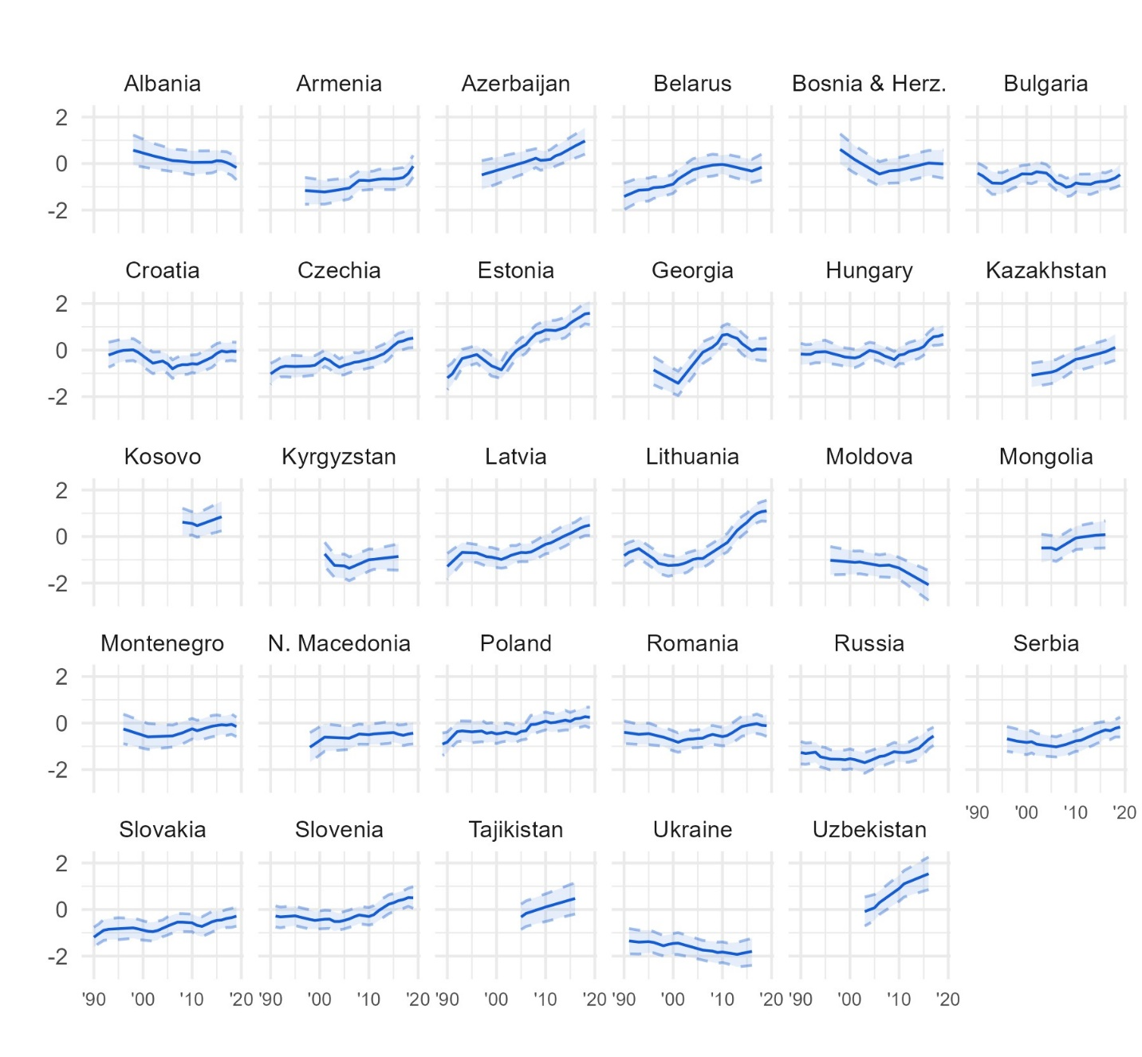
Figure D32. Latent trends in trust in the police within each country in Eastern Europe and Central Asia, from Bayesian latent trend models.
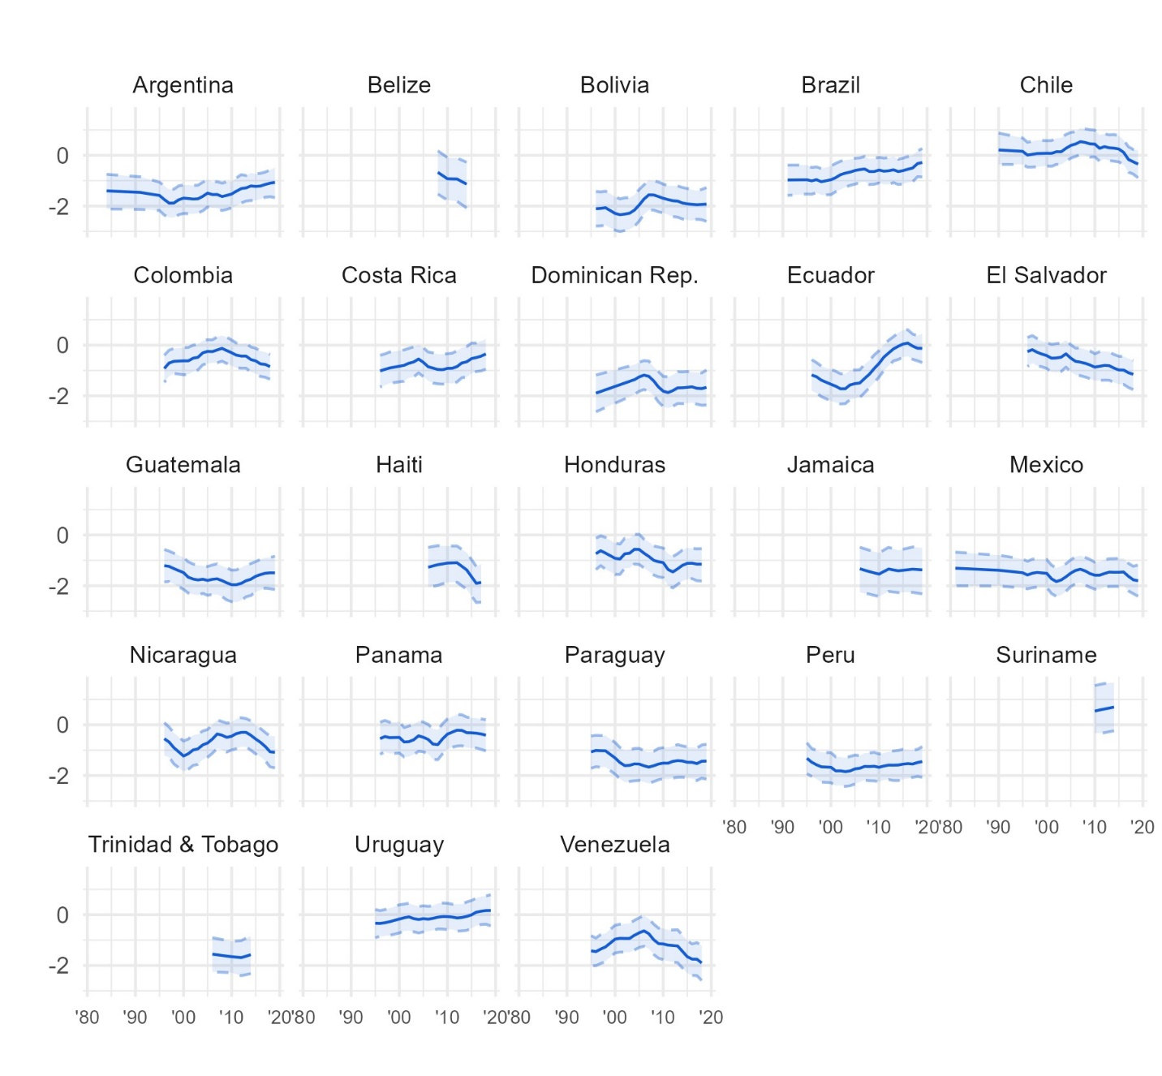
Figure D33. Latent trends in trust in the police within each country in Latin America and the Caribbean, from Bayesian latent trend models.
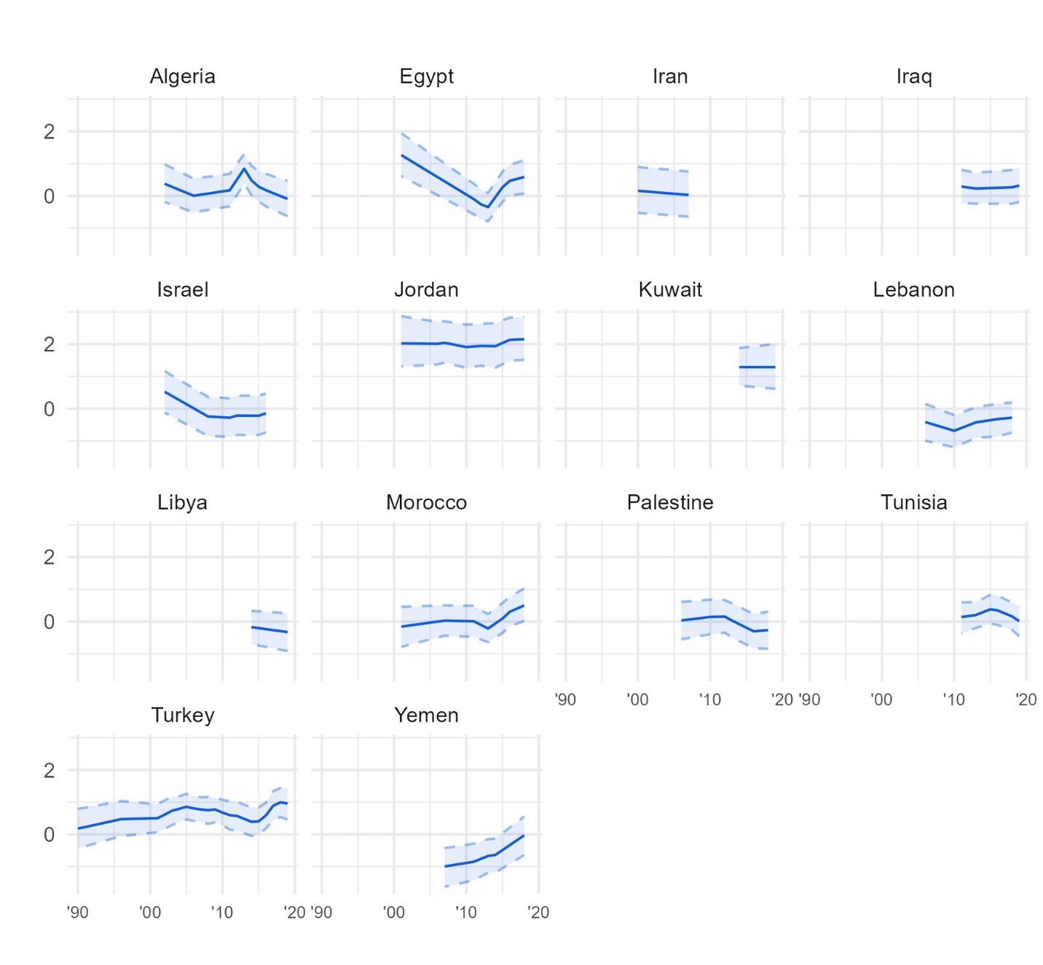
Figure D34. Latent trends in trust in the police within each country in the Middle East and North Africa, from Bayesian latent trend models.
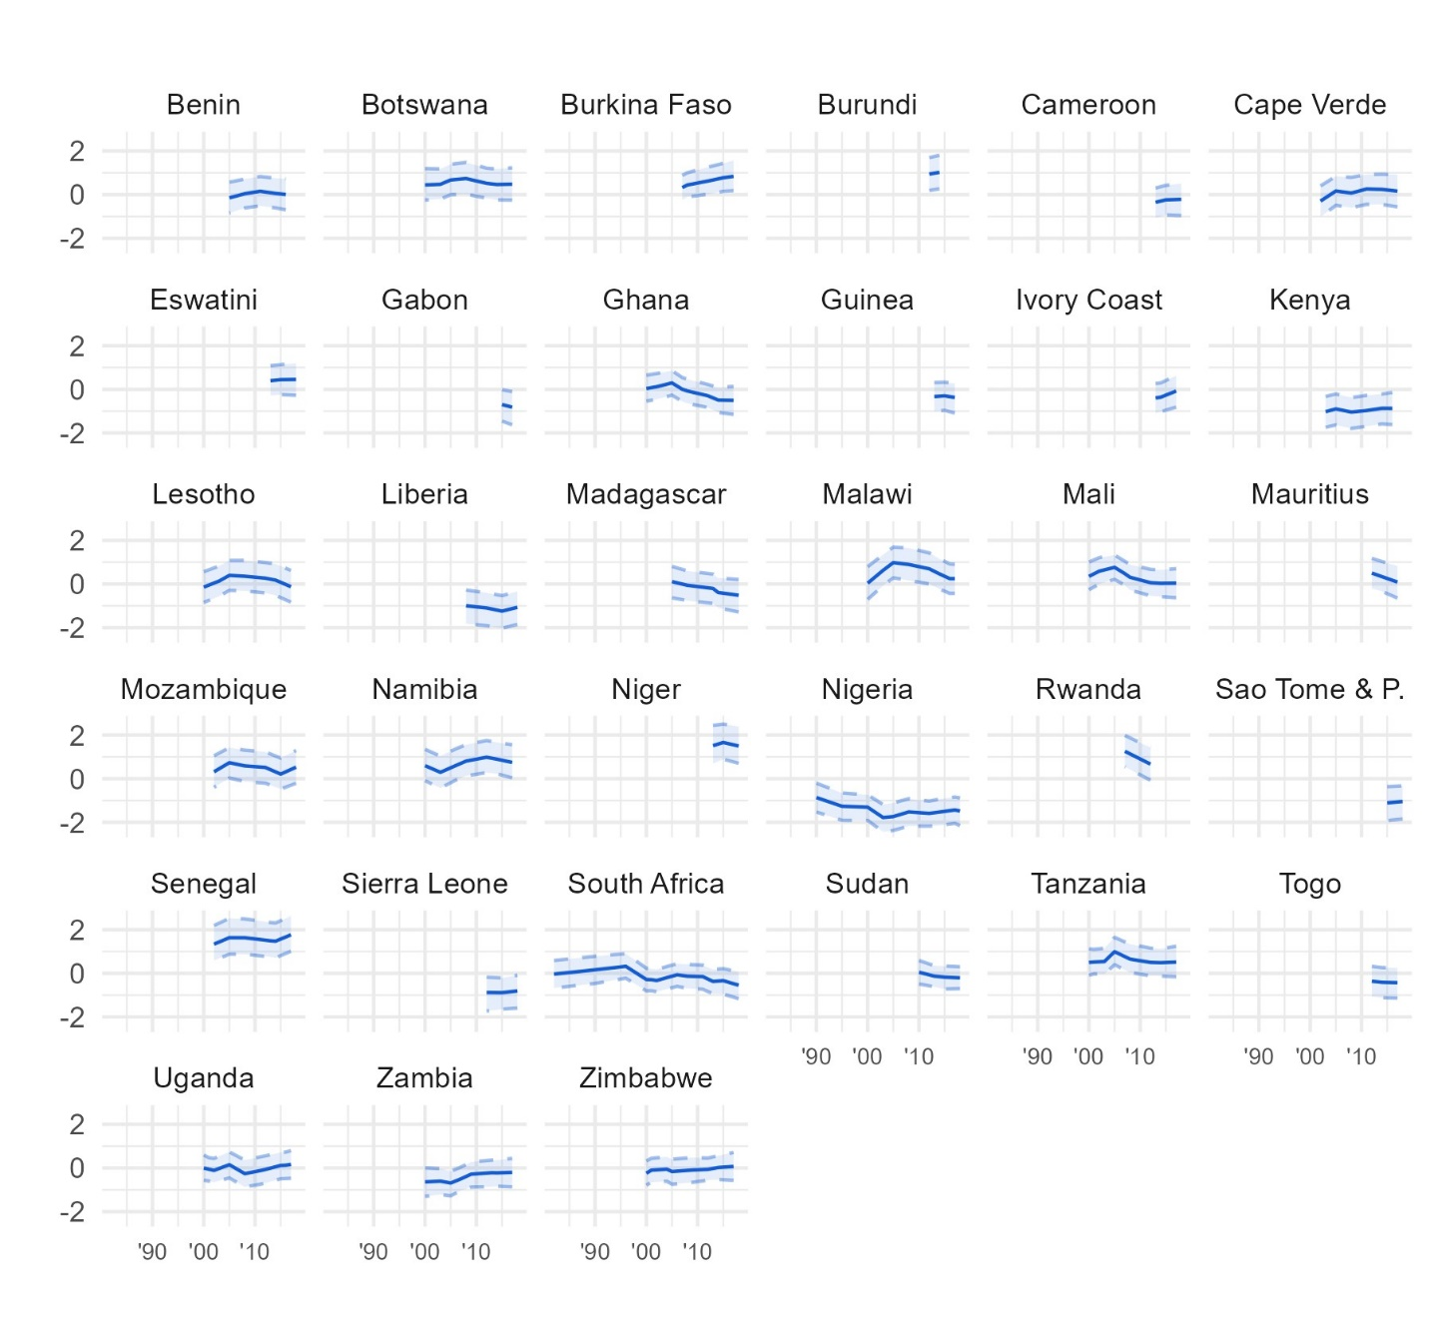
Figure D35. Latent trends in trust in the police within each country in Sub-Saharan Africa, from Bayesian latent trend models.
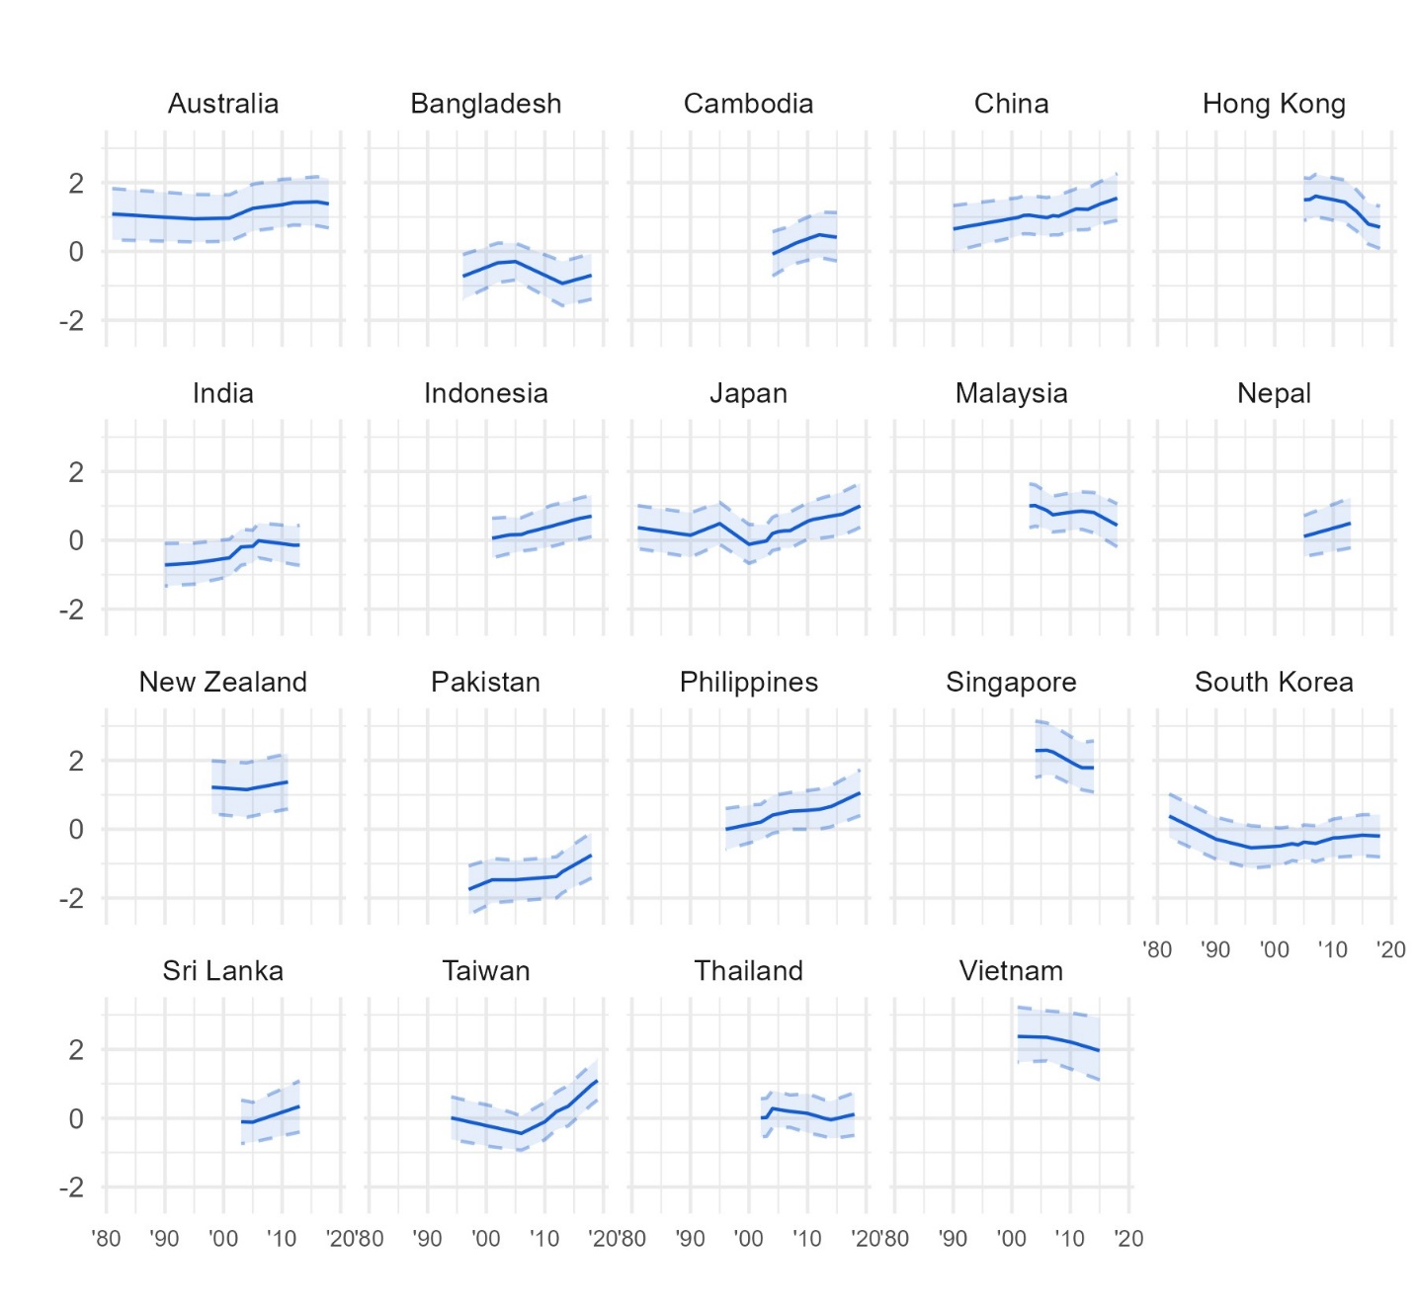
Figure D36. Latent trends in trust in the police within each country in Asia and the Pacific, from Bayesian latent trend models.

- Factor analyses
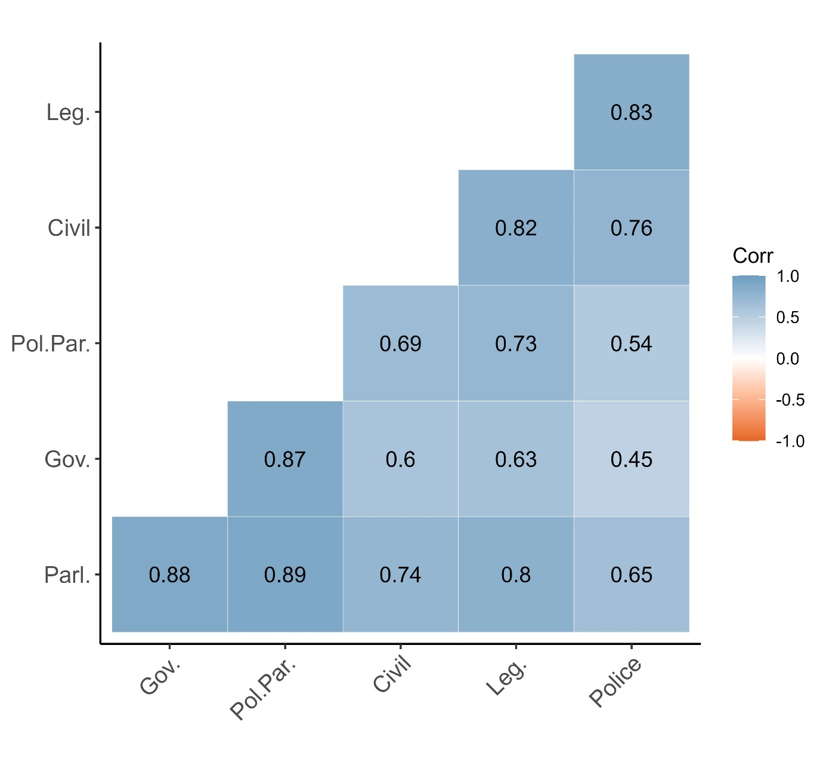
Figure E1. Pearson’s r pairwise correlations between Bayesian estimates of latent trust in six institutions in 89 democratic countries. The total number of observations is 10,656, based on country-year estimates for every year in the period for which we have data in each country.
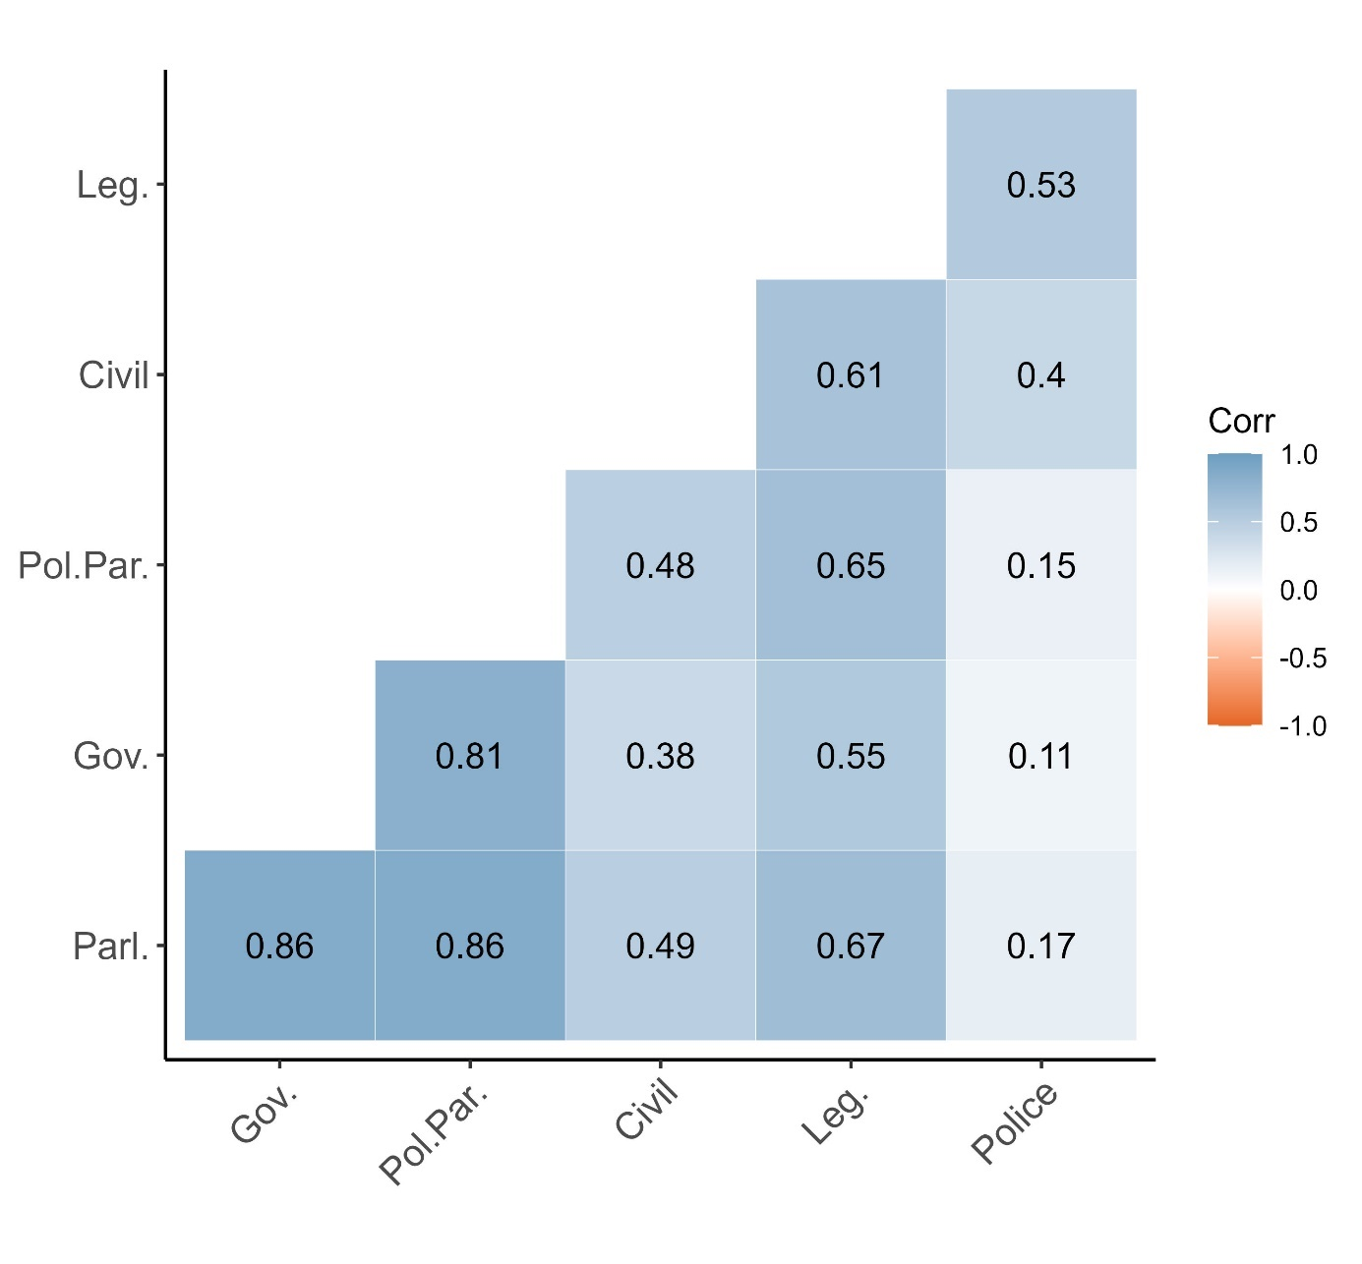
Figure E2. Pearson’s r pairwise correlations between country-centred versions of Bayesian estimates of latent trust in six institutions in 89 democratic countries. These are based on the same data as Figure 1, but here the value of each estimate is first centred to reflect within-country variations.

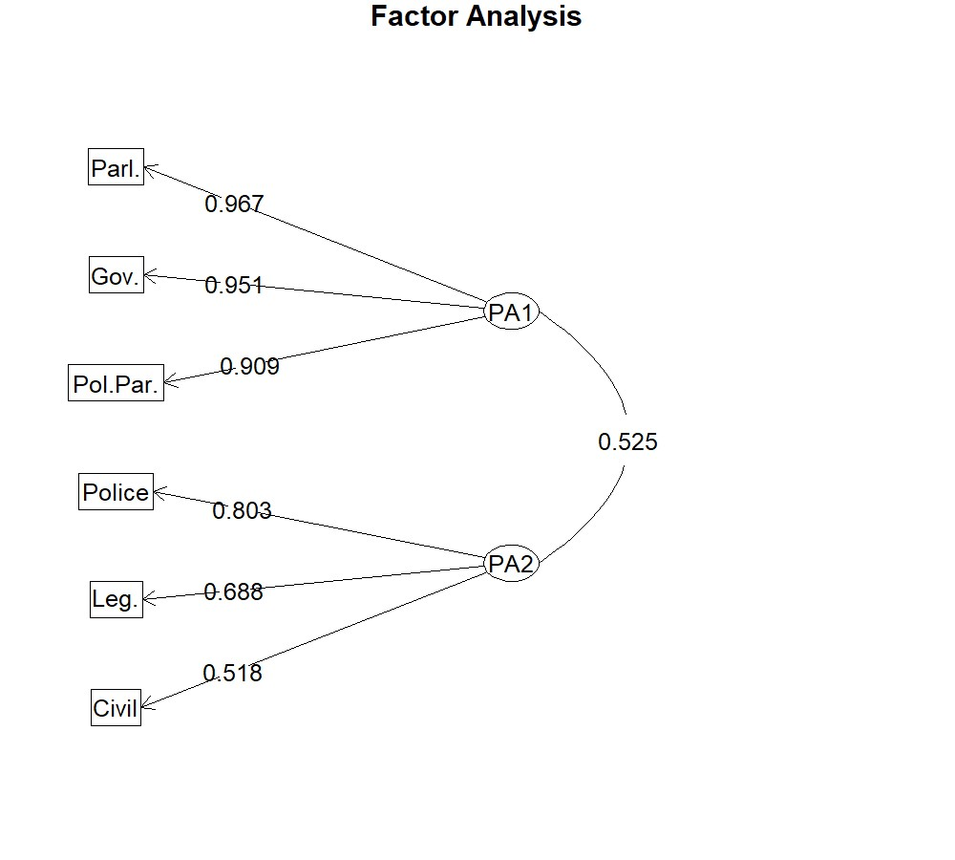
Figure E3. Factor diagram depicting the results of exploratory factor analysis (EFA) of Bayesian trust estimates centred by country, using the same data as in Figure 2.

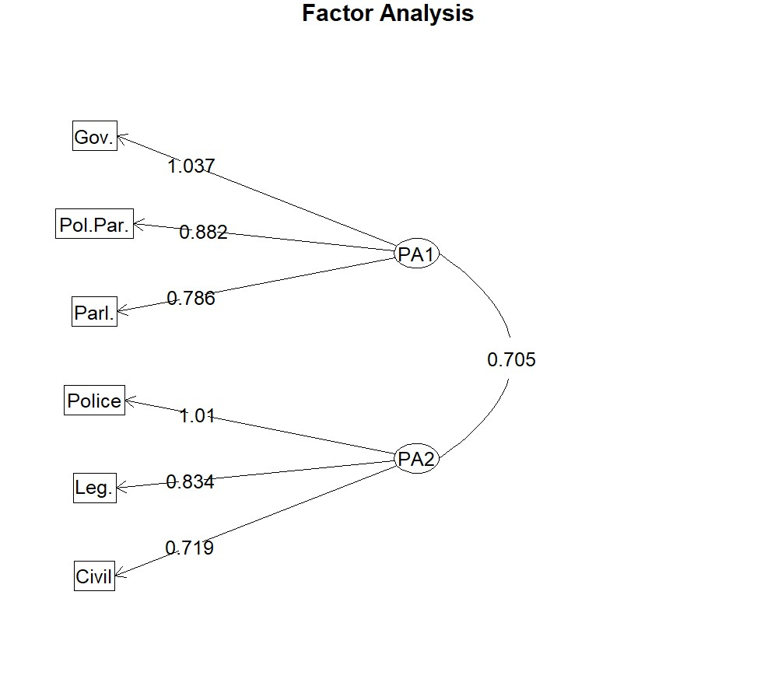
Figure E4. Factor diagram depicting the results of exploratory factor analysis (EFA) of uncentred Bayesian trust estimates, using the same data as in Figure 1 in the main text.

- Sensitivity analysis
For sensitivity analysis of our main results, we first use Stimson’s (1991, 2018) ‘dyad-ratios algorithm’ for uncovering latent trends in these aggregate measures by region as well as globally. The dyad-ratios algorithm offers a solution to the problem of irregular and infrequent availability of survey data and has been used in many previous studies of public ‘mood’. In essence, it uses the ratio of aggregate-level survey responses to a particular question (‘survey item’) fielded by the same survey project in the same country at two or more points in time, to derive information about the relative state of political trust over time according to that survey measure. The dyad-ratios method extracts the underlying tendency of all survey items, weighting each series based on their loading onto the underlying dimension, akin to a form of dynamic factor analysis. We run the algorithm using the “DyadRatios” package in R, separately for each type of political trust in each region as well as for the entire global dataset. For each type of trust, we treat each substantive variation of question wording and response scale from each survey source in each country as a unique item.
Each survey item can be expressed as the ratio of reported trust or satisfaction at two points in time: a “dyad.” This ratio provides an estimate of relative support in years t+i and t+j:
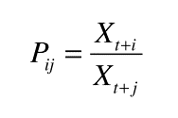
This enables recursive estimation of the index of each measure of trust for each time period. The dyad-ratios algorithm estimates the squared correlation of each item-series, interpretable as a factor loading, with the underlying dimension, and uses this to weight the series in the calculation of the overall trend (Bartle, Dellepiane-Avellaneda, and Stimson 2011, 269).
All of these dyad-ratios models converged. The percentage of variance explained by the global model for trust in parliament is 38.7%. For government, it is 39.5%, for political parties it is 37.9%, for the civil service it is 47.7%, for the legal system it is 30.8% and for the police it is 44.24%. All models except for trust in the police in the LAC region have explained variance above 30%, most considerably higher, which is typical for these kinds of models (Stimson 2018, 210).
  - Stimson’s dyad-ratios algorithm
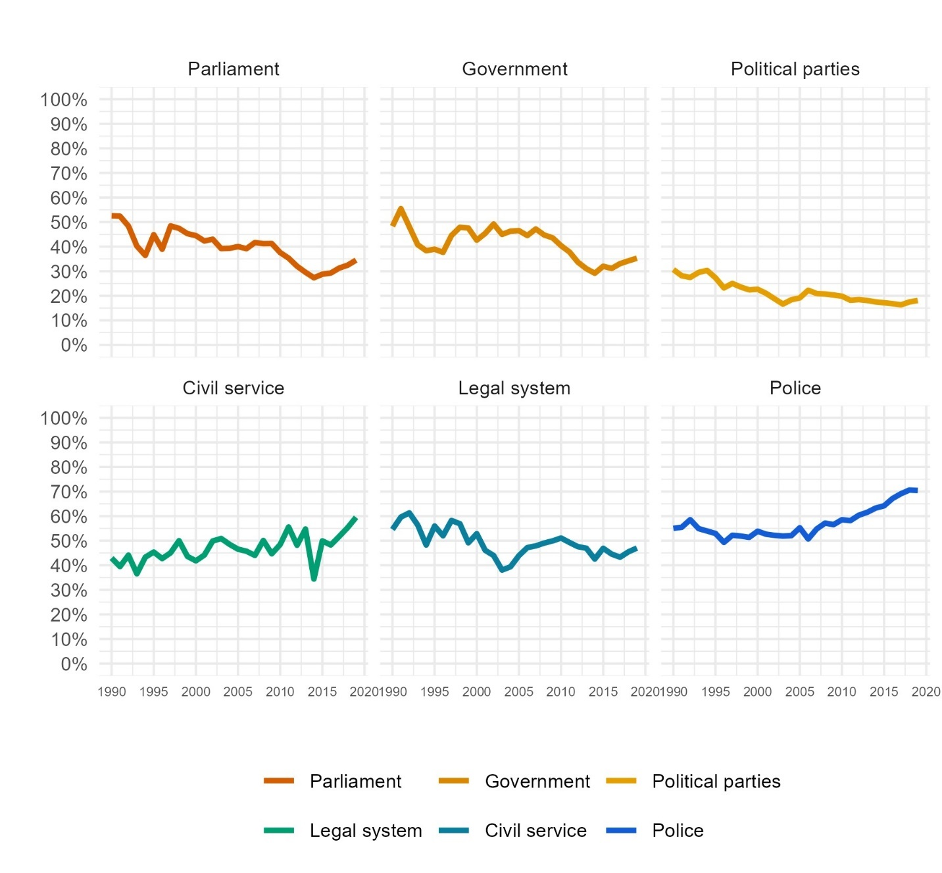
Figure E1. Global trends in six measures of political trust, from Stimson’s dyad-ratios algorithm estimates.

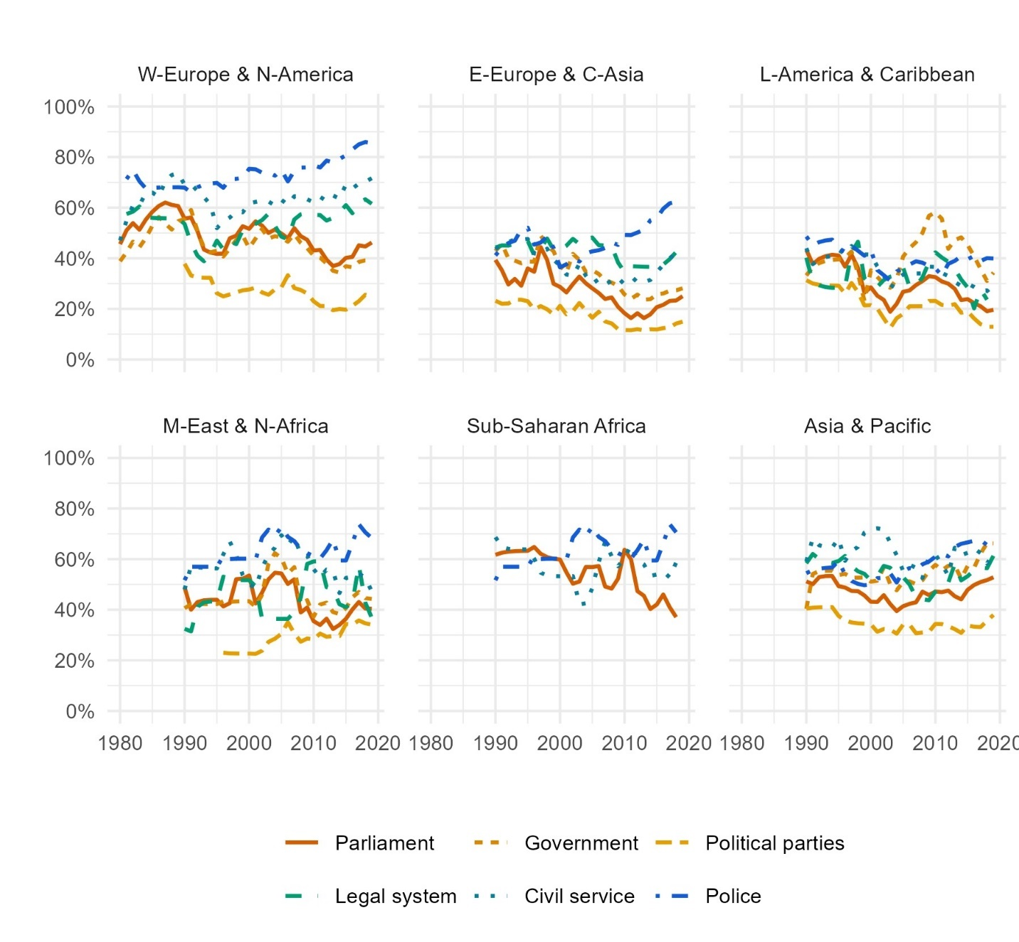
Figure E2. Estimated trends in six measures of political trust from Stimson’s dyad-ratios algorithm, by world region (panels by region).

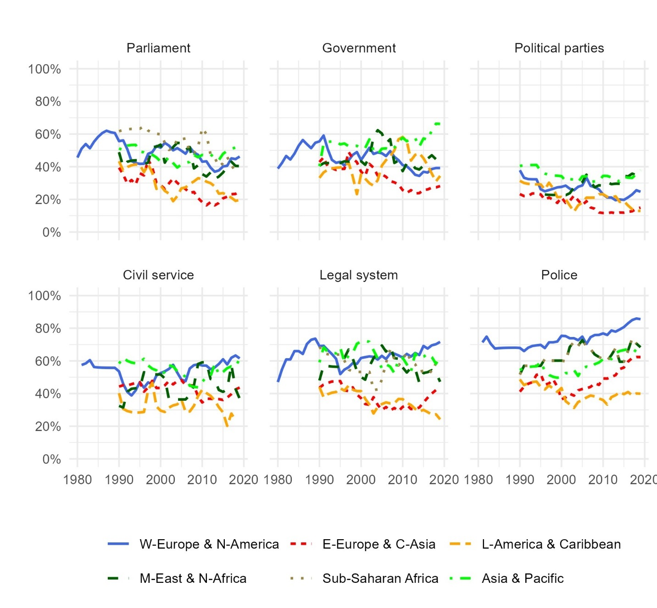
Figure E3. Estimated trends in six measures of political trust from Stimson’s dyad-ratios algorithm, by world region (panels by measure).

  - Multi-level regression models (MLMs)
We also run multi-level linear regression models with random intercepts, with each of the trust measures as the dependent variable in separate models: first using the entire global dataset, including only countries classified as democratic, as in our main analysis, and then separately for each region. These models are run using the individual-level data which includes about 4.3 million respondents. The models are specified so that individuals are nested within survey projects, which in turn are nested within countries, and the intercepts for each level are allowed to vary (allowing the slopes to vary as well resulted in models that did not converge). Every model includes only the variable for the year that the survey was conducted in as an independent variable. We run the models using the same survey weights used in the main analysis, via the “weights” option in the “lmer” function in R. Table E8 below presents results from the global models when omitting the weights, showing that results are substantively the same. These models take the following form, where i stands for the individual respondent, j for survey project, and k for country:
$y_{ijk}=β_{0}+β_{1}x_{ijk}+v_{0k}+u_{0jk}+e_{ijk}$
Figure E4 presents the predicted margins for trust by year for each measure globally, Figure E5 presents the same estimates by region and Tables E1 to E7 present the full regression output from these models.
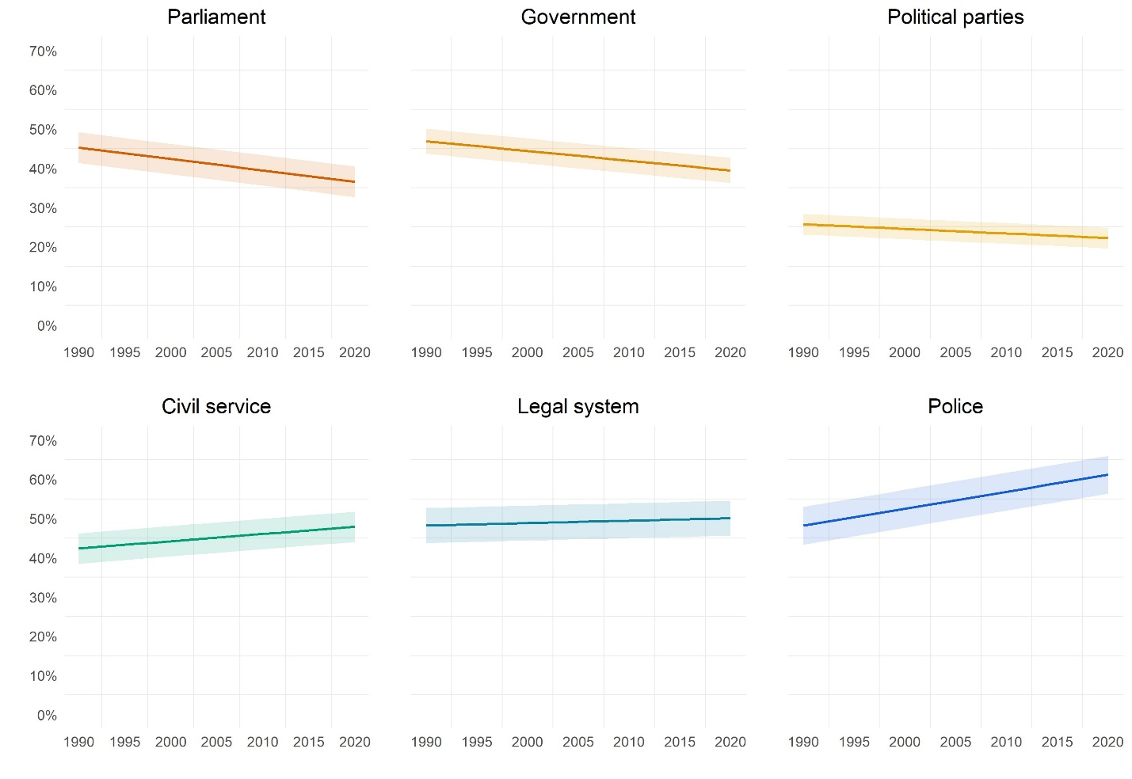
Figure E4. Global trends in six measures of political trust, from multi-level linear regression models on the individual (respondent) level with random intercepts, where respondents are nested within survey sources which in turn are nested within countries.

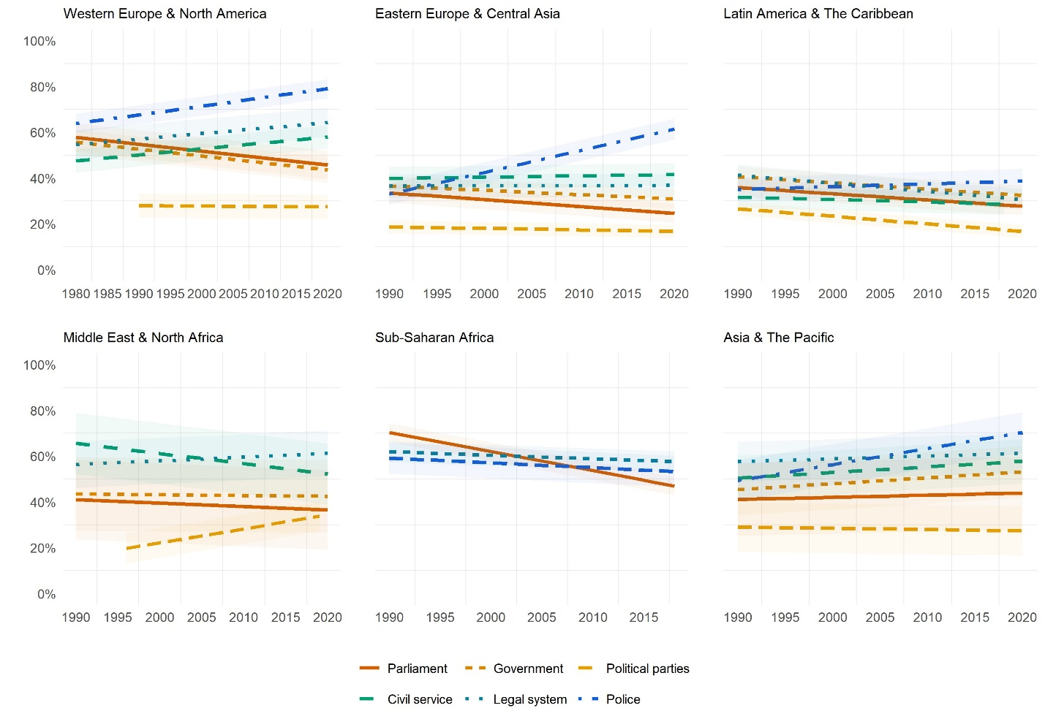
Figure E5. Estimated trends in six measures of political trust, from multi-level linear regression models specified as in Figure E4, by world region.

Table E1. Output from multi-level regression models of trends in political trust: Global dataset. Models are linear regression models on dichotomized trust variables on the individual level, four decimal points are shown as the coefficients are interpretable as changes in proportion (not percentage points).

 | (1) | (2) | (3) | (4) | (5) | (6)
 | Parliament | Government | Political Parties | Civil service | Legal system | Police
Constant | 6.2169** | 5.4002** | 2.6039** | -3.2420** | -0.7566** | -8.1390**
 | (0.0897) | (0.1118) | (0.0931) | (0.1302) | (0.0957) | (0.0989)
Year | -0.0029** | -0.0025** | -0.0012** | 0.0018** | 0.0006** | 0.0043**
 | (0.0000) | (0.0001) | (0.0000) | (0.0001) | (0.0000) | (0.0000)
Var: study:country  (Intercept) | 0.0306 | 0.0211 | 0.0125 | 0.0234 | 0.0373 | 0.0424
Var: country  (Intercept) | 0.0255 | 0.0156 | 0.0093 | 0.0184 | 0.0331 | 0.0380
Var: Residual | 0.2090 | 0.2197 | 0.1604 | 0.2272 | 0.2177 | 0.2084
Num. groups:  study:country | 471 | 438 | 290 | 217 | 371 | 339
Num. groups:  country | 88 | 78 | 74 | 71 | 88 | 88
Observations | 3488882 | 2790165 | 2598742 | 1076881 | 2690830 | 2529830
Standard errors in parentheses
⁺ p < 0.10,* p < 0.05,** p < 0.01,*** p < 0.001

Table E2. Output from multi-level regression models of trends in political support: Western-Europe and North-America. Models are linear regression models on dichotomized trust variables on the individual level, four decimal points are shown as the coefficients are interpretable as changes in proportion (not percentage points).
 | (1) | (2) | (3) | (4) | (5) | (6)
 | Parliament | Government | Political Parties | Civil service | Legal system | Police
Constant | 6.5429** | 6.5878** | 0.6375** | -4.7019** | -4.2463** | -6.8830**
 | (0.1277) | (0.1450) | (0.1520) | (0.1589) | (0.1285) | (0.1240)
Year | -0.0030** | -0.0030** | -0.0002 | 0.0026** | 0.0024** | 0.0038**
 | (0.0001) | (0.0001) | (0.0001) | (0.0001) | (0.0001) | (0.0001)
Var: study:country  (Intercept) | 0.0242 | 0.0191 | 0.0160 | 0.0158 | 0.0232 | 0.0103
Var: country  (Intercept) | 0.0185 | 0.0144 | 0.0119 | 0.0105 | 0.0195 | 0.0079
Var: Residual | 0.2288 | 0.2276 | 0.1804 | 0.2339 | 0.2187 | 0.1780
Num. groups:  study:country | 178 | 152 | 91 | 80 | 130 | 111
Num. groups:  country | 22 | 23 | 23 | 23 | 23 | 23
Observations | 1429313 | 1179779 | 1024308 | 464060 | 1116356 | 963067
Standard errors in parentheses
⁺ p < 0.10,* p < 0.05,** p < 0.01,*** p < 0.001

Table E3. Output from multi-level regression models of trends in political support: E-Europe and C-Asia. Models are linear regression models on dichotomized trust variables on the individual level, four decimal points are shown as the coefficients are interpretable as changes in proportion (not percentage points).
 | (1) | (2) | (3) | (4) | (5) | (6)
 | Parliament | Government | Political Parties | Civil service | Legal system | Police
Constant | 6.2327** | 4.1022** | 1.4940** | -0.6847 | 0.2250 | -18.4858**
 | (0.1836) | (0.2537) | (0.1912) | (0.3645) | (0.2145) | (0.2389)
Year | -0.0030** | -0.0019** | -0.0007** | 0.0005* | 0.0001 | 0.0095**
 | (0.0001) | (0.0001) | (0.0001) | (0.0002) | (0.0001) | (0.0001)
Var: study:country  (Intercept) | 0.0113 | 0.0123 | 0.0055 | 0.0132 | 0.0150 | 0.0168
Var: country  (Intercept) | 0.0060 | 0.0064 | 0.0026 | 0.0072 | 0.0091 | 0.0065
Var: Residual | 0.1819 | 0.2047 | 0.1279 | 0.2302 | 0.2184 | 0.2308
Num. groups:  study:country | 157 | 155 | 113 | 73 | 123 | 124
Num. groups:  country | 17 | 17 | 17 | 17 | 17 | 17
Observations | 962730 | 777298 | 749032 | 252859 | 671493 | 628494
Standard errors in parentheses
⁺ p < 0.10,* p < 0.05,** p < 0.01,*** p < 0.001

Table E4. Output from multi-level regression models of trends in political support: Latin America and the Caribbean. Models are linear regression models on dichotomized trust variables on the individual level, four decimal points are shown as the coefficients are interpretable as changes in proportion (not percentage points).
 | (1) | (2) | (3) | (4) | (5) | (6)
 | Parliament | Government | Political Parties | Civil service | Legal system | Police
Constant | 5.6865*** | 5.8417*** | 6.8148*** | 2.4972*** | 7.4558*** | -2.1297***
 | (0.1860) | (0.2472) | (0.1656) | (0.3108) | (0.2007) | (0.1949)
Year | -0.0027*** | -0.0027*** | -0.0033*** | -0.0011*** | -0.0035*** | 0.0012***
 | (0.0001) | (0.0001) | (0.0001) | (0.0002) | (0.0001) | (0.0001)
Var: study:country  (Intercept) | 0.0184 | 0.0252 | 0.0039 | 0.0075 | 0.0108 | 0.0057
Var: country  (Intercept) | 0.0013 | 0.0000 | 0.0047 | 0.0036 | 0.0073 | 0.0159
Var: Residual | 0.2055 | 0.2212 | 0.1619 | 0.2031 | 0.2128 | 0.2231
Num. groups:  study:country | 56 | 62 | 49 | 32 | 53 | 49
Num. groups:  country | 21 | 20 | 20 | 17 | 20 | 20
Observations | 661044 | 493448 | 623716 | 207786 | 583091 | 641259
Standard errors in parentheses
⁺ p < 0.10,* p < 0.05,** p < 0.01,*** p < 0.001

Table E5. Output from multi-level regression models of trends in political support: M-East and N-Africa. Models are linear regression models on dichotomized trust variables on the individual level, four decimal points are shown as the coefficients are interpretable as changes in proportion (not percentage points).
 | (1) | (2) | (3) | (4) | (5)
 | Parliament | Government | Political Parties | Legal system | Police
Constant | 3.4179*** | 1.1394 | -12.0001*** | 9.5017*** | -2.6850***
 | (0.5829) | (0.7113) | (0.7175) | (0.5782) | (0.6649)
Year | -0.0015*** | -0.0004 | 0.0061*** | -0.0044*** | 0.0016***
 | (0.0003) | (0.0004) | (0.0004) | (0.0003) | (0.0003)
Var: study:country  (Intercept) | 0.0278 | 0.0223 | 0.0141 | 0.0154 | 0.0079
Var: country  (Intercept) | 0.0246 | 0.0196 | 0.0002 | 0.0130 | 0.0071
Var: Residual | 0.2229 | 0.2290 | 0.1971 | 0.2231 | 0.2209
Num. groups:  study:country | 20 | 16 | 14 | 15 | 13
Num. groups:  country | 4 | 4 | 4 | 4 | 4
Observations | 121132 | 99961 | 90099 | 86992 | 80518
Standard errors in parentheses
⁺ p < 0.10,* p < 0.05,** p < 0.01,*** p < 0.001
Table E6. Output from multi-level regression models of trends in political support: Sub-Saharan Africa. Models are linear regression models on dichotomized trust variables on the individual level, four decimal points are shown as the coefficients are interpretable as changes in proportion (not percentage points).
 | (1) | (2) | (3)
 | Parliament | Legal system | Police
Constant | 17.2602*** | 3.7265*** | 4.7615***
 | (0.5187) | (0.4794) | (0.4834)
Year | -0.0083*** | -0.0016*** | -0.0021***
 | (0.0003) | (0.0002) | (0.0002)
Var: study:country  (Intercept) | 0.0093 | 0.0118 | 0.0111
Var: country  (Intercept) | 0.0000 | 0.0000 | 0.0100
Var: Residual | 0.2389 | 0.2322 | 0.2318
Num. groups:  study:country | 23 | 22 | 21
Num. groups:  country | 16 | 16 | 16
Observations | 164719 | 136472 | 134417
Standard errors in parentheses
⁺ p < 0.10,* p < 0.05,** p < 0.01,*** p < 0.001

Table E7. Output from multi-level regression models of trends in political support: Asia and the Pacific. Models are linear regression models on dichotomized trust variables on the individual level, four decimal points are shown as the coefficients are interpretable as changes in proportion (not percentage points).
 | (1) | (2) | (3) | (4) | (5) | (6)
 | Parliament | Government | Political Parties | Civil service | Legal system | Police
Constant | -1.4569*** | -4.6643*** | 1.3687** | -4.3266*** | -1.8657*** | -13.4895***
 | (0.3421) | (0.3856) | (0.4295) | (0.3885) | (0.3683) | (0.4395)
Year | 0.0009*** | 0.0026*** | -0.0005* | 0.0024*** | 0.0012*** | 0.0070***
 | (0.0002) | (0.0002) | (0.0002) | (0.0002) | (0.0002) | (0.0002)
Var: study:country  (Intercept) | 0.0533 | 0.0312 | 0.0201 | 0.0186 | 0.0197 | 0.0132
Var: country  (Intercept) | 0.0406 | 0.0194 | 0.0160 | 0.0127 | 0.0097 | 0.0108
Var: Residual | 0.1900 | 0.2176 | 0.1854 | 0.2331 | 0.2196 | 0.2258
Num. groups:  study:country | 37 | 38 | 21 | 22 | 28 | 21
Num. groups:  country | 8 | 8 | 8 | 8 | 8 | 8
Observations | 168741 | 183432 | 94318 | 115727 | 122943 | 101838
Standard errors in parentheses
⁺ p < 0.10,* p < 0.05,** p < 0.01,*** p < 0.001

  - Global MLMs without using survey weights.
Table E8. Output from multi-level regression models of trends in political trust, without survey weights: Global dataset. Models are linear regression models on dichotomized trust variables on the individual level, four decimal points are shown as the coefficients are interpretable as changes in proportion (not percentage points).

 | (1) | (2) | (3) | (4) | (5) | (6)
 | Parliament | Government | Political Parties | Civil service | Legal system | Police
Constant | 6.1363*** | 5.0949*** | 2.7087*** | -3.5197*** | -0.7189*** | -8.2438***
 | (0.0890) | (0.1115) | (0.0928) | (0.1296) | (0.0946) | (0.0975)
Year | -0.0029*** | -0.0023*** | -0.0012*** | 0.0020*** | 0.0006*** | 0.0044***
 | (0.0000) | (0.0001) | (0.0000) | (0.0001) | (0.0000) | (0.0000)
Var: study:country  (Intercept) | 0.0106 | 0.0144 | 0.0077 | 0.0094 | 0.0089 | 0.0070
Var: country  (Intercept) | 0.0200 | 0.0154 | 0.0079 | 0.0158 | 0.0239 | 0.0278
Var: Residual | 0.2086 | 0.2194 | 0.1600 | 0.2269 | 0.2174 | 0.2081
Num. groups:  study:country | 471 | 438 | 290 | 217 | 371 | 339
Num. groups:  country | 88 | 78 | 74 | 71 | 88 | 88
Observations | 3488882 | 2790165 | 2598742 | 1076881 | 2690830 | 2529830
Standard errors in parentheses
⁺ p < 0.10,* p < 0.05,** p < 0.01,*** p < 0.001

  - Global MLMs using logistic regression models.
Table E8. Output from multi-level regression models of trends in political trust, using logistic regression models (with survey weights). Global dataset. Models failed to converge and were “nearly unidentifiable” because of large eigenvalues and eigenvalue ratios, but the results are highly consistent with other approaches. The coefficients and standard errors for the year variable are reported both as logistic coefficients and odds ratios (with approximated standard errors, using the delta method).
 | (1) | (2) | (3) | (4) | (5) | (6)
 | Parliament | Government | Political Parties | Civil service | Legal system | Police
Constant | 27.3049*** | 22.6685*** | 13.7311*** | -15.7551*** | -5.8099*** | -42.1426***
 | (0.0485) | (0.0381) | (0.0557) | (0.0719) | (0.0404) | (0.0593)
Year | -0.0138*** | -0.0115*** | -0.0075*** | 0.0077*** | 0.0029*** | 0.0211***
 | (0.0000) | (0.0000) | (0.0000) | (0.0001) | (0.0000) | (0.0001)
Year, odds ratios | 0.9861*** | 0.9884*** | 0.9925*** | 1.0077*** | 1.0027*** | 1.0213***
 | 3.98E-05 | 4.68E-05 | 4.24E-05 | 7.36E-05 | 4.29E-05 | 5.30E-05
Var: study:country  (Intercept) | 0.2483 | 0.3174 | 0.2448 | 0.1987 | 0.1859 | 0.1482
Var: country  (Intercept) | 0.4169 | 0.2992 | 0.2466 | 0.2998 | 0.4779 | 0.6134
Var: Residual
Num. groups:  study:country | 471 | 438 | 290 | 217 | 371 | 339
Num. groups:  country | 88 | 78 | 74 | 71 | 88 | 88
Observations | 3488882 | 2790165 | 2598742 | 1076881 | 2690830 | 2529830
Standard errors in parentheses
⁺ p < 0.10,* p < 0.05,** p < 0.01,*** p < 0.001

  - Global MLMs using aggregated dataset.
Table E8. Output from multi-level regression models of trends in political trust, on the aggregated version of our dataset. Global dataset. Models are linear regression models on on the aggregated proportions of trusting respondents in each survey, multiplied by 100 to reflect percentage points of trusting respondents (not proportions).

 | (1) | (2) | (3) | (4) | (5) | (6)
 | Parliament | Government | Political Parties | Civil service | Legal system | Police
Constant | 618.61** | 710.52** | 329.26** | -389.78** | 40.48 | -832.52**
 | (63.62) | (89.28) | (55.07) | (71.25) | (55.90) | (56.90)
Year | -0.29** | -0.33** | -0.15** | 0.22** | 0.00 | 0.44**
 | (0.03) | (0.04) | (0.03) | (0.04) | (0.03) | (0.03)
Var: study:country  (Intercept) | 61.21 | 67.69 | 60.35 | 65.26 | 55.72 | 44.38
Var: country  (Intercept) | 201.66 | 150.72 | 81.06 | 156.53 | 249.09 | 280.20
Var: Residual | 90.35 | 116.01 | 42.32 | 55.43 | 62.34 | 59.10
Num. groups:  study:country | 471 | 438 | 290 | 217 | 371 | 339
Num. groups:  country | 88 | 78 | 74 | 71 | 88 | 88
Observations | 2387 | 1831 | 1766 | 810 | 2016 | 1910
Standard errors in parentheses
⁺ p < 0.10,* p < 0.05,** p < 0.01,*** p < 0.001

- Stan model information and code
  - Model information
In the main (Bayesian) analysis of this study, we use the modelling approach proposed by Claassen (2019a, 2019b, 2020) and adapt for our purposes the code that he has publicly provided (Claassen n.d.). The models are estimated using Bayesian Markov-Chain Monte Carlo (MCMC) methods via the Stan software, which implements Hamiltonian Monte Carlo sampling (Carpenter et al. 2017). We first run these models for each measure separately to estimate trends in those measures within each country, using R and the Stan code presented in section E.2 below. We then use the code presented in section E.3 below to estimate latent trends within each world region, again for each measure separately, where we add a parameter for country to account for different levels of trust between countries. Finally, we run the code presented in section E.4 below to estimate global trends in each trust measure: here, we include the country parameter and add another parameter for world region and another for the type of trust measure in one overall model.
All models are run with four parallel chains for 1,000 samples each, with the first 500 samples in each chain used for warm up and discarded. The target average acceptance probability (adapt_delta) value for all models was set to 0.99 and the maximum treedepth parameter was set to 13. All models converged and the R-hat diagnostic reached a value of between 0.95 and 1.05 for all parameters in all models. In all models, treedepth was satisfactory for all transitions and no divergent transitions were found. In all models, the E-BFMI, effective sample size and R-hat values were satisfactory for all parameters.
  - Code: Country models
// bayesian latent trait model for estimating latent trust by country
// item intercepts and slopes identified by fixing expectations
// non-centered parameterisation for all parameters

data{
int<lower=1> N; // number of national survey opinions
int<lower=1> J; // number of countries
int<lower=1> K; // number of items
int<lower=1> P; // number of items-country combinations
int<lower=1> T; // number of years
int<lower=1,upper=J> jj[N]; // country j for opinion n
int<lower=1,upper=K> kk[N]; // item k for opinion n
int<lower=1,upper=P> pp[N]; // item-country p for opinion n
int<lower=1,upper=T> tt[N]; // year t for opinion n
int<lower=1> x[N]; // vector of survey responses, count
int<lower=1> samp[N]; // vector of sample sizes
int it_len[K]; // number of countries for each item
real mn_resp_log; // observed response mean proportion on logit scale
}

parameters{
real<lower=0> sigma_theta; // opinion evolution error variance
vector[P] delta_raw; // P raw item-country effects
matrix[T,J] theta_raw; // raw matrix of T by J latent traits
row_vector[J] theta_init; // initial latent traits for first year
real<lower=0> phi; // dispersion parameter
corr_matrix[2] Omega; // correlation matrix for item pars
vector<lower=0>[2] tau; // cor -> cov conversion
real<lower=0> sigma_delta; // item-country intercept error variance
real mu_lambda; // item intercept expectation
matrix[K,2] Gamma_raw; // non-centered parameters for item parameters
}

transformed parameters{
matrix[T,J] theta; // matrix of T by J latent traits
matrix[T-1,J] theta_hat; // matrix of T-1 by J fitted latent traits
vector[N] theta_tt_jj; // N-vector for expanded theta vales
vector<lower=0,upper=1>[N] eta; // fitted values, on logit scale
vector[K] lambda; // estimated item intercepts
vector[K] gamm; // estimated item slopes
real mu_gamm; // item slope expectation
matrix[2,2] Sigma; // variance-covariance matrix for item ints and slopes
matrix[K,2] Gamma; // matrix of item intercepts and slopes
vector<lower=0>[N] alpha; // beta shape par 1
vector<lower=0>[N] beta; // beta shape par 2
vector[P] delta; // P item-country effects
theta[1] = theta_init;
mu_gamm = 1.0; // fix expectation of item slopes
delta = sigma_delta* delta_raw;
theta[1] = theta_init;
for (t in 2:T) // dynamic model for theta
theta[t] = theta[t-1] + sigma_theta* theta_raw[t-1];
Sigma = quad_form_diag(Omega, tau);
for (k in 1:K) // bivariate normal for item ints and slopes
Gamma[k] = [ mu_lambda , mu_gamm ] + Gamma_raw[k]* Sigma;
lambda = Gamma[,1];
gamm = Gamma[,2];
for (i in 1:N)
theta_tt_jj[i] = theta[tt[i], jj[i]]; // expand theta to N-vector
eta = inv_logit(lambda[kk] + gamm[kk] .* theta_tt_jj + delta[pp]); // fitted values model
alpha = phi* eta; // reparamaterise beta-binom alpha par
beta = phi* (1 - eta); // reparamaterise beta-binom beta par
}

model{
int pos; // local variable indicating which item to evaluate
x ~ beta_binomial(samp, alpha, beta); // response model
phi ~ gamma(3, 0.04);
sigma_theta ~ normal(0, 2);
sigma_delta ~ normal(0, 2);
tau ~ normal(0, 2);
Omega ~ lkj_corr(2);
theta_init ~ normal(0, 1);
mu_lambda ~ normal(mn_resp_log, 0.5);
to_vector(Gamma_raw) ~ normal(0, 1);
to_vector(theta_raw) ~ normal(0, 1);
pos = 1;
for (k in 1:K) { // standard normal prior for item-country effects within items
segment(delta_raw, pos, it_len[k]) ~ normal(0, 1);
pos = pos + it_len[k];
}
}

generated quantities {
vector[N] x_pred; // fitted data to check model
vector[N] log_lik; // log lik for WAIC calc
for (i in 1:N) {
x_pred[i] = beta_binomial_rng(samp[i], alpha[i], beta[i]);
log_lik[i] = beta_binomial_lpmf(x[i] | samp[i], alpha[i], beta[i]);
}
}

  - Code: Regional models
// bayesian latent trait model for estimating latent trust by regions
// item intercepts and slopes identified by fixing expectations
// non-centered parameterisation for all parameters

data{
int<lower=1> N; // number of national survey opinions
int<lower=1> J; // number of countries
int<lower=1> L; // number of regions
int<lower=1> K; // number of items
int<lower=1> P; // number of items-country combinations
int<lower=1> T; // number of years
int<lower=1,upper=L> ll[N]; // region l for opinion n
int<lower=1,upper=J> jj[N]; // country j for opinion n
int<lower=1,upper=K> kk[N]; // item k for opinion n
int<lower=1,upper=P> pp[N]; // item-country p for opinion n
int<lower=1,upper=T> tt[N]; // year t for opinion n
int<lower=1> x[N]; // vector of survey responses, count
int<lower=1> samp[N]; // vector of sample sizes
int it_len[K]; // number of countries for each item
real mn_resp_log; // observed response mean proportion on logit scale
}

parameters{
real<lower=0> sigma_theta; // opinion evolution error variance
vector[P] delta_raw; // P raw item-country effects
vector[J] delta_raw_j; // J raw country effects
matrix[T,L] theta_raw; // raw matrix of T by L latent traits
row_vector[L] theta_init; // initial latent traits for first year
real<lower=0> phi; // dispersion parameter
corr_matrix[2] Omega; // correlation matrix for item pars
vector<lower=0>[2] tau; // cor -> cov conversion
real<lower=0> sigma_delta; // item-country intercept error variance
real<lower=0> sigma_delta_j; // country intercept error variance
real mu_lambda; // item intercept expectation
matrix[K,2] Gamma_raw; // non-centered parameters for item parameters
}

transformed parameters{
matrix[T,L] theta; // matrix of T by L latent traits
matrix[T-1,L] theta_hat; // matrix of T-1 by L fitted latent traits
vector[N] theta_tt_ll; // N-vector for expanded theta vales
vector<lower=0,upper=1>[N] eta; // fitted values, on logit scale
vector[K] lambda; // estimated item intercepts
vector[K] gamm; // estimated item slopes
real mu_gamm; // item slope expectation
matrix[2,2] Sigma; // variance-covariance matrix for item ints and slopes
matrix[K,2] Gamma; // matrix of item intercepts and slopes
vector<lower=0>[N] alpha; // beta shape par 1
vector<lower=0>[N] beta; // beta shape par 2
vector[P] delta; // P item-country effects
vector[J] delta_j; // J country effects
theta[1] = theta_init;
mu_gamm = 1.0; // fix expectation of item slopes
delta = sigma_delta* delta_raw;
delta_j = sigma_delta_j* delta_raw_j;
theta[1] = theta_init;
for (t in 2:T) // dynamic model for theta
theta[t] = theta[t-1] + sigma_theta* theta_raw[t-1];
Sigma = quad_form_diag(Omega, tau);
for (k in 1:K) // bivariate normal for item ints and slopes
Gamma[k] = [ mu_lambda , mu_gamm ] + Gamma_raw[k]* Sigma;
lambda = Gamma[,1];
gamm = Gamma[,2];
for (i in 1:N)
theta_tt_ll[i] = theta[tt[i], ll[i]]; // expand theta to N-vector
eta = inv_logit(lambda[kk] + gamm[kk] .* theta_tt_ll + delta[pp] + delta_j[jj]); // fitted values model
alpha = phi* eta; // reparamaterise beta-binom alpha par
beta = phi* (1 - eta); // reparamaterise beta-binom beta par
}

model{
int pos; // local variable indicating which item to evaluate
x ~ beta_binomial(samp, alpha, beta); // response model
phi ~ gamma(3, 0.04);
sigma_theta ~ normal(0, 2);
sigma_delta ~ normal(0, 2);
sigma_delta_j ~ normal(0, 2);
tau ~ normal(0, 2);
Omega ~ lkj_corr(2);
theta_init ~ normal(0, 1);
mu_lambda ~ normal(mn_resp_log, 0.5);
to_vector(Gamma_raw) ~ normal(0, 1);
to_vector(theta_raw) ~ normal(0, 1);
pos = 1;
for (k in 1:K) { // standard normal prior for item-country effects within items
segment(delta_raw, pos, it_len[k]) ~ normal(0, 1);
pos = pos + it_len[k];
}
delta_raw_j ~ normal(0, 1); // standard normal prior for country effects
}

generated quantities{
vector[N] x_pred; // fitted data to check model
vector[N] log_lik; // log lik for WAIC calc
for (i in 1:N) {
x_pred[i] = beta_binomial_rng(samp[i], alpha[i], beta[i]);
log_lik[i] = beta_binomial_lpmf(x[i] | samp[i], alpha[i], beta[i]);
}
}
  - Code: Global model
// bayesian latent trait model for estimating latent trust globally, by trust object
// item intercepts and slopes identified by fixing expectations
// non-centered parameterisation for all parameters

data{
int<lower=1> N; // number of national survey opinions
int<lower=1> J; // number of countries
int<lower=1> L; // number of regions
int<lower=1> M; // number of support types
int<lower=1> K; // number of items
int<lower=1> P; // number of items-country combinations
int<lower=1> T; // number of years
int<lower=1,upper=M> mm[N]; // type m for opinion n
int<lower=1,upper=L> ll[N]; // region l for opinion n
int<lower=1,upper=J> jj[N]; // country j for opinion n
int<lower=1,upper=K> kk[N]; // item k for opinion n
int<lower=1,upper=P> pp[N]; // item-country p for opinion n
int<lower=1,upper=T> tt[N]; // year t for opinion n
int<lower=1> x[N]; // vector of survey responses, count
int<lower=1> samp[N]; // vector of sample sizes
int it_len[K]; // number of countries for each item
real mn_resp_log; // observed response mean proportion on logit scale
}

parameters{
real<lower=0> sigma_theta; // opinion evolution error variance
vector[P] delta_raw; // P raw item-country effects
vector[J] delta_raw_j; // J raw country effects
matrix[T,M] theta_raw; // raw matrix of T by M latent traits
row_vector[M] theta_init; // initial latent traits for first year
real<lower=0> phi; // dispersion parameter
corr_matrix[2] Omega; // correlation matrix for item pars
vector<lower=0>[2] tau; // cor -> cov conversion
real<lower=0> sigma_delta; // item-country intercept error variance
real<lower=0> sigma_delta_j; // country intercept error variance
real mu_lambda; // item intercept expectation
matrix[K,2] Gamma_raw; // non-centered parameters for item parameters
}

transformed parameters{
matrix[T,M] theta; // matrix of T by M latent traits
matrix[T-1,M] theta_hat; // matrix of T-1 by M fitted latent traits
vector[N] theta_tt_mm; // N-vector for expanded theta vales
vector<lower=0,upper=1>[N] eta; // fitted values, on logit scale
vector[K] lambda; // estimated item intercepts
vector[K] gamm; // estimated item slopes
real mu_gamm; // item slope expectation
matrix[2,2] Sigma; // variance-covariance matrix for item ints and slopes
matrix[K,2] Gamma; // matrix of item intercepts and slopes
vector<lower=0>[N] alpha; // beta shape par 1
vector<lower=0>[N] beta; // beta shape par 2
vector[P] delta; // P item-country effects
vector[J] delta_j; // J country effects
theta[1] = theta_init;
mu_gamm = 1.0; // fix expectation of item slopes
delta = sigma_delta* delta_raw;
delta_j = sigma_delta_j* delta_raw_j;
theta[1] = theta_init;
for (t in 2:T) // dynamic model for theta
theta[t] = theta[t-1] + sigma_theta* theta_raw[t-1];
Sigma = quad_form_diag(Omega, tau);
for (k in 1:K) // bivariate normal for item ints and slopes
Gamma[k] = [ mu_lambda , mu_gamm ] + Gamma_raw[k]* Sigma;
lambda = Gamma[,1];
gamm = Gamma[,2];
for (i in 1:N)
theta_tt_mm[i] = theta[tt[i], mm[i]]; // expand theta to N-vector
eta = inv_logit(lambda[kk] + gamm[kk] .* theta_tt_mm + delta[pp]); // fitted values model
alpha = phi* eta; // reparamaterise beta-binom alpha par
beta = phi* (1 - eta); // reparamaterise beta-binom beta par
}

model{
int pos; // local variable indicating which item to evaluate
x ~ beta_binomial(samp, alpha, beta); // response model
phi ~ gamma(3, 0.04);
sigma_theta ~ normal(0, 2);
sigma_delta ~ normal(0, 2);
sigma_delta_j ~ normal(0, 2);
tau ~ normal(0, 2);
Omega ~ lkj_corr(2);
theta_init ~ normal(0, 1);
mu_lambda ~ normal(mn_resp_log, 0.5);
to_vector(Gamma_raw) ~ normal(0, 1);
to_vector(theta_raw) ~ normal(0, 1);
pos = 1;
for (k in 1:K) { // standard normal prior for item-country effects within items
segment(delta_raw, pos, it_len[k]) ~ normal(0, 1);
pos = pos + it_len[k];
}
delta_raw_j ~ normal(0, 1); // standard normal prior for country effects
}

generated quantities {
vector[N] x_pred; // fitted data to check model
vector[N] log_lik; // log lik for WAIC calc
for (i in 1:N) {
x_pred[i] = beta_binomial_rng(samp[i], alpha[i], beta[i]);
log_lik[i] = beta_binomial_lpmf(x[i] | samp[i], alpha[i], beta[i]);
}
}

- Survey weights
The construction, availability and reliability of survey weights is notoriously inconsistent between survey projects around the world, although their use has become more widespread, more sophisticated and more consistent in recent years. We believe that at least when the main purpose is to gauge the state of affairs in a population as a whole – as in our analysis of trends in political support – weights that appear to properly account for any non-response and sampling biases in the dataset – e.g. by accounting for selection probability due to the sampling procedure, as well as sex, age, education and/or geographical region - should be used, although less traditional weights should be approached with more care, especially when comparing data between different survey projects and waves.
Generally, we include and apply survey weights where available and we generally opt for more comprehensive weights were there is more than one weight variable provided (e.g. where one variable weighs for sex, age, region and education but another ‘only’ for sex, age and region, we opt for the former. We also add weights to account for the oversampling of respondents in East Germany within Germany after reunification, where not already available. However, we avoid using weights which weigh for respondents vote choice and/or turnout, because that tends to change estimates pretty dramatically but such weights are only inconsistently available. Where we do not use weights for particular survey-country-year observations, it is in most cases because only a vote choice weight was variable, where weights are constructed to weigh a sample up to a whole population, or in cases of extreme and/or suspicious weight values which mostly appear in the CSES and ISSP data. Below is a detailed explanation of our decision process for using, dropping or recalibrating weights in each survey project where we have investigated them.
  - Applicant Countries Eurobarometer
Weights available, weighted by sex, age, region, size of settlement and education.
  - Afrobarometer
Weights are available in all waves, appear to differ by country but adjust for various over- or under-sampling factors.
  - American National Election Studies
Weights are available in 1958, 1960, 1974, 1976 and 1992-2020 but apparently not in other years. The cumulative codebook does not give details on how the weight variables were constructed. Other codebooks suggest that selection probability, age, education and geographical area were used.
  - AmericasBarometer (LAPOP)
The project website (https://www.vanderbilt.edu/lapop/raw-data.php) states that some samples are weighted and others are not, but that the weight variable must be used where available.
  - Arab Barometer
Weights not available in the first two waves but available in waves 3-5. We cannot find any information in the codebooks, technical reports or on their website about how those weights were calculated or how consistent they are between countries.
  - AsiaBarometer
Weights are available in 3 out of 5 waves but only in a few countries and we can find no information on how they were constructed.
  - Asian Barometer Survey
Separate weights by country in the first wave and waves 3-5, appear constructed differently, according to a technical codebook and variable labels in the first wave dataset. No weights in the second wave dataset. No weights in the datasets for the two waves of the South Asian Barometer Survey.
  - Australian Election Study
Weights available in 1993, from the codebook that year:
“The weights adjust the sample by State/Territory to reflect the distribution of enrolments in the population.”
Weights are not available again until in 2010, where they are different and weight for sex, age, state and past respondent vote. Same in 2013 and 2016. From the 2016 technical report:
“The weights for the two cohorts – enrolled voters and Australian adults – were calculated through the
process known as “raking” (or iterative proportional fitting), which ensures that weights accurately
reflect a range of different benchmarks. For the population of Australian adults, weights were derived
to reflect the total number of Australian adults, as reported by the Australian Bureau of Statistics, for
each state/territory, age group, and sex. For the population of enrolled voters, weights were derived to
reflect the total number of enrolled voters, as reported by the Australian Electoral Commission, for
each state/ territory, age-group and sex. Additionally, the weights for enrolled voters also matched the
distribution of first preferences for the House of Representatives in the 2016 Federal Election.”

In 2019, the weights were calculated using various other attributes as well (education, household internet access etc.), the description in the technical report is long so won’t be copied here but it is does seem sophisticated.
  - British Election Study
Weights are available in all waves except in the two surveys from 1974. The codebooks in 2019 and 2017 explain that the weighting variables weight for selection probabilities (because of household sampling strategies) and for gender, age, education and region. From the 2015 codebook:
“For the main survey we include two versions of the combined selection and post-stratification weights – the weights as originally calculated and the weights capped at the 2nd and 98th percentiles, to reduce the effects of any extreme weights. We recommend using these capped post-stratification weights.”
In 2010, they weighted for sex, age and region but apparently not education. At least from 1983-1992, they apparently only weighted for region. 1997 is less clear on that, whereas 2001 appears to weight for age and sex as well. 2005 weighs for sex and age and apparently nation.
  - British Social Attitudes
They have a sophisticated and convincing weighting procedure in all waves.
  - Canadian Election Study
Weights available in 1965. From the codebook in that year:
“Two forms of the weight variable are present in the study – an integer weight variable and a decimal weight variable. Both versions correct sampling deficiencies in identical fashion, only one of the variables uses integer values and the other, decimal numbers. The user must decide which form of the weight variable is most desirable for the analysis programs at his/her computer installation. Bear in mind, however, that a version of the weight variable must be always used when executing analysis programs on the data.”
Weight does not appear to be available in 1968 or 1972. In 1988, there is a 300 respondent “over sample” of “French speakers in New Brunswick and Ontario, and English speakers in Quebec” – we use the weight which “Includes Over Sample” (wt1) instead of the one that excludes it and codes all of those respondents as 0 (wt5).
Weights are available in all waves since 1974 but it is unclear from codebooks how exactly they were coded; we use the weights labelled “national weight” and these generally appear to weigh for selection probability via factors such as region and phone ownership.
  - Candidate Countries Eurobarometer
Weights appear to be available in all waves.
  - Caucasus Barometer
Weights adjust for household selection probability, non-response rates in each household’s “primary sampling unit” (PSU) (which are constituencies in Azerbaijan and Georgia, electricity grids in Armenia). The weights values are very high and the data’s caretaker explained (via email) that they were scaled to population size: the means by country support that, so we divide the values of the weight by its mean value in each country. There is one weight variable for household weights, another for individual weights. we use the latter, which also adjust for sex and age profiles of the populations. In later years, they apparently also include wider geographical area or type (urban vs. rural).
  - Central and Eastern Eurobarometer
Weights available in all waves, some variations between waves and countries in how they were constructed.
  - Comparative National Elections Project
Four weight variables are provided in the combined dataset (‘Merge54’, the version that includes data up to 2021) but no explanation of them can be found in the technical information provided. The labels explain that one of the variables just weights so that the sample sizes in each country count equally, two other variables are just called “WtCombined” but another is called “WtWithin” and labelled “WithinWeight with missing data”. Since we am only interested in weights within countries, we use this last variable.
  - Comparative Study of Electoral Systems
Weights are composed in different ways and they recommend researchers familiarizing themselves with the construction of each before using them, and note that if the sample and demographic weights are to be combined, some are already combined in the original datasets so the values are duplicates. All sorts of information is available on their website through: https://cses.org/data-download/
Most of the original weights look alright in terms of summary statistics at least (mean around 1, low standard deviations) but the exceptions are all weights from the Philippines, design weights from Mexico in 2006 and 2012 and weights from Ireland in 2002 (two of the weights in the INES combined dataset for that year have way too high values and CSES appears to have used one of those) - their values are much too high.
The description of those weight variables in the codebooks seem fine, but only the Philippines part explains why the values are so high: "weights are used to adjust to known area population distribution [by region]. The weight projection is computed by dividing the projected population in the area by the sample size of the same area."
The UK/GB weight in 1997 is borderline; its mean is around 0.79 but the min, max and standard deviation look alright.
Exploring the standardized weight variables by age and education, we trust the Irish 2002 weight but are unsure about the variables from the Philippines and Mexico - the original post-stratification weights for Mexico have reasonable values so we include those but drop the weights for the Philippines (which have a high standard deviation even when standardized, and no correlation with age or education).
  - Consolidation of Democracy in Central and Eastern Europe
Weights available, separate by country, no information on how they were constructed.
  - Danish Election Study
The codebook for the merged version of data from 1971-1998 from “The European Voter” project says:
“The weight variables have been included where possible, however, no continuity exists between the weight variables for the separate election studies. In the case of the 1998 election study two separate variables have been coded called weigde98 and weigpo98, the former weighting to achieve demographic representativity, the latter for party representativity.” (I use the demographic version)
In line with that, all observations in some years have the value 99 (I recode these as 1). In 1979 and 1994, the weights have high and odd values – the minimum and maximum are 87 and 400 in 1979 and 2072 and 100001 in 1994, respectively. Rescaling them does not help much, especially in 1994, and exploring the values by respondents’ education and age doesn’t inspire confidence, so we drop those weights.
In 2001, the weight is by sex, age and county (region) – the original version has a minimum of 5210 and a maximum of 99999 and they provide another version that is divided by 10000… so we use the latter. 2005 only has weights called “weighted partyshare” so we don’t use those.
Weights in 2007, 2011, 2015 and 2019 are by age, region, gender and education.
  - Dutch Parliamentary Election Studies
Weights available since 1986. From the codebook in that year:
“The weights which have been included in the datafile in VAR384 and VAR385 are based on a multivariate population distribution of sex, degree of urbanization of residence, and age. This population information has been obtained from publications of the Netherlands Central Bureau of Statistics.” “If weighting by means of these variables is desired and all substantive variables to be used come from the questionnaire used in the first wave of interviews, VAR384 should be used.”
We use var384. Similar in 1989, where we use var290:
“VAR290 and VAR291 differ from each other in the number of weights that are equal to zero. VAR290 contains no such weights, while VAR291 contains zero weights for all respondents who participated only in the first wave, and not in the second. Users are recommended to use VAR290 to weigh the data if all relevant information has been collected during the first wave of interviews.”
No information available on the weight in 1994, but we include it.
This is a bit difficult because the first weight includes voting as a weight, which we avoid, but the second only includes geographical weights. we first decided to use the former because it apparently also weighs for non-voters, so should reflect the population, but on further inspection, the mean of that variable is around 0.8 (instead of 1) so we keep the simpler post-stratification variable which is also more consistent with other years.
In 2002, they provide one weight which weighs for various demographic factors (apparently sex, age, marital status, household size, region and urbanization) and another that adds electoral choice / non-vote to that. Here we use the former version, because it includes many more demographic factors than the one in 1998, and apparently adding the electoral weight results in a lot more variation in the weights and a small correlation with the demographic weights.
In 2006, 16 weight variables are provided! For different waves of the survey, with and without turnout weights and with and without population size weights. we use the wgt7 weight: it’s for all waves, without turnout weights (the correlation between those two versions is only 0.42 r) or population size weights: it adjusts for gender, age, marital status, urbanization, region and ethnicity. The same apparently applies in 2010 and very similar in 2012, except there are fewer variables there.
  - EU Neighbourhood Barometer
Weights are available in all waves and mostly consistently constructed. See their website: https://www.gesis.org/en/services/finding-and-accessing-data/international-survey-programs/eu-neighbourhood-barometer
“For each of the participating countries a comparison between the sample composition and a proper universe description is carried out for the preparation of post-stratification weights (redressment). The universe description is based on quotas drawn from national statistics. As such in all countries, gender, age, region and size of locality (rural/urban) are introduced in the iteration procedure. The application of the demographic country weight (W1) is recommended for descriptive analysis on country level.”
They provide an Excel sheet with information about distributions of weighting factors by country and this suggests that a few countries also include education and one (Tunisia) also includes income (apparently).
  - Eurasia Barometer
No weights available.
  - Eurobarometer
Weights are available consistently since wave 32 (conducted in 1989), inconsistently before that. Post-stratification weights and various population weights (especially for combining Great Britain and Northern Ireland into the UK and East and West Germany into Germany), but no design weights. Information provided on the GESIS website: https://www.gesis.org/en/eurobarometer-data-service/survey-series/standard-special-eb/weighting-overview
  - European Election Studies
The EES data include various separate weights.
The 2004 dataset has various weight variables, there is a demographic weight variable constructed by each fieldwork organization; the codebook notes, on p. 44, that “For most of the countries, the exact way in which this weight variable was constructed has not been documented by the field work organizations.” There is also a political weight variable, constructed by a fairly complicated combination of European and national party vote / turnout, which we are sceptical of, and two other weights for sample size / population in each participating country. We stick with the basic demographic weight variable.
The 2014 dataset has variables that weigh for gender, age, urbanization and region as well as other versions which also weigh for turnout and election results in the EP elections. Again we stick with the former.
The 2019 dataset has basically the same variables as in 2014 but also a variable that also adjusts for education levels (except in Greece) and a variable that only weighs for turnout and vote. Here, we use the weight that includes weighting for education.
  - European Quality of Life Survey
We cannot find a detailed description of the weights in a codebook, but the variable labels say “Final design weight” (d_weight) and “Standardised Final Calibration weight for within country metrics and comparisons” (weight) – we assume that the latter also includes design weights.
  - European Social Survey
Weights are available in all waves and appear to be consistently constructed: See: https://www.europeansocialsurvey.org/methodology/ess_methodology/data_processing_archiving/weighting.html
  - European Values Study
The EVS includes weights in all waves but there are some differences between waves and countries. In 2017, there is a weight that adjusts for sex, age, education and region and a separate one excluding education (we use the one including it).
The 2017 codebook also mentions a separate ‘design weight’ correcting for selection probabilities which should be provided for a few countries but is not included in the calibration weight variable. We do not see that variable in the dataset and from the discussion in the codebook and the fact that they don’t include it in the main weight, we presume it’s not considered very important.
  - Finnish National Election Study
There is no weight variable in 1991. In 2003 and 2007, there is a weight variable that only weighs for the proportion of Finnish and Swedish speaking respondents (which we include). In 2011, there is only one weight variable which only weights for party vote choice, so we do not include that.
There is only one weight variable in the 2015 data and this includes vote share as well as age and constituency according to the variable label, according to the codebook (p.7) it also includes gender and mother tongue:
“There is a weight variable (paino) in the data that weights the sample to match the mother
tongue, age, gender and electoral district distributions in the population as well as the actual
vote share of parties in the elections.”

While we generally avoid vote weights, we include this one since no other weight variable is available.
  - French Election Studies
A weight variable is provided in 1958, which takes the values 1, 2 or 3 to “obtain an appropriate representation of isolated rural areas” and according to the codebook (in French, Google Translated to English): “During statistical data processing, this weight variable must be used to obtain a representative sample of the base population”. No weight in 1962, 1978 or 1986/1988. 1993 and 1997 have variables called “poid” (“weight”) something but no information on how they are constructed and the one in 1993 has values ranging from 680-1482 and the ones in 1997 have no values.
Several weight variables are available in the 2007 dataset. Some weigh for vote (in the legislative and/or presidential elections) and one weights for demographics + size of household and the occupation of the head of the household. we do not know of any weights in other datasets that include the latter weighting factor, so one might prefer the weight that only weighs for sex, age and education. However, the 2012 data does not include that variable, only the one which also includes household weights, so for more consistency between years we use that one in both cases (the correlation between the two in 2007 is 0.88 Pearson’s r). From the 2007 codebook (p.5 – Google Translate):
“The weighting was calculated from the quotas of sex, age, level of diplomas, PCS of the head of household and size household and votes in the presidential and legislative elections.
Eight weighting variables are available:
- Weight 1: Adjustment according to the following variables: sex, age and level of diploma.
- Weight 2: Adjustment according to the variables: sex, age and level of diploma + PCS of the head of household and size of the household
(number of people aged 18 and over in the household).
- Weight 3: Adjustment according to the vote in the first round of the presidential election.
- Weight 4: Adjustment according to the vote in the legislative elections.
- Weight 5: Combines the two previous adjustment criteria.
- Weight 6: Adjustment sex + age + diploma + votes in the presidential election and in the legislative elections.
- Weight 7: Adjustment sex + age + diploma + PCS head of household + number of people aged 18 and over in the household
+ votes in the presidential and legislative elections.
- Weight 8: "design" coefficient.”

Four weight variables in the 2012 data, from the codebook:
“The following 4 weight variables have been created:
1. Weight0: Adjustment based on socio-demographic criteria: Sex, age, profession of the head of the family, Region, Category of municipality.
2. Weight1: Weight0 adjustment + vote in the 1st round of the 2012 presidential election.
3. Weight2: Weight1 adjustment + vote in the 2nd round of the 2012 presidential election.
4. Weight3: Weight2 adjustment + diploma level.”
  - German Election Studies
The “European Voter” dataset, from which the data for many of the earlier waves of the German Election Study and a few other national election studies (NES) in our dataset is derived, has three weight variables, one for an “unknown weight, only in 1998”, another for demographic representativeness and another for respondents’ vote/non-vote: as in (most) other datasets, we use the second instead of the third.
In 2002, there are separate variables for whether the weights are proportional by East and West Germany or not; we use the proportional version. The 2005 dataset has the same but also a design weight for East-West, we was not sure whether the proportional variable there also weighs for East/West selection probability, so we checked the means of both variables by region; the means of the variables are the same in each region: 1,215 in West Germany and 0.592 in East Germany in both cases. This means that the proportional weighting variable also corrects for that factor. The same check in later years yields the same results so we use that variable in all cases. However, it is unclear exactly how the weights were constructed apart from that.
In 2009, 2013 and 2017 there are several weight variables included. Here we use wei_ipfges_1, as that appears to be the most complete design + post-stratification variable for the whole sample (we always choose the most complete weight variables when there are different options, except we avoid vote-weighted variables). we do the same in 2013 and 2017.
In 2009, 2013 and 2017, the weights adjust for gender, age and region using “iterative proportional fitting” (IPF).
  - General Election Study Belgium
The 1991 dataset has one weight variable that the codebook explains adjusts for sex, age and vote choice but according to their overview, the sample does not deviate significantly from the population in terms of sex or age and since we avoid vote weights (both because our purpose is to estimate views of the whole adult population, not just the voting population, and because most of our datasets don’t include those), we don’t use that weight.
In the 1995 data and onwards, however, they thankfully provide separate variables with and without voting weights, so we use the latter. Those adjust for age, gender and region in all years.
  - Icelandic National Election Study
There is a weight for all waves of the data which weighs for gender, age and district. There is also another weight which also adjusts for turnout, and another which adjusts for “election behaviour”. Finally, there is a weight in 1987 which adjusts for a lower proportion of 18-23 year old respondents in that study because a part of that sample is based on a panel that also responded to the 1983 study (so only respondents of that age are weighted, multiplied by 1,64).
  - Irish National Election Study
The combined 2002-2011 dataset includes different weight variables for each year.
Despite the codebook listing several weight variables for 2002, the combined dataset only includes one which weighs for vote reported and turnout as well as age, gender, class and household size. Since it is the only weight available in 2002 that seems to weigh the whole sample and be reasonable (the others weigh for part of the sample and have very high values) and it has reasonable summary statistics (mean about 1, max around 6), we include it even if it also weighs for reported vote and turnout. The original 2002 dataset includes no weight variables.
The 2016 data includes a weight, which according to the codebook adjusts for gender, age, class and region.
  - International Social Justice Project
Several weight variables are included in the combined 1991-1996 dataset, but the codebook indicates that the “WEIGHT” variable is the newest one, coded to be consistent between waves, and this one has by far the most valid observations and a mean around 1 so we use that variable. However, we find no information on how the weights are constructed.
  - International Social Survey Programme (ISSP)
They do not use their weight variable in cross-tabulations and do not appear to recommend using the weights across countries, because the weighting procedures differ. However, weights appear available in all waves, most years and most countries and their means are in all cases close to 1.
I checked out all the country reports from the recent (2018-2020) ‘Social Inequality V’ module and the variation in country weight construction there looks similar to the general variation in weight variable construction between survey sources and countries in general; most weigh for gender, age and some sort of region / urbanisation of locality; some add education or similar; New Zealand controls for Maori descent, deprivation and occupation; Denmark includes immigration status / ethnic origin, family type and employment status etc.
The mean values of weights by country and wave seem reasonable, but there are some unreasonably high values (above 20 or so) in South Africa, New Zealand, India, Chile, Argentina and especially New Zealand (max around 90) - but only 28 observations in total have weight values above 15, we recode those to 1.
Surveys were conducted separately in East Germany and West Germany in 1991 (ROG II) and 1998 (ROG III) but no weights are provided in those country-years - we weight them so that the sample-size proportion of each is roughly equal to the population size proportion of each in those years - which has been fairly consistently about 20% East Germany and 80% West Germany since reunification (around 15 to around 65 million. We create a separate weight_DE variable (which takes the value 1 for other countries) for this and then multiply it with the general weight variable.
  - Integrated and United
Both waves include a weight, no information appears to be provided about how they are constructed, but they are described in the codebooks as national weights to be used for analyses by country (they also include weights by country population, which we don’t use).
  - Latinobarómetro
Weights are available in all waves but we cannot find information on how they were coded. There are many different documents accompanying the project and many of them are in Spanish, so we may be missing something: https://www.latinobarometro.org/latContents.jsp
  - Life in Transition Survey
The dataset for the first wave (in 2006) includes three weight variables, labelled “democratic weight”, “crude democratic weight” and “federalist weight” but no information is provided in the codebook on these. The first two have very high values and as we have no idea what the last one might stand for, we exclude it.
The dataset for the second wave (in 2010) has variables named the same and explanations in the labels: “democratic” weights weigh each country according to its population size but “federalist” weights weigh them so that each country weighs the same regardless of sample or population size. Cute naming conventions, but we include neither here.
The dataset for the third wave (2016) includes a variable called “weight_sample” and labelled “Survey weights that add up to the number of interviews conducted”. There is no information in the wave report on how it was constructed, but it mentions that charts in the report use “survey-weighted observations” and this variable has a mean around 1 and variation within country, so we include it.
  - New Baltic Barometer
Weight available in all waves. Unclear how it was constructed exactly, the technical report for the 2000 wave lists age, gender and nationality as “statistics for weighting” in Lithuania but unclear for the other countries.
  - New Europe Barometer
Weights available in all waves, appear to be mostly consistently constructed. From the codebook (p.3):
“WEIGHT VARIABLE, w: In order to match census data, the weight variable (w) is applied in some surveys to effect marginal adjustments by gender, age and education and in the Baltic republics, ethnic composition. If no weights were included on the original data file, w has a value of 1. So that all countries are weighted equally in multinational comparisons, each country’s respondents in each year is weighted to equal 1000. Except for Russia, where surveys have 1600 to 2000 respondents, this normally corresponds closely to the actual total number of respondents in a country.”
  - New Russia Barometer
Weights available in almost all waves, their construction differs a bit between years but mostly based on age, gender and education – in some years (i.e. election years), they weigh for partisan preference. The first wave apparently only weighs for education, whereas most also weigh for town size. See: https://www.cspp.strath.ac.uk/NRBsamples.html

  - Norwegian Election Study
In “The European Voter” merged dataset of NES data from 1965-1997, there is a weight variable with the value 1 for all observations and the label: “weight: norweg. principal investigators recommend not to use it”. The codebook for that dataset says: “In general, there are more observations in the elections from 1985, but we have not applied any weights to correct for the variations over the years. One should however notice that the study from 1973 is not strictly comparable with other elections, as the youngest are not included.
In line with that, there are no weights available in the original datasets until 2013 and 2017. We cannot find documentation explaining how the 2013 one was constructed but the 2017 one is post-stratified by gender, education and age.
  - Political Action
Two waves, no weights. The codebook from the first wave (in 1979) explains (on p.X) that “To avoid the use of weighting factors for correction of oversampling, such cases have been randomly extracted from the cross section and given a special code on V3”.
  - Swedish National Election Study
No weight in 1960, 1964, 1968, 1970, 1973 or 1979. Weight variable in 1976 that only has a few respondents coded as 2 (others as 1). Similar in 1982, 1985 and 1988; around/less than 5% of respondents are weighted double and the label for them is “Weighted respondent” (other label is “Original respondent”). No weight in 1994, 1998, 2002 or 2006. Weight variables are available in 2010 and 2014 with no information, just called a “weight variable for participants in the 2010 elections”. No apparent weight in 2018.
  - US General Social Survey
Weights available since 2004, weighing for household size and area non-response. It is unclear whether the WTSSALL variable should be used. On p.x it is explained that the weighting variable is available from 2004 because in that year, major changes were made to the sampling method:
“In 2004 there were two major changes. First, a new sample frame was adopted based on the 2000 US Census. This is explained in Appendix A. Second, a non-respondent, sub-sampling design was utilized. This is explained in Appendix A. The adoption of the non-respondent, sub-sampling design means that a weight variable must be employed (see Appendix A). These two features will continue for the foreseeable future.”
Based on that, we decide only to use the weight from 2004 (WTSSNR).
  - World Values Survey
Weights are provided in all waves but only some countries in each wave. The mostly appear to weigh by sex, age, education and region.

References
Bartle, John, Sebastian Dellepiane-Avellaneda, and James Stimson. 2011. “The moving centre: Preferences for government activity in Britain, 1950-2005.” British Journal of Political Science 41(2): 259–285.
Carpenter, Bob et al. 2017. “Stan: A probabilistic programming language.” Journal of Statistical Software 76(1).
Claassen, Chris. “Estimating mood from existing surveys.” http://chrisclaassen.com/estimating-mood.html (Accessed February 23, 2024).
Claassen, Christopher. 2020. “Does Public Support Help Democracy Survive?” American Journal of Political Science 64(1): 118–134.
Claassen, Christopher. 2017. “Estimating Smooth Country-Year Panels of Public Opinion.” SSRN Electronic Journal (Claassen).
Claassen, Christopher. 2019a. “Estimating smooth country-year panels of public opinion.” Political Analysis 27(1): 1–20.
Claassen, Christopher. 2019b. “In the Mood for Democracy? Democratic Support as Thermostatic Opinion.” American Political Science Review: 1–18.
Earle, Timothy C. 2010a. “Distinguishing trust from confidence: Manageable difficulties, worth the effort reply to: Trust and confidence: The difficulties in distinguishing the two concepts in research.” Risk Analysis 30(7): 1025–1027.
Earle, Timothy C. 2010b. “Trust in risk management: A model-based review of empirical research.” Risk Analysis 30(4): 541–574.
Foa, R.S., A. Klassen, M. Slade, A. Rand, et al. 2020. The Global Satisfaction with Democracy Report 2020. Cambridge, United Kingdom: Centre for the Future of Democracy.
Graham, Matthew H. 2021. “‘We Don’t Know’ Means "They ’re Not Sure".” (January 2020).
Hardin, Russell. 2002. Trust & Trustworthiness. New York: Russell Sage Foundation.
Kołczyńska, Marta, and Matthew Schoene. 2018. “Survey Data Harmonization and the Quality of Data Documentation in Cross-national Surveys.” In Advances in Comparative Survey Methods, ed. B. Johnson, T.P., Pennell, B.-E., Stoop, I.A.L., Dorer. New York: Wiley, p. 963–984.
Luhmann, Niklas. 1988. “Familiarity, confidence, and trust: Problems and alternatives.” In Trust: Making and Breaking Cooperative Relations, ed. Diego Gambetta. Oxford: Basil Blackwell, p. Chapter 6.
Norris, Pippa. 2022. In Praise of Skepticism: Trust but Verify. New York: Oxford University Press.
Shoemaker, Pamela J., Martin Eichholz, and Elizabeth A. Skewes. 2002. “Item nonresponse: Distinguishing between don’t know and refuse.” International Journal of Public Opinion Research 14(2): 193–201.
Stimson, J. A. 1991. Public Opinion in America: Moods, Cycles, and Swings. Boulder, CO: Westview.
Stimson, James A. 2018. “The Dyad Ratios Algorithm for Estimating Latent Public Opinion: Estimation, Testing, and Comparison to Other Approaches.” Bulletin of Sociological Methodology/Bulletin de Méthodologie Sociologique 137–138(1): 201–218. https://doi.org/10.1177/0759106318761614 (Accessed March 5, 2024).
Uslaner, Eric M. 2018. “The study of trust.” In The Oxford Handbook of Social and Political Trust, ed. Eric M. Uslaner. New York: Oxford University Press, p. 3–13.

Some, primarily in the fields of philosophy and organizational studies, suggest that ‘confidence’ and ‘trust’ are distinct attitudes (e.g. Earle 2010b, 2010a; Hardin 2002; Luhmann 1988) but the concepts are treated as equivalent in most social science survey research (Uslaner 2018) and recent empirical reviews have found no differences between surveys conducted in the same country-years using one word or the other (Kołczyńska and Schoene 2018; Norris 2022).
These variables encompass at least four types of measures: 1) WVS/EVS type measures of ‘confidence’ in the national (executive) government. 2) The traditional ANES 'trust-in-government' measure, asking respondents whether they think that the government in [their capital] can be trusted “to do the right thing” most of the time, some of time or none of the time. The Canadian Election Study also used this measure until and including 1993, when it also included 1) and then only used the latter in following years. The ANES measure is used in all waves of the American National Election Studies (ANES) as well as the CNEP surveys, both ISJP waves and both waves of the Political Action surveys. 3) A similar question to 2) (with the same or similar response options) in some years of the BES, which asked respondents if they thought they could "trust British governments of any party to place the needs of the nation above the interests of their own political party?" 4) Measures from the Australian Election study which before 2001 usually asked: "In general, do you feel that the people in government are too often interested in looking after themselves, or do you feel that they can be trusted to do the right thing nearly all the time?". In 1987 they used the ANES measure and in 1993 they used both the ANES measure and their original measure. From 2001, they used their original measure as well as a confidence measure similar to 1) in various (sometimes the same) years. In both cases, we use their original measure wherever available to make the time-series as consistent over time as possible, but use the confidence and ANES measures when the original measure is not available.
This is the most conservative method, recommended by Stimson in the algorithm guidelines, but coding measures of the same type of support from each project in each country as the same item regardless of question wording and response scales – as in our main analysis - results in the same substantive findings.

