Table of Contents

Section A. Qualitative evidence to corroborate the spillover of Capitol insurrection 3

Table A.1. Top queries related to the search topic “Far-right politics” in Google Trend 3

A.2. Whom were reported by mainstream media after the Capitol insurrection 4

A.3. Concerns about domestic confounding events 6

Figure A.1. Google Trends: Search for democracy and far-right politics in Eastern Europe 8

Section B. Study 1 – LISS dataset: Additional Tables and Figures 9

Table B.1. Question-wording & variable operationalization 9

Figure B.1. Covariate balance tests 13

Figure B.2. Probability of voting for a far-right party and coefficient estimates (Main effect and effect over time) 14

Table B.2. Effect of Capitol insurrection on the expressed support for the domestic far-right party 15

Table B.3. Comparing the predicted probability of expressing support for a far-right party across waves (Control group vs. Treatment group in Wave 13) 16

Figure B.3. Without entropy weight 17

Figure B.4. Entropy balancing using only imbalanced covariates 18

Table B.4. Other model specifications: without entropy weight, and entropy weight created by imbalanced covariates only 19

Figure B.5. Logit regression 20

Table B.5. Other model specification: Logit regression 21

Figure B.6. Predicted probability of voting for a far-left party and coefficient estimates 22

Figure B.7. Predicted probability of voting for an incumbent party and coefficient estimates 23

Table B.6. Placebo tests: Changing DV to expressed support for a far-left party or an incumbent party 24

Figure B.8. Including respondents who do not express vote preference 25

Table B.7. Including respondents who do not express vote preference 26

Figure B.9. Replicating Figure 4 by including respondents who do not express vote preference 27

Table B.8. Replicating Table B.3 by including missing answers of expressed vote preference 28

Figure B.10. 2018 LISS dataset: Predicted probability of voting for a far-right party and coefficient estimates 29

Table B.9. Using 2018 LISS dataset as pseudo-treatment 30

Table B.10. Effect of Capitol insurrection on left/right self-placement, confidence in democratic institutions, and recall vote 31

Section C. Study 2 – GLES dataset: Additional Tables and Figures 32

Table C.1. Question-wording & variable operationalization 32

Table C.2. Effect of Capitol insurrection on the expressed support for the domestic far-right party 36

Figure C.1. Including respondents who do not express vote preference 37

Table C.3. Including respondents who do not express vote preference 38

Table C.4. Drop-out rates from wave 14 to wave 15 39

Figure C.2. Probability of voting for the Linke party or candidate and the coefficient estimates 40

Figure C.3. Probability of voting for the Green party or candidate and the coefficient estimates 41

Table C.5. Placebo outcomes: Linke and the Green 42

Figure C.4. Including respondents who were surveyed on 3rd Nov 2020 43

Table C.6. Including respondents who were surveyed on 3rd Nov 2020 44

Figure C.5. Predicted left/right self-placement and the coefficient estimates 45

Figure C.6. Predicted level of support for strong leaders and the coefficient estimates 46

Table C.7. Effect of Capitol insurrection on left/right self-placement and support for strong leaders 47

Bibliography 48

# **Section A. Qualitative evidence to corroborate the spillover of Capitol insurrection**

## Table A.1. Top queries related to the search topic “Far-right politics” in Google Trend

|  |  |
| --- | --- |
| **Country** | **Top Queries** |
| Austria | rechtsextremismus |
| Belgium | extreem rechts |
| France | extreme droite |
| Germany | rechtsextremismus |
| Italy | estrema destra |
| Netherlands | extreem rechts |
| Portugal | extrema direita |
| Spain | extrema derecha |
| UK | far right |

Note: The search period is from 25th December 2020 to 25th January 2021. These are the queries with the highest search volume in the selected time frame and country.

## A.2. Whom were reported by mainstream media after the Capitol insurrection

One limitation of the Google Trends analysis is that it cannot distinguish between how mainstream parties/elites framed the US Capitol insurrection from the framings of far-right parties/elites. As described in the theoretical section, some domestic far-right politicians may dissociate themselves from the far-right coup attempt abroad, in an attempt to assure their supporters that they are not threats to democracy. As such, the attribute associations between far-right and threats to democracy presumed in the theoretical framework may not hold. To deal with this concern, I look at the Netherlands Public Television (NOS) for the Netherlands and the Tagesschau for Germany, regarding whom these two mainstream news outlets reported right after the January 6th Capitol insurrection.

For the case of the Netherlands, the NOS had an article that described the uproar worldwide after the Capitol insurrection (NOS, 2021). In terms of domestic politicians’ reactions, the news merely reported the responses by the Prime Minister Mark Rutte, saying:

“Prime Minister Rutte calls on President Trump to recognize the election of his rival Biden. He calls the images from Washington terrible in an English tweet. It is the first time that Rutte has spoken out so explicitly about what he has so far called an internal matter of the US. However, he previously expressed his surprise at Trump's accusations of electoral fraud.” (English translation)

“Premier Rutte roept president Trump op de verkiezing van zijn rivaal Biden te erkennen. Hij noemt de beelden uit Washington in een Engelstalige tweet verschrikkelijk...Het is voor het eerst dat Rutte zich zo expliciet uitspreekt over wat hij tot nu toe een interne aangelegenheid van de VS noemde. Wel sprak hij eerder zijn verbazing uit over Trumps beschuldigingen van kiesfraude.” (Dutch version)

For the case of Germany, the Tagesschau likewise documented “Reactions to riots (Reaktionen auf Auschreitungen)” (Tagesschau, 2021). In terms of the reactions to the Capitol insurrection, the domestic politicians being reported are namely the then chancellor Angela Merkel and the president Frank-Walter Steinmeier. The following are their quotes cited by the television presenter:

Angela Merkel: “A basic rule of democracy is: After elections there are winners and losers. Both have their role to play with decency and a sense of responsibility so that democracy itself remains the winner.” (English translation)

“Eine Grundregel der Demokratie ist: Nach Wahlen gibt es Gewinner und Verlierer. Beide haben ihre Rolle mit Anstand und Verantwortungsbewusstsein zu spielen, damit die Demokratie selbst Sieger bleibt.” (German version)

Frank-Walter Steinmeier: “These scenes that we have seen are the result of lies and more lies, of division and contempt for democracy, of hatred and incitement - even from the highest levels.” (English translation)

“Diese Szenen, die wir gesehen haben, sind das Ergebnis von Lügen und noch mehr Lügen, von Spalterei und Demokratieverachtung, von Hass und Hetze – auch von allerhöchster Stelle.” (German version)

Taken together, we can see that these mainstream outlets did not report how domestic far-right parties reacted to the Capitol insurrection right after the autocratization event. The silencing of the domestic far-right parties’ responses is in line with the theoretical argument. In other words, the news reports were dominated by mainstream politicians’ condemnation, and we should expect that the attribute associations between far-right and concern for democracy are predominantly driven by mainstream actors.

## A.3. Concerns about domestic confounding events

One potential threat to the spillover effect is that the January 6th Capitol riot occurred simultaneously with other domestic events in the countries being studied. This section is to check the presence of collateral events that can affect the expressed support for the domestic far-right party.

For Study 1, I scrapped the news of Netherland Public Television (NOS) from its webpage (<https://nos.nl/>). Afterward, I used Google Translate to translate the headlines into English. The scrapping period is the field period of LISS Wave 13 (i.e. from 4th January to 23rd February 2021). One domestic issue that emerged from time to time was the handling of the COVID-19 pandemic by the government. Yet, it is unclear how the government's COVID-19 policies could *abruptly* change the expressed support within a short period, as shown in Figure B.2 panel (c). This is because the first incident of the COVID-19 case, which was reported on 27th February 2020, was long before the field period of Wave 13. Theoretically, it is possible that the anti-lockdown riots on 23rd–26th January 2021 could change the expressed support for the far-right party, even though the direction of this change is unclear. Still, this domestic event failed to explain Figure B.2 panel (c). That is: why the expressed support for far-right abruptly dropped in the first two weeks since the January 6th Capitol riot.

For Study 2, I similarly scrapped all headlines from Tagesschau that were reported in between Waves 14 and 15 (from 18th November 2020 to 24th February 2021). As mentioned in the manuscript, one domestic event that could affect the expressed support for the far-right party is the Christian Democratic Union (CDU) leadership contest, which was held on the 15th January 2021. In this intra-party contest, Armin Laschet was elected as party leader with 52.79% of delegate votes. Still, I suggest this domestic event would speak against the effect of Capitol insurrection because mainstream media depicted Laschet as the successor of Merkel (Carrel & Käckenhoff, 2020), whom AfD voters heavily dislike (Chan, 2022). Thus, if the election of Laschet did change the expressed support for the far-right party, this domestic event should push voters towards supporting the AfD.

Due to space limitations, the headlines of NOS and those of Tagesschau are documented in another file, which can be downloaded via this anonymous URL: <https://drive.proton.me/urls/76P4W383NW#khIqIGdmgHck>

## Figure A.1. Google Trends: Search for democracy and far-right politics in Eastern Europe

Note: The search period is from 25th December 2020 to 25th January 2021. The Y-axis is the count of the search that is normalized to a 0-100 range. The red solid line is the search for the topic of “Coup d'état”. The blue solid line is the search for the term “democracy” in each country’s main language. The purple dotted line is the search for the topic of “far-right politics”. ρ denotes the correlation between the trends of “democracy” and “far-right politics”.

# **Section B. Study 1 – LISS dataset: Additional Tables and Figures**

## Table B.1. Question-wording & variable operationalization

|  |  |  |
| --- | --- | --- |
| **Variable (name in the dataset)** | **Question or description of socio-demographic variables** | **Answer and coding** |
| Expressed vote preference in waves 12, 13, and 14   * Far-right (fr) * Far-right that includes non-response (fr_m) * Far-left (fl) * Incumbent (govt) | If parliamentary elections were held today, for which party would you vote? | 1. I would not vote  2. VVD (liberal party)  3. PVV (Wilders freedom party)  4. CDA (Christian democrat party)  5. D66 (social-liberal party)  6. GroenLinks (green party)  7. SP (socialist party)  8. PvdA (labor party)  9. ChristenUnie (Christian union party)  10. Partij voor de Dieren (animal welfare party)  11. 50PLUS (fifty plus party)  12. SGP (Christian Reformed party)  13. DENK  14. Forum voor Democratie (Party for Democracy)  15. Blank  16. Other party  -9 I don’t know  -8 I prefer not to say   * 3, 14 are coded as far-right * 6, 7, 10 are coded as far-left * 2, 4, 5, 9 are coded as incumbent vote * 1, 15, -9, -8 are coded as missing in fr, while they are coded as 0 in fr_m |
| Left/right self-placement (lr_self) | In politics, a distinction is often made between "the left" and "the right". Where would you place yourself on the scale below, where 0 means left and 10 means right? | 0 left  1-9  10 right |
| Confidence in democratic institutions (demo) | And can you indicate, on a scale from 0 to 10, how much confidence you personally have in each of the following institutions?  Democracy | 0 no confidence at all  10 full confidence |
| Recall vote choice in waves 13   * Far-right (recall_fr) * Far-right (recall_fr_m) | Did you vote in the most recent parliamentary elections, held on 15 March 2017? | 1. Yes  2. No  3. Not eligible to vote  -9 I don't know   * 2, -9, are coded as missing in recall_fr, while they are coded as 0 in recall_fr_m * 3 is coded as missing in both recall_fr and recall_fr_m |
| For which party did you vote in the parliamentary elections of 15 March 2017? | 1. VVD (liberal party)  2. PVV (Wilders freedom party)  3. CDA (Christian democrat party)  4. D66 (social-liberal party)  5. GroenLinks (green party)  6. SP (socialist party)  7. PvdA (labor party)  8. ChristenUnie (Christian union party)  9. Partij voor de Dieren (animal welfare party)  10. 50PLUS (fifty plus party)  11. SGP (Christian Reformed party)  12. DENK  13. Forum voor Democratie (Party for Democracy)  14. Blank  15. Other party  -9 I don’t know  -8 I prefer not to say   * 2, 13 are coded as far-right * 14, -9, -8 are coded as missing in recall_fr, while they are coded as 0 in recall_fr_m |
| Age (age) | Age of the household member | 16 to 103 |
| Gender (gender) | Gender | 1 Male  2 Female |
| Civil status | Civil status | 1 Married  2 Separated/Divorced  3 Widow or widower  4 Never been married |
| Education level (edu) | Level of education in CBS (Statistics Netherlands) categories | 1 primary school  2 vmbo (intermediate secondary education, US: junior high school)  3 havo/vwo (higher secondary education/preparatory university education, US:  senior high school)  4 mbo (intermediate vocational education, US: junior college)  5 hbo (higher vocational education, US: college)  6 wo (university) |
| Income level (income) | Personal net monthly income in categories | 0 No income  1 EUR 500 or less  2 EUR 501 to EUR 1000  3 EUR 1001 to EUR 1500  4 EUR 1501 to EUR 2000  5 EUR 2001 to EUR 2500  6 EUR 2501 to EUR 3000  7 EUR 3001 to EUR 3500  8 EUR 3501 to EUR 4000  9 EUR 4001 to EUR 4500  10 EUR 4501 to EUR 5000  11 EUR 5001 to EUR 7500  12 More than EUR 7500  13 I don't know  14 I prefer not to say   * 13, 14 are coded as missing |
| Place of residence (urban) | Urban character of place of residence | 1 Extremely urban  2 Very urban  3 Moderately urban  4 Slightly urban  5 Not urban |
| Respondent’s origin (origin) | Origin | 0 Dutch background  101 First generation foreign, Western background  102 First generation foreign, non-western background  201 Second generation foreign, Western background  202 Second generation foreign, non-western background  999 Origin unknown or part of the information unknown (missing values)   * 0 is coded as Dutch; 101, 102, 201, 202 are coded as non-Dutch * 999 is coded as missing |

## Figure B.1. Covariate balance tests

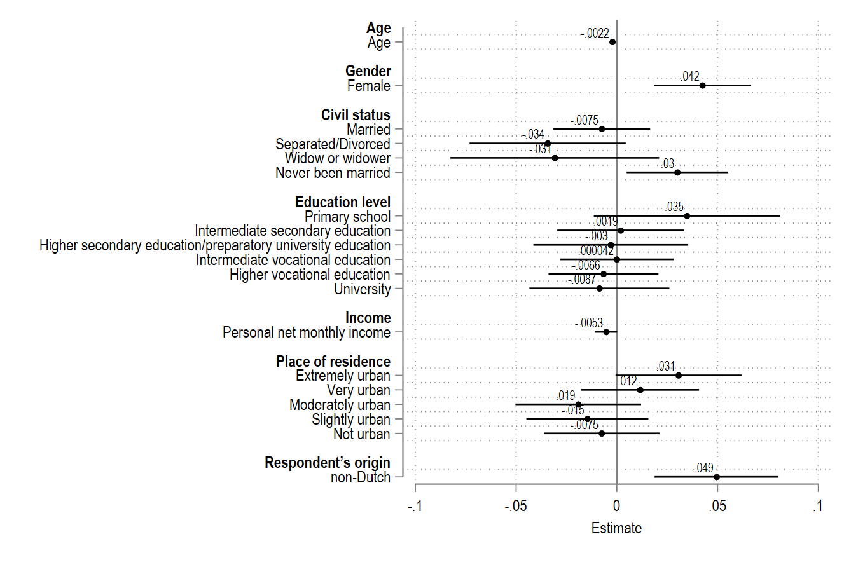

Note: The coefficient plot shows the estimates of OLS models that regress treatment assignment on the observed covariates. Nominal and ordinal variables are coded as a dummy for each level. Horizontal lines represent 95% confidence intervals.

## Figure B.2. Probability of voting for a far-right party and coefficient estimates (Main effect and effect over time)

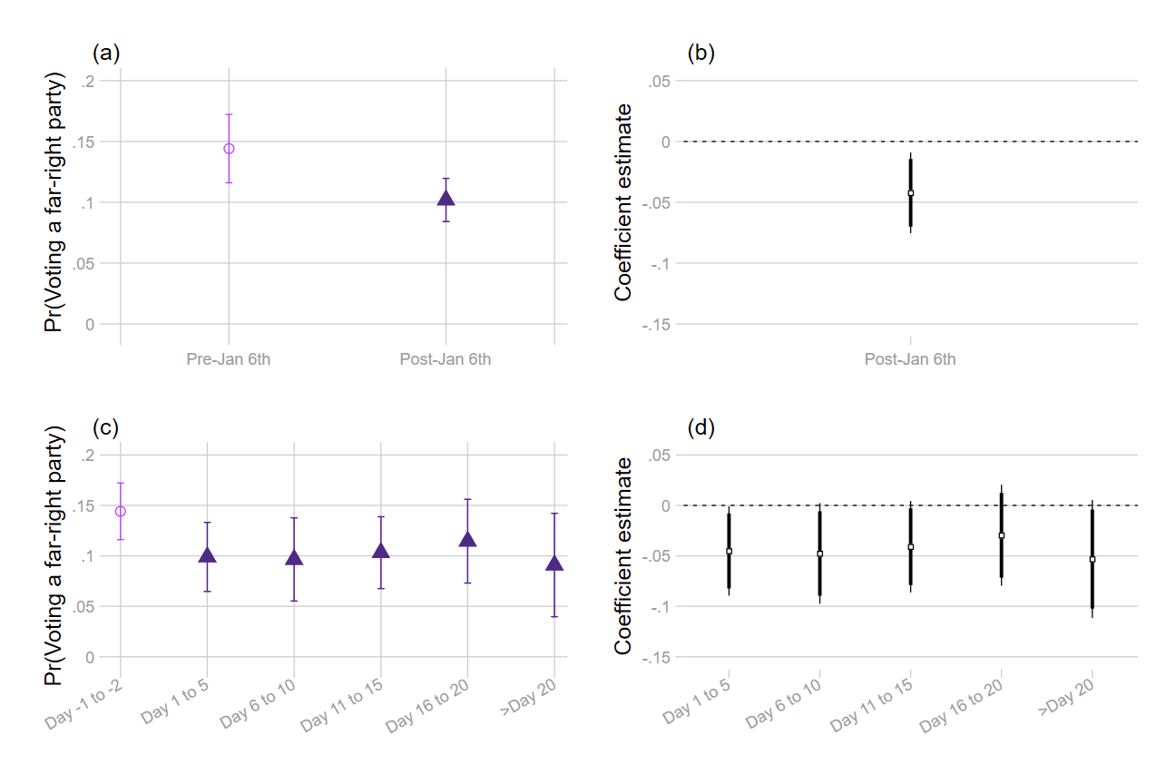

Note: The dependent variable is a binary outcome, which is coded as 1 if the respondent expresses support for a far-right party (i.e. Wilders Freedom Party or Party for Democracy) and 0 if he/she expresses support for other parties. In panels (a) and (c), the predicted probabilities of voting for a far-right party are shown with 95% confidence intervals. Panels (b) and (d) report the estimates of the Capitol insurrection (see Table B.2); thin and thick bars indicate 90% and 95% confidence intervals respectively. All models are entropy-weighted using age, gender, civil status, education level, income, urban character of the place of residence, and respondent’s origin.

## Table B.2. Effect of Capitol insurrection on the expressed support for the domestic far-right party

|  |  |  |
| --- | --- | --- |
|  | (1) | (2) |
| Post-Jan 6th | -0.04* (0.02) |  |
| Day 1 to 5 |  | -0.05* (0.02) |
| Day 6 to 10 |  | -0.05+ (0.03) |
| Day 11 to 15 |  | -0.04+ (0.02) |
| Day 16 to 20 |  | -0.03 (0.03) |
| Day>20 |  | -0.05+ (0.03) |
| Constant | 0.14*** (0.01) | 0.14*** (0.01) |
| Observations | 1804 | 1804 |
| R-squared | 0.00 | 0.00 |

Note: Entries are coefficients of OLS regression. Standard errors are shown in parentheses. Entropy weight is created based on observable covariates, including age, gender, civil status, education level, income, urban character of the place of residence, and respondent's origin. The moment is set to the variance of each covariate.

+ *p* < 0.10, * *p* < 0.05, ** *p* < 0.01, *** *p* < 0.001

## Table B.3. Comparing the predicted probability of expressing support for a far-right party across waves (Control group vs. Treatment group in Wave 13)

|  |  |
| --- | --- |
|  | (1) |
| Treatment | -0.01 (0.02) |
| wave 13 | -0.03 (0.02) |
| wave 14 | -0.05* (0.02) |
| Treatment # wave 13 | -0.03 (0.03) |
| Treatment # wave 14 | -0.01 (0.03) |
| Constant | 0.17*** (0.02) |
| Observations | 4248 |
| R-squared | 0.01 |

Note: Entries are coefficients of OLS regression. Standard errors are shown in parentheses. Entropy weight is created based on observable covariates, including age, gender, civil status, education level, income, urban character of the place of residence, and respondent's origin. The moment is set to the variance of each covariate.

+ *p* < 0.10, * *p* < 0.05, ** *p* < 0.01, *** *p* < 0.001

## Figure B.3. Without entropy weight

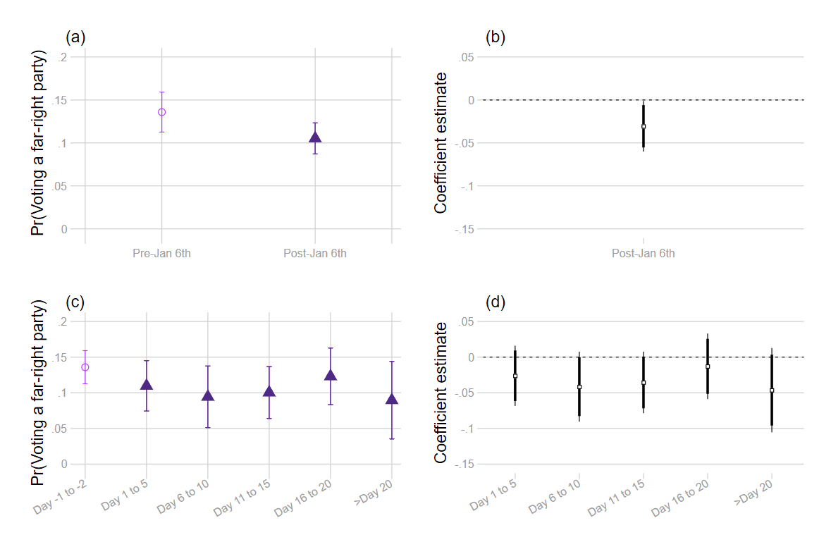

The dependent variable is a binary outcome, which is coded as 1 if the respondent expresses support for a far-right party (i.e. Wilders Freedom Party or Party for Democracy) and 0 if he/she expresses support for other parties. In panels (a) and (c), the predicted probabilities of voting for a far-right party are shown with 95% confidence intervals. Panels (b) and (d) report the estimates of the Capitol riot (see Model 1 and Model 2 in Table B.4); thin and thick bars indicate 90% and 95% confidence intervals respectively.

## Figure B.4. Entropy balancing using only imbalanced covariates

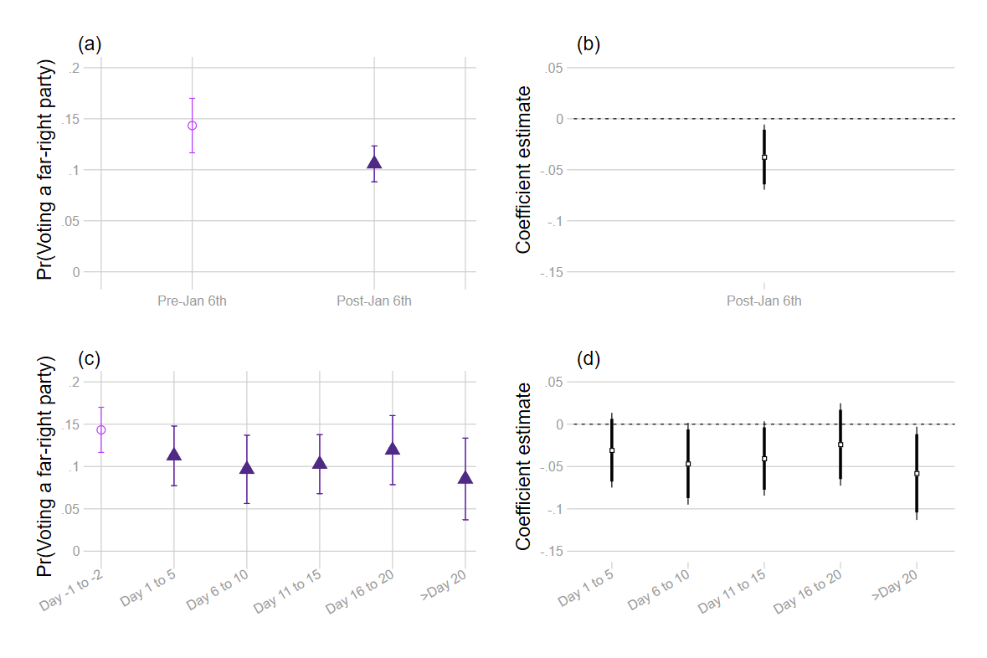

The dependent variable is a binary outcome, which is coded as 1 if the respondent expresses support for a far-right party (i.e. Wilders Freedom Party or Party for Democracy) and 0 if he/she expresses support for other parties. In panels (a) and (c), the predicted probabilities of voting for a far-right party are shown with 95% confidence intervals. Panels (b) and (d) report the estimates of the Capitol riot (see Model 3 and Model 4 in Table B.4); thin and thick bars indicate 90% and 95% confidence intervals respectively. All models are entropy-weighted using age, gender, and respondent’s origin.

## Table B.4. Other model specifications: without entropy weight, and entropy weight created by imbalanced covariates only

|  |  |  |  |  |
| --- | --- | --- | --- | --- |
|  | (1) Without entropy weight | (2) Without entropy weight | (3) Entropy balancing using only imbalanced covariates | (4) Entropy balancing using only imbalanced covariates |
| Post-Jan 6th | -0.03* (0.01) |  | -0.04* (0.02) |  |
| Day 1 to 5 |  | -0.03 (0.02) |  | -0.03 (0.02) |
| Day 6 to 10 |  | -0.04+ (0.03) |  | -0.05+ (0.02) |
| Day 11 to 15 |  | -0.04 (0.02) |  | -0.04+ (0.02) |
| Day 16 to 20 |  | -0.01 (0.02) |  | -0.02 (0.02) |
| Day>20 |  | -0.05 (0.03) |  | -0.06* (0.03) |
| Observations | 1952 | 1952 | 1906 | 1906 |
| R-squared | 0.00 | 0.00 | 0.00 | 0.00 |

Note: Entries are coefficients of OLS regression. Standard errors are shown in parentheses. Model 1 does not include any entropy weighting. Model 2 uses entropy weight that is created based on imbalanced covariates only (i.e. age, gender, and respondent's origin). The moment is set to the variance of each covariate.

+ *p* < 0.10, * *p* < 0.05, ** *p* < 0.01, *** *p* < 0.001

## Figure B.5. Logit regression

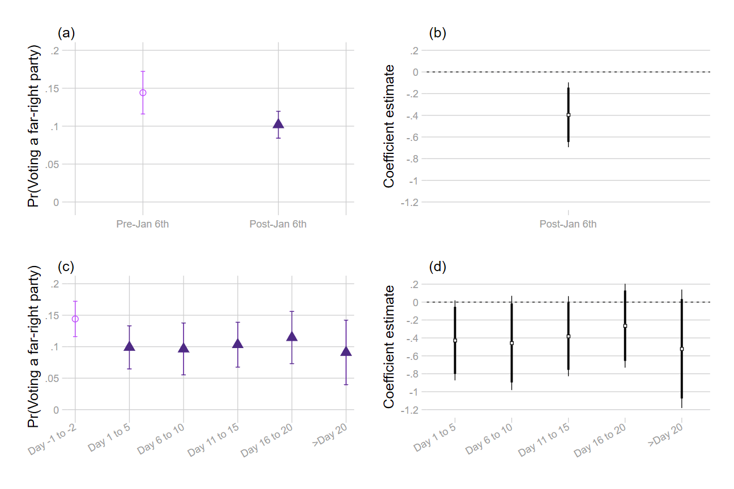

The dependent variable is a binary outcome, which is coded as 1 if the respondent expresses support for a far-right party (i.e. Wilders Freedom Party or Party for Democracy) and 0 if he/she expresses support for other parties. In panels (a) and (c), the predicted probabilities of voting for a far-right party are shown with 95% confidence intervals. Panels (b) and (d) report the estimates of the Capitol riot (see Table B.5); thin and thick bars indicate 90% and 95% confidence intervals respectively. All models are entropy-weighted using age, gender, civil status, education level, income, urban character of the place of residence, and respondent’s origin.

## Table B.5. Other model specification: Logit regression

|  |  |  |
| --- | --- | --- |
|  | (1) | (2) |
|  |  |  |
| Post-Jan 6th | -0.39** (0.15) |  |
| Day 1 to 5 |  | -0.43+ (0.23) |
| Day 6 to 10 |  | -0.46+ (0.27) |
| Day 11 to 15 |  | -0.38+ (0.23) |
| Day 16 to 20 |  | -0.26 (0.24) |
| Day>20 |  | -0.52 (0.34) |
| Constant | -1.78*** (0.12) | -1.78*** (0.12) |
| Observations | 1804 | 1804 |

Note: Entries are coefficients of logit regression. Standard errors are shown in parentheses. Entropy weight is created based on observable covariates, including age, gender, civil status, education level, income, urban character of the place of residence, and respondent's origin. The moment is set to the variance of each covariate.

+ *p* < 0.10, * *p* < 0.05, ** *p* < 0.01, *** *p* < 0.001

## Figure B.6. Predicted probability of voting for a far-left party and coefficient estimates

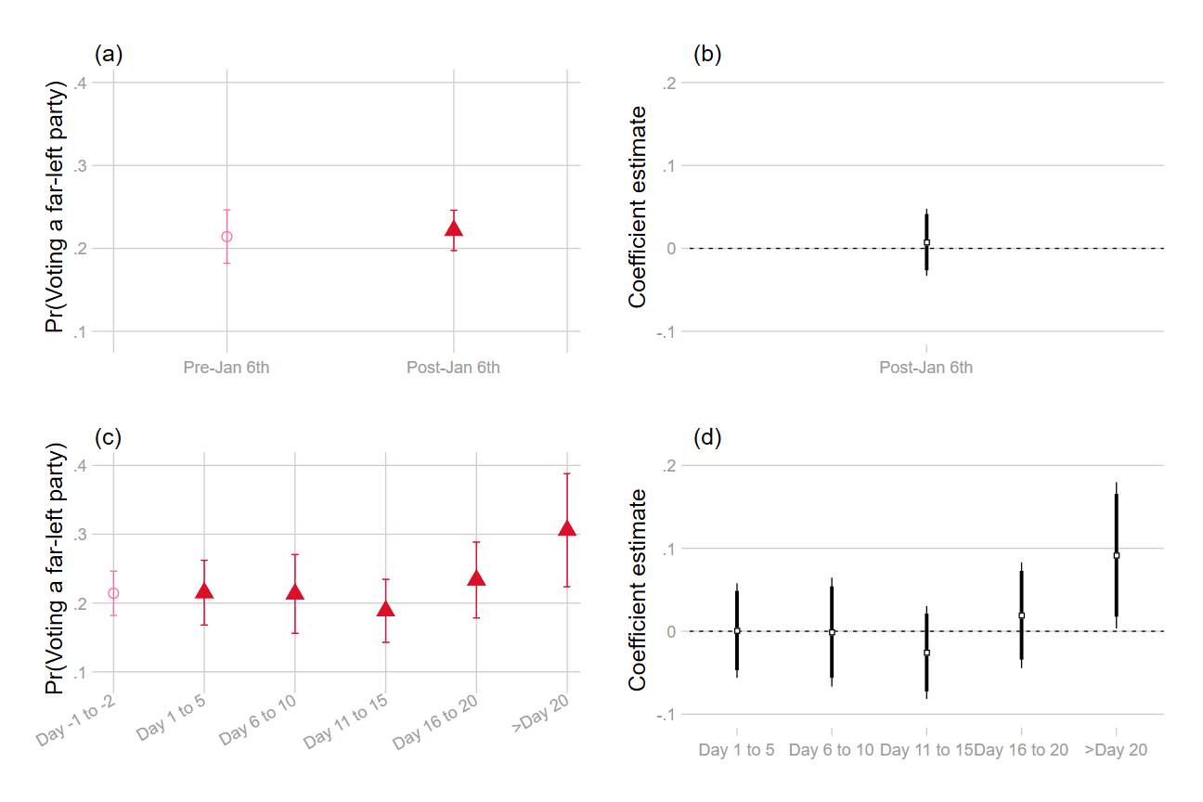

Note: The dependent variable is a binary outcome, which is coded as 1 if the respondent expresses support for a far-left party (i.e. GroenLinks (Green Party), SP (Socialist Party) or Partij voor de Dieren (Animal Welfare Party)) and 0 if he/she expresses support for other parties. In panels (a) and (c), the predicted probabilities of voting for a far-left party are shown with 95% confidence intervals. Panels (b) and (d) report the estimates of the Capitol riot (see Table B.6 Models 1 and 2); thin and thick bars indicate 90% and 95% confidence intervals respectively. All models are entropy-weighted using age, gender, civil status, education level, income, urban character of the place of residence, and respondent’s origin.

## Figure B.7. Predicted probability of voting for an incumbent party and coefficient estimates

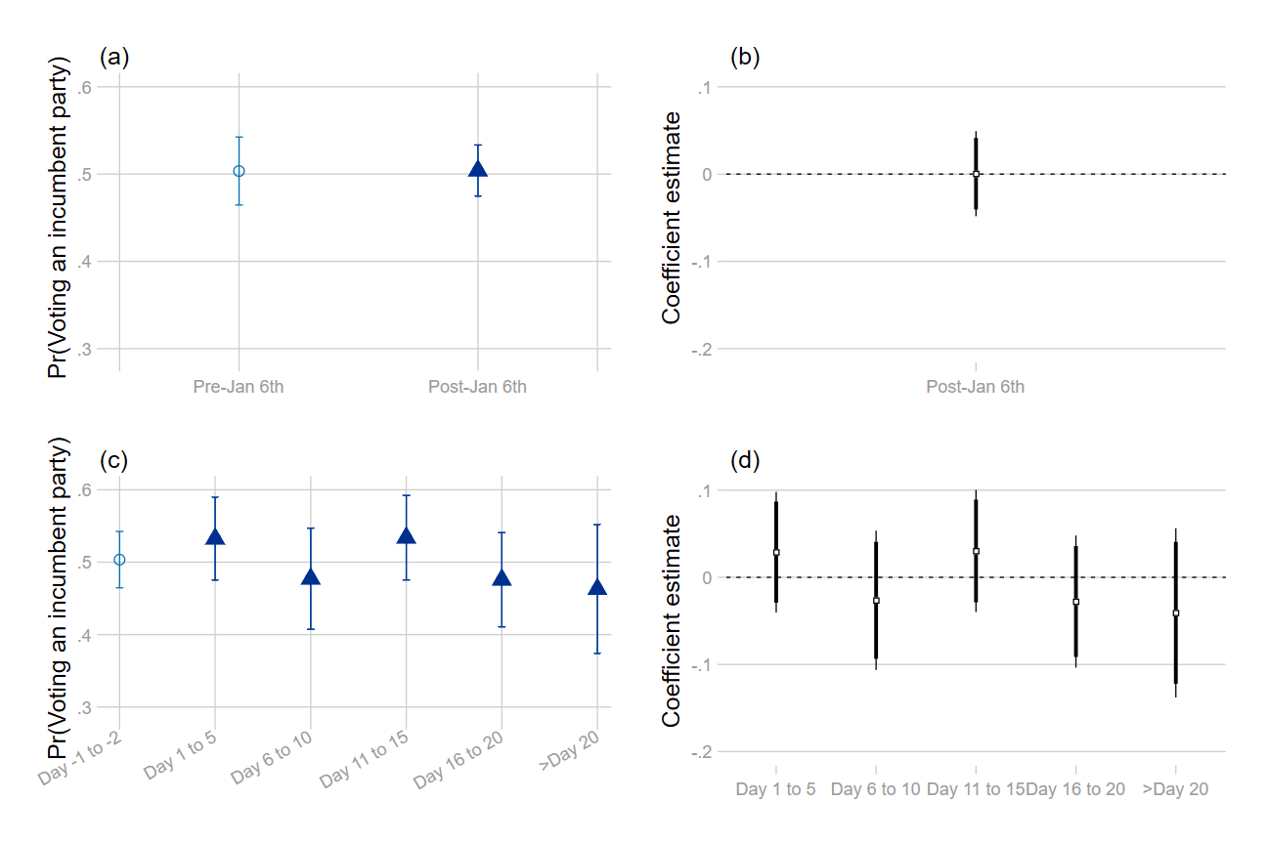

Note: The dependent variable is a binary outcome, which is coded as 1 if the respondent expresses support for an incumbent party (i.e. VVD (Liberal Party), CDA (Christian Democrat Party); D66 (Social-liberal Party) ChristenUnie (Christian Union Party)) and 0 if he/she expresses support for other parties. In panels (a) and (c), the predicted probabilities of voting for an incumbent party are shown with 95% confidence intervals. Panels (b) and (d) report the estimates of the Capitol riot (see Table B.6 Models 3 and 4); thin and thick bars indicate 90% and 95% confidence intervals respectively. All models are entropy-weighted using age, gender, civil status, education level, income, urban character of the place of residence, and respondent’s origin.

## Table B.6. Placebo tests: Changing DV to expressed support for a far-left party or an incumbent party

|  |  |  |  |  |
| --- | --- | --- | --- | --- |
|  | (1) Far-left party | (2) Far-left party | (3) Incumbent party | (4) Incumbent party |
| Post-Jan 6th | 0.01 (0.02) |  | 0.00 (0.02) |  |
| Day 1 to 5 |  | 0.00 (0.03) |  | 0.03 (0.04) |
| Day 6 to 10 |  | -0.00 (0.03) |  | -0.03 (0.04) |
| Day 11 to 15 |  | -0.03 (0.03) |  | 0.03 (0.04) |
| Day 16 to 20 |  | 0.02 (0.03) |  | -0.03 (0.04) |
| Day>20 |  | 0.09* (0.04) |  | -0.04 (0.05) |
| Constant | 0.21*** (0.02) | 0.21*** (0.02) | 0.50*** (0.02) | 0.50*** (0.02) |
| Observations | 1804 | 1804 | 1804 | 1804 |
| R-squared | 0.00 | 0.00 | 0.00 | 0.00 |

Note: In Models 1 and 2, the dependent variable is expressed support for a far-left party. In Models 3 and 4, the dependent variable is expressed support for an incumbent party. Entries are coefficients of OLS regression. Standard errors are shown in parentheses. Entropy weight is created based on observable covariates, including age, gender, civil status, education level, income, urban character of the place of residence, and respondent's origin. The moment is set to the variance of each covariate.

+ *p* < 0.10, * *p* < 0.05, ** *p* < 0.01, *** *p* < 0.001

## Figure B.8. Including respondents who do not express vote preference

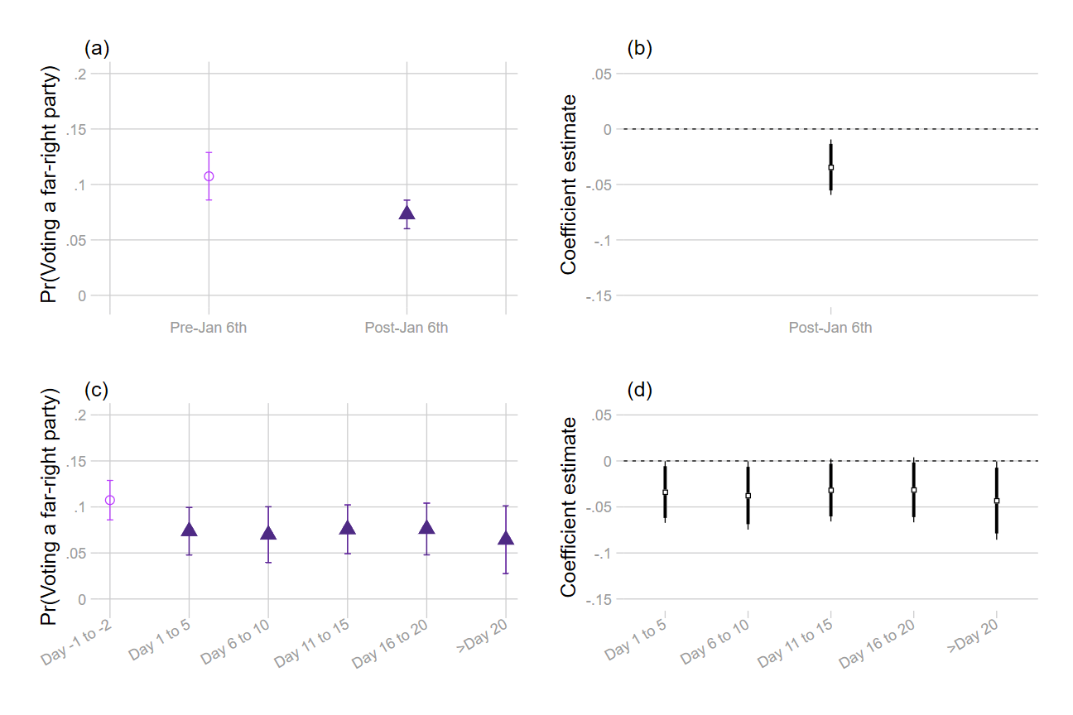

Note: The dependent variable is a binary outcome, which is coded as 1 if the respondent expresses support for a far-right party (i.e. Wilders Freedom Party or Party for Democracy) and 0 if he/she expresses support for other parties or does not reveal any vote preferences. These answers include: (i) choose abstention, (ii) say they cast a blank vote, (iii) I don't know, or (iv) I prefer not to say. In panels (a) and (c), the predicted probabilities of voting for a far-right party are shown with 95% confidence intervals. Panels (b) and (d) report the estimates of the Capitol riot (see Table B.7); thin and thick bars indicate 90% and 95% confidence intervals respectively. All models are entropy-weighted using age, gender, civil status, education level, income, urban character of the place of residence, and respondent’s origin.

## Table B.7. Including respondents who do not express vote preference

|  |  |  |
| --- | --- | --- |
|  | (1) | (2) |
| Post-Jan 6th | -0.03** (0.01) |  |
| Day 1 to 5 |  | -0.03* (0.02) |
| Day 6 to 10 |  | -0.04* (0.02) |
| Day 11 to 15 |  | -0.03+ (0.02) |
| Day 16 to 20 |  | -0.03+ (0.02) |
| Day>20 |  | -0.04* (0.02) |
| Constant | 0.11*** (0.01) | 0.11*** (0.01) |
| Observations | 2460 | 2460 |
| R-squared | 0.00 | 0.00 |

Note: Entries are coefficients of OLS regression. Standard errors are shown in parentheses. Entropy weight is created based on observable covariates, including age, gender, civil status, education level, income, urban character of the place of residence, and respondent's origin. The moment is set to the variance of each covariate.

+ *p* < 0.10, * *p* < 0.05, ** *p* < 0.01, *** *p* < 0.001

## Figure B.9. Replicating Figure 4 by including respondents who do not express vote preference

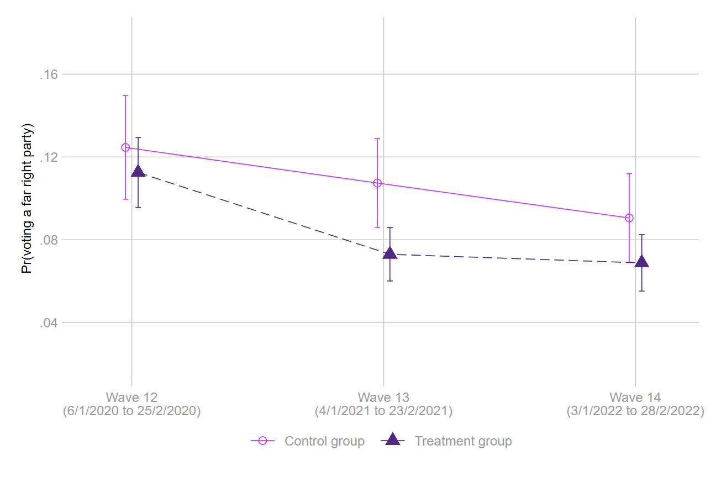

Note: The dependent variable is a binary outcome, which is coded as 1 if the respondent expresses support for a far-right party (i.e. Wilders freedom party or Party for Democracy) and 0 if he/she expresses support for other parties or does not reveal any vote preferences. These answers include: (i) choose abstention, (ii) say they cast a blank vote, (iii) I don't know, or (iv) I prefer not to say. The predicted probabilities of voting for a far-right party are shown with 95% confidence intervals (see Table B.8 for regression table). The model is entropy-weighted using age, gender, civil status, education level, income, urban character of the place of residence, and respondent’s origin. The model is estimated based on respondents who participated in all three waves.

## Table B.8. Replicating Table B.3 by including missing answers of expressed vote preference

|  |  |
| --- | --- |
|  | (1) |
| Treatment | -0.01 (0.02) |
| wave 13 | -0.02 (0.02) |
| wave 14 | -0.03* (0.02) |
| Treatment # wave 13 | -0.02 (0.02) |
| Treatment # wave 14 | -0.01 (0.02) |
| Constant | 0.12*** (0.01) |
| Observations | 6658 |
| R-squared | 0.00 |

Note: Respondents who answer (i) abstention, (ii) casting a blank vote, (iii) I don't know, or (iv) I prefer not to say are included and coded as zero. Entries are coefficients of OLS regression. Standard errors are shown in parentheses. Entropy weight is created based on observable covariates, including age, gender, civil status, education level, income, urban character of the place of residence, and respondent's origin. The moment is set to the variance of each covariate.

+ *p* < 0.10, * *p* < 0.05, ** *p* < 0.01, *** *p* < 0.001

## Figure B.10. 2018 LISS dataset: Predicted probability of voting for a far-right party and coefficient estimates

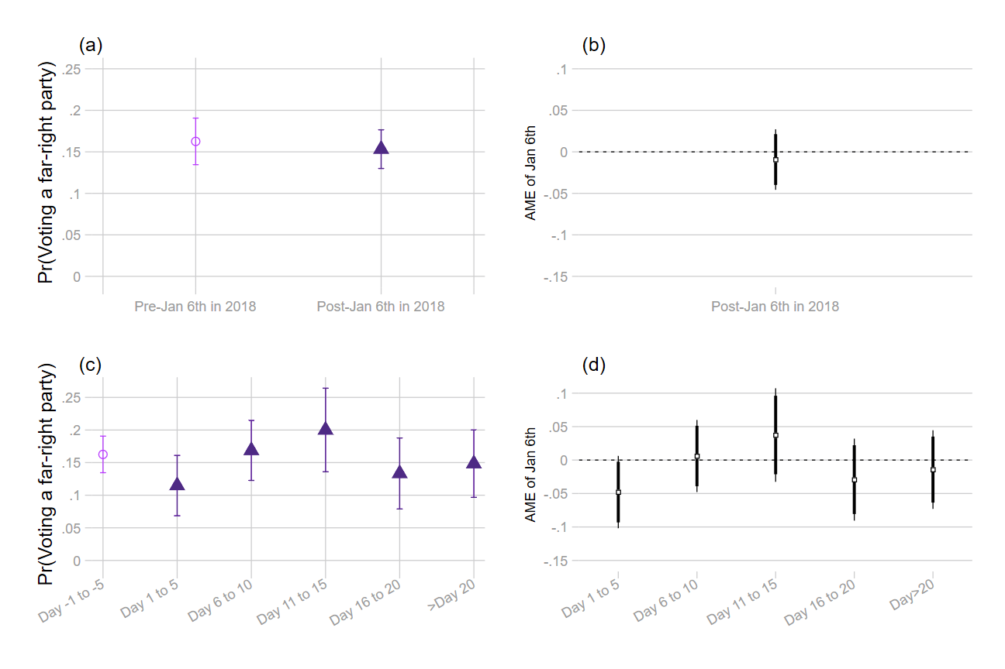

Note: The dependent variable is a binary outcome, which is coded as 1 if the respondent expresses support for a far-right party (i.e. Wilders Freedom Party or Party for Democracy) and 0 if he/she expresses support for other parties or does not reveal any vote preferences. These answers include: (i) choose abstention, (ii) say they cast a blank vote, (iii) I don't know, or (iv) I prefer not to say. In panels (a) and (c), the predicted probabilities of voting for a far-right party are shown with 95% confidence intervals. Panels (b) and (d) report the estimates of the Capitol riot (see Table B.9); thin and thick bars indicate 90% and 95% confidence intervals respectively. All models are entropy-weighted using age, gender, civil status, education level, income, urban character of the place of residence, and respondent’s origin.

## Table B.9. Using 2018 LISS dataset as pseudo-treatment

|  |  |  |
| --- | --- | --- |
|  | (1) | (2) |
| Post-Jan 6th in 2018 | -0.01 (0.02) |  |
| Day 1 to 5 |  | -0.05+ (0.03) |
| Day 6 to 10 |  | 0.01 (0.03) |
| Day 11 to 15 |  | 0.04 (0.04) |
| Day 16 to 20 |  | -0.03 (0.03) |
| Day>20 |  | -0.01 (0.03) |
| Constant | 0.16*** (0.01) | 0.16*** (0.01) |
| Observations | 1643 | 1643 |
| R-squared | 0.00 | 0.00 |

Note: Entries are coefficients of OLS regression. Standard errors are shown in parentheses. Entropy weight is created based on observable covariates, including age, gender, civil status, education level, income, urban character of the place of residence, and respondent's origin. The moment is set to the variance of each covariate.

+ *p* < 0.10, * *p* < 0.05, ** *p* < 0.01, *** *p* < 0.001

## Table B.10. Effect of Capitol insurrection on left/right self-placement, confidence in democratic institutions, and recall vote

|  |  |  |  |
| --- | --- | --- | --- |
|  | (1) Left/right self-placement | (2) Confidence in democratic institutions | (3) Recall vote for far-right parties |
| Post-Jan 6th | -0.07 (0.07) | 0.03 (0.06) | -0.01 (0.01) |
| Constant | 5.20*** (0.06) | 6.57*** (0.05) | 0.12*** (0.01) |
| Observations | 4565 | 5001 | 3787 |
| R-squared | 0.00 | 0.00 | 0.00 |

Note: Entries are coefficients of OLS regression. Standard errors are shown in parentheses. Entropy weight is created based on observable covariates, including age, gender, civil status, education level, income, urban character of the place of residence, and respondent's origin. The moment is set to the variance of each covariate.

+ *p* < 0.10, * *p* < 0.05, ** *p* < 0.01, *** *p* < 0.001

# **Section C. Study 2 – GLES dataset: Additional Tables and Figures**

## Table C.1. Question-wording & variable operationalization

|  |  |  |
| --- | --- | --- |
| **Variable (name in the dataset)** | **Question** | **Answer and coding** |
| Expressed vote preference in waves 13, 14 and 15   * Far-right party vote (fr _party_) * Far-right party vote that includes non-response (m_fr_party_) * Far-right candidate vote (fr _cand_) * Far-right candidate vote that includes non-response (m_ fr _cand_) | Intro: You have two votes in the federal election. The first vote is for a candidate in your local constituency, the second vote is for a party.  Question in wave 13:  How would you mark your ballot?  Question in waves 14, 15:  How will you mark your ballot? | (1) CDU/CSU  (4) SPD  (5) FDP  (6) GRÜNE  (7) DIE LINKE  (120) BIG  (151) Die PARTEI  (171) FAMILIE  (180) FREIE WAEHLER  (206) NPD  (209) ödp  (215) PIRATEN  (225) REP  (237) Tierschutzpartei  (322) AfD  (323) DIE RECHTE  (331) LKR  (349) DiB  (351) Bündnis C  (801) other party  (-98) don’t know  --------------------------------  (-93) not asked, terminated  (-95) not participated  (-97) not applicable [i.e. respondents who answered “not likely to vote” or “certain note to vote” in the vote intention question]  (-99) no answer   * 322, 323, 206, 225 are coded as far-right * -97,-98, -99 are coded as missing in fr_party_ and fr _cand_ , while they are coded as 0 in m_fr _party_ and m_ fr _cand_ * -93 is coded as missing in fr_party_, fr_cand_, m_fr_party_ and m_fr_cand_ |
| Left/right self-placement (lr_self) | In politics people often talk of "left" and "right". And where would you place yourself? | (1) 1 left  (2) 2  (3) 3  (4) 4  (5) 5  (6) 6  (7) 7  (8) 8  (9) 9  (10) 10  (11) 11 right  (-98) don’t know  ----------------------------------------  (-93) not asked, terminated  (-95) not participated  (-99) no answer   * -93, -95,-98, -99 are coded as missing |
| Support for strong leaders (strong_) | Here you can find several statements with which some people agree, while others do not. How much do you agree or disagree with the following statements?  We need strong leaders so we can live safely in society. | (1) strongly disagree  (2) disagree  (3) neither agree nor disagree  (4) agree  (5) strongly agree  ------------------------------------------  (-93) not asked, terminated  (-95) not participated  (-99) no answer   * -93, -95, -99 are coded as missing |

## Table C.2. Effect of Capitol insurrection on the expressed support for the domestic far-right party

|  |  |  |
| --- | --- | --- |
|  | (1) Party vote: Far-right | (2) Candidate vote: Far-right |
| wave 14 | -0.00 (0.00) | -0.00 (0.00) |
| wave 15 | -0.01** (0.00) | -0.01** (0.00) |
| Constant | 0.13*** (0.00) | 0.13*** (0.00) |
| Observations | 12,091 | 11,979 |
| Clusters | 5,647 | 5,612 |
| Individual FE | Yes | Yes |
| R-squared | 0.00 | 0.00 |

Note: Entries are coefficients of individual fixed effect regression. Standard errors are clustered at individual level and are shown in parentheses.

+ *p* < 0.10, * *p* < 0.05, ** *p* < 0.01, *** *p* < 0.001

## Figure C.1. Including respondents who do not express vote preference

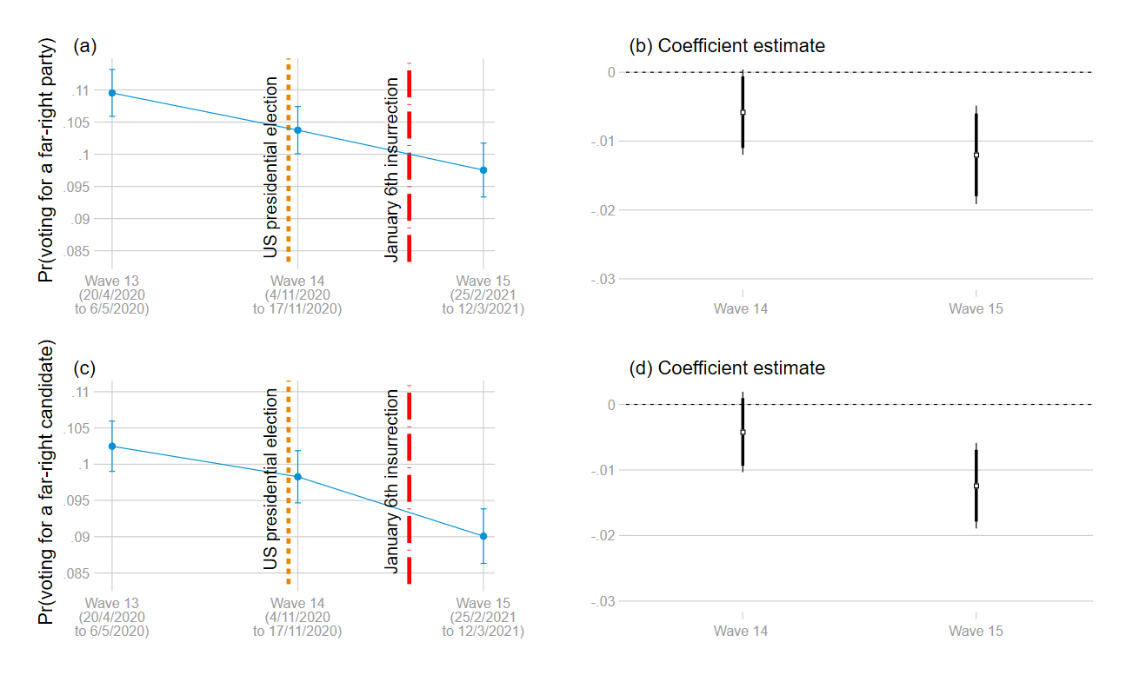

Note: The dependent variable is a binary outcome, which is coded as 1 if the respondent expresses support for a far-right party (i.e. AfD, Die Rechte, NPD, and the REP) and 0 if he/she expresses support for other parties, (i) claim they do not intend to vote, (ii) answer don’t know, or (iii) provide no answer. In panels (a) and (c), the predicted probabilities of voting for a far-right party are shown with 95% confidence intervals. Panels (b) and (d) report the estimates of the Capitol riot (see Table C.3); thin and thick bars indicate 90% and 95% confidence intervals respectively.

## Table C.3. Including respondents who do not express vote preference

|  |  |  |
| --- | --- | --- |
|  | (1) Party vote: AfD | (2) Candidate vote: AfD |
| wave 14 | -0.01+ (0.00) | -0.00 (0.00) |
| wave 15 | -0.01** (0.00) | -0.01*** (0.00) |
| Constant | 0.11*** (0.00) | 0.10*** (0.00) |
| Observations | 14,912 | 14,912 |
| Clusters | 6,496 | 6,496 |
| Individual FE | Yes | Yes |
| R-squared | 0.00 | 0.00 |

Note: Entries are coefficients of individual fixed effect regression. Standard errors are clustered at individual level and are shown in parentheses.

+ *p* < 0.10, * *p* < 0.05, ** *p* < 0.01, *** *p* < 0.001

## Table C.4. Drop-out rates from wave 14 to wave 15

|  |  |  |  |
| --- | --- | --- | --- |
| **Group** | **Observations** | **Attrition rate (S.E.)** | **p-value** |
| Non-far-right supporters (Party vote) | 4048 | 0.258  (0.007) | 0.707 |
| Far-right supporters (Party vote) | 618 | 0.251  (0.017) |
| Non-far-right supporters (Candidate vote) | 4066 | 0.260  (0.007) | 0.482 |
| Far-right supporters (Candidate vote vote) | 580 | 0.247  (0.018) |

Note: The group is operationalized by their expressed vote preference in wave 13. Respondents are counted as dropping out from the survey if he/she does not participate in the survey of that wave or terminate the survey.

## Figure C.2. Probability of voting for the Linke party or candidate and the coefficient estimates

Note: The dependent variable is a binary outcome, which is coded as 1 if the respondent expresses support for a the Linke and 0 if he/she expresses support for other parties. In panels (a) and (c), the predicted probabilities of voting for a far-right party are shown with 95% confidence intervals. Panels (b) and (d) report the estimates of the Capitol riot (see Table C.5); thin and thick bars indicate 90% and 95% confidence intervals respectively.

## Figure C.3. Probability of voting for the Green party or candidate and the coefficient estimates

Note: The dependent variable is a binary outcome, which is coded as 1 if the respondent expresses support for a the Green and 0 if he/she expresses support for other parties. In panels (a) and (c), the predicted probabilities of voting for a far-right party are shown with 95% confidence intervals. Panels (b) and (d) report the estimates of the Capitol riot (see Table C.5); thin and thick bars indicate 90% and 95% confidence intervals respectively.

## Table C.5. Placebo outcomes: Linke and the Green

|  |  |  |  |  |
| --- | --- | --- | --- | --- |
|  | (1) Party vote: Linke | (2) Candidate vote: Linke | (3) Party vote: Green | (4) Candidate vote: Green |
| wave 14 | 0.00 (0.00) | 0.00 (0.00) | 0.00 (0.01) | 0.01 (0.00) |
| wave 15 | 0.01 (0.00) | 0.01 (0.00) | 0.01 (0.01) | 0.01* (0.01) |
| Constant | 0.13*** (0.00) | 0.11*** (0.00) | 0.19*** (0.00) | 0.17*** (0.00) |
| Observations | 12,091 | 11,979 | 12,091 | 11,979 |
| Clusters | 5,647 | 5,612 | 5,647 | 5,612 |
| Individual FE | Yes | Yes | Yes | Yes |
| R-squared | 0.00 | 0.00 | 0.00 | 0.00 |

Note: Entries are coefficients of individual fixed effect regression. Standard errors are clustered at individual level and are shown in parentheses.

+ *p* < 0.10, * *p* < 0.05, ** *p* < 0.01, *** *p* < 0.001

## Figure C.4. Including respondents who were surveyed on 3rd Nov 2020

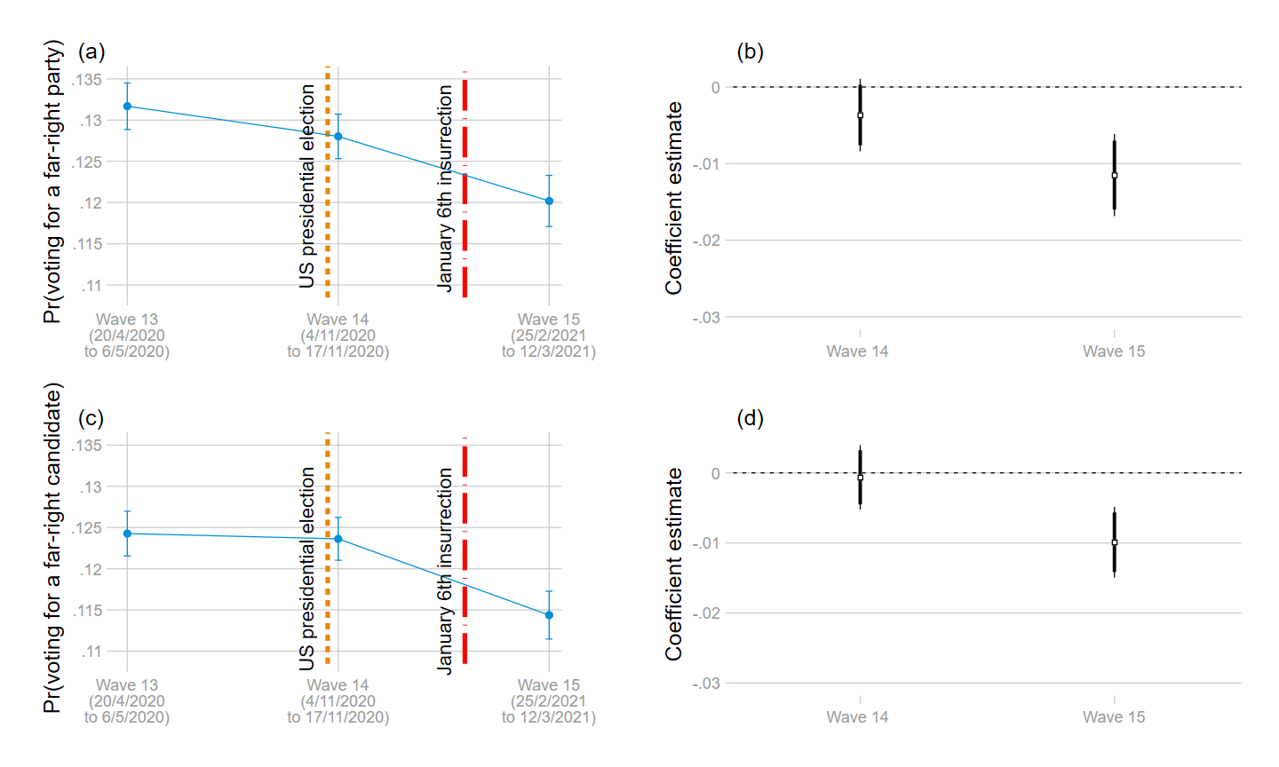

Note: The dependent variable is a binary outcome, which is coded as 1 if the respondent expresses support for a far-right party (i.e. Alternative for Germany, AfD) and 0 if he/she expresses support for other parties. In panels (a) and (c), the predicted probabilities of voting for a far-right party are shown with 95% confidence intervals. Panels (b) and (d) report the estimates of the Capitol insurrection (see Table C.6); thin and thick bars indicate 90% and 95% confidence intervals respectively.

## Table C.6. Including respondents who were surveyed on 3rd Nov 2020

|  |  |  |
| --- | --- | --- |
|  | (1) Party vote: far-right | (2) Candidate vote: far-right |
| wave 14 | -0.00 (0.00) | -0.00 (0.00) |
| wave 15 | -0.01*** (0.00) | -0.01*** (0.00) |
| Constant | 0.13*** (0.00) | 0.12*** (0.00) |
| Observations | 21,968 | 21,748 |
| Clusters | 9,364 | 9,318 |
| Individual FE | Yes | Yes |
| R-squared | 0.00 | 0.00 |

Note: Entries are coefficients of individual fixed effect regression. Standard errors are clustered at individual level and are shown in parentheses.

+ *p* < 0.10, * *p* < 0.05, ** *p* < 0.01, *** *p* < 0.001

## Figure C.5. Predicted left/right self-placement and the coefficient estimates

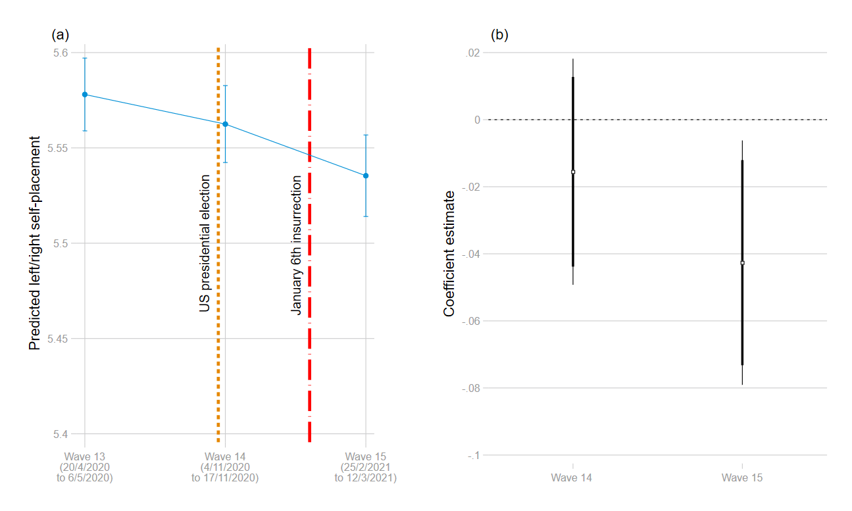

Note: The dependent variable is a 10-point scale outcome, which is coded as 1 if the respondent places himself/herself as “left” and 11 as “right”. In panel (a), the predicted left/right self-placement is shown with 95% confidence intervals. Panel (b) reports the estimates of the Capitol riot (see Table C.7); thin and thick bars indicate 90% and 95% confidence intervals respectively.

## Figure C.6. Predicted level of support for strong leaders and the coefficient estimates

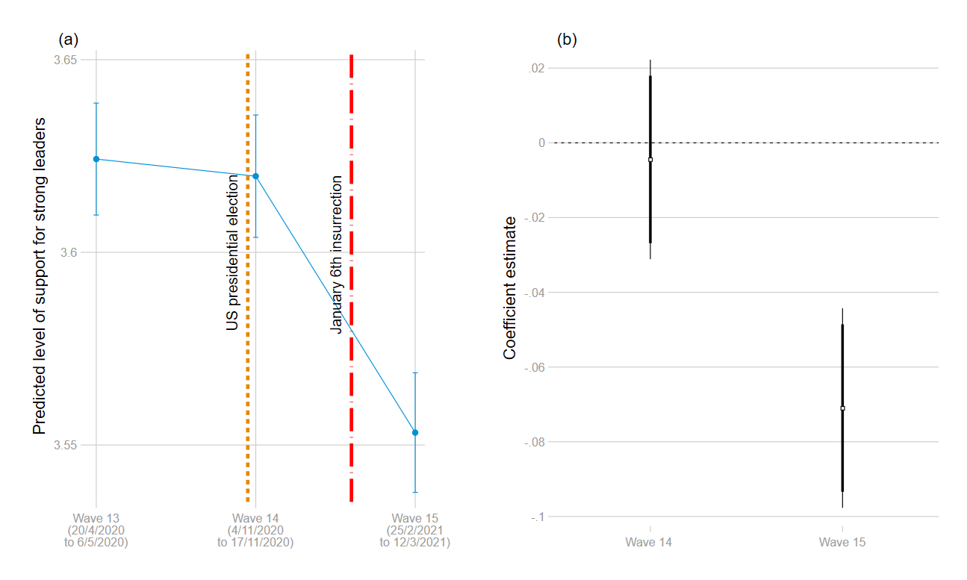

Note: The dependent variable is a 5-point scale outcome, which is coded as 1 if the respondent strongly disagrees that “We need strong leaders so we can live safely in society” and 5 if he/she strongly agrees. In panel (a), the predicted level of support for strong leaders is shown with 95% confidence intervals. Panel (b) reports the estimates of the Capitol riot (see Table C.7); thin and thick bars indicate 90% and 95% confidence intervals respectively.

## Table C.7. Effect of Capitol insurrection on left/right self-placement and support for strong leaders

|  |  |  |
| --- | --- | --- |
|  | (1) left/right self-placement | (2) strong leaders |
| wave 14 | -0.02 (0.02) | -0.00 (0.01) |
| wave 15 | -0.04* (0.02) | -0.07*** (0.01) |
| Constant | 5.58*** (0.01) | 3.62*** (0.01) |
| Observations | 13,456 | 14,693 |
| Clusters | 6,026 | 6,435 |
| Individual FE | Yes | Yes |
| R-squared | 0.00 | 0.00 |

Note: Entries are coefficients of individual fixed effect regression. Standard errors are clustered at individual level and are shown in parentheses. + *p* < 0.10, * *p* < 0.05, ** *p* < 0.01, *** *p* < 0.001

# Bibliography

Carrel, P., & Käckenhoff, T. (2020, September 13). *Would-be Merkel successor Laschet emboldened by local election win*. Retrieved from https://www.reuters.com/article/us-germany-politics/would-be-merkel-successor-laschet-loses-ground-in-local-election-win-idUSKBN2640IW

Chan, K. M. (2022). The Making of Radical-Right Voters: Persuasion and Contrast Effects in a Dynamic Political Context. *Political Psychology*. https://doi.org/10.1111/pops.12801

NOS. (2021). *Rutte: Trump moet nu Biden erkennen als opvolger*. Retrieved from https://nos.nl/collectie/13854/artikel/2363346-rutte-trump-moet-nu-biden-erkennen-als-opvolger

Tagesschau. (2021). *Tagesschau 20:00 Uhr, 07.01.2021*. Retrieved from https://www.youtube.com/watch?v=-rmYyhhhr_E&t=293s