Appendix

Table T1. Variations in measurement of contextual variables across countries

 | France | Germany | Netherlands | Great Britain
Immigration | % foreign born | % immigrant families | % first or second generation immigrant | % foreign born
Unemployment | % of population unemployed | % of population unemployed | % of population claiming unemployment benefit | % of unemployed in active population
Age groups | % below 44 / % below 25

Table T2. Variations in measurement of education level

 | Great Britain  (England and Wales) | Germany | The Netherlands | France
Low education | Technical, no formal qualifications | Keinen Schulabschluss / Volks- oder Hauptschulabschluss | Basisschool / VMBO | Below BEPC
2 | GCSE or equivalent | Mittlere Reife / Realschulabschluss | MBO 1-3 | CAP-BEP, BEPC
3 | A-level or equivalent | Fachhochschulreife | MBO 4-plus | Baccalauréat
High education | University degree equivalent or higher | Allgemeine Hochschulreife) | HBO / WHO | Diplôme d’études supérieurs

Table T3. Correlations between context variables

UK
 | Immigrants | Unemployment | 16 to 24 | 25 to 44
Immigrants | 1.00
Unemployment | 0.30 | 1.00
Aged 16 to 24 | 0.30 | 0.22 | 1.00
Aged 25 to 44 | 0.64 | 0.26 | 0.15 | 1.00
Germany
 | Immigrants | Unemployment | 16 to 24 | 25 to 44
Immigrants | 1.00
Unemployment | 0.23 | 1.00
Aged 16 to 24 | 0.25 | 0.16 | 1.00
Aged 25 to 44 | 0.23 | 0.02 | 0.20 | 1.00
France
 | Immigrants | Unemployment | 16 to 24 | 25 to 44
Immigrants | 1.00
Unemployment | 0.43 | 1.00
Aged 16 to 24 | 0.26 | 0.25 | 1.00
Aged 25 to 44 | 0.08 | 0.42 | 0.34 | 1.00
Netherlands
 | Immigrants | Unemployment | 16 to 24 | 25 to 44
Immigrants | 1.00
Unemployment | 0.27 | 1.00
Aged 16 to 24 | 0.22 | -0.05 | 1.00
Aged 25 to 44 | 0.62 | 0.26 | 0.32 | 1.00

Table T4. Multilevel path model results Great Britain

 |  | PRR |  | Threat |  | Populist attitudes |  | Decline
 |  | Coef. | S.E. | Coef. | S.E. | Coef. | S.E. | Coef. | S.E.
Within
 | Male | .027* | .011 | -.018* | .008 | -.034*** | .008 | -.027* | .012
 | Age | -.147*** | .013 | .047*** | .008 | .079*** | .008 | .037** | .012
 | Low education | Ref. |  | Ref. |  | Ref. |  | Ref.
 | Med education | .078*** | .013 | .073*** | .008 | .109*** | .008 | .014 | .013
 | High education | .144*** | .013 | .165*** | .008 | .180*** | .008 | .015 | .013
Between
 | Migration | .176*** | .034 | .095* | .040 | .328*** | .085 | .210*** | .028
 | Unemployment | -.257*** | .038 | -.288*** | .050 | -.193** | .067 | .409*** | .033
 | Youth | -.073* | .032 | -.076* | .036 | .017 | .049 | .093*** | .026
RMSEA |  | .017
CFI |  | .993
TLI |  | .947
Chi²/df |  | 30.122/5
Note: *** = p<.001; ** = p<.01; * = p<.05. All coefficients are standardized.

Table T5. Multilevel path model results France

 |  | PRR |  | Threat |  | Populist attitudes |  | Decline
 |  | Coef. | S.E. | Coef. | S.E. | Coef. | S.E. | Coef. | S.E.
Within
 | Male | .075*** | .012 | -.018** | .007 | -.060*** | .007 | -.027** | .010
 | Age | .101*** | .014 | .196*** | .007 | .022** | .008 | .115 | .011
 | Low education | Ref. |  | Ref. |  | Ref. |  | Ref.
 | Med education | .010 | .013 | .038*** | .007 | .017* | .007 | .028** | .011
 | High education | .014 | .012 | .147*** | .007 | .058*** | .007 | .047*** | .010
Between
 | Migration | -.188*** | .032 | -.351*** | .025 | -.170*** | .027 | .076** | .028
 | Unemployment | .154*** | .031 | .277*** | .027 | .489*** | .033 | .335*** | .030
 | Youth | .004 | .036 | -.036 | .029 | -.008 | .032 | .042 | .035
RMSEA |  | .022
CFI |  | .992
TLI |  | .939
Chi²/df |  | 55.337/5
Note: *** = p<.001; ** = p<.01; * = p<.05. All coefficients are standardized.

Table T6. Multilevel path model results The Netherlands

 |  | PRR |  | Threat |  | Populist attitudes |  | Decline
 |  | Coef. | S.E. | Coef. | S.E. | Coef. | S.E. | Coef. | S.E.
Within
 | Male | .115*** | .019 | .063*** | .013 | -.019 | .012 | -.013 | .021
 | Age | -.103*** | .019 | -.016 | .014 | .041** | .013 | -.036 | .023
 | Low education | Ref. |  | Ref. |  | Ref. |  | Ref.
 | Med education | -.088*** | .021 | -.152*** | .016 | -.171*** | .015 | -.029 | .025
 | High education | -.145*** | .025 | -.290*** | .016 | -.397*** | .016 | -.155*** | .027
Between
 | Migration | .042 | .087 | -.283*** | .069 | -.060 | .088 | .625*** | .093
 | Unemployment | .048 | .116 | .011 | .083 | .367** | .139 | .175 | .098
 | Youth | -.223* | .112 | -.114 | .075 | -.298* | .120 | -.113 | .090
RMSEA |  | .023
CFI |  | .997
TLI |  | .974
Chi²/df |  | 21.898/5
Note: *** = p<.001; ** = p<.01; * = p<.05. All coefficients are standardized.

Table T7. Multilevel path model results Germany

 |  | PRR |  | Threat |  | Populist attitudes |  | Decline
 |  | Coef. | S.E. | Coef. | S.E. | Coef. | S.E. | Coef. | S.E.
Within
 | Male | .111*** | .013 | -.009 | .008 | .042*** | .008 | -.024* | .011
 | Age | -.100*** | .014 | -.090*** | .008 | .123*** | .008 | .019 | .011
 | Low education | Ref. |  | Ref. |  | Ref. |  | Ref.
 | Med education | .019 | .013 | .103*** | .008 | .116*** | .008 | .032** | .012
 | High education | -.023 | .014 | .003 | .008 | .032*** | .008 | .021 | .012
Between
 | Migration | -.197** | .070 | -.231*** | .046 | -.211*** | .057 | .530** | .162
 | Unemployment | .252*** | .067 | .195*** | .044 | .304*** | .058 | .573** | .173
 | Youth | -.261** | .081 | -.093 | .051 | -.066 | .058 | -.158 | .099
RMSEA |  | .016
CFI |  | .997
TLI |  | .975
Chi²/df |  | 25.510/5
Note: *** = p<.001; ** = p<.01; * = p<.05. All coefficients are standardized.

Figure F1. Contextual conditions among those who perceive local decline
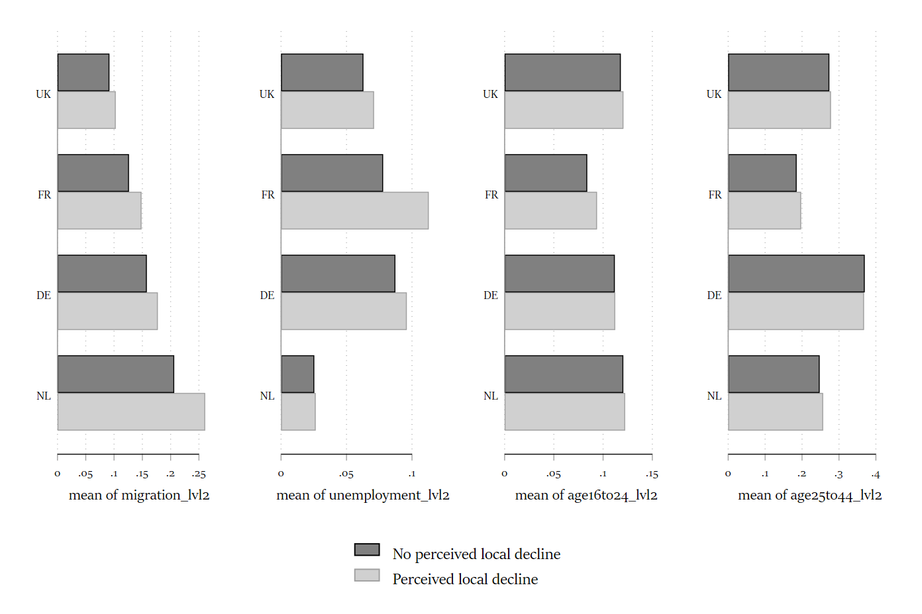

Figure F2. Replication using change measures
By level of education
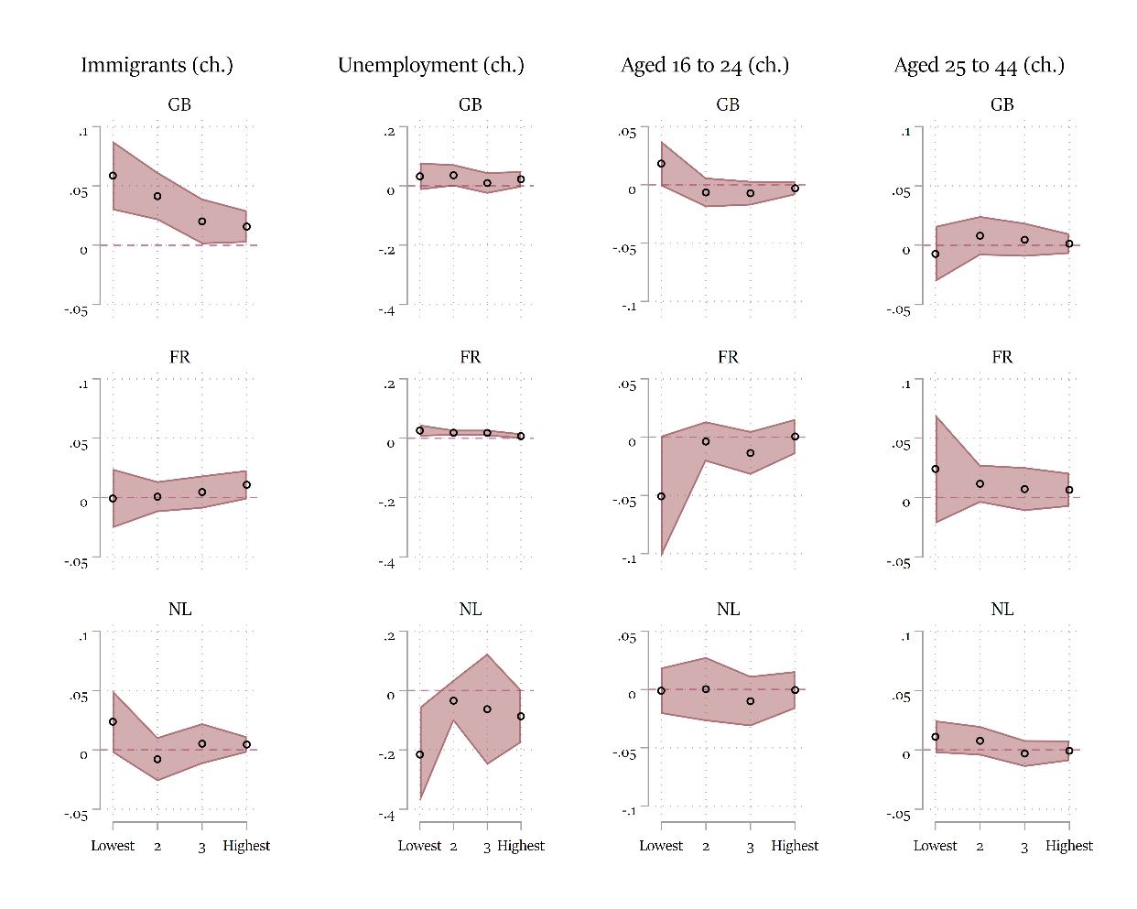
By local attachment
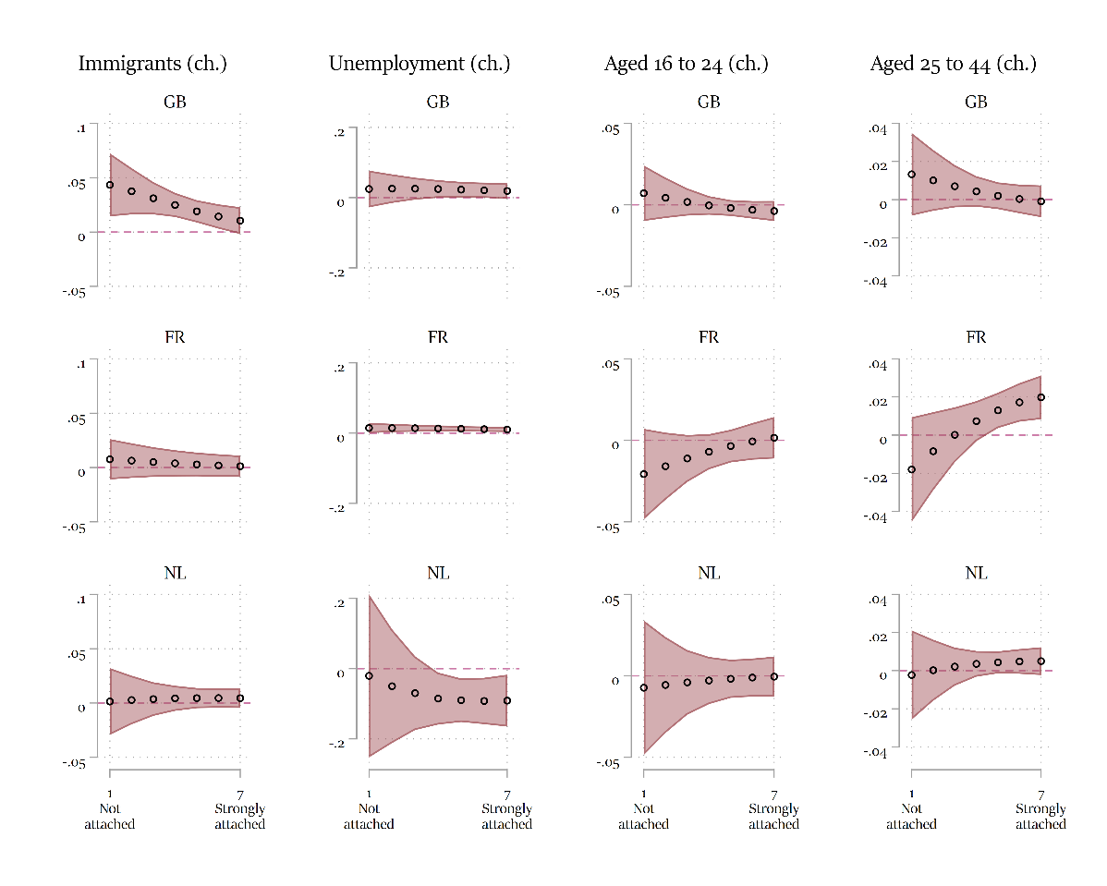
Figure F3. Replication controlling for class (in NL and UK only)

By level of education

By neighborhood attachment

