Supplementary Information

The Populist Backlash against Globalization:
A Meta-Analysis of the Causal Evidence
Gábor Scheiring, Manuel Serrano-Alarcón, Alexandru Moise,
Courtney McNamara, David Stuckler

British Journal of Political Science

Contents
The Populist Backlash against Globalization: A Meta-Analysis of the Causal Evidence 0
Supplement S1. Search strategy 1
Table S1.1 Database search string 2
Supplement S2. Geographic, methodological, and disciplinary heterogeneity 3
Figure S2.1. The number of studies by year 3
Figure S2.2 Countries analyzed in single-country studies 4
Figure S2.3. Causal inference designs by discipline 6
Supplement S3. Narrative review of main causal factors 7
Import exposure 7
Labor market uncertainty 9
Austerity and redistribution 10
Automation 11
Financial market shocks 12
Supplement S4. Meta-analysis details 14
Criteria for including estimates in the meta dataset 14
Table S4.1 Binomial test of equal sample size (publication bias test) 14
References 15

Supplement S1. Search strategy
We searched three academic databases following PRISMA guidelines: Web of Science, Scopus, and EBSCO Discovery Service. The search took place between January 26 and February 6, 2022, and was repeated between July 19 and 25, 2022. We focused on abstracts, keywords, and titles of studies published in English. We used no other filters. Our search covered published articles, books, book chapters, and grey literature (working papers, theses). Our search strategy covered three dimensions. We included a combination of keywords covering the outcome of interests (populism), a set of keywords covering the treatment (economic insecurity), and a set of keywords related to research design (causal inference). Table S1 in the online supplement shows the whole verbatim search strategy. The joint search string included 98 keywords plus Boolean operators (OR). The operationalization of these three concepts required careful conceptual mapping of the underlying phenomena.

Table S1.1 Database search string
1 | insecurity / security  vulnerability  uncertainty / certainty  risk  shock  crisis  decline  hardship  other | "economic insecurity" OR "financial insecurity" OR "labor market insecurity" OR "work insecurity" OR "employment insecurity" OR "economic security" OR "financial security" OR "labor market security" OR "work security" OR "employment security"  OR  "economic vulnerability" OR "financial vulnerability" OR "labor market vulnerability" OR "employment vulnerability"  OR  "economic uncertainty" OR "financial uncertainty" OR "labor market uncertainty" OR "employment uncertainty" OR "economic certainty" OR "financial certainty" OR "labor market certainty" OR "employment certainty"  OR  "economic risk" OR "financial risk" OR "labor market risk" OR "employment risk" OR "unemployment risk" OR "globali?ation risk"  OR  "economic shock" OR "financial shock" OR "labor market shock" OR "trade shock" OR "import shock" OR "globali?ation shock" OR "employment shock" OR "unemployment shock"  OR  "economic cris?s" OR "financial cris?s" OR "labor market cris?s" OR "globali?ation cris?s" OR "employment cris?s" OR "unemployment cris?s"  OR  "economic decline" OR "financial decline" OR "labor market decline" OR "employment decline" OR recession  OR  unemploy* OR poor OR poverty OR impoverish* OR deprived OR deprivation OR hardship OR "economic grievance*"  OR  competition OR liberali?ation OR globali?ation OR "economic backlash" OR trade OR import OR spending OR budget OR tariff* OR technolog* OR austerity OR robot* OR automation OR automati?ation OR deindustriali* OR precar* OR "left behind"
2 | populism (outcome) | populis* OR "radical left" OR "radical right" OR "radical party" OR "radical parties" OR "radical politic*" OR "far right" OR "far left" OR "new right" OR "new left" OR "extreme right" OR "extreme left" OR nazi OR fascis* OR neo-fascis*
3 | natural experiments (method) | experiment* OR causal* OR instrument* OR "difference in difference*" OR "difference-in-difference*" OR diff-in-diff OR DD OR discontinuity OR "synthetic control" OR "randomized control trial" OR RCT OR "controlled study" OR "field trial" OR exogenous
 | full search string | EBSCO Discovery: S1 AND S2 AND S3  Elsevier Scopus: #1 AND #2 AND #3  Web of Science: #1 AND #2 AND #3

Supplement S2. Geographic, methodological, and disciplinary heterogeneity
As Figure S1 shows, except for an early study published in 2011, all studies have been published after 2016. Populism studies as a field is much older; the difference is due to our focus on quasi-experimental studies, which started to gain popularity only recently in the social sciences.

Figure S2.1. The number of studies by year
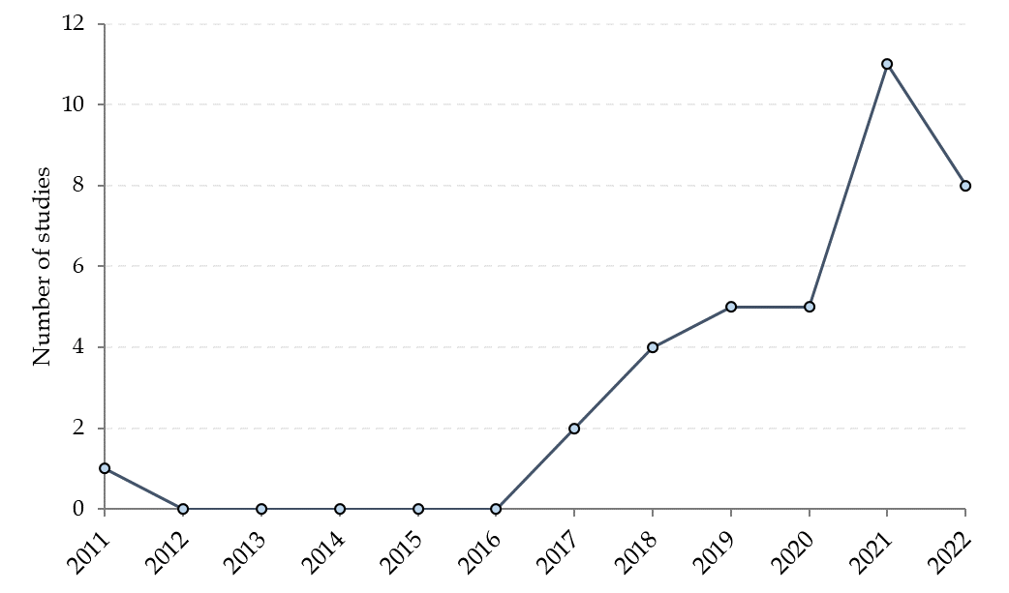
We found significant geographic heterogeneity. A few countries dominate the field regarding the number of authorships by country (most studies have multiple authors. Italy leads the field with 25 authorships, followed by the U.K. (15) and the U.S. (15), Switzerland (9), Germany (6), Canada (4), France (3), Sweden (2), and Spain (1). There are only three non-Western countries in the sample, each claiming one authorship: China, Hungary, and Turkey. The same skew is present in the countries analyzed. As the map displayed in Figure S2 shows, except for a working paper analyzing Brazil, all papers cover countries in Europe and North America. Within Europe, only two single-country studies focus on Eastern Europe. We found ten multi-country studies; these cover various areas of Europe, with five only concentrating on Western Europe. None of these multi-country studies explore the country-level details.

Figure S2.2 Countries analyzed in single-country studies
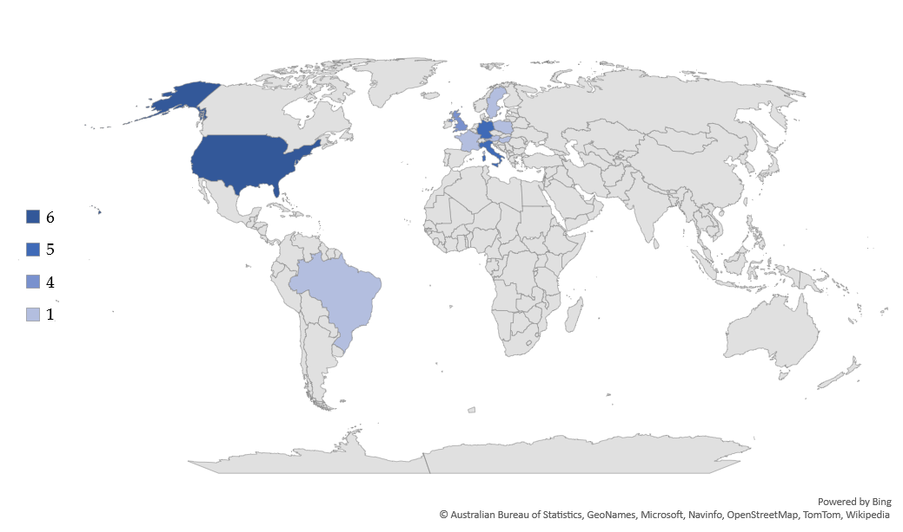
Number of studies
Note: The map displays the number of single-country studies for each country. Multi-country studies are not shown (these cover various groups of European countries without exploring the country-level details).
There are several reasons for this multi-layered geographic concentration. First, globalization impacts politics differently in semi-peripheral, emerging economies. For example, Rudra et al. (2021) suggest that most emerging economies are still in the “honeymoon phase” with globalization, dominated by early optimism and focus on benefits. Also, the mechanisms are likely to differ, requiring researchers to concentrate on less-studied phenomena. Second, data limitations also play a central role. Most studies rely on fine-grained administrative data; thus, data collection poses significant methodological challenges outside Europe and North America. Third, brain drain could also play a key role, whereby those with the necessary research skills migrate to the West. Finally, a general social science skew that rewards studies on Western Europe and North America with more citations could lead to a neglect of non-Western cases.
Most studies (20) analyze the populist radical right in terms of the outcome variable. A smaller group of studies (13) explores the whole populist spectrum (both left and right). We only found 2 studies that analyze a combination of populist attitudes, and one study analyzes the populist left. Researchers prefer to operationalize these outcome variables by analyzing vote shares (27 studies), with less emphasis on vote choice (4 studies) or some composite measure of political orientation (5 studies). There is also an asymmetric heterogeneity in variable types, with the majority analyzing change (20 studies), with less emphasis on levels (7 studies), scores (5 studies), binary outcomes (3 studies), or using some combination of these (one study).
In terms of primary causal inference design, instrumental variables dominate the field with 22 studies. We found 7 studies relying on difference-in-differences estimation, 4 studies using regression discontinuity, 2 studies using survey experiments, and one study exploiting variation across sibling pairs. Some studies combine multiple causal inference designs. These secondary experimental designs comprise 4 studies using matching, 2 studies using difference-in-differences, 2 using instrumental variables, one using regression discontinuity, and one event study.
Sample sizes vary from 24 countries to 97,035 individuals. Most studies focus on 1990-2020, although a few analyze earlier periods, with two studies on Nazi Germany (Doerr et al. 2022; Galofré-Vilà et al. 2021) and one on postwar Italy (Caprettini et al. 2021). Some use panel data modeling within variation only. Others use differenced variables in a repeated cross-sectional design with higher-level fixed effects. Yet, others use cross-sectional data without differencing. Some studies use repeated cross-sections.
Both economics and political science journals hosting the reviewed studies boast high average impact factors, 5.63 for political science, 4.86 for economics, 3.90 for interdisciplinary journals, and 3.06 for the one sociology journal that made it to the sample. This shows that the association between economic insecurity and populism is at the heart of disciplinary debates, with studies published in leading disciplinary journals in political science and economics. In terms of the number of citations, political science papers have the biggest impact on average (211 citations per paper on average), followed by economics (154), interdisciplinary studies (49), and sociology (19).
Even though we found a large diversity in outcome variables, there are some critical differences across disciplines, which might lead to disciplinary differences in findings. Economists strongly prefer a contextual-level measurement of populism, such as regions, sub-regions, or municipalities. Only one economics paper uses an individual-level primary outcome variable. Contextual variables might allow researchers to detect dynamically changing economic factors affecting regions or municipalities. In contrast, political scientists and sociologists seem more open to individual-level variables. By prioritizing individual-level analysis, political scientists and sociologists might be predisposed to analyze more static factors, attitudes, and values, amplifying the cultural determinants of populism.
We also find significant variation in the preferred research designs, reflecting these disciplinary differences. As Figure S3 shows, most economics studies (12 papers) use instrumental variable modeling as their primary design, followed by difference-in-difference (5 papers) and regression discontinuity designs (2). Political scientists also prefer instrumental variables (5) but are open to using survey experiments (2 studies) as the primary design. These differences are likely related to political scientists’ preference to analyze individual-level attitudes more suitable for survey experiments. Even though these disciplinary differences might be crucial — to foreshadow our results — we did not find much difference in the economic insecurity-populism association by outcome level or research design across different study designs.

Figure S2.3. Causal inference designs by discipline
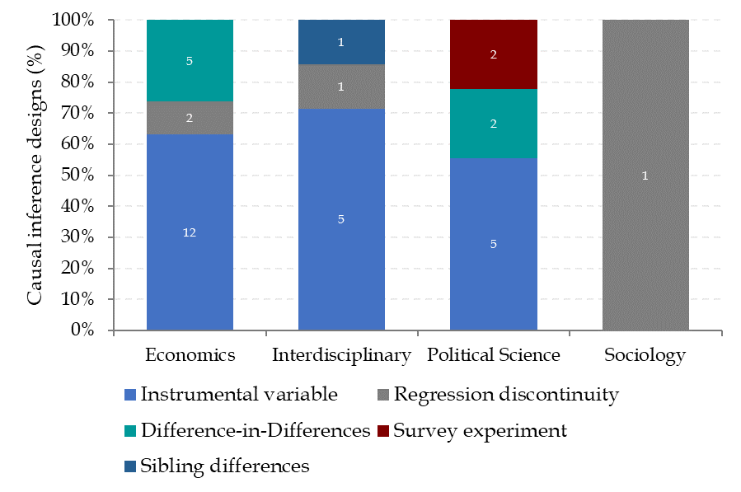
Note: The numbers in each column show the number of studies.

Supplement S3. Narrative review of main causal factors

Import exposure
The share of imports from low-wage countries grew from 15% to 28% in the 2000s in the U.S., with China accounting for 89% of the increase. This “China shock” had wide-ranging consequences for American workers, leading to the closure of manufacturing plants, a drop in employment, and increasing mortality (Acemoglu et al. 2016; Autor et al. 2013; Pierce and Schott 2020). Empirical evidence suggests that exposure to trade shocks increases the demand for social protection (Owen and Quinn 2016).
In the canonical study in this research space, Autor et al. (2020) analyze the political consequences of rising import exposure in the U.S. Their study builds on their equally highly influential previous analysis of the labor market impact of import exposure (Autor et al. 2013). One of the long-lasting contributions of Autor et al. (2013) is the introduction of a shift-share instrument to identify the causal effect of exposure to imports from China. Using industry-level data, they instrument Chinese exports to the U.S. with Chinese exports to eight other high-income countries. They exploit the fact that in the 2000s, much of the growth in Chinese imports stemmed from the rising competitiveness of Chinese manufacturers. This instrument removes the endogenous domestic component of American imports from China that could threaten causal identification.
Autor et al. (2020) apply the same instrument to explain various expressions of political polarization. Analyzing 3,772 sub-regions (commuting zones) in the 2000-2016 period, Autor et al. (2020) find that import exposure in the 2000s increased the campaign contributions by more ideologically extreme donors on both sides of the spectrum, increased the popularity of conservative media (Fox News), and conservative viewpoints (measured by the Pew Ideology Score). Regarding electoral effects, sub-regions with greater exposure to Chinese imports were more likely to elect a Republican Congressperson after 2010, mainly at the cost of moderate Democrats. They also saw a moderate increase in the vote share of Republican presidential candidates in the 2000-2008 period and a substantial increase in the 2008-2016 period. The study concludes that the net result of these political changes is that although more ideologically extreme members of both parties gained office, only the Republicans were able to gain more seats due to trade shocks.
In another highly influential paper, Colantone and Stanig (2018a) analyze the political impact of import exposure in 15 Western European countries. They follow Autor et al. (2020) and instrument imports to Europe using Chinese imports to the United States. They combine data on vote shares with information on parties’ positions on morality, law and order, protectionism, nationalism, and E.U. integration. Analyzing 198 NUTS-2 regions from 1988 to 2007, Colantone and Stanig (2018a) find that the Chinese import shock increased support for radical-right parties and a general shift to the right in the electorate. Colantone and Stanig (2018a) also point out that a one-standard-deviation increase in the import shock led to a 1.7-percentage-point increase in the support for the radical right. This effect is substantial. The average radical-right vote share was 5% in Western Europe between 1988 and 2007, implying that one-third of the populist radical right’s votes were attributable to the import shock in Western Europe. Echoing the magnitude reported by Colantone and Stanig (2018b, 2018a), Dippel et al. (2021) also find that import exposure explains around one-third of the overall growth of nationalist parties in 1987–2009.
In a related paper, Colantone and Stanig (2018b) use a similarly constructed instrumental variable to analyze the political effect of import shocks in 167 sub-regions (NUTS-3) in the U.K. from 1990 to 2007. They find that the Leave share at the Brexit referendum was systematically higher in regions more exposed to the Chinese import shock. The import shock also led to an increase in anti-immigration attitudes. They find a large effect size, explaining around one-third of the Leave vote.
Guiso et al. (2019) extend this literature by focusing on policy constraints emanating from Eurozone membership. Analyzing 1,942 NUTS-3 sub-regions in 19 E.U. countries in 2000–2014, they find that the import exposure has boosted populism in Eurozone countries more than non-Eurozone countries. The policy straitjacket imposed by the Eurozone increases economic insecurity because it binds governments’ hands to respond to economic shocks, thereby contributing to the spread of populism.

Labor market uncertainty
Studies on labor market uncertainty encompass regional-level employment change, unemployment, and novel measures of uncertainty. In a highly cited research, Algan et al. (2017) analyze the causal effect of unemployment during the Great Recession on trust and populism in 222 regions in 25 E.U. countries from 2000-2016. To explore causality, they rely on an instrumental variable extracting the component of increases in unemployment explained by the pre-crisis share of construction in regional value added, which strongly determines the impact of the crisis. Algan et al. (2017) note that their instrument might be endogenous but address these threats to identification by providing detailed evidence that alternative mechanisms are unlikely to bias the main results. Their 2SLS estimates find a large effect, with a 1-percentage-point increase in the unemployment rate leading to a rise in voting for the populist parties by 2 to 4 percentage points. They also find a strong link between unemployment and various forms of political distrust and anti-immigration attitudes.
Dehdari (2022) analyzes 5,662 sub-regions (electoral precincts) in Sweden over 2006-2010. He measures labor market uncertainty by the number of layoff notices received by low-skilled workers interacted with immigrants' precinct-level visibility. This measure also captures shocks to unemployment risk among workers who do not necessarily lose their jobs while excluding workers who voluntarily quit their jobs. To identify causality, he relies on an instrument that predicts the number of layoff notices by the national trends in notices within each industry and the sectoral composition in each electoral precinct. This identification strategy assumes that the pre-treatment sectoral composition of the electoral precincts does not lead to changes correlating with populism other than layoffs. Dehdari addresses potential threats to identification by controlling for variables frequently used in studies that estimate correlations between socioeconomic factors and populism. Dehdari (2022) finds a large effect, with labor market uncertainty explaining 31% of the total vote increase for the radical right Sweden Democrats in 2007–2010.
Lechler (2019) analyzes 260 regions in the European Union from 1994 to 2014 using the China-shock instrument and dynamic panel modeling. She finds that declining employment increases Eurosceptic voting. Lechler (2019) adds that the effect is powerful for unemployed and low-skilled workers in regions with a high share of migrants from other European member states. Labor market dislocations driven by the Great Recession also fuel right-wing populism outside Europe. Analyzing 558 Brazilian sub-regions over the 2014-2018 period, Barros and Santos Silva (2019) find that male-speciﬁc labor market shocks increased support for Bolsonaro.
Siedler (2011) uses longitudinal data on 504 sibling pairs in Germany over 1990-2004. These sibling-differences models exploit age differences between siblings that led to a variation in the experience of parental unemployment during childhood. Comparing sibling pairs eliminates family background effects. Siedler (2011) finds that growing up with unemployed parents is associated with a two percentage points increase in the probability of supporting a right-wing extremist party in West Germany and five percentage points in East Germany.
Rhodes-Purdy et al. (2021) conducted a survey experiment covering 997 American citizens in 2020. They measure populist attitudes using a multidimensional composite index, combining anti-elitism, people centrism, and Manichaeism. Among their experimental treatment categories, they analyze the role of economic anxiety and economic anger. Respondents had to complete a short writing exercise about a time they felt anxious about the country’s economy (economic anxiety treatment), a time they felt angry about the country’s economy (economic anger treatment), a time they felt political leaders had betrayed the people they were supposed to represent (populism) or a time they felt that people with values and beliefs like their own did not belong in this country (cultural discontent). Using structural equation modeling, Rhodes-Purdy et al. (2021) find that negative economic priming induces cultural discontent mediated by economic anger, with cultural discontent catalyzing populism.

Austerity and redistribution
Austerity is an upstream economic shock that could fuel populism by decreasing resources available to households. Fetzer (2019) investigates the impact of austerity on the Brexit referendum in the U.K. He analyzes 570 sub-regions (electoral districts) and 40,000 individuals in 2000-2016 to understand the causal link between austerity and support for the UKIP and the Leave vote. Relying on difference-in-differences methods, Fetzer (2019) finds that those exposed to welfare cuts experienced large increases in their tendency to express support for UKIP and support Leave in 2016. Due to austerity, UKIP vote shares increased between 3.5 to 11.9 percentage points. Leave support in 2016 would have been at least six percentage points lower without austerity.
Austerity’s disruptive political potential is not new. Galofré-Vilà et al. (2021) analyze a sample of 98 municipalities and 1,024 sub-regions (districts) from 1930 to 1933 in Germany. Using a combination of instrumental variable estimation and geographic regression discontinuity, they show that areas more affected by austerity had higher vote shares for the Nazi Party. Galofré-Vilà et al. (2021) also find that this is not purely a sociotropic effect, as areas with more austerity experienced higher suffering (measured by mortality), which fueled the support for the Nazi Party.
On the opposite side of austerity, several studies consistently show a robust association between higher redistribution and lower support for populism. Albanese et al. (2022) analyze 560 municipalities in Italy between 2008 and 2013, exploiting a spatial discontinuity between regions eligible and not eligible for higher E.U. funding. They find that higher E.U. financing in the 2008-2012 period led to five percentage points lower support for populist parties in the 2013 general election. Exploiting a similar discontinuity in access to higher E.U. funds in the U.K., Crescenzi et al. (2020) also find that citizens living in areas eligible for the highest amount of E.U. Structural Funds and experiencing improvements in their local labor market have been more inclined to express a pro-Europe vote at the Referendum on Brexit. However, they also add that this effect hinges on actual labor market improvements, without which higher E.U. funding does not dampen populism.

Automation
Technological advancement profoundly affected work and labor relations over the last decades. Low-skilled workers whose jobs are easier to automate have lost out (Autor and Dorn 2013; Dekker et al. 2017). The disruptive potential of automation is well-known since the Luddites set out to destroy machines in the early 19th century.
Anelli et al. (2021) analyze the impact of industrial robot adoption on individual voting behavior between 1999 and 2015 in 13 western European countries covering 97,035 individuals. Measuring economic insecurity generated by robotization poses methodological challenges. Traditional measures of individual exposure to automation based on the current occupation of respondents are potentially contaminated by the consequences of automation itself. The number of people in specific sectors at risk of automation might already be lower because of past automation, leading to lower risk scores than the actual risk considering historical trends.
Anelli et al. (2021) introduce a new measure of individual exposure to automation that considers pre-automation employment records. Following the shift-share method, they instrument robot adoption with robot adoption in other countries, thus purging their models from endogeneity related to domestic demand factors. Anelli et al. (2021) find that exposure to automation led to a 2.8-percentage-point increase in the probability of voting for a radical-right party in Europe in the 1999-2015 period. This effect is large since the baseline probability of voting for a radical right party in their sample is 4.8%. Furthermore, they also find evidence that automation increases nativism, status threat, and cultural traditionalism.
Frey et al. (2018) analyze 722 sub-regions (commuting zones) and 3,108 counties in the U.S. between 2011 and 2016. They use two instrumental variables to identify causality. They replace the 2011 distribution of commuting zone-level employment with employment shares in 1980 and use variation in robot usage across industries in ten European countries. Frey et al. (2018) find that electoral districts with higher exposure to robots were significantly more likely to support Trump in 2016. Trump gained, on average, 1.3 percentage points of the two-party vote share for each unit increase in the exposure to robots. According to their results, had the use of robots not increased in the years leading up to the election, Trump would have lost Michigan, Pennsylvania, and Wisconsin, thus leaving Clinton with a majority in the Electoral College.

Financial market shocks
Low-wage countries are often considered winners of relocations from high-income countries; thus, import exposure and robotization likely play a minor role in populism. Rudra et al. (2021) argue that developing countries are in the early “honeymoon phase” with globalization when the benefits are more visible than the costs. East-Central Europe is home to archetypical foreign-investment-driven export economies relying on comparatively cheap labor. However, this does not mean that the region does not experience the negative consequences of domestic disintegration as their countries integrate into the global economy (Scheiring 2021). Researchers have to look at processes other than robotization or import exposure — financial market shocks are a case in point.
Gyongyosi and Verner (2022) analyze the causal effect of a foreign currency debt shock on right-wing populism in 3,454 sub-regions of Hungary. As Gyongyosi and Verner (2022) describe, Hungary experienced a significant lending boom in the 2000s, including risky foreign currency loans. By 2008 more than 60% of household debt was denominated in Swiss francs in Hungary. Because of the financial crisis between September 2008 and the election held in April 2010, the exchange rate depreciated by 23 percent, leading to a rapid, unexpected increase in the indebtedness of the households. Using data from the household credit register, election outcomes, banks’ balance sheets, and data on municipality characteristics, Gyongyosi and Verner (2022) instrument the share of household loans with variations in banks’ lending policy and market shares across regions. They show that the foreign currency debt shock increased the vote share of the far-right Jobbik party by five percentage points on average, i.e., 35% of the total increase in the far-right vote share.
Poland also experienced a similar, though significantly smaller, and belated foreign currency debt shock. Ahlquist et al. (2020) conducted a survey experiment covering 2,044 individuals in 2015 and used matching methods to create balanced treatment and control groups. They find that individuals exposed to the 2015 surprise revaluation of the Swiss franc were more likely to demand government support and vote for the largest opposition party, the national-populist PiS. The foreign currency debt shock produced a 0.4% increase in the PiS share of the vote or about two parliamentary seats. This is a small effect, but only around 4% of Polish households had Swiss franc debts in 2015.
Analyzing the political effect of bank failures in the 1930s in Germany, Doerr et al. (2022) find that the collapse of the Danat bank (targeted by anti-Jewish Nazi propaganda) led to declining incomes and increased Nazi votes. They also point out that the Dresdner Bank’s failure (not subject to Nazi propaganda) had the same income eﬀect without increasing Nazi votes. The interaction of bank failure with political supply factors, i.e., Nazi propaganda, increased the Nazi vote share.

Supplement S4. Meta-analysis details

Criteria for including estimates in the meta dataset
We constructed a meta-dataset by including the main estimates reported in the 36 studies. We included only those main estimates that fulfilled the following criteria:
- authors consider the estimate the most important one,
- the estimate is the most conservative in terms of the number of control variables (fully adjusted models only),
- the estimate comes from a model that follows causal identification.
We included more than one estimate for a study if the authors used
- multiple relevant outcomes (for example, left- and right-wing populism),
- different relevant subsamples (for instance, men and women),
- different relevant treatment variables (for example estimating the effect of the China shock and automation also).

Table S4.1 Binomial test of equal sample size (publication bias test)
Window of t-statistic |  | Number of estimates |  | p-value
lower value | higher value | t<1.96 | t>1.96
1.79 | 2.13 | 4 | 16 | 0.0118
1.62 | 2.3 | 10 | 24 | 0.0243
1.45 | 2.47 | 13 | 26 | 0.0533
1.28 | 2.64 | 14 | 30 | 0.0226
1.111 | 2.809 | 15 | 35 | 0.0066
0.941 | 2.979 | 16 | 41 | 0.0013
0.771 | 3.149 | 17 | 46 | 0.0003
0.601 | 3.319 | 17 | 51 | 0
0.431 | 3.489 | 19 | 58 | 0
0.261 | 3.659 | 22 | 61 | 0

References
Acemoglu D, et al. (2016), Import Competition and the Great US Employment Sag of the 2000s. Journal of Labor Economics, 34, S141-S198.
Ahlquist J, et al. (2020), The Political Consequences of External Economic Shocks: Evidence from Poland. American Journal of Political Science, 64, 904-920.
Albanese G, et al. (2022), Populist Voting and Losers’ Discontent: Does Redistribution Matter? European Economic Review, 141, 104000.
Algan Y, et al. (2017), The European Trust Crisis and the Rise of Populism. Brookings Papers on Economic Activity, 2017, 309-400.
Anelli M, et al. (2021), Individual Vulnerability to Industrial Robot Adoption Increases Support for the Radical Right. Proceedings of the National Academy of Sciences, 118, e2111611118.
Autor D H and Dorn D (2013), The Growth of Low-Skill Service Jobs and the Polarization of the US Labor Market. American Economic Review, 103, 1553-1597.
Autor D H, et al. (2013), The China Syndrome: Local Labor Market Effects of Import Competition in the United States. American Economic Review, 103, 2121-2168.
Autor D H, et al. (2020), Importing Political Polarization? The Electoral Consequences of Rising Trade Exposure. American Economic Review, 110, 3139-3183.
Barros L and Santos Silva M (2019), #Elenão: Economic Crisis, the Political Gender Gap, and the Election of Bolsonaro; IAI Discussion Papers No. 242, Georg-August-Universität Göttingen, Ibero-America Institute for Economic Research (IAI), Göttingen.
Caprettini B, et al. (2021), Redistribution, Voting and Clientelism: Evidence from the Italian Land Reform; CEPR Discussion Paper, DP15679, June 21, 2021, London, Centre for Economic Policy Research.
Colantone I and Stanig P (2018a), The Trade Origins of Economic Nationalism: Import Competition and Voting Behavior in Western Europe. American Journal of Political Science, 62, 936-953.
Colantone I and Stanig P (2018b), Global Competition and Brexit. American Political Science Review, 112, 201-218.
Crescenzi R, et al. (2020), It's Not About the Money: EU Funds, Local Opportunities, and Euroscepticism. Regional Science and Urban Economics, 84, 103556.
Dehdari S H (2022), Economic Distress and Support for Radical Right Parties—Evidence from Sweden. Comparative Political Studies, 55, 191-221.
Dekker F, et al. (2017), Fear of Robots at Work: The Role of Economic Self-Interest. Socio-Economic Review, 15, 539-562.
Dippel C, et al. (2021), The Effect of Trade on Workers and Voters. The Economic Journal, 132, 199-217.
Doerr S, et al. (2022), Financial Crises and Political Radicalization: How Failing Banks Paved Hitler's Path to Power. Journal of Finance, Forthcoming.
Fetzer T (2019), Did Austerity Cause Brexit? American Economic Review, 109, 3849-3886.
Frey C B, et al. (2018), Political Machinery: Did Robots Swing the 2016 US Presidential Election? Oxford Review of Economic Policy, 34, 418-442.
Galofré-Vilà G, et al. (2021), Austerity and the Rise of the Nazi Party. Journal of Economic History, 81, 81-113.
Goldsmith-Pinkham P, et al. (2020), Bartik Instruments: What, When, Why, and How. American Economic Review, 110, 2586-2624.
Guiso L, et al. (2019), Global Crises and Populism: The Role of Eurozone Institutions. Economic Policy, 34, 95-139.
Gyongyosi G and Verner E (2022), Financial Crisis, Creditor-Debtor Conflict, and Populism. Journal of Finance, Forthcoming.
Lechler M (2019), Employment Shocks and Anti-EU Sentiment. European Journal of Political Economy, 59, 266-295.
Owen E and Quinn D P (2016), Does Economic Globalization Influence the US Policy Mood?: A Study of US Public Sentiment, 1956–2011. British Journal of Political Science, 46, 95-125.
Pierce J R and Schott P K (2020), Trade Liberalization and Mortality: Evidence from US Counties. American Economic Review: Insights, 2, 47-64.
Rhodes-Purdy M, et al. (2021), Populist Psychology: Economics, Culture, and Emotions. Journal of Politics, 83, 1559-1572.
Rudra N, et al. (2021), Globalization Backlash in Developing Countries: Broadening the Research Agenda. Comparative Political Studies, 54, 2416-2441.
Scheiring G (2021), Varieties of Dependency, Varieties of Populism: Neoliberalism and the Populist Countermovements in the Visegrád Four. Europe-Asia Studies, 73, 1569-1595.
Siedler T (2011), Parental Unemployment and Young People's Extreme Right-Wing Party Affinity: Evidence from Panel Data. Journal of the Royal Statistical Society. Series A (Statistics in Society), 174, 737-758.

EBSCO Discovery is a combination of multiple databases. We searched Business Source Ultimate, Academic Search Index, OpenAIRE, OAIster, MEDLINE, ScienceDirect, JSTOR, Emerald Insight, IMF eLibrary, and OECD iLibrary.
Based on our inclusion criteria, the most important reasons for exclusion were: a) studies dealing with concepts only indirectly related to populism, such as trust or nationalism, or incumbent turnover during elections, b) studies not analyzing economic insecurity, including studies on perceived status loss or sociotropic concerns about the country’s situation, c) studies falling short of empirical quasi-experiments even if they control for selection or time-invariant unobservable heterogeneity, studies not in English and papers that are not primary empirical research (E.g., reviews, opinion articles, commentaries, policy papers, or encyclopaedia entries). Some articles had multiple reasons for exclusion; we only list the main reason for exclusion in such cases.
Gyongyosi and Verner (2022) analyze the role of a foreign currency debt shock in the success of the radical right in Hungary. We coded authorship based on the first version of the paper, which in this case was a working paper. However, if we coded authorship based on the last version, then Hungary could not claim any authorship. Demonstrating the importance of studying populism, Central European University (CEU) was forced to leave Hungary because of an unprecedented political persecution.
As of October 11, 2022, in Google Scholar.
Following their lead, this China shock instrument has become the single most influential instrumental variable in the field. This China shock instrument is a Bartik-style shift share instrument, frequent also in studies on automation and labor market uncertainty (altogether 19 studies rely on a shift-share design). Such instruments have two components. The “share” component typically captures local pre-treatment exposure to shocks, such as initial, lagged occupational or industrial structure. The “shift” component typically leverages exogenous national or global variations in the shock, such as industry-specific Chinese exports to other countries. Although these instruments are currently widely popular, they pose some methodological challenges (see Goldsmith-Pinkham et al. 2020). Shift-share instruments do not fully remove endogeneity, as local shares still are part of the instrument, and the “shift” component only provides weights for these local shares in the regression models. Thus, the credibility of shift-share instruments depends on the authors’ ability to convince readers that the initial shares used in the instrument are exogenous.
This study is an outlier. The experimental part of the survey (information messages) is not directly related to the estimation of the effect of the foreign currency debt shock. Thus, strictly speaking, they do not follow experimental design to calculate the effect of foreign currency debt shock on populism. However, a) they follow a carefully differentiated approach that eliminates pre-treatment differences between groups also using matching, b) the experimental treatments are closely related to the foreign currency debt shock and show that messaging addressing these shocks affects policy preferences. Therefore, we included this study as a quasi-experiment.

