A New Dilemma of Social Democracy? The British Labour Party,
the White Working Class and Ethnic Minority Representation

* ONLINE APPENDIX MATERIAL *

Appendix 1: The Distribution of Economic and Social Values among Different Social Groups
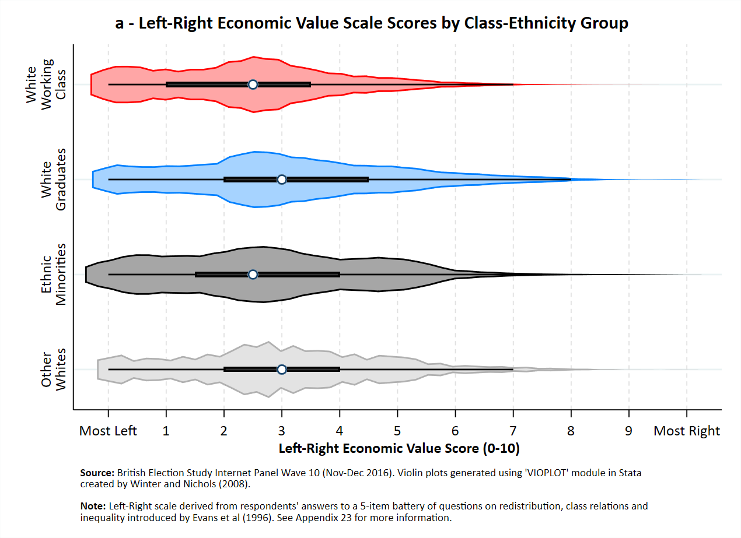

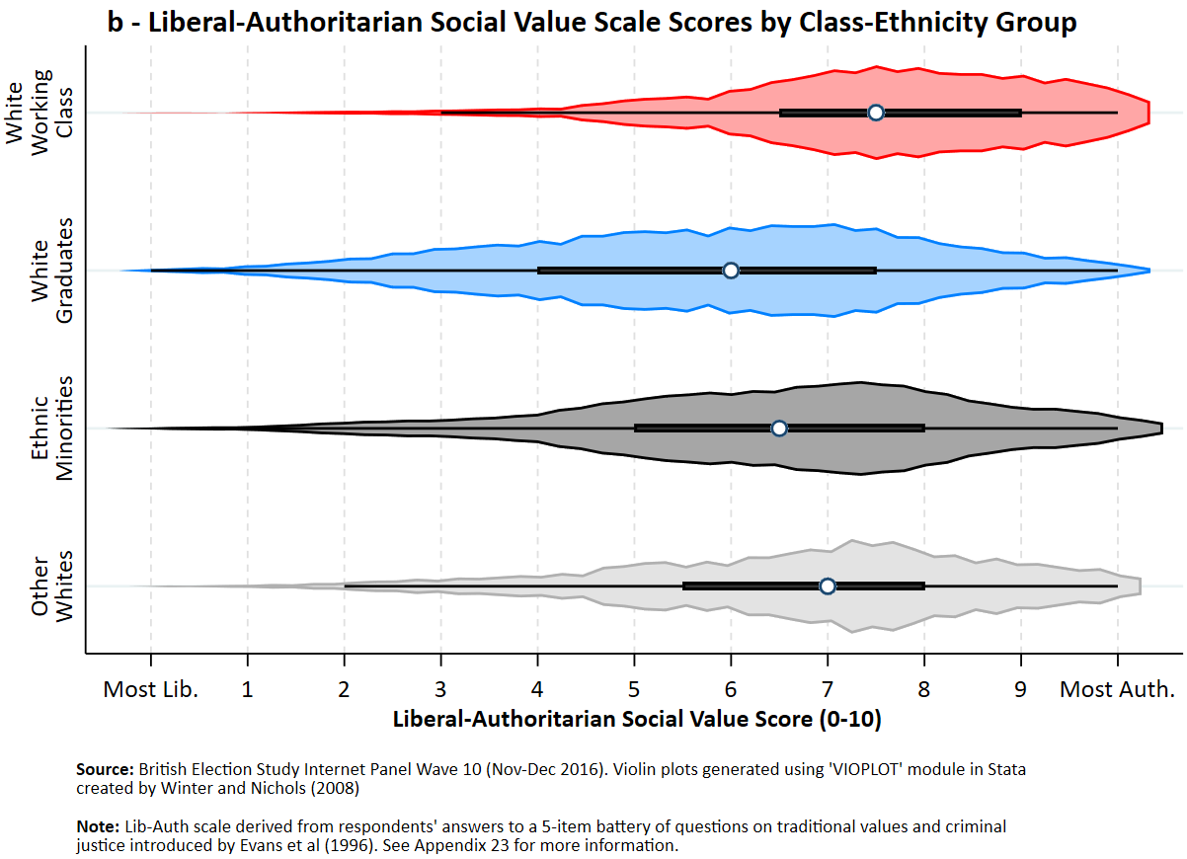

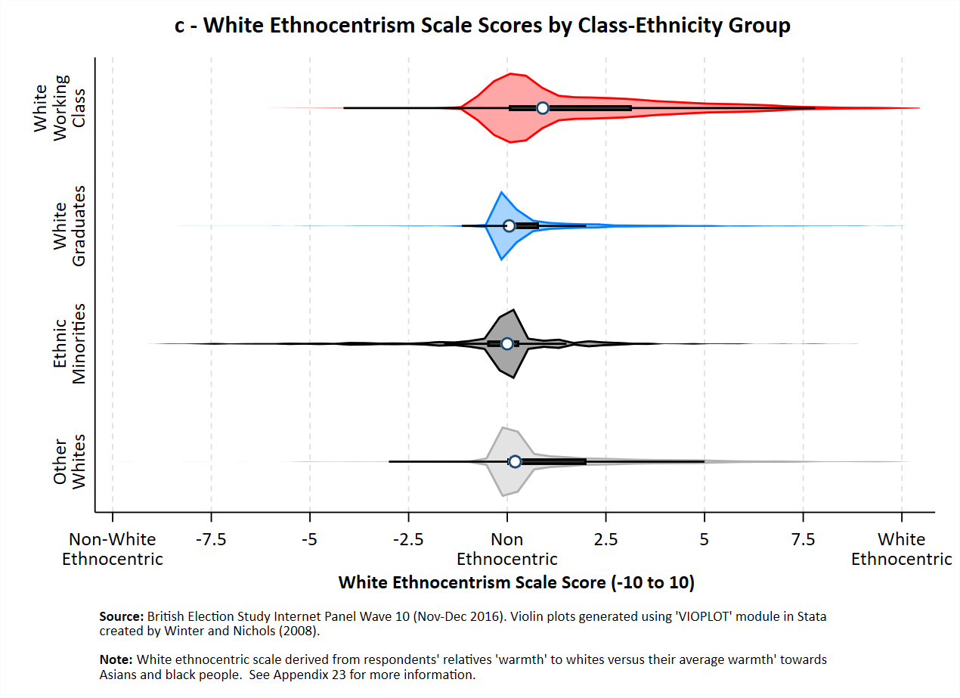

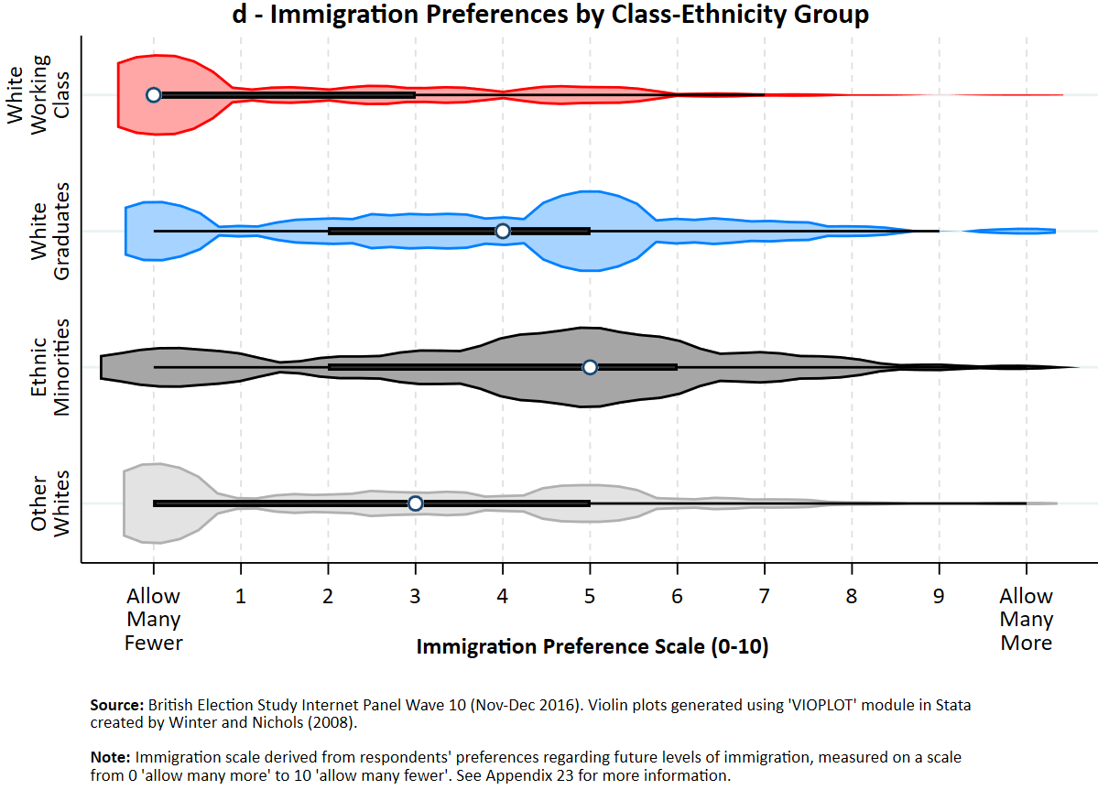

Note: The violin plots indicate the distribution of white working class, white graduate, non-white, and ‘other white’ respondents’ preferences on the left-right economic value (a), libertarian-authoritarian social value (b), white ethnocentrism (c), and immigration preference (d) scales, respectively. See Appendix 22 for information on the construction of these variables. Data are from waves 10 and 11 of the BESIP (Nov-Dec 2016 and Apr-May 2017). ‘Don’t knows’ were excluded. The data suggest that Labour’s tripolar coalition is likely to be relatively united in terms of attitudes to economic inequality and class relations, but more divided in terms of ‘second dimension’ issues of law and order and traditional morality, as well as comfort with ethnic heterogeneity and immigration. Violin plots were generate using ‘VIOPLOT’ module in Stata, as created by Winter and Nichols (2008).

Appendix 2: Evaluations of How Well Labour Looks After Different Groups’ Interests (0-3) According to Different Social Groups, 2016 - 2021

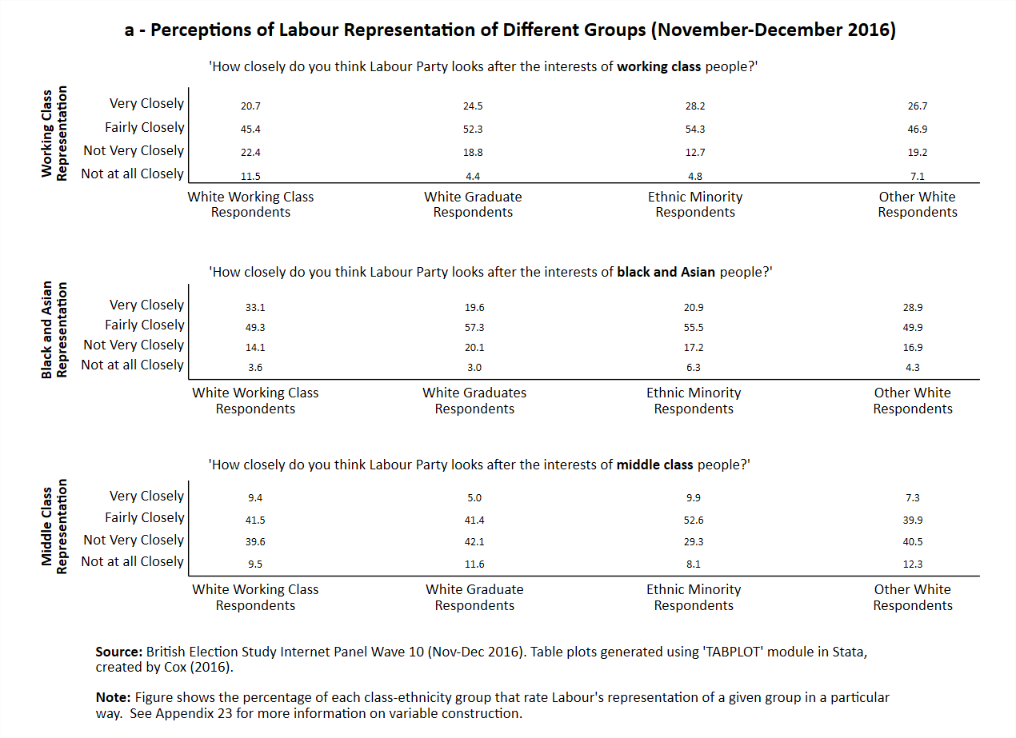

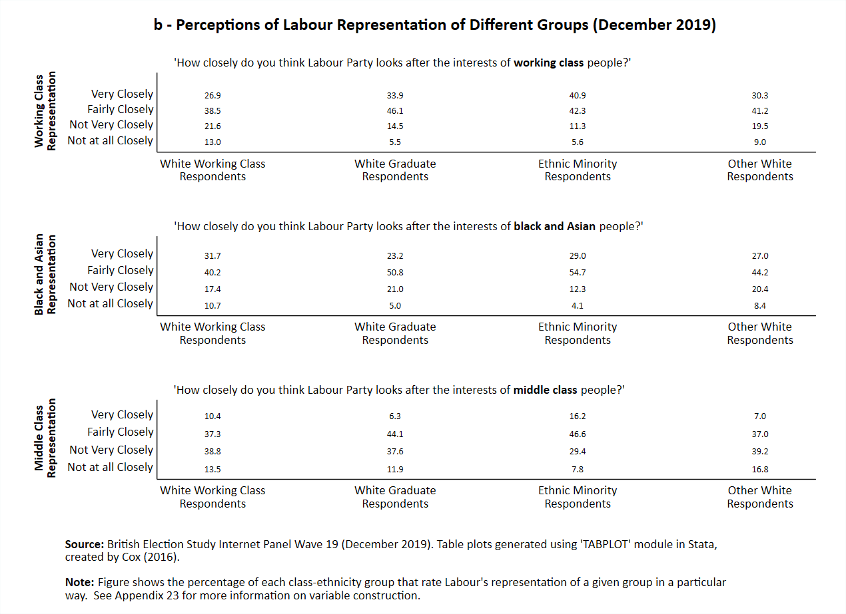

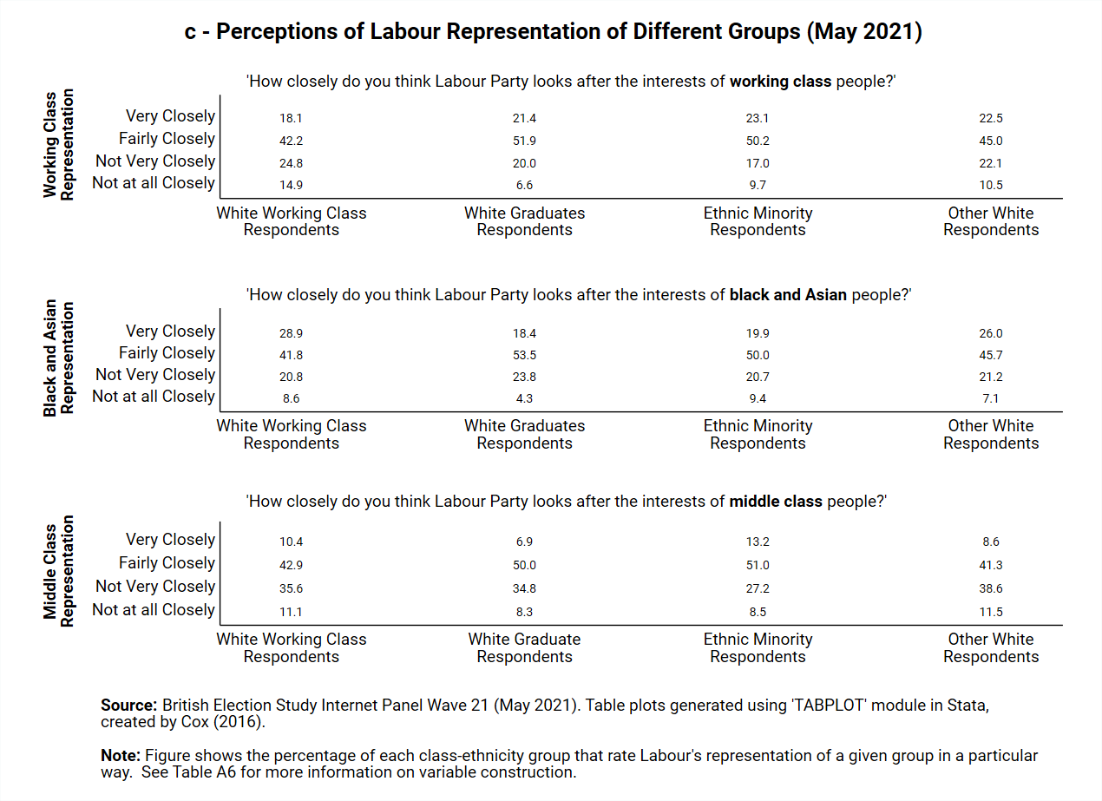

Note: The table plots in Appendix 2 indicate the percentage of white working class, white graduate, ethnic minority and ‘other white’ respondents who rate Labour’s representation of working class, black and Asian, and middle class people as either “very close”, “fairly close”, “not very close”, or “not at all close”, in 2016 (A2a), 2019 (A2b), and 2021 (A2c), respectively. ‘Don’t know’ responses were excluded. Data are from waves 10, 19, and 21 of the British Election Study Internet Panel. In all waves, the white working class were the most likely to rate Labour’s representation of working class representation the most negatively, and, persistently, more white working class people rated Labour’s representation of black and Asians as ‘very close’ than did so rate the party’s representation of the working class. Table plots were generate using ‘TABPLOT’ module in Stata, as created by Cox (2016).
Appendix 3: Evaluations of Labour’s Representation of the Working Class Relative to Black and Asian People According to Different Social Groups, 2016 - 2021

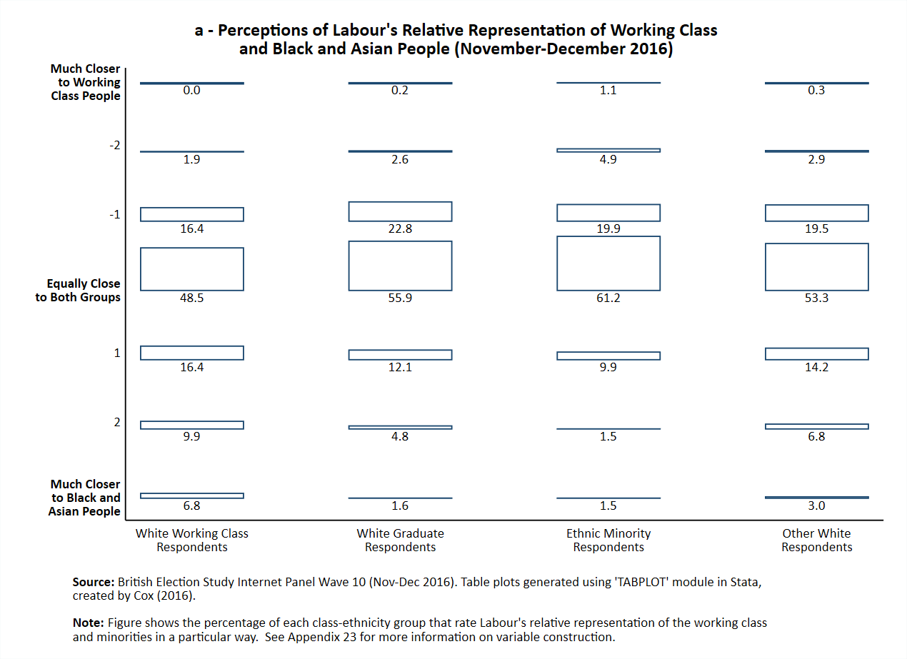

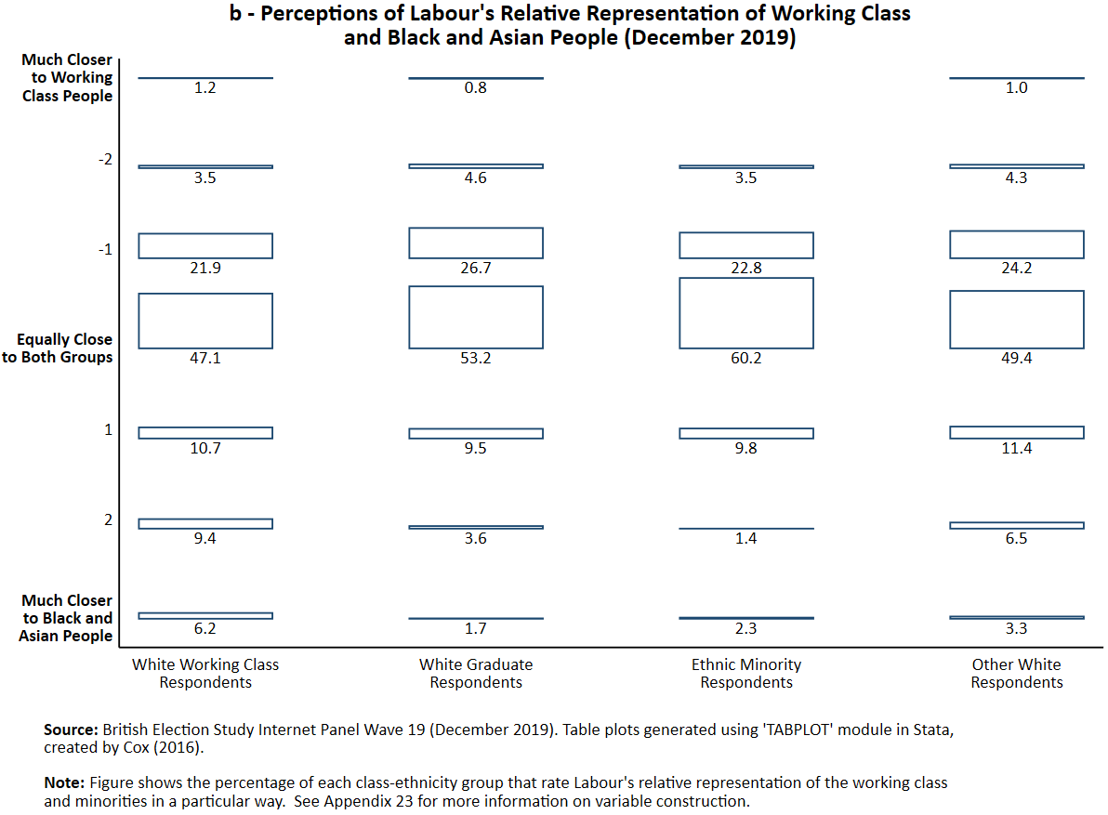

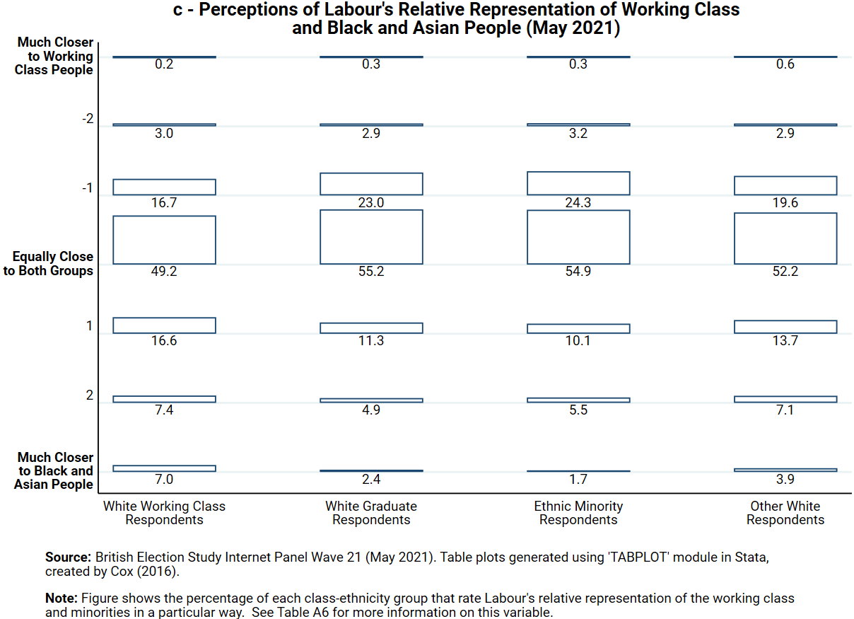

Note: The data for Appendix 3 is taken from a series of questions in the British Election Study Internet Panel [BESIP] that asked respondents “how closely [they] think the Labour Party looks after the interests of” ‘working class people’ and ‘black and Asian people’ on a scale of 0 (“not at all closely”) to 3 (“very closely”). Here we have subtracted average ratings of how well Labour represent the working class from average ratings of how well Labour represent black and Asian people. ‘Don’t know’ respondents have been excluded. The resulting scale ranges from -3 (indicating a respondent thinks that Labour represent the working class interests very closely but do not represent black and Asian people’s interests at all closely) to +3 (the reverse), with 0 as neutral half-way point where people evaluates Labour’s representation of the two different groups as equal. The table plots here indicate the percentage of white working class, white graduate, ethnic minority and ‘other white’ respondents who rate Labour’s relative representation of the two groups in a particular way in 2016 (A3a), 2019 (A3b), and 2021 (A3c), respectively. Data are from waves 10, 19, and 21 of the British Election Study Internet Panel. In all waves, the white working class were more likely to rate Labour as closer to black and Asian people than the working class per se. Table plots were generated using ‘TABLOT’ module in Stata, as created by Cox (2016).

Appendix 4: Replication of Tables 1-3 in the Main Text Using a Pooled Sample of BESIP Waves 10, 19, 20, and 21 (No Ethnocentrism Controls)

Table 1 Replication: The Impact of Evaluations of Labour’s Black and Asian Representation on Evaluations of Labour’s Working Class Representation, Interacted With Respondent Class-Ethnicity Group. Replication of Table 1 (Wave 10, Dec 2016 Data Only), Using a Pooled Dataset of Waves 10, 19 (Dec 2019), 20 (May 2020), and 21 (May 2021).
BESIP Data
(Waves 10, 19, 20 & 21, Dec 2016 – May 2021)
 | Model A | Model B | Model C
Labour Black and Asian [BME] Representation Rating  Respondent Group  White Graduates  Ethnic Minorities  Other Whites  (Ref: White Working Class)  Labour BME Representation * Respondent Group  Labour BME * White Graduate  Labour BME * Ethnic Minority  Labour BME * Other Whites  Left – Right Economic Values Scale  Liberal-Authoritarian Social Values Scale  Demographic Controls  Survey Wave Fixed Effects  Strength of Labour Partisanship | 0.23 (0.02) **  - 0.06 (0.05)  - 0.09 (0.08)  - 0.02 (0.05)  0.10 (0.03) **  0.19 (0.04) **  0.09 (0.03) **  X  X | 0.21 (0.03) **  - 0.01 (0.06)  - 0.10 (0.09)  - 0.04 (0.06)  0.11 (0.03) **  0.20 (0.04) **  0.09 (0.03) **  - 0.00 (0.00)  - 0.03 (0.01) **  X  X | 0.20 (0.03) **  0.04 (0.06)  - 0.06 (0.08)  - 0.03 (0.05)  0.08 (0.03) **  0.15 (0.04) **  0.09 (0.03) **  0.03 (0.00) **  - 0.02 (0.00) **  X  X  X
Constant  N – Respondents  R2 | 1.37 (0.105) **  49,584  0.11 | 1.56 (0.11) **  41,814  0.11 | 1.30 (0.06) **  41,321  0.15

Source: Pooled dataset of BESIP Wave 10 [Nov-Dec 2016], Wave 19 [Dec 2019], Wave 20 [May 2020], and Wave 21 [May 2021]. Data are weighted using the standard BESIP survey wave for the relevant wave. Standard errors are clustered at the respondent level as some respondents appeared in multiple waves. * p-value < 0.05; ** p-value < 0.01

Note: Each model presents the results from a different OLS regression predicting evaluations of how closely the Labour Party ‘look after working class interests’ (0 – 3). Perceived Labour BME representation is measured on the same scale. The results indicate, in harmony with the results from just Wave 10 presented in the main article, that the working class see a slightly less strongly positive relationship between Labour’s representation of non-whites and their representation of the working class, relative to other groups in the electorate. Please note that we are unable to include the control for ethnocentrism here, as this was not fielded close to any other BESIP Wave beside Wave 10 (the main reason we present only the results from this wave in the main text).

Demographic Controls: Age, Gender; Country. Women, under-25s and over-65s, and those outside Scotland are more likely to rate Labour’s WC representation more positively.

Table 2 Replication: The Impact of Evaluations of Labour’s Black and Asian (BME), Middle Class (MC), and Working Class (WC) Representation on Support for Labour, by Respondent Class-Ethnicity Group. Replication of Table 2 (Wave 10, Dec 2016 Data Only), Using a Pooled Dataset of Waves 10, 19 (Dec 2019), 20 (May 2020), and 21 (May 2021).
BESIP Data
(Waves 10, 19, 20 & 21,
Dec 2016 – May 2021)
 | Model A | Model B
Labour BME Representation Rating  Labour MC Representation Rating  Labour WC Representation Rating  Respondent Group  White Graduates  Ethnic Minorities  Other Whites  (Ref: White Working Class)  White Graduate * Labour Representation Ratings  White Graduate * Labour BME  White Graduate * Labour MC  White Graduates * Labour WC  Ethnic Minority * Labour Representation Ratings  Ethnic Minority * Labour BME  Ethnic Minority * Labour MC  Ethnic Minority * Labour WC  Other Whites * Labour Representation Ratings  Other Whites * Labour BME  Other Whites * Labour MC  Other Whites * Labour WC  Left – Right Economic Value Scale  Liberal-Authoritarian Social Value Scale  Demographic Controls  Survey Wave Fixed Effects | - 0.32 (0.07) **  0.92 (0.07) **  1.07 (0.07) **  0.32 (0.23)  1.69 (0.33) **  0.59 (0.22) **  0.30 (0.08) **  0.18 (0.08) *  - 0.49 (0.08) **  0.51 (0.13) **  - 0.33 (0.12) **  - 0.61 (0.12) **  - 0.01 (0.08)  0.04 (0.07)  - 0.38 (0.07) **  X  X | - 0.28 (0.09) **  0.83 (0.08) **  1.14 (0.08) **  0.40 (0.26)  2.07 (0.37) **  0.87 (0.25) **  0.38 (0.10) **  - 0.07 (0.09)  - 0.49 (0.09) **  0.49 (0.16) **  - 0.47 (0.14) **  - 0.64 (0.14) **  - 0.01 (0.09)  - 0.09 (0.09)  - 0.39 (0.09) **  - 0.39 (0.01) **  - 0.18 (0.01) **  X  X
Constant  N – Respondents | - 3.49 (0.21) **  41,699 | - 1.82 (0.24) **  35,508

Source: Pooled dataset of BESIP Wave 10 [Nov-Dec 2016], Wave 19 [Dec 2019], Wave 20 [May 2020], and Wave 21 [May 2021]. Data are weighted using the standard BESIP survey wave for the relevant wave. Standard errors are clustered at the respondent level as some respondents appeared in multiple waves. * p-value < 0.05; ** p-value < 0.01

Note: Each model presents the results from different logistic regressions predicting support for Labour (1) vs any other party (0). The results indicate, in harmony with the results from just Wave 10 presented in the main article that after evaluations of middle and working class representation are controlled for, Labour’s perceived representation of ethnic minority communities is actually a negative predictor of white working class support for the party. Please note that we are unable to include the control for ethnocentrism here, as this was not fielded close to any other BESIP Wave beside Wave 10 (the main reason we present only the results from this wave in the main text).

Demographic Controls: Age, Gender; Country.

Table 3 Replication: The Impact of Evaluations of Labour’s Relative Representation of WC and BME People on Support for Labour, by Respondent Class-Ethnicity Group. Replication of Table 3 (Wave 10, Dec 2016 Data Only), Using a Pooled Dataset of Waves 10, 19 (Dec 2019), 20 (May 2020), and 21 (May 2021).
BESIP Data
(Waves 10, 19, 20 & 21,
Dec 2016 – May 2021)
 | Model A | Model B
Labour BME – Labour WC Representation Rating  Respondent Group  White Graduates  Ethnic Minorities  Other Whites  (Ref: White Working Class)  Respondent Group * Labour BME – Labour WC Interaction  White Graduates  Ethnic Minorities  Other Whites  (Ref: White Working Class)  Left – Right Economic Value Scale  Liberal-Authoritarian Social Value Scale  Demographic Controls  Survey Wave Fixed Effects | - 0.64 (0.05) **  0.15 (0.05) **  0.88 (0.08) **  - 0.18 (0.05) **  0.36 (0.05) **  0.46 (0.09) **  0.20 (0.05) **  X  X | - 0.65 (0.06) **  0.02 (0.07)  0.98 (0.10) **  - 0.10 (0.06)  0.38 (0.07) **  0.50 (0.12) **  0.18 (0.07) **  - 0.42 (0.01) **  - 0.19 (0.01) **  X  X
Constant  N – Respondents | - 0.38 (0.07) **  42,030 | - 1.45 (0.10) **  35,701

Source: Pooled dataset of BESIP Wave 10 [Nov-Dec 2016], Wave 19 [Dec 2019], Wave 20 [May 2020], and Wave 21 [May 2021]. Data are weighted using the standard BESIP survey wave for the relevant wave. Standard errors are clustered at the respondent level as some respondents appeared in multiple waves. * p-value < 0.05; ** p-value < 0.01

Note: Each model presents the results from different logistic regressions predicting support for Labour (1) vs any other party (0). The results indicate, in harmony with the results from just Wave 10 presented in the main article that believing that Labour more closely represents minority communities than the working class is a strongly negative predictor of white working class support for the party.

Demographic Controls: Age, Gender; Country.

Appendix 5: What Can Ethnocentrism Predict? The Impact of Ethnocentrism on Attitudes to Immigration and European Integration

BESIP Data
(Wave 10 – Nov/Dec 2016)
Respondent Group  White Graduates  Ethnic Minorities  Other Whites  (Ref: White Working Class)  White Ethnocentrism Scale [2017]  Left – Right Economic Value Scale  Liberal-Authoritarian Social Value Scale  Demographic Controls | DV = Anti-Immigration Sentiment (0-10) |  |  |  | DV = Anti-EU Integration Sentiment (0-10)
 | Model A | Model B |  | Model C | Model D | Model E | Model F
 | - 1.91 (0.08) **  - 1.96 (0.19) **  - 0.82 (0.07) **  X |  | - 1.43 (0.08) **  - 1.16 (0.18) **  - 0.57 (0.07) **  0.43 (0.01) **  X | - 0.69 (0.07) **  - 1.15 (0.18) **  - 0.36 (0.07) **  0.28 (0.01) **  0.04 (0.01) **  0.58 (0.01) **  X | - 1.90 (0.10) **  - 1.95 (0.19) **  - 0.85 (0.09) **  X | - 1.49 (0.10) **  - 1.25 (0.19) **  - 0.64 (0.09) **  0.38 (0.01) **  X | - 0.83 (0.09) **  - 1.26 (0.18) **  - 0.48 (0.08) **  0.22 (0.01) **  0.15 (0.01) **  0.58 (0.01) **  X
Constant  N – Respondents  R-Squared | 6.43 (0.14) **  15,663  0.12 |  | 5.94 (0.13) **  15,663  0.24 | 2.91 (0.13) **  15,663  0.40 | 5.71 (0.17) **  16,006  0.12 | 5.27 (0.17) **  16,006  0.17 | 1.93 (0.16) **  16,006  0.30
Source: BESIP Wave 10 [Nov-Dec 2016] for all variables except ethnocentrism, which was recorded in Wave 11 [April 2017]. All data were treated using the BESIP Wave 10 survey weight. * p-value < 0.05; ** p-value < 0.01

Note: Models A-C present OLS regressions predicting respondents’ preferences regarding future levels of immigration, measured on a scale from 0 ‘allow many more’ and 10 ‘allow many fewer’. Models D-F present OLS regressions predicting respondents’ preferences regarding European integration, measured on a scale from 0 ‘unite fully with the European Union’ and 10 ‘protect our independence’. The data show that white ethnocentrism is a significant predictor of opposition to further immigration and European Union integration, two attitudes linked to ethnocentrism elsewhere (Sobolewska and Ford 2020a). This variable can explain about 24% of the difference between white graduates’ and the white working class (after controlling for age, gender and country) on immigration preferences and about 20% of the gap between these two groups in terms of attitudes to European integration. These results provide good evidence for the construct validity of our approach to operationalising ethnocentrism. Note that these coefficients are not standardised. A 1sd increase of white ethnocentrism leads to a 0.59 increase in anti-immigration sentiment, as opposed to a 0.08 increase for a 1sd increase in the right-wing economic values scale and a 1.30 increase in the authoritarian social values scale (Model C). A 1sd increase of white ethnocentrism leads to a 0.47 increase in anti-EU sentiment, as opposed to a 0.29 increase for a 1sd increase in the right-wing economic values scale and a 1.31 increase in the authoritarian social values scale (Model F)

Demographic Controls: Age, Gender; Country.

Appendix 6: What Predicts Belief that Labour Represents the Working Class? The Moderating Role of White Ethnocentrism
BESIP Data
(Wave 10 - Nov/Dec 2016)
 | Model A | Model B | Model C | Model D
Labour Black and Asian [BME] Representation Rating  White Ethnocentrism  Respondent Group  White Graduates  Ethnic Minorities  Other Whites  (Ref: White Working Class)  White Ethnocentrism * Labour Representation Rating  White Ethnocentrism * Labour BME  Demographic Controls  Ideology Controls  Strength of Labour Partisanship Control | 0.30 (0.01) **  - 0.05 (0.01) **  0.20 (0.03) **  0.24 (0.05) **  0.15 (0.03) **  X | 0.35 (0.02) **  0.02 (0.02)  0.20 (0.03) **  0.25 (0.05) **  0.15 (0.03) **  - 0.03 (0.01) **  X | 0.35 (0.02) **  0.03 (0.02)  0.16 (0.03) **  0.24 (0.05) **  0.13 (0.03) **  - 0.03 (0.01) **  X  X | 0.32 (0.02) **  0.02 (0.02)  0.18 (0.03) **  0.21 (0.05) **  0.15 (0.03) **  - 0.03 (0.01) **  X  X  X
Constant  N – Respondents  R2 | 1.26 (0.05) **  13,310  0.09 | 1.17 (0.06) **  13,310  0.10 | 1.20 (0.07) **  13,310  0.10 | 0.95 (0.06) **  13,310  0.14
Source: BESIP Wave 10 [Nov-Dec 2016] for all variables. The data are weighted using the standard BESIP wave 10 survey weight. * p-value < 0.05; ** p-value < 0.01

Note: Each model presents the results from a different OLS regression. The dependent variables are respondents’ evaluations of how closely the Labour Party ‘look after working class interests’ on a scale of 0 – 3, with evaluations of black and Asian interest representation measured on the same scale. Please note that these models are exactly the same as those presented in Table 1 of the main text, but here it is ethnocentrism, rather than respondent’s social group, that is interacted with evaluations of how well Labour looks after black and Asian interests. This interaction effect performs as expected: white ethnocentrics become especially less likely to say that Labour looks after working class interests when they associated the party more with minorities, regardless of whether one also controls for left-right and liberal-authoritarian ideology and partisanship. These results provide good evidence for the construct validity of our approach to operationalising ethnocentrism. See Appendix 7 for a visualisation of the substantive size of these associations.

Demographic Controls: Age, Gender; Country.

Ideology Controls: Left-Right and Libertarian-Authoritarian Value Scales

Appendix 7: What Predicts Belief that Labour Represents Working Class? The Moderating Role of White Ethnocentrism
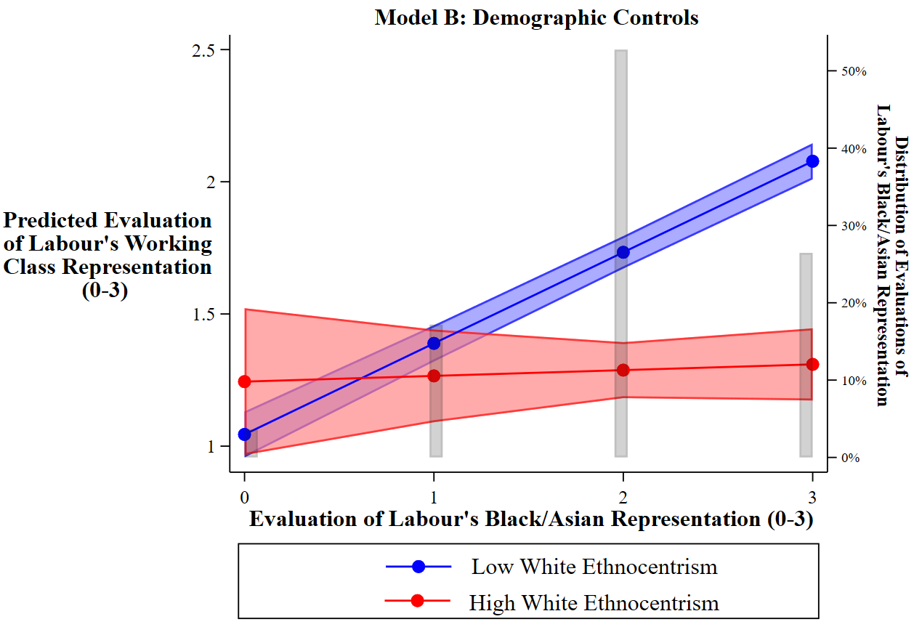

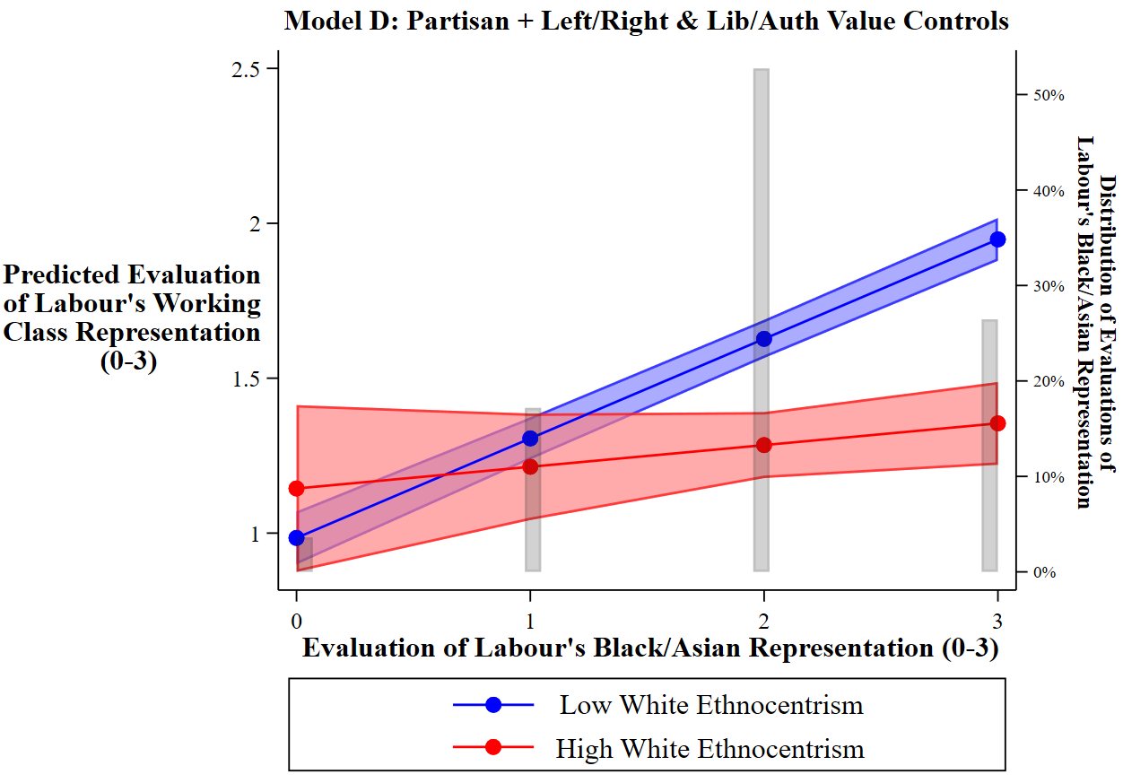

Source: BESIP Wave 10 [Nov-Dec 2016].

Note: Appendix 7 presents predicted values for the variable ‘how closely does Labour represent working class interests’ (0-3) based on coefficients from Appendix 6, Model B (top figure) and Model D (bottom figure) respectively. The estimates demonstrate how the value of this variable is predicted to change depending on evaluations of how closely Labour look after black and Asian people’s interests, for respondents with low levels of white ethnocentrism (ethnocentrism = 0) and high levels (ethnocentrism = 10), respectively. The top figure controls only for age, gender, UK country, and the race-class group variable from the main text (respondents are classified as white university graduate, white working class, ethnic minority or all non-graduate and non-working class whites). The bottom figure also controls for respondents’ scores on the left-right and libertarian-authoritarian value scales as well as their strength of Labour partisanship. The estimates are for a middle-aged, white working-class, English male and, in the bottom figure, he is also a non-Labour partisan with mean values on the left-right and libertarian-authoritarian values scales. 95% confidence intervals are provided for each point estimate. Both of the figures tell the same story. While evaluations of how well Labour looks after non-white interests are positively associated with evaluations of how well the party also looks after the working class for non-ethnocentrics, there is no such relationship for those with high levels of ethnocentrism. In fact, prior to controlling for strength of Labour partisanship, the relationship may actually be negative.

Appendix 8: The Impact of Ethnocentrism and Evaluations of Labour’s Minority (BME), Middle Class (MC), and Working Class (WC) Representation on Labour Support
BESIP Data
(Wave 10 - Nov/Dec 2016)
 |  | Model A | Model B | Model C | Model D | Model E | Model F | Model G
White Ethnocentrism  Labour BME Representation Rating  Labour MC Representation Rating  Labour WC Representation Rating  Respondent Group  White Graduates  Ethnic Minorities  Other Whites  (Ref: White Working Class)  Ethnocentrism * Labour Representation Ratings  White Ethnocentrism * Labour BME  White Ethnocentrism * Labour MC  White Ethnocentrism * Labour WC  Left – Right Economic Value Scale  Liberal-Authoritarian Social Value Scale  Demographic Controls |  | - 0.02 (0.09)  0.88 (0.16) **  - 0.29 (0.09) **  X | - 0.19 (0.02) **  - 0.22 (0.09) *  0.53 (0.16) **  - 0.41 (0.09) **  X | - 0.22 (0.10) *  0.96 (0.17) **  - 0.23 (0.10) *  - 0.44 (0.02) **  - 0.23 (0.01) **  X | - 0.12 (0.02) **  - 0.29 (0.11) **  0.74 (0.18) **  - 0.28 (0.10) **  - 0.44 (0.02) **  - 0.20 (0.02) **  X | 0.06 (0.03)  0.15 (0.04) **  - 0.21 (0.10) *  0.53 (0.16) **  - 0.41 (0.09) *  - 0.12 (0.02) **  X | 0.12 (0.04) **  0.20 (0.04) **  - 0.28 (0.10) **  0.74 (0.18) **  - 0.29 (0.10) **  - 0.12 (0.02) **  - 0.44 (0.02) **  - 0.20 (0.01) **  X | 0.11 (0.06)  - 0.18 (0.06) **  0.81 (0.06) **  0.67 (0.06) **  - 0.27 (0.11) *  0.62 (0.20) **  - 0.29 (0.10) **  - 0.14 (0.03) **  - 0.01 (0.03)  0.05 (0.03) *  - 0.42 (0.02) **  - 0.17 (0.02) **  X
 | Constant  N – Respondents | - 0.24 (0.13)  11,433 | - 0.05 (0.14)  11,433 | 1.97 (0.17) **  11,433 | 1.91 (0.17) **  11,433 | - 0.34 (0.15) **  11,433 | 1.55 (0.19) **  11,433 | - 0.61 (0.24)  11,433
Source: BESIP Wave 10 [Nov-Dec 2016] for all variables except ethnocentrism, which was recorded in BESIP Wave 11 [April 2017]. Data are weighted using the standard BESIP wave 10 survey weight. * p-value < 0.05; ** p-value < 0.01

Note: Each model presents the results from different logistic regressions predicting support for Labour (1) vs any other party (0). These models detail the impact of levels of white ethnocentrism on the predicted likelihood of a Labour vote intention as of November-December 2016. The first four models (A-D) show the direct impact of ethnocentrism (net of respondents’ age, gender, country, and class-ethnicity group) as well as the extent to which levels of ethnocentrism mediate the differences between different class-ethnicity groups in their proclivity to support Labour. Interestingly, as of late 2016, there is no actual gap between white graduates and the white working class left to ‘explain’ (net of age, gender, and country controls), so white ethnocentrism cannot mediate the gap there. However, controlling for white ethnocentrism does reduce the net gap in Labour support between ethnic minorities and the white working class by around 38%. The marginal net ‘effect’ of white ethnocentrism on decreasing Labour support in Model D is comparable to that of social authoritarianism, though less than half the size of economically right-wing attitudes (white ethnocentrism ranges over a 21-point scale, while authoritarianism and the left-right values indicators are both 11-point scales). Models E-G show how the impact of ethnocentrism on Labour support is moderated by the extent to which a respondent believes that Labour ‘look after the interests of Black and Asian people’. In all three models, regardless if one controls for left-right and libertarian-authoritarian values or evaluations of the party’s middle and working class interest representation, there is a significant interaction. White ethnocentrics are less likely to support Labour when they associate the party with the representation of non-whites. The net impact of white ethnocentrism is actually positively associated with Labour for those respondents who do not associate Labour with minority interests at all. White ethnocentrics are also more likely to support Labour when they believe that the party looks after working class interests more closely, holding all else constant. See Appendices 9 and 10 for a visualisation of the substantive size of these associations.

Demographic Controls: Age, Gender; Country.

Appendix 9: The Impact of Evaluations of Labour's Black & Asian Representation on Support for the Labour Party (Dec 2016)

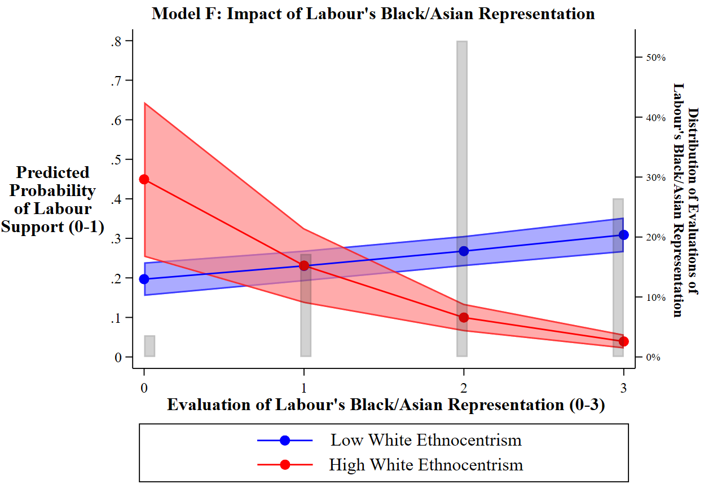

Source: BESIP Wave 10 [Nov-Dec 2016].

Note: Figure 9 presents the predicted probabilities of hypothetical individuals intending to vote for the Labour Party as opposed to any other party, using data from Appendix 8, Model F. The estimates demonstrate how the likelihood of Labour support is predicted to change depending on evaluations of how closely Labour ‘look after the interests of black and Asian people’, for those with a low level of ethnocentrism (white ethnocentrism = 0) in red, and for those with a very high level of ethnocentrism (white ethnocentrism = 10) in blue. 95% confidence intervals are provided for each point estimate. The histograms display the observed variation in evaluations of how well Labour looks after black and Asian people, across the entire sample population. The probabilities are for a white, middle-aged, man in England with the sample average values on the left-right and libertarian-authoritarian value scales. The figure demonstrates that the marginal impact of increasing belief that Labour looks after non-white interests is slightly positively associated with support for the party among non-ethnocentrics, but substantially negatively associated with Labour support among highly ethnocentric voters.

Appendix 10: The Impact of Left-Right, Libertarian-Authoritarian, and White Ethnocentrism on Support for the Labour Party (Dec 2016)
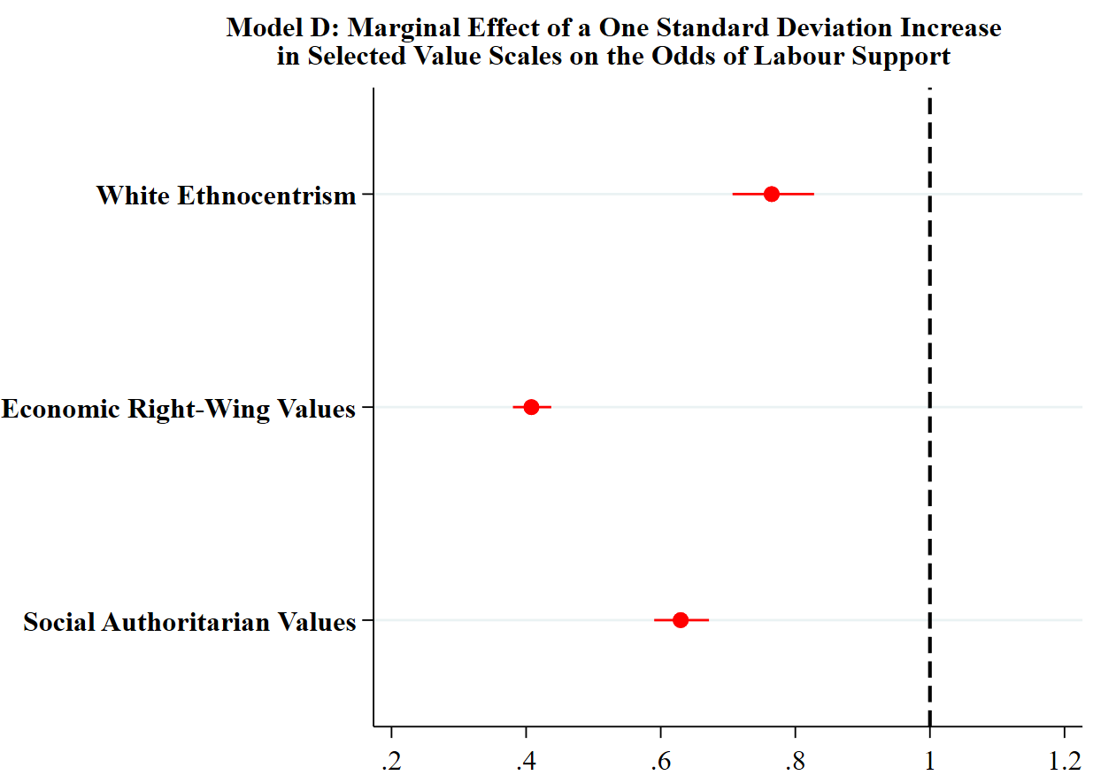

Source: BESIP Wave 10 [Nov-Dec 2016].

Note: Appendix 10 is a coefficient plot the presents the marginal effect of a one standard deviation in a respondents’ score on the white ethnocentrism, economic left-right, and social libertarian-authoritarian scales on the odds of that respondent having a Labour vote intention in November-December of 2016. These odds are derived from Model D of Appendix 8. Please note that, these are the net effects of a one standard deviation in each case, holding constant the values of respondents’ age, class-ethnicity group, gender, country, and their scores on the other two values scales in each case. 95% confidence intervals are provided for each estimate. A one standard deviation increase in white ethnocentrism (that is, being a standard deviation more ethnocentric than the sample mean) reduces the odds that one would support Labour by about 23%. A one standard deviation increase in the social libertarian-authoritarian scale (that is being a standard deviation more authoritarian than the sample mean) reduces the odds of supporting Labour by 37%. The largest marginal effect, however, is a one standard deviation increase in the economic left-right scale (that is, being a standard deviation more economically right-wing than the sample mean), which would reduce the odds of supporting Labour by around 59%. These figures demonstrate the value of using ethnocentrism in models of British political behaviour as well as the more traditional economic left-right and social liberal-authoritarian scales (Sobolewska and Ford 2020; Evans et al 1996).

Appendix 11: What Predicts White Ethnocentrism in Britain?
BESIP Data
(Wave 10: Nov/Dec 2016)
 | Model A | Model B | Model C
Respondent Group  White Graduates  Ethnic Minorities  Other Whites  (Ref: White Working Class)  Age  26-44  45-64  65+  (Ref: 18-24 Year Olds)  Female  UK Country  Scotland  Wales  (Ref: England)  Left – Right Economic Values Scale  Liberal-Authoritarian Social Values Scale | - 1.09 (0.08) **  - 1.90 (0.15) **  - 0.57 (0.08) **  0.54 (0.10) **  0.82 (0.09) **  1.24 (0.09) **  - 0.15 (0.04) **  - 0.15 (0.07) *  - 0.01 (0.08) | - 0.04 (0.01) **  0.34 (0.01) ** | - 0.56 (0.08) **  - 1.71 (0.15) **  - 0.37 (0.08) **  0.08 (0.09)  0.19 (0.09) *  0.52 (0.09) **  - 0.24 (0.04) **  - 0.03 (0.06)  0.00 (0.08)  - 0.03 (0.01) *  0.31 (0.01) **
Constant  N – Respondents  R2 | 1.16 (0.11) **  16,401  0.07 | - 0.98 (0.06) **  16,401  0.11 | - 0.44 (0.12) **  16,401  0.15

Source: BESIP Wave 10 [Nov-Dec 2016] for all variables except ethnocentrism, which was recorded in BESIP Wave 11 [April 2017]. * p-value < 0.05; ** p-value < 0.01

Note: Each model presents the results from a different OLS regression. The dependent variables are respondents’ levels of ethnocentrism. This variable was created by subtracting respondent’s stated average ‘warmth of feeling’ towards both ‘black people’ and ‘Asian people’ born in Britain from their warmth of feeling toward ‘white people’ also born here. All 3 of these variables were rescaled to run 0 (very cold) to 10 (very warm), so the final variable runs from -10 (feel very warm to non-whites, very cold to whites) to +10 (very warm to whites, very cold to non-whites) with 0 as a non-ethnocentric middle point. The data were weighted using the standard BESIP wave 10 survey weight. Being a white, working class, older male is associated with higher levels of white ethnocentrism, as is being more economically left-wing and social authoritarian.

Appendix 12: The Impact of Evaluations of Labour’s Black and Asian Representation on Evaluations of Labour’s Working Class Representation – Controlling for Immigration Attitudes Rather than Ethnocentrism (Table 1 Robustness Test)
BESIP Data
(Wave 10 - Nov/Dec 2016)
 | Model A | Model B | Model C
Labour Black and Asian [BME] Representation Rating  Respondent Group  White Graduates  Ethnic Minorities  Other Whites  (Ref: White Working Class)  Labour BME Representation * Respondent Group  Labour BME * White Graduate  Labour BME * Ethnic Minority  Labour BME * Other Whites  Pro-Immigration Attitudes Scale  Left – Right Economic Values Scale  Liberal-Authoritarian Social Values Scale  Demographic Controls  Strength of Labour Partisanship | 0.13 (0.04) **  - 0.12 (0.10)  - 0.16 (0.14)  - 0.14 (0.09)  0.17 (0.05) **  0.25 (0.07) **  0.16 (0.04) **  X | 0.16 (0.04) **  - 0.24 (0.09) **  - 0.19 (0.14)  - 0.18 (0.09) *  0.18 (0.04) **  0.20 (0.07) **  0.15 (0.04) **  0.06 (0.01) **  X | 0.16 (0.04) **  - 0.16 (0.09)  - 0.16 (0.13)  - 0.15 (0.08)  0.14 (0.04) **  0.16 (0.06) **  0.14 (0.04) **  0.06 (0.00) **  0.05 (0.01) **  0.03 (0.01) **  X  X
Constant  N – Respondents  R2 | 1.62 (0.09) **  18,308  0.08 | 1.30 (0.09) **  18,308  0.12 | 0.92 (0.09) **  18,308  0.15

Source: BESIP Wave 10 [Nov-Dec 2016] for all variables. Data are weighted using the standard BESIP wave 10 survey weight. * p-value < 0.05; ** p-value < 0.01

Note: Each model presents the results from a different OLS regression predicting evaluations of how closely the Labour Party ‘look after working class interests’ (0 – 3). Perceived Labour BME representation is measured on the same scale. These models are exactly the same as those in Table 1 of the main text; however, here we substitute a measure of respondents’ attitudes towards immigration for the scale of white ethnocentrism that we use in the main text. This was the respondents’ response to a question in the BESIP that asked: “Some people think that the UK should allow *many more* immigrants to come to the UK to live (10) and others think that the UK should allow *many fewer* immigrants (0). Where would you place yourself on this scale?”. Accordingly, respondents with higher values on this variable are generally more pro-immigration. While, as mentioned in the text, we have reservations about the extent to which this variable captures antipathy towards non-white individuals and are concerned that this could fluctuate in response to concerns that one is already relatively deprived of political representation (and other resources) relative to those already in the country, it does have one major advantage over our ethnocentrism measure in that it was actually measured at the same time as the rest of the survey items on political representation, rather than in an adjacent wave (meaning that our sample size increases). Accordingly, we use this measure as a robustness check here. As you can see, our main results are unaffected: regardless of the control for attitudes towards immigration, members of the white working class are less likely to see Labour’s attempts to represent both blacks and Asians and the working class as strongly positively correlated. Those who are more pro-immigration are also more likely to say that Labour closely represents the working class.

Demographic Controls: Age, Gender; Country.
Appendix 13: The Impact of Evaluations of Labour’s Black and Asian (BME), Middle Class (MC), and Working Class (WC) Representation on Support for Labour - Controlling for Immigration Attitudes Rather than Ethnocentrism (Table 2 Robustness Test)
 | BESIP Data (Wave 10 - Nov/Dec 2016)
 | Model A | Model B | Model C
Labour BME Representation Rating  Labour MC Representation Rating  Labour WC Representation Rating  Respondent Group  White Graduates  Ethnic Minorities  Other Whites  (Ref: White Working Class)  White Graduate * Labour Representation Ratings  White Graduate * Labour BME  White Graduate * Labour MC  White Graduates * Labour WC  Ethnic Minority * Labour Representation Ratings  Ethnic Minority * Labour BME  Ethnic Minority * Labour MC  Ethnic Minority * Labour WC  Other Whites * Labour Representation Ratings  Other Whites * Labour BME  Other Whites * Labour MC  Other Whites * Labour WC  Pro-Immigration Attitudes Scale  Left – Right Economic Value Scale  Liberal-Authoritarian Social Value Scale  Demographic Controls | - 0.72 (0.13) **  1.15 (0.11) **  1.24 (0.11) **  0.23 (0.40)  1.95 (0.53) **  0.55 (0.38)  0.53 (0.14) **  0.12 (0.13)  - 0.74 (0.12) **  0.90 (0.21) **  - 0.60 (0.20) **  - 1.01 (0.20) **  0.25 (0.14)  - 0.16 (0.12)  - 0.54 (0.11) **  X | - 0.59 (0.13) **  1.15 (0.11) **  1.14 (0.11) **  - 0.07 (0.41)  2.00 (0.56) **  0.48 (0.39)  0.56 (0.14) **  - 0.02 (0.13)  - 0.69 (0.13) **  0.86 (0.23) **  - 0.72 (0.20) **  - 1.02 (0.21) **  0.24 (0.14)  - 0.25 (0.12) *  - 0.51 (0.12) **  0.19 (0.01) **  X | - 0.59 (0.13) **  0.96 (0.11) **  1.21 (0.11) **  - 0.04 (0.41)  2.22 (0.56) **  0.57 (0.39)  0.59 (0.15) **  - 0.08 (0.13)  - 0.64 (0.13) **  0.80 (0.23) **  - 0.60 (0.21) **  - 1.08 (0.20) **  0.20 (0.14)  - 0.21 (0.12)  - 0.46 (0.12) **  0.15 (0.01) **  - 0.41 (0.02) **  - 0.09 (0.02) **  X
Constant  N – Respondents | - 3.29 (0.37) **  15,674 | - 4.09 (0.37) **  15,674 | - 2.29 (0.39) **  15,674

Source: BESIP Wave 10 [Nov-Dec 2016] for all variables. Data are weighted using the standard BESIP wave 10 survey weight. * p-value < 0.05; ** p-value < 0.01

Note: Each model presents the results from different logistic regressions predicting support for Labour (1) vs any other party (0). These models are exactly the same as those in Table 2 of the main text; however, here we substitute a measure of respondents’ attitudes towards immigration for the scale of white ethnocentrism that we use in the main text (see note to Appendix 11 for question wording). While, as mentioned in the text, we have reservations about the extent to which this variable captures antipathy towards non-white individuals and are concerned that this could fluctuate in response to concerns that one is already relatively deprived of political representation (and other resources) relative to those already in the country, it does have one major advantage over our ethnocentrism measure in that it was actually measured at the same time as the rest of the survey items on political representation, rather than in an adjacent wave (meaning that our sample size increases). Accordingly, we use this measure as a robustness check here. As you can see, our main results are unaffected: regardless of the control for attitudes towards immigration, members of the white working class are less likely to support Labour if they associate the party with minority representation (especially relative to graduates and minorities).

Demographic Controls: Age, Gender; Country.
 | BESIP Wave 10 Data  (DV = Labour Vote  Intention 2016) |  | BESIP Wave 19 Data  (DV = Labour Vote 2019 General Election)
Labour BME – Labour WC Representation Rating  Respondent Group  White Graduates  Ethnic Minorities  Other Whites  (Ref: White Working Class)  Respondent Group * Labour BME - WC Rating Interaction  White Graduate * Labour BME - WC  Ethnic Minority * Labour BME - WC  Other Whites * Labour BME - WC  Pro-Immigration Attitudes Scale  Left – Right Economic Value Scale  Liberal-Authoritarian Social Value Scale  Lagged Labour Vote [2017]  Demographic Controls | Model A | Model B | Model C | Model D | Model E | Model F
 | - 0.85 (0.08) **  - 0.15 (0.08)  0.70 (0.13) **  - 0.39 (0.08) **  0.55 (0.09) **  0.77 (0.14) **  0.35 (0.08) **  X | - 0.80 (0.09) **  - 0.39 (0.09) **  0.64 (0.14) **  - 0.37 (0.09) **  0.53 (0.10) **  0.80 (0.15) **  0.29 (0.09) **  0.17 (0.01) **  - 0.45 (0.02) **  - 0.09 (0.01) **  X | - 0.49 (0.11) **  0.57 (0.14) **  1.34 (0.22) **  0.07 (0.14)  0.32 (0.12) *  0.19 (0.24)  0.10 (0.12)  X | - 0.34 (0.16) *  - 0.07 (0.25)  1.58 (0.46) **  - 0.21 (0.25)  0.43 (0.19) *  0.30 (0.42)  0.34 (0.19)  0.32 (0.03) **  X | - 0.64 (0.15) **  0.25 (0.30)  0.76 (0.48)  0.09 (0.28)  0.61 (0.19) **  0.81 (0.46)  0.46 (0.18) *  3.66 (0.17) **  X | - 0.53 (0.21) **  - 0.21 (0.32)  0.85 (0.54)  - 0.17 (0.31)  0.57 (0.25) *  0.60 (0.58)  0.55 (0.25) *  0.29 (0.04) **  3.62 (0.19) **  X
Constant  N – Respondents | - 0.27 (0.11)  15,748 | 0.61 (0.17) **  15,748 | - 0.30 (0.21)  5,612 | - 2.20 (0.73)  1,998 | - 3.00 (0.59) **  2,775 | - 3.78 (0.59) **  1,926
Appendix 14: The Impact of Evaluations of Labour’s Relative Representation of Ethnic Minorities and the Working Class on Support for Labour - Controlling for Immigration Attitudes Rather than Ethnocentrism (Table 3 Robustness Test)
Source: Models A-B: BESIP Wave 10 [Nov-Dec 2016] for all variables. Models C-F: BESIP Wave 19 [Dec 2019] for all variables except the ‘pro-immigration attitudes scale’, which was measured in BESIP Wave 17 [Nov 2019], and the lagged dependent variable, ‘Labour Vote [2017]’, which was measured in BESIP Wave 13 [June 2017] following the 2017 UK General Election. Models A and B are weighted using the standard Wave 10 BESIP survey weight. Model C is weighted the standard Wave 19 BESIP survey weight. Models D-F are weighted using the Wave 13 (June 2017) to Wave 19 panel weight to adjust for non-random patterns of attribution between those surveys. * p-value < 0.05; ** p-value < 0.01

Note: Each model presents the results from different logistic regressions predicting support for Labour (1) vs any other party (0). These models are exactly the same as those in Table 3 of the main text; however, here we substitute a measure of respondents’ attitudes towards immigration for the scale of white ethnocentrism that we use in the main text (see note to Appendix 11 for question wording). While, as mentioned in the text, we have reservations about the extent to which this variable captures antipathy towards non-white individuals and are concerned that this could fluctuate in response to concerns that one is already relatively deprived of political representation (and other resources) relative to those already in the country, it does have one major advantage over our ethnocentrism. This is because immigration attitudes were actually measured in Wave 10 and Wave 17 of the BESIP, which is the same wave as the rest of the data for Models A and B (Wave 10) or at least only one month prior to the same wave, in the case of Models C-F (Wave 19), respectively. Ethnocentrism, on the other hand, was only measured in Wave 11. Consequently, our sample size increases considerably when we use this measure as a robustness check here. As you can see, our main results are unaffected: regardless of the control for attitudes towards immigration, members of the white working class are less likely to support Labour if they associate the party with minority representation (especially relative to graduates).

Demographic Controls: Age, Gender; Country.

Appendix 15: The Impact of Evaluations of Labour’s Black and Asian Representation on Evaluations of Labour’s Working Class Representation, With Additional Control for Attitudes to European Union Integration (Table 1 Robustness Test)
BESIP Data
(Wave 10 - Nov/Dec 2016)
 | Model A | Model B | Model C
Labour Black and Asian [BME] Representation Rating  Respondent Group  White Graduates  Ethnic Minorities  Other Whites  (Ref: White Working Class)  Labour BME Representation * Respondent Group  Labour BME * White Graduate  Labour BME * Ethnic Minority  Labour BME * Other Whites  White Ethnocentrism Scale  Left – Right Economic Values Scale  Liberal-Authoritarian Social Values Scale  Anti-European Union Integration Scale  Demographic Controls  Strength of Labour Partisanship | 0.14 (0.05) **  - 0.27 (0.11) *  - 0.14 (0.17)  - 0.25 (0.11) *  0.20 (0.05) **  0.18 (0.09) *  0.18 (0.05) **  - 0.05 (0.00) **  X | 0.15 (0.05) **  - 0.30 (0.11) **  - 0.17 (0.17)  - 0.26 (0.10) *  0.20 (0.05) **  0.17 (0.08) *  0.18 (0.05) **  - 0.03 (0.01) **  - 0.05 (0.00) **  X | 0.15 (0.04) **  - 0.22 (0.10) *  - 0.15 (0.17)  - 0.22 (0.10) *  0.17 (0.05) **  0.15 (0.08)  0.17 (0.05) **  - 0.03 (0.01) **  0.05 (0.01) **  0.02 (0.00) **  - 0.04 (0.00) **  X  X
Constant  N – Respondents  R2 | 1.85 (0.11) **  13,184  0.12 | 1.84 (0.10) **  13,184  0.12 | 1.44 (0.10) **  13,184  0.15

Source: BESIP Wave 10 [Nov-Dec 2016] for all variables except ethnocentrism, which was recorded in BESIP Wave 11 [April 2017]. Data are weighted using the standard BESIP wave 10 survey weight. * p-value < 0.05; ** p-value < 0.01

Note: Each model presents the results from a different OLS regression predicting evaluations of how closely the Labour Party ‘look after working class interests’ (0 – 3). Perceived Labour BME representation is measured on the same scale. These models are the same as in Table 1 of the main text; however, here we also add a control measuring respondents’ attitudes towards European Union [EU] integration. This was taken from a question in the BESIP that asked respondents: ‘Some people feel that Britain should do all it can to unite fully with the European Union (0). Other people feel that Britain should do all it can to protect its independence from the European Union (10). Where would you place **yourself** on this scale?’, This is because attitudes towards the EU and the UK’s exit from it were a highly salient predictor of political preferences during the mid- to late-2010s that also split the electorate along lines of class, race, and education (Sobolewska and Ford 2020), and it seems prudent, therefore, to ascertain whether or not our results are simply reflecting Brexit attitudes of the ‘Leave’ camp among the white working class. As it happens, however, our results are entirely robust to the inclusion of this additional control, suggesting that we are not simply restating the presence of a ‘Brexit divide’.

Demographic Controls: Age, Gender; Country.

Appendix 16: The Impact of Evaluations of Labour’s Black and Asian (BME), Middle Class (MC), and Working Class (WC) Representation on Support for Labour, With Additional Control for Attitudes to European Union Integration (Table 2 Robustness Test)
BESIP Data
(Wave 10 - Nov/Dec 2016)
 | Model A | Model B | Model C
Labour BME Representation Rating  Labour MC Representation Rating  Labour WC Representation Rating  Respondent Group  White Graduates  Ethnic Minorities  Other Whites  (Ref: White Working Class)  White Graduate * Labour  Representation Ratings  White Graduate * Labour BME  White Graduate * Labour MC  White Graduates * Labour WC  Ethnic Minority * Labour  Representation Ratings  Ethnic Minority * Labour BME  Ethnic Minority * Labour MC  Ethnic Minority * Labour WC  Other Whites * Labour  Representation Ratings  Other Whites * Labour BME  Other Whites * Labour MC  Other Whites * Labour WC  White Ethnocentrism Scale  Left – Right Economic Value Scale  Liberal-Authoritarian Social Value Scale  Anti-European Union Integration Scale  Demographic Controls | - 0.61 (0.15) **  1.12 (0.14) **  1.17 (0.14) **  - 0.11 (0.48)  2.41 (0.65) **  0.32 (0.46)  0.60 (0.17) **  - 0.04 (0.16)  - 0.72 (0.16) **  0.82 (0.23) **  - 0.68 (0.23) **  - 1.21 (0.22) **  0.26 (0.16)  - 0.15 (0.15)  - 0.55 (0.15) **  - 0.22 (0.01) **  X | - 0.62 (0.15) **  1.12 (0.14) **  1.16 (0.14) **  - 0.19 (0.48)  2.29 (0.64) **  0.26 (0.46)  0.62 (0.17) **  - 0.05 (0.16)  - 0.71 (0.16) **  0.83 (0.24) **  - 0.69 (0.24) **  - 1.21 (0.23) **  0.29 (0.17)  - 0.16 (0.15)  - 0.55 (0.15) **  - 0.05 (0.02) **  - 0.21 (0.01) **  X | - 0.63 (0.16) **  0.95 (0.14) **  1.23 (0.14) **  - 0.08 (0.48)  2.48 (0.63) **  0.35 (0.45)  0.65 (0.18) **  - 0.14 (0.16)  - 0.68 (0.16) **  0.74 (0.25) **  - 0.58 (0.25) *  - 1.22 (0.24) **  0.24 (0.17)  - 0.13 (0.15)  - 0.50 (0.15) **  - 0.04 (0.02)  - 0.41 (0.02) **  0.08 (0.02) **  - 0.18 (0.01) **  X
Constant  N – Respondents | - 2.08 (0.44) **  11,354 | - 2.04 (0.44) **  11,354 | - 0.77 (0.45) **  11,354

Source: BESIP Wave 10 [Nov-Dec 2016] for all variables except ethnocentrism, which was recorded in BESIP Wave 11 [April 2017]. Data are weighted using the standard BESIP wave 10 survey weight. * p-value < 0.05; ** p-value < 0.01

Note: Each model presents the results from different logistic regressions predicting support for Labour (1) vs any other party (0). These models are the same as in Table 2 of the main text; however, here we also add a control measuring respondents’ attitudes towards European Union [EU] integration. This was taken from a question in the BESIP that asked respondents: ‘Some people feel that Britain should do all it can to unite fully with the European Union (0). Other people feel that Britain should do all it can to protect its independence from the European Union (10). Where would you place **yourself** on this scale?’, This is because attitudes towards the EU and the UK’s exit from it were a highly salient predictor of political preferences during the mid- to late-2010s that also split the electorate along lines of class, race, and education (Sobolewska and Ford 2020), and it seems prudent, therefore, to ascertain whether or not our results are simply reflecting Brexit attitudes of the ‘Leave’ camp among the white working class. As it happens, however, our results are entirely robust to the inclusion of this additional control, suggesting that we are not simply restating the presence of a ‘Brexit divide’.

Demographic Controls: Age, Gender; Country.
 | BESIP Wave 10 Data  (DV = Labour Vote  Intention 2016) |  | BESIP Wave 19 Data  (DV = Labour Vote 2019 General Election)
Labour BME – Labour WC Representation Rating  Respondent Group  White Graduates  Ethnic Minorities  Other Whites  (Ref: White Working Class)  Respondent Group * Labour BME - WC Rating Interaction  White Graduate * Labour BME - WC  Ethnic Minority * Labour BME - WC  Other Whites * Labour BME - WC  White Ethnocentrism Scale  Left – Right Economic Value Scale  Liberal-Authoritarian Social Value Scale  Anti-European Union Integration Scale  Lagged Labour Vote [2017]  Demographic Controls | Model A | Model B | Model C | Model D | Model E | Model F
 | - 0.76 (0.10) **  - 0.57 (0.10) **  0.46 (0.16) **  - 0.62 (0.10) **  0.56 (0.12) **  0.82 (0.16) **  0.36 (0.11) **  - 0.24 (0.01) **  X | - 0.81 (0.11) **  - 0.47 (0.11) **  0.57 (0.18) **  - 0.44 (0.10) **  0.56 (0.12) **  0.79 (0.14) **  0.31 (0.12) **  - 0.05 (0.01) **  - 0.45 (0.02) **  - 0.08 (0.02) **  - 0.19 (0.01) **  X | - 0.36 (0.15) *  - 0.01 (0.16)  0.91 (0.25) **  - 0.18 (0.16)  0.34 (0.16) *  0.17 (0.28)  0.20 (0.17)  - 0.31 (0.02)**  X | - 0.46 (0.17) **  0.29 (0.24)  1.09 (0.44) *  - 0.46 (0.24)  0.66 (0.21) **  0.59 (0.42)  0.62 (0.20) **  - 0.12 (0.05) *  - 0.33 (0.03) **  X | - 0.57 (0.16) **  - 0.26 (0.32)  0.58 (0.49)  - 0.15 (0.30)  0.72 (0.21) **  0.99 (0.40) *  0.61 (0.19) **  - 0.25 (0.03) **  3.41 (0.17) **  X | - 0.68 (0.20) **  - 0.38 (0.35)  0.37 (0.52)  - 0.35 (0.32)  0.83 (0.25) **  1.28 (0.42) **  0.77 (0.24) **  - 0.10 (0.06)  - 0.26 (0.04) **  3.41 (0.17) **  X
Constant  N – Respondents | 1.07 (0.15) **  11,403 | 2.25 (0.18) **  11,403 | 1.17 (0.24) **  5,523 | 1.14 (0.60)  2,261 | - 1.42 (0.62) **  2,729 | - 1.27 (0.64) **  2,195

Appendix 17: The Impact of Evaluations of Labour’s Relative Representation of Ethnic Minorities and the Working Class on Support for Labour with Additional Control for Attitudes to European Union Integration (Table 3 Robustness Test)

Source: Models A-B: BESIP Wave 10 [Nov-Dec 2016] for all variables except ethnocentrism, which was recorded in BESIP Wave 11 [April 2017]. Models C-F: BESIP Wave 19 [Dec 2019] for all variables except ethnocentrism, which was recorded in BESIP Wave 11 [April 2017], and the lagged dependent variable, Labour Vote [2017], which was measured in BESIP Wave 13 [June 2017] following the 2017 UK General Election. Models A and B are weighted using the standard Wave 10 BESIP survey weight. Model C is weighted the standard Wave 19 BESIP survey weight. Models D-F are weighted using the Wave 13 (June 2017) to Wave 19 panel weight to adjust for non-random patterns of attribution between those surveys. * p-value < 0.05; ** p-value < 0.01.

Note: Each model presents the results from different logistic regressions predicting support for Labour (1) vs any other party (0). These models are the same as in Table 3 of the main text; however, here we also add a control measuring respondents’ attitudes towards European Union [EU] integration. This was taken from a question in the BESIP that asked respondents: ‘Some people feel that Britain should do all it can to unite fully with the European Union (0). Other people feel that Britain should do all it can to protect its independence from the European Union (10). Where would you place **yourself** on this scale?’. This is because attitudes towards the EU were a highly salient predictor of political preferences during the mid- to late-2010s that also split the electorate along lines of class, race, and education (Sobolewska and Ford 2020). IT seems prudent, therefore, to ascertain whether or not our results are simply reflecting Brexit attitudes of the ‘Leave’ camp among the white working class. As it happens, however, our results are entirely robust to the inclusion of this additional control, suggesting that we are not simply restating the presence of a ‘Brexit divide’.

Demographic Controls: Age, Gender; Country.

Appendix 18: The Impact of Evaluations of Labour’s Black and Asian (BME), Middle Class (MC), and Working Class (WC) Representation on Support for Labour - Sample Restricted to Whites with a Working Class Identity (Table 2 Robustness Test)
 | BESIP Data (Wave 10 - Nov/Dec 2016)
 | Model A | Model B | Model C
Labour BME Representation Rating  Labour MC Representation Rating  Labour WC Representation Rating  White Ethnocentrism Scale  Left – Right Economic Value Scale  Liberal-Authoritarian Social Value Scale  Demographic Controls | - 0.55 (0.07) **  0.88 (0.06) **  1.05 (0.06) **  X | - 0.52 (0.07) **  0.86 (0.06) **  1.02 (0.06) **  - 0.13 (0.28) **  X | - 0.50 (0.07) **  0.70 (0.06) **  1.03 (0.06) **  - 0.08 (0.02) **  - 0.37 (0.03) **  - 0.20 (0.02) **  X
Constant  N – Respondents | - 2.46 (0.28) **  4,613 | - 2.41 (0.28) **  4,613 | - 0.52 (0.33)  4,613

Source: BESIP Wave 10 [Nov-Dec 2016] for all variables. Data are weighted using the standard BESIP wave 10 survey weight. * p-value < 0.05; ** p-value < 0.01

Note: Each model presents the results from different logistic regressions predicting support for Labour (1) vs any other party (0). These models are similar to those in Table 2 of the main text; however, here we have limited our sample only to ethnically white respondents who identify as working class when asked (some 37% of our sample in the 2019 General Election wave), rather than use the objective definition of working class based on occupation and educational attainment that we adopt in the main text. Note that we do not compare working class identifiers to middle class identifiers here because, unlike white graduates, we do not consider white middle class identifiers per se to be either particularly socially liberal / pro-minority or part of Labour’s recent ‘tripolar coalition’. Consequently, a comparison between white working class and white middle class identifiers would not be particularly illuminating for the electoral trade-off facing Labour and other social democratic parties that we have posited. For more information of the origins and consequences of class identity in the British context as opposed to elsewhere in Europe, please consult Evans and Mellon (2016), Evans, Stubager, and Langsæther (2022), Evans and Tilley (2017) and Stubager et al. (2018). The results closely mirror the conclusions from the main part of our analysis. White working-class identifiers, like the ‘objective’ white working class (by occupation and educational attainment) are less likely to have a Labour vote intention in November-December 2016 if they associate Labour with more closely representing the interests of black and Asian people. This holds even controlling for respondents’ scores on the left-right, liberal-authoritarian and white ethnocentric value scales. In contrast, this group are more likely to have a Labour vote intention if they associate the party more closely with working and middle class group representation.

Demographic Controls: Age, Gender; Country.

Appendix 19: The Impact of Evaluations of Labour’s Relative Representation of Ethnic Minorities and the Working Class on Support for Labour – Sample Restricted to Whites with a Working Class Identity (Table 3 Robustness Test)
 | BESIP Wave 10 Data  (DV = Labour Vote  Intention 2016) |  | BESIP Wave 19 Data  (DV = Labour Vote 2019 General Election)
Labour BME – Labour WC Representation Rating  White Ethnocentrism Scale  Left – Right Economic Value Scale  Liberal-Authoritarian Social Value Scale  Lagged Labour Vote [2017]  Demographic Controls | Model A | Model B | Model C | Model D | Model E | Model F
 | - 0.75 (0.05) **  X | - 0.75 (0.05) **  - 0.10 (0.03) **  - 0.45 (0.04) **  - 0.25 (0.03) **  X | - 0.48 (0.05) **  X | - 0.50 (0.09) **  - 0.23 (0.06) **  - 0.45 (0.04) **  - 0.25 (0.03) **  X | - 0.36 (0.09) **  - 0.23 (0.06) **  - 0.45 (0.04) **  - 0.25 (0.03) **  3.41 (0.22) **  X | - 0.39 (0.11) **  - 0.30 (0.06) ** 0.30) **  -  3.29 (0.23) **  X
Constant  N – Respondents | - 0.27 (0.32)  3,157 | 1.94 (0.36)  3,157 | 0.37 (0.30)  2,712 | 0.26 (0.63)  1,153 | - 2.54 (0.71) **  1,377 | - 2.49 (0.78) **  1,119
Source: Models A-B: BESIP Wave 10 [Nov-Dec 2016] for all variables. Models C-F: BESIP Wave 19 [Dec 2019] for all variables except the ‘pro-immigration attitudes scale’, which was measured in BESIP Wave 17 [Nov 2019], and the lagged dependent variable, ‘Labour Vote [2017]’, which was measured in BESIP Wave 13 [June 2017] following the 2017 UK General Election. Models A and B are weighted using the standard Wave 10 BESIP survey weight. Model C is weighted the standard Wave 19 BESIP survey weight. Models D-F are weighted using the Wave 13 (June 2017) to Wave 19 panel weight to adjust for non-random patterns of attribution between those surveys. * p-value < 0.05; ** p-value < 0.01

Note: Each model presents the results from different logistic regressions predicting support for Labour (1) vs any other party (0). These models are similar to those in Table 3 of the main text; however, here we have limited our sample only to ethnically white respondents who identify as working class when asked (some 49% of our sample in the 2019 General Election wave), rather than use the objective definition of working class based on occupation and educational attainment that we adopt in the main text. Note that we do not compare working class identifiers to middle class identifiers here because, unlike white graduates, we do not consider white middle class identifiers per se to be either particularly socially liberal / pro-minority or part of Labour’s recent ‘tripolar coalition’. Consequently, a comparison between white working class and white middle class identifiers would not be particularly illuminating for the electoral trade-off facing Labour and other social democratic parties that we have posited. For more information of the origins and consequences of class identity in the British context as opposed to elsewhere in Europe, please consult Evans and Mellon (2016), Evans, Stubager, and Langsæther (2022), Evans and Tilley (2017) and Stubager et al. (2018). The results closely mirror the conclusions from the main part of our analysis. White working-class identifiers, like the ‘objective’ white working class (by occupation and educational attainment) are less likely to have supported Labour in 2016 and in the 2019 general election if they believed that the party more closely represented minorities than the white working class. They were also specifically more likely to have defected from the party between the 2017 and 2019 elections if they held these beliefs.

Demographic Controls: Age, Gender; Country.
Appendix 20: The Impact of Evaluations of Labour’s Black and Asian Representation on Evaluations of Labour’s Working Class Representation - Additional Controls for Trade Union Membership and Religion (Table 1 Robustness Test)
BESIP Data
(Wave 10 - Nov/Dec 2016)
 | Model A | Model B | Model C
Labour Black and Asian [BME] Representation Rating  Respondent Group  White Graduates  Ethnic Minorities  Other Whites  (Ref: White Working Class)  Labour BME Representation * Respondent Group  Labour BME * White Graduate  Labour BME * Ethnic Minority  Labour BME * Other Whites  White Ethnocentrism Scale  Left – Right Economic Values Scale  Liberal-Authoritarian Social Values Scale  Demographic Controls  Strength of Labour Partisanship | 0.11 (0.05) *  - 0.17 (0.11)  - 0.20 (0.17)  - 0.21 (0.11)  0.20 (0.05) **  0.25 (0.09) **  0.19 (0.05) **  X | 0.13 (0.05) **  - 0.23 (0.11) *  - 0.25 (0.17)  - 0.24 (0.11) *  0.20 (0.05) **  0.23 (0.09) **  0.18 (0.05) **  - 0.05 (0.01) **  X | 0.13 (0.04) **  - 0.18 (0.10)  - 0.21 (0.17)  - 0.21 (0.10) *  0.17 (0.05) **  0.18 (0.08) *  0.17 (0.05) **  - 0.04 (0.01) **  0.05 (0.01) **  - 0.00 (0.01)  X  X
Constant  N – Respondents  R2 | 1.62 (0.11) **  12,982  0.08 | 1.66 (0.11) **  12,982  0.10 | 1.39 (0.11) **  12,982  0.14

Source: BESIP Wave 10 [Nov-Dec 2016] for all variables except ethnocentrism, which was recorded in BESIP Wave 11 [April 2017]. Data are weighted using the standard BESIP wave 10 survey weight. * p-value < 0.05; ** p-value < 0.01

Note: Each model presents the results from a different OLS regression predicting evaluations of how closely the Labour Party ‘look after working class interests’ (0 – 3). Perceived Labour BME representation is measured on the same scale. These models are exactly the same as those in Table 1 of the main text. The only difference is that here we show that our results are robust to the inclusion of additional controls for current trade union membership (a binary variable where those who ‘don’t know’ if they are member are included as non-members) and religion (a 6-category variable distinguishing Church of England members from members of the Church of Scotland (and Presbyterians), Catholics, Other Christians (e.g. Methodists and other non-Conformists), Non-Christian Religious Members (e.g. Muslims and Hindus) and those with No Religion. Our main findings are entirely robust to the inclusion of these additional controls.

Demographic Controls: Age, Gender; Country; Current Trade Union Membership (Yes; No); Religion (Church of England; Catholic; Church of Scotland / Presbyterian; Other Christian; Non-Christian Religion; No Religion).
Appendix 21: The Impact of Evaluations of Labour’s Black and Asian (BME), Middle Class (MC), and Working Class (WC) Representation on Support for Labour - Additional Controls for Trade Union Membership and Religion (Table 2 Robustness Test)
 | BESIP Data (Wave 10 - Nov/Dec 2016)
 | Model A | Model B | Model C
Labour BME Representation Rating  Labour MC Representation Rating  Labour WC Representation Rating  Respondent Group  White Graduates  Ethnic Minorities  Other Whites  (Ref: White Working Class)  White Graduate * Labour Representation Ratings  White Graduate * Labour BME  White Graduate * Labour MC  White Graduates * Labour WC  Ethnic Minority * Labour Representation Ratings  Ethnic Minority * Labour BME  Ethnic Minority * Labour MC  Ethnic Minority * Labour WC  Other Whites * Labour Representation Ratings  Other Whites * Labour BME  Other Whites * Labour MC  Other Whites * Labour WC  White Ethnocentrism Scale  Left – Right Economic Value Scale  Liberal-Authoritarian Social Value Scale  Demographic Controls | - 0.81 (0.15) **  1.16 (0.14) **  1.31 (0.14) **  0.25 (0.48)  2.63 (0.65) **  0.47 (0.46)  0.59 (0.17) **  0.04 (0.15)  - 0.75 (0.15) **  0.98 (0.27) **  - 0.60 (0.25) *  - 1.34 (0.25) **  0.27 (0.16)  - 0.13 (0.15)  - 0.53 (0.15) **  X | - 0.81 (0.16) **  1.17 (0.14) **  1.28 (0.14) **  0.06 (0.49)  2.40 (0.66) **  0.32 (0.47)  0.63 (0.18) **  - 0.01 (0.16)  - 0.72 (0.16) **  0.98 (0.28) **  - 0.63 (0.26) **  - 1.32 (0.25) **  0.32 (0.17)  - 0.15 (0.15)  - 0.52 (0.14) **  - 0.13 (0.02) **  X | - 0.77 (0.17) **  0.97 (0.14) **  1.34 (0.14) **  0.07 (0.49)  2.63 (0.65) **  0.38 (0.47)  0.66 (0.19) **  - 0.12 (0.16)  - 0.70 (0.16) **  0.88 (0.28) **  - 0.55 (0.26) *  - 1.32 (0.27) **  0.28 (0.18)  - 0.14 (0.15)  - 0.48 (0.15) **  - 0.08 (0.02) **  - 0.42 (0.02) **  - 0.16 (0.02) **  X
Constant  N – Respondents | - 3.75 (0.45) **  11,145 | - 3.52 (0.46) **  11,145 | - 1.40 (0.47) **  11,145

Source: BESIP Wave 10 [Nov-Dec 2016] for all variables except ethnocentrism, which was recorded in BESIP Wave 11 [April 2017]. Data are weighted using the standard BESIP wave 10 survey weight. * p-value < 0.05; ** p-value < 0.01

Note: Each model presents the results from different logistic regressions predicting support for Labour (1) vs any other party (0). These models are exactly the same as those in Table 2 of the main text. The only difference is that here we show that our results are robust to the inclusion of additional controls for current trade union membership (a binary variable where those who ‘don’t know’ if they are member are included as non-members) and religion (a 6-category variable distinguishing Church of England members from members of the Church of Scotland (and Presbyterians), Catholics, Other Christians (e.g. Methodists and other non-Conformists), Non-Christian Religious Members (e.g. Muslims and Hindus) and those with No Religion. Our main findings are entirely robust to the inclusion of these additional controls. Union members, Catholics, religious minorities and the non-religious are more likely to vote Labour.

Demographic Controls: Age, Gender; Country; Current Trade Union Membership (Yes; No); Religion (Church of England; Catholic; Church of Scotland / Presbyterian; Other Christian; Non-Christian Religion; No Religion).
Appendix 22: The Impact of Evaluations of Labour’s Relative Representation of Ethnic Minorities and the Working Class on Support for Labour - Additional Controls for Trade Union Membership and Religion (Table 3 Robustness Test)
 | BESIP Wave 10 Data  (DV = Labour Vote  Intention 2016) |  | BESIP Wave 19 Data  (DV = Labour Vote 2019 General Election)
Labour BME – Labour WC Representation Rating  Respondent Group  White Graduates  Ethnic Minorities  Other Whites  (Ref: White Working Class)  Respondent Group * Labour BME - WC Rating Interaction  White Graduate * Labour BME - WC  Ethnic Minority * Labour BME - WC  Other Whites * Labour BME - WC  White Ethnocentrism Scale  Left – Right Economic Value Scale  Liberal-Authoritarian Social Value Scale  Lagged Labour Vote [2017]  Demographic Controls | Model A | Model B | Model C | Model D | Model E | Model F
 | - 0.91 (0.10) **  - 0.17 (0.10)  0.89 (0.18) **  - 0.34 (0.10) **  0.56 (0.11) **  0.93 (0.18) **  0.34 (0.11) **  X | - 0.92 (0.11) **  - 0.32 (0.11) **  0.83 (0.19) **  - 0.31 (0.10) **  0.56 (0.12) **  0.88 (0.20) **  0.31 (0.12) **  - 0.10 (0.02) **  - 0.46 (0.02) **  - 0.18 (0.02) **  X | - 0.49 (0.12) **  0.53 (0.14) **  1.40 (0.26) **  0.09 (0.14)  0.31 (0.13) *  0.28 (0.27)  0.11 (0.13)  X | - 0.59 (0.14) **  0.21 (0.21)  1.29 (0.47) **  - 0.16 (0.21)  0.60 (0.18) **  0.34 (0.50)  0.38 (0.18) *  - 0.20 (0.05) **  X | - 0.61 (0.15) **  0.20 (0.31)  0.71 (0.56)  0.10 (0.29)  0.61 (0.19) **  0.81 (0.46)  0.46 (0.18) *  3.64 (0.17) **  X | - 0.74 (0.20) **  0.06 (0.31)  0.45 (0.59)  - 0.05 (0.29)  0.74 (0.24) **  1.13 (0.51) *  0.61 (0.23) **  - 0.17 (0.08) *  3.62 (0.19) **  X
Constant  N – Respondents | - 0.81 (0.16)  11,197 | 1.57 (0.20) **  11,486 | - 0.87 (0.24)  5,450 | - 1.16 (0.65)  2,262 | - 3.38 (0.59) **  2,721 | - 3.32 (0.69) **  2,196
Source: Models A-B: BESIP Wave 10 [Nov-Dec 2016] for all variables except ethnocentrism, which was recorded in BESIP Wave 11 [April 2017]. Models C-F: BESIP Wave 19 [Dec 2019] for all variables except ethnocentrism, which was recorded in BESIP Wave 11 [April 2017], and the lagged dependent variable, Labour Vote [2017], which was measured in BESIP Wave 13 [June 2017] following the 2017 UK General Election. Models A and B are weighted using the standard Wave 10 BESIP survey weight. Model C is weighted the standard Wave 19 BESIP survey weight. Models D-F are weighted using the Wave 13 (June 2017) to Wave 19 panel weight to adjust for non-random patterns of attribution between those surveys. * p-value < 0.05; ** p-value < 0.01

Note: Each model presents the results from different logistic regressions predicting support for Labour (1) vs any other party (0). These models are exactly the same as those in Table 3 of the main text. The only difference is that here we show that our results are robust to the inclusion of additional controls for current trade union membership (a binary variable where those who ‘don’t know’ if they are member are included as non-members) and religion (a 6-category variable distinguishing Church of England members from members of the Church of Scotland (and Presbyterians), Catholics, Other Christians (e.g. Methodists and other non-Conformists), Non-Christian Religious Members (e.g. Muslims and Hindus) and those with No Religion. Our main findings are entirely robust to the inclusion of these additional controls. Union members, Catholics, religious minorities and the non-religious are more likely to vote Labour.

Demographic Controls: Age, Gender; Country; Current Trade Union Membership (Yes; No); Religion (Church of England; Catholic; Church of Scotland / Presbyterian; Other Christian; Non-Christian Religion; No Religion).

Appendix 23: Variables and Coding Decisions

VARIABLE | CODING INFORMATION (British Election Study Internet Panel)
Respondent Group

White Working Class | Description = Ethnically white respondents with a lower technical, routine or semi-routine form of employment (non-self-employed), excluding foremen. Retired or temporarily unemployed respondents are classified on the basis of the last form of employment. Examples of lower technical, routine and semi-routine jobs include metal workers, shelf fillers, security workers, waiters, cleaners, drivers, checkout workers, assemblers, scaffolders, chemical process workers, miners, telephone salespeople, care workers, childminders, gardeners etc.  Codes = if p_ethnicity == 1 (‘white British’) | p_ethnicity == 2 (‘any other white background’) & inrange(ns_sec,111-135) (‘lower technical craft occupations’ – ‘routine agricultural occupations’) & selfNumEmployees == 0 (‘does not have employees’) & selfOccStatus == 1 (‘is an employee’).
White Graduates | Description = Ethnically white respondents with a university degree (or equivalent) or are currently attending university.  Codes = if p_ethnicity == 1 (‘white British’) | p_ethnicity == 2 (‘any other white background’) & if inlist(p_educationW10,13,14,15,16,17) (‘highest educational qualification is an undergraduate or postgraduate degree, including nursing/teaching qualifications but not trade / vocational diplomas’) OR workingStatus == 5 (‘currently a full time university student’).
Other Whites | Description = Ethnically white respondents who do also do not have a university degree or a routine or semi-routine form of employment (e.g. non-university educated self-employed people, professionals, managers, and intermediate workers, or the long-term unemployed).
Ethnic Minorities | Description = Ethnically non-white respondents (including mixed race respondents).  Codes = if inrange(p_ethnicity,3,15) (‘white and Black Caribbean’ to ‘other ethnic group’).
Labour Black and Asian [BME] Representation Rating  (0-3) | Description: Evaluations of how well the respondent believes that the Labour Party looks after the interests of non-white people.  Question Wording: labLookAfterBA: “Some people say that all political parties look after certain groups and are not so concerned about others. How closely do you think the Labour Party looks after the interests of Black and Asian people?” 1 = Not at all closely; 2 = Not very closely; 3 = Fairly closely; 4 = Very Closely; 9999 = Don’t Know.  Coding: Rescaled to run 0-3; don’t knows treated as missing data.
Labour Middle Class [MC] Representation Rating  (0-3) | Description: Evaluations of how well the respondent believes that the Labour Party looks after the interests of middle class people.  Question Wording: labLookAfterMC: “Some people say that all political parties look after certain groups and are not so concerned about others. How closely do you think the Labour Party looks after the interests of Middle class people?” 1 = Not at all closely; 2 = Not very closely; 3 = Fairly closely; 4 = Very Closely; 9999 = Don’t Know.  Coding: Rescaled to run 0-3; don’t knows treated as missing data.
Labour Working Class [WC] Representation Rating  (0-3) | Description: Evaluations of how well the respondent believes that the Labour Party looks after the interests of working class people.  Question Wording: labLookAfterWC: “Some people say that all political parties look after certain groups and are not so concerned about others. How closely do you think the Labour Party looks after the interests of working class people?” 1 = Not at all closely; 2 = Not very closely; 3 = Fairly closely; 4 = Very Closely; 9999 = Don’t Know.  Coding: Rescaled to run 0-3; don’t knows treated as missing data.
Labour BME – WC Rating  (-3 - +3) | Description: Evaluations of how well the respondent believes that the Labour Party looks after the interests of working class people relative to non-white people.  Coding: labLookAfterBA – labLookAfterWC. Consequently runs from -3 (respondent believes Labour look after WC interests ‘very closely’ and black and Asian interests ‘not at all closely’) to +3 (the reverse), with 0 as a neutral mid-point where both groups are represented to the same degree.
Vote Labour  1 = Labour  0 = Other | Description: Respondent voted or intends to vote (depending on the exact BESIP wave) for the Labour Party as opposed to any other political party.  Coding: = 1 if generalElectionVote == 1; = 0 if inlist(generalElectionVote,1,3,4,5,6,7,8,9,10). Non-voters or undecided voters are excluded.
White Ethnocentrism Scale  (-10 = Cold to whites, warm to non-whites, to  +10 = warm to whites, cold to non-whites). | Description: Respondent feels closer to white people than non-whites (i.e. greater perceived social distance from non-white people).  Question Wording: groupThermometer1: “Please rate your feelings towards people from different groups **born in Britain**, with one hundred meaning a very warm, favourable feeling, zero meaning a very cold, unfavourable feeling, and fifty meaning not particularly warm or cold.”  - warmWhite = White people  - warm Asian = Asian people  - warmBlack = Black people  Coding: Respondents warmth towards non-white people was measured by averaging their warmth towards Asians and Blacks. This value was then subtracted from their warmth towards whites. This produces a scale ranging (hypothetically) from -100 (maximum warmth to non-whites; maximum coldness to whites) to +100 (maximum warmth to whites; maximum coldness to non-whites), with 0 representing a neutral midpoint where the respondent is equally warm to all ethnic groups. The scale was subsequently recoded to run from -10 to +10 to aid interpretation. Respondents who answered ‘don’t know; to any of these questions were excluded.
Left-Right Economic  Value Scale  (0 = Far left; to,  10 = Far right) | Description: Respondents’ inferred left-right ideological position based on their responses to 5 questions principally probing their attitudes to economic inequality developed by Evans et al (1996). Specifically, their strength of agreement with the following statements:  - ‘Government should redistribute income from the better off to those who are less well off’  - ‘Big business takes advantage of ordinary people’  - ‘Ordinary working people do not get their fair share of the nation’s wealth’.  - ‘There is one law for the rich and one for poor’.  - ‘Management will always try to get the better of employees if it gets the chance’  Coding: Agreement with these statements was measured on 5-point scale (strongly disagree to strongly agree), with ‘don’t knows’ counted as missing data. Responses to each item were then summed to produce a 10-point scale of ideology, subsequently reverse coded to run from 0 (‘most left-wing’) to 10 (‘most right-wing’).
Liberal – Authoritarian  Value Scale  (0 = Most liberal; to,  10 = Most authoritarian) | Description: Respondents’ inferred liberal-authoritarian ideological position based on their responses to 5 questions principally probing their attitudes to authority and the need for strong punishments to prevent infringements on social order developed by Evans et al (1996). Specifically, their strength of agreement with the following statements:  - ‘Young people today don’t have enough respect for traditional British values’  - ‘For some crimes, the death penalty is the most appropriate sentence’  - ‘Schools should teach children to obey authority’.  - ‘Censorship of films and magazines is necessary to uphold moral standards’.  - ‘People who break the law should be given stiffer sentences’  Coding: Agreement with these statements was measured on 5-point scale (strongly disagree to strongly agree), with ‘don’t knows’ counted as missing data. Responses to each item were then summed to produce a 10-point scale of ideology, running from 0 (“most libertarian”) to 10 (“most authoritarian”).
Immigration  Preference Scale  (0 = Most anti-immigration; to,  10 = Most pro-immigration) | Description: A measure of respondents’ sentiment towards further immigration into Britain.  Question Wording: “Some people think that the UK should allow *many more* immigrants to come to the UK to live and others think that the UK should allow *many fewer* immigrants. Where would you place yourself on this scale?”  Coding: Original response scale varied between 0 (‘allow many fewer’) to 10 (‘allow many more’), with ‘don’t knows’ being coded as 99. For the inferential models conducted using this variable, the variable was reverse-coded so that higher values indicated a desire for ‘many fewer’ immigrations. ‘Don’t knows’ were counted as missing data and excluded.
European Union  Preference Scale  (0 = Most pro-EU integration; to,  10 = Most anti-EU integration) | Description: A measure of respondents’ sentiment towards the European Union.  Question Wording: “Some people feel that Britain should do all it can to unite fully with the European Union. Other people feel that Britain should do all it can to protect its independence from the European Union. Where would you place yourself on this scale?”  Coding: Original response scale varied between 0 (‘unite fully with the EU’) to 10 (‘protect our independence’), with ‘don’t knows’ being coded as 99. This coding was retained for the purposes of our analysis. ‘Don’t knows’ were counted as missing data and excluded.
Age  18-24  26-44  45-64  65+ | Coding: Age in years, transformed into a 4-category nominal variable.
Gender  Male  Female | Description: Gender, coded as a binary nominal variable.
Country  England  Wales  Scotland | Description: Country of respondent, coded as a 3-category nominal variable.
Strength of Labour Partisanship  0 = Not a Labour Partisan  1 = Weak Labour Partisan  2 = Fairly Strong Labour Partisan  3 = Very Strong Labour Partisan | Description: Respondent’s strength of partisan attachment to the Labour Party.  Question Wording:  - ‘partyId’ = “Generally speaking, do you think of yourself as Labour, Conservative, Liberal Democrat or what?” [8-12 party options listed, as well as ‘Other’, ‘No – None’ and ‘Don’t Know’]. If they answer ‘None’ or ‘DK’ they are asked:  - ‘partyIdSqueeze’ = “Do you generally think of yourself as a little closer to one of the parties than the others? If yes, which?” [8-12 party options listed, as well as ‘Other’, ‘No – None’ and ‘Don’t Know’]. If the respondent listed party for either this question or the previous one, they are asked:  - ‘partyIdStrength’ = “Would you call yourself very strong, fairly strong, or not very strong X?” (Where X is the name if the party they had listed on one of the two previous questions): 0 = ‘Very strong’, 2 = ‘Fairly strong’, 3 = Not very strong’, 9999 = ‘Don’t Know’.  Coding: Respondents who were not close to any party, or were close to a party other than Labour (no matter how close) were coded as ‘0’. Respondents who answered, ‘Labour’ to either the ‘PartyID’ or ‘partyIDSqueeze’ questions were assigned 1 if they subsequently stated that they were ‘not very strong Labour’, 2 if ‘fairly strong Labour’, and 3 if ‘very strong Labour’.
Housing Tenure  Homeowner  Private Renter  Council Renter | Description: Housing tenure of respondent, coded as a 3-category nominal variable.  Coding: = 1 (‘homeowner’) if p_housing == 1 (‘own outright’) | == 2 (‘own with a mortgage’) | == 3 (‘own through shared ownership scheme’). = 2 (‘private renter’) if p_housing == 4 (‘rent from a private landlord’) | == 7 (‘pay rent to friend or family member’) | == 8 (‘live rent free with friends or family’) | == 9 (‘other’). = 3 (‘council renter’) if p_housing == 5 (‘rent from local authority’) | == 6 (‘rent from housing association’).
Current TU Membership  Member  Non-Member | Description: Dichotomous nominal variable recording whether respondent is currently a member of a trade union (‘don’t knows’ classified as non-members’).
Religion  Church of England  Roman Catholic  Church of Scotland / Presbyterian  Other Christian  Non-Christian  Non-Religious | Description: Religion of respondent, coded as 6-category nominal variable.
Subjective Class Identity | Description: Respondents’ subjective class identity, which was then matched to their ethnicity data in order to capture an alternative self-assessment based measure of the white working class for some of the robustness checks details in our appendices.  This data was taken from successive questions in the British Election Study Internet Panel that asked respondents:  - ‘subjClass’ = “Do you ever think of yourself as belonging to any particular class?” 1) Yes, Middle Class; 2) Yes, Working Class; 3) Yes, Other [Write In]; 4) No; 99) Don’t Know.  - ‘subjClassSqueeze’ [asked if responded 3-99 on the previous question]: “Most people say they belong either to the middle class or to the working class. If you had to make a choice, would you call yourself middle class or working class?” 1) Middle Class; 2) Working Class; 99) Don’t Know.  Coding = We classified the subjective white working class as all ethnically white respondents who responded with ‘2’ on question A, or ‘2’ on question B. All those who responded with anything else (including ‘don’t know’) were classified as non-white working class for the purpose of our supplementary analysis. Please note that the follow-up ‘squeeze’ question was not asked in Wave 10 (only Wave 19), so for the replication of the models that used this wave of the panel, we use only respondents answers to question A, resulting in a slightly smaller sample pool of white working class respondents.

Appendix 24: The Impact of Respondent Social Group on Evaluation of Labour’s Representation of Different Social Groups, 2016-2021
BESIP Data
(Wave 10, Wave 19, Wave 20, and Wave 21, 2016-2021))
Respondent Group  White Graduates  Ethnic Minorities  Other Whites  (Ref: White Working Class)  Age Group  26-44  45-64  65+  (Ref: 18-25)  Female  (Ref: Male)  Country  Wales  Scotland  (Ref: England)  Wave  Wave 19  Wave 20  Wave 21  (Ref: Wave 10) | a) Labour WC | b) Labour BME | c) Labour MC | d) Labour BME – Labour WC
 | 0.22 (0.02) **  0.25 (0.03) **  0.15 (0.02) **  - 0.14 (0.02) **  - 0.15 (0.02) **  - 0.09 (0.02) **  0.13 (0.01) **  - 0.03 (0.02)  - 0.15 (0.02) **  0.05 (0.02) **  0.08 (0.02) **  - 0.13 (0.01) ** | - 0.06 (0.02) **  - 0.06 (0.03) *  0.02 (0.01)  - 0.04 (0.02) *  0.13 (0.02) **  0.11 (0.02) **  - 0.05 (0.01) **  - 0.09 (0.02) **  - 0.21 (0.02) **  - 0.08 (0.02) **  - 0.10 (0.02) **  - 0.12 (0.01) ** | - 0.06 (0.02) **  0.07 (0.02) **  - 0.09 (0.02) **  - 0.06 (0.02) **  - 0.21 (0.02) **  - 0.34 (0.02) **  0.08 (0.01) **  0.07 (0.02) **  0.15 (0.01) **  - 0.03 (0.01) *  0.04 (0.02) *  0.08 (0.01) ** | - 0.29 (0.02) **  - 0.32 (0.03) **  - 0.17 (0.02) **  - 0.10 (0.03) **  - 0.27 (0.02) **  - 0.19 (0.02) **  - 0.18 (0.01) **  - 0.07 (0.02) **  - 0.07 (0.02) **  - 0.12 (0.02) *  - 0.17 (0.02) *  0.01 (0.01)
Constant  N – Respondents  R2 | 1.84 (0.03) **  54,545  0.03 | 2.02 (0.03) **  49,859  0.02 | 1.63 (0.03) **  53,148  0.04 | 0.19 (0.03) **  49,584  0.03

Source: A pooled dataset of observations from BESIP Wave 10 [Nov-Dec 2016], Wave 19 [Dec 2019], Wave 20 [June 2020] and Wave 21 [May 2021]. Data are weighted using the relevant standard BESIP wave survey weight. Standard errors are clustered at the level of the respondent as certain individuals were re-surveyed in multiple waves.
* p-value < 0.05; ** p-value < 0.01

Note: Models A-C present the results from different OLS regressions predicting evaluations of how closely the Labour Party ‘look after the interests of’ working class (‘Labour WC’), black and Asian (‘Labour BME’), and middle class (‘Labour MC’) people respectively. These variables ranged from 0 (‘not at all closely’) to 3 (‘very closely’). Model D presents the results from an OLS regression predicting evaluations of the extent to which Labour more closely represent black and Asian people or the working class. This variable was derived from subtracting respondents’ evaluations of how closely Labour represent the working class from how closely they represent blacks and Asians. Consequently, the variable runs from -3 to +3, with higher values indicating perceived greater relative emphasis on blacks and Asians rather than the working class. Please note that the data in Models A-C were used to construct Figure 2.A in the main text, and the data in Model D was used to construct Figure 2.B.

Demographic Controls: Age, Gender; Country. Each model also contained a fixed-effect for survey wave.

Appendix 25: What Predicts Belief that Labour Represents Black and Asians Better than the Working Class?

 | BESIP Data  (Wave 10 - Nov/Dec 2016) |  | BESIP Data  (Wave 19 - Dec 2019) |  | BESIP Data  (Wave 21 - May 2021)
Respondent Group  White Graduates  Ethnic Minorities  Other Whites  (Ref: White Working Class)  White Ethnocentrism Scale [2017]  Left – Right Economic Value Scale  Liberal-Authoritarian Social Value Scale  Demographic Controls | Model A | Model B | Model C | Model D | Model E | Model F
 | - 0.34 (0.03) **  - 0.42 (0.05) **  - 0.22 (0.03) **  X | - 0.20 (0.04) **  - 0.27 (0.06) **  - 0.13 (0.04) **  0.07 (0.01) **  - 0.02 (0.01) **  0.04 (0.01) **  X | - 0.29 (0.07) **  - 0.21 (0.10) *  - 0.15 (0.07) *  X | - 0.16 (0.08) *  - 0.16 (0.14)  - 0.15 (0.08)  0.06 (0.02) **  X | - 0.24 (0.05) **  - 0.31 (0.08) **  - 0.15 (0.05) **  X | - 0.18 (0.06) **  - 0.32 (0.08) **  - 0.15 (0.06) **  0.02 (0.01) *  0.04 (0.01) **  X
Constant  N – Respondents  R-Squared | 0.17 (0.04) **  21,289  0.03 | - 0.05 (0.06)  13,464  0.07 | 0.12 (0.11)  6,057  0.02 | - 0.04 (0.06)  2,779  0.03 | 0.26 (0.08) **  7,596  0.03 | - 0.01 (0.09)  6,566  0.04
Source: BESIP Wave 10 [Nov-Dec 2016] for all variables except ethnocentrism, which was recorded in Wave 11 [April 2017]. * p-value < 0.05; ** p-value < 0.01

Note: Each model in Appendix 25 presents the results from different OLS regressions predicting the extent to which Labour represents ethnic minorities better than the working class. This is an interval variable ranging from -3 to +3, where higher values indicate belief that Labour represents minorities better. This variable was constructed by subtracting respondents’ evaluations of how well Labour represents working class interests (0-3) from ratings of how well Labour represent black and Asian interests (0-3). It is possible to construct this variable for BESIP Waves 10, 19 and 21 (Dec 2016, Dec 2019, and May 2021, respectively). The table shows how the white working class are consistently more likely than other groups to believe that Labour represent the interests of black and Asian people more closely than working class interests. Using the Wave 10 data, we can show that this is true controlling for respondent’s levels of ethnocentrism (which was measured in the next wave, in May 2017) without losing too many cases. We can also control for left-right and libertarian-authoritarian values, which were also measured in Wave 10. With the Wave 19 data, it is not possible to control for left-right and libertarian-authoritarian values AND ethnocentrism without suffering severe case loss as these variables measured neither in Wave 19, not in the same nearby wave. Controlling for the earlier measure of ethnocentrism does not change the results, however. With the Wave 21 data we can show that the group differences are robust to controlling for the two value controls as they were once again included in the Wave 21 survey. The data in each model were weighted using the Wave 10, 19, and 21 cross-sectional weight (depending on the model). Please see Appendix 23 for more information on variable coding.

Appendix 26: The Impact of Evaluations of Labour’s Middle Class Representation on Evaluations of Labour’s Working Class Representation
BESIP Data
(Wave 10 - Nov/Dec 2016)
 | Model A | Model B | Model C | Model D
Labour Middle Class [MC] Representation Rating  Respondent Group  White Graduates  Ethnic Minorities  Other Whites  (Ref: White Working Class)  Labour MC Representation * Respondent Group  Labour MC * White Graduate  Labour MC * Ethnic Minority  Labour MC * Other Whites  White Ethnocentrism Scale  Left – Right Economic Values Scale  Liberal-Authoritarian Social Values Scale  Demographic Controls  Strength of Labour Partisanship | 0.14 (0.05) **  0.17 (0.08) *  - 0.24 (0.14)  0.13 (0.08)  0.04 (0.05)  0.31 (0.08) **  0.03 (0.05)  X | 0.14 (0.04) **  0.15 (0.08)  - 0.29 (0.14) *  0.12 (0.08)  0.03 (0.05)  0.31 (0.08) **  0.02 (0.05)  - 0.03 (0.01) **  X | 0.16 (0.04) **  0.10 (0.08)  - 0.30 (0.14) *  0.09 (0.08)  0.05 (0.05)  0.31 (0.08) **  0.03 (0.05)  - 0.03 (0.01) **  0.04 (0.01) **  0.00 (0.01)  X | 0.12 (0.04) **  0.12 (0.08)  - 0.30 (0.14) *  0.10 (0.08)  0.04 (0.05)  0.29 (0.07) **  0.03 (0.05)  - 0.03 (0.01) **  0.06 (0.01) **  0.01 (0.01) **  X  X
Constant  N – Respondents  R2 | 1.57 (0.08) **  14,024  0.05 | 1.61 (0.08) **  14,024  0.05 | 1.48 (0.11) **  14,024  0.06 | 1.28 (0.08) **  14,024  0.09

Source: BESIP Wave 10 [Nov-Dec 2016] for all variables except ethnocentrism, which was recorded in BESIP Wave 11 [April 2017].
* p-value < 0.05; ** p-value < 0.01

Note: Each model presents the results from a different OLS regression. The dependent variables are respondents’ evaluations of how closely the Labour Party ‘look after working class interests’ on a scale of 0 – 3. Perceived Labour representation of BME people is measured on the same scale. The data are weighted using the standard BESIP wave 10 survey weight. Interestingly, we uncover no interaction effect here whereby the WWC associate middle class representation less positively with working class representation than other white groups, regardless of controls. That said, it should be noted that a) the association between middle class and working class interest representation is not particularly strongly positive for any group (other than minorities, interestingly), and b) very few respondents believe that Labour are very good at representing middle class interests anyway (Appendices 2-3). It may simply be that those that do are just exceptionally strong Labour partisans who rate the party’s ability to represent all groups extremely positively. Please see Appendix 27 for a visualisation of these associations.

Demographic Controls: Age Group, Gender; Country.

Appendix 27: The Impact of Evaluations of Labour’s Middle Class Representation on Evaluations of Labour’s Working Class Representation
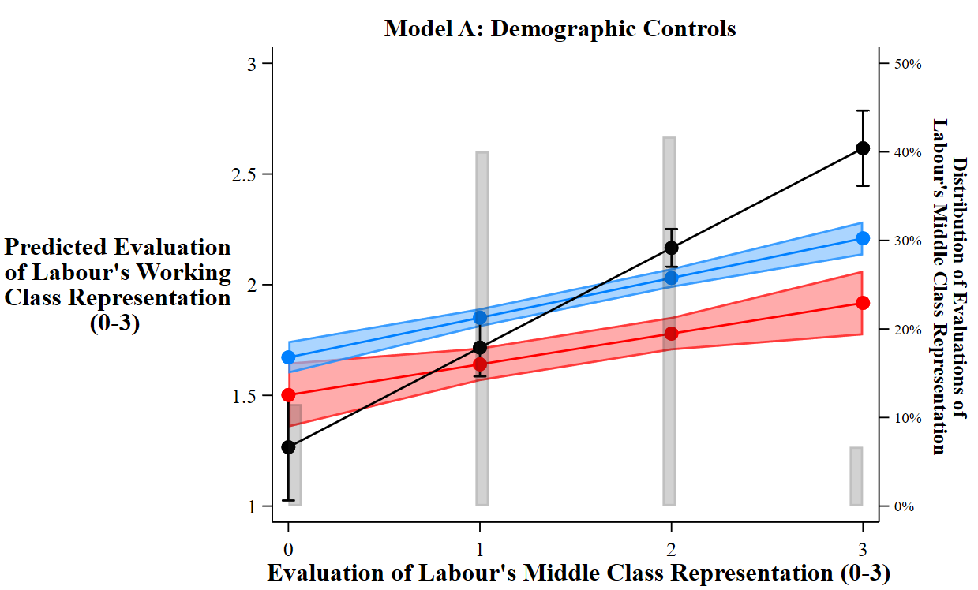
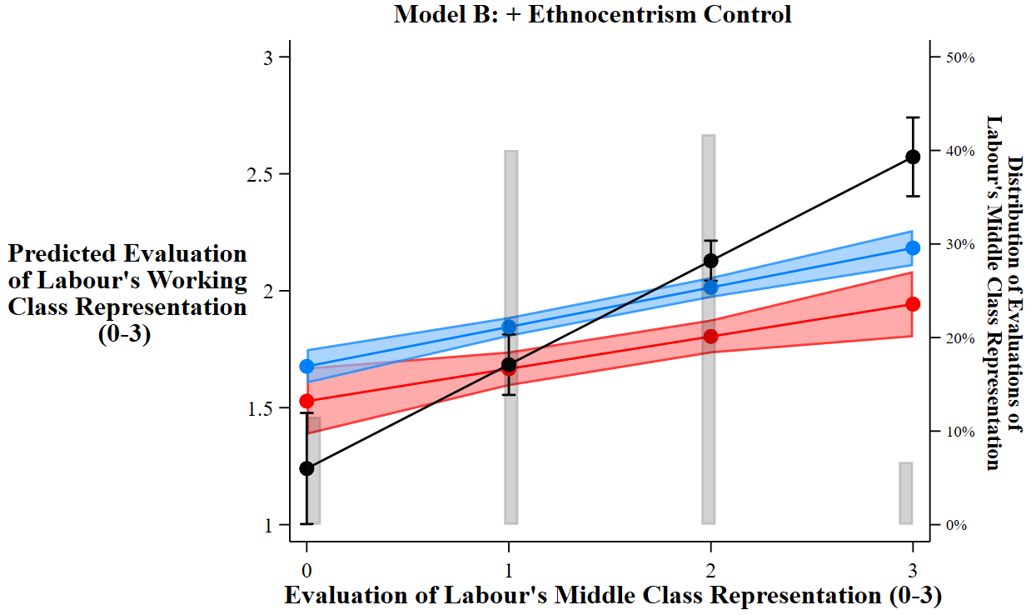

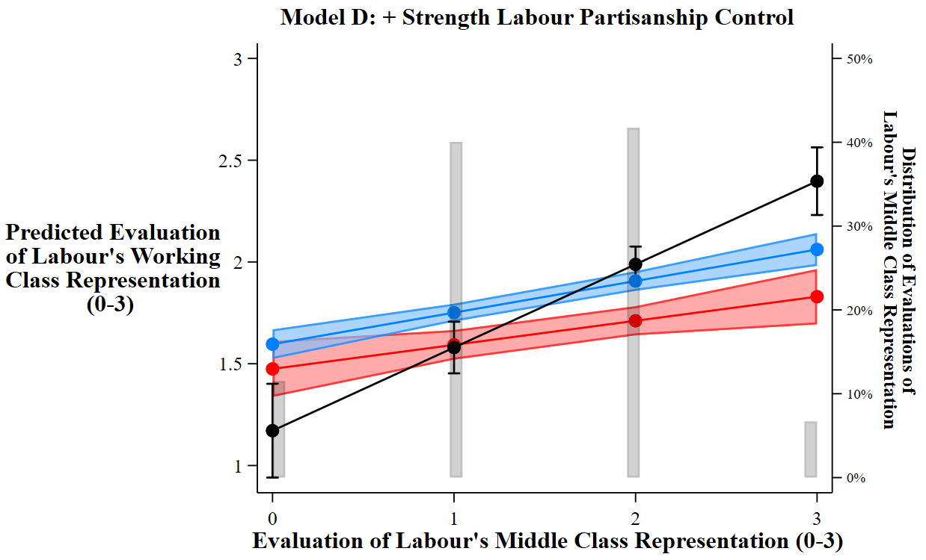
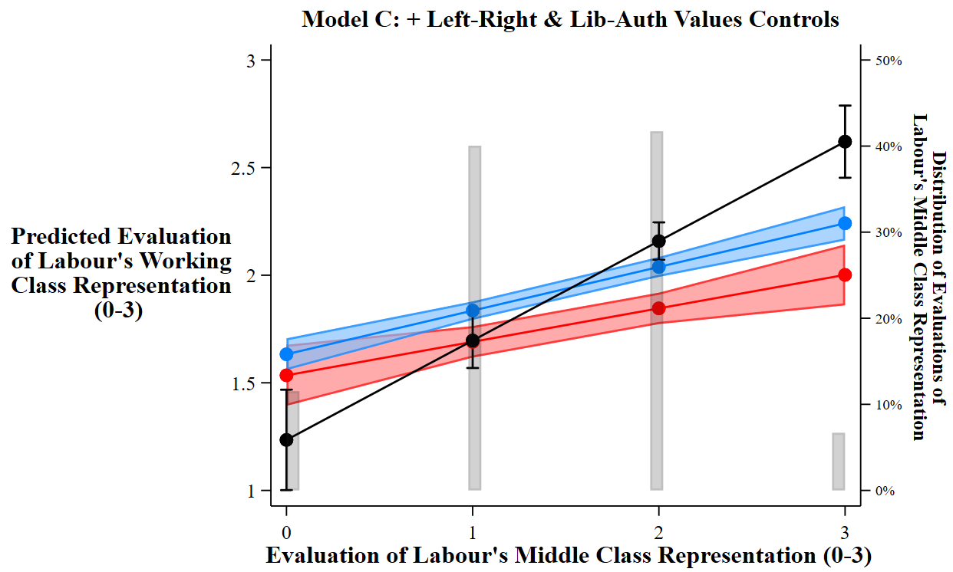

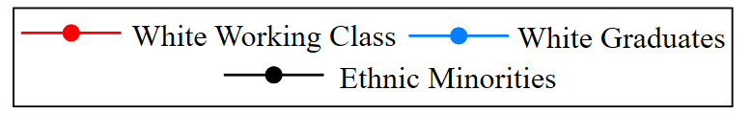
Source: BESIP Wave 10 [Nov-Dec 2016].

Note: Appendix 27 presents predicted values for the variable ‘how closely does Labour represent working class interests’ (0-3) based on coefficients from Models A-D of Appendix 26. The estimates demonstrate how the value of this variable is predicted to change depending on evaluations of how closely Labour ‘look after the interests of middle class people’, for white working class (red), white graduate (blue), and ethnic minority (black) respondents, respectively. 95% confidence intervals are provided for each point estimate. The histograms display the observed variation in evaluations of how well Labour looks after middle class people, across the entire sample population. The estimates in all cases are for a middle-aged English male, with the sample average values assigned for all further controls added to each model. Model A only controls for demographic characteristics (age, gender, and UK country); Model B adds the control for levels of white ethnocentrism; Model C further adds the controls for left-right and libertarian-authoritarian values; Model D adds the control for strength of Labour partisanship. In all models we can see that the lines for white graduates and the white working class are almost parallel. This indicates that the impact of evaluations of Labour’s middle class representation has a fairly similar relationship to evaluations of Labour’s working class representation for both groups (unlike the impact of evaluations of the party’s black and Asian representation, displayed in Table 1). That said, evaluations of how well Labour represents both sides of the class divide are noticeably more positively associated for ethnic minority respondents than the two white groups.

Appendix 28: The Impact of Evaluations of Labour’s Black and Asian (BME), Middle Class (MC), and Working Class (WC) Representation on Support for Labour, With Non-Voters Included (Table 2 Robustness Test)
BESIP Data
(Wave 10 - Nov/Dec 2016)
 | Model A | Model B | Model C
Labour BME Representation Rating  Labour MC Representation Rating  Labour WC Representation Rating  Respondent Group  White Graduates  Ethnic Minorities  Other Whites  (Ref: White Working Class)  White Graduate * Labour  Representation Ratings  White Graduate * Labour BME  White Graduate * Labour MC  White Graduates * Labour WC  Ethnic Minority * Labour  Representation Ratings  Ethnic Minority * Labour BME  Ethnic Minority * Labour MC  Ethnic Minority * Labour WC  Other Whites * Labour  Representation Ratings  Other Whites * Labour BME  Other Whites * Labour MC  Other Whites * Labour WC  White Ethnocentrism Scale  Left – Right Economic Value Scale  Liberal-Authoritarian Social Value Scale  Demographic Controls | - 0.74 (0.14) **  1.13 (0.13) **  1.32 (0.13) **  0.37 (0.48)  2.34 (0.64)  0.49 (0.46)  0.55 (0.16) **  0.10 (0.15)  - 0.77 (0.14) **  0.99 (0.23) **  - 0.56 (0.23) *  - 1.31 (0.23) **  0.25 (0.16)  - 0.10 (0.14)  - 0.54 (0.14) **  X | - 0.75 (0.15) **  1.14 (0.14) **  1.29 (0.13) **  0.14 (0.48)  2.07 (0.64) **  0.33 (0.46)  0.61 (0.17) **  0.04 (0.15)  - 0.74 (0.15) **  1.00 (0.24) **  - 0.58 (0.23) *  - 1.30 (0.23) **  0.31 (0.16) *  - 0.12 (0.15)  - 0.54 (0.14)  - 0.15 (0.02) **  X | - 0.71 (0.16) **  0.94 (0.14) **  1.36 (0.14) **  0.06 (0.49)  2.26 (0.65) **  0.38 (0.46)  0.66 (0.18) **  - 0.09 (0.16)  - 0.70 (0.15) **  0.97 (0.26) **  - 0.51 (0.24) *  - 1.34 (0.25) **  0.27 (0.17)  - 0.10 (0.15)  - 0.50 (0.15) **  - 0.08 (0.02) **  - 0.41 (0.02) **  0.18 (0.02) **  X
Constant  N – Respondents | - 3.44 (0.44) **  11,767 | - 3.24 (0.44) **  11,767 | - 1.33 (0.45) **  11,767

Source: BESIP Wave 10 [Nov-Dec 2016] for all variables except ethnocentrism, which was recorded in BESIP Wave 11 [April 2017]. Data are weighted using the standard BESIP wave 10 survey weight. * p-value < 0.05; ** p-value < 0.01

Note: Each model presents the results from different logistic regressions predicting support for Labour (1) vs any other party or an intention to not vote at all (0). These models are otherwise the same as those in Table 2 of the main text, where the dependent variable was a binary indicator of whether the respondent intended to vote Labour (1) or any other party (0). Here, however, we also include non-voters in the ‘non supporter’ category. As it happens, our key findings are unchanged by this different dependent variable: white working class voters who perceived Labour as being close to ethnic minorities were less likely to have a Labour vote intention in mid-2016.

Demographic Controls: Age, Gender; Country.

Appendix 29: The Impact of Evaluations of Labour’s Black and Asian (BME), Middle Class (MC), and Working Class (WC) Representation on Support for Labour, With Subjective Propensity to Vote Labour (0-10) as an Alternative Dependent Variable (Table 2 Robustness Test)
BESIP Data
(Wave 10 - Nov/Dec 2016)
 | Model A | Model B | Model C
Labour BME Representation Rating  Labour MC Representation Rating  Labour WC Representation Rating  Respondent Group  White Graduates  Ethnic Minorities  Other Whites  (Ref: White Working Class)  White Graduate * Labour  Representation Ratings  White Graduate * Labour BME  White Graduate * Labour MC  White Graduates * Labour WC  Ethnic Minority * Labour  Representation Ratings  Ethnic Minority * Labour BME  Ethnic Minority * Labour MC  Ethnic Minority * Labour WC  Other Whites * Labour  Representation Ratings  Other Whites * Labour BME  Other Whites * Labour MC  Other Whites * Labour WC  White Ethnocentrism Scale  Left – Right Economic Value Scale  Liberal-Authoritarian Social Value Scale  Demographic Controls | - 0.68 (0.14) **  1.15 (0.14) **  1.40 (0.12) **  - 0.65 (0.43)  0.54 (0.69)  0.14 (0.41)  0.41 (0.16) **  0.91 (0.16) **  - 0.65 (0.14) **  1.32 (0.32) **  0.31 (0.28)  - 0.81 (0.32) *  0.10 (0.15)  0.29 (0.15)  - 0.46 (0.13) **  X | - 0.58 (0.14) **  1.15 (0.14) **  1.25 (0.12) **  - 1.03 (0.43) *  0.94 (0.68)  - 0.33 (0.41)  0.43 (0.16) **  0.82 (0.16)  - 0.52 (0.15) **  1.23 (0.32) **  0.27 (0.28)  - 0.70 (0.32) *  0.11 (0.15)  0.23 (0.15)  - 0.39 (0.13) **  - 0.23 (0.02) **  X | - 0.47 (0.14) **  0.86 (0.14) **  1.33 (0.14) **  - 0.88 (0.43) *  - 0.66 (0.65)  - 0.06 (0.41)  0.50 (0.16) **  0.44 (0.16) **  - 0.50 (0.14) **  1.17 (0.31) **  0.29 (0.27)  - 0.74 (0.31)  0.12 (0.15)  0.14 (0.15)  - 0.41 (0.13) **  - 0.14 (0.02) **  - 0.49 (0.02) **  0.37 (0.02) **  X
Constant  N – Respondents  R-Squared | 2.76 (0.42) **  13,104  0.26 | 3.09 (0.41) **  13,104  0.27 | - 6.24 (0.42) **  13,104  0.37

Source: BESIP Wave 10 [Nov-Dec 2016] for all variables except ethnocentrism, which was recorded in BESIP Wave 11 [April 2017]. Data are weighted using the standard BESIP wave 10 survey weight. * p-value < 0.05; ** p-value < 0.01

Note: Each model presents the results from different OLS regression predicting respondents’ subjective likelihood of voting for the Labour Party. This was derived from a question in the BESIP that asked respondents: “How likely is it that you would ever vote Labour?”, with responses measured on a scale from 0 (‘very unlikely’) to 10 (‘very likely’). These models are otherwise the same as those in Table 2 of the main text, where the dependent variable was a binary indicator of whether the respondent intended to vote Labour (1) or any other party (0). As it happens, our key findings are unchanged by this different, somewhat richer, dependent variable: white working class voters who perceive Labour as being close to ethnic minorities state that they are less likely to vote for the party (particularly relative to other members of Labour’s coalition like white graduates and non-whites themselves).

Demographic Controls: Age, Gender; Country.
Appendix 30: The Impact of Evaluations of Labour’s Black and Asian (BME), Middle Class (MC), and Working Class (WC) Representation on Support for Labour. Sample Restricted to ‘Potential Labour Voters’ (PTV Labour > 0) (Table 2 Robustness Test)
BESIP Data
(Wave 10 - Nov/Dec 2016)
 | Model A | Model B | Model C
Labour BME Representation Rating  Labour MC Representation Rating  Labour WC Representation Rating  Respondent Group  White Graduates  Ethnic Minorities  Other Whites  (Ref: White Working Class)  White Graduate * Labour  Representation Ratings  White Graduate * Labour BME  White Graduate * Labour MC  White Graduates * Labour WC  Ethnic Minority * Labour  Representation Ratings  Ethnic Minority * Labour BME  Ethnic Minority * Labour MC  Ethnic Minority * Labour WC  Other Whites * Labour  Representation Ratings  Other Whites * Labour BME  Other Whites * Labour MC  Other Whites * Labour WC  White Ethnocentrism Scale  Left – Right Economic Value Scale  Liberal-Authoritarian Social Value Scale  Demographic Controls | - 0.74 (0.19) **  0.97 (0.17) **  1.17 (0.16) **  - 0.21 (0.57)  2.77 (0.77) **  - 0.05 (0.55)  0.68 (0.21) **  0.11 (0.19)  - 0.71 (0.18) **  0.94 (0.31) **  - 0.59 (0.29) *  - 1.45 (0.28) **  0.43 (0.21) *  - 0.06 (0.18)  - 0.47 (0.18) **  X | - 0.76 (0.20) **  0.95 (0.17) **  1.15 (0.17) **  - 0.41 (0.58)  2.48 (0.78) **  0.23 (0.56)  0.71 (0.21) **  0.11 (0.19)  - 0.69 (0.19) **  0.95 (0.32) **  - 0.57 (0.30)  - 1.42 (0.29) **  0.46 (0.21) *  - 0.05 (0.18)  - 0.46 (0.18) *  - 0.09 (0.02) **  X | - 0.77 (0.21) **  0.82 (0.17) **  1.15 (0.17) **  - 0.48 (0.59)  2.53 (0.79) **  - 0.20 (0.56)  0.74 (0.23) **  - 0.01 (0.19)  - 0.59 (0.19) **  0.88 (0.32) **  - 0.48 (0.31)  - 1.36 (0.31) **  0.43 (0.22)  - 0.03 (0.18)  - 0.40 (0.19) *  - 0.05 (0.02) *  - 0.37 (0.02) **  0.10 (0.02) **  X
Constant  N – Respondents | - 2.61 (0.53) **  7,298 | - 2.43 (0.53) **  7,298 | - 0.86 (0.55)  7,298
Source: BESIP Wave 10 [Nov-Dec 2016] for all variables except ethnocentrism, which was recorded in BESIP Wave 11 [April 2017]. Data are weighted using the standard BESIP wave 10 survey weight. * p-value < 0.05; ** p-value < 0.01

Note: Each model presents the results from different logistic regressions predicting support for Labour (1) vs any other party (0). These models are the same as in Table 2 of the main text; however, in response to a request by an anonymous reviewer, we have attempted to limit our sample to only those respondents who might be considered ‘potential Labour voters’. The concern is that the pool of people that might be bothered about Labour’s representation of ethnic minority communities (in absolute terms and relative to the representation of the working class) could be largely filled with those who could never imagine voting for the party under any situation. To assuage these concerns, we have here limited our sample to all those who responded with at least a ‘1’ when presented with a scale running from 0 (‘very unlikely’) to 10 (‘very likely’) on which they were asked to select “how likely is it that you would ever vote for Labour?”. This means that we exclude the roughly 34% (or so) of our sample that could be considered the least likely Labour voters (or voters that Labour would perhaps have the hardest time canvassing for their support). This seems to make no difference to our main finding: white working class voters are less likely to support Labour when they associate the party more strongly with the representation of non-white communities (even when controlling for levels of white ethnocentrism). Our findings are not driven by those who would never vote Labour anyway, but are robust to only examining the two-thirds of our sample that could be considered ‘potential’ Labour voters.

Please note that we are unable to conduct a similar restricted sample replication analysis on the models from Table 3 of the main text (i.e. 2019 General Election vote choice), as the question about subjective likelihood of ever voting Labour was not included in the relevant BESIP survey wave. That said, given that we include a lagged dependent variable in that model we are confident that we do enough to control for longstanding dislike / antipathy to the party.

Demographic Controls: Age, Gender; Country.

Appendix 31: The Impact of Evaluations of Labour’s Relative Representation of Ethnic Minorities and the Working Class on Support for Labour – Additional Control for Absolute Ratings of Labour’s Minority and Working Class Representation (Table 3 Robustness Test)
 | BESIP Wave 10 Data  (DV = Labour Vote  Intention 2016) |  | BESIP Wave 19 Data  (DV = Labour Vote 2019 General Election)
Labour BME – Labour WC Representation Rating  Labour BME + Labour WC Representation Rating  Respondent Group  White Graduates  Ethnic Minorities  Other Whites  (Ref: White Working Class)  Respondent Group * Labour BME - WC Rating Interaction  White Graduate * Labour BME - WC  Ethnic Minority * Labour BME - WC  Other Whites * Labour BME - WC  White Ethnocentrism Scale  Left – Right Economic Value Scale  Liberal-Authoritarian Social Value Scale  Lagged Labour Vote [2017]  Demographic Controls | Model A | Model B | Model C | Model D | Model E | Model F
 | - 0.87 (0.09) **  0.23 (0.02) **  - 0.12 (0.10)  0.79 (0.16) **  - 0.40 (0.09) **  0.55 (0.10) **  0.86 (0.17) **  0.33 (0.10) **  X | - 0.89 (0.09) **  0.29 (0.03) **  - 0.33 (0.11) **  0.73 (0.18) **  - 0.37 (0.10) **  0.58 (0.12) **  0.86 (0.19) **  0.32 (0.12) **  - 0.10 (0.02) **  - 0.47 (0.02) **  - 0.20 (0.02) **  X | - 0.49 (0.12) **  0.56 (0.03) **  0.57 (0.14) **  1.36 (0.24) **  0.11 (0.14)  0.32 (0.13) **  0.29 (0.24)  0.11 (0.13)  X | - 0.49 (0.15) **  0.60 (0.06) **  0.48 (0.21) *  1.45 (0.41) **  0.02 (0.21)  0.49 (0.19) **  0.30 (0.42)  0.32 (0.19)  - 0.22 (0.05) **  X | - 0.61 (0.15) **  0.43 (0.07) **  0.34 (0.30)  0.83 (0.49)  0.11 (0.28)  0.61 (0.19) **  0.83 (0.43)  0.46 (0.18) *  3.51 (0.17) **  X | - 0.67 (0.20) **  0.45 (0.07) **  0.28 (0.30)  0.69 (0.50)  0.04 (0.27)  0.68 (0.24) **  1.08 (0.47) *  0.54 (0.23) *  -- 0.18 (0.07) **  3.50 (0.19) **  X
Constant  N – Respondents | - 1.14 (0.16)**  11,486 | 0.77 (0.20) **  11,486 | - 2.84 (0.26)**  5,612 | - 3.56 (0.67)  2,297 | - 4.80 (0.64) **  2,775 | - 4.99 (0.73) **  2,231
Source: Models A-B: BESIP Wave 10 [Nov-Dec 2016] for all variables. Models C-F: BESIP Wave 19 [Dec 2019] for all variables except the ‘pro-immigration attitudes scale’, which was measured in BESIP Wave 17 [Nov 2019], and the lagged dependent variable, ‘Labour Vote [2017]’, which was measured in BESIP Wave 13 [June 2017] following the 2017 UK General Election. Models A and B are weighted using the standard Wave 10 BESIP survey weight. Model C is weighted the standard Wave 19 BESIP survey weight. Models D-F are weighted using the Wave 13 (June 2017) to Wave 19 panel weight to adjust for non-random patterns of attribution between those surveys. * p-value < 0.05; ** p-value < 0.01

Note: Each model presents the results from different logistic regressions predicting support for Labour (1) vs any other party (0). These models are exactly the same as those in Table 3 of the main text; however, here we also include an additional control which is the sum of respondents’ evaluations of Labour’s representation of black and Asian (BME) people and working class (WC) people – both of which are measured on a 3-point scale from ‘not at all closely’ (0) to ‘very closely’ (3) – rather than the difference between these two scores (as with ‘Labour BME – Labour WC’). By including this variable, we hope to further isolate the effect of a respondent believing that Labour better represents minorities than the working class from any other effect of the respondent not believing that Labour represents either group particularly well. As you can see, however, our main findings holds up: though respondents who believe that Labour represents both groups well are more likely to support the party, white working class voters that think Labour represents minorities more closely than the working class are less likely to support it.

Demographic Controls: Age, Gender; Country.
 | BESIP Wave 10 Data  (DV = Labour Vote  Intention 2016) |  | BESIP Wave 19 Data  (DV = Labour Vote 2019 General Election)
Labour BME – Labour WC Representation Rating  Respondent Group  White Graduates  Ethnic Minorities  Other Whites  (Ref: White Working Class)  Respondent Group * Labour BME - WC Rating Interaction  White Graduate * Labour BME - WC  Ethnic Minority * Labour BME - WC  Other Whites * Labour BME - WC  White Ethnocentrism Scale  Left – Right Economic Value Scale  Liberal-Authoritarian Social Value Scale  Lagged Labour Vote [2017]  Demographic Controls | Model A | Model B | Model C | Model D | Model E | Model F
 | - 0.89 (0.09) **  - 0.08 (0.09)  0.73 (0.15) **  - 0.36 (0.09) **  0.55 (0.10) **  0.91 (0.16) **  0.34 (0.10) **  X | - 0.92 (0.11) **  - 0.29 (0.11) **  0.66 (0.17) **  - 0.34 (0.10) **  0.58 (0.12) **  0.95 (0.18) **  0.33 (0.11) **  - 0.10 (0.02) **  - 0.45 (0.02) **  - 0.19 (0.01) **  X | - 0.47 (0.10) **  0.71 (0.13) **  1.13 (0.21) **  0.17 (0.13)  0.29 (0.11) **  0.12 (0.27)  0.10 (0.11)  X | - 0.47 (0.13) **  0.44 (0.21) *  1.30 (0.40) **  - 0.08 (0.21)  0.43 (0.16) **  0.30 (0.44)  0.29 (0.16)  - 0.23 (0.05) **  X | - 0.48 (0.15) **  0.58 (0.27) *  1.25 (0.44) **  0.32 (0.27)  0.41 (0.19) *  0.77 (0.40)  0.33 (0.17)  3.41 (0.16) **  X | - 0.55 (0.19) **  - 0.43 (0.35)  1.11 (0.50) *  0.16 (0.28)  0.46 (0.23) *  0.87 (0.48)  0.39 (0.22)  - 0.17 (0.06) **  3.31 (0.18) **  X
Constant  N – Respondents | 0.34 (0.14) **  11,823 | 1.75 (0.18) **  11,823 | - 0.69 (0.21)  6,017 | - 0.99 (0.61)  2,436 | - 3.31 (0.55) **  3,033 | - 3.21 (0.64) **  2,432
Appendix 32: The Impact of Evaluations of Labour’s Relative Representation of Ethnic Minorities and the Working Class on Support for Labour, With Non-Voters Included (Table 3 Robustness Test)
Source: Models A-B: BESIP Wave 10 [Nov-Dec 2016] for all variables except ethnocentrism, which was recorded in BESIP Wave 11 [April 2017]. Models C-F: BESIP Wave 19 [Dec 2019] for all variables except ethnocentrism, which was recorded in BESIP Wave 11 [April 2017], and the lagged dependent variable, Labour Vote [2017], which was measured in BESIP Wave 13 [June 2017] following the 2017 UK General Election. Models A and B are weighted using the standard Wave 10 BESIP survey weight. Model C is weighted the standard Wave 19 BESIP survey weight. Models D-F are weighted using the Wave 13 (June 2017) to Wave 19 panel weight to adjust for non-random patterns of attribution between those surveys. * p-value < 0.05; ** p-value < 0.01.

Note: Each model presents the results from different logistic regressions predicting support for Labour (1) vs any other party or an intention to not vote at all (0). These models are otherwise the same as those in Table 3 of the main text, where the dependent variable was a binary indicator of whether the respondent intended to vote Labour (1) or any other party (0). Here, however, we also include non-voters in the ‘non supporter’ category. As it happens, our key findings are unchanged by this different dependent variable: white working class voters who perceived Labour as being close to ethnic minorities were less likely to have a Labour vote intention in mid-2016 (Models A & B) and in the 2019 general election itself (Models C-F).

Demographic Controls: Age, Gender; Country.
Appendix 33: The Impact of Evaluations of Labour’s Relative Representation of Ethnic Minorities and the Working Class on the Defection of White Working Class Supporters from Labour 2017-19. Sample Restricted to White Working Class 2017 Labour Voters

BESIP Wave 19 Data
Baseline Category = Loyalty to Labour Party 2017 – 2019

Labour BME – Labour WC Representation Rating  Demographic Controls | Defect:  Conservatives | Defect:  UKIP /  Brexit Party | Defect:  Libs/Greens/  SNP/Plaid | Defect:  Abstain
 | 1.06 (0.35) **  X | 0.87 (0.61)  X | 0.81 (0.50)  X | - 0.75 (0.48)  X
Constant | - 2.27 (1.25) | - 18.47 (0.50) | - 3.06 (0.77) | - 17.29 (1.06)
N | 128
MODEL A

BESIP Wave 19 Data
Baseline Category = Loyalty to Labour Party 2017 – 2019

Labour BME – Labour WC Representation Rating  White Ethnocentrism Scale  Demographic Controls | Defect:  Conservatives | Defect:  UKIP /  Brexit Party | Defect:  Libs/Greens/  SNP/Plaid | Defect:  Abstain
 | 0.97 (0.42) *  0.60 (0.21) **  X | 0.63 (0.53)  0.45 (0.17) *  X | 0.90 (0.63)  - 0.03 (0.18)  X  X | - 0.80 (0.46)  0.41 (0.20) *  X  X
Constant | - 1.95 (1.20) | - 18.50 (0.48) | - 3.47 (1.00) | - 17.28 (0.85)
N | 103
MODEL B

Source: BESIP Wave 19 [Dec 2019] for all variables except ethnocentrism, which was recorded in BESIP Wave 11 [April 2017], and the lagged dependent variable, Labour Vote [2017], which was measured in BESIP Wave 13 [June 2017] following the 2017 UK General Election. Models are weighted using the Wave 13 (June 2017) to Wave 19 panel weight to adjust for non-random patterns of attribution between those surveys. * p-value < 0.05; ** p-value < 0.01.

Note: The models display the results of two multinomial logit regressions predicting defection from Labour between the June 2017 and December 2019 General Elections among our sample of white working class voters who supported Labour in the 2017 contest. The models demonstrate the extent to which the belief that Labour represents minorities better than the working class (‘Labour BME – Labour WC Representation Rating’) predicts 4 different types of defection – moving to the Conservatives; moving to UKIP or the Brexit Party; moving to the Lib Dems, Greens, Plaid Cymru or the Scottish National Party [SNP]; moving to abstaining altogether – relative to remaining loyal and continuing to vote for Labour in 2019. One should note that our sample pool here is relatively modest, and we have relatively few observations of white working class voters who supported Labour in 2017 defecting to parties other than the Conservatives or abstention in 2019 (hence why we amalgamate supporters who opted for one of the right-leaning (UKIP/Brexit Party) or left-leaning (Liberals, Greens, SNP, Plaid) options. That said, the available evidence suggests that beliefs that the Labour Party better represents minorities than the working class do have value in helping to explain the defection of white working class supporters from the party between 2017 and 2019. Whether or not one controls for white ethnocentrism (Model A does not, Model B does), white working class respondents that believed that the party better represents minorities were more likely to defect to the Conservatives than stick with the party. In our sample, they were not statistically significantly more likely to switch to other parties, however. The evidence suggests that they may also have been less likely to abstain; however, this result is not statistically significant at conventional levels. The model also suggests that white working class supporters with higher levels of white ethnocentrism were also more likely to switch to the Conservatives and right-wing alternatives like UKIP or the Brexit Party, but not socially liberal alternatives like the Liberal Democrats, Greens, or the civic nationalist Plaid Cymru or SNP, which is what we might expect. White ethnocentrics also seem slightly more likely to switch to not voting at between 2017 and 2019.

Demographic Controls: Age, Gender; Country

(Cox 2016; Winter and Nichols 2012)
Bibliography
Abbott, Jared et al. 2021. Commonsense Solidarity: How a Working-Class Coalition Can Be Built, and Maintained. Jacobin - Centre for Working Class Politics.
Abou-Chadi, Tarik, Reto Mitteregger, and Cas Mudde. 2021. Left Behind by the Working Class? Social Democracy’s Electoral Crisis and the Rise of the Radical Right. Berlin: Friedrich-Ebert-Stiftung.
Abou-Chadi, Tarik, and Markus Wagner. 2020. ‘Electoral Fortunes of Social Democratic Parties: Do Second Dimension Positions Matter?’ Journal of European Public Policy 27(2): 246–72.
Achen, Christopher H., and Larry M. Bartels. 2017. Democracy for Realists: Why Elections Do Not Produce Responsive Government. Oxford: Princeton University Press.
Ahler, Douglas J., and Gaurav Sood. 2018. ‘The Parties in Our Heads: Misperceptions about Party Composition and Their Consequences’. Journal of Politics 80(3): 964–81.
Angelucci, Davide, and Davide Vittori. 2023. ‘Look Where You’re Going: The Cultural and Economic Explanations of Class Voting Decline’. West European Politics 46(1): 122–47.
Barton, Cassie. 2020. ‘GE2019: How Did Demographics Affect the Result?’ House of Commons Library. https://commonslibrary.parliament.uk/ge2019-how-did-demographics-affect-the-result/ (January 12, 2022).
BBC News. 2019. ‘Election 2019: Britain’s Most Diverse Parliament’. BBC News Online. https://www.bbc.co.uk/news/election-2019-50808536 (January 21, 2022).
Berman, Sheri, and Maria Snegovaya. 2019. ‘Populism and the Decline of Social Democracy’. Journal of Democracy 30(3): 5–19.
Bickerton, Chris. 2019. ‘Labour’s Lost Working-Class Voters Have Gone for Good’. The Guardian. https://www.theguardian.com/commentisfree/2019/dec/19/labour-working-class-voters-brexit (January 12, 2022).
Butler, David, and Donald E. Stokes. 1974. Political Change in Britain: Basis of Electoral Choice. London: Macmillan.
Campbell, Angus, Philip E. Converse, Warren Miller, and Donald E. Stokes. 1960. The American Voter. Chicago: University of Chicago Press.
Campbell, Rosie, and Oliver Heath. 2021. ‘Fueling the Populist Divide: Nativist and Cosmopolitan Preferences for Representation at the Elite and Mass Level’. Political Behavior 43: 1707–29.
Clarke, Harold D., Matthew J. Goodwin, and Paul Whiteley. 2017. Brexit: Why Britain Voted to Leave the European Union. Cambridge: Cambridge University Press.
Collins, Alan, Stephen Drinkwater, and Colin Jennings. 2020. Working Paper - Quantitative Political Economy Research Group Selectively Liberal? Socio-Economic Change and Attitudes Toward Homosexual Relations. King’s College London: QPE Working Paper.
Cooley, Erin, Jazmin L. Brown-Iannuzzi, Ryan F. Lei, and William Cipolli. 2019. ‘Complex Intersections of Race and Class: Among Social Liberals, Learning About White Privilege Reduces Sympathy, Increases Blame, and Decreases External Attributions for White People Struggling With Poverty’. Journal of Experimental Psychology: General 148(12): 2218–28.
Cox, Nicholas. 2016. ‘Speaking Stata: Multiple Bar Charts in Table Form’. The Stata Journal 16(2): 491–510.
Dancygier, Rafaela M. 2010. Immigration and Conflict in Europe. Cambridge: Cambridge University Press.
———. 2017. Dilemmas of Inclusion: Muslims in European Politics. Princeton (US): Princeton University Press.
Dawson, Michael C. 1994. Behind the Mule: Race and Class in African-American Politics. Princeton: Princeton University Press.
Ehsan, Rakib, and Doug Stokes. 2021. ‘Poor White Men and Labour’s Identity Trap’. The Critic. https://thecritic.co.uk/issues/may-2021/poor-white-men-and-labours-identity-trap/ (November 5, 2021).
English, Micah, and Joshua L. Kalla. 2021. ‘Racial Equality Frames and Public Policy Support: Survey Experimental Evidence’. Working Paper - OSF Preprints, 23rd April 2021: 1–15.
Evans, Geoffrey, Roosmarijn de Geus, and Jane Green. 2023. ‘Boris Johnson to the Rescue? How the Conservatives Won the Radical-Right Vote in the 2019 General Election’. Political Studies (Forthcoming).
Evans, Geoffrey, Anthony Heath, and Mansur Lalljee. 1996. ‘Measuring Left-Right and Libertarian-Authoritarian Values in the British Electorate’. The British Journal of Sociology 47(1): 93–112.
Evans, Geoffrey, and Jonathan Mellon. 2016. British Social Attitudes 33: Social Class - Identity, Awareness and Political Attitudes: Why Are We Still Working Class? London: National Centre for Social Research.
Evans, Geoffrey, Rune Stubager, and Peter Egge Langsæther. 2022. ‘The Conditional Politics of Class Identity: Class Origins, Identity and Political Attitudes in Comparative Perspective’. West European Politics 45(6): 1178–1205.
Evans, Geoffrey, and James Tilley. 2017. The New Politics of Class: The Political Exclusion of the British Working Class. Oxford: Oxford University Press.
Fieldhouse, Edward et al. 2021. ‘British Election Study Combined Wave 1-20 Internet Panel Legacy’. https://www.britishelectionstudy.com/data-objects/panel-study-data/.
———. 2023. ‘Volatility, Realignment and Electoral Shocks: Brexit and the UK General Election of 2019’. PS: Political Science (Forthcoming): X–X.
Ford, Robert, and Matthew J. Goodwin. 2017. ‘Britain After Brexit: A Nation Divided’. Journal of Democracy 28(1): 17–30.
Ford, Robert, and Will Jennings. 2020. ‘The Changing Cleavage Politics of Western Europe’. Annual Review of Political Science 23(1): 295–314.
Fukuyama, Francis. 2018. ‘Against Identity Politics: The New Tribalism and the Crisis of Democracy’. Foreign Affairs 97(5): 90–114.
Gest, Justin. 2016. The New Minority: White Working-Class Politics in an Age of Immigration. Oxford: Oxford University Press.
Gingrich, Jane. 2017. ‘A New Progressive Coalition? The European Left in a Time of Change’. Political Quarterly 88(1): 39–51.
Goes, Eunice. 2020. ‘Labour’s 2019 Campaign: A Defeat of Epic Proportions’. Parliamentary Affairs 73(Supplement_1): 84–102.
Goodwin, Matthew J., and Oliver Heath. 2020. Low-Income Voters, the 2019 General Election and the Future of British Politics. York: Joseph Rowntree Foundation.
Gregory, Andy. 2020. ‘Black Lives Matter: Keir Starmer Takes the Knee in Solidarity with “All Those Opposing Anti-Black Racism”’. The Independent. https://www.independent.co.uk/news/uk/politics/black-lives-matter-keir-starmer-labour-take-knee-george-floyd-funeral-a9557166.html (May 29, 2022).
Gurr, Ted. 1970. Why Men Rebel. Princeton: Princeton University Press.
Hainmueller, Jens, and Daniel J. Hopkins. 2015. ‘The Hidden American Immigration Consensus: A Conjoint Analysis of Attitudes toward Immigrants’. American Journal of Political Science 529–548(3): 59.
Harris, Eloisa. 2022. ‘Educational Divides and Class Coalitions: How Mainstream Party Voters Divide and Unite Over Immigration Issues’. Journal of Ethnic and Migration Studies X(X): 1–20.
Häusermann, Silja et al. 2021. Transformation of the Left: The Resonance of Progressive Programs among the Potential Social Democratic Electorate. Berlin: Friedrich-Ebert-Stiftung.
Heath, Anthony F et al. 2013. The Political Integration of Ethnic Minorities in Britain. Oxford: Oxford University Press.
Heath, Oliver. 2015. ‘Policy Representation, Social Representation and Class Voting in Britain’. British Journal of Political Science 45(1): 173–93.
Hochschild, Arlie R. 2016. Strangers in Their Own Land: Anger and Mourning on the American Right. New York City: The New Press.
Hooghe, Liesbet, and Gary Marks. 2018. ‘Cleavage Theory Meets Europe’s Crises: Lipset, Rokkan, and the Transnational Cleavage’. Journal of European Public Policy 25(1): 109–35.
Huddy, Leonie. 2013. ‘From Group Identity to Political Cohesion and Commitment’. In The Oxford Handbook of Political Psychology, eds. David O. Sears and Jack S. Levy. Oxford: Oxford University Press, 737–73.
Jennings, Will, and Gerry Stoker. 2017. ‘Tilting Towards the Cosmopolitan Axis? Political Change in England and the 2017 General Election’. Political Quarterly 88(3): 359–69.
Kam, Cindy D., and Donald R. Kinder. 2012. ‘Ethnocentrism as a Short-Term Force in the 2008 American Presidential Election’. American Journal of Political Science 56(2): 326–40.
Kane, John V., Lilliana Mason, and Julie Wronski. 2021. ‘Who’s at the Party? Group Sentiments, Knowledge, and Partisan Identity’. The Journal of Politics 83(4): 1783–99.
Kaufmann, Eric. 2018. Whiteshift. London: Penguin.
Kinder, Donald R., and Cindy D. Kam. 2009. Us Versus Them: Ethnocentrism Foundations of American Opinion. Chicago: University of Chicago Press.
Kriesi, Hanspeter et al. 2008. West European Politics in the Age of Globalisation. Cambridge: Cambridge University Press.
Kunda, Ziva. 1990. ‘The Case for Motivated Reasoning’. Psychological Bulletin 108(3): 480–98.
Labour Party. 2021a. ‘Black, Asian and Minority Ethnic (BAME) Communities and the Labour Movement’. Labour.org.uk. https://labour.org.uk/members/take-part/bame-communities/ (January 19, 2022).
———. 2021b. ‘Labour’s Legacy’. Labour.org.uk. https://labour.org.uk/about/labours-legacy/ (January 12, 2022).
Laniyonu, Ayobami. 2019. ‘A Comparative Analysis of Black Racial Group Consciousness in the United States and Britain’. Journal of Race, Ethnicity and Politics 4(1): 117–47.
Leeper, Thomas J., and Rune Slothuus. 2014. ‘Political Parties, Motivated Reasoning, and Public Opinion Formation’. Political Psychology 35(SUPPL.1): 129–56.
Lilla, Mark. 2016. ‘The End to Identity Liberalism’. New York Times. https://www.nytimes.com/2016/11/20/opinion/sunday/the-end-of-identity-liberalism.html (January 14, 2022).
Lipset, Seymour M. 1959. ‘Democracy and Working-Class Authoritarianism’. American Sociological Review 24(4): 482–501.
Lomax, Nik, Pia Wohland, Philip Rees, and Paul Norman. 2020. ‘The Impacts of International Migration on the UK’s Ethnic Populations’. Journal of Ethnic and Migration Studies 46(1): 177–99.
Lupu, Noam. 2016. Party Brands in Crisis: Partisanship, Brand Dilution, and the Breakdown of Political Parties in Latin America. Cambridge: Cambridge University Press.
Martin, Nicole S. 2019. ‘Ethnic Minority Voters in the UK 2015 General Election: A Breakthrough for the Conservative Party?’ Electoral Studies 57: 174–85.
Mason, Lilliana, Julie Wronski, and John V. Kane. 2021. ‘Activating Animus: The Uniquely Social Roots of Trump Support’. American Political Science Review 115(4): 1508–16.
Mason, Paul. 2021. ‘Booing the Knee? This Is the Moment to Take Back Football from the Racists’. Medium. https://medium.com/mosquito-ridge/booing-the-knee-this-is-the-moment-to-take-back-football-from-the-racists-8b5cb5cb281a (January 17, 2022).
McDonnell, Adam, and Chris Curtis. 2019. ‘How Britain Voted in the 2019 General Election’. YouGov. https://yougov.co.uk/topics/politics/articles-reports/2019/12/17/how-britain-voted-2019-general-election (November 21, 2021).
Motyl, Alexander J. 2001. ‘Ethnocentrism’. In Encyclopedia of Nationalism - Volume 2, London: Academic Press, 152–53.
Norton, Michael I., and Samuel R. Sommers. 2011. ‘Whites See Racism as a Zero-Sum Game That They Are Now Losing’. Perspectives on Psychological Science 6(3): 215–18.
Oesch, Daniel, and Line Rennwald. 2018. ‘Electoral Competition in Europe’s New Tripolar Political Space: Class Voting for the Left, Centre-Right and Radical Right’. European Journal of Political Research 57(4): 783–807.
O’Neill, Brendan. 2021. ‘The Working-Class Revolt Against Labour’. Spiked Online. https://www.spiked-online.com/2021/05/07/the-working-class-revolt-against-labour/ (January 14, 2022).
Pettigrew, Thomas F. et al. 2008. ‘Relative Deprivation and Intergroup Attitudes’. Journal of Social Issues 64(2): 385–401.
Poston Jr., Dudley J., and Rogelio Sáenz. 2020. ‘The US White Majority Will Soon Disappear Forever’. The Conversation. https://theconversation.com/the-us-white-majority-will-soon-disappear-forever-115894 (December 1, 2020).
Przeworski, Adam, and John D Sprague. 1986. Paper Stones: A History of Electoral Socialism. Chicago: University of Chicago Press.
Quilter-Pinner, Harry, Parth Patel, Tom O’Grady, and Sofia Collignon. 2022. Closing the Gap: Parliament, Representation and the Working Class. London: Institute for Public Policy (IPPR).
Rae, Alasdair. 2021. ‘UK Constituencies By Deprivation’. Statsmapsnpix.com. http://www.statsmapsnpix.com/2021/05/far-too-many-words-about-chart.html (January 12, 2022).
Robison, Joshua, and Rachel L. Moskowitz. 2019. ‘The Group Basis of Partisan Affective Polarization’. Journal of Politics 81(3): 1075–79.
Robison, Joshua, Rune Stubager, Mads Thau, and James Tilley. 2021. ‘Does Class-Based Campaigning Work? How Working Class Appeals Attract and Polarize Voters’. Comparative Political Studies 54(5): 723–52.
Rydgren, Jens. 2013. ‘Introduction: Class Politics and the Radical Right’. In Class Politics and the Radical Right, Abingdon (UK): Routledge, 1–9.
Sandhu, Kam. 2018. ‘Working Class in Britain? You Must Be White’. New Internationalist. https://newint.org/features/2018/03/01/working-class-in-britain (January 14, 2022).
Scott, Ralph. 2022. ‘Does University Make You More Liberal? Estimating the Within-Individual Effects of Higher Education on Political Values’. Electoral Studies 77(June 2021): 102471.
Shayo, Moses. 2009. ‘A Model of Social Identity with an Application to Political Economy: Nation, Class, and Redistribution’. American Political Science Review 103(2): 147–74.
Siegel, Nina. 2016. ‘A Pro-Immigrant Party Rises in the Netherlands’. New York Times. https://www.nytimes.com/2016/07/30/world/europe/dutch-denk-party.html (September 16, 2022).
Siroky, David et al. 2020. ‘Grievances and Rebellion: Comparing Relative Deprivation and Horizontal Inequality’. Conflict Management and Peace Science 37(6): 694–715.
Smith, Matthew. 2019. ‘Left-Wing vs Right-Wing: It’s Complicated’. YouGov. https://yougov.co.uk/topics/politics/articles-reports/2019/08/13/left-wing-vs-right-wing-its-complicated (September 27, 2019).
Sniderman, Paul M., Edward G. Carmines, Geoffrey C. Layman, and Paul M. Sniderman. 1996. ‘Beyond Race: Social Justice as a Race Neutral Ideal’. American Journal of Political Science 40(1): 33–55.
Sobolewska, Maria, and Robert Ford. 2020a. Brexitland. Cambridge: Cambridge University Press.
———. 2020b. Brexitland. Cambridge: Cambridge University Press.
Stouffer, Samuel A. et al. 1949. The American Soldier: Adjustment to Army Life, Vol. 1. Princeton: Princeton University Press.
Stubager, Rune et al. 2018. ‘In the Eye of the Beholder: What Determines How People Sort Others into Social Classes?’ Social Science Research 76: 132–43.
Thau, Mads. 2019. ‘How Political Parties Use Group-Appeals: Evidence from Britain 1964-2015’. Political Studies 67(1): 63–82.
———. 2021. ‘The Social Divisions of Politics: How Parties’ Group-Based Appeals Influence Social Group Differences in Vote Choice’. Journal of Politics 83(2): 675–88.
Thompson, Paul, Frederick Harry Pitts, Jo Ingold, and Jon Cruddas. 2021. ‘Class Composition, Labour’s Strategy and the Politics of Work’. The Political Quarterly (December): 1–8.
Thorpe, Andrew. 2015. A History of the British Labour Party. London: Palgrave Macmillan.
Wainwright, Daniel. 2019. ‘General Election 2019: How Labour’s “Red Wall” Turned Blue’. BBC News Online. https://www.bbc.co.uk/news/election-2019-50771014 (January 12, 2022).
Walters, Michaels B. 2006. The Trouble with Diversity: How We Learned to Love Identity and Ignore Inequality. Basingstoke: Palgrave Macmillan.
Winter, Nick, and Austin Nichols. 2012. VIOPLOT: Stata Module to Produce Violin Plots with Current Graphics. Statistical Software Components S456902: Boston College Department of Economics.
Zhirkov, Kirill, and Nicholas A. Valentino. 2022. ‘The Origins and Consequences of Racialized Schemas about U.S. Parties’. The Journal of Race, Ethnicity, and Politics 7(3): 484–504.

