SUPPLEMENTARY MATERIAL
Support for deliberative mini-publics among the losers of representative democracy (Ref.: Ms. No. BJPOLS-D-22-00649)
Jean-Benoit PILET¹*, Camille BEDOCK², David TALUKDER³ and Sacha RANGONI¹
* corresponding author
¹ Université libre de Bruxelles (ULB), Belgium, ² CNRS. Sciences Po Bordeaux, France, ³ University of Namur, Belgium

Appendix 1. Descriptive statistics of the, dependent, independent and control variables

Variable | Mean | Standard deviation | Number of respondents
Satisfaction with democracy “On the whole, how satisfied are you with the way democracy works in [country], on a 0 to 10 scale?” | 5.3 | 2.7 | 14 847
Incongruence with the government | 0.2 | 0.16 | 13 429
Incongruence with the parliament | 0.2 | 0.17 | 13 429
Vote at the last election
 | % | Number of respondents
Voted for a government party | 24.9 | 3765
Abstained | 19.9 | 3009
Voted for a party currently in opposition | 20.7 | 3135
Voted for a party permanently in opposition | 34.6 | 5233
Total | 100 | 15142
Level of education
 | % | Number of respondents
Lower secondary or less | 29.2 | 4490
Higher secondary | 32.5 | 4998
Tertiary | 38.3 | 5899
Total | 100 | 15387
Perception of current income
 | % | Number of respondents
Living comfortably | 20.9 | 3152
Coping | 45.7 | 6891
Difficult | 23.5 | 3545
Very difficult | 9.8 | 1482
Total | 100 | 15070
Internal political efficacy (‘Politics is too complicated for people like me’)
 | % | Number of respondents
Strongly disagree | 42.6 | 6146
Somewhat disagree | 31.5 | 4547
Somewhat agree | 19.4 | 2792
Strongly agree | 6.5 | 935
Total | 100 | 15070

Appendix 2. Multinomial logit models with a trichotomized dependent variable (reference variable: opposed to DMPs replacing elected politicians)
Ref : OPPOSED | Neutral | Favorable | Neutral | Favorable | Neutral | Favorable | Neutral | Favorable | Neutral | Favorable | Neutral | Favorable | Neutral | Favorable
 | Model 0 | Model 0 | Model 1 | Model 1 | Model 2 | Model 2 | Model 3 | Model 3 | Model 4 | Model 4 | Model 5 | Model 5 | Model 6 | Model 6
Vote (ref = voted for a government party)
Abstained |  |  | 0.168** | 0.0358 |  |  |  |  |  |  | 0.0682 | -0.0245 | 0.0498 | -0.0195
 |  |  | (0.0647) | (0.0705) |  |  |  |  |  |  | (0.0699) | (0.0763) | (0.0701) | (0.0765)
Voted for a party permanently in opposition |  |  | 0.247*** | 0.330*** |  |  |  |  |  |  | 0.225*** | 0.358*** | 0.213*** | 0.370***
 |  |  | (0.0574) | (0.0593) |  |  |  |  |  |  | (0.0604) | (0.0620) | (0.0604) | (0.0620)
Voted for a party currently in opposition |  |  | 0.111 | 0.193** |  |  |  |  |  |  | 0.117 | 0.219*** | 0.0902 | 0.241***
 |  |  | (0.0613) | (0.0636) |  |  |  |  |  |  | (0.0634) | (0.0655) | (0.0636) | (0.0658)
Ideological incongruence with government |  |  |  |  | -0.738*** | 1.015*** |  |  |  |  | -0.662*** | 1.017***
 |  |  |  |  | (0.144) | (0.144) |  |  |  |  | (0.146) | (0.147)
Ideological incongruence with Parliament |  |  |  |  |  |  | -0.743*** | 0.527*** |  |  |  |  | -0.685*** | 0.555***
 |  |  |  |  |  |  | (0.136) | (0.135) |  |  |  |  | (0.138) | (0.139)
Education (ref. Tertiary)
1.Lower secondary or less |  |  |  |  |  |  |  |  | 0.275*** | 0.274*** | 0.311*** | 0.314*** | 0.308*** | 0.318***
 |  |  |  |  |  |  |  |  | (0.0523) | (0.0545) | (0.0553) | (0.0577) | (0.0553) | (0.0576)
2. Higher secondary |  |  |  |  |  |  |  |  | 0.143** | 0.154** | 0.179*** | 0.145** | 0.180*** | 0.149**
 |  |  |  |  |  |  |  |  | (0.0500) | (0.0523) | (0.0525) | (0.0549) | (0.0524) | (0.0549)
Perception income (ref. living comfortably)
2.Coping |  |  |  |  |  |  |  |  | 0.291*** | 0.0592 | 0.249*** | 0.110 | 0.257*** | 0.0930
 |  |  |  |  |  |  |  |  | (0.0560) | (0.0564) | (0.0582) | (0.0588) | (0.0582) | (0.0587)
3.Difficult |  |  |  |  |  |  |  |  | 0.387*** | 0.212** | 0.340*** | 0.263*** | 0.355*** | 0.242***
 |  |  |  |  |  |  |  |  | (0.0651) | (0.0659) | (0.0685) | (0.0697) | (0.0685) | (0.0695)
4.Very difficult |  |  |  |  |  |  |  |  | 0.435*** | 0.393*** | 0.409*** | 0.367*** | 0.430*** | 0.352***
 |  |  |  |  |  |  |  |  | (0.0882) | (0.0887) | (0.0936) | (0.0965) | (0.0937) | (0.0965)
Satisfaction with democracy | -0.0853*** | -0.0879*** | -0.0740*** | -0.0745*** | -0.0836*** | -0.0767*** | -0.0839*** | -0.0760*** | -0.0721*** | -0.0762*** | -0.0615*** | -0.0513*** | -0.0618*** | -0.0507***
 | (0.00750) | (0.00862) | (0.00794) | (0.00902) | (0.00808) | (0.00909) | (0.00803) | (0.00914) | (0.00787) | (0.00890) | (0.00884) | (0.00975) | (0.00880) | (0.00978)
Politics is too complicated (ref strongly disagree)
2. Somewhat disagree | 0.541*** | 0.299*** | 0.532*** | 0.294*** | 0.536*** | 0.366*** | 0.544*** | 0.344*** | 0.508*** | 0.272*** | 0.504*** | 0.331*** | 0.512*** | 0.310***
 | (0.0479) | (0.0511) | (0.0481) | (0.0515) | (0.0500) | (0.0536) | (0.0498) | (0.0534) | (0.0485) | (0.0516) | (0.0507) | (0.0545) | (0.0506) | (0.0542)
3.Somewhat agree | 0.752*** | 0.743*** | 0.743*** | 0.756*** | 0.765*** | 0.831*** | 0.775*** | 0.809*** | 0.707*** | 0.698*** | 0.721*** | 0.802*** | 0.729*** | 0.782***
 | (0.0586) | (0.0607) | (0.0590) | (0.0611) | (0.0624) | (0.0647) | (0.0624) | (0.0645) | (0.0594) | (0.0617) | (0.0636) | (0.0660) | (0.0636) | (0.0658)
4.Strongly agree | 0.579*** | 1.224*** | 0.600*** | 1.273*** | 0.562*** | 1.353*** | 0.573*** | 1.362*** | 0.559*** | 1.200*** | 0.552*** | 1.359*** | 0.562*** | 1.365***
 | (0.105) | (0.0974) | (0.106) | (0.0982) | (0.118) | (0.104) | (0.118) | (0.105) | (0.107) | (0.0994) | (0.120) | (0.106) | (0.120) | (0.107)
Gender (Women =1) | -0.00403 | -0.226*** | -0.00700 | -0.230*** | -0.00903 | -0.233*** | -0.00663 | -0.237*** | -0.0249 | -0.247*** | -0.0285 | -0.254*** | -0.0268 | -0.257***
 | (0.0416) | (0.0438) | (0.0419) | (0.0440) | (0.0436) | (0.0459) | (0.0436) | (0.0459) | (0.0422) | (0.0442) | (0.0443) | (0.0466) | (0.0443) | (0.0465)
Age | -0.0125*** | -0.00808*** | -0.0120*** | -0.00843*** | -0.0134*** | -0.00941*** | -0.0135*** | -0.00934*** | -0.0134*** | -0.00873*** | -0.0143*** | -0.0109*** | -0.0145*** | -0.0108***
 | (0.00133) | (0.00138) | (0.00135) | (0.00141) | (0.00140) | (0.00145) | (0.00140) | (0.00145) | (0.00136) | (0.00140) | (0.00144) | (0.00150) | (0.00144) | (0.00150)
Constant | 0.528*** | 0.331*** | 0.297** | 0.0953 | 0.698*** | 0.0478 | 0.714*** | 0.154 | 0.126 | 0.0796 | 0.124 | -0.460*** | 0.148 | -0.361**
 | (0.0896) | (0.0928) | (0.105) | (0.110) | (0.0990) | (0.103) | (0.0994) | (0.103) | (0.103) | (0.106) | (0.126) | (0.131) | (0.126) | (0.131)
Observations | 13,413 | 13,413 | 13,299 | 13,299 | 12,257 | 12,257 | 12,257 | 12,257 | 13,238 | 13,238 | 12,045 | 12,045 | 12,045 | 12,045
Robust standard errors in parentheses
*** p<0.001, ** p<0.01, * p<0.05

Appendix 3. Descriptive statistics of the statistical relationship between satisfaction with democracy and our main independent variables

One-Way ANOVA comparing the mean satisfaction with democracy across vote at the last national election
Vote at the last national election | Summary of SWD
 | Mean | Freq.
Abstained | 5,018 | 2791
Voted for a party permanently in opposition | 4,498 | 5058
Voted for a party currently in opposition | 5,469 | 3097
voted for a government party | 6,655 | 3724
Total | 5,349 | 14670
p-value (Between-groups) | 0,000

One-Way ANOVA comparing the mean satisfaction with democracy across gender
Gender | Summary of SWD
 | Mean | Freq.
Male | 5,418 | 7265
Female | 5,264 | 7566
Total | 5,340 | 14831
p-value (Between-groups) | 0,0005

One-Way ANOVA comparing the mean satisfaction with democracy across level of formal education
Level of formal education | Summary of SWD
 | Mean | Freq.
Lower secondary or less | 5,103 | 4258
Higher secondary | 5,276 | 4805
Tertiary | 5,569 | 5759
Total | 5,340 | 14822
p-value (Between-groups) | 0,000

One-Way ANOVA comparing the mean satisfaction with democracy across perception of current income

Perception of current income | Summary of SWD
 | Mean | Freq.
Living comfortably | 6,208 | 3093
Coping | 5,542 | 6691
Difficult | 4,776 | 3413
Very difficult | 3,849 | 1403
Total | 5,341 | 14600
p-value (Between-groups) | 0,000

Correlations between satisfaction with democracy and ideological congruence
 | Satisfaction with democracy
Ideological incongruence with Parliament | -0,0025
p-value | 0,7773
Ideological incongruence with government | 0,0084
p-value | 0,3322

Appendix 4 – Path analyses (Robustness check)

Model A (sets of regressions using SEM with Country clustered robust standard error)

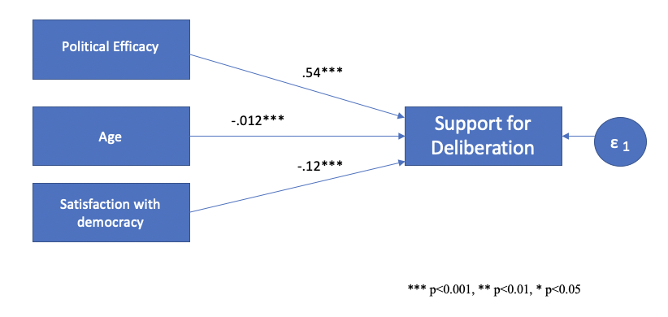

 |  | Robust
Coef. | Coefficient | Std. Err. | z | P>z | [95% Conf. | Interval]
Structural
Support for Deliberation
Age | 0,11551 | .0039022 | -2.96 | 0.003 | -.0192001 | -.0039037
Satisfaction w. democracy | -0,1213272 | .0343138 | -3.54 | 0.000 | -.1885811 | -.0540734
Politics is too complicated | 0,5440096 | .033395 | 16.29 | 0.000 | .4785566 | .6094625
_cons | 4,597475 | .2900632 | 15.85 | 0.000 | 4.028961 | 5.165988
var(e.supportddgen2) | 8,888805 | .2001886 |  |  | 8.504977 | 9.289956

Fit statistic | Value | Description
Size of residuals
SRMR | 0 | Standardized root mean squared
CD | 0,043 | Coefficient of determination

Model B path analysis (direct and indirect effect with Country clustered robust standard error)
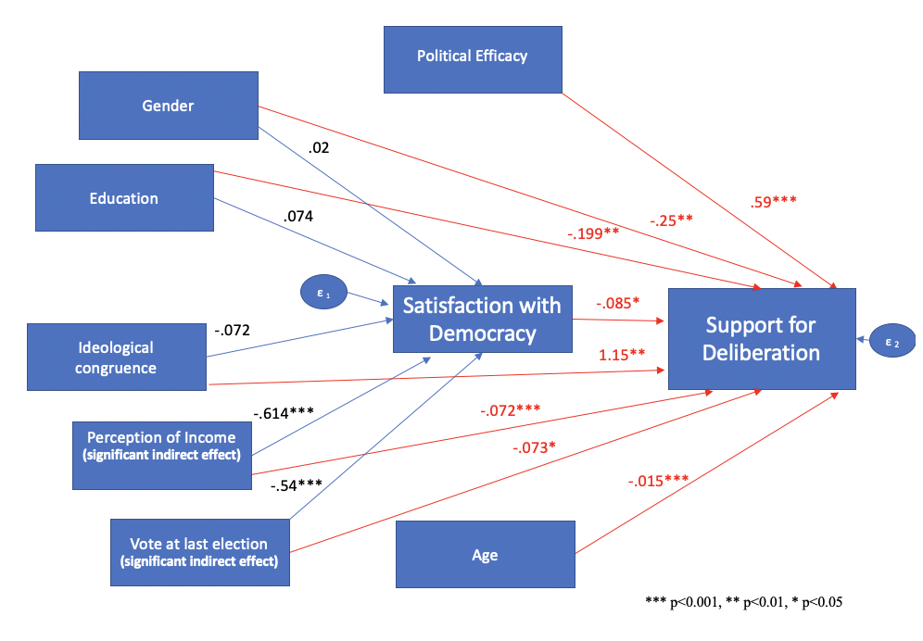

Direct effect
 | Coef, | Robust standard error | z | P>z | [95% Conf, | Interval]
Structural
DV : Support for Deliberation
Satisfaction w. democracy | -0,085 | 0,034 | -2,470 | 0,014 | -0,152 | -0,017
Age | -0,015 | 0,004 | -3,930 | 0,000 | -0,022 | -0,007
Education | -0,199 | 0,069 | -2,890 | 0,004 | -0,334 | -0,064
Perception of income | 0,178 | 0,042 | 4,240 | 0,000 | 0,096 | 0,261
Gender | -0,253 | 0,082 | -3,090 | 0,002 | -0,414 | -0,092
Politics is too complicated | 0,591 | 0,031 | 19,240 | 0,000 | 0,531 | 0,652
Ideological Incongruence with government | 1,157 | 0,411 | 2,810 | 0,005 | 0,351 | 1,962
Vote last election (0 :Abstention to 4: vote for a government party) | -0,073 | 0,037 | -2,000 | 0,045 | -0,145 | -0,002
DV : Satisfaction w. democracy
Education | 0,074 | 0,072 | 1,020 | 0,308 | -0,068 | 0,215
Perception of income | -0,614 | 0,053 | -11,640 | 0,000 | -0,717 | -0,511
Gender | 0,020 | 0,047 | 0,430 | 0,667 | -0,073 | 0,114
Ideological Incongruence with government | -0,072 | 0,367 | -0,200 | 0,844 | -0,792 | 0,648
Vote at last election | 0,543 | 0,101 | 5,370 | 0,000 | 0,345 | 0,741
Indirect effect
 | Coef, | Robust Std, Err, | z | P>z | [95% Conf, | Interval]
Structural
DV : Support for Deliberation
Satisfaction w. democracy | 0,000 | (no path)
Age | 0,000 | (no path)
Education | -0,006 | 0,006 | -1,030 | 0,305 | -0,018 | 0,006
Perception of income | 0,052 | 0,024 | 2,160 | 0,030 | 0,005 | 0,099
Gender | -0,002 | 0,004 | -0,420 | 0,676 | -0,010 | 0,006
Politics is too complicated | 0,000 | (no path)
Ideological Incongruence with government | 0,006 | 0,031 | 0,200 | 0,841 | -0,054 | 0,066
Vote at last election | -0,046 | 0,019 | -2,390 | 0,017 | -0,084 | -0,008
Total effect
 | Coef, | Robust Std, Err, | z | P>z | [95% Conf, | Interval]
Structural
Support for Deliberation
Satisfaction w. democracy | -0,085 | 0,034 | -2,470 | 0,014 | -0,152 | -0,017
Age | -0,015 | 0,004 | -3,930 | 0,000 | -0,022 | -0,007
Education | -0,205 | 0,071 | -2,870 | 0,004 | -0,345 | -0,065
Perception of income | 0,230 | 0,056 | 4,150 | 0,000 | 0,122 | 0,339
Gender | -0,255 | 0,085 | -3,000 | 0,003 | -0,422 | -0,089
Politics is too complicated | 0,591 | 0,031 | 19,240 | 0,000 | 0,531 | 0,652
Ideological Incongruence with government | 1,163 | 0,401 | 2,900 | 0,004 | 0,376 | 1,950
Vote last election | -0,119 | 0,044 | -2,720 | 0,006 | -0,205 | -0,034
Satisfaction w. democracy
Education | 0,074 | 0,072 | 1,020 | 0,308 | -0,068 | 0,215
Perception of income | -0,614 | 0,053 | -11,640 | 0,000 | -0,717 | -0,511
Gender | 0,020 | 0,047 | 0,430 | 0,667 | -0,073 | 0,114
Ideological Incongruence with government | -0,072 | 0,367 | -0,200 | 0,844 | -0,792 | 0,648
Vote last election | 0,543 | 0,101 | 5,370 | 0,000 | 0,345 | 0,741

Fit statistic | Value | Description
Size of residuals
SRMR | 0,01 | Standardized root mean squared
CD | 0,151 | Coefficient of determination

