SUPPLEMENTARY MATERIAL
Comparison of The PopuList 3.0 to the Populism and Political Parties Expert Survey (POPPA)

Introduction

How does The PopuList compare to other datasets that include indicators related to populism, the far left, and the far right? The Populism and Political Parties Expert Survey (POPPA) is an expert survey that measures several characteristics of political parties, including populism (Meijers and Zaslove 2021). Although there are other expert surveys that examine populism and related concepts – like the Chapel Hill Expert Survey (Polk et al. 2017) and the Global Party Survey (Norris 2020) – we focus on POPPA because it includes the most fine-grained measure of populism to date for political parties. POPPA measures the positions and attitudes of 250 parties (populist as well as non-populist) in 28 European countries and was administered in 2018. It is important to emphasise that whereas we categorise parties as either populist/far left/far right or not, POPPA works with continuous measures.

Below we examine how the categorisations of The PopuList compare to the POPPA measures. Such a comparison is useful because it allows us to identify outliers: (1) parties that are classified by us as populist/far left/far right, but do not score high on the corresponding continuous measures; (2) parties that are not classified under one of The PopuList’s categories, but do score high on the related continuous measure in POPPA.

We would like to emphasise that the researchers behind the POPPA dataset have already examined how the two datasets compare (Meijers and Zaslove 2021). This comparison was based on The PopuList 2.0. The point-biserial correlation was r = 0.67, and, hence, generally acceptable. Below, we focus on comparing POPPA to The PopuList 3.0. Most importantly, we examine in greater depth parties that stand out in the ways described above. First, we focus on populist parties, and then on far-right and far-left parties. We do not examine Euroscepticism because that is a secondary category in The PopuList (i.e., we have only examined Euroscepticism for parties that are either populist, and/or far-left/right).

Populism

POPPA measures populism as a weighted arithmetic mean of five items:

- “Politics is a moral struggle between good and bad” (Manichean worldview);
- “The ordinary people are indivisible (i.e., the people are seen as homogenous)” (indivisible people);
- “The ordinary people’s interests are singular (i.e., a ‘general will’)” (general will);
- “Sovereignty should lie exclusively with the ordinary people (i.e., the ordinary people, not the elites, should have the final say in politics)” (people-centrism);
- “Anti-elite dispositions” (anti-elitism).

All items are measured on an 11-point scale (0-10).

The point-biserial correlation between this measure of populism (directly available in the POPPA dataset) and our own dichotomous classification of populist parties is r = 0.66, and, hence, comparable to the correlation with The PopuList 2.0. The mean populism score of populist parties (excluding borderline cases) is M = 7.47 (n = 54). The minimum value is 2.68, and the maximum value is 10.00. The mean populism value of non-populist parties is M = 3.34 (n = 173): 4 full points less on an 11-point scale. The difference between these means is statistically significant (t = -14.38, p < 0.0001), see Figure 1 below.

Figure 1. Comparing the mean populism scores (by POPPA) for parties that are classified as populist versus not populist (by The PopuList 3.0)
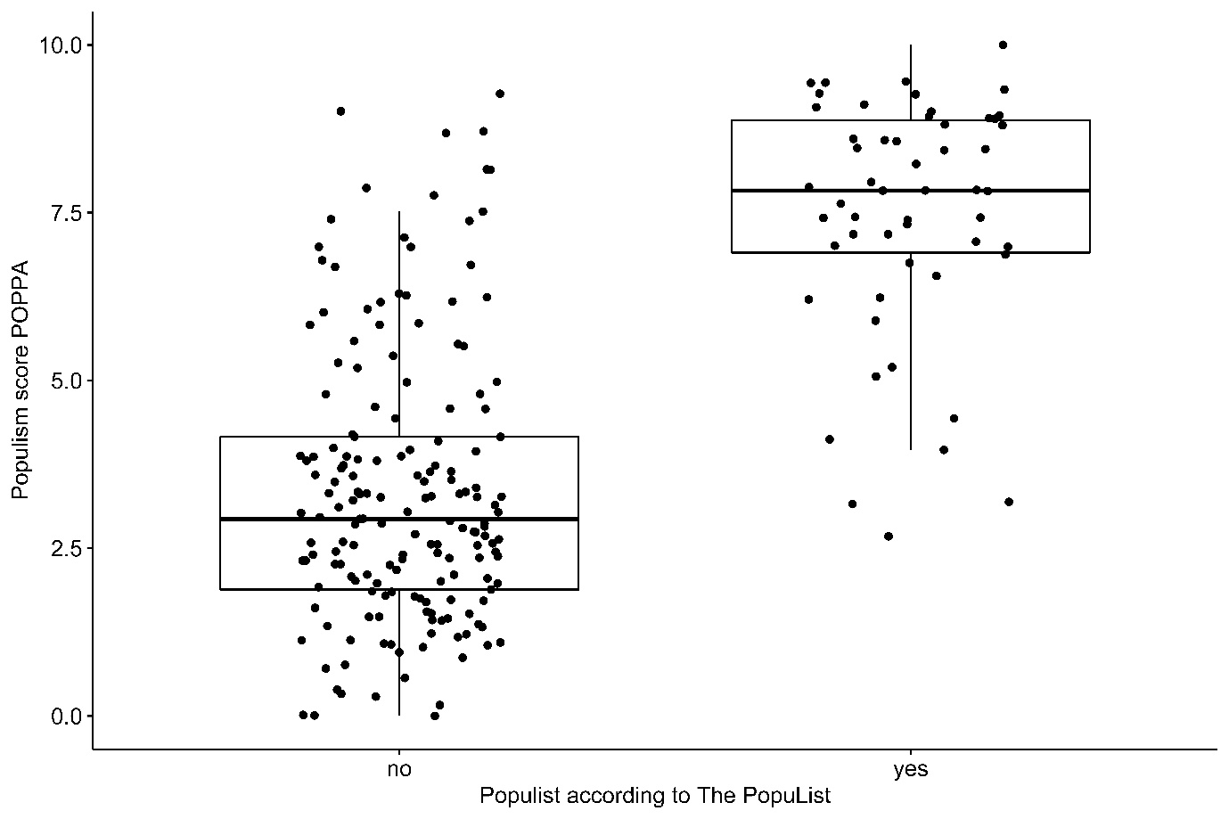

We have checked which populist parties in The Populist 3.0 score relatively low on populism in the POPPA dataset (i.e., below the 75th percentile, which is 6.73). There are ten cases that fulfil this criterion. An inspection of these cases shows that they mostly include parties from Central and Eastern Europe that hold an ideological position that is relatively moderate and ‘reformist’ in character (Hanley and Sikk 2016), and that often have had – or still have – government responsibilities. We discuss two of them for illustrative purposes.

The first one is Citizens for European Development of Bulgaria (GERB), a right-wing party that has been a central force in Bulgarian politics since the late 2000s. Its leader, Boyko Borisov, served three times as prime minister. The low score in POPPA might well be due to the party’s central role in the political system and its involvement in corruption scandals. Yet, because of the party’s continued populist framing of the political and self-depiction as carrier of the general will of the Bulgarian people, we have nevertheless coded it as populist. Second, Smer (Direction) has been a central political force in the politics of Slovakia and has led several government coalitions. As in the case of GERB, the party has been tainted by corruption while in government. This might well be the reason that the POPPA experts have scored Smer low on the dimensions pertaining to populism. But despite its role as a central force in Slovak politics, we have classified the party as populist because of its persistent populist rhetoric.

These cases show that a party that plays a central role in a country’s political system, sometimes even as a leading government party, tends to score lower on POPPA’s continuous populism scale. This makes sense given POPPA’s purpose: showing how populist political parties are. But the considerations for The PopuList are different. Parties that are ideologically moderate and/or tone down their populism because of office responsibilities do not necessarily cease to be populist. Hence, such parties could (and often should) still be classified as populist within our dichotomous approach. We have decided to classify parties that continuously employ a populist message as populist parties – even in the event of a (temporary) attenuation of their populist rhetoric.

There are also two parties that are not classified as populist in The PopuList (and fulfil our criteria for selection) but score relatively high on POPPA’s populism score – i.e., higher than the 90th percentile (8.57). The discrepancy stems from the fact that anti-establishment parties get a high overall populism score in POPPA. However, because we see people-centrism as an additional necessary feature of populism, we have only included parties as full part of the set if they are both people-centric and anti-elitist.

An example of a party that scores high on POPPA’s populism score but is not classified as populist in The PopuList is the Slovak L’SNS (The Kotlebists – People’s Party Our Slovakia), an extremist far-right party that employs a strong anti-establishment and even anti-democratic rhetoric. The party has often framed the alleged superiority of the Slovak people in elitist terms and, hence, we have not coded the party as populist.

The far right

POPPA contains several variables that together can be used to measure a party’s far-right ideology. First, it includes an item that examines a party’s immigration position. This item is measured on a scale (recoded) from 0 (strongly in favour of immigration) to 10 (strongly opposed to immigration). Second, POPPA asks experts to estimate to what extent a party has “an exclusive idea of who can and should belong to the nation-state (nativism)” (0 = not at all nativist, 10 = very nativist). Third, it includes a measure of the extent to which a party prioritises civil liberties (0) or law and order (10). These three variables strongly correlate and they form a reliable scale (α = 0.96), so we have computed the mean score of these variables as a measure of far-right ideology.

The point-biserial correlation between parties’ far-right position and their classification as either far right or not is r = 0.68, which is acceptable. The mean far-right score of far-right parties is M = 8.89 (n = 32). The minimum value is 7.43 and the maximum value is 10.00. The mean score of parties that are not far-right is M = 4.26 (n = 207): more than 3.5 points lower. The minimum value is 1.14 and the maximum value is 9.12, indicating that there are also some non-far-right parties that score very high on far-right attitudes. The difference between these means is statistically significant (t = -27.12, p < 0.0001), and displayed in Figure 2.

Figure 2. Comparing the mean far-right scores (by POPPA) for parties that are classified as far right versus not far right (by The PopuList 3.0)
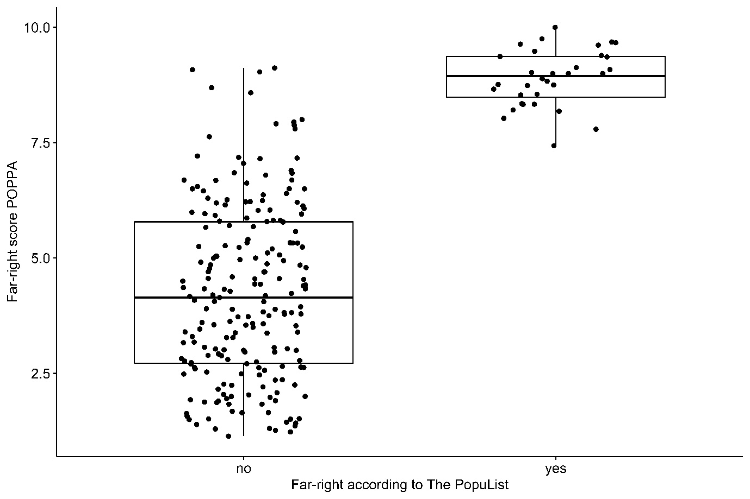

There are no far-right parties in The PopuList 3.0 that score relatively low on far-right attitudes in the POPPA dataset (i.e., below the 75th percentile, which is 6.57). There are also no parties that have a far-right score above the 90th percentile (= 8.74) in the POPPA dataset but that are not classified as far right in The PopuList 3.0. This comparison shows that there is a strong overlap between the classification in The PopuList 3.0 and the continuous measure of POPPA when it comes to the far-right category.

The far left

Finally, we used a party’s position on socioeconomic issues in the POPPA dataset as a proxy for far-left ideology. To be clear, such a measure is far from ideal. One key problem with this measure is that many parties with ideologies that are not far left score high on this value. Think, for example, of green parties. But the item taps into the far-left ideology at least to some extent. The item (recoded) measures to what extent a party is in favour of a reduced government role in the economy (0) versus an active government role in the economy (10).

Unsurprisingly, the point-biserial correlation is relatively low (r = 0.51), also compared to the correlations presented above. The mean economic position of far-left parties (excluding borderline cases) is M = 8.55 (n = 16, min = 6.38 / max = 9.77). The mean among other parties is M = 4.77 (n = 221, min = 0.29 / max = 9.20). This is a big difference that is statistically significant (t = -14.72, p < 0.0001). See Figure 3 below.

Figure 3. Comparing the mean far-left scores (by POPPA) for parties that are classified as far left versus not far left (by The PopuList 3.0)
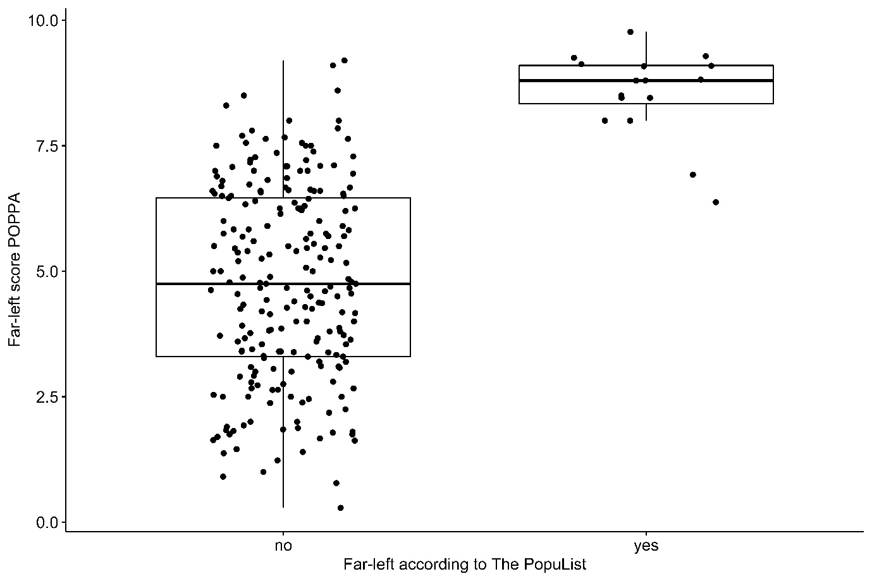

There is one far-left party in The PopuList 3.0 that scores below the 75th percentile in the POPPA dataset, which is 6.80. This is the Slovene party Levica, which supported a previous government coalition and, at the time of writing, is part of the government coalition (but this is after POPPA was in the field). The government support might have caused coders to see the party as relatively moderate. There is also one party not classified as far left in The PopuList that scores above the overall 90th percentile in the POPPA dataset. This is Human Shield (ŽZ) in Croatia, a populist party with an ambiguous ideological profile that combined libertarian stances of the post-materialist left with anti-immigration positions in recent years.

Conclusion

In this supplementary material we have compared the categorisations in The PopuList 3.0 with measures of related constructs in the POPPA dataset. We have not only examined the relevant point-biserial correlation coefficients but also compared mean scores for parties that are categorised as populist/far left/far right with parties that are not. The results indicate that, when it comes to populist parties and far-right parties, the magnitude of the correlations is acceptable and the differences between the means of parties classified as populist or far right and those that are not are relatively large. But the point-biserial correlation for far-left parties is relatively low. This is most likely due to the less-than-ideal measure of far-left ideology in POPPA: in contrast to the composite measures of populism and far-right positions, the single available item of socioeconomic ideology does not seem to capture far-left ideology in full.

We have examined populist/far-left/far-right parties that score relatively low on the relevant POPPA measures (below the 75th percentile, taking into account the whole dataset), and parties that are not classified as such but score relatively high (above the 90th percentile, taking into account the whole dataset). The analyses show that there are relatively few outliers. The most important discrepancies relate to parties that are coded as populist in The PopuList but score relatively low on populism in POPPA. These cases consist mostly of parties from Central and Eastern Europe that hold an overall ideological position that is relatively moderate and that often have had, or still have, government responsibilities. There are also some parties that are not coded as populist, but score, nevertheless, high on the POPPA populism score. These cases turn out to be parties that might be anti-establishment, but do not necessarily qualify as populist.

These findings show how dichotomous and continuous measures of populism (and related concepts) have different strengths and weaknesses. As always, it depends on a researcher’s specific research question which dataset is more useful.

References

Hanley, S., & Sikk, A. (2016). Economy, corruption or floating voters? Explaining the breakthroughs of anti-establishment reform parties in eastern Europe. Party Politics, 22(4), 522–533.

Meijers, M., & Zaslove, A. (2021). Measuring populism in political parties: appraisal of a new approach. Comparative Political Studies, 54(2), 372-407.

Norris, P. (2020). Measuring populism worldwide. Party Politics, 26(6), 697-717.

Polk, J., Rovny, J., Bakker, R., Edwards, E., Hooghe, L., Jolly, S., ... & Zilovic, M. (2017). Explaining the salience of anti-elitism and reducing political corruption for political parties in Europe with the 2014 Chapel Hill Expert Survey data. Research & Politics, 4(1), 1-9.

BBT and GERB in BG, HDSSB, HDZ and BM365 in Croatia, SF in Ireland, SNS and Smer in Slovakia, and ZL and N.Si in Slovenia.

