How Local Factions Pressure Parties:

Activist Groups and Primary Contests in the Tea Party Era

Rachel M. Blum & Mike Cowburn

Supplementary Material
This supplementary material includes three sections: descriptive statistics about the variables in our study, further details about approach to district assignment and balancing assignment, and a series of robustness checks used to further support our main results.

Descriptive Statistics
This section includes basic descriptive information about the key variables in our study, and the relationships between them absent any weighting or conditioning.
Table A1 shows the correlations between our key variables, including our two dependent variables, our treatment variable as well as the components that are used to construct the treatment, and the variables used for propensity score estimation.
Table A1: Correlation between variables
Variables | (1) | (2) | (3) | (4) | (5) | (6) | (7) | (8) | (9) | (10)
(1) Republican Presidential Vote Share  (H1 DV) | 1.000
(2) Legislator Position  (H2 DV) | 0.730 | 1.000
(3) Factionalism  (Treatment) | 0.356 | 0.270 | 1.000
(4) TP Primary Candidate  (Treatment Component) | 0.205 | 0.131 | 0.777 | 1.000
(5) 3+ TP Groups  (Treatment Component) | 0.474 | 0.332 | 0.649 | 0.226 | 1.000
(6) District Median Income  (Propensity Score Estimation) | -0.120 | -0.055 | 0.014 | 0.027 | -0.002 | 1.000
(7) District % White  (Propensity Score Estimation) | 0.306 | 0.325 | 0.201 | 0.079 | 0.302 | 0.153 | 1.000
(8) District Median Age  (Propensity Score Estimation) | 0.214 | 0.185 | 0.193 | 0.070 | 0.288 | 0.187 | 0.448 | 1.000
(9) District Rural–Urban  (Propensity Score Estimation) | -0.073 | -0.039 | -0.005 | 0.021 | -0.011 | 0.155 | -0.000 | 0.075 | 1.000
(10) Democratic 2008  (Propensity Score Estimation) | -0.491 | -0.598 | -0.152 | -0.084 | -0.179 | -0.034 | -0.159 | -0.035 | -0.034 | 1.000
Table A2: Correlation Between Dependent Variables in Treatment and Control Groups by Year
Year | Group | Correlation
2008 | Control | 0.525
2008 | Treatment | 0.608
2016 | Control | 0.810
2016 | Treatment | 0.788
Table A2 shows the correlations between our dependent variables in our treatment and control groups in our final pre-treatment and initial post-treatment years of our analysis.
Figure A1: Correlation Between Change in Dependent Variables
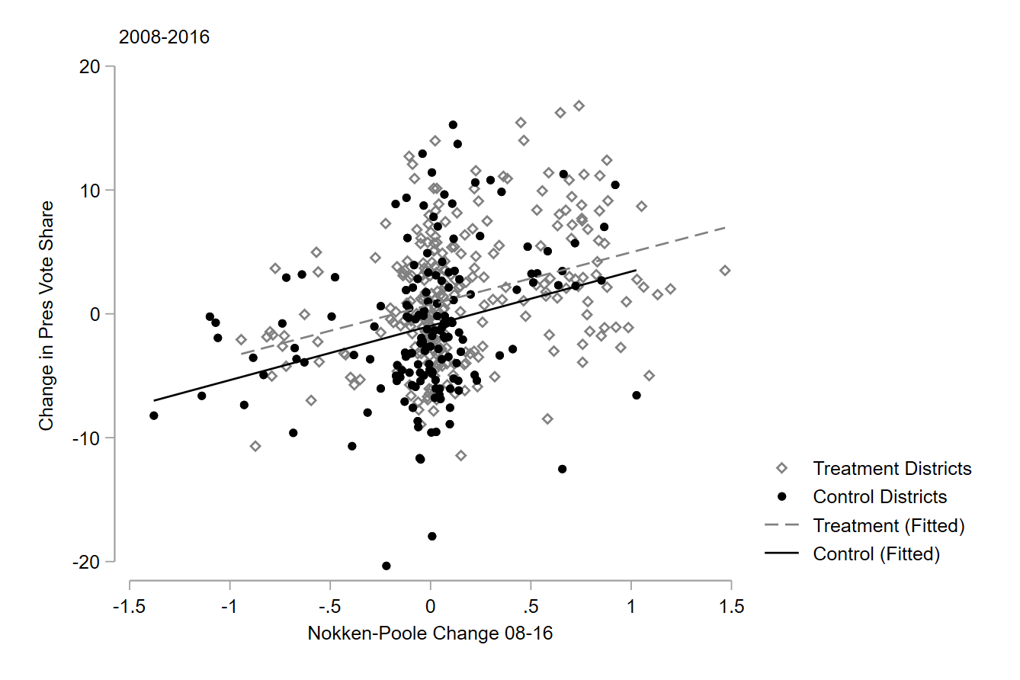
Figure A1 shows the correlation between the change in our dependent variables between 2008 and 2016 for our treatment and control districts. As expected, our dependent variables are correlated in both groups. Our treatment districts experience higher levels of change on both outcomes, as shown in our main findings, but these changes are aligned, as shown by the parallel fitted lines in this figure.

Figure A2: Correlation between Tea Party groups and Republican presidential vote share.
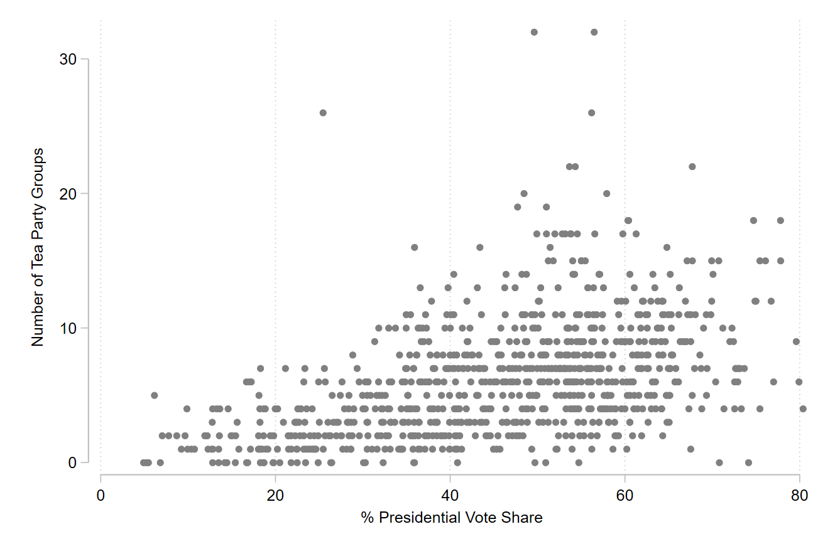
Figure A2 shows the correlation between the number of Tea Party groups in a district (one component of our treatment variable) and the presidential vote share in that district. Though there is a clear alignment in terms of the lower end of the presidential vote share and the number of Tea Party groups it is also notable that there are many districts with comparatively few groups and high levels of Republican presidential vote share.
Table A3 and Table A4 present the descriptive statistics for our two dependent variables in both the final pre-treatment (2008) and initial post-treatment (2016) years.
Table A3: Presidential Vote Share (H1) Descriptive Statistics
Year | N | Mean | Sd | Min | Max
2008 | 435 | 45.423 | 14.326 | 5.204 | 76.994
2016 | 435 | 45.972 | 16.797 | 4.896 | 80.372
Table A4: Legislator Position (H2) Descriptive Statistics
Year | N | Mean | Sd | Min | Max
2008 | 435 | -0.173 | 0.434 | -0.726 | 0.991
2016 | 435 | 0.093 | -0.470 | -0.761 | 1
Figure A3: Tea Party Candidates in Contested Republican Primaries by Type
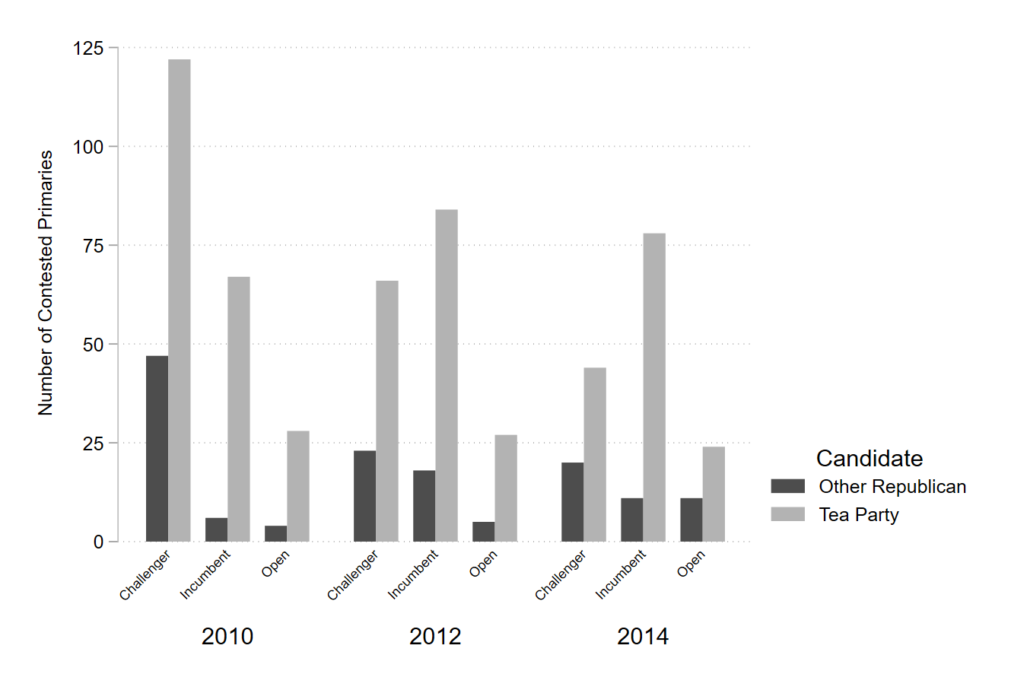
Figure A2 shows the number of Tea Party candidates in challenger (Democratic incumbent running for in the district), incumbent (Republican incumbent running in the district), and open (incumbent not running for either party) in each of the election cycles in our treatment period.

District Assignment
This section provides further information about the identity of and differences between the districts in our control and treatment groups. In Table B1 we present the number of districts that are assigned into control and treatment groups in our main analyses, as well as the number of groups that would be assigned if we used each of the two components of our treatment group as our treatment.
Table B1: Districts in Treatment & Control Groups
 | Factionalism (Treatment) |  | Activist Presence |  | Candidate Presence
 | Interacted Pre | Interacted Post | TP Groups Pre | TP Groups Post | Primary Pre | Primary Post
Control | 171 | 167 | 91 | 92 | 121 | 120
Treated | 264 | 268 | 344 | 343 | 314 | 315
Total | 435 | 435 | 435 | 435 | 435 | 435
In Figure B1 (H1) and Figure B2 (H2) we present our ‘raw’ parallel trends between our control and treatment groups. These are the trends of our groups without balancing using our propensity scores. In both cases, we are clearly able to demonstrate parallel trends in the three periods prior to our treatment. Though our treatment group is more Republican (H1) and further to the right (H2) on these measures, the trends only begin to diverge once we enter our treatment period. That we can demonstrate PTA absent our IPW approach gives further confidence in the robustness of our findings, and our inclusion of pre-treatment partisanship in our IPW estimation. We demonstrate the weighted parallel trends in Figure 4 and Figure 5 of the main text.
Figure B1: PTA Using Unweighted Figures – Presidential Vote Share (H1)
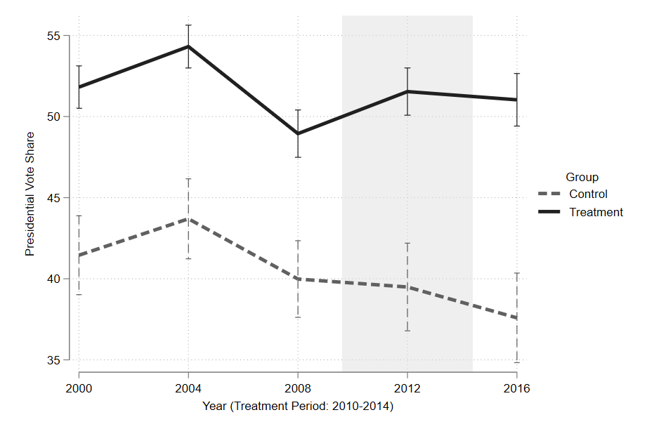
Figure B2: PTA Using Unweighted Figures – Legislator Position (H2)
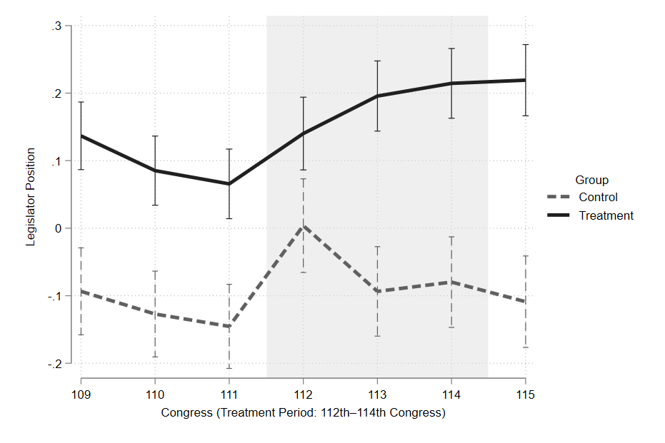

Balance with Other Numbers of Tea Party Groups
The following tables demonstrate balance using one to six Tea Party groups in the district as the cut-off for treatment with balance on the confounding variables used for propensity score estimation before and after the weighting process. These tables were used to justify the selection of three or more Tea Party groups as the cut-off for treatment assignment in our main analyses. Our models are repeated in the robustness checks which follow this section using different cut-offs for treatment.
Table B2: One TP Group
Values of Weights (IPW) | Mean | Sd | p50 | Max | Min | SMD
Control | 3.371 | 0.800 | 3.225 | 5.713 | 2.191 | -
Treatment | 1.423 | 0.133 | 1.408 | 1.833 | 1.224 | -
Unweighted Values
Percent White (Control) | 51.249 | 31.576 | 61.45 | 96.6 | 0.026 | -
Percent White (Treatment) | 58.669 | 30.021 | 68.7 | 95.8 | 0.098 | 0.241
Median Income (Control) | $56,583 | $16,987 | $53,222 | $125,675 | $23,773 | -
Median Income (Treatment) | $57,548 | $15,636 | $53,732 | $129,821 | $31,368 | 0.059
Median Age (Control) | 37.248 | 3.720 | 37.45 | 51.1 | 26 | -
Median Age (Treatment) | 37.825 | 3.434 | 37.6 | 55.7 | 28.2 | 0.161
Rural–Urban (Control) | 3.415 | 1.735 | 3 | 6 | 1 | -
Rural–Urban (Treatment) | 3.432 | 1.642 | 4 | 6 | 1 | 0.010
Democratic 2008 (Control) | 0.663 | 0.474 | 1 | 1 | 0 | -
Democratic 2008 (Treatment) | 0.551 | 0.498 | 1 | 1 | 0 | –0.232
Weighted Values
Percent White (Control) | 56.921 | 30.741 | 67.3 | 96.6 | 0.026 | -
Percent White (Treatment) | 56.570 | 30.781 | 67 | 95.8 | 0.098 | –0.011
Median Income (Control) | $57,212 | $16,797 | $53,746 | $125,675 | $23,773 | -
Median Income (Treatment) | $57,264 | $15,619 | $53,505 | $129,821 | $31,368 | 0.003
Median Age (Control) | 37.700 | 3.730 | 38.1 | 51.1 | 26 | -
Median Age (Treatment) | 37.666 | 3.444 | 37.5 | 55.7 | 28.2 | –0.009
Rural–Urban (Control) | 3.418 | 1.717 | 3 | 6 | 1 | -
Rural–Urban (Treatment) | 3.427 | 1.658 | 4 | 6 | 1 | 0.006
Democratic 2008 (Control) | 0.577 | 0.494 | 1 | 1 | 0 | -
Democratic 2008 (Treatment) | 0.582 | 0.493 | 1 | 1 | 0 | 0.011
Table B3: Two TP Groups
Values of Weights (IPW) | Mean | Sd | p50 | Max | Min | SMD
Control | 3.022 | 0.992 | 2.834 | 8.562 | 1.614 | -
Treatment | 1.497 | 0.221 | 1.451 | 2.61 | 1.157 | -
Unweighted Values
Percent White (Control) | 49.840 | 31.823 | 57.4 | 96.6 | 0.026 | -
Percent White (Treatment) | 59.772 | 29.776 | 69.6 | 95.8 | 0.098 | 0.325
Median Income (Control) | $55,972 | $16,572 | $52,893 | $125,675 | $23,773 | -
Median Income (Treatment) | $57,906 | $15,752 | $54,034 | $129,821 | $31,368 | 0.120
Median Age (Control) | 36.927 | 3.800 | 37.1 | 51.1 | 26 | -
Median Age (Treatment) | 38.016 | 3.330 | 37.8 | 55.7 | 28.2 | 0.305
Rural–Urban (Control) | 3.419 | 1.794 | 3 | 6 | 1 | -
Rural–Urban (Treatment) | 3.432 | 1.605 | 4 | 6 | 1 | 0.007
Democratic 2008 (Control) | 0.674 | 0.469 | 1 | 1 | 0 | -
Democratic 2008 (Treatment) | 0.539 | 0.499 | 1 | 1 | 0 | –0.277
Weighted Values
Percent White (Control) | 57.085 | 30.541 | 67.8 | 96.6 | 0.026 | -
Percent White (Treatment) | 56.689 | 30.849 | 67.246 | 95.8 | 0.098 | –0.013
Median Income (Control) | $57,294 | $16,714 | $53,746 | $125,675 | $23,773 | -
Median Income (Treatment) | $57,315 | $15,619 | $53,673 | $129,821 | $31,368 | 0.001
Median Age (Control) | 37.788 | 3.842 | 38.1 | 51.1 | 26 | -
Median Age (Treatment) | 37.701 | 3.335 | 37.5 | 55.7 | 28.2 | –0.024
Rural–Urban (Control) | 3.416 | 1.768 | 3 | 6 | 1 | -
Rural–Urban (Treatment) | 3.432 | 1.624 | 4 | 6 | 1 | 0.009
Democratic 2008 (Control) | 0.575 | 0.494 | 1 | 1 | 0 | -
Democratic 2008 (Treatment) | 0.582 | 0.492 | 1 | 1 | 0 | 0.014
Table B4: 3 TP Groups (used in main analysis due to best balance - Table 2)
Values of Weights (IPW) | Mean | Sd | p50 | Max | Min | SMD
Control | 2.601 | 0.982 | 2.287 | 10.171 | 1.302 | -
Treatment | 1.631 | 0.318 | 1.565 | 4.232 | 1.12 | -
Unweighted Values
Percent White (Control) | 37.911 | 33.622 | 33.500 | 96.6 | 0.026 | -
Percent White (Treatment) | 48.000 | 36.305 | 62.925 | 95.8 | 0.098 | 0.288
Median Income (Control) | $54,555 | $16,778 | $51,647 | $125,675 | $19,311 | -
Median Income (Treatment) | $54,992 | $15,244 | $51,700 | $129,821 | $25,630 | 0.273
Median Age (Control) | 36.591 | 3.956 | 36.7 | 51.1 | 22.3 | -
Median Age (Treatment) | 37.929 | 3.468 | 37.8 | 55.7 | 21.0 | 0.360
Rural–Urban (Control) | 3.443 | 1.846 | 3 | 6 | 1 | -
Rural–Urban (Treatment) | 3.408 | 1.551 | 4 | 6 | 1 | –0.021
Democratic 2008 (Control) | 0.682 | 0.466 | 1 | 1 | 0 | -
Democratic 2008 (Treatment) | 0.524 | 0.500 | 1 | 1 | 0 | –0.327
Weighted Values
Percent White (Control) | 44.607 | 35.029 | 48 | 96.6 | 0.026 | -
Percent White (Treatment) | 44.234 | 36.398 | 56.1 | 95.8 | 0.098 | –0.010
Median Income (Control) | $54,584 | $16,216 | $51,738 | $125,675 | $19,311 | -
Median Income (Treatment) | $54,751 | $15,353 | $51,576 | $129,821 | $25,630 | 0.010
Median Age (Control) | 37.598 | 4.045 | 37.7 | 51.1 | 22.3 | -
Median Age (Treatment) | 37.480 | 3.542 | 37.4 | 55.7 | 21.0 | –0.031
Rural–Urban (Control) | 3.416 | 1.81 | 3 | 6 | 1 | -
Rural–Urban (Treatment) | 3.421 | 1.585 | 4 | 6 | 1 | 0.003
Democratic 2008 (Control) | 0.570 | 0.495 | 1 | 1 | 0 | -
Democratic 2008 (Treatment) | 0.580 | 0.494 | 1 | 1 | 0 | 0.021

Table B5: Four TP Groups
Values of Weights (IPW) | Mean | Sd | p50 | Max | Min | SMD
Control | 2.271 | 1.090 | 1.916 | 11.900 | 1.196 | -
Treatment | 1.801 | 0.530 | 1.660 | 4.889 | 1.097 | -
Unweighted Values
Percent White (Control) | 48.600 | 30.106 | 51.575 | 96.6 | 0.260 | -
Percent White (Treatment) | 62.891 | 29.629 | 72.800 | 95.8 | 0.098 | 0.475
Median Income (Control) | $57,353 | $16,782 | $53,969 | $125,675 | $23,773 | -
Median Income (Treatment) | $57,185 | $15,436 | $53,400 | $129,821 | $31,683 | –0.010
Median Age (Control) | 36.773 | 3.700 | 36.8 | 51.1 | 26 | -
Median Age (Treatment) | 38.372 | 3.24 | 38.2 | 55.7 | 28.2 | 0.462
Rural–Urban (Control) | 3.396 | 1.865 | 3 | 6 | 1 | -
Rural–Urban (Treatment) | 3.453 | 1.493 | 4 | 6 | 1 | 0.034
Democratic 2008 (Control) | 0.682 | 0.466 | 1 | 1 | 0 | -
Democratic 2008 (Treatment) | 0.504 | 0.500 | 1 | 1 | 0 | –0.366
Weighted Values
Percent White (Control) | 57.160 | 29.857 | 65.512 | 96.6 | 0.260 | -
Percent White (Treatment) | 56.612 | 32.165 | 68.700 | 95.8 | 0.098 | –0.017
Median Income (Control) | $56,772 | $15,873 | $53,617 | $125,675 | $23,773 | -
Median Income (Treatment) | $57,018 | $15,824 | $53,194 | $129,821 | $31,683 | 0.016
Median Age (Control) | 37.952 | 3.973 | 38.1 | 51.1 | 26 | -
Median Age (Treatment) | 37.803 | 3.238 | 37.6 | 55.7 | 28.2 | –0.041
Rural–Urban (Control) | 3.410 | 1.822 | 3 | 6 | 1 | -
Rural–Urban (Treatment) | 3.433 | 1.547 | 4 | 6 | 1 | 0.014
Democratic 2008 (Control) | 0.560 | 0.497 | 1 | 1 | 0 | -
Democratic 2008 (Treatment) | 0.574 | 0.495 | 1 | 1 | 0 | 0.028
Table B6: Five TP Groups
Values of Weights (IPW) | Mean | Sd | p50 | Max | Min | SMD
Control | 1.907 | 0.809 | 1.642 | 9.375 | 1.116 | -
Treatment | 2.114 | 0.764 | 1.877 | 6.256 | 1.108 | -
Unweighted Values
Percent White (Control) | 49.646 | 29.873 | 55.100 | 96.6 | 0.26 | -
Percent White (Treatment) | 64.270 | 29.716 | 74.136 | 95.8 | 0.98 | 0.490
Median Income (Control) | $57,867 | $17,397 | $54,202 | $129,821 | $23,773 | -
Median Income (Treatment) | $56,567 | $14,335 | $53,160 | $124,627 | $31,368 | –0.082
Median Age (Control) | 36.876 | 3.689 | 36.80 | 51.5 | 26 | -
Median Age (Treatment) | 38.544 | 3.112 | 38.4 | 55.7 | 29.8 | 0.489
Rural–Urban (Control) | 3.390 | 1.875 | 3 | 6 | 1 | -
Rural–Urban (Treatment) | 3.470 | 1.398 | 4 | 6 | 1 | 0.048
Democratic 2008 (Control) | 0.658 | 0.475 | 1 | 1 | 0 | -
Democratic 2008 (Treatment) | 0.500 | 0.500 | 0 | 1 | 0 | –0.325
Weighted Values
Percent White (Control) | 56.909 | 29.578 | 65.3 | 96.6 | 0.26 | -
Percent White (Treatment) | 56.465 | 33.010 | 69.5 | 95.8 | 0.98 | –0.014
Median Income (Control) | $56,871 | $16,377 | $53,324 | $129,821 | $23,773 | -
Median Income (Treatment) | $56,906 | $14,906 | $53,512 | $124,627 | $31,368 | 0.002
Median Age (Control) | 37.943 | 4.052 | 37.8 | 51.5 | 26 | -
Median Age (Treatment) | 37.874 | 3.096 | 37.7 | 55.7 | 29.8 | –0.019
Rural–Urban (Control) | 3.437 | 1.831 | 4 | 6 | 1 | -
Rural–Urban (Treatment) | 3.442 | 1.470 | 4 | 6 | 1 | 0.003
Democratic 2008 (Control) | 0.567 | 0.496 | 1 | 1 | 0 | -
Democratic 2008 (Treatment) | 0.571 | 0.495 | 1 | 1 | 0 | 0.008
Table B7: Six TP Groups
Values of Weights (IPW) | Mean | Sd | p50 | Max | Min | SMD
Control | 2.411 | 1.046 | 2.092 | 8.561 | 1.157 | -
Treatment | 1.444 | 0.190 | 1.398 | 2.324 | 1.166 | -
Unweighted Values
Percent White (Control) | 50.068 | 29.976 | 56.249 | 96.6 | 0.026 | -
Percent White (Treatment) | 65.300 | 29.421 | 75.315 | 95.8 | 0.17 | 0.512
Median Income (Control) | $57,583 | $17,152 | $53,970 | $129,821 | $23,773 | -
Median Income (Treatment) | $56,815 | $14,391 | $53,367 | $124,627 | $31,368 | –0.048
Median Age (Control) | 36.984 | 3.686 | 36.9 | 51.5 | 26 | -
Median Age (Treatment) | 38.579 | 3.075 | 38.4 | 55.7 | 29.8 | 0.470
Rural–Urban (Control) | 3.370 | 1.865 | 3 | 6 | 1 | -
Rural–Urban (Treatment) | 3.507 | 1.352 | 4 | 6 | 1 | 0.084
Democratic 2008 (Control) | 0.672 | 0.494 | 1 | 1 | 0 | -
Democratic 2008 (Treatment) | 0.462 | 0.499 | 0 | 1 | 0 | –0.433
Weighted Values
Percent White (Control) | 56.776 | 29.575 | 65.300 | 96.6 | 0.026 | -
Percent White (Treatment) | 56.318 | 33.503 | 69.964 | 95.8 | 0.17 | –0.014
Median Income (Control) | $56,915 | $16,302 | $53,336 | $129,821 | $23,773 | -
Median Income (Treatment) | $56,809 | $14,854 | $53,367 | $124,627 | $31,368 | –0.007
Median Age (Control) | 37.892 | 3.998 | 37.700 | 51.5 | 26 | -
Median Age (Treatment) | 37.883 | 3.089 | 37.800 | 55.7 | 29.8 | –0.003
Rural–Urban (Control) | 3.432 | 1.825 | 4 | 6 | 1 | -
Rural–Urban (Treatment) | 3.430 | 1.435 | 4 | 6 | 1 | –0.001
Democratic 2008 (Control) | 0.569 | 0.494 | 1 | 1 | 0 | -
Democratic 2008 (Treatment) | 0.570 | 0.495 | 1 | 1 | 0 | 0.001

Robustness Checks
The below section is the results of our robustness checks. Alongside our main analyses we conduct multiple robustness checks, namely; moving the boundary for the number of Tea Party groups required to be considered in the treatment group, only including the distinct sub-components of our treatment variable—activist presence and candidate presence—as our treatment, restricting primaries to challengers who received at least twenty-five percent of the vote, restricting primary challengers to those who filed campaign receipts with the Federal Election Committee (FEC), using static weights based on 2008 districts, extending our treatment period to include primaries in 2016, repeating our analysis of legislator position using 2018 as the post-treatment period, using lagged versions of our dependent variables, including the alternative dependent variable as a confounding variable, and using doubly robust estimators. The results of these robustness checks give us greater confidence in our main findings, with an effect found in almost all models.
The results in Table C1 point in the theorized direction regardless of how many Tea Party groups we require for a district to be considered in our treatment group though this effect decreases in size and loses significance when we consider one or two groups as sufficient to be considered treated, largely due to a lack of data in the control group.
Table C1: Presidential Vote Share – Robustness Check using different #TP Groups
 | 1+ TP Groups | 2+ TP Groups | 4+ TP Groups | 5+ TP Groups | 6+ TP Groups
2016 (Time) | 0.174 | 0.065 | –0.509 | –0.299 | –0.277
 | (0.798) | (0.811) | (0.769) | (0.674) | (0.600)
Factionalism (Treatment) | 4.610*** | 5.496*** | 5.798*** | 5.897*** | 6.145***
 | (1.620) | (1.545) | (1.414) | (1.356) | (1.365)
Diff-in-diff | 0.429 | 0.912 | 2.298* | 2.784** | 2.742***
 | (1.041) | (1.132) | (1.219) | (1.154) | (1.010)
Observations | 870 | 870 | 870 | 870 | 870
R-squared | 0.022 | 0.035 | 0.052 | 0.061 | 0.066
Mean Control 2008 | 42.58 | 42.28 | 43.08 | 43.37 | 43.65
 | (1.439) | (1.348) | (1.124) | (0.999) | (0.938)
Mean Treated 2008 | 47.19 | 47.77 | 48.87 | 49.26 | 49.80
 | (0.744) | (0.755) | (0.858) | (0.917) | (0.992)
Diff 2008 | 4.610 | 5.496 | 5.798 | 5.897 | 6.145
 | (1.620) | (1.545) | (1.414) | (1.356) | (1.365)
Mean Control 2016 | 42.76 | 42.34 | 42.57 | 43.07 | 43.38
 | (1.689) | (1.609) | (1.431) | (1.270) | (1.195)
Mean Treated 2016 | 47.80 | 48.75 | 50.66 | 51.75 | 52.26
 | (0.878) | (0.877) | (0.957) | (1.034) | (1.093)
Diff 2016 | 5.040 | 6.408 | 8.097 | 8.681 | 8.887
 | (1.903) | (1.832) | (1.722) | (1.637) | (1.619)
The results in Table C2 remain significant in the theorized direction regardless of how many Tea Party groups we require for a district to be considered in our treatment group. The substantive size of the effect decreases slightly when a single Tea Party group is considered as a treated district.
Table C2: Representative Position – Robustness Check using different #TP Groups
 | 1+ TP Groups | 2+ TP Groups | 4+ TP Groups | 5+ TP Groups | 6+ TP Groups
2016 (Time) | 0.050 | 0.041 | 0.033 | 0.041 | 0.048
 | (0.034) | (0.034) | (0.029) | (0.031) | (0.030)
Factionalism (Treatment) | 0.041 | 0.054 | 0.074* | 0.082* | 0.077*
 | (0.047) | (0.046) | (0.044) | (0.044) | (0.044)
Diff-in-diff | 0.087** | 0.112** | 0.149*** | 0.158*** | 0.153***
 | (0.043) | (0.044) | (0.043) | (0.046) | (0.046)
Observations | 870 | 870 | 870 | 870 | 870
R-squared | 0.021 | 0.029 | 0.047 | 0.056 | 0.054
Mean Control 2008 | –0.041 | –0.046 | –0.044 | –0.040 | –0.030
 | (0.041) | (0.039) | (0.033) | (0.031) | (0.029)
Mean Treated 2008 | 0.001 | 0.008 | 0.029 | 0.042 | 0.048
 | (0.024) | (0.025) | (0.029) | (0.031) | (0.033)
Diff 2008 | 0.041 | 0.054 | 0.073 | 0.082 | 0.077
 | (0.048) | (0.046) | (0.044) | (0.044) | (0.044)
Mean Control 2016 | 0.010 | –0.005 | -0.012 | 0.001 | 0.018
 | (0.042) | (0.040) | (0.035) | (0.033) | (0.032)
Mean Treated 2016 | 0.138 | 0.161 | 0.211 | 0.242 | 0.249
 | (0.027) | (0.027) | (0.031) | (0.034) | (0.036)
Diff 2016 | 0.128 | 0.166 | 0.223 | 0.240 | 0.231
 | (0.050) | (0.049) | (0.047) | (0.047) | (0.048)
Table C3 and Table C4 show the main results if we independently use the two components of our main treatment variable as the treatment condition. In Table C3, we use the presence of three Tea Party groups as our treatment. For both outcomes, our effect size retains significance and increases substantively, likely due in part to the imbalance between the numbers of treatment and control districts, shown in Table B1.
Table C3: Tea Party Groups (Activist Presence) as Treatment
 | Pres Vote Share | Leg Position
2016 (Time) | –3.972** | –0.040
 | (1.723) | (0.060)
3+ TP Groups (Treatment) | 8.891*** | 0.079
 | (2.350) | (0.065)
Diff-in-diff (Time x Treatment) | 5.641*** | 0.191***
 | (1.946) | (0.065)
Observations | 870 | 870
R-squared | 0.150 | 0.06
Mean Control 2008 | 38.55 | –0.074
 | (2.228) | (0.061)
Mean Treated 2008 | 47.44 | 0.005
 | (0.748) | (0.023)
Diff 2008 | 8.891 | 0.079
 | (2.350) | (0.065)
Mean Control 2016 | 34.58 | –0.114
 | (1.722) | (0.071)
Mean Treated 2016 | 49.11 | 0.156
 | (0.832) | (0.025)
Diff 2016 | 14.53 | 0.270
 | (1.913) | (0.075)
In Table C4, we present our results only using Tea Party primaries as our treatment condition. In this case, our results for H1 are completely removed and essentially zero. The rightward movement of voters therefore appears more closely connected to the presence of activist groups in a given district than of factional candidates in congressional primaries. Our finding for H2 remains substantively significant, suggesting that legislative primaries are important in their ability to pressure parties at the elite level.
Table C4: TP Primary (Candidate Presence) Only as Treatment
 | Pres Vote Share | Leg Position
2016 (Time) | 0.529 | 0.048
 | (0.690) | (0.034)
TP Primary 10-14 (Treatment) | 4.644*** | 0.032
 | (1.642) | (0.048)
Diff-in-diff (Time x Treatment) | –0.149 | 0.087**
 | (0.773) | (0.042)
Observations | 870 | 870
R-squared | 0.020 | 0.019
Mean Control 2008 | 42.32 | –0.037
 | (1.463) | (0.042)
Mean Treated 2008 | 46.97 | –0.005
 | (0.745) | (0.024)
Diff 2008 | 4.644 | 0.032
 | (1.642) | (0.048)
Mean Control 2016 | 42.85 | 0.011
 | (1.695) | (0.042)
Mean Treated 2016 | 47.35 | 0.130
 | (0.894) | (0.027)
Diff 2016 | 4.495 | 0.119
 | (1.916) | (0.050)
In Table C5 we restrict our analyses only to primary elections where the second-placed candidate received more than twenty-five percent of the vote. The effect remains present in both models despite the smaller size of the treatment group.
Table C5: Only Including Primaries Where Non-Winner Receives 25 percent of Votes
 | Pres Vote Share | Leg Position
2016 (Time) | –0.482 | 0.032
 | (0.735) | (0.029)
Factionalism (>25%) (Treatment) | 5.080*** | 0.026
 | (1.413) | (0.043)
Diff-in-diff (Time x Treatment) | 1.953* | 0.154***
 | (1.178) | (0.044)
Observations | 870 | 870
R-squared | 0.037 | 0.031
Mean Control 2008 | 43.21 | –0.025
 | (1.136) | (0.033)
Mean Treated 2008 | 48.29 | 0.001
 | (0.841) | (0.028)
Diff 2008 | 5.080 | 0.026
 | (1.413) | (0.043)
Mean Control 2016 | 42.73 | 0.007
 | (1.421) | (0.035)
Mean Treated 2016 | 49.76 | 0.187
 | (0.942) | (0.031)
Diff 2016 | 7.034 | 0.180
 | (1.705) | (0.047)
In Table C6, we only include primaries where the losing candidate in Republican primaries filed an FEC report, suggesting they raised a minimum of $5,000. Both models retained significance.
Table C6: Only Including Primaries Where Non-Winner Files FEC Report
 | Pres Vote Share | Leg Position
2016 (Time) | –0.319 | 0.033
 | (0.736) | (0.030)
Factionalism w/receipts (Treatment) | 6.292*** | 0.067
 | (1.392) | (0.044)
Diff-in-diff (Time x Treatment) | 1.523 | 0.141***
 | (1.106) | (0.044)
Observations | 870 | 870
R-squared | 0.053 | 0.042
Mean Control 2008 | 42.74 | –0.041
 | (1.139) | (0.034)
Mean Treated 2008 | 49.04 | 0.026
 | (0.800) | (0.027)
Diff 2008 | 6.292 | 0.067
 | (1.392) | (0.043)
Mean Control 2016 | 42.43 | –0.008
 | (1.440) | (0.036)
Mean Treated 2016 | 50.24 | 0.200
 | (0.900) | (0.030)
Diff 2016 | 7.815 | 0.208
 | (1.698) | (0.046)
Not all primary challengers are equally threatening. In Table C7, we restrict inclusion in our treatment to those Tea Party-supported primary candidates that can be considered ‘quality’. For simplicity, we use Jacobson’s (1978, 1989) definition of quality as being candidates who have previously held elected public office. All primary candidates were hand coded as quality by one of the authors using Vote Smart, Ballotpedia, and biographical information on candidates’ websites. Our results for H1 lose significance when we restrict treatment in this way, though remain in the theorized direction. Our results for H2, perhaps unsurprisingly, increase in substantive size, suggesting that incumbents are more responsive to quality Tea Party-supported challengers, and that quality Tea Party-supported candidates are more likely to enter Congress.
Table C7: Only Including Primaries with ‘Quality’ Tea Party Candidate
 | Pres Vote Share | Leg Position
2016 (Time) | 0.093 | 0.052**
 | (0.415) | (0.024)
Factionalism w/‘Quality’ (Treatment) | 10.246*** | 0.140***
 | (1.327) | (0.049)
Diff-in-diff (Time x Treatment) | 1.387 | 0.272***
 | (0.969) | (0.058)
Observations | 870 | 870
R-squared | 0.147 | 0.158
Mean Control 2008 | 43.80 | –0.039
 | (0.795) | (0.024)
Mean Treated 2008 | 54.05 | 0.101
 | (1.062) | (0.042)
Diff 2008 | 10.25 | 0.140
 | (1.327) | (0.049)
Mean Control 2016 | 43.90 | 0.013
 | (0.973) | (0.025)
Mean Treated 2016 | 55.53 | 0.424
 | (1.074) | (0.045)
Diff 2016 | 11.63 | 0.411
 | (1.449) | (0.052)
One potential counter-argument to our findings is that 2010 was an unusual year, with many Tea Party candidates standing in primary elections and the party performing unusually well in a ‘wave’ election that November. Our results are consistent if we only consider the 2012 and 2014 primaries within our treatment, as shown in Table C8.
Table C8: Only Including 12-14 Primaries as Treatment
 | Pres Vote Share | Leg Position
2016 (Time) | –0.345 | 0.053*
 | (0.553) | (0.028)
Factionalism: 12-14 only (Treatment) | 6.061*** | 0.070
 | (1.313) | (0.043)
Diff-in-diff (Time x Treatment) | 1.375* | 0.116***
 | (0.825) | (0.043)
Observations | 870 | 870
R-squared | 0.051 | 0.040
Mean Control 2008 | 43.34 | –0.038
 | (0.984 | (0.029)
Mean Treated 2008 | 49.40 | 0.032
 | (0.869) | (0.031)
Diff 2008 | 6.061 | 0.070
 | (1.313) | (0.043)
Mean Control 2016 | 42.99 | 0.015
 | (1.211) | (0.032)
Mean Treated 2016 | 50.43 | 0.202
 | (0.992) | (0.033)
Diff 2016 | 7.436 | 0.186
 | (1.565) | (0.046)
The weights in Table C9 use data from 2008 only. Control districts were matched to treatment districts with similar characteristics. If no treatment district was sufficiently similar, the district was removed from the dataset, giving a smaller sample size. In addition, because these weights are ‘fixed’ to a congressional district number, they could not change over time, meaning that if redistricting altered the configurations of districts in a state (as it did for example in California), the weight could not be reallocated. In addition, districts that were only created following redistricting were unable to be included in this analysis. These constraints led us to use the IPW weighting in our main analysis and give us caution over the below results. The removal of districts and potentially incorrect weighting based on outdated district numbers remove the significance in H2 but we note that the direction of the relationship is the same (and significant at the p<0.1 level in the presidential vote share model).
Table C9: Alternative Weighting Using 2008 Fixed Weights
 | Pres Vote Share | Leg Position
2016 (time) | –1.630 | 0.081*
 | (1.435) | (0.044)
Factionalism (treatment) | 4.178*** | 0.133**
 | (1.484) | (0.055)
Diff-in-diff | 3.676* | 0.054
 | (2.097) | (0.054)
Observations | 789 | 789
R-squared | 0.044 | 0.051
Mean Control 2008 | 44.77 | –0.067
 | (0.994) | (0.049)
Mean Treated 2008 | 48.95 | 0.066
 | (1.101) | (0.026)
Diff 2008 | 4.178 | 0.133
 | (1.484) | (0.055)
Mean Control 2016 | 43.14 | 0.014
 | (1.035) | (0.049)
Mean Treated 2016 | 50.99 | 0.201
 | (1.060) | (0.029)
Diff 2016 | 7.853 | 0.187
 | (1.481) | (0.057)
In Table C10 we conduct our analyses using all Tea Party-aligned candidates within our treatment rather than restricting inclusion only to those candidates in contested primaries. Making this change moved twenty-eight districts from our control to our treatment group. Most of these were unchallenged Republican incumbents, who adopted the Tea Party label and then didn’t face a primary challenger in 2010, 2012, or 2014. We theorize that this group moved rightward solely through adaptation and successfully prevented being ‘primaried’ by adopting the Tea Party label. This group included notable figures such as Jim Jordan and Steve King. Other districts were unchallenged Tea Party candidates running against Democrats in districts where no contested primary took place due to lack of interest, usually due to a perceived lack of competitiveness in the November general election. As expected, our findings hold including these districts and for both models, the size of rightward movement increased.
Table C10: All TP Candidates (not just contested primaries)
 | Pres Vote Share | Leg Position
2016 (time) | –0.399 | 0.012
 | (1.413) | (0.040)
Factionalism – any TP candidate | 6.786*** | 0.074*
 | (1.464) | (0.041)
Diff-in-diff | 1.843 | 0.154***
 | (2.077) | (0.058)
Observations | 870 | 870
R-squared | 0.061 | 0.046
Mean Control 2008 | 41.65 | –0.055
 | (0.996) | (0.028)
Mean Treated 2008 | 48.43 | 0.019
 | (1.072) | (0.030)
Diff 2008 | 6.786 | 0.074
 | (1.464) | (0.041)
Mean Control 2016 | 41.25 | –0.043
 | (1.003) | (0.028)
Mean Treated 2016 | 49.88 | 0.185
 | (1.079) | (0.030)
Diff 2016 | 8.629 | 0.228
 | (1.473) | (0.041)
We also coded 2016 primaries as featuring a ‘Tea Party’ candidate. We followed the same method as outlined in the main paper, though official endorsements or associations with the Tea Party were scarcer in this election cycle. The inclusion of the 2016 cycle produced results that included no gap during our analysis, with every primary election included in either our pre-treatment, treatment, or post-treatment period. Including Tea Party primaries from 2016 moved eighteen districts from our control to our treatment group. The results in Table C11 are broadly consistent with our main findings, though H1 loses significance.
Table C11: Including 2016 ‘Tea Party’ Primaries
 | Pres Vote Share  inc. 2016 Primaries | Leg Position  inc. 2016 Primaries
2016 (Time) | –0.916 | 0.009
 | (1.426) | (0.041)
Factionalism inc. 2016 (Treatment) | 5.566*** | 0.041
 | (1.463) | (0.042)
Diff-in-diff (Time x Treatment) | 2.361 | 0.156***
 | (2.085) | (0.060)
Observations | 870 | 870
R-squared | 0.047 | 0.033
Mean Control 2008 | 42.60 | –0.028
 | (0.995) | (0.029)
Mean Treated 2008 | 48.17 | 0.013
 | (1.072) | (0.031)
Diff 2008 | 5.566 | 0.041
 | (1.463) | (0.042)
Mean Control 2016 | 41.69 | –0.019
 | (1.022) | (0.029)
Mean Treated 2016 | 49.61 | 0.178
 | (1.079) | (0.031)
Diff 2016 | 7.927 | 0.197
 | (1.486) | (0.043)
In Table C12 we repeat our analysis for H2 using positions from the 116th Congress as the post-treatment period. This period did not start with an election in which Trump featured on the ballot and serves as further evidence that we are capturing an effect of factional pressure separate from the Trump phenomenon.
Table C12: H2 with 116th Congress (2019–2021) as Post
Leg Position
116th Post
2016 (Time) | –0.017
 | (0.041)
Factionalism (Treatment) | 0.067
 | (0.042)
Diff-in-diff (Time x Treatment) | 0.105*
 | (0.060)
Observations | 870
R-squared | 0.023
Mean Control 2008 | –0.046
 | 0.029
Mean Treated 2008 | 0.021
 | 0.031
Diff 2008 | 0.067
 | 0.042
Mean Control 2016 | –0.062
 | 0.029
Mean Treated 2016 | 0.109
 | 0.031
Diff 2016 | 0.171
 | 0.042
An alternative explanation for district-level change is the replacement of incumbent representatives with comparative more extreme alternatives. The below models include three indicators of representative replacement corresponding with the number of times a district elected a new representative (one, two, or three or more new members) between our pre and post periods; we use no replacement as our base category. We do so to address the possibility that any effects are the result of the increasingly routine replacement of moderate members with comparatively extreme representatives (Theriault 2006). The below models in Table C13 therefore use the following specification:

Y_{it} = 𝛼 + 𝜆²⁰¹⁶_{t} + γ^{Factionalism}_{i} + δ^{(2016*Factionalism)}_{it} + 𝛽₁^{Partisanship}_{it} + 𝛽₂^{Replacement}_{it} + ε_{it}
Our findings in Table C13 remain significant even when we control for representative replacement, and representative replacement is not a significant coefficient in either of our models. This gives us confidence that we are not simply capturing the effect of new, more extreme, representatives replacing long-serving moderates.
Table C13: Legislator Replacement
 | Pres Vote Share  New Rep Model | Leg Position  New Rep Model
2016 (time) | –0.697 | 0.035
 | (0.808) | (0.031)
Factionalism (treatment) | 5.296*** | 0.066
 | (1.450) | (0.044)
Diff-in-diff | 2.066* | 0.129***
 | (1.186) | (0.043)
New Representative (1) | 2.675 | 0.016
 | (1.779) | (0.045)
New Representative (2) | 3.866* | –0.010
 | (2.073) | (0.062)
New Representative (3+) | 1.169 | –0.071
 | (3.235) | (0.081)
Observations | 870 | 870
R-squared | 0.055 | 0.038
Mean Control 2008 | 41.45 | –0.048
 | (1.538) | (0.045)
Mean Treated 2008 | 46.74 | 0.018
 | (1.268) | (0.038)
Diff 2008 | 5.296 | 0.066
 | (1.450) | (0.044)
Mean Control 2016 | 40.75 | –0.014
 | (1.827) | (0.046)
Mean Treated 2016 | 48.11 | 0.181
 | (1.340) | (0.040)
Diff 2016 | 7.362 | 0.195
 | (1.760) | (0.047)
In Table C14 we include lagged versions of dependent variables in each model, as expected the lagged versions of each dependent variable are highly significant predictors of our outcomes. Our model for H1 loses significance and decreases substantively in size, our model for H2 also decreases in substantive size but remains statistically significant, giving further confidence in our findings for this analysis.
Table C14: Lagged Dependent Variables as Controls
 | Pres Vote Share -  Lagged Model | Leg Position -  Lagged Model
2016 (time) | 2.679*** | –0.010
 | (0.961) | (0.016)
Factionalism (treatment) | -0.031 | –0.008
 | (1.046) | (0.018)
Diff-in-diff | 1.337 | 0.047**
 | (1.102) | (0.023)
Lagged DV | 89.044*** | 0.943***
 | (2.678) | (0.013)
Observations | 870 | 870
R-squared | 0.731 | 0.879
Mean Control 2008 | 0.810 | –0.014
 | (1.635) | (0.014)
Mean Treated 2008 | 0.779 | –0.022
 | (1.601) | (0.011)
Diff 2008 | –0.031 | –0.008
 | (1.046) | (0.018)
Mean Control 2016 | 3.489 | –0.027
 | (1.060) | (0.011)
Mean Treated 2016 | 4.794 | 0.015
 | (1.387) | (0.009)
Diff 2016 | 1.306 | 0.039
 | (0.696) | (0.015)
Table C15 presents the main results with the inclusion of the alternative dependent variable as an additional control. Our model for H2 retains significance in the theorized direction, though our model for H1 is non-significant and the direction is reversed. These models further suggest the greater robustness of our finding for H2 than H1.
Table C15: Alternative Dependent Variable as Control
 | Pres Vote Share  inc. leg position | Leg Position  inc. pres vote share
2016 (time) | –1.502* | 0.049*
 | (0.837) | (0.029)
Factionalism (treatment) | 4.133*** | –0.047
 | (1.240) | (0.038)
Diff-in-diff | –1.007 | 0.086**
 | (1.141) | (0.038)
Alternative DV | 24.048*** | 0.020***
 | (1.109) | (0.001)
Observations | 870 | 870
R-squared | 0.501 | 0.495
Mean Control 2008 | 43.74 | –0.890
 | (1.012) | (0.045)
Mean Treated 2008 | 47.87 | –0.937
 | (0.708) | (0.050)
Diff 2008 | 4.133 | –0.047
 | (1.240) | (0.038)
Mean Control 2016 | 42.24 | –0.841
 | (1.024) | (0.041)
Mean Treated 2016 | 45.36 | –0.802
 | (0.529) | (0.050)
Diff 2016 | 3.126 | 0.039
 | (1.171) | (0.031)
As we were writing this paper, academic discourse around the optimal estimator for conducting DiD analyses has been ongoing. Without wishing to make any methodological commentary about approaches to DiD studies, we are keen to demonstrate that our findings are not an artifact of the estimator used. Table C15 presents our results using a variety of estimators, including Sant’Anna and Zhao’s (2020) doubly robust estimator. Under most of the below estimators, our results are substantively unchanged.
Table C16: Alternative DiD Estimators
 | Pres Vote Share | Legislator Position
Doubly Robust IPW | 2.032* | 0.126***
 | (1.179) | (0.043)
Doubly Robust Improved Estimator | 2.032* | 0.126***
 | (1.179) | (0.043)
Regression Augmented Estimator | 2.032* | 0.126***
 | (1.179) | (0.043)
Abadie (2005) IPW Estimator | 2.309 | 0.127***
 | (2.801) | (0.043)
IPW and Regression Adjustment Estimator | 2.032* | 0.126***
 | (1.179) | (0.043)
We acknowledge that our approach to ‘controlling’ for partisanship uses a rather blunt instrument (partisan control of the district in 2008). We use this approach in our main analysis given the endogeneity issues inherent with using more granular controls and approaches. Here, we present two alternative models that attempt to further control for partisan differences across districts. We include the additional variables as separate controls rather than in our propensity score estimation strategy given the endogeneity issues identified.
In the first set of models, we construct an index of district partisanship based on House results in the final two cycles prior to treatment. The partisan index takes the value 1 if the Republican candidate won the district with over 60 percent of the vote in 2006 and 2008; takes the value 2 if the Republican candidate won the district in both 2006 and 2008 (not achieving 60 percent of the vote); takes the value 3 if neither party won the district in both elections; takes the value 4 if the Democratic candidate won the district in both 2006 and 2008; and takes the value 5 if the Democratic candidate won the district with over 60 percent of the vote in both cycles. Unsurprisingly, this variable is negatively correlated with both outcomes. In both cases, the substantive size of our DiD effect is reduced, and in the case of H1 some significance is lost. In H2 significance is retained and the substantive size is only reduced by around one-third.
As an even more granular approach to partisanship, we include 2008 PVI scores from the Cook Political Report. These scores are essentially lagged versions of our DV in the case of H1 (the scores are estimated using presidential vote shares in 2000 and 2004) and so it is unsurprising that our effect once again loses significance in this model, though, again, the relationship is in the theorized direction. For H2, our results remain substantively significant.
Table C17: Including Pretreatment Partisan Index & 2008 PVI as Controls
 | Pres Vote Share (Partisan Index) | Legislator Position (Partisan Index) | Pres Vote Share (2008 PVI) | Legislator Position (2008 PVI)
2016 (time) | –0.213 | 0.053** | –0.525 | 0.040
 | (0.860) | (0.023) | (0.918) | (0.026)
Factionalism (treatment) | 5.161*** | 0.043** | 0.377 | –0.096***
 | (1.263) | (0.019) | (1.068) | (0.028)
Diff-in-diff | 0.951 | 0.082** | 1.449 | 0.109***
 | (1.169) | (0.034) | (1.152) | (0.036)
Partisan Index | –5.234*** | –0.215*** | - | -
 | (0.404) | (0.006)
2008 PVI | - | - | 0.813*** | 0.025***
 |  |  | (0.039) | (0.001)
Observations | 870 | 870 | 870 | 870
R-squared | 0.332 | 0.630 | 0.560 | 0.619
Mean Control 2008 | 60.57 | 0.692 | 46.43 | 0.070
 | (1.745 | 0.030 | 0.878) | (0.022)
Mean Treated 2008 | 65.73 | 0.735 | 46.81 | –0.027
 | (1.387) | (0.024) | (0.575) | (0.017)
Diff 2008 | 5.161 | 0.043 | 0.377 | –0.096
 | (1.263) | (0.019) | (1.068) | (0.028)
Mean Control 2016 | 60.36 | 0.745 | 45.90 | 0.109
 | (1.898) | (0.034) | (1.096) | (0.021)
Mean Treated 2016 | 66.47 | 0.870 | 47.73 | 0.122
 | (1.370) | (0.030) | (0.594) | (0.020)
Diff 2016 | 6.112 | 0.125 | 1.826 | 0.012
 | (1.466) | (0.035) | (1.287) | (0.030)

Placebo Tests
As discussed in the main text, we also conduct independent placebo tests for treatment (Table C18) and time (Table C19). We present our results for the treatment placebo in Table C18, and show the confidence intervals around the means in Figure C1 (H1) and Figure C2 (H2). For each hypothesis, we use an alternative indicator of partisanship as the placebo treatment. For H1, we consider districts that were represented by a Republican in the House of Representatives after the 2008 election as our treatment condition. For H2, we consider districts that had a Republican lean according to 2008 PVI scores as treated. In each case, these conditions represent the best endogenous approximation of district partisanship available. For both hypotheses, the treatment conditions are, as expected, highly significant, but our DiD coefficients in each case are non-significant. These null results indicate that our main findings are not simply a byproduct of district partisanship or general over-time trends but are instead the result of concerted action by the Tea Party faction at the activist and candidate level.
Figure C1: Treatment Placebo H1
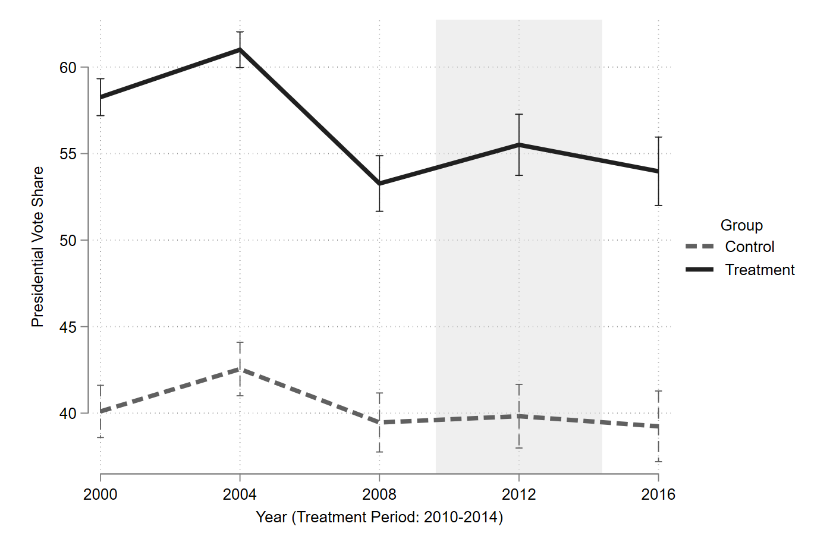
Figure C2: Treatment Placebo H2
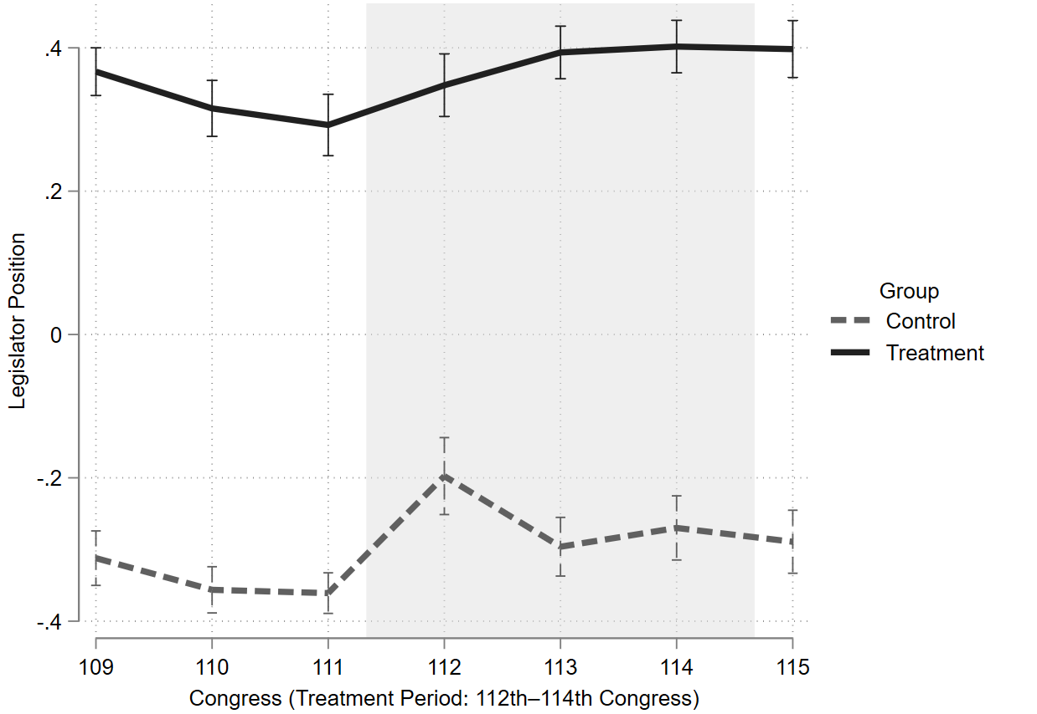
Table C18: Placebo Treatment (2008 Partisanship)
 | Pres  Vote Share | Legislator Position
2016 (Time) | –0.223 | 0.072***
 | (0.453) | (0.025)
Republican Held District 2008 (Treatment H1) | 13.808*** | -
 | (1.342)
Republican Lean PVI 2008 (Treatment H2) | - | 0.653***
 |  | (0.031)
Diff-in-diff (Time x Treatment) | 0.930 | 0.034
 | (0.871) | (0.037)
Observations | 870 | 870
R-squared | 0.202 | 0.565
Mean Control 2008 | 39.46 | –0.361
 | (0.908 | 0.020)
Mean Treated 2008 | 53.27 | 0.292
 | (0.988) | (0.023)
Diff 2008 | 13.81 | 0.653
 | (1.342) | (0.031)
Mean Control 2016 | 39.24 | –0.289
 | (1.081) | (0.023)
Mean Treated 2016 | 53.98 | 0.398
 | (1.222) | (0.021)
Diff 2016 | 14.74 | 0.687
 | (1.631) | (0.032)
We present the results of our time placebo in Table C19. Here, we simply randomize the date of each observation within our dataset. As expected, our DiD coefficient is non-significant and close to zero. This result gives further confidence that we are not simply observing general differences between our treatment and control districts across the entire period but are instead being produced via the theorized mechanism of factional activity in the Tea Party era.
Figure C3: Timing Placebo H1
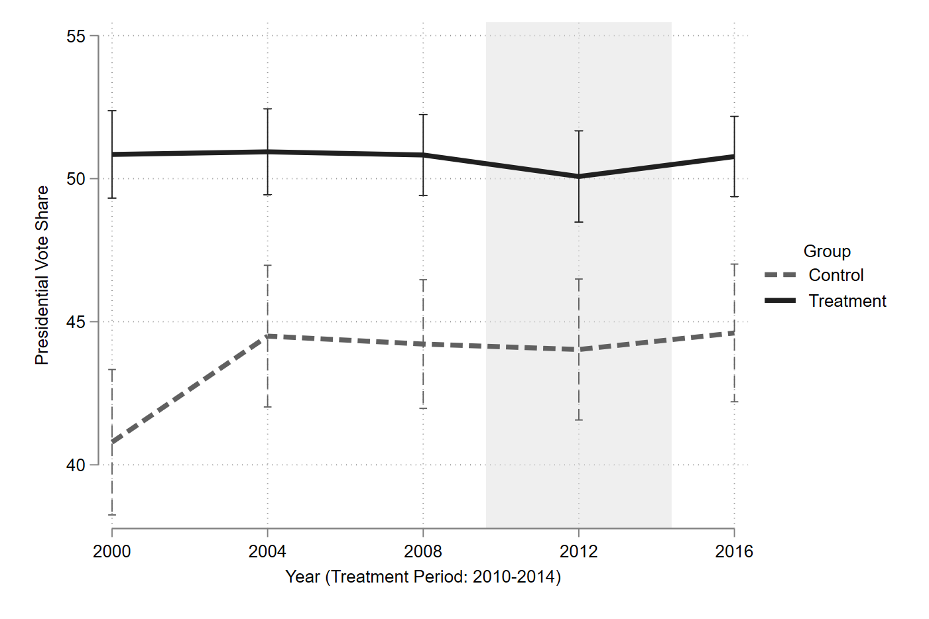
Figure C4: Timing Placebo H2
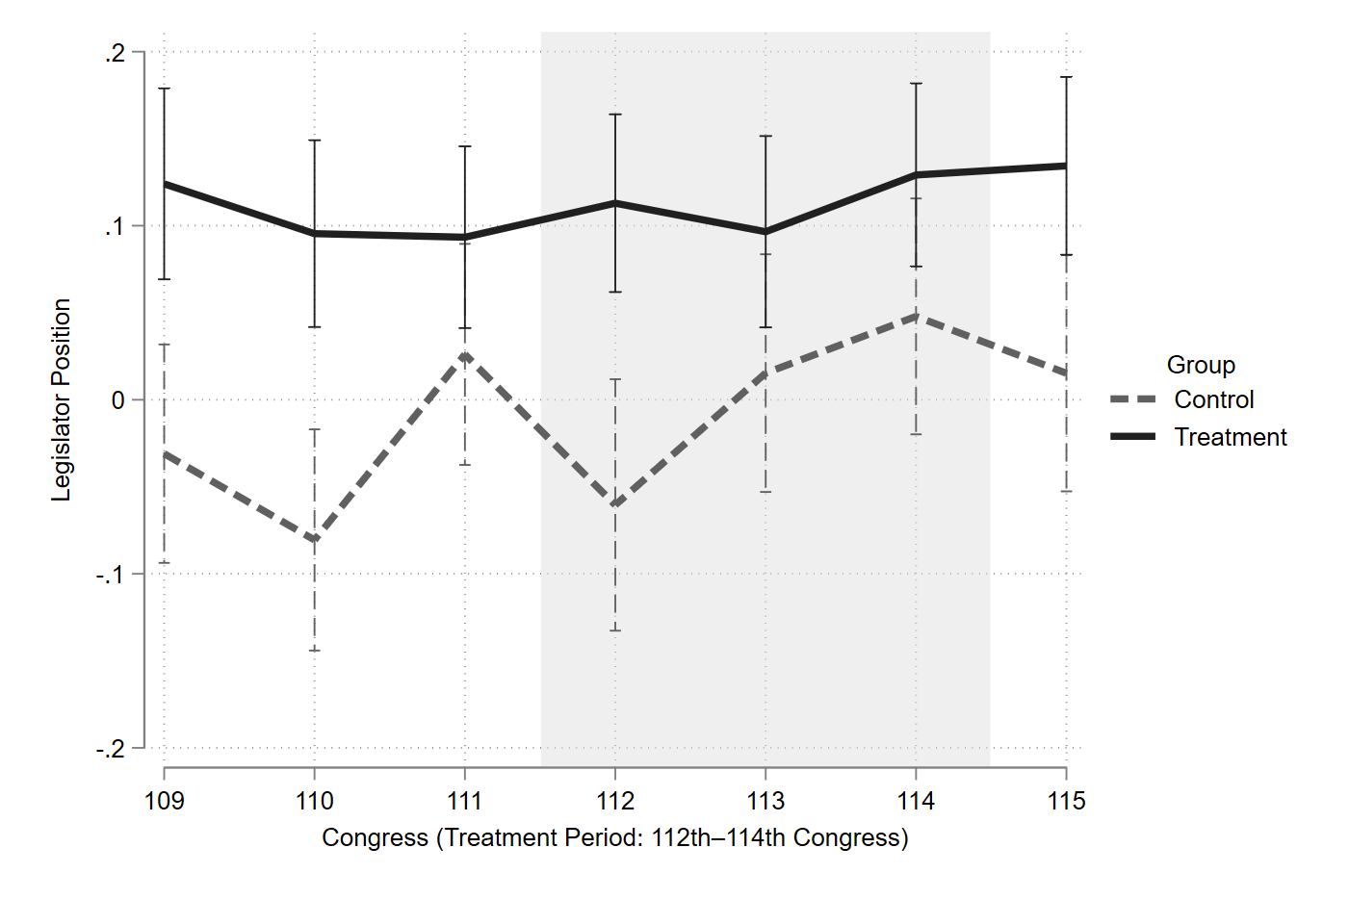
Table C19: Placebo Timing (Date Randomization)
 | Pres Vote Share | Legislator Position
2016 (Time: Randomized) | 0.388 | –0.011
 | (1.333) | (0.047)
Factionalism (Treatment) | 6.607*** | 0.067
 | (1.675) | (0.053)
Diff-in-diff (Time x Treatment) | –0.443 | 0.052
 | (1.726) | (0.061)
Observations | 870 | 870
R-squared | 0.051 | 0.013
Mean Control 2008 | 44.22 | 0.026
 | (1.393) | (0.041)
Mean Treated 2008 | 50.83 | 0.093
 | (0.946) | (0.034)
Diff 2008 | 6.607 | 0.067
 | (1.675) | (0.053)
Mean Control 2016 | 44.61 | 0.015
 | (1.564) | (0.046)
Mean Treated 2016 | 50.77 | 0.134
 | (0.973) | (0.033
Diff 2016 | 6.164 | 0.119
 | (1.839) | (0.057)

Given our pre-period measures positions in the 111th Congress we do not include replacements in 2008 primary or general elections, we include replacements in special elections during the 111th Congress. Given our analysis concludes in the 115th Congress we include replacement in 2016 primary or general election but not in special elections during the 115th Congress.

