**Supplementary Table 1.** The components and cutoff values for scores were developed

|  |  |  |  |
| --- | --- | --- | --- |
|  | **Traditional Japanese Diet Score** |  | **Modified Japanese Diet Score** |
| **Food/Food Group** | **Cut off** a |  | **Cut off** a |
| White rice | ≥2 times/day |  | - |
| Whole grains | - |  | ≥3 times/week b |
| Miso soup | ≥5 times/week |  | ≥5 times/week |
| Soybean products | ≥3 times/week |  | ≥3 times/week |
| Vegetables | ≥5 times/week c |  | ≥1.7 servings/day d |
| Mushrooms | ≥3 times/week |  | ≥3 times/week |
| Seaweeds | ≥3 times/week |  | ≥3 times/week |
| Fruits | - |  | ≥3 times/week |
| Fish and shellfish | ≥3 times/week |  | ≥3 times/week |
| Milk and dairy products | - |  | ≥5 times/week |
| High-sodium foods e | ≥1 time/week |  | <1 time/week |
| Green tea | ≥1 cup/day |  | ≥1 cup/day |
| Total score (points) | 9 |  | 11 |

a The cutoff value was determined based on the median frequency (or serving) of each component intake, except for whole grains (≥3 times/week for the modified Japanese diet score). One point was assigned to each component that meets the cutoff value.

b Including rice mixed with millet and barley, brown rice, germinated rice, under- or half-milled rice.

c Including only cooked vegetables (e.g., dishes with lots of vegetables and soups).

d Including cooked vegetables, raw vegetables, and 100% fruits and vegetable juice.

e Including pickled plums, pickled vegetables, dried fish, salted fish, and fish roe.

**Supplementary Table 2.** The number of people above cut-off values according to the quartiles of the Traditional Japanese Diet score

|  |  |  |  |  |  |  |  |  |
| --- | --- | --- | --- | --- | --- | --- | --- | --- |
|  | **Traditional Japanese Diet Score** | | | | | | | |
|  |
|  | **Q1** | | **Q2** | | **Q3** | | **Q4** | |
| **Food groups** | (n = 4,453) | | (n = 1,925) | | (n = 3,092) | | (n = 2,743) | |
| White rice | 1,019 | (22.9) | 901 | (46.9) | 1,659 | (53.7) | 1,821 | (66.5) |
| Miso soup | 603 | (13.6) | 796 | (41.4) | 1,902 | (61.6) | 2,272 | (83.0) |
| Soybean products | 769 | (17.3) | 862 | (44.9) | 2,058 | (66.6) | 2,489 | (90.9) |
| Vegetables a | 277 | (6.2) | 403 | (21.0) | 1,340 | (43.4) | 2,178 | (79.5) |
| Mushrooms | 160 | (3.6) | 257 | (13.4) | 983 | (31.8) | 2,071 | (75.6) |
| Seaweeds | 123 | (2.8) | 229 | (11.9) | 912 | (29.5) | 2,066 | (75.4) |
| Fish and shellfish | 375 | (8.4) | 495 | (25.8) | 1,352 | (43.8) | 2,128 | (77.7) |
| High-sodium foods b | 1,141 | (25.6) | 928 | (48.3) | 1,836 | (59.4) | 2,204 | (80.5) |
| Green tea | 1,244 | (28.0) | 892 | (46.4) | 1,695 | (54.9) | 1,878 | (68.6) |

Data are presented as n (%) for categorical measures.

a Including only cooked vegetables (e.g., dishes with lots of vegetables and soups.)

b Including pickled plums, pickled vegetables, dried fish, salted fish, and fish roe.

Q: quartile.

|  |  |  |  |  |  |  |  |  |
| --- | --- | --- | --- | --- | --- | --- | --- | --- |
|  | **Modified Japanese Diet Score** | | | | | | | |
|  |
|  | **Q1** | | **Q2** | | **Q3** | | **Q4** | |
| **Food groups** | (n = 3,553) | | (n = 3,692) | | (n = 2,775) | | (n = 2,193) | |
| Whole grains a | 200 | (5.6) | 514 | (13.9) | 500 | (18.1) | 725 | (33.1) |
| Miso soup | 475 | (13.4) | 1,576 | (42.7) | 1,719 | (62.1) | 1,803 | (82.3) |
| Soybean products | 469 | (13.2) | 1,678 | (45.5) | 2,001 | (72.3) | 2,030 | (92.7) |
| Vegetables b | 266 | (7.5) | 1,403 | (38.1) | 2,006 | (72.4) | 2,049 | (93.5) |
| Mushrooms | 86 | (2.4) | 521 | (14.1) | 1,145 | (41.4) | 1,719 | (78.5) |
| Seaweeds | 82 | (2.3) | 487 | (13.2) | 1,058 | (38.2) | 1,703 | (77.7) |
| Fruits | 167 | (4.7) | 666 | (18.1) | 1,086 | (39.2) | 1,557 | (71.1) |
| Fish and shellfish | 249 | (7.0) | 927 | (25.1) | 1,407 | (50.8) | 1,767 | (80.7) |
| Milk and dairy products | 378 | (10.6) | 1,271 | (34.5) | 1,365 | (49.3) | 1,578 | (72.0) |
| High-sodium foods c | 1,722 | (48.5) | 1,625 | (44.0) | 1,446 | (52.1) | 1,319 | (60.2) |
| Green tea | 952 | (26.8) | 1,711 | (46.4) | 1,518 | (54.8) | 1,528 | (69.7) |

**Supplementary Table 3.** The number of people above cut-off values according to the quartiles of the Modified Japanese Diet Score

Data are presented as n (%) for categorical measures.

a Including rice mixed with millet and barley, brown rice, germinated rice, under- or half-milled rice

b Including cooked vegetables, raw vegetables, and 100% vegetable juices.

c Including pickled plums, pickled vegetables, dried fish, salted fish, and fish roe.

Q: quartile.

**Supplementary Table 4.** Associations between Japanese diet scores and hypertension prevalence ratio (95%CI) in study sites using the first blood pressure measurement

|  |  |  |  |  |  |  |  |  |  |
| --- | --- | --- | --- | --- | --- | --- | --- | --- | --- |
|  | **Q1** | | **Q2** | | **Q3** | | **Q4** | | **P for trend** |
| **Traditional Japanese Diet Score** | 0-2 | | 3 | | 4-5 | | 6-9 | |  |
| No. of participants | 3,177 | | 1,437 | | 2,339 | | 1,990 | |  |
| No. of cases | 689 | | 349 | | 557 | | 475 | |  |
| Model 1 | 1.00 | (reference) | 0.95 | (0.82-1.11) | 0.93 | (0.82–1.04) | 0.89 | (0.82–0.96) | <0.01 |
| Model 2 | 1.00 | (reference) | 0.94 | (0.86–1.03) | 0.98 | (0.87–1.11) | 0.97 | (0.90–1.05) | 0.64 |
| **Modified Japanese Diet Score** | 0-2 | | 3-4 | | 5-6 | | 7-11 | |  |
| No. of participants | 2,546 | | 2,718 | | 2,060 | | 1,619 | |  |
| No. of cases | 597 | | 649 | | 450 | | 374 | |  |
| Model 1 | 1.00 | (reference) | 0.93 | (0.88–0.98) | 0.80 | (0.73–0.87) | 0.79 | (0.75–0.83) | <0.001 |
| Model 2 | 1.00 | (reference) | 0.97 | (0.95–1.01) | 0.91 | (0.86–0.98) | 0.95 | (0.89–1.02) | 0.001 |

Model 1 was estimated by using a multilevel Poisson regression model with the study sites included as a random effect and adjustments for age and sex.

Model 2 was adjusted for marital status, educational attainment, employment status, job position, work shift, occupation type, alcohol consumption, smoking status, leisure-time physical activity, and body mass index.

Q: quartile.

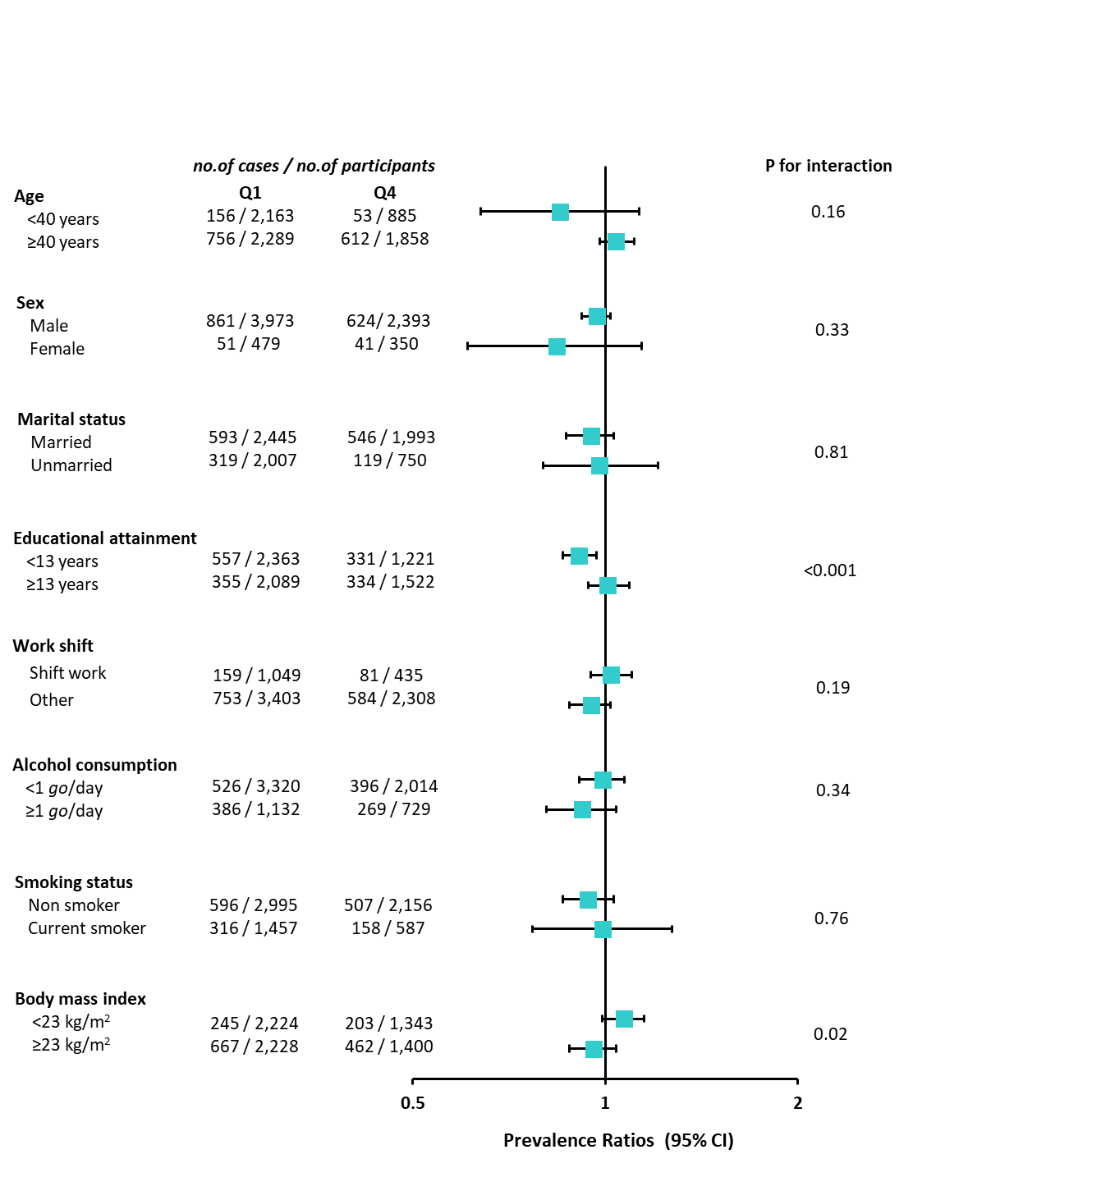

**Supplementary Figure 1.** Prevalence ratios (95% CI) for hypertension of the highest (Q4) versus lowest (Q1) quartiles of the traditional Japanese diet score in subgroups.

Prevalence ratios with 95% CI were estimated using a multilevel Poisson regression model with the study sites included as a random effect and adjustments for age, sex, marital status, educational attainment, work shift, alcohol consumption, smoking status, and body mass index. 95%CI: 95% confidence intervals.

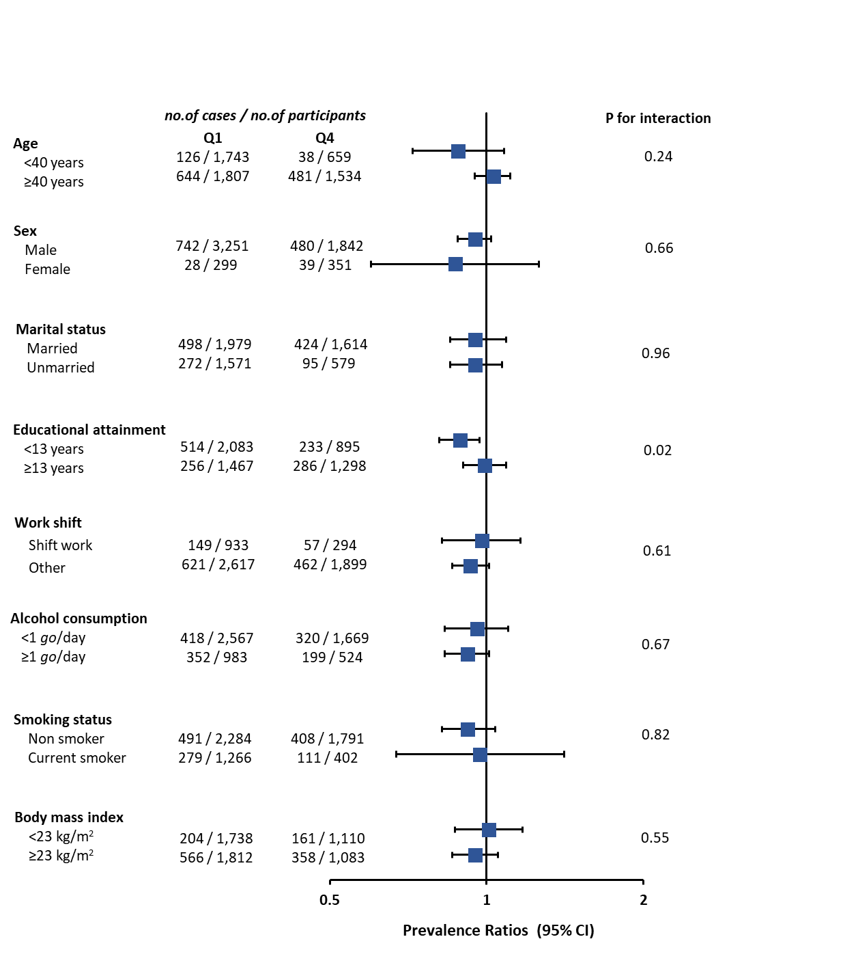

**Supplementary Figure 2.** Prevalence ratios (95% CI) for hypertension of the highest (Q4) versus lowest (Q1) quartiles of the modified Japanese diet score in subgroups.

Prevalence ratios with 95% CI were estimated using a multilevel Poisson regression model with the study sites included as a random effect and adjustments for age, sex, marital status, educational attainment, work shift, alcohol consumption, smoking status, and body mass index. 95%CI: 95% confidence intervals.