**Supplementary Materials**

**Supplementary Tables**

**Supplementary Table 1:** Details of SNPs for serum folate levels (Iceland and Denmark).

**Supplementary Table 2:** Details of SNPs for serum folate levels (South Asian).

**Supplementary Table 3:** Sensitivity analysis of the relationship between serum folate levels and psoriasis.

**Supplementary Figures**

**Supplementary Figure 1:** Flow chart of participant selection for the observational study.

**Supplementary Figure 2:** Single SNP analysis in Mendelian randomization assessing independent contributions of each SNP as instrumental variables.

**Supplementary Figure 3:** The leave-one-out stability test assesses causal estimates of serum folate on psoriasis. The MR results are calculated for the remaining IVs after removing them one by one.

**Supplementary Table 1:** Details of SNPs for serum folate levels (Iceland and Denmark).

|  |  |  |  |  |  |  |  |
| --- | --- | --- | --- | --- | --- | --- | --- |
| **SNP** | **EA** | **OA** | **EAF** | **Beta** | **SE** | ***P*-value** | **F-statistic** |
| rs652197 | C | T | 0.179 | 0.069 | 0.010 | 1.4E-12 | 23.39 |
| rs1801133 | G | A | 0.668 | 0.096 | 0.006 | 9.5E-53 | 125.77 |
| rs17421511 | G | A | 0.827 | 0.098 | 0.012 | 1.8E-15 | - |

SNP, single nucleotide polymorphism; EA, effect allele; OA, other allele; EAF, effect allele frequency.

**Supplementary Table 2:** Details of SNPs for serum folate levels (South Asian).

|  |  |  |  |  |  |  |
| --- | --- | --- | --- | --- | --- | --- |
| **SNP** | **EA** | **OA** | **EAF** | **Beta** | **SE** | ***P*-value** |
| rs116949171 | A | G | 0.963 | -0.155 | 0.024 | 1.4E-10 |
| rs1801133 | G | A | 0.864 | 0.172 | 0.013 | 8.3E-38 |
| rs61930974 | C | T | 0.967 | -0.200 | 0.027 | 1.4E-13 |
| rs74794636 | C | A | 0.965 | -0.283 | 0.027 | 4.0E-26 |
| rs1893007 | T | C | 0.896 | -0.095 | 0.015 | 4.3E-10 |
| rs12367973 | G | A | 0.944 | -0.108 | 0.020 | 4.9E-08 |

SNP, single nucleotide polymorphism; EA, effect allele; OA, other allele; EAF, effect allele frequency.

**Supplementary Table 3:** Sensitivity analysis of the relationship between serum folate levels and psoriasis.

|  |  |  |  |  |  |  |  |  |  |  |  |
| --- | --- | --- | --- | --- | --- | --- | --- | --- | --- | --- | --- |
|  | **Crude model** | |  | **Model 1** | |  | **Model 2** | |  | **Model 3** | |
| **OR (95% CI)** | ***P*-value** | **OR (95% CI)** | ***P*-value** | **OR (95% CI)** | ***P*-value** | **OR (95% CI)** | ***P*-value** |
| **Serum Folate** | 1.00 (0.98, 1.01) | 0.613 |  | 0.99 (0.97, 1.01) | 0.309 |  | 0.99 (0.97, 1.00) | 0.107 |  | 0.99 (0.97, 1.01) | 0.205 |
| **Quartiles of Serum Folate** |  |  |  |  |  |  |  |  |  |  |  |
| Q1 | ref |  |  | ref |  |  | ref |  |  | ref |  |
| Q2 | 0.80 (0.59, 1.08) | 0.139 |  | 0.79 (0.58, 107) | 0.119 |  | 0.77 (0.57, 1.05) | 0.095 |  | 0.78 (0.57, 1.06) | 0.107 |
| Q3 | 0.85 (0.62, 1.16) | 0.299 |  | 0.83 (0.61, 1.13) | 0.237 |  | 0.78 (0.57, 1.07) | 0.120 |  | 0.80 (0.58, 1.10) | 0.162 |
| Q4 | 0.91 (0.65, 1.27) | 0.566 |  | 0.84 (0.60, 1.18) | 0.317 |  | 0.76 (0.54, 1.08) | 0.121 |  | 0.81 (0.57, 1.14) | 0.219 |

OR, odds ratio; CI, confidence interval. Model 1 was adjusted for age and sex; Model 2 was adjusted for age, sex, race/ethnicity, education level, and PIR; Model 3 was adjusted for age, sex, race/ethnicity, education level, poverty income ratio, body mass index, diabetes, smoking, hypertension, alcohol use and dietary folate intake.

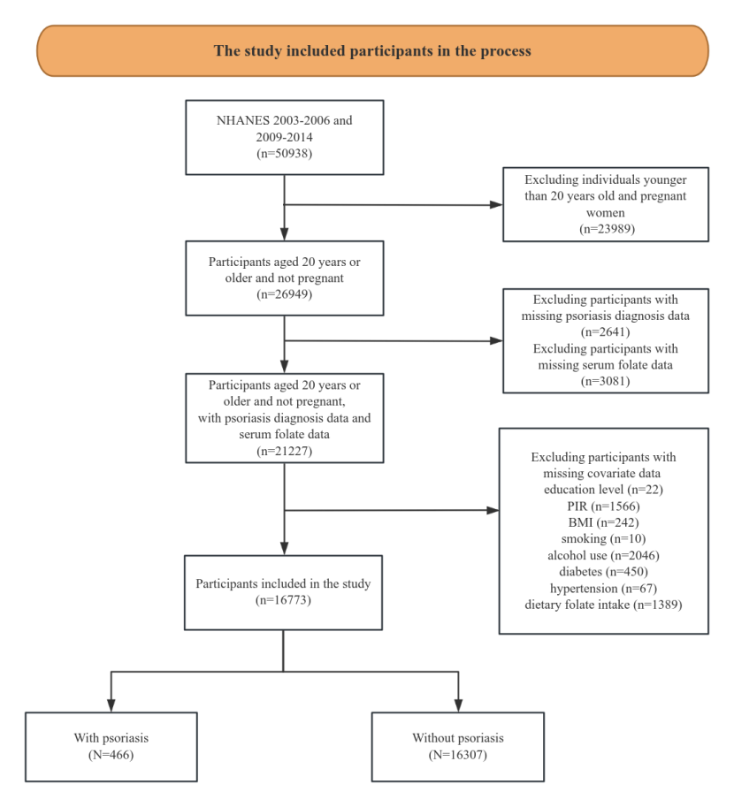

**Supplementary Figure 1:** Flow chart of participant selection for the observational study.



**Supplementary Figure 2:** Single SNP analysis in Mendelian randomization assessing independent contributions of each SNP as instrumental variables. **A**. (Iceland and Denmark); **B**. (South Asian).



**Supplementary Figure 3:** The leave-one-out stability test assesses causal estimates of serum folate on psoriasis. The MR results are calculated for the remaining IVs after removing them one by one.