Supplementary Table 1. STROBE-MR checklist of recommended items to address in reports of Mendelian randomization studies

Supplementary Table 2. The category contains data from the touchscreen questionnaire on the reported frequency of intake of a range of common food and drink items.

Supplementary Table 1. STROBE-MR checklist of recommended items to address in reports of Mendelian randomization studies

Item No. | Section | Checklist item | Page No. | Relevant text from manuscript
1 | TITLE and ABSTRACT | Indicate Mendelian randomization (MR) as the study’s design in the title and/or the abstract if that is a main purpose of the study | 1-2 | Title page & Abstract
 | INTRODUCTION
2 | Background | Explain the scientific background and rationale for the reported study. What is the exposure? Is a potential causal relationship between exposure and outcome plausible? Justify why MR is a helpful method to address the study question | 3-4 | Introduction (paragraphs 1-4)
3 | Objectives | State specific objectives clearly, including pre-specified causal hypotheses (if any). State that MR is a method that, under specific assumptions, intends to estimate causal effects | 4 | Introduction (paragraphs 4)
 | METHODS
4 | Study design and data sources | Present key elements of the study design early in the article. Consider including a table listing sources of data for all phases of the study. For each data source contributing to the analysis, describe the following: | 4-7 | Methods (Data Sources & Outcome Phenotype definition & Instrumental Variables (IV) Selection & Mendelian Randomization Analysis & Sensitivity analysis)
 | a) | Setting: Describe the study design and the underlying population, if possible. Describe the setting, locations, and relevant dates, including periods of recruitment, exposure, follow-up, and data collection, when available. | 4-6 | Methods (Paragraph 1, Data Sources & Outcome Phenotype definition)
 | b) | Participants: Give the eligibility criteria, and the sources and methods of selection of participants. Report the sample size, and whether any power or sample size calculations were carried out prior to the main analysis | 5-6 | Methods (Data Sources & Outcome Phenotype definition)
 | c) | Describe measurement, quality control and selection of genetic variants | 6 | Methods (Instrumental Variables (IV) Selection)
 | d) | For each exposure, outcome, and other relevant variables, describe methods of assessment and diagnostic criteria for diseases | 5-6 | Methods (Data Sources & Outcome Phenotype definition)
 | e) | Provide details of ethics committee approval and participant informed consent, if relevant | 4 | Methods (Paragraph 1)
5 | Assumptions | Explicitly state the three core IV assumptions for the main analysis (relevance, independence and exclusion restriction) as well assumptions for any additional or sensitivity analysis | 4 | Methods (Paragraph 1 & Figure 1)
6 | Statistical methods: main analysis | Describe statistical methods and statistics used
 | a) | Describe how quantitative variables were handled in the analyses (i.e., scale, units, model) | 6-7 | Methods (Instrumental Variables (IV) Selection & Mendelian Randomization Analysis & Sensitivity analysis)
 | b) | Describe how genetic variants were handled in the analyses and, if applicable, how their weights were selected | 6-7 | Methods (Mendelian Randomization Analysis & Sensitivity analysis)
 | c) | Describe the MR estimator (e.g. two-stage least squares, Wald ratio) and related statistics. Detail the included covariates and, in case of two-sample MR, whether the same covariate set was used for adjustment in the two samples | 6-7 | Methods (Mendelian Randomization Analysis & Sensitivity analysis)
 | d) | Explain how missing data were addressed |  | N/A
 | e) | If applicable, indicate how multiple testing was addressed |  | N/A
7 | Assessment of assumptions | Describe any methods or prior knowledge used to assess the assumptions or justify their validity | 6-7 | Methods (Mendelian Randomization Analysis & Sensitivity analysis)
8 | Sensitivity analyses and additional analyses | Describe any sensitivity analyses or additional analyses performed (e.g. comparison of effect estimates from different approaches, independent replication, bias analytic techniques, validation of instruments, simulations) | 6-7 | Methods (Mendelian Randomization Analysis & Sensitivity analysis)
9 | Software and pre-registration
 | a) | Name statistical software and package(s), including version and settings used | 6 | Methods (Instrumental Variables (IV) Selection)
 | b) | State whether the study protocol and details were pre-registered (as well as when and where) |  | N/A
 | RESULTS
10 | Descriptive data
 | a) | Report the numbers of individuals at each stage of included studies and reasons for exclusion. Consider use of a flow diagram | 8 | Results (Paragraph 1)
 | b) | Report summary statistics for phenotypic exposure(s), outcome(s), and other relevant variables (e.g. means, SDs, proportions) |  | Supplementary material 2
 | c) | If the data sources include meta-analyses of previous studies, provide the assessments of heterogeneity across these studies |  | N/A
 | d) | For two-sample MR:  i. Provide justification of the similarity of the genetic variant-exposure associations between the exposure and outcome samples  ii. Provide information on the number of individuals who overlap between the exposure and outcome studies | 8 | Results (Paragraph 1)
11 | Main results
 | a) | Report the associations between genetic variant and exposure, and between genetic variant and outcome, preferably on an interpretable scale | 8-10 | Results
 | b) | Report MR estimates of the relationship between exposure and outcome, and the measures of uncertainty from the MR analysis, on an interpretable scale, such as odds ratio or relative risk per SD difference |  | Supplementary material 2
 | c) | If relevant, consider translating estimates of relative risk into absolute risk for a meaningful time period |  | N/A
 | d) | Consider plots to visualize results (e.g. forest plot, scatterplot of associations between genetic variants and outcome versus between genetic variants and exposure) | 8-10 | Results (Figure 2-4 & Supplementary material 2)
12 | Assessment of assumptions
 | a) | Report the assessment of the validity of the assumptions | / | Figure 2-4 & Supplementary material 2,
 | b) | Report any additional statistics (e.g., assessments of heterogeneity across genetic variants, such as I², Q statistic or E-value) | / | Supplementary material 2
13 | Sensitivity analyses and additional analyses
 | a) | Report any sensitivity analyses to assess the robustness of the main results to violations of the assumptions | 8-10 | Results (Figure 2-4 & Supplementary material 2)
 | b) | Report results from other sensitivity analyses or additional analyses |  | Supplementary material 2
 | c) | Report any assessment of direction of causal relationship (e.g., bidirectional MR) |  | N/A
 | d) | When relevant, report and compare with estimates from non-MR analyses |  | N/A
 | e) | Consider additional plots to visualize results (e.g., leave-one-out analyses) |  | Figure 2-4
 | DISCUSSION
14 | Key results | Summarize key results with reference to study objectives | 11 | Discussion (paragraph 1)
15 | Limitations | Discuss limitations of the study, taking into account the validity of the IV assumptions, other sources of potential bias, and imprecision. Discuss both direction and magnitude of any potential bias and any efforts to address them | 14-15 | Discussion (paragraph 8)
16 | Interpretation
 | a) | Meaning: Give a cautious overall interpretation of results in the context of their limitations and in comparison with other studies | 11-14 | Discussion (paragraph 2-7)
 | b) | Mechanism: Discuss underlying biological mechanisms that could drive a potential causal relationship between the investigated exposure and the outcome, and whether the gene-environment equivalence assumption is reasonable. Use causal language carefully, clarifying that IV estimates may provide causal effects only under certain assumptions | 11-14 | Discussion (paragraph 2-7)
 | c) | Clinical relevance: Discuss whether the results have clinical or public policy relevance, and to what extent they inform effect sizes of possible interventions | 11-14 | Discussion (paragraph 2-7)
17 | Generalizability | Discuss the generalizability of the study results (a) to other populations, (b) across other exposure periods/timings, and (c) across other levels of exposure | 13-15 | Discussion (paragraph 8)
 | OTHER INFORMATION
18 | Funding | Describe sources of funding and the role of funders in the present study and, if applicable, sources of funding for the databases and original study or studies on which the present study is based | 16 | Acknowledgements
19 | Data and data sharing | Provide the data used to perform all analyses or report where and how the data can be accessed, and reference these sources in the article. Provide the statistical code needed to reproduce the results in the article, or report whether the code is publicly accessible and if so, where | 5/16 | Methods (Data Sources) & Table 1 & Data availability
20 | Conflicts of Interest | All authors should declare all potential conflicts of interest | 16 | Competing interests section

Supplementary Table 2. The category contains data from the touchscreen questionnaire on the reported frequency of intake of a range of common food and drink items.
 | Value Type | Notes | Screenshot of touchscreen questionnaire used in the UK Biobank Assessment Centres using the ACE system
Cheese intake | Categorical (single)  Never  Less than once a week  Once a week  2-4 times a week  5-6 times a week  Once or more daily  Do not know  Prefer not to answer | ACE touchscreen question "How often do you eat cheese? (Include cheese in pizzas, quiches, cheese sauce etc)"  If the participant activated the Help button they were shown the message:  Please provide an average considering your intake over the last year  If you are unsure, please provide an estimate or select Do not know. | 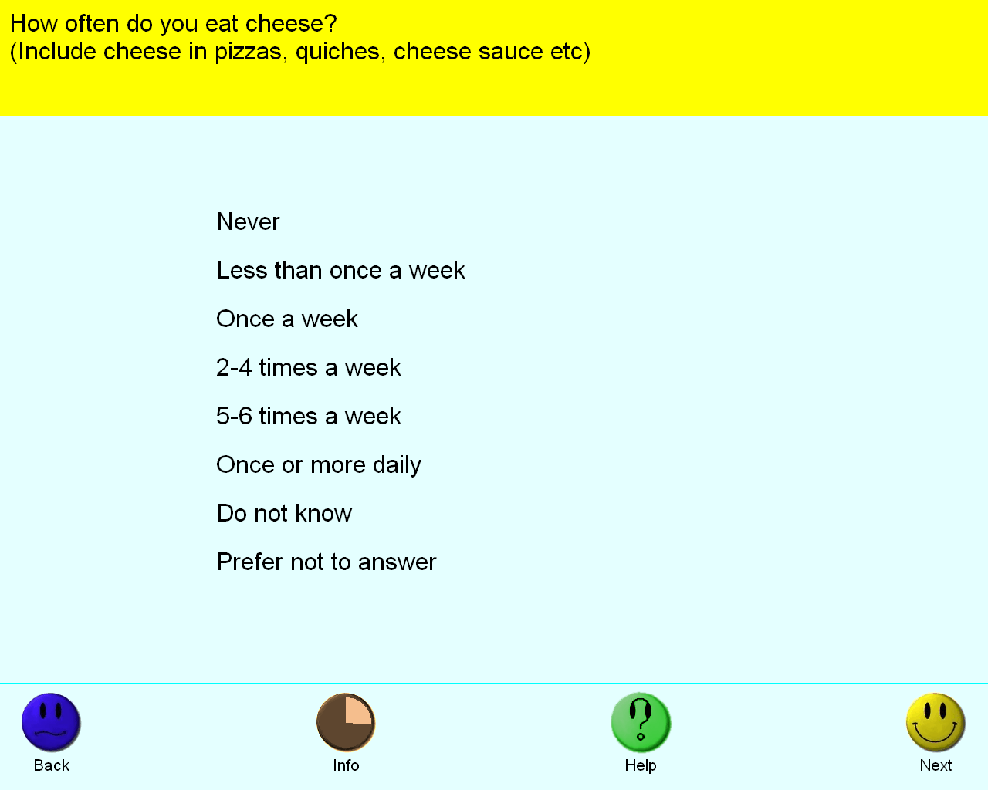
Processed meat intake | Categorical (single)  Never  Less than once a week  Once a week  2-4 times a week  5-6 times a week  Once or more daily  Do not know  Prefer not to answer | ACE touchscreen question "How often do you eat processed meats (such as bacon, ham, sausages, meat pies, kebabs, burgers, chicken nuggets)?"  If the participant activated the Help button they were shown the message:  Please provide an average considering your intake over the last year  If you are unsure, please provide an estimate or select Do not know. | 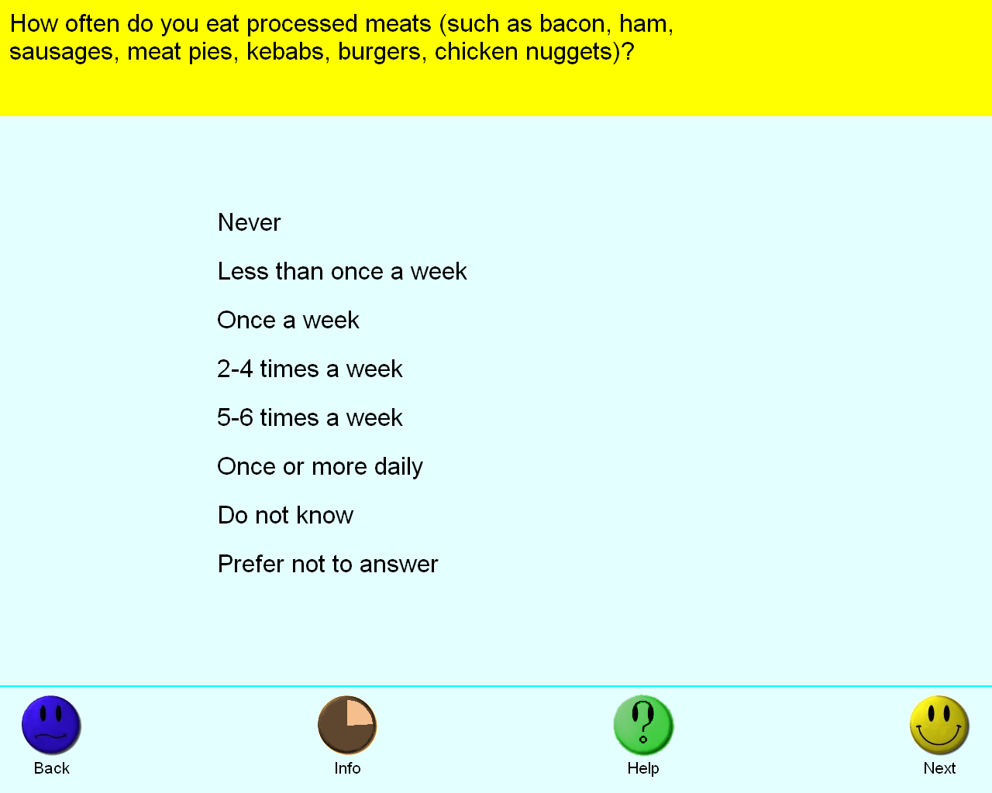
Poultry intake | Categorical (single)  Never  Less than once a week  Once a week  2-4 times a week  5-6 times a week  Once or more daily  Do not know  Prefer not to answer | ACE touchscreen question "How often do you eat chicken, turkey or other poultry? (Do not count processed meats)"  If the participant activated the Help button they were shown the message:  Please provide an average considering your intake over the last year  If you are unsure, please provide an estimate or select Do not know.  Poultry include fowl (e.g. chicken, turkey, quail), waterfowl (e.g. duck, goose) and game (e.g. pheasant). | 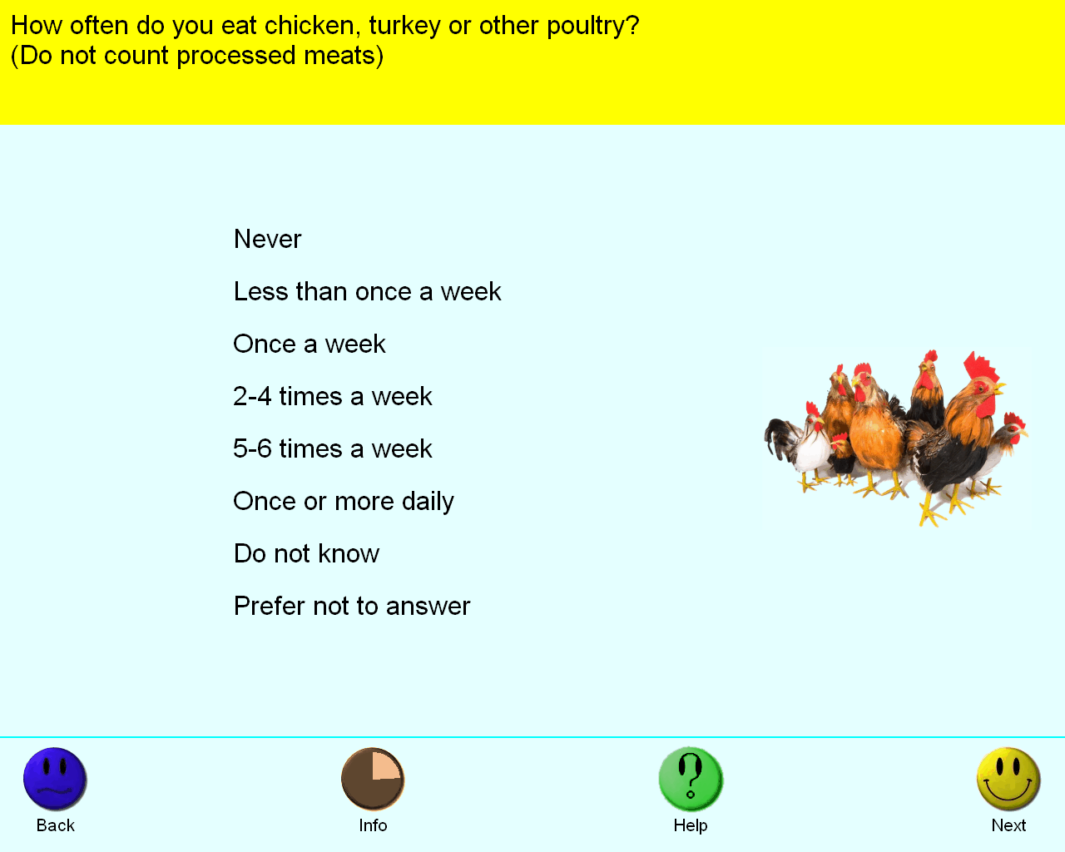
Beef intake | Categorical (single)  Never  Less than once a week  Once a week  2-4 times a week  5-6 times a week  Once or more daily  Do not know  Prefer not to answer | ACE touchscreen question "How often do you eat beef? (Do not count processed meats)"  If the participant activated the Help button they were shown the message:  Please provide an average considering your intake over the last year  If you are unsure, please provide an estimate or select Do not know. | 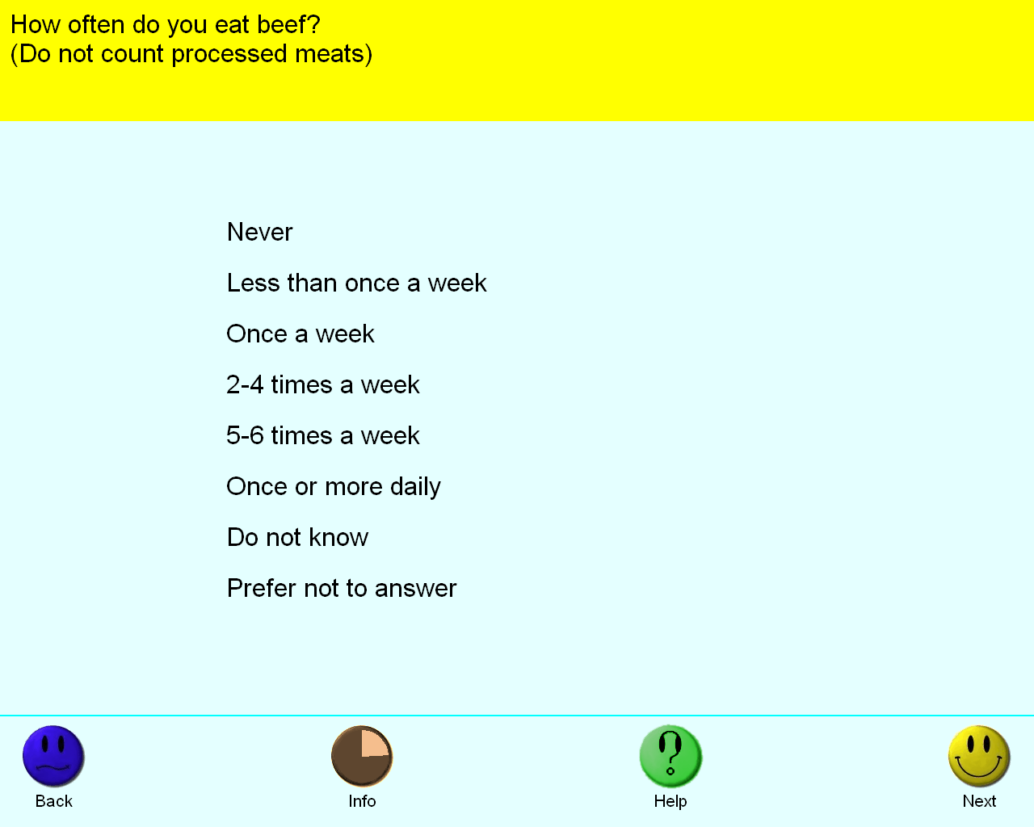
Non-oily fish intake | Categorical (single)  Never  Less than once a week  Once a week  2-4 times a week  5-6 times a week  Once or more daily  Do not know  Prefer not to answer | ACE touchscreen question "How often do you eat other types of fish? (e.g. cod, tinned tuna, haddock)"  If the participant activated the Help button they were shown the message:  Please provide an average considering your intake over the last year.  If you are unsure, please provide an estimate or select Do not know. | 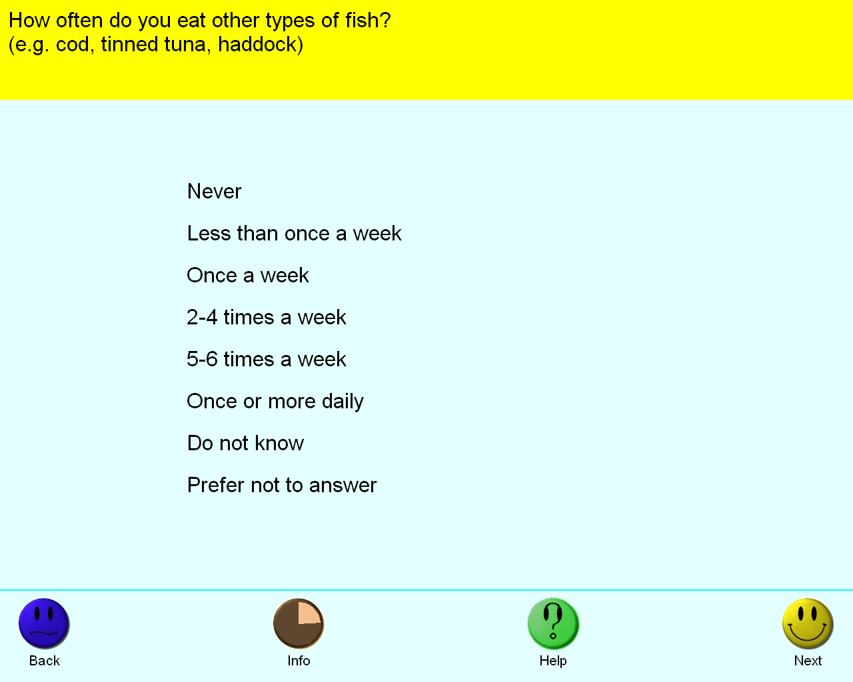
Oily fish intake | Categorical (single)  Never  Less than once a week  Once a week  2-4 times a week  5-6 times a week  Once or more daily  Do not know  Prefer not to answer | ACE touchscreen question "How often do you eat oily fish? (e.g. sardines, salmon, mackerel, herring)"  If the participant activated the Help button they were shown the message:  Please provide an average considering your intake over the last year.  If you are unsure, please provide an estimate or select Do not know.  Oily fish include:  Salmon Anchovies; Trout Swordfish; Mackerel Bloater  Herring Cacha; Sardines Carp; Pilchards Hilsa; Kipper Jack fish  Eel Katla; Whitebait Orange roughy; Tuna (fresh only) Pangas  Sprats | 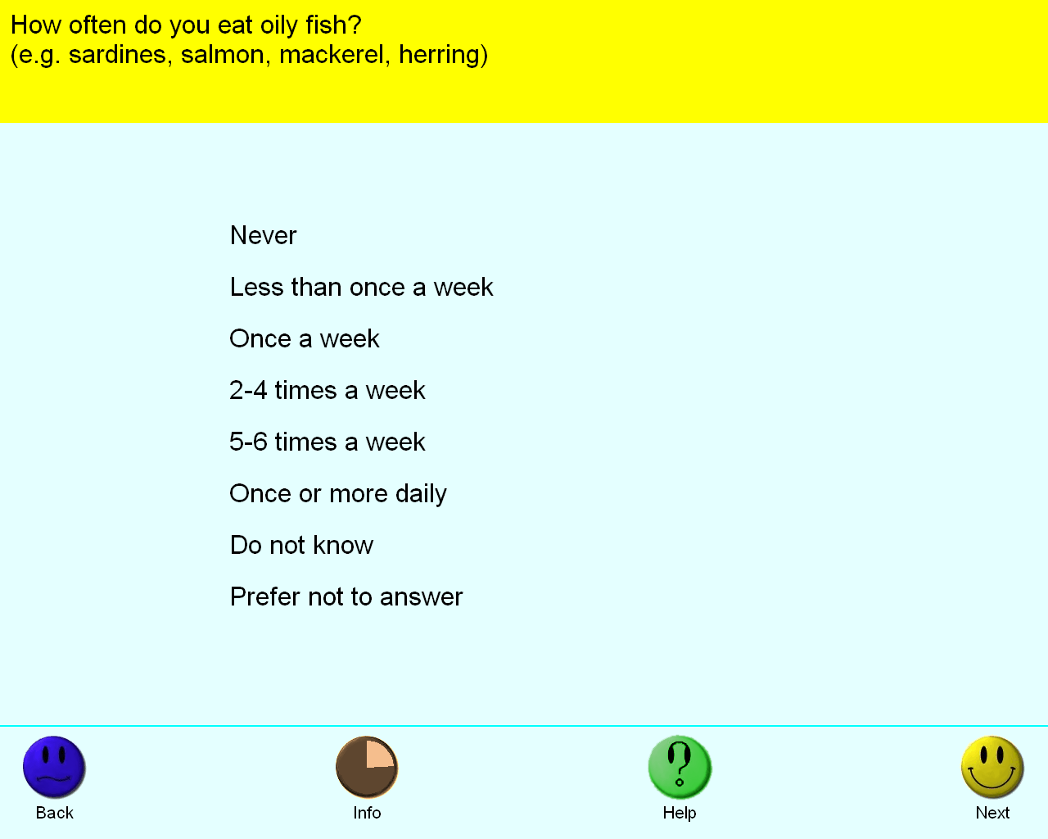
Pork intake | Categorical (single)  Never  Less than once a week  Once a week  2-4 times a week  5-6 times a week  Once or more daily  Do not know  Prefer not to answer | ACE touchscreen question "How often do you eat pork? (Do not count processed meats such as bacon or ham)"  If the participant activated the Help button they were shown the message:  Please provide an average considering your intake over the last year  If you are unsure, please provide an estimate or select Do not know. | 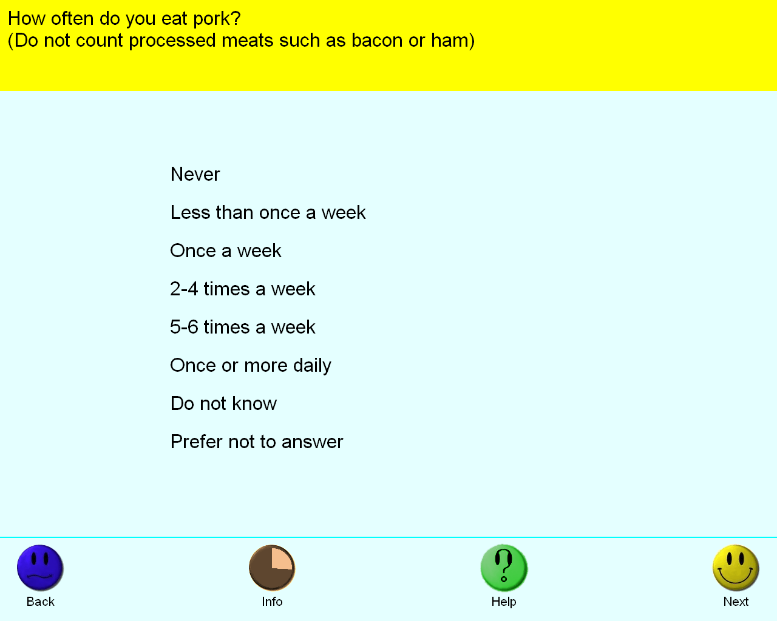
Lamb/mutton intake | Categorical (single)  Never  Less than once a week  Once a week  2-4 times a week  5-6 times a week  Once or more daily  Do not know  Prefer not to answer | ACE touchscreen question "How often do you eat lamb/mutton? (Do not count processed meats)"  If the participant activated the Help button they were shown the message:  Please provide an average considering your intake over the last year  If you are unsure, please provide an estimate or select Do not know. | 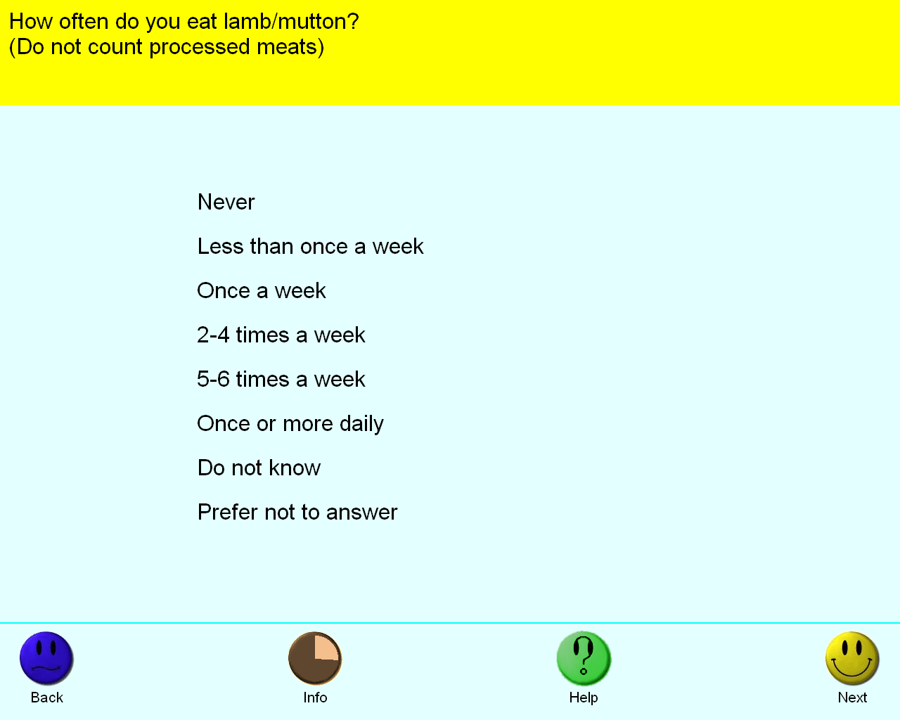
Alcohol intake frequency | Categorical (single)  Daily or almost daily  Three or four times a week  Once or twice a week  One to three times a month  Special occasions only  Never  Prefer not to answer | ACE touchscreen question "About how often do you drink alcohol?"  If the participant activated the Help button they were shown the message:  If this varies a lot, please provide an average considering your intake  over the last year | 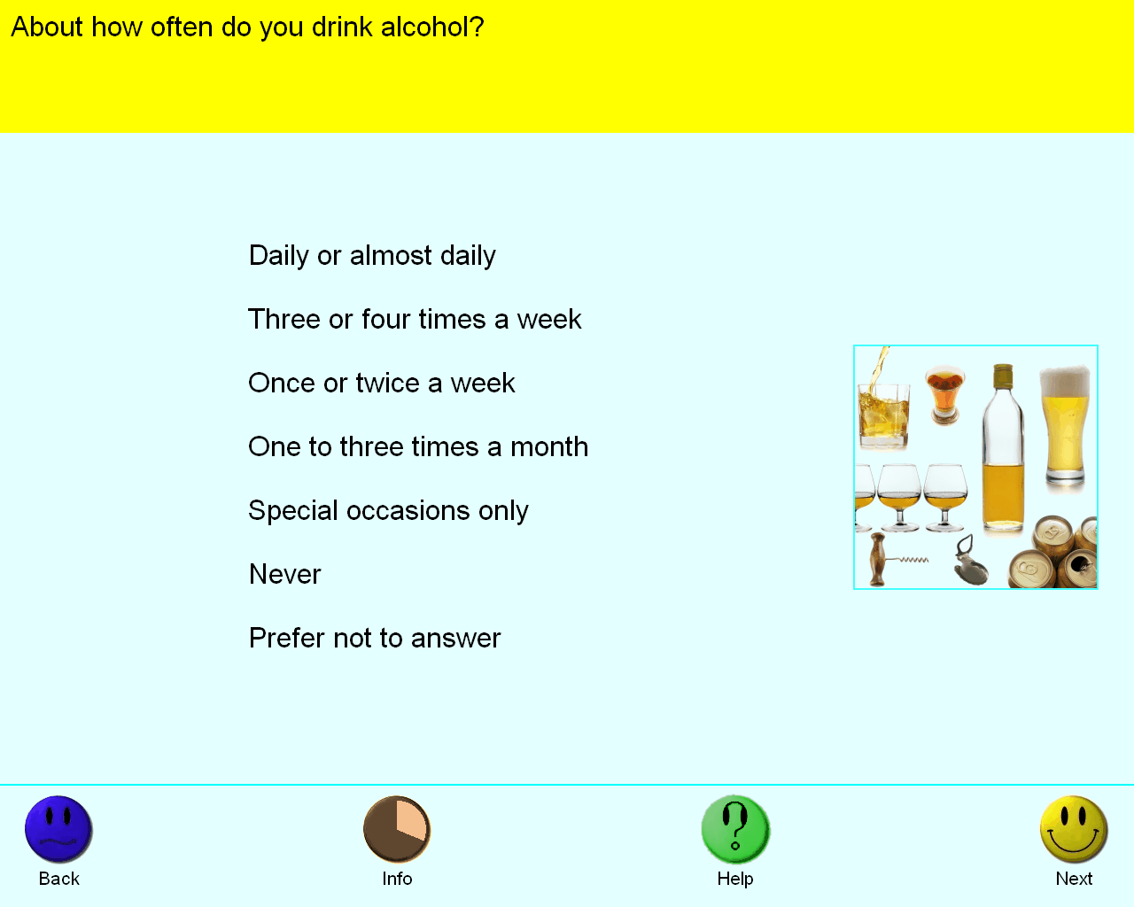
Average weekly red wine intake | Integer, glasses | ACE touchscreen question "In an average WEEK, how many glasses of RED wine would you drink? (There are six glasses in an average bottle)"  The following checks were performed:  If answer < 0 then rejected  If answer > 250 then rejected  If answer > 100 then participant asked to confirm  If the participant activated the Help button they were shown the message:  Please include sparkling red wine here. | 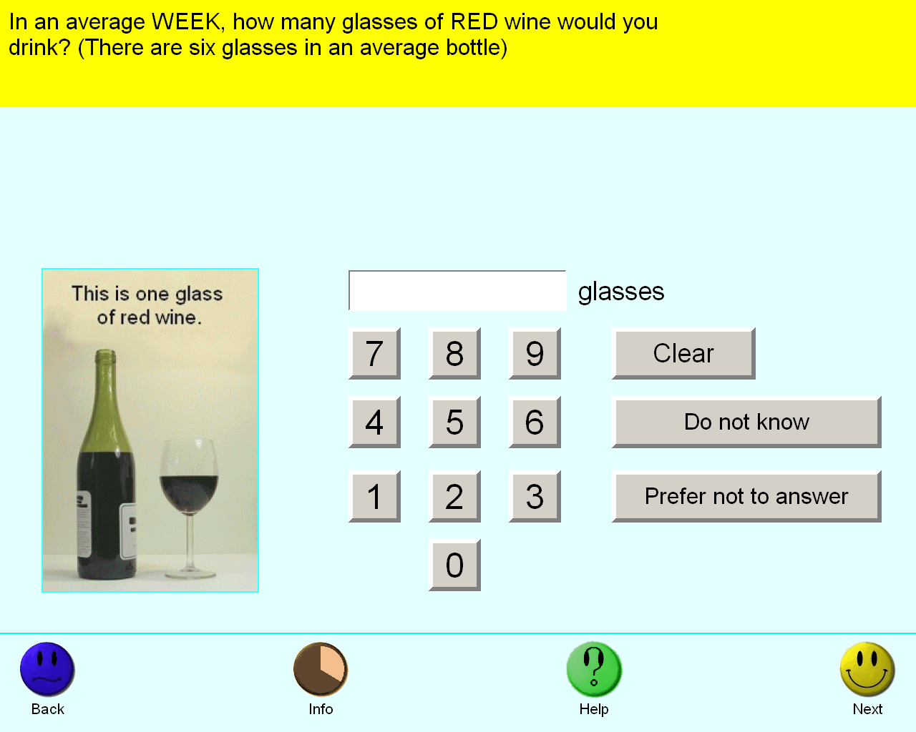
Coffee intake | Integer, cups/day | ACE touchscreen question "How many cups of coffee do you drink each DAY? (Include decaffeinated coffee)"  The following checks were performed:  If answer < 0 then rejected  If answer > 99 then rejected  If answer > 10 then participant asked to confirm  If the participant activated the Help button they were shown the message:  Please provide an average considering your intake over the last year.  If you are unsure, please provide an estimate or select Do not know. | 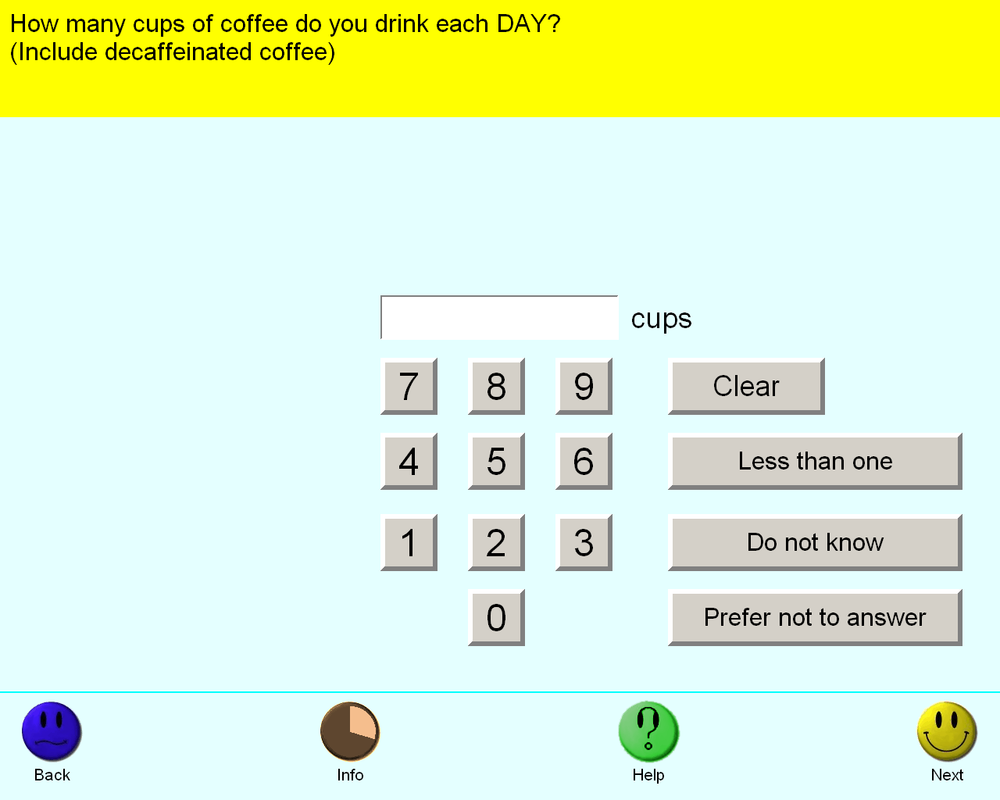
Tea intake | Integer, cups/day | ACE touchscreen question "How many cups of tea do you drink each DAY? (Include black and green tea)"  The following checks were performed:  If answer < 0 then rejected  If answer > 99 then rejected  If answer > 20 then participant asked to confirm  If the participant activated the Help button they were shown the message:  Please provide an average considering your intake over the last year.  If you are unsure, please provide an estimate or select Do not know. | 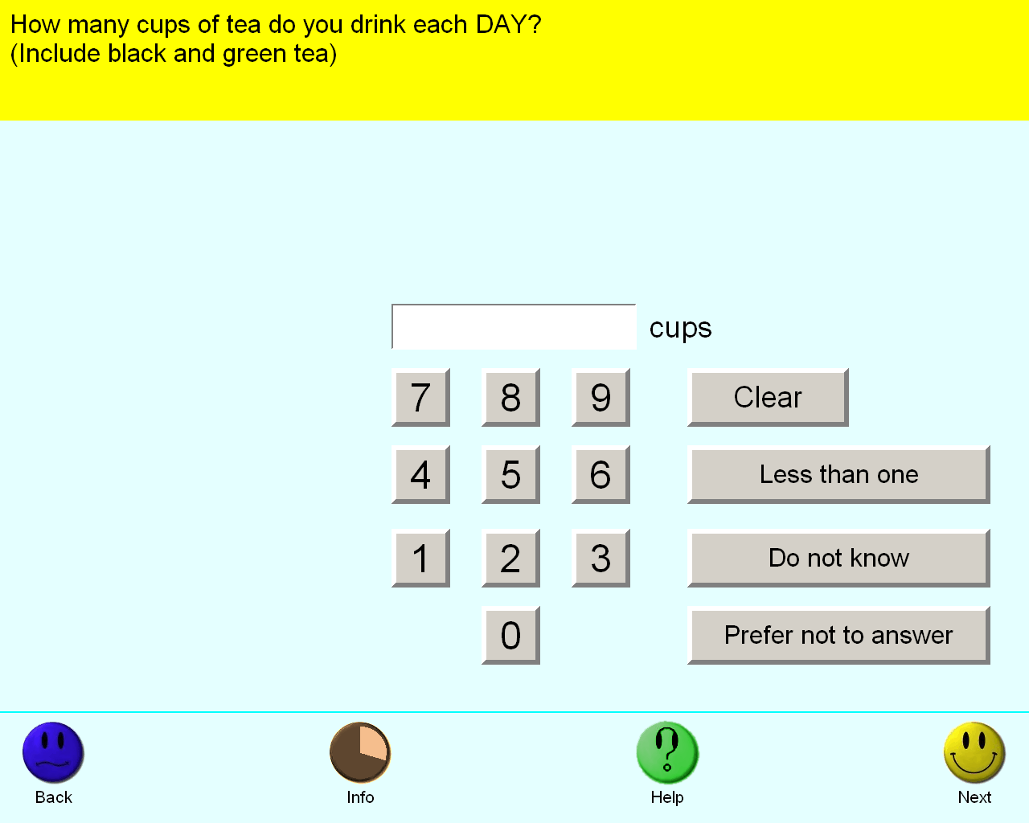
Cooked vegetable intake | Integer, tablespoons/day | ACE touchscreen question "On average how many heaped tablespoons of COOKED vegetables would you eat per DAY? (Do not include potatoes; put '0' if you do not eat any)"  The following checks were performed:  If answer > 50 then rejected  If the participant activated the Help button they were shown the message:  Please provide an average considering your intake over the last year.  If you are unsure, please provide an estimate or select Do not know.  If you have less than one tablespoon a day select Less than one. | 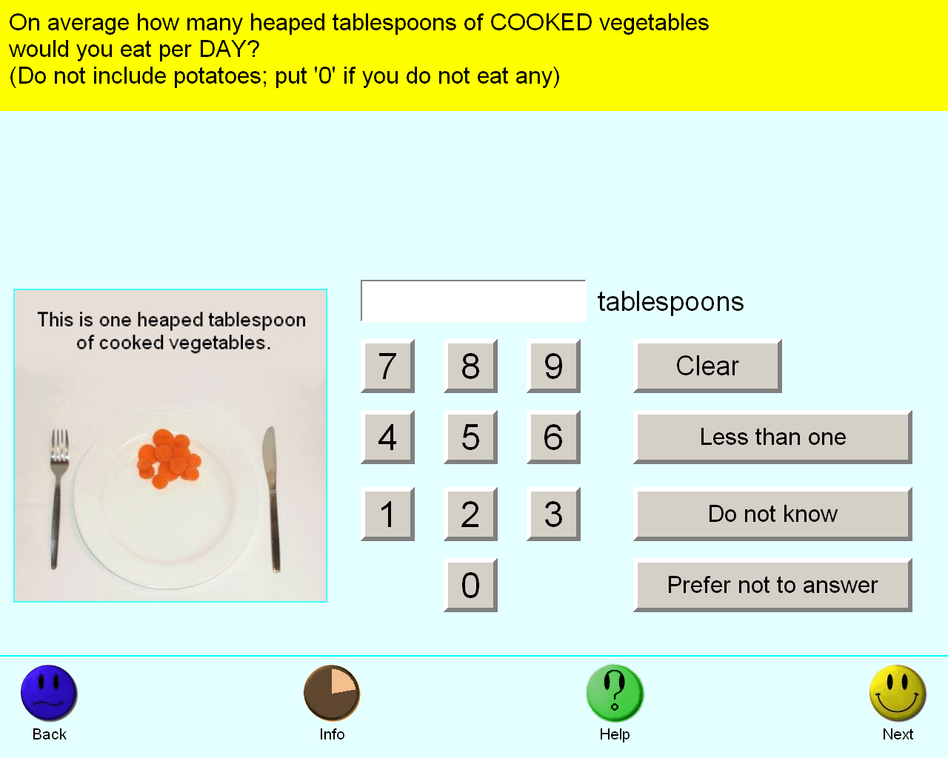
Salad / raw vegetable intake | Integer, tablespoons/day | ACE touchscreen question "On average how many heaped tablespoons of SALAD or RAW vegetables would you eat per DAY? (Include lettuce, tomato in sandwiches; put '0' if you do not eat any)"  The following checks were performed:  If answer > 50 then rejected  If the participant activated the Help button they were shown the message:  Please provide an average considering your intake over the last year.  If you are unsure, please provide an estimate or select Do not know.  If you have less than one tablespoon a day select Less than one. | 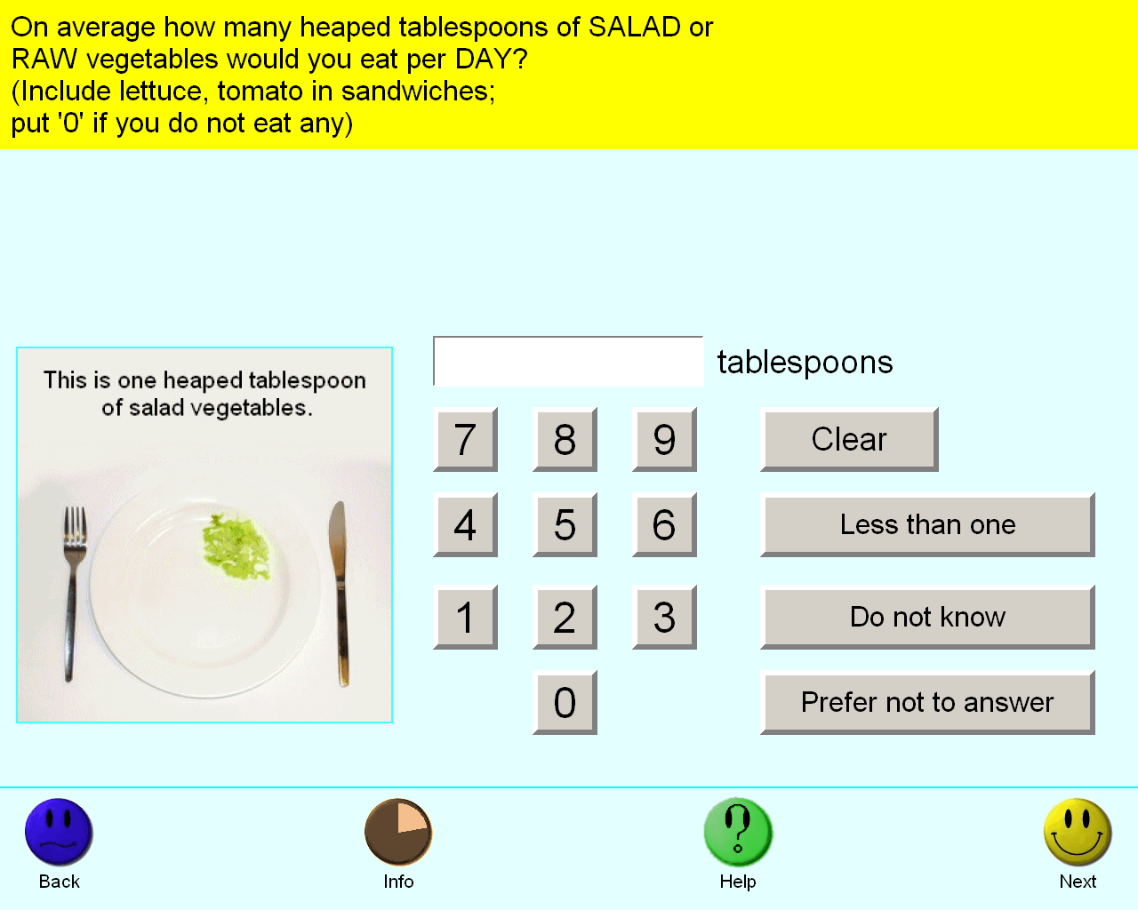
Fresh fruit intake | Integer, pieces/day | ACE touchscreen question "About how many pieces of FRESH fruit would you eat per DAY? (Count one apple, one banana, 10 grapes etc as one piece; put '0' if you do not eat any)"  The following checks were performed:  If answer > 50 then rejected  If the participant activated the Help button they were shown the message:  Please provide an average considering your intake over the last year.  If you are unsure, please provide an estimate or select Do not know. | 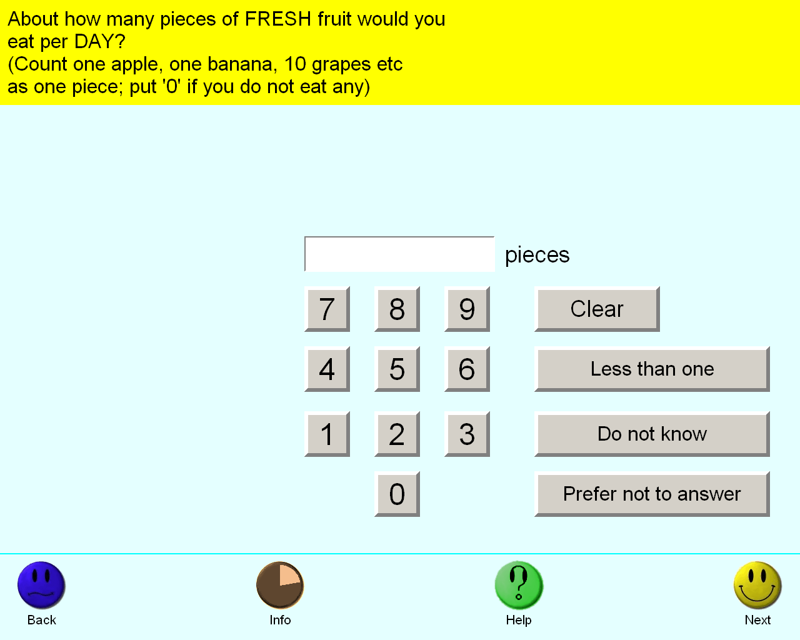
Dried fruit intake | Integer, pieces/day | ACE touchscreen question "About how many pieces of DRIED fruit would you eat per DAY? (Count one prune, one dried apricot, 10 raisins as one piece; put '0' if you do not eat any)"  The following checks were performed:  If answer > 100 then rejected  If the participant activated the Help button they were shown the message: Please provide an average considering your intake over the last year. If you are unsure, please provide an estimate or select Do not know. | 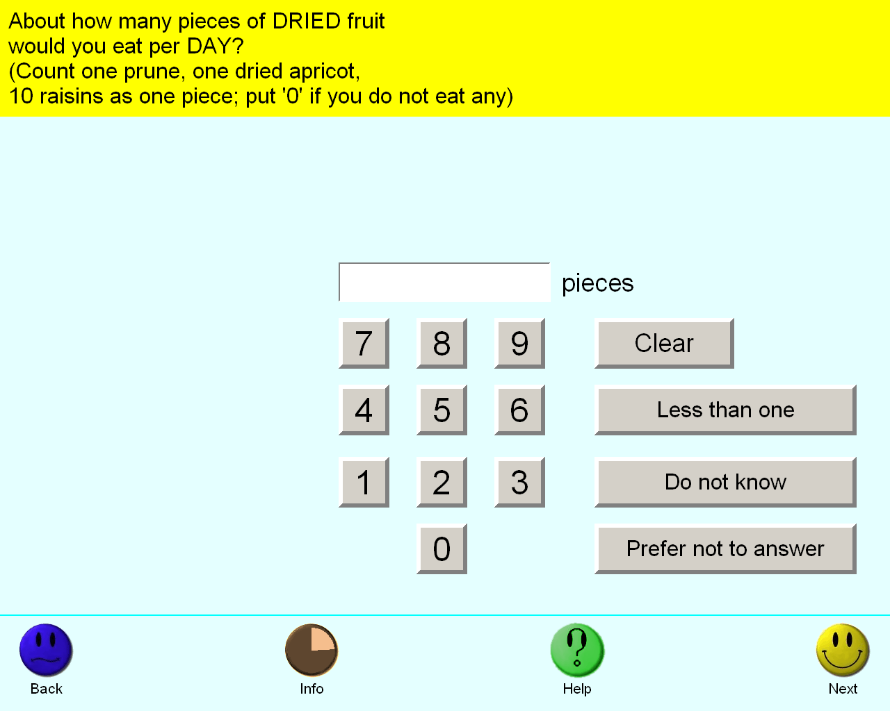
Bread intake | Integer, slices/week | ACE touchscreen question "How many slices of bread do you eat each WEEK?"  The following checks were performed:  If answer < 0 then rejected  If answer > 250 then rejected  If answer > 50 then participant asked to confirm  If the participant activated the Help button they were shown the message:  For other types of bread:  - one bread roll = 2 slices  - one pitta bread = 2 slices | 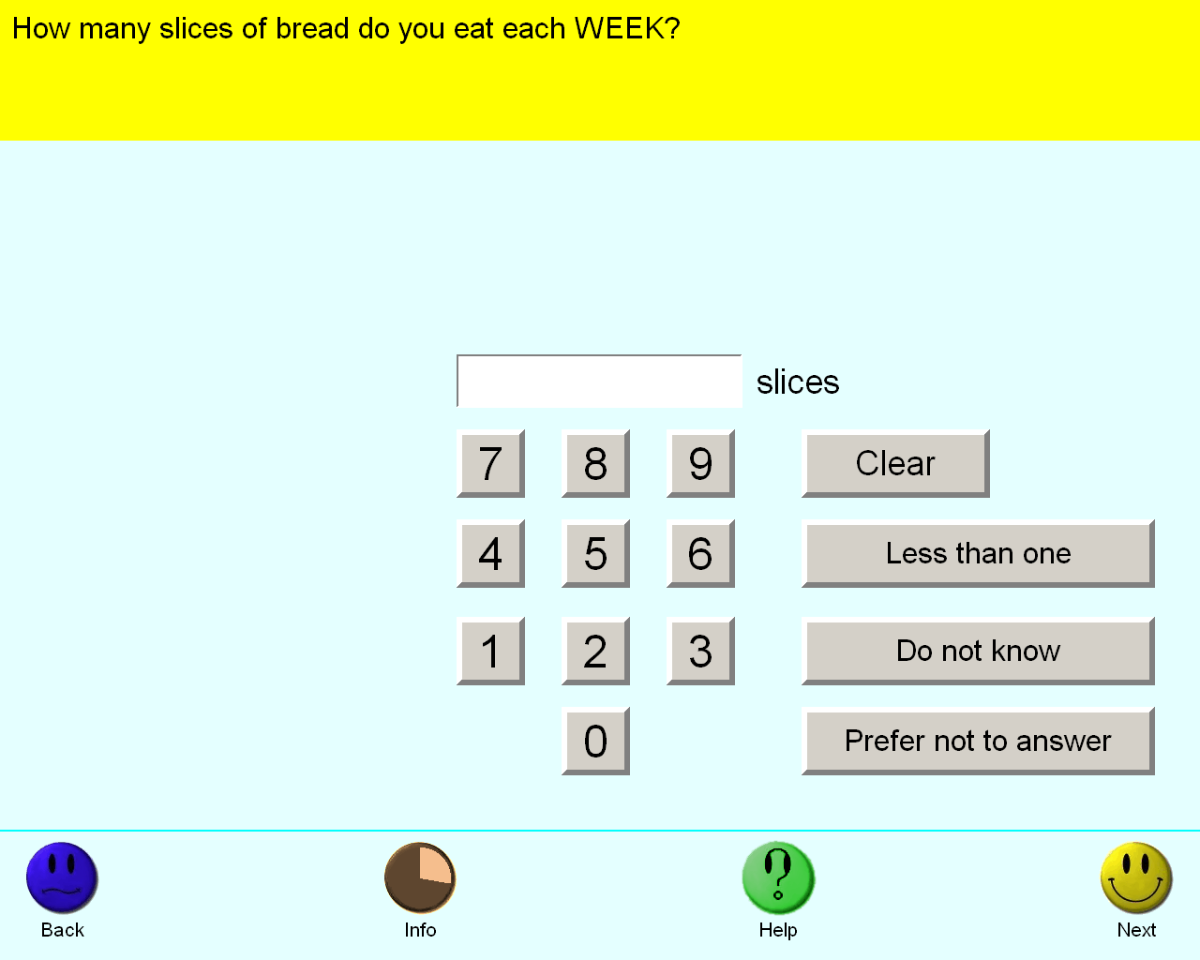
Cereal intake | Integer, bowls/week | ACE touchscreen question "How many bowls of cereal do you eat a WEEK?"  The following checks were performed:  If answer < 0 then rejected  If answer > 99 then rejected  If answer > 14 then participant asked to confirm  If the participant activated the Help button they were shown the message:  Please provide an average considering your intake over the last year.  If you are unsure, please provide an estimate or select Do not know. | 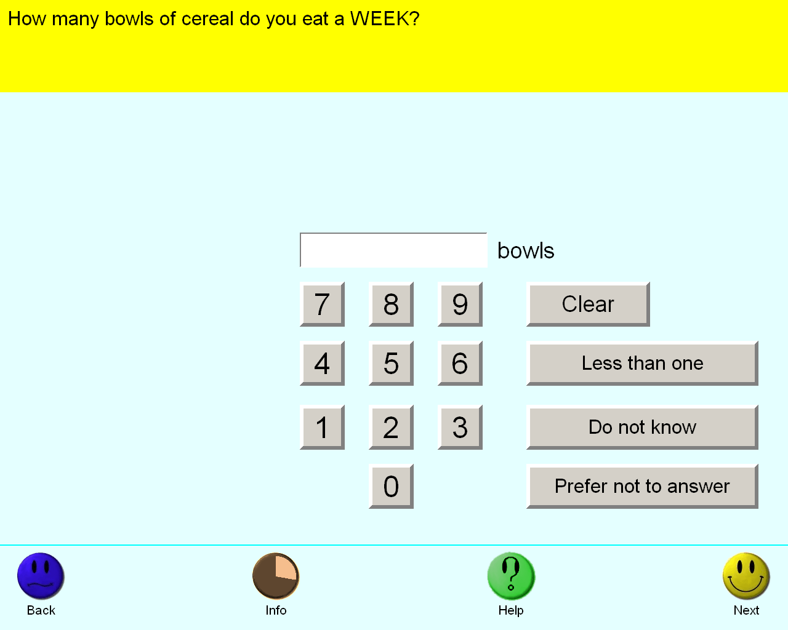
ACE = Automatic Computer-based Evaluation

