Supplementary Material 1. Participant flowchart for adults with 1d of valid dietary data in NNPAS 2011-12.

Individuals who participated in the NNPAS (n=12,153)

Individuals younger than 19 years old were excluded (n=2812)

NNPAS participants aged ≥19 years (n=9341)

Individuals with a Goldberg cut-off of <0.9 (n=2043)

NNPAS participants aged ≥19 years who had valid dietary recall data (n=7298)

n participants vary by outcome (range=1982 to 6003)

Supplementary Material 2. All UPF items in the AUSNUT 2011-13 Nova database that contain ≥25% whole grain per 100g dry weight.
Category Code | Category Label
12101022 | Quinoa, cooked in water & fat (margarine), no added salt
12207003 | Bread, from wholemeal flour, commercial
12207004 | Bread, from wholemeal flour, commercial, toasted
12208001 | Bread, from wholemeal flour, commercial, added fibre
12208002 | Bread, from wholemeal flour, commercial, added fibre, toasted
12208003 | Bread, from wholemeal flour, commercial, added fibre & vitamins B1, B3, B6 & E, Fe & Zn
12208004 | Bread, from wholemeal flour, commercial, added fibre & vitamins B1, B3, B6 & E, Fe & Zn, toasted
12208005 | Bread, from wholemeal flour, commercial, added iron
12208006 | Bread, from wholemeal flour, commercial, added iron, toasted
12208007 | Bread, from wholemeal flour, commercial, added omega-3 polyunsaturates
12208008 | Bread, from wholemeal flour, commercial, added omega-3 polyunsaturates, toasted
12209001 | Bread, damper, from wholemeal flour, homemade from basic ingredients
12210003 | Bread, from rye flour, light, commercial
12210004 | Bread, from rye flour, light, commercial, toasted
12214008 | Bread roll, for use in subway sandwich recipes
12301004 | Muffin, English style, from wholemeal flour, commercial, toasted
12307002 | Bread, garlic or herb, homemade, cooked
12307004 | French toast, wholemeal bread, plain
12503001 | Breakfast cereal, puffed or popped rice, no added sugar or salt, unfortified
12505001 | Breakfast cereal, wheat bran, flakes, unfortified
12505002 | Breakfast cereal, whole wheat, biscuit, no added sugar or salt, unfortified
12505003 | Breakfast cereal, whole wheat, biscuit, no added sugar, unfortified
12505004 | Breakfast cereal, whole wheat, biscuit, added sugar & salt, unfortified
12505005 | Breakfast cereal, whole wheat, flakes, no added sugar, unfortified
12505006 | Breakfast cereal, whole wheat, puffed, no added sugar or salt, unfortified
12506001 | Breakfast cereal, wheat bran, flakes, added vitamins B1, B2 B3, B6, & folate, Fe & Zn
12506007 | Breakfast cereal, whole wheat, biscuit, added vitamins B1, B2 & B3
12506008 | Breakfast cereal, whole wheat, biscuit, added vitamins B1, B2 & B3, Ca, Fe & Zn
12506009 | Breakfast cereal, whole wheat, biscuit, added vitamins B1, B2, B3 & folate, Fe & Zn
12506010 | Breakfast cereal, whole wheat, biscuit, bran, added vitamins B1, B2, B3 & folate & Fe
12506011 | Breakfast cereal, whole wheat, biscuit, not further defined
12506012 | Breakfast cereal, whole wheat, flakes, added vitamins B1, B2, B3 & folate
12506013 | Breakfast cereal, whole wheat, flakes, added vitamins B1, B2, B3, C & folate & Fe
12506014 | Breakfast cereal, whole wheat, small biscuit, added vitamins B1, B2, B3 & folate
12506015 | Breakfast cereal, wheat based, commercial, not further defined
12507002 | Breakfast cereal, whole wheat, small biscuit, with honey, added vitamins B1, B2, B3 & folate, Fe & Zn
12508001 | Breakfast cereal, whole wheat, flakes, added dried fruit &/or nuts, no added sugar, unfortified
12509001 | Breakfast cereal, wheat bran, flakes, sultanas, added vitamins B1, B2, B3, B6 & folate, Fe & Zn
12509002 | Breakfast cereal, whole wheat, small biscuit, with apricot, added vitamins B1, B2, B3 & folate, Ca & Fe
12509003 | Breakfast cereal, whole wheat, small biscuit, with berries, added vitamins B1, B2, B3 & folate, Ca & Fe
12509004 | Breakfast cereal, whole wheat, small biscuit, with blackcurrant paste, added vitamins B1, B2, B3 & folate
12509005 | Breakfast cereal, whole wheat, small biscuit, with fruit paste, added vitamins B1, B2, B3 & C & Fe
12509006 | Breakfast cereal, whole wheat, flakes, dried fruit, added vitamins B1, B2, B3, C & folate
12509007 | Breakfast cereal, whole wheat, flakes, dried fruit & nuts, added fibre, vitamins B1, B2, B3 & folate, Ca & Fe
12510001 | Breakfast cereal, wheat bran, flakes, honey & almond, added vitamins B1, B2 B3, B6 & folate, Fe & Zn
12510002 | Breakfast cereal, wheat bran, flakes, sultanas, added vitamins B1, B2, B3 & folate & Fe
12511001 | Breakfast cereal, mixed grain (barley & soy), flakes, honey, unfortified
12511002 | Breakfast cereal, mixed grain (wheat & corn), flakes or extruded, no added salt, unfortified
12511004 | Breakfast cereal, mixed grain (wheat, rice & oat), flakes, honey, unfortified
12511005 | Breakfast cereal, oat & whole wheat, biscuit, added salt, unfortified
12512002 | Breakfast cereal, mixed grain (wheat, oat, rice & corn), clusters, added vitamins B1, B2, B3, C & folate, Fe & Zn
12512003 | Breakfast cereal, mixed grain (wheat, corn, rice & oat), extruded, added vitamins B1, B2, B3, B6, C, E & folate, Ca, Fe & Zn
12512005 | Breakfast cereal, mixed grain (wheat, rice & oat), flakes, honey, added vitamins B1, B2, B3 & folate & Fe
12512006 | Breakfast cereal, whole wheat, biscuit, multigrain, added vitamins B1, B2, B3 & E & Fe
12513001 | Breakfast cereal, mixed grain (wheat & corn), extruded, chocolate malt coating, added vitamins B1, B2, B3, B6, C, E & folate, Ca, Fe & Zn
12513003 | Breakfast cereal, mixed grain (wheat, oat & corn), extruded, added vitamins B1, B2, B3, B6, C & folate, Fe & Zn
12513004 | Breakfast cereal, mixed grain (wheat, oat & corn), extruded, added vitamins B1, B2, B3, B6, C & folate, Ca, Fe & Zn
12513006 | Breakfast cereal, mixed grain (wheat, corn, rice & oat), extruded, honey, added vitamins B1, B2, B3, B6, C, E & folate, Ca, Fe & Zn
12513007 | Breakfast cereal, mixed grain (wheat, oat & corn), extruded, cocoa coating, added B1, B2, B3, B6, C & folate, Ca, Fe & Zn
12513008 | Breakfast cereal, mixed grain (wheat, corn & rice), extruded, cocoa coating, added vitamins B1, B2, B3, B6, C, E & folate, Ca, Fe, Mg & Zn
12514001 | Breakfast cereal, mixed grain (barley & oat), flakes, honey, added fruit, nuts & seeds, unfortified
12514002 | Breakfast cereal, mixed grain (wheat & oat), flakes, dried fruit, no added salt, unfortified
12514003 | Breakfast cereal, mixed grain (wheat, rice & oat), flakes, dried fruit, no added salt, unfortified
12514004 | Breakfast cereal, mixed grain (wheat, rice & oat), flakes, cashew, almond, hazelnut & coconut, unfortified
12514005 | Breakfast cereal, mixed grain (wheat, rice & oat), flakes & clusters, apple & raisins, unfortified
12514006 | Breakfast cereal, mixed grain (wheat, corn, rice & oat), flakes, added fruit &/or nuts, no added salt, unfortified
12514007 | Muesli, commercial, gluten free
12514008 | Muesli, commercial, toasted, added dried fruit, unfortified
12514009 | Muesli, commercial, toasted, added dried fruit & nuts, unfortified
12514010 | Muesli, commercial, toasted, added nuts, unfortified
12515003 | Breakfast cereal, mixed grain (rice & wheat), flakes, nuts, added vitamins B1, B2 & B3, Ca & Fe
12515004 | Breakfast cereal, mixed grain (wheat & corn), flakes, berries & sultanas, added vitamins A, B1, B2, B3, B6, E & folate, Ca, Fe & Zn
12515005 | Breakfast cereal, mixed grain (wheat & corn), flakes, sultana, apple & currant, added vitamins B1, B2, B3, B6, E & folate, Ca, Fe & Zn
12515006 | Breakfast cereal, mixed grain (wheat & oat), clusters, almond, added vitamins B1, B2, B3, B6, C, E & folate, Ca, Fe & Zn
12515007 | Breakfast cereal, mixed grain (wheat & oat), flakes, apple, sultana & cranberry, added vitamins B1, B2, B3, B6, C, E & folate
12515008 | Breakfast cereal, mixed grain (wheat & oat), flakes, apricot & sultana, added vitamins B1, B2, B3 & folate & Fe
12515009 | Breakfast cereal, mixed grain (wheat & oat), flakes, berries, added vitamins B1, B2, B3 & folate & Fe
12515011 | Breakfast cereal, mixed grain (wheat, oat & corn), flakes, fruit, added vitamins B1, B2, B3, B6, E & folate, Ca, Fe & Zn
12515012 | Breakfast cereal, mixed grain (wheat, oat & corn), flakes, fruit & nuts, added vitamins B1, B2, B3, C & folate & Fe
12515013 | Breakfast cereal, mixed grain (wheat, oat & corn), flakes, fruit & nuts, added vitamins B1, B2, B3, B6, E & folate, Ca, Fe & Zn
12515014 | Breakfast cereal, mixed grain (wheat, rice & oat), flakes & clusters, apple, added vitamins B1, B2, B3, B6, E & folate, Fe & Zn
12515015 | Breakfast cereal, mixed grain (wheat, oat & corn), flakes & clusters, pomegranate & berries, added vitamins A, B1, B2, B3, B6, E & folate, Ca, Fe & Zn
12515016 | Breakfast cereal, mixed grain (wheat, rice & oat), flakes & clusters, sultanas, added vitamins B1, B2, B3, B6, C & folate, Fe & Zn
12515017 | Breakfast cereal, mixed grain (wheat, rice & oat), flakes, dried fruit, added vitamins B1, B2, B3 & E & Fe
12515018 | Breakfast cereal, mixed grain (wheat, corn, rice & oat), clusters, apple & almonds, added vitamins B1, B2, B3 & folate & Fe
12515019 | Breakfast cereal, mixed grain (wheat, corn, rice & oat), clusters, sultana & berries, added vitamins B1, B2, B3, E & folate, Ca & Fe
12515020 | Breakfast cereal, mixed grain (wheat, corn, rice & oat), flakes & clusters, honey & macadamias, added vitamins B1, B2, B3, E & folate, Ca & Fe
12515021 | Breakfast cereal, mixed grain (wheat, corn, rice & oat), flakes, apricot & coconut, added vitamins B1, B2, B3, E & folate, Ca & Fe
12515022 | Breakfast cereal, mixed grain (wheat, corn, rice & oat), flakes, berries, added vitamins B1, B2, B3, E & folate, Ca & Fe
12515023 | Breakfast cereal, mixed grain (wheat, corn, rice & oat), flakes, fruit, added vitamins B1, B2, B3 & folate & Fe
12515024 | Breakfast cereal, mixed grain (wheat, corn, rice & oat), flakes, fruit, added vitamins B1, B2, B3, & folate, Ca & Fe
12515025 | Breakfast cereal, mixed grain (wheat, corn, rice & oat), flakes, fruit & nuts, added vitamins B1, B2, B3, C & folate & Fe
12515026 | Breakfast cereal, mixed grain, commercial, not further defined
12515027 | Muesli, commercial, toasted, added dried fruit & nuts, added vitamins B2, B3, E & folate & Ca
12516001 | Breakfast cereal, barley, flakes, honey, added sultanas, unfortified
12516003 | Breakfast cereal, not further defined
12601006 | Porridge, rolled oats, prepared with rice milk
12601007 | Porridge, rolled oats, prepared with soy milk
12601009 | Porridge, rolled oats, prepared with soy milk & water
12601011 | Porridge, rolled oats mixed with sugar or honey & other flavours, prepared with water
12601012 | Porridge, rolled oats mixed with sugar or honey & other flavours, prepared with cows milk
12601013 | Porridge, rolled oats mixed with sugar or honey & other flavours, prepared with soy milk
12601016 | Porridge, rolled oats mixed with sugar, flavours & dried fruit, prepared with soy milk
12601017 | Oats, rolled, mixed with sugar or honey & other flavours, uncooked
12601018 | Oats, rolled, mixed with sugar, flavours & dried fruit, uncooked
13201008 | Biscuit, savoury, from wholemeal wheat flour
13201009 | Biscuit, savoury, from wholemeal wheat flour, added grains
13201010 | Biscuit, savoury, from wholemeal wheat flour, crispbread
13201011 | Biscuit, savoury, from wholemeal wheat flour, Salada style, high fibre
13203001 | Biscuit, savoury, from rye flour, crispbread
13203002 | Biscuit, savoury, from rye flour, crispbread, with added grains (buckwheat, linseed, soy, sesame)
13204001 | Biscuit, savoury, rice cake, from brown rice, plain
13204002 | Biscuit, savoury, rice cake, from brown rice, flavoured
13204003 | Biscuit, savoury, rice cake, from brown rice, carob coated
13204009 | Biscuit, savoury, rice cracker, from brown rice, all flavours
13307010 | Scone, wholemeal, commercial
13307011 | Scone, wholemeal, homemade from basic ingredients
13401021 | Pastry, shortcrust, wholemeal, commercial, raw
13401022 | Pastry, shortcrust, wholemeal, commercial, baked
13503022 | Filled bread roll, commercial, ham, oil based sauce
13503056 | Sandwich or roll, filled with ham
13503059 | Sandwich or roll, filled with ham & tomato, toasted
13503066 | Sandwich or roll, filled with vegemite
13507005 | Mexican nachos, corn chips, with salsa
13511004 | Rice, brown, fried, no meat or vegetables, oil not further defined, homemade
13511005 | Rice, brown, fried with bacon or ham, egg & mixed vegetables
13511006 | Rice, brown, fried with chicken, egg & mixed vegetables
13511007 | Rice, brown, fried with mixed vegetables
13601003 | Crepe or pancake, buckwheat flour, homemade from basic ingredients
13601013 | Crepe or pancake, wholemeal wheat flour, commercial or homemade
13606003 | Crumpet, from wholemeal flour, commercial, toasted
20106002 | Milk, oat, fluid, unfortified
20106003 | Milk, oat, fluid, added calcium
20106004 | Milk, rice, fluid, added calcium
20106005 | Milk, rice, fluid, protein enriched, added calcium
26201001 | Corn chips, cheese flavoured, salted
26201002 | Corn chips, other flavours, salted
26201003 | Corn chips, plain, toasted, no added salt
26201004 | Corn chips, plain toasted, salted
26201006 | Corn chips, not further defined
26202002 | Popcorn, commercial, butter flavoured, salted
26202003 | Popcorn, microwaved, butter flavoured, salted
26202004 | Popcorn, regular, unflavoured, salted, vegetable oil
26202005 | Popcorn, regular, unflavoured, unsalted, vegetable oil
26202006 | Popcorn, commercial, sugar coating
26301004 | Grain waves wheat snack, plain, original
26301005 | Grain waves wheat snack, cheese or sour cream & chives
26301006 | Grain waves wheat snack, other flavours
28302001 | Bar, muesli or snack, plain or with 10% dried fruit
28302002 | Bar, muesli or snack, plain or with 10% dried fruit, added vitamins B1, B2, B3, folate & Fe
28302003 | Bar, muesli or snack, plain or with 10% dried fruit, high fibre, added vitamins B1, B2, B3, B6, E, & folate, Fe & Zn
28302004 | Bar, muesli or snack, with 10% dried fruit & 5% nuts
28302005 | Bar, muesli or snack, with 10% dried fruit & 10% nuts
28302010 | Bar, muesli or snack, with 20% dried fruit & 5% nuts
28302012 | Bar, muesli or snack, with 30% dried fruit & 30% nuts
28302013 | Bar, muesli or snack, with 10% nuts
28302014 | Bar, muesli or snack, with 10% nuts, added flaxseeds
28302021 | Bar, muesli or snack, not further defined
28303002 | Bar, muesli or snack, plain or with 10% dried fruit, yoghurt-coated
28303004 | Bar, muesli or snack, with 15% dried fruit & 15% nuts, yoghurt-coated
28303006 | Bar, muesli or snack, with 10% nuts, chocolate-coated
28303007 | Bar, muesli or snack, with chocolate chips or coating

Supplementary Material 3. All UPF items in the AUSNUT 2011-13 Nova database that contain ≥50% whole grain per 100g dry weight.
Category Code | Category Label
12101022 | Quinoa, cooked in water & fat (margarine), no added salt
12207003 | Bread, from wholemeal flour, commercial
12207004 | Bread, from wholemeal flour, commercial, toasted
12208001 | Bread, from wholemeal flour, commercial, added fibre
12208002 | Bread, from wholemeal flour, commercial, added fibre, toasted
12208003 | Bread, from wholemeal flour, commercial, added fibre & vitamins B1, B3, B6 & E, Fe & Zn
12208004 | Bread, from wholemeal flour, commercial, added fibre & vitamins B1, B3, B6 & E, Fe & Zn, toasted
12208005 | Bread, from wholemeal flour, commercial, added iron
12208006 | Bread, from wholemeal flour, commercial, added iron, toasted
12208007 | Bread, from wholemeal flour, commercial, added omega-3 polyunsaturates
12208008 | Bread, from wholemeal flour, commercial, added omega-3 polyunsaturates, toasted
12209001 | Bread, damper, from wholemeal flour, homemade from basic ingredients
12301004 | Muffin, English style, from wholemeal flour, commercial, toasted
12307004 | French toast, wholemeal bread, plain
12503001 | Breakfast cereal, puffed or popped rice, no added sugar or salt, unfortified
12505001 | Breakfast cereal, wheat bran, flakes, unfortified
12505002 | Breakfast cereal, whole wheat, biscuit, no added sugar or salt, unfortified
12505003 | Breakfast cereal, whole wheat, biscuit, no added sugar, unfortified
12505004 | Breakfast cereal, whole wheat, biscuit, added sugar & salt, unfortified
12505005 | Breakfast cereal, whole wheat, flakes, no added sugar, unfortified
12505006 | Breakfast cereal, whole wheat, puffed, no added sugar or salt, unfortified
12506001 | Breakfast cereal, wheat bran, flakes, added vitamins B1, B2 B3, B6, & folate, Fe & Zn
12506007 | Breakfast cereal, whole wheat, biscuit, added vitamins B1, B2 & B3
12506008 | Breakfast cereal, whole wheat, biscuit, added vitamins B1, B2 & B3, Ca, Fe & Zn
12506009 | Breakfast cereal, whole wheat, biscuit, added vitamins B1, B2, B3 & folate, Fe & Zn
12506010 | Breakfast cereal, whole wheat, biscuit, bran, added vitamins B1, B2, B3 & folate & Fe
12506011 | Breakfast cereal, whole wheat, biscuit, not further defined
12506012 | Breakfast cereal, whole wheat, flakes, added vitamins B1, B2, B3 & folate
12506013 | Breakfast cereal, whole wheat, flakes, added vitamins B1, B2, B3, C & folate & Fe
12506014 | Breakfast cereal, whole wheat, small biscuit, added vitamins B1, B2, B3 & folate
12507002 | Breakfast cereal, whole wheat, small biscuit, with honey, added vitamins B1, B2, B3 & folate, Fe & Zn
12508001 | Breakfast cereal, whole wheat, flakes, added dried fruit &/or nuts, no added sugar, unfortified
12509002 | Breakfast cereal, whole wheat, small biscuit, with apricot, added vitamins B1, B2, B3 & folate, Ca & Fe
12509003 | Breakfast cereal, whole wheat, small biscuit, with berries, added vitamins B1, B2, B3 & folate, Ca & Fe
12509004 | Breakfast cereal, whole wheat, small biscuit, with blackcurrant paste, added vitamins B1, B2, B3 & folate
12509005 | Breakfast cereal, whole wheat, small biscuit, with fruit paste, added vitamins B1, B2, B3 & C & Fe
12509006 | Breakfast cereal, whole wheat, flakes, dried fruit, added vitamins B1, B2, B3, C & folate
12509007 | Breakfast cereal, whole wheat, flakes, dried fruit & nuts, added fibre, vitamins B1, B2, B3 & folate, Ca & Fe
12510002 | Breakfast cereal, wheat bran, flakes, sultanas, added vitamins B1, B2, B3 & folate & Fe
12511001 | Breakfast cereal, mixed grain (barley & soy), flakes, honey, unfortified
12511004 | Breakfast cereal, mixed grain (wheat, rice & oat), flakes, honey, unfortified
12511005 | Breakfast cereal, oat & whole wheat, biscuit, added salt, unfortified
12512002 | Breakfast cereal, mixed grain (wheat, oat, rice & corn), clusters, added vitamins B1, B2, B3, C & folate, Fe & Zn
12512003 | Breakfast cereal, mixed grain (wheat, corn, rice & oat), extruded, added vitamins B1, B2, B3, B6, C, E & folate, Ca, Fe & Zn
12512006 | Breakfast cereal, whole wheat, biscuit, multigrain, added vitamins B1, B2, B3 & E & Fe
12513001 | Breakfast cereal, mixed grain (wheat & corn), extruded, chocolate malt coating, added vitamins B1, B2, B3, B6, C, E & folate, Ca, Fe & Zn
12513006 | Breakfast cereal, mixed grain (wheat, corn, rice & oat), extruded, honey, added vitamins B1, B2, B3, B6, C, E & folate, Ca, Fe & Zn
12513008 | Breakfast cereal, mixed grain (wheat, corn & rice), extruded, cocoa coating, added vitamins B1, B2, B3, B6, C, E & folate, Ca, Fe, Mg & Zn
12514001 | Breakfast cereal, mixed grain (barley & oat), flakes, honey, added fruit, nuts & seeds, unfortified
12514002 | Breakfast cereal, mixed grain (wheat & oat), flakes, dried fruit, no added salt, unfortified
12514003 | Breakfast cereal, mixed grain (wheat, rice & oat), flakes, dried fruit, no added salt, unfortified
12514004 | Breakfast cereal, mixed grain (wheat, rice & oat), flakes, cashew, almond, hazelnut & coconut, unfortified
12514005 | Breakfast cereal, mixed grain (wheat, rice & oat), flakes & clusters, apple & raisins, unfortified
12514006 | Breakfast cereal, mixed grain (wheat, corn, rice & oat), flakes, added fruit &/or nuts, no added salt, unfortified
12514008 | Muesli, commercial, toasted, added dried fruit, unfortified
12514009 | Muesli, commercial, toasted, added dried fruit & nuts, unfortified
12514010 | Muesli, commercial, toasted, added nuts, unfortified
12515003 | Breakfast cereal, mixed grain (rice & wheat), flakes, nuts, added vitamins B1, B2 & B3, Ca & Fe
12515006 | Breakfast cereal, mixed grain (wheat & oat), clusters, almond, added vitamins B1, B2, B3, B6, C, E & folate, Ca, Fe & Zn
12515008 | Breakfast cereal, mixed grain (wheat & oat), flakes, apricot & sultana, added vitamins B1, B2, B3 & folate & Fe
12515009 | Breakfast cereal, mixed grain (wheat & oat), flakes, berries, added vitamins B1, B2, B3 & folate & Fe
12515015 | Breakfast cereal, mixed grain (wheat, oat & corn), flakes & clusters, pomegranate & berries, added vitamins A, B1, B2, B3, B6, E & folate, Ca, Fe & Zn
12515017 | Breakfast cereal, mixed grain (wheat, rice & oat), flakes, dried fruit, added vitamins B1, B2, B3 & E & Fe
12515018 | Breakfast cereal, mixed grain (wheat, corn, rice & oat), clusters, apple & almonds, added vitamins B1, B2, B3 & folate & Fe
12515020 | Breakfast cereal, mixed grain (wheat, corn, rice & oat), flakes & clusters, honey & macadamias, added vitamins B1, B2, B3, E & folate, Ca & Fe
12515022 | Breakfast cereal, mixed grain (wheat, corn, rice & oat), flakes, berries, added vitamins B1, B2, B3, E & folate, Ca & Fe
12515024 | Breakfast cereal, mixed grain (wheat, corn, rice & oat), flakes, fruit, added vitamins B1, B2, B3, & folate, Ca & Fe
12515025 | Breakfast cereal, mixed grain (wheat, corn, rice & oat), flakes, fruit & nuts, added vitamins B1, B2, B3, C & folate & Fe
12515027 | Muesli, commercial, toasted, added dried fruit & nuts, added vitamins B2, B3, E & folate & Ca
12516001 | Breakfast cereal, barley, flakes, honey, added sultanas, unfortified
12516003 | Breakfast cereal, not further defined
12601006 | Porridge, rolled oats, prepared with rice milk
12601007 | Porridge, rolled oats, prepared with soy milk
12601009 | Porridge, rolled oats, prepared with soy milk & water
12601011 | Porridge, rolled oats mixed with sugar or honey & other flavours, prepared with water
12601012 | Porridge, rolled oats mixed with sugar or honey & other flavours, prepared with cows milk
12601013 | Porridge, rolled oats mixed with sugar or honey & other flavours, prepared with soy milk
12601016 | Porridge, rolled oats mixed with sugar, flavours & dried fruit, prepared with soy milk
12601017 | Oats, rolled, mixed with sugar or honey & other flavours, uncooked
12601018 | Oats, rolled, mixed with sugar, flavours & dried fruit, uncooked
13201010 | Biscuit, savoury, from wholemeal wheat flour, crispbread
13203001 | Biscuit, savoury, from rye flour, crispbread
13203002 | Biscuit, savoury, from rye flour, crispbread, with added grains (buckwheat, linseed, soy, sesame)
13204001 | Biscuit, savoury, rice cake, from brown rice, plain
13204002 | Biscuit, savoury, rice cake, from brown rice, flavoured
13204003 | Biscuit, savoury, rice cake, from brown rice, carob coated
13204009 | Biscuit, savoury, rice cracker, from brown rice, all flavours
13307010 | Scone, wholemeal, commercial
13307011 | Scone, wholemeal, homemade from basic ingredients
13401021 | Pastry, shortcrust, wholemeal, commercial, raw
13401022 | Pastry, shortcrust, wholemeal, commercial, baked
13511004 | Rice, brown, fried, no meat or vegetables, oil not further defined, homemade
13511005 | Rice, brown, fried with bacon or ham, egg & mixed vegetables
13511006 | Rice, brown, fried with chicken, egg & mixed vegetables
13511007 | Rice, brown, fried with mixed vegetables
13601003 | Crepe or pancake, buckwheat flour, homemade from basic ingredients
13601013 | Crepe or pancake, wholemeal wheat flour, commercial or homemade
20106002 | Milk, oat, fluid, unfortified
20106003 | Milk, oat, fluid, added calcium
20106004 | Milk, rice, fluid, added calcium
20106005 | Milk, rice, fluid, protein enriched, added calcium
26202002 | Popcorn, commercial, butter flavoured, salted
26202003 | Popcorn, microwaved, butter flavoured, salted
26202004 | Popcorn, regular, unflavoured, salted, vegetable oil
26202005 | Popcorn, regular, unflavoured, unsalted, vegetable oil
26301004 | Grain waves wheat snack, plain, original
26301005 | Grain waves wheat snack, cheese or sour cream & chives
26301006 | Grain waves wheat snack, other flavours
28302001 | Bar, muesli or snack, plain or with 10% dried fruit
28302002 | Bar, muesli or snack, plain or with 10% dried fruit, added vitamins B1, B2, B3, folate & Fe
28302010 | Bar, muesli or snack, with 20% dried fruit & 5% nuts
28302013 | Bar, muesli or snack, with 10% nuts

Supplementary Material 4. Description of covariates included in characteristic and cardiometabolic risk measure regression analyses.
Covariates include:
- Age: participants age in years.
- Sex: male or female.
- Nutrient intakes: energy (kJ/d), fibre (g/d), sodium (mg/d), saturated fat intake (g/d), polyunsaturated fat intake (g/d), monounsaturated fat intake (g/d), trans fat intake (mg/d), and free sugar intake (% energy).
- Alcohol intake (g/day).
- Smoking status: current daily, current weekly (at least once weekly but not daily), current less than weekly, ex-smoker, or never smoked.
- Education level: postgraduate degree, graduate diploma, bachelor’s degree, advanced diploma, certificate iii/iv, certificate i/ii, undefined certificate, or no non-school qualification.
- Physical activity level: high, moderate, low, sedentary (very low), or sedentary (no exercise).
- Country of birth: Australia, or other.
- Remoteness area categories from the Australian Statistical Geography Standard (ASGS) 2016 [39]: major cities of Australia, inner regional Australia, or other.
- National Index of Relative Socio-economic Disadvantage 2011 (SEIFA) [40]: decile 1 – lowest to decile 10 – highest.

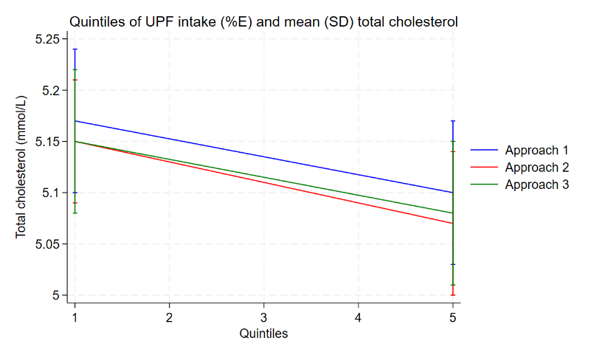
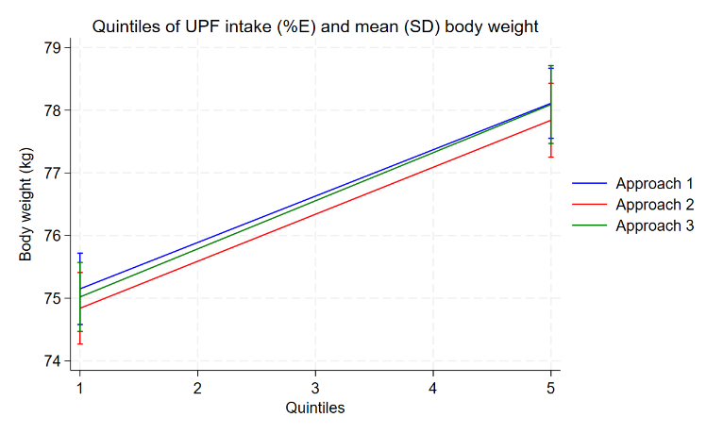
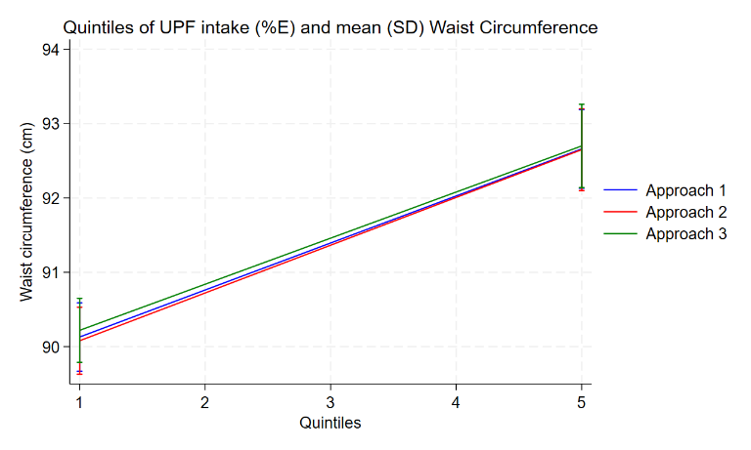
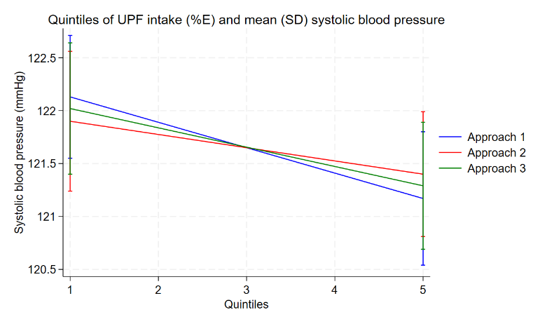
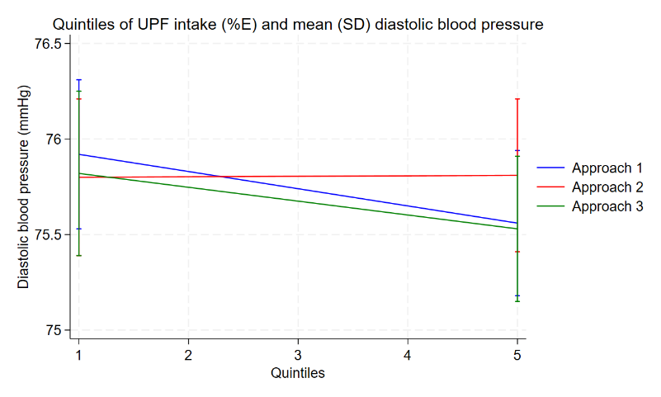
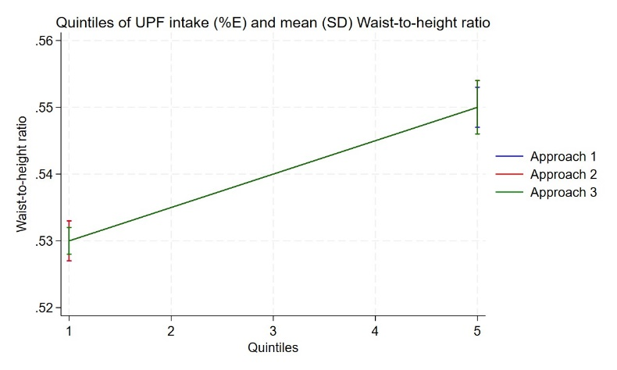
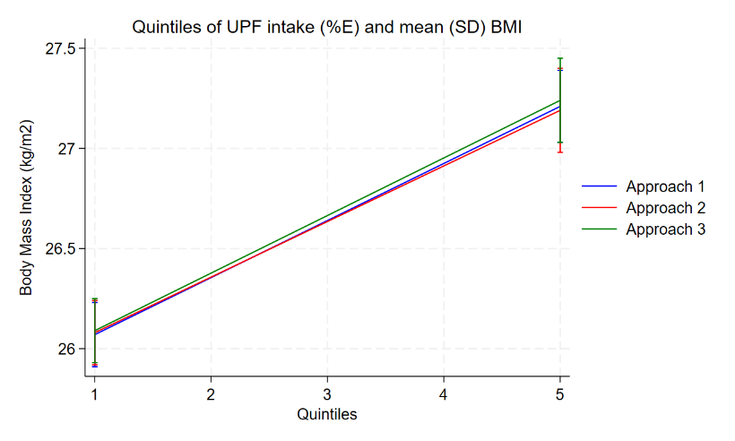
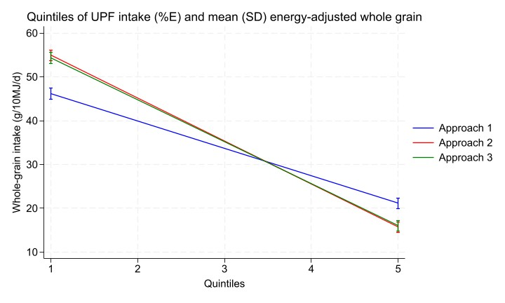
Supplementary Material 5. Slopes of associations between quintiles of UPF energy intake (%) and mean (SD) for each cardiometabolic risk measure across all approaches.
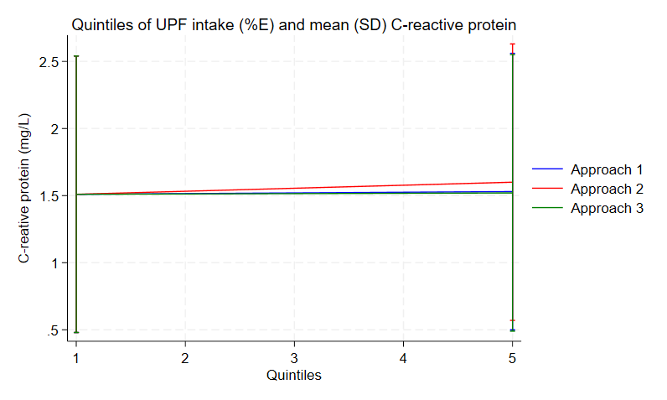
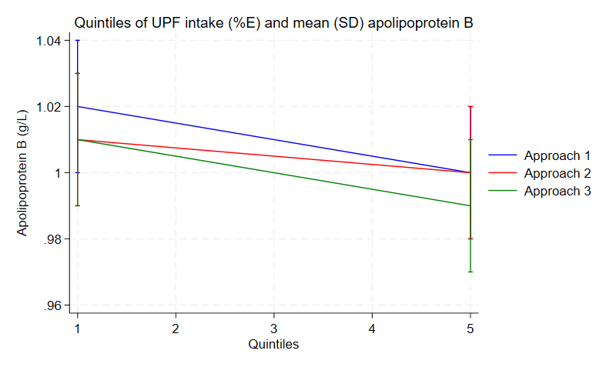
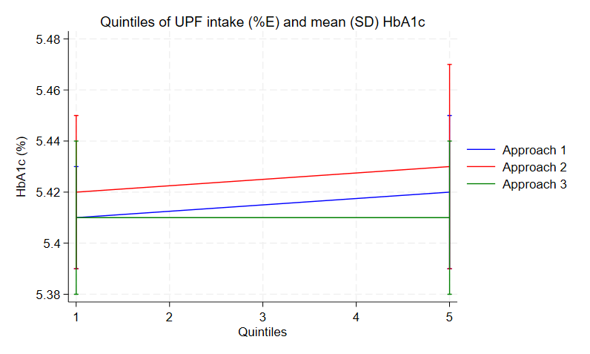
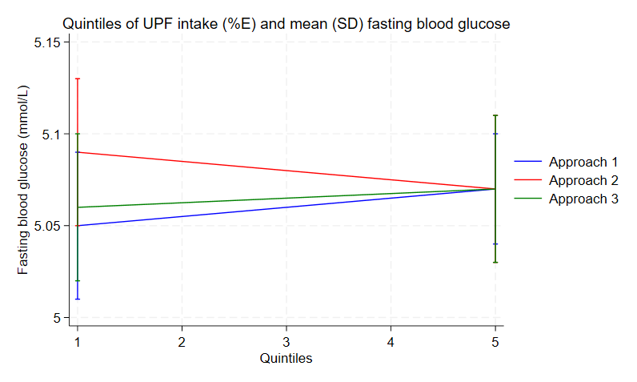
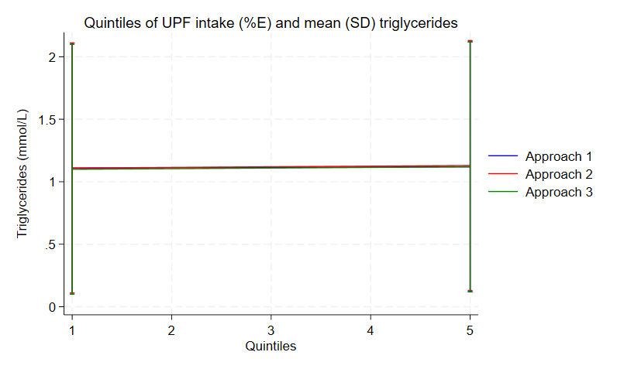
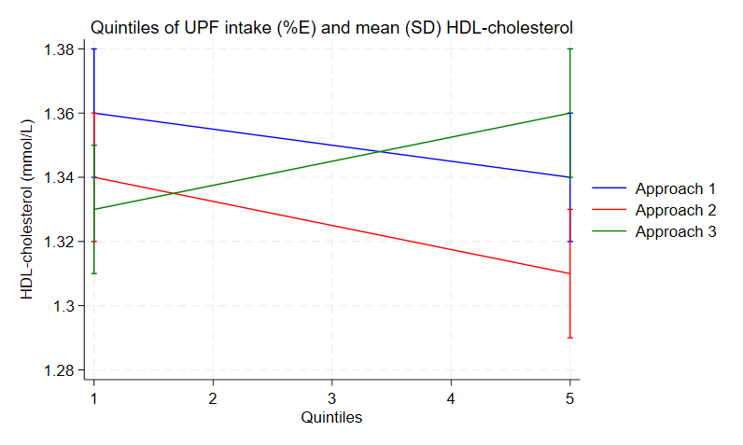
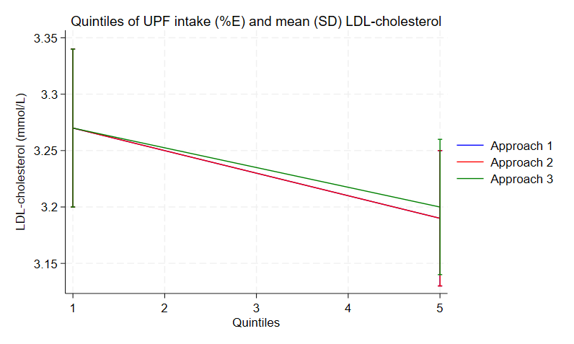

Supplementary Material 6. Whole grain and nutrient intakes, and characteristics of participants in NNPAS 2011-12 by quintiles of proportion of energy from ultra-processed foods according to the Nova UPF definition (Approach 1), and when foods ≥25% and ≥50% whole grain were excluded from this definition (Approach 2 and 3, respectively) (19+ years) (n= 2448).
 | Proportion of energy from UPF (%) |  |  |  |  | p-value†
 | Q1 | Q2 | Q3 | Q4 | Q5
Approach 1
n | 521 | 519 | 492 | 454 | 462 | -
Median proportion of energy from UPF (%) (IQR) | 28.9 (20.7-35.6) | 47.3 (43.4-49.9) | 58.9 (56.3-61.9) | 70.2 (67.1-73.2) | 84.8 (80.5-90.1) | -
Median proportion of energy from ≥25% WG UPF (%) (IQR) | 0 (0-3.6) | 0 (0-7.6) | 0 (0-6.9) | 0 (0-6.9) | 0 (0-7.4) | -
Median proportion of energy from ≥50% WG UPF (%) (IQR) | 0 (0-1.9) | 0 (0-5.8) | 0 (0-5.1) | 0 (0-4.6) | 0 (0-5.7) | -
Median whole-grain intake (g/10MJ/day) (IQR) | 36.9 (0-82.3) | 39.2 (9.2-68.7) | 36.0 (5.6-66.3) | 24.9 (0-52.7) | 11.6 (0-39.7) | -
Age‡§ | 48.6(1.2)^{B} | 46.7(1.0)^{B} | 43.7(1.2)^{AB} | 40.7(1.3)^{A} | 39.2(1.1)^{A} | <0.0001
Female (%)‖‖ | 52.2(2.7)^{A} | 51.0(3.6)^{A} | 51.2(4.3)^{A} | 44.7(3.8)^{A} | 49.4(3.2)^{A} | 0.5995
Energy intake (kJ/day)‡¶ | 9337(177)^{A} | 9767(241)^{AB} | 10134(225)^{B} | 10246(256)^{AB} | 10617(235)^{B} | 0.0001
Fibre intake (g/day)‡¶ | 27.7(1.1)^{B} | 27.5(0.7)^{B} | 27.1(0.9)^{B} | 24.4(0.9)^{AB} | 23.8(0.8)^{A} | <0.0001
Sodium intake (mg/day)‡¶ | 2130(118)^{A} | 2508(78)^{AB} | 2819(82)^{BC} | 3082(129)^{C} | 3239(130)^{C} | <0.0001
Saturated fat intake (g/day)‡¶ | 26.0(0.9)^{A} | 29.8(1.1)^{AB} | 33.6(1.1)^{BC} | 37.2(1.5)^{C} | 38.4(1.4) | <0.0001
Polyunsaturated fat intake (g/day)‡¶ | 12.8(0.6)^{A} | 13.3(0.5)^{AB} | 13.9(0.5)^{AB} | 13.6(0.5)^{AB} | 15.3(0.7)^{B} | 0.0100
Monounsaturated fat intake (g/day)‡¶ | 30.2(1.3)^{A} | 31.7(1.0)^{AB} | 34.4(1.1)^{AB} | 34.7(1.3)^{AB} | 36.4(1.4)^{B} | 0.0003
Trans fat intake (mg/day)‡¶ | 1234(64.0) | 1514(76.2)^{A} | 1697(86.3)^{AB} | 1819(93.6)^{AB} | 1951(114.0)^{B} | <0.0001
Free sugar intake (% energy)‡¶ | 7.2(0.3)^{A} | 8.5(0.5)^{A} | 10.5(0.4)^{B} | 11.6(0.6)^{B} | 14.3(0.5) | <0.0001
Alcohol intake (g/day)‡¶ | 25.0(3.4)^{C} | 20.2(2.3)^{BC} | 13.5(1.5)^{AB} | 13.6(1.7)^{ABC} | 10.1(2.2)^{A} | 0.0006
University graduate (%)‖‖ | 25.3(3.0)^{A} | 23.4(2.6)^{A} | 21.9(3.7)^{A} | 21.6(3.2)^{A} | 22.0(3.6)^{A} | 0.2447
Current smoker daily (%)‖‖ | 8.0(1.8)^{A} | 9.7(2.1)^{A} | 7.6(1.7)^{A} | 12.1(2.1)^{A} | 16.8(2.8)^{A} | 0.0018
Low physical activity level (%)‖‖ | 32.5(3.1)^{A} | 29.1(2.6)^{A} | 39.6(2.8)^{A} | 40.1(3.4)^{A} | 31.7(3.8)^{A} | 0.2624
Born in Australia (%)‖‖ | 52.9(3.7)^{A} | 66.9(3.5)^{AB} | 67.0(4.3)^{AC} | 70.6(3.9)^{BC} | 71.3(4.1)^{BC} | 0.0030
Inner regional living in Australia (%)‖‖ | 17.2(2.2)^{A} | 17.7(2.1)^{A} | 20.7(2.8)^{A} | 18.1(3.0)^{A} | 15.7(2.2)^{A} | 0.4339
Lowest 10% SEIFA ranking (%)‖‖ | 8.0(2.0)^{A} | 8.8(1.8)^{A} | 4.6(1.2)^{A} | 8.8(2.7)^{A} | 10.8(3.3)^{A} | 0.9374
Approach 2
n | 549 | 487 | 515 | 432 | 465 | -
Median proportion of energy from UPF (%) (IQR) | 25.7 | 42.4 | 54.2 | 66.6 | 81.7 | -
Median whole-grain intake (g/10MJ/day) (IQR) | 42.0 | 47.7 | 37.0 | 23.4 | 4.0 | -
Age‡§ | 48.3(1.1)^{B} | 47.1(1.2)^{B} | 45.1(1.0)^{B} | 39.8(1.1)^{A} | 38.6(1.1)^{A} | <0.0001
Female (%)‖‖ | 48.1(2.8)^{A} | 53.7(3.9)^{A} | 53.3(3.1)^{A} | 43.8(4.1)^{A} | 50.6(2.6)^{A} | 0.2706
Energy intake (kJ/day)‡¶ | 9272(180)^{A} | 9682(251)^{AB} | 10190(251)^{B} | 10382(228)^{B} | 10574(239)^{B} | <0.0001
Fibre intake (g/day)‡¶ | 28.8(1.0)^{C} | 27.4(0.8)^{BC} | 27.5(1.0)^{BC} | 24.5(0.8)^{AB} | 22.2(0.8)^{A} | <0.0001
Sodium intake (mg/day)‡¶ | 2142(115)^{A} | 2444(75)^{AB} | 2731(74)^{B} | 3185(119)^{C} | 3279(133)^{C} | <0.0001
Saturated fat intake (g/day)‡¶ | 25.2(1.0) | 30.1(1.1)^{A} | 33.3(1.3)^{AB} | 37.8(1.5)^{BC} | 38.8(1.3)^{C} | <0.0001
Polyunsaturated fat intake (g/day)‡¶ | 12.6(0.6)^{A} | 13.0(0.5)^{A} | 14.2(0.6)^{AB} | 13.9(0.5)^{AB} | 15.1(0.6)^{B} | 0.0013
Monounsaturated fat intake (g/day)‡¶ | 29.4(1.2)^{A} | 31.3(1.0)^{A} | 33.7(1.1)^{AB} | 36.4(1.2)^{B} | 36.7(1.3)^{B} | <0.0001
Trans fat intake (mg/day)‡¶ | 1216(84.4)^{A} | 1499(63.3)^{AB} | 1704(105.5)^{BC} | 1901(95.7)^{C} | 1897(94.2)^{C} | <0.0001
Free sugar intake (% energy)‡¶ | 7.0(0.3) | 8.8(0.4)^{A} | 10.1(0.4)^{AB} | 11.6(0.5)^{B} | 14.7(0.5) | <0.0001
Alcohol intake (g/day)‡¶ | 22.8(3.2)^{A} | 19.0(2.2)^{A} | 15.3(1.4)^{A} | 13.0(1.8)^{A} | 12.1(2.3)^{A} | 0.0075
University graduate (%)‖‖ | 25.2(3.3)^{A} | 24.9(3.0)^{A} | 20.1(3.6)^{A} | 21.5(3.1)^{A} | 22.4(3.8)^{A} | 0.4634
Current smoker daily (%)‖‖ | 8.8(2.0)^{A} | 8.5(2.2)^{A} | 9.1(1.9)^{A} | 10.7(2.1)^{A} | 17.0(3.0)^{A} | 0.0202
Low physical activity level (%)‖‖ | 29.3(2.8)^{A} | 34.6(3.4)^{A} | 35.8(3.7)^{A} | 38.6(3.7)^{A} | 34.9(3.5)^{A} | 0.6781
Born in Australia (%)‖‖ | 53.6(3.7)^{A} | 67.5(3.5)^{AB} | 68.9(4.3)^{AB} | 66.6(4.2)^{AB} | 72.2(3.5)^{B} | 0.0042
Inner regional living in Australia (%)‖‖ | 16.6(2.3)^{A} | 19.2(2.5)^{A} | 19.0(2.7)^{A} | 19.4(3.4)^{A} | 15.3(2.2)^{A} | 0.4547
Lowest 10% SEIFA ranking (%)‖‖ | 8.2(2.0)^{A} | 7.8(1.6)^{A} | 5.4(1.4)^{A} | 6.8(2.5)^{A} | 12.6(3.4)^{A} | 0.8682
Approach 3
n | 544 | 493 | 511 | 437 | 463 | -
Median proportion of energy from UPF (%) (IQR) | 26.64 | 43.32 | 55.68 | 67.55 | 82.26 | -
Median whole-grain intake (g/10MJ/day) (IQR) | 41.52 | 47.29 | 36.92 | 23.36 | 4.47 | -
Age‡§ | 48.4(1.1)^{C} | 47.0(1.2)^{C} | 44.2(1.0)^{BC} | 41.1(1.2)^{AB} | 38.3(1.1)^{A} | <0.0001
Female (%)‖‖ | 48.3(2.8)^{A} | 53.4(3.9)^{A} | 51.9(3.5)^{A} | 45.6(4.0)^{A} | 50.3(2.9)^{A} | 0.5814
Energy intake (kJ/day)‡¶ | 9239(184)^{A} | 9588(219)^{AB} | 10310(257)^{BC} | 10296(233)^{BC} | 10668(235)^{C} | <0.0001
Fibre intake (g/day)‡¶ | 28.1(1.0)^{B} | 27.8(0.8)^{B} | 27.8(1.0)^{B} | 23.8(0.8)^{A} | 23.0(0.9)^{A} | <0.0001
Sodium intake (mg/day)‡¶ | 2134(117)^{A} | 2432(76)^{A} | 2823(80)^{B} | 3096(123)^{BC} | 3297(129)^{C} | <0.0001
Saturated fat intake (g/day)‡¶ | 25.6(1.0)^{A} | 29.0(0.9)^{A} | 33.9(1.3)^{B} | 37.6(1.4)^{BC} | 39.0(1.3)^{C} | <0.0001
Polyunsaturated fat intake (g/day)‡¶ | 12.5(0.6)^{A} | 13.2(0.5)^{AB} | 14.2(0.6)^{AB} | 13.6(0.5)^{AB} | 15.4(0.7)^{B} | 0.0014
Monounsaturated fat intake (g/day)‡¶ | 29.5(1.3)^{A} | 31.0(1.0)^{AB} | 34.2(1.1)^{BC} | 35.8(1.3)^{BC} | 37.0(1.3)^{C} | <0.0001
Trans fat intake (mg/day)‡¶ | 1232(84.9)^{A} | 1500(77.6)^{AB} | 1678(93.4)^{BC} | 1923(92.0)^{C} | 1884(93.6)^{C} | <0.0001
Free sugar intake (% energy)‡¶ | 7.2(0.4)^{A} | 8.5(0.4)^{A} | 10.3(0.4)^{B} | 11.6(0.6)^{B} | 14.5(0.6) | <0.0001
Alcohol intake (g/day)‡¶ | 22.9(3.2)^{A} | 18.4(2.2)^{A} | 15.4(1.5)^{A} | 13.5(1.8)^{A} | 12.1(2.5)^{A} | 0.0131
University graduate (%)‖‖ | 24.7(3.2)^{A} | 24.9(3.0)^{A} | 23.0(3.4)^{A} | 20.9(3.0)^{A} | 20.6(3.6)^{A} | 0.2220
Current smoker daily (%)‖‖ | 8.8(2.0)^{A} | 9.7(2.2)^{A} | 7.8(1.7)^{A} | 11.6(2.1)^{A} | 16.2(2.9)^{A} | 0.0602
Low physical activity level (%)‖‖ | 29.5(2.7)^{A} | 31.9(3.1)^{A} | 38.5(3.9)^{A} | 39.5(3.8)^{A} | 33.8(3.73^{A} | 0.1232
Born in Australia (%)‖‖ | 52.9(3.6)^{A} | 67.3(3.7)^{AB} | 70.1(4.0)^{BC} | 67.1(4.0)^{AC} | 71.5(3.9)^{BC} | 0.0022
Inner regional living in Australia (%)‖‖ | 17.1(2.3)^{A} | 18.9(2.3)^{A} | 16.6(2.4)^{A} | 22.2(3.4)^{A} | 14.7(2.2)^{A} | 0.1313
Lowest 10% SEIFA ranking (%)‖‖ | 8.2(1.9)^{A} | 8.6(1.7)^{A} | 4.9(1.3)^{A} | 6.9(2.4)^{A} | 12.4(3.4)^{A} | 0.7264
Abbreviations: National Index of Relative Socio-economic Disadvantage 2011 (SEIFA), ultra-processed food (UPF), whole grain (WG).
*N (weighted) is based on participants 19 years and over within the NNPAS 2011-12 that have complete information for all characteristics of interest
† Associations with continuous variables were determined through a test for trend post linear regression. Associations with categorical variables were determined through Pearson’s chi2 analysis. Significance is determined at P <0.05.
‡ Reported as x̅ (SEM)
§ Linear regression adjusted for sex
‖ Reported as percentage (SE)
¶ Linear regression adjusted for age and sex

Supplementary Material 7. Association between quintiles of energy intake (%E) from ultra-processed food (UPF) and unadjusted cardiometabolic risk measures for whole-grain modified UPF definitions in Australian adults with 1d of intake.
 | Proportion of energy intake from UPF (%) ª |  |  |  |  | P-value for linear trend‡ | P-value  for sig. difference§ | Adjusted R-squared
 | Q1 | Q2 | Q3 | Q4 | Q5
Energy adjusted WG intake (g/10MJ/day)|| (n=4461)
Unadjusted
Approach 1 | 47.4(1.2) | 38.0(1.2)^{A} | 37.8(1.2)^{A} | 31.3(1.3)^{A} | 19.8(1.3) | <0.0001 | <0.0001 | 0.0577
Approach 2 | 55.7(1.2) | 44.3(1.2)^{A} | 38.1(1.2)^{A} | 30.0(1.2) | 15.0(1.2) | <0.0001 | <0.0001 | 0.1357
Approach 3 | 55.1(1.3) | 42.6(1.2)^{A} | 39.1(1.1)^{A} | 30.0(1.2) | 15.3(1.2) | <0.0001 | <0.0001 | 0.1277
Body weight (kg) (n=6003)
Unadjusted
Approach 1 | 75.0(0.6)^{A} | 76.0(0.6)^{AB} | 77.1(0.7)^{AB} | 76.9(0.7)^{AB} | 77.9(0.7)^{B} | 0.0017 | 0.0393 | 0.0034
Approach 2 | 74.9(0.6)^{A} | 76.5(0.7)^{AB} | 76.8(0.6)^{AB} | 77.1(0.7)^{AB} | 77.6(0.7)^{B} | 0.0038 | 0.0384 | 0.0030
Approach 3 | 75.2(0.6)^{A} | 76.1(0.7)^{A} | 76.8(0.6)^{A} | 77.0(0.6)^{A} | 77.8(0.7)^{A} | 0.0039 | 0.0757 | 0.0028
BMI (kg/m²) (n=5970)
Unadjusted
Approach 1 | 26.3(0.2)^{A} | 26.8(0.2)^{A} | 26.8(0.2)^{A} | 26.6(0.2)^{A} | 26.8(0.2)^{A} | 0.0768 | 0.1012 | 0.0018
Approach 2 | 26.3(0.2)^{A} | 26.7(0.2)^{A} | 26.8(0.2)^{A} | 26.6(0.2)^{A} | 26.8(0.2)^{A} | 0.1436 | 0.1527 | 0.0014
Approach 3 | 26.3(0.2)^{A} | 26.8(0.2)^{A} | 26.8(0.2)^{A} | 26.6(0.2)^{A} | 26.8(0.2)^{A} | 0.0996 | 0.1352 | 0.0015
Waist circumference (cm) (n=5901)
Unadjusted
Approach 1 | 90.9(0.5)^{A} | 91.8(0.6)^{A} | 92.2(0.6)^{A} | 90.7(0.6)^{A} | 91.1(0.6)^{A} | 0.7253 | 0.3156 | 0.0015
Approach 2 | 91.0(0.5)^{A} | 91.7(0.6)^{A} | 91.8(0.5)^{A} | 91.1(0.5)^{A} | 91.0(0.6)^{A} | 0.6995 | 0.6486 | 0.0007
Approach 3 | 91.2(0.5)^{A} | 91.4(0.6)^{A} | 92.0(0.5)^{A} | 91.0(0.5)^{A} | 91.1(0.6)^{A} | 0.7477 | 0.5968 | 0.0007
Waist:height ratio (n=5875)
Unadjusted
Approach 1 | 0.54(0.003)^{A} | 0.55(0.003)^{A} | 0.54(0.003)^{A} | 0.53(0.003)^{A} | 0.54(0.004)^{A} | 0.1010 | 0.0681 | 0.0030
Approach 2 | 0.54(0.003)^{A} | 0.54(0.003)^{A} | 0.54(0.003)^{A} | 0.54(0.003)^{A} | 0.54(0.004)^{A} | 0.1013 | 0.1759 | 0.0018
Approach 3 | 0.54(0.003)^{A} | 0.54(0.003)^{A} | 0.54(0.003)^{A} | 0.54(0.003)^{A} | 0.54(0.004)^{A} | 0.1484 | 0.1901 | 0.0018
Systolic blood pressure (mmHg) (n=5787)
Unadjusted
Approach 1 | 123.9(0.7)^{AB} | 125.3(1.0)^{B} | 122.8(0.7)^{AB} | 121.5(0.7)^{A} | 118.2(0.6) | <0.0001 | <0.0001 | 0.0165
Approach 2 | 124.0(0.7)^{AB} | 125.4(1.0)^{B} | 123.1(0.6)^{AB} | 121.2(0.8)^{A} | 118.1(0.6) | <0.0001 | <0.0001 | 0.0178
Approach 3 | 124.0(0.7)^{AB} | 125.5(1.0)^{B} | 122.7(0.7)^{AB} | 121.4(0.8)^{A} | 118.1(0.6) | <0.0001 | <0.0001 | 0.0174
Diastolic blood pressure (mmHg) (n=5787)
Unadjusted
Approach 1 | 76.0(0.4)^{AB} | 77.2(0.5)^{B} | 76.4(0.4)^{AB} | 75.8(0.4)^{AB} | 75.2(0.4)^{A} | 0.0313 | 0.0594 | 0.0035
Approach 2 | 75.9(0.4)^{A} | 77.2(0.5)^{A} | 76.1(0.4)^{A} | 75.9(0.4)^{A} | 75.4(0.4)^{A} | 0.0928 | 0.1448 | 0.0028
Approach 3 | 75.9(0.4)^{A} | 77.1(0.5)^{A} | 76.1(0.4)^{A} | 76.2(0.5)^{A} | 75.2(0.4)^{A} | 0.0930 | 0.1162 | 0.0033
Total cholesterol (mmol/L) (n=2424)
Unadjusted
Approach 1 | 5.3(0.1)^{A} | 5.1(0.1)^{A} | 5.1(0.1)^{A} | 5.0(0.1)^{A} | 5.0(0.1)^{A} | 0.0243 | 0.1262 | 0.0106
Approach 2 | 5.2(0.1)^{A} | 5.1(0.1)^{A} | 5.1(0.1)^{A} | 5.0(0.1)^{A} | 5.0(0.1)^{A} | 0.0165 | 0.1720 | 0.0096
Approach 3 | 5.2(0.1)^{A} | 5.1(0.1)^{A} | 5.1(0.1)^{A} | 5.0(0.1)^{A} | 5.0(0.1)^{A} | 0.0227 | 0.2319 | 0.0083
Fasting LDL-cholesterol (mmol/L) (n=1982)
Unadjusted
Approach 1 | 3.3(0.1)^{A} | 3.2(0.1)^{A} | 3.1(0.1)^{A} | 3.1(0.1)^{A} | 3.2(0.1)^{A} | 0.1075 | 0.3842 | 0.0078
Approach 2 | 3.3(0.1)^{A} | 3.2(0.1)^{A} | 3.1(0.1)^{A} | 3.1(0.1)^{A} | 3.2(0.1)^{A} | 0.0974 | 0.3562 | 0.0080
Approach 3 | 3.3(0.1)^{A} | 3.2(0.1)^{A} | 3.1(0.1)^{A} | 3.1(0.1)^{A} | 3.2(0.1)^{A} | 0.1309 | 0.3677 | 0.0069
HDL-cholesterol (mmol/L) (n=2842)
Unadjusted
Approach 1 | 1.4(0.02)^{AB} | 1.4(0.02)^{B} | 1.4(0.02)^{AB} | 1.3(0.02)^{AB} | 1.3(0.02)^{A} | 0.0021 | 0.0187 | 0.0112
Approach 2 | 1.4(0.02)^{A} | 1.4(0.02)^{A} | 1.4(0.02)^{A} | 1.4(0.03)^{A} | 1.3(0.02) | 0.0076 | 0.0043 | 0.0141
Approach 3 | 1.4(0.02)^{A} | 1.4(0.02)^{A} | 1.4(0.02)^{A} | 1.3(0.02)^{A} | 1.3(0.02)^{A} | 0.0332 | 0.1102 | 0.0090
Fasting triglycerides (mmol/L) (n=2418)
Unadjusted
Approach 1 | 1.1(1.0)^{A} | 1.1(1.0)^{A} | 1.1(1.0)^{A} | 1.1(1.0)^{A} | 1.1(1.0)^{A} | 0.7007 | 0.5924 | 0.0028
Approach 2 | 1.1(1.0)^{A} | 1.1(1.0)^{A} | 1.1(1.0)^{A} | 1.1(1.0)^{A} | 1.1(1.0)^{A} | 0.9527 | 0.2060 | 0.0065
Approach 3 | 1.1(1.0)^{A} | 1.1(1.0)^{A} | 1.1(1.0)^{A} | 1.1(1.0)^{A} | 1.1(1.0)^{A} | 0.9147 | 0.5941 | 0.0032
Fasting plasma glucose (mmol/L) (n=2418)
Unadjusted
Approach 1 | 5.1(1.0)^{A} | 5.0(1.0)^{A} | 5.0(1.0)^{A} | 5.0(1.0)^{A} | 5.0(1.0)^{A} | 0.0839 | 0.3873 | 0.0027
Approach 2 | 5.1(1.0)^{A} | 5.0(1.0)^{A} | 5.0(1.0)^{A} | 5.0(1.0)^{A} | 5.0(1.0)^{A} | 0.0351 | 0.1370 | 0.0060
Approach 3 | 5.1(1.0)^{A} | 5.0(1.0)^{A} | 5.0(1.0)^{A} | 5.0(1.0)^{A} | 5.0(1.0)^{A} | 0.0758 | 0.2418 | 0.0037
HbA1c (%) (n=2833)
Unadjusted
Approach 1 | 5.5(1.0)^{B} | 5.4(1.0)^{AB} | 5.4(1.0)^{AB} | 5.4(1.0)^{AB} | 5.3(1.0)^{A} | 0.0020 | 0.0213 | 0.0075
Approach 2 | 5.5(1.0)^{B} | 5.4(1.0)^{AB} | 5.4(1.0)^{AB} | 5.4(1.0)^{AB} | 5.3(1.0)^{A} | 0.0042 | 0.0303 | 0.0073
Approach 3 | 5.5(1.0)^{B} | 5.4(1.0)^{AB} | 5.4(1.0)^{AB} | 5.4(1.0)^{AB} | 5.3(1.0)^{A} | 0.0057 | 0.0044 | 0.0096
Apolipoprotein B (g/L) (n=2423)
Unadjusted
Approach 1 | 1.0(0.02)^{A} | 1.0(0.02)^{A} | 1.0(0.02)^{A} | 1.0(0.02)^{A} | 1.0(0.02)^{A} | 0.2607 | 0.4490 | 0.0057
Approach 2 | 1.0(0.02)^{A} | 1.0(0.02)^{A} | 1.0(0.02)^{A} | 1.0(0.02)^{A} | 1.0(0.02)^{A} | 0.2988 | 0.5226 | 0.0061
Approach 3 | 1.0(0.02)^{A} | 1.0(0.02)^{A} | 1.0(0.02)^{A} | 1.0(0.02)^{A} | 1.0(0.02)^{A} | 0.2941 | 0.5998 | 0.0046
C-reactive protein (CRP) (mg/L) (n=2840)
Unadjusted
Approach 1 | 1.4(1.0)^{A} | 1.3(1.0)^{A} | 1.3(1.0)^{A} | 1.5(1.0)^{A} | 1.6(1.0)^{A} | 0.1441 | 0.1538 | 0.0048
Approach 2 | 1.4(1.0)^{A} | 1.4(1.0)^{A} | 1.3(1.0)^{A} | 1.3(1.0)^{A} | 1.7(1.0)^{A} | 0.1375 | 0.0592 | 0.0109
Approach 3 | 1.4(1.0)^{A} | 1.3(1.0)^{A} | 1.4(1.0)^{A} | 1.4(1.0)^{A} | 1.6(1.0)^{A} | 0.1072 | 0.1319 | 0.0068
* Values are reported as x̅ | SEM
† Means sharing capital letters within rows are not statistically significant from each other. Significance is determined at P<0.005 (Pairwise comparison with Bonferroni correction for multiple comparisons)
‡ P-value for linear trend. A significance is determined at p <0.05
§ P-value for significant difference determined through test for equality of means. Significance is determined at p<0.05
Quintiles sharing capital letters within rows are not statistically significant from each other. Comparison of means were conducted through pairwise comparison. All comparisons applied a Bonferroni correction or multiple comparisons such that a significant difference was observed at P <0.005.

Supplementary Material 8. Association between quintiles of energy intake (%E) from ultra-processed food (UPF) and cardiometabolic risk measures for whole-grain modified UPF definitions in Australian adults with 2d of intake.
 | Proportion of energy intake from UPF (%) ª |  |  |  |  | P-value for linear trend^{b} | P-value for sig. difference^{c} | Adjusted R-squared
 | Q1 | Q2 | Q3 | Q4 | Q5
Energy adjusted WG intake (g/10MJ/day)|| (n=2127)
Adjusted
Approach 1 | 47.67(1.3)^{C} | 37.37(1.3)^{BC} | 37.65(1.25)^{BC} | 32.26(1.27)^{AB} | 22.0(1.43)^{A} | <0.0001 | <0.0001 | 0.1148
Approach 2 | 57.39(1.3)^{B} | 44.32(1.28)^{AB} | 39.39(1.24)^{A} | 29.24(1.22) | 16.17(1.37) | <0.0001 | <0.0001 | 0.1992
Approach 3 | 56.66(1.33)^{C} | 43.45(1.29)^{BC} | 37.53(1.23)^{AB} | 29.73(1.25)^{A} | 17.29(1.36) | <0.0001 | <0.0001 | 0.1811
Unadjusted
Approach 1 | 49.68(1.27)^{B} | 37.61(1.31)^{AB} | 38.32(1.24)^{A} | 42.14(1.28)^{A} | 20.66(1.45) | <0.0001 | <0.0001 | 0.0668
Approach 2 | 57.68(1.28)^{C} | 45.12(1.26)^{BC} | 38.38(1.24)^{AB} | 30.05(1.21)^{A} | 15.78(1.4) | <0.0001 | <0.0001 | 0.1557
Approach 3 | 56.91(1.29)^{C} | 44.01(1.29)^{BC} | 37.12(1.24)^{AB} | 30.58(1.24)^{A} | 16.7(1.38) | <0.0001 | <0.0001 | 0.1365
Body weight (kg)|| (n=2785)
Adjusted
Approach 1 | 72.75(0.66)^{A} | 74.48(0.81)^{AB} | 74.53(0.76)^{AB} | 74.31(0.87)^{AB} | 75.56(0.81)^{B} | 0.0140 | 0.0648 | 0.2578
Approach 2 | 72.73(0.59)^{A} | 74.01(0.85)^{AB} | 74.7(0.85)^{AB} | 74.34(0.76)^{AB} | 75.85(0.89)^{B} | 0.0124 | 0.0666 | 0.2585
Approach 3 | 72.52(0.62)^{A} | 74.21(0.8)^{AB} | 74.48(0.72)^{AB} | 74.61(0.75)^{AB} | 75.81(0.89)^{B} | 0.0054 | 0.0307 | 0.2588
Unadjusted
Approach 1 | 72.86(0.81)^{A} | 74.59(0.9)^{A} | 74.22(0.9)^{A} | 74.51(1.06)^{A} | 75.45(0.92)^{A} | 0.0681 | 0.3068 | 0.0027
Approach 2 | 73.19(0.69)^{A} | 74.27(0.92)^{A} | 74.27(1.02)^{A} | 74.04(0.92)^{A} | 75.86(1.05)^{A} | 0.0862 | 0.3493 | 0.0029
Approach 3 | 73.08(0.71)^{A} | 74.25(0.91)^{A} | 73.83(0.91)^{A} | 74.66(0.94)^{A} | 75.81(1.02)^{A} | 0.0455 | 0.2560 | 0.0032
BMI (kg/m²)|| (n=2775)
Adjusted
Approach 1 | 25.51(0.23)^{A} | 25.79(0.25)^{A} | 25.92(0.24)^{A} | 25.67(0.25)^{A} | 26.33(0.26)^{A} | 0.0261 | 0.1810 | 0.1240
Approach 2 | 25.5(0.2)^{A} | 25.66(0.25)^{A} | 25.77(0.24)^{A} | 25.91(0.25)^{A} | 26.38(0.26)^{A} | 0.0046 | 0.0898 | 0.1234
Approach 3 | 25.38(0.22)^{A} | 25.71(0.24)^{AB} | 25.86(0.22)^{AB} | 25.91(0.25)^{AB} | 26.35(0.26)^{B} | 0.0026 | 0.0589 | 0.1247
Unadjusted
Approach 1 | 25.87(0.23)^{A} | 25.95(0.27)^{A} | 26.05(0.28)^{A} | 25.5(0.3)^{A} | 25.85(0.29)^{A} | 0.5146 | 0.6985 | 0.0015
Approach 2 | 25.85(0.2)^{A} | 26.01(0.26)^{A} | 25.7(0.29)^{A} | 25.67(0.31)^{A} | 25.89(0.3)^{A} | 0.8517 | 0.9602 | 0.0005
Approach 3 | 25.76(0.21)^{A} | 26.01(0.26)^{A} | 25.76(0.27)^{A} | 25.81(0.31)^{A} | 25.87(0.29)^{A} | 0.9981 | 0.9604 | 0.0004
Waist circumference (cm)|| (n=2738)
Adjusted
Approach 1 | 88.43(0.62)^{A} | 89.61(0.65)^{A} | 89.84(0.64)^{A} | 89.21(0.71)^{A} | 90.89(0.67)^{A} | 0.0211 | 0.0920 | 0.2927
Approach 2 | 88.35(0.62)^{A} | 89.27(0.74)^{AB} | 89.36(0.58)^{AB} | 89.81(0.58)^{AB} | 91.18(0.7)^{B} | 0.0027 | 0.0487 | 0.2936
Approach 3 | 88.2(0.64)^{A} | 89.36(0.66)^{AB} | 89.15(0.52)^{AB} | 89.96(0.62)^{AB} | 91.31(0.7)^{B} | 0.0009 | 0.0167 | 0.2945
Unadjusted
Approach 1 | 89.77(0.69)^{A} | 90.16(0.76)^{A} | 90.23(0.8)^{A} | 88.7(0.92)^{A} | 89.11(0.81)^{A} | 0.2530 | 0.6074 | 0.0019
Approach 2 | 89.81(0.67)^{A} | 90.35(0.86)^{A} | 89.05(0.84)^{A} | 89.29(0.88)^{A} | 89.46(0.91)^{A} | 0.5072 | 0.8800 | 0.0011
Approach 3 | 89.69(0.69)^{A} | 90.33(0.8)^{A} | 88.74(0.79)^{A} | 89.7(0.92)^{A} | 89.51(0.85)^{A} | 0.7010 | 0.7819 | 0.0014
Waist:height ratio|| (n=2729)
Adjusted
Approach 1 | 0.52(0.004)^{A} | 0.53(0.004)^{A} | 0.53(0.004)^{A} | 0.53(0.004)^{A} | 0.54(0.004)^{A} | 0.0416 | 0.1567 | 0.2526
Approach 2 | 0.52(0.004)^{A} | 0.53(0.004)^{A} | 0.53(0.003)^{A} | 0.53(0.004)^{A} | 0.54(0.004)^{A} | 0.0017 | 0.0320 | 0.2531
Approach 3 | 0.52(0.004)^{A} | 0.53(0.004)^{AB} | 0.53(0.003)^{AB} | 0.53(0.004)^{AB} | 0.54(0.004)^{B} | 0.0011 | 0.0232 | 0.2537
Unadjusted
Approach 1 | 0.54(0.004)^{A} | 0.53(0.005)^{A} | 0.54(0.005)^{A} | 0.52(0.005)^{A} | 0.52(0.005)^{A} | 0.0035 | 0.0322 | 0.0075
Approach 2 | 0.53(0.004)^{A} | 0.54(0.005)^{A} | 0.53(0.005)^{A} | 0.53(0.005)^{A} | 0.52(0.005)^{A} | 0.0435 | 0.2344 | 0.0037
Approach 3 | 0.53(0.004)^{A} | 0.54(0.005)^{A} | 0.53(0.005)^{A} | 0.53(0.006)^{A} | 0.52(0.005)^{A} | 0.0591 | 0.2763 | 0.0030
Systolic blood pressure (mmHg)¶ (n=2700)
Adjusted
Approach 1 | 120.0(0.89)^{A} | 122.6(0.98)^{A} | 123.1(1.1)^{A} | 121.3(0.88)^{A} | 121.5(0.86)^{A} | 0.5590 | 0.1769 | 0.3007
Approach 2 | 120.2(0.84)^{A} | 121.9(0.94)^{A} | 123.8(1.3)^{A} | 120.9(0.96)^{A} | 121.8(0.87)^{A} | 0.4387 | 0.2288 | 0.3015
Approach 3 | 120.4(0.89)^{A} | 122.2(0.95)^{A} | 123.7(1.2)^{A} | 120.5(0.86)^{A} | 121.7(0.88)^{A} | 0.7390 | 0.1747 | 0.3015
Unadjusted
Approach 1 | 123.0(1.03)^{BC} | 124.0(1.23)^{BC} | 124.3(1.17)^{C} | 119.7(1.05)^{AB} | 117.6(0.86)^{A} | <0.0001 | 0.0001 | 0.0198
Approach 2 | 123.0(1.03)^{B} | 124.0(1.18)^{B} | 123.8(1.37)^{B} | 120.1(1.17)^{AB} | 117.7(0.89)^{A} | <0.0001 | 0.0001 | 0.0170
Approach 3 | 123.3(1.02)^{B} | 124.1(1.21)^{B} | 123.8(1.35)^{B} | 119.7(1.06)^{AB} | 117.7(0.89)^{A} | <0.0001 | 0.0001 | 0.0183
Diastolic blood pressure (mmHg)¶ (n=2700)
Adjusted
Approach 1 | 75.32(0.63)^{A} | 75.9(0.54)^{A} | 75.93(0.65)^{A} | 75.56(0.7)^{A} | 75.8(0.53)^{A} | 0.4539 | 0.6565 | 0.1449
Approach 2 | 75.13(0.58)^{A} | 75.94(0.59)^{A} | 75.43(0.6)^{A} | 75.89(0.77)^{A} | 75.13(0.5)^{A} | 0.9759 | 0.8365 | 0.1445
Approach 3 | 75.24(0.58)^{A} | 75.96(0.61)^{A} | 75.63(0.65)^{A} | 75.55(0.71)^{A} | 75.12(0.49)^{A} | 0.7031 | 0.8807 | 0.1442
Unadjusted
Approach 1 | 75.82(0.58)^{A} | 76.18(0.6)^{A} | 76.37(0.68)^{A} | 75.1(0.68)^{A} | 74.03(0.62)^{A} | 0.0112 | 0.0614 | 0.0063
Approach 2 | 75.6(0.59)^{A} | 76.4(0.68)^{A} | 75.3(0.63)^{A} | 75.89(0.84)^{A} | 74.3(0.53)^{A} | 0.0773 | 0.1077 | 0.0042
Approach 3 | 75.68(0.58)^{A} | 76.38(0.7)^{A} | 75.64(0.67)^{A} | 75.43(0.79)^{A} | 74.36(0.51)^{A} | 0.0467 | 0.1355 | 0.0037
Total cholesterol (mmol/L)** (n=1332)
Adjusted
Approach 1 | 4.09(0.43)^{A} | 4.25(0.45)^{A} | 4.1(0.44)^{A} | 4.13(0.42)^{A} | 4.09(0.43)^{A} | 0.6760 | 0.7803 | 0.1861
Approach 2 | 5.04(0.1)^{A} | 5.11(0.09)^{A} | 5.05(0.08)^{A} | 5.02(0.06)^{A} | 5.05(0.08)^{A} | 0.8009 | 0.9431 | 0.1838
Approach 3 | 5.05(0.09)^{A} | 5.11(0.09)^{A} | 5.0(0.08)^{A} | 5.05(0.07)^{A} | 5.06(0.08)^{A} | 0.9048 | 0.9447 | 0.1840
Unadjusted
Approach 1 | 5.15(0.1)^{A} | 5.25(0.1)^{A} | 4.96(0.1)^{A} | 5.02(0.09)^{A} | 4.88(0.09)^{A} | 0.0078 | 0.0457 | 0.0195
Approach 2 | 5.23(0.08)^{A} | 5.15(0.11)^{A} | 4.98(0.09)^{A} | 4.99(0.07)^{A} | 4.91(0.09)^{A} | 0.0089 | 0.1301 | 0.0150
Approach 3 | 5.22(0.08)^{A} | 5.15(0.1)^{A} | 4.93(0.09)^{A} | 5.03(0.08)^{A} | 4.93(0.09)^{A} | 0.0161 | 0.1390 | 0.0147
Fasting LDL-cholesterol (mmol/L)** (n=1116)
Adjusted
Approach 1 | 3.12(0.1)^{A} | 3.21(0.09)^{A} | 3.09(0.07)^{A} | 3.21(0.06)^{A} | 3.06(0.08)^{A} | 0.6759 | 0.4578 | 0.2324
Approach 2 | 3.15(0.1)^{A} | 3.21(0.07)^{A} | 3.1(0.07)^{A} | 3.17(0.05)^{A} | 3.08(0.07)^{A} | 0.5206 | 0.7081 | 0.2303
Approach 3 | 3.16(0.09)^{A} | 3.21(0.07)^{A} | 3.09(0.07)^{A} | 3.18(0.06)^{A} | 3.07(0.07)^{A} | 0.4715 | 0.6849 | 0.2307
Unadjusted
Approach 1 | 3.21(0.1)^{AB} | 3.31(0.09)^{A} | 3.01(0.09)^{AB} | 3.18(0.08)^{AB} | 2.99(0.09)^{A} | 0.0294 | 0.0567 | 0.0226
Approach 2 | 3.3(0.09)^{A} | 3.26(0.09)^{A} | 3.0(0.09)^{A} | 3.13(0.06)^{A} | 3.0(0.08)^{A} | 0.0096 | 0.1075 | 0.0234
Approach 3 | 3.3(0.09)^{A} | 3.25(0.08)^{A} | 2.99(0.09)^{A} | 3.16(0.07)^{A} | 3.0(0.08)^{A} | 0.0120 | 0.0903 | 0.0228
HDL-cholesterol (mmol/L)** (n=1550)
Adjusted
Approach 1 | 1.36(0.03)^{A} | 1.4(0.03)^{A} | 1.38(0.03)^{A} | 1.36(0.03)^{A} | 1.39(0.03)^{A} | 0.9090 | 0.7788 | 0.2845
Approach 2 | 1.37(0.03)^{A} | 1.39(0.03)^{A} | 1.36(0.03)^{A} | 1.37(0.02)^{A} | 1.38(0.04)^{A} | 0.9262 | 0.9744 | 0.2832
Approach 3 | 1.37(0.03)^{A} | 1.38(0.03)^{A} | 1.37(0.03)^{A} | 1.38(0.03)^{A} | 1.38(0.04)^{A} | 0.8053 | 0.9968 | 0.2827
Unadjusted
Approach 1 | 1.38(0.03)^{A} | 1.43(0.04)^{A} | 1.38(0.04)^{A} | 1.35(0.03)^{A} | 1.34(0.03)^{A} | 0.1398 | 0.4600 | 0.0066
Approach 2 | 1.39(0.02)^{A} | 1.42(0.05)^{A} | 1.38(0.04)^{A} | 1.35(0.03)^{A} | 1.35(0.04)^{A} | 0.1231 | 0.5597 | 0.0052
Approach 3 | 1.39(0.03)^{A} | 1.4(0.05)^{A} | 1.39(0.04)^{A} | 1.36(0.03)^{A} | 1.35(0.04)^{A} | 0.2427 | 0.8203 | 0.0029
Fasting triglycerides (mmol/L) †† (n=1345)
Adjusted
Approach 1 | 1.05(1.0)^{A} | 1.03(1.0)^{A} | 1.06(1.0)^{A} | 1.08(1.0)^{A} | 1.12(1.01)^{A} | 0.2114 | 0.7516 | 0.2274
Approach 2 | 1.03(1.0)^{A} | 1.02(1.0)^{A} | 1.09(1.0)^{A} | 1.08(1.0)^{A} | 1.12(1.1)^{A} | 0.0924 | 0.3220 | 0.2292
Approach 3 | 1.04(1.0)^{A} | 1.03(1.0)^{A} | 1.08(1.0)^{A} | 1.08(1.0)^{A} | 1.11(1.0)^{A} | 0.1532 | 0.5788 | 0.2272
Unadjusted
Approach 1 | 1.12(1.0)^{A} | 1.09(1.0)^{A} | 1.09(1.0)^{A} | 1.11(1.0)^{A} | 1.1(1.0)^{A} | 0.8197 | 0.9934 | 0.0004
Approach 2 | 1.12(1.0)^{A} | 1.06(1.0)^{A} | 1.11(1.01)^{A} | 1.12(1.01)^{A} | 1.11(1.0)^{A} | 0.7622 | 0.7502 | 0.0022
Approach 3 | 1.13(1.0)^{A} | 1.07(1.0)^{A} | 1.1(1.0)^{A} | 1.11(1.0)^{A} | 1.11(1.0)^{A} | 0.9615 | 0.9357 | 0.0014
Fasting blood glucose (mmol/L)‡‡ (n=1345)
Adjusted
Approach 1 | 5.01(1.02)^{A} | 5.03(1.02)^{A} | 4.93(1.01)^{A} | 5.0(1.02)^{A} | 5.0(1.02)^{A} | 0.8170 | 0.5074 | 0.2499
Approach 2 | 5.01(1.02)^{A} | 4.99(1.02)^{A} | 4.98(1.02)^{A} | 4.97(1.01)^{A} | 5.01(1.02)^{A} | 0.8904 | 0.9461 | 0.2480
Approach 3 | 5.0(1.02)^{A} | 4.96(1.02)^{A} | 5.0(1.02)^{A} | 4.99(1.01)^{A} | 5.01(1.02)^{A} | 0.7952 | 0.9756 | 0.2480
Unadjusted
Approach 1 | 5.11(1.02)^{A} | 5.11(1.02)^{A} | 4.99(1.02)^{A} | 5.04(1.02)^{A} | 4.94(1.01)^{A} | 0.0154 | 0.0598 | 0.0098
Approach 2 | 5.13(1.02)^{A} | 5.07(1.02)^{A} | 5.0(1.03)^{A} | 5.01(1.01)^{A} | 4.96(1.01)^{A} | 0.0342 | 0.3338 | 0.0074
Approach 3 | 5.13(1.02)^{A} | 5.04(1.02)^{A} | 5.02(1.07)^{A} | 5.03(1.02)^{A} | 4.97(1.01)^{A} | 0.0733 | 0.5002 | 0.0058
HbA1c (%)‡‡ (n=1542)
Adjusted
Approach 1 | 5.42(1.01)^{A} | 5.44(1.01)^{A} | 5.34(1.01)^{A} | 5.39(1.01)^{A} | 5.36(1.01)^{A} | 0.2578 | 0.4486 | 0.2439
Approach 2 | 5.42(1.01)^{A} | 5.38(1.01)^{A} | 5.42(1.01)^{A} | 5.34(1.01)^{A} | 5.39(1.01)^{A} | 0.4324 | 0.3416 | 0.2429
Approach 3 | 5.4(1.01)^{A} | 5.4(1.01)^{A} | 5.41(1.01)^{A} | 5.39(1.01)^{A} | 5.36(1.01)^{A} | 0.4526 | 0.8950 | 0.2405
Unadjusted
Approach 1 | 5.52(1.01)^{B} | 5.51(1.01)^{B} | 5.4(1.01)^{AB} | 5.42(1.01)^{AB} | 5.32(1.01)^{A} | 0.0003 | 0.0054 | 0.0206
Approach 2 | 5.53(1.01)^{B} | 5.46(1.01)^{AB} | 5.44(1.01)^{AB} | 5.39(1.01)^{AB} | 5.35(1.01)^{A} | 0.0012 | 0.0292 | 0.0150
Approach 3 | 5.51(1.01)^{B} | 5.48(1.01)^{B} | 5.44(1.01)^{AB} | 5.42(1.01)^{AB} | 5.32(1.01)^{A} | 0.0006 | 0.0041 | 0.0160
Apolipoprotein B (g/L)** (n=1332)
Adjusted
Approach 1 | 1.0(0.03)^{A} | 1.0(0.02)^{A} | 1.0(0.02)^{A} | 0.98(0.02)^{A} | 0.95(0.02)^{A} | 0.1418 | 0.5354 | 0.2184
Approach 2 | 1.0(0.03)^{A} | 1.0(0.02)^{A} | 0.99(0.02)^{A} | 0.98(0.02)^{A} | 0.97(0.02)^{A} | 0.2665 | 0.7906 | 0.2165
Approach 3 | 1.0(0.03)^{A} | 1.01(0.02)^{A} | 0.98(0.02)^{A} | 0.98(0.02)^{A} | 0.96(0.02)^{A} | 0.1886 | 0.6066 | 0.2173
Unadjusted
Approach 1 | 1.02(0.02)^{A} | 1.02(0.03)^{A} | 0.98(0.03)^{A} | 0.99(0.03)^{A} | 0.93(0.03)^{A} | 0.0073 | 0.0961 | 0.0134
Approach 2 | 1.03(0.02)^{A} | 1.0(0.03)^{A} | 0.97(0.03)^{A} | 0.98(0.02)^{A} | 0.95(0.02)^{A} | 0.0206 | 0.2323 | 0.0116
Approach 3 | 1.04(0.02)^{A} | 1.01(0.02)^{A} | 0.96(0.03)^{A} | 0.99(0.02)^{A} | 0.95(0.02)^{A} | 0.0155 | 0.1559 | 0.0142
C-reactive protein (CRP) (mg/L)** (n=1550)
Adjusted
Approach 1 | 1.33(1.02)^{A} | 1.18(1.01)^{A} | 1.27(1.02)^{A} | 1.35(1.02)^{A} | 1.56(1.05)^{A} | 0.0942 | 0.2775 | 0.2522
Approach 2 | 1.31(1.02)^{A} | 1.2(1.02)^{A} | 1.3(1.02)^{A} | 1.29(1.02)^{A} | 1.57(1.05)^{A} | 0.1266 | 0.3711 | 0.2518
Approach 3 | 1.34(1.02)^{A} | 1.19(1.02)^{A} | 1.27(1.02)^{A} | 1.33(1.02)^{A} | 1.55(1.05)^{A} | 0.1155 | 0.3037 | 0.2516
Unadjusted
Approach 1 | 1.46(1.03)^{A} | 1.26(1.02)^{A} | 1.3(1.02)^{A} | 1.44(1.03)^{A} | 1.6(1.05)^{A} | 0.2999 | 0.3710 | 0.0069
Approach 2 | 1.5(1.03)^{A} | 1.24(1.02)^{A} | 1.24(1.02)^{A} | 1.41(1.03)^{A} | 1.69(1.05)^{A} | 0.2342 | 0.1056 | 0.0123
Approach 3 | 1.52(1.03)^{A} | 1.22(1.02)^{A} | 1.25(1.02)^{A} | 1.43(1.03)^{A} | 1.67(1.05)^{A} | 0.2429 | 0.0913 | 0.0123
* Values are reported as x̅ | SEM
† Means sharing capital letters within rows are not statistically significant from each other. Significance is determined at P<0.005 (Pairwise comparison with Bonferroni correction for multiple comparisons)
‡ P-value for linear trend. A significance is determined at p <0.05
§ P-value for significant difference determined through test for equality of means. Significance is determined at p<0.05
‖ Age, sex, education, physical activity level, smoking status, socio-economic status, country of birth, and area remoteness
¶ Age, sex, education, physical activity level, smoking status, socio-economic status, country of birth, area remoteness, Na intake, and BMI
** Age, sex, education, physical activity level, smoking status, socio-economic status, country of birth, area remoteness, saturated fat intake, monounsaturated fat, polyunsaturated fat intake, trans saturated fat intake, alcohol intake, and BMI
†† Age, sex, education, physical activity level, smoking status, socio-economic status, country of birth, area remoteness, saturated fat intake, monounsaturated fat, polyunsaturated fat intake, trans saturated fat intake, free sugar intake, alcohol intake, and BMI
‡‡ Age, sex, education, physical activity level, smoking status, socio-economic status, country of birth, area remoteness, free sugar intake, and BMI
Quintiles sharing capital letters within rows are not statistically significant from each other. Comparison of means were conducted through pairwise comparison. All comparisons applied a Bonferroni correction or multiple comparisons such that a significant difference was observed at P <0.005.

Supplementary Material 9. Association between quintiles of energy intake (%E) from ultra-processed food (UPF) and cardiometabolic risk measures for whole-grain modified UPF definitions in Australian adults with 1 or 2d of intake.
 | Proportion of energy intake from UPF (%) ª |  |  |  |  | P-value for linear trend^{b} | P-value for sig. difference^{c} | Adjusted R-squared
 | Q1 | Q2 | Q3 | Q4 | Q5
Energy adjusted WG intake (g/10MJ/day)|| (n=3952)
Adjusted
Approach 1 | 41.08(1.26)^{B} | 33.25(1.24)^{AB} | 34.03(1.21)^{AB} | 29.28(1.2)^{A} | 20.5(1.26) | <0.0001 | <0.0001 | 0.0830
Approach 2 | 49.27(1.26)^{B} | 39.61(1.02)^{AB} | 34.24(1.21)^{A} | 26.57(1.16) | 15.72(1.23) | <0.0001 | <0.0001 | 0.1420
Approach 3 | 48.45(1.26)^{C} | 38.3(1.25)^{BC} | 34.36(1.19)^{AB} | 27.68(1.17)^{A} | 15.81(1.24) | <0.0001 | <0.0001 | 0.1365
Unadjusted
Approach 1 | 42.1(1.25)^{B} | 34.23(1.25)^{AB} | 34.61(1.19)^{AB} | 29.17(1.21)^{A} | 19.18(1.26) | <0.0001 | <0.0001 | 0.0465
Approach 2 | 49.98(1.25)^{B} | 40.21(1.22)^{AB} | 34.31(1.2)^{A} | 26.83(1.15) | 15.08(1.24) | <0.0001 | <0.0001 | 0.1125
Approach 3 | 48.91(1.26)^{C} | 39.02(1.25)^{BC} | 34.48(1.17)^{AB} | 27.97(1.16)^{A} | 15.16(1.24) | <0.0001 | <0.0001 | 0.1126
Body weight (kg)|| (n=4867)
Adjusted
Approach 1 | 74.03(0.49)^{A} | 75.18(0.64)^{AB} | 75.2(0.62)^{AB} | 75.31(0.72)^{AB} | 76.88(0.57)^{B} | 0.0006 | 0.0027 | 0.2371
Approach 2 | 73.92(0.57)^{A} | 74.49(0.64)^{AB} | 75.53(0.65)^{AB} | 76.55(0.69)^{B} | 76.13(0.63)^{AB} | 0.0010 | 0.0179 | 0.2376
Approach 3 | 74.03(0.55)^{A} | 74.47(0.63)^{A} | 75.15(0.62)^{A} | 76.51(0.72)^{A} | 76.45(0.64)^{A} | 0.0007 | 0.0203 | 0.2377
Unadjusted
Approach 1 | 74.05(0.56)^{A} | 75.22(0.67)^{AB} | 75.23(0.75)^{AB} | 75.23(0.75)^{AB} | 76.87(0.71)^{B} | 0.0091 | 0.0517 | 0.0030
Approach 2 | 74.02(0.64)^{A} | 74.52(0.69)^{A} | 75.41(0.77)^{A} | 76.39(0.78)^{A} | 76.26(0.73)^{A} | 0.0039 | 0.0700 | 0.0032
Approach 3 | 74.27(0.62)^{A} | 74.39(0.66)^{A} | 74.9(0.74)^{A} | 76.52(0.76)^{A} | 76.53(0.75)^{A} | 0.0043 | 0.0678 | 0.0037
BMI (kg/m²)|| (n=4842)
Adjusted
Approach 1 | 25.91(0.14)^{A} | 26.13(0.2)^{AB} | 26.21(0.2)^{AB} | 26.23(0.22)^{AB} | 26.75(0.18)^{B} | 0.0014 | 0.0230 | 0.0973
Approach 2 | 25.84(0.15)^{A} | 25.96(0.19)^{AB} | 26.15(0.2)^{AB} | 26.71(0.23)^{B} | 26.57(0.19)^{AB} | 0.0002 | 0.0044 | 0.0988
Approach 3 | 25.88(0.16)^{AB} | 25.91(0.17)^{AC} | 26.12(0.2)^{ABC} | 26.68(0.23)^{CD} | 26.65(0.19)^{BD} | 0.0003 | 0.0061 | 0.0990
Unadjusted
Approach 1 | 26.15(0.15)^{A} | 26.27(0.21)^{A} | 26.35(0.23)^{A} | 26.1(0.23)^{A} | 26.36(0.2)^{A} | 0.6752 | 0.8368 | 0.0005
Approach 2 | 26.08(0.15)^{A} | 26.18(0.19)^{A} | 26.18(0.23)^{A} | 26.61(0.24)^{A} | 26.19(0.22)^{A} | 0.2825 | 0.4283 | 0.0014
Approach 3 | 26.1(0.16)^{A} | 26.14(0.18)^{A} | 26.17(0.22)^{A} | 26.56(0.25)^{A} | 26.27(0.22)^{A} | 0.2321 | 0.6099 | 0.0011
Waist circumference (cm)|| (n=4781)
Adjusted
Approach 1 | 89.83(0.38)^{A} | 89.93(0.5)^{AB} | 90.31(0.5)^{AB} | 90.4(0.57)^{AB} | 91.7(0.52)^{B} | 0.0008 | 0.0094 | 0.2704
Approach 2 | 89.23(0.43)^{A} | 89.33(0.51)^{A} | 90.14(0.46)^{AB} | 91.58(0.56)^{B} | 91.43(0.48)^{B} | <0.0001 | 0.0009 | 0.2724
Approach 3 | 89.29(0.42)^{A} | 89.36(0.47)^{A} | 89.87(0.45)^{AB} | 91.53(0.59)^{B} | 91.67(0.5)^{B} | <0.0001 | 0.0007 | 0.2728
Unadjusted
Approach 1 | 90.33(0.46)^{A} | 90.64(0.56)^{A} | 90.83(0.6)^{A} | 89.79(0.65)^{A} | 90.14(0.64)^{A} | 0.4980 | 0.7961 | 0.0007
Approach 2 | 90.32(0.45)^{A} | 90.14(0.61)^{A} | 90.33(0.6)^{A} | 91.06(0.64)^{A} | 89.87(0.63)^{A} | 0.9882 | 0.7415 | 0.0008
Approach 3 | 90.39(0.49)^{A} | 90.14(0.54)^{A} | 90.03(0.59)^{A} | 91.0(0.64)^{A} | 90.15(0.64)^{A} | 0.8308 | 0.7589 | 0.0006
Waist:height ratio|| (n=4759)
Adjusted
Approach 1 | 0.53(0.002)^{A} | 0.53(0.003)^{AB} | 0.53(0.003)^{AB} | 0.53(0.003)^{AB} | 0.54(0.003)^{B} | 0.0024 | 0.0425 | 0.2299
Approach 2 | 0.53(0.002)^{A} | 0.53(0.003)^{A} | 0.53(0.003)^{AB} | 0.54(0.003)^{B} | 0.54(0.003)^{B} | <0.0001 | 0.0003 | 0.2325
Approach 3 | 0.53(0.002)^{A} | 0.53(0.003)^{A} | 0.53(0.003)^{AB} | 0.54(0.004)^{B} | 0.54(0.003)^{B} | <0.0001 | 0.0003 | 0.2328
Unadjusted
Approach 1 | 0.54(0.002)^{A} | 0.54(0.003)^{A} | 0.54(0.004)^{A} | 0.53(0.004)^{A} | 0.53(0.004)^{A} | 0.0106 | 0.1209 | 0.0030
Approach 2 | 0.54(0.002)^{A} | 0.54(0.003)^{A} | 0.53(0.003)^{A} | 0.54(0.004)^{A} | 0.53(0.004)^{A} | 0.1032 | 0.2063 | 0.0021
Approach 3 | 0.54(0.003)^{A} | 0.54(0.003)^{A} | 0.53(0.004)^{A} | 0.54(0.004)^{A} | 0.53(0.004)^{A} | 0.1896 | 0.5052 | 0.0013
Systolic blood pressure (mmHg)¶ (n=4699)
Adjusted
Approach 1 | 121.6(0.68)^{A} | 123.0(0.75)^{A} | 121.9(0.8)^{A} | 122.1(0.67)^{A} | 121.9(0.71)^{A} | 0.8923 | 0.7314 | 0.2881
Approach 2 | 122.1(0.74)^{A} | 122.1(0.69)^{A} | 122.8(0.8)^{A} | 121.7(0.84)^{A} | 121.8(0.71)^{A} | 0.6626 | 0.8721 | 0.2878
Approach 3 | 122.1(0.71)^{A} | 122.3(0.69)^{A} | 123.0(0.84)^{A} | 121.3(0.74)^{A} | 121.8(0.69)^{A} | 0.4698 | 0.7003 | 0.2882
Unadjusted
Approach 1 | 124.1(0.8)^{C} | 124.6(0.92)^{C} | 122.9(0.82)^{BC} | 120.4(0.72)^{AB} | 118.4(0.72)^{A} | <0.0001 | <0.0001 | 0.0153
Approach 2 | 124.6(0.88)^{C} | 123.9(0.78)^{BC} | 123.3(0.86)^{BC} | 120.7(0.88)^{AB} | 188.0(0.7)^{A} | <0.0001 | <0.0001 | 0.0163
Approach 3 | 124.6(0.83)^{C} | 124.0(0.82)^{BC} | 123.3(0.89)^{BC} | 120.4(0.85)^{AB} | 118.2(0.7)^{A} | <0.0001 | <0.0001 | 0.0166
Diastolic blood pressure (mmHg)¶ (n=4699)
Adjusted
Approach 1 | 75.78(0.46)^{A} | 76.54(0.47)^{A} | 76.02(0.41)^{A} | 75.48(0.39)^{A} | 75.75(0.43)^{A} | 0.4106 | 0.4403 | 0.1356
Approach 2 | 75.8(0.49)^{A} | 76.33(0.43)^{A} | 75.78(0.42)^{A} | 75.94(0.51)^{A} | 75.72(0.4)^{A} | 0.6992 | 0.8257 | 0.1350
Approach 3 | 75.99(0.47)^{A} | 76.3(0.46)^{A} | 76.0(0.46)^{A} | 74.48(0.42)^{A} | 75.8(0.38)^{A} | 0.3606 | 0.7291 | 0.1352
Unadjusted
Approach 1 | 76.19(0.43)^{A} | 76.8(0.51)^{A} | 76.31(0.44)^{A} | 75.08(0.39)^{A} | 75.2(0.46)^{A} | 0.0059 | 0.0234 | 0.0038
Approach 2 | 76.2(0.5)^{A} | 76.59(0.47)^{A} | 75.78(0.45)^{A} | 75.99(0.55)^{A} | 75.0(0.41)^{A} | 0.0315 | 0.1040 | 0.0023
Approach 3 | 76.38(0.46)^{A} | 76.48(0.5)^{A} | 76.04(0.47)^{A} | 75.47(0.49)^{A} | 75.2(0.4)^{A} | 0.0112 | 0.1253 | 0.0021
Total cholesterol (mmol/L)** (n=1933)
Adjusted
Approach 1 | 5.1(0.08)^{A} | 5.19(0.07)^{A} | 5.08(0.07)^{A} | 5.02(0.07)^{A} | 5.04(0.07)^{A} | 0.2238 | 0.4401 | 0.1496
Approach 2 | 5.16(0.07)^{A} | 5.13(0.08)^{A} | 5.09(0.07)^{A} | 5.06(0.06)^{A} | 5.01(0.07)^{A} | 0.1337 | 0.6984 | 0.1483
Approach 3 | 5.13(0.07)^{A} | 5.15(0.06)^{A} | 5.07(0.06)^{A} | 5.04(0.06)^{A} | 5.05(0.06)^{A} | 0.2245 | 0.5945 | 0.1478
Unadjusted
Approach 1 | 5.19(0.08)^{A} | 5.23(0.07)^{A} | 5.05(0.07)^{A} | 5.01(0.07)^{A} | 4.95(0.07)^{A} | 0.0032 | 0.0276 | 0.0133
Approach 2 | 5.27(0.07)^{B} | 5.16(0.09)^{AB} | 5.05(0.07)^{AB} | 5.07(0.06)^{AB} | 4.9(0.08)^{A} | 0.0009 | 0.0222 | 0.0166
Approach 3 | 5.24(0.07)^{B} | 5.17(0.08)^{AB} | 5.03(0.06)^{AB} | 5.04(0.07)^{AB} | 4.96(0.07)^{A} | 0.0024 | 0.0376 | 0.0119
Fasting LDL-cholesterol (mmol/L)** (n=1982)
Adjusted
Approach 1 | 3.2(0.08)^{A} | 3.27(0.06)^{A} | 3.14(0.06)^{A} | 3.2(0.07)^{A} | 3.13(0.06)^{A} | 0.3852 | 0.5179 | 0.1938
Approach 2 | 3.24(0.07)^{A} | 3.24(0.06)^{A} | 3.16(0.06)^{A} | 3.21(0.06)^{A} | 3.08(0.06)^{A} | 0.1241 | 0.4706 | 0.1955
Approach 3 | 3.25(0.07)^{A} | 3.24(0.06)^{A} | 3.15(0.05)^{A} | 3.18(0.06)^{A} | 3.11(0.06)^{A} | 0.1348 | 0.5387 | 0.1940
Unadjusted
Approach 1 | 3.23(0.08)^{A} | 3.32(0.06)^{A} | 3.11(0.07)^{A} | 3.18(0.07)^{A} | 3.08(0.07)^{A} | 0.0507 | 0.0852 | 0.0114
Approach 2 | 3.31(0.07)^{A} | 3.28(0.08)^{A} | 3.1(0.07)^{A} | 3.21(0.07)^{A} | 3.03(0.07)^{A} | 0.0080 | 0.0887 | 0.0165
Approach 3 | 3.32(0.07)^{A} | 3.26(0.07)^{A} | 3.08(0.06)^{A} | 3.18(0.07)^{A} | 3.08(0.06)^{A} | 0.0129 | 0.1052 | 0.0135
HDL-cholesterol (mmol/L)** (n=2239)
Adjusted
Approach 1 | 1.36(0.02)^{A} | 1.38(0.02)^{A} | 1.36(0.02)^{A} | 1.34(0.03)^{A} | 1.37(0.03)^{A} | 0.7774 | 0.7954 | 0.2776
Approach 2 | 1.38(0.02)^{A} | 1.37(0.03)^{A} | 1.35(0.02)^{A} | 1.35(0.03)^{A} | 1.36(0.03)^{A} | 0.5021 | 0.8309 | 0.2775
Approach 3 | 1.38(0.02)^{A} | 1.37(0.03)^{A} | 1.35(0.02)^{A} | 1.36(0.03)^{A} | 1.36(0.03)^{A} | 0.6147 | 0.9109 | 0.2769
Unadjusted
Approach 1 | 1.38(0.02)^{A} | 1.4(0.03)^{A} | 1.38(0.03)^{A} | 1.32(0.03)^{A} | 1.33(0.03)^{A} | 0.0220 | 0.1965 | 0.0078
Approach 2 | 1.39(0.02)^{A} | 1.4(0.03)^{A} | 1.37(0.03)^{A} | 1.32(0.03)^{A} | 1.32(0.03)^{A} | 0.0111 | 0.1320 | 0.0086
Approach 3 | 1.39(0.02)^{A} | 1.4(0.03)^{A} | 1.37(0.03)^{A} | 1.33(0.03)^{A} | 1.32(0.03)^{A} | 0.0124 | 0.1682 | 0.0081
Fasting triglycerides (mmol/L) †† (n=1890)
Adjusted
Approach 1 | 1.07(1.0)^{A} | 1.1(1.0)^{A} | 1.09(1.0)^{A} | 1.08(1.0)^{A} | 1.11(1.0)^{A} | 0.6128 | 0.9583 | 0.2359
Approach 2 | 1.09(1.0)^{A} | 1.03(1.0)^{A} | 1.13(1.0)^{A} | 1.1(1.0)^{A} | 1.1(1.0)^{A} | 0.3796 | 0.3652 | 0.2393
Approach 3 | 1.06(1.0)^{A} | 1.05(1.0)^{A} | 1.13(1.0)^{A} | 1.1(1.0)^{A} | 1.1(1.0)^{A} | 0.3541 | 0.5669 | 0.2378
Unadjusted
Approach 1 | 1.1(1.0)^{A} | 1.11(1.0)^{A} | 1.08(1.0)^{A} | 1.07(1.0)^{A} | 1.08(1.0)^{A} | 0.5571 | 0.9613 | 0.0006
Approach 2 | 1.14(1.0)^{A} | 1.02(1.0)^{A} | 1.11(1.0)^{A} | 1.11(1.0)^{A} | 1.08(1.0)^{A} | 0.8926 | 0.2828 | 0.0061
Approach 3 | 1.11(1.0)^{A} | 1.05(1.0)^{A} | 1.11(1.0)^{A} | 1.1(1.0)^{A} | 1.08(1.0)^{A} | 0.9800 | 0.7147 | 0.0020
Fasting blood glucose (mmol/L)‡‡ (n=1890)
Adjusted
Approach 1 | 5.0(1.01)^{A} | 4.98(1.01)^{A} | 4.93(1.01)^{A} | 5.02(1.02)^{A} | 4.99(1.01)^{A} | 0.8564 | 0.5115 | 0.2392
Approach 2 | 4.99(1.01)^{A} | 5.0(1.01)^{A} | 4.96(1.01)^{A} | 4.97(1.01)^{A} | 5.0(1.01)^{A} | 0.9551 | 0.9159 | 0.2377
Approach 3 | 5.0(1.01)^{A} | 4.97(1.01)^{A} | 4.95(1.01)^{A} | 5.01(1.01)^{A} | 4.99(1.01)^{A} | 0.9705 | 0.7535 | 0.2382
Unadjusted
Approach 1 | 5.06(1.01)^{A} | 5.0(1.02)^{A} | 4.92(1.01)^{A} | 5.0(1.02)^{A} | 4.95(1.01)^{A} | 0.1308 | 0.1731 | 0.0057
Approach 2 | 5.08(1.02)^{A} | 5.01(1.01)^{A} | 4.92(1.02)^{A} | 4.96(1.01)^{A} | 4.97(1.02)^{A} | 0.0640 | 0.1106 | 0.0069
Approach 3 | 5.09(1.02)^{B} | 4.99(1.01)^{AB} | 4.89(1.01)^{A} | 5.01(1.01)^{AB} | 4.96(1.01)^{AB} | 0.1019 | 0.0514 | 0.0098
HbA1c (%)‡‡ (n=2230)
Adjusted
Approach 1 | 5.41(1.0)^{A} | 5.4(1.01)^{A} | 5.36(1.01)^{A} | 5.45(1.01)^{A} | 5.39(1.01)^{A} | 09391 | 0.1748 | 0.2285
Approach 2 | 5.41(1.01)^{A} | 5.39(1.01)^{A} | 5.41(1.01)^{A} | 5.41(1.01)^{A} | 5.4(1.01)^{A} | 0.8811 | 0.9388 | 0.2253
Approach 3 | 5.41(1.01)^{A} | 5.37(1.01)^{A} | 5.41(1.01)^{A} | 5.43(1.01)^{A} | 5.39(1.01)^{A} | 0.8456 | 0.7698 | 0.2264
Unadjusted
Approach 1 | 5.47(1.01)^{B} | 5.41(1.01)^{AB} | 5.36(1.01)^{A} | 5.43(1.01)^{AB} | 5.33(1.01)^{A} | 0.0067 | 0.0040 | 0.0096
Approach 2 | 5.48(1.01)^{A} | 5.39(1.01)^{A} | 5.4(1.01)^{A} | 5.39(1.01)^{A} | 5.35(1.01)^{A} | 0.0134 | 0.1149 | 0.0072
Approach 3 | 5.48(1.01)^{B} | 5.38(1.01)^{AB} | 5.39(1.01)^{AB} | 5.42(1.01)^{AB} | 5.34(1.01)^{A} | 0.0195 | 0.0597 | 0.0089
Apolipoprotein B (g/L)** (n=1932)
Adjusted
Approach 1 | 0.98(0.02)^{A} | 1.01(0.02)^{A} | 0.99(0.02)^{A} | 0.97(0.02)^{A} | 0.95(0.02)^{A} | 0.1085 | 0.1019 | 0.1751
Approach 2 | 0.99(0.02)^{A} | 1.0(0.02)^{A} | 1.0(0.02)^{A} | 0.97(0.02)^{A} | 0.95(0.02)^{A} | 0.1375 | 0.3346 | 0.1741
Approach 3 | 0.99(0.02)^{A} | 1.0(0.02)^{A} | 0.99(0.02)^{A} | A0.97(0.02)^{A} | 0.95(0.02)^{A} | 0.1003 | 0.3800 | 0.1733
Unadjusted
Approach 1 | 1.0(0.02)^{A} | 1.01(0.02)^{A} | 0.98(0.02)^{A} | 0.97(0.02)^{A} | 0.94(0.02)^{A} | 0.0429 | 0.1496 | 0.0073
Approach 2 | 1.01(0.02)^{A} | 0.99(0.02)^{A} | 0.98(0.02)^{A} | 0.98(0.02)^{A} | 0.94(0.02)^{A} | 0.0573 | 0.3683 | 0.0068
Approach 3 | 1.01(0.02)^{A} | 0.99(0.02)^{A} | 0.97(0.02)^{A} | 0.98(0.02)^{A} | 0.95(0.02)^{A} | 0.0611 | 0.3529 | 0.0061
C-reactive protein (CRP) (mg/L)** (n=2237)
Adjusted
Approach 1 | 1.4(1.02)^{AB} | 1.16(1.01)^{A} | 1.37(1.03)^{AB} | 1.42(1.02)^{AB} | 1.6(1.03)^{B} | 0.0210 | 0.0083 | 0.2553
Approach 2 | 1.33(1.02)^{A} | 1.24(1.02)^{A} | 1.28(1.02)^{A} | 1.46(1.03)^{A} | 1.63(1.04)^{A} | 0.0179 | 0.1043 | 0.2543
Approach 3 | 1.33(1.02)^{A} | 1.23(1.02)^{A} | 1.35(1.03)^{A} | 1.42(1.02)^{A} | 1.62(1.04)^{A} | 0.0121 | 0.0775 | 0.2532
Unadjusted
Approach 1 | 1.44(1.03)^{AB} | 1.11(1.01)^{A} | 1.34(1.03)^{AB} | 1.46(1.03)^{AB} | 1.61(1.04)^{B} | 0.0245 | 0.0107 | 0.0138
Approach 2 | 1.39(1.03)^{A} | 1.21(1.02)^{A} | 1.17(1.01)^{A} | 1.5(1.04)^{A} | 1.7(1.05)^{A} | 0.0153 | 0.0304 | 0.0175
Approach 3 | 1.38(102)^{A} | 1.2(1.01)^{A} | 1.22(1.02)^{A} | 1.5(1.03)^{A} | 1.68(1.05)^{A} | 0.0105 | 0.0376 | 0.0143
* Values are reported as x̅ | SEM
† Means sharing capital letters within rows are not statistically significant from each other. Significance is determined at P<0.005 (Pairwise comparison with Bonferroni correction for multiple comparisons)
‡ P-value for linear trend. A significance is determined at p <0.05
§ P-value for significant difference determined through test for equality of means. Significance is determined at p<0.05
‖ Age, sex, education, physical activity level, smoking status, socio-economic status, country of birth, and area remoteness
¶ Age, sex, education, physical activity level, smoking status, socio-economic status, country of birth, area remoteness, Na intake, and BMI
** Age, sex, education, physical activity level, smoking status, socio-economic status, country of birth, area remoteness, saturated fat intake, monounsaturated fat, polyunsaturated fat intake, trans saturated fat intake, alcohol intake, and BMI
†† Age, sex, education, physical activity level, smoking status, socio-economic status, country of birth, area remoteness, saturated fat intake, monounsaturated fat, polyunsaturated fat intake, trans saturated fat intake, free sugar intake, alcohol intake, and BMI
‡‡ Age, sex, education, physical activity level, smoking status, socio-economic status, country of birth, area remoteness, free sugar intake, and BMI
Quintiles sharing capital letters within rows are not statistically significant from each other. Comparison of means were conducted through pairwise comparison. All comparisons applied a Bonferroni correction or multiple comparisons such that a significant difference was observed at P <0.005.
Supplementary Material 10. Association between quintiles of energy intake (%E) from ultra-processed food (UPF) and cardiometabolic risk measures relevant to T2D for whole-grain modified UPF definitions in Australian adults with1d of intake and excluding T2D (n=254).
 | Proportion of energy intake from UPF (%) ª |  |  |  |  | P-value for linear trend^{b} | P-value for sig. difference^{c} | Adjusted R-squared
 | Q1 | Q2 | Q3 | Q4 | Q5
Body weight (kg)|| (n=5833)
Adjusted
Approach 1 | 74.9(0.6)^{A} | 75.8(0.6)^{AB} | 76.3(0.6)^{AB} | 77.0(0.6)^{AB} | 77.8(0.6)^{B} | 0.0003 | 0.0120 | 0.2249
Approach 2 | 74.7(0.5)^{A} | 76.2(0.7)^{AB} | 76.3(0.6)^{AB} | 76.9(0.6)^{B} | 77.8(0.6)^{B} | 0.0005 | 0.0061 | 0.2251
Approach 3 | 74.9(0.5)^{A} | 75.9(0.6)^{AB} | 76.2(0.5)^{AB} | 76.9(0.6)^{AB} | 77.9(0.6)^{B} | 0.0004 | 0.0087 | 0.2252
Unadjusted
Approach 1 | 74.8(0.6)^{A} | 75.9(0.6)^{AB} | 76.6(0.7)^{AB} | 76.9(0.7)^{AB} | 77.6(0.6)^{B} | 0.0017 | 0.0364 | 0.0032
Approach 2 | 74.7(0.6)^{A} | 76.3(0.7)^{AB} | 76.5(0.6)^{AB} | 76.8(0.7)^{AB} | 77.6(0.6)^{B} | 0.0022 | 0.0256 | 0.0032
Approach 3 | 75.0(0.6)^{A} | 75.8(0.7)^{AB} | 76.4(0.6)^{AB} | 76.7(0.6)^{AB} | 77.8(0.7)^{B} | 0.0021 | 0.0501 | 0.0030
BMI (kg/m²)|| (n=5800)
Adjusted
Approach 1 | 26.0(0.2)^{A} | 26.5(0.2)^{AB} | 26.6(0.2)^{AB} | 26.7(0.2)^{AB} | 27.1(0.2)^{B} | <0.0001 | 0.0011 | 0.0882
Approach 2 | 26.0(0.2)^{A} | 26.5(0.2)^{AB} | 26.5(0.2)^{AB} | 26.7(0.2)^{AB} | 27.1(0.2)^{B} | 0.0001 | 0.0014 | 0.0879
Approach 3 | 26.0(0.2)^{A} | 26.5(0.2)^{AB} | 26.5(0.2)^{AB} | 26.6(0.2)^{AB} | 27.2(0.2)^{B} | 0.0001 | 0.0011 | 0.0885
Unadjusted
Approach 1 | 26.2(0.2)^{A} | 26.7(0.2)^{A} | 26.7(0.2)^{A} | 26.5(0.2)^{A} | 26.8(0.2)^{A} | 0.0598 | 0.1073 | 0.0017
Approach 2 | 26.2(0.2)^{A} | 26.6(0.2)^{A} | 26.7(0.2)^{A} | 26.5(0.2)^{A} | 26.7(0.2)^{A} | 0.1174 | 0.1577 | 0.0014
Approach 3 | 26.2(0.2)^{A} | 26.6(0.2)^{A} | 26.7(0.2)^{A} | 26.5(0.2)^{A} | 26.8(0.2)^{A} | 0.0678 | 0.1017 | 0.0017
Waist circumference (cm)|| (n=5734)
Adjusted
Approach 1 | 89.9(0.4)^{A} | 90.7(0.5)^{AB} | 91.3(0.5)^{AB} | 91.2(0.5)^{AB} | 92.2(0.5)^{B} | 0.0008 | 0.0120 | 0.2557
Approach 2 | 89.9(0.4)^{A} | 90.7(0.5)^{AB} | 91.0(0.5)^{AB} | 91.4(0.5)^{AB} | 92.3(0.6)^{B} | 0.0003 | 0.0082 | 0.2559
Approach 3 | 90.0(0.4)^{A} | 90.5(0.5)^{AB} | 91.0(0.4)^{AB} | 91.4(0.5)^{AB} | 92.4(0.6)^{B} | 0.0002 | 0.0066 | 0.2562
Unadjusted
Approach 1 | 90.5(0.5)^{A} | 91.6(0.6)^{A} | 91.8(0.5)^{A} | 09.5(0.6)^{A} | 90.8(0.6)^{A} | 0.7272 | 0.2747 | 0.0016
Approach 2 | 90.7(0.5)^{A} | 91.4(0.7)^{A} | 91.6(0.5)^{A} | 90.7(0.5)^{A} | 90.8(0.6)^{A} | 0.7535 | 0.6623 | 0.0007
Approach 3 | 90.9(0.5)^{A} | 91.1(0.6)^{A} | 91.6(0.5)^{A} | 90.7(0.5)^{A} | 90.9(0.6)^{A} | 0.8496 | 0.7581 | 0.0005
Waist:height ratio|| (n=5708)
Adjusted
Approach 1 | 0.5 (0.003)^{A} | 0.5(0.003)^{AB} | 0.5(0.003)^{AB} | 0.5(0.003)^{AB} | 0.5(0.003)^{B} | 0.0006 | 0.0069 | 0.2193
Approach 2 | 0.5(0.002)^{A} | 0.5(0.003)^{AB} | 0.5(0.003)^{AB} | 0.5(0.003)^{AB} | 0.5(0.004)^{B} | 0.0003 | 0.0112 | 0.2192
Approach 3 | 0.5(0.002)^{A} | 0.5(0.003)^{AB} | 0.5(0.003)^{AB} | 0.5(0.003)^{AB} | 0.5(0.004)^{B} | 0.0002 | 0.0059 | 0.2196
Unadjusted
Approach 1 | 0.5(0.003)^{A} | 0.5(0.004)^{A} | 0.5(0.003)^{A} | 0.5(0.003)^{A} | 0.5(0.004)^{A} | 0.0927 | 0.0531 | 0.0031
Approach 2 | 0.5(0.003)^{A} | 0.5(0.004)^{A} | 0.5(0.003)^{A} | 0.5(0.003)^{A} | 0.5(0.004)^{A} | 0.1185 | 0.2279 | 0.0017
Approach 3 | 0.5(0.003)^{A} | 0.5(0.003)^{A} | 0.5(0.003)^{A} | 0.5(0.003)^{A} | 0.5(0.004)^{A} | 0.1738 | 0.2322 | 0.0017
Fasting triglycerides (mmol/L) †† (n=2269)
Adjusted
Approach 1 | 1.1(1.0)^{A} | 1.1(1.0)^{A} | 1.1(1.0)^{A} | 1.0(1.0)^{A} | 1.1(1.0)^{A} | 0.8556 | 0.4542 | 0.2167
Approach 2 | 1.1(1.0)^{A} | 1.0(1.0)^{A} | 1.1(1.0)^{A} | 1.1(1.0)^{A} | 1.1(1.0)^{A} | 0.6750 | 0.2556 | 0.2183
Approach 3 | 1.1(1.0)^{A} | 1.0(1.0)^{A} | 1.1(1.0)^{A} | 1.1(1.0)^{A} | 1.1(1.0)^{A} | 0.7521 | 0.6189 | 0.2162
Unadjusted
Approach 1 | 1.1(1.0)^{A} | 1.1(1.0)^{A} | 1.1(1.0)^{A} | 1.0(1.0)^{A} | 1.1(1.0)^{A} | 0.5997 | 0.5635 | 0.0033
Approach 2 | 1.1(1.0)^{A} | 1.0(1.0)^{A} | 1.1(1.0)^{A} | 1.1(1.0)^{A} | 1.1(1.0)^{A} | 0.8459 | 0.4477 | 0.0044
Approach 3 | 1.1(1.0)^{A} | 1.0(1.0)^{A} | 1.1(1.0)^{A} | 1.1(1.0)^{A} | 1.0(1.0)^{A} | 0.9774 | 0.7365 | 0.0022
Fasting blood glucose (mmol/L)‡‡ (n=2269)
Adjusted
Approach 1 | 4.9(1.0)^{A} | 4.9(1.0)^{A} | 4.9(1.0)^{A} | 5.0(1.0)^{A} | 4.9(1.0)^{A} | 0.9271 | 0.6042 | 0.2565
Approach 2 | 5.0(1.0)^{A} | 4.9(1.0)^{A} | 4.9(1.0)^{A} | 4.9(1.0)^{A} | 4.9(1.0)^{A} | 0.7924 | 0.7988 | 0.2562
Approach 3 | 4.9(1.0)^{A} | 4.9(1.0)^{A} | 4.9(1.0)^{A} | 4.9(1.0)^{A} | 4.9(1.0)^{A} | 0.8932 | 0.8723 | 0.2558
Unadjusted
Approach 1 | 5.0(1.0)^{A} | 4.9(1.0)^{A} | 4.9(1.0)^{A} | 4.9(1.0)^{A} | 4.9(1.0)^{A} | 0.1559 | 0.2832 | 0.0032
Approach 2 | 5.0(1.0)^{A} | 4.9(1.0)^{A} | 4.9(1.0)^{A} | 4.9(1.0)^{A} | 4.9(1.0)^{A} | 0.1745 | 0.3437 | 0.0036
Approach 3 | 5.0(1.0)^{A} | 4.9(1.0)^{A} | 4.9(1.0)^{A} | 4.9(1.0)^{A} | 4.9(1.0)^{A} | 0.1538 | 0.2986 | 0.0037
HbA1c (%)‡‡ (n=2663)
Adjusted
Approach 1 | 5.3(1.0)^{A} | 5.3(1.0)^{A} | 5.3(1.0)^{A} | 5.4(1.0)^{A} | 5.3(1.0)^{A} | 0.5378 | 0.3027 | 0.2747
Approach 2 | 5.4(1.0)^{A} | 5.3(1.0)^{A} | 5.3(1.0)^{A} | 5.4(1.0)^{A} | 5.3(1.0)^{A} | 0.7655 | 0.1954 | 0.2742
Approach 3 | 5.3(1.0)^{A} | 5.3(1.0)^{A} | 5.3(1.0)^{A} | 5.4(1.0)^{A} | 5.3(1.0)^{A} | 0.6546 | 0.1365 | 0.2753
Unadjusted
Approach 1 | 5.4(1.0)^{B} | 5.4(1.0)^{AB} | 5.3(1.0)^{A} | 5.3(1.0)^{AB} | 5.3(1.0)^{A} | 0.0009 | 0.0031 | 0.0145
Approach 2 | 5.4(1.0)^{B} | 5.3(1.0)^{AB} | 5.3(1.0)^{AB} | 5.3(1.0)^{AB} | 5.3(1.0)^{A} | 0.0009 | 0.0105 | 0.0120
Approach 3 | 5.4(1.0)^{B} | 5.3(1.0)^{AB} | 5.3(1.0)^{AB} | 5.3(1.0)^{AB} | 5.3(1.0)^{A} | 0.0007 | 0.0034 | 0.0140
* Values are reported as x̅ | SEM
† Means sharing capital letters within rows are not statistically significant from each other. Significance is determined at P<0.005 (Pairwise comparison with Bonferroni correction for multiple comparisons)
‡ P-value for linear trend. A significance is determined at p <0.05
§ P-value for significant difference determined through test for equality of means. Significance is determined at p<0.05
‖ Age, sex, education, physical activity level, smoking status, socio-economic status, country of birth, and area remoteness
†† Age, sex, education, physical activity level, smoking status, socio-economic status, country of birth, area remoteness, saturated fat intake, monounsaturated fat, polyunsaturated fat intake, trans saturated fat intake, free sugar intake, alcohol intake, and BMI
‡‡ Age, sex, education, physical activity level, smoking status, socio-economic status, country of birth, area remoteness, free sugar intake, and BMI
Quintiles sharing capital letters within rows are not statistically significant from each other. Comparison of means were conducted through pairwise comparison. All comparisons applied a Bonferroni correction or multiple comparisons such that a significant difference was observed at P <0.005

