## Supplemental file

Figure S1. The flow chart of study participants

Figure S2. Relationship of coffee consumption with new-onset acute kidney injury in unsweetened (A) and sweetened (B) coffee consumers*

Table S1. Coffee additives categories

Table S2. Relationship of coffee consumption with different additives (unsweetened or sweetener) (versus no coffee consumption) with risk of new-onset acute kidney injury in various subgroups*

Table S3. Relationship of coffee consumption with different additives (unsweetened or sweetener) (versus no coffee consumption) with risk of new-onset acute kidney injury stratified by weighted genetic caffeine metabolism score (wCMSG4)*

Table S4. Relationship of coffee consumption with new-onset acute kidney injury in coffee consumers with different additives (milk and/or sweetener) after excluding those developing acute kidney injury within 2 years

Table S5. Relationship of coffee consumption with new-onset acute kidney injury in coffee consumers with different additives (milk and/or sweetener) after further adjustment for intake of dairy product and total sugar

Table S6. Relationship of coffee consumption with new-onset acute kidney injury in coffee consumers with different additives (milk and/or sweetener) after further adjustment for the usage of diuretics and nonsteroidal anti-inflammatory drugs, history of hospital admission for major surgery, and baseline eGFR levels

Table S7. Relationship of coffee consumption with new-onset acute kidney injury in various subgroups among unsweetened coffee consumers*

Table S8. Relationship of coffee consumption with new-onset acute kidney injury among unsweetened coffee consumers stratified by weighted genetic caffeine metabolism score (wCMSG4)*

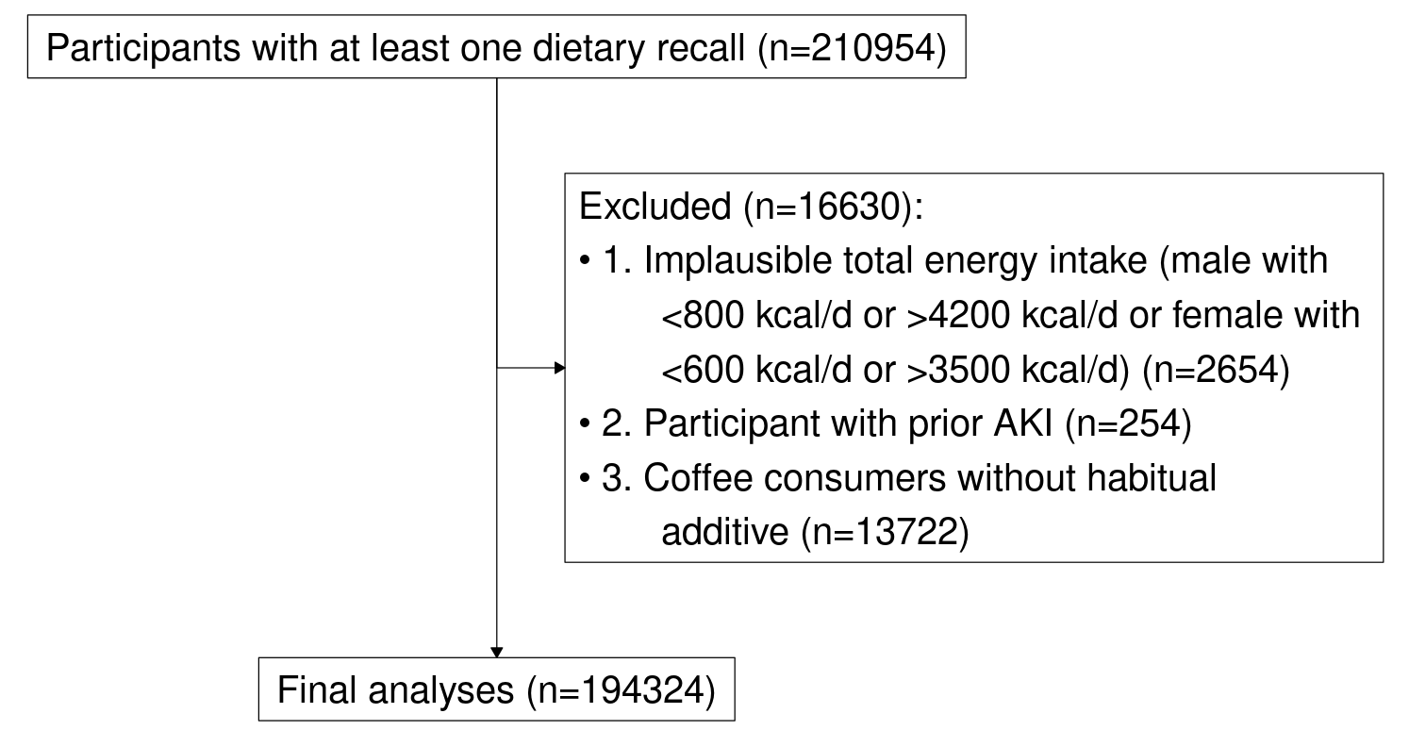

## Figure S1. The flow chart of study participants

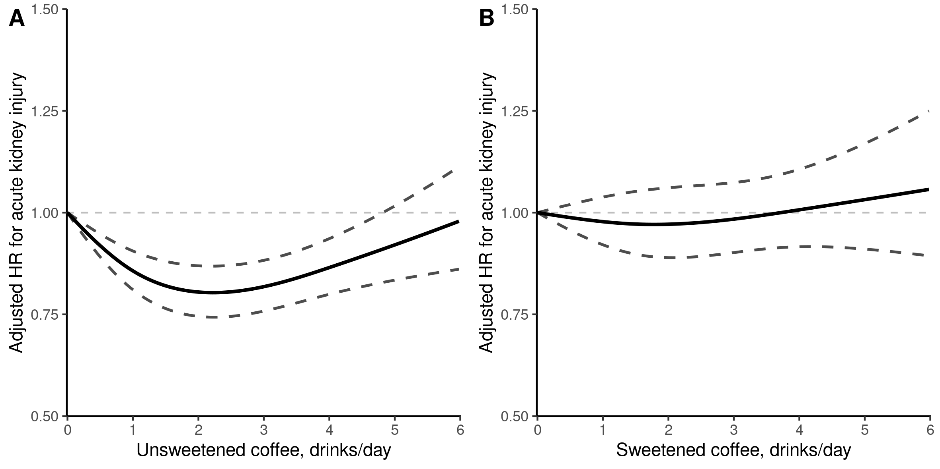

## Figure S2. Relationship of coffee consumption with new-onset acute kidney injury in unsweetened (A) and sweetened (B) coffee consumers*

* Adjusted for age, sex, ethnicity, body mass index, healthy diet score, income, employment, education level, Townsend deprivation index, smoking status, alcohol drinking, optimal physical activity, hypertension, diabetes mellitus, high cholesterol, chronic kidney disease, and cardiovascular disease

## Table S1. Coffee additives categories

|  |  |  |
| --- | --- | --- |
| **Categories of coffee additives** | n | % |
| **Non-consumers** | 48405 | 23.3 |
| **Habitual additive consumers** |  |  |
| no additives | 21053 | 10.1 |
| milk | 83761 | 40.3 |
| sugar | 3208 | 1.5 |
| artificial sweetener | 1562 | 0.8 |
| sugar & artificial sweetener | 105 | 0.1 |
| milk & sugar | 24717 | 11.9 |
| milk & artificial sweetener | 10639 | 5.1 |
| milk & sugar & artificial sweetener | 874 | 0.4 |
| **Non-habitual additive consumers** | 13722 | 6.6 |
| **Total** | 208046 | 100 |

## Table S2. Relationship of coffee consumption with different additives (unsweetened or sweetener) (versus no coffee consumption) with risk of new-onset acute kidney injury in various subgroups*

|  |  |  |  |  |
| --- | --- | --- | --- | --- |
| **Subgroups** | **Non-coffee consumers** | **Unsweetened coffee** | **Sweetened coffee** | **P value for interaction** |
| Age, yr |  |  |  | 0.755 |
| <60 | ref | 0.84 (0.75,0.93) | 0.96 (0.85,1.09) |  |
| ≥60 | ref | 0.87 (0.80,0.94) | 1.02 (0.93,1.11) |  |
| Sex |  |  |  | 0.616 |
| Female | ref | 0.81 (0.73,0.90) | 0.93 (0.83,1.05) |  |
| Male | ref | 0.85 (0.78,0.93) | 1.00 (0.92,1.10) |  |
| Body mass index, kg/m^2 |  |  |  | 0.547 |
| <30 | ref | 0.82 (0.76,0.89) | 0.95 (0.87,1.04) |  |
| ≥30 | ref | 0.87 (0.79,0.97) | 1.02 (0.91,1.15) |  |
| Smoking status |  |  |  | 0.859 |
| Current | ref | 0.80 (0.66,0.98) | 0.96 (0.79,1.16) |  |
| Previous | ref | 0.86 (0.78,0.95) | 1.02 (0.92,1.14) |  |
| Never | ref | 0.82 (0.75,0.90) | 0.94 (0.84,1.05) |  |
| Alcohol drinking |  |  |  | 0.961 |
| <1 times/w | ref | 0.84 (0.75,0.93) | 0.98 (0.87,1.10) |  |
| ≥1 times/w | ref | 0.82 (0.76,0.89) | 0.97 (0.88,1.06) |  |
| Optimal physical activity |  |  |  | 0.157 |
| No | ref | 0.87 (0.79,0.96) | 0.96 (0.86,1.07) |  |
| Yes | ref | 0.80 (0.73,0.87) | 0.99 (0.90,1.10) |  |
| Diabetes |  |  |  | 0.796 |
| No | ref | 0.84 (0.78,0.90) | 0.97 (0.90,1.05) |  |
| Yes | ref | 0.81 (0.69,0.95) | 0.99 (0.83,1.18) |  |
| Hypertension |  |  |  | 0.074 |
| No | ref | 0.76 (0.67,0.87) | 0.84 (0.73,0.98) |  |
| Yes | ref | 0.86 (0.80,0.93) | 1.02 (0.94,1.11) |  |
| High cholesterol |  |  |  | 0.325 |
| No | ref | 0.82 (0.76,0.89) | 0.95 (0.87,1.03) |  |
| Yes | ref | 0.89 (0.77,1.02) | 1.08 (0.93,1.26) |  |
| Cardiovascular disease |  |  |  | 0.575 |
| No | ref | 0.82 (0.76,0.88) | 0.97 (0.89,1.05) |  |
| Yes | ref | 0.90 (0.77,1.04) | 1.02 (0.87,1.19) |  |
| Chronic kidney disease |  |  |  | 0.908 |
| No | ref | 0.84 (0.78,0.91) | 0.99 (0.91,1.08) |  |
| Yes | ref | 0.87 (0.76,1.01) | 1.02 (0.87,1.19) |  |

* Adjusted for age, sex, ethnicity, body mass index, healthy diet score, income, employment, education level, Townsend deprivation index, smoking status, alcohol drinking, optimal physical activity, hypertension, diabetes mellitus, high cholesterol, chronic kidney disease, and cardiovascular disease

## Table S3. Relationship of coffee consumption with different additives (unsweetened or sweetener) (versus no coffee consumption) with risk of new-onset acute kidney injury stratified by weighted genetic caffeine metabolism score (wCMSG4)*

|  |  |  |  |  |
| --- | --- | --- | --- | --- |
| **Subgroups** | **Non-coffee consumers** | **Unsweetened coffee** | **Sweetened coffee** | **P value for interaction** |
| wCMSG4 |  |  |  | 0.736 |
| T1 | ref | 0.78 (0.70,0.87) | 0.95 (0.84,1.07) |  |
| T2 | ref | 0.85 (0.75,0.95) | 0.95 (0.83,1.08) |  |
| T3 | ref | 0.86 (0.77,0.96) | 0.99 (0.87,1.12) |  |

* Adjusted for age, sex, ethnicity, body mass index, healthy diet score, income, employment, education level, Townsend deprivation index, smoking status, alcohol drinking, optimal physical activity, hypertension, diabetes mellitus, high cholesterol, chronic kidney disease, and cardiovascular disease

**Table S4. Relationship of coffee consumption with new-onset acute kidney injury in coffee consumers with different additives (milk and/or sweetener) after excluding those developing acute kidney injury within 2 years**

|  |  |  |  |  |  |  |
| --- | --- | --- | --- | --- | --- | --- |
|  | **Non-consumer** | **Coffee consumers** | | | | |
| **0-1.5 drinks/d** | **1.5-2.5 drinks/d** | **2.5-3.5 drinks/d** | **3.5-4.5 drinks/d** | **>4.5 drinks/d** |
| **Unsweetened coffee** | ref | 0.84 (0.77, 0.92) | 0.79 (0.71, 0.86) | 0.81 (0.73, 0.90) | 0.87 (0.76, 0.99) | 1.00 (0.87, 1.15) |
| No additive | ref | 0.95 (0.82, 1.11) | 0.78 (0.65, 0.93) | 0.81 (0.66, 0.99) | 0.82 (0.64, 1.06) | 0.91 (0.68, 1.21) |
| Milk only addition | ref | 0.82 (0.75, 0.90) | 0.79 (0.72, 0.88) | 0.82 (0.72, 0.92) | 0.89 (0.77, 1.03) | 1.03 (0.88, 1.21) |
| **Sweetened coffee** | ref | 0.94 (0.86, 1.04) | 0.97 (0.87, 1.08) | 1.04 (0.91, 1.19) | 0.88 (0.74, 1.05) | 1.09 (0.91, 1.30) |
| Sweetener only addition | ref | 1.31 (1.05, 1.63) | 1.16 (0.89, 1.51) | 0.78 (0.53, 1.16) | 0.99 (0.62, 1.58) | 1.19 (0.78, 1.81) |
| Milk & Sweetener addition | ref | 0.90 (0.81, 1.00) | 0.94 (0.84, 1.06) | 1.08 (0.94, 1.24) | 0.87 (0.72, 1.05) | 1.07 (0.89, 1.30) |

Adjusted for age, sex, ethnicity, body mass index, healthy diet score, income, employment, education level, Townsend deprivation index, smoking status, alcohol drinking, optimal physical activity, hypertension, diabetes mellitus, high cholesterol, chronic kidney disease, and cardiovascular disease

**Table S5. Relationship of coffee consumption with new-onset acute kidney injury in coffee consumers with different additives (milk and/or sweetener) after further adjustment for intake of dairy product and total sugar**

|  |  |  |  |  |  |  |
| --- | --- | --- | --- | --- | --- | --- |
|  | **Non-consumer** | **Coffee consumers** | | | | |
| **0-1.5 drinks/d** | **1.5-2.5 drinks/d** | **2.5-3.5 drinks/d** | **3.5-4.5 drinks/d** | **>4.5 drinks/d** |
| **Unsweetened coffee** | *ref* | 0.85 (0.78, 0.92) | 0.79 (0.72, 0.87) | 0.82 (0.74, 0.91) | 0.88 (0.77, 1.00) | 1.02 (0.89, 1.17) |
| No additive | *ref* | 0.96 (0.82, 1.11) | 0.78 (0.66, 0.93) | 0.79 (0.64, 0.97) | 0.80 (0.62, 1.04) | 0.87 (0.66, 1.16) |
| Milk only addition | *ref* | 0.83 (0.76, 0.91) | 0.80 (0.72, 0.89) | 0.84 (0.74, 0.94) | 0.91 (0.79, 1.06) | 1.08 (0.92, 1.27) |
| **Sweetened coffee** | *ref* | 0.97 (0.88, 1.07) | 0.98 (0.87, 1.09) | 1.05 (0.92, 1.20) | 0.88 (0.73, 1.05) | 1.11 (0.93, 1.33) |
| Sweetener only addition | *ref* | 1.35 (1.09, 1.67) | 1.15 (0.89, 1.50) | 0.77 (0.53, 1.13) | 0.95 (0.59, 1.51) | 1.12 (0.73, 1.72) |
| Milk & Sweetener addition | *ref* | 0.92 (0.83, 1.02) | 0.95 (0.85, 1.07) | 1.09 (0.95, 1.26) | 0.87 (0.72, 1.05) | 1.11 (0.92, 1.34) |

Adjusted for age, sex, ethnicity, body mass index, healthy diet score, income, employment, education level, Townsend deprivation index, smoking status, alcohol drinking, optimal physical activity, hypertension, diabetes mellitus, high cholesterol, chronic kidney disease, cardiovascular disease, intake of dairy product, and total sugar.

**Table S6. Relationship of coffee consumption with new-onset acute kidney injury in coffee consumers with different additives (milk and/or sweetener) after further adjustment for the usage of diuretics and nonsteroidal anti-inflammatory drugs, history of hospital admission for major surgery, and baseline eGFR levels**

|  |  |  |  |  |  |  |
| --- | --- | --- | --- | --- | --- | --- |
|  | **Non-consumer** | **Coffee consumers** | | | | |
| **0-1.5 drinks/d** | **1.5-2.5 drinks/d** | **2.5-3.5 drinks/d** | **3.5-4.5 drinks/d** | **>4.5 drinks/d** |
| **Unsweetened coffee** | *ref* | 0.85 (0.78, 0.93) | 0.81 (0.73, 0.89) | 0.81 (0.73, 0.91) | 0.92 (0.81, 1.05) | 1.05 (0.91, 1.21) |
| No additive | *ref* | 0.98 (0.84, 1.15) | 0.83 (0.70, 0.99) | 0.78 (0.63, 0.96) | 0.90 (0.70, 1.16) | 0.93 (0.69, 1.25) |
| Milk only addition | *ref* | 0.83 (0.75, 0.91) | 0.81 (0.73, 0.89) | 0.83 (0.73, 0.93) | 0.93 (0.80, 1.07) | 1.09 (0.93, 1.27) |
| **Sweetened coffee** | *ref* | 0.96 (0.87, 1.06) | 0.99 (0.88, 1.11) | 1.05 (0.92, 1.20) | 0.91 (0.76, 1.09) | 1.14 (0.95, 1.36) |
| Sweetener only addition | *ref* | 1.35 (1.08, 1.69) | 1.21 (0.92, 1.58) | 0.79 (0.53, 1.17) | 1.00 (0.62, 1.62) | 1.19 (0.77, 1.83) |
| Milk & Sweetener addition | *ref* | 0.91 (0.82, 1.01) | 0.96 (0.85, 1.08) | 1.09 (0.95, 1.26) | 0.90 (0.74, 1.09) | 1.13 (0.93, 1.37) |

Adjusted for age, sex, ethnicity, body mass index, healthy diet score, income, employment, education level, Townsend deprivation index, smoking status, alcohol drinking, optimal physical activity, hypertension, diabetes mellitus, high cholesterol, chronic kidney disease, cardiovascular disease, usage of diuretics and nonsteroidal anti-inflammatory drugs, history of hospital admission for major surgery, and baseline eGFR levels.

## Table S7. Relationship of coffee consumption with new-onset acute kidney injury in various subgroups among unsweetened coffee consumers*

|  |  |  |  |  |  |  |  |
| --- | --- | --- | --- | --- | --- | --- | --- |
| **Subgroups** | **Non** | **coffee consumers** | | | | | **P for** |
| **consumer** | **0-1.5 drinks/d** | **1.5-2.5 drinks/d** | **2.5-3.5 drinks/d** | **3.5-4.5 drinks/d** | **>4.5 drinks/d** | **interaction** |
| Age, yr |  |  |  |  |  |  | 0.315 |
| <60 | ref | 0.91 (0.79,1.05) | 0.75 (0.63,0.88) | 0.77 (0.64,0.93) | 0.91 (0.74,1.14) | 0.88 (0.69,1.11) |  |
| ≥60 | ref | 0.85 (0.76,0.94) | 0.83 (0.75,0.93) | 0.85 (0.75,0.97) | 0.86 (0.74,1.01) | 1.09 (0.92,1.29) |  |
| Sex |  |  |  |  |  |  | 0.720 |
| Female | ref | 0.80 (0.70,0.91) | 0.78 (0.67,0.90) | 0.83 (0.70,0.97) | 0.80 (0.66,0.98) | 0.92 (0.74,1.15) |  |
| Male | ref | 0.87 (0.78,0.98) | 0.78 (0.70,0.89) | 0.79 (0.69,0.91) | 0.91 (0.77,1.07) | 1.04 (0.87,1.25) |  |
| Body mass index, kg/m^2 |  |  |  |  |  |  | 0.611 |
| <30 | ref | 0.83 (0.75,0.92) | 0.78 (0.70,0.87) | 0.76 (0.66,0.87) | 0.87 (0.74,1.03) | 1.03 (0.86,1.24) |  |
| ≥30 | ref | 0.86 (0.75,0.99) | 0.80 (0.69,0.94) | 0.92 (0.78,1.09) | 0.89 (0.73,1.09) | 0.99 (0.80,1.22) |  |
| Smoking status |  |  |  |  |  |  | 0.527 |
| Current | ref | 0.80 (0.60,1.07) | 0.66 (0.47,0.92) | 0.79 (0.57,1.10) | 0.75 (0.51,1.11) | 1.08 (0.79,1.49) |  |
| Previous | ref | 0.80 (0.70,0.92) | 0.84 (0.73,0.96) | 0.84 (0.72,0.98) | 0.98 (0.81,1.18) | 1.00 (0.81,1.24) |  |
| Never | ref | 0.88 (0.78,0.99) | 0.76 (0.66,0.86) | 0.78 (0.67,0.91) | 0.78 (0.64,0.96) | 0.93 (0.74,1.16) |  |
| Alcohol drinking |  |  |  |  |  |  | 0.274 |
| <1 times/w | ref | 0.92 (0.80,1.06) | 0.73 (0.61,0.88) | 0.77 (0.62,0.94) | 0.81 (0.64,1.03) | 0.91 (0.72,1.14) |  |
| >=1 times/w | ref | 0.79 (0.71,0.88) | 0.78 (0.70,0.87) | 0.81 (0.71,0.91) | 0.87 (0.75,1.02) | 1.03 (0.87,1.22) |  |
| Optimal physical activity |  |  |  |  |  |  | 0.259 |
| No | ref | 0.91 (0.81,1.03) | 0.77 (0.67,0.88) | 0.86 (0.74,1.00) | 0.91 (0.76,1.10) | 0.97 (0.79,1.18) |  |
| Yes | ref | 0.75 (0.67,0.85) | 0.79 (0.69,0.90) | 0.78 (0.67,0.90) | 0.85 (0.71,1.03) | 0.97 (0.79,1.20) |  |
| Diabetes |  |  |  |  |  |  | 0.958 |
| No | ref | 0.84 (0.77,0.92) | 0.79 (0.72,0.88) | 0.81 (0.72,0.91) | 0.88 (0.76,1.01) | 1.01 (0.87,1.18) |  |
| Yes | ref | 0.85 (0.69,1.06) | 0.73 (0.57,0.93) | 0.78 (0.60,1.01) | 0.79 (0.58,1.09) | 0.91 (0.65,1.27) |  |
| Hypertension |  |  |  |  |  |  | 0.730 |
| No | ref | 0.77 (0.66,0.91) | 0.70 (0.59,0.84) | 0.75 (0.61,0.92) | 0.79 (0.61,1.02) | 0.91 (0.69,1.19) |  |
| Yes | ref | 0.86 (0.78,0.95) | 0.81 (0.73,0.91) | 0.83 (0.73,0.93) | 0.89 (0.77,1.03) | 1.02 (0.87,1.20) |  |
| High cholesterol |  |  |  |  |  |  | 0.629 |
| No | ref | 0.84 (0.76,0.92) | 0.76 (0.69,0.85) | 0.78 (0.70,0.88) | 0.83 (0.71,0.96) | 1.01 (0.86,1.17) |  |
| Yes | ref | 0.85 (0.70,1.02) | 0.85 (0.70,1.04) | 0.90 (0.71,1.12) | 1.02 (0.78,1.33) | 0.94 (0.69,1.29) |  |
| Chronic kidney disease |  |  |  |  |  |  | 0.370 |
| No | ref | 0.85 (0.77,0.94) | 0.79 (0.71,0.88) | 0.77 (0.68,0.87) | 0.90 (0.78,1.05) | 1.08 (0.92,1.26) |  |
| Yes | ref | 0.91 (0.76,1.09) | 0.79 (0.64,0.97) | 0.91 (0.73,1.15) | 0.89 (0.67,1.18) | 0.80 (0.56,1.14) |  |
| Cardiovascular disease |  |  |  |  |  |  | 0.144 |
| No | ref | 0.81 (0.74,0.89) | 0.78 (0.71,0.87) | 0.79 (0.70,0.89) | 0.85 (0.74,0.98) | 1.03 (0.89,1.20) |  |
| Yes | ref | 1.01 (0.83,1.22) | 0.76 (0.61,0.96) | 0.89 (0.69,1.14) | 0.92 (0.68,1.25) | 0.80 (0.57,1.14) |  |

* Adjusted for age, sex, ethnicity, body mass index, healthy diet score, income, employment, education level, Townsend deprivation index, smoking status, alcohol drinking, optimal physical activity, hypertension, diabetes mellitus, high cholesterol, chronic kidney disease, and cardiovascular disease

## Table S8. Relationship of coffee consumption with new-onset acute kidney injury among unsweetened coffee consumers stratified by weighted genetic caffeine metabolism score (wCMSG4)*

|  |  |  |  |  |  |  |  |
| --- | --- | --- | --- | --- | --- | --- | --- |
| **Subgroups** | **Non** | **coffee consumers** | | | | | **P for** |
| **consumer** | **0-1.5 drinks/d** | **1.5-2.5 drinks/d** | **2.5-3.5 drinks/d** | **3.5-4.5 drinks/d** | **>4.5 drinks/d** | **interaction** |
| wCMSG4 |  |  |  |  |  |  | 0.760 |
| T1 | ref | 0.80 (0.69,0.92) | 0.76 (0.65,0.89) | 0.69 (0.57,0.84) | 0.79 (0.63,0.99) | 0.96 (0.75,1.22) |  |
| T2 | ref | 0.82 (0.71,0.96) | 0.75 (0.63,0.89) | 0.88 (0.74,1.06) | 0.97 (0.78,1.20) | 1.01 (0.79,1.29) |  |
| T3 | ref | 0.88 (0.76,1.01) | 0.82 (0.70,0.95) | 0.82 (0.69,0.99) | 0.83 (0.66,1.04) | 0.99 (0.78,1.26) |  |

* Adjusted for age, sex, ethnicity, body mass index, healthy diet score, income, employment, education level, Townsend deprivation index, smoking status, alcohol drinking, optimal physical activity, hypertension, diabetes mellitus, high cholesterol, chronic kidney disease, and cardiovascular disease