|  |  |
| --- | --- |
| Table S1. Example of foods and ingredients included in the CHDI components. | |
| Components | Example of included items |
| Fruits | All fruits, except fruits juices |
| Vegetables | All vegetables, except tubers. |
| Fish and seafood | Boiled and fried fish |
| Red meat | Beef and pork |
| SSB | Sweetened juices, sweetened coffees and teas, sodas. |
| Whole cereals | Whole bread, brown rice and oatmeal |
| Legumes | Beans and lentils |
| Nuts | Nuts and peanuts |
| Processed meat | Processed meat, such as sausage and ham |
| Dairy | All dairy, such as milks, yogurts and cheeses. |
| Ultraprocessed food | All ultra-processed foods classified by Nova (e.g., sweet bread, salty and sweet biscuits, margarine etc.) |

|  |  |  |  |  |  |
| --- | --- | --- | --- | --- | --- |
| Table S2. Baseline characteristics of individuals according to the CAC incidence on follow-up (*n* 2,224). | | | | | |
|  | No CAC incidence | | CAC incidence | | *p*-valuea |
|  | n | % | n | % |  |
| Total | 1,893 | 85.1 | 331 | 14.9 |  |
| Sex |  |  |  |  | 0.012 |
| Male | 681 | 36.0 | 143 | 43.2 |  |
| Female | 1,212 | 64.0 | 188 | 56.8 |  |
| Age group |  |  |  |  | <0.001 |
| Adults (34–59 years) | 1,796 | 94.9 | 285 | 86.1 |  |
| Elderly (> 60 years) | 97 | 5.1 | 46 | 13.9 |  |
| Self-reported race |  |  |  |  | 0.068 |
| White | 1,016 | 53.7 | 199 | 60.1 |  |
| Brown | 454 | 24.0 | 78 | 23.6 |  |
| Black | 341 | 18.0 | 42 | 12.7 |  |
| Indigenous and Asians | 82 | 4.3 | 12 | 3.6 |  |
| Income |  |  |  |  | 0.255 |
| Low | 959 | 50.7 | 160 | 48.3 |  |
| Medium | 621 | 32.8 | 104 | 31.4 |  |
| High | 313 | 16.5 | 67 | 20.2 |  |
| Smoking |  |  |  |  | <0.001 |
| Never and past smoker | 1,639 | 86.6 | 257 | 77.6 |  |
| Current smoker | 254 | 13.4 | 74 | 22.4 |  |
| High alcohol consumption |  |  |  |  | 0.353 |
| No | 1,714 | 90.5 | 305 | 92.2 |  |
| Yes | 179 | 9.5 | 26 | 7.8 |  |
| Physical activity level |  |  |  |  | 0.244 |
| Low | 1,544 | 81.6 | 261 | 78.9 |  |
| Moderate-to-vigorous | 349 | 18.4 | 70 | 21.1 |  |
| aChi-square test. |  |  |  |  |  |

|  |  |  |  |  |  |
| --- | --- | --- | --- | --- | --- |
| Table S3.Baseline characteristics of individuals according to the CAC progression on follow-up (*n* 725). | | | | | |
|  | No CAC progression | | CAC progression | | *p*-valuea |
|  | n | % | n | % |  |
| Total | 283 | 39.0 | 442 | 61.0 |  |
| Sex |  |  |  |  | 0.174 |
| Male | 167 | 59.0 | 283 | 64.0 |  |
| Female | 116 | 41.0 | 159 | 36.0 |  |
| Age group |  |  |  |  | 0.130 |
| Adults (34–59 years) | 192 | 67.8 | 323 | 73.1 |  |
| Elderly (> 60 years) | 91 | 32.2 | 119 | 26.9 |  |
| Self-reported race |  |  |  |  | 0.223 |
| White | 163 | 57.6 | 242 | 54.8 |  |
| Brown | 60 | 21.2 | 107 | 24.2 |  |
| Black | 31 | 11.0 | 62 | 14.0 |  |
| Indigenous and Asians | 29 | 10.2 | 31 | 7.00 |  |
| Renda per capita |  |  |  |  | 0.538 |
| Low | 119 | 40.1 | 196 | 44.3 |  |
| Medium | 81 | 28.6 | 133 | 30.1 |  |
| High | 83 | 29.3 | 113 | 25.6 |  |
| Smoking |  |  |  |  | 0.200 |
| Never and past smoker | 235 | 83.0 | 350 | 79.2 |  |
| Current smoker | 48 | 17.0 | 92 | 20.8 |  |
| High alcohol consumption |  |  |  |  | 0.3094 |
| No | 256 | 90.5 | 389 | 88.0 |  |
| Yes | 27 | 9.5 | 53 | 12.0 |  |
| Physical activity level |  |  |  |  | 0.469 |
| Low | 215 | 76.0 | 346 | 78.3 |  |
| Moderate-to-vigorous | 68 | 24.0 | 96 | 21.7 |  |
| aChi-square test. |  |  |  |  |  |

|  |  |  |  |  |  |  |
| --- | --- | --- | --- | --- | --- | --- |
| Table S4. Carotid intima-media thickness baseline values according to baseline characteristics (*n* 7,341). ELSA-Brasil. | | | | | | |
|  |  |  | cIMT (mm) | | |  |
|  | *n* | % | mean | 95% CI | | *p*-valuea |
| Total | 7,341 | 100 | 0.600 | 0.596 | 0.602 |  |
| Sex |  |  |  |  |  | <0.001 |
| Men | 3,160 | 43.0 | 0.618 | 0.613 | 0.622 |  |
| Women | 4,181 | 57.0 | 0.585 | 0.581 | 0.589 |  |
| Age group |  |  |  |  |  | <0.001 |
| Adults (34–59 years) | 6,096 | 83.0 | 0.578 | 0.575 | 0.581 |  |
| Elderly (> 60 years) | 1,245 | 17.0 | 0.701 | 0.694 | 0.708 |  |
| Self-reported race |  |  |  |  |  | <0.001 |
| White | 4,366 | 59.5 | 0.598 | 0.592 | 0.600 |  |
| Brown | 1,685 | 23.0 | 0.590 | 0.585 | 0.596 |  |
| Black | 1,001 | 13.6 | 0.620 | 0.612 | 0.628 |  |
| Indigenous and Asians | 289 | 3.9 | 0.614 | 0.600 | 0.629 |  |
| Renda per capita |  |  |  |  |  | <0.001 |
| Low | 2,624 | 35.8 | 0.595 | 0.589 | 0.600 |  |
| Medium | 2,551 | 34.8 | 0.592 | 0.587 | 0.597 |  |
| High | 2,166 | 29.5 | 0.613 | 0.607 | 0.618 |  |
| Smoking |  |  |  |  |  | <0.001 |
| Never and past smoker | 6,406 | 87.3 | 0.597 | 0.594 | 0.600 |  |
| Current smoker | 935 | 12.7 | 0.614 | 0.605 | 0.623 |  |
| High alcohol consumption |  |  |  |  |  | 0.040 |
| No | 6,485 | 88.3 | 0.598 | 0.595 | 0.601 |  |
| Yes | 856 | 11.7 | 0.608 | 0.599 | 0.616 |  |
| Physical activity level |  |  |  |  |  | 0.755 |
| Low | 5,600 | 76.3 | 0.599 | 0.596 | 0.602 |  |
| Moderate-to-vigorous | 1,741 | 23.7 | 0.600 | 0.595 | 0.606 |  |
| at-test or ANOVA. |  |  |  |  |  |  |

|  |  |  |  |
| --- | --- | --- | --- |
| Table S5. Linear mixed-effects models between the Cardiovascular Health Diet Index components with longitudinal carotid intima-media thickness (*n* 7,341). ELSA-Brasil, 2008-2010 – 2017-2018. | | | |
|  | cIMT (mm) | |  |
|  | *β* | (95% CI) | *p*-value |
| *Cardiovascular Health Diet Index components* | | | |
|  |  |  |  |
| Vegetables | 0.0002 | –0.0008; 0.0013 | 0.640 |
| Vegetables score x time | –0.0001 | –0.0002; 0.0001 | 0.102 |
|  |  |  |  |
| Fruits | 0.0007 | –0.0003; 0.0017 | 0.152 |
| Fruits x time | –0.0001 | –0.0002; –0.0000 | 0.013 |
|  |  |  |  |
| Whole cereals | –0.0009 | –0.0017; –0.0001 | 0.031 |
| Whole cereals score x time | –0.0002 | –0.0003; –0.0001 | <0.001 |
|  |  |  |  |
| Nuts | –0.0012 | –0.0020; –0.0003 | 0.007 |
| Nuts x time | –0.0001 | –0.0002; –0.000 | 0.029 |
|  |  |  |  |
| Legumes | –0.0007 | –0.0017; 0.0003 | 0.149 |
| Legumes x time | 0.0002 | 0.0001; 0.0003 | <0.001 |
|  |  |  |  |
| Fish | –0.0001 | –0.0008; 0.0008 | 0.920 |
| Fish x time | 0.0001 | –0.0000; 0.0001 | 0.188 |
|  |  |  |  |
| Dairy | –0.0002 | –0.0010; 0.0005 | 0.572 |
| Dairy x time | –0.0001 | –0.0002; –0.0000 | 0.17 |
|  |  |  |  |
| Red meat | –0.0004 | –0.0015; 0.0006 | 0.409 |
| Red meat x time | –0.0001 | –0.0002; –0.0000 | 0.041 |
|  |  |  |  |
| Processed meat | –0.0008 | –0.0014; –0.0001 | 0.040 |
| Processed meat x time | –0.0001 | –0.0002; –0.0000 | 0.004 |
|  |  |  |  |
| SSBs | –0.0012 | –0.0022; –0.0003 | 0.009 |
| SSBs x time | –0.0000 | –0.0001; 0.0001 | 0.392 |
|  |  |  |  |
| Ultra-processed foods | –0.0017 | –0.0027; –0.0007 | <0.001 |
| Ultra-processed foods x time | 0.0002 | 0.0001; 0.0003 | <0.001 |
| Values are regression coefficients (*β)* and 95% confidence intervals (95% CIs) based on linear mixed models, and reflect differences in cIMT averaged across a median follow-up of 8.2 years per 10 points higher score in the diet quality scores, adjusted by age, sex, self-reported race, per capita income, smoking status, alcohol consumption, physical activity level, total energy intake, and presence of dyslipidemia and statin use. cIMT, carotid intima-media thickness. CHDI, Cardiovascular Health Diet Index. | | | |

|  |  |  |  |  |
| --- | --- | --- | --- | --- |
| Table S6. Poisson regression models of the association between Healthy Eating Index-2015 with CAC incidence (*n* 2,224). ELSA-Brasil, 2008-2010 – 2012-2014. | | | | |
|  | CAC incidence | | |  |
|  | IRR | 95% CI | | p-value |
| Healthy Eating Index-2015 score |  |  |  |  |
| Unadjusted model | 1.10 | 0.97 | 1.23 | 0.119 |
| Model 1 | 1.04 | 0.93 | 1.17 | 0.494 |
| Model 2 | 1.07 | 0.95 | 1.20 | 0.246 |
| Model 1 adjusted by age, sex, self-reported race and per capita income. Model 2 adjusted by Model 1 plus smoking status, alcohol consumption, physical activity level and total energy intake. | | | | |

|  |  |  |  |  |
| --- | --- | --- | --- | --- |
| Table S7. Poisson regression models of the association between Healthy Eating Index-2015 with CAC progression (*n* 725).ELSA-Brasil, 2008-2010 – 2012-2014. | | | | |
|  | CAC progression | | |  |
|  | IRR | 95% CI | | p-value |
| Healthy Eating Index-2015 score |  |  |  |  |
| Unadjusted model | 1.10 | 0.97 | 1.23 | 0.119 |
| Model 1 | 1.04 | 0.93 | 1.17 | 0.494 |
| Model 2 | 1.07 | 0.95 | 1.20 | 0.246 |
| Model 1 adjusted by age, sex, self-reported race and per capita income. Model 2 adjusted by Model 1 plus smoking status, alcohol consumption, physical activity level and total energy intake. | | | | |

|  |  |  |  |
| --- | --- | --- | --- |
| Table S8. Linear mixed-effects regressions between the Healthy Eating Index-2015 with longitudinal carotid intima-media thickness (*n* 7,341). ELSA-Brasil, 2008-2010 – 2017-2019. | | | |
|  | cIMT (mm) | |  |
|  | *β* | (95% CI) | *p*-value |
| *Healthy Eating Index-2015* | | | |
| Unadjusted model |  |  |  |
| HEI-2015 score | –0.0048 | –0.0078; –0.0018 | 0.002 |
| HEI-2015 score x time | –0.0005 | –0.0009; –0.0002 | 0.002 |
| Model 1 |  |  |  |
| HEI-2015 score | –0.0022 | –0.0051; 0.0008 | 0.151 |
| HEI-2015 score x time | –0.0006 | –0.0009; –0.0003 | <0.001 |
| Model 2 |  |  |  |
| HEI-2015 score | –0.0007 | –0.0038; 0.0023 | 0.632 |
| HEI-2015 score x time | –0.0005 | –0.0009; –0.0002 | 0.002 |
| Values are regression coefficients (*β)* and 95% confidence intervals (95% CIs) based on linear mixed models, and reflect differences in cIMT averaged across a median follow-up of 8.2 years per 10 points higher score in the diet quality score, adjusted by age, sex, self-reported race, per capita income, smoking status, alcohol consumption, physical activity level, total energy intake, and presence of dyslipidemia and statin use. cIMT, carotid intima-media thickness. HEI-2015, Healthy Eating Index-2015. | | | |

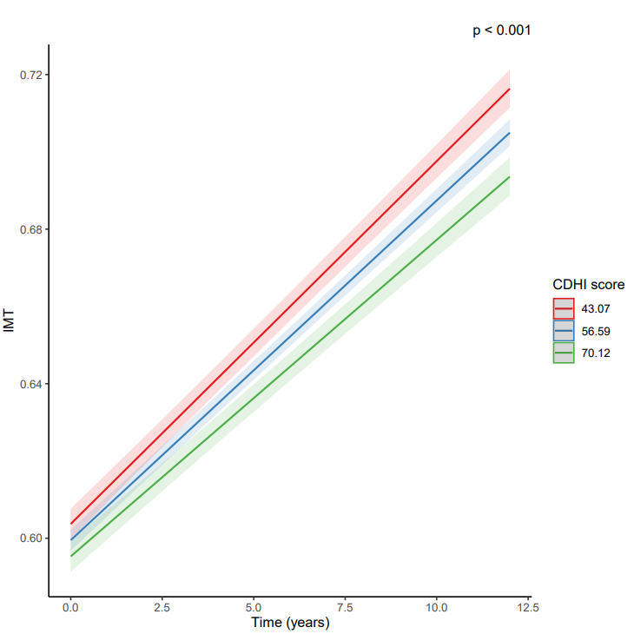

1st tertile

2nd tertile

3rd tertile

**Figure S1**. cIMT changes over time according to the Cardiovascular Health Diet Index (CHDI) categories. 1st tertile mean 42.2 (min – max: 12.0 – 50.5), 2nd tertile mean 56.1 (50.6 – 61.9), 3rd tertile mean 71.6 (62.0 – 106.5).