**Associations of** **various healthy dietary patterns with biological age acceleration and the mediating role of gut microbiota: results from the China Multi-Ethnic Cohort study**

Supplementary materials

Supplementary Methods 2

Assessment of dietary score 2

Covariates 2

Statistical analysis 3

Follow-up adjusted for baseline analysis 3

Quantile G-computation method 3

The correlation between taxa and multiple test correction 3

Supplementary Figures 4

Supplementary Figure 1. Flowchart of participant selection in the study. 4

Supplementary Figure 2. The constructed directed acyclic graph (DAG) 5

Supplementary Figure 3. The rarefaction curves 6

Supplementary Figure 4. The correlation between taxa in phylum 7

Supplementary Tables 8

Supplementary Table 1. The food groups and scoring criteria of dietary patterns. 8

Supplementary Table 2. The missing information of covariates 10

Supplementary Table 3. Comparison of the baseline characteristics between the complete-cases data (association analysis samples) and the corresponding entire-population dataset. 11

Supplementary Table 4. Relative weights of food groups associated with KDM-AA. 12

Supplementary Table 5. Stratified analysis on the association between various dietary patterns and KDM-AA according to predefined characteristics. 14

Supplementary Table 6. Baseline characteristics of the mediation analysis sample according to quintiles of various dietary patterns scores (N = 764). 15

Supplementary Table 7. Mediating effects of α-diversity indices on the associations between various dietary patterns and KDM-AA. 17

Supplementary Table 8. Mediating effects of taxa at phylum-level and genus-level on the associations between dietary patterns and KDM-AA. 18

Supplementary Table 9. Sensitivity analysis of the associations of dietary patterns with KDM-AA in association analysis samples further excluding outliers of KDM-AA that were greater than 4 times the standard deviation. 20

Supplementary Table 10. Sensitivity analysis of the associations of dietary patterns with KDM-AA in entire-population dataset imputed covariates. 21

Supplementary Table 11. Sensitivity analysis of the associations of binary dietary indicators with KDM-AA. 22

Supplementary Table 12. Sensitivity analysis of the associations of ternary dietary indicators with KDM-AA. 22

Supplementary Table 13. Sensitivity analysis of the associations of quaternary dietary indicators with KDM-AA. 23

Supplementary Table 14. Sensitivity analysis of the cross-sectional analysis of the association between dietary patterns and KDM-AA. 24

Supplementary Table 15. Sensitivity analysis of the association between dietary patterns and KDM-AA in association analysis samples further excluding baseline chronic disease. 25

Reference 26

# Supplementary Methods

## Assessment of dietary score

PDI,hPDI and uPDI were conducted to measure individuals' adherence to plant-based diet[1]. The plant-based diet included 7 healthy plant foods (tubers, fresh vegetables, soybean products, fresh fruits, coarse grain, tea, vegetable oil), 2 unhealthy plant foods (preserved vegetables, fine grain (rice and wheat products)) and 6 animal foods (red and processed meat, poultry, fish/sea food, eggs, dairy products, animal oil). The food groups used to assess the plant-based diet in our study differ from previous studies[1, 2], possibly due to relatively large differences in Chinese and western diets, where certain food groups are consumed less in China[3]. Additionally, this study excluded nuts and sugar due to a lack of consumption profile for these food groups. Each food group was categorized into quintiles (Q1-Q5) and assigned a score from 1 to 5. The theoretical range for the total scores is 15-75. Three plant-based diet indices used different scoring criteria (positive or negative scores) for healthy plant foods, unhealthy plant foods, and animal foods, respectively. The detailed food groups and scoring criteria provided in **Table S1**.

The Healthy Diet Score (HDS) is determined by 5 specific healthy dietary groups: fresh vegetables, soybean products, fresh fruits, fish/seafood, and dairy products [4] (**Table S1**). Nut consumption was not included in the analysis due to the lack of corresponding consumption information. Each food group was categorized into quintiles (Q1-Q5) and assigned a score from 1 to 5. All groups were assigned positive scores (the lowest quintile for 1, the highest quintile for 5). The total score ranging from 5 to 25.

The DASH score was calculated to assess adherence to DASH diet, including seven food groups: fresh fruit, fresh vegetables, soybean products, dairy products, coarse grain, red and processed meat, and salt[5] (**Table S1**). In our cohort, there was a low consumption of non-fat and low-fat soybean products, as well as SSBs. Therefore, we substituted full-fat soybean products and excluded SSBs in our calculations. Each group was categorized into quintiles (Q1-Q5) and assigned a score from 1 to 5. we assigned reverse scores (the lowest quintile for 5, the highest quintile for 1) for red and processed meat as well as salt, while the other groups were assigned positive scores. The theoretical range for the total DASH scores is 7-35.

The aMED score was computed to evaluate adherence to a mediterranean diet among non-mediterranean populations, considering eight food groups: fresh vegetables, soybean products, fresh fruit, coarse grain, fish/seafood, MUFA: SFA (the ratio of monounsaturated fatty acids to saturated fatty acids), red and processed meats, and alcohol[5] (**Table S1**). The nut was not included due to the lack of information on nut consumption. Each group was categorized into quintiles (Q1-Q5) and assigned a score from 1 to 5. We assigned reverse scores for red and processed meat, while the other groups (except for alcohol) were assigned positive scores. Alcohol consumption was assigned higher scores for moderate drinking, lower scores for lower or excessive drinking, and score ranged from 1 to 5. Specifically, the alcohol consumptions were categorized into five groups: (10,30], (0,10] or (30,40], 0 or (40,45], (45,50], and >50 grams per day for men; (5,15], (0,5] or (15,25], 0 or (25,30], (30,35], and >35 grams per day for women, and then we assigned descending scores of 1-5 to corresponding individuals. The theoretical range for the total aMED score is 8-40.

## Covariates

The main covariates based on the DAG diagram in the association analysis were elaborated as follows: age (years), sex (female, male), ethnicity(Han, Non-Han), marital status (married, unmarried), education (college or above, high school, less than high school, never been to school), annual household income(<12000CNY,12000-19999CNY,20000-59999CNY,60000-99999CNY,100000-200000CNY, >200000 CNY), family history of cardiovascular metabolic diseases (yes, no), urbanicity (rural , urban), smoking status(never smoking, current smoking, present smoking), total energy intake (kcal/week), physical activity (METs-h/day), BMI(kg/m2), insomnia symptom(yes, no), dietary supplement(yes, no) , depressive symptom (yes, no), anxiety symptom (yes , no), beverage consumption(never drinking, current drinking, present drinking), Occupation[Primary industry (refers to occupations that involves getting raw materials, such as agriculture, forestry, fishing, and mining), Secondary industry(refers to occupations that involves the transformation of the raw material into manufactured goods, such as factory worker),Tertiary industry(refers to occupations that involves the giving away direct services to its consumers, such as administrator, teacher, sales, etc.)].

Previous studies have indicated that alcohol intake is a significant confounding factor in the association between the microbiome and disease[6]. Therefore, in the mediation analysis, we additionally adjusted for pure alcohol intake. The main covariates in the mediation analysis were further elaborated as follows: age (years), sex (female, male), ethnicity (Han, Non-Han), family history of cardiovascular metabolic diseases (yes, no), marital status (married, unmarried), urbanicity (rural, urban), physical activity (METs-h/day), total energy intake (kcal/week), BMI (kg/m2), insomnia symptom (yes, no), and alcohol intake (g/week).

## Statistical analysis

### Follow-up adjusted for baseline analysis

Follow-up adjusted for baseline analysis[7] refers to constructing regression of follow-up outcomes on baseline exposures while simultaneously adjusting for baseline outcome variables. To some extent, this approach alleviates concerns related to reverse causality and reduces the impact of unmeasured confounding by adjusting for baseline outcomes. The constructed regression model is as follows:

Y1 represents the follow-up outcome variable. X0 represents the baseline exposure variable. Y0 represents the baseline outcome variable and Z0 represents potential confounding factors at baseline.

### Quantile G-computation method

In our study, the QGC method was used to assess the relative contributions of all food groups in the study and corresponding food groups in each dietary pattern associated with KDM-AA. The QGC method directly constructs linear or generalized linear models based on classification of quantile exposures and estimates effects using the g-computation method and concept[8]. QGC is widely used in analyzing data with multidimensional mixtures or multiple exposures in epidemiological studies. In our study, the specific process is as follows:

Firstly, classifying component variables by processing them into quantiles or treating them as original scales. In our study, food groups were categorized into quintiles and coded as 1-5.

Secondly, fitting regression model. The constructed regression model is as follows (omitting covariates for model simplification).

$$Y_{i}=β_{0}+\sum_{j=1}^{k}{β_{j}X_{ji}^{q}}+ε_{i}$$

𝑘 represents the total number of exposures. 𝜀 represents the error term. 𝛽𝑗 represents the respective effects of each food group. 𝜓 = $Σ_{j=1}^{k}$ βj represents the overall combined effect size of all food groups, indicating the average change in outcome variable when each group changes by one quintile simultaneously. QGC calculates the weights of food group for positive and negative effects separately, with the sum of the weights being 1 and -1 respectively.

### The correlation between taxa and multiple test correction

Given the potential strong correlations between taxa, which could result in non-independence of single tests[9]. We used Spearman correlation to describe the correlation between the 16 most abundant phylum. For phylum with |r|>0.3 and corresponding *P* value < 0.05, no multiple testing correction was applied[10]. Finally, we performed multiple testing corrections on 7 phylum-level taxa, including Synergistetes, Spirochaetes, Tenericutes, Gemmatimonadetes, Firmicutes, Verrucomicrobia, and Bacteroidetes. The detailed results could be found in **Figure S4**. At the genus-level, we applied multiple testing corrections to the genus within the same phylum.

# Supplementary Figures

## Supplementary Figure 1. Flowchart of participant selection in the study.

Diet-related data include FFQ-related food groups which are necessary for constructing the six dietary indices. Anomalous total energy intake was < 4200 kcal/week or >24500 kcal/week for female, <5600 kcal/week or >29400 kcal/week for male. Implausible BMI was defined as < 14 kg/m2 or >45 kg/m2. Gastrointestinal-related diseases included digestive ulcers, gastritis, gallstones, and cholecystitis. Covariates in association analysis sample included age, sex, ethnicity, marital status, education, annual household income, occupation, family history of cardiovascular metabolic diseases, urbanicity, smoking status, physical activity, total energy intake, BMI, dietary supplement, insomnia symptom, depressive symptom, anxiety symptom, beverage consumption. Covariates in mediation analysis sample included age, sex, ethnicity, marital status, family history, urbanicity, physical activity, total energy intake, BMI, insomnia symptom, and alcohol intake.

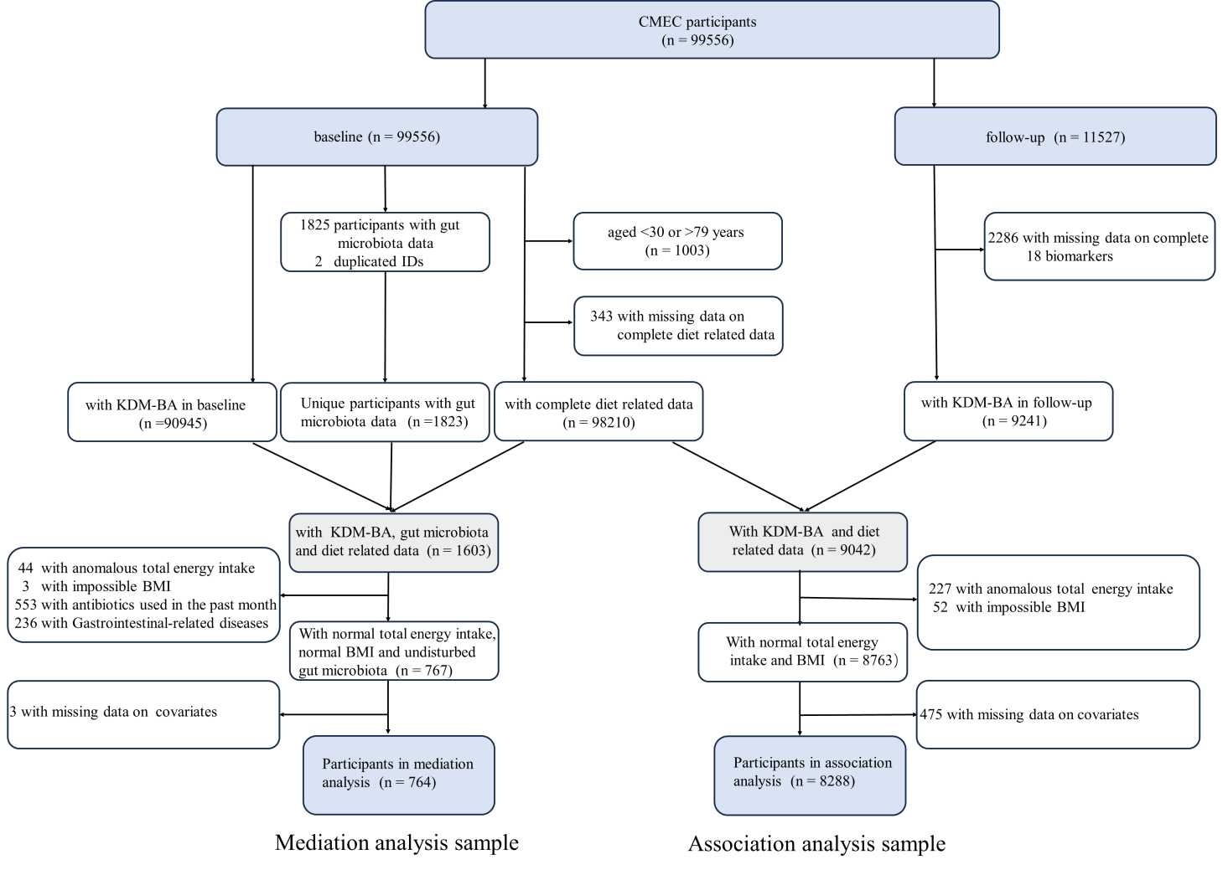

## Supplementary Figure 2. The constructed directed acyclic graph (DAG)

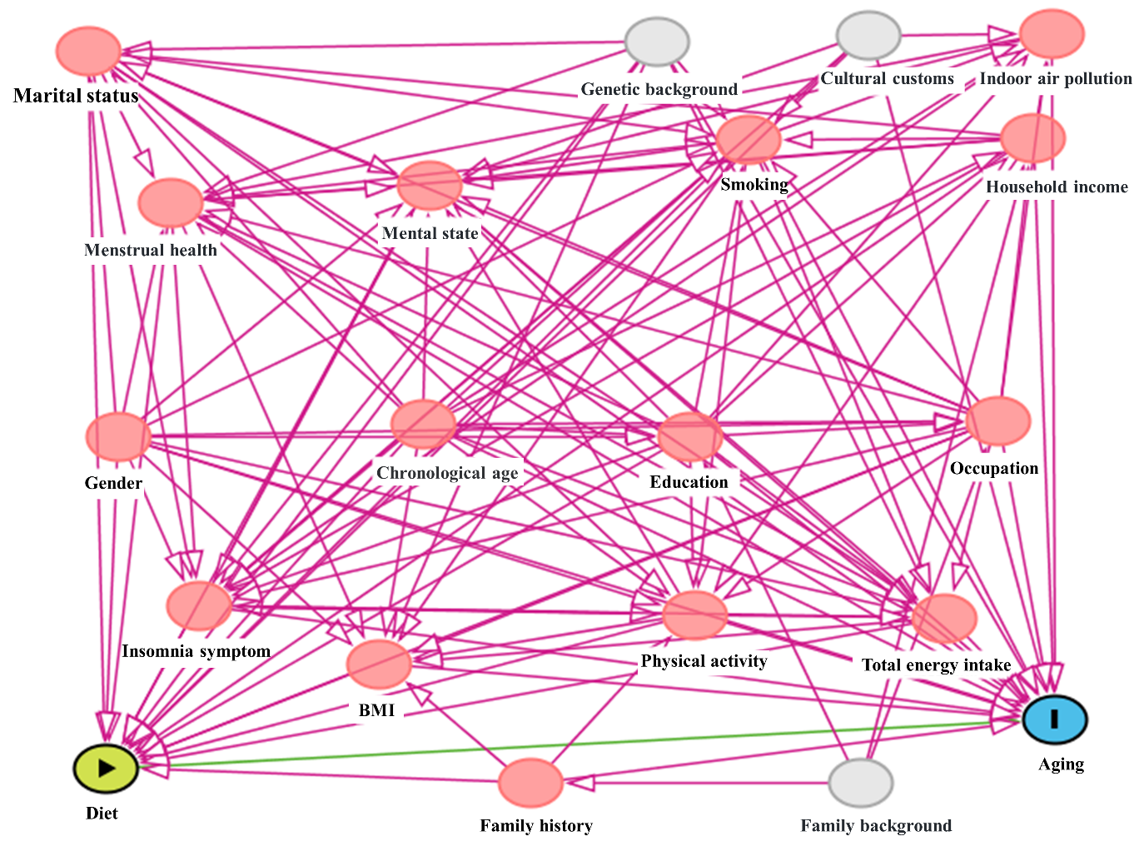

## Supplementary Figure 3. The rarefaction curves

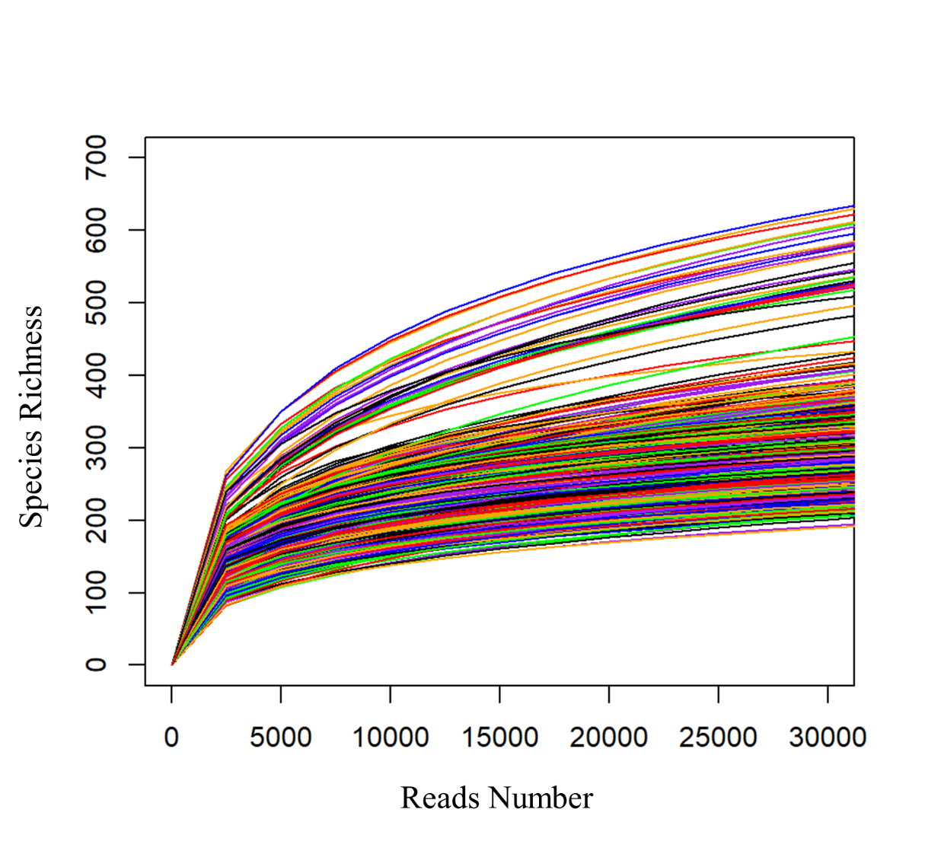

## Supplementary Figure 4. The correlation between taxa in phylum

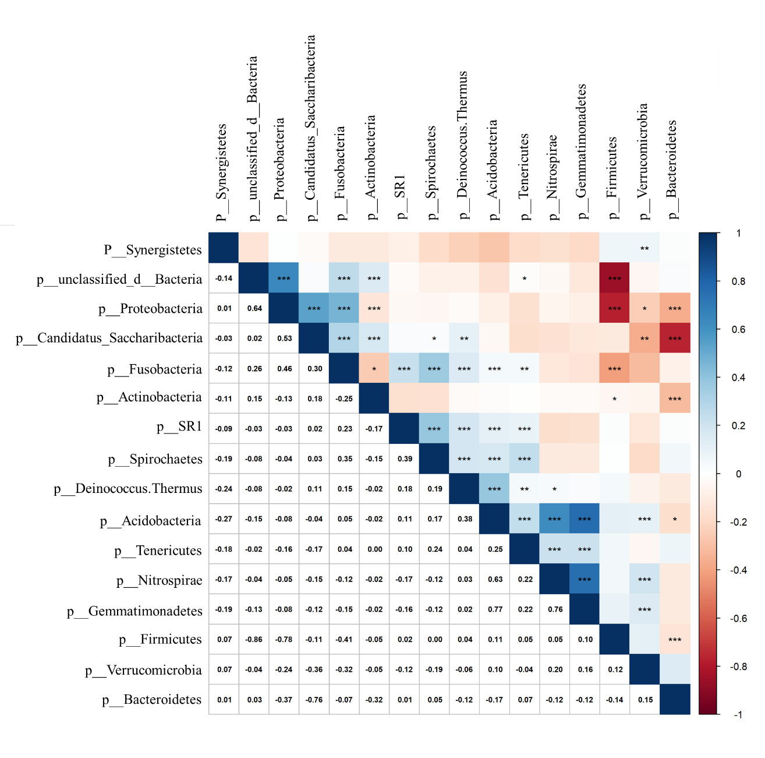

# Supplementary Tables

## Supplementary **Table 1. The food** groups **and scoring criteria of dietary patterns.**

|  |  |  |  |  |
| --- | --- | --- | --- | --- |
| **Dietary patterns** | **Food groups** | **Scoring criteria** | **Minimal score** | **Maximal score** |
| **PDI** |  |  | 1 | 5 |
| Tubers | Positive scores | Quintile 1 | Quintile 5 |
| Fresh vegetables | Quintile 1 | Quintile 5 |
| Soybean products | Quintile 1 | Quintile 5 |
| Fresh fruits | Quintile 1 | Quintile 5 |
| Coarse grain | Quintile 1 | Quintile 5 |
| Tea | Quintile 1 | Quintile 5 |
| Vegetable oil | Quintile 1 | Quintile 5 |
| Preserved vegetables | Positive scores | Quintile 1 | Quintile 5 |
| Fine grain | Quintile 1 | Quintile 5 |
| Red and processed meat | Negative scores | Quintile 5 | Quintile 1 |
| Poultry | Quintile 5 | Quintile 1 |
| Fish/sea food | Quintile 5 | Quintile 1 |
| Eggs | Quintile 5 | Quintile 1 |
| Dairy products | Quintile 5 | Quintile 1 |
| Animal oil | Quintile 5 | Quintile 1 |
| **Total** |  | **15** | **75** |
| **hPDI** |  |  | 1 | 5 |
| Tubers | Positive scores | Quintile 1 | Quintile 5 |
| Fresh vegetables | Quintile 1 | Quintile 5 |
| Soybean products | Quintile 1 | Quintile 5 |
| Fresh fruits | Quintile 1 | Quintile 5 |
| Coarse grain | Quintile 1 | Quintile 5 |
| Tea | Quintile 1 | Quintile 5 |
| Vegetable oil | Quintile 1 | Quintile 5 |
| Preserved vegetables | Negative scores | Quintile 5 | Quintile 1 |
| Fine grain | Quintile 5 | Quintile 1 |
| Red and processed meat | Quintile 5 | Quintile 1 |
| Poultry | Quintile 5 | Quintile 1 |
| Fish/sea food | Quintile 5 | Quintile 1 |
| Eggs | Quintile 5 | Quintile 1 |
| Dairy products | Quintile 5 | Quintile 1 |
| Animal oil | Quintile 5 | Quintile 1 |
| **Total** |  | **15** | **75** |
| **uPDI** |  |  | 1 | 5 |
|  | Tubers | Negative scores | Quintile 5 | Quintile 1 |
| Fresh vegetables | Quintile 5 | Quintile 1 |
| Soybean products | Quintile 5 | Quintile 1 |
| Fresh fruits | Quintile 5 | Quintile 1 |
| Coarse grain | Quintile 5 | Quintile 1 |
| Tea | Quintile 5 | Quintile 1 |
| Vegetable oil | Quintile 5 | Quintile 1 |
| Preserved vegetables | Positive scores | Quintile 1 | Quintile 5 |
| Fine grain | Quintile 1 | Quintile 5 |
| Red and processed meat | Negative scores | Quintile 5 | Quintile 1 |
| Poultry | Quintile 5 | Quintile 1 |
| Fish/sea food | Quintile 5 | Quintile 1 |
| Eggs | Quintile 5 | Quintile 1 |
| Dairy products | Quintile 5 | Quintile 1 |
| Animal oil | Quintile 5 | Quintile 1 |
| **Total** |  | **15** | **75** |
| **HDS** |  |  | 1 | 5 |
|  | Fresh vegetables | Positive scores | Quintile 1 | Quintile 5 |
| Soybean products | Quintile 1 | Quintile 5 |
| Fresh fruits | Quintile 1 | Quintile 5 |
| Fish/sea food | Quintile 1 | Quintile 5 |
| Dairy products | Quintile 1 | Quintile 5 |
| **Total** |  | **5** | **25** |
| **DASH** |  |  | 1 | 5 |
| Fresh fruits | Positive scores | Quintile 1 | Quintile 5 |
| Fresh vegetables | Quintile 1 | Quintile 5 |
| Soybean products | Quintile 1 | Quintile 5 |
| Dairy products | Quintile 1 | Quintile 5 |
| Coarse grain | Quintile 1 | Quintile 5 |
| Red and processed meat | Negative scores | Quintile 5 | Quintile 1 |
| Salt | Quintile 5 | Quintile 1 |
| **Total** |  | **5** | **35** |
| **aMED** |  |  | 1 | 5 |
| Fresh vegetables | Positive scores | Quintile 1 | Quintile 5 |
| Soybean products | Quintile 1 | Quintile 5 |
| Fresh fruits | Quintile 1 | Quintile 5 |
| Coarse grain | Quintile 1 | Quintile 5 |
| Fish/sea food | Quintile 1 | Quintile 5 |
| MUFA: SFA | Quintile 1 | Quintile 5 |
| red and processed meats | Negative scores | Quintile 5 | Quintile 1 |
| alcohol | moderate alcohol intake criteria a | 1 | 5 |
| **Total** |  | **5** | **40** |

Abbreviations: PDI = plant-based diet index, hPDI = healthy plant-based diet index, uPDI = unhealthy plant-based diet index, HDS = healthy diet score, DASH = Dietary Approaches to Stop Hypertension, aMED = alternative Mediterranean diets, MUFA: SFA = the ratio of monounsaturated fatty acids to saturated fatty acids.

1. According to the encouragement of moderate alcohol intake, the alcohol consumptions were categorized into five groups: (10,30], (0,10] or (30,40], 0 or (40,45], (45,50], and >50 grams per day for men; (5,15], (0,5] or (15,25], 0 or (25,30], (30,35], and >35 grams per day for women, and then we assigned descending scores of 1-5 to corresponding individuals.

## Supplementary Table 2. The missing information of covariates

|  |  |  |
| --- | --- | --- |
| **Characteristic** | **Entire-population**  **(association analysis)** | **Entire-population**  **(mediation analysis)** |
| Number of participants | 8763 | 767 |
| Female | 0 | 0 |
| Age (years) | 0 | 0 |
| Married | 1 | 0 |
| Urban residence | 0 | 0 |
| Ethnicity | 0 | 0 |
| Education | 1 | - |
| Annual household income (RMB/year) | 7 | - |
| Occupation | 10 | - |
| Family history | 0 | 0 |
| Smoking status | 0 | - |
| Beverage consumption | 0 | - |
| Dietary supplement | 0 | - |
| Physical activity (METs-h/day) | 68 | 3 |
| Total energy intake(kcal/week) | 0 | 0 |
| Depressive symptom(%) | 6 | - |
| Anxiety symptom(%) | 6 | - |
| Insomnia symptom(%) | 6 | 0 |
| Alcohol intake (g/week) | - | 0 |
| KDM-AA (baseline) | 389 | - |
| combination | 475 | 3 |

The proportion of missing covariates in the full data of association analysis ranges from 0.01% to 4.4%.

The proportion of missing covariates in the full data of mediation analysis ranges from 0.00% to 0.39%.

## Supplementary Table 3. Comparison of the baseline characteristics between the complete-cases data (association analysis samples) and the corresponding entire-population dataset.

|  |  |  |  |
| --- | --- | --- | --- |
| **Characteristic** | **complete-cases data** | **entire-population dataset** | ***P* value** b |
| Number of participants | 8288 | 8763 |  |
| KDM-AA (years) | 0.2(-2.9, 3.4) | 0.2(-2.9, 3.4) | 0.672 |
| PDI a | 45 (41, 49) | 45(41, 49) | 0.133 |
| hPDI a | 45 (41, 49) | 45(42, 49) | 0.010 * |
| uPDI a | 47 (43, 52) | 47(43, 52) | 0.537 |
| HDS a | 15 (12, 17) | 15(12, 17) | 0.044 * |
| DASH a | 21(18, 24) | 21(18, 24) | 0.995 |
| aMED a | 25(22, 28) | 25(22, 28) | 0.150 |
| Female (%) | 5104 (61.6) | 5391 (61.5) | 0.945 |
| Age (years) | 51 (44, 59) | 51 (44,59) | 0.919 |
| Married (%) | 7416 (89.5) | 7838 (89.5) | 0.979 |
| Urban residence (%) | 2957 (35.7) | 2993 (34.2) | 0.039* |
| Ethnicity (%) |  |  | 0.006** |
| Han | 5023 (60.6) | 5128 (58.5) |  |
| Non-Han | 3265 (39.4) | 3635 (41.5) |  |
| Education (%) |  |  | 0.116 |
| College or above | 924(11.2) | 941 (10.7) |  |
| High school | 3267(39.4) | 3351 (38.2) |  |
| Less than high school | 1994(24.1) | 2114 (24.1) |  |
| Never been to school | 2103(25.4) | 2356 (26.9) |  |
| Annual household income  (RMB/year) |  |  | 0.875 |
| <12000 | 1261(15.2) | 1353 (15.5) |  |
| 12000-19999 | 1445(17.4) | 1572 (18.0) |  |
| 20000-59999 | 3091(37.3) | 3269 (37.3) |  |
| 60000-99999 | 1255(15.1) | 1298 (14.8) |  |
| 100000-200000 | 974(11.8) | 1001 (11.4) |  |
| >200000 | 262(3.2) | 263 (3.0) |  |
| Occupation (%) |  |  | 0.919 |
| Primary industry | 2782(33.6) | 2966 (33.9) |  |
| Secondary industry | 527(6.4) | 537 (6.1) |  |
| Tertiary industry | 3318(40.0) | 3491 (39.9) |  |
| Unemployed | 1661(20.0) | 1759 (20.1) |  |
| Family history (%) | 3103 (37.4) | 3207 (36.6) | 0.261 |
| Smoking status (%) |  |  | 0.989 |
| Never | 6354(76.7) | 6726 (76.8) |  |
| Current | 1526(18.4) | 1606 (18.3) |  |
| Former | 408(5.0) | 431 (4.9) |  |
| Beverage consumption (%) |  |  | 0.036* |
| Never | 7788(94.0) | 8152 (93.0) |  |
| Current | 462 (5.6) | 571 (6.5) |  |
| Former | 38(0.5) | 40 (0.5) |  |
| Dietary supplement (%) | 1434(17.3) | 1468 (16.8) | 0.350 |
| Physical activity (METs-h/day) | 27.44 (17.6,42.1) | 27.4(17.6, 42.1) | 0.809 |
| Total energy intake(kcal/week) | 12436 (9828,15546) | 12449(9821,15635) | 0.588 |
| BMI((kg/m2)) | 24.19 (22.0, 26.6) | 24.3(22.0, 26.7) | 0.387 |
| Depressive symptom (%) | 405(4.9) | 426 (4.9) | 0.975 |
| Anxiety symptom (%) | 486(5.9) | 504 (5.8) | 0.787 |
| Insomnia symptom (%) | 3654 (44.1) | 3835 (44.0) | 0.710 |

1. Describing dietary indicators as continuous variables.
2. T-tests and Chi-square tests were conducted to assess the differences in baseline characteristics between complete-cases data and entire-population dataset.

*** presented *P* value < 0.001. ** presented *P* value >=0.001 & < 0.01. * presented *P* value >=0.01 & <0.05

## Supplementary Table 4. Relative weights of food groups associated with KDM-AA.

|  |  |  |  |  |
| --- | --- | --- | --- | --- |
| **Dietary patterns** | **Food groups** | **Estimation** | **Weight** | ***P* value** |
| **PDI/hPDI/uPDI** | Preserved vegetables | 0.080 | 0.523 | 0.004** |
| Red and processed meat | 0.045 | 0.293 | 0.213 |
| Vegetable oil | 0.028 | 0.184 | 0.337 |
| Fish/sea food | -0.006 | 0.005 | 0.830 |
| Fresh vegetables | -0.010 | 0.008 | 0.798 |
| Eggs | -0.016 | 0.014 | 0.638 |
| Poultry | -0.041 | 0.035 | 0.235 |
| Animal oil | -0.044 | 0.038 | 0.799 |
| Coarse grain | -0.066 | 0.057 | 0.321 |
| Tubers | -0.083 | 0.073 | 0.006** |
| Fresh fruits | -0.093 | 0.081 | 0.004** |
| Wheat products | -0.122 | 0.107 | 0.010* |
| Soybean products | -0.131 | 0.115 | 0.002** |
| Dairy products | -0.142 | 0.124 | 0.049* |
| Tea | -0.394 | 0.343 | 0.000*** |
| **HDS** | Fresh vegetables | -0.002 | 0.005 | 0.911 |
| Fish/sea food | -0.005 | 0.013 | 0.925 |
| Fresh fruits | -0.111 | 0.266 | 0.000*** |
| Dairy products | -0.147 | 0.352 | 0.028* |
| Soybean products | -0.152 | 0.364 | 0.000*** |
| **DASH** | Salt | 0.146 | 0.601 | 0.000 *** |
| Red and processed meat | 0.097 | 0.399 | 0.005 ** |
| Fresh vegetables | -0.012 | 0.031 | 0.718 |
| Coarse grain | -0.052 | 0.131 | 0.330 |
| Fresh fruits | -0.087 | 0.218 | 0.006 ** |
| Dairy products | -0.103 | 0.260 | 0.136 |
| Soybean products | -0.143 | 0.360 | 0.000 *** |
| **aMED** | Red and processed meat | 0.141 | 0.426 | 0.000*** |
| MUFA/SFA | 0.097 | 0.294 | 0.001 ** |
| Alcohol | 0.092 | 0.279 | 0.039* |
| Fresh vegetables | -0.007 | 0.021 | 0.833 |
| Fish/sea food | -0.012 | 0.038 | 0.655 |
| Coarse grain | -0.072 | 0.228 | 0.154 |
| Fresh fruits | -0.098 | 0.310 | 0.003** |
| Soybean products | -0.128 | 0.403 | 0.001** |
| **All food components** | Salt | 0.123 | 0.255 | 0.000*** |
|  | MUFA/SFA | 0.094 | 0.196 | 0.071 |
| Red and processed meat | 0.087 | 0.180 | 0.030* |
| Preserved vegetables | 0.073 | 0.151 | 0.013* |
| Alcohol | 0.053 | 0.110 | 0.093 |
| Wheat products | 0.046 | 0.096 | 0.127 |
| Animal oil | 0.005 | 0.011 | 0.659 |
| Eggs | 0.001 | 0.001 | 0.981 |
| Fish/sea food | -0.004 | 0.003 | 0.777 |
| Fresh vegetables | -0.009 | 0.008 | 0.831 |
| Poultry | -0.044 | 0.041 | 0.181 |
| Coarse grain | -0.065 | 0.061 | 0.384 |
| Vegetable oil | -0.065 | 0.061 | 0.270 |
| Dairy products | -0.071 | 0.066 | 0.538 |
| Tubers | -0.082 | 0.076 | 0.009** |
| Fresh fruits | -0.082 | 0.076 | 0.014* |
| Rice | -0.123 | 0.114 | 0.012* |
| Soybean products | -0.134 | 0.125 | 0.001** |
| Tea | -0.395 | 0.368 | 0.000 *** |

1. The estimated values and relative weights were calculated using QGC. The *P*-values were obtained by constructing a linear regression model that used the same food groups and covariates as QGC, with the food groups categorized into quintiles and then included in the model as continuous variables.
2. All model were adjusted for the baseline KDM-AA, age, sex, ethnicity, marital status, education, annual household income, occupation, family history, urbanicity, smoking status, physical activity, total energy intake, BMI, dietary supplement, insomnia symptom, depressive symptom, anxiety symptom, beverage consumption.

*** presented *P* value <0.001. ** presented *P* value >=0.001 & <0.01. * presented *P* value >=0.01 & <0.05

## Supplementary Table 5. Stratified analysis on the association between various dietary patterns and KDM-AA according to predefined characteristics.

|  |  |  |  |  |  |  |  |  |  |  |  |  |  |
| --- | --- | --- | --- | --- | --- | --- | --- | --- | --- | --- | --- | --- | --- |
| **Subgroup** | **N0. of participants** | **DASH** | | **HDS** | | **aMED** | | **PDI** | | **hPDI** | | **uPDI** | |
| **β(95%CI)** | ***P* value** | **β(95%CI)** | ***P* value** | **β(95%CI)** | ***P* value** | **β(95%CI)** | ***P* value** | **β(95%CI)** | ***P* value** | **β(95%CI)** | ***P* value** |
| **sex** |  |  |  |  |  |  |  |  |  |  |  |  |  |
| male | 3184 | -0.85(-1.24,-0.46) | 0.57 | -0.81(-1.18,-0.44) | 0.62 | -0.61(-0.99,-0.22) | 0.69 | -0.38(-0.73,-0.04) | 0.43 | 0.05(-0.30,0.39) | 0.00* | 0.58(0.20,0.96) | 0.51 |
| female | 5104 | -1.01(-1.40,-0.62) |  | -0.68(-1.07,-0.28) |  | -0.49(-0.89,-0.09) |  | -0.59(-0.97,-0.20) |  | -0.77(-1.14,-0.40) |  | 0.77(0.36,1.19) |  |
| **age(years)** |  |  |  |  |  |  |  |  |  |  |  |  |  |
| <60 | 6226 | -0.99(-1.32,-0.66) | 0.50 | -0.87(-1.21,-0.54) | 0.09 | -0.56(-0.90,-0.22) | 0.89 | -0.44（-0.76,-0.12） | 0.83 | -0.36(-0.67,-0.04) | 0.38 | 0.69(0.35,1.04) | 0.79 |
| >=60 | 2062 | -0.77(-1.32,-0.23) |  | -0.33(-0.87,0.22) |  | -0.52(-1.05,0.02) |  | -0.50(-0.99,-0.02) |  | -0.61(-1.09,-0.13) |  | 0.78(0.23,1.34) |  |
| **Ethnicity** |  |  |  |  |  |  |  |  |  |  |  |  |  |
| Han | 5023 | -0.88(-1.23,-0.54) | 0.68 | -0.68(-1.04,-0.32) | 0.63 | -0.54(-0.90,-0.18) | 0.79 | -0.18(-0.53,0.17) | 0.03* | -0.34(-0.69,0.01) | 0.53 | 0.73(0.35,1.10) | 0.57 |
| non-Han | 3265 | -0.75(-1.28, -0.22) |  | -0.52(-1.04,-0.00) |  | -0.45(-0.99, 0.09) |  | -0.77(-1.20, -0.35) |  | -0.51(-0.93,-0.10) |  | 0.53(-0.01, 1.08) |  |
| **physical activity** |  |  |  |  |  |  |  |  |  |  |  |  |  |
| <27.4 | 4138 | -0.73(-1.13,-0.34) | 0.16 | -0.37(-0.77,0.04) | 0.02* | -0.48(-0.89,-0.08) | 0.74 | -0.58(-0.97,-0.19) | 0.38 | -0.54(-0.92,-0.17) | 0.34 | 0.49(0.08,0.91) | 0.18 |
| >=27.4 | 4150 | -1.14(-1.56,-0.73) |  | -1.06(-1.46,-0.66) |  | -0.58(-0.99,-0.17) |  | -0.34(-0.71,0.04) |  | -0.28(-0.65,0.09) |  | 0.89(0.47,1.30) |  |
| **BMI(kg/m2)** |  |  |  |  |  |  |  |  |  |  |  |  |  |
| <28 | 7062 | -0.98(-1.28,-0.67) | 0.35 | -0.74(-1.05,-0.44) | 0.70 | -0.51(-0.82,-0.19) | 0.67 | -0.44(-0.74,-0.15) | 0.69 | -0.39(-0.68,-0.11) | 0.38 | 0.67(0.35,0.99) | 0.91 |
| >=28 | 1226 | -0.56(-1.38,0.25) |  | -0.58(-1.34,0.18) |  | -0.33(-1.08,0.43) |  | -0.29(-0.99,0.42) |  | -0.06(-0.74,0.62) |  | 0.63(-0.11,1.36) |  |
| **Education level** |  |  |  |  |  |  |  |  |  |  |  |  |  |
| equal/lower than high school | 7364 | -0.91(-1.22,-0.61) | 0.60 | -0.79(-1.09,-0.49) | 0.13 | -0.56(-0.86,-0.26) | 0.77 | -0.42(-0.71,-0.14) | 0.64 | -0.33(-0.61,-0.06) | 0.45 | 0.73(0.43, 1.03) | 0.82 |
| higher than high school | 924 | -0.66(-1.56,0.24) |  | 0.01(-0.99, 1.01) |  | -0.41(-1.34, 0.52) |  | -0.66(-1.63, 0.30) |  | -0.69(-1.57, 0.20) |  | 0.60(-0.44, 1.65) |  |
| **Smoking status** |  |  |  |  |  |  |  |  |  |  |  |  |  |
| current/former smoking | 1934 | -0.61(-1.14,-0.09) | 0.30 | -0.73(-1.23, -0.24) | 0.89 | -0.54(-1.06, -0.02) | 0.99 | -0.63(-1.08,-0.17) | 0.51 | -0.11(-0.57, 0.35) | 0.20 | 0.70(0.18, 1.22) | 0.87 |
| never smoking | 6354 | -0.95(-1.28, -0.61) |  | -0.69(-1.03,-0.35) |  | -0.54(-0.88,-0.20) |  | -0.44(-0.76,-0.11) |  | -0.47(-0.78,-0.16) |  | 0.65(0.30,0.10) |  |

The *β* value is obtained by comparing the maximum and minimum quantiles of dietary indicators.

All models were adjusted for covariates: the baseline KDM-AA, age, sex, ethnicity, marital status, education, annual household income, occupation, family history, urbanicity, smoking status, physical activity, total energy intake, BMI, dietary supplement, insomnia symptom, depressive symptom, anxiety symptom, beverage consumption, with appropriately excluding stratification variables. * indicate *P* < 0.05 in the heterogeneity test.

## Supplementary Table 6. Baseline characteristics of the mediation analysis sample according to quintiles of various dietary patterns scores (N = 764).

|  |  |  |  |  |  |  |  |  |  |  |  |  |  |
| --- | --- | --- | --- | --- | --- | --- | --- | --- | --- | --- | --- | --- | --- |
| **Characteristic** | **Total** | **PDI** | | **hPDI** | | **uPDI** | | **HDS** | | **DASH** | | **aMED** | |
| **Q1** | **Q5** | **Q1** | **Q5** | **Q1** | **Q5** | **Q1** | **Q5** | **Q1** | **Q5** | **Q1** | **Q5** |
| Number of participants | 764 | 188 | 120 | 191 | 141 | 160 | 140 | 184 | 124 | 157 | 104 | 192 | 142 |
| KDM-BA (years) | 45.75  (37.68,53.3) | 43.29  (35.54,51.84) | 48.11  (37.75,56.12) | 43.72  (35.75,51.95) | 48.56  (38.24,54.65) | 44.12  (36.81,50.19) | 46.16  (38.99,55.06) | 47.66  (39.67,56.91) | 43.29  (35.48,48.56) | 48.34  (39.3,56.33) | 42.6  (35.33,49.6) | 47.66  (39.66,56.46) | 43.64  (35.6,55.29) |
| KDM-AA (years) | 0.19  (-2.45,3.19) | 0.17  (-2.70, 2.82) | 0.43  (-2.66,2.80) | -0.42  (-2.92,2.39) | 0.5  (-2.66,3.19) | -0.54  (-2.9,2.08) | 0.54  (-1.53,3.49) | 0.8  (-1.22,3.49) | -1.07  (-3.06,1.99) | 0.26  (-2.28,3.47) | -0.22  (-2.95,2.56) | 0.92  (-1.07,3.78) | -0.29  (-2.88,2.93) |
| α-Diversity a |  |  |  |  |  |  |  |  |  |  |  |  |  |
| Shannon | 5.45  (4.85,5.86) | 5.28  (4.78, 5.80) | 5.53  (4.93,5.93) | 5.27  (4.77,5.75) | 5.58  (5.15,5.91) | 5.39  (4.85,5.75) | 5.49  (4.9,5.88) | 5.63  (5.1,5.92) | 5.36  (4.85,5.77) | 5.39  (4.74,5.82) | 5.29  (4.8,5.8) | 5.51  (4.98,5.89) | 5.44  (4.88,5.85) |
| Simpson | 0.97  (0.95,0.98) | 0.97  (0.94, 0.98) | 0.98  (0.96,0.98) | 0.97  (0.94,0.98) | 0.98  (0.96,0.98) | 0.97  (0.96,0.98) | 0.98  (0.95,0.99) | 0.98  (0.95,0.99) | 0.97  (0.95,0.98) | 0.97  (0.94,0.98) | 0.97  (0.95,0.98) | 0.98  (0.95,0.98) | 0.97  (0.95,0.98) |
| ACE index | 4013.66  (3394.39,  4545.32) | 3793.08 (3247.74, 4400.16) | 4313.9  (3456.69,  4787.46) | 3766.1  (3243.59,  4303.12) | 4375.16  (3832.51,  4783.02) | 3787.6  (3336.86,  4364.4) | 4158.05  (3506.88,  4724.86) | 4281.83  (3616.02,  4753.32) | 3708.71  (3338.8,  4250.21) | 3973.84  (3302.59,  4512.59) | 3780.55  (3286.49,  4389.59) | 4127.56  (3503.69,  4706.5) | 3903.08  (3307.97,  4406.08) |
| Chao1 index | 3995.93  (3402.86,  4534.92) | 3833.92 (3296.62, 4445.46) | 4279.02  (3502.62,  4740.75) | 3748.96  (3302.55,  4291.19) | 4346.22  (3849.53,  4741.31) | 3757.93  (3351.85,  4334.46) | 4127.48  (3527.44,  4684.51) | 4255.53  (3600.5,  4727.85) | 3728.42  (3364.21,  4273.6) | 3952.18  (3305.44,  4534.77) | 3749.4  (3333.23,  4352.12) | 4134.42  (3506.41,  4672.24) | 3903.78  (3315.3,  4418.67) |
| Obs index | 2557.5  (2133.5,  2989.5) | 2459.50 (2062.75, 2872.50) | 2794  (2192,  3137.75) | 2423  (2062.5,  2814.5) | 2849  (2424,  3108) | 2461  (2114.5,  2833.25) | 2714.5  (2212,  3028.25) | 2754.5  (2306.25,  3101.75) | 2386.5  (2133.5,  2833.25) | 2575  (2062,  2905) | 2439.5  (2033.75,  2886.75) | 2623.5  (2196.25,  3053.25) | 2494  (2093.5,  2903.25) |
| Female (%) | 354 (46.3%) | 98 (52.1%) | 44 (36.7%) | 76 (39.8%) | 59 (41.8%) | 69 (43.1%) | 64 (45.7%) | 76 (41.3%) | 65 (52.4%) | 47 (29.9%) | 61 (58.7%) | 57 (29.7%) | 91 (64.1%) |
| Age (years) | 46(38,52) | 44(36.75, 50) | 47.5(40,54) | 44(37,51) | 48(40,54) | 45(37.75,51) | 46(39,52) | 47.5(40,55) | 43(36,50) | 47(40,55) | 43(36,50) | 47(40,54) | 44(37,53.75) |
| Married (%) | 690 (90.3%) | 170 (90.4%) | 108 (90.0%) | 181 (94.8%) | 123 (87.2%) | 149 (93.1%) | 121 (86.4%) | 156 (84.8%) | 115 (92.7%) | 138 (87.9%) | 98 (94.2%) | 167 (87.0%) | 134 (94.4%) |
| Urban residence (%) | 142 (18.6%) | 47 (25.0%) | 17 (14.2%) | 43 (22.5%) | 8 (5.7%) | 39 (24.4%) | 9 (6.4%) | 16 (8.7%) | 38 (30.6%) | 25 (15.9%) | 28 (26.9%) | 24 (12.5%) | 35 (24.6%) |
| Ethnicity (%) |  |  |  |  |  |  |  |  |  |  |  |  |  |
| Han | 570 (74.6%) | 169 (89.9%) | 60 (50.0%) | 187 (97.9%) | 40 (28.4%) | 154 (96.3%) | 82 (58.6%) | 83 (45.1%) | 124 (100%) | 117 (74.5%) | 85 (81.7%) | 85 (44.3%) | 136 (95.8%) |
| Non-Han | 194 (25.4%) | 19 (10.1%) | 60 (50.0%) | 4 (2.1%) | 101 (71.6%) | 6 (3.8%) | 58 (41.4%) | 101 (54.9%) | 0 (0%) | 40 (25.5%) | 19 (18.3%) | 107 (55.7%) | 6 (4.2%) |

1. α-diversity indices were standardized.

## Supplementary Table 7. Mediating effects of α-diversity indices on the associations between various dietary patterns and KDM-AA.

|  |  |  |  |  |  |
| --- | --- | --- | --- | --- | --- |
| **α- diversity** | **Dietary indicators** | **Total effect mean difference(95%CI)** | **Direct effect mean difference(95%CI)** | **Indirect effect mean difference(95%CI)** | **Proportion mediated(%)** |
| Shannon index | PDI | -0.124(-0.443, 0.189) | -0.147(-0.474,0.171) | 0.023(-0.005,0.064) | -0.070 |
|  | hPDI | -0.203(-0.577,0.147) | -0.203(-0.569,0.140) | 0.000(-0.032,0.031) | 0.338 |
|  | uPDI | 0.379(0.044,0.716)* | 0.376(0.045,0.714)* | 0.003(-0.024,0.028) | 0.493 |
|  | HDS | -0.391(-0.767,-0.029)* | -0.400(-0.772,-0.046)* | 0.009(-0.019,0.042) | -0.017 |
|  | aMED | -0.360(-0.709,-0.031)* | -0.377(-0.713,-0.053)* | 0.018(-0.009,0.061) | -0.042 |
|  | DASH | -0.275(-0.557,0.032) | -0.277(-0.565,0.031) | 0.002(-0.023,0.030) | -0.004 |
| Simpson index | PDI | -0.129(-0.454,0.214) | -0.148(-0.472,0.198) | 0.018(-0.012,0.06) | -0.044 |
|  | hPDI | -0.191(-0.559,0.174) | -0.185(-0.553,0.175) | -0.006(-0.042,0.027) | 0.018 |
|  | uPDI | 0.377(0.025,0.725)* | 0.371(0.028,0.702)* | 0.006(-0.02,0.039) | 0.013 |
|  | HDS | -0.386(-0.747,-0.027)* | -0.39(-0.746,-0.037)* | 0.004(-0.028,0.04) | -0.005 |
|  | aMED | -0.351(-0.681,-0.018)* | -0.358(-0.68,-0.024)* | 0.007(-0.026,0.052) | -0.014 |
|  | DASH | -0.276(-0.561,0.006) | -0.273(-0.558,0.007) | -0.004(-0.038,0.026) | 0.008 |
| ACE index | PDI | -0.128(-0.467,0.172) | -0.151(-0.496,0.162) | 0.022(-0.005,0.067) | -0.063 |
|  | hPDI | -0.205(-0.589,0.165) | -0.206(-0.59,0.158) | 0.001(-0.023,0.027) | -0.003 |
|  | uPDI | 0.376(0.03,0.707)* | 0.369(0.027,0.702)* | 0.006(-0.012,0.036) | 0.012 |
|  | HDS | -0.392(-0.744,-0.034)* | -0.401(-0.748,-0.044)* | 0.009(-0.013,0.042) | -0.016 |
|  | aMED | -0.351(-0.702,-0.011)* | -0.376(-0.729,-0.037)* | 0.025(-0.006,0.075) | -0.061 |
|  | DASH | -0.272(-0.563,0.037) | -0.276(-0.565,0.028) | 0.004(-0.017,0.03) | -0.006 |
| Chao1 index | PDI | -0.132(-0.441,0.19) | -0.152(-0.463,0.168) | 0.02(-0.005,0.064) | -0.064 |
|  | hPDI | -0.205(-0.576,0.153) | -0.206(-0.578,0.157) | 0.001(-0.026,0.029) | -0.001 |
|  | uPDI | 0.38(0.043,0.708)* | 0.373(0.037,0.701)* | 0.007(-0.013,0.036) | 0.013 |
|  | HDS | -0.395(-0.756,-0.034)* | -0.403(-0.763,-0.042)* | 0.008(-0.016,0.041) | -0.013 |
|  | aMED | -0.367(-0.718,-0.023)* | -0.392(-0.741,-0.046)* | 0.025(-0.003,0.071) | -0.056 |
|  | DASH | -0.278(-0.593,0.032) | -0.28(-0.592,0.029) | 0.002(-0.022,0.026) | -0.006 |
| Obs index | PDI | -0.126(-0.444,0.202) | -0.15(-0.47,0.172) | 0.024(-0.004,0.068) | -0.082 |
|  | hPDI | -0.207(-0.562,0.146) | -0.207(-0.568,0.144) | 0.001(-0.027,0.027) | -0.001 |
|  | uPDI | 0.38(0.054,0.739)* | 0.374(0.029,0.73)* | 0.007(-0.015,0.037) | 0.012 |
|  | HDS | -0.39(-0.752,-0.036)* | -0.402(-0.772,-0.056)* | 0.012(-0.013,0.05) | -0.026 |
|  | aMED | -0.368(-0.718,-0.006)* | -0.392(-0.738,-0.039)* | 0.025(-0.003,0.072) | -0.058 |
|  | DASH | -0.267(-0.565,0.048) | -0.273(-0.571,0.034) | 0.006(-0.015,0.035) | -0.013 |

Results were adjusted for covariates: age, sex, ethnicity, marital status, urbanicity, physical activity, total energy intake, BMI, insomnia symptoms, and alcohol intake.

Dietary indicators and α-diversity indices were standardized.

*P < 0.05.

## Supplementary Table 8. Mediating effects of taxa at phylum-level and genus-level on the associations between dietary patterns and KDM-AA.

|  |  |  |  |  |  |  |  |  |  |  |  |
| --- | --- | --- | --- | --- | --- | --- | --- | --- | --- | --- | --- |
| **Exposure** | **Outcome** | **Mediator** | **Indirect effects** **mean difference(95%CI)** | **P indirect** | **PFDR indirect** | **Direct effects mean difference(95%CI)** | **P direct** | | | **PFDR direct** | **Proportion mediated (%)** |
| **hPDI** | **KDM-AA** | **p__Synergistetes** | **-0.017(-0.040, -0.001)** | **0.03\*** | **0.210** | **-0.180(-0.532,0.187)** | | **0.344** | **0.344** | | **5.61** |
| hPDI | KDM-AA | p__Gemmatimonadetes | -0.009(-0.071,0.040) | 0.67 | 0.972 | -0.202(-0.555, 0.153) | | 0.278 | 0.344 | | 1.89 |
| hPDI | KDM-AA | p__Verrucomicrobia | -0.003(-0.020,0.013) | 0.718 | 0.972 | -0.193(-0.521, 0.148) | | 0.278 | 0.344 | | 0.49 |
| hPDI | KDM-AA | p__Firmicutes | 0.003(-0.021,0.030) | 0.776 | 0.972 | -0.190(-0.539,0.153) | | 0.278 | 0.344 | | -0.57 |
| hPDI | KDM-AA | p__Bacteroidetes | 0.002(-0.018,0.025) | 0.852 | 0.972 | -0.196(-0.540,0.171) | | 0.268 | 0.344 | | -0.14 |
| hPDI | KDM-AA | p__Spirochaetes | 0.011(-0.121,0.165) | 0.868 | 0.972 | -0.210(-0.571,0.120) | | 0.222 | 0.344 | | 0.16 |
| hPDI | KDM-AA | p__Tenericutes | -0.001(-0.020,0.017) | 0.972 | 0.972 | -0.194(-0.563,0.178) | | 0.31 | 0.344 | | 0.02 |
| **hPDI** | **KDM-AA** | **g__Pyramidobacter** | **-0.027(-0.069, -0.0001)** | **0.048\*** | **0.096** | **-0.156(-0.530,0.193)** | | **0.39** | **0.39** | | **9.19** |
| hPDI | KDM-AA | g__Cloacibacillus | -0.007(-0.022,0.003) | 0.236 | 0.236 | -0.179(-0.560,0.209) | | 0.344 | 0.39 | | 1.72 |
| PDI | KDM-AA | p__Synergistetes | -0.009(-0.029, 0.006) | 0.208 | 0.957 | -0.122(-0.451,0.195) | | 0.476 | 0.518 | | 3.18 |
| PDI | KDM-AA | p__Firmicutes | 0.011(-0.010,0.044) | 0.36 | 0.957 | -0.146(-0.501,0.182) | | 0.394 | 0.518 | | -2.80 |
| PDI | KDM-AA | p__Gemmatimonadetes | -0.020(-0.085,0.018) | 0.41 | 0.957 | -0.119(-0.477,0.211) | | 0.518 | 0.518 | | 4.80 |
| PDI | KDM-AA | p__Verrucomicrobia | -0.003(-0.020,0.012) | 0.678 | 0.992 | -0.127(-0.475,0.216) | | 0.492 | 0.518 | | 0.50 |
| PDI | KDM-AA | p__Bacteroidetes | 0.002(-0.014,0.026) | 0.836 | 0.992 | -0.131(-0.463,0.173) | | 0.438 | 0.518 | | -0.13 |
| PDI | KDM-AA | p__Spirochaetes | 0.004(-0.073,0.085) | 0.922 | 0.992 | -0.133(-0.457,0.195) | | 0.416 | 0.518 | | 0.02 |
| PDI | KDM-AA | p__Tenericutes | 0.000(-0.015,0.015) | 0.992 | 0.992 | -0.127(-0.469,0.223) | | 0.432 | 0.518 | | 0.00 |
| **PDI** | **KDM-AA** | **g__Pyramidobacter** | **-0.021(-0.051, -0.0004)** | **0.042\*** | **0.084** | **-0.102(-0.441,0.244)** | | **0.56** | **0.56** | | **7.27** |
| PDI | KDM-AA | g__Cloacibacillus | -0.0016(-0.017,0.010) | 0.830 | 0.830 | -0.123(-0.453,0.218) | | 0.464 | 0.56 | | 0.45 |

Results were adjusted for covariates: age, sex, ethnicity, marital status, urbanicity, physical activity, total energy intake, BMI, insomnia symptoms, and alcohol intake.

Dietary indicators were standardized.

*P < 0.05.

## Supplementary Table 9. Sensitivity analysis of the associations of dietary patterns with KDM-AA in association analysis samples further excluding outliers of KDM-AA that were greater than 4 times the standard deviation.

|  |  |  |  |  |  |  |  |  |  |  |  |  |  |  |  |  |  |  |
| --- | --- | --- | --- | --- | --- | --- | --- | --- | --- | --- | --- | --- | --- | --- | --- | --- | --- | --- |
|  | PDI | | | hPDI | | | uPDI | | | HDS | | | DASH | | | aMED | | |
|  | Median | N | β(95%CI) | Median | N | β(95%CI) | Median | N | β(95%CI) | Median | N | β(95%CI) | Median | N | β(95%CI) | Median | N | β(95%CI) |
| Q1 | 38 | 1719 | 0(ref) | 38 | 1678 | 0(ref) | 39 | 1689 | 0(ref) | 10 | 1813 | 0(ref) | 15 | 2035 | 0(ref) | 18 | 1745 | 0(ref) |
| Q2 | 43 | 2045 | -0.06  (-0.30, 0.17) | 43 | 2073 | -0.07  (-0.30, 0.17) | 44 | 1627 | 0.13  (-0.12,0.38) | 13 | 2119 | -0.17  (-0.41, 0.06) | 19 | 1925 | **-0.30**  **(-0.53, -0.08)** | 22 | 1969 | -0.16  (-0.40, 0.08) |
| Q3 | 46 | 1752 | **-0.26**  **(-0.50,-0.01)** | 46 | 1725 | -0.09  (-0.34, 0.15) | 47 | 1824 | **0.26**  **(0.01, 0.51)** | 16 | 1621 | **-0.33**  **(-0.58, -0.07)** | 22 | 1419 | **-0.53**  **(-0.78, -0.28)** | 25 | 1455 | **-0.34**  **(-0.60, -0.09)** |
| Q4 | 49 | 1369 | -0.20  (-0.46 ,0.07) | 49 | 1376 | **-0.28**  **(-0.54,-0.02)** | 51 | 1518 | 0.18  (-0.09, 0.45) | 17 | 1293 | **-0.32**  **(-0.59, -0.04)** | 24 | 1745 | **-0.54**  **(-0.78, -0.30)** | 27 | 1891 | **-0.40**  **(-0.65, -0.15)** |
| Q5 | 53 | 1394 | **-0.43**  **(-0.70,-0.17)** | 53 | 1427 | **-0.39**  **(-0.65,-0.13)** | 56 | 1621 | **0.66**  **(0.37, 0.95)** | 20 | 1433 | **-0.68**  **(-0.96, -0.39)** | 27 | 1155 | **-0.89**  **(-1.17, -0.61)** | 30 | 1219 | **-0.54**  **(-0.82, -0.25)** |
| Continues a | 45 | 8279 | **-0.15**  **(-0.23, -0.07)** | 45 | 8279 | **-0.13**  **(-0.21, -0.05)** | 47 | 8279 | **0.25**  **(0.16, 0.34)** | 15 | 8279 | **-0.22**  **(-0.31, -0.13)** | 21 | 8279 | **-0.32**  **(-0.41, -0.24)** | 25 | 8279 | **-0.19**  **(-0.28, -0.11)** |
| *P* trend b |  |  | **0.001** |  |  | **0.001** |  |  | **<0.001** |  |  | **<0.001** |  |  | **<0.001** |  |  | **<0.001** |

1. Continuous dietary indicators were standardized.
2. Two-sided *P* trends were obtained by assigning median values to each quintile, and then incorporating it into the model as a continuous variable.

*P* values less than 0.05 are indicated in bold type. *** presented *P* value < 0.001. ** presented *P* value >=0.001 & < 0.01. * presented *P* value >=0.01 & <0.05.

Results were adjusted for covariates: the baseline KDM-AA, age, sex, ethnicity, marital status, education, annual household income, occupation, family history, urbanicity, smoking status, physical activity, total energy intake, BMI, dietary supplement, insomnia symptom, depressive symptom, anxiety symptom, beverage consumption.

## Supplementary Table 10. Sensitivity analysis of the associations of dietary patterns with KDM-AA in entire-population dataset imputed covariates.

|  |  |  |  |  |  |  |  |  |  |  |  |  |  |  |  |  |  |  |
| --- | --- | --- | --- | --- | --- | --- | --- | --- | --- | --- | --- | --- | --- | --- | --- | --- | --- | --- |
|  | PDI | | | hPDI | | | uPDI | | | HDS | | | DASH | | | aMED | | |
|  | Median | N | β(95%CI) | Median | N | β(95%CI) | Median | N | β(95%CI) | Median | N | β(95%CI) | Median | N | β(95%CI) | Median | N | β(95%CI) |
| Q1 | 38 | 1721 | 0(Ref) | 39 | 2171 | 0(Ref) | 39 | 2130 | 0(Ref) | 10 | 2005 | 0(Ref) | 15 | 2127 | 0(Ref) | 19 | 1904 | 0(Ref) |
| Q2 | 43 | 2134 | -0.04  (-0.27, 0.19) | 43 | 1696 | -0.04  (-0.27, 0.19) | 45 | 1812 | 0.11  (-0.13, 0.34) | 13 | 2264 | -0.16  (-0.38, 0.07) | 19 | 2071 | **-0.29**  **(-0.52, -0.07)** | 23 | 2109 | -0.12  (-0.35, 0.11) |
| Q3 | 46 | 1847 | **-0.26**  **(-0.50, -0.02)** | 46 | 1799 | -0.12  (-0.35, 0.11) | 48 | 1472 | 0.21  (-0.05, 0.47) | 16 | 1710 | **-0.32**  **(-0.56, -0.07)** | 22 | 1517 | **-0.51**  **(-0.76, -0.27)** | 25 | 1533 | **-0.30**  **(-0.56, -0.05)** |
| Q4 | 49 | 1480 | -0.15  (-0.40, 0.11) | 49 | 1451 | **-0.27**  **(-0.51, -0.02)** | 51 | 1641 | 0.12  (-0.14, 0.38) | 17 | 1321 | -0.26  (-0.53, 0.01) | 23 | 1303 | **-0.42**  **(-0.68, -0.16)** | 28 | 1963 | **-0.36**  **(-0.60, -0.11)** |
| Q5 | 53 | 1531 | **-0.46**  **(-0.73, -0.20)** | 53 | 1646 | **-0.39**  **(-0.63, -0.15)** | 56 | 1708 | **0.60**  **(0.32, 0.87)** | 20 | 1463 | **-0.62**  **(-0.90, -0.34)** | 26 | 1745 | **-0.73**  **(-0.98, -0.48）** | 31 | 1254 | **-0.44**  **(-0.72, -0.16)** |
| Continues a | 45 | 8763 | **-0.15**  **(-0.23, -0.07)** | 45 | 8763 | **-0.14**  **(-0.22, -0.06)** | 47 | 8763 | **0.23**  **(0.14, 0.32)** | 15 | 8763 | **-0.19**  **(-0.28, -0.11)** | 21 | 8763 | **-0.28**  **(-0.37, -0.20)** | 25 | 8763 | **-0.16**  **(-0.25, -0.08)** |
| *P* trend b |  |  | **<0.001\*\*\*** |  |  | **<0.001\*\*\*** |  |  | **<0.001\*\*\*** |  |  | **<0.001\*\*\*** |  |  | **<0.001\*\*\*** |  |  | **<0.001\*\*\*** |

a. Continuous dietary indicators were standardized.

b. Two-sided *P* trends were obtained by assigning median values to each quintile, and then incorporating it into the model as a continuous variable.

*P* values less than 0.05 are indicated in bold type. *** presented *P* value <0.001. ** presented *P* value >=0.001 & <0.01. * presented *P* value >=0.01 & <0.05.

Results were adjusted for covariates: the baseline KDM-AA, age, sex, ethnicity, marital status, education, annual household income, occupation, family history, urbanicity, smoking status, physical activity, total energy intake, BMI, dietary supplement, insomnia symptom, depressive symptom, anxiety symptom, beverage consumption.

## Supplementary Table 11. Sensitivity analysis of the associations of binary dietary indicators with KDM-AA.

|  |  |  |  |  |  |  |  |  |  |  |  |  |  |  |  |  |  |  |
| --- | --- | --- | --- | --- | --- | --- | --- | --- | --- | --- | --- | --- | --- | --- | --- | --- | --- | --- |
|  | PDI | | | hPDI | | | uPDI | | | HDS | | | DASH | | | aMED | | |
|  | Median | N | β(95%CI) | Median | N | β(95%CI) | Median | N | β(95%CI) | Median | N | β(95%CI) | Median | N | β(95%CI) | Median | N | β(95%CI) |
| Q1 | 41 | 3770 | 0(ref) | 41 | 3756 | 0(ref) | 42 | 3773 | 0(ref) | 12 | 3937 | 0(ref) | 17 | 3965 | 0(ref) | 22 | 3717 | 0(ref) |
| Q2 | 49 | 4518 | **-0.27**  **(-0.44, -0.11)** | 49 | 4532 | **-0.22**  **(-0.38, -0.06)** | 52 | 4515 | **0.28**  **(0.10, 0.46)** | 17 | 4351 | **-0.32**  **(-0.50, -0.15)** | 24 | 4323 | **-0.47**  **(-0.63, -0.30)** | 28 | 4517 | **-0.32**  **(-0.49, -0.15)** |

*P* values less than 0.05 are indicated in bold type.

Results were adjusted for covariates: the baseline KDM-AA, age, sex, ethnicity, marital status, education, annual household income, occupation, family history, urbanicity, smoking status, physical activity, total energy intake, BMI , dietary supplement, insomnia symptom, depressive symptom, anxiety symptom, beverage consumption.

## Supplementary Table 12. Sensitivity analysis of the associations of ternary dietary indicators with KDM-AA.

|  |  |  |  |  |  |  |  |  |  |  |  |  |  |  |  |  |  |  |
| --- | --- | --- | --- | --- | --- | --- | --- | --- | --- | --- | --- | --- | --- | --- | --- | --- | --- | --- |
|  | PDI | | | hPDI | | | uPDI | | | HDS | | | DASH | | | aMED | | |
|  | Median | N | β(95%CI) | Median | N | β(95%CI) | Median | N | β(95%CI) | Median | N | β(95%CI) | Median | N | β(95%CI) | Median | N | β(95%CI) |
| Q1 | 40 | 2678 | 0(ref) | 40 | 2640 | 0(ref) | 40 | 2476 | 0(ref) | 10 | 2440 | 0(ref) | 16 | 2616 | 0(ref) | 20 | 2329 | 0(ref) |
| Q2 | 45 | 2845 | -0.16  (-0.36, 0.03) | 45 | 2843 | -0.14  (-0.33, 0.06) | 47 | 2669 | 0.17  (-0.04, 0.38) | 14 | 2299 | -0.05  (-0.27, 0.16) | 21 | 2770 | **-0.37**  **(-0.57, -0.17)** | 25 | 2845 | **-0.26**  **(-0.46, -0.05)** |
| Q3 | 51 | 2765 | **-0.31**  **(-0.51, -0.10)** | 51 | 2805 | **-0.37**  **(-0.57, -0.18)** | 54 | 3143 | **0.35**  **(0.13, 0.58)** | 18 | 3549 | **-0.24**  **(-0.45, -0.03)** | 25 | 2902 | **-0.64**  **(-0.84, -0.43)** | 29 | 3114 | **-0.41**  **(-0.62, -0.20)** |
| *P* trend a |  |  | **0.003\*\*** |  |  | **<0.001\*\*\*** |  |  | **0.002\*\*** |  |  | **<0.001\*\*\*** |  |  | **<0.001\*\*\*** |  |  | **0.023\*** |

1. Two-sided *P* trends were obtained by assigning median values to each quintile, and then incorporating it into the model as a continuous variable.

*P* values less than 0.05 are indicated in bold type. *** presented *P* value < 0.001 . ** presented *P* value >=0.001 & < 0.01 . * presented *P* value >=0.01 & <0.05.

Results were adjusted for covariates: the baseline KDM-AA, age, sex, ethnicity, marital status, education, annual household income, occupation, family history, urbanicity, smoking status, physical activity, total energy intake, BMI , dietary supplement, insomnia symptom, depressive symptom, anxiety symptom, beverage consumption.

## Supplementary Table 13. Sensitivity analysis of the associations of quaternary dietary indicators with KDM-AA.

|  |  |  |  |  |  |  |  |  |  |  |  |  |  |  |  |  |  |  |
| --- | --- | --- | --- | --- | --- | --- | --- | --- | --- | --- | --- | --- | --- | --- | --- | --- | --- | --- |
|  | PDI | | | hPDI | | | uPDI | | | HDS | | | DASH | | | aMED | | |
|  | Median | N | β(95%CI) | Median | N | β(95%CI) | Median | N | β(95%CI) | Median | N | β(95%CI) | Median | N | β(95%CI) | Median | N | β(95%CI) |
| Q1 | 38 | 1721 | 0(ref) | 38 | 1680 | 0(ref) | 39 | 2065 | 0(ref) | 10 | 1817 | 0(ref) | 15 | 2038 | 0(ref) | 20 | 1748 | 0(ref) |
| Q2 | 43 | 2049 | -0.06  (-0.30, 0.17) | 43 | 2076 | -0.06  (-0.29, 0.18) | 45 | 1708 | 0.13  (-0.11, 0.37) | 13 | 2120 | -0.19  (-0.42, 0.04) | 19 | 1927 | **-0.31**  **(-0.54, -0.08)** | 23 | 1969 | -0.18  (-0.42, 0.06) |
| Q3 | 46 | 2258 | -0.21  (-0.45, 0.02) | 46 | 2250 | -0.09  (-0.33, 0.14) | 49 | 2181 | **0.27**  **(0.04, 0.51)** | 16 | 1621 | **-0.34**  **(-0.60, -0.09)** | 22 | 2059 | **-0.46**  **(-0.69, -0.23)** | 26 | 2152 | **-0.37**  **(-0.61, -0.13)** |
| Q4 | 51 | 2260 | **-0.42**  **(-0.66, -0.18)** | 51 | 2282 | **-0.42**  **(-0.65, -0.19)** | 55 | 2334 | **0.46**  **(0.21, 0.72)** | 19 | 2730 | **-0.50**  **(-0.75, -0.26)** | 26 | 2264 | **-0.80**  **(-1.03, -0.56)** | 30 | 2419 | **-0.48**  **(-0.72, -0.24)** |
| *P* trend a |  |  | **<0.001** |  |  | **<0.001** |  |  | **<0.001** |  |  | **<0.001** |  |  | **<0.001** |  |  | **<0.001** |

1. Two-sided *P* trends were obtained by assigning median values to each quintile, and then incorporating it into the model as a continuous variable.

*P* values less than 0.05 are indicated in bold type. *** presented *P* value < 0.001 . ** presented *P* value >=0.001 & < 0.01 . * presented *P* value >=0.01 & <0.05.

Results were adjusted for covariates: the baseline KDM-AA, age, sex, ethnicity, marital status, education, annual household income, occupation, family history, urbanicity, smoking status, physical activity, total energy intake, BMI , dietary supplement, insomnia symptom, depressive symptom, anxiety symptom, beverage consumption.

## Supplementary Table 14. Sensitivity analysis of the cross-sectional analysis of the association between dietary patterns and KDM-AA.

|  |  |  |  |  |  |  |  |  |  |  |  |  |  |  |  |  |  |  |
| --- | --- | --- | --- | --- | --- | --- | --- | --- | --- | --- | --- | --- | --- | --- | --- | --- | --- | --- |
|  | PDI | | | hPDI | | | uPDI | | | HDS | | | DASH | | | aMED | | |
|  | Median | N | β(95%CI) | Median | N | β(95%CI) | Median | N | β(95%CI) | Median | N | β(95%CI) | Median | N | β(95%CI) | Median | N | β(95%CI) |
| Q1 | 38 | 18810 | 0(ref) | 38 | 18493 | 0(ref) | 39 | 20733 | 0(ref) | 10 | 21562 | 0(ref) | 15 | 22455 | 0(ref) | 19 | 20822 | 0(ref) |
| Q2 | 42 | 16206 | 0.06  (-0.04, 0.15) | 43 | 21996 | -0.01  (-0.09, 0.08) | 45 | 17328 | **0.26**  **(0.17, 0.35)** | 13 | 14782 | **-0.16**  **(-0.25, -0.06)** | 19 | 13553 | **-0.19**  **(-0.29, -0.10)** | 23 | 21138 | -0.08  (-0.17, 0.00) |
| Q3 | 45 | 18282 | 0.00  (-0.09, 0.10) | 45 | 12194 | -0.09  (-0.19, 0.02) | 48 | 14301 | **0.39**  **(0.29, 0.49)** | 15 | 23602 | **-0.21**  **(-0.30, -0.12)** | 21 | 21977 | **-0.31**  **(-0.40, -0.23)** | 25 | 15088 | **-0.17**  **(-0.27, -0.07)** |
| Q4 | 48 | 19899 | -0.03  (-0.12, 0.07) | 48 | 19615 | -0.10  (-0.19, 0.00) | 52 | 19988 | **0.49**  **(0.39, 0.58)** | 17 | 13082 | **-0.38**  **(-0.49, -0.27)** | 23 | 12306 | **-0.41**  **(-0.51, -0.30)** | 27 | 13048 | **-0.30**  **(-0.41, -0.20)** |
| Q5 | 53 | 13967 | -0.02  (-0.12, 0.09) | 53 | 14866 | **-0.23**  **(-0.34, -0.12)** | 57 | 14814 | **0.66**  **(0.55, 0.78)** | 20 | 14136 | **-0.57**  **(-0.69, -0.46)** | 26 | 16873 | **-0.59**  **(-0.69, -0.49)** | 30 | 17068 | **-0.48**  **(-0.58, -0.37)** |
| Continues a | 45 | 87164 | -0.01  (-0.05, 0.02) | 45 | 87164 | **-0.08**  **(-0.11, -0.04)** | 48 | 87164 | **0.24**  **(0.21, 0.28)** | 14 | 87164 | **-0.20**  **(-0.23, -0.16)** | 21 | 87164 | **-0.22**  **(-0.26, -0.19)** | 25 | 87164 | **-0.17**  **(-0.21, -0.14)** |
| *P* trend b |  |  | 0.413 |  |  | **<0.001\*\*\*** |  |  | **<0.001\*\*\*** |  |  | **<0.001\*\*\*** |  |  | **<0.001\*\*\*** |  |  | **<0.001\*\*\*** |

a. Continuous dietary indicators were standardized.

b. Two-sided *P* trends were obtained by assigning median values to each quintile, and then incorporating it into the model as a continuous variable.

*P* values less than 0.05 are indicated in bold type. *** presented *P* value < 0.001 . ** presented *P* value >=0.001 & < 0.01 . * presented *P* value >=0.01 & <0.05.

Results were adjusted for covariates: the baseline KDM-AA, age, sex, ethnicity, marital status, education, annual household income, occupation, family history, urbanicity, smoking status, physical activity, total energy intake, BMI , dietary supplement, insomnia symptom, depressive symptom, anxiety symptom, beverage consumption.

## Supplementary Table 15. Sensitivity analysis of the association between dietary patterns and KDM-AA in association analysis samples further excluding baseline chronic disease.

|  |  |  |  |  |  |  |  |  |  |  |  |  |  |  |  |  |  |  |
| --- | --- | --- | --- | --- | --- | --- | --- | --- | --- | --- | --- | --- | --- | --- | --- | --- | --- | --- |
|  | PDI | | | hPDI | | | uPDI | | | HDS | | | DASH | | | aMED | | |
|  | Median | N | β(95%CI) | Median | N | β(95%CI) | Median | N | β(95%CI) | Median | N | β(95%CI) | Median | N | β(95%CI) | Median | N | β(95%CI) |
| Q1 | 38 | 1295 | 0(ref) | 38 | 1304 | 0(ref) | 39 | 1293 | 0(ref) | 10 | 1706 | 0(ref) | 15 | 1448 | 0(ref) | 20 | 1269 | 0(ref) |
| Q2 | 43 | 1584 | -0.13  (-0.40,0.14) | 43 | 1567 | -0.07  (-0.34,0.20) | 44 | 1240 | 0.10  (-0.19,0.39) | 14 | 1132 | 0.10  (-0.18,0.37) | 19 | 1418 | -0.25  (-0.51,0.02) | 23 | 1469 | -0.13  (-0.41, 0.14) |
| Q3 | 46 | 855 | -0.18  (-0.50,0.14) | 45 | 908 | -0.05  (-0.36,0.26) | 47 | 1409 | 0.26  (-0.03,0.55) | 15 | 1216 | -0.11  (-0.39,0.17) | 22 | 1086 | **-0.44**  **(-0.73,-0.15)** | 26 | 1080 | **-0.32**  **(-0.62,-0.01)** |
| Q4 | 48 | 1441 | **-0.29**  **(-0.57,-0.01)** | 48 | 1385 | -0.26  (-0.54,0.02) | 51 | 1122 | 0.22  (-0.10,0.53) | 17 | 1008 | 0.01  (-0.29,0.31) | 24 | 1340 | **-0.51**  **(-0.79,-0.23)** | 28 | 1452 | **-0.35**  **(-0.64,-0.06)** |
| Q5 | 53 | 1023 | **-0.37**  **(-0.68,-0.05)** | 53 | 1034 | **-0.37**  **(-0.68,-0.07)** | 56 | 1134 | **0.61**  **(0.27,0.95)** | 20 | 1136 | **-0.54**  **(-0.84,-0.23)** | 27 | 906 | **-0.85**  **(-1.17,-0.52)** | 31 | 928 | **-0.48**  **(-0.82,-0.15)** |
| Continues a | 45 | 6198 | **-0.12**  **(-0.22,-0.03)** | 45 | 6198 | **-0.13**  **(-0.22,-0.04)** | 47 | 6198 | **0.25**  **(0.14,0.36)** | 15 | 6198 | **-0.20**  **(-0.31,-0.10)** | 21 | 6198 | **-0.32**  **(-0.42,-0.22)** | 25 | 6198 | **-0.18**  **(-0.28,-0.08)** |
| *P* trend b |  |  | **0.01\*** |  |  | **0.006\*\*** |  |  | **<0.001\*\*\*** |  |  | **0.001\*\*** |  |  | **<0.001\*\*\*** |  |  | **0.003\*\*** |

a. Continuous dietary indicators were standardized.

b. Two-sided *P* trends were obtained by assigning median values to each quintile, and then incorporating it into the model as a continuous variable.

Self-reported chronic diseases included diabetes, hypertension, hyperlipidemia, coronary heart disease and stroke.

*P* values less than 0.05 are indicated in bold type. *** presented *P* value < 0.001. ** presented *P* value >=0.001 & < 0.01. * presented *P* value >=0.01 & <0.05.

Results were adjusted for covariates: the baseline KDM-AA, age, sex, ethnicity, marital status, education, annual household income, occupation, family history, urbanicity, smoking status, physical activity, total energy intake, BMI , dietary supplement, insomnia symptom, depressive symptom, anxiety symptom, beverage consumption.

# Reference

1. Satija A., Bhupathiraju S.N., Rimm E.B., Spiegelman D., Chiuve S.E., Borgi L., et al., Plant-Based Dietary Patterns and Incidence of Type 2 Diabetes in US Men and Women: Results from Three Prospective Cohort Studies*.* *PLoS Med*. 2016; 13: e1002039

2. Shan Z., Wang F., Li Y., Baden M.Y., Bhupathiraju S.N., Wang D.D., et al., Healthy Eating Patterns and Risk of Total and Cause-Specific Mortality*.* *JAMA Intern Med*. 2023; 183: 142-153

3. Chen H., Shen J., Xuan J., Zhu A., Ji J.S., Liu X., et al., Plant-based dietary patterns in relation to mortality among older adults in China*.* *Nat Aging*. 2022; 2: 224-230

4. Mente A., Dehghan M., Rangarajan S., O’Donnell M., Hu W., Dagenais G., et al., Diet, cardiovascular disease, and mortality in 80 countries*.* *European Heart Journal*. 2023; 44: 2560-2579

5. Xiao X., Qin Z., Lv X., Dai Y., Ciren Z., Yangla Y., et al., Dietary patterns and cardiometabolic risks in diverse less-developed ethnic minority regions: results from the China Multi-Ethnic Cohort (CMEC) Study*.* *Lancet Reg Health West Pac*. 2021; 15: 100252

6. Vujkovic-Cvijin I., Sklar J., Jiang L., Natarajan L., Knight R., and Belkaid Y., Host variables confound gut microbiota studies of human disease*.* *Nature*. 2020; 587: 448-454

7. Tennant P.W.G., Arnold K.F., Ellison G.T.H., and Gilthorpe M.S., Analyses of 'change scores' do not estimate causal effects in observational data*.* *Int J Epidemiol*. 2022; 51: 1604-1615

8. Keil A.P., Buckley J.P., O'Brien K.M., Ferguson K.K., Zhao S., and White A.J., A Quantile-Based g-Computation Approach to Addressing the Effects of Exposure Mixtures*.* *Environ Health Perspect*. 2020; 128: 47004

9. Ryan C.P., Lee N.R., Carba D.B., MacIsaac J.L., Lin D.T.S., Atashzay P., et al., Pregnancy is linked to faster epigenetic aging in young women*.* *Proc Natl Acad Sci U S A*. 2024; 121: e2317290121

10. Ye D., Huang J., Wu J., Xie K., Gao X., Yan K., et al., Integrative metagenomic and metabolomic analyses reveal gut microbiota-derived multiple hits connected to development of gestational diabetes mellitus in humans*.* *Gut Microbes*. 2023; 15: 2154552